**Matching SCE Trainer Packages for this Learn-/Training Document**



Learn-/Training Document  
  
Siemens Automation Cooperates with Education (SCE) | As of Version V15.1

**siemens.com/sce**

TIA Portal Module 142-200

Industrial Security with SIMATIC S7-1500   
and SCALANCE S615

Industrial Communication SIMATIC NET

* **IE SCALANCE S615 with SINEMA RC Basic software**  
  Order no.: 6GK1950-0BB13
* **IE SCALANCE S615 LAN Router**  
  Order no.: 6GK1950-0BB23

SIMATIC Controllers

* **SIMATIC CPU 1516F PN/DP Safety**

Order no.: 6ES7516-3FN00-4AB2

* **SIMATIC ET 200SP Open Controller CPU 1515SP PC F and HMI RT SW**  
  Order no.: 6ES7677-2SB42-4AB1
* **SIMATIC ET 200SP Distributed Controller CPU 1512SP F-1 PN Safety**

Order no.: 6ES7512-1SK00-4AB2

* **SIMATIC S7 CPU 1516-3 PN/DP**  
  Order no.: 6ES7516-3AN00-4AB3
* **SIMATIC CPU 1512C PN with software and PM 1507**   
  Order no.: 6ES7512-1CK00-4AB1
* **SIMATIC CPU 1512C PN with Software, PM 1507 and CP 1542-5 (PROFIBUS)**  
  Order no.: 6ES7512-1CK00-4AB2
* **SIMATIC CPU 1512C PN with Software**  
  Order no.: 6ES7512-1CK00-4AB6
* **SIMATIC CPU 1512C PN with software and CP 1542-5 (PROFIBUS)**  
  Order no.: 6ES7512-1CK00-4AB7

**SIMATIC STEP 7 Software for Training**

* **SIMATIC STEP 7 Professional V15.1 - Single License**  
  Order no.: 6ES7822-1AA05-4YA5
* **SIMATIC STEP 7 Professional V15.1 - 6+20 User Classroom License**   
  Order no.: 6ES7822-1BA05-4YA5
* **SIMATIC STEP 7 Professional V15.1 - 6+20 User Upgrade License**  
  Order no.: 6ES7822-1AA05-4YE5
* **SIMATIC STEP 7 Professional V15.1 - Student License for 20 Users**  
  Order no.: 6ES7822-1AC05-4YA5

Note that these trainer packages are replaced with successor packages when necessary. An overview of the currently available SCE packages is available at: [siemens.com/sce/tp](http://www.siemens.com/sce/tp)

**Continued training**

For regional Siemens SCE continued training, get in touch with your regional SCE contact

[siemens.com/sce/contact](http://www.siemens.com/contact)

**Additional information regarding SCE**

[siemens.com/sce](http://www.siemens.com/sce)

**Information regarding use**

The SCE Learn-/Training Document for the integrated automation solution Totally Integrated Automation (TIA) was prepared for the program "Siemens Automation Cooperates with Education (SCE)" specifically for training purposes for public educational facilities and R&D institutions. Siemens does not guarantee the contents.

This document is to be used only for initial training on Siemens products/systems.   
This means it can be copied in whole or in part and given to trainees/students for use within the scope of their training/course of study. Disseminating or duplicating this document and sharing its content is permitted within public training and advanced training facilities for training purposes or as part of a course of study.

Exceptions require written consent from the Siemens. Send all related requests to

[scesupportfinder.i-ia@siemens.com](mailto:scesupportfinder.i-ia@siemens.com).

Offenders will be held liable. All rights including translation are reserved, particularly if a patent is granted or a utility model or design is registered.

Use for industrial customer courses is explicitly not permitted. We do not consent to commercial use of the Learn-/Training Document.

We wish to thank the TU Dresden and the Michael Dziallas Engineering Corporation and all other involved persons for their support during the preparation of this Learn-/Training Document.

Table of contents

1 Goal 6

2 Requirement 6

3 Required hardware and software 7

4 Theory 8

4.1 Structure and operation of SCALANCE S615 8

4.1.1 Industrial Ethernet Security S615 8

4.1.2 SET button 9

4.1.3 LED indicator lights 10

4.1.4 Network ports 11

4.2 VLAN: Virtual networks 12

4.3 Router 12

4.4 Firewall 13

4.4.1 Implicit rule 14

4.4.2 Stateful inspection 14

4.5 CIDR notation 14

4.6 Setting the IP address on the programming device 16

5 Task 19

6 Planning 19

7 Structured step-by-step instructions 20

7.1 Retrieving an existing project 20

7.2 Setting the IP address of the SCALANCE S615 22

7.3 Basic configuration of the SCALANCE S615 24

7.4 Configuration of the DHCP server 32

7.5 Setting up the firewall 38

7.6 Setting up the service user 42

7.7 Configuration of the CPU 1516F 47

7.8 Testing the rule set 51

7.9 Checklist – step-by-step instructions 56

8 Exercise 57

8.1 Task – Exercise 57

8.2 Planning 57

8.3 Checklist – Exercise 57

9 Additional information 58

Industrial security with S7-1500 and SCALANCE S615

# Goal

In this chapter you will learn to configure Industrial Ethernet Security SCALANCE S615 and to connect an S7-1500 controller to other networks securely.

The SIMATIC S7 controllers listed in chapter 3 can be used.

# Requirement

This chapter builds on the chapter OPC UA with SIMATIC S7-1500 as OPC server. To perform the work in this chapter, you can use the following project, for example: "SCE_EN_092-300_OPC_UA_S7-1500_R1807.zap15".

# Required hardware and software

**1** Engineering station: Requirements include hardware and operating system   
(for additional information, see Readme on the TIA Portal Installation DVDs)

**2** SIMATIC STEP 7 Professional software in TIA Portal – V15.1 or higher

**3** SIMATIC S7-1500 controller, e.g. CPU 1516F-3 PN/DP –   
Firmware V2.1 or higher with memory card

**4** Industrial Ethernet Security SCALANCE S615

5 Ethernet-connection between engineering station and SCALANCE S615 and between control and SCALANCE S615

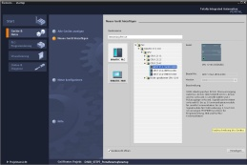

**2** SIMATIC STEP 7 Professional (TIA Portal) V15.1 or higher



**1** Engineering station

**5** Ethernet connection

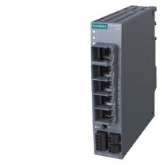  
**4** IE Security SCALANCE S615

**5** Ethernet connection

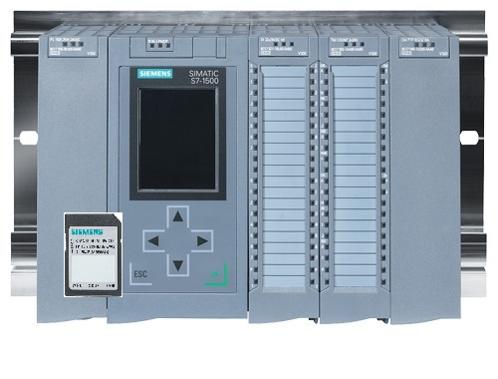  
**3** SIMATIC S7-1500 controller

# Theory

## Structure and operation of SCALANCE S615

The following section provides a short description of the SCALANCE S615. Additional details and information can be found in the manuals, which can be downloaded from [support.automation.siemens.com](http://support.automation.siemens.com/).

### Industrial Ethernet Security S615

The SCALANCE S615 is an industrial Ethernet router and firewall for process automation.

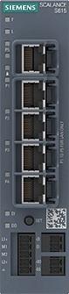

⑥

①

②

③

⑤

④

1. Network ports
2. SET button
3. Digital input
4. Digital output
5. Supply input for the power supply
6. LED display

### SET button

The SET button on a SCALANCE S615 is located on the front of the housing.

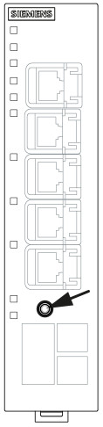

The SET button has several functions. If the button is pressed briefly for less than 3 seconds, the device performs a restart. When pressed for longer than 10 seconds, the device is reset to the factory settings.

The button can also be used to bring the device into the boot loader. In case of a defective firmware, a new firmware can be installed using the boot loader. More detailed information on this topic can be found in the manual.

### LED indicator lights

SCALANCE S615 is equipped with various LEDs that provide an overview of the system status.

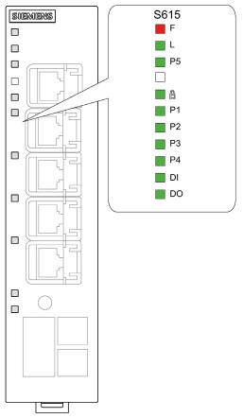

|  |  |
| --- | --- |
| F | LED to display the error status |
| L | LED to display the power supply |
|  | LED to display the VPN connections |
| DI | LED to display the digital input |
| DO | LED to display the digital output |
| P | LEDs to display the port status |

A detailed description of each LED can be found in the manual of the device.

④

### Network ports

SCALANCE S615 has five network ports. The first four ports are factory configured as VLAN 1 (INT) and the fifth as VLAN 2 (EXT).

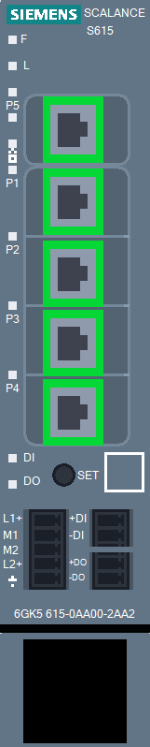

VLAN 1 (INT)  
192.168.1.1/24

VLAN 2 (EXT)  
DHCP

This interconnection can be changed as desired. By default, VLAN 2 is configured as an insecure external network and VLAN 1 as a protective internal network.

VLAN 1 is configured in the factory settings with IP 192.168.1.1/24. However, the device in the VLAN 2 does not have a fixed IP address, instead a dynamic IP address can be set using DHCP.

## VLAN: Virtual networks

Devices, such as switches, usually have multiple network ports, all of which belong to the network. A device at port A can therefore communicate unhindered with a device at port B. To separate the individual devices from each other, dedicated physical devices would have to be used accordingly per network.

Virtual Local Area Networks (VLANs) can be used to divide a physical network device into virtual networks. Each port is permanently assigned to a VLAN. A device on a port in VLAN 1 can now only communicate with devices in VLAN 1. Each VLAN is configured with a unique ID in the device. This ID is generally 12 bits long and is displayed in decimal form.

You have the option of assigning several VLANs to one port. Packets leaving such a port will be provided with a tag containing the ID of the VLAN. Incoming packets are checked for an existing tag and the packet is assigned to the VLAN with the ID contained in the tag. To evaluate the tags correctly, the partner on such a port must of course be configured accordingly.

The same physical network structure can therefore be used cost-effectively to separate individual device groups from each other.

SCALANCE S615 is divided into two separate networks at the factory. A secure network with VLAN ID 1 and an insecure network with VLAN ID 2 (see section 4.1.4).

## Router

In contrast to a switch, a router can connect different networks with each other. It has a physical connection and a suitable IP address for each network. This makes it accessible to other devices in the network and allows it to exchange packets between the connected networks.

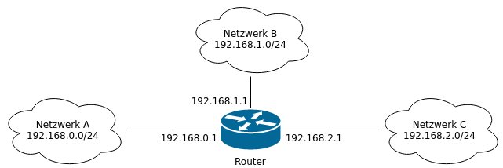

Router

Network B  
192.168.1.0/24

Network C  
192.168.2.0/24

Network A  
192.168.0.0/24

## Firewall

A firewall can filter packets that pass through it. The device can use different criteria for this purpose, such as source and target addresses or TCP ports. More powerful devices are also able to understand more complex things, such as what data the user is currently sending to a website.

SCALANCE S615 is both a router and firewall and can check packets that are routed through it from one VLAN to another (layer 3). This means it is not able to control packets that are forwarded through it within a VLAN (layer 2).

The firewall in the S615 can process information up to layer 4. This includes IP addresses and the protocol used, e.g. TCP or UDP, and the ports used.

The filtering itself is done based on a rule set that exists in the form of a table. Each line hereby corresponds to one rule.

|  |  |  |  |  |  |
| --- | --- | --- | --- | --- | --- |
| **Source IP** | **Destination IP** | **Protocol** | **Source port** | **Destination port** | **Action** |
| 192.168.1.24/32 | 192.168.2.5/32 | any |  |  | Accept |
| 192.168.1.0/24 | 0.0.0.0/0 | tcp | * | 443 | Accept |
| 0.0.0.0/0 | 0.0.0.0/0 | any |  |  | Drop |

This rule set is processed from top to bottom and the first matching rule is used. In the above example, the node with the IP 192.168.1.24 would be able to establish any type of communication with node 192.168.2.5.

Nodes from network 192.168.1.x would be able to contact any other address via TCP and port 443 (HTTPS). The last rule ensures that all other packets are dropped.

It is generally possible to execute one of three actions.

* Packets can be accepted and forwarded.
* It is also possible to reject or drop them. In this case, the sender is not informed about the whereabouts of the packet.
* Finally, it is possible to reject the packets. In this case, the sender receives corresponding feedback that its packets were rejected.

Accept and Drop are used in most cases, and Reject is only used for special cases.

### Implicit rule

What happens to packets that match none of the configured rules? The answer depends on the manufacturer of the filter. Most manufacturers have an implicit rule at the end of the rule set that either allows everything or drops everything. This behavior can usually be adjusted.

In the case of SCALANCE S615, the implicit rule drops all packets.

### Stateful inspection

Most firewalls do not just filter incoming packets, they also remember which computer has established which connection. For example, a computer that calls a website gets response packets from the server. Modern firewalls check packets only during connection setup, so that these response packets do not also have to be defined in the filter rules.

If node 192.168.1.5 tries to reach an encrypted web page on node 192.168.3.25 via port 443, this connection setup is checked against the rule set. If the rule set accepts this connection, the firewall remembers the validity of this connection in a special session table. Any subsequent packet belonging to this connection, whether from the client or web server, on any source or destination port, is now accepted by the firewall.

Using this method, the administrator only must generate the rule set required for the connection setup.

## CIDR notation

To ensure the most efficient use of existing IP addresses, these are nowadays classified with the subnet mask and not by the IP address.

The subnet mask is often represented as a suffix added at the end the actual address. This representation is also called CIDR (Classless Inter-Domain Routing) notation.

* Example: 192.168.0.1/24

The suffix /24 indicates the number of bits set in the subnet mask. In the example, the first 24 bits of the subnet mask would be set.

* Binary: 11111111.11111111.11111111.00000000
* Decimal: 255.255.255.0

In the firewall rules this notation is used to define ranges for the source and destination addresses. The suffix specifies the bit up to which the address on the packet must match the address in the rule.

|  |  |
| --- | --- |
| **Address in the rule set** | **Description** |
| 192.168.1.1/32 | All bits must match.  Only the address 192.168.1.1 conforms to the rule |
| 192.168.1.0/24 | The first 3 octets must match.  All addresses that begin with 192.168.1.x conform to the rule. |
| 0.0.0.0/0 | No bit must match.  All addresses conform to the rule |
| 192.168.1.0/25 | The first 3 octets and the highest bit of the 4th octet must match.  Here only the addresses 192.168.1.0 to 192.168.1.127 conform to the rule |

Appropriate tools can be helpful for more complex ranges, such as the last example. A simple Internet search for "subnet computers" or "CIDR computers" should produce enough online tools.

A helpful intuitive tool can be found for example here:

[heise.de/netze/tools/netzwerkrechner/](https://www.heise.de/netze/tools/netzwerkrechner/)

## Setting the IP address on the programming device

To program SIMATIC S7-1500 from the PC, the programming device or a laptop, you need a TCP/IP connection or, optionally, a PROFIBUS connection.

For the PC and SIMATIC S7-1500 to communicate with each other via TCP/IP, it is important that the IP addresses of both devices match.

The procedure for setting the IP address of a computer with Windows 10 operating system is presented in the following.

* Locate the network icon in the taskbar at the bottom  and click → "Network settings".

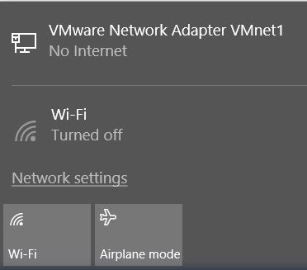

* In the network settings window that opens, click → "Ethernet" and then → "Change adapter options".

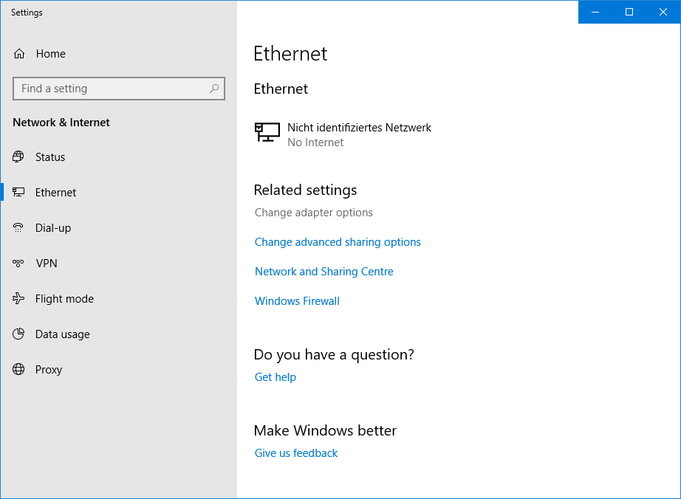

* Select the desired → "LAN connection" that you want to use to connect to the controller and click → "Properties".

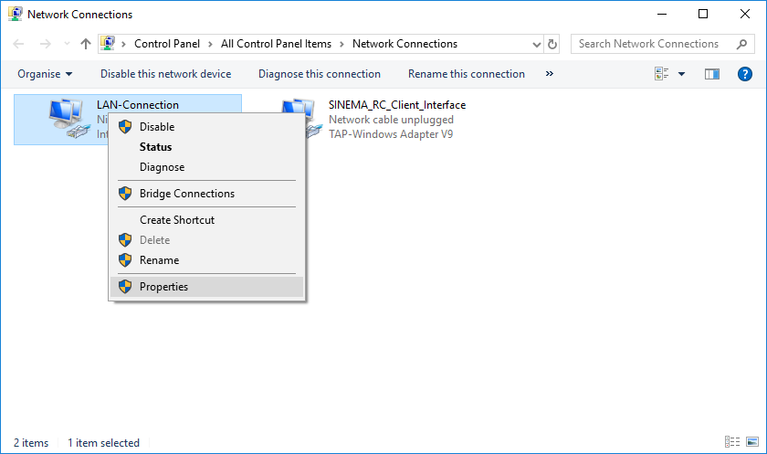

* Next, select the → "Properties" for → "Internet Protocol Version 4 (TCP/IP)".

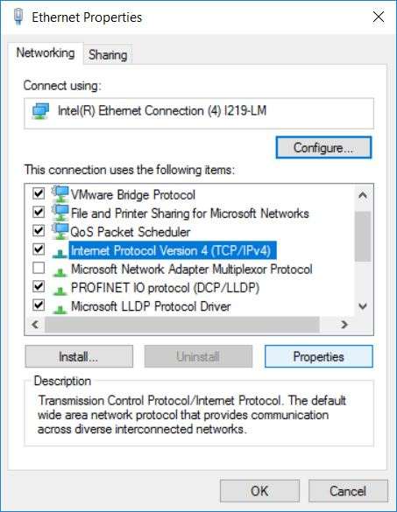

* You can now use, for example, the following IP address: 192.168.1.99 with the subnet mask 255.255.255.0 and apply the settings (→ "OK")

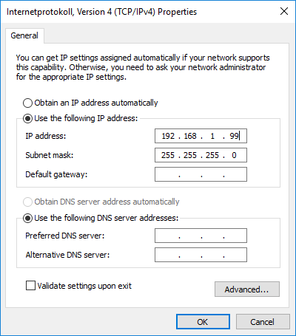

# Task

In this section, the hardware and the program from chapter "SCE_EN_092-300_OPC_UA_S7-1500" shall be extended by the SCALANCE S615.

Using SCALANCE S615, a secured access to the controller from the company network is to be enabled. The web server on the CPU is to be freely accessible for diagnostic purposes, while only authenticated users are to be allowed access to the programming via the TIA Portal.

# Planning

First, the SCALANCE S615 must be configured with a new IP address and the basic configuration carried out.

The S615 can then be entered in the CPU 1516F as a router, and the configuration can be transferred to the CPU.

After successful basic configuration of both devices, the physical networking of the components can be set up as follows.

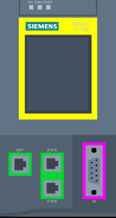

CPU 1516F

S615

P5

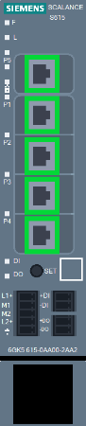

Company network  
10.0.0.0/24

Plant network  
192.168.1.0/24

P1

X2

P4

PG/PC

Finally, the access rules will be created and tested in SCALANCE S615.

IMPORTANT:   
Because the programming device is located in different subnets during commissioning, you must never allow the TIA Portal to generate a project-specific IP address. Instead, configure the correct IP settings statically in the programming device. Later, the S615 is assigned the correct IP addresses dynamically.

# Structured step-by-step instructions

You can find instructions on how to carry out planning below. If you already have a good understanding of everything, it is enough to focus on the numbered steps. Otherwise, simply follow the steps of the instructions illustrated below.

## Retrieving an existing project

* Before you can extend the project "SCE_EN_092-300 OPC UA S7-1500_R1807.zap15" from chapter "SCE_EN_092-300 OPC UA S7-1500", you have to retrieve it from the archive.
* To retrieve an existing project that has been archived, you must select the relevant archive from the project view under → Project → Retrieve. Confirm your selection with "Open". (→ Project → Retrieve → Select a .zap archive … → Open)

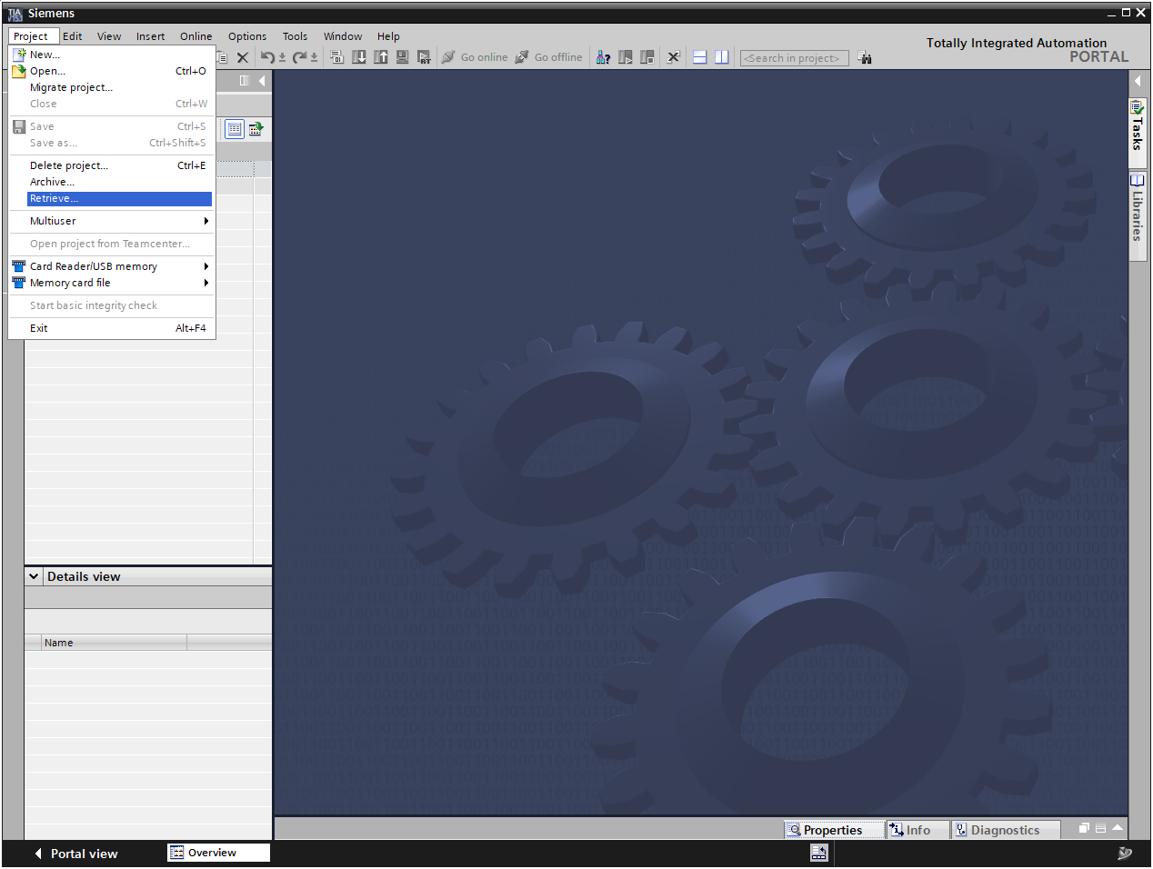

* As the next step, select the target directory where the retrieved project it to be stored. Confirm your selection with "OK". (→ Destination directory … → Select folder)
* Save the retrieved and opened project under the name 142-200_Industrial_Security_with_S615. (→ Project → Save as … → 142-200_Industrial_Security_with_S615 → Save)

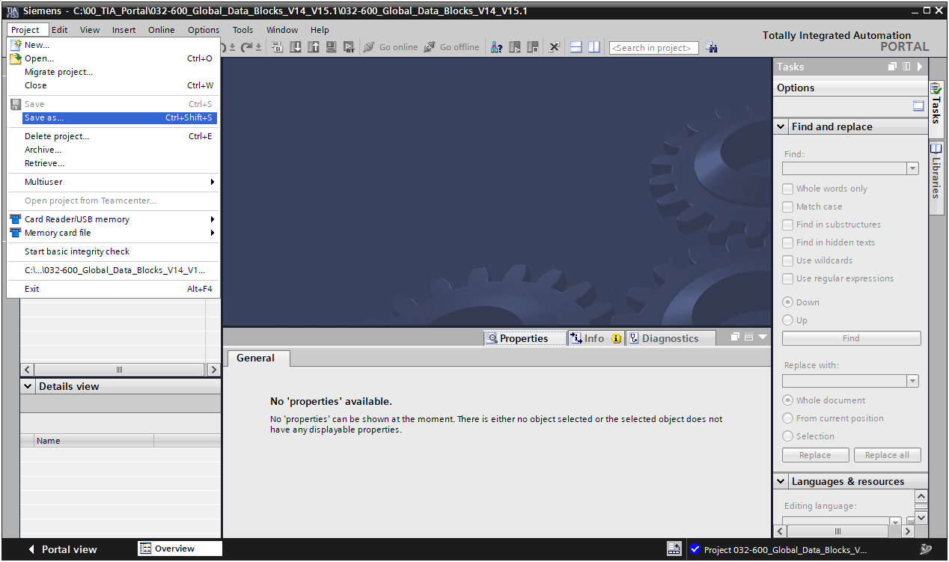

## Setting the IP address of the SCALANCE S615

* Connect the programming device to port 4 of the SCALANCE S615.
* Disconnect all other connections to the SCALANCE S615
* Make sure that your programming device is in subnet 192.168.1.0/24. Follow the instructions in section 4.6.
* Open the search for Accessible devices. (→ )
* Select your PN/IE interface and start the search. (→)
* Select the SCALANCE S-600 and click on "Show". (→)

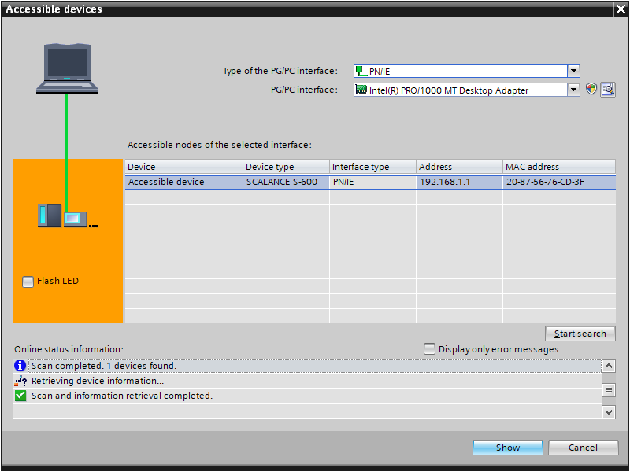

* Under "Online access", open the "Online & diagnostics" item of the displayed device.

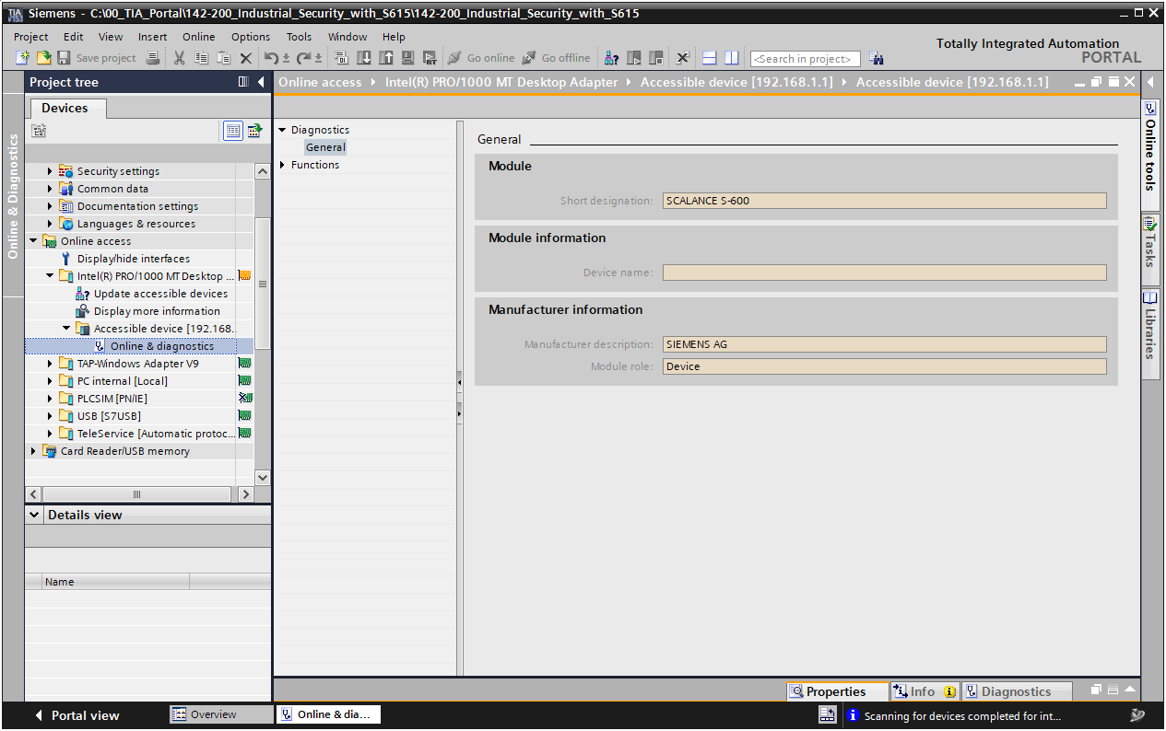

* Set the IP address to 192.168.1.254/24. (→ Functions → Assign IP address → IP address: 192.168.1.254 → Subnet mask: 255.255.255.0 → )

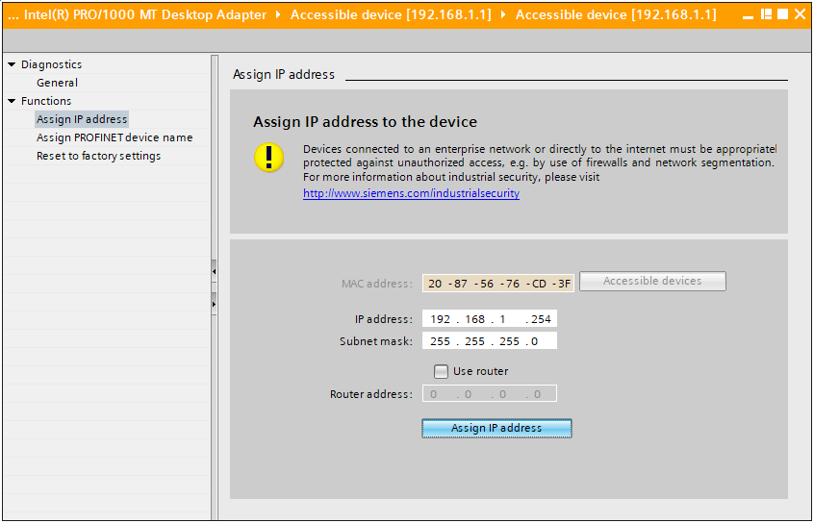

## Basic configuration of the SCALANCE S615

* In the browser, open the SCALANCE S615 web interface (→ <https://192.168.1.254>).
* The web interface of the SCALANCE S615 is protected with a self-signed certificate. To continue, confirm the exception.

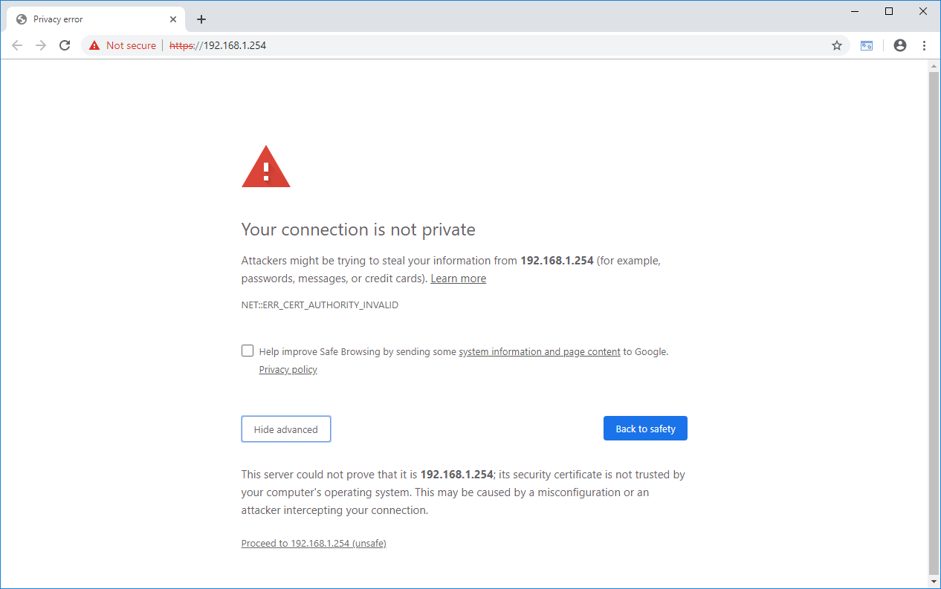

Note:

* *Depending on the browser, the confirmation of the certificate looks somewhat different.*

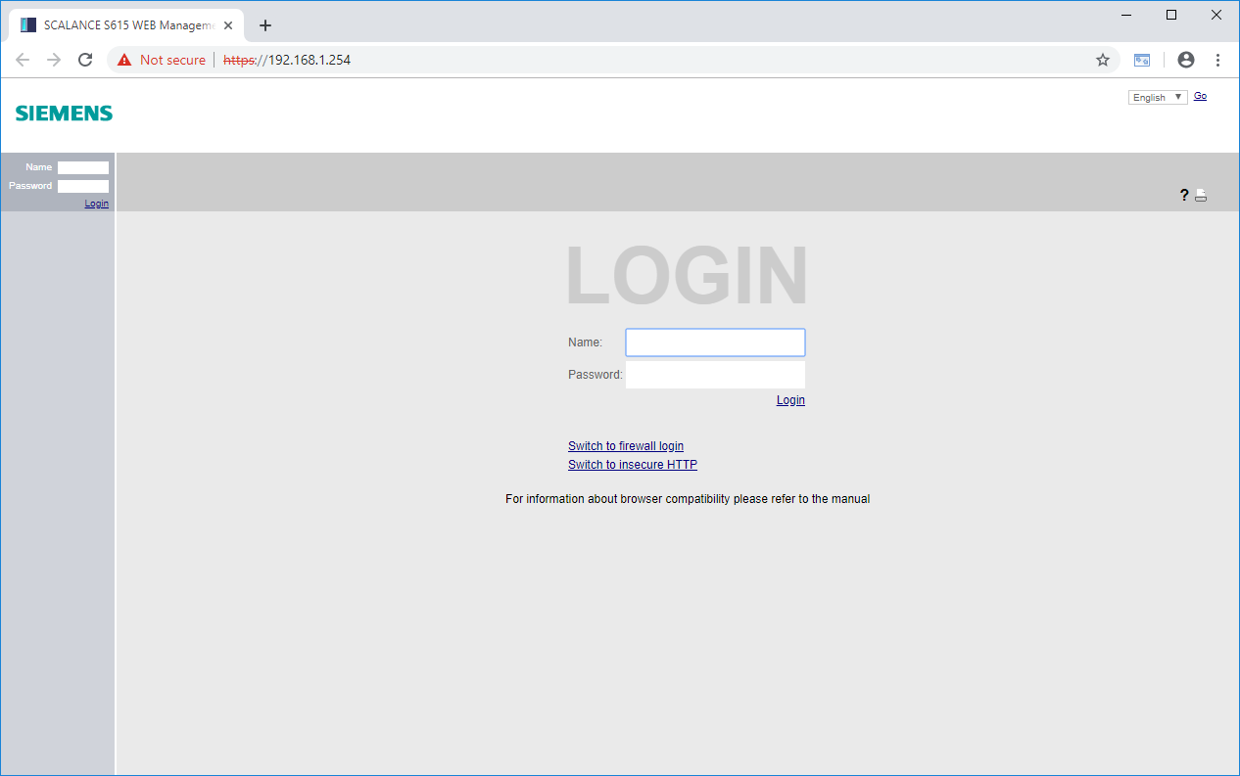

* First change the language of the user interface to English. (→ English → Go)

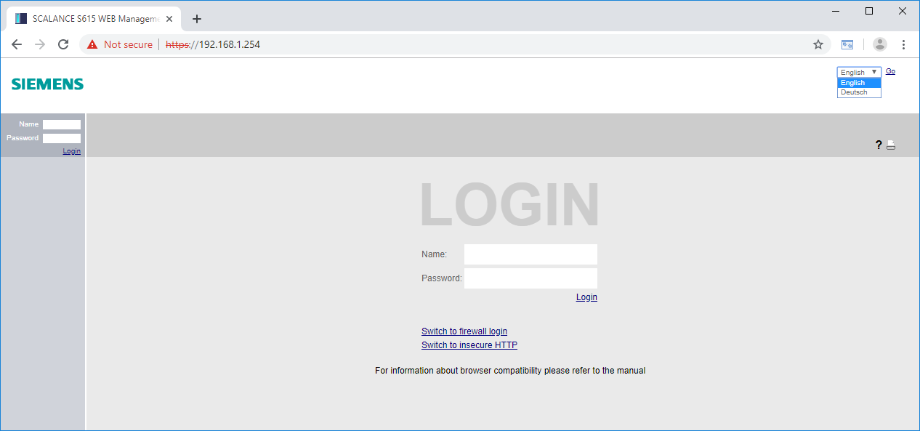

* Next you can log in with the user "admin" and the password "admin". (→ Name: admin → Password: admin → Login)

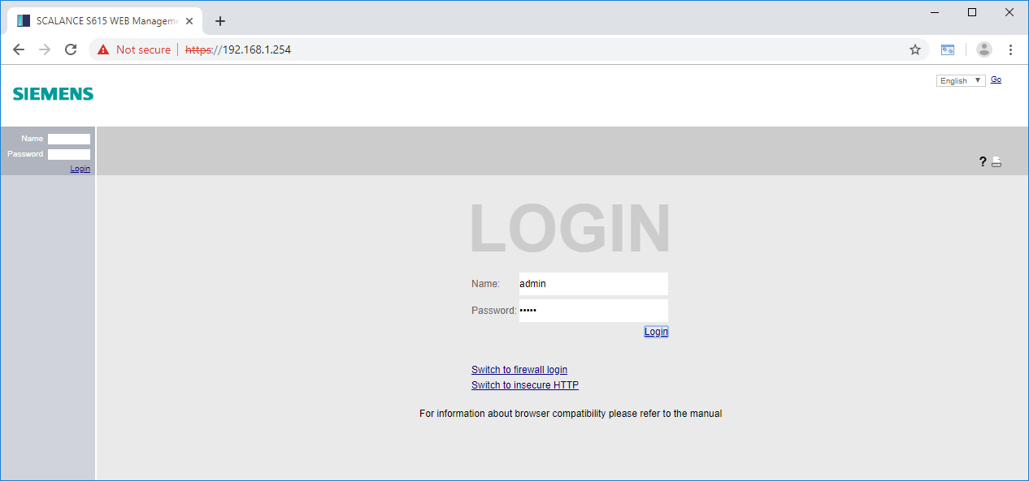

* The default access must be changed before the first login. (→ OK)

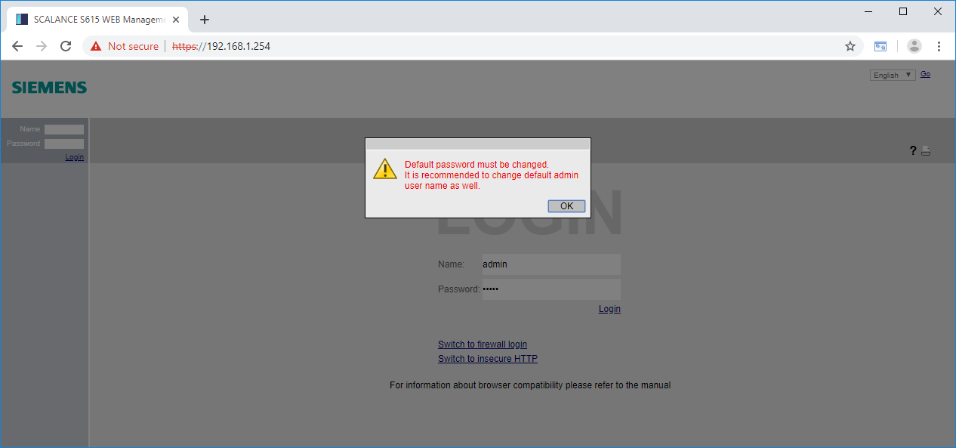

* First enter the old password "admin" and then a new password twice.  
  → Current user password: admin  
  → New password: ***  
  → Confirm password: ***  
  → Apply settings

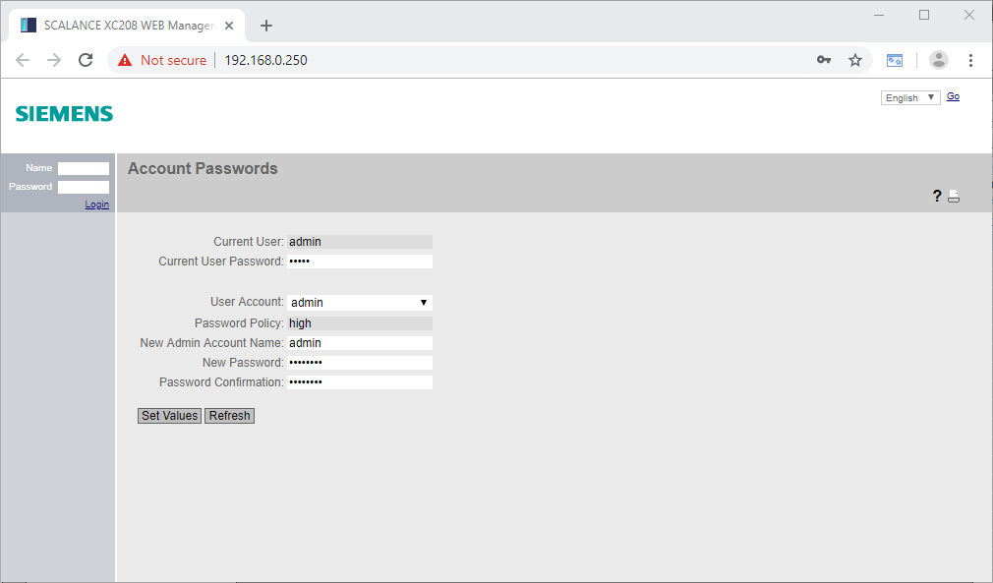

Note:

* *The new password needs at least eight characters, a number, an uppercase character and a special character!*
* Once the access data and login has been successfully changed, DCP access to the device is permitted only in read-only mode. (→ OK)

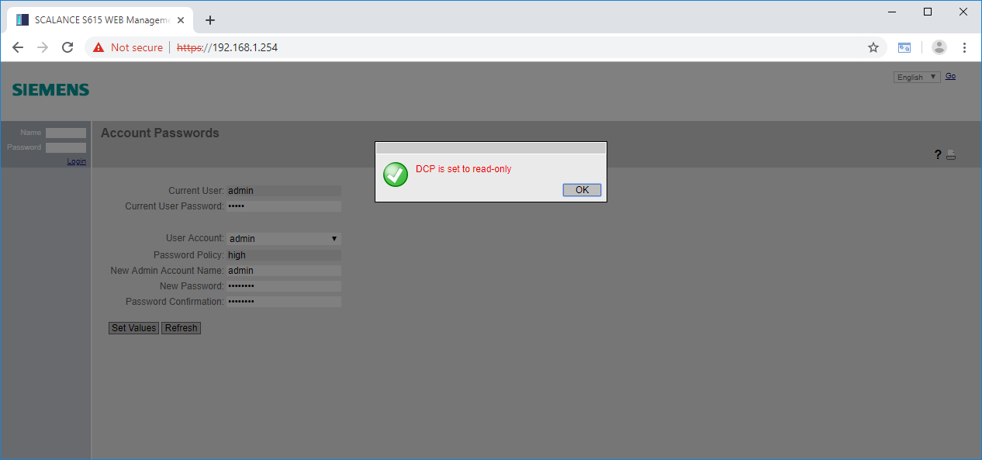

* In the following configuration wizard, set VLAN 2 to the static address 10.0.0.254/24 and click "Next". (External (vlan2) → DHCP → IP Address: 10.0.0.254 →  Subnet Mask: 255.255.255.0 → Next)

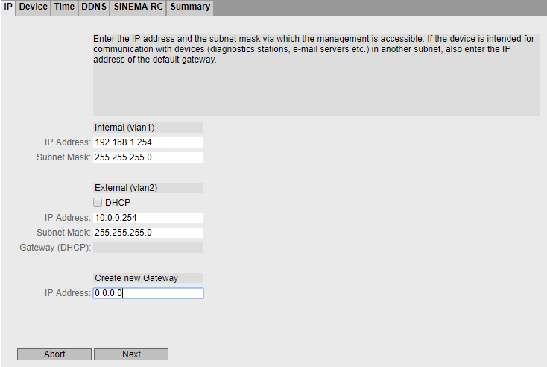

* Fill in the identification data as required and click "Next".

(→ System Name: … → System Location: … → System Contact: … → Next)

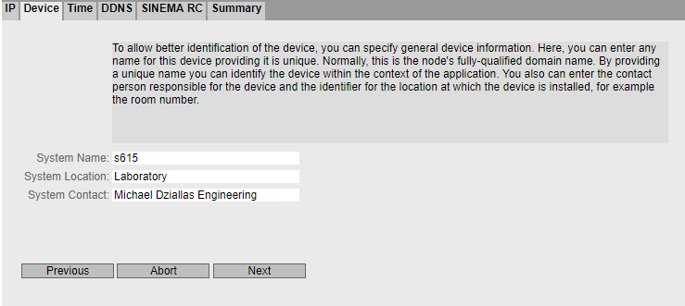

* Accept the PC time and click "Next". (→ Use PC Time → Next)

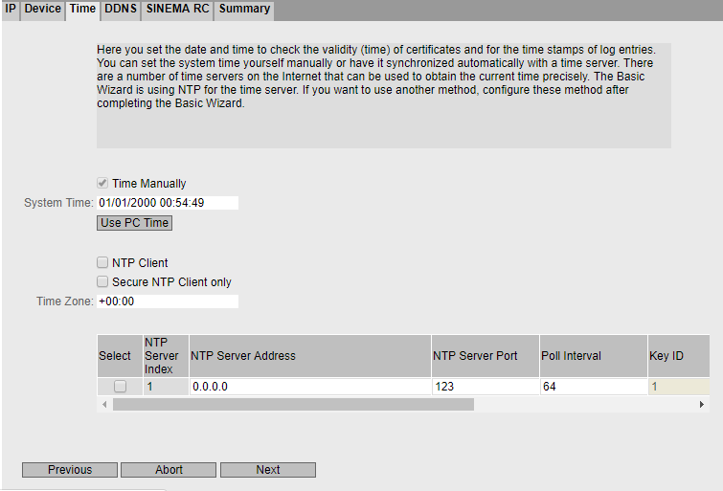

* Skip the dynamic DNS settings with "Next". (→ Next)

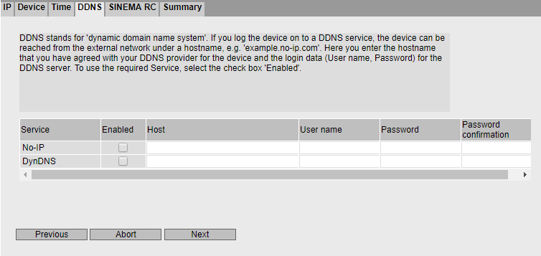

* Skip the SINEMA RC settings with "Next". (→ Next)

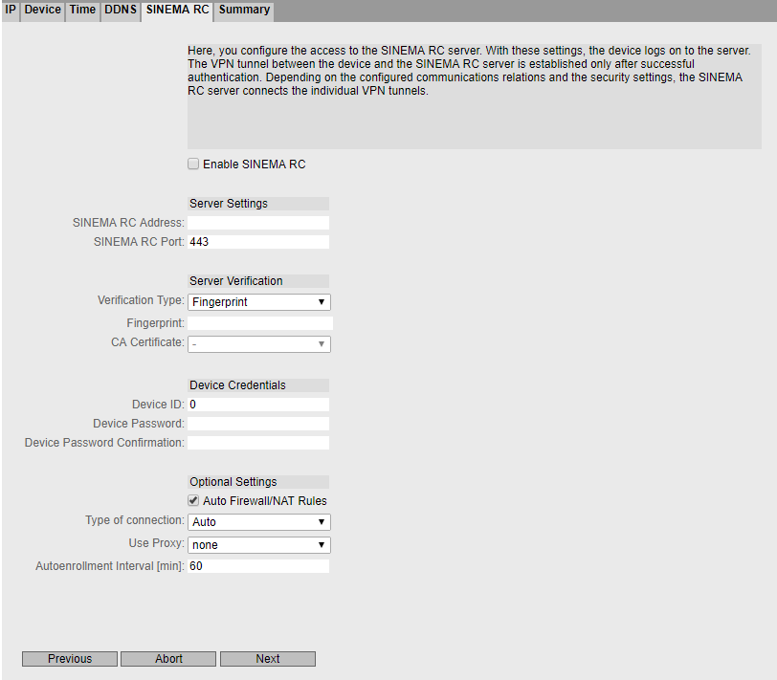

* Check all settings again in the summary and confirm the configuration. (→ Set Values)

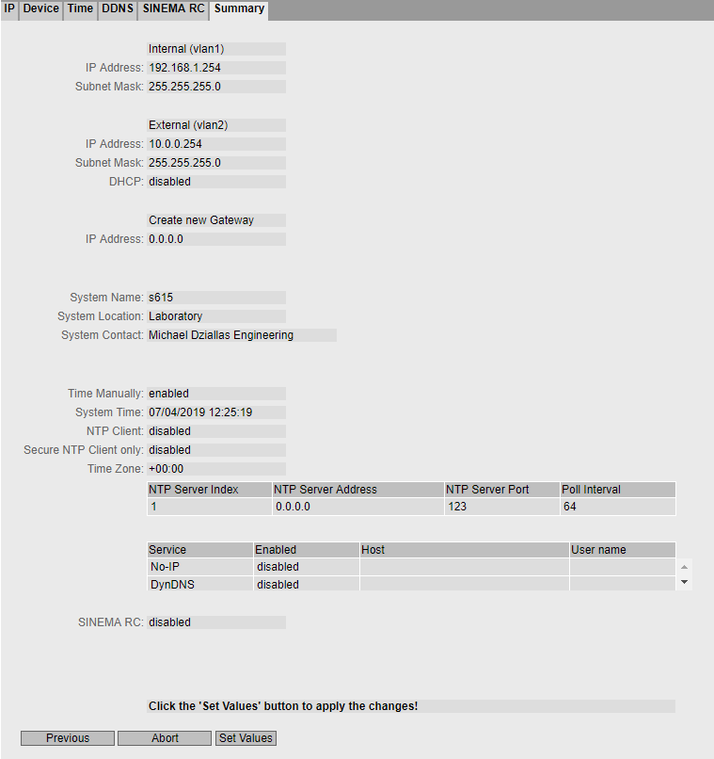

* After accepting the settings, you will be taken to the final web interface of the SCALANCE S615.

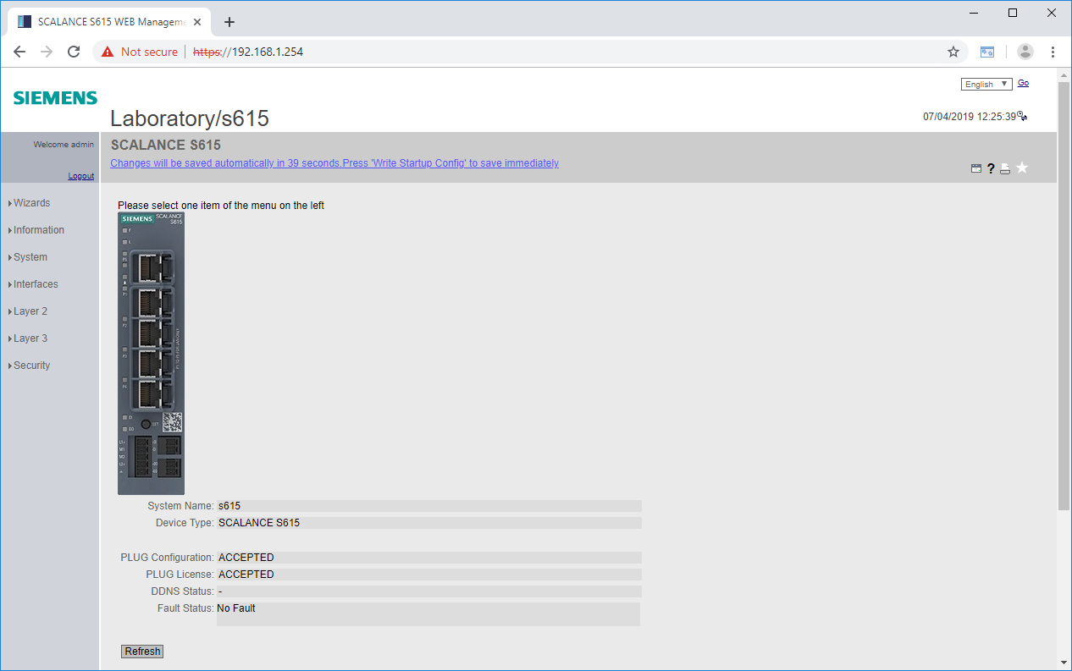

## Configuration of the DHCP server

To make the connection to the plant network as easy as possible for the service technician and later during the tests, the SCALANCE S615 is assigned dynamic addresses both in the secured and in the unsecured range.

* In the menu system, go to the DHCP server settings. (→ System → DHCP → DHCP Server)

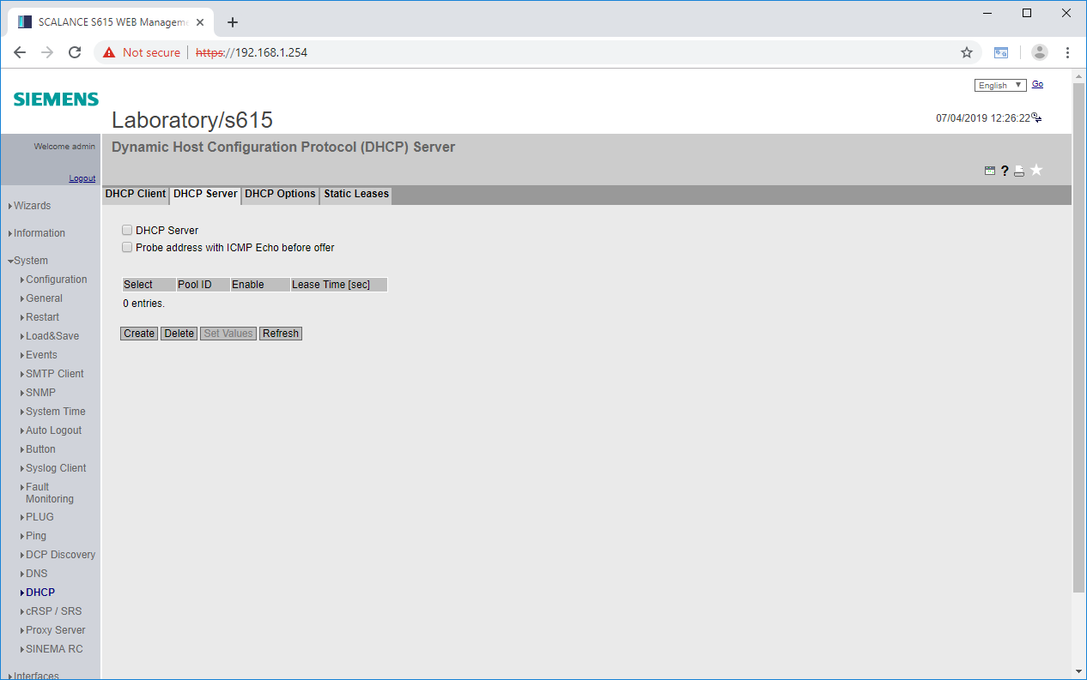

* First generate a new pool of IP addresses. (→ Create)

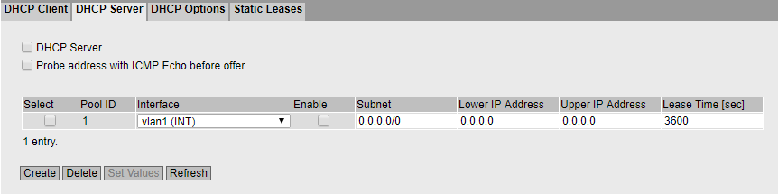

* Select vlan1 for the interface. (→ Interface: vlan1 (INT))
* Set the correct subnet. (→ Subnet: 192.168.1.0/24)
* Set the first IP address. (→ Lower IP Address: 192.168.1.208)
* Set the last IP address. (→ Upper IP Address: 192.168.108.223)
* Apply the settings. (→ Set Values)

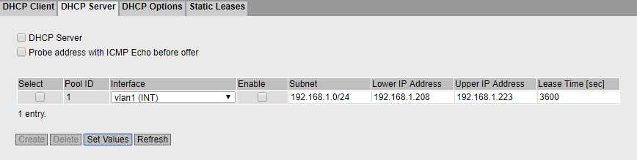

* Generate another pool of IP addresses (→ Generate)

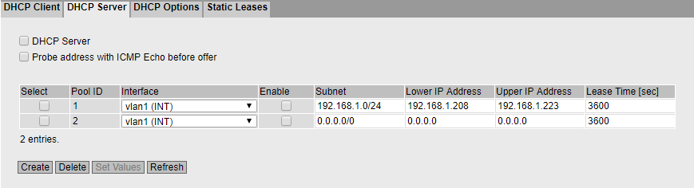

* Select vlan2 for the interface. (→ Interface: vlan2 (EXT))
* Set the correct subnet. (→ Subnet: 10.0.0.0/24)
* Set the first IP address. (→ Lower IP Address: 10.0.0.1)
* Set the last IP address. (→ Upper IP Address: 10.0.0.127)

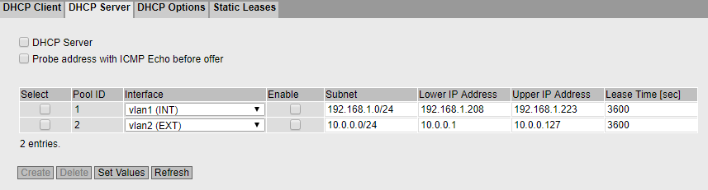

* Go to the DHCP Options tab (→ DHCP Options)

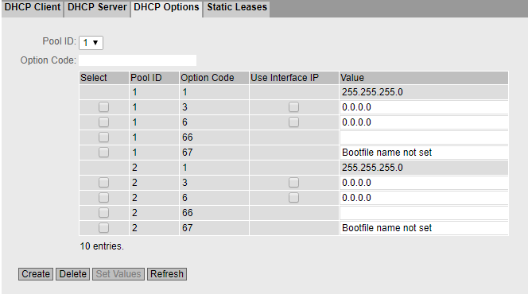

* In both pools, use the interface IP for option 3 and accept the settings.

(→ Pool ID: 1 → Option Code: 3 → Use Interface IP)  
(→ Pool ID: 2 → Option value: 3 → Use Interface IP)  
(→ Set Values)

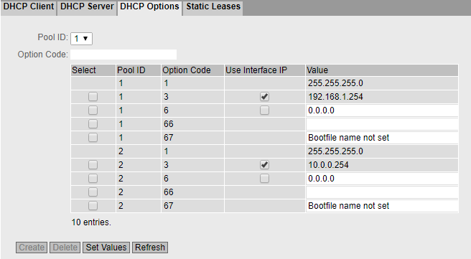

* Go back to the DHCP server. (→ DHCP Server)
* Select the DHCP server. (→  DHCP Server)
* Select the two pools. (→  Select)
* Apply the settings (→ Set Values)

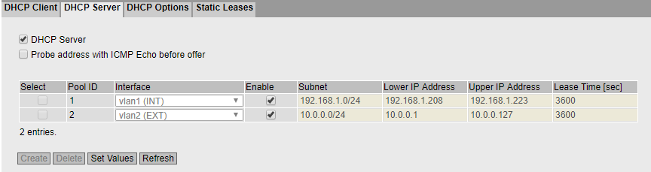

Note:

* *S615 will then distribute addresses from subnet 192.168.1.0/24 to ports 1 to 4 and from network 10.0.0.0/24 to port 5. In each case it supplies its own IP as gateway.*
* For the settings on the programming device, follow the instructions in section 4.6 up to the settings of the Internet protocol, version 4 (TCP/IP).
* Obtain the IP address automatically instead of the static configuration.  
  (→ Obtain an IP address automatically → Obtain DNS server address automatically)

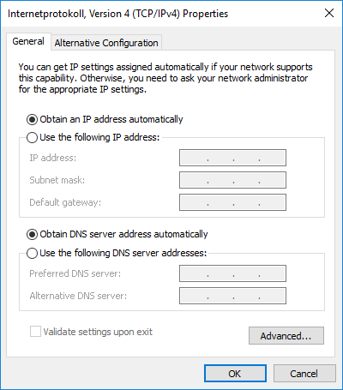

* Confirm the changes and open the status of the connection in the network connections. (→ LAN connection → Status)

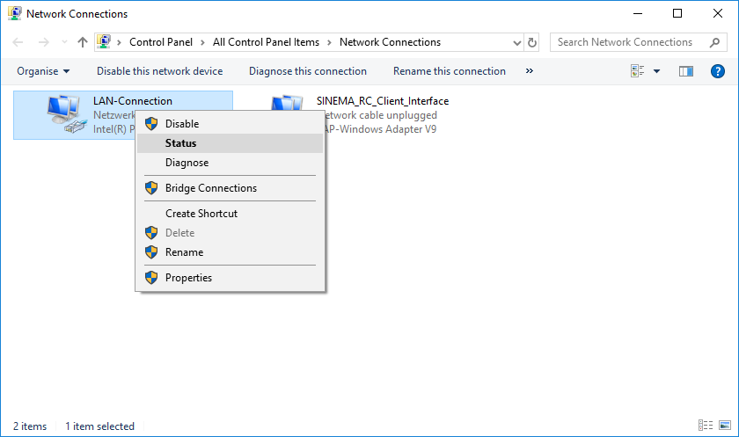

* Click Details. (→ Details)

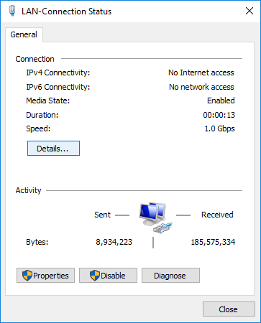

* Make sure that the programming device has been assigned a suitable IP address and a gateway.

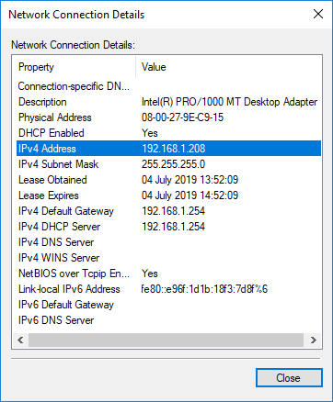

## Setting up the firewall

In the factory configuration, SCALANCE S615 does not allow connections between the two VLANs. Devices on ports 1 to 4 cannot communicate with devices on port 5 and vice versa. This connection must be released so that, for example, devices from the company network can access the OPC UA server of the CPU.

* Open the firewall settings in the Security menu. (→ Security → Firewall)

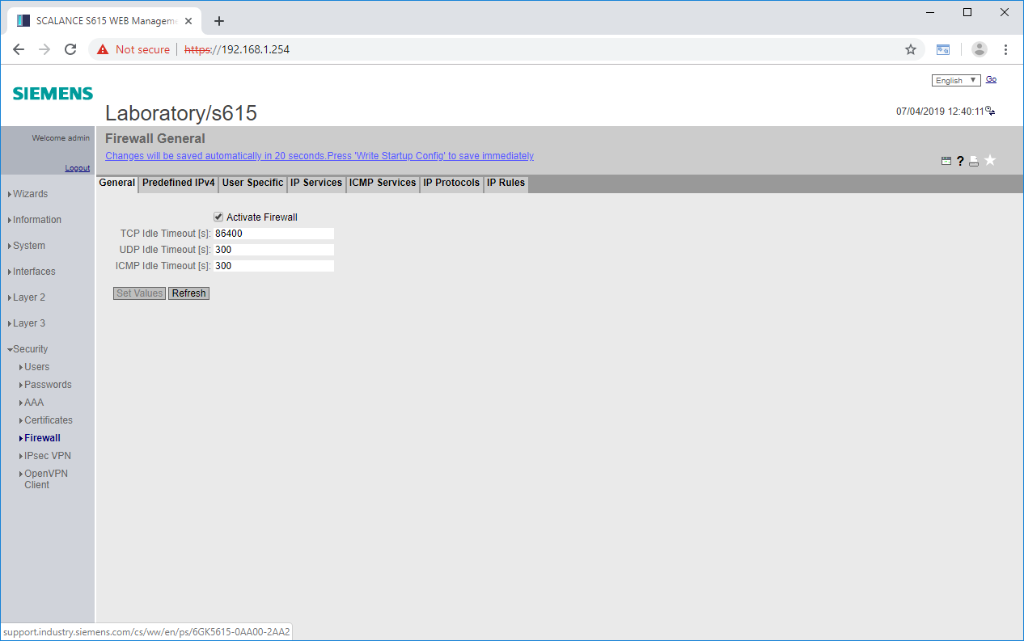

* Go to the Predefined IPv4 Rules tab. (→ Predefined IPv4 rules)

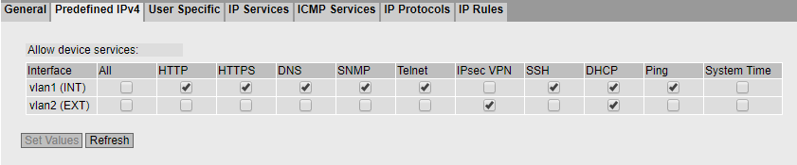

* Allow external access via HTTPS and Ping to the S615 and accept the settings. (→ vlan2 (EXT) →  HTTPS →  Ping)

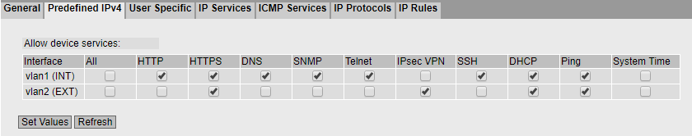

Note:

* *Selecting the check box for HTTPS allows external access to the configuration interface and should not be done without due consideration. However, we need this access later for authentication on the S615. Because the externally connected company network is not a public network, the risk here is relatively low. A SCALANCE S615 connected to the Internet should only allow external IPsec VPN, ping and, depending on the configuration, DHCP.*
* Go to the IP Services tab. (→ IP Services)

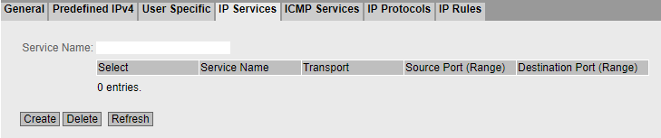

* Create a new service for the web server of the CPU.  
  (→ Service Name: https → Create)

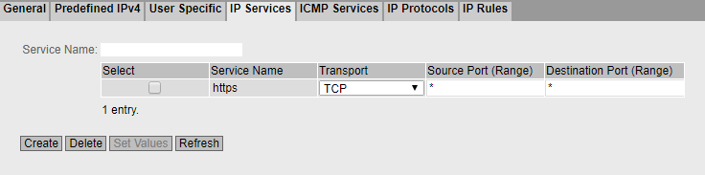

* Enter the HTTPS port as the destination port and apply the settings.  
  (→ Destination Port: 443 → Set Values)

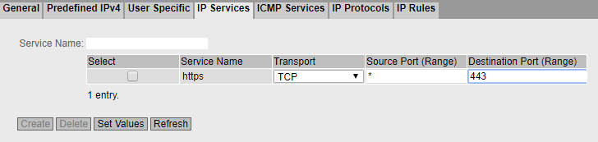

* Go to the IP Rules tab. (→ IP Rules)

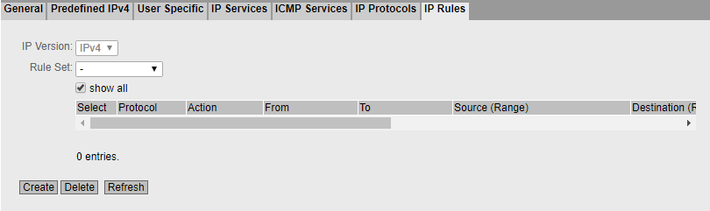

* Create a new rule. (→ Create)

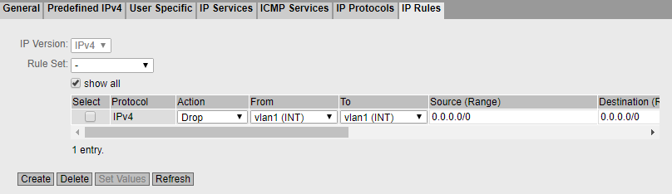

* Set the action to Accept. (→ Action: Accept)
* Select vlan2 as the source interface. (→ From: vlan2 (EXT))
* Select vlan1 as the destination interface. (→ To: vlan1 (INT))
* Enter the company subnet 10.0.0.0/24 as the source network. (→ Source: 10.0.0.0/24)
* Specify the X2 IP of the S7-1500 as the destination. (→ Destination: 192.168.1.1/32)
* As service, select the HTTPS service you just created. (→ Service: https)
* Apply the settings. (→ Set Values)





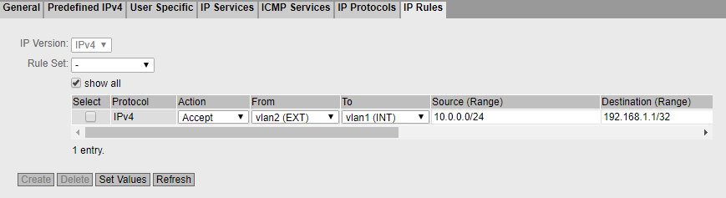

## Setting up the service user

After external access to the web server has been set up, specific rules are created in the next step, which are activated by logging on to the system with a user.

* Open the local user administration. (→ Security → Users → Local Users)

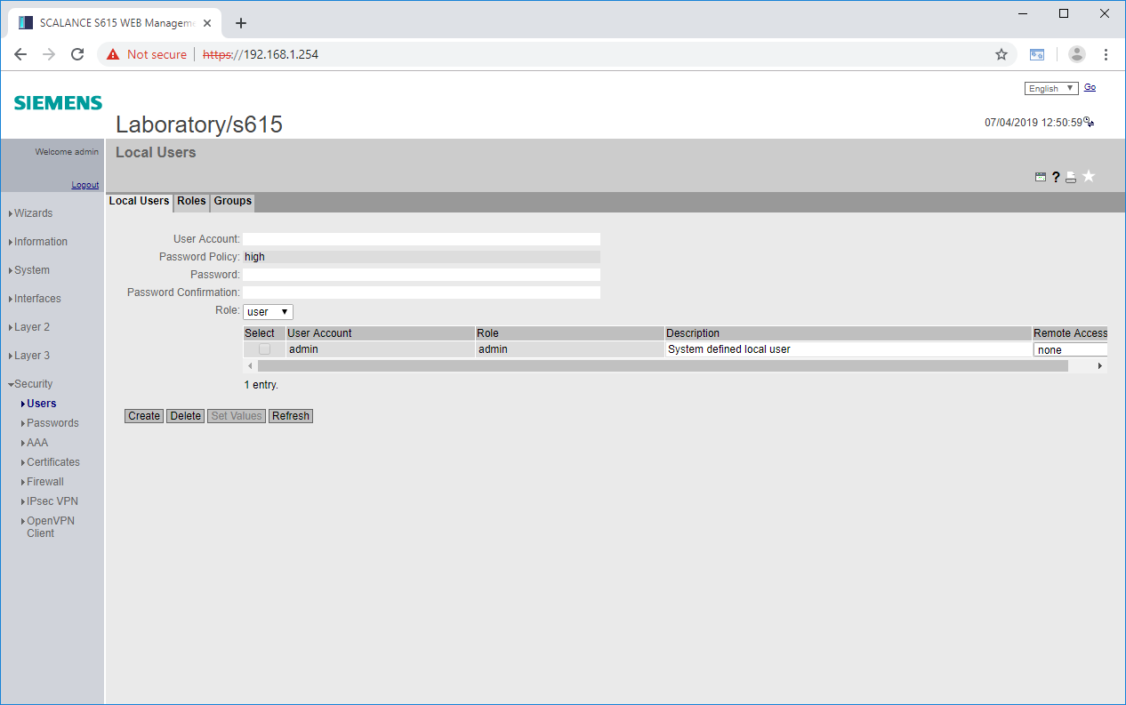

* Specify a new username. (→ User account: support)
* Enter a password. (→ Password: *** → Confirm password: ***)
* Select "user" as role. (→ Role: user)

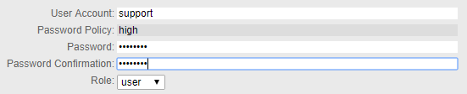

* Click Create. (→ Create)

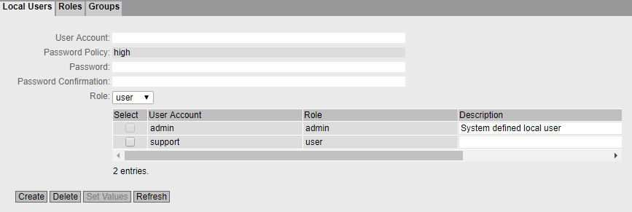

* Select "only" as remote access (→ support → Remote access: only)
* Apply the settings. (→ Set Values)

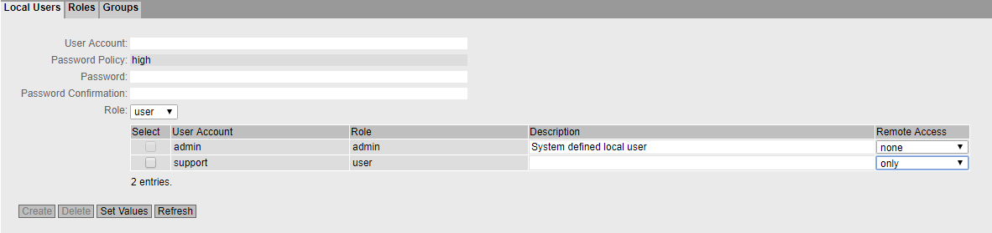

* Under firewall, switch to the User Specific tab. (→ Security → Firewall → User Specific)

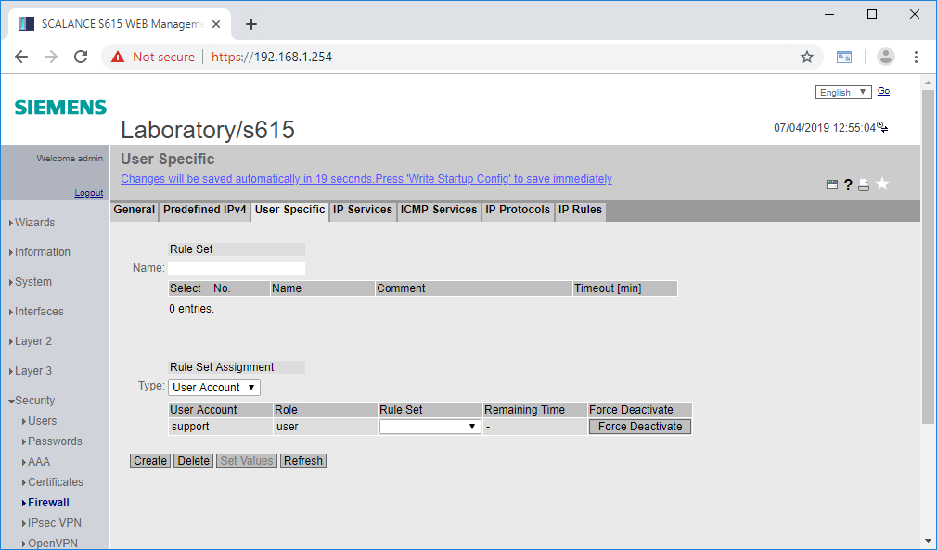

* Add a new rule set "support_rules". (→ Rule Set → Name: support_rules → Create)

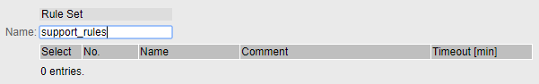

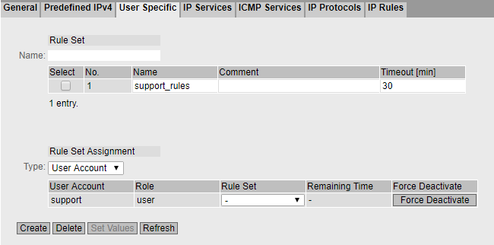

* Assign the rule set "support_rules" to the user "support". (→ Rule Set Assignment → support → Rule Set: support_rules)
* Apply the new settings. (→ Set Values)

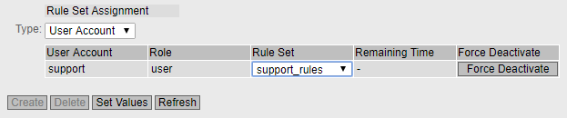

Note:

* *This will apply the additional rule set "support_rules" to the computer of the user "support" after successful login to the system.*
* Go to the IP Rules tab. (→ Security → Firewall → IP Rules)

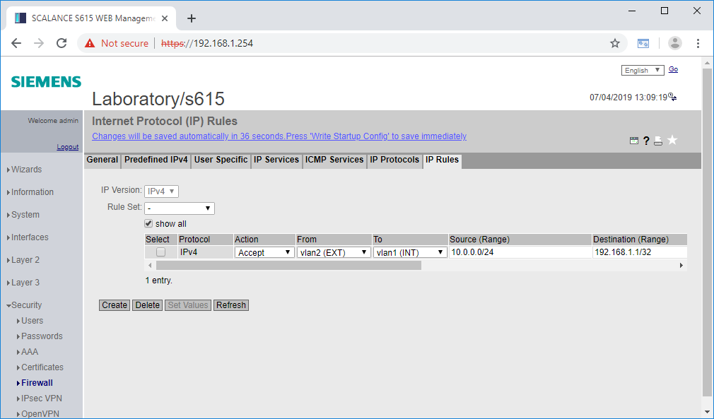

* Create a new rule. (→ Create)
* Set the action to Accept. (→ Action: Accept)
* Select vlan2 as the source interface. (→ From: vlan2 (EXT))
* Select vlan1 as the destination interface. (→ To: vlan1 (INT))
* Enter "DYNAMIC" as the source network. (→ Source: DYNAMIC)
* Enter the X2 IP of the S7-1500 as the destination. (→ Destination: 192.168.1.1/32)
* Select "all" as service. (→ Service: all)
* Apply the settings. (→ Set Values)





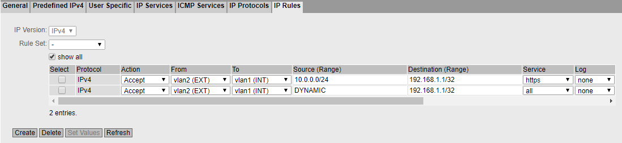

* Next, select "support_rules" under rule set. (→ Rule Set: support_rules →  show all)

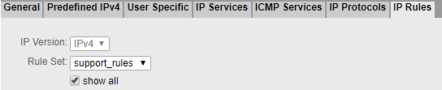

* Select the "Assign to" check box in the rule you have just created. (→  Assign to)



* Apply the settings. (→ Set Values)

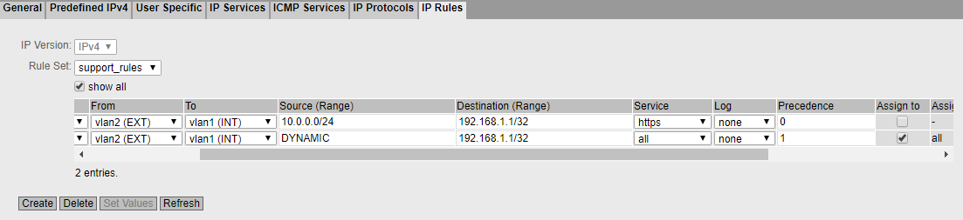

Note:

* *The placeholder DYNAMIC is replaced with the IP of the logged-in user during login. Due to the assignment of the rule to the rule set "support_rules", this rule is only active after the corresponding user has logged in.*

## Configuration of the CPU 1516F

The network configuration must then be adapted and transferred to the CPU 1516F.

* Connect the X2 interface of the CPU 1516F-3 PN/DP to port 1 of the SCALANCE S615.
* Open the properties of the X2 interface of the CPU_1516F in the TIA Portal.  
  (→ CPU_1516F → X2 → Properties)
* Go the IP configuration. (→ Ethernet addresses → IP protocol)

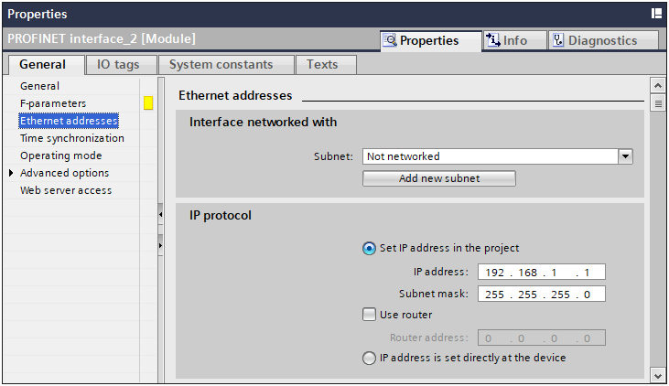

* Set the IP address of the S615 as router. (→ Use router → Router address: 192.168.1.254)

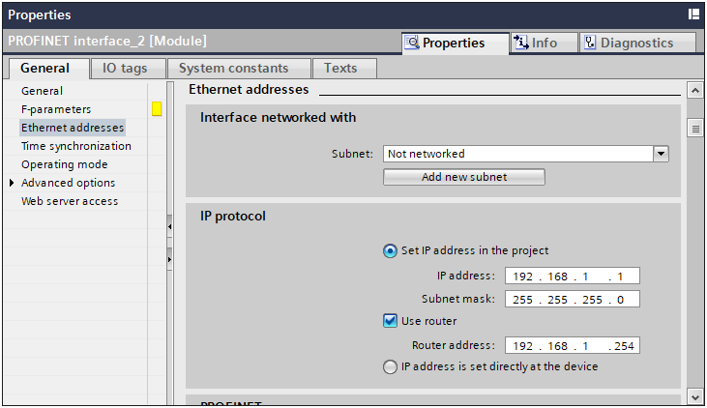

* Open the properties of the web server of the CPU 1516F-3 PN/DP.  
  (→ CPU_1516F → Properties → Web server)

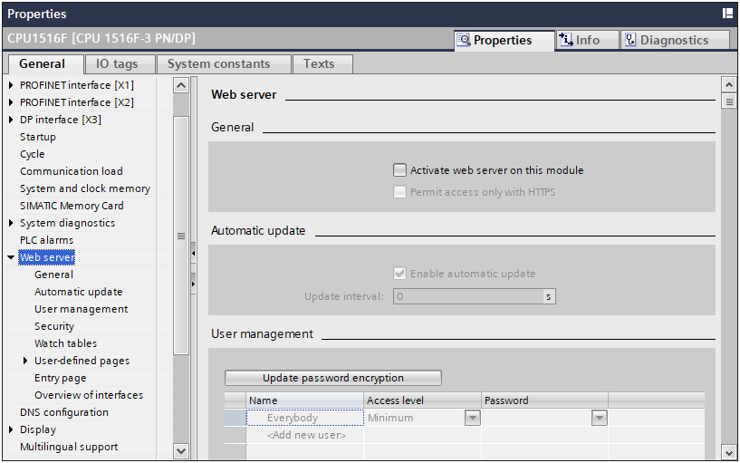

* Activate the web server. (→ General →  Activate web server on this module)
* Restrict access to HTTPS. (→ General →  Permit access only with HTTPS)



* Create a new user. (→ User management → Name: admin → Password: ***)

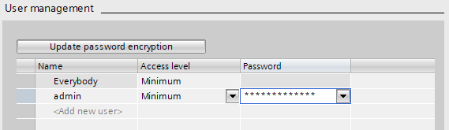

* Set the access level of the new user to Administrative. (→ User management → admin → Access level → Administrative)

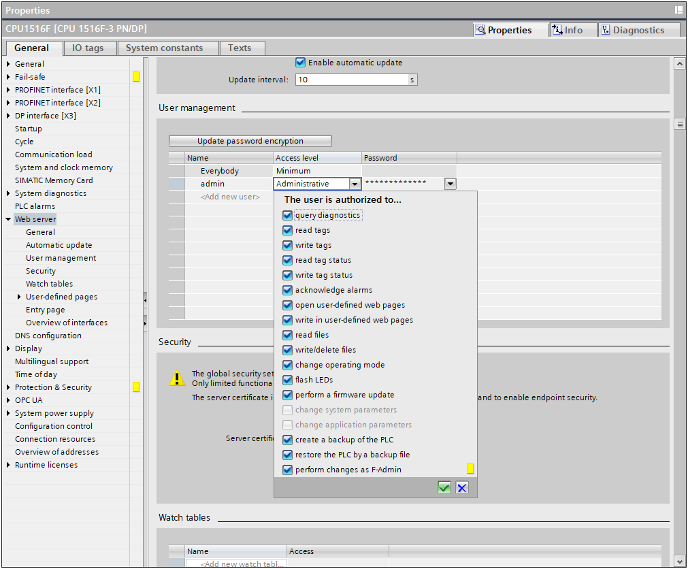

* Enable the web server on interface X2. (→ Overview of interfaces → PROFINET interface_2)

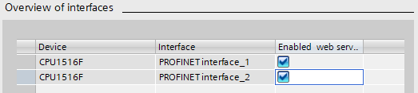

* Download the configuration to the CPU. (→ CPU_1516F →  → )

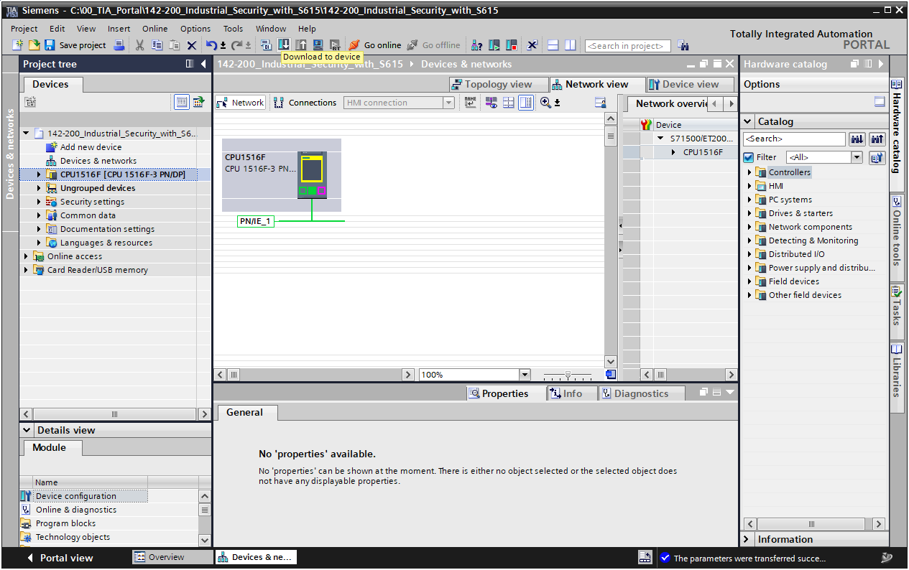

* When downloading, make sure that you are now connected to interface X2! (→ Connection to interface/subnet: Direct at slot '1 X2')

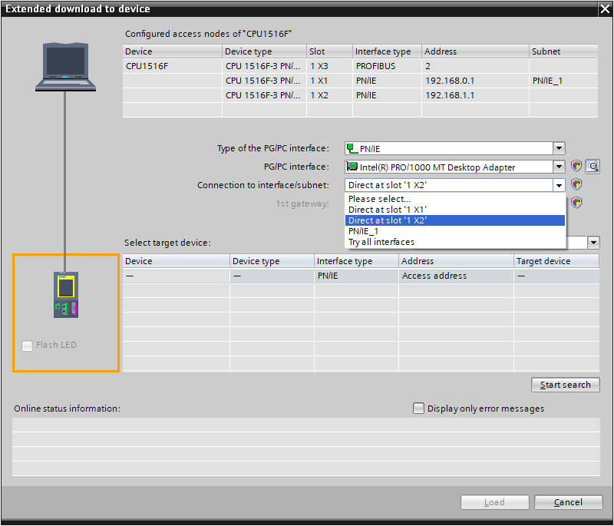

## Testing the rule set

* Connect the computer to port 5 on the SCALANCE S615.
* Make sure the computer has received a new address in subnet 10.0.0.0/24 from SCALANCE S615. (→ LAN connection → Status)

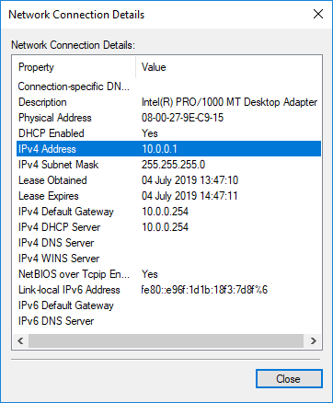

* Open the web server of the CPU 1516F-3 PN/DP with the browser.  
  (→ <https://192.168.1.1>)

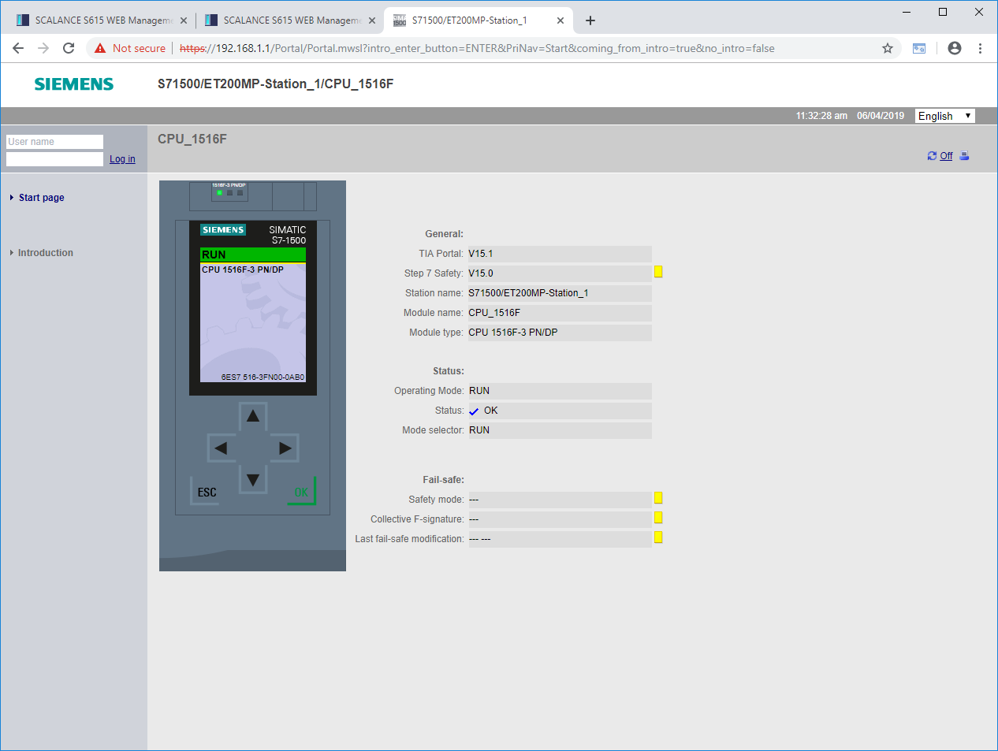

* Try to establish an online connection to the CPU 1516F-3 PN/DP with the TIA Portal. (→ TIA Portal → CPU_1516F → )

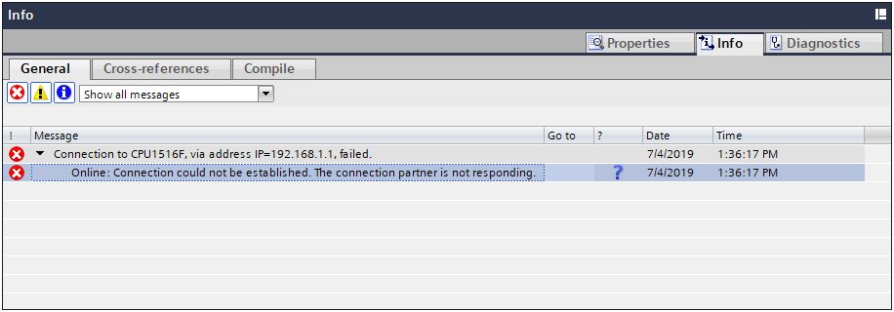

Note:

* *A connection setup with the CPU_1516F should not be possible at this time, because only port 443 and 4840 are enabled.*
* Open the web interface of the SCALANCE S615 in the browser. Because you are on the external side of the device this time, use the external IP address of the device. (→ <https://10.0.0.254>)

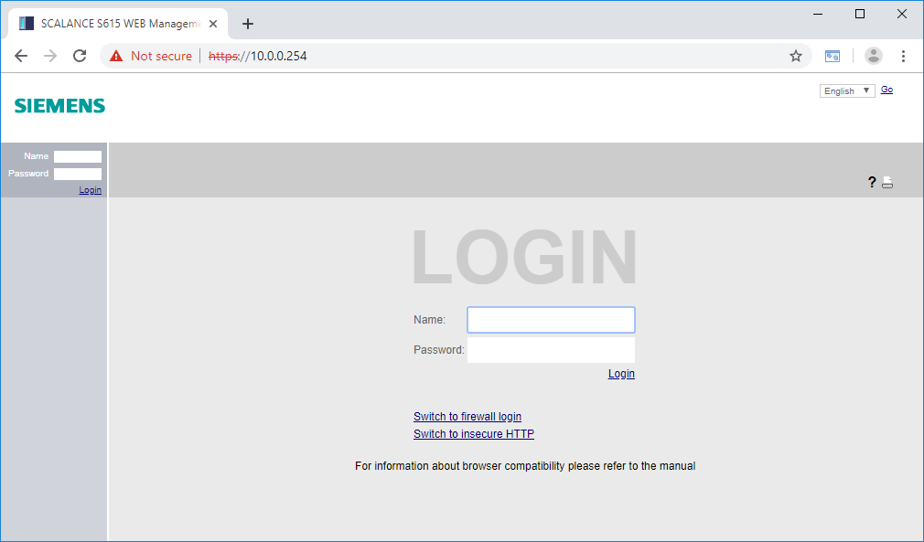

* Go to the firewall login. (→ Switch to firewall login)

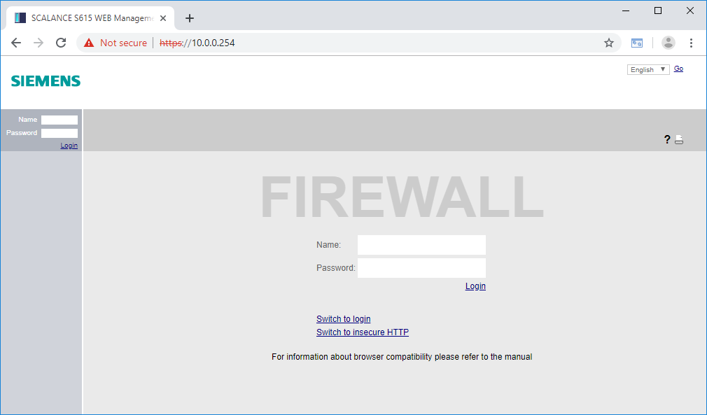

* Log in with the user "support". (→ Name: support → Password: ***)

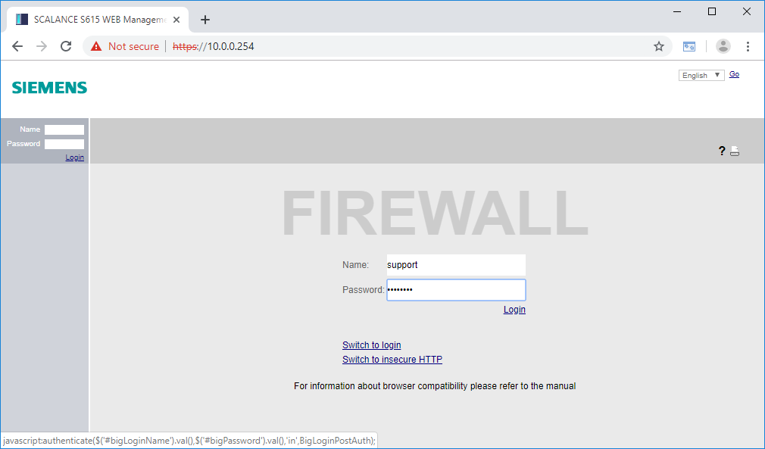

* Click Login. (→ Login)
* The firewall rule set "support_rules" should then be activated for 30 minutes.

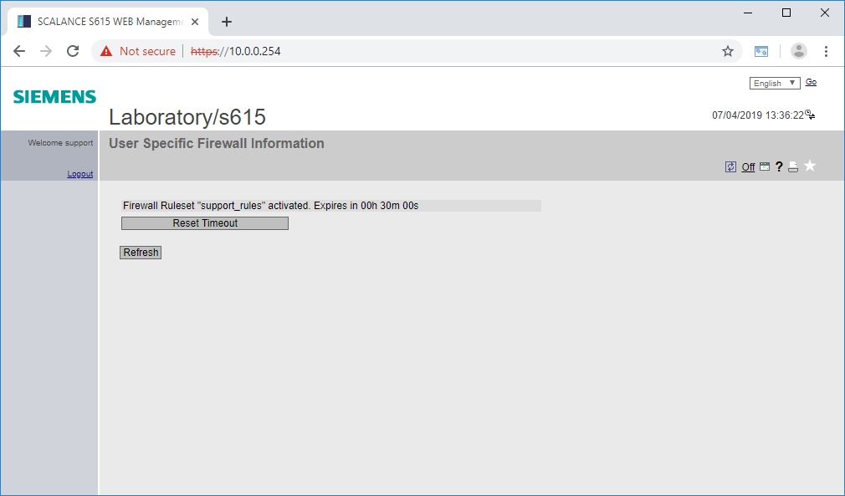

Note:

* *With the "Reset Timeout" button, you can reset the validity of the rule sets to 30 minutes. With a click on Logout, all rule sets are terminated again.*
* Try again to establish an online-connection to the CPU 1516F-3 PN/DP in the TIA Portal.   
  (→ TIA Portal → CPU_1516F → )

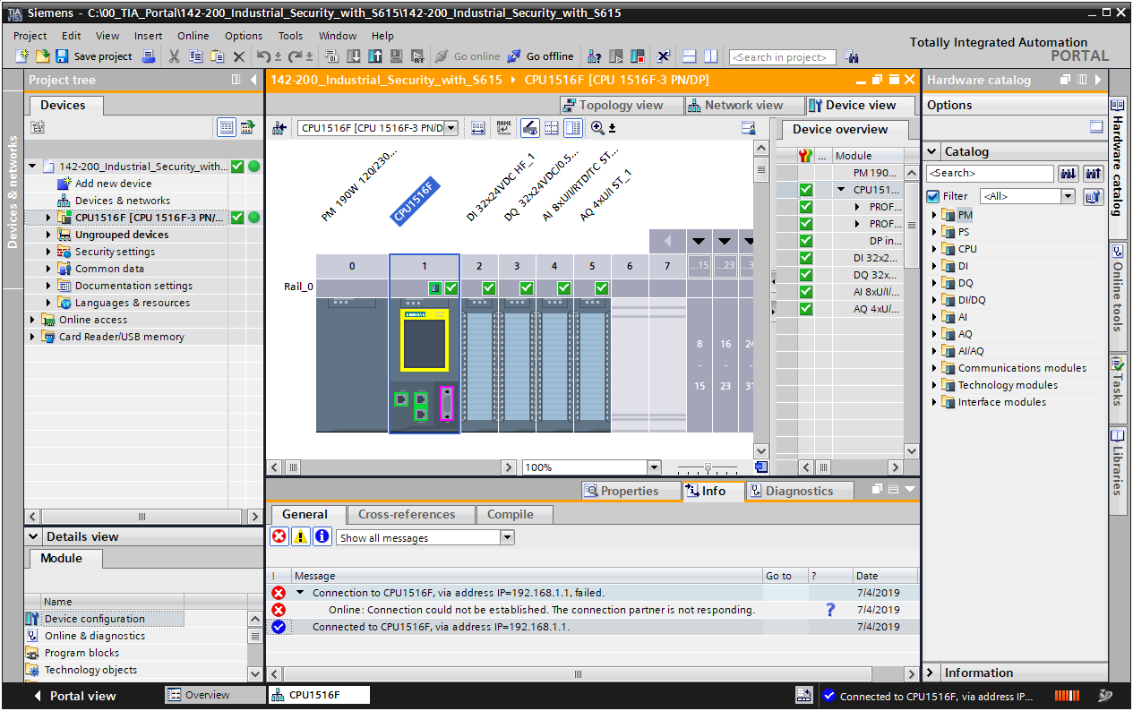

Note:

* *This time, the connection setup should work properly through the additional rule set.*

## Checklist – step-by-step instructions

The following checklist helps students/trainees to independently check whether all steps of the step-by-step instructions have been carefully completed and enables them to successfully complete the module on their own.

| **No.** | Description | **Checked** |
| --- | --- | --- |
| 1 | Project successfully retrieved from archive |  |
| 2 | Programming device connected to port 4 of the S615 |  |
| 3 | IP address successfully set |  |
| 4 | Web management login and password changed |  |
| 5 | System correctly configured with the wizard |  |
| 6 | DHCP pool created for vlan1 |  |
| 7 | DHCP pool created for vlan2 |  |
| 8 | DHCP options correctly configured for both pools |  |
| 9 | DHCP server and both pools activated |  |
| 10 | Programming device obtains IP automatically |  |
| 11 | Global rule for HTTPS added to CPU |  |
| 12 | Support user created |  |
| 13 | Support rule set created |  |
| 14 | Web server activated on the CPU_1516F |  |
| 15 | Programming device connected to port 5 of the S615 |  |
| 16 | Programming device automatically obtains IP here too |  |
| 17 | Web server of the CPU 1516F successfully opened |  |
| 18 | Online connection to CPU_1516F with TIA not possible |  |
| 19 | Successfully logged in to the firewall as support user |  |
| 21 | Online-connection to CPU_1516F with TIA now possible |  |

# Exercise

## Task – Exercise

Due to the digitalization of the production plant, a global access to the OPC UA server of controller is also required in this step. Create a new rule that allows access to the OPC UA server of the controller from the company network.

Before the configuration, inform yourself, which port the OPC UA needs to connect to the CPU.

## Planning

Plan the implementation of the task on your own.

## Checklist – Exercise

The following checklist helps students/trainees to independently check whether all steps of the exercise have been carefully completed and enables them to successfully complete the module on their own.

| **No.** | Description | **Checked** |
| --- | --- | --- |
| 1 | New rule created |  |
| 2 | OPC UA connection successfully established from the company network |  |
| 3 | An online connection to the CPU is still not available without login. |  |

# Additional information

More information for further practice and consolidation is available as orientation, for example: Getting Started, videos, tutorials, apps, manuals, programming guidelines and trial software / firmware, under the following link:   
  
[www.siemens.com/sce/s7-1500](http://www.siemens.com/sce/s7-1500)

**Preview "Additional information" – In preparation**

 Further Information

Siemens Automation Cooperates with Education  
siemens.com/sce

SCE Learn-/Training Documents  
**siemens.com/sce/documents**

SCE Trainer Packages  
**siemens.com/sce/tp**

SCE Contact Partners   
**siemens.com/sce/contact**

Digital Enterprise  
**siemens.com/digital-enterprise**

Industrie 4.0   
**siemens.com/future-of-manufacturing**

Totally Integrated Automation (TIA)  
**siemens.com/tia**

TIA Portal  
**siemens.com/tia-portal**

SIMATIC Controller  
**siemens.com/controller**

SIMATIC Technical Documentation   
**siemens.com/simatic-docu**

Industry Online Support  
**support.industry.siemens.com**

Product catalogue and online ordering system Industry Mall   
**mall.industry.siemens.com**

Siemens   
Digital Industries, FA   
P.O. Box 4848  
90026 Nuremberg  
Germany

Subject to change and errors  
© Siemens 2019

**siemens.com/sce**