

Learn-/Training Document  
  
Siemens Automation Cooperates with Education (SCE) | As of Version V15.1

**siemens.com/sce**

TIA Portal Module 142-100

Industrial Ethernet with SIMATIC S7-1500 and

SCALANCE XC208

**Matching SCE Trainer Packages for this Learn-/Training Document**

Industrial Communication SIMATIC NET

* **IE SCALANCE Switch XC208**  
  Order no.: 6GK1950-0BB12

SIMATIC Controllers

* **SIMATIC CPU 1516F PN/DP Safety**

Order no.: 6ES7516-3FN00-4AB2

* **SIMATIC ET 200SP Open Controller CPU 1515SP PC F and HMI RT SW**  
  Order no.: 6ES7677-2SB42-4AB1
* **SIMATIC ET 200SP Distributed Controller CPU 1512SP F-1 PN Safety**

Order no.: 6ES7512-1SK00-4AB2

* **SIMATIC S7 CPU 1516-3 PN/DP**  
  Order no.: 6ES7516-3AN00-4AB3
* **SIMATIC CPU 1512C PN with software and PM 1507**   
  Order no.: 6ES7512-1CK00-4AB1
* **SIMATIC CPU 1512C PN with Software, PM 1507 and CP 1542-5 (PROFIBUS)**  
  Order no.: 6ES7512-1CK00-4AB2
* **SIMATIC CPU 1512C PN with Software**  
  Order no.: 6ES7512-1CK00-4AB6
* **SIMATIC CPU 1512C PN with software and CP 1542-5 (PROFIBUS)**  
  Order no.: 6ES7512-1CK00-4AB7

**SIMATIC STEP 7 Software for Training**

* **SIMATIC STEP 7 Professional V15.1 - Single License**  
  Order no.: 6ES7822-1AA05-4YA5
* **SIMATIC STEP 7 Professional V15.1 - 6+20 User Classroom License**   
  Order no.: 6ES7822-1BA05-4YA5
* **SIMATIC STEP 7 Professional V15.1 - 6+20 User Upgrade License**  
  Order no.: 6ES7822-1AA05-4YE5
* **SIMATIC STEP 7 Professional V15.1 - Student License for 20 Users**  
  Order no.: 6ES7822-1AC05-4YA5

Note that these trainer packages are replaced with successor packages when necessary. An overview of the currently available SCE packages is available at: [siemens.com/sce/tp](http://www.siemens.com/sce/tp)

**Continued training**

For regional Siemens SCE continued training, get in touch with your regional SCE contact

[siemens.com/sce/contact](http://www.siemens.com/contact)

**Additional information regarding SCE**

[siemens.com/sce](http://www.siemens.com/sce)

**Information regarding use**

The SCE Learn-/Training Document for the integrated automation solution Totally Integrated Automation (TIA) was prepared for the program "Siemens Automation Cooperates with Education (SCE)" specifically for training purposes for public educational facilities and R&D institutions. Siemens does not guarantee the contents.

This document is to be used only for initial training on Siemens products/systems. This means it can be copied in whole or in part and given to trainees/students for use within the scope of their training/course of study. Disseminating or duplicating this document and sharing its content is permitted within public training and advanced training facilities for training purposes or as part of a course of study.

Exceptions require written consent from the Siemens. Send all related requests to

[scesupportfinder.i-ia@siemens.com](mailto:scesupportfinder.i-ia@siemens.com).

Offenders will be held liable. All rights including translation are reserved, particularly if a patent is granted or a utility model or design is registered.

Use for industrial customer courses is explicitly not permitted. We do not consent to commercial use of the Learn-/Training Document.

We wish to thank the TU Dresden and the Michael Dziallas Engineering Corporation and all other involved persons for their support during the preparation of this Learn-/Training Document.

Table of contents

1 Goal 6

2 Requirement 6

3 Required hardware and software 7

4 Theory 8

4.1 Structure and operation of SCALANCE XC208 8

4.1.1 Industrial Ethernet switch XC208 8

4.1.2 SELECT/SET button 9

4.1.3 LED indicator lights 10

4.1.4 Port LEDs 11

4.2 PROFINET 12

4.2.1 DCP: Discovery and Configuration Protocol 12

4.3 LLDP: Link Layer Discovery Protocol 13

4.4 High-availability networks 14

4.4.1 The MRP ring protocol 14

5 Task 16

6 Planning 16

7 Structured step-by-step instructions 17

7.1 Retrieving an existing project 17

7.2 Setting the IP address 19

7.3 Inserting the SCALANCE XC208 21

7.4 Configuration of the SCALANCE XC208 via the web interface 24

7.5 Configuration of the SCALANCE XC208 using TIA 29

7.6 Disabling unused ports 32

7.7 Assignment to the CPU 1516F 33

7.8 Compiling and loading the CPU 1516F-3 PN/DP 36

7.9 Establishing an online connection to the CPU 1516F-3 PN/DP 37

7.10 Configuration of the topology 37

7.11 Compiling and loading the CPU 1516F-3 PN/DP 41

7.12 Checking the current topology state 42

7.13 Evaluating the diagnostics buffer of the CPU 1516F-3 PN/DP 43

7.14 End of topology discovery 45

7.15 End of detection of accessible devices 48

7.16 Activation of media redundancy 51

7.17 Checking the ring status 53

7.18 Diagnostics of the ring status in the web interface 55

7.19 Archiving the project 57

7.20 Checklist – step-by-step instructions 58

8 Exercise 59

8.1 Task – Exercise 59

8.2 Planning 59

8.3 Checklist – Exercise 59

9 Additional information 60

Industrial Ethernet with S7-1500 and SCALANCE XC208

# Goal

In this chapter you learn to configure the SCALANCE XC208 Industrial Ethernet switch and to connect it to an S7-1500 controller.

The SIMATIC S7 controllers listed in chapter 3 can be used.

# Requirement

This section builds on the chapter Global data blocks with S7-1500. To perform the work in this chapter, you can use the following project, for example: "SCE_EN_032-600_Global_ Data_Block_R1704.zap14".

# Required hardware and software

**1** Engineering station: Requirements include hardware and operating system   
(for additional information, see Readme on the TIA Portal Installation DVDs)

**2** SIMATIC STEP 7 Professional software in TIA Portal – V15.1 or higher

**3** SIMATIC S7-1500 controller, e.g. CPU 1516F-3 PN/DP –   
Firmware V2.1 or higher with memory card

**4** Industrial Ethernet Switch SCALANCE XC208

**5** Ethernet connection between engineering station and controller and   
between controller and ET 200 SP distributed I/O

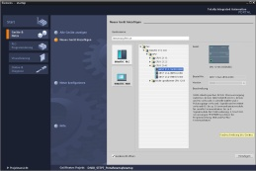

**2** SIMATIC STEP 7 Professional   
(TIA Portal) V15.1

or higher



**1** Engineering station

**5** Ethernet connection

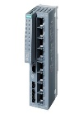  
**4** IE switch SCALANCE XC208

**5** Ethernet connection

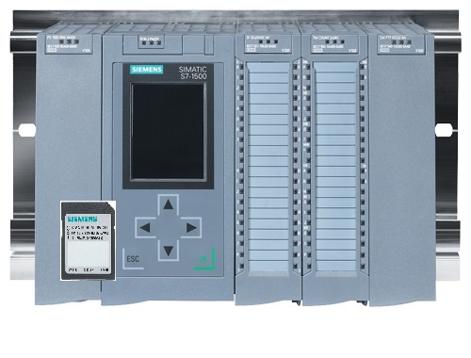  
**3** SIMATIC S7-1500 controller

# Theory

## Structure and operation of SCALANCE XC208

### Industrial Ethernet switch XC208

SCALANCE XC208 is an Industrial Ethernet switch for process automation.

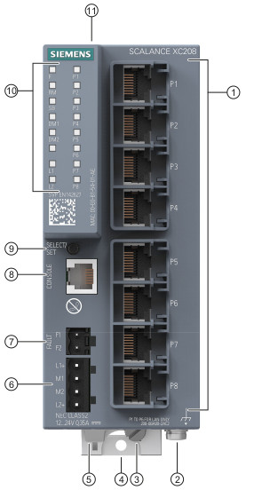

1. Network ports
2. Grounding screw
3. Knurled screw
4. Fastening bolt
5. Lever aid for operating the fastening bolt with a screwdriver
6. Power supply
7. Signaling contact
8. Serial interface
9. "SELECT/SET" button
10. LED display
11. C-PLUG slot for

removable data storage medium for storing the configuration data

### SELECT/SET button

The display mode of the LEDs can be changed using the SELECT/SET button. The device can also be reset to the factory settings by means of this switch.

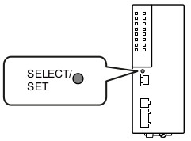

There are four different display modes. These can be alternated during operation by briefly pressing the SELECT/SET button and are indicated by the DM1 and DM2 LEDs.

|  |  |  |
| --- | --- | --- |
|  | **DM1** | **DM2** |
| **Display mode A** | Off | Off |
| **Display mode B** | On | Off |
| **Display mode C** | Off | On |
| **Display mode D** | On | On |

To reset the unit to the factory settings, simply press and hold the SELECT/SET button for 12 seconds. After 9 seconds, the DM1 and DM2 LEDs should start to flash and the port LEDs should switch on one after the other. After 12 seconds, the device automatically restarts with the factory settings.

### LED indicator lights

The SCALANCE XC208 is equipped with various LEDs that provide an overview of the system status.

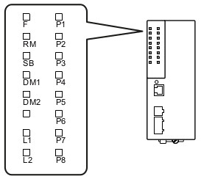

|  |  |
| --- | --- |
| **FA** | LED to display the error status |
| **RM** | LED to display the "redundancy manager" function |
| **SB** | LED to display the "standby" function |
| **DM1/DM2** | LEDs to display the display mode |
| **L1/L2** | LEDs to display the power supply |
| **P** | LEDs to display the port status |

An exact description of the status of each LED can be found in the device manual.

④

### Port LEDs

The port LEDs provide information about the status of the individual ports and are therefore a good troubleshooting aid. The status of the individual LEDs depends on the selected display mode. The table below provides a short overview.

A complete description of all statuses can be found in the manual.

#### Display mode A

In display mode A, you can see from the port LEDs whether a valid link is available.

|  |  |  |
| --- | --- | --- |
| **LED color** | **LED status** | **Meaning** |
| - | Off | No valid link at the port (e.g. the communication partner is switched off or the cable is not connected). |
| Green | On | Link is available and port in normal state.  In this state, the port can receive and transmit data. |
| Flashes 1x per period | Link is available and port in "Blocking" state.  In this state, the port sends and receives only management data (no user data). |
| Flashes 3x per period | Link is available and port is switched off by management.  In this state, no data is sent or received via the port. |
| Flashes 4x per period | Link is available and in "Monitor Port" state.  In this state, the data traffic of another port is mirrored to this port. |
| Yellow | Flashes / lights up | Data reception at port |

## PROFINET

PROFINET or Process Field Network is an open standard for networking industrial production devices via Ethernet. PROFINET is developed by the PROFIBUS Nutzerorganisation e.V. (PNO) and uses existing protocols in addition to independently developed protocols.

Two of these protocols are mentioned and configured in the course of this chapter. One is the "Discovery and Configuration Protocol" (DCP) and the other is the Link Layer Discovery Protocol (LLDP).

### DCP: Discovery and Configuration Protocol

DCP is a PROFINET-specific protocol and mandatory for PROFINET communications. The protocol works on layer 2 of the OSI layer model and is therefore restricted to the broadcast-domain**1**.

DCP is used, for example, to identify the MAC address of certain PROFINET nodes and to transmit a basic configuration to them. These include, for example, the device name and the IP address of the PROFINET node.

The "Accessible devices" function of the TIA portal, for example, uses the DCP protocol to receive this information from all PROFINET nodes connected to the bus.

1 In Ethernet, a broadcast domain is the area in which a broadcast packet can propagate. A simple network of computers and switches corresponds to a single broadcast domain. This single domain can be further subdivided by the use of routers or VLANs.

## LLDP: Link Layer Discovery Protocol

The Link Layer Discovery Protocol is an existing manufacturer-independent network protocol. PROFINET uses an extended version of the protocol that is, however, compatible with the standard.

LLDP, like DCP, is an OSI layer 2 protocol and is subject to the same limitations. LLDP offers the possibility to exchange information between adjacent devices. For data exchange, data units (LLDP DUs) are exchanged between the stations.

These LLDP DUs include TLVs (Type-Length-Value), i.e. the data type of the data contained, the length of this data and its actual content. Typical contents of these data units are, for example, the station name, the port name via which the LLDP-DU was sent and other information.

Each station stores the exchanged data. You then have the option to retrieve it again, for example, to determine the topology of the network.

## High-availability networks

The SCALANCE XC208 supports various protocols to increase the availability of the Ethernet network. These include classic network protocols such as Spanning Tree (STP), but also special protocols such as the Media Redundancy Protocol (MRP).

By default, the classic protocols on the XC208 are switched off because their recovery times are too long. Recovery time, sometimes also referred to as convergence time, is the time required by a network protocol to determine the topology and establish an error-free state. In the case of STP, this time is up to 50 seconds, i.e. in the worst case the entire network cannot transmit data for 50 seconds.

There are more specific ring protocols that have a very low convergence time in the range of several 100 milliseconds.

### The MRP ring protocol

The Media Redundancy Protocol can be used in conjunction with the SIMATIC controllers. The protocol requires a ring topology and is limited to one ring in the case of the SCALANCE XC208. Therefore, the switch cannot be used in multiple (MRP) rings at the same time.

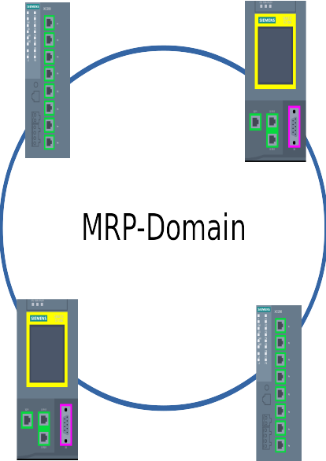

Within the ring or MRP domain, one node must be defined as a ring manager (RM). This can also be selected automatically among the nodes, in which case ring manager now becomes the device with the lowest MAC address. In general, this decision should not be left to the devices, as the selected ring manager may be in an unfavorable position or is unsuitable for other reasons (e.g. CPU power).

In addition, the ring ports must be defined at each node. A node has two ports in a ring. On the XC208, these are by default the two ports P1 and P2. However, these can also be changed.

The ring manager now regularly checks whether the ring is closed using special test packets. As long as it gets its test packets back on its redundant port, data packets at this port are blocked.

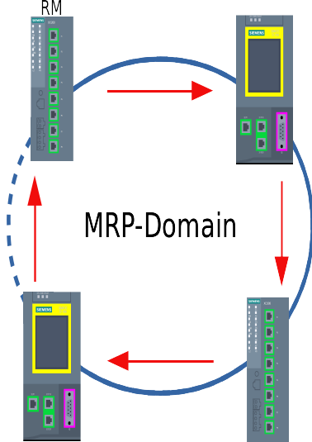

As soon as the ring manager no longer receives its test packets, it activates the normal data traffic on the redundant port as well in order to complete the ring again. Depending on the configuration, this happens within 200 to 500 ms.

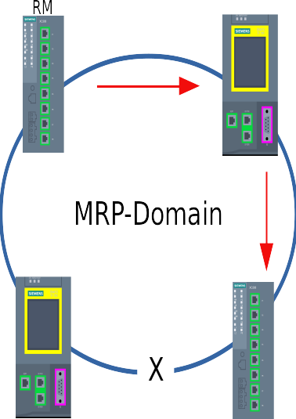

If the ring is closed again, the ring manager receives its test packets again and interrupts the data traffic at one of its ring ports.

Additional details and information can be found in the manuals, which can be downloaded from [support.automation.siemens.com](http://support.automation.siemens.com/).

## 

# Task

In this section, the hardware and the program from chapter "SCE_EN_032-600_Global_Data_Blocks" shall be extended by the SCALANCE XC208.

The entire topology of the PROFINET bus can be checked using the SCALANCE XC208. Changes and errors in the topology are reported directly to the assigned controller and can now be read via the diagnostics buffer.

The configuration of the switch can continue to be managed completely via the TIA Portal. The selected settings are transferred from the IO controller directly to the XC208.

# Planning

The existing project is first extended by the XC208. The physical networking of the components should look as follows.

CPU 1516F

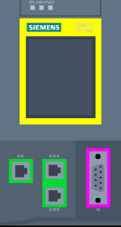

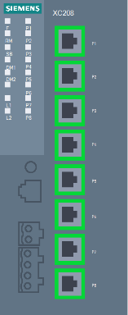

X1P1R

P1

XC208



PG/PC

P8

Then the CPU 1516F-3 PN/DP is configured as the IO controller for the XC208, and the PROFINET device name is assigned.

After the project has been expanded, it must be saved, compiled and downloaded to the CPU 1516F-3 PN/DP. Through the assignment of the CPU as IO controller for the XC208, a part of the configuration of the XC208 is taken over by the CPU. In addition, error messages of the XC208 are then available in the diagnostics buffer of the CPU.

The network topology is determined and applied last, and the ports are configured.

After reloading the devices, the result is archived in order to backup the working version.

# Structured step-by-step instructions

You can find instructions on how to carry out planning below. If you already have the necessary prior knowledge, the numbered steps are sufficient for the processing. Otherwise, follow the steps illustrated below.

## Retrieving an existing project

* Before you can expand the "SCE_EN_032-600_Globale_Data_Blocks_R1704.zap14" project from chapter "SCE_EN_032-600_Global_Data_Blocks", you must retrieve this project from the archive.
* To do this, you must select the respective archive from the project view under → Project → Retrieve. Confirm your selection with "Open". (→ Project → Retrieve → Select a .zap archive … → Open)

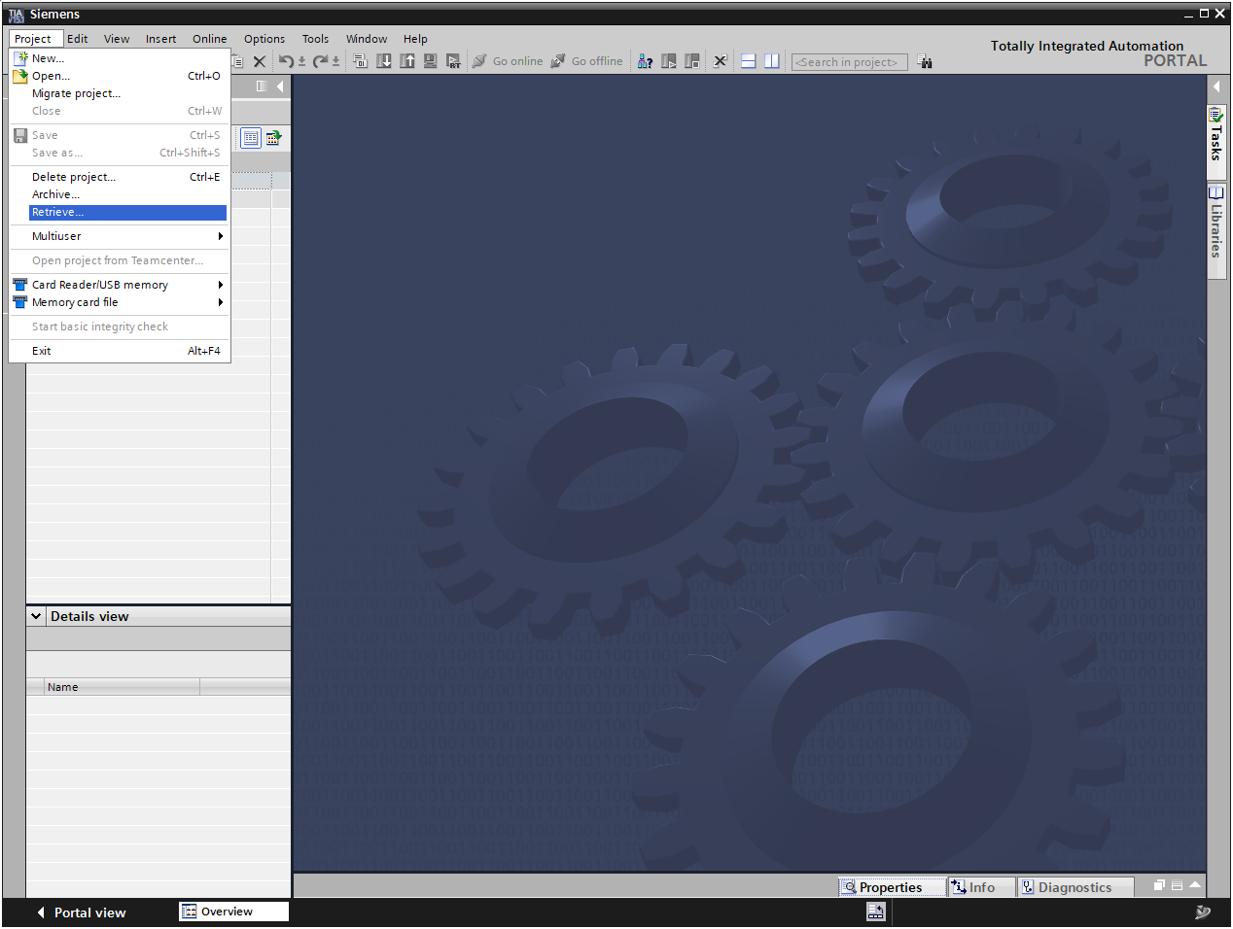

* As the next step, select the target directory where the retrieved project is to be stored. Confirm your selection with "OK". (→ Destination directory … → Select folder)
* Since this is a TIA V14 project, the project must be upgraded before opening it. (→ Upgrade)

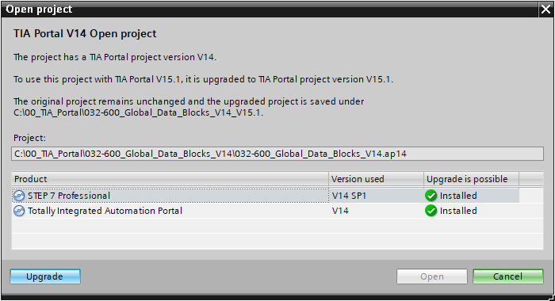

* Save the upgraded and opened project under the name 140-100_Industrial_Ethernet_ with_XC208. (→ Project → Save as … → 142-00_Industrial_Ethernet_with_XC208 → Save)

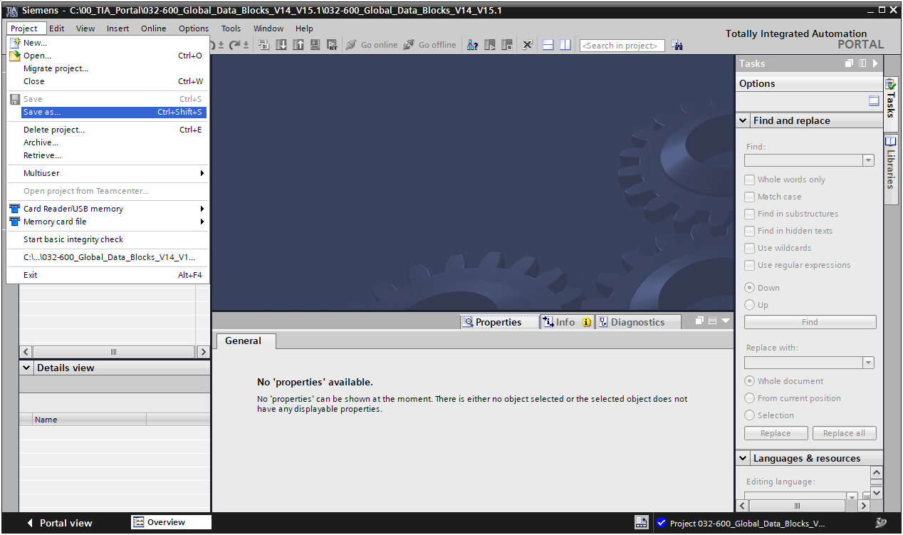

## Setting the IP address

* Open the search for "Accessible devices". (→ )
* Select your PN/IE interface and start the search. (→)
* Select the SCALANCE XC-200 and click "Show". (→)

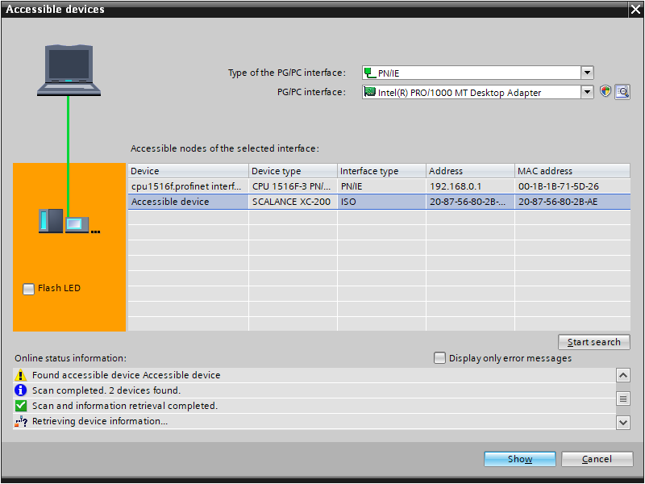

* Under "Online access", open the "Online & diagnostics" item of the displayed device.

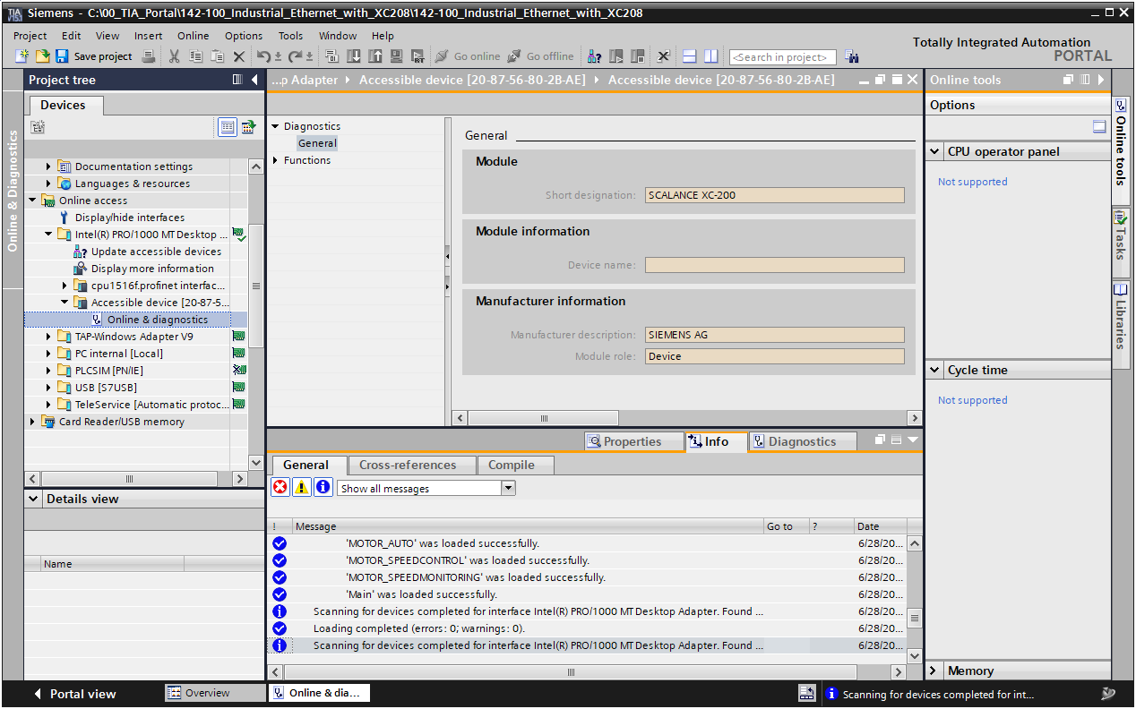

* Set the IP address to 192.168.0.250/24. (→ Functions → Assign IP address → IP address: 192.168.0.250 → Subnet mask: 255.255.255.0 → )

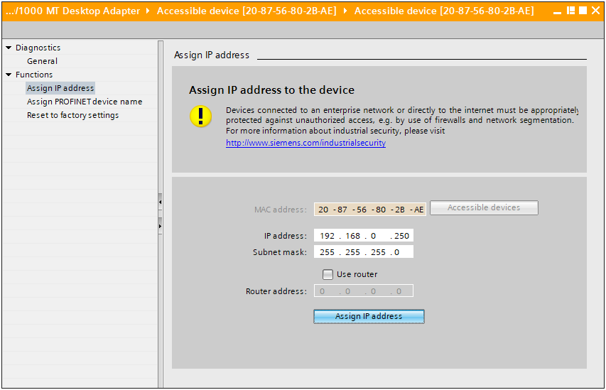

## Inserting the SCALANCE XC208

* Open the "Devices & networks" item in the Project view.

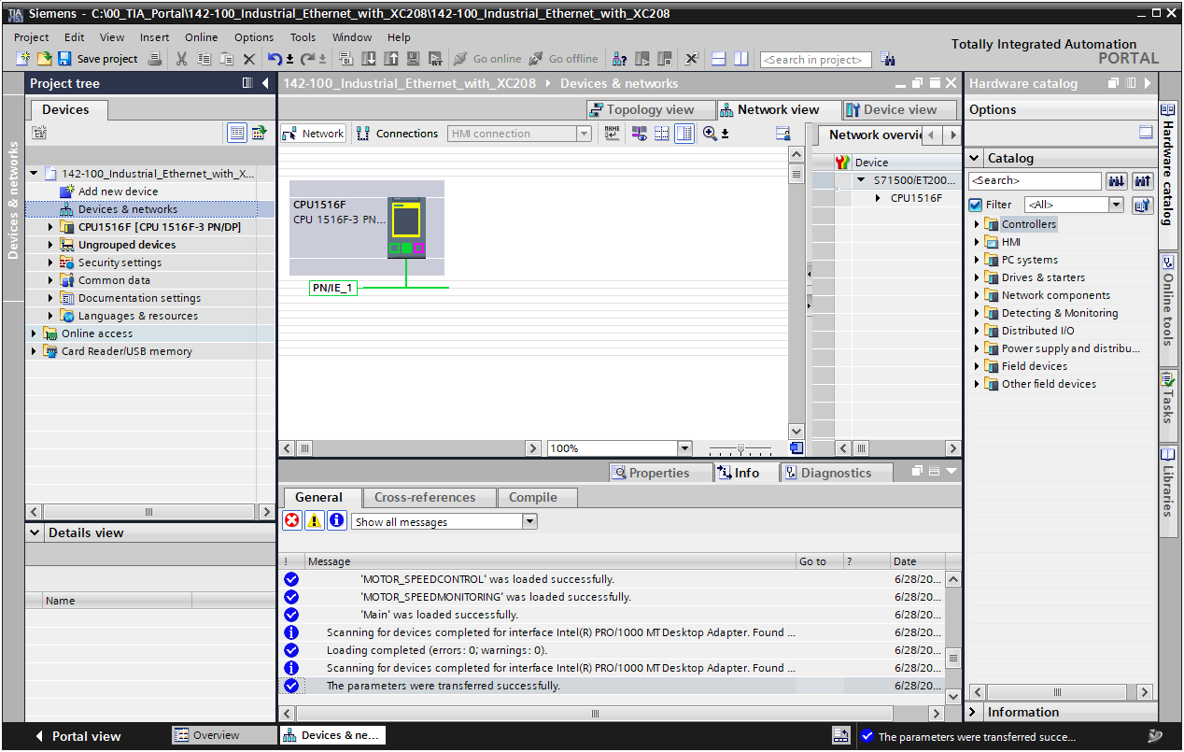

* In menu "Online" → "Hardware detection", open the "PROFINET devices from network …" item (Online → Hardware detection → PROFINET devices from network …)

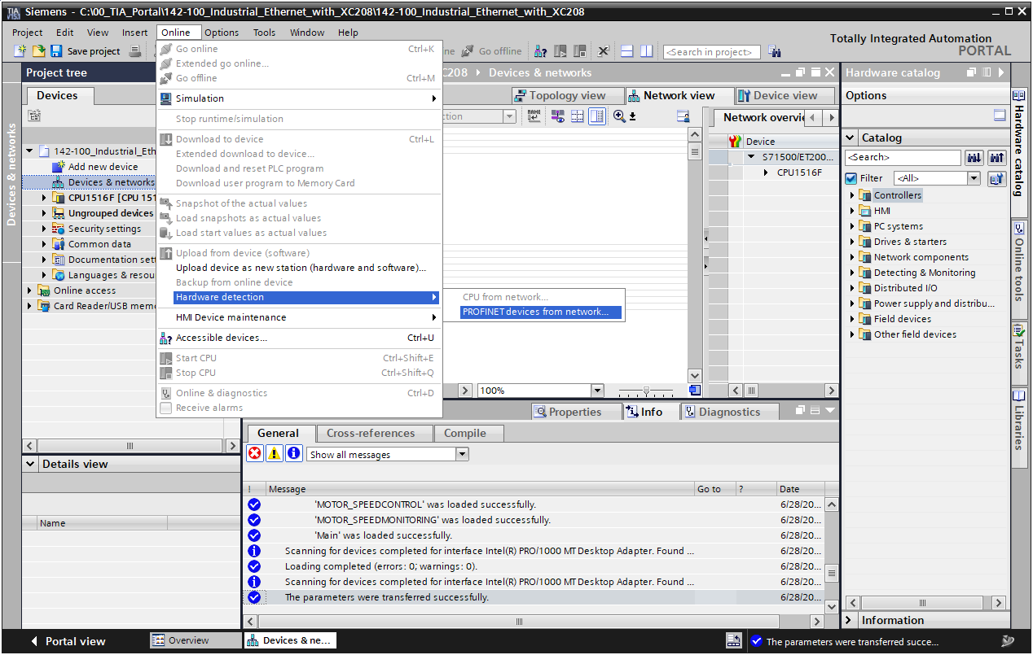

* Select the appropriate interface and start the search for devices. (→ PG/PC interface … → Start search)

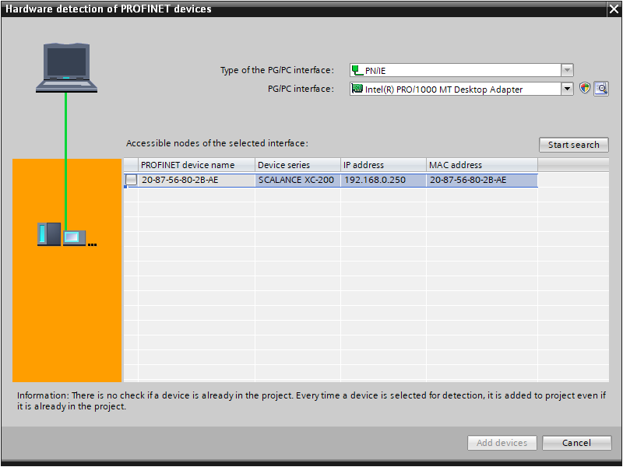

* Select the SCALANCE XC-200 and add the device. (→  SCALANCE XC-200 → Add devices)

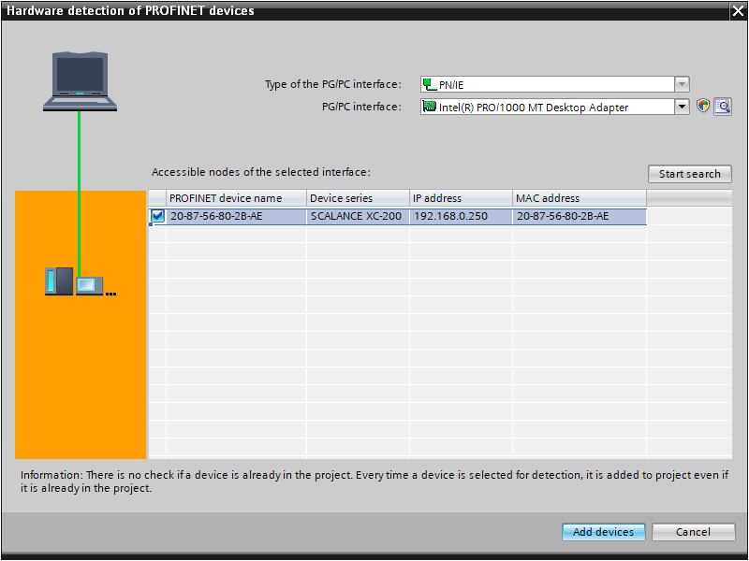

* Confirm the successful addition of the module (→ OK)

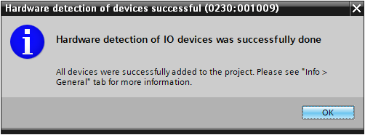

* The SCALANCE XC208 should then be present in the device overview.

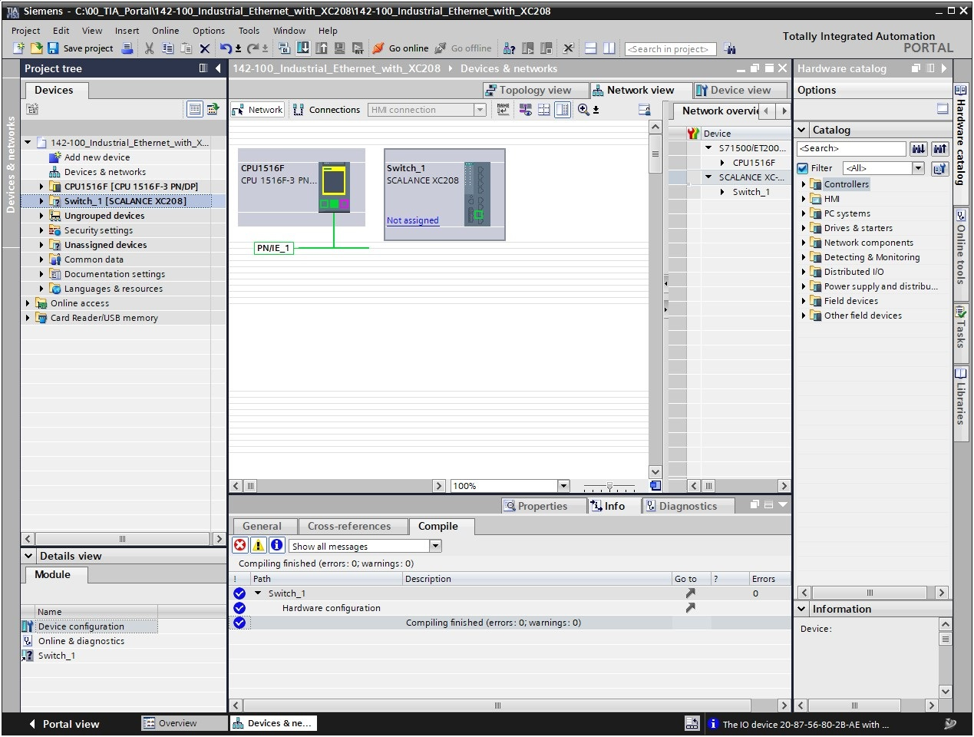

## Configuration of the SCALANCE XC208 via the web interface

* Open Management in the properties of the XC208, and open Web Based Management from there. (→ Switch_1 → Properties → Management → Web Based Management)

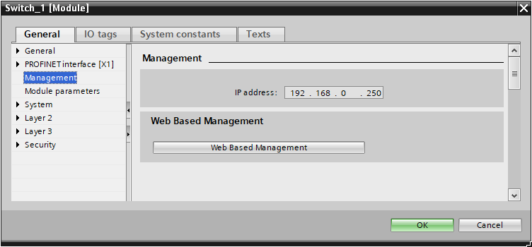

* You can set the language to English in the newly opened browser window.  
  (→ English → Go)

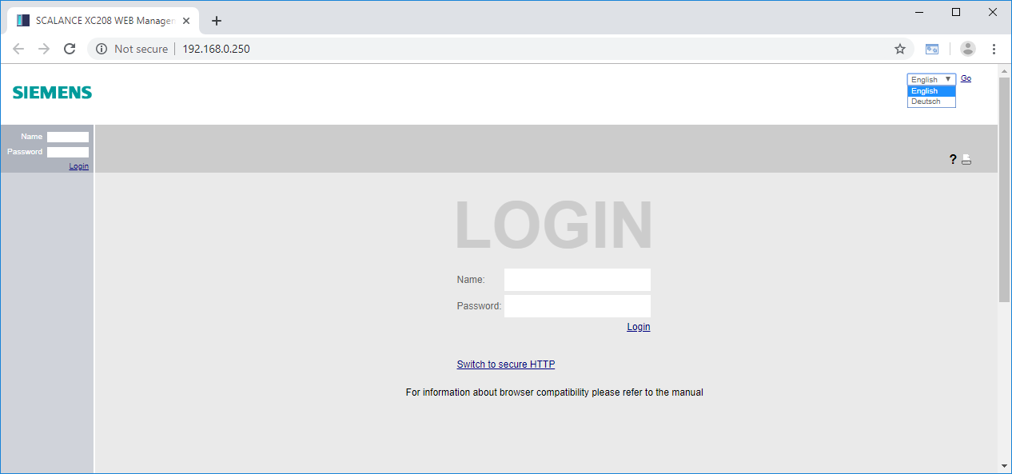

* Now you can log in with the user "admin" and the password "admin".  
  (→ Name: admin → Password: admin → Login)

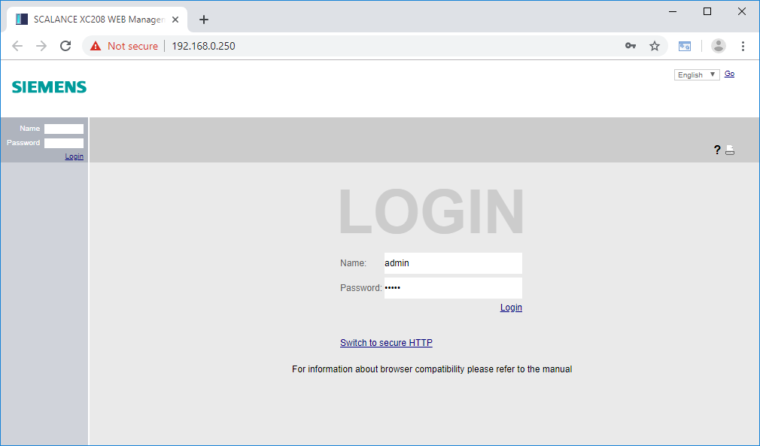

***Note:***

* *The standard web connection is unencrypted. If you are not in an isolated network, please switch here to the secure HTTPS connection (switch to secure HTTP connection).*
* The default access must be changed before the first login. (→ OK)

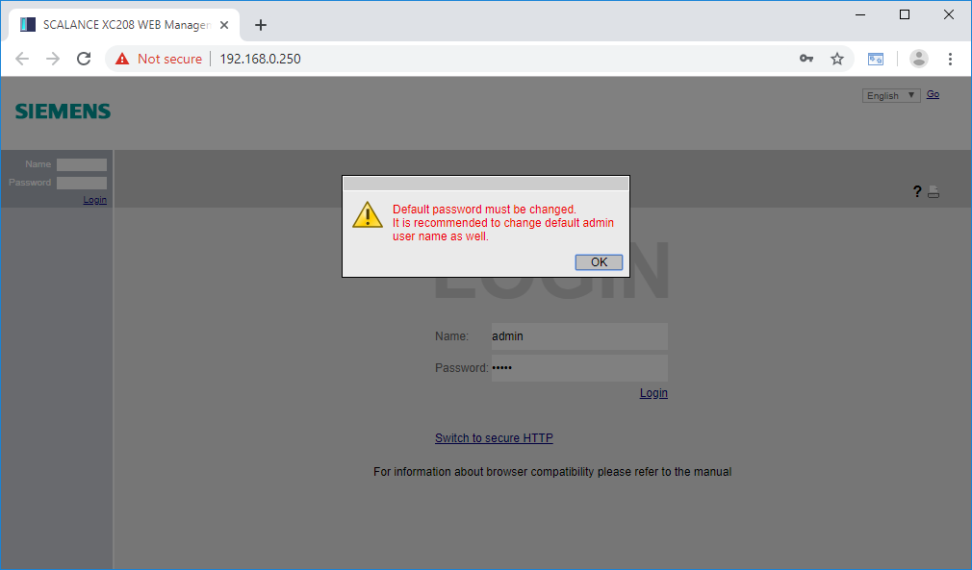

* First enter the old password "admin" and then a new password twice.  
  → Current user password: admin  
  → New password: ***  
  → Confirm password: ***  
  → Apply settings

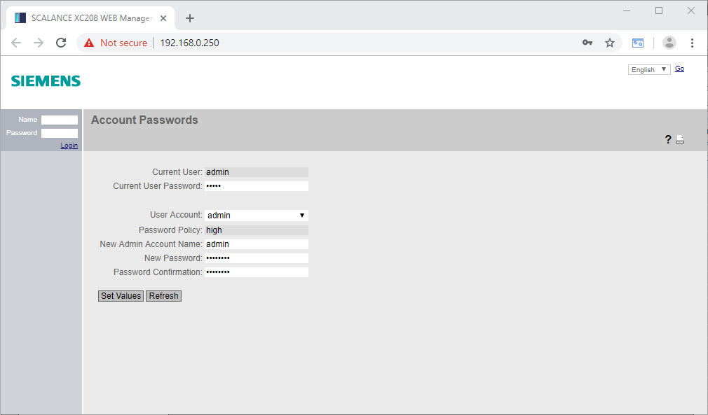

Note:

* *The new password must have at least 8 characters, 1 number, 1 uppercase character and a special character!*
* After successful login, switch to the item "Configuration" in the "System" menu.  
  (→ System → Configuration)

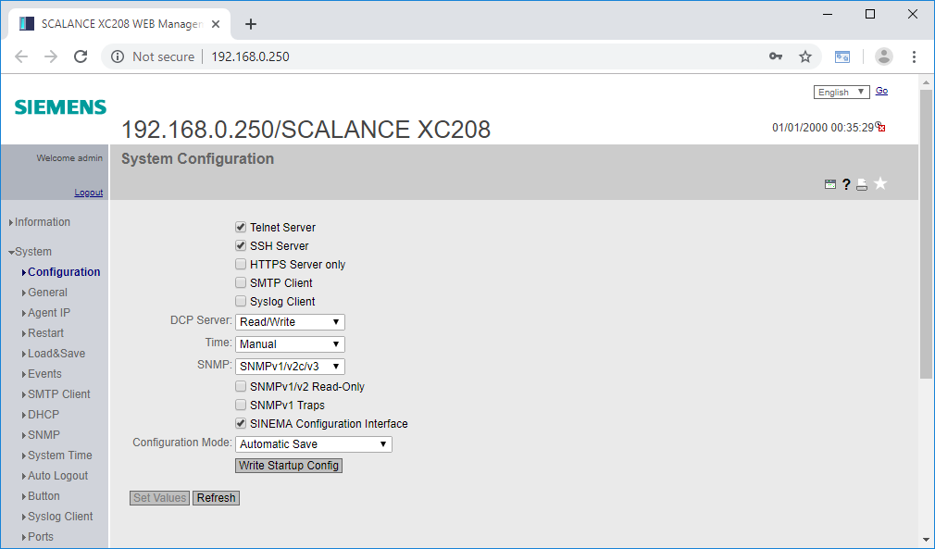

* Deselect the Telnet server. (→  Telnet Server)
* Select the SSH server. (→  SSH Server)
* Restrict Web access to HTTPS connections.

(→  HTTPS Server only → OK)

* Select write protection for SNMP v1 and v2c.

(→  SNMPv1/v2c Read-Only)

* Click on Set Values (→ Set Values)

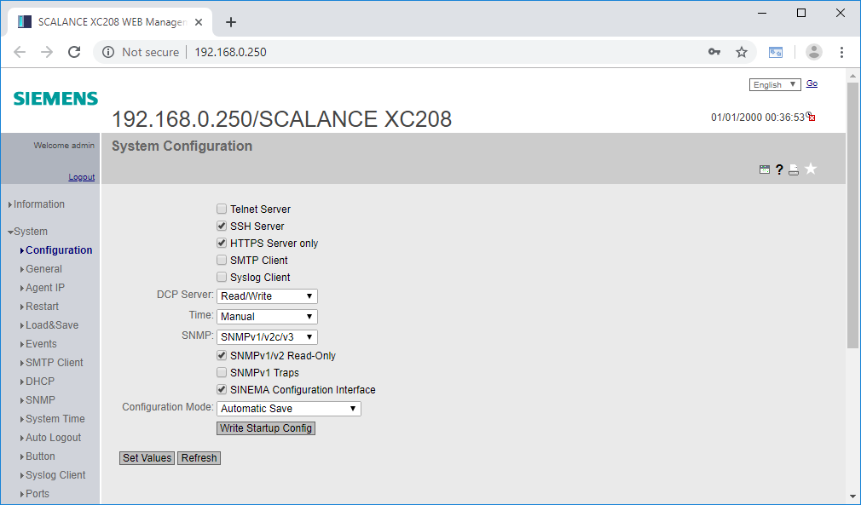

Note:

* *Telnet, as well as SNMP and HTTP are unencrypted connections and should not be used. It is possible to secure HTTP using SSL/TLS (HTTPS). For Telnet, SSH is a secure alternative. For SNMP, encryption version 3 must be used.*
* *However, since the TIA portal uses SNMP for the direct online connection to the XC208, it cannot be completely deactivated. Therefore, write access is prevented for the insecure versions here.*
* You will then be redirected to the encrypted connection and must issue an exception for the unknown certificate.

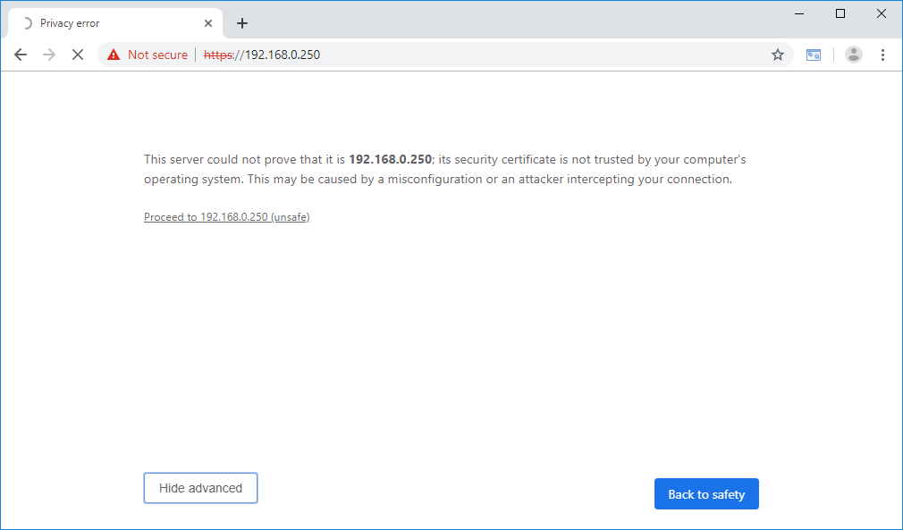

Note:

* *Depending on the browser, the confirmation of the certificate looks different.*

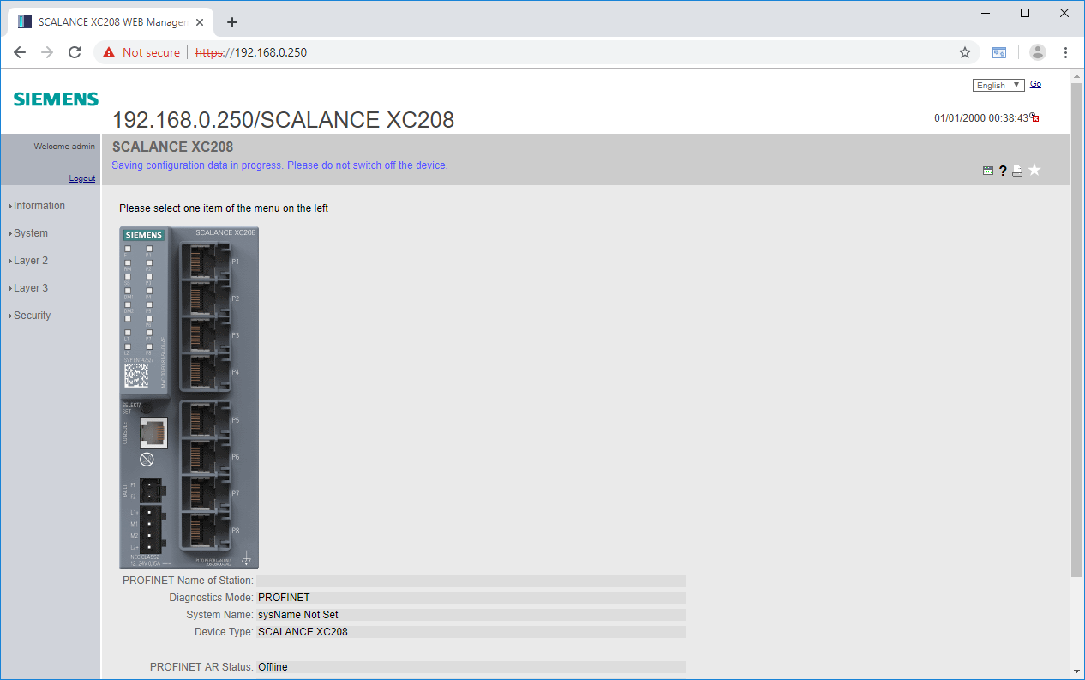

## Configuration of the SCALANCE XC208 using TIA

In addition to the configuration via the web interface, the XC208 can also be configured with the TIA Portal. TIA does not automatically recognize configuration changes made on the web interface, these must be manually updated in the TIA Portal.

Downloading the configuration using the TIA Portal entails a restart of the device. In addition, after assignment of an IO controller, the device can no longer be downloaded without this assignment being canceled beforehand. However, the IO controller is able to transmit a portion of the configuration made in the TIA Portal to the XC208.

* Open the properties of the XC208 in the TIA Portal. (→ Switch_1 → Properties)

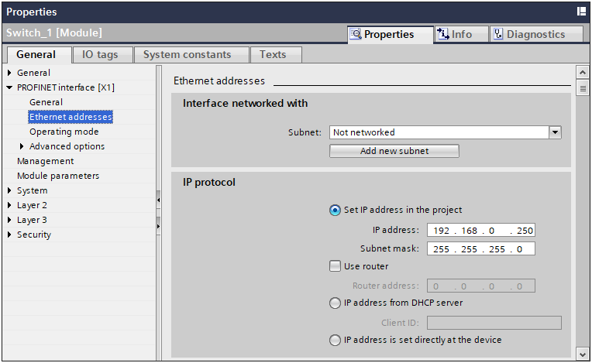

* Go to the system configuration. (→ System → Configuration)

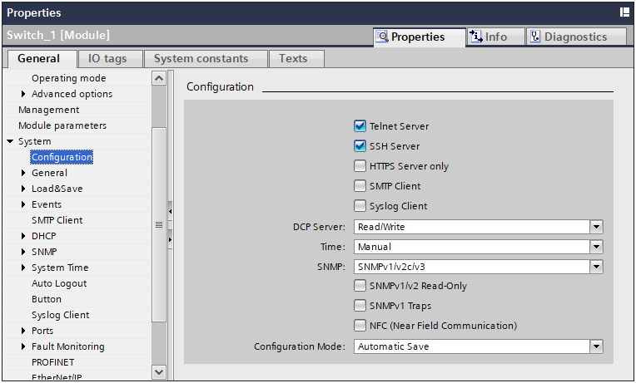

* Deselect the Telnet server. (→  Telnet Server)
* Select the SSH server. (→  SSH Server)
* Restrict Web access to HTTPS connections.

(→  HTTPS Server only → OK)

* Select write protection for SNMP v1 and v2c.

(→  SNMPv1/v2c Read-Only)

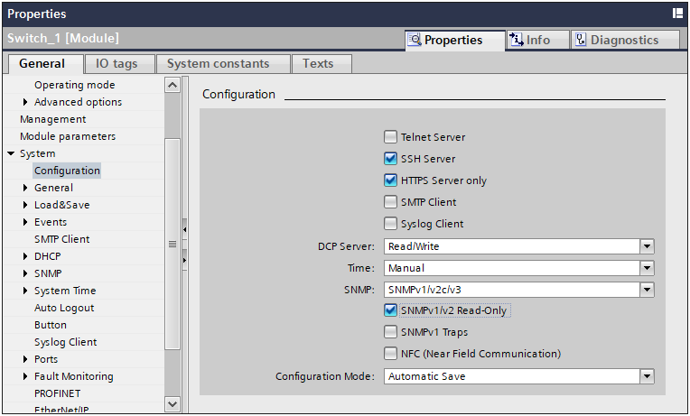

* Select the XC208 in the navigation, compile the configuration and select Download to device. (→ Switch_1 →  → )

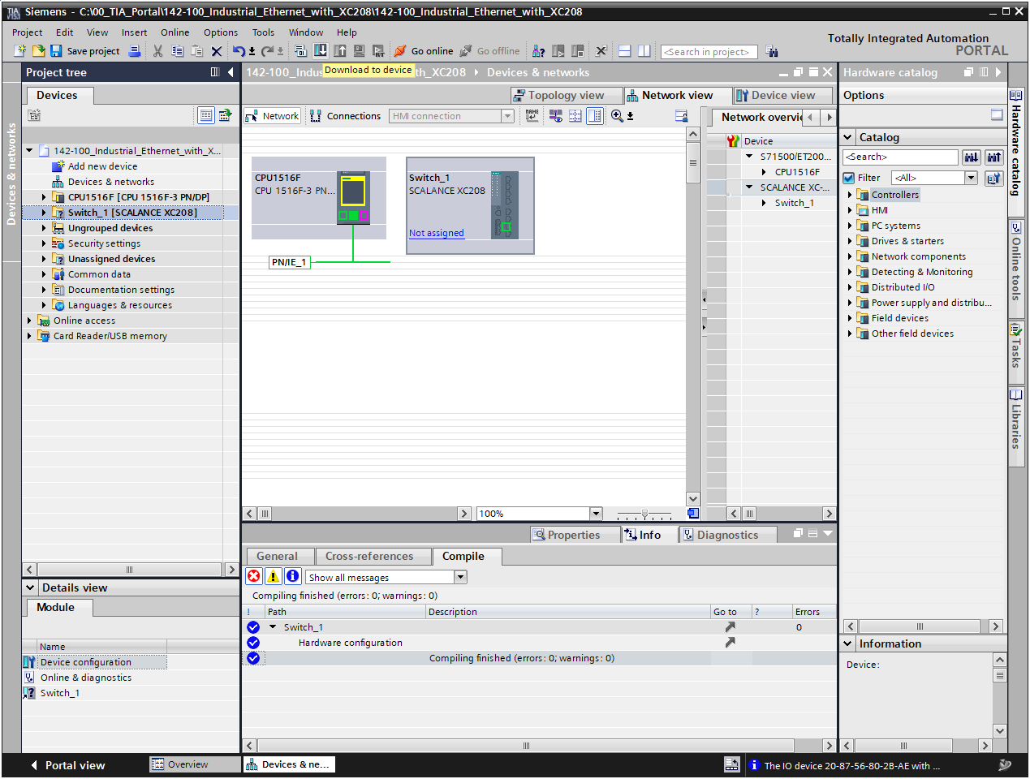

* Accept the certificate of the XC208 in the preview for loading.  
  (→ Accept certificate of the partner)

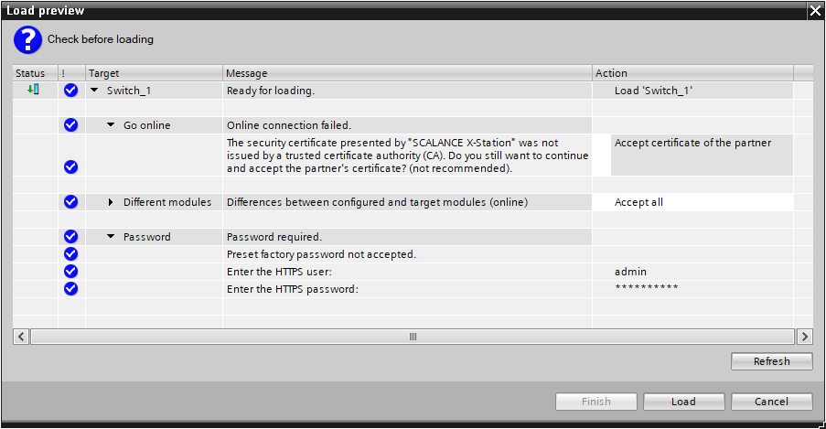

* Enter the HTTPS user and the password you just set.  
  (→ HTTPS user: admin → HTTPS password: …)



* Accept any further preconditions and click "Load". (→)



Note:

* *The device is restarted when downloading using the TIA Portal.*
* Save the configuration by finishing the loading process. (→ Action: Save configuration → )

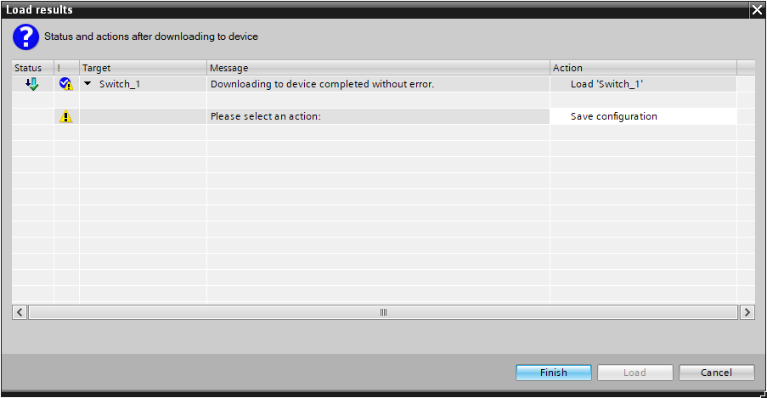

## Disabling unused ports

For security reasons, unused ports should be disabled. Active ports could be used to introduce an external system into the plant. If all unused ports are disabled, the external system can only be connected via an already used port.

* Re-open the properties of the XC208 (→ Switch_1 → Properties)
* Go to the port configuration. (→ System → Ports → Configuration)

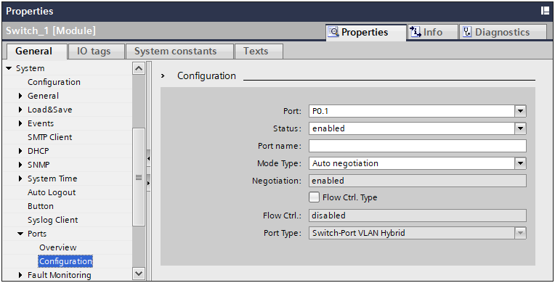

* Disable port 4 (→ Port: P0.4 → Status: disabled)

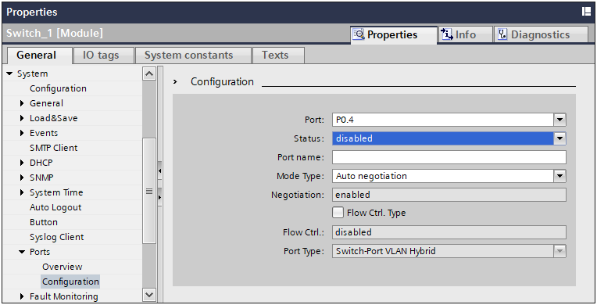

* Repeat the step for ports 5 through 7.

## Assignment to the CPU 1516F

* Assign the SCALANCE XC208 to the CPU 1516F (→ Not assigned → CPU_1516F.PROFINET interface_1)

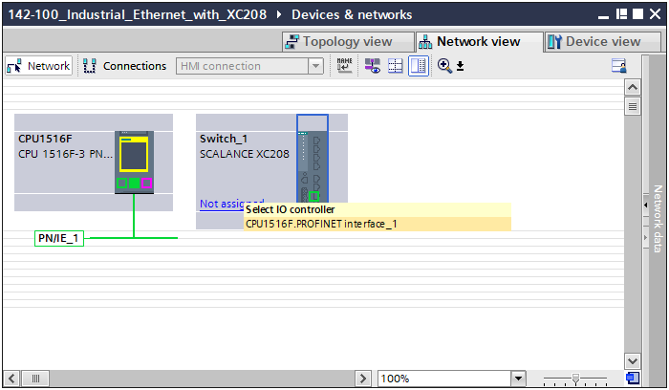

* Assign the PROFINET device name to the SCALANCE XC208 (→ right-click on XC208 → Assign device name)

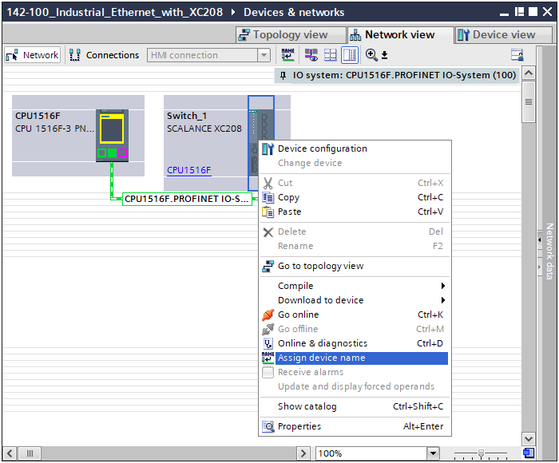

* Select the suitable interfaces in the new dialog and click "Update list" (→ Type of the PG/PC interface → PG/PC interface → Update list)

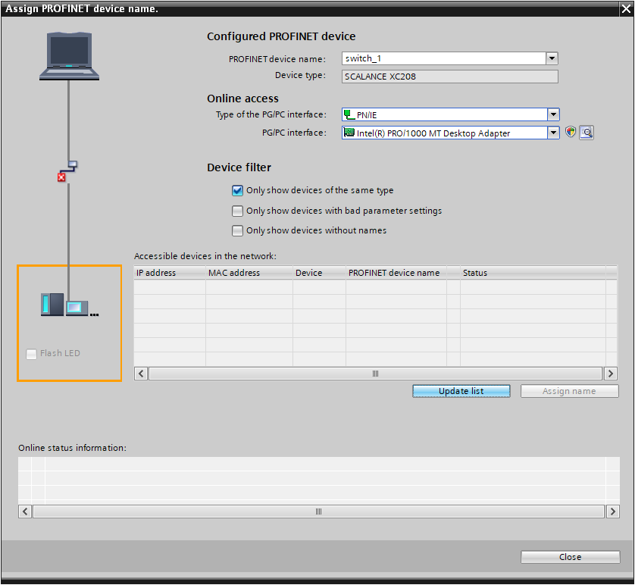

* Select the SCALANCE XC208 and assign the device name to it.  
  (→ SCALANCE XC200 → Assign name)

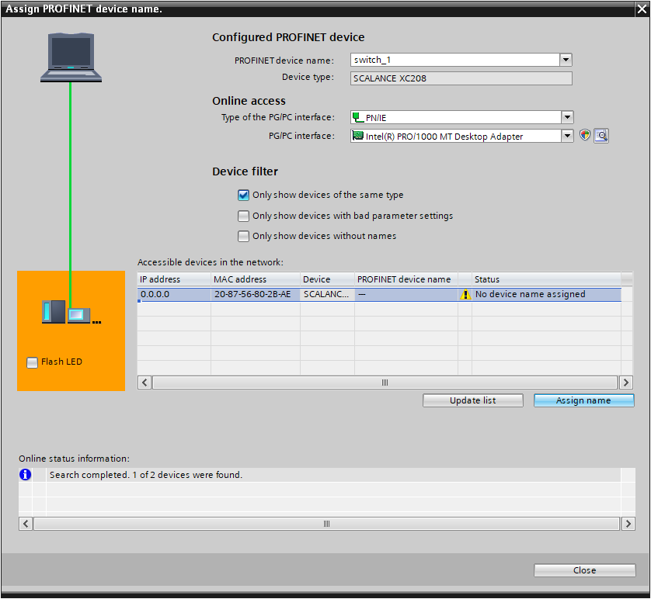

* The successful assignment of the device name is signaled with a corresponding message. Afterwards, close the window. (→ Status: OK → Close)

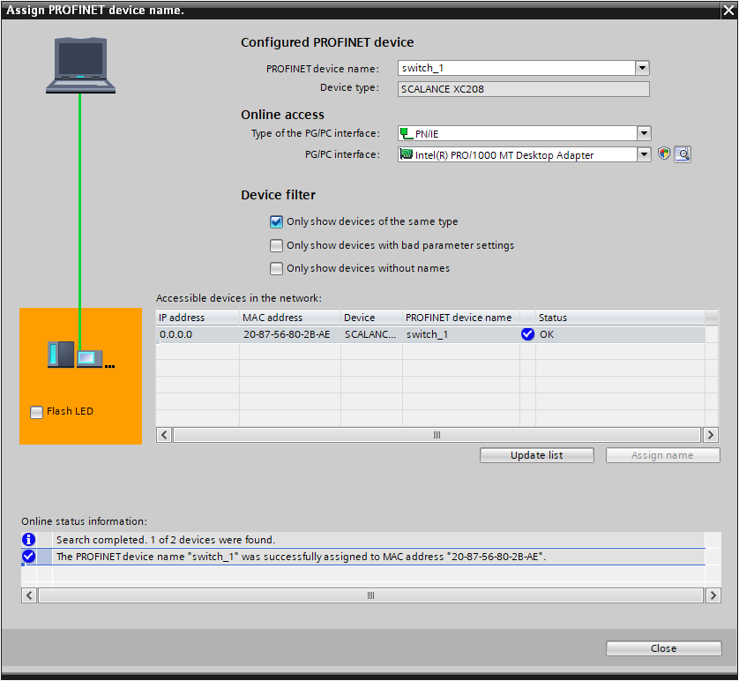

## Compiling and loading the CPU 1516F-3 PN/DP

* Select the CPU 1516F-3 PN/DP in the device overview and compile the configuration. (→ CPU_1516F → )
* Then, download the compiled configuration to the device. (→ CPU_1516F → )

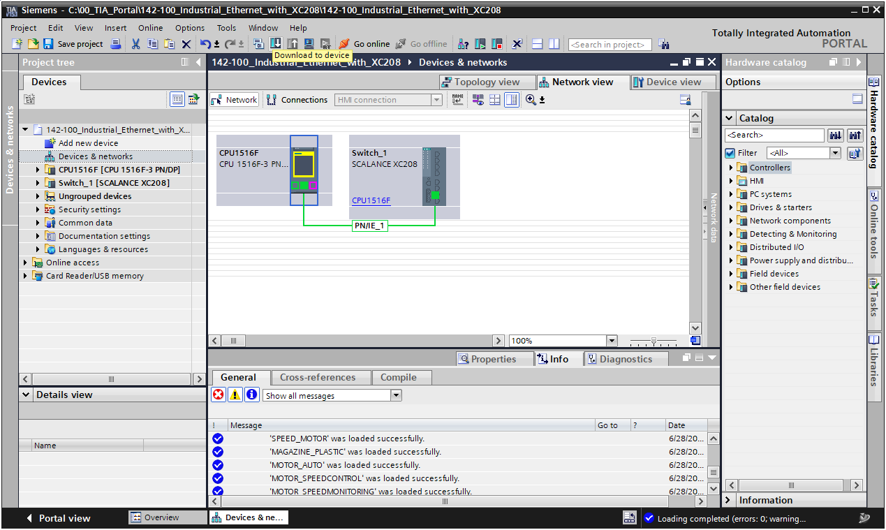

## Establishing an online connection to the CPU 1516F-3 PN/DP

* After successful downloading the configuration, establish an online connection to the CPU.  
  (→ CPU_1516F → )

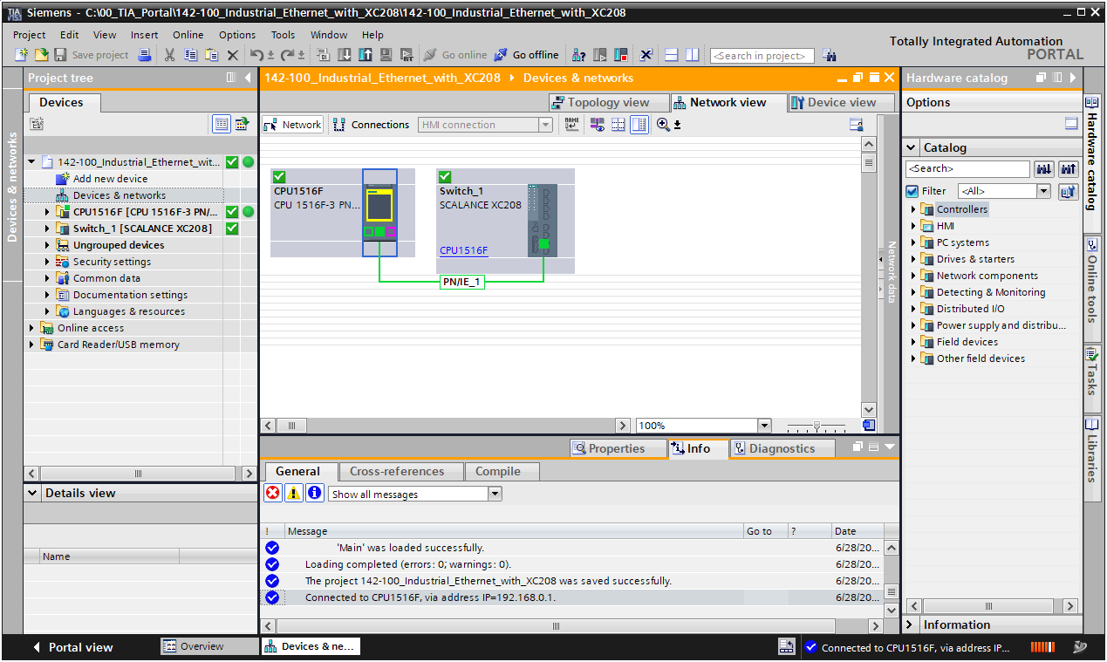

Note:

* *Neither device should signal an error and both should have a . A dedicated online connection to the XC208 is not necessary, because the CPU in its role as IO controller knows the status of the device.*

## Configuration of the topology

* Switch to the "Topology view" tab under "Devices & networks".  
  (→ )

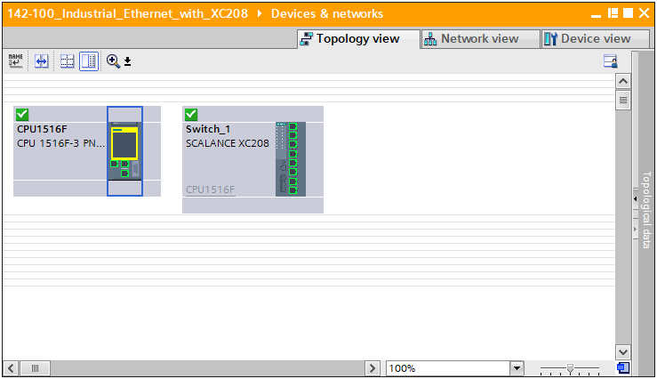

* On the right side, open the gray "Topological data" bar and go to the "Topology comparison" tab (→ Topological data → Topology comparison)



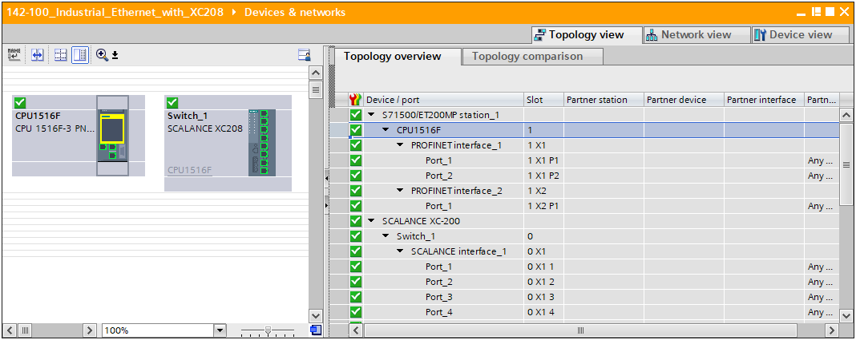

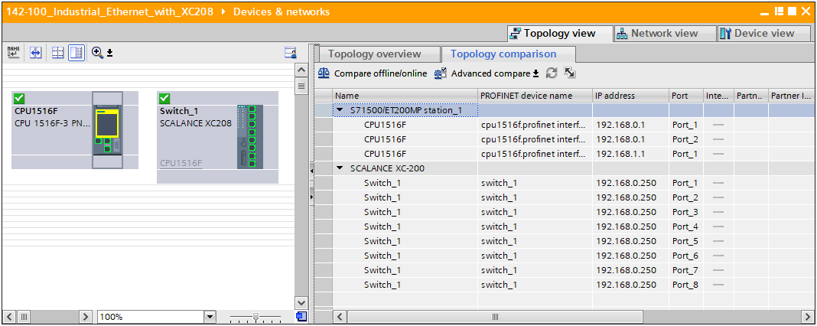

* Now start a comparison of the offline topology with the online topology

(→)

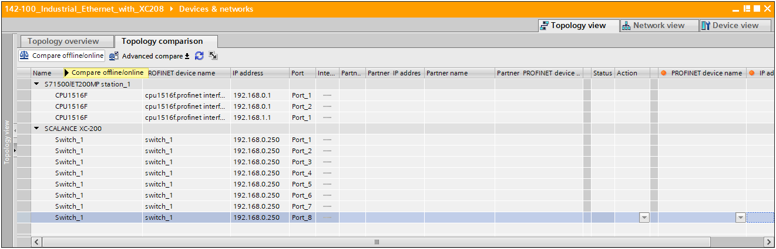

* Confirm the assigning of temporary IP addresses. (→ OK)

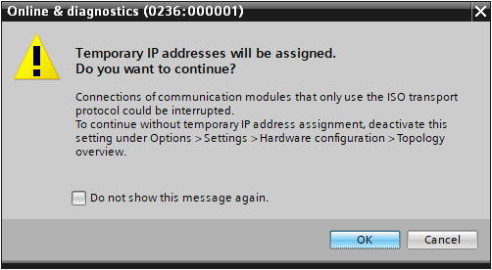

Note:

* *This can lead to interrupted connections.*
* After a successful comparison, the table should then be filled with additional data.

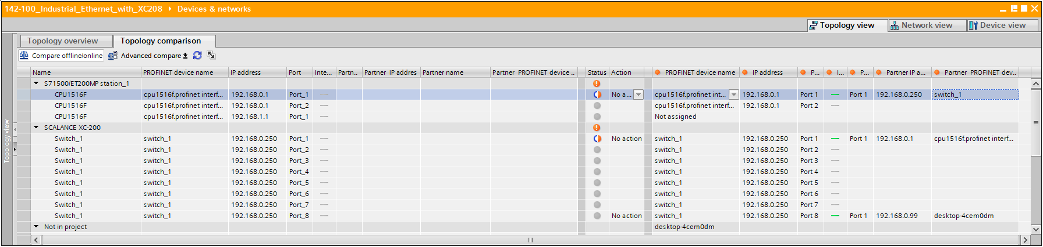

* Apply the complete online topology in your project.

(→ right-click in the "Action" column → Apply → Apply all)

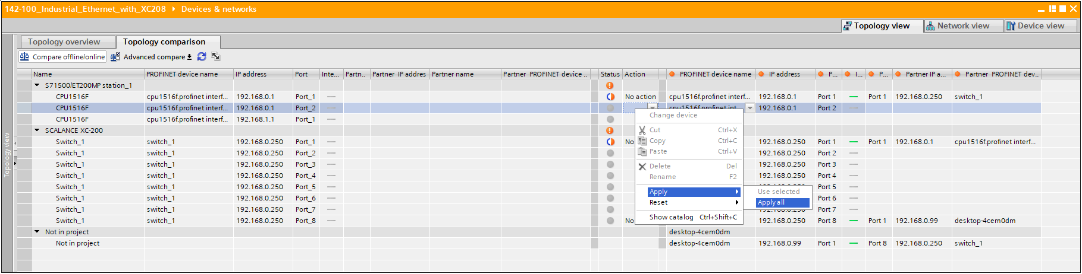

* Execute the actions by clicking "Synchronize" (→)

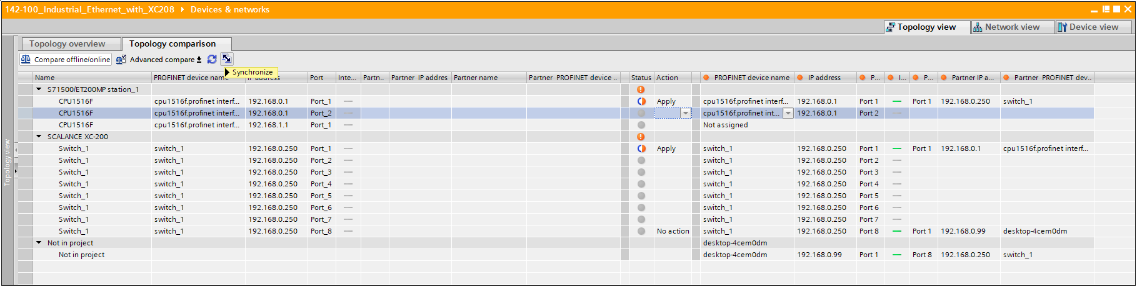

* Confirm the disconnection of the online connections. (→ Yes)

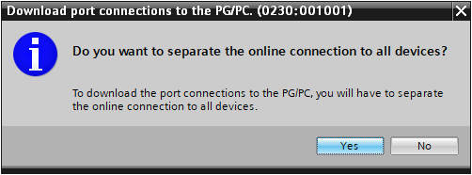

* Zoom out of the table with the topological data so that you have a clear view of the topology view.

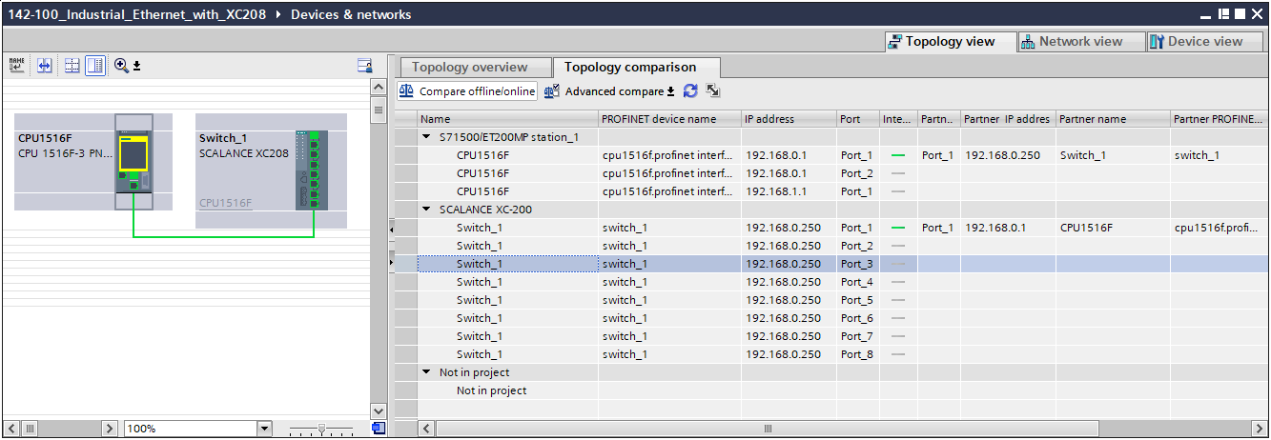

## Compiling and loading the CPU 1516F-3 PN/DP

* Select the CPU 1516F-3 PN/DP in the device overview and compile the configuration. (→ CPU_1516F → )
* Next, download the compiled configuration to the device.

(→ CPU_1516F → )

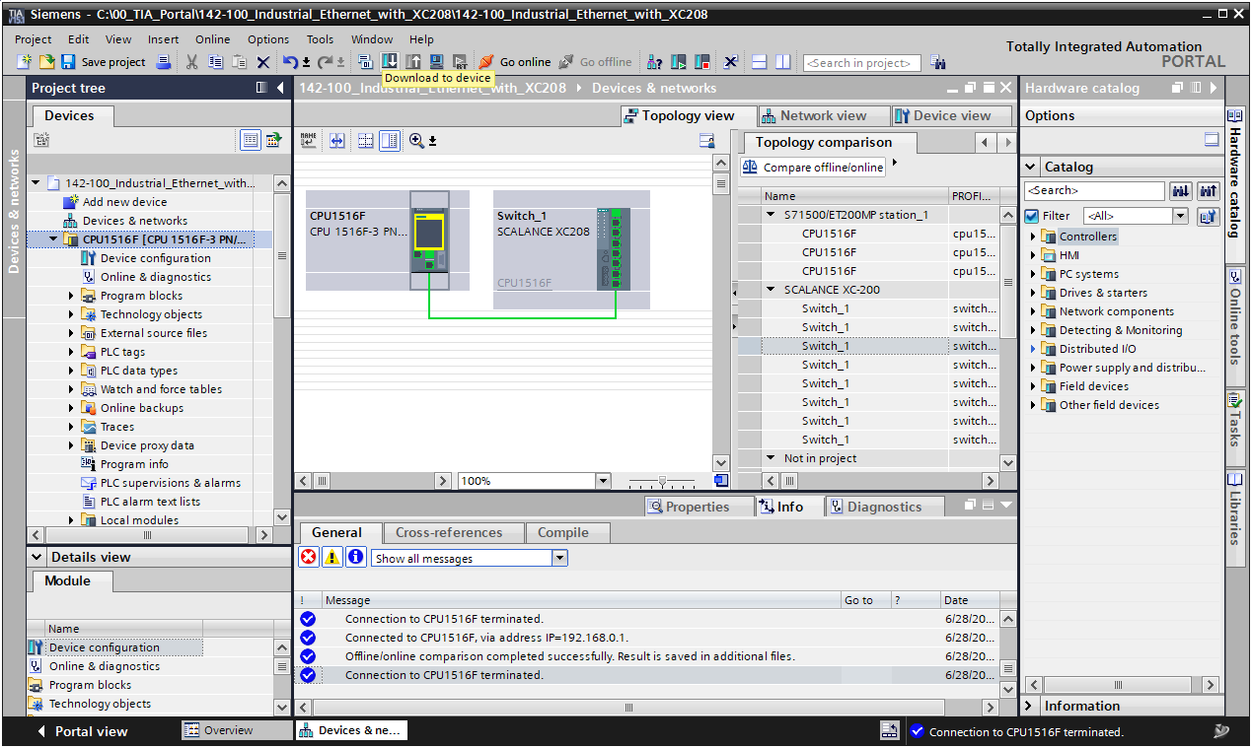

## Checking the current topology state

* Establish an online connection to the CPU 1516F-3 PN/DP. (→ CPU_1516F →)

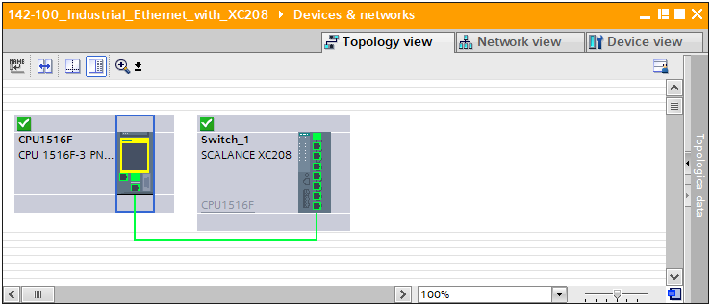

Note:

* *The connection between CPU and XC208 should be shown in green in the topology view and thus as error-free.*
* Move the connection between the S7 controller and the switch to port 2 of the XC208 and observe the changes in the topology view.

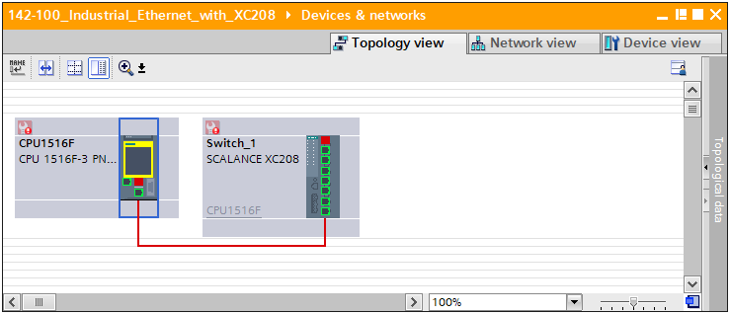

Note:

* *Both devices should now signal an error, and the connection between the CPU and XC208 should be shown in red and thus as faulty*.

## Evaluating the diagnostics buffer of the CPU 1516F-3 PN/DP

* Open the diagnostics buffer of the CPU_1516F. (→ Double-click →  Diagnostics buffer)



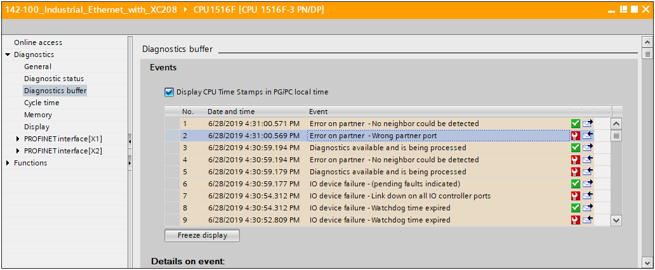

* Select the incoming event that indicates the partner error. (→ Error on partner)

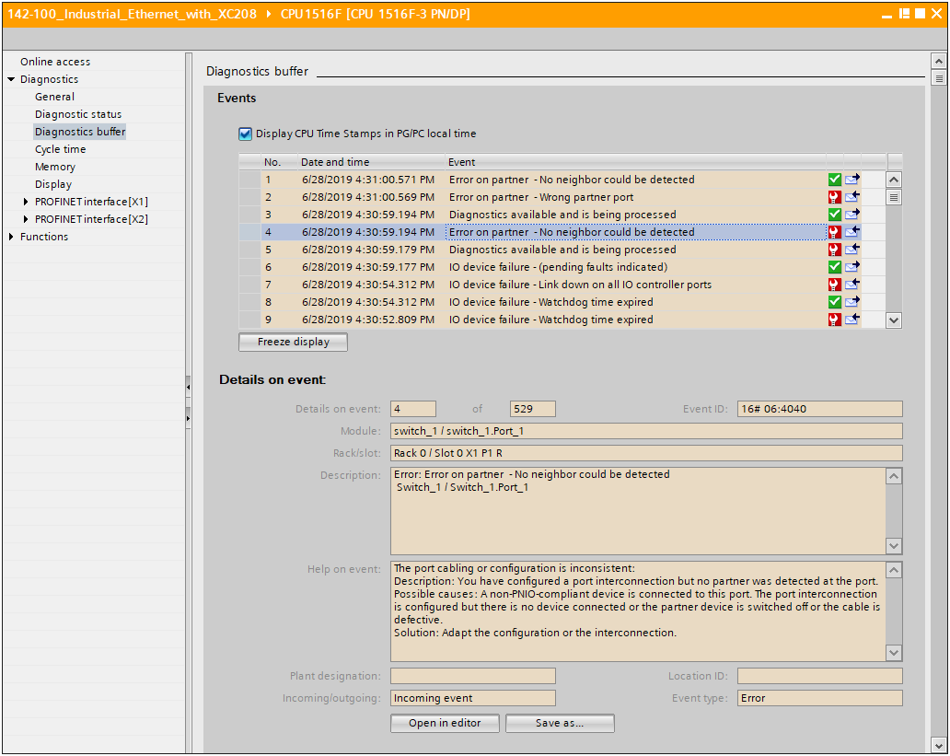

Note:

* *The CPU is now able to report information about the current topology from the perspective of the CPU and the switch.*

## End of topology discovery

The topology discovery uses the Link Layer Discovery Protocol (LLDP) to determine the connections between the different nodes. By deactivating LLDP on individual ports, this discovery can be restricted, e.g. in order to limit topology discovery to individual parts of the system. But security can also be a reason to restrict the protocol. An attacker is also able to determine the exact topology with LLDP and thus identify critical points.

* Move the connection between the S7 and the XC208 to port 3 of the XC208
* Open the properties of the XC208 (→ Switch_1 → Properties)
* Go to the LLDP settings (→ Layer 2 → LLDP)

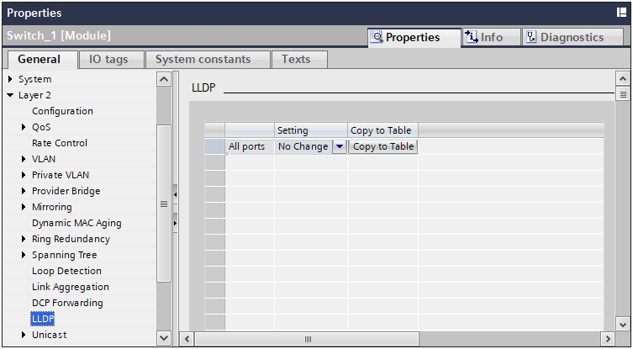

* Scroll down to the table with the port settings

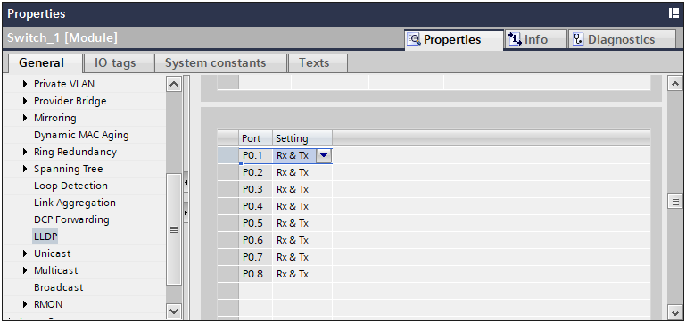

* Disable LLDP for port 3 (→ P0.3: -)

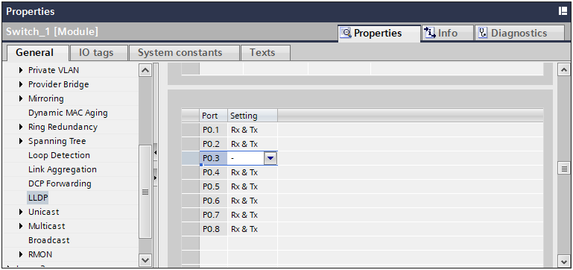

* Download the changes to the CPU. (→ CPU_1516F →  → )
* Now open the topology comparison again.

(→ Devices & networks → Topology view → Topological data → Topology comparison)

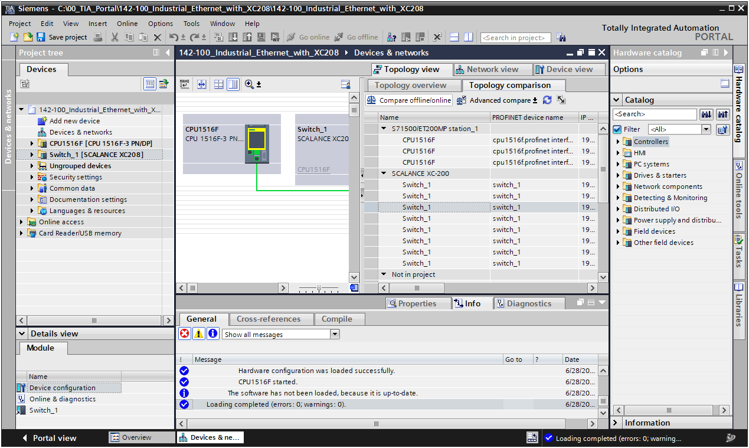

* Update the topology comparison. (→ )

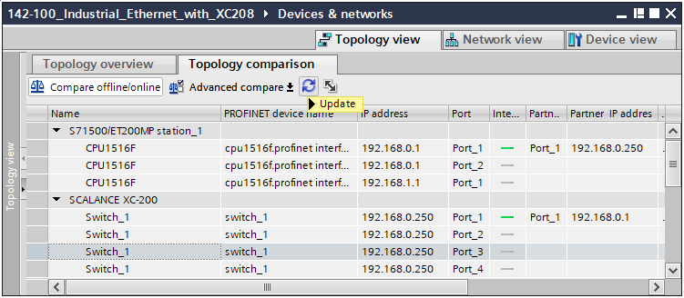

* Confirm the assigning of temporary IP addresses. (→ OK)



* No partner should be found on either the switch or the CPU.

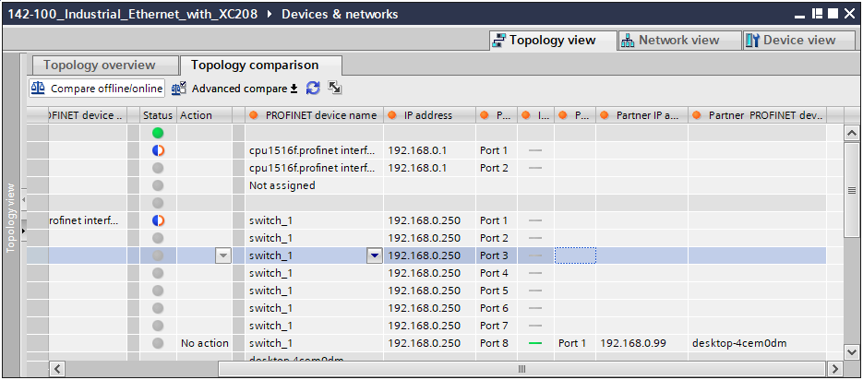

## End of detection of accessible devices

In addition to topology discovery, there is also the option to interrupt the detection of accessible devices. Accessible devices in PROFINET are determined via the "Discovery and Configuration Protocol" (DCP). The switch is adjustable so that DCP packets are not forwarded to the configured ports. Incoming packets will still be accepted.

* Open the properties of the XC208. (→ Switch_1 → Properties)
* Go to the DCP settings. (→ Layer 2 → DCP Forwarding)

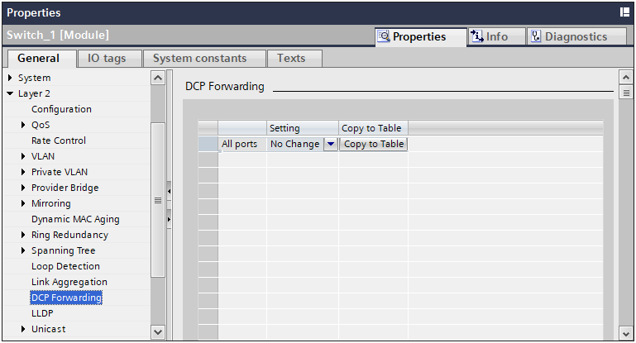

* Scroll down to the table with the port settings

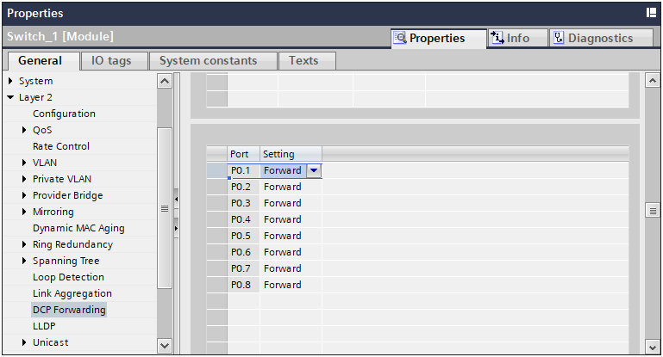

* Disable DCP forwarding for port 3 (→ P0.3: Block)

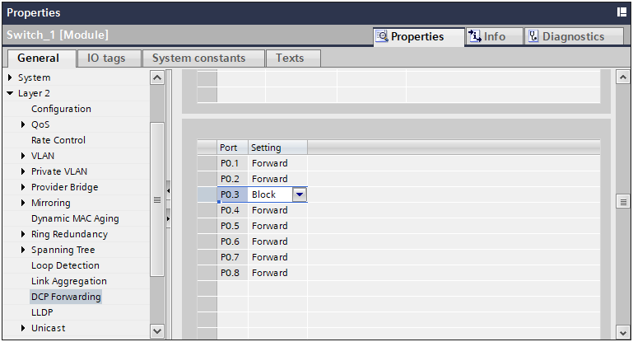

* Download the changes to the CPU. (→ CPU_1516F →  → )
* Open the "Accessible devices" dialog. (→ ).

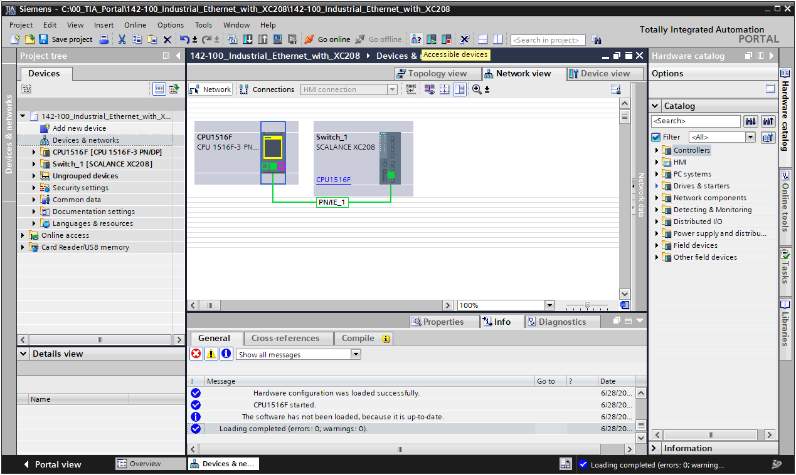

* Start the search for accessible devices. (→)

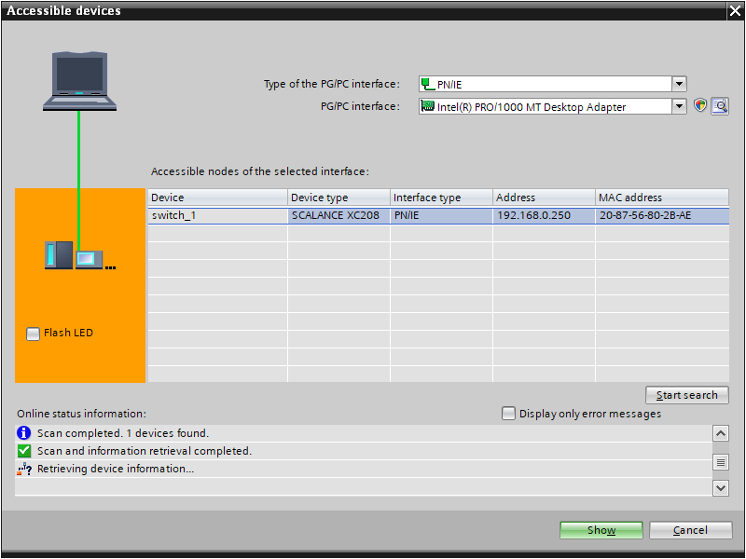

* The CPU no longer appears in the list of accessible devices.

## Activation of media redundancy

* Move the connection between the S7 controller and the XC208 back to port 1 of the XC208
* Open the properties of the XC208. (→ Switch_1 → Properties)

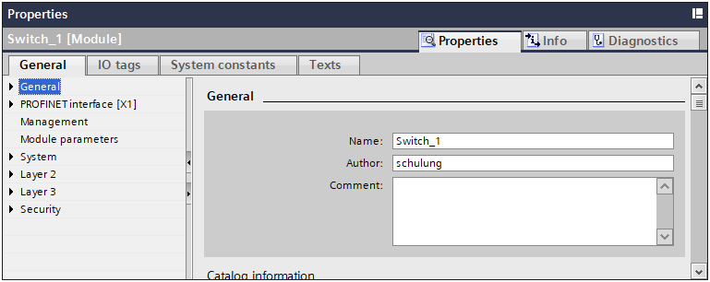

* Go to the "Ring Redundancy" item in the "Layer 2" menu. (→ Layer 2 → Ring Redundancy)

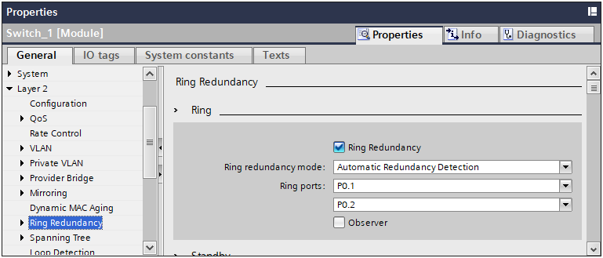

* Set the ring redundancy mode to MRP Auto-Manager.
* Set the ring ports to P0.1 and P0.2.

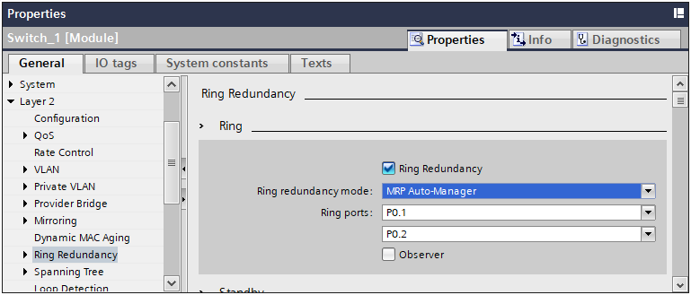

* Now open the properties of the X1 interface in the CPU_1516F.  
  (→ CPU_1516F → Device configuration → X1 → Properties)

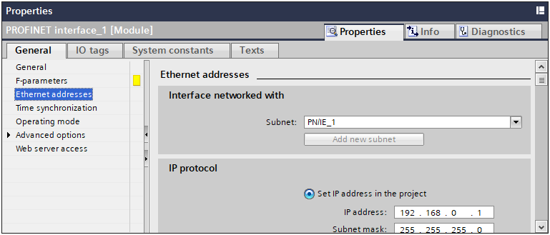

* Under "Advanced options", switch to "Media redundancy": (→ Advanced options → Media redundancy)

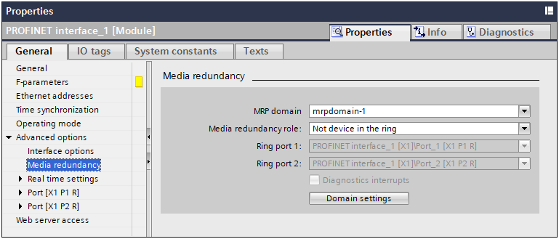

* Set the media redundancy role to client. (→ Media redundancy role: Client)

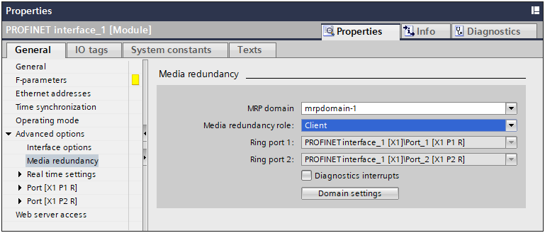

* Then download the changes in the CPU_1516F. (→ CPU_1516F →  → )

## Checking the ring status

* Connect to the CPU. (→ CPU_1516F → )
* Open the online diagnostics of the XC208. (→ Switch_1 → Online & diagnostics)

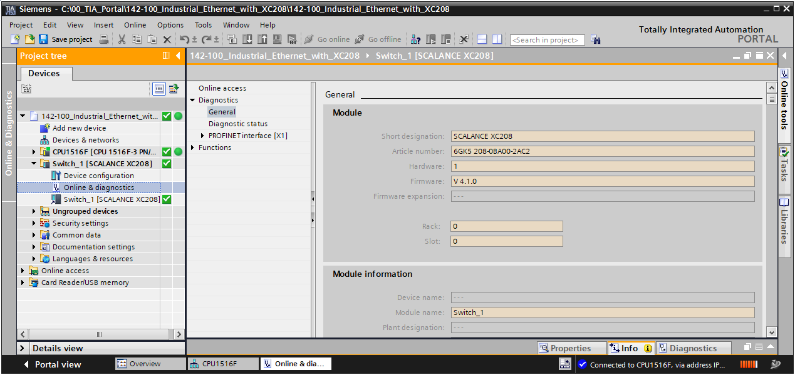

* Go to the diagnostics of the MRP domain.

(→ Diagnostics → PROFINET interface [X1] → Domain → MRP domain)

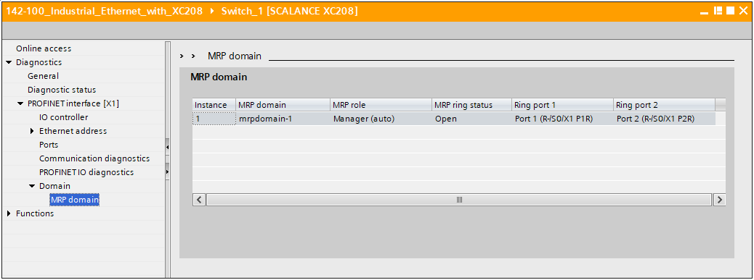

Note:

* *The MRP ring status should be described as open, because the redundant line is not yet inserted.*
* Now connect port P2 of the XC208 to port X1P2R on the CPU 1516F-3 PN/DP.

CPU 1516F





X1P1R

P1

XC208

X1P2R

P2

PG/PC



P8

* Check the MRP ring status again in the online diagnostics.

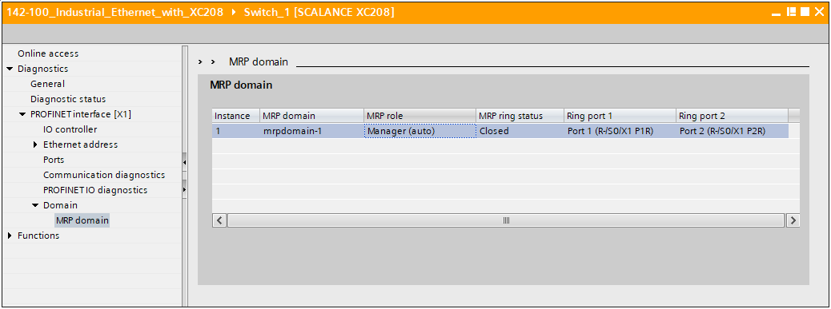

Note:

* *The MRP ring status should now be described as closed.*

## Diagnostics of the ring status in the web interface

* Open the web interface of the XC208 (→ <https://192.168.0.250>)
* Go to the redundancy information (→ Information → Redundancy)

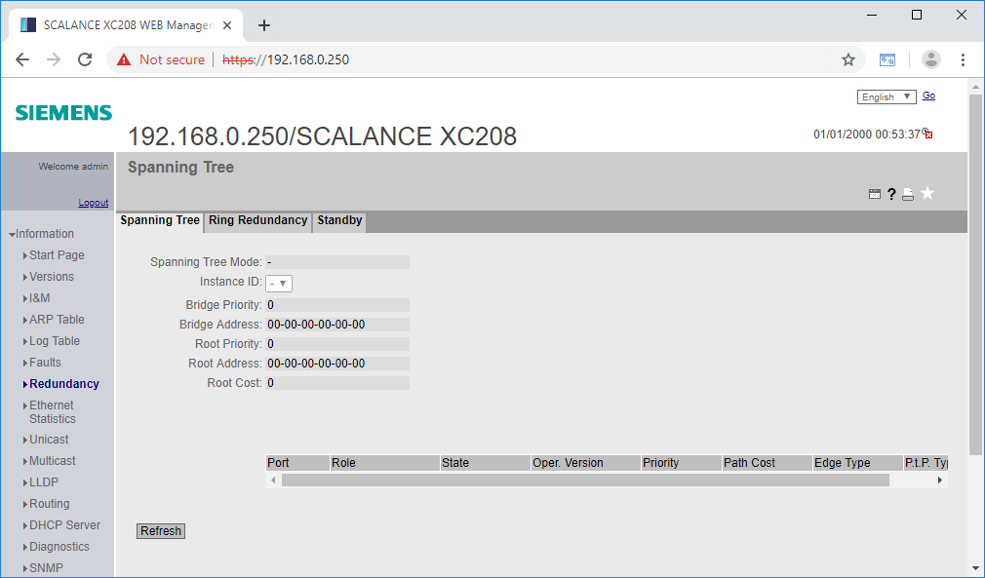

* Go to the Ring Redundancy tab (→ Ring Redundancy)

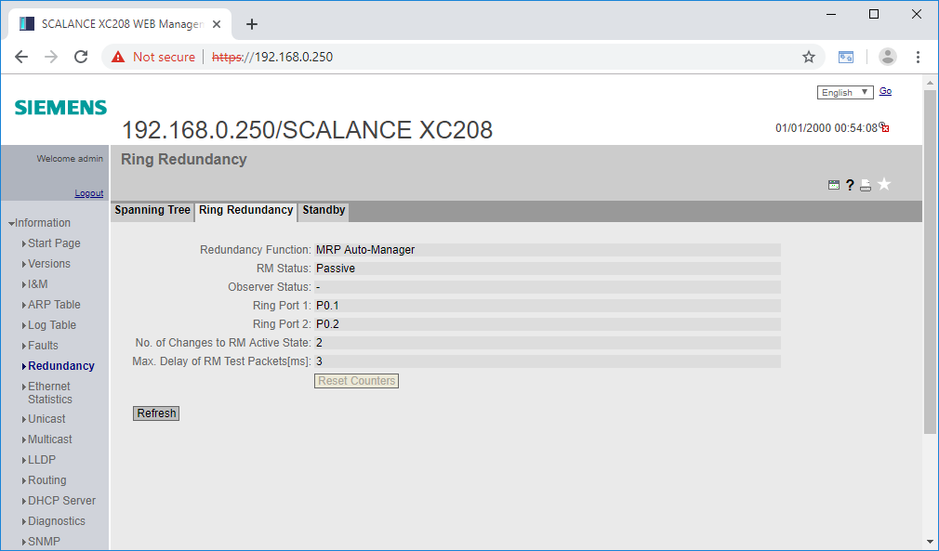

Note:

* *The ring status is output here under RM Status. Since the ring is closed, the ring manager behaves passively.*
* Open the ring by disconnecting one of the two connections between S7 and XC208.
* Update the display in the web page. (→ Update)

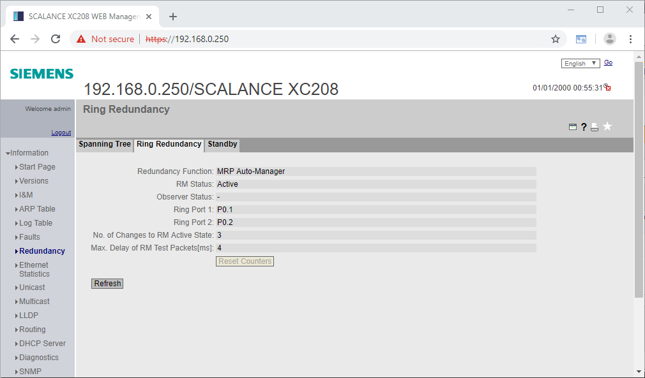

Note:

* *The status then changes to active because the ring manager became active and has activated its redundant port.*

## Archiving the project

* Finally, the complete project is to be archived. Select the "Archive …" command in the "Project" menu. Enter a target path in the following dialog and archive the project. (→ Project → Archive → Destination path … → Archive)

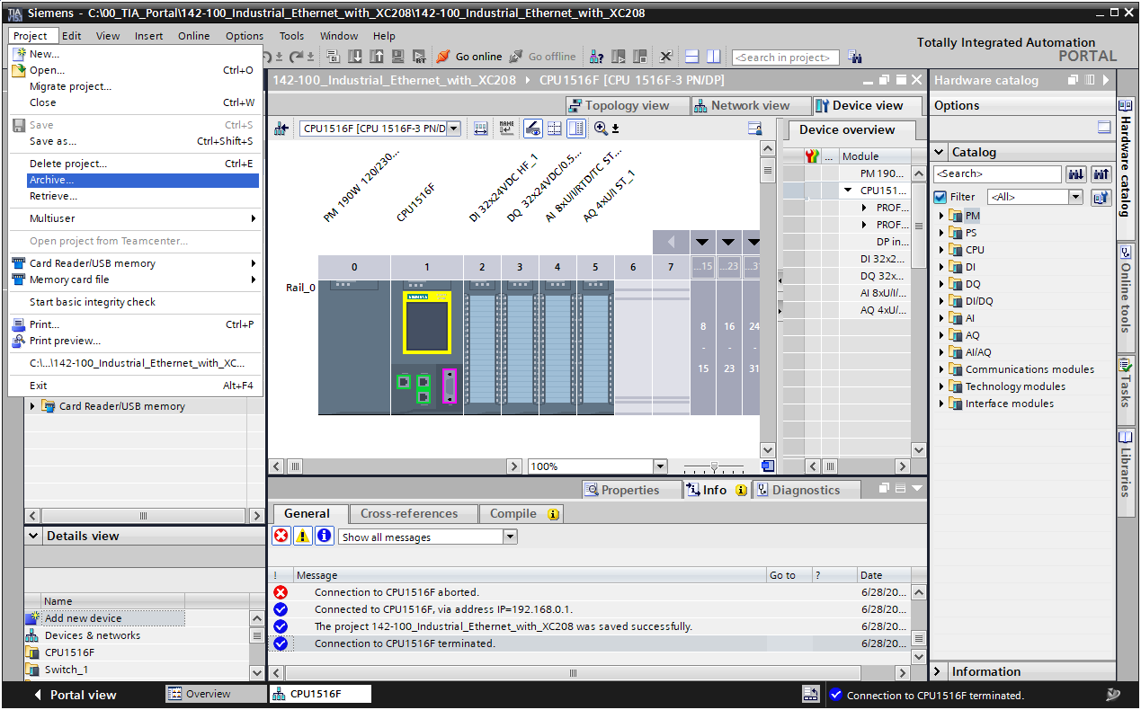

## Checklist – step-by-step instructions

The following checklist helps students/trainees to independently check whether all steps of the step-by-step instructions have been carefully completed and enables them to successfully complete the module on their own.

| **No.** | Description | **Checked** |
| --- | --- | --- |
| 1 | Project successfully retrieved from archive |  |
| 2 | SCALANCE XC208 added |  |
| 3 | IP address successfully set |  |
| 4 | Web management login and password changed |  |
| 5 | Basic configuration completed (HTTPS, SNMP, Ports, etc.) |  |
| 6 | CPU_1516F assigned to XC208 as IO controller |  |
| 7 | CPU_1516F compiled and downloaded |  |
| 8 | Insecure HTTP access no longer possible |  |
| 9 | Link via ports 4 to 7 no longer possible |  |
| 11 | Topology synchronized |  |
| 12 | CPU_1516F compiled and downloaded again |  |
| 13 | Online connection to CPU_1516F established |  |
| 14 | CPU connected to port 1 of XC208: Topology view error-free |  |
| 15 | CPU connected to port 2 of XC208: Errors in topology view |  |
| 16 | Diagnostics buffer of the CPU_1516F evaluated |  |
| 17 | LLDP on port 3 deactivated |  |
| 18 | Configuration successfully downloaded to CPU_1516F |  |
| 19 | Topology discovery with CPU connected to port 3 is no longer possible |  |
| 20 | DCP on port 3 deactivated |  |
| 21 | Configuration successfully downloaded to CPU_1516F |  |
| 22 | CPU connected to port 3 no longer visible as accessible device |  |
| 23 | CPU reconnected to correct port on XC208 |  |
| 24 | Ring redundancy at switch_1 set to MRP Auto-Manager |  |
| 25 | CPU_1516F configured as client in the MRP ring |  |
| 26 | Configuration successfully downloaded to CPU_1516F |  |
| 27 | Ring interrupted: MRP ring status open |  |
| 28 | Ring closed: MRP ring status closed |  |
| 29 | Project successfully archived |  |

# Exercise

## Task – Exercise

The changed cabling is to be applied to the topology of the current project. This allows errors in the cabling of the PROFINET bus to be diagnosed better and faster.

Also, the topology discovery and the detection of accessible devices on port 3 of the switch will be activated and tested again in order to be able to comfortably expand the system on this port in the future.

For security reasons, port 3 should be deactivated until it is ultimately used.

## Planning

In the next step, plan the implementation of the task on your own.

## Checklist – Exercise

The following checklist helps students/trainees to independently check whether all steps of the exercise have been carefully completed and enables them to successfully complete the module on their own.

| **No.** | Description | **Checked** |
| --- | --- | --- |
| 1 | New inserted connection configured in the topology view |  |
| 2 | LLDP for port 3 enabled again |  |
| 3 | DCP enabled for port 3 again |  |
| 4 | Port 3 deactivated |  |
| 5 | Configuration was compiled without error message |  |
| 6 | Configuration downloaded to CPU_1516F without error message |  |
| 7 | Devices show no group error |  |
| 8 | Group error when connection to P2 at Switch_1 is disconnected |  |
| 9 | Project successfully archived |  |

# Additional information

More information for further practice and consolidation is available as orientation, for example: Getting Started, videos, tutorials, apps, manuals, programming guidelines and trial software / firmware, under the following link:

[siemens.de/sce/s7-1500](http://www.siemens.de/sce/s7-1500)

**Preview "Additional information" – In preparation**

 Further Information

Siemens Automation Cooperates with Education  
siemens.com/sce

SCE Learn-/Training Documents  
**siemens.com/sce/documents**

SCE Trainer Packages  
**siemens.com/sce/tp**

SCE Contact Partners   
**siemens.com/sce/contact**

Digital Enterprise  
**siemens.com/digital-enterprise**

Industrie 4.0   
**siemens.com/future-of-manufacturing**

Totally Integrated Automation (TIA)  
**siemens.com/tia**

TIA Portal  
**siemens.com/tia-portal**

SIMATIC Controller  
**siemens.com/controller**

SIMATIC Technical Documentation   
**siemens.com/simatic-docu**

Industry Online Support  
**support.industry.siemens.com**

Product catalogue and online ordering system Industry Mall   
**mall.industry.siemens.com**

Siemens  
Digital Industries, FA   
P.O. Box 4848  
90026 Nuremberg  
Germany

Subject to change and errors  
© Siemens 2019

**siemens.com/sce**