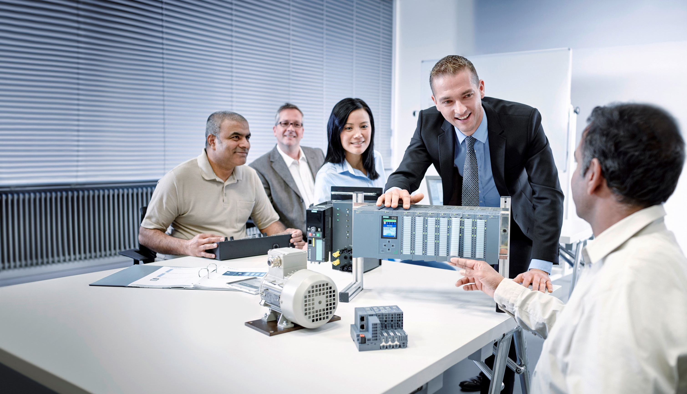**Matching SCE Trainer Packages for these Learn-/Training Document**

Learn-/Training Document  
  
Siemens Automation Cooperates with Education   
(SCE) | From Version V14 SP1

**siemens.com/sce**

TIA Portal Module 011-001

Firmware Update with SIMATIC S7-1200



* **SIMATIC S7-1200 AC/DC/RELAY (set of 6) "TIA Portal"**  
  Order no.: 6ES7214-1BE30-4AB3
* **SIMATIC S7-1200 DC/DC/DC (set of 6) "TIA Portal"**  
  Order no.: 6ES7214-1AE30-4AB3
* **Upgrade SIMATIC STEP 7 BASIC V14 SP1 (for S7-1200) (set of 6) "TIA Portal"**  
  Order no.: 6ES7822-0AA04-4YE5

Please note that these trainer packages are replaced with successor packages when necessary.

An overview of the currently available SCE packages is provided at: [siemens.com/sce/tp](http://www.siemens.com/sce/tp)

**Continued training**

For regional Siemens SCE continued training, contact your regional SCE representative: [siemens.com/sce/contact](http://www.siemens.com/contact)

**Additional information regarding SCE**

[siemens.com/sce](http://www.siemens.com/sce)  
  
  
**Information regarding use**

The SCE Learn-/Training Document for the integrated automation solution Totally Integrated Automation (TIA) was prepared for the program "Siemens Automation Cooperates with Education (SCE)" specifically for training purposes for public educational facilities and R&D institutions. Siemens AG does not guarantee the contents.

This document is to be used only for initial training on Siemens products/systems, which means it can be copied in whole or part and given to those being trained for use within the scope of their training. Circulation or copying this Learn-/Training Document and sharing its content is permitted within public training and advanced training facilities for training purposes.

Exceptions require written consent from the Siemens AG contact person: Roland Scheuerer roland.scheuerer@siemens.com.

Offenders will be held liable. All rights including translation are reserved, particularly if a patent is granted or a utility model or design is registered.

Use for industrial customer courses is explicitly not permitted. We do not consent to commercial use of the Learn-/Training Document.

We wish to thank the TU Dresden, particularly Prof. Dr.-Ing. Leon Urbas and the Michael Dziallas Engineering Corporation and all other involved persons for their support during the preparation of this Learn-/Training Document.

Table of Contents

1 Goal 4

2 Requirement 4

3 Required hardware and software 4

4 Theory 5

4.1 SIMATIC S7-1200 automation system 5

4.2 Operator controls and display elements of the CPU 1214C DC/DC/DC 6

4.2.1 Front view of the CPU 1214C DC/DC/DC 6

4.2.2 SIMATIC Memory Card (MC) 7

4.2.3 Operating modes of the CPU 7

4.2.4 Status and error displays 8

4.3 STEP 7 Basic programming software (TIA Portal V14) 9

4.3.1 Basic settings for the TIA Portal 9

4.3.2 Setting the IP address on the programming device 11

4.3.3 Setting the IP address in the CPU 14

4.3.4 Restoring the factory settings of the CPU 17

4.3.5 Downloading a firmware update from the SIEMENS Support website 19

4.3.6 Firmware update of the CPU 27

5 Additional information 30

Firmware Update with SIMATIC S7-1200

# Goal

This chapter will show how the **firmware version of the CPU** of **SIMATIC S7-1200** can be checked and upgraded using the TIA Portal.

The SIMATIC S7 controllers listed in Chapter 3 can be used.

# Requirement

No prerequisites have to be met for successful completion of this chapter.

# Required hardware and software

1. Engineering station: requirements for hardware and operating system

(for additional information, see Readme on the TIA Portal Installation DVD)

**2** SIMATIC STEP 7 Basic software in TIA Portal – V14 SP1 or higher

**3** SIMATIC S7-1200 controller, e.g. CPU 1214C DC/DC/DC – Firmware V4.2.1 or higher

**4** Ethernet connection between engineering station and controller

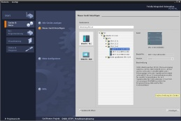

**2** SIMATIC STEP 7 Basic (TIA Portal) V14 SP1 or higher



**1** Engineering station

**4** Ethernet connection

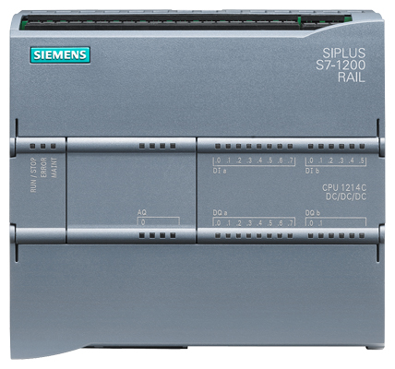

**3** SIMATIC S7-1200 controller

# Theory

## SIMATIC S7-1200 automation system

The SIMATIC S7-1200 automation system is a modular microcontroller system for the lower performance range.

A comprehensive range of modules is available to optimally adapt the system to the automation task.

The S7 controller consists of a power supply and a CPU with integrated inputs and outputs or additional input or output modules for digital and analog signals.

If necessary, communication processors and function modules for special tasks such as stepper motor control are also used.

## Operator controls and display elements of the CPU 1214C DC/DC/DC

### Front view of the CPU 1214C DC/DC/DC

With an integrated power supply (24 V connection) and integrated inputs and outputs, the CPU 1214C DC/DC/DC is ready for immediate use without additional components.

For communication with a programming device, the CPU has an integrated TCP/IP connection.

The CPU can thus communicate with HMI devices or other CPUs over an Ethernet network.



1. 24 V connection

② Plug-in terminal block for user wiring (behind the cover flaps)

③ Status LEDs for the integrated IO and the operating mode of the CPU

④ TCP/IP connection (on the bottom of the CPU)

### SIMATIC Memory Card (MC)

The optional **SIMATIC Memory Card (MC)** stores the program, data, system data, files and projects. It can be used for:

* Transfer of a program to multiple CPUs
* Firmware update of CPUs, signal modules (SM) and communication modules (CM)
* Simple CPU replacement

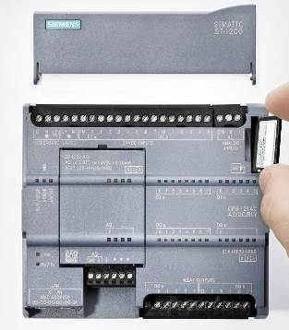

### Operating modes of the CPU

The CPU can have the following three operating modes:

* In **STOP** mode, the CPU is not executing the program and you can download a project.
* In **STARTUP** mode, the CPU is starting up.
* In **RUN** mode, the program is being executed cyclically.

The CPU does not have a physical switch for changing the operating mode.

You use the button on the operator panel of the STEP 7 Basic software to change the operating mode (**STOP** or **RUN**). The operator panel also contains an **MRES** button for performing a memory reset and displays the status LEDs of the CPU.

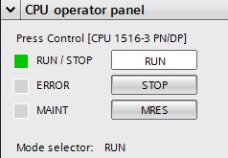

### Status and error displays

The **Status LED RUN/STOP** on the front of the CPU indicates the current operating mode of the CPU by the color indicated.



* **Yellow** light indicates   
  **STOP** mode.
* **Green** light indicates   
  **RUN** mode.
* A **flashing light** indicates   
  **STARTUP** mode.

In addition, there is an **ERROR** LED for indicating errors and a **MAINT** LED for indicating a maintenance requirement.

## STEP 7 Basic programming software (TIA Portal V14)

STEP 7 Basic V14 (TIA Portal V14) software is the programming tool for the following automation systems:

* SIMATIC S7-1200
* Basic Panels

STEP 7 Basic V14 provides the following functions for plant automation:

* Configuration and parameter assignment of the hardware
* Specification of the communication
* Firmware update
* Programming
* Testing, commissioning and service with operational/diagnostic functions
* Documentation
* Creation of visualizations for SIMATIC Basic Panels with the integrated WinCC Basic software

Support is provided for all functions through detailed online help.

### Basic settings for the TIA Portal

* Users can specify their own default settings for certain settings in the TIA Portal. A few important settings are shown here.
* In the project view, select the → "Options" menu and then → "Settings".

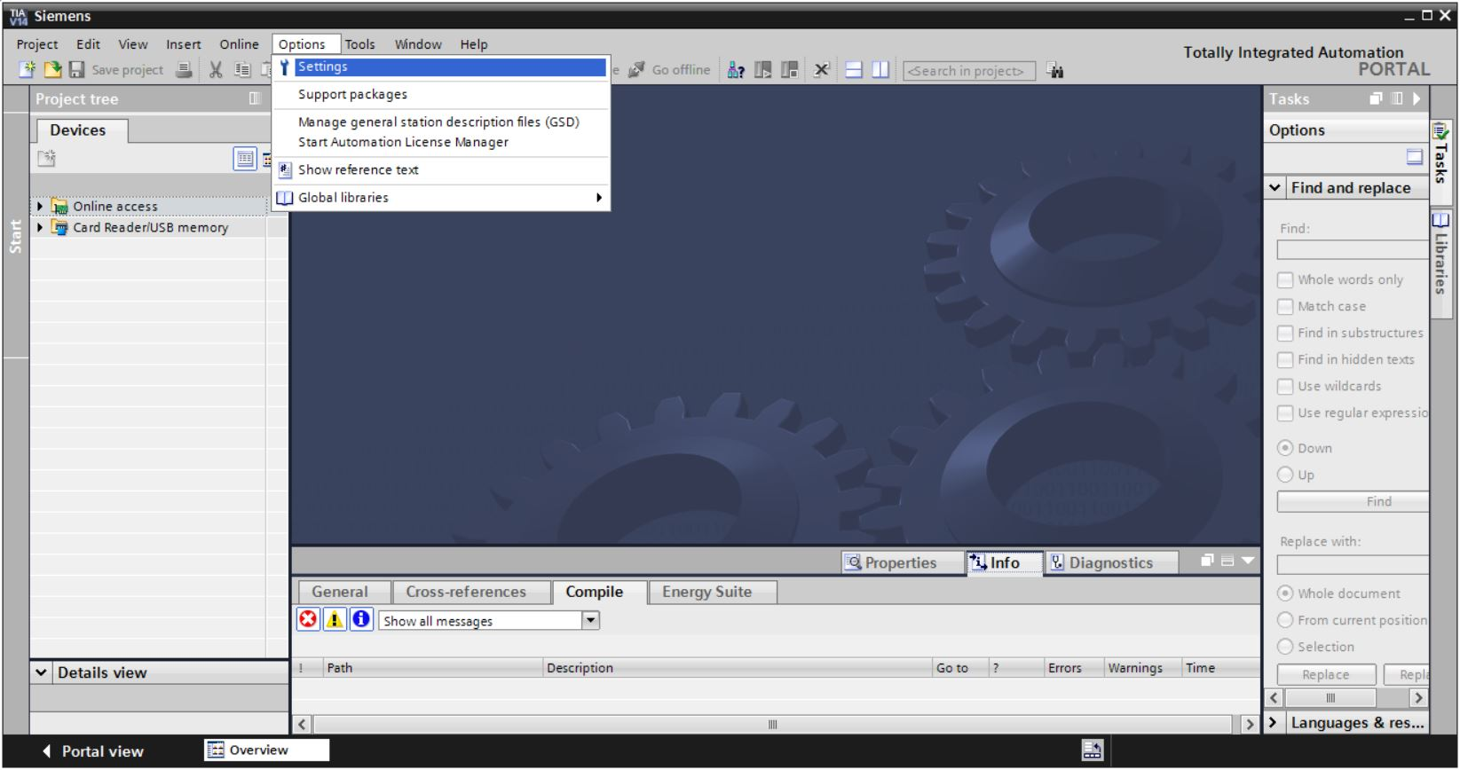

* One basic setting is the selection of the user interface language and the language for the program display. In the curriculums to follow, "English" will be used for both settings.
* Under → "General" in "Settings", select "User interface language → English" and "Mnemonic → International".

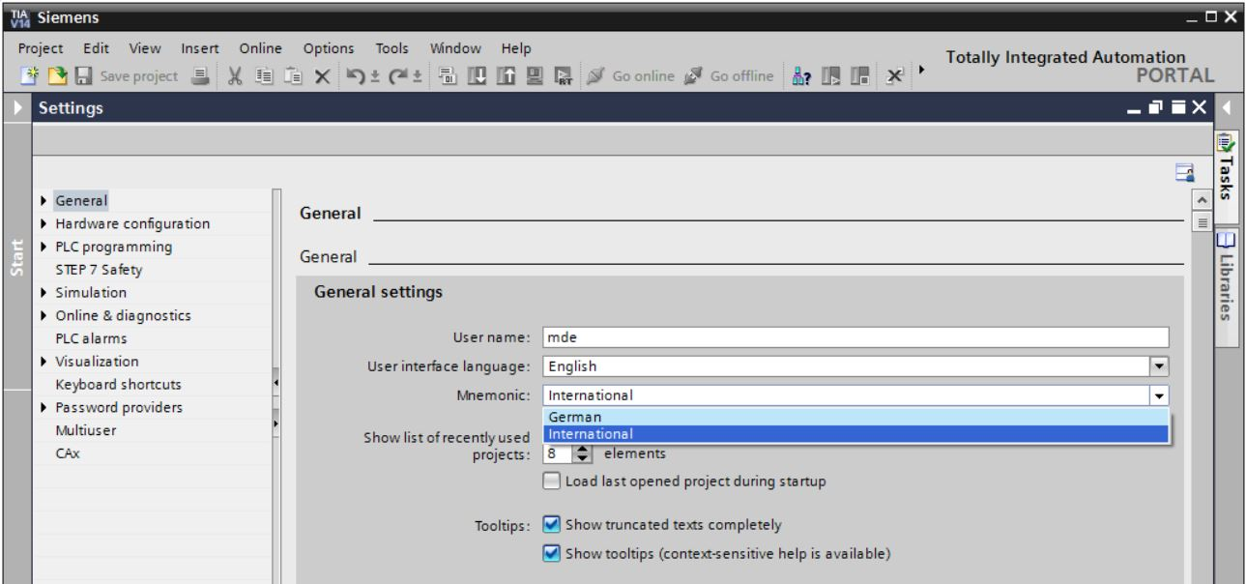

**Note:** These settings can always be changed.

### Setting the IP address on the programming device

You need a TCP/IP connection in order to upgrade the CPU of a SIMATIC S7-1200 controller from the PC, the programming device or a laptop.

It is important that the IP addresses of both devices match for the computer and SIMATIC S7‑1200 to communicate with each other via TCP/IP.

First, we will show you how to set the IP address of a computer with the Windows 10 operating system.

* Select the network icon in the taskbar at the bottom 003 and click → "Network settings".

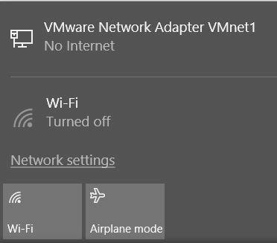

* In the network settings window that opens, click → "Ethernet" and then on → "Change adapter options".

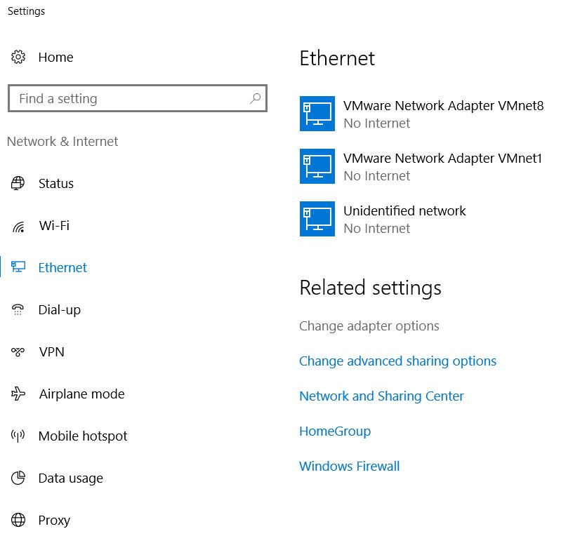

* Select the desired → "LAN Connection" that you want to use to connect to the controller and click → "Properties".

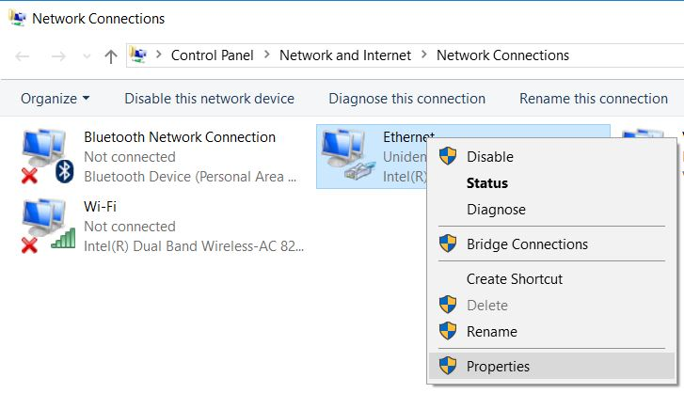

* Select → "Properties" for → "Internet Protocol Version 4 (TCP/IPv4)".

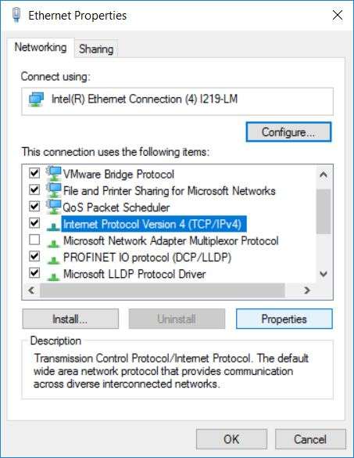

* You can now use the following IP address, for example → IP address: 192.168.0.99 and enter the following → subnet mask 255.255.255.0. Accept the settings. (→ "OK")

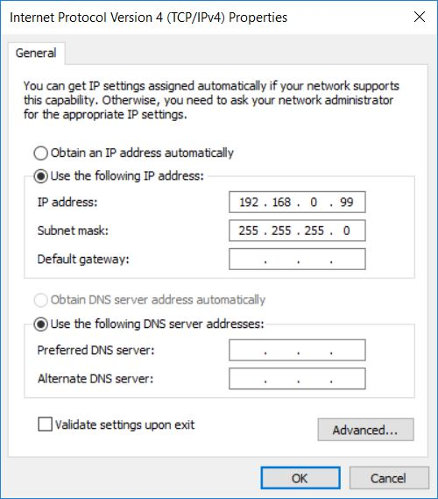

### Setting the IP address in the CPU

Before a firmware update of the CPU can be performed, set the IP address of the SIMATIC S7‑1200 correctly so that the programming device can reach the CPU via TCP (IP communication). The IP address of the SIMATIC S7-1200 is set as follows:

* Double-click the Totally Integrated Automation Portal to select it. (® TIA Portal V14)

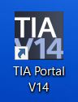

* Click → "Online&Diagnostics" and open → "Project view".

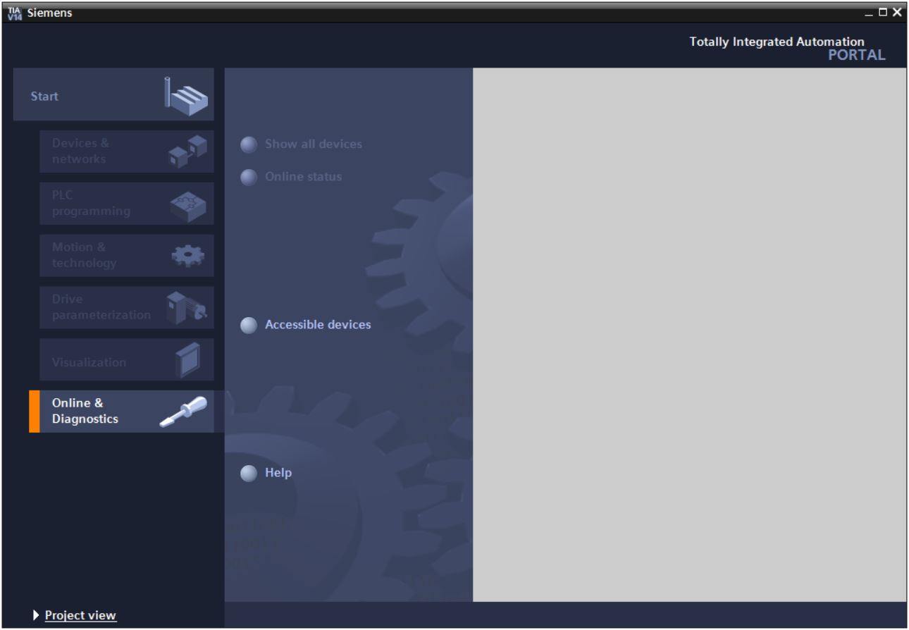

* In the project tree under → "Online access", select the network adapter that was set previously. If you click → "Update accessible devices", you will see the IP address (if previously set) or the MAC address (if IP address has not yet been assigned) of the connected SIMATIC S7-1200. Select → "Online&Diagnostics".

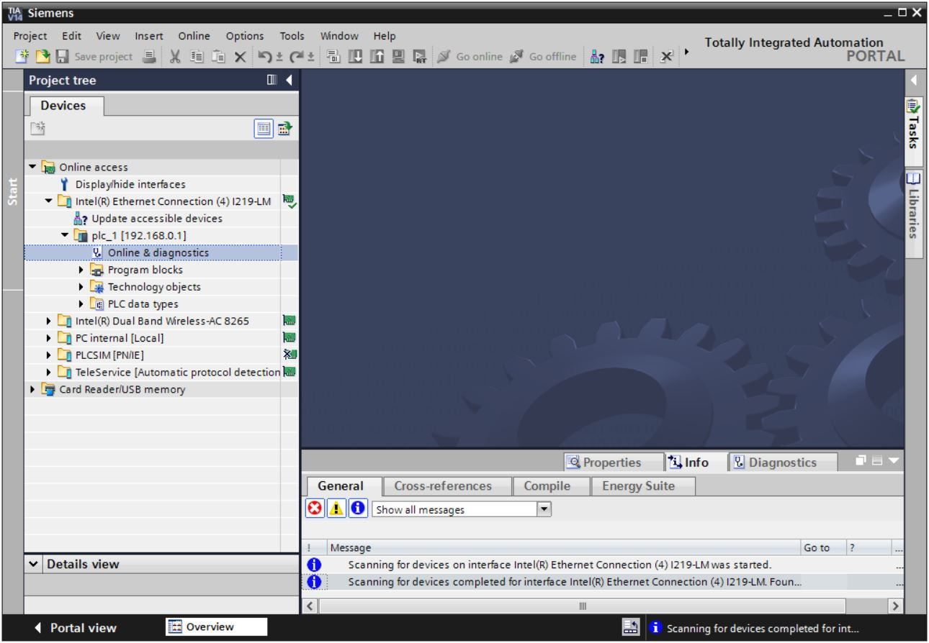

* Under → "Functions", you now find the → "Assign IP address" item. Enter the following IP address here (example): → IP address: 192.168.0.1 → Subnet mask 255.255.255.0. Click → "Assign IP address" and this new address will be assigned to your SIMATIC S7-1200.

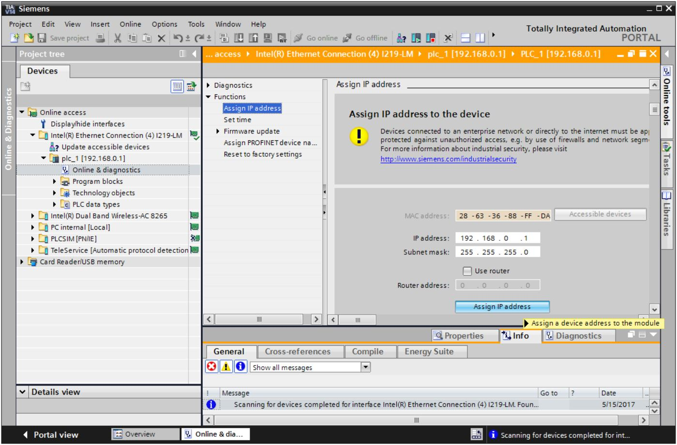

* If the IP address was not successfully assigned, you will receive a message in the → "Info" window under → "General".

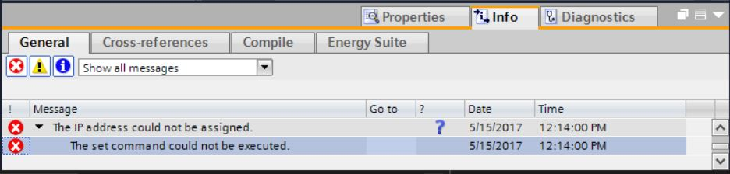

### Restoring the factory settings of the CPU

* If the IP address could not be assigned, the program data on the CPU must be deleted. This is done by resetting the CPU. To reset the controller, select the → "Reset to factory settings" function and then → "Delete IP address" and click → "Reset".

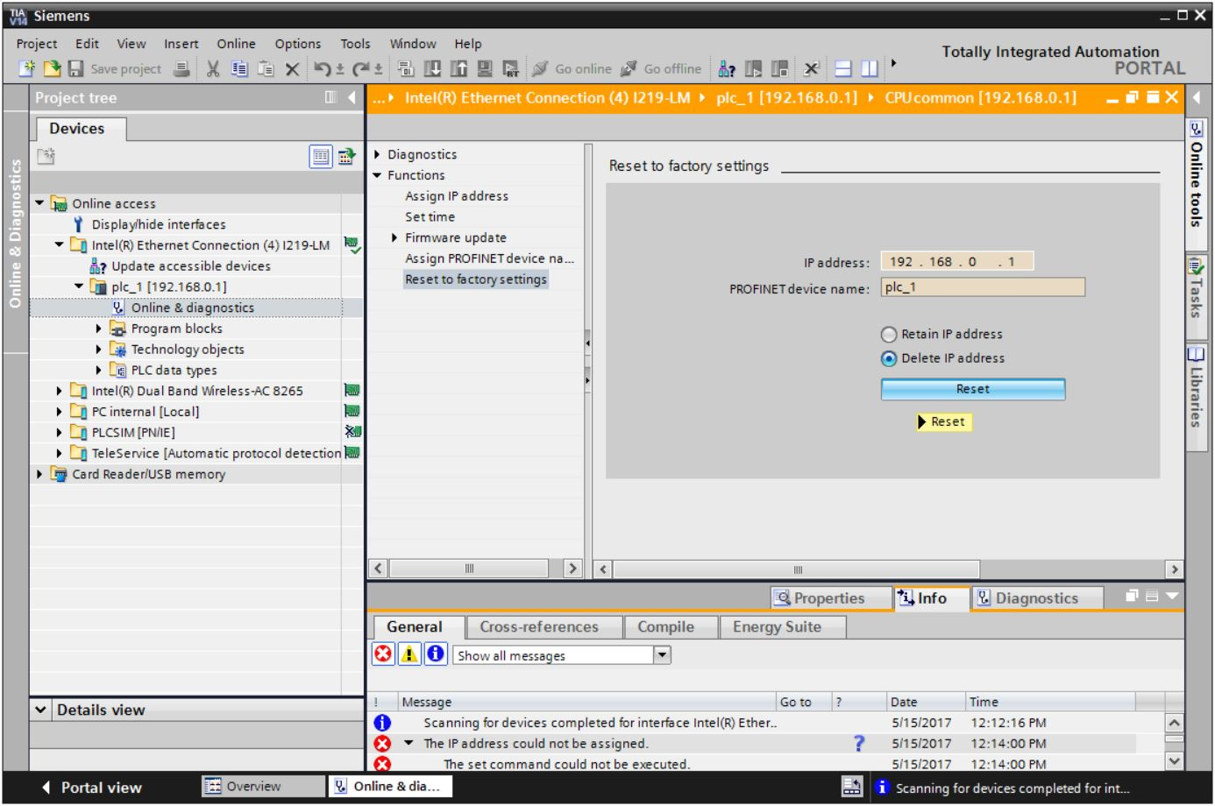

* Confirm the prompt asking if you really want to reset the module with → "Yes".

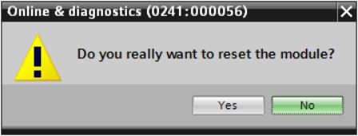

* If necessary, stop the CPU. (→ "Yes")

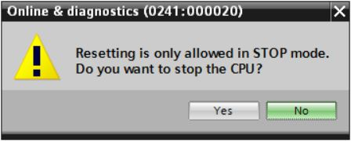

* Once the CPU has been reset, click → "Update accessible devices" again. The MAC address of the connected SIMATIC S7-1200 can now be seen. Select → "Online&Diagnostics" again. Select →"Assign IP address" under →"Functions". Enter the following IP address here (example): IP address: 192.168.0.1 Subnet mask 255.255.255.0. Click "Assign IP address" and this new address will be assigned to your SIMATIC S7-1200.

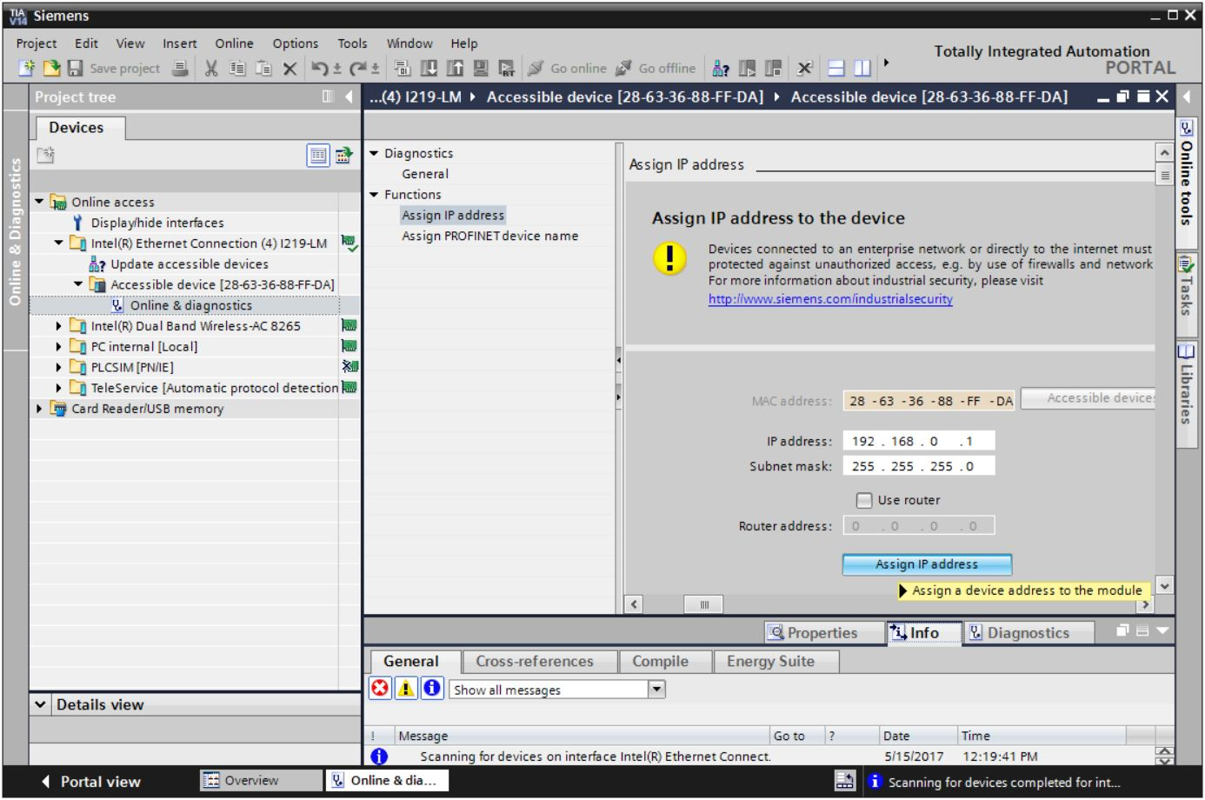

* You will receive a message regarding successful transfer of parameters in the → "Info" → "General" window.

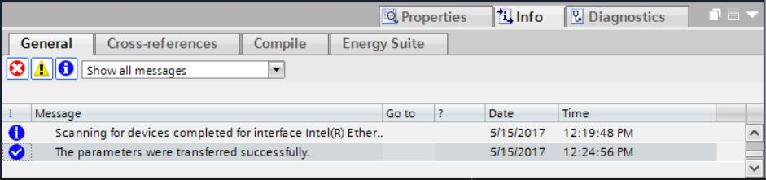

### Downloading a firmware update from the SIEMENS Support website

You can download current firmware updates free of charge from the Industry Online Support of SIEMENS AG.

* Open your choice of Internet browser and enter the address

→ [support.automation.siemens.com](http://support.automation.siemens.com/)

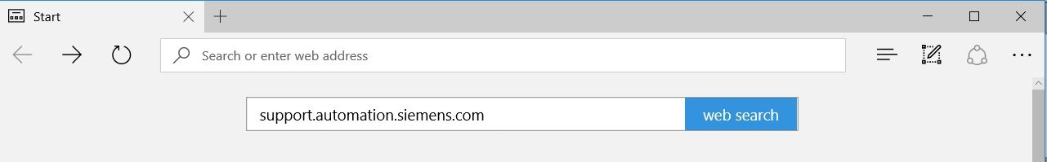

* Select your desired language → "Language" → "English".

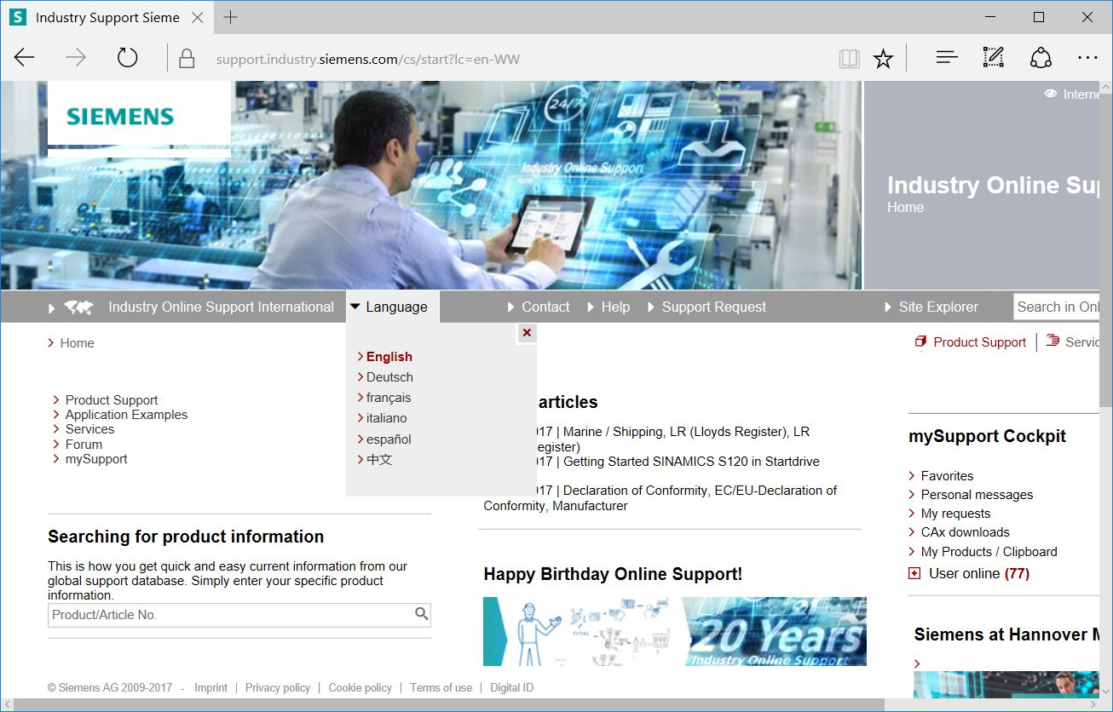

* In "Searching for product information", enter the CPU for which you need a firmware update. For example: → "S7-1200 CPU1214C"

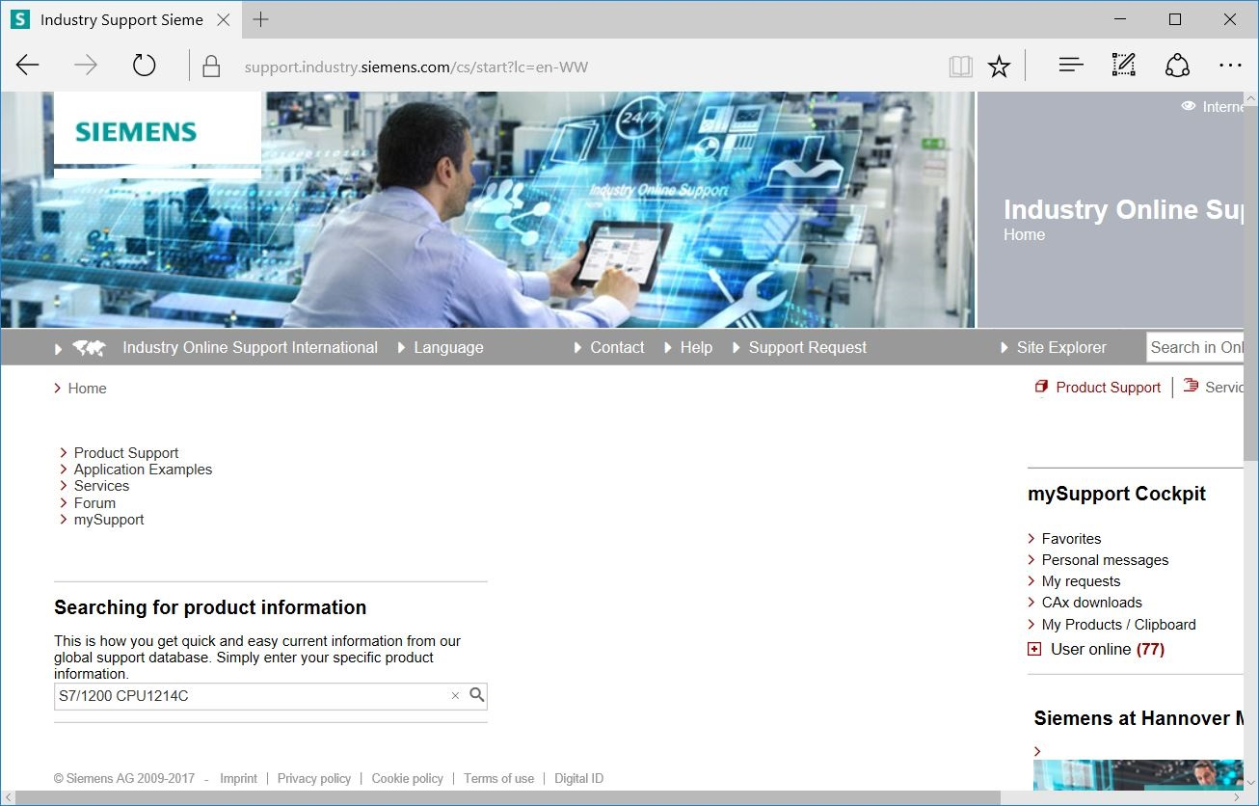

* Under "Filter criteria for entries" select the "Entry type" → "Download" and click the entry with firmware updates for your CPU in the selection list.

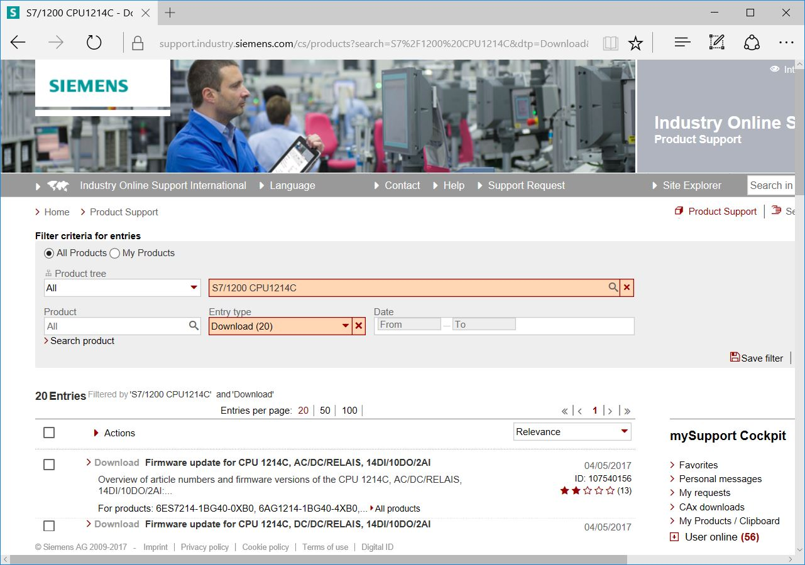

* Various updates are offered in the next window. Select the update recommended for the upgrade.

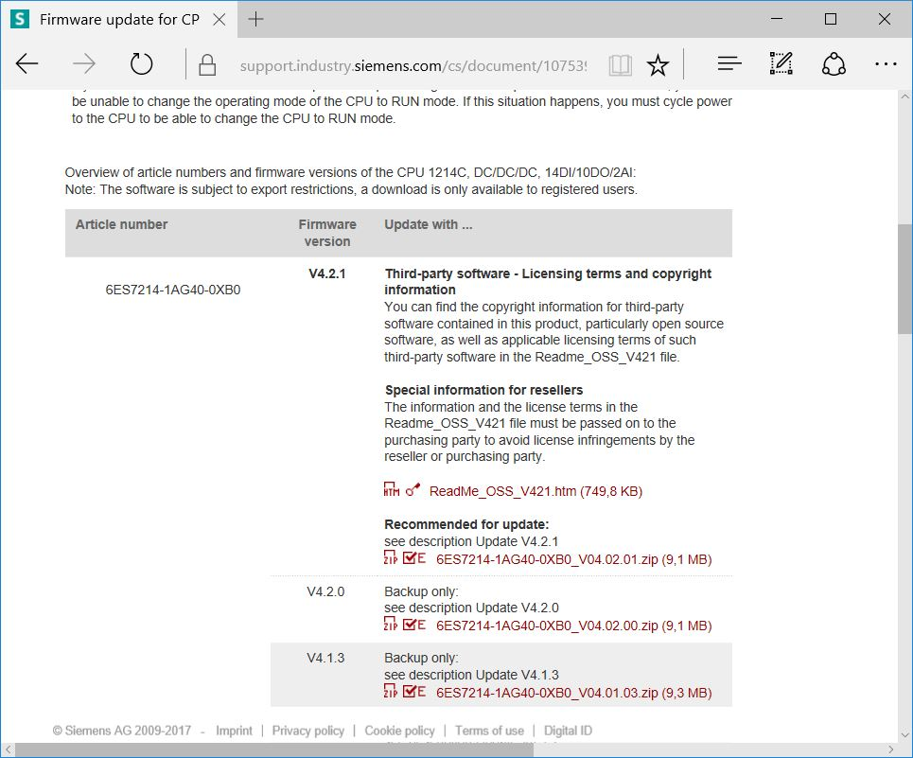

* If you have not already registered, do so in the next window. (→ "Yes I would like to register now"), or if already registered – log in with your "Login" and "Password". (→ "Login")

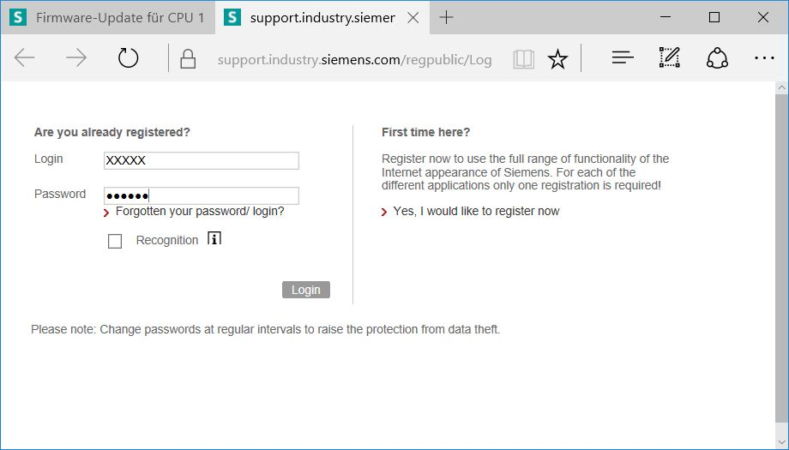

* Enter the requested data for the registration, select the option "Download of export restricted software" and then save the registration. (→  → "Save")

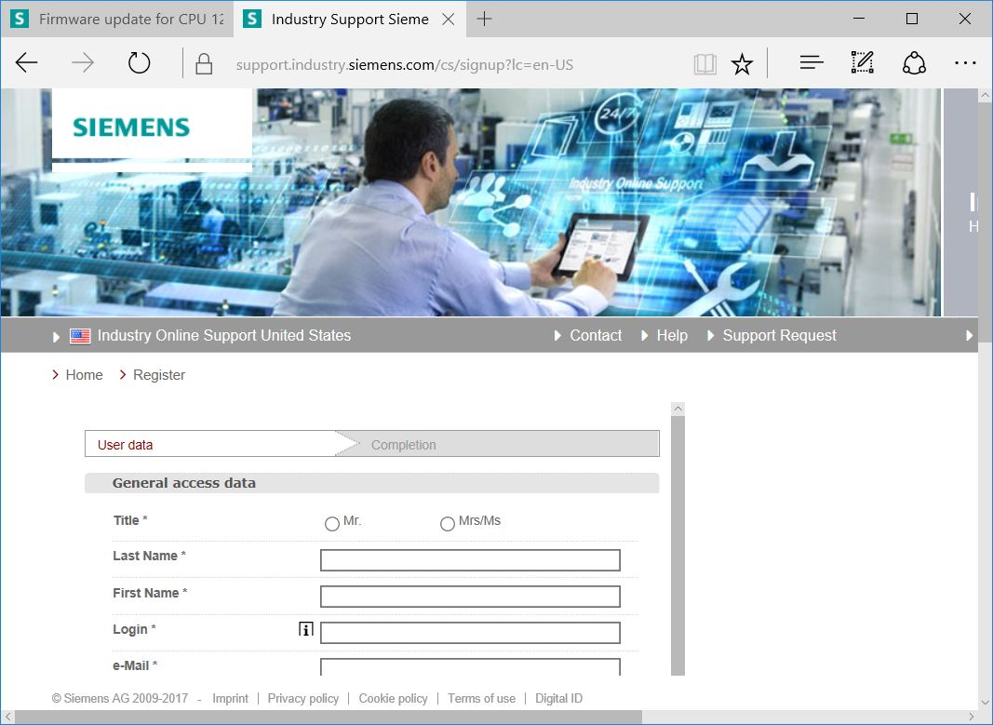

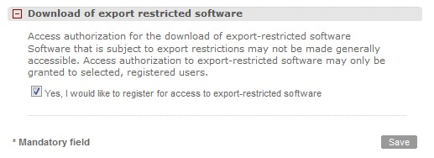

* Go back to the Login. After login, consent to the procedure for export-restricted software.   
  (→ I agree → "Next")

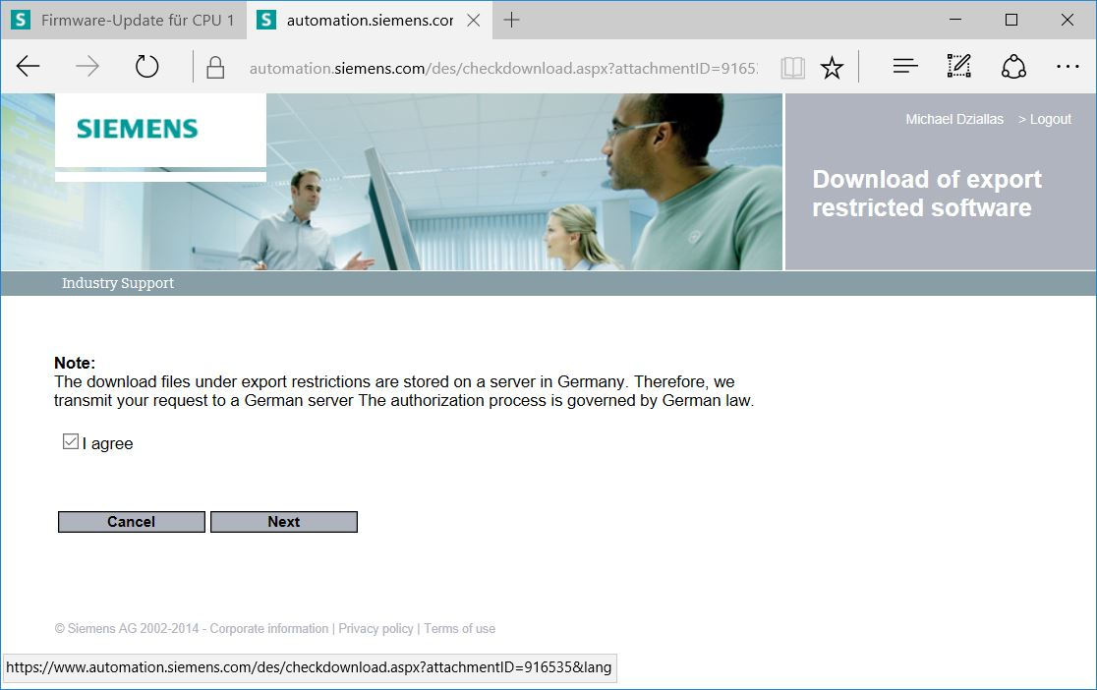

* Enter the requested data for "Download recipient" and "Final recipient".

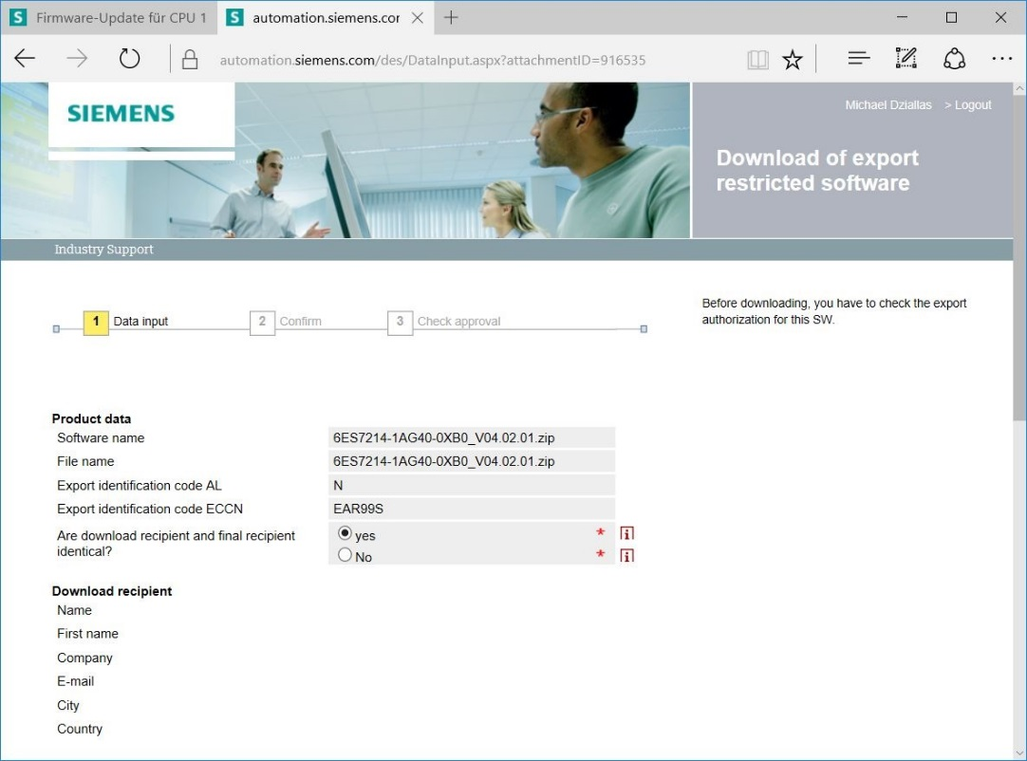

* Enter the requested data for use of the software. (→ "Next")

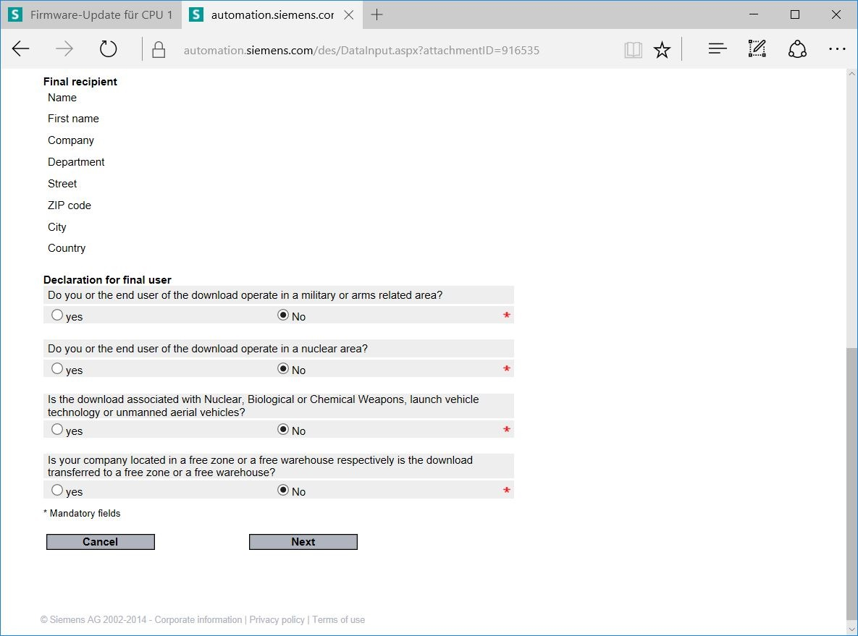

* Confirm that your inputs are correct and accept the export regulations. (→ "Next")

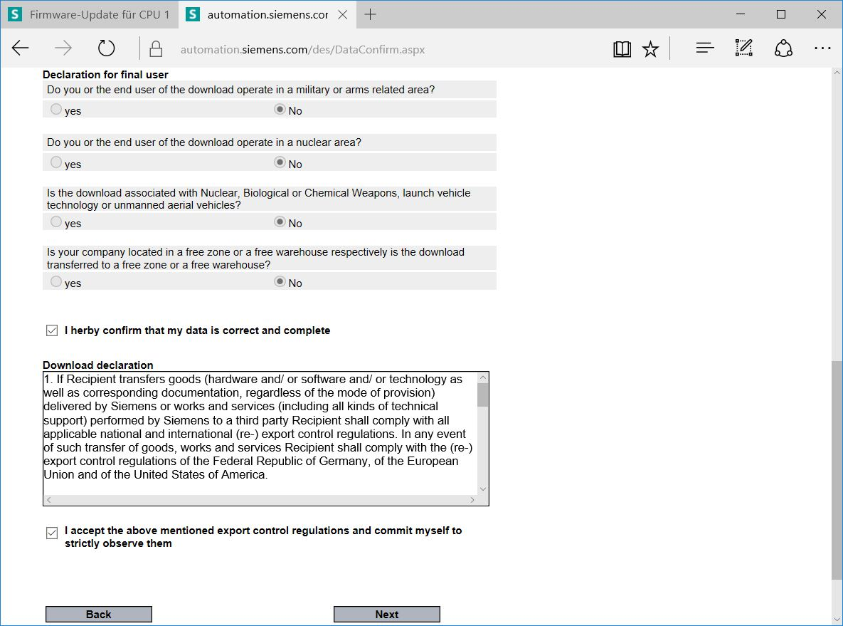

* Once you have received confirmation of the export release, you can save the firmware update on your computer. (→ "Save as")

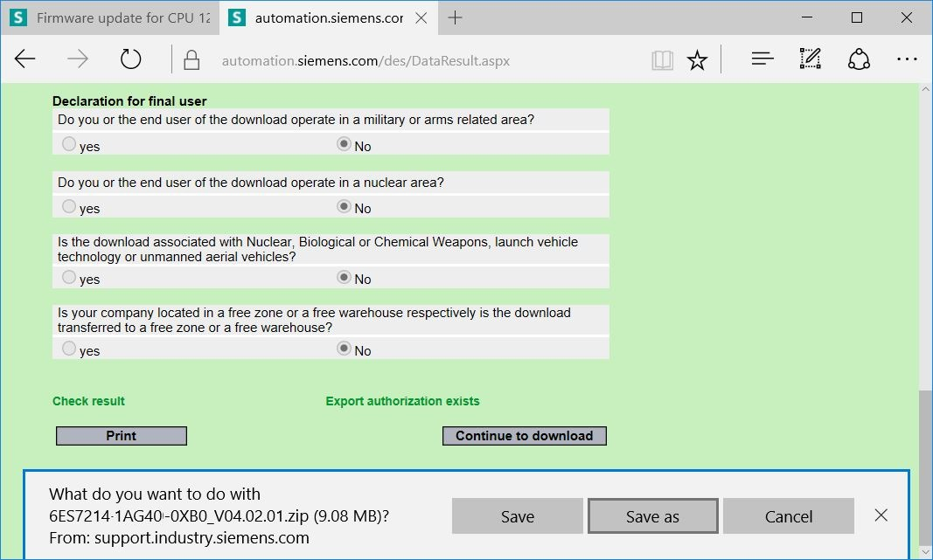

* Enter the desired memory location on your computer and click → "Save".

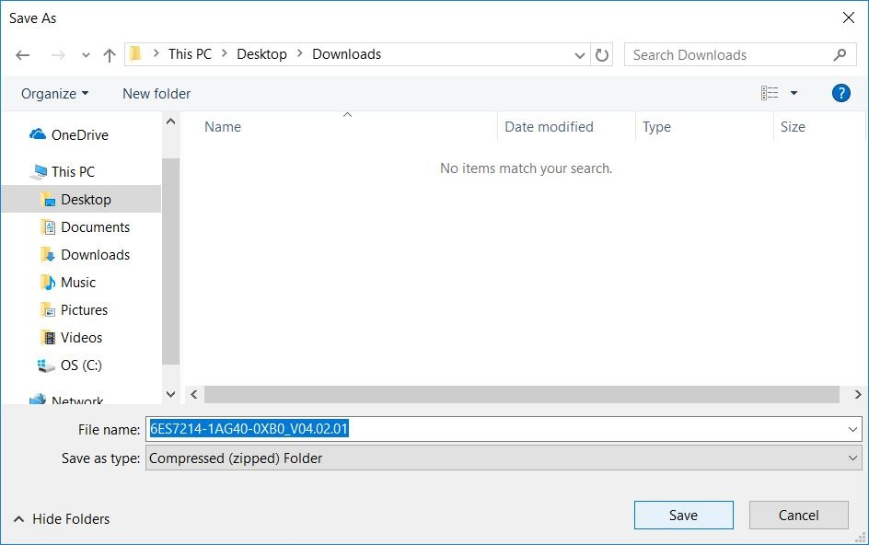

* Click the downloaded compressed file in Windows Explorer and select → "Extract All".

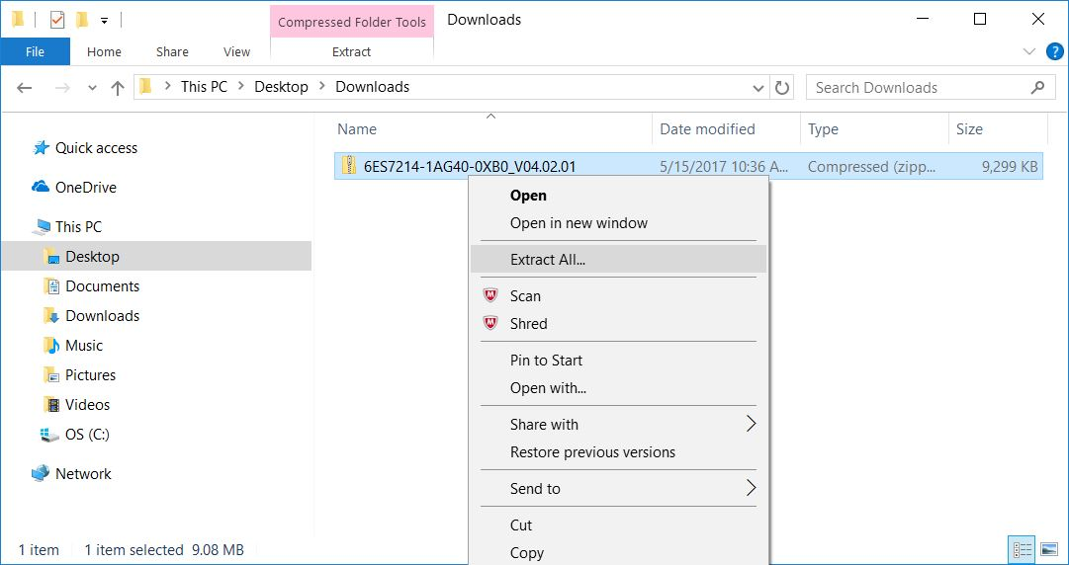

### Firmware update of the CPU

The files with the firmware update can be imported into the "SIMATIC S7-1200" CPU as follows.

* In the project tree under → "Online access", select the network adapter that was set previously. If you click → "Update accessible devices", you will see the IP address of the connected SIMATIC S7-1200. Select →"Online&Diagnostics". Under the "General" menu item, you can check the current firmware in your CPU in "Diagnostics".

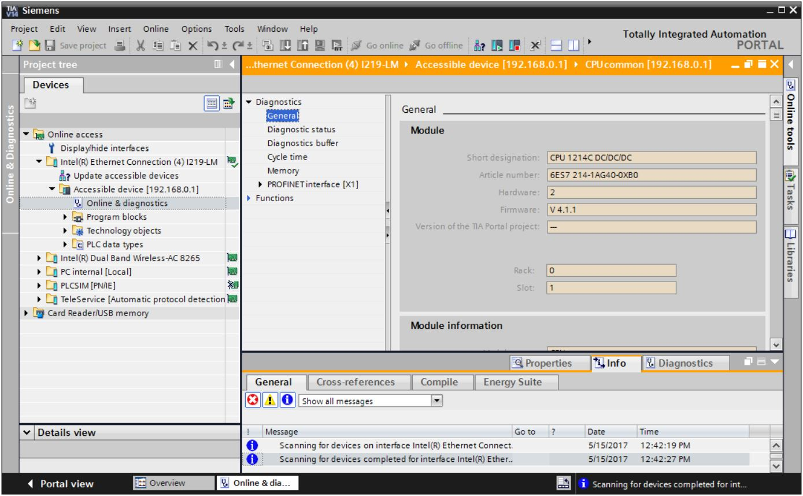

* In the → "Functions" menu, change to → "Firmware update" → "PLC". In the → "Firmware loader" sub-item, click → "Browse".

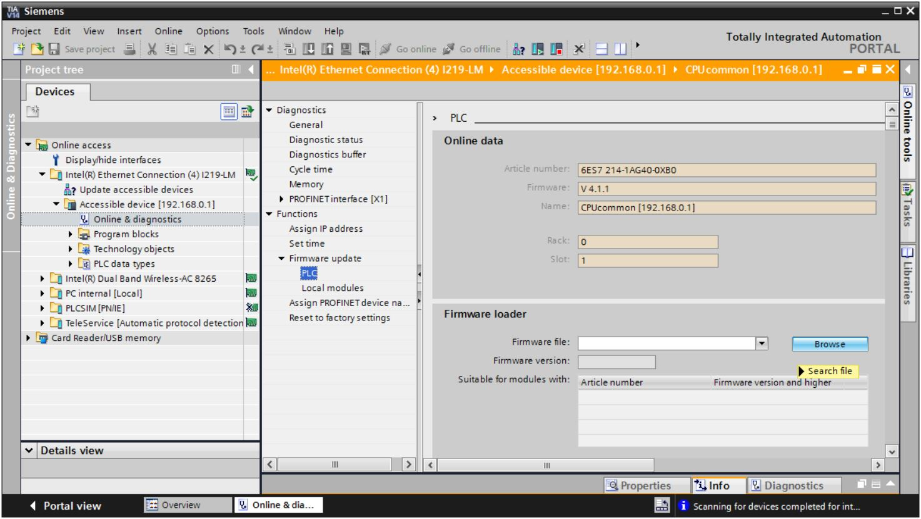

* Select the previously downloaded and extracted firmware file → "6ES7 ***-*****-****.upd" on your computer and click → "Open".

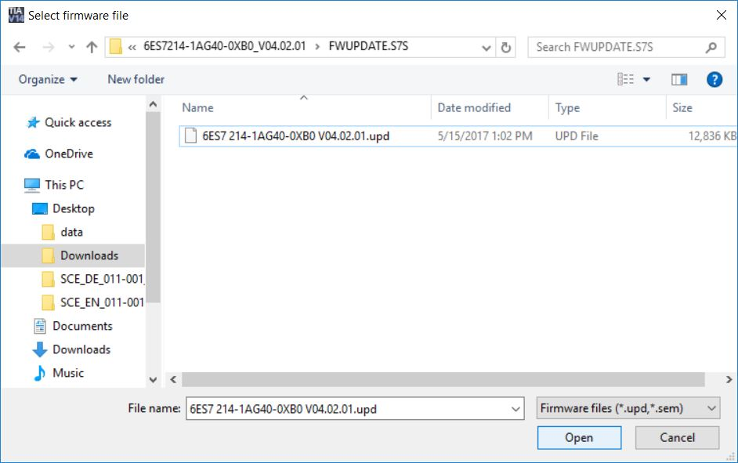

* The following dialog indicates whether your firmware file is compatible with your CPU.   
  Now start the update. (→ "Run update")

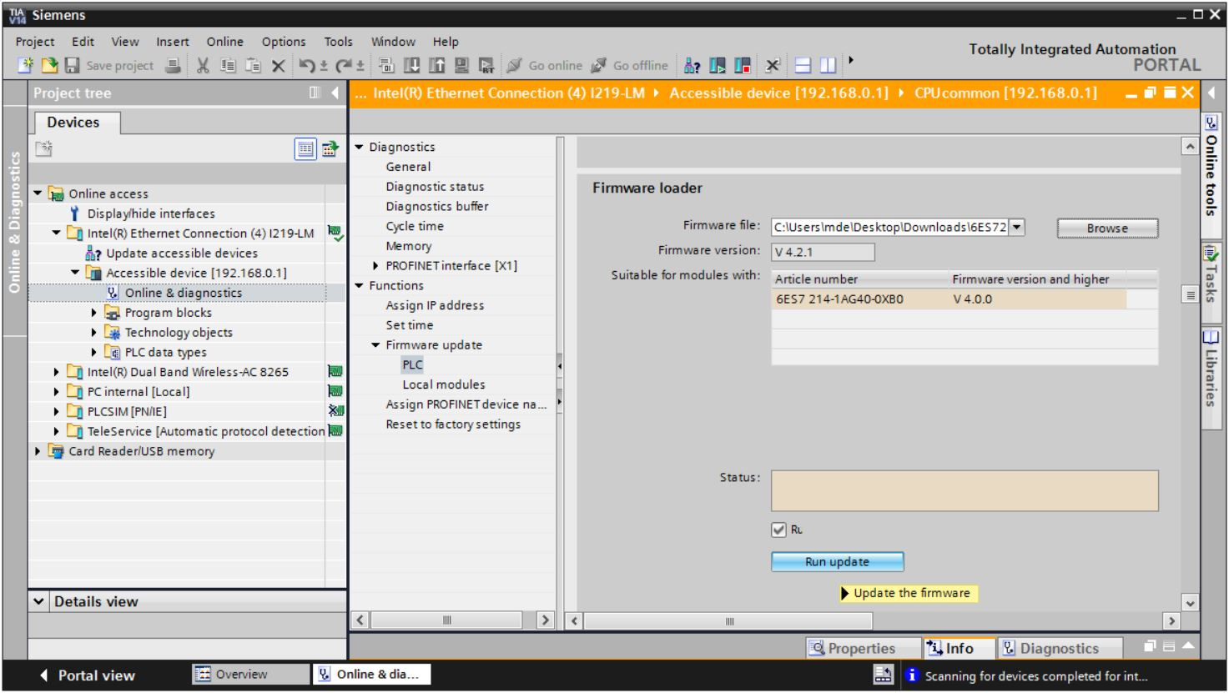

* The progress of the update and its successful completion are indicated with the following dialogs. Click → "OK" to confirm.

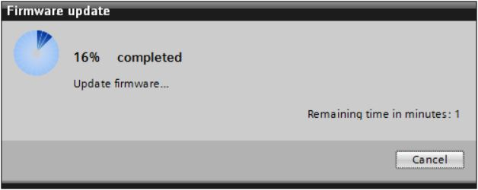

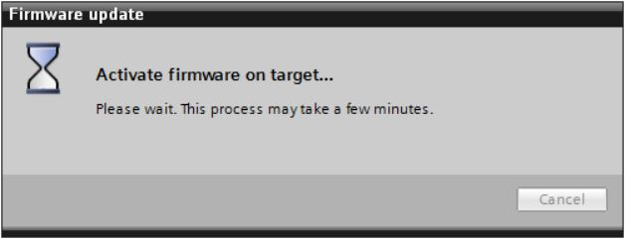

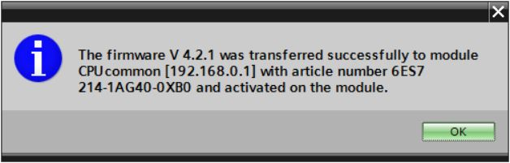

# Additional information

You can find additional information as an orientation aid for initial and advanced training, for example, Getting Started, videos, tutorials, apps, manuals, programming guidelines and trial software/firmware, at the following link:

[siemens.com/sce/s7-1200](http://www.siemens.com/sce/s7-1200)  
  
**Preview "Additional information"**

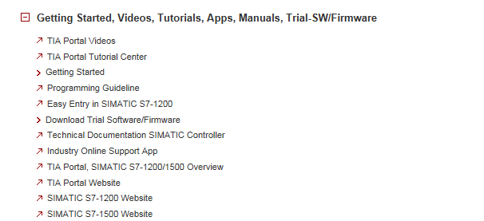

Further information

Siemens Automation Cooperates with Education  
**siemens.com/sce**

SCE Training Curriculums  
**siemens.com/sce/documents**

SCE Trainer Packages  
**siemens.com/sce/tp**

SCE Contact Partners   
**siemens.com/sce/contact**

Digital Enterprise  
**siemens.com/digital-enterprise**

Industrie 4.0   
**siemens.com/future-of-manufacturing**

Totally Integrated Automation (TIA)  
**siemens.com/tia**

TIA Portal  
**siemens.com/tia-portal**

SIMATIC Controller  
**siemens.com/controller**

SIMATIC Technical Documentation   
**siemens.com/simatic-docu**

Industry Online Support  
**support.industry.siemens.com**

Product catalogue and online ordering system Industry Mall   
**mall.industry.siemens.com**

Siemens AG  
Digital Factory   
P.O. Box 4848  
90026 Nuremberg  
Germany

Errors excepted and subject to change without prior notice.  
© Siemens AG 2018

**siemens.com/sce**