**Matching SCE Trainer Packages for these Learn/Training Document**

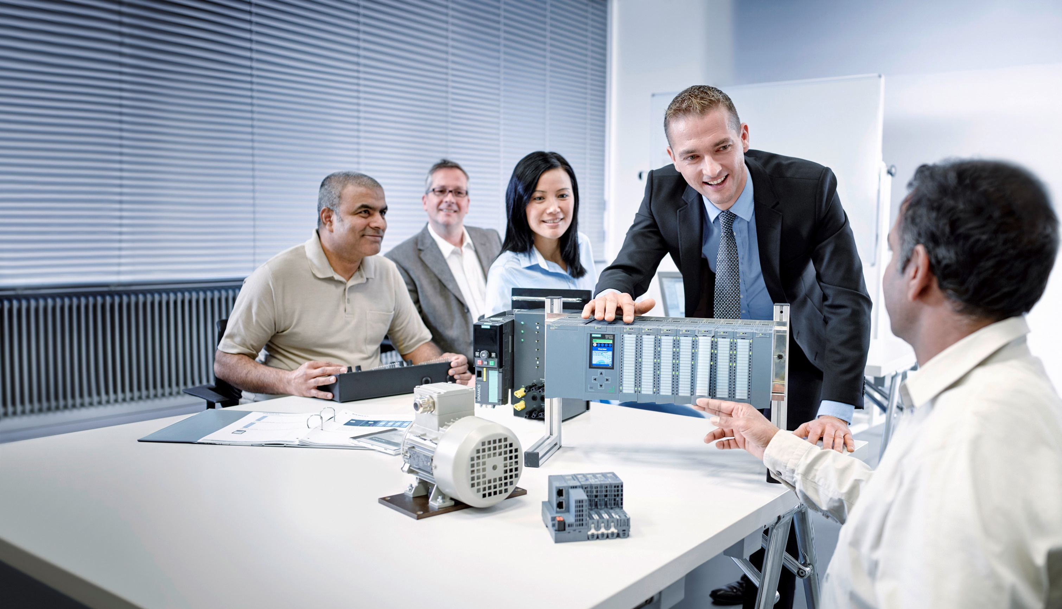

Learn-/Training Document  
  
Siemens Automation Cooperates with Education (SCE) | Version V15 and higher

**siemens.com/sce**

TIA Portal Module 014-101

Specific hardware configuration

with SIMATIC IOT2000EDU

* **SIMATIC IOT2020 with Intel Quark x1000, 512 MB RAM**  
  Order No.: 124-4037 Can be ordered from RS Components [rs-components.com](http://www.rs-components.com/)
* **SIMATIC IOT2040 with Intel Quark x1020 (+Secure Boot), 1 GB RAM**  
  Order No.: 6ES7647-0AA00-1YA2
* **SIMATIC IOT2000EDU Software Controller executable on IOT2020 and IOT2040**  
  Order No.: 6ES7671-0LE00-0YB0
* **SIMATIC IO-Shield: SIMATIC IOT2000 Input/Output Module with 5 DI, 2 DO, 2 AI, ARDUINO Shield for IOT2020/2040**  
  Order No.: 6ES7647-0KA01-0AA2
* **3rd Party IO-Shield: IKHDS Power Shield for IOT2020/2040 with 6 DI, 5 DO (RA), 1 DO (PWM), 2 AI, 1 AO**   
  [Order No.: 100301 Can be ordered from KAFTAN media UG kaftan-media.com/iot2000](http://www.kaftan-media.com/iot2000)

**SIMATIC STEP 7 Software for Training**

* **SIMATIC STEP 7 Professional V15 - Single license**

Order no.: 6ES7822-1AA05-4YA5

* **SIMATIC STEP 7 Professional V15 - Classroom license (up to 6 users)**

Order no.: 6ES7822-1BA05-4YA5

* **SIMATIC STEP 7 Professional V15 - Upgrade license (up to 6 users)**

Order no.: 6ES7822-1AA05-4YE5

* **SIMATIC STEP 7 Professional V15 - Student license (up to 20 users)**

Order no.: 6ES7822-1AC05-4YA5

Note that these products and trainer packages are replaced with successor packages when necessary.

You can find an overview of the currently available SCE packages at:[siemens.com/sce/tp](http://www.siemens.com/tp)

**Continued education**

For regional Siemens SCE continued education, get in touch with your regional SCE contact:

[siemens.com/sce/contact](http://www.siemens.de/contact)

**Additional information regarding SCE**

[siemens.com/sce](http://www.siemens.com/sce)  
  
  
**Information regarding use**

The SCE Learn-/Training Document for the integrated automation solution Totally Integrated Automation (TIA) was prepared for the program "Siemens Automation Cooperates with Education (SCE)" specifically for training purposes for public educational facilities and R&D institutions. Siemens AG does not guarantee the contents.

This document is to be used only for initial training on Siemens products/systems, which means it can be copied in whole or part and given to those being trained for use within the scope of their training. Circulation or copying this Learn-/Training Document and sharing its content is permitted within public training and advanced training facilities for training purposes.

Exceptions require written consent from the Siemens AG contact person: Roland Scheuerer roland.scheuerer@siemens.com.

Offenders will be held liable. All rights including translation are reserved, particularly if a patent is granted or a utility model or design is registered.

Use for industrial customer courses is explicitly not permitted. We do not consent to commercial use of the Learn-/Training Document.

We would like to thank Michael Dziallas Engineering and all those involved for their support in creating this SCE Learn-/Training Document.

**Table of contents**

[1 Objective 5](#_Toc516483821)

[2 Requirement 5](#_Toc516483822)

[3 Hardware and software required 6](#_Toc516483823)

[4 Theory 7](#_Toc516483824)

[4.1 SIMATIC IOT2000 7](#_Toc516483825)

[4.1.1 Range of modules 8](#_Toc516483826)

[4.2 Control and display elements of the IOT2040 9](#_Toc516483827)

[4.2.1 Top side of the IOT2040 9](#_Toc516483828)

[4.2.2 Front side of the IOT2040 9](#_Toc516483829)

[4.2.3 Bottom side of the IOT2040 10](#_Toc516483830)

[4.2.4 Micro SD card 10](#_Toc516483831)

[4.2.5 LED display 11](#_Toc516483832)

[4.3 Commissioning of the IOT2000 12](#_Toc516483833)

[4.3.1 Creating the SD card 13](#_Toc516483834)

[4.3.2 Setting the IP address of the engineering station 16](#_Toc516483835)

[4.3.3 Establishing an SSH connection 19](#_Toc516483836)

[4.3.4 Establishing the SCP/SFTP connection for the file transfer 21](#_Toc516483837)

[4.3.5 Setting the IP address using iot2000setup 23](#_Toc516483838)

[4.3.6 Setting the IP address using /etc/network/interfaces 26](#_Toc516483839)

[4.4 IOT2000EDU Runtime 29](#_Toc516483840)

[4.4.1 Installation 29](#_Toc516483841)

[4.4.2 Autostart 32](#_Toc516483842)

[4.4.3 Basic configuration 34](#_Toc516483843)

[4.4.4 Adaptation of the configuration (optional) 36](#_Toc516483844)

[4.5 Programming software STEP 7 Professional V15 (TIA Portal V15) 39](#_Toc516483845)

[4.5.1 Project 39](#_Toc516483846)

[4.5.2 Hardware configuration 39](#_Toc516483847)

[4.5.3 Planning the hardware 40](#_Toc516483848)

[4.5.4 TIA Portal – Project view and portal view 41](#_Toc516483849)

[4.5.5 Basic settings for the TIA Portal 43](#_Toc516483850)

[4.5.6 Installation of the Hardware Support Package 45](#_Toc516483851)

[5 Task 48](#_Toc516483852)

[6 Planning 48](#_Toc516483853)

[7 Structured step-by-step instructions 49](#_Toc516483854)

[7.1 Creating a new project 49](#_Toc516483855)

[7.2 Inserting the SIMATIC IOT2000EDU Runtime 50](#_Toc516483856)

[7.3 Configuration of Ethernet interface of the IOT2000 54](#_Toc516483857)

[7.4 Saving and compiling the hardware configuration 56](#_Toc516483858)

[7.5 Downloading the hardware configuration to the device 57](#_Toc516483859)

[7.6 Downloading the hardware configuration to the PLCSIM simulation (optional) 63](#_Toc516483860)

[7.7 Archiving the project 67](#_Toc516483861)

[7.8 Checklist 68](#_Toc516483862)

[8 Additional information 69](#_Toc516483863)

Specific hardware configuration –

SIMATIC IOT2000

# Objective

In this section you first learn how to set up the IOT2000 and to prepare the TIA Portal for the IOT2000. Then, a project is created and the hardware is configured.

# Requirement

Nothing is required from other chapters to successfully complete this chapter.

You only need an IOT2000 (here IOT2040) with the SIMATIC IOT2000EDU Software Controller executable on IOT2020 and IOT2040, a MicroSD Card and an IO-Shield.

Additionally, you need a PC with the STEP 7 Professional V15 (TIA Portal V15) software and a few freely available tools that are explained in the course of the document.

# Hardware and software required

1 Engineering Station: Requirements are hardware and operating system   
(for additional information, see Readme on the TIA Portal Installation DVDs)

2 SIMATIC STEP 7 Professional software in TIA Portal V15 or higher

3 Software for writing the example image on the SD card, e.g. Win32 Disk Imager

4 Software for SSH access, e.g. PuTTY

5 Software for SFTP/SCP file transfer, e.g. WinSCP

6 SIMATIC IOT2000 controller, e.g. IOT2040 with MicroSD Card and IO-Shield

7 Ethernet connection between the engineering station and controller

8 SIMATIC IOT2000EDU Software Controller executable on IOT2020 and IOT2040

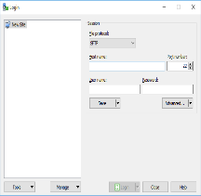

**5** WinSCP

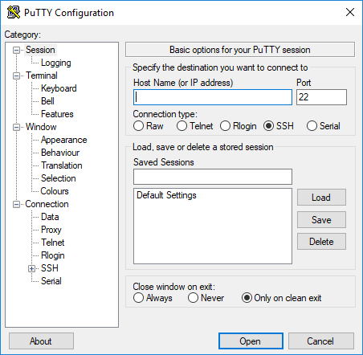

**4** PuTTY

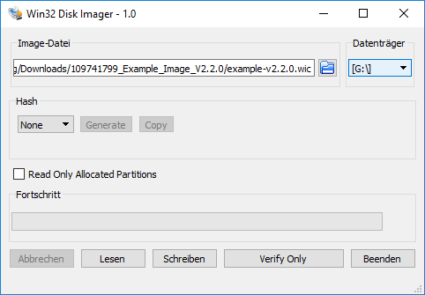

**3** Win32 Disk Imager



**1** Engineering station

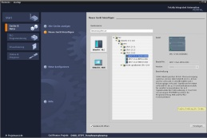

**2** SIMATIC STEP 7 Professional   
(TIA Portal) V15 or higher

**7** Ethernet connection

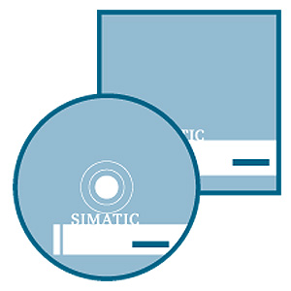

**8** SIMATIC IOT2000EDU   
Software Controller

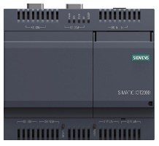

**6** SIMATIC IOT2000 Controller

# 

# Theory

## SIMATIC IOT2000

SIMATIC IOT2000 is a micro PC system based on Intel X1000 SoC (System on Chip). IOT2000 uses the Linux operating system, which can be oriented to individual requirements with the help of the Yocto project.

In addition, it provides an Arduino UNO-compatible header for optimal adaptation to its application.

The so-called GPIOs (General Purpose Input/Outputs), which are accessible from the outside with the help of the header, can be programmed and used in many different ways, e.g. Java or C++, but also using the TIA Portal.

This module teaches you step-by-step how to program the IOT2000 with the TIA Portal. The TIA Portal programming is described in the following sections.

### Range of modules

SIMATIC IOT2000 is available in two different versions, which differ in the interfaces present. IOT2020 provides only one Ethernet interface and two USB interfaces as external interfaces, while IOT2040 provides an additional Ethernet interface and two additional COM ports.

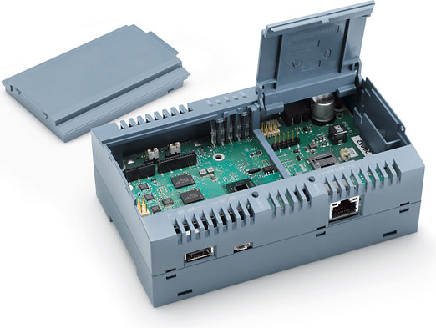

An Arduino UNO-compatible header is available in each version and can be used to put any Arduino shields into operation. The option also exists to develop and use your own shields.

The programming is different, depending on the shield. The TIA Portal is only able to use the individual GPIOs (General Purpose Input/Outputs) as pure digital and analog inputs and outputs. Higher functions, such as I²C (Inter-Integrated Circuit) or SPI (Serial Peripheral Interface), are not usable.

A MicroSD card is needed for the operating system. The "Operating system from Siemens" needs a minimum of 2 GB.

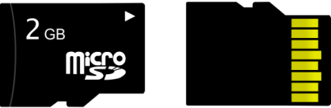

## Control and display elements of the IOT2040

### Top side of the IOT2040

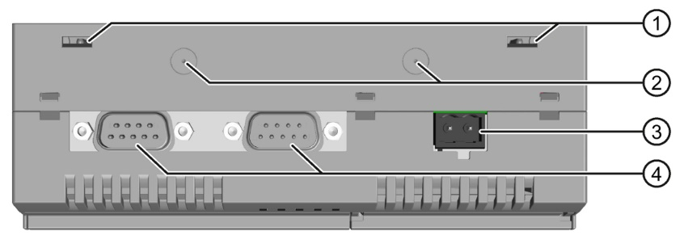

1) Openings for push-in lugs for wall mounting

2) Markings for installation of antennas

3) Connection for the power supply (24 V)

4) COM interfaces (RS232/422/485)

### Front side of the IOT2040

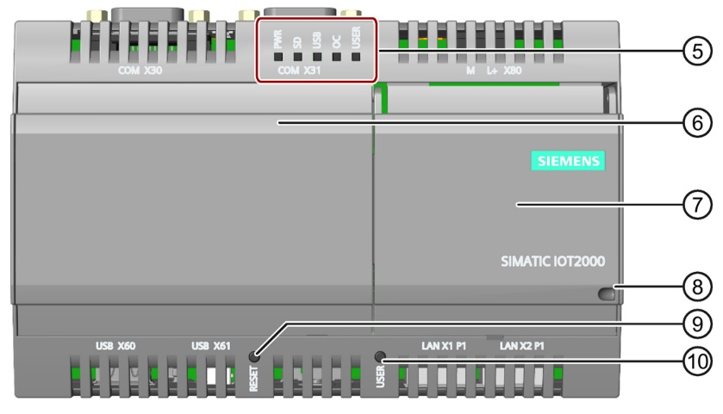

5) LED display

6) Left cover

7) Right cover

8) Securing device

9) RESET button for the CPU

10) USER button, programmable (not via the TIA Portal)

### Bottom side of the IOT2040

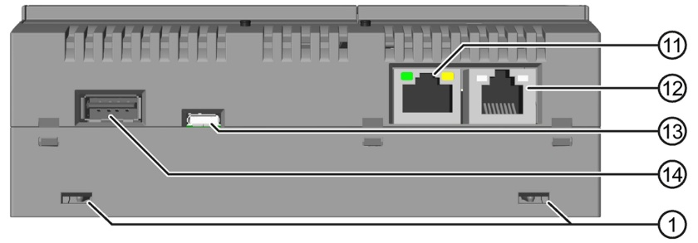

11) Ethernet interface 10/100 Mbps

12) Ethernet interface 10/100 Mbps, prepared for PoE (Power over Ethernet)

13) USB type Micro-B

14) USB type A

### Micro SD card

The **micro SD card** keeps the operating system at the ready and provides space for programs and data. Any **micro SD card** can be used here. Without a card with a compatible system, the IOT2000 is not executable.

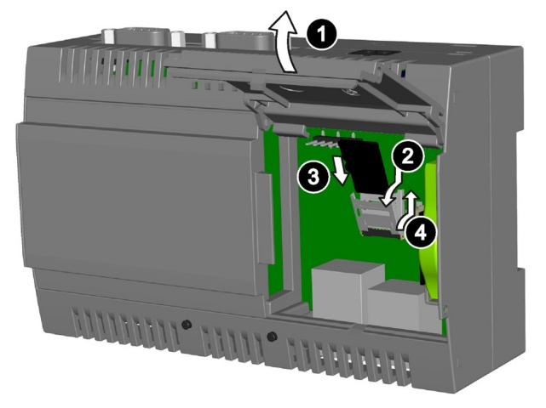1) Open the right cover.

2) Carefully press down the micro SD bracket   
 and fold it forward.

3) Slide the micro SD card with correct   
 orientation into the bracket frame. The   
 contacts of the micro SD card must   
 point in the direction of the motherboard.

4) Fold back the bracket frame and   
 carefully push the frame upward until it   
 engages.

### LED display

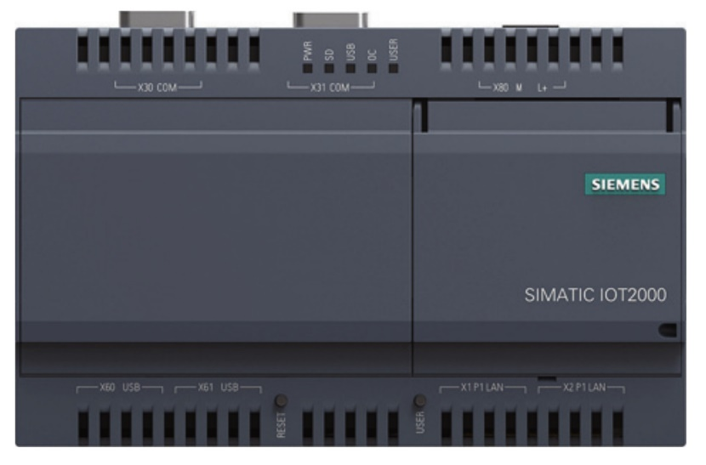

LED displays

The LEDs on the front side of the device indicate the operating state:

* The PWR (green) LED indicates whether the system is supplied with voltage.
* The SD (green) LED indicates accesses to the SD card.
* The USB (green) LED indicates whether 5 V is available for the USB port
* The OC (red) LED lights up if the supply voltage is too high
* The USER (green/red/orange) LED can be programmed via the operating system   
  (not via the TIA Portal)

## Commissioning of the IOT2000

Before you can start programming the IOT2000 via the TIA Portal, it must be commissioned. You can also follow the device instructions for commissioning the hardware (see Document ID: [A5E37656491-AB](https://support.industry.siemens.com/cs/document/109741658)).

The installation of the needed software is described in the following steps. The following things are needed on the *engineering station* for this:

* SD card reader and micro SD to SD adapter or micro SD card reader
* SIMATIC IOT2000 SD card example image (*109741799\_Example\_Image\_V2.2.0.zip*):  
  <https://support.industry.siemens.com/cs/document/109741799>
* Tool for writing the example image to the SD card, e.g. Win32 Disk Imager:  
  <https://sourceforge.net/projects/win32diskimager>
* SSH client, e.g. PuTTY:  
  <https://www.chiark.greenend.org.uk/~sgtatham/putty/latest.html>
* SCP/SFTP client, e.g. WinSCP:  
  <https://winscp.net/eng/downloads.php>

**Note:** The required software should also be available on each website as a portable version. These versions require no software installation.

### Creating the SD card

The *example image* must be unpacked and written to the *SD card* with the help of the *Win32 Disk Imager.*

* Connect the *SD card* to the computer or insert it into the SD card reader.
* Unpack the example image *"109741799\_Example\_Image\_V2.2.0.zip"* via the shortcut menu and "Extract All…" (→ Extract All…)

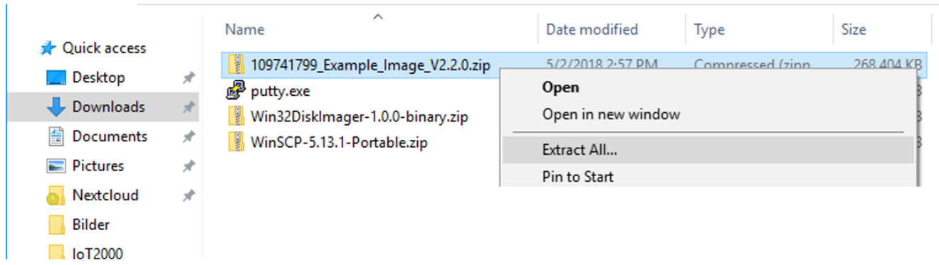

* Select a destination path and click "Extract" (→ Extract)

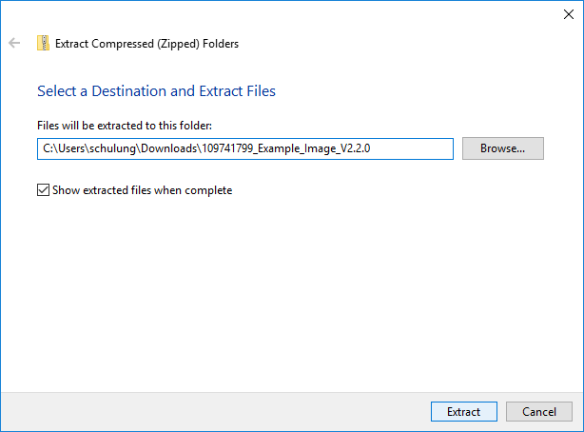

* Start *Win32 Disk Imager*

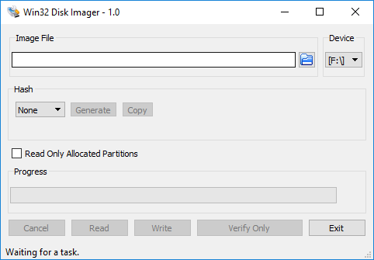

* For the *Image File,* select the example image "*example-v2.2.0.wic"* you just unpacked. Be sure to select the file type "*\*.\**"

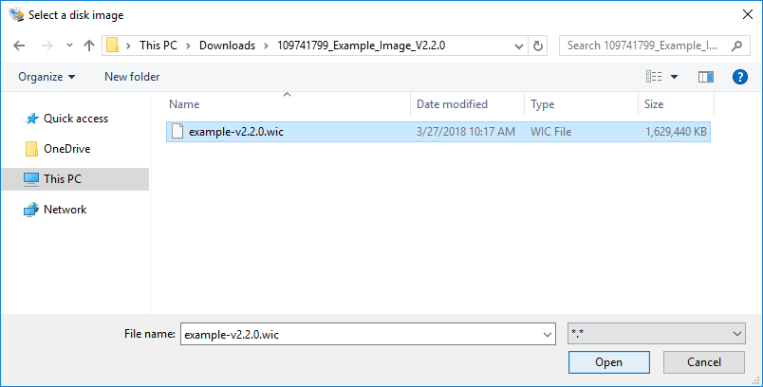

* Select the device, making sure that it is the micro SD card. Then click on "Write".

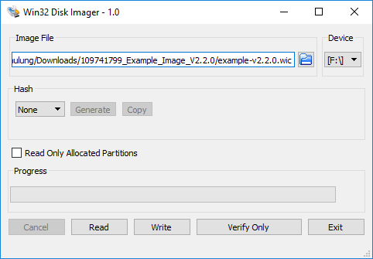

* Read the warning and confirm it with "Yes":

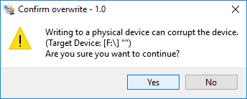

* Close the *Win32 Disk Imager* after the successful write operation.
* Disconnect the SD card from the computer and insert it into the – disconnected from the voltage source – IOT2000.

**Note:** The SD card has now been divided into two partitions by the image. Windows can read only the first of these partitions. Both partitions should no longer be opened with Windows if possible.

* Reconnect the IOT2000 to the voltage supply.

### Setting the IP address of the engineering station

Now that the SD card has been written with the operating system and inserted in the IOT2000, the operating system can be configured. This is done using an SSH connection. The example image has a preconfigured IP address: **192.168.200.1/24\*.**

For the PC and SIMATIC IOT2000 to communicate with one another via IP, it is important that the IP addresses of both devices match.

First, it is shown here how the IP address of a PC can be set with the Windows 10 operating system.

* Locate the network icon  in the task bar at the bottom and click on → "Network & Internet settings".

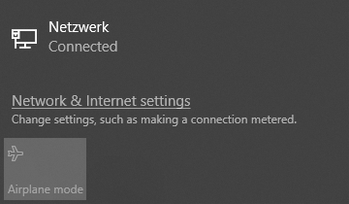

* In the Network settings window that opens, click on → "Change adapter options".

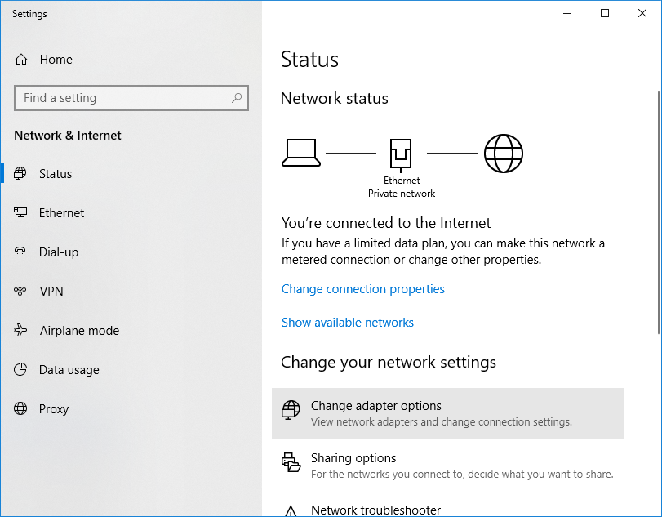

**Note:** The notation **192.168.200.1/24\*** contains information for the IP address and for the subnet mask 255.255.255.0 with 24 bits to 1.

* Select the desired → "LAN connection" you want to use to connect to the controller and click → "Properties".

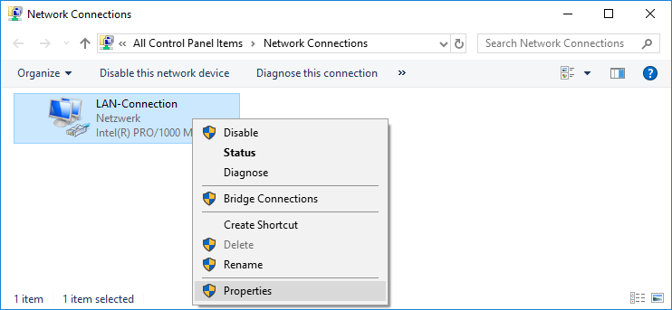

* Select → "Properties" under → "Internet Protocol Version 4 (TCP/IP)".

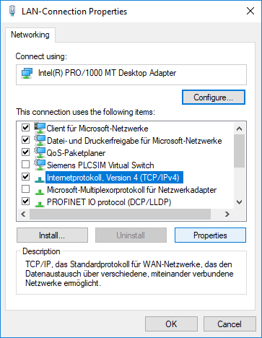

* You can now use the following IP address, for example, → IP address: 192.168.200.99 → Subnet mask 255.255.255.0 and accept the settings (→ "OK")

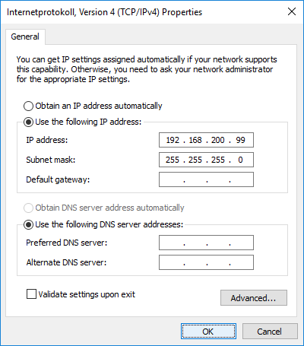

### Establishing an SSH connection

Now that the programming device has an IP address in the preconfigured subnet of the IOT2000 (192.168.200.1/24), it should be possible to establish a Secure Shell (SSH) connection. This is needed to perform the next steps.

**Important:** Unlike the Windows command line, the shell of the Linux system is case-sensitive. In addition, there are no drives with letters (C:\ or D:\). Instead, there is just the root directory whose file path is "/". All directories and path information are separated from one another with a forward slash "/". The backward slash "\" used for paths under Windows is an escape character and, in most cases, has undesired consequences in commands.

* Start **PuTTY**
* Under **Host Name (or IP address)**, enter the **IP** and the **Port** of the **IOT2000** ( → Host Name: 192.168.200.1 → Port: 22)
* Select the **SSH** item under **Connection type** ( → Connection type: SSH)

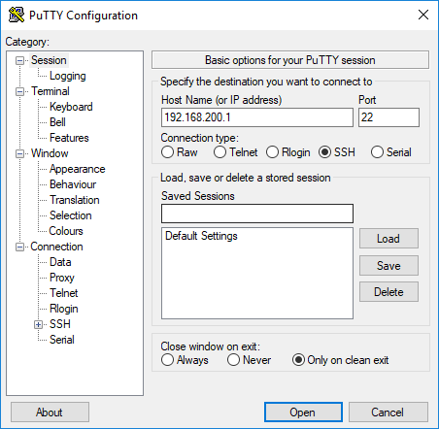

**Note:** The notation **192.168.200.1/24\*** contains information for the IP address and for the subnet mask 255.255.255.0 with 24 bits to 1.

* Click on **Open** ( → Open)
* Confirm the fingerprint of the IOT2000 with **Yes** ( → Yes)

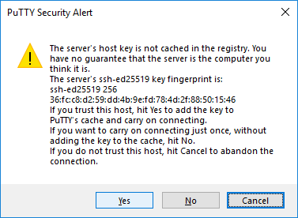

**Note:** Like in the case of an HTTPS connection, the identity of the partner is checked in the SSH connection. This is done using the fingerprints of the SSH key. If a connection to a partner (IP or host name) is being established for the first time, the fingerprint must be manually confirmed and thus cached. In this way it is ensured that the connection partner is not an unknown third party (attacker).

* Enter the user name **root** for the **login** and confirm the entry with **ENTER** ( → Login as: root, → Enter )

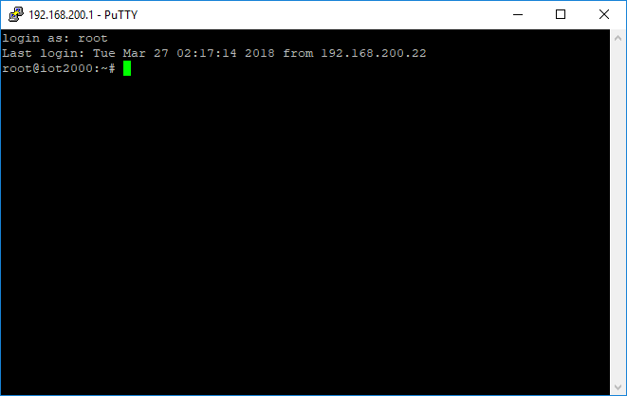

### Establishing the SCP/SFTP connection for the file transfer

To transfer files from the local programming device to the IOT2000, the SSH connection is also used. Here, there are programs that can transmit and receive with SCP and SFTP files via the SSH connection. WinSCP is used in the next steps.

* Start **WinSCP**

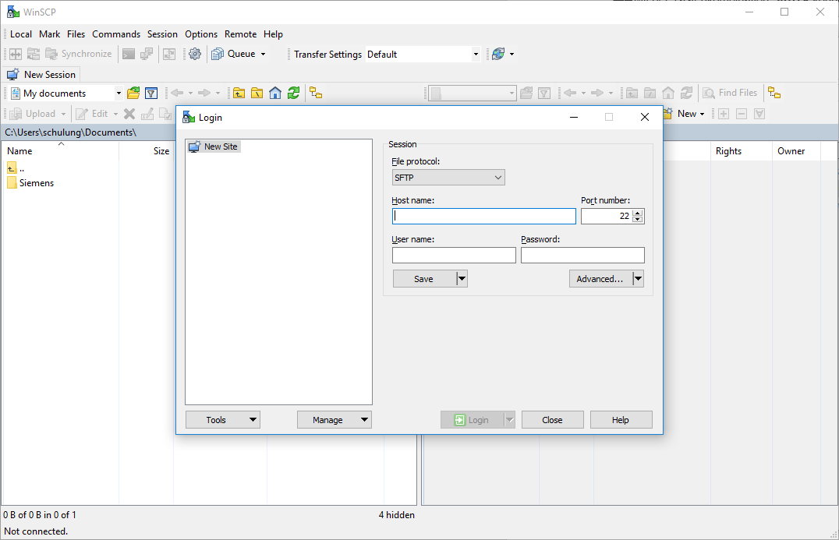

* Enter the **IP** and the **Port** of the **IOT2000** ( → Host Name: 192.168.200.1 → Port: 22).
* Enter the user name **root** under **User name** ( → User name: root).
* Leave the **Password** field empty.

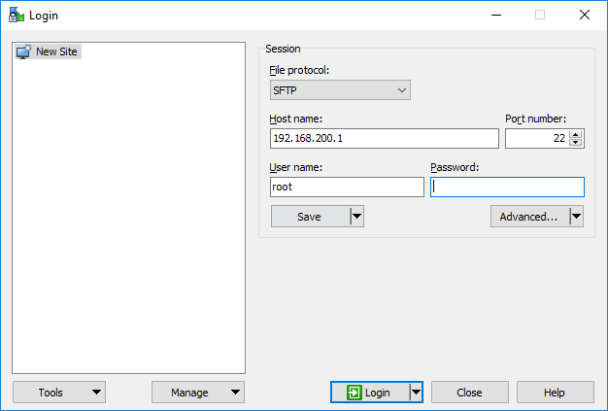

* Click **Login** ( → Login)
* Confirm the fingerprint of the IOT2000 ( → Yes)

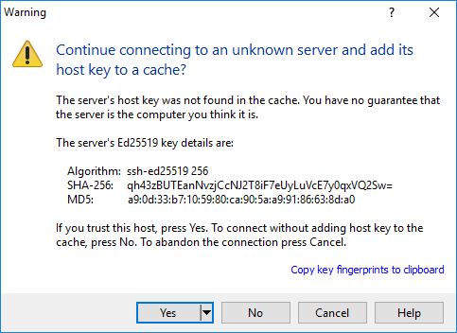

* You should now have two file browsers side-by-side. On the left side is the local programming device and on the right side is the IOT2000 with its directories.

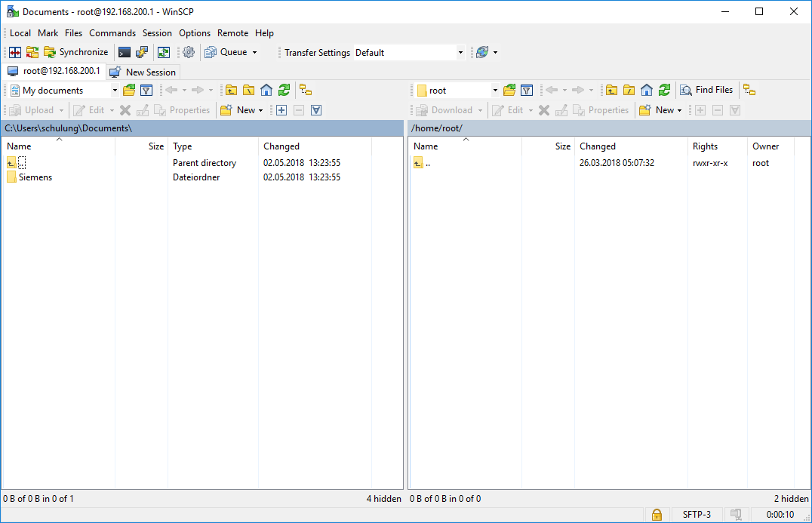

### Setting the IP address using iot2000setup

Unlike for the S7-1500, for example, it is not possible to make the IP settings of the IOT2000 later using the TIA Portal. Rather, these must be changed directly in the operating system. We are now directly connected to the running operating system via the SSH connection.

The **iot2000setup** tool can be used for changing the IP address. Alternatively, the file **/etc/network/interfaces** can be edited. Both methods are shown in the following.

* Enter the command **iot2000setup** in the shell and confirm the command with the **Enter key** ( → iot2000setup ↵)

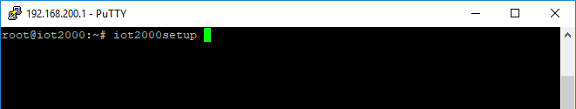

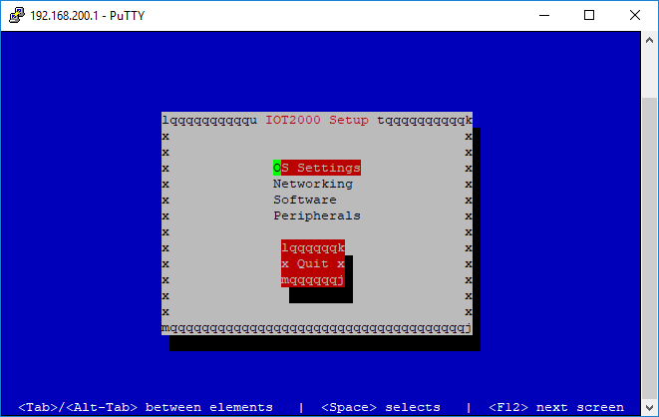

**Note:** The display results from the character set that is set within PuTTY (UTF-8). But, don't let it bother you. It doesn't affect how the program works. The character set can be changed to ISO-8859-15 in the Sessions settings under Window → Translation.

* Use the arrow, tab and Enter keys to navigate to menu item → Networking → Configure Interfaces.

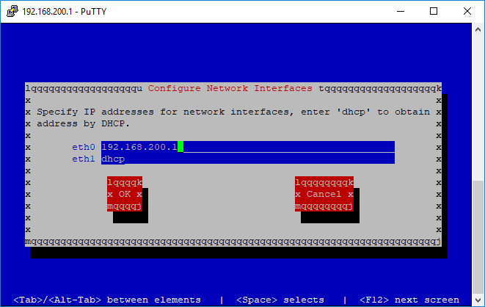

* Change the address for the **eth0** interface to **192.168.0.1** ( → eth0: 192.168.0.1).

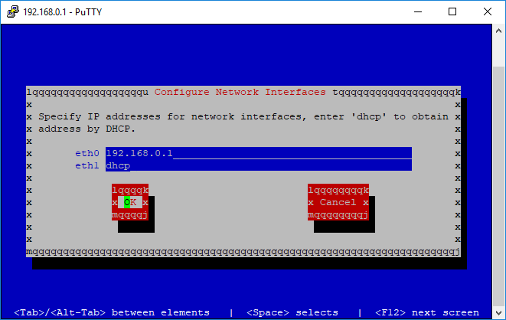

* Confirm the changes using the **OK** field ( → OK)

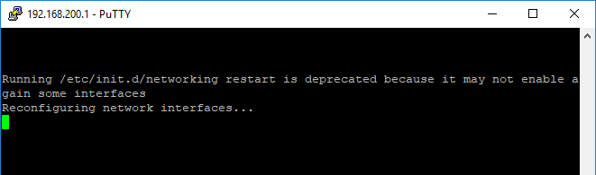

**Note:** The IP address is immediately changed and a new connection can only be established again when the programming device is also in the corresponding subnet!

* Adapt the address of the engineering station to the new subnet and establish an SSH connection to the IOT again.

### Setting the IP address using /etc/network/interfaces

Because only the IP address and not the subnet mask or the gateway can be changed using the **iot2000setup**, it is shown in the following how the corresponding configuration file **/etc/network/interfaces** can be manually adapted.

Experienced users can directly edit the file in the shell, e.g. with **nano**. Less confident users should edit the file with the help of **WinSCP**. This is explained on the next page.

* Start **nano** and transfer the file path **/etc/network/interfaces** as the parameter ( → nano /etc/network/interfaces ↵).

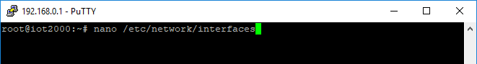

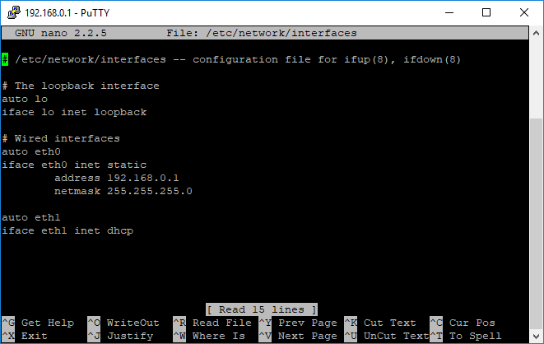

* You can exit the program again with key combination **Ctrl+X**. ( → Ctrl+X)
* Any changes can be accepted with **Y** or discarded with **N.**

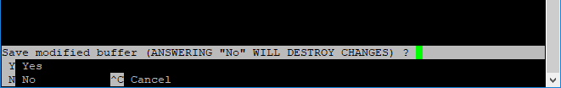

* Establish an SCP connection to the IOT2000 using **WinSCP**.
* Change to the **/etc/network** folder on the right side.

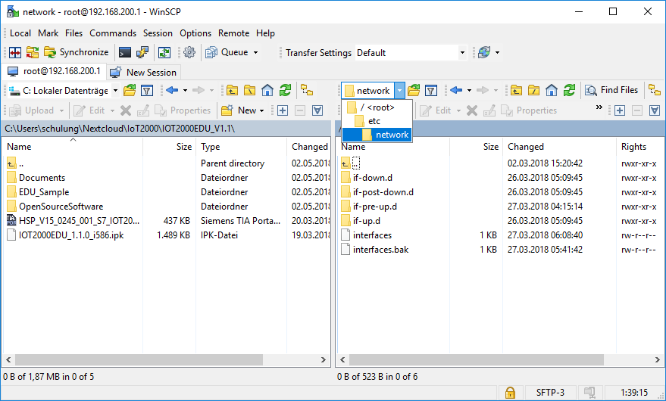

* **Right-click** on the **interfaces** file and select the **Edit** menu item.

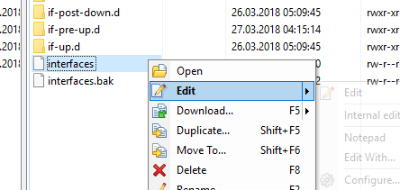

* Adapt the desired values in the editor and click on Save at the top left (Ctrl+S).

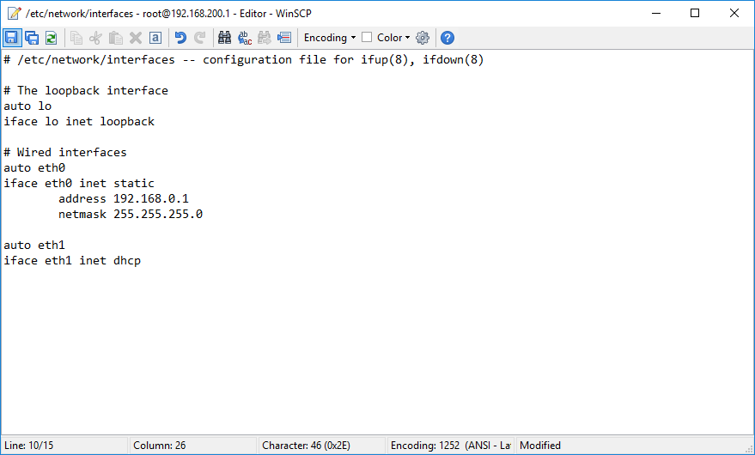

* The file is now automatically saved on the IOT2000 (see main window)

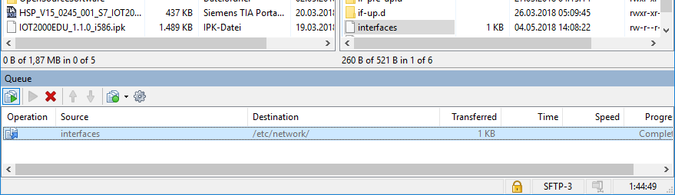

## IOT2000EDU Runtime

So that a connection between the TIA Portal and the IOT2000 can be established later, IOT2000EDU Runtime is needed. This is a program that simulates an S7 controller on the IOT2000. This runtime program is available for purchase exclusively by schools and universities as "SCE SIMATIC IOT2000EDU Software Controller executable on IOT2020 and IOT2040" on a DVD from Siemens.

### Installation

The DVD contains an ipk file named "*IOT2000EDU\_1.1.0\_i586.ipk".*

* Establish an SCP connection to the IOT with the help of WinSCP.
* Navigate on the local left side to the DVD or the folder with the *IOT2000EDU\_1.1.0\_i586.ipk* file.
* Navigate on the right IOT2000 side to the */home/root* folder.

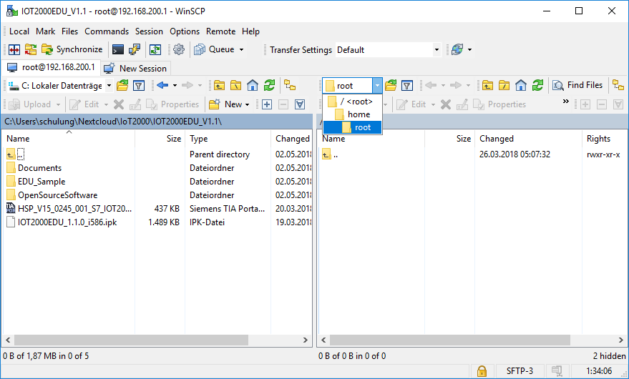

* Drag the *IOT2000EDU\_1.1.0\_i586.ipk* file onto the right side to copy it from the local programming device to the IOT2000.

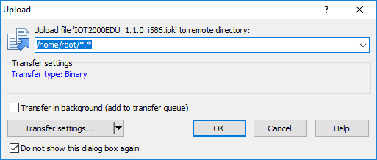

* Click "OK" to start the transfer.

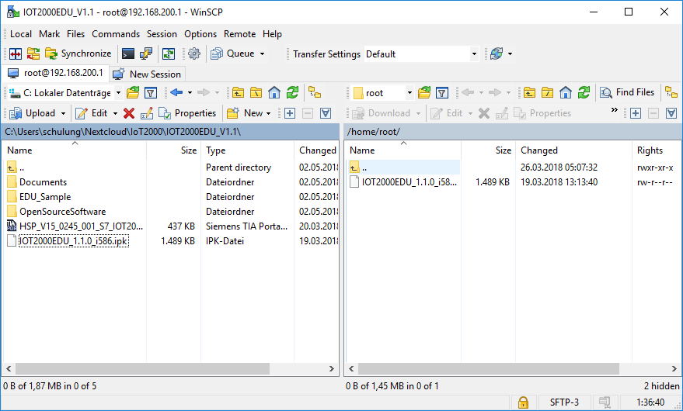

* Establish an SSH connection to the IOT2000.
* Execute **pwd** to ensure that you are in the */home/root* directory   
  ( → pwd ↵).

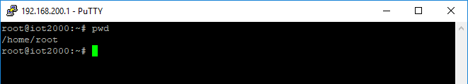

* If you are in a different directory, use **cd** to change to the /home/root directory ( → cd /home/root ↵).

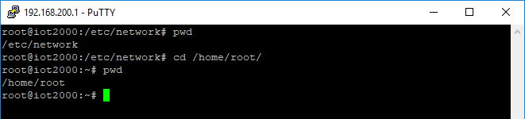

* You can have the content of the current directory listed with the **ls** command   
  ( → ls -l ↵).

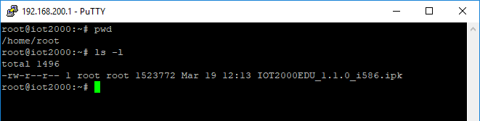

* The *IOT2000EDU\_1.1.0\_i586.ipk* file copied with WinSCP beforehand should now be displayed (possibly also other files).
* Install *IOT2000EDU\_1.1.0\_i586.ipk* with the **opkg** program ( → opkg install IOT2000EDU\_1.1.0\_i586.ipk ).

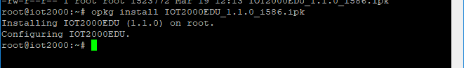

* Use **opkg** to check the status of the installation ( → opkg info IOT2000EDU ↵).

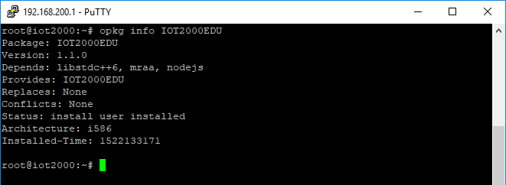

* Start **IOT2000EDU** Runtime for the first time ( → IOT2000EDU ↵).

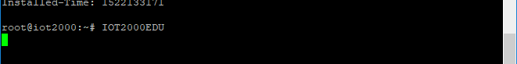

**Note:** The runtime runs in this way in the foreground. If the SSH connection is closed, the runtime also stops. To manually exit the program, use key combination **Ctrl+c**.

### Autostart

So that the IOT2000EDU Runtime also starts up automatically each time the system starts, a separate script is needed. This "iot2000edu" script is not included on the DVD, but can be downloaded on the Internet at [www.siemens.com/sce/iot2000/modules](http://www.siemens.com/sce/iot2000/modules), Module „SCE\_EN\_014-101 Hardware Configuration IOT2000“ under "Documents".

The *iot2000edu* script file must be copied to the IOT2000 with the help of WinSCP.

* Establish a connection to the IOT2000 with **WinSCP**.
* Navigate locally to script file *iot2000edu.*
* Navigate on the IOT2000 to the */etc/init.d* folder.

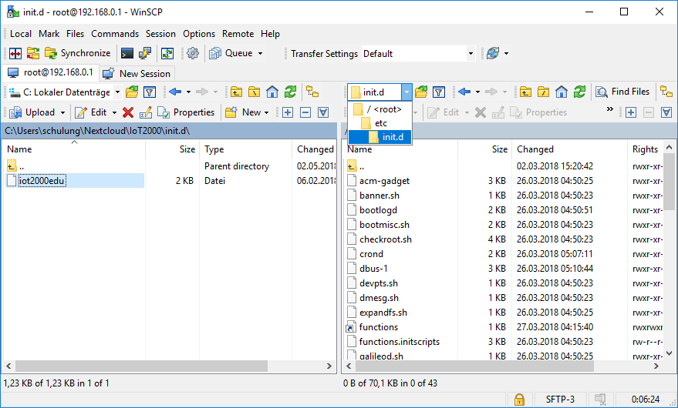

* Drag the file from your local folder to the IOT2000.

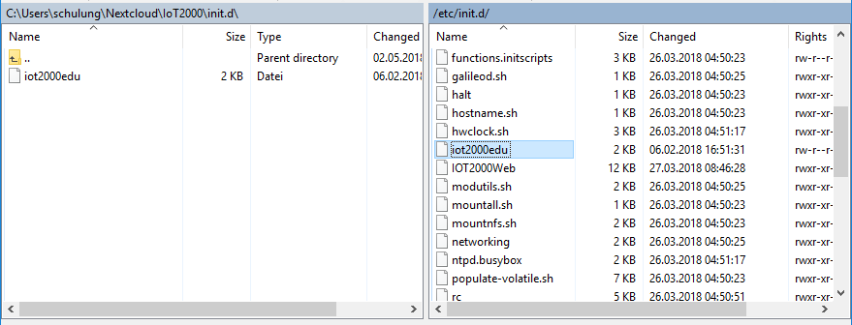

* Start an SSH connection to the IOT2000 with **PuTTY**.
* Mark the */etc/init.d/iot2000edu* file as executable with **chmod** (→ chmod +x /etc/init.d/iot2000edu ↵).

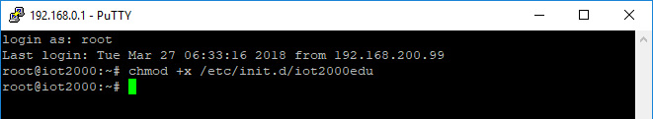

* Use update-rc.d to add the iot2000edu script to the autostart (→ update-rc.d iot2000edu defaults ↵).

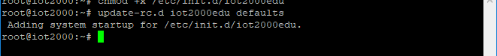

* The start script can also be used manually to start or stop the runtime in the background ( → /etc/init.d/iot2000edu start ↵ → /etc/init.d/iot2000edu start ↵).





### Basic configuration

The runtime assigns the individual I/O addresses to certain GPIO pins (General Purpose Input/Outputs) on the Arduino UNO header. The assignment is made using the *io.conf* file. The */home/root/IOT2000EDU* directory is created by the start of the runtime. This directory also contains a sample configuration named *io.conf.sample*.

This sample configuration is intended for the SIMATIC IOT2000 IO-Shield produced by Siemens. If you use a different shield, a compatible *io.conf* must be created.

The addresses for programming on TIA Portal in combination with the interface assignment of the SIMATIC IOT2000 IO Shield and the pins on the arduino header are as follows:

| **Addresses**  **on TIA Portal** | **Addresses**  **on TIA Portal** | **Pin on  arduino header** |
| --- | --- | --- |
| E101.4 | DI0 | D12 |
| E101.3 | DI1 | D11 |
| E101.2 | DI2 | D10 |
| E101.1 | DI3 | D9 |
| E100.4 | DI4 | D4 |
| A101.0 | DQ0 | D8 |
| A100.7 | DQ1 | D7 |
| EW103 | U0 | A0 |
| EW105 | I0 | A1 |
| EW107 | U1 | A2 |
| EW109 | I1 | A3 |

In the first step, the sample configuration will be used as the configuration for the IOT2000EDU Runtime. The *io.conf.sample* should be copied to the *io.conf* file for this. The option also exists to rename the file, but this comes with the risk that you may no longer be able to revert back to the original in the case of an erroneous configuration.

* Start an SCP connection to the IOT2000 with WinSCP.
* In the IOT2000, navigate to path /home/root/*IOT2000EDU.*

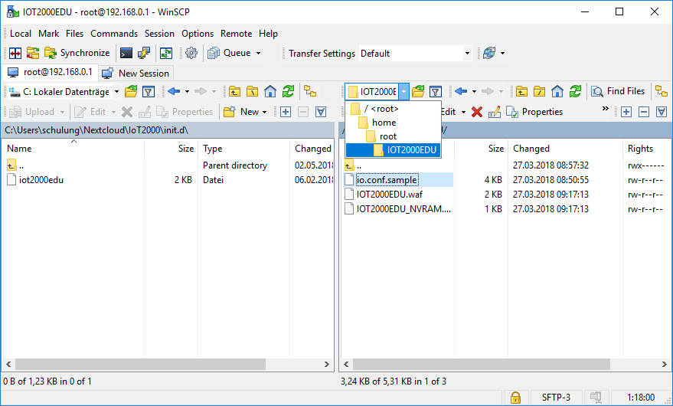

* Right-click the *io.conf.sample* file and select **Duplicate** in the shortcut menu.

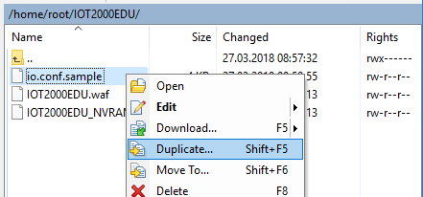

* Specify *io.conf* for the **target file** ( → Target remote path: /home/root/ IOT2000EDU/io.conf).

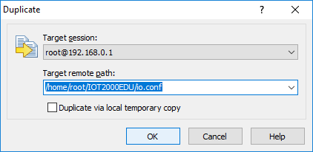

* Confirm the window with OK ( → OK).

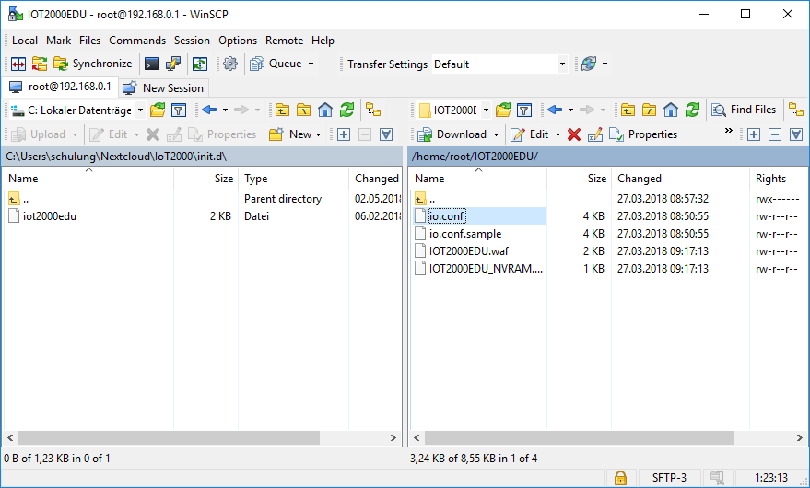

* Restart the IOT2000EDU Runtime: either by a **reboot** or using the start script. You must use an SSH connection in either case ( → /etc/init.d/iot2000edu restart ↵).

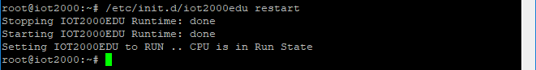

### Adaptation of the configuration (optional)

If you are not using the SIMATIC IOT IO-Shield but instead a shield from another manufacturer or even one of your own, the supplied configuration file must be adapted.

The configuration file is kept in JSON format and must be able to be interpreted error-free as JSON by the runtime. You can find a visual online editor on the website <https://jsoneditoronline.org/>. The website checks the syntax and is relatively intuitive to use. The data can be exchanged between the editor in WinSCP and the online editor with copy & paste. It is best to use WinSCP for editing the configuration. Windows and Linux have different control characters for representing a line break. If you edit or create the file with a Windows editor, e.g. Wordpad or Notepad, this can lead to problems.

The configuration file contains a JSON object, which is subdivided into five JSON lists:

* + \_\_comments
  + address\_space
  + gpio
  + analog
  + pwm

The **\_\_comments** section contains general descriptions, such as the name of the configuration, etc., and is intended more for the user than for the runtime.

The **address\_space** section contains the start addresses for the digital and analog inputs and outputs. You can find an exact description starting in section *7.1 Configuring and operating shields* in document *S7 Software Controller IOT2000EDU* on the IOT2000EDU DVD. The important thing here is the size of the memory that is allocated starting from the start address:

* + digital\_in\_start: 3 bytes in the inputs (e.g. %I100.0 to %I102.7)
  + digital\_out\_start: 3 bytes in the outputs (e.g. %Q100.0 to %Q102.7)
  + analog\_in\_start: 12 bytes in the inputs (e.g. %IW103 to %IW113)
  + pwm\_out\_start: 6 bytes in the outputs (e.g. %IB103 to %IB108)

Ensure that the input and output addresses do not overlap or, ideally, keep the preset range unchanged.

The digital inputs and outputs are defined In the **gpio** section. Each digitally used GPIO receives its own small section, which defines the port as an input or output via the pin number and assigns it a start value.

{

"pin": 4,

"is\_output": 0,

"initial\_value": 0

}

The analog inputs are defined in the **analog** area. The ADC (analog-to-digital converter) of the X1000 processor is also activated via the pin number. The resolution of the ADC must also be specified. A 2-byte integer is returned irrespective of the resolution setting.

{

"pin": 0,

"pin\_resolution": 9

}

The analog or PWM (pulse-width modulation) outputs are declared in the **pwm** section, since the processor does not have a proper DAC (digital-to-analog converter). Here too, the pin number of the desired PWM port is specified in the configuration. In addition, the period of the PWM signal is set (between 667 us and 41665 us).

{

"pin": 9,

"period\_us": 10000

}

To find out which function is available at which pin, refer to the following figure and table. In addition, the input and output addresses, based on the sample configuration, are inserted for later use in the TIA Portal.

The precise details can be found in section 7.2 Configuring the Arduino Shield, of operating manual   
S7 Software Controller IOT2000EDU on the Runtime DVD.

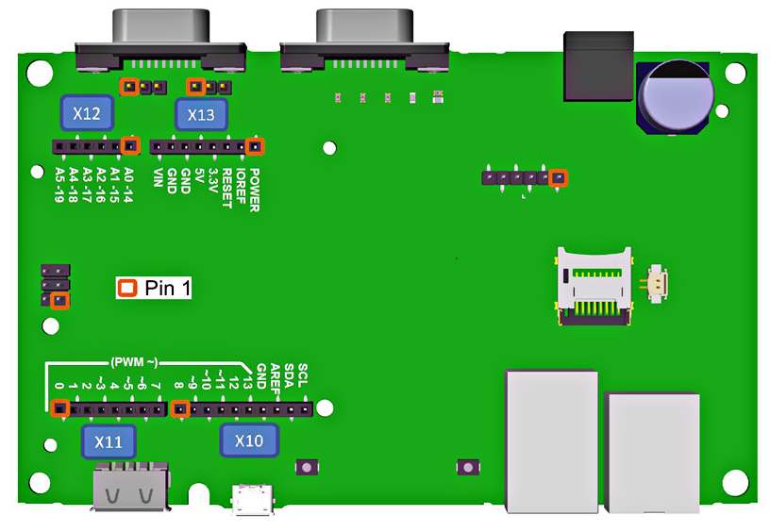

| **Interface** | **Pin** | **io.conf pin numbers** | | | **I/O** | |
| --- | --- | --- | --- | --- | --- | --- |
| **Digital** | **Analog** | **PWM** | **Digital** | **Analog** |
| X11 | 1 | 0 |  |  | 100.0 |  |
| 2 | 1 |  |  | 100.1 |  |
| 3 | 2 |  |  | 100.2 |  |
| 4 | 3 |  | 3 | 100.3 | IB103 |
| 5 | 4 |  |  | 100.4 |  |
| 6 | 5 |  | 5 | 100.5 | IB104 |
| 7 | 6 |  | 6 | 100.6 | IB105 |
| 8 | 7 |  |  | 100.7 |  |
| X10 | 1 | 8 |  |  | 101.0 |  |
| 2 | 9 |  | 9 | 101.1 | IB106 |
| 3 | 10 |  | 10 | 101.2 | IB107 |
| 4 | 11 |  | 11 | 101.3 | IB108 |
| 5 | 12 |  |  | 101.4 |  |
| 6 | 13 |  |  | 101.5 |  |
| 7 |  |  |  |  |  |
| 8 |  |  |  |  |  |
| 9 | 18 | 4 |  | 102.2 | QW111 |
| 10 | 19 | 5 |  | 102.3 | QW113 |
| X12 | 1 | 14 | 0 |  | 101.6 | QW103 |
| 2 | 15 | 1 |  | 101.7 | QW105 |
| 3 | 16 | 2 |  | 102.0 | QW107 |
| 4 | 17 | 3 |  | 102.1 | QW109 |
| 5 | 18 | 4 |  | 102.2 | QW111 |
| 6 | 19 | 5 |  | 102.3 | QW113 |

**Note:** Of course, each pin can be used only once in the configuration: either as a digital input, digital output, analog input or PWM output!

## Programming software STEP 7 Professional V15 (TIA Portal V15)

The STEP 7 Professional V15 (TIA Portal V15) software is the programming tool for the automation systems.

With STEP 7 Professional V15, the following functions be used for automation of a plant:

* Configuration and parameter assignment of the hardware
* Specification of the communication
* Programming
* Testing, commissioning and service with operational/diagnostic functions
* Documentation
* Creation of visualizations for SIMATIC Basic Panels with integrated WinCC Basic.
* All functions are supported by an extensive online help.

### Project

You create a project in the TIA Portal for performing an automation and visualization task. A project in the TIA Portal contains the configuration data for the installation and networking of devices as well as the programs and the configuration of the visualization.

### Hardware configuration

The hardware configuration contains the configuration of devices, consisting of the automation system hardware, the field devices on the PROFINET bus system and the hardware for visualization. The configuration of the networks specifies the communication between the various hardware components. Individual hardware components are inserted from catalogs into the hardware configuration*.*

In this case, the hardware of SIMATIC IOT2000 automation systems consists only of the controller (CPU). There are no signal modules here as there are in other control systems, and field devices are not yet supported at present.

The hardware configuration enables automation and visualization solutions to be downloaded to the automation system and the controller to have access to the connected signal modules.

### Planning the hardware

Before you can configure the hardware, you must plan it. In general, you start by selecting the required controllers and the number needed. Next you select the communication modules and signal modules. The signal modules are selected based on the number and type of inputs and outputs needed. Finally, an adequate power supply must be selected for each controller or field device.

The functionality needed and the environmental conditions are of critical importance for planning the hardware configuration. For example, the temperature range in the application area is one of the limiting factors for selecting possible devices. Fail-safe capability could be another requirement.

The [TIA Selection Tool](https://eb.automation.siemens.com/mall/en/WW/Catalog/Configurators) (select Automation technology → TIA Selection Tool and follow the instructions) offers you support. Note: The TIA Selection Tool requires Java.

**Notice for online research:** To obtain the device specifications, look for the manual described as "Product Manual" or "Manual" among the various manuals listed.

### TIA Portal – Project view and portal view

The TIA Portal has two important views. When started, the TIA Portal displays the portal view by default. This view makes the first steps easier, especially for beginners.

The portal view provides you with a task-oriented view of the tools for working with the project. Here, you can quickly decide what you want to do and open the tool for the task at hand. When needed, the system automatically switches to the project view for a selected task.

Figure 1 shows the portal view. You have the possibility to change between this view and the project view at the bottom left.

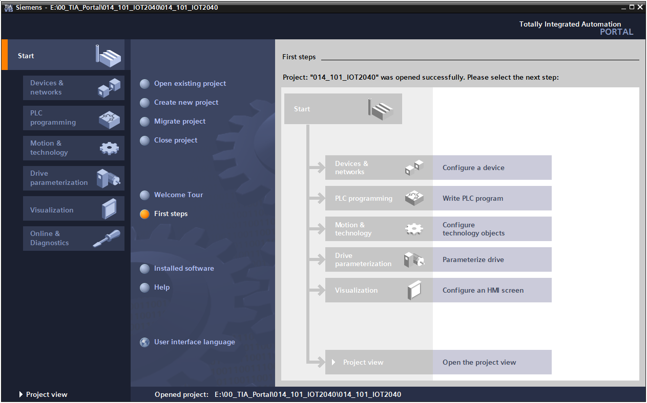

Figure 1: Portal view

The project view, as shown in Figure 2, is used for hardware configuration, programming, creation of the visualization and many other tasks.

With the default setting, the menu bar containing the toolbars is at the top, the project tree containing all the components of a project is on the left and the so-called task cards containing instructions, libraries, etc. are on the right.

If an element is selected in the project tree (for example, the device configuration), it is displayed in the middle and can be worked on there.

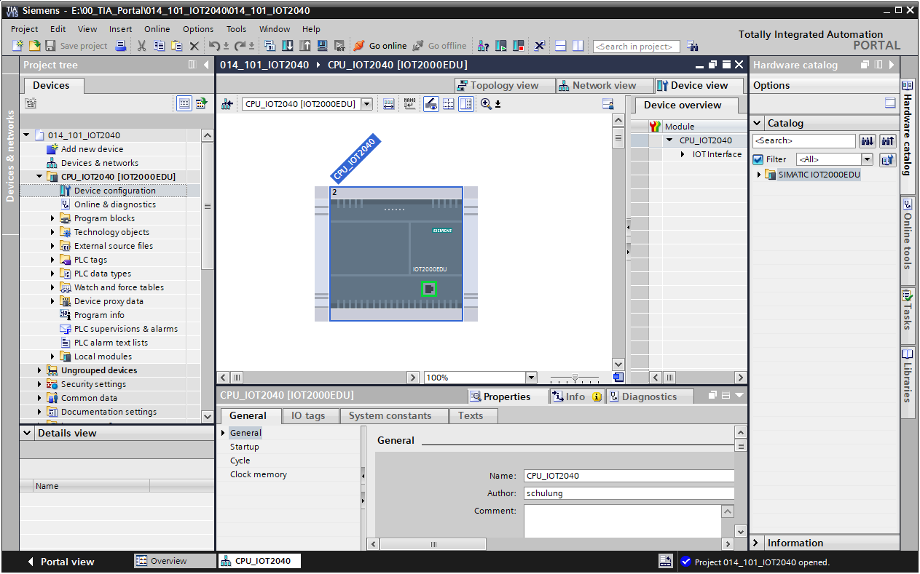

Figure 2: Project view

### Basic settings for the TIA Portal

* The user can make customized default settings for certain settings in the TIA Portal. Some of the important settings are shown here.
* In the menu of the Project view, select → "Options" and then → "Settings".

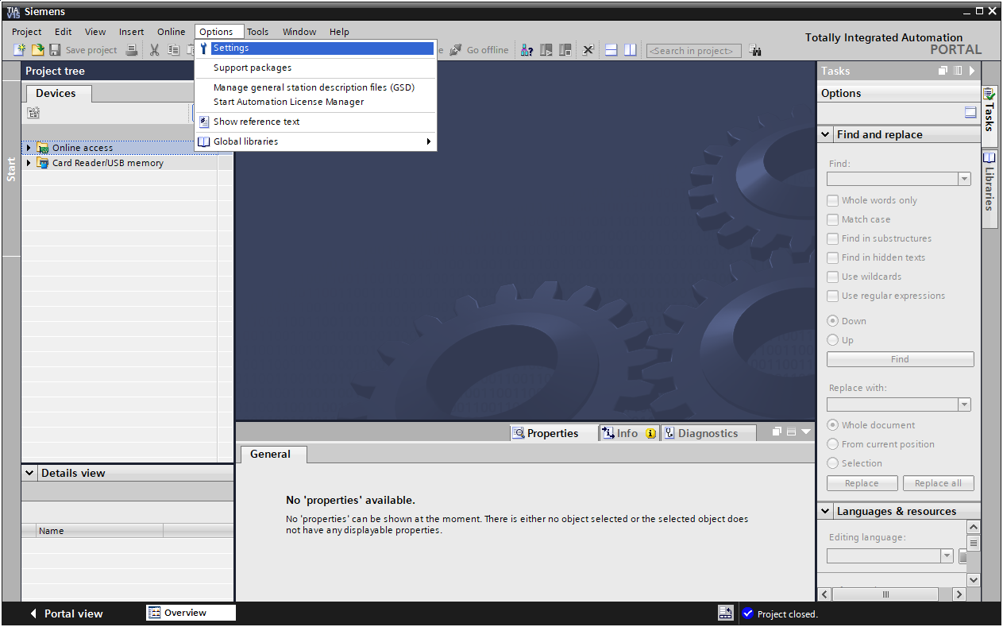

* A basic setting is the choice of user interface language and the language for the program display. English is used for both settings in this document.
* In the → "General" item of "Settings", select → "English" for "User interface language" and → "International" for "Mnemonics".

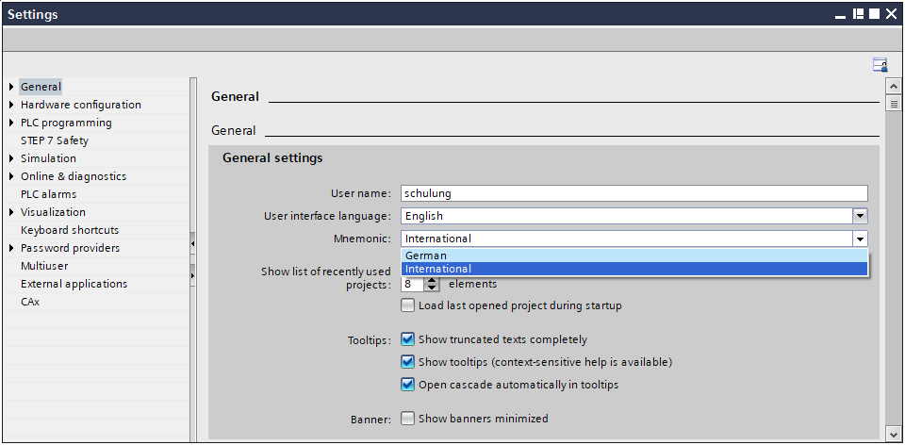

**Note:** These settings can always be changed back and forth between "English" and "International".

### Installation of the Hardware Support Package

So that the IOT2000EDU Runtime and the IOT2040 can be created as hardware in the TIA Portal, the appropriate Hardware Support Package (HSP) *HSP\_V15\_0245\_001\_ S7\_IOT2000EDU\_1.1.isp15* from the IOT2000EDU DVD must be installed in the TIA Portal.

* To do this, start the Totally Integrated Automation Portal (® TIA Portal V15).



* Switch to the → "Project view".

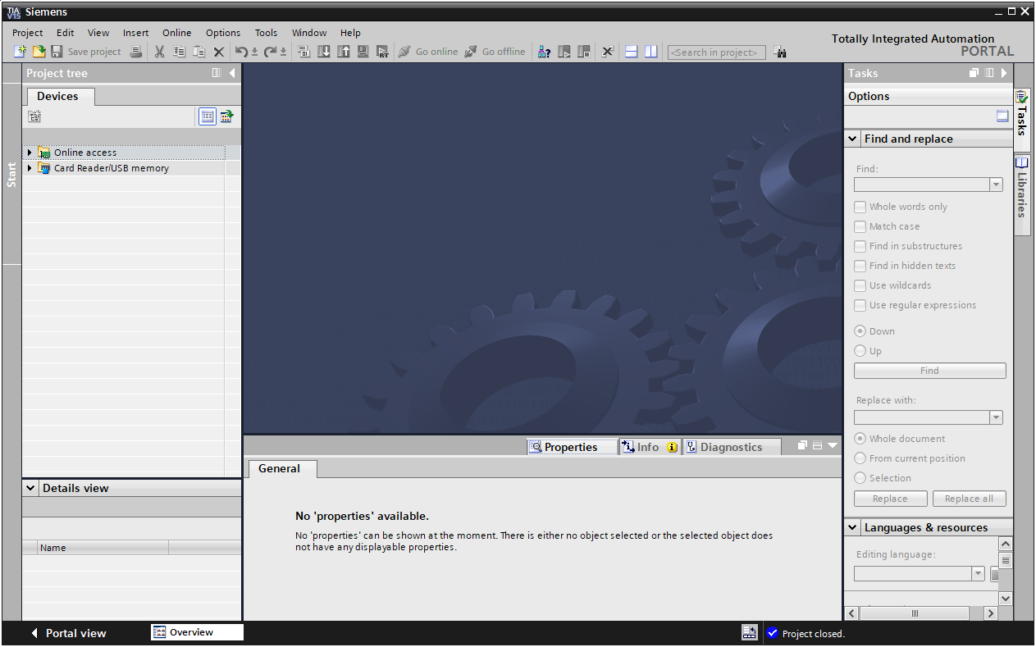

* Under the → "Options" menu select → "Support Packages".

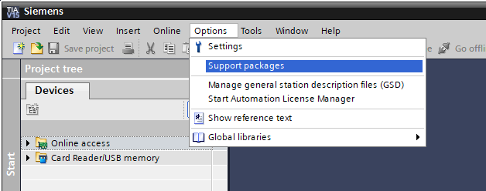

* Under → "Installation of Support Packages", select the → "Add from file system" action.

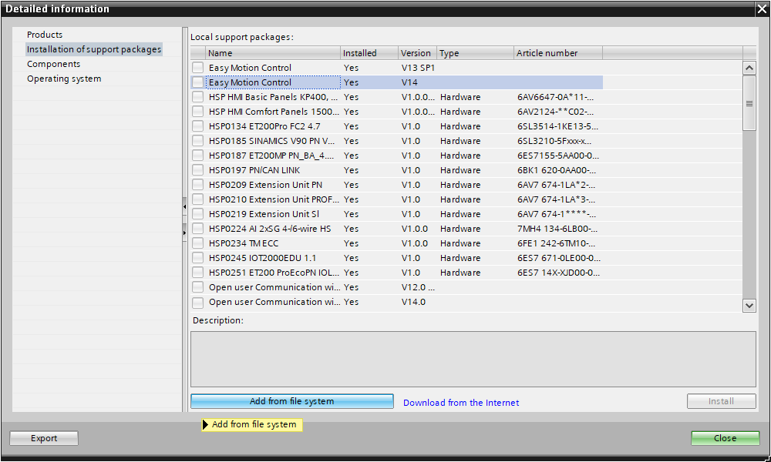

* Navigate to support package → *HSP\_V15\_0245\_001\_S7\_IOT2000EDU\_1.1.isp15* and confirm the dialog with → "Open".

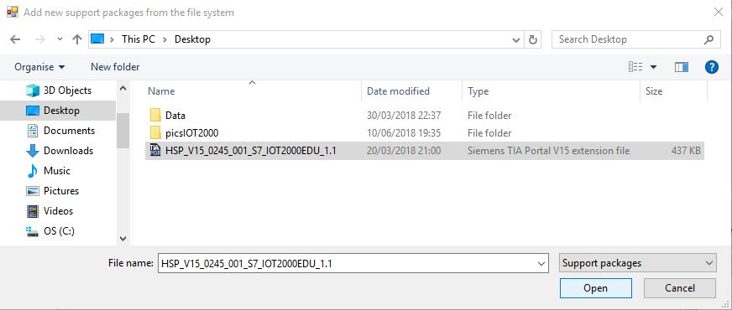

* Now, select → "HSP0245 IOT2000EDU 1.1" from the list of local support packages and click → "Install".

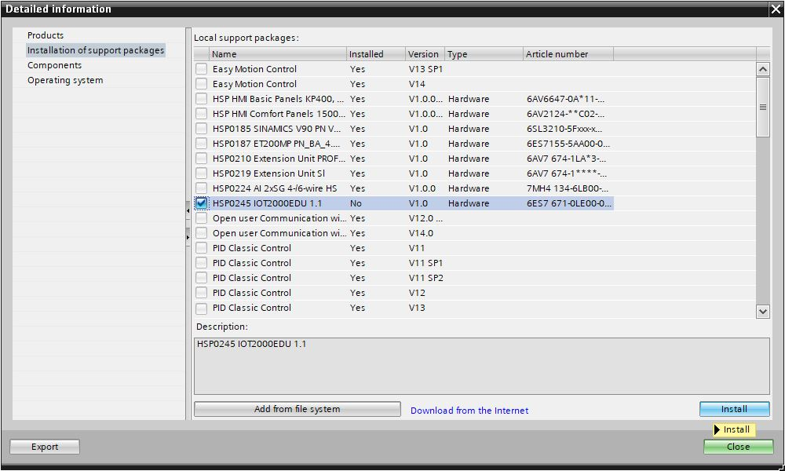

* Confirm the installation with → "Continue".

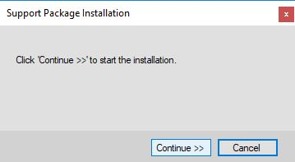

* The HSP should now have been installed successfully.

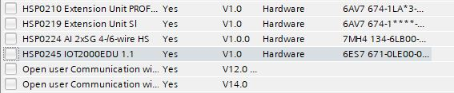

* Close the Support Package administration with → "Close".

# Task

Create a project and configure the compact CPU of your hardware that corresponds to a part of the **SIMATIC IOT2040** trainer package.

* SIMATIC IOT2040 with Intel Quark x1020  
  (Order number: 6ES7647-0AA00-1YA2)

# Planning

Because a new system is involved, a new project must be created.

The hardware is already specified for this project with the SIMATIC IOT2040 trainer package. For this reason, no selection has to be made. Instead, the listed CPU of the trainer package only has to be inserted in the project. To ensure that the correct module is inserted, the order number from the task should be checked one more time directly on the mounted devices (see Table 1).

For the configuration, the Ethernet interface must be set for the CPU. For the digital and analog inputs and outputs, the address ranges according to Table 1 are set.

|  |  |  |  |
| --- | --- | --- | --- |
| **Module** | **Order number** | **Slot** | **Address range** |
| SIMATIC IOT2040 | 6ES7647-0AA00-1YA2 | 1 | DI 100.0 – 102.3 DQ 100.0 – 102.3 AI 103 – 113 AQ 103 – 108 |

Table 1: Overview of planned configuration

To complete the configuration, the HW configuration must be compiled and downloaded. Configuration errors can be detected during compilation and incorrect modules can be detected when the controller is started *(only possible when configured hardware is present and identical).*

The checked project must be saved and archived.

# Structured step-by-step instructions

You can find instructions on how to perform planning below. If you already have a good understanding of everything, it is sufficient to focus on the numbered steps. Otherwise, simply follow the steps of the instructions.

## Creating a new project

* To do this, select the Totally Integrated Automation Portal, which is opened with a double-click. (® TIA Portal V15).



* In the portal view, select → "Create new project" under the "Start" menu command.

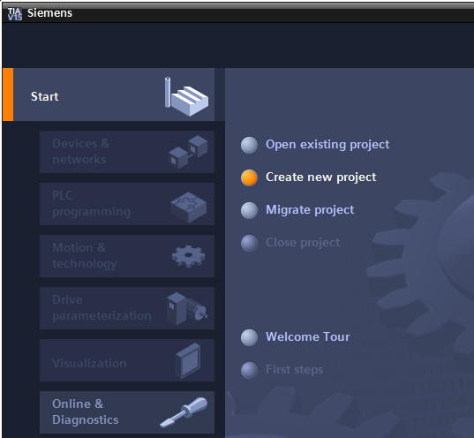

* Edit Project name, Path, Author and Comment as appropriate and click → "Create".

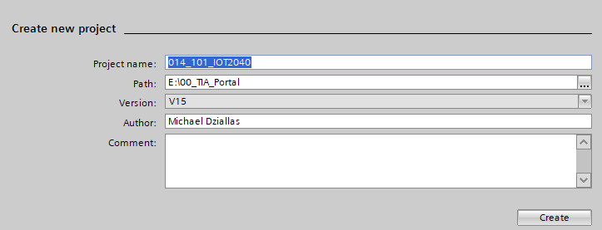

* The project is created and opened, and the "Start" menu "First steps" opens automatically.

## Inserting the SIMATIC IOT2000EDU Runtime

* In the → "Start" portal, → "First steps" → select "Devices & networks" → "Configure a device".

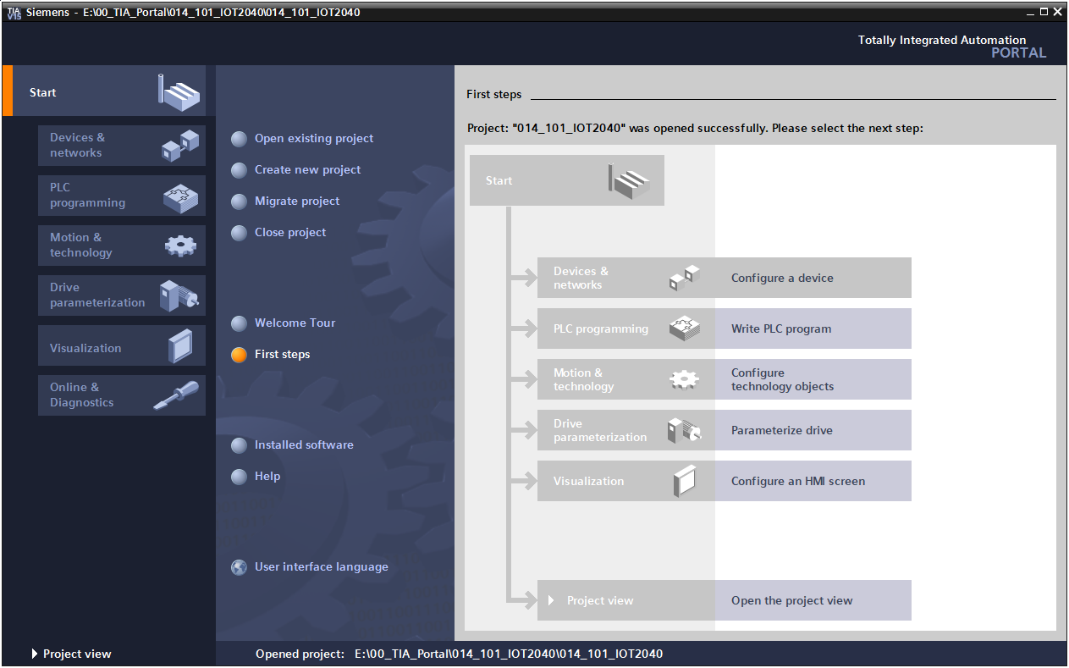

* In the "Devices & networks" portal, the "Show all devices" menu opens.
* Switch to the "Add new device" menu.

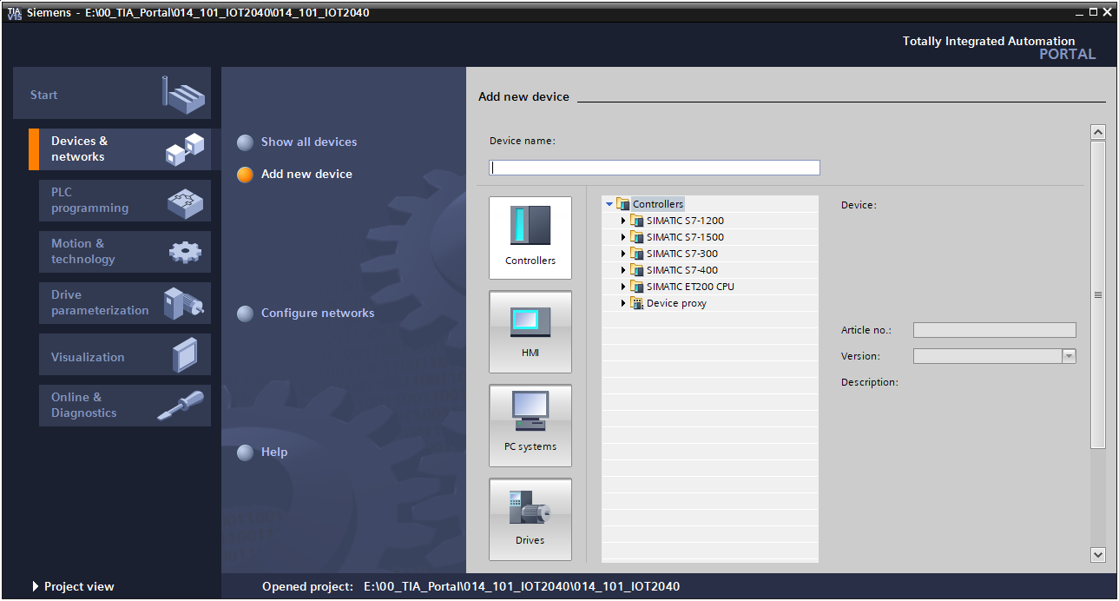

* The specified model of the CPU will now be added as a new device (PC systems → SIMATIC IOT2000EDU → 6ES7 671-0LE00-0YB0 → V1.1).

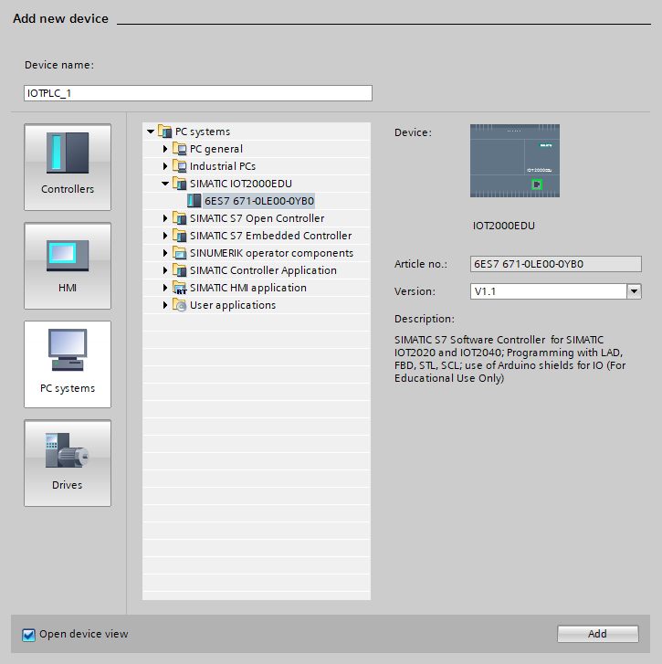

* Assign a device name (device name → "CPU\_IOT2040").



* Select "Open device view".



* Click → "Add".

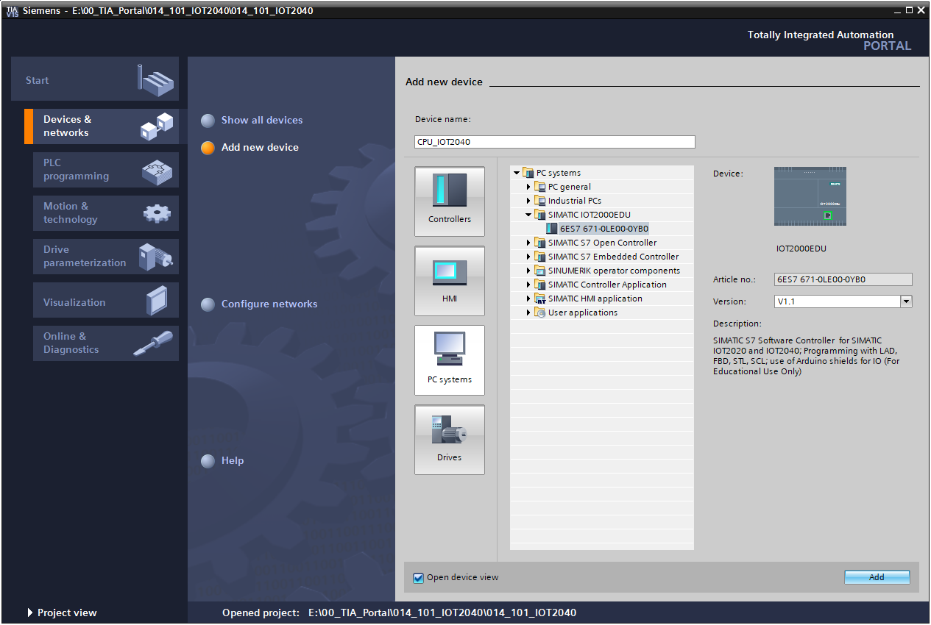

**Note:** A desired CPU may come in multiple variants that differ in their functional scope (work memory, integrated memory, technology functions, etc.). In this case, you should ensure that the selected CPU corresponds to your requirements.

The TIA Portal now automatically changes to the project view and displays the selected CPU in slot 1 of a standard mounting rail in the device configuration.

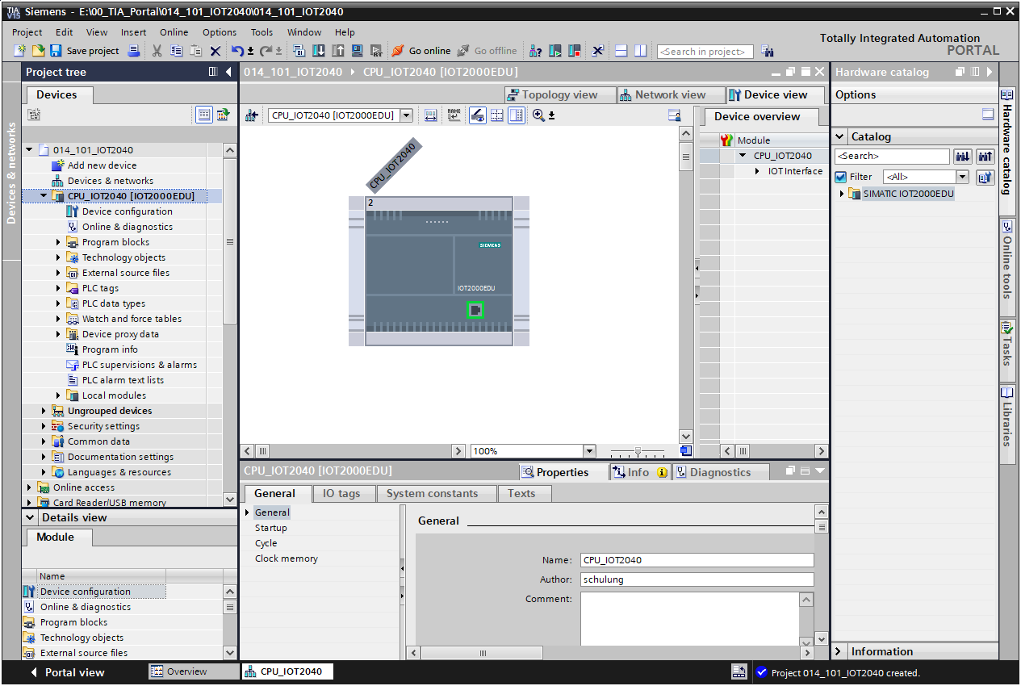

**Note:** You can now configure the CPU there according to your specifications. Settings for the PROFINET interface, startup characteristics, cycle, password protection, communication load and many other options are possible here.

## Configuration of Ethernet interface of the IOT2000

* Select the Ethernet interface with a double-click.

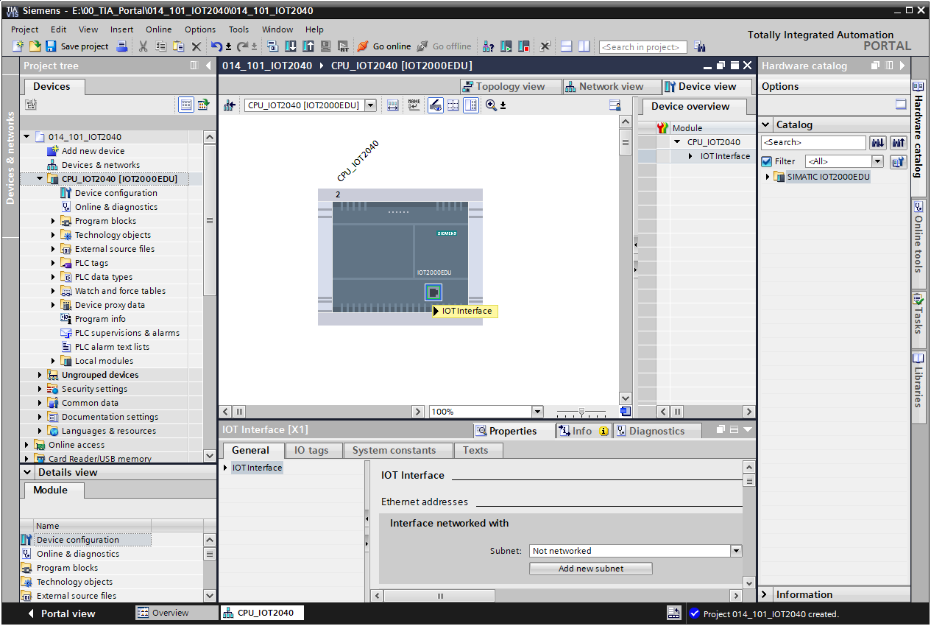

* On the → "Properties" tab, open the → "IOT Interface" menu and select the → "Ethernet addresses" entry there.

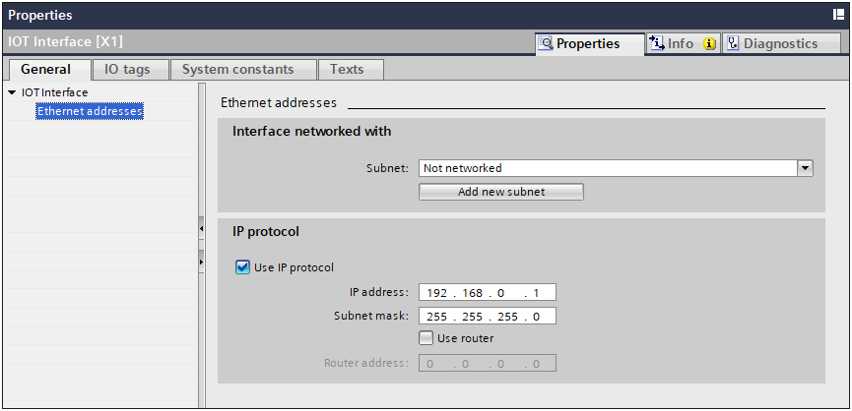

* Under "Interface networked with", there is only one entry available: "Not networked".
* Add an Ethernet subnet with the → "Add new subnet" button.

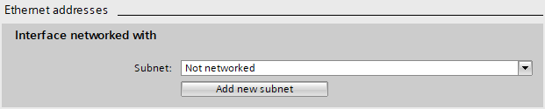

* The "IP address" and "Subnet mask" must match the address set in the operating system.

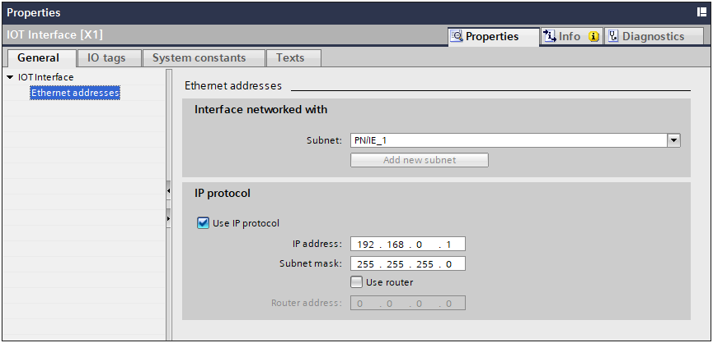

**Note:** The TIA Portal is not able to change the IP settings of the IOT2000 and cannot communicate with the device if the IP address is configured incorrectly.

## Saving and compiling the hardware configuration

* Before you compile the configuration, you should save your project by clicking the ®  button.
* To compile your CPU with the device configuration, first select the → "CPU\_IOT2040 [IOT2000EDU]" folder and click the → "Compile" button .

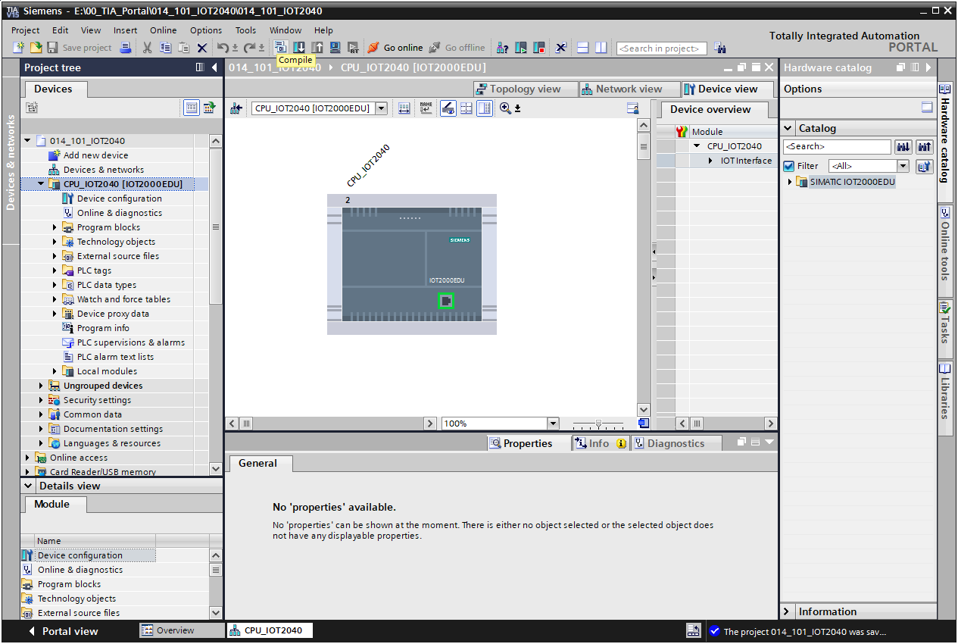

**Note:** You should use the "Save project" function periodically when working on a project because saving does not occur automatically. The only time you are prompted to save the project is when you close the TIA Portal.

* If the configuration is compiled without errors, you see the following:

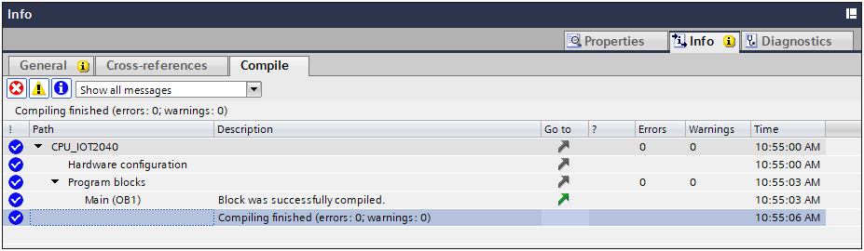

## Downloading the hardware configuration to the device

* To download your complete CPU, select the → "CPU\_IOT2040 [IOT2000EDU]" folder again and click the → "Download to device" button 0009.

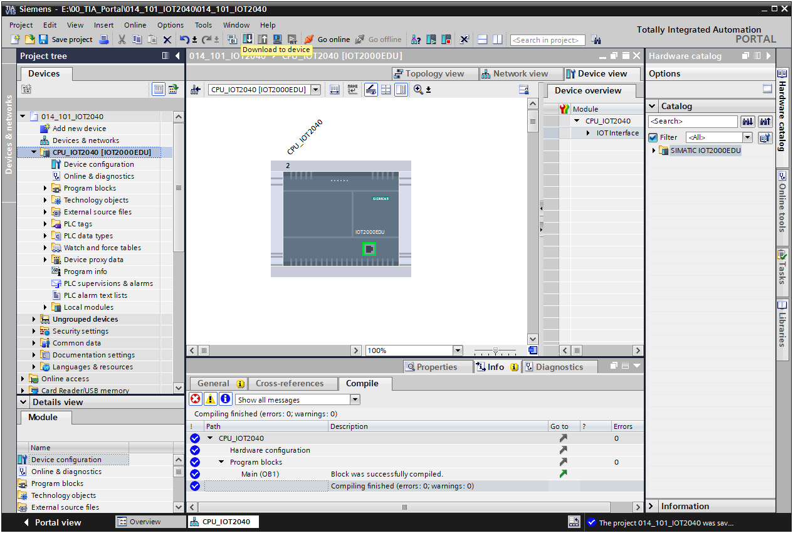

* The manager for configuration of connection properties (Extended download) opens.

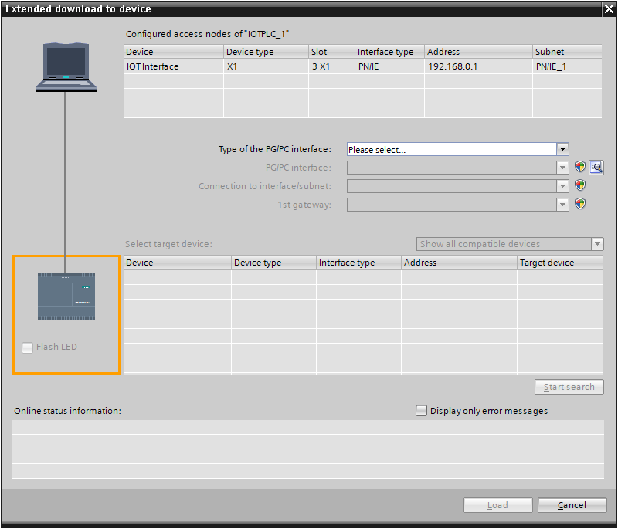

* First, the interface must be correctly selected. This is done in three steps:
* Type of PG/PC interface: → PN/IE

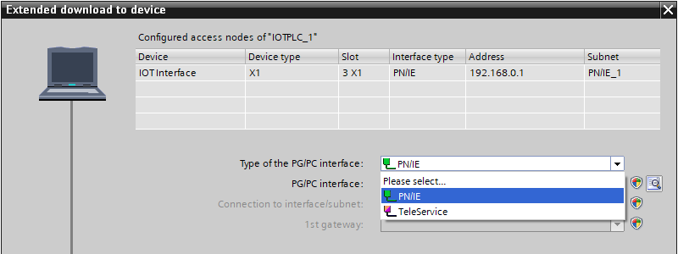

* PG/PC interface → here: Intel(R) Ethernet Connection (4) I217-LM

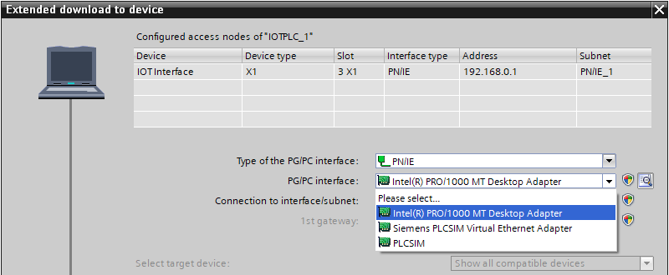

* Connection to interface/subnet → "PN/IE\_1"

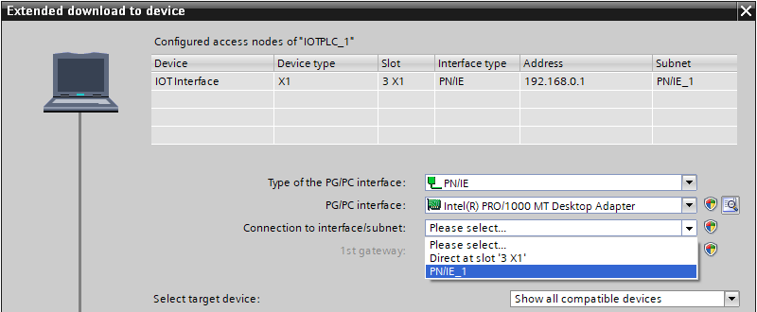

* The field → "Show all compatible devices" must be selected, and the search for devices in the network must be started by clicking the →  button.

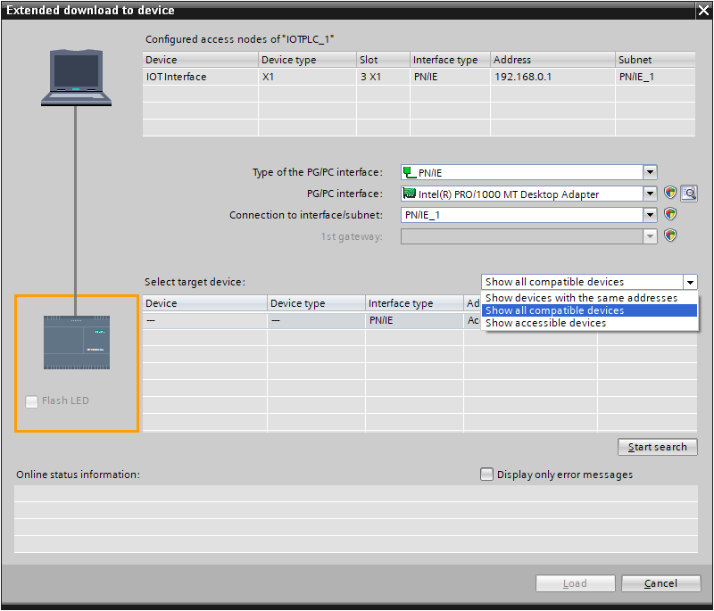

* If your CPU is displayed in the "Compatible devices in target subnet" list, select it and start the download. (→ IOT2000EDU → "Load")

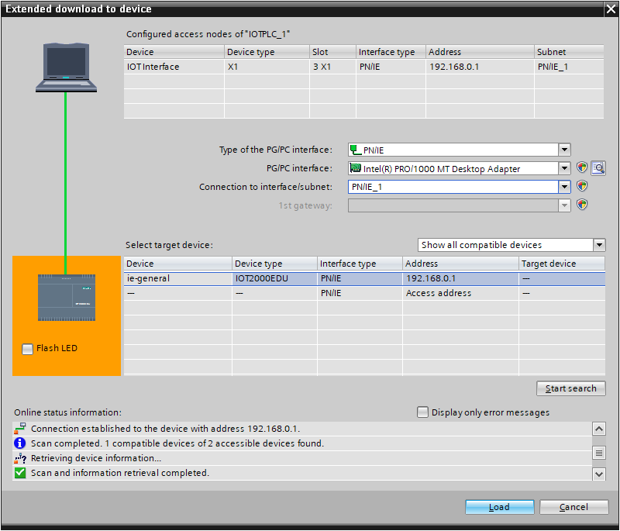

* You first receive a preview. Any red marked fields in the "Action" column must be manually confirmed. Continue with → "Load".

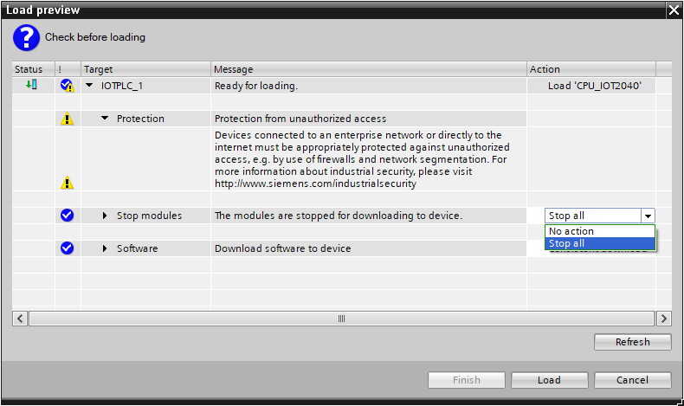

**Note:** In the "Load preview", you should see the  symbol in each line. You can see additional information in the "Message" column.

* Select the → "Start module" option before completing the download operation with → "Finish".

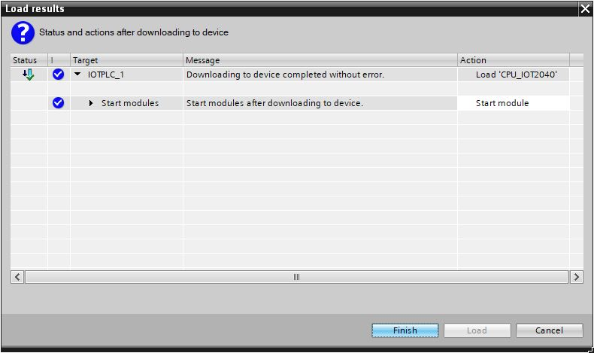

* The project view is opened again automatically after a successful download operation. A download report appears on the "General" tab of the Info field. This can be helpful for troubleshooting if the download operation was unsuccessful.

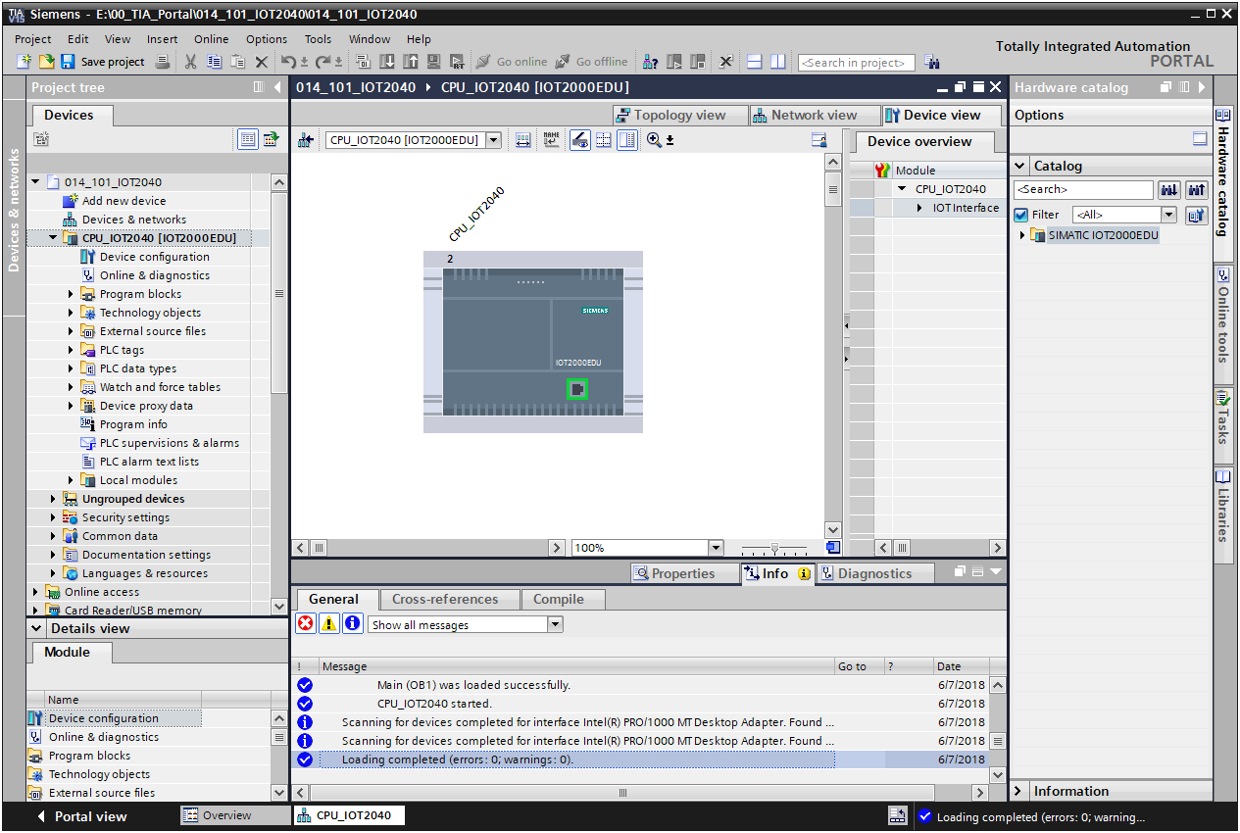

## Downloading the hardware configuration to the PLCSIM simulation (optional)

* If hardware is not available, the hardware configuration can be downloaded **alternatively** to a PLC simulation (S7-PLCSIM).
* First, start the simulation by selecting the → "CPU\_IOT2040 [IOT2000EDU]" folder and clicking the → "Start simulation" button capture_015_06122013_083638__.

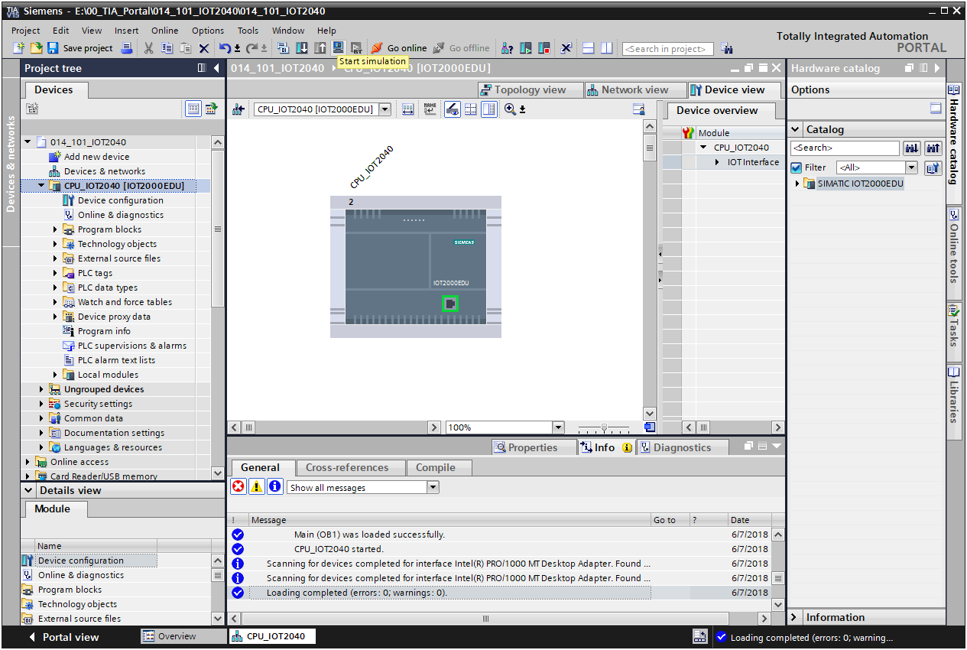

* Confirm the notice "Starting simulation will disable all other online interfaces" with → "OK".

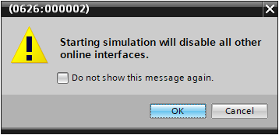

* The "S7-PLCSIM1" software is started in a separate window.

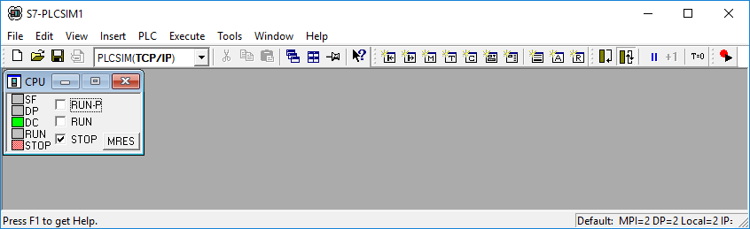

* Shortly afterward you see a preview for the download in the TIA Portal. Continue with → "Load".

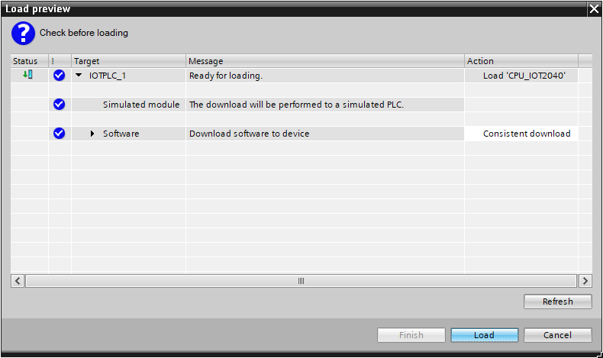

**Note:** In the "Load preview", you should see the  symbol in each line. You can see additional information in the "Message" column.

* The project view is opened again automatically after a successful download operation. A download report appears on the "General" tab of the Info field. This can be helpful for troubleshooting if the download operation was unsuccessful.

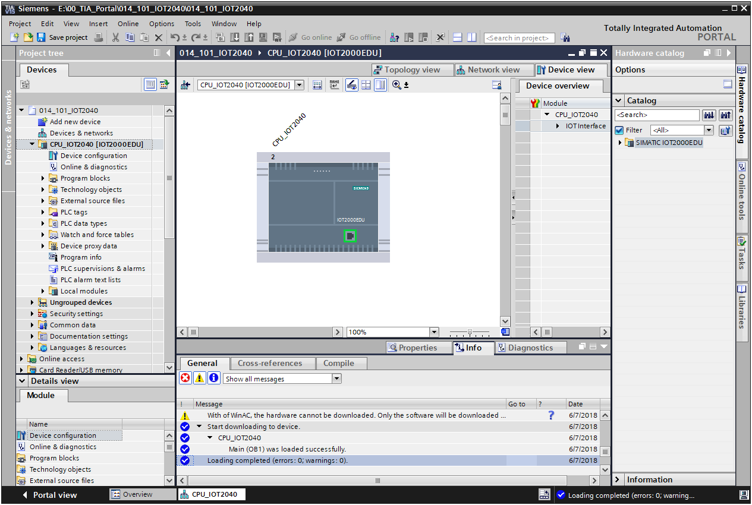

* The PLCSIM simulation has the following appearance in the project view. You can change back to the compact view of the simulation by clicking the →  button in the menu bar.



* To control inputs and outputs, use menu item → "Insert" and add an → "Input"

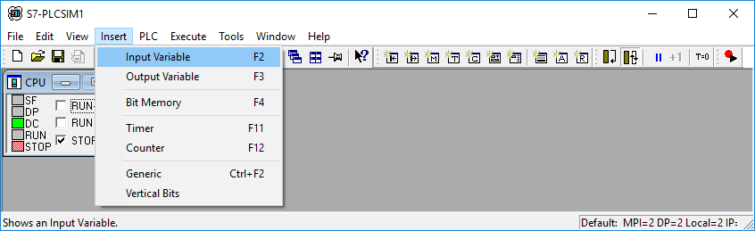

* On the new sub-window "IB0", you must now also enter the correct address of the input byte → "IB100"

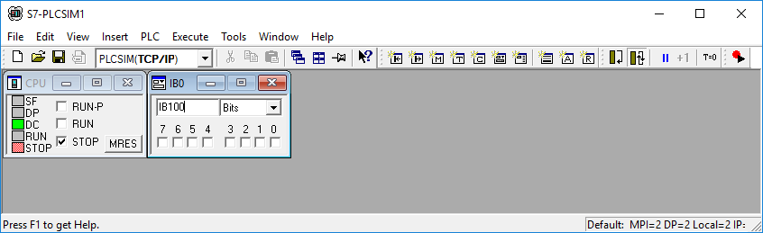

## Archiving the project

* To archive the project, select the → "Archive…" command in the → "Project" menu.

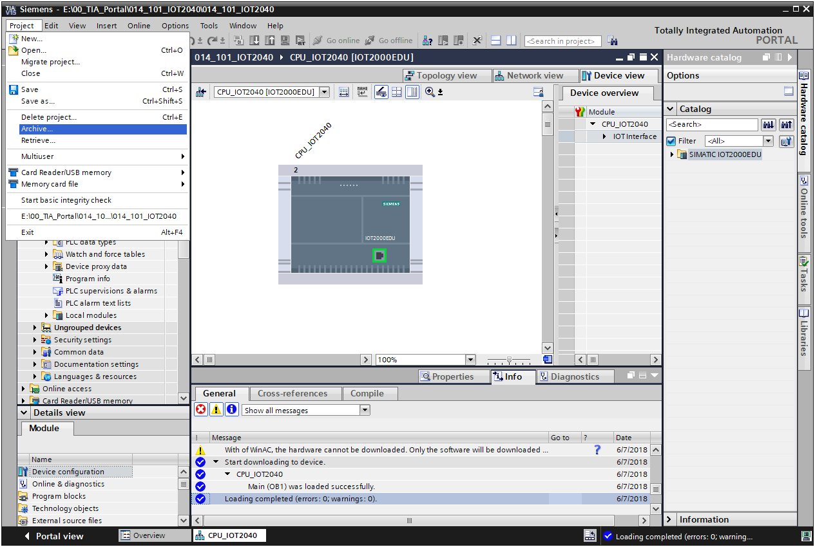

* Confirm the prompt "Save project?" with →"Yes".

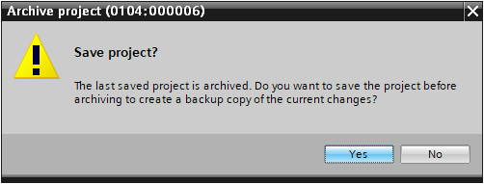

* Select a folder in which you want to archive your project and save the project as file type "TIA Portal project archive" (→ "TIA Portal project archive" → "SCE\_EN\_014-101\_Hardware Configuration\_IOT2000…" → "Save").

## Checklist

|  |  |  |
| --- | --- | --- |
| **No.** | Description | **Completed** |
| 1 | Project created |  |
| 2 | Slot 1: CPU\_IOT2040 with the correct order number |  |
| 3 | Slot 1: CPU\_IOT2040 with the correct firmware version |  |
| 7 | Hardware configuration compiled without error message |  |
| 8 | Hardware configuration downloaded without error message |  |
| 9 | Project successfully archived |  |

# Additional information

More information for further practice and consolidation is available as orientation, for example: Getting Started, videos, tutorials, apps, manuals, programming guidelines and trial software / firmware, under the following link:   
  
[www.siemens.com/sce/iot2000edu/modul1](http://www.siemens.com/sce/iot2000edu/modul1)

**Preview „Additional information“**

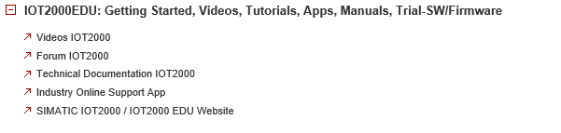

Further information

Siemens Automation Cooperates with Education  
**siemens.com/sce**

SCE Training Curriculums  
**siemens.com/sce/module**

SIMATIC IOT2000   
**siemens.com/sce/IOT2000**

SCE Trainer Packages  
**siemens.com/sce/tp**

IOT2000 Forum  
[**siemens.com/iot2000-forum**](http://www.siemens.com/iot2000-forum)

SCE Contact Partners   
**siemens.com/sce/contact**

Digital Enterprise  
**siemens.com/digital-enterprise**

Industry 4.0   
**siemens.com/future-of-manufacturing**

Totally Integrated Automation (TIA)  
**siemens.com/tia**

TIA Portal  
**siemens.com/tia-portal**

SIMATIC Controller  
**siemens.com/controller**

SIMATIC Technical Documentation   
**siemens.com/simatic-docu**

Industry Online Support  
**support.industry.siemens.com**

Product catalog and online ordering system Industry Mall   
**mall.industry.siemens.com**

Siemens AG  
Digital Factory   
P.O. Box 4848  
90026 Nuremberg  
Germany

Subject to change and errors  
© Siemens AG 2018

**siemens.com/sce**