

Learn-/Training Document  
  
Siemens Automation Cooperates with Education (SCE) | As of Version V15.1

**siemens.com/sce**

TIA Portal Module 020-112

SIMIT Process Simulation –   
Coupling with SIMATIC S7-1500 / OPC UA

**Matching SCE Trainer Packages for this Learn-/Training Document**

SIMATIC Controllers with SIMATIC STEP 7 V15.1

* **SIMATIC ET 200SP Distributed Controller CPU 1512SP F-1 PN Safety**

Order no.: 6ES7512-1SK00-4AB2

* **SIMATIC CPU 1516F PN/DP Safety with Software**

Order no.: 6ES7516-3FN00-4AB2

* **SIMATIC S7 CPU 1516 PN/DP with Software**Order no.: 6ES7516-3AN00-4AB3
* **SIMATIC CPU 1512C-1 PN withSoftware**Order no.: 6ES7512-1CK00-4AB6
* **SIMATIC CPU 1512C-1 PN with Software and PM 1507**Order no.: 6ES7512-1CK00-4AB1
* **SIMATIC CPU 1512C-1 PN with Software and CP 1542-5 (CP PROFIBUS)**Order no.: 6ES7512-1CK00-4AB7
* **SIMATIC CPU 1512C-1 PN with Software, PM 1507 and CP 1542-5 (CP PROFIBUS)**Order no.: 6ES7512-1CK00-4AB2

SIMIT Simulation Platform

* **SIMIT Simulation Platform with Dongle V10.0**

Order no.: 6DL8913-0AK00-0AS5

* **Upgrade SIMIT Simulation Platform V10.0**

Order no.: 6DL8913-0AK00-0AS6

* **Demo Version SIMATIC SIMIT Simulation Platform V10.0**

Download: [support.industry.siemens.com/cs/ww/de/ps/17120/dl](https://support.industry.siemens.com/cs/ww/de/ps/17120/dl)

**SIMATIC STEP 7 Software for Training**

* **SIMATIC STEP 7 Professional V15.1 - Single License**  
  Order no.: 6ES7822-1AA05-4YA5
* **SIMATIC STEP 7 Professional V15.1 - 6+20 User Classroom License**   
  Order no.: 6ES7822-1BA05-4YA5
* **SIMATIC STEP 7 Professional V15.1 - 6+20 User Upgrade License**  
  Order no.: 6ES7822-1AA05-4YE5
* **SIMATIC STEP 7 Professional V15.1 - Student License for 20 Users**  
  Order no.: 6ES7822-1AC05-4YA5

Note that these trainer packages are replaced with successor packages when necessary.

An overview of the currently available SCE packages is available at: [siemens.com/sce/tp](http://www.siemens.com/sce/tp)

**Continued training**

For regional Siemens SCE continued training, get in touch with your regional SCE contact

[siemens.com/sce/contact](http://www.siemens.com/contact)

**Additional information regarding SCE**

[siemens.com/sce](http://www.siemens.com/sce)

**Information regarding use**

The SCE Learn-/Training Document for the integrated automation solution Totally Integrated Automation (TIA) was prepared for the program "Siemens Automation Cooperates with Education (SCE)" specifically for training purposes for public educational facilities and R&D institutions. Siemens does not guarantee the contents.

This document is only to be used for initial training on Siemens products/systems. This means it can be copied in whole or in part and given to trainees/students for use within the scope of their training/course of study. Disseminating or duplicating this document and sharing its content is permitted within public training and advanced training facilities for training purposes or as part of a course of study.

Exceptions require written consent from the Siemens. Send all related requests to

[scesupportfinder.i-ia@siemens.com](mailto:scesupportfinder.i-ia@siemens.com).

Offenders will be held liable. All rights including translation are reserved, particularly if a patent is granted or a utility model or design is registered.

Use for industrial customer courses is explicitly not permitted. We do not consent to commercial use of the Learn-/Training Document.

We wish to thank the TU Dresden and the Michael Dziallas Engineering Corporation and all other involved persons for their support during the preparation of this Learn-/Training Document.

**Table of contents**

1 Goal 5

2 Requirement 5

3 Required hardware and software 6

4 Theory 7

4.1 SIMIT V10 7

5 Required settings in Windows 10 8

5.1 Read permission for the SIMIT directory 8

6 Task 10

7 Planning 10

8 Structured step-by-step instructions 11

8.1 Retrieving an existing project in the TIA Portal 11

8.2 Creating a SIMIT application with "PLCSIM Advanced" coupling 21

8.3 Starting an existing SIMIT project with "OPC UA Client" coupling with a CPU 1516F as OPC UA server 30

9 Additional information 41

SIMIT Process Simulation – Coupling with SIMATIC S7-1500   
via OPC UA

# Goal

The following pages will show how a coupling with a SIMATIC S7-1500 via OPC UA can be set up in the SIMIT process simulation software.

The order in which existing SIMIT projects with this coupling variant can be started together with a TIA Portal project for simulation of a program solution will also be described.

# Requirement

This chapter builds on the chapter "SCE_EN_092-300 OPC UA with SIMATIC S7-1500 as OPC Server …". To perform the work in this chapter, you can use the following project, for example: "sce-092-300-opc-ua-s7-1500 ...".

# Required hardware and software

**1** Engineering station: Requirements include hardware and operating system   
(for additional information, see Readme on the TIA Portal Installation DVDs)

**2** SIMATIC STEP 7 Professional software in TIA Portal – V15.1 or higher

**3** SIMIT software – V10.0 Update 1 or higher (with dongle or in Demo mode)

**4** SIMATIC S7-1500 controller, e.g. CPU 1516F-3 PN/DP –   
Firmware V2.6 or higher with memory card

**5** Ethernet connection between engineering station and controller

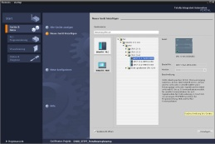

**2** SIMATIC STEP 7 Professional (TIA Portal) V15.1 or higher



**3** SIMIT – V10.0 Update 1 or higher



**1** Engineering station

**5** Ethernet connection

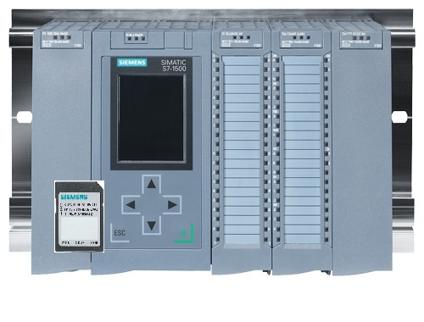

**4** SIMATIC S7-1500 controller

# Theory

## SIMIT V10

SIMIT is a process simulation software that can be used for the following:

* Complete plant simulation
* Simulation of signals, devices and plant responses
* Input and output simulator of test signals for an automation controller
* Testing and commissioning of automation software

SIMIT provides the following components for creating a simulation:

* **Chart**

To build a simulation, components available in the libraries are put together in the chart editor and suitable parameters are entered.

* **Visualization**

Visualizations provide an overview of the signals of your plant. Signals are visualized with controls (input and display objects) and graphical objects.

* **Coupling**

The coupling is the interface to the automation system and is required for signal exchange. In addition to couplings with PLCSIM, PLCSIM Advanced, PRODAVE, etc., there is also a coupling with SIMIT as OPC UA client.

**Demo mode**

In demo mode you can get an impression of the use and performance capability of SIMIT without having to have a valid license.

However, SIMIT has only a limited range of functions in demo mode.

Previously created models can be opened, simulated and changed in demo mode. New models can also be created. In demo mode, the models can only be run on the computer on which they were created.

SIMIT Simulation is limited to 45 minutes in demo mode. The simulation must then be restarted.

Note:   
 – Further details and information can be found in the manuals, which can be downloaded from   
 [support.automation.siemens.com](http://support.automation.siemens.com/).

# Required settings in Windows 10

Before you can set up a coupling with a SIMATIC S7-1500 via OPC-UA in the SIMIT process simulation software, the following settings in Windows 10 must be checked.

## Read permission for the SIMIT directory

The user who is logged onto the computer must have read permission for the following drive path:

C:\ProgramData\Siemens\Automation\SIMIT\8.0\PKI\own\private

* Navigate with Windows 10 “Explorer” to the specified directory C:\ProgramData\Siemens\Automation\SIMIT\8.0\PKI\own\private  
  ( → Explorer → C → ProgramData → Siemens → Automation → SIMIT→ 8.0 → PKI → own → private)

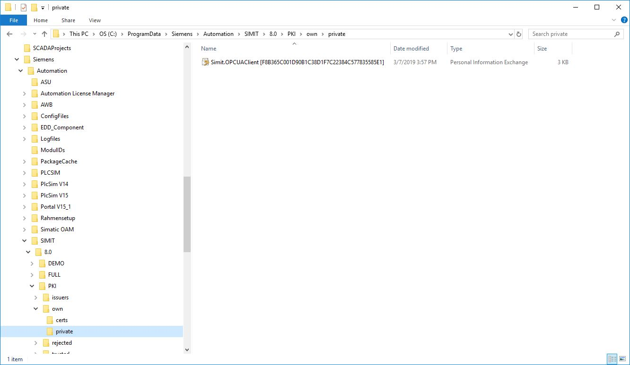

* If you receive the message shown here, you can get access to this folder by clicking "Continue". However, this only works if you have administrator rights on the computer. If not, you must reach out to your administrator. ( → Continue)

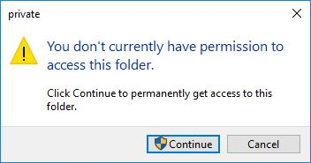

# Task

A SIMIT simulation is to be created with a coupling with SIMATIC S7-1500 via OPC UA. In so doing, the symbols of the inputs and outputs in the SIMATIC S7-1500 are to be accessed.

# Planning

First, an existing TIA Portal project with activated OPC UA server is retrieved.

The following adaptations are then made:

* All FBs and DBs are removed from the project because the tags created there will otherwise be imported as signals.
* In the tag tables, the "Writable from HMI/OPC UA" attribute must be deselected for the PLC outputs. Otherwise, they will be imported into SIMIT as PLC inputs.
* The IO addresses to be simulated using SIMIT must not exist as hardware modules. You will remove all affected IO modules accordingly.

Finally, the hardware configuration with the tag tables is also downloaded to the controller.

Next, a SIMIT project is created and a new coupling "OPC UA Client" with the SIMATIC S7-1500 is created there.

The IO addresses are then imported from the SIMATIC S7-1500 via OPC UA.

For simulation of a program solution, an existing TIA Portal project with activated OPC UA server is opened and downloaded to the SIMATIC S7-1500.

The SIMIT project is now opened and started for testing the program solution.

# Structured step-by-step instructions

You can find instructions on how to implement planning below. If you have advanced knowledge, it is sufficient to complete the numbered steps. Otherwise, it is recommended that you follow the individual steps of the instructions below.

## Retrieving an existing project in the TIA Portal

* Before you can access the "sce-092-300-opc-ua-s7-1500…" project from chapter "SCE_EN_092-300-OPC UA-S7-1500", you must retrieve it. To retrieve an existing project that has been archived, you must select the relevant archive with → Project → Retrieve in the project view. Confirm your selection with "Open".

(→ Project → Retrieve → Select a .zap archive … → Open)

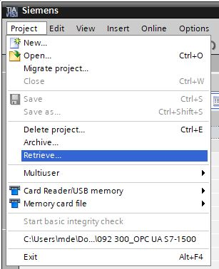

* The next step is to select the destination folder where the retrieved project will be stored. Confirm your selection with "OK". ( → Target directory … → OK)
* All FBs and DBs must be removed from the project because the tags created there will otherwise be imported as signals. You can delete any program blocks in the project by selecting them and right-clicking. Select "Delete" to confirm the removal. (→ CPU_1516F → Program blocks → Delete)

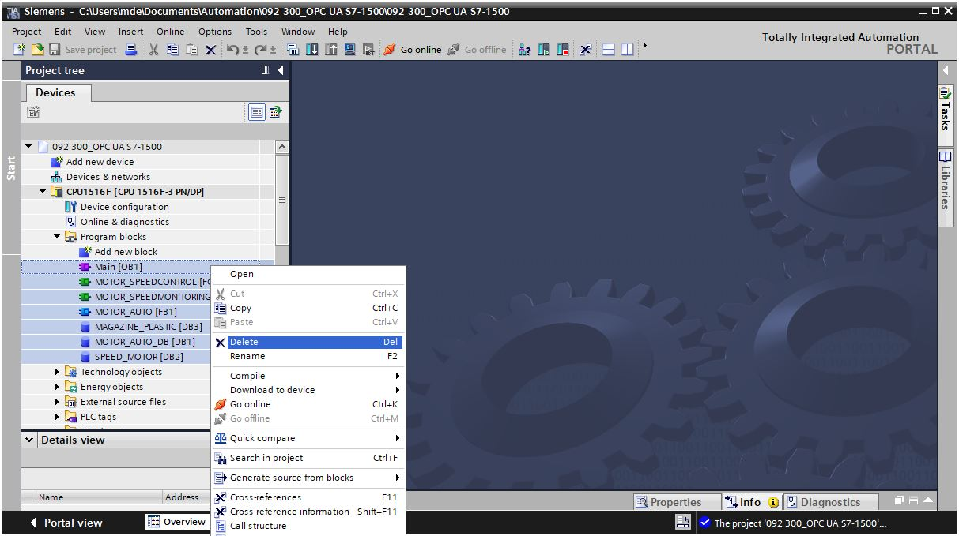

* In the tag tables, the "Writable from HMI/OPC UA" attribute must be deselected for the PLC outputs. Otherwise, they will be imported into SIMIT as PLC inputs. Open the "Tag table_sorting station" and deselect the "Writable from HMI/OPC UA" attribute for all output signals. ( → CPU_1516F → PLC tags → Tag table_Sorting station →  Writable from HMI/OPC UA)

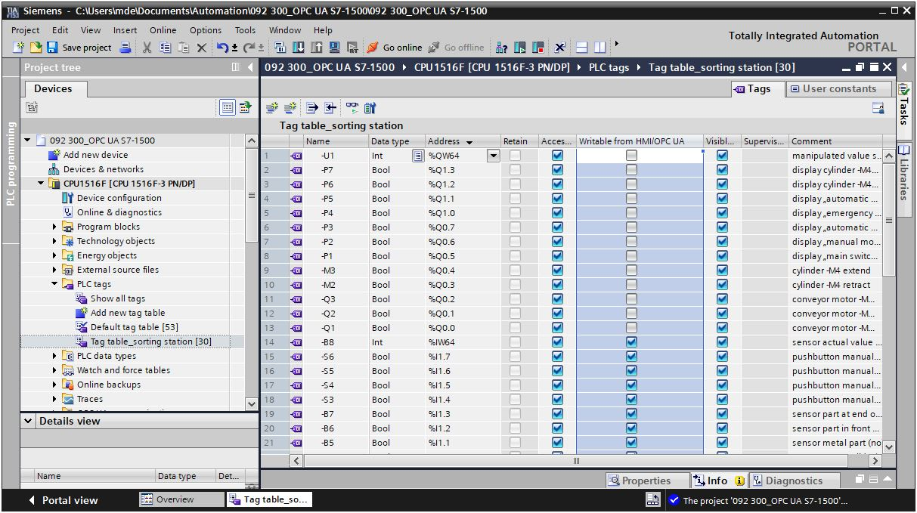

* The IO addresses to be simulated using SIMIT must not exist as hardware modules. All I/O modules are removed accordingly by selecting them and then right-clicking. Select "Delete" to confirm the removal. ( → CPU_1516F → Device configuration → Delete)

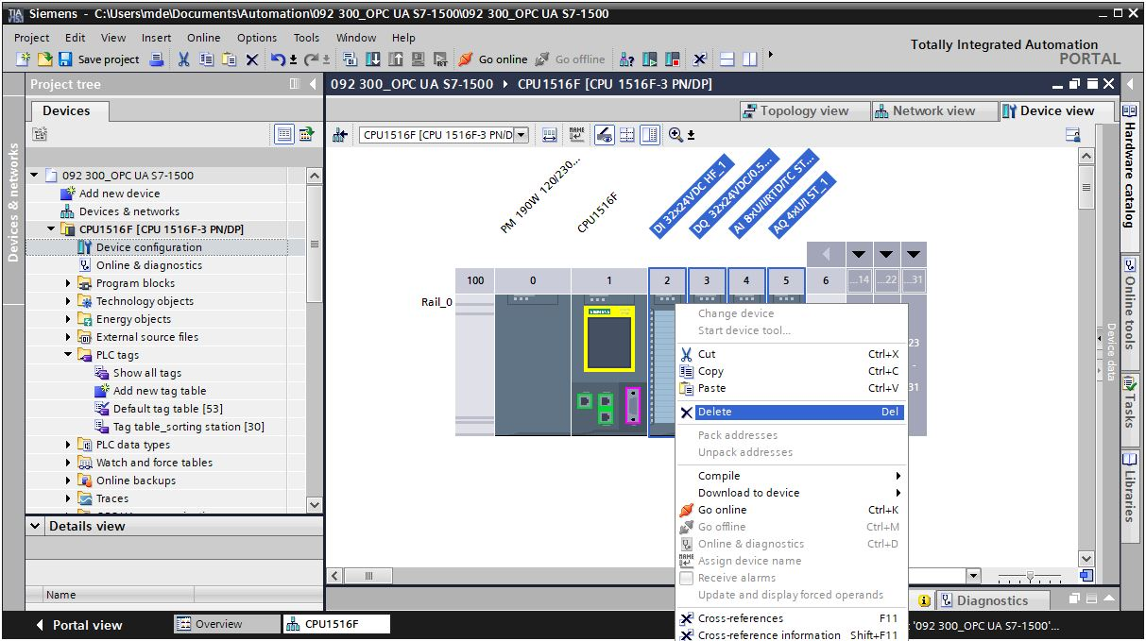

* Click the "CPU_1516F" folder. In the menu, select the "005" button and then the   
  "052" button for compiling. (→ CPU_1516F → 005 → 052)

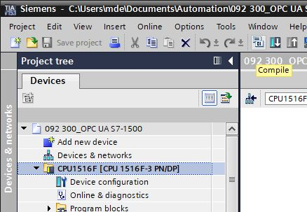

* To download your entire CPU, select the → "CPU_1516F [CPU1516F-3 PN/DP]" folder and click the → "Download to device" button "0009".

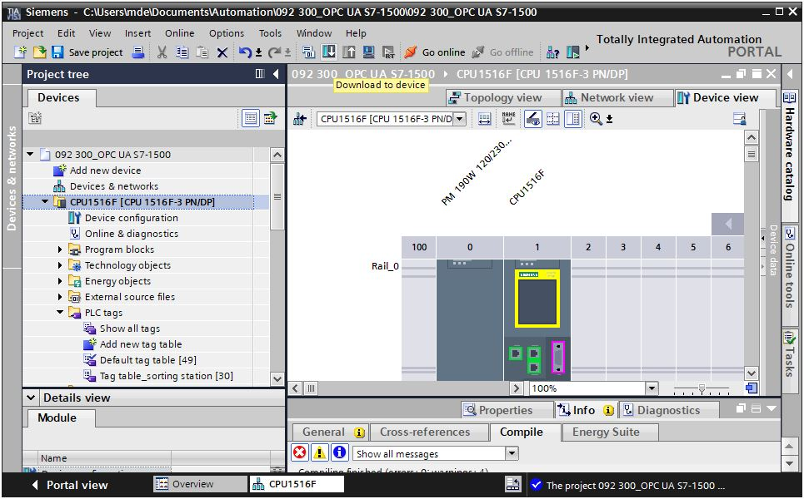

* The manager for configuring the connection properties (extended download) opens shortly thereafter.

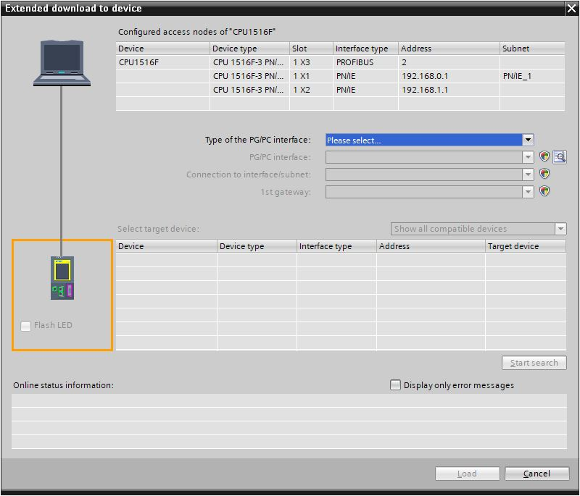

* First, the interface must be correctly selected. This happens in three steps.

→ Type of the PG/PC interface → PN/IE

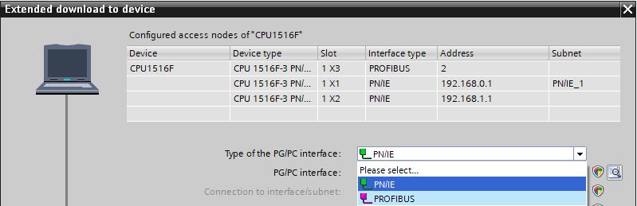

→ PG/PC interface → here: Intel(R) Ethernet Connection I217-LM

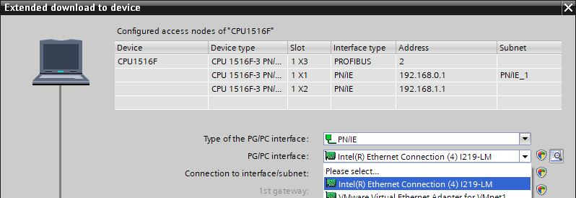

→ Connection to interface/subnet → "PN/IE_1"

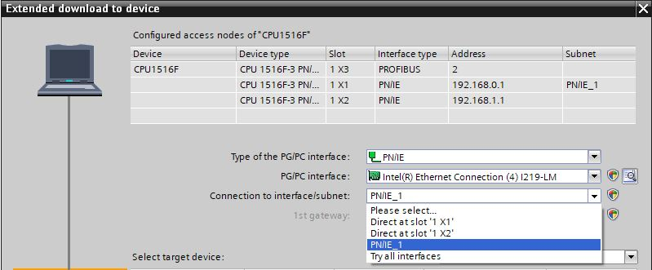

* The → "Show all compatible devices" check box must then be selected. The search for devices in the network is started by clicking the →  button.

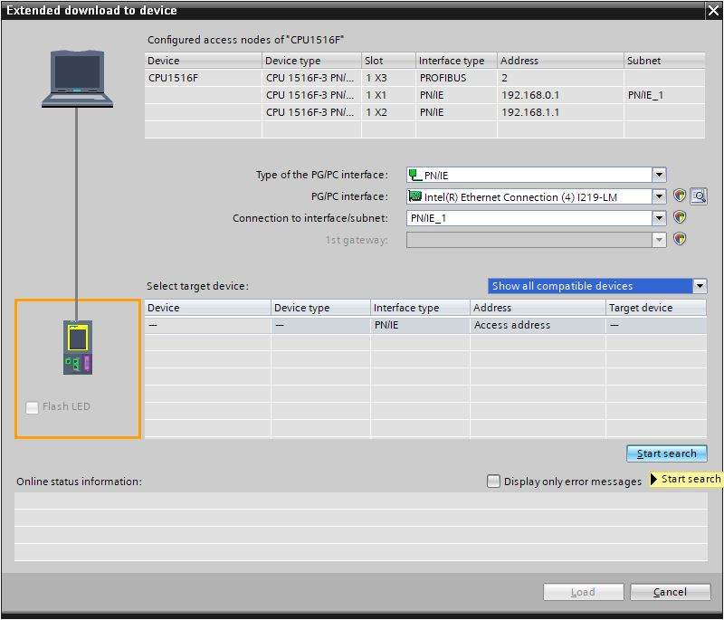

* If the controller is shown in the list of target devices, it must be selected before starting the download. (→ CPU1516F-3 PN/DP → Load)

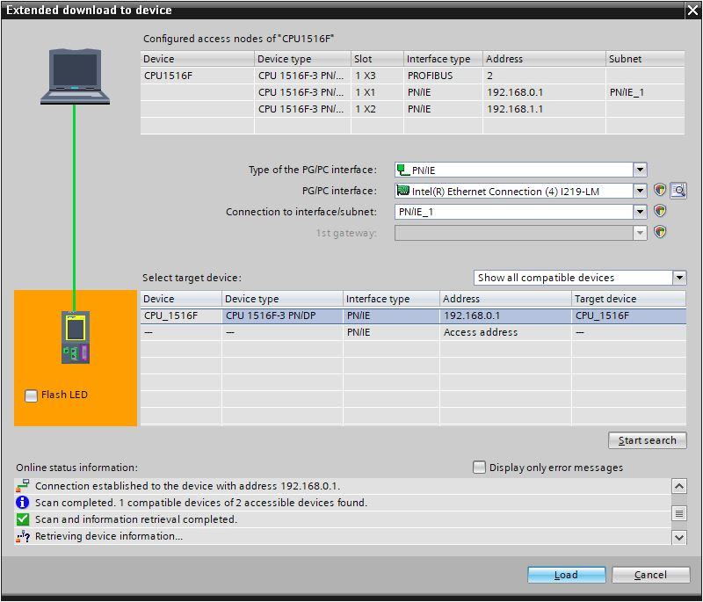

* You first obtain a preview. Confirm the suggested actions and continue with → "Load".

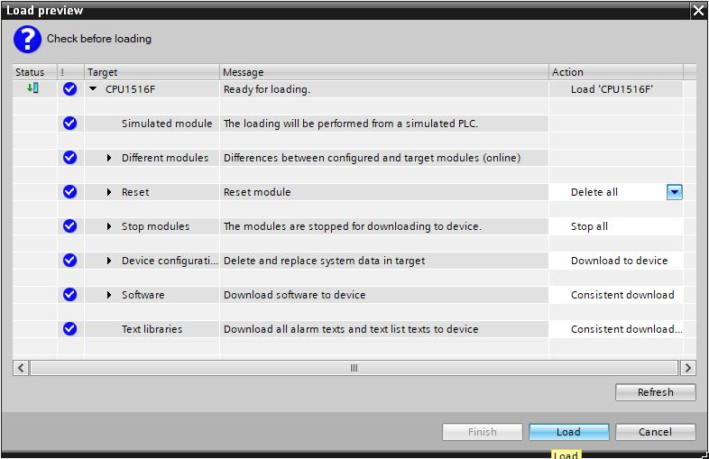

Note:   
 – The  symbol should be visible in every line of the "Load preview". You can find additional   
 information in the "Message" column.

* The → "Start module" option is now selected before the download operation can be completed with → "Finish".

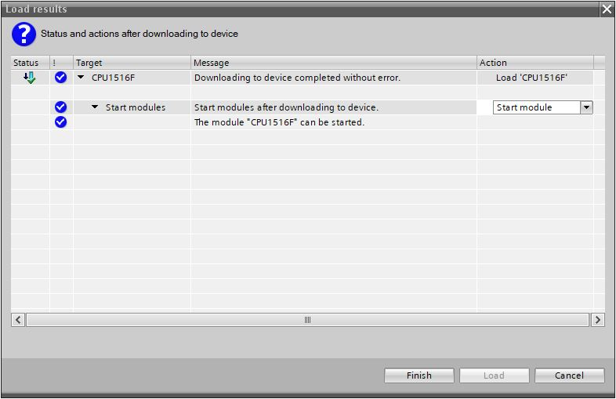

## Creating a SIMIT application with "PLCSIM Advanced" coupling

* Start SIMIT from the desktop of your computer by double-clicking on the logo for the "SIMIT SP" application ( → SIMIT SP)



* Create a new project "020-112_SIMIT S7-1500 OPC UA". ( → Create new project → 020-112_SIMIT S7-1500 OPC UA → Create)

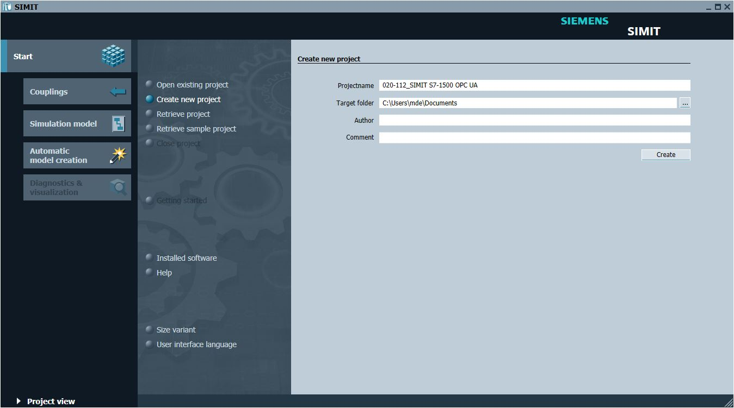

* Change to the "Project view". ( → Project view)

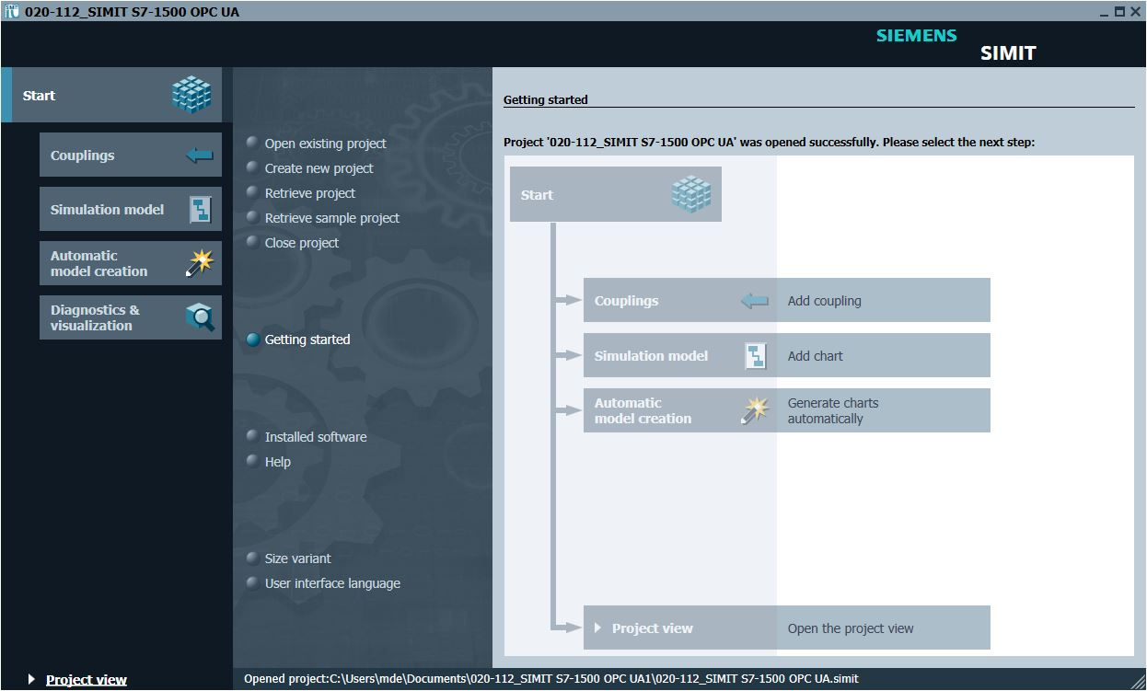

* Create a "New coupling" "OPC UA Client" for your project under "Couplings".   
  (→ Couplings → New coupling → OPC UA Client → OK)

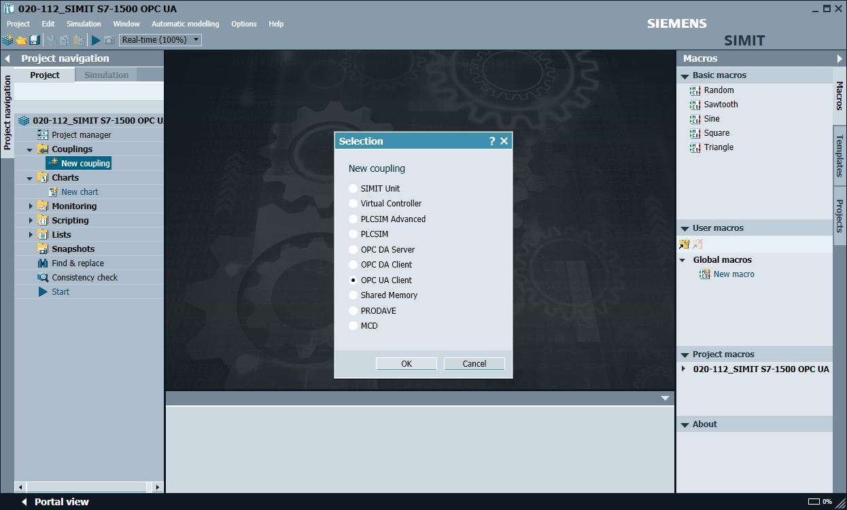

* Change to the TIA Portal and open the "Device configuration" in the previously retrieved project "092-300_OPC UA S7-1500". Select the CPU. In the properties under OPC UA, copy the address of the OPC UA server activated there. (→ 092-300_OPC UA S7-1500 → Device configuration → CPU_1516F → Properties → OPC UA → General → Server addresses → opc-tcp://192.168.0.1:4840 → Copy)

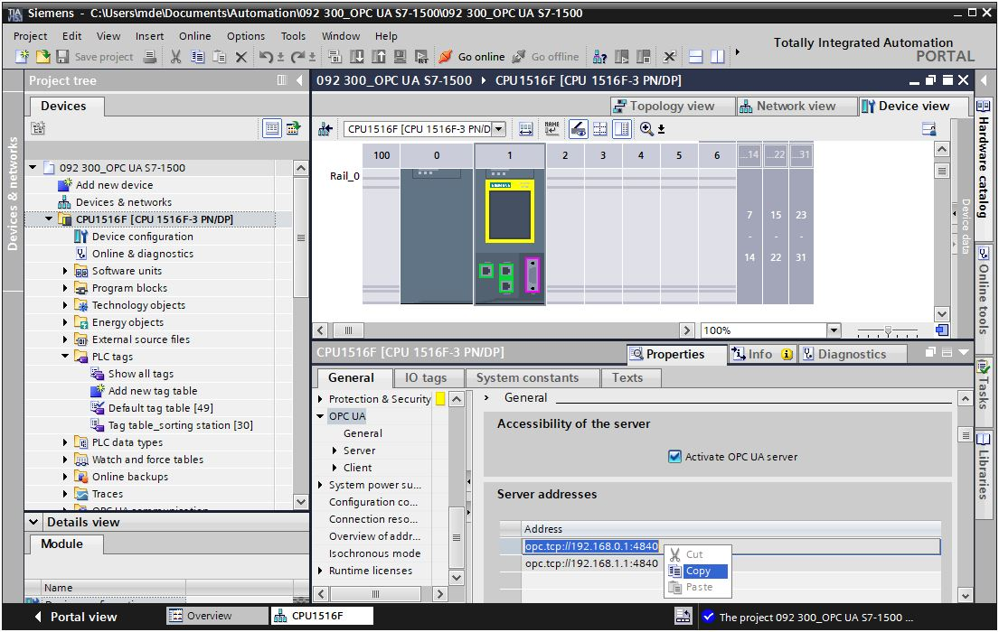

* Paste the previously copied OPC UA server address of the CPU 1516F into SIMIT as "OPC UA Server URL" under "Couplings", "OPC UA client". (→ SIMIT → Couplings → OPC UA Client → Properties → OPC UA Server URL → Paste)

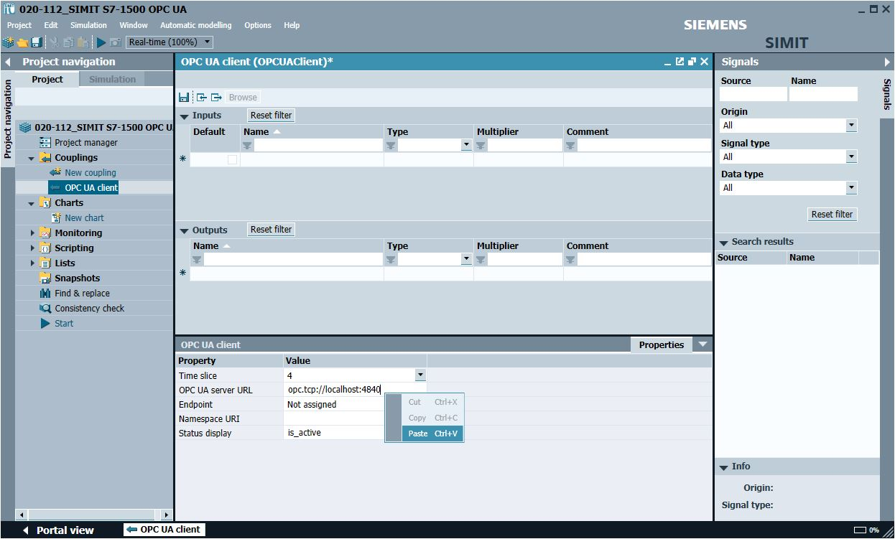

* Under "Properties", select the settings shown below for "Endpoint" and "Namespace URI". (→ Properties → Endpoint → Name space URI)

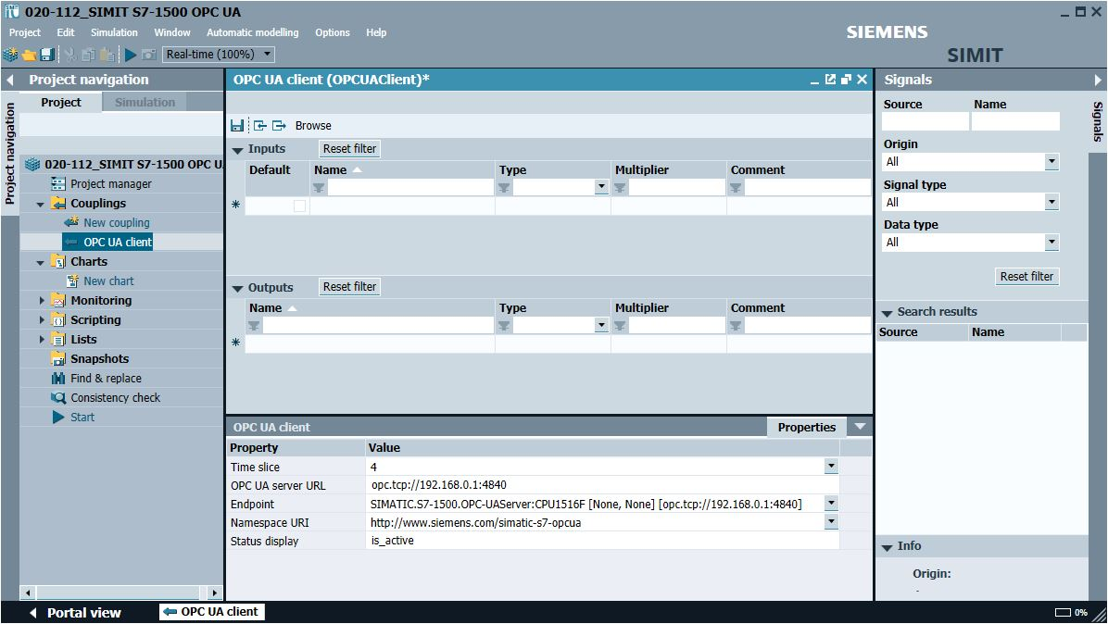

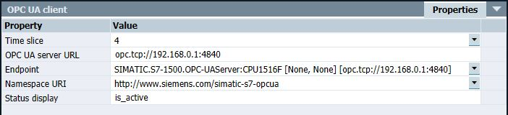

Note:   
 – If the following error message appears, you need to check the required settings in Windows 10   
 described in chapter 5

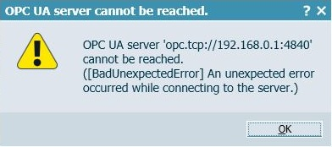

* When you click the "" button, the inputs and outputs from the tag table previously downloaded to the CPU 1516F are imported and made available for further use in the simulation. ( → Browse)

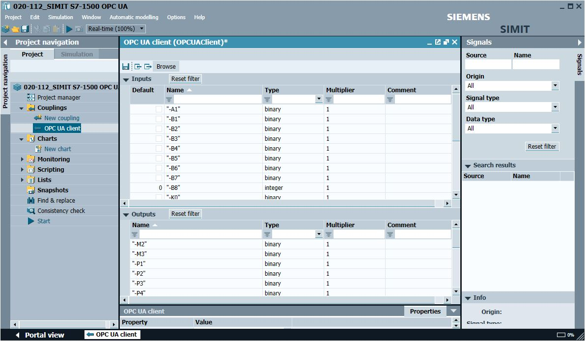

* Select " Save all". (→ ) Click " Start" to start the simulation. (→ )

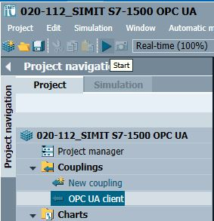

* After starting the simulation, you can test the access to the inputs and outputs of the S7-1500 station in SIMIT.
* You can see whether this access is functioning in the tag tables in TIA Portal by clicking the 00011 button. (® 00011)
* Clicking on "" again ends the simulation in SIMIT. (→ )

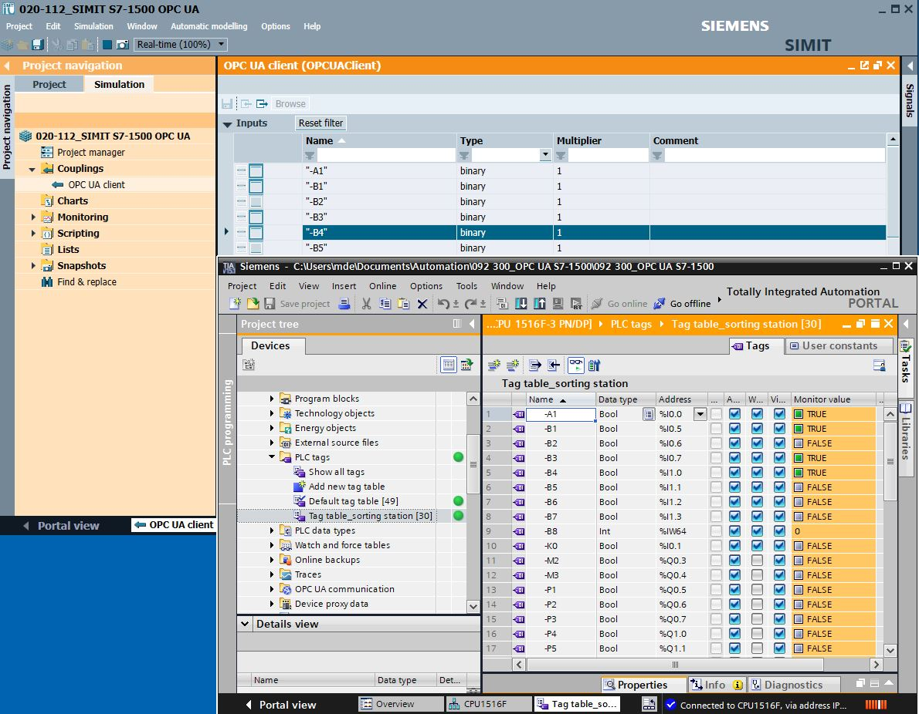

* "Archive" the SIMIT project. (→ Project → Archive)

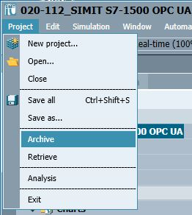

## Starting an existing SIMIT project with "OPC UA Client" coupling with a CPU 1516F as OPC UA server

* Start the "TIA Portal" from the desktop of your computer by double-clicking on the logo for the application. (→ TIA Portal)

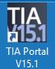

* Open or retrieve the desired TIA Portal project. Here, the project for the sorting station "sce-092-300-opc-ua-s7-1500…" is opened. Change to the project view. ( → Open existing project → sce-092-300-opc-ua-s7-1500… → Open → Project view)

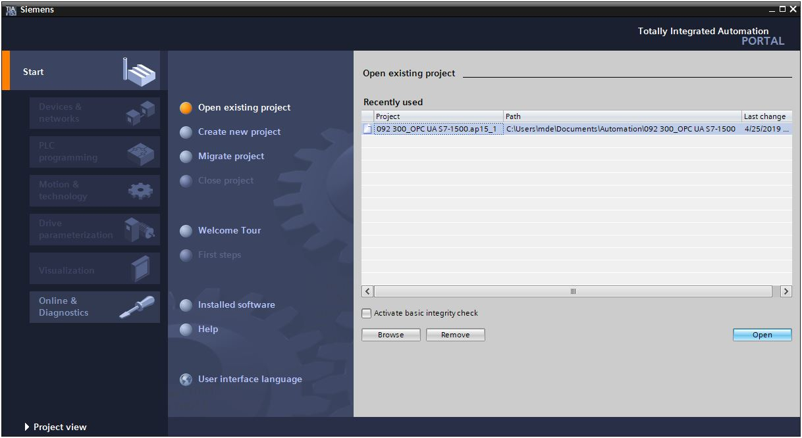

* To download your entire CPU, select the → "CPU_1516F [CPU1516F-3 PN/DP]" folder and click the → "Download to device" button "0009".

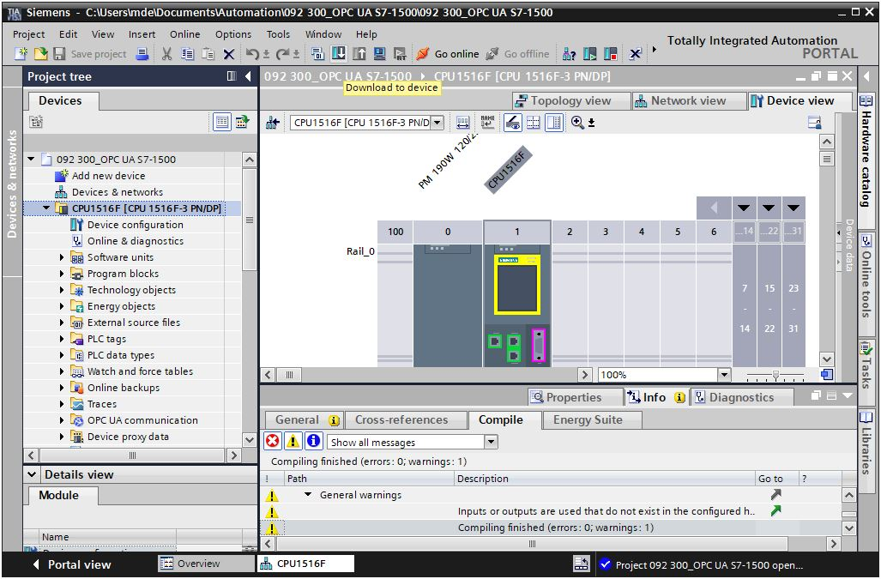

Note:   
 – The IO addresses to be simulated using SIMIT must not exist as hardware modules.

* The manager for configuring the connection properties (extended download) opens shortly thereafter.



* First, the interface must be correctly selected. This happens in three steps.  
  → Type of the PG/PC interface → PN/IE



→ PG/PC interface → here: Intel(R) Ethernet Connection I217-LM



→ Connection to interface/subnet → "PN/IE_1"



* The → "Show all compatible devices" check box must then be selected. The search for devices in the network is started by clicking the →  button.



* If the controller is shown in the list, it must be selected before the download can be started. (→ CPU1516F-3 PN/DP → Load)



* You first obtain a preview. Confirm the suggested actions and continue with → "Load".



Note:   
 – The  symbol should be visible in every line of the "Load preview". You can find additional  
 information in the "Message" column

* The → "Start module" option is now selected. You can then finish the download operation with → "Finish".



* Start SIMIT from the desktop of your computer by double-clicking on the logo for the "SIMIT SP" application (→ SIMIT SP)



* Open or retrieve the desired project. This is where the project for the sorting station "020-112-sce-sorting-station-s7-1500-opc-ua-r1904-en.simarc" is retrieved. ( → Retrieve project → 020-112-sce-sortieranlage-s7-1500-opc-ua-r1904-en.simarc → Retrieve)

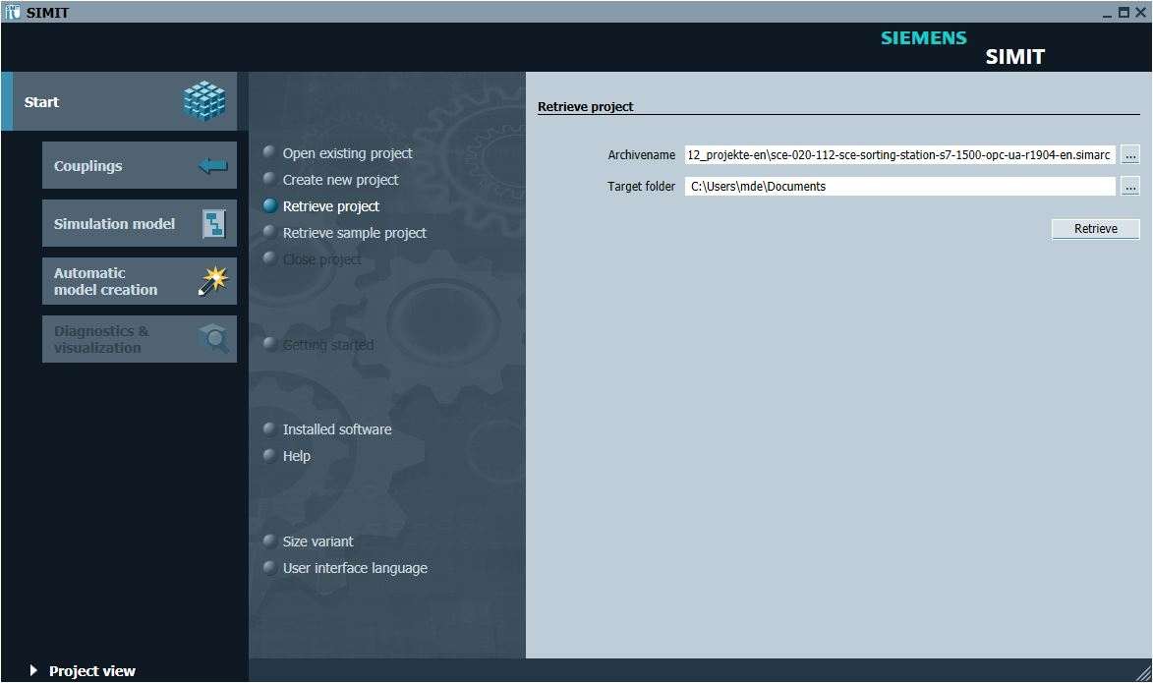

* Confirm the security prompt with "Yes". ( → Yes)

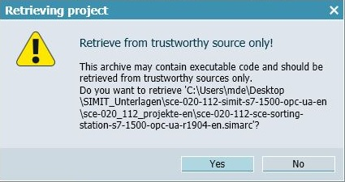

* Change to the "Project view". ( → Project view)

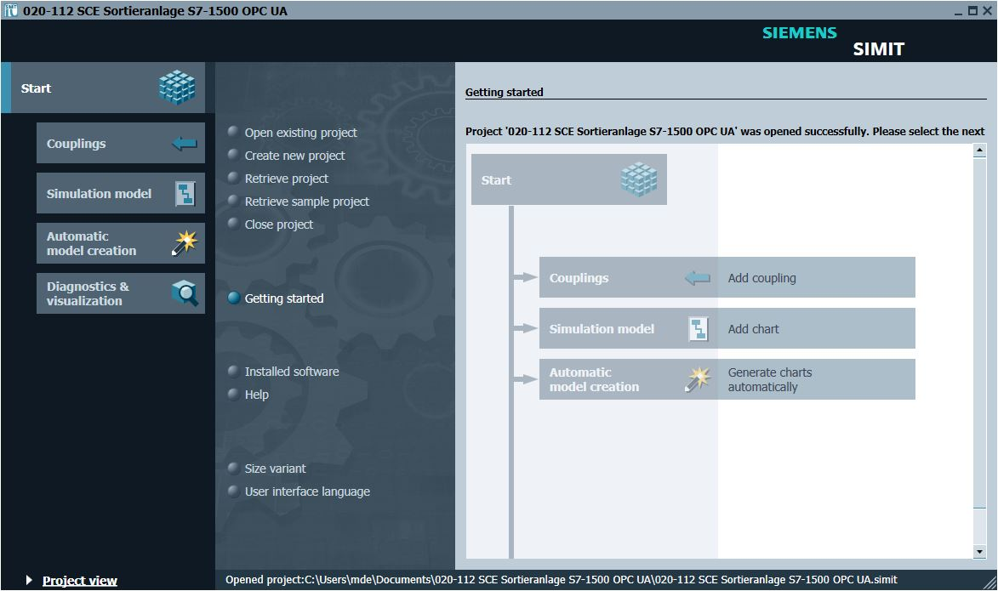

* Double-click the "01_operating screen" chart to open it. ( → 01_operating screen)

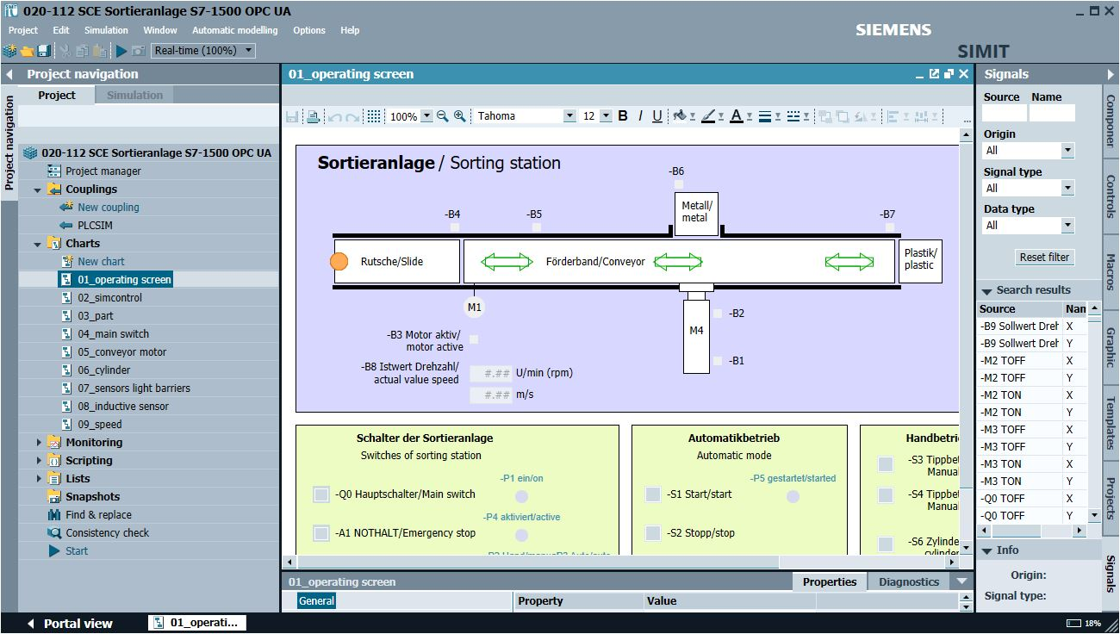

* Select " Save all" and select " Start" to start the simulation. (→  → )

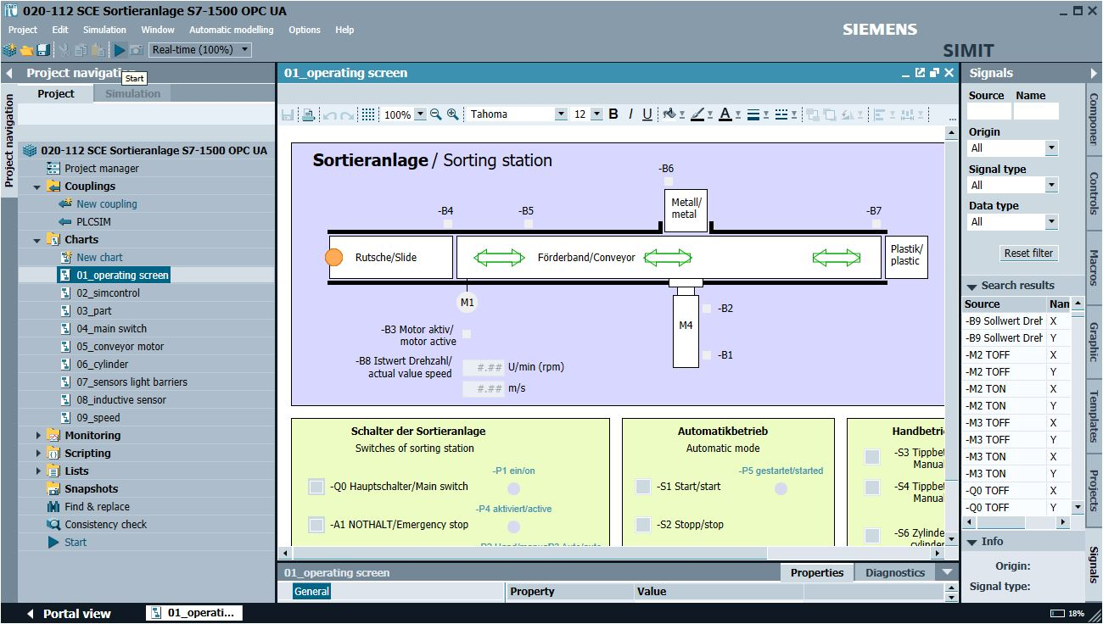

* The simulation is activated. The application turns orange to indicate this.

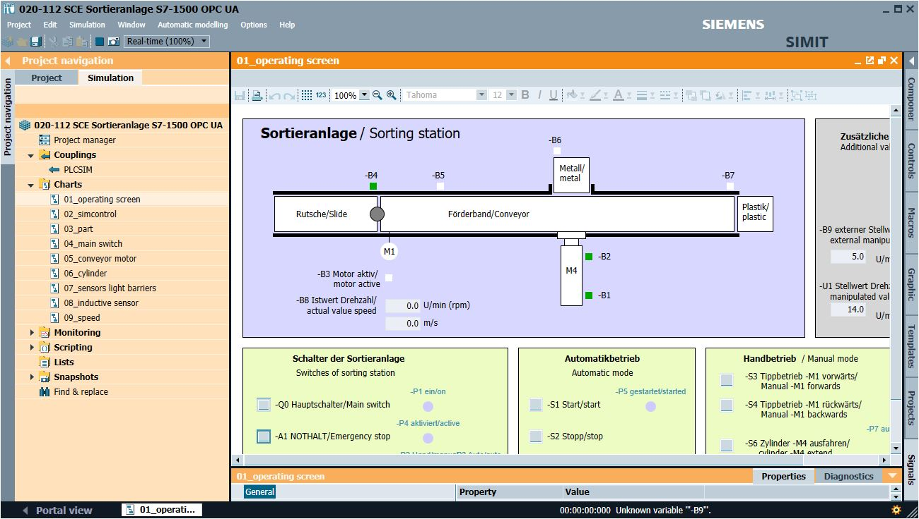

* The application can be tested in SIMIT. Clicking on "" again ends the simulation in SIMIT. (→ )

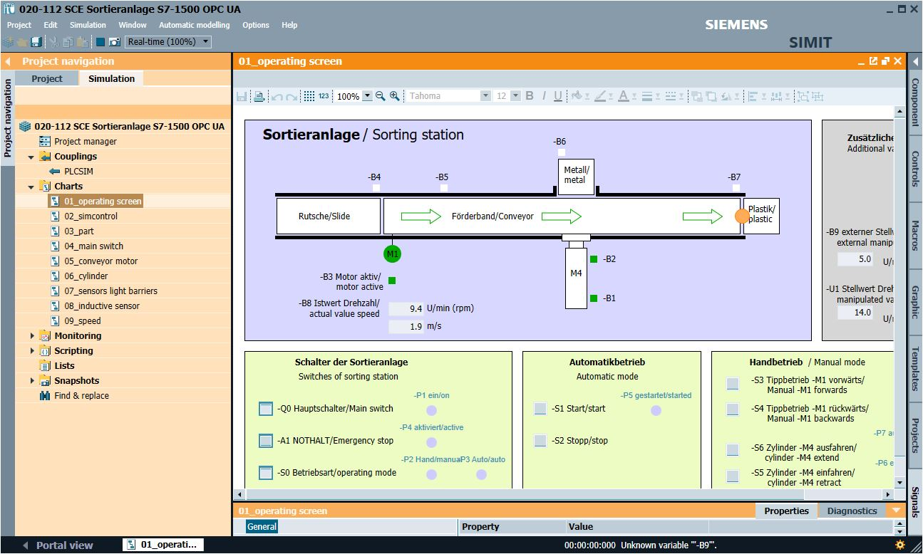

# Additional information

You can find additional information as an orientation aid for initial and advanced training, for example: Getting Started, videos, tutorials, apps, manuals, programming guidelines and trial software/firmware, at the following link:

[siemens.com/sce/s7-1200](http://www.siemens.com/sce/s7-1200)

Preview „Additional information“

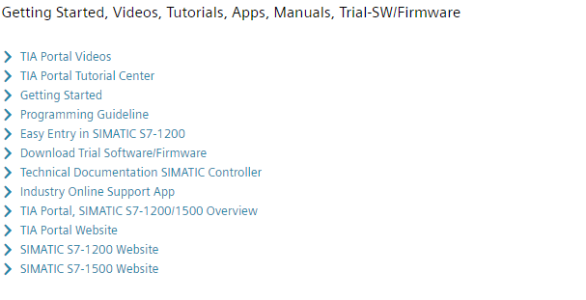

Further Information

Siemens Automation Cooperates with Education  
**siemens.com/sce**

SCE Learning/Training Documents  
**siemens.com/sce/module**

SCE Trainer Packages  
**siemens.com/sce/tp**

SCE Contact Partners   
**siemens.com/sce/contact**

Digital Enterprise  
**siemens.com/digital-enterprise**

Industry 4.0   
**siemens.com/future-of-manufacturing**

Totally Integrated Automation (TIA)  
**siemens.com/tia**

TIA Portal  
**siemens.com/tia-portal**

SIMATIC Controller  
**siemens.com/controller**

SIMATIC Technical Documentation   
**siemens.com/simatic-docu**

Industry Online Support  
**support.industry.siemens.com**

Industry Mall catalog and ordering system   
**mall.industry.siemens.com**

Siemens  
Digital Industries, FA   
P.O. Box 4848  
90026 Nuremberg  
Germany

Errors excepted and subject to change without prior notice.  
© Siemens 2019

**siemens.com/sce**