**si**



Learn-/Training Document  
  
Siemens Automation Cooperates with Education (SCE) | As of Version V15.1

**siemens.com/sce**

TIA Portal Module 020-110

SIMIT Process Simulation –

Coupling with S7-PLCSIM Advanced / TCP/IP

**Matching SCE Trainer Packages for this Learn-/Training Document**

SIMIT Simulation Platform

* **SIMIT Simulation Platform with Dongle V10.0**(includes SIMIT S & CTE, FLOWNET, CONTEC libraries) ‒ 2500-Simulation-Tags

Order no.: 6DL8913-0AK00-0AS5

* **Upgrade SIMIT Simulation Platform from V8.x/V9.x to V10.0**((includes SIMIT S & CTE, FLOWNET, CONTEC libraries)

Order no.: 6DL8913-0AK00-0AS6

* **Demoversion SIMIT Simulation Platform V10.0**

Download: [support.industry.siemens.com/cs/ww/de/ps/17120/dl](https://support.industry.siemens.com/cs/ww/de/ps/17120/dl)

**SIMATIC STEP 7 Software for Training**

* **SIMATIC STEP 7 Professional V15.1 - Single License**  
  Order no.: 6ES7822-1AA05-4YA5
* **SIMATIC STEP 7 Professional V15.1 - 6+20 User Classroom License**   
  Order no.: 6ES7822-1BA05-4YA5
* **SIMATIC STEP 7 Professional V15.1 - 6+20 User Upgrade License**  
  Order no.: 6ES7822-1AA05-4YE5
* **SIMATIC STEP 7 Professional V15.1 - Student License for 20 Users**  
  Order no.: 6ES7822-1AC05-4YA5

Note that these trainer packages are replaced with successor packages when necessary.

An overview of the currently available SCE packages is available at: [siemens.com/sce/tp](http://www.siemens.com/sce/tp)

**Continued training**

For regional Siemens SCE continued training, get in touch with your regional SCE contact

[siemens.com/sce/contact](http://www.siemens.com/contact)

**Additional information regarding SCE**

[siemens.com/sce](http://www.siemens.com/sce)

**Information regarding use**

The SCE Learn-/Training Document for the integrated automation solution Totally Integrated Automation (TIA) was prepared for the program "Siemens Automation Cooperates with Education (SCE)" specifically for training purposes for public educational facilities and R&D institutions. Siemens does not guarantee the contents.

This document is only to be used for initial training on Siemens products/systems. This means it can be copied in whole or in part and given to trainees/students for use within the scope of their training/course of study. Disseminating or duplicating this document and sharing its content is permitted within public training and advanced training facilities for training purposes or as part of a course of study.

Exceptions require written consent from the Siemens. Send all related requests to

[scesupportfinder.i-ia@siemens.com](mailto:scesupportfinder.i-ia@siemens.com).

Offenders will be held liable. All rights including translation are reserved, particularly if a patent is granted or a utility model or design is registered.

Use for industrial customer courses is explicitly not permitted. We do not consent to commercial use of the Learn-/Training Document.

We wish to thank the TU Dresden and the Michael Dziallas Engineering Corporation and all other involved persons for their support during the preparation of this Learn-/Training Document.

Table of contents

[1 Goal 5](#_Toc16614526)

[2 Requirement 5](#_Toc16614527)

[3 Required hardware and software 6](#_Toc16614528)

[4 Theory 7](#_Toc16614529)

[4.1 SIMIT V10 7](#_Toc16614530)

[4.2 Adding a user to the SIEMENS TIA Openness group 8](#_Toc16614531)

[5 Task 11](#_Toc16614532)

[6 Planning 11](#_Toc16614533)

[7 Structured step-by-step instructions 12](#_Toc16614534)

[7.1 Retrieving an existing project in the TIA Portal 12](#_Toc16614535)

[7.2 Creating a SIMIT application with "PLCSIM Advanced" coupling 15](#_Toc16614536)

[7.3 Starting an existing SIMIT project with "PLCSIM Advanced" 22](#_Toc16614537)

[8 Additional information 33](#_Toc16614538)

SIMIT Process Simulation – Coupling with S7-PLCSIM Advanced via TCP/IP

# Goal

The following pages will show how a coupling with a SIMATIC S7-1500 program can be set up in PLCSIM Advanced via TCP/IP in the SIMIT process simulation software.

The order in which the existing SIMIT projects with this coupling variant can be started together with a TIA Portal project for simulation will also be described.

# Requirement

This chapter builds on the chapter "Global data blocks with SIMATIC S7 CPU 1516F-3 PN/DP". You can use the following project for this chapter, for example: "sce-032-600\_Global\_Data\_Blocks…".

# Required hardware and software

**1** Engineering station: Requirements include hardware and Windows 10 operating system  
(for additional information, see Readme on the TIA Portal Installation DVDs)

**2** SIMATIC STEP 7 Professional software in TIA Portal – V15.1 or higher

**3** SIMATIC S7-PLCSIM Advanced software – V2.0 SP1 or higher

**4** SIMIT software – V10.0 Update 1 or higher (with dongle or in Demo mode)

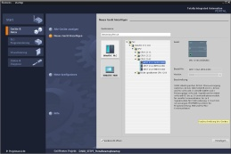

**2** SIMATIC STEP 7 Professional   
(TIA Portal) – V15.1 or higher

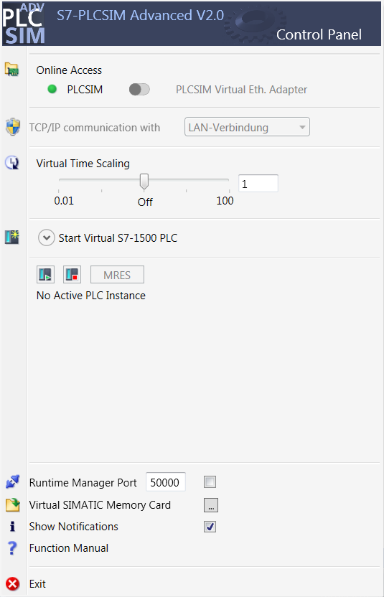

**3** SIMATIC S7-PLCSIM Advanced –  
V2.0 SP1 or higher



**1** Engineering station



**4** SIMIT – V10.0 Update 1 or higher

# Theory

## SIMIT V10

SIMIT is **process simulation software** that can be used for the following:

* + Complete plant simulation
  + Simulation of signals, devices and plant response
  + Input and output simulator of test signals for an automation controller
  + Testing and commissioning automation software

SIMIT provides the following components to create a simulation:

* + **Chart**

To develop a simulation, you combine the components available in the libraries using the chart editor and enter appropriate parameters.

* + **Visualization**

Visualizations provide an overview of the signals of your plant. Signals are visualized with controls (input and display objects) and graphical objects.

* + **Coupling**

The coupling is the interface to the automation system and is required for signal exchange. In addition to couplings with PLCSIM, PLCSIM Advanced, PRODAVE, etc., there is also a coupling with SIMIT as OPC UA client.

**Demo mode**

In Demo mode you can get an impression of the handling and performance of SIMIT without requiring a valid license.

However, SIMIT has only a limited range of functions in Demo mode.

Existing models can be opened and simulated in Demo mode. It is also possible to change these models and create new models. The models created or modified in this way can only be run on the computer on which they were created.

SIMIT Simulation is limited to 45 minutes in Demo mode. The simulation must then be restarted.

Note:

* *Further details and information can be found in the manuals, which can be downloaded from*[*support.automation.siemens.com*](http://support.automation.siemens.com/)*.*

Required settings in Windows 10

Before you can set up a coupling with PLCSIM Advanced in the SIMIT process simulation software, you must check the following settings in Windows 10.

## Adding a user to the SIEMENS TIA Openness group

The user who is logged onto the computer must be added to the "SIEMENS TIA Openness" group. This is done in "Computer Management".

* Open Computer Management via the Windows 10 Help. (→ Computer Management)

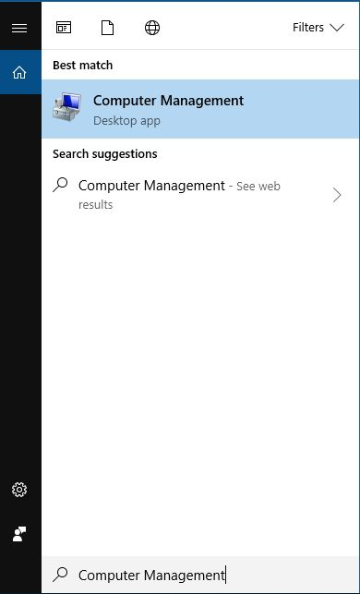

* Under Computer Management (Local), select the → "Siemens TIA Openness" group and choose → "Add to Group" in order to add the logged-on user to the "SIEMENS TIA Openness" group. (→ Computer Management (Local) → System → Local Users and Groups → Groups → SIEMENS TIA Openness → Add to Group)

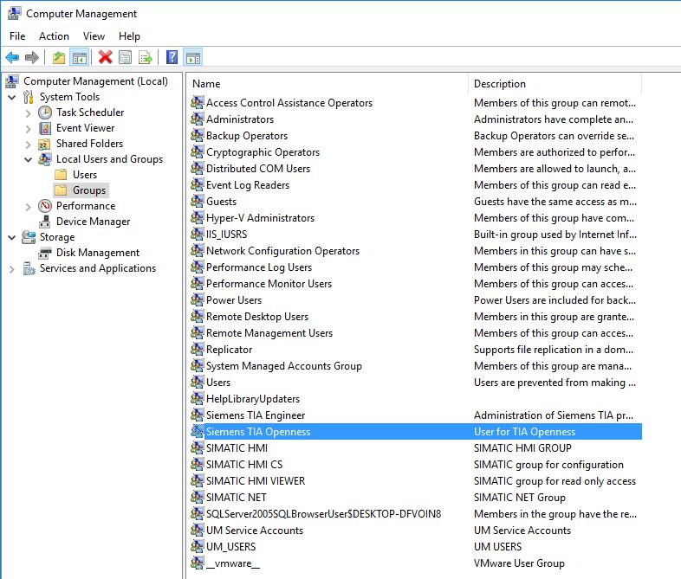

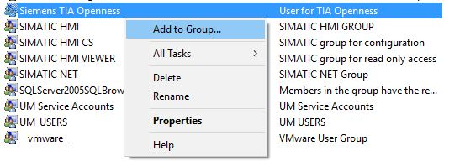

* The currently logged on user must be entered under → "Members". If not, the user must be entered using → "Add" and the user must be logged on again (→ Members → Add → \*current user name\* → OK → OK)

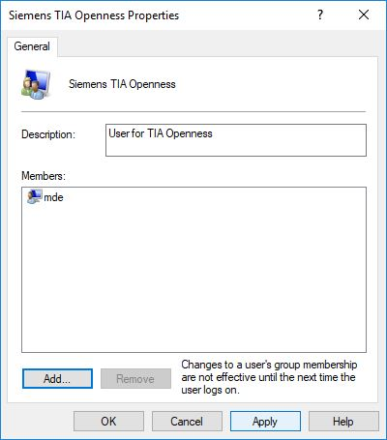

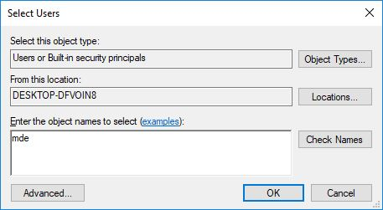

Note:

* *Remember to log the user off from and back onto the computer.*

# Task

A SIMIT simulation with a coupling to PLCSIM Advanced via TCP/IP is to be created. In so doing, the symbols of an existing TIA Portal project are to be accessed.

# Planning

The first step is to retrieve the existing TIA Portal project and close it again.

A SIMIT project is then created and a new "PLCSIM Advanced" coupling is created into which symbols from the TIA Portal project will be imported.

The SIMIT project is started for simulation of a program solution. PLCSIM Advanced can then be activated in the background, and the TIA Portal project can be loaded into PLCSIM Advanced for testing.

# Structured step-by-step instructions

You can find instructions on how to perform planning below. If you already have a good understanding of everything, it will be sufficient to focus on the numbered steps. Otherwise, follow the individual instructions in the steps below.

## Retrieving an existing project in the TIA Portal

* Before you can access the "sce-032-600\_Global\_Data\_Blocks…" project from chapter "SCE\_EN\_032-600 Global Data Blocks", you must retrieve this project. To retrieve an existing project that has been archived, you must select the relevant archive with → "Project" → "Retrieve" in the project view. Confirm your selection with "Open". (→ Project → Retrieve → Select a .zap archive … → Open)

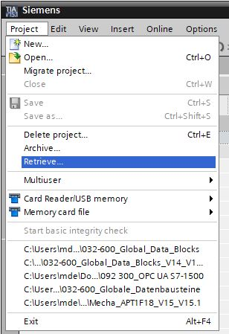

* The next step is to select the destination folder where the retrieved project is to be stored. Confirm your selection with "OK". (→ Destination folder … → OK)
* In the project properties, the "  Support simulation during block compilation" option must be selected for "Protection".

(→ 032-600\_Globale\_Data\_Blocks… → Properties → Protection →  Support simulation during block compilation → OK)

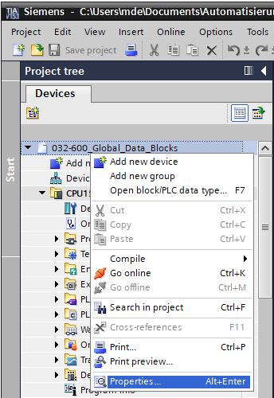

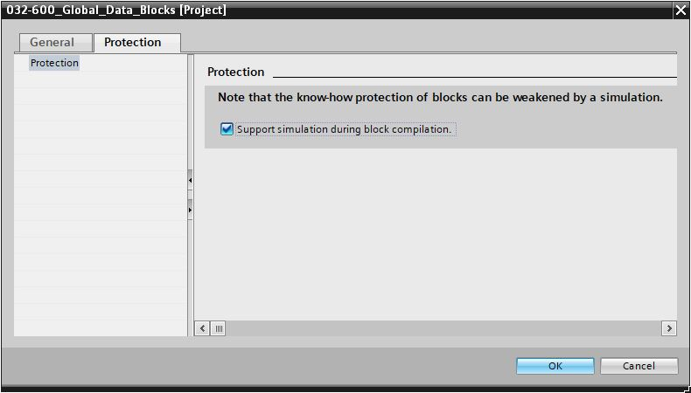

* Click the "CPU\_1516F" folder. In the menu, select the "009" button and then the "D:\00_DATA\SIEMENS\Unterlagen\08_Ausbildungsunterlage_TIA-Portal_R1502_dt\032-100 FC-Programmierung\pics\052.jpg" button for compiling.   
  (→ CPU\_1516F → 009 → D:\00_DATA\SIEMENS\Unterlagen\08_Ausbildungsunterlage_TIA-Portal_R1502_dt\032-100 FC-Programmierung\pics\052.jpg)

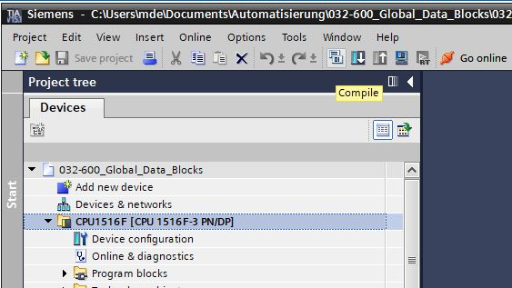

* "Close" the project again. (→ Project → Close).

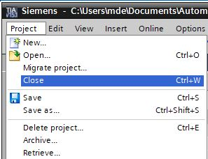

## Creating a SIMIT application with "PLCSIM Advanced" coupling

* Start SIMIT from the desktop of your computer by double-clicking on the logo for the "SIMIT SP" application (→ SIMIT SP)



* Create a new project "020-110\_SIMIT S7-1500 PLCSIMAdv\_IE". (→ Create new project → 020-110\_SIMIT S7-1500 PLCSIMAdv\_IE → Create)

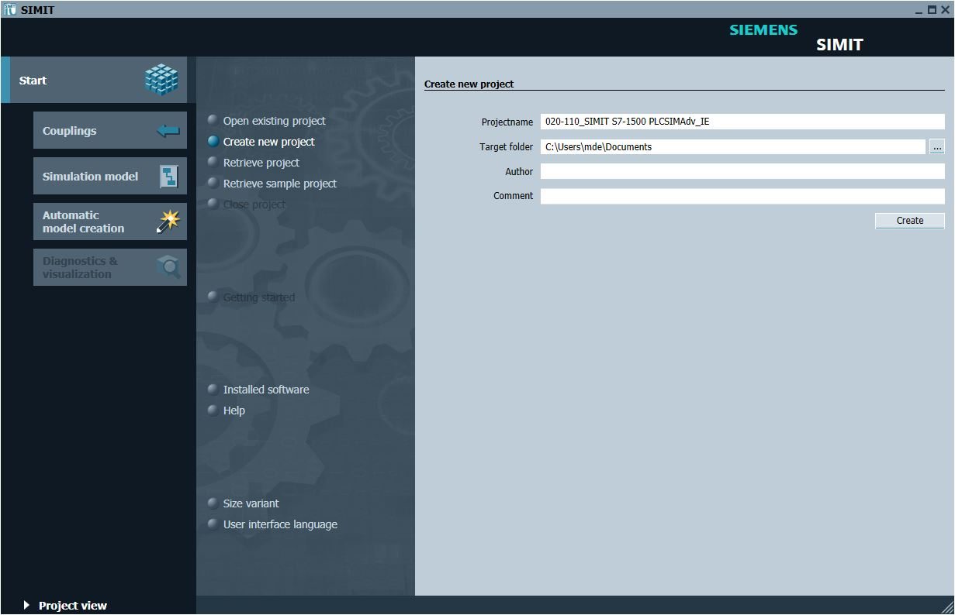

* Change to the "Project view". (→ Project view)

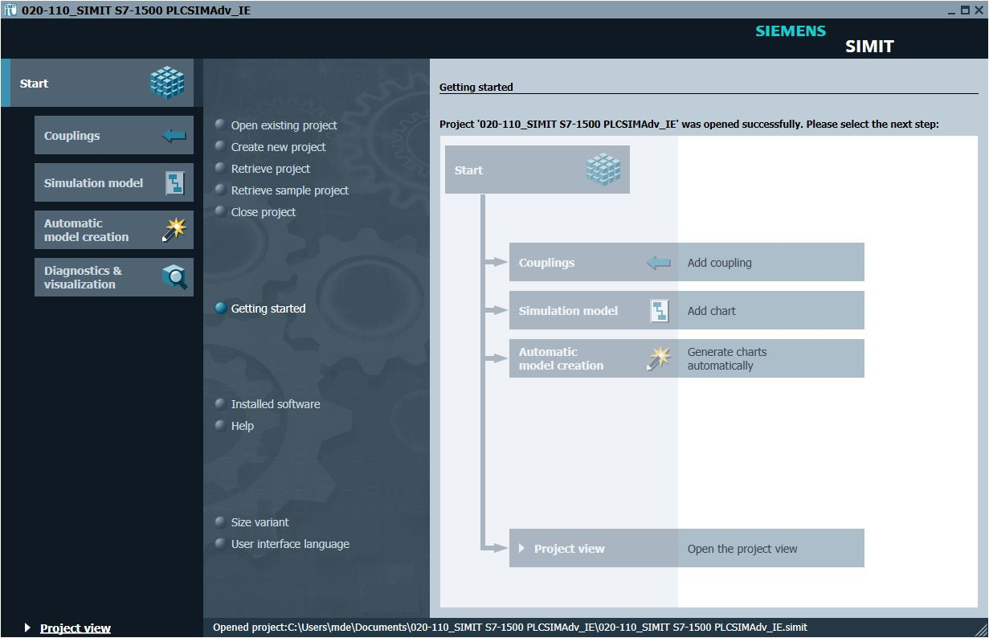

* Create a "New coupling" "PLCSIM Advanced" for your project under "Couplings". (→ Couplings → New coupling → PLCSIM Advanced → OK)

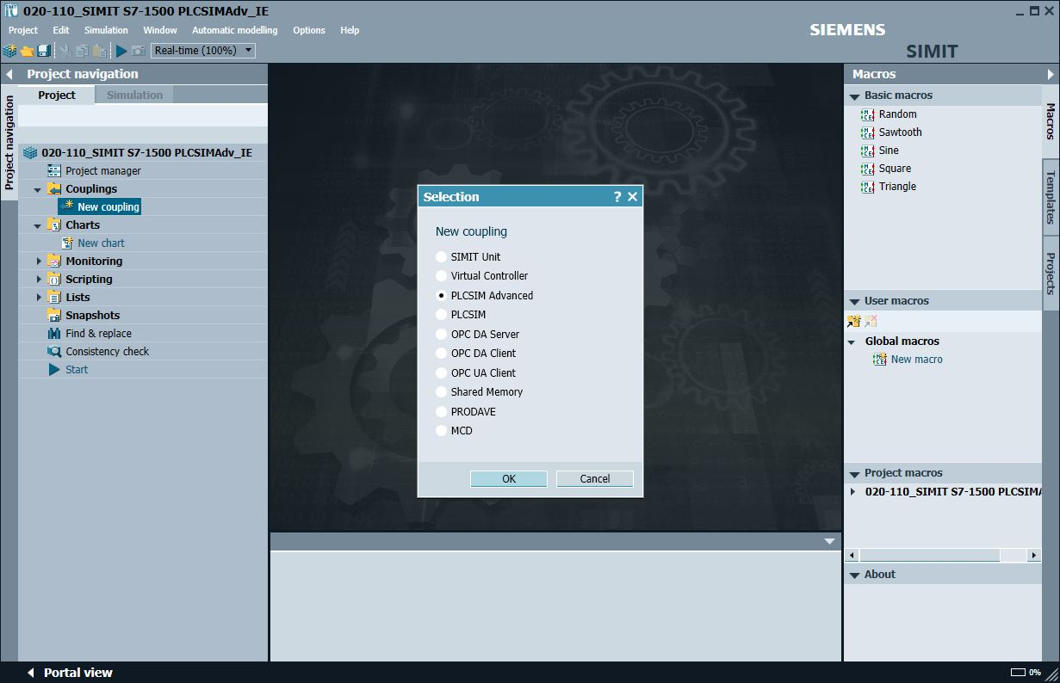

* Select your previously retrieved project for "TIA Portal project" and click "Open". The preview of the stations in this TIA project is now created. (→ TIA Portal project → 032-600\_Global\_Data\_Blocks… → Open)

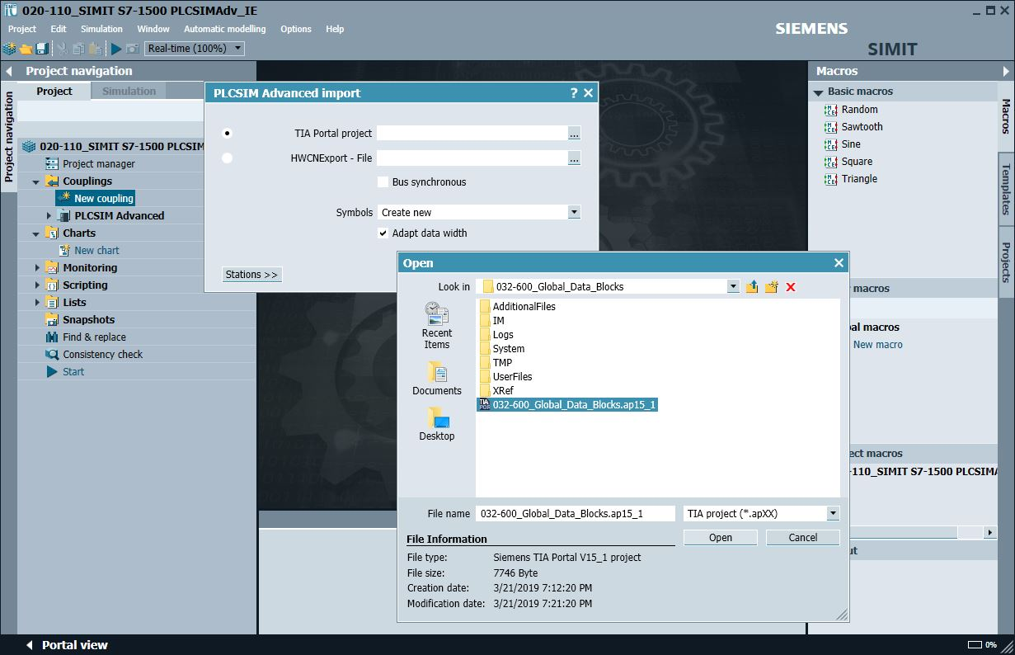

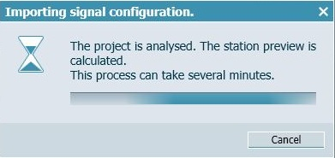

Note:

* *If the following error message regarding the TIA Firewall appears, you need to check the required settings in Windows 10 as described in chapter 5.*

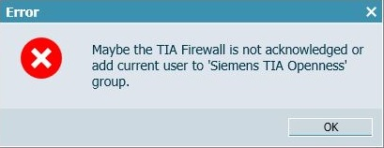

* Check the setting for the data import from your project and click "Import". (→ Import)

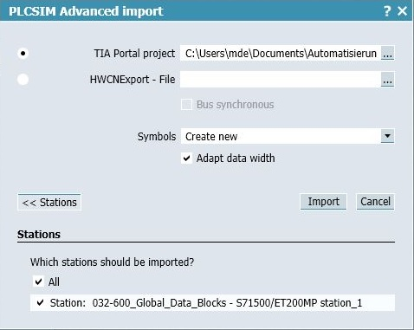

* Double-click the coupling for the created station "S7-1500-ET 200MP station\_1" to open it. The inputs and outputs from the tag table of the S7-1500 station are now available for further use in the simulation. Select " Save all". (→ S7-1500-ET 200MP station\_1 → )

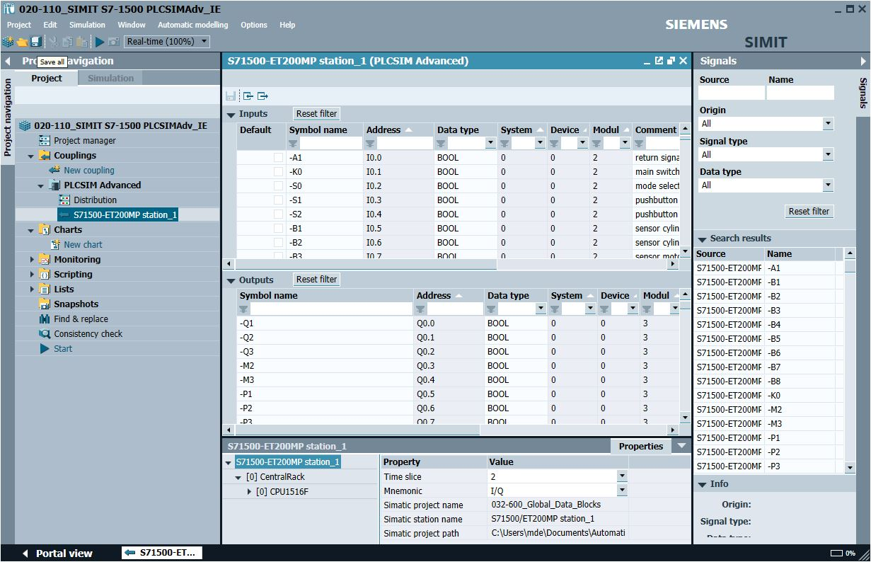

* Click " Start" to start the simulation. (→ )

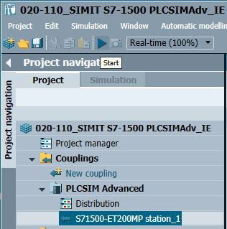

* When the simulation is started, PLCSIM Advanced is also automatically activated in the background. This allows you to test the access to the inputs and outputs of the S7-1500 station in SIMIT. Clicking on "" again ends the simulation in SIMIT. (→ )

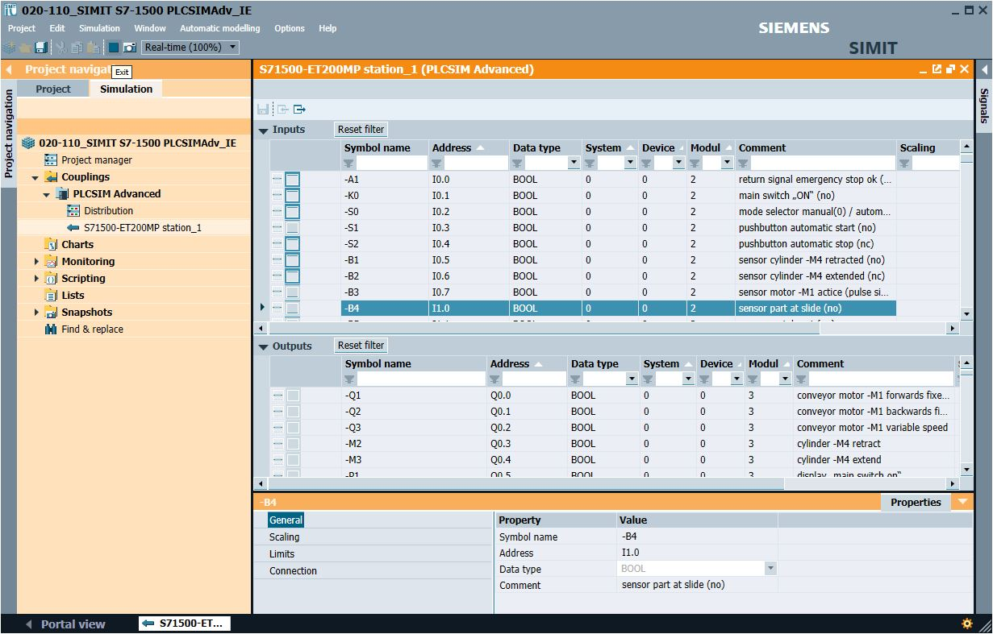

* "Archive" the SIMIT project. (→ Project → Archive)

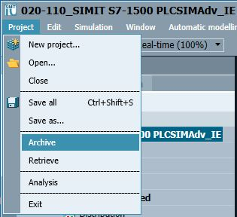

## Starting an existing SIMIT project with "PLCSIM Advanced"

* Start SIMIT from the desktop of your computer by double-clicking on the logo for the "SIMIT SP" application (→ SIMIT SP)



* Open or retrieve the desired project. The project for the sorting station "020-100-sce-sorting-station-plcsim-adv-en.simarc" will be retrieved here. (→ Retrieve project → 020-100-sce-sorting-station-plcsim-adv-en.simarc → Retrieve)

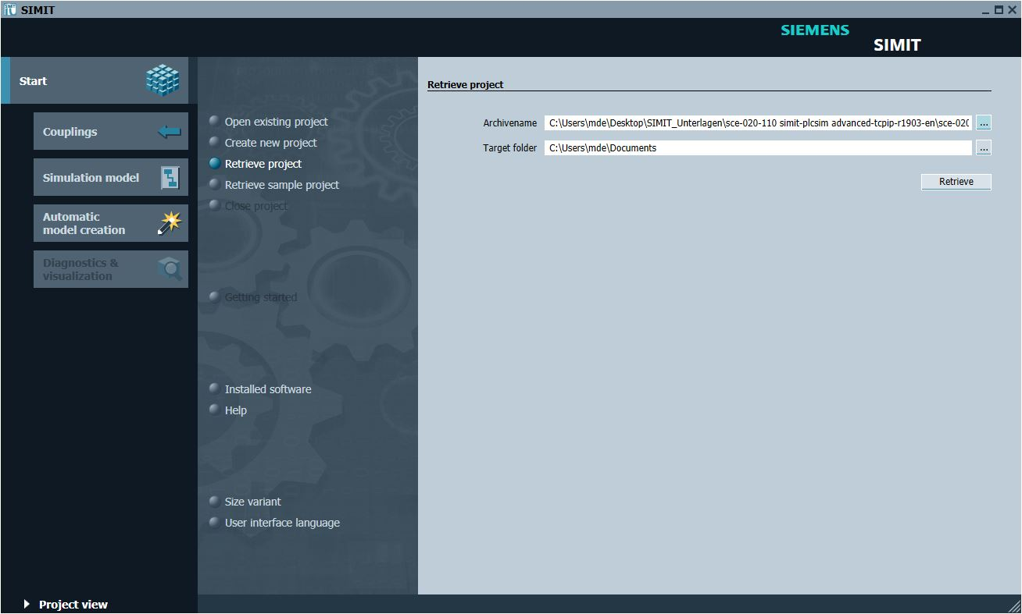

* Confirm the security prompt with "Yes". (→ Yes)

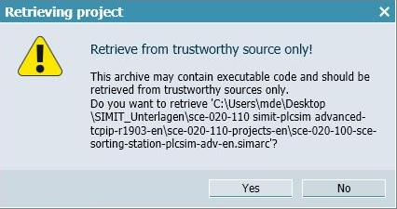

* Change to the "Project view". (→ Project view)

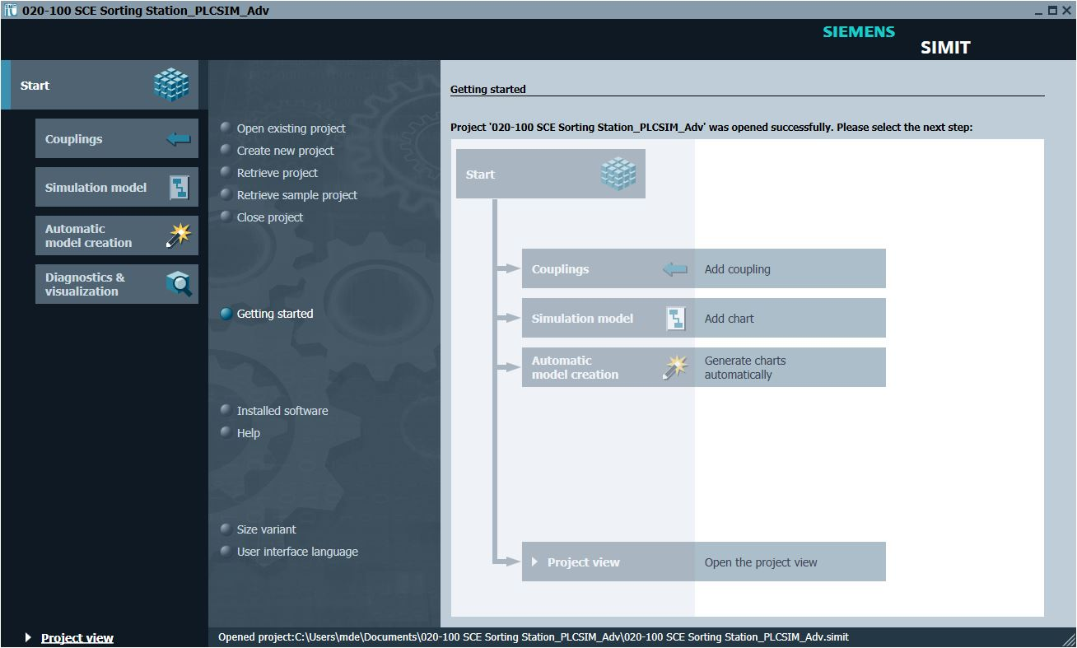

* Double-click the "01\_operating screen" chart to open it. (→ 01\_operating screen)

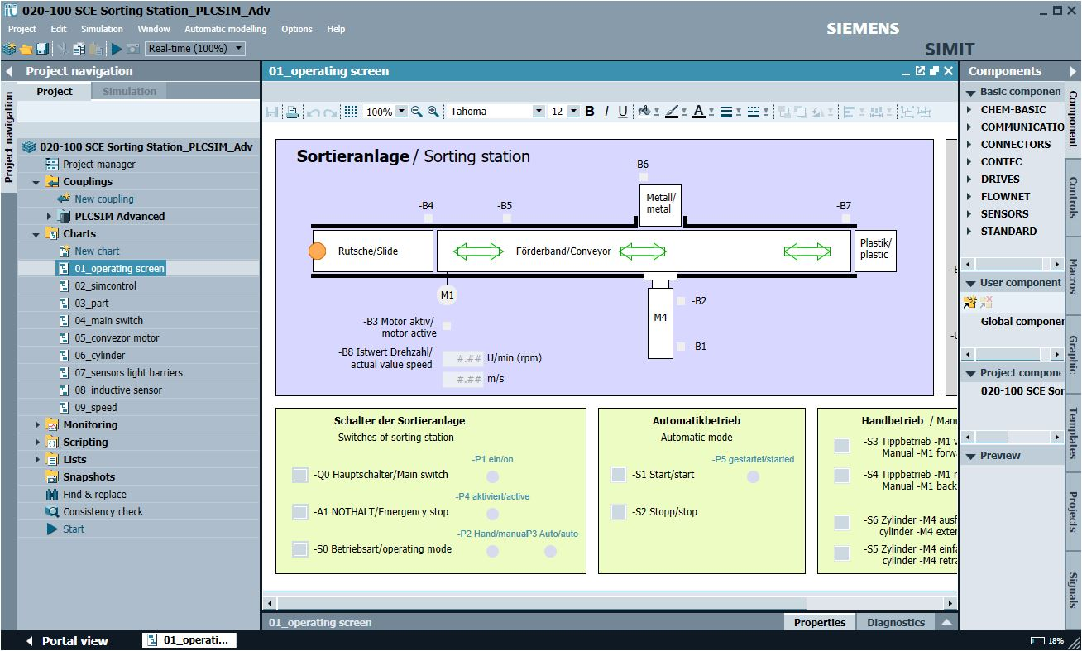

* Select " Save all" and select " Start" to start the simulation. (→  → )

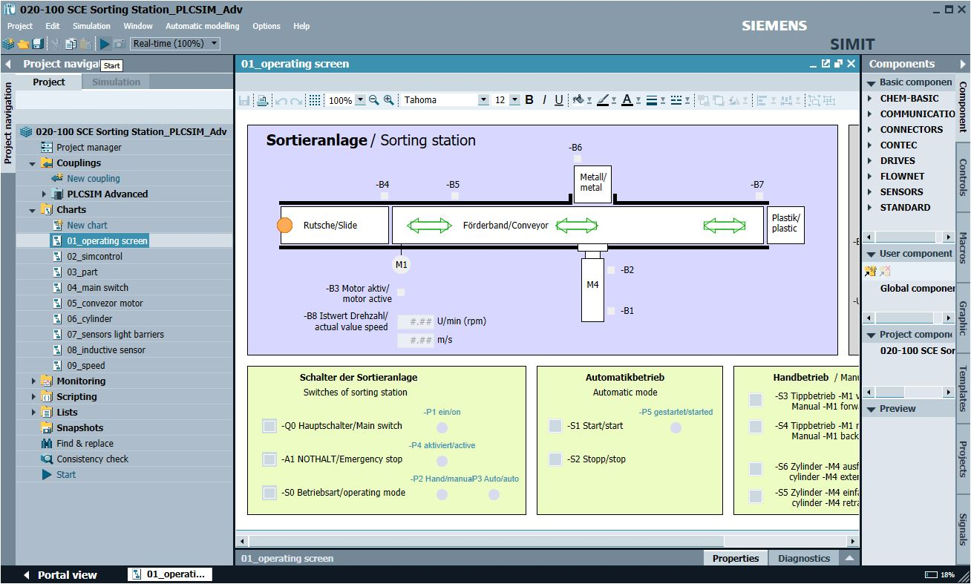

* The simulation is activated. The application turns orange to indicate this.

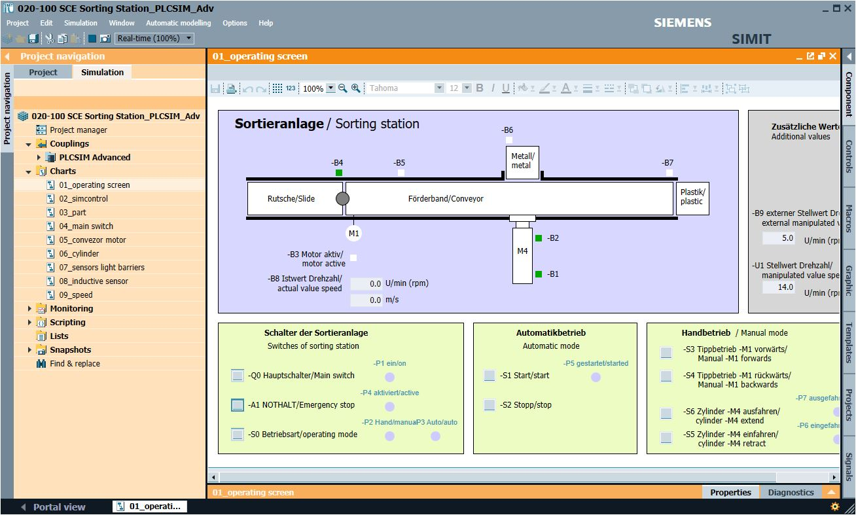

* Start the "TIA Portal" from the desktop of your computer by double-clicking on the logo for the application. (→ TIA Portal)

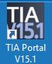

* Open or retrieve the desired TIA Portal project. The project for the sorting station project "SCE\_EN\_032-600\_Global\_Data\_Blocks…" opens here. Change to the project view.

(→ Open existing project → SCE\_EN\_032-600\_Global\_Data\_Blocks… → Open → Project view)

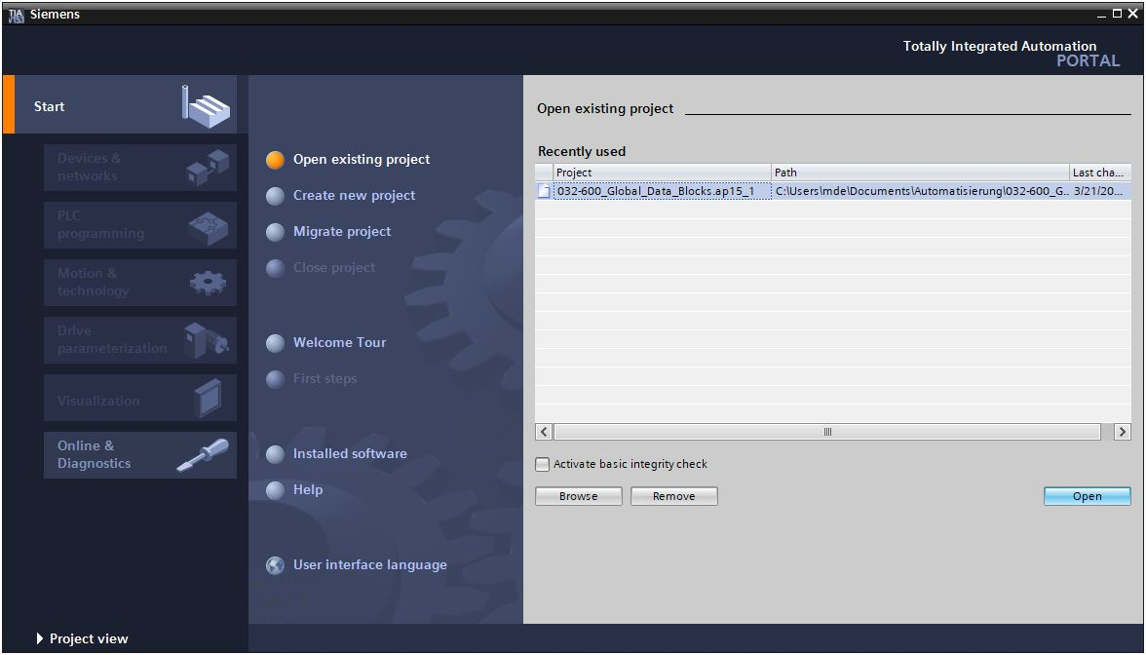

* To download your entire CPU, select the → "CPU\_1516F [CPU1516F-3 PN/DP]" folder and click the 0009 → "Download to device" button.

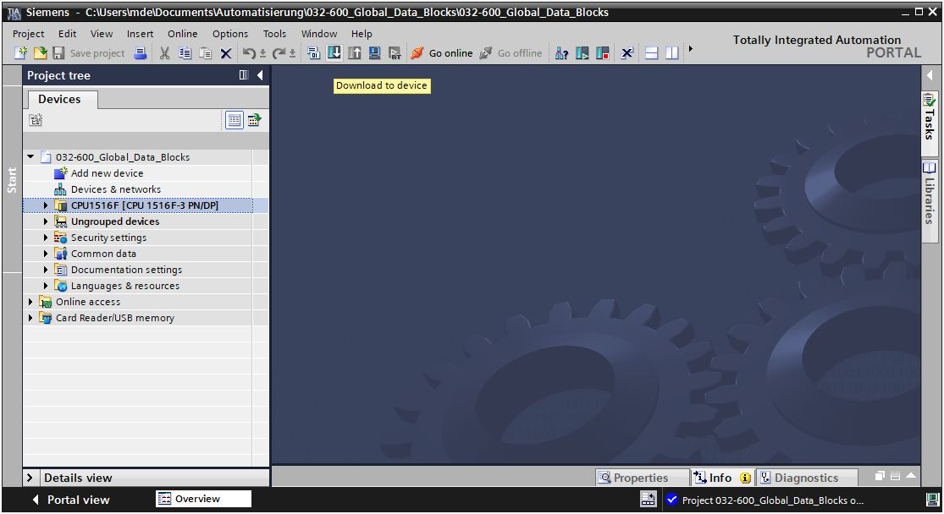

* The manager for configuring the connection properties (Extended download) opens.

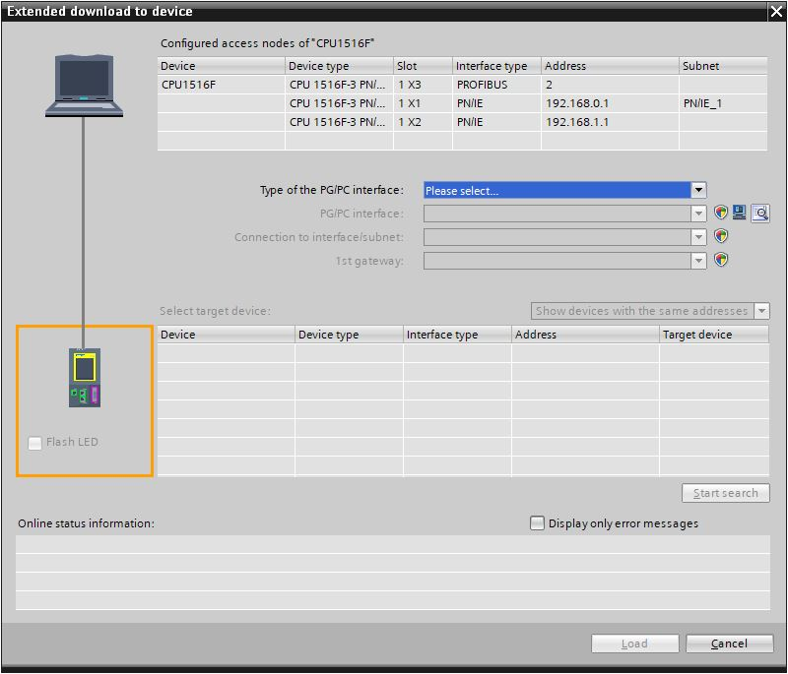

* First, the interface must be correctly selected. This happens in three steps.   
  → Type of the PG/PC interface → PN/IE

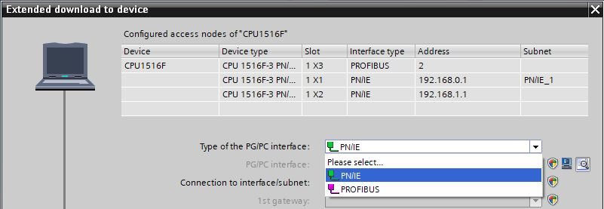

→ PG/PC interface → PLCSIM (if PLCSIM Advanced was started beforehand, it is already preset)

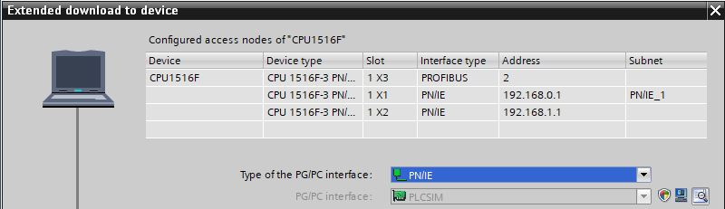

→ Connection to interface/subnet → "PN/IE\_1"

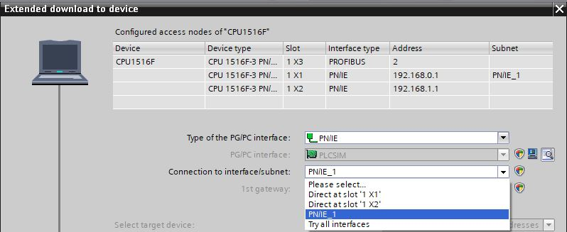

* The search for target devices must then be started by clicking the → "034" button.

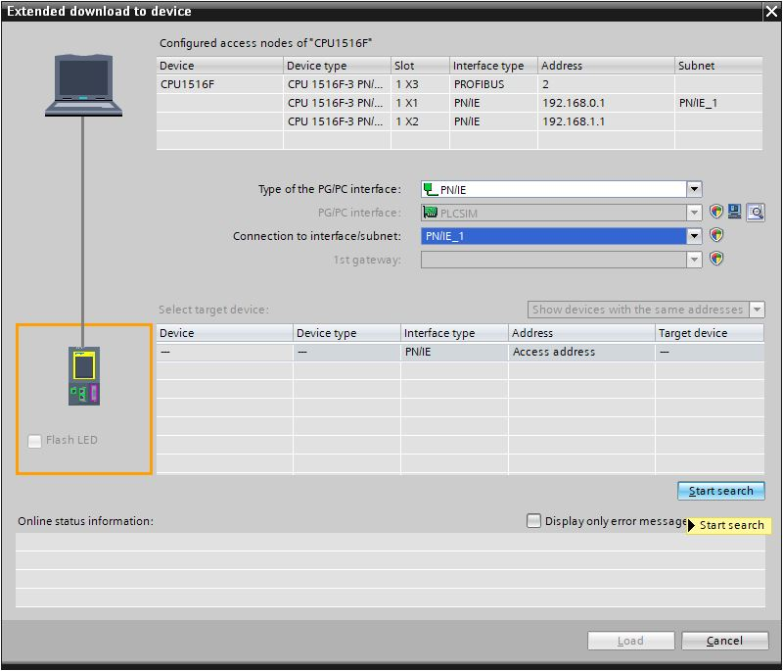

* If the controller is shown in the list of target devices, it must be selected before the download.   
  (→ CPU1516F → Load)

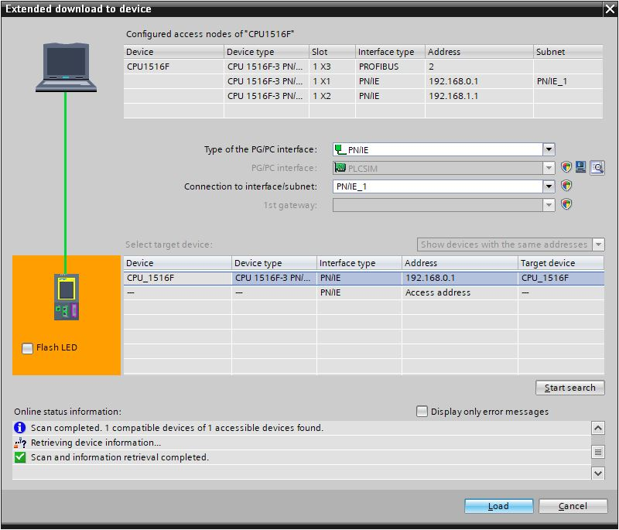

* You first obtain a preview. Confirm the suggested actions and continue with → "Load".

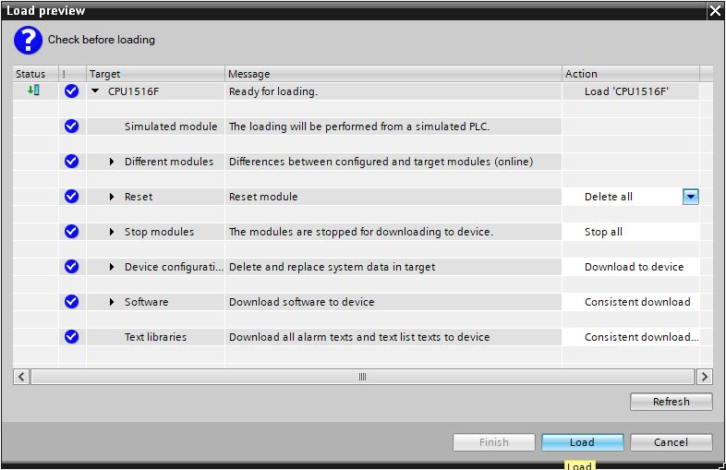

Note:

* *The* ****** *symbol should be visible in every line of the "Load preview". You can find additional information in the "Message" column.*
* The → "Start module" option will be selected next before the download operation can be completed with → "Finish".

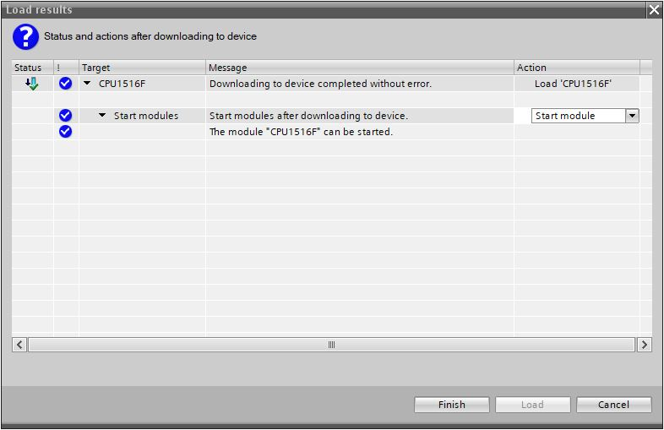

* The application can be tested in SIMIT. Clicking on "" again ends the simulation in SIMIT. (→ )

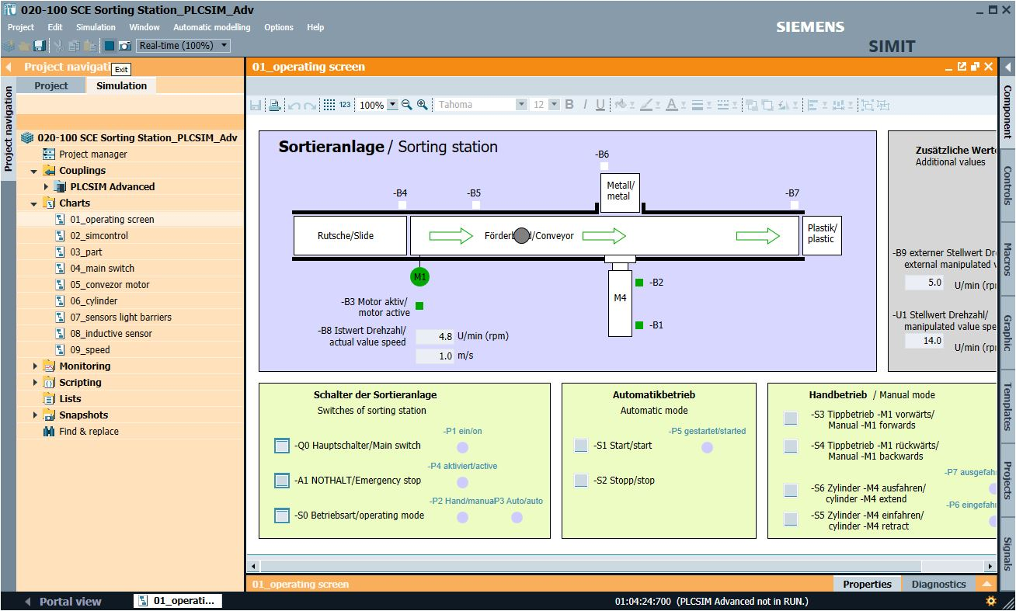

Note:

* *When the simulation in SIMIT ends, the instance in PLCSIM Advance is also deleted. This means that it is no longer possible to work "online" from the TIA Portal.*

# Additional information

More information for further practice and consolidation is available as orientation, for example: Getting Started, videos, tutorials, apps, manuals, programming guidelines and trial software / firmware, under the following link:   
  
[siemens.com/sce](https://new.siemens.com/global/en/company/sustainability/education/sce/learning-training-documents/example-processes.html)

**Preview "Additional information"**

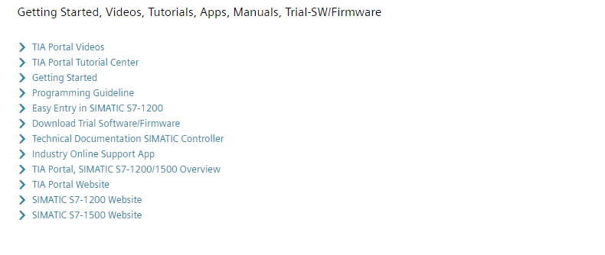

Further Information

Siemens Automation Cooperates with Education  
siemens.com/sce

SCE Learn-/Training Documents  
**siemens.com/sce/documents**

SCE Trainer Packages  
**siemens.com/sce/tp**

SCE Contact Partners   
**siemens.com/sce/contact**

Digital Enterprise  
**siemens.com/digital-enterprise**

Industrie 4.0   
**siemens.com/future-of-manufacturing**

Totally Integrated Automation (TIA)  
**siemens.com/tia**

TIA Portal  
**siemens.com/tia-portal**

SIMATIC Controller  
**siemens.com/controller**

SIMATIC Technical Documentation   
**siemens.com/simatic-docu**

Industry Online Support  
**support.industry.siemens.com**

Product catalogue and online ordering system Industry Mall   
**mall.industry.siemens.com**

Siemens  
Digital Industries, FA   
P.O. Box 4848  
90026 Nuremberg  
Germany

Subject to change and errors  
© Siemens 2019

**siemens.com/sce**