

Learn-/Training Document  
  
Siemens Automation Cooperates with Education (SCE) | From Version V15.1

**siemens.com/sce**

TIA Portal Module 020-100

Process description of sorting station

Continued training

For regional Siemens SCE continued training, get in touch with your regional SCE contact [siemens.com/sce/contact](http://www.siemens.com/contact)

**Additional information regarding SCE**

[siemens.com/sce](http://www.siemens.com/sce)  
  
  
**Information regarding use**

The SCE Learn-/Training Document for the integrated automation solution Totally Integrated Automation (TIA) was prepared for the program "Siemens Automation Cooperates with Education (SCE)" specifically for training purposes for public educational facilities and R&D institutions. Siemens does not guarantee the contents.

This document is only to be used for initial training on Siemens products/systems. This means it can be copied in whole or in part and given to trainees/students for use within the scope of their training/course of study. Disseminating or duplicating this document and sharing its content is permitted within public training and advanced training facilities for training purposes or as part of a course of study.

Exceptions require written consent from Siemens. Send all related requests to [scesupportfinder.i-ia@siemens.com](mailto:scesupportfinder.i-ia@siemens.com).

Offenders will be held liable. All rights including translation are reserved, particularly if a patent is granted or a utility model or design is registered.

Use for industrial customer courses is explicitly not permitted. We do not consent to commercial use of the Learn-/Training Document.

We wish to thank the TU Dresden, the Michael Dziallas Engineering Corporation and all other involved persons for their support during the preparation of this Learn-/Training Document.

Table of contents

1 Description of functions 5

1.1 Brief description 5

1.2 Technology diagram 5

1.3 Switching on 6

1.4 Operating mode selection 6

1.5 EMERGENCY STOP 6

1.6 Manual mode 6

1.6.1 Retracting and extending the cylinder 6

1.6.2 Conveyor motor in manual mode 6

1.6.3 Initial state 7

1.7 Automatic mode 7

1.7.1 Starting and stopping 7

1.7.2 Conveyor control 7

1.7.3 Cylinder control 7

1.7.4 Speed control (conveyor speed) 8

1.7.5 Speed control 8

1.8 Indicator lights 8

2 Reference list 9

3 Description of components of the station 11

3.1 Manual operation 11

3.1.1 Pushbuttons 11

3.1.2 Switches 11

3.1.3 Feedback from EMERGENCY STOP pushbutton 11

3.2 Sensors 11

3.2.1 Position switches 11

3.2.2 Limit switches 11

3.2.3 Light barriers / optical sensors 11

3.2.4 Metal detection / Inductive sensor 12

3.2.5 Motor speed 12

3.3 Actuators 12

3.3.1 Conveyor motor 12

3.3.2 Cylinders 12

3.3.3 Displays 12

4 Brief description of the simulation 13

5 Additional information 15

Process Description - Sorting Station

The "Sorting station" example process is described in the following.

# Description of functions

## Brief description

The automated sorting station (see Figure 1) is used to separate plastic and metal components. A component is fed to the conveyor via a chute. The conveyor starts as soon as the component has been detected. If a component made of metal is on the conveyor, it is detected, transported up to the height of the metal magazine and pushed by a cylinder into the metal magazine. If no metal is detected, the component is made of plastic. The plastic component is transported to the end of the belt, where it falls into the plastic magazine. As soon as a component is sorted, the next component can be fed.

## Technology diagram

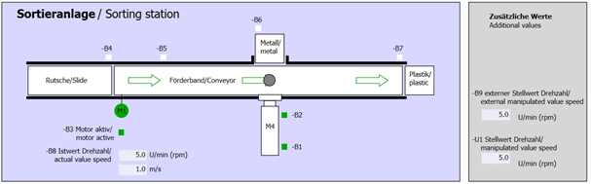

Figure 1: Technology diagram

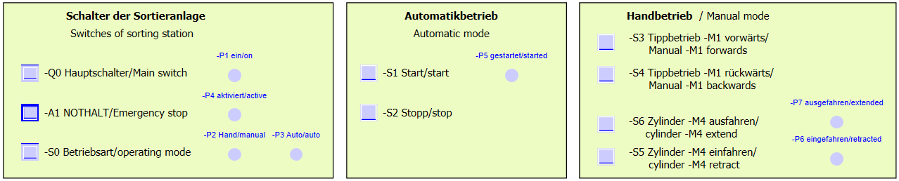

Figure 2: Control panel

## Switching on

The station is switched on with the main switch Q0. Relay K0 (main switch "ON") is energized and provides the supply voltage for the sensors and actuators.

This operating state is indicated by indicator light P1 (main switch on)

## Operating mode selection

Once the station has been switched on, two operating modes are possible: manual mode or automatic mode. The operating mode is selected using switch S0.

The selected operating mode is indicated by indicator lights P2 (manual mode) and P3 (automatic mode).

## EMERGENCY STOP

In the absence of feedback from the EMERGENCY STOP (A1), all drives must be stopped immediately.

When feedback from the EMERGENCY STOP function is present again, the station may only start up again after another start signal.

Activation of the EMERGENCY STOP is indicated by indicator lights P4 (EMERGENCY STOP activated).

## Manual mode

The station is set up in manual mode.

### Retracting and extending the cylinder

After pushbutton S5 (cylinder M4 extend) is pressed, cylinder M4 is extended. When the front-end position is reached (extended position), the cylinder pauses in this position. After pushbutton S4 is pressed, the cylinder retracts. A change of direction is to be possible at any time. When the two pushbuttons are pressed simultaneously, no motion should take place.

### Conveyor motor in manual mode

With pushbutton S3 (pushbutton manual mode conveyor M1 forwards), motor Q1 (conveyor motor M1 forwards fixed speed) is moved forward in manual mode. With pushbutton S4 (pushbutton manual mode conveyor M1 backwards), motor Q2 (conveyor motor M1 backwards fixed speed) is moved backward in manual mode. When the two pushbuttons are pressed simultaneously, no motion should take place.

For safety reasons, only the preset speed may be used here. Output Q3 (conveyor motor M1 variable speed) must therefore be deactivated.

### Initial state

At station start or after release of EMERGENCY STOP, the station must be moved in manual mode to a defined operating state (initial state). In the initial state, the conveyor is empty and stopped and the cylinder is retracted.

## Automatic mode

In automatic mode, the station executes the process (see also Brief description).

### Starting and stopping

If the station is in the initial state, automatic mode starts when pushbutton S1 (automatic start) is pressed. When pushbutton S2 (automatic stop) is pressed, automatic mode is ended again as soon as the initial state has been reached.

If EMERGENCY STOP has been tripped or the operating mode changed, automatic mode is ended immediately (without return to the initial state).

The current state is indicated by indicator light P6 (automatic mode started).

### Conveyor control

If light sensor B4 (chute occupied) detects a component, the conveyor motor starts. The component slides onto the transport conveyor and is further conveyed.

If inductive sensor B5 detected a metal component, this is transported up to light sensor B6 (part in front of cylinder M4). The conveyor is then switched off. As soon as B3 (sensor motor M1 active) no longer supplies a signal, the Cylinder control (see below) is activated and moves the component into the metal magazine. As soon as the cylinder is retracted again, the sorting station is back in the initial state.

If a metal component was not detected by sensor B5, this is recognized when light sensor B6 (part in front of cylinder M4) is reached. The plastic component is then transported to the end of the conveyor. It is detected there by light sensor B7 and conveyed after a delay time into the plastic magazine at the end of the conveyor.

### Cylinder control

If a metal component reaches light sensor B6 (part in front of cylinder M4) and the conveyor has stopped, cylinder M4 moves to the front-end position B2 (cylinder M4 extended), thereby pushing the metal component from the conveyor into the metal magazine. Cylinder M4 then moves to the rear end position B1 (cylinder M4 retracted).

### Speed control (conveyor speed)

In automatic mode, the motor can be moved at a fixed or variable speed.

Fixed speed requires signal "1" at Q1 "Conveyor motor M1 forwards fixed speed" or Q2 "Conveyor motor M1 backwards fixed speed". For variable speed, Q3 "Conveyor motor M1 variable speed" must be activated and a "manipulated value for motor speed" (analog value +/-10 V corresponds to +/- 50 rpm or 10 m/s) must be specified at U1. Signal "1" must not be present at Q1 "Conveyor motor M1 forwards fixed speed" or Q2 "Conveyor motor M1 backwards fixed speed". Otherwise, U1 has no effect on the speed of the conveyor.

### Speed control

A speed control can be integrated for control of the conveyor speed. This uses the speed sensor for evaluating the current speed. A speed of 5 rpm corresponds to a conveyor belt speed of 1 m/s.

## Indicator lights

As soon as relay K0 (main switch "ON") becomes energized, indicator light P1 (main switch on) lights up.

If switch S0 (mode selector manual/automatic) is set to Manual, the indicator light P2 (manual mode) lights up. If switch S0 is set to Automatic, the indicator light P3 (automatic mode) lights up.

If the EMERGENCY STOP function has tripped, P4 (EMERGENCY STOP activated) lights up.

If automatic mode has been selected and the station is in the initial state, P5 (automatic mode started) flashes to signal that automatic mode can be started. As soon as automatic mode has been started, P5 lights up.

Indicator light P6 (cylinder M4 retracted) lights up as soon as end position sensor B1 (sensor cylinder M4 retracted) has been reached. Indicator light P7 (cylinder M4 extended) lights up as soon as cylinder M4 has reached the front-end position sensor B2 (sensor cylinder M4 extended). Indicator lights P6 and P7 are not lit if the cylinder is located in neither of the two end positions.

# Reference list

By default, the S7-1200 has only 14 digital Inputs, 10 digital outputs, 2 analog inputs und 1 analog output. Therefore, the signals shown in the list with blue text are not available for it.

|  |  |  |  |  |
| --- | --- | --- | --- | --- |
| **DI** | **Type** | **Identifier** | **Function** | **NC/NO** |
| I 0.0 | BOOL | -A1 | Return signal emergency stop OK | NC |
| I 0.1 | BOOL | -K0 | Main switch "ON" | NO |
| I 0.2 | BOOL | -S0 | Mode selector manual (0)/ automatic (1) | Manual = 0  Auto = 1 |
| I 0.3 | BOOL | -S1 | Pushbutton automatic start | NO |
| I 0.4 | BOOL | -S2 | Pushbutton automatic stop | NC |
| I 0.5 | BOOL | -B1 | Sensor cylinder M4 retracted | NO |
| I 0.6 | BOOL | -B2 | Sensor cylinder M4 extended | NC |
| I 0.7 | BOOL | -B3 | Sensor motor M1 active (pulse signal also suitable for positioning) | NO |
| I 1.0 | BOOL | -B4 | Sensor at chute occupied | NO |
| I 1.1 | BOOL | -B5 | Sensor metal part | NO |
| I 1.2 | BOOL | -B6 | Sensor part in front of cylinder M4 | NO |
| I 1.3 | BOOL | -B7 | Sensor part at end of conveyor | NO |
| I 1.4 | BOOL | -S3 | Pushbutton manual mode conveyor M1 forwards | NO |
| I 1.5 | BOOL | -S4 | Pushbutton manual mode conveyor M1 backwards | NO |
| I 1.6 | BOOL | -S5 | Pushbutton manual mode cylinder M4 retract | NO |
| I 1.7 | BOOL | -S6 | Pushbutton manual mode cylinder M4 extend | NO |

|  |  |  |  |  |
| --- | --- | --- | --- | --- |
| **DO** | **Type** | **Identifier** | **Function** |  |
| Q 0.0 | BOOL | -Q1 | Conveyor motor M1 forwards fixed speed |  |
| Q 0.1 | BOOL | -Q2 | Conveyor motor M1 backwards fixed speed |  |
| Q 0.2 | BOOL | -Q3 | Conveyor motor M1 variable speed |  |
| Q 0.3 | BOOL | -M2 | Cylinder M4 retract |  |
| Q 0.4 | BOOL | -M3 | Cylinder M4 extend |  |
| Q 0.5 | BOOL | -P1 | Display "main switch on" |  |
| Q 0.6 | BOOL | -P2 | Display "MANUAL" mode |  |
| Q 0.7 | BOOL | -P3 | Display "AUTOMATIC" mode |  |
| Q 1.0 | BOOL | -P4 | Display "emergency stop activated" |  |
| Q 1.1 | BOOL | -P5 | Display "automatic mode started" |  |
| Q 1.2 | BOOL | -P6 | Display "cylinder M4 retracted" |  |
| Q 1.3 | BOOL | -P7 | Display "cylinder M4 extended" |  |
| **AI** | **Type** | **Identifier** | **Function** |  |
| IW 64 | INT | -B8 | Sensor actual value speed of motor +/- 10V |  |
| IW 66 | INT | -B9 | Setpoint specification via potentiometer +/- 10V |  |
|  |  |  |  |  |
| **AO** | **Type** | **Identifier** | **Function** |  |
| QW 64 | INT | -U1 | Manipulated value speed of motor in 2 directions +/- 10V |  |

|  |  |  |  |
| --- | --- | --- | --- |
| **Legend for reference list** | | | |
| DI | Digital Input | DO | Digital Output |
| AI | Analog Input | AO | Analog Output |
| I | Input | O | Output |
| NC | Normally Closed (Öffner) |  |  |
| NO | Normally Open (Schließer) |  |  |

# Description of components of the station

## Manual operation

### Pushbuttons

The utilized pushbuttons can supply either a "0" or "1" signal. Depending on whether you have planned them as normally closed or normally-open contacts (see Reference list), they supply a "1" or "0" signal when not actuated. The signal changes to "0" or "1" only while the pushbutton is being pressed.

### Switches

The utilized switches can also supply either a "0" or "1" signal. Depending on whether you have planned them as normally closed or normally-open contacts (see Reference list), they supply a "1" or "0" signal when not actuated. The signal changes to "0" or "1" when the switch is actuated. This signal is present as long as the switch is not actuated again.

### Feedback from EMERGENCY STOP pushbutton

EMERGENCY STOP pushbuttons are pushbuttons with an additional mechanical lock and are connected to a safety relay. They thus behave like a switch. The EMERGENCY STOP feedback from the safety relay is planned as a normally closed contact for safety reasons. If a wire break occurs, therefore, this feedback is no longer present and the station responds as if an EMERGENCY STOP has tripped.

## Sensors

### Position switches

A main switch is actuated to switch on the station. This energizes a relay and supplies the power to the station. A position switch provides feedback on the operation of the relay.

### Limit switches

The limit switches supply a signal when the cylinder is either fully retracted or extended. The limit switches are implemented as normally-closed or normally-open contacts.

### Light barriers / optical sensors

The light barriers supply a "1" signal as soon as an object is in the sensing range.

### Metal detection / Inductive sensor

The inductive sensor supplies a "1" signal as soon as a metallic object enters its sensing range. In the case of non-metallic objects, the signal remains at "0".

### Motor speed

The motor speed is recorded by an incremental encoder at the conveyor motor and provided as an analog value via a transducer. The speed falls within the range from -50 rpm to 50 rpm. That corresponds to a conveyor belt speed of -10 m/s to +10 m/s.

In addition, pulses are received at "Sensor conveyor motor M1 active" that can also be used for positioning. The resolution is 20 pulses per total conveyor belt length (10 m).

## Actuators

### Conveyor motor

The conveyor motor drives the conveyor belt. It has multiple signal combinations so that the conveyor belt can be moved at fixed or variable speed in both directions.

Fixed speed requires signal "1" at Q1 "Conveyor motor M1 forwards fixed speed" or Q2 "Conveyor motor M1 backwards fixed speed". For variable speed, Q3 "Conveyor motor M1 variable speed" must be activated and a "manipulated value for motor speed" (analog value +/-10 V corresponds to +/- 50 rpm or 10 m/s) must be specified at U1. Signal "1" must not be present at Q1 "Conveyor motor M1 forwards fixed speed" or Q2 "Conveyor motor M1 backwards fixed speed". Otherwise, U1 has no effect. Simultaneous activation of signals Q1 and Q2 causes the conveyor to stop and must be prevented by the control program.

### Cylinders

Cylinder M4 is controlled using two separate signals. Activation of one signal (M3) causes the cylinder to extend and activation of the other signal (M2) causes the cylinder to retract. The signals must not be activated simultaneously, otherwise an undefined state occurs and the cylinder pauses at its position. This must be prevented by the control program.

### Displays

All indicator lights are located on the control panel. If signal "1" is present, these indicator lights illuminate.

# Brief description of the simulation

The simulation of the sorting station consists of 9 diagrams. The 01_operating screen diagram is important for operation (see Figure 3), which contains the control panel and a representation of the station.

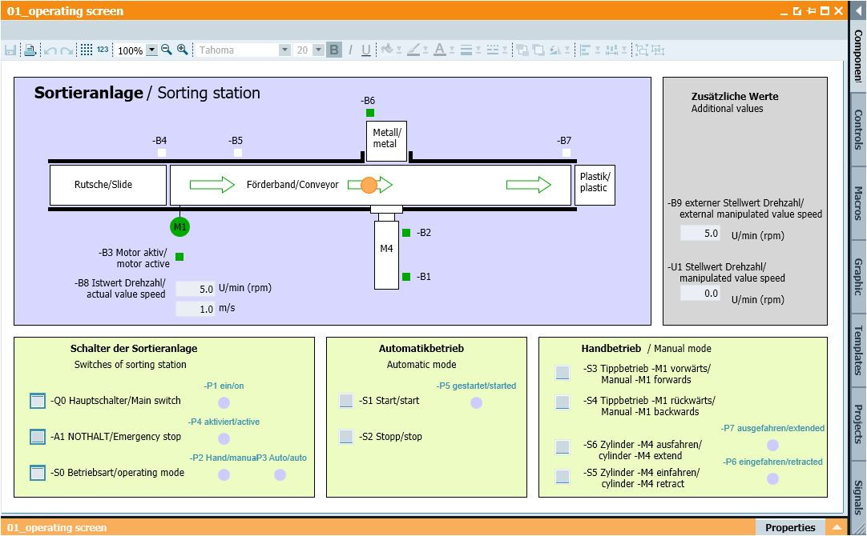

Figure 3: The operating screen

Figure 4 shows the 02_simcontrol diagram. It allows important simulation settings to be made. The first settings affect the creation of the components. Here, you can select between automatic and manual creation of components. With automatic creation of components, a new component is always created and sent to the station when the previous component has been sorted. A single component is created with manual creation of components. The next settings allow you to specify whether a metal component or plastic component will be created. The following selections are available: Produce only metal components, Produce only plastic components and Randomly produce metal or plastic components Only one of the three options should be selected.

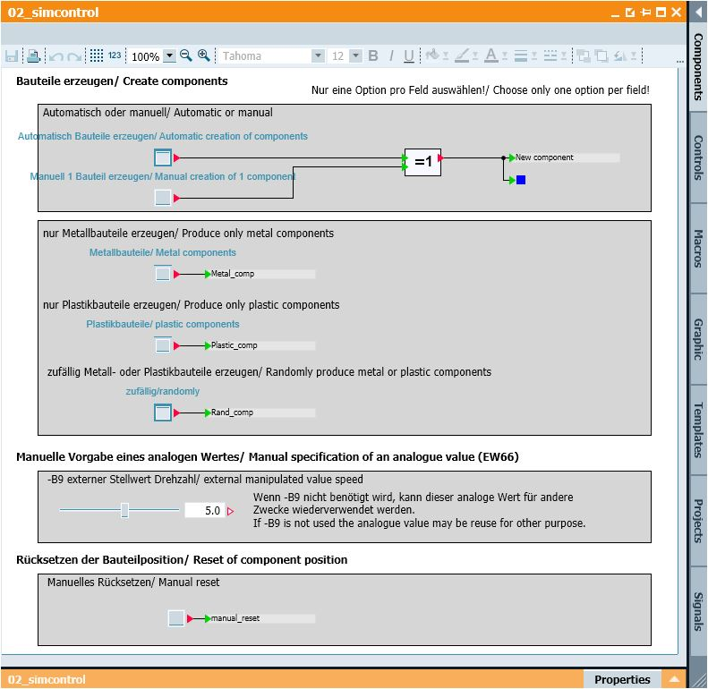

Figure 4: Simulation control

In the "Manual specification of an analog value" area, a value between -50 and +50 can be set for input word IW 66 (see Reference list). This corresponds to an input voltage of -/+10 V. This value is then converted to a digital value between -27648 and +27648 and is thus available as an analog input value.

The last setting concerns the manual resetting of the current component. This resets the position of the component and a new component can be created.

# Additional information

More information for further practice and consolidation is available as orientation, for example: Getting Started, videos, tutorials, apps, manuals, programming guidelines and trial software / firmware, under the following link:

[siemens.com/sce/s7-1200](http://www.siemens.com/sce/s7-1200)

Preview „Additional information“

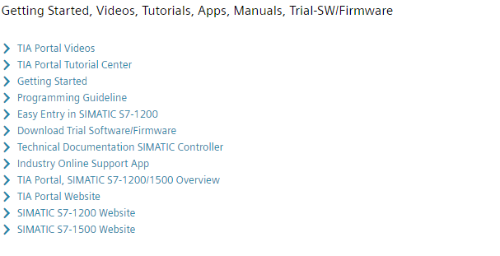

Further Information

Siemens Automation Cooperates with Education  
siemens.com/sce

SCE Learn-/Training Documents  
**siemens.com/sce/documents**

SCE Trainer Packages  
**siemens.com/sce/tp**

SCE Contact Partners   
**siemens.com/sce/contact**

Digital Enterprise  
**siemens.com/digital-enterprise**

Industrie 4.0   
**siemens.com/future-of-manufacturing**

Totally Integrated Automation (TIA)  
**siemens.com/tia**

TIA Portal  
**siemens.com/tia-portal**

SIMATIC Controller  
**siemens.com/controller**

SIMATIC Technical Documentation   
**siemens.com/simatic-docu**

Industry Online Support  
**support.industry.siemens.com**

Product catalogue and online ordering system Industry Mall   
**mall.industry.siemens.com**

Siemens  
Digital Industries, FA  
P.O. Box 4848  
90026 Nuremberg  
Germany

Subject to change and errors  
© Siemens 2019

**siemens.com/sce**