––––

Learn-/Training Document  
  
Siemens Automation Cooperates with Education (SCE) | As of NX MCD V12/TIA Portal V15.0

**siemens.com/sce**

DigitalTwin@Education Module 150-001

Virtual commissioning of a production plant   
using a dynamic 3D model

**Matching SCE trainer packages for this Learn-/Training Document**

**SIMATIC STEP 7 Software for Training (incl. PLCSIM Advanced)**

* **SIMATIC STEP 7 Professional V15.0 - Single License**  
  Order no.: 6ES7822-1AA05-4YA5
* **SIMATIC STEP 7 Professional V15.0 - Classroom License for 6 Users**   
  Order no.: 6ES7822-1BA05-4YA5
* **SIMATIC STEP 7 Professional V15.0 - Upgrade License for 6 Users**  
  Order no.: 6ES7822-1AA05-4YE5
* **SIMATIC STEP 7 Professional V15.0 - Student License for 20 Users**  
  Order no.: 6ES7822-1AC05-4YA5

**SIMATIC WinCC Engineering/Runtime Advanced software in the TIA Portal**

* **SIMATIC WinCC Advanced V15.0 - Classroom License for 6 Users**  
  6AV2102-0AA05-0AS5
* **Upgrade SIMATIC WinCC Advanced V15.0 - Classroom License for 6 Users**   
  6AV2102-4AA05-0AS5
* **SIMATIC WinCC Advanced V15.0 - Student License for 20 Users**  
  6AV2102-0AA05-0AS7

**NX V12.0 Educational Bundle (Schools, universities, not for in-company training centers)**

* **Contact person:** [academics.plm@siemens.com](mailto:academics.plm@siemens.com)

**Additional information regarding SCE**

[siemens.de/sce](http://www.siemens.de/sce)

**Information regarding use**

The SCE Learn-/Training Document for the integrated automation solution Totally Integrated Automation (TIA) was prepared for the program "Siemens Automation Cooperates with Education (SCE)" specifically for training purposes for public educational and R&D institutions. Siemens does not guarantee the contents.

This document is only to be used for initial training on Siemens products/systems. This means it can be copied in whole or in part and given to trainees/students for use within the scope of their training/course of study. Disseminating or duplicating this document and sharing its content is permitted within public training and advanced training facilities for training purposes or as part of a course of study.

Exceptions require written consent from Siemens. Send all related requests to

[scesupportfinder.i-ia@siemens.com](mailto:scesupportfinder.i-ia@siemens.com).

Offenders will be held liable. All rights including translation are reserved, particularly if a patent is granted or a utility model or design is registered.

Use for industrial customer courses is expressly prohibited. We do not consent to commercial use of the training documents.

We wish to thank the HS Darmstadt, particularly Mr. Heiko Webert and Mr. Prof. Dr.-Ing. Stephan Simons, and all other persons involved for their support in the preparation of this SCE learning/training document.

Table of Contents

1 Goal 7

2 Requirement 7

3 Required hardware and software 8

4 Theory 9

4.1 Virtual commissioning 9

4.1.1 What is virtual commissioning and what is a digital twin? 9

4.1.2 SIMATIC S7-PLCSIM Advanced: 11

4.1.3 What is CAD/CAE/CAM? 11

4.1.4 NX 12

4.1.5 Mechatronics Concept Designer 12

4.1.6 Alternative to MCD: TECNOMATIX Process Simulate 13

4.2 Model description of the digital twin "SortingPlant" 13

4.2.1 Signal table for the model integration in the PLC 14

5 Task 17

6 Planning 17

7 Structured step-by-step instructions 18

7.1 Retrieving an existing project in the TIA Portal 18

7.2 Compiling and saving the project 19

7.3 Start a virtual CPU via PLCSIM Advanced 21

7.4 Start a simulated HMI 24

7.5 Open the prepared digital twin and start simulation in NX MCD 26

7.6 Testing of interactions between CPU, HMI and digital twin 28

7.6.1 Scenario 1: Movement of the sorting system at constant speed 29

7.6.2 Scenario 2: Movement of the sorting system at variable speed 31

7.7 Checklist – step-by-step instructions 34

8 Additional Information 35

**List of figures**

Figure 1: Overview of required software and hardware components in this module 8

Figure 2: Digitalization process of the automation industry, focusing on virtual commissioning [1] 9

Figure 3: Principle of virtual commissioning (acc. to [2]) 10

Figure 4: Example of a CAE model in NX MCD [3] 12

Figure 5: CAD/CAE model of the digital twin "SortingPlant" 13

Figure 6: Opening the Project view. 18

Figure 7: Retrieving a TIA project 19

Figure 8: Compiling the entire hardware configuration in the TIA project 20

Figure 9: Control panel of PLCSIM Advanced 21

Figure 10: Configuration of a virtual PLC 22

Figure 11: Status of the virtual PLC, no PLC program available 22

Figure 12: Downloading to the virtual PLC 23

Figure 13: Status of the virtual PLC, PLC program downloaded and started 23

Figure 14: Starting the HMI simulation 24

Figure 15: HMI simulation of the model control in WinCC Runtime Advanced 25

Figure 16: Opening the digital twin "SortingPlant" 26

Figure 17: Model representation of the digital twin in MCD 27

Figure 18: Simulation environment and simulation details in MCD 27

Figure 19: Go to "Trimetric view" in MCD 28

Figure 20: Sequence of Scenario 1 in HMI simulation and display of HMI signals in MCD model (orange: steps for scenario 1; blue: input signals; green: output signals) 29

Figure 21: Sequence of Scenario 2 in HMI simulation and display of HMI signals in MCD model (orange: steps for scenario 2; blue: input signals; green: output signals) 31

Figure 22: Status of the virtual PLC, PLC program running 33

Figure 23: Status of the virtual PLC, inactive instance 33

**List of tables**

Table 1: Input signals of the SortingPlant model from the 3D model to the PLC (NO: normally open; NC: normally closed) 14

Table 2: Output signals of the SortingPlant model from the PLC to the 3D model 16

Table 3: Checklist of the "Virtual commissioning of a production plant using a dynamic 3D model". 34

Virtual commissioning of a production plant using a dynamic 3D model

# Goal

The following pages show how you can perform virtual commissioning of the dynamic 3D model using the TIA Portal and a WinCC HMI.

The CAD tool NX V12.0 and the CAE add-on Mechatronics Concept Designer V12.0 were used to create the dynamic 3D model.

# Requirement

In general, you should be familiar with the **basics of PLC programming in the TIA Portal**, especially the **SCL** programming language. Knowledge of visualization from module "**SCE_EN_042_201_WinCC Advanced with TP700 Comfort and SIMATIC S7-1500**" is also required.

Since the PLC is simulated in this workshop using S7-PLCSIM Advanced, there are no hardware components for the controller in this module.

# Required hardware and software

The following components are required for this module:

**1** **Engineering Station**: Requirements include hardware and operating system (for additional information: see Readme on the TIA Portal Installation DVDs, and in the NX software package)

**2 SIMATIC STEP 7 Professional software in TIA Portal** – V15.0 or higher

**3 SIMATIC WinCC Runtime Advanced software in the TIA Portal** – V15.0 or higher

**4 SIMATIC S7-PLCSIM Advanced software** – V2.0 or higher

**5 NX software with Mechatronics Concept Designer add-on** – V12.0 or higher



**1** Engineering station

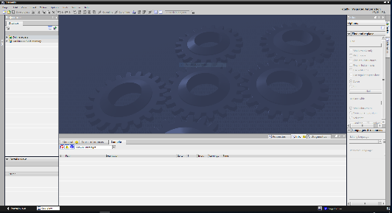

**2** SIMATIC STEP 7 Professional (TIA Portal) V15.0 or higher





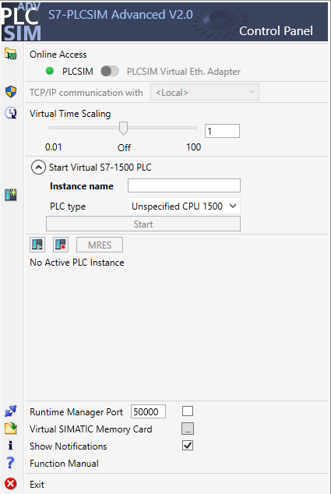

**4** PLCSIM Advanced

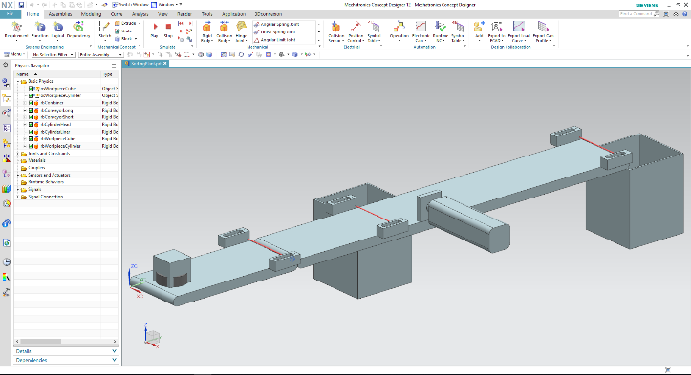

**5** NX / MCD



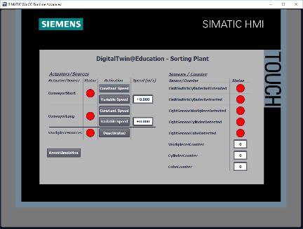

**3** WinCC RT Advanced



Figure 1: Overview of required software and hardware components in this module

As you can see from Figure 1, the engineering station is the only hardware component of the system. The remaining components are based exclusively on software.

# Theory

## Virtual commissioning

Given that methods used in the digitalization process are becoming increasingly complex, the industry has been looking for ways to shorten the time for commissioning. Virtual commissioning offers an immense advantage in this area.

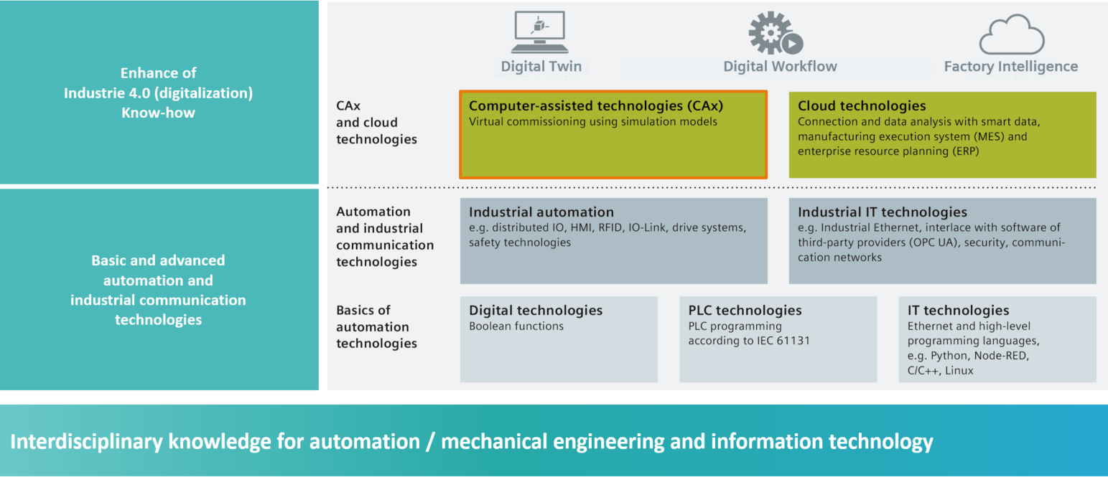

Figure 2: Digitalization process of the automation industry, focusing on virtual commissioning [1]

### What is virtual commissioning and what is a digital twin?

The concept of virtual commissioning comprises several intertwining sub-areas aimed at

* creating,
* modifying and
* expanding

systems and system components, of a production line, virtually testing them and optimizing the process. This procedure helps to detect and eliminate errors at an early stage of development before the real plant is put into operation. This concept allows a parallelization of the mechanical and electrical design, as well as the creation of the control software. This speed up the commissioning of the real plant and lowers possible costs of errors after delivery, as these errors have ideally already been corrected during development.

Virtual commissioning is based on a 3D simulation model that simulates the behavior of a plant, production line or individual cell. This map is also known as a "digital twin". The extent to which the virtual model resembles the real model depends on the model's level of detail: The more features that can be assigned to the simulation model, the more accurate the map of the real plant. However, each additional feature also means more development effort for the model. A compromise needs to be found between the necessary simulation depth and the development effort for the current project.

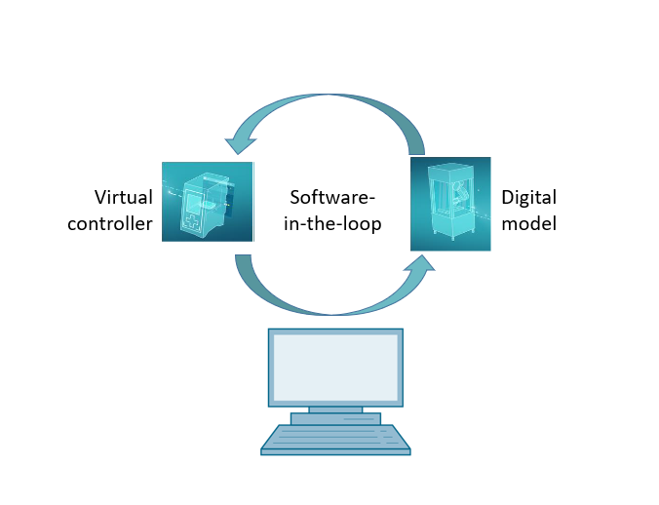

Figure 3: Principle of virtual commissioning (acc. to [2])

The principle of virtual commissioning is based on the following cornerstones:

* A **virtual controller** enables testing of the automation program, consisting of the PLC logic and the corresponding visualization.
* The **digital model** consists of the physical and kinematic features of the mechanical components within the simulation model.
* The behavior and functionality can be validated through the **interaction between the virtual controller and the digital model**.

This concept, as shown in Figure 3, corresponds to the **Software-in-the-Loop (SiL)** modeling method: All components are detached from real hardware, the simulations are run exclusively on development computers.

If you were to perform commissioning with real hardware, using a real PLC for example, one would speak of the Hardware-in-the-loop (HiL) concept.

However, the Software-in-the-loop simulation principle will be used as a basis for this workshop.

There are several ways to create a digital model. Using the NX tool you can create a 3D model of the mechanical components and create a map of the real plant. Using the NX add-on Mechatronics Concept Designer, this map can be turned into a complete digital twin by adding physical and kinematic features. In addition to NX and MCD, the TECHNOMATIX Process Simulate software of Siemens can also be used to create a digital model. However, it also maps other features.

The SIMATIC S7-PLCSIM Advanced software can be used to simulate a PLC. The configuration is carried out completely in the TIA Portal and downloaded to the simulated device via a virtual interface. For additional information on this, refer to Chapter 4.1.2.

The CAD/CAE/CAM terminology is explained in Chapter 4.1.3. For a description of NX, refer to Chapter 4.1.4. The NX add-on Mechatronics Concept Designer (MCD) is presented in   
Chapter 4.1.5. In Chapter 4.1.6 a short comparison is made with the TECHNOMATIX Process Simulate simulation software.

### SIMATIC S7-PLCSIM Advanced:

The SIMATIC S7-PLCSIM Advanced tool is used to create and commission a virtual controller. This is limited to the two most common Siemens controllers: S7-1500 and ET 200SP. Through use of the virtual controller, the use of a real PLC is not necessary, so that commissioning can be carried out completely by the software. In addition to the loaded PLC program, other controller functions are also available for the simulation, such as the web server, the OPC UA server and other S7 communications. This means that early testing of the controller software is already possible without hardware. This saves rework time for the customer.

### What is CAD/CAE/CAM?

In the course of the digital representation of products, the following terminology has been established in the design phase.

Computer-aided design (CAD) describes the use of computers to create, modify, optimize and analyze any design. These designs can be created in two- or three-dimensional space. CAD is often used in connection with mechanical designs in mechanical engineering, but is now also used in many sectors, such as architecture, multimedia or automation engineering.

Computer-aided engineering (CAE) uses a CAD design and enhances this with dynamic features for simulations. Depending on the application, these are physical features, kinematics and kinetics as well as flow or thermal analyses.

Computer-aided manufacturing (CAM) uses a CAD design to generate a manufacturing plan for (C)NC machines.

### NX

NX is a Siemens PLM software tool, which enables the design of virtual 2D and 3D models. It consists of various individual modules that cover wide areas of the product design phase for various CAD, CAE and CAM applications. This includes product design, product modeling, product validation and product documentation. This simplifies the interaction of a company's various design departments, such as between mechanical design, onboard electronics and automation engineering.

### Mechatronics Concept Designer

The Mechatronics Concept Designer is an expansion module for the NX software and includes a "physics engine" to assign physical and kinematic features to the CAD model. Furthermore, the model can be equipped with sensors and actuators and the corresponding signals for controlling these can be assigned. Using sequence information of the operation or motion sequences, the automation engineer can validate the interaction of mechanics, electronics and automation. All previous properties can be tested directly using an integrated simulation to identify weaknesses in the design before real production of the model begins.

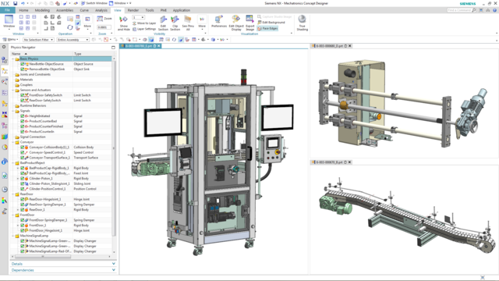

Figure 4: Example of a CAE model in NX MCD [3]

### Alternative to MCD: TECNOMATIX Process Simulate

The TECNOMATIX Process Simulate software provides another option for creating a simulation model. The main difference from the Mechatronics Concept Designer (see Chapter 4.1.5) is that the tool is not based on a "physics engine". Therefore, the components do not receive any physical or kinematic features. A major advantage is that the interactions of several processes as well as the intertwining of the processes of several cells can be reproduced and an entire production line can be simulated more easily. In addition, TECNOMATIX Process Simulate is often used for programming a robot program. For this purpose, Tecnomatix provides simulated robot controllers on which the original robot program can be executed. Finally, it is possible to create logics in Tecnomatix, so that the behavior of components can be demonstrated.

The behavior model of this workshop is instead based on physical features, which is why TECNOMATIX Process Simulate is not used here.

## Model description of the digital twin "SortingPlant"

This workshop aims to use a simple mechatronic model created using NX/MCD for virtual commissioning. The finished dynamic 3D model (see Figure 5) is already earmarked for this module and explained below.

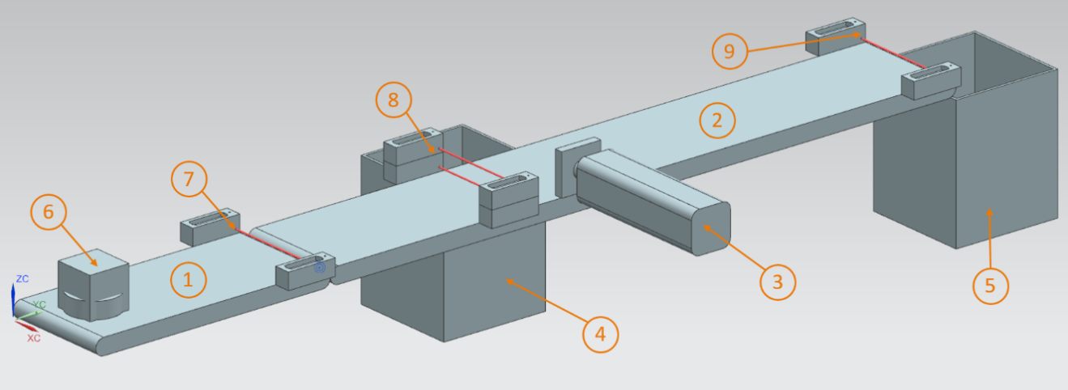

Figure 5: CAD/CAE model of the digital twin "SortingPlant"

The SortingPlant consists of two different conveyor belts. The first and shorter conveyor belt (see Figure 5, Element 1) is responsible for transporting the workpieces to the sorting process. Both cuboid and cylindrical workpieces are possible as workpieces (see Figure 5, Element 6). It should be noted that the cuboid workpiece is higher than the cylindrical workpiece. The first light sensor (see Figure 5, Element 7) is used to count the workpieces that pass through the sorting process.

The second and longer conveyor belt (see Figure 5, Element 2) is responsible for sorting the workpieces. The pusher (see Figure 5, Element 3) is used to separate out the cylindrical workpieces into the first container (see Figure 5, Element 4). The total number of cylindrical workpieces in the sorting process is accordingly incremented by one. A combination of two light sensors (see Figure 5, Element 8) is used to unambiguously identify the cylindrical workpiece. Due to the lower height, only the lower of the two light sensors is triggered for the cylindrical workpiece, while both light sensors are activated for the cuboid workpiece. An XOR combination of both light sensors provides a suitable logic for identifying the cylindrical workpieces.

If it is a cuboid workpiece, it is transported via the conveyor belt to the second container. (see Figure 5, Element 5). The last light sensor (see Figure 5, Element 9) counts the total number of cuboid workpieces in the sorting process.

### Signal table for the model integration in the PLC

|  |  |  |  |  |  |
| --- | --- | --- | --- | --- | --- |
| **Digital input** | **Element in the model** | **TIA Portal address** | **Data type** | **NC/ NO** | **Function** |
| csLightSensorCube _Detected | Element 9 | %I0.0 | BOOL | NO | 0: Light sensor for cube has not detected a workpiece 1: A workpiece was detected in the feed area of the light sensor for cubes |
| csLightSensorCylinder  _Detected | Element 8 | %I0.1 | BOOL | NO | 0: Light sensor for cube has not detected a workpiece 1: A workpiece was detected in the feed area of the light sensor for cylinders |
| csLightSensorWorkpiece  _Detected | Element 7 | %I0.2 | BOOL | NO | 0: Light sensors for cubes and cylinders have not detected either of the two workpieces 1: A workpiece was detected in the feed area of the light sensor |
| csLimitSwitchCylinder  NotExtended_Activated | Element 3 | %I0.3 | BOOL | NO | 0: The push cylinder  is fully extended  1: The push cylinder  is not fully extended |
| csLimitSwitchCylinder  Retracted_Activated | Element 3 | %I0.4 | BOOL | NO | 0: The push cylinder  is not fully retracted  1: The push cylinder  is fully retracted |

Table 1: Input signals of the SortingPlant model from the 3D model to the PLC (NO: normally open; NC: normally closed)

|  |  |  |  |  |  |
| --- | --- | --- | --- | --- | --- |
| **Digital output** | **Element**  **in the model** | **TIA Portal address** | **Data type** | | **Function** |
| osWorkpieceCylinder  _SetActive | Element 6 | %Q0.0 | BOOL | | 0: No cylindrical workpieces are produced for the simulation  1: New cylindrical workpieces are produced for the simulation |
| osWorkpieceCube  _SetActive | Element 6 | %Q0.1 | BOOL | | 0: No cuboidal workpieces are produced for the simulation  1: New cuboidal workpieces are produced for the simulation |
| pcCylinderHeadRetract  _SetActive | Element 3 | %Q0.2 | BOOL | | 0: Push cylinder is not to be retracted  1: Push cylinder is to be retracted |
| pcCylinderHeadExtend  _SetActive | Element 3 | %Q0.3 | BOOL | 0: Push cylinder is not to be extended  1: Push cylinder is to be extended | |
| scConveyorLongConstSpeed  _SetActive | Element 2 | %Q0.4 | BOOL | 0: The long conveyor belt is not to move further at a constant speed  1: The long conveyor belt is to move further at a constant speed | |
| scConveyorLongVarSpeed  _SetActive | Element 2 | %Q0.5 | BOOL | 0: The long conveyor belt is not to move further at a variable speed  1: The long conveyor belt is to move further at a variable speed | |
| scConveyorShortConstSpeed  _SetActive | Element 1 | %Q0.6 | BOOL | 0: The short conveyor belt is not to move further at a constant speed  1: The short conveyor belt is to move further at a constant speed | |
| scConveyorShortVarSpeed  _SetActive | Element 1 | %Q0.7 | BOOL | 0: The short conveyor belt is not to move further at a variable speed  1: The short conveyor belt is to move further at a variable speed | |
| scConveyorLongVarSpeed  _SetSpeed | Element 2 | %QD64 | REAL | variable velocity  for long conveyor belt  in m/s | |
| scConveyorShortVarSpeed  _SetSpeed | Element 1 | %QD68 | REAL | variable velocity for short conveyor belt in m/s | |

Table 2: Output signals of the SortingPlant model from the PLC to the 3D model

# Task

In this module, a preconfigured digital twin is to be commissioned. To do this, you must first unpack the provided projects and load them. In addition to the program for the CPU and the HMI, this also includes the mechatronic model from the Mechatronics Concept Designer (MCD). The interface between virtual PLC, simulated HMI and the digital twin is implemented using PLCSIM Advanced.

# Planning

Already finished projects and files are available for this module, so that commissioning with subsequent testing can be carried out exclusively here.

The PLC and the HMI were created and configured with the **SIMATIC STEP 7 Professional V15.0** software. The PLC is simulated virtually using the **SIMATIC** **S7-PLCSIM Advanced V2.0** software. The HMI is simulated with the TIA Portal option package **SIMATIC WinCC Runtime Advanced V15.0**. The virtual PLC and the simulated HMI are connected via the simulated Ethernet interfaces.

The digital twin was created using **Mechatronics Concept Designer V12.0**. The suitably configured signals are already connected to the inputs and outputs of the PLC.

# Structured step-by-step instructions

The following describes how to perform virtual commissioning of the dynamic 3D model. The instructions cover the following:

* Commissioning of the virtual PLC and the HMI simulation using a prepared TIA project
* Setting up a virtual PLC in PLCSIM Advanced
* Downloading the programs to the virtual PLC and the simulated HMI
* Loading the dynamic 3D model and starting the simulation in NX MCD
* Testing the functionality of the digital twin using two example scenarios

You can find more information about this module at some places in this document. This information is provided in a blue-green information box and serves to deepen your knowledge.

## Retrieving an existing project in the TIA Portal

* Start the "**TIA Portal V15.0**" software. You can do this either by searching for TIA Portal V15 in the Start menu or by double-clicking the corresponding icon on the desktop.
* After that, the TIA Portal should open at the start screen. If not set by default, open the "**Project View**" of the TIA Portal, as shown in Figure 6, Step 1. (→ Project view)

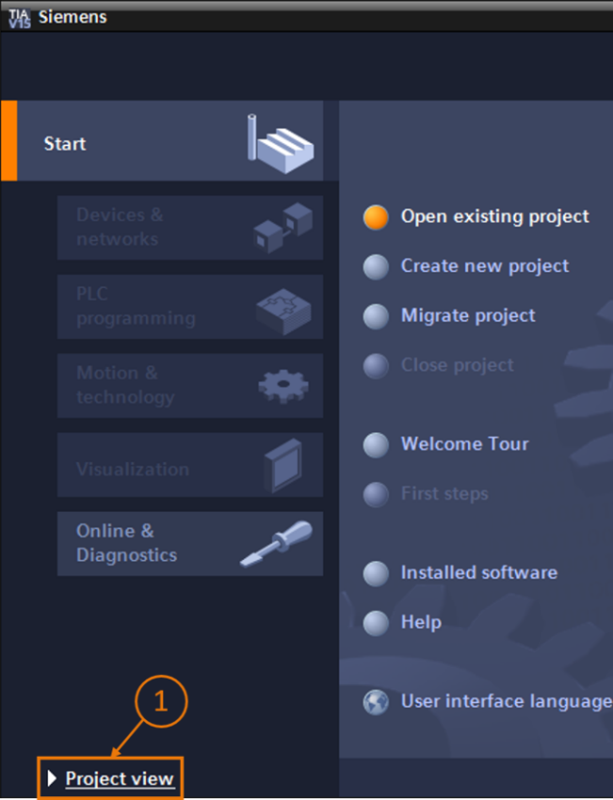

Figure 6: Opening the Project view.

* In the project view, you now have the option of retrieving a project. Various projects within the ZIP file "150-001-project-hs-darmstadt-0919-en.zip" are made available with this module. The TIA Project has the name "**150-001_DigitalTwinAtEducation_TIAP_Basic.zap15**". To retrieve the project from the archive, select Project in the menu bar in the Project view of TIA Portal. Next, select Retrieve (see Figure 7) and search for the corresponding archive. Next, confirm your selection with "OK". (→ Project → Retrieve → *Selection of the corresponding zap archive* → Open)

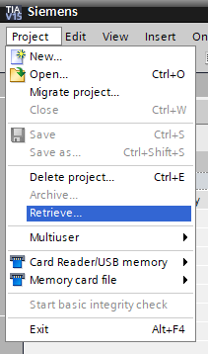

Figure 7: Retrieving a TIA project

* Now, select a target directory into which the project is to be retrieved. Navigate to the desired directory (in this case, e.g. "*C:\DigitalTwinAtEducation*") and confirm the selection by clicking "OK". (→ *Select target directory* → OK)

The project has now been successfully retrieved and is ready to be used.

## Compiling and saving the project

The retrieved TIA project now has to be compiled.

However, you should first check the Ethernet communication. In the provided TIA project, the IP address **192.168.0.1** was selected for the CPU and the IP address **192.168.0.10** for the HMI. If these addresses are already assigned in your system, you must adapt them according to existing SCE curriculums / training curriculums, as listed in Chapter 2 .

If the Ethernet communication has been selected appropriately, proceed as follows:

* In the project tree, select and right-click on "**CPU_1516F**". In the drop-down menu that appears, you will see the sub-item "**Compile**". You then have several options. Start, as shown in Figure 8, with the compilation of the hardware configuration. (→ Project tree → select "CPU_1516F" → right-click → Compile → Hardware (rebuild all))

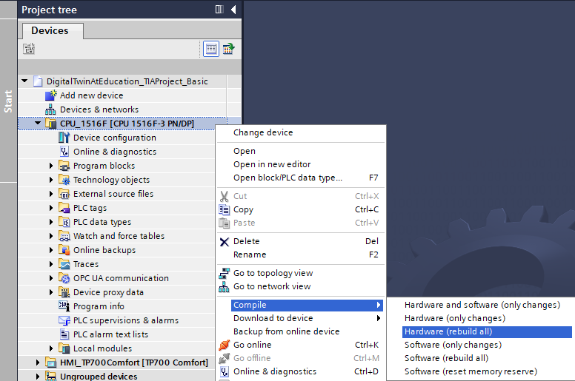

Figure 8: Compiling the entire hardware configuration in the TIA project

* After that, compile the CPU software. (→ Project tree → select "CPU_1516F" → right-click → Compile → Software (rebuild all))
* Once the latest version of the CPU has been compiled, the HMI visualization is compiled. To do this, select "**HMI_TP700Comfort**" in the project tree, right-click and select "**Compile**". First, compile the hardware completely. (→ Project tree → select "HMI_TP700Comfort" → right-click → Compile → Hardware (rebuild all))
* Next, compile the HMI software. (→ Project tree → select "HMI_TP700Comfort" → right-click → Compile → Hardware (rebuild all))
* Save the project. (→ Project →  Save)
* The TIA project is then functional and can be used for a simulation. **For the following steps, keep the TIA Portal open:**

## Start a virtual CPU via PLCSIM Advanced

To execute the simulation, the PLC used must be commissioned virtually. The "**S7-PLCSIM Advanced V2.0**" tool is used for this purpose.

* To begin with, start the software. To do this, search for S7-PLCSIM Advanced V2.0 via the Windows Start menu. Alternatively, double-click the corresponding desktop shortcut to start the software.
* PLCSIM Advanced, Version 2.0 starts by default as background process. You can control the software via the information area in the Windows taskbar (bottom right of your Windows desktop). Search for the PLCSIM Advanced icon in the information area and right-click the icon to open the **configuration window**. (→ Information area →  → right-click)

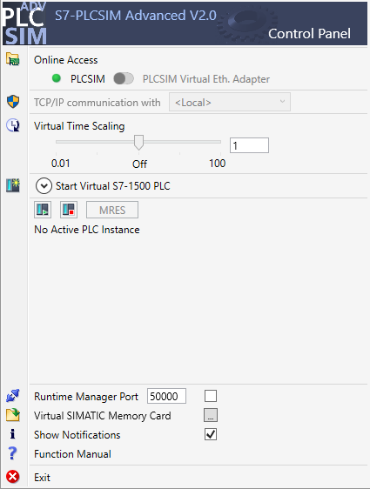

Figure 9: Control panel of PLCSIM Advanced

You should now be able to see the PLCSIM Advanced control panel (see Figure 9).

* First, make sure that the following basic settings have been made:
  + **"PLCSIM"** is activated for online access.
* Virtual Time Scaling is **switched off**, i.e. it remains at multiplier 1.
* Click the "**Start Virtual S7-1500 PLC**" arrow to open the sub-menu for configuring the virtual PLC. Assign the instance name "**DigTwinAtEdu_PLCSIM**" as shown in Figure 10, and select an "**Unspecified CPU 1500**" as PLC model. **It is important to use exactly this instance name, otherwise the signals of the mechatronic model will not be connected to the virtual PLC.** All necessary settings have now been made and you can then start the virtual PLC by clicking "**Start**". (→ Start Virtual S7-1500 PLC → Instance name: DigTwinAtEdu_PLCSIM → PLC type: Unspecified CPU 1500 → Start)

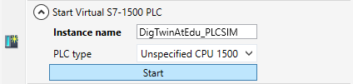

Figure 10: Configuration of a virtual PLC

* The virtual PLC should now be present and the status, as shown in Figure 11, should be:

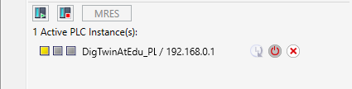

Figure 11: Status of the virtual PLC, no PLC program available

This indicates that an instance has been created, but the PLC has not yet been started. To start it, a control program must first be loaded into the virtual PLC.

* Go back to TIA Portal. Select "**CPU_1516F**" in the project tree and click the "**Download to device**" button  on the menu bar. (→ Project tree → select "CPU_1516F" → "Download to device" )
* The "Extended download" window opens. As shown in Figure 12, select "**PN/IE**" as the type of PG/PC interface and select PLCSIM as the interface. The connection is made to **slot '1 X1'**. Start a search. The virtual PLC from the PLCSIM Advanced instance should be found. Complete the process by clicking "**Load**".

(→ Type of the PG/PC interface: PN/IE → PG/PC interface: PLCSIM → Connection to interface: Slot '1 X1' → Click "Start search" button → Select virtual PLC as target device → Click "Load")

It may happen that the PG/PC interface selection menu shows the PLCSIM value grayed out, as in Figure 12. This occurs if no other active interfaces, except PLCSIM, are available. In this case you can continue.

**NOTE**

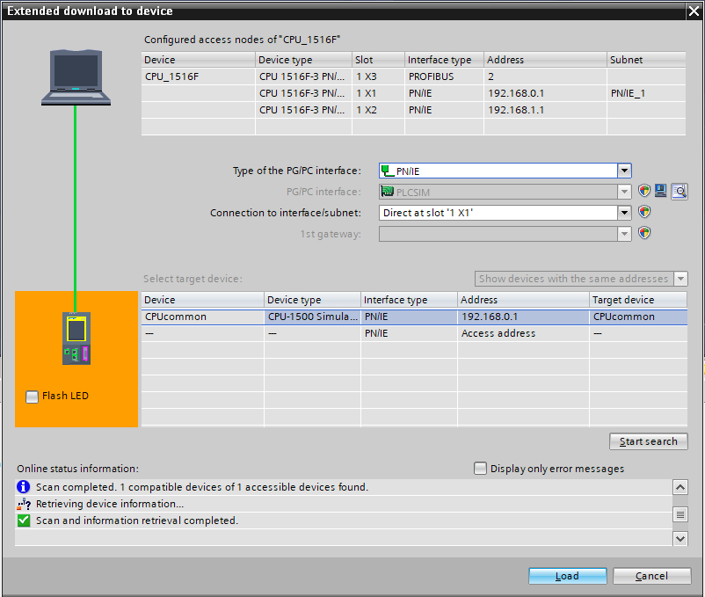

Figure 12: Downloading to the virtual PLC

* Then, follow the instructions in the load preview. Make sure that the PLC will be started afterwards.
* Go back to the PLCSIM Advanced software and check the new status of the virtual PLC. This should be displayed as in Figure 13.

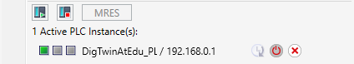

Figure 13: Status of the virtual PLC, PLC program downloaded and started

Now, you can see that the virtual PLC in PLCSIM Advanced has been successfully commissioned.

## Start a simulated HMI

After successfully starting a virtual PLC with PLCSIM Advanced, an HMI is simulated in this step.

* To do this, return to the TIA Project already opened in Step 7.1.
* Select "**HMI_TP700Comfort**" in the project tree. Right-click the associated configuration to open it and navigate in the opened shortcut menu to item "**Start simulation**". (see

Figure 14). Alternatively, you can also start the simulation with *Ctrcl+Shift+X*.

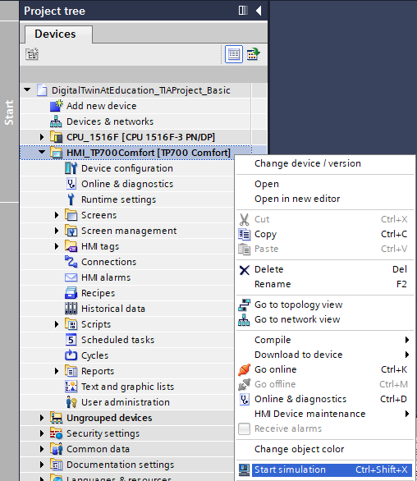

Figure 14: Starting the HMI simulation

The HMI simulation tool "**WinCC Runtime Advanced**" now starts and displays the preconfigured HMI in a separate window.

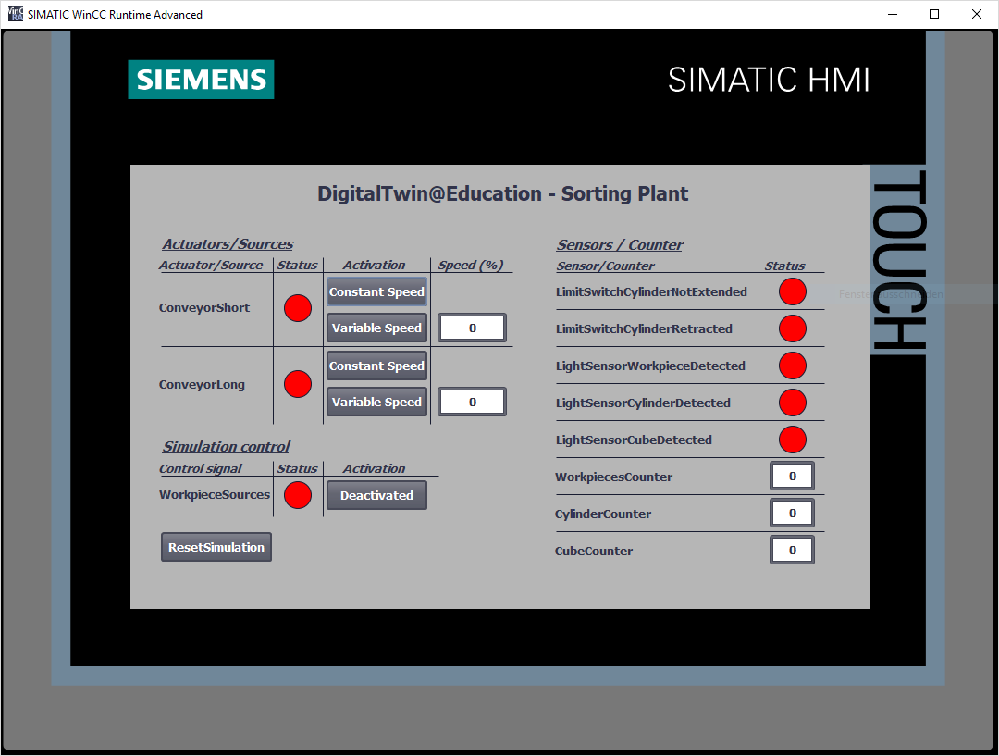

Figure 15: HMI simulation of the model control in WinCC Runtime Advanced

* Next, you should first check whether the input/output fields have a start value, as in this case **"0"** (see for comparison Figure 15). If the fields are not initialized, which is shown by the expression "#####", the configured connection is faulty. Therefore, you should check the hardware configuration and connection of the CPU1516F and HMI_TP700 again. If in doubt, refer to the documents listed in Chapter 2 again.

The HMI is now ready for virtual commissioning.

## Open the prepared digital twin and start simulation in NX MCD

For the last part of the virtual commissioning, the physical simulation model from the CAE program NX MCD is now required, whose simulation is prepared and started in the following steps.

* The ZIP file "**150-001-project-hs-darmstadt-0919-en.zip**" also contains the archive with the necessary MCD files. Using Windows or a separate tool, unpack the archive "**150-001_DigitalTwinAtEducation_MCD_dynModel_**  
  **Signals.zip**" into a folder of your choice. (here e.g. "*C:\DigitalTwinAtEducation*")
* Start the "**Mechatronics Concept Designer 12.0**" software. To do this, you can search for Mechatronics Concept Designer 12.0 in the start menu or open the corresponding shortcut on the desktop by double-clicking on it.
* You should see the main menu of the Mechatronics Concept Designer. Open the MCD project "**SortingPlant**". Click on the "Open" icon in the menu bar of the Mechatronics Concept Designer. The selection window from Figure 16 appears, in which you can navigate to the path of the unpacked archive. Select the "SortingPlant" file from the displayed Part files (*.prt). To load only the relevant data of the digital twin, make sure in the options that the file is only "partially loaded". Finish the process by clicking "**OK**". (→ Open  → select path to unpacked archive → select SortingPlant.prt → Option: Partially Load → "OK")

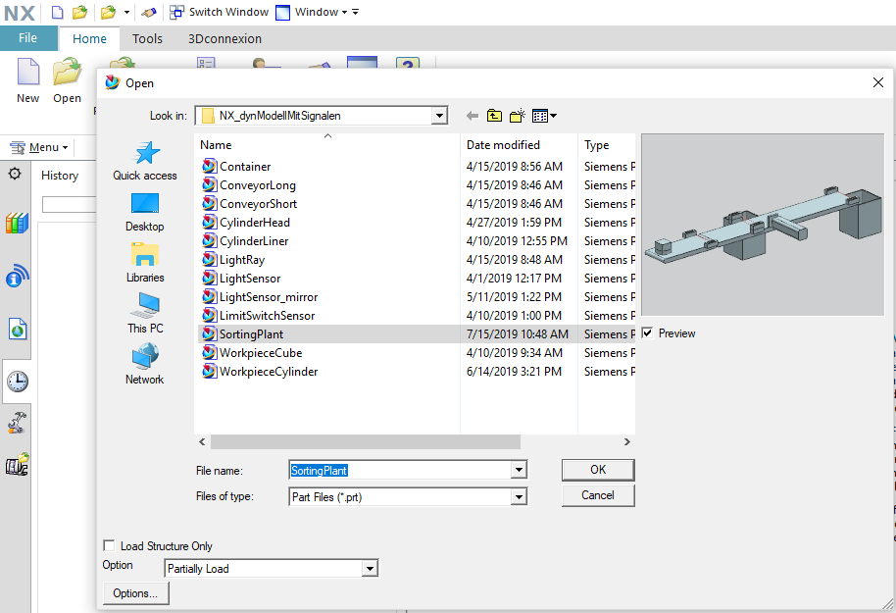

Figure 16: Opening the digital twin "SortingPlant"

* The project opens and the 3D model of the sorting plant is displayed in the lower right window. (see Figure 17).

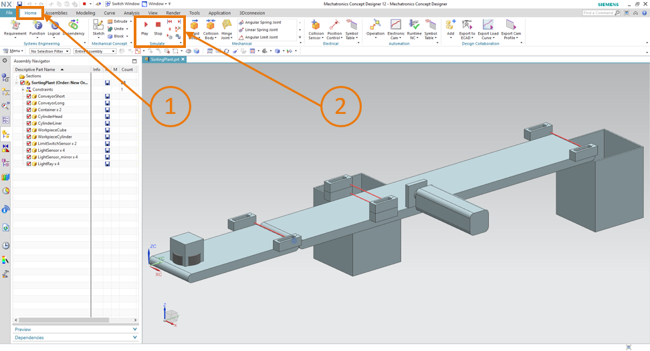

Figure 17: Model representation of the digital twin in MCD

* To start the simulation, go to the "**Home page**" menu in the menu bar at the top (see   
  Figure 17, Step 1). There you can now find, among other things, the icons to control the NX MCD simulation (see Figure 17, Step 2). Click the **Start** icon to start the simulation. You can see from the lower display bar of the program (see Figure 18) that the simulation is running.

(Start page → Simulate → Start  )

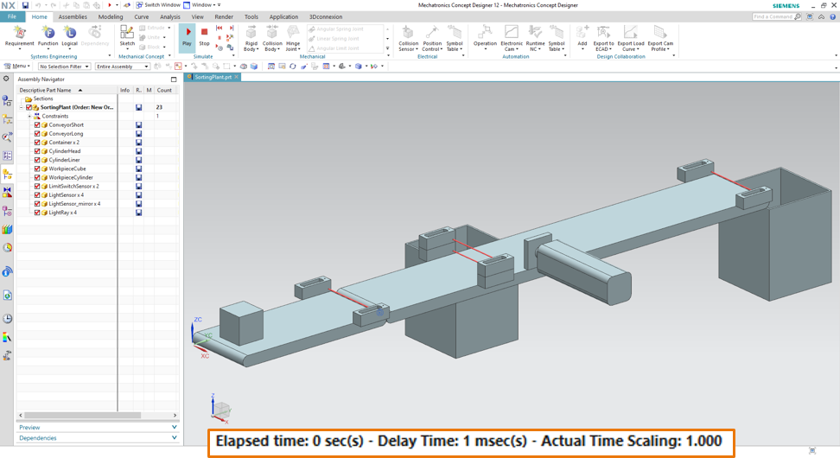

Figure 18: Simulation environment and simulation details in MCD

The simulation of all required individual components is now in operation and you can test the interaction between them below.

## Testing of interactions between CPU, HMI and digital twin

To test the function of the three simulations, first refer to the following two examples. To illustrate the necessary steps in the HMI simulation and to classify the HMI signals for the models in MCD, you can refer to Figure 20 for scenario 1 and Figure 21 for scenario 2. To appraise the reaction of the simulations, it is helpful to keep the simulated HMI in WinCC Runtime Advanced as well as the virtual 3D model in NX MCD visible in parallel on the screen.

**NOTE**

If the 3D view of the SortingPlant differs from the view shown in Figure 17 and Figure 18, you are not in the standard view of MCD, the so-called "Trimetric view". To return to this view, either select Trimetric in →Orient view→ in the View bar or press the *Pos1* key of a traditional computer keyboard. Alternatively, you can search for Trimetric using NX's search function at the top right of the screen (see Figure 19) and select Trimetric from the drop-down list.

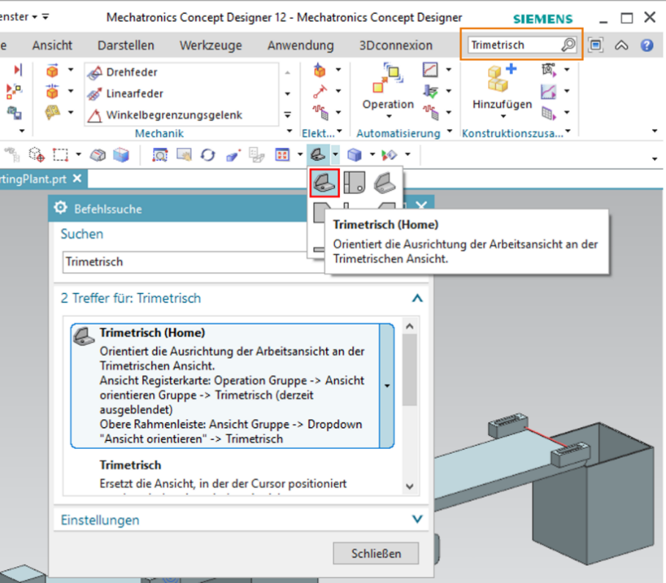

Figure 19: Go to "Trimetric view" in MCD

### Scenario 1: Movement of the sorting system at constant speed

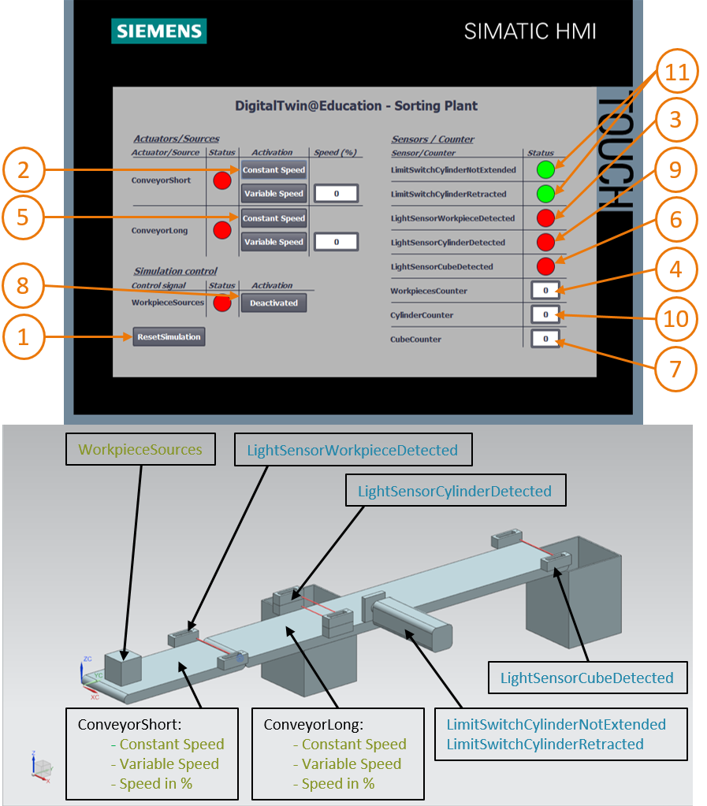

Figure 20: Sequence of Scenario 1 in HMI simulation and display of HMI signals in MCD model (orange: steps for scenario 1; blue: input signals; green: output signals)

* First, reset the simulation. To do this, press the "**Reset Simulation**" button in the simulated HMI (see Figure 20, Step 1). All buttons should be switched off and all I/O fields should be reset. No changes are visible in the 3D simulation in NX MCD, the cuboid body retains its position and the push cylinder is retracted.
* Next, press the "**Constant Speed**" button of the "**ConveyorShort**" conveyor belt in the HMI (see Figure 20, Step 2). You should now see that the cuboid workpiece is moving along the first conveyor belt. When the workpiece has reached the end of the conveyor belt, the "**LightSensorWorkpieceDetected**" light sensor (see Figure 20, Step 3) is triggered, which increments the "**Workpiece Counter**" (see Figure 20, Step 4). However, the workpiece now stops and is not transported via the second conveyor belt, as the second conveyor belt has not yet been activated in the PLC program or via the HMI.
* To do this, start the second conveyor belt "**ConveyorLong**" at constant speed by clicking its "**Constant Speed**" button (see Figure 20, Step 5). Now the cuboid workpiece should continue to move. During this process you can see that the "**LightSensorCylinderDetected**" signal does not trigger, because both middle light sensors react to the workpiece. As described in Chapter 4.2, in this case it is definitely not a cylindrical workpiece. The light sensor "**LightSensorCubeDetected**" (see Figure 20, Step 6) is activated for this. As a result, the "**CubeCounter**" is incremented (see Figure 20, Step 7). The cuboid workpiece then falls into the rear container.
* Because there are now no more workpieces left, press the "**WorkpieceSources**" button (see Figure 20, Step 8) to generate additional workpieces virtually. Cuboid and cylindrical workpieces subsequently appear at regular intervals due to the MCD simulation. While the above-described workflow for the cuboid pieces does not change, the following behavior occurs for the cylindrical workpieces: As with the cuboid workpieces, the "**LightSensorWorkpieceDetected**" light sensor is triggered, which increments the "**Workpiece Counter**". Because the cylindrical workpiece is smaller in height than the cuboid workpiece, only one of the two light sensor in the middle is triggered. Therefore, this object is identified as a cylindrical workpiece, which is why the signal "**LightSensorCylinderDetected**" is triggered (see Figure 20, Step 9), so that the "**CylinderCounter**" is incremented (see Figure 20, Step 10). The cylindrical workpiece is now sorted into the front container using the push cylinder (see Figure 20, Step 11).

### Scenario 2: Movement of the sorting system at variable speed

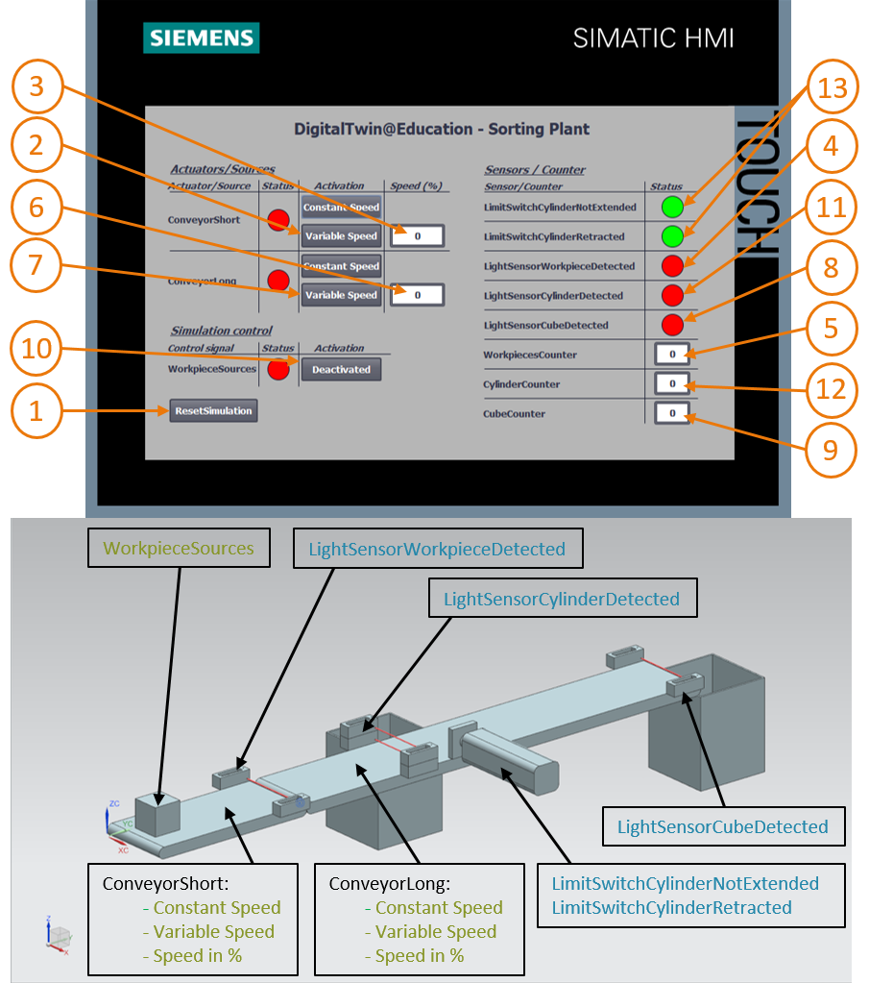

Figure 21: Sequence of Scenario 2 in HMI simulation and display of HMI signals in MCD model (orange: steps for scenario 2; blue: input signals; green: output signals)

* Deactivate all buttons of the HMI for this next scenario, stop the simulation in NX MCD by clicking the stop symbol  and then reset the simulation by clicking "**ResetSimulation**" in the HMI (see Figure 21, Step 1). Then restart the simulation in NX MCD by clicking the Start button . All buttons in the HMI should now be deactivated and all I/O fields reset. The cuboid body in NX MCD retains its position and the push cylinder is retracted.
* Select the "**Variable Speed**" button on the "**ConveyorShort**" conveyor belt (see Figure 21, Step 2). The conveyor remains stopped. The reason for this is that the input field for the speed is still set to 0% and the motor is therefore not running yet. Set the speed to 50% (see Figure 21, Step 3). Now the cuboid piece should move along the first conveyor belt. At the end of the conveyor belt, the "**WorkpieceCounter**" is incremented again (see Figure 21, Step 5) via a positive edge at "**LightSensorWorkpieceDetected**" (see Figure 21, Step 4). Since the second conveyor belt has not yet been activated, the cuboid piece remains at the end of the conveyor belt.
* First enter a motor speed of 50% for the second conveyor belt "**ConveyorLong**" in the input field (see Figure 21, Step 6). Next, activate the "**Variable Speed**" button on the "**ConveyorLong**" conveyor belt (see Figure 21, Step 7). The cuboid workpiece will then move further. In this case too, the "**LightSensorCylinderDetected**" signal is not triggered because both middle light sensors trigger. However, the "**LightSensorCubeDetected**" signal (see Figure 21, Step 8) is set, which increments the "**CubeCounter**" (see Figure 21, Step 9). The workpiece falls into the rear container.
* However, there are no further workpieces, as the generation of new workpieces has not yet been activated. To do this, click the "**WorkpieceSources**" button (see Figure 21, Step 10). Rectangular and cylindrical workpieces should now be generated at regular intervals. As already noted in Scenario 1 (Chapter 7.6.1), the cylindrical workpiece is clearly identified on the basis of the height in the middle light sensors, which is why the "**LightSensorCylinderDetected**" signal is triggered (see Figure 21, Step 11) and the "**CylinderCounter**" is incremented (see Figure 21, Step 12). The cylindrical workpiece is then sorted into the front container using the push cylinder (see Figure 21, Step 13).
* When you are finished testing, stop the simulation in NX MCD by clicking the Stop icon. . Reset the HMI by pressing the "**ResetSimulation**" button. Also, close the simulated HMI instance of WinCC Runtime Advanced. Also, stop the virtual PLC in PLCSIM Advanced. Open the control panel, as described in Chapter 7.3. You see the virtual PLC DigTwinAtEdu_PLCSIM with IP address and further control symbols on the right side (see Figure 22).



Figure 22: Status of the virtual PLC, PLC program running

* First switch off the virtual PLC by clicking the **PowerOff** icon . The instance is then grayed out, which means that it has become inactive (see Figure 23).

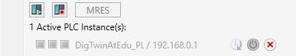

Figure 23: Status of the virtual PLC, inactive instance

* Finally press the button "**Power off and unregister instance**" . Now the instance of the virtual PLC is no longer registered in the system.

You have now completed the first module and carried out the virtual commissioning of a prepared digital twin.

In the next module you will learn more details about the underlying TIA project.

## Checklist – step-by-step instructions

The following checklist helps students to independently check whether all steps of the step-by-step instructions have been carefully completed and enables them to successfully complete the module on their own.

|  |  |  |
| --- | --- | --- |
| **No.** | **Description** | **Checked** |
| 1 | Project files for module 1 successfully downloaded from the SCE homepage. |  |
| 2 | The TIA project for module 1 was successfully retrieved from the archive in the TIA Portal. |  |
| 3 | The Ethernet communication in the TIA project was aligned with the existing system and adapted where required. |  |
| 4 | The hardware and software configuration of the PLC program was successfully compiled. |  |
| 5 | The PLC program was successfully saved. |  |
| 6 | The PLCSIM Advanced tool was successfully opened. |  |
| 7 | The virtual PLC was configured and successfully started in PLCSIM Advanced. |  |
| 8 | The TIA project was successfully downloaded to the virtual PLC. |  |
| 9 | The HMI simulation was started successfully. |  |
| 10 | The archive with the 3D models was successfully unpacked on the Windows system. |  |
| 11 | The "*SortingPlant*" model was successfully opened in the NX tool Mechatronics Concept Designer (NX MCD). |  |
| 12 | The simulation of the dynamic 3D model was successfully started in NX MCD. |  |
| 13 | Scenario 1 was tested successfully. |  |
| 14 | Scenario 2 was tested successfully. |  |
| 15 | All simulation instances (PLCSIM Advanced, HMI and NX MCD) were successfully ended. |  |

Table 3: Checklist of the "Virtual commissioning of a production plant using a dynamic 3D model".

# Additional Information

You can find additional information as an orientation aid to familiarize yourself or deepen your knowledge, for example: Getting Started, videos, tutorials, apps, manuals, programming guidelines and trial software/firmware, at the following link:

**Preview "Additional information" – In preparation**

Here are some interesting links:

[1] [automation.siemens.com/sce-static/media-support/e20001-a110-p260-x-7600.pdf](https://automation.siemens.com/sce-static/media-support/e20001-a110-p260-x-7600.pdf)

[2] [new.siemens.com/global/en/products/automation/industry-software/automation-software/tia-portal/virtual-commissioning.html](https://new.siemens.com/global/en/products/automation/industry-software/automation-software/tia-portal/virtual-commissioning.html)

[3] [plm.automation.siemens.com/global/en/products/mechanical-design/mechatronic-concept-design.html](https://www.plm.automation.siemens.com/global/en/products/mechanical-design/mechatronic-concept-design.html)

Additional information

Siemens Automation Cooperates with Education  
**siemens.com/sce**

SCE Learn-/Training Document  
**siemens.com/sce/module**

SCE Trainer Packages  
**siemens.com/sce/tp**

SCE Contact Partners   
**siemens.com/sce/contact**

Digital Enterprise  
**siemens.com/digital-enterprise**

Totally Integrated Automation (TIA)  
**siemens.com/tia**

TIA Portal  
**siemens.com/tia-portal**

TIA Selection Tool **siemens.com/tia/tia-selection-tool**

SIMATIC Controller  
**siemens.com/controller**

SIMATIC Technical Documentation   
**siemens.com/simatic-docu**

Industry Online Support  
**support.industry.siemens.com**

Industry Mall catalog and ordering system   
**mall.industry.siemens.com**

Siemens   
Digital Industries, FA  
P.O. Box 4848  
90026 Nuremberg  
Germany

Errors excepted and subject to change without prior notice.  
© Siemens 2020

**siemens.com/sce**