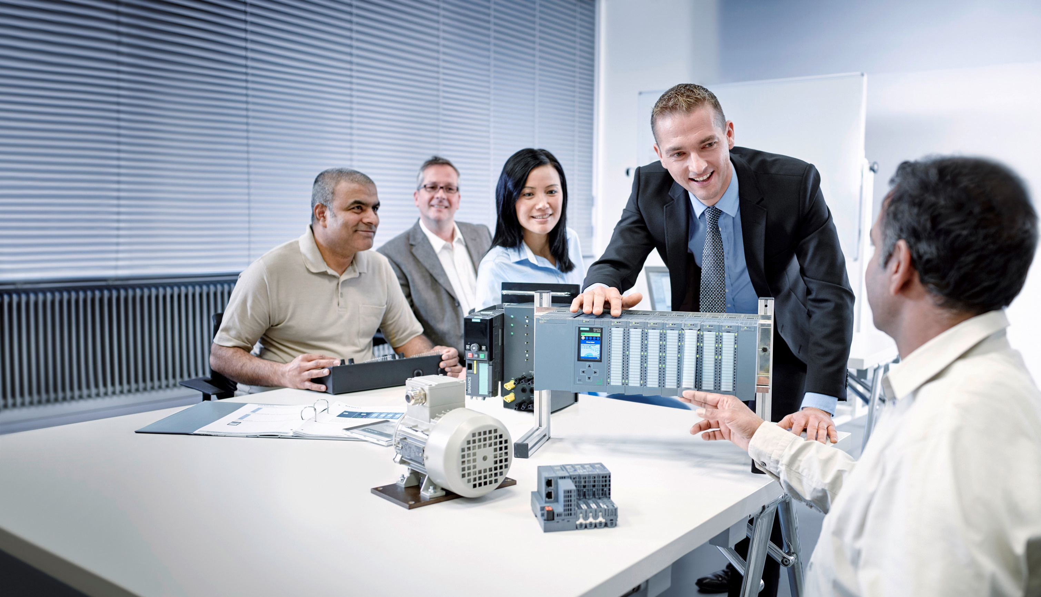**Matching SCE Trainer Packages for these Learn-/Training Document**

Learn-/Training Document  
  
Siemens Automation Cooperates with Education (SCE) | From Version V14 SP1

**siemens.com/sce**

TIA Portal Module 031-420

Diagnostics via Web with SIMATIC S7-1200

* **SIMATIC S7-1200 AC/DC/RELAY (set of 6) "TIA Portal"**  
  Order no.: 6ES7214-1BE30-4AB3
* **SIMATIC S7-1200 DC/DC/DC (set of 6) "TIA Portal"**  
  Order no.: 6ES7214-1AE30-4AB3
* **Upgrade SIMATIC STEP 7 BASIC V14 SP1 (for S7-1200) (set of 6) "TIA Portal"**  
  Order no.: 6ES7822-0AA04-4YE5

Please note that these trainer packages are replaced with successor packages when necessary.

An overview of the currently available SCE packages is provided at: [siemens.com/sce/tp](http://www.siemens.com/sce/tp)

**Continued training**

For regional Siemens SCE continued training, please contact your regional SCE contact [siemens.com/sce/contact](http://www.siemens.com/contact)

**Additional information regarding SCE**

[siemens.com/sce](http://www.siemens.com/sce)  
  
  
**Information regarding use**

The SCE Learn-/Training Document for the integrated automation solution Totally Integrated Automation (TIA) was prepared for the program "Siemens Automation Cooperates with Education (SCE)" specifically for training purposes for public educational facilities and R&D institutions. Siemens AG does not guarantee the contents.

This document is to be used only for initial training on Siemens products/systems, which means it can be copied in whole or part and given to those being trained for use within the scope of their training. Circulation or copying this Learn-/Training Document and sharing its content is permitted within public training and advanced training facilities for training purposes.

Exceptions require written consent from the Siemens AG contact person: Roland Scheuerer roland.scheuerer@siemens.com.

Offenders will be held liable. All rights including translation are reserved, particularly if a patent is granted or a utility model or design is registered.

Use for industrial customer courses is explicitly not permitted. We do not consent to commercial use of the Learn-/Training Document.

We wish to thank the TU Dresden, particularly Prof. Dr.-Ing. Leon Urbas and the Michael Dziallas Engineering Corporation and all other involved persons for their support during the preparation of this Learn-/Training Document.

Table of contents

1 Goal 4

2 Prerequisite 4

3 Required hardware and software 5

4 Theory 6

4.1 Diagnostics via web server 6

5 Task 8

6 Planning 8

7 Structured step-by-step instructions 9

7.1 Retrieve an existing project 9

7.2 Configure the web server 10

7.3 Save project and download CPU 14

7.4 Diagnostics for the S7-1200 via the web 15

7.5 Checklist 21

8 Additional information 22

Diagnostics via web server

# Goal

In this module, the reader will become acquainted with the contents that can be displayed via the web server of the CPU 1214C.

This module will present the diagnostic functions in the web server that, for example, you can test with the TIA project from the SCE_EN_031-410_Basics Diagnostics with SIMATIC S7-1200 module.

The SIMATIC S7 controllers listed in Chapter 3 can be used.

# Prerequisite

This chapter builds on the hardware configuration of the SIMATIC S7 CPU1214C DC/DC/DC. However, other hardware configurations can be used. You can use the following project for this chapter, for example:

SCE_EN_031-410_Basics_Diagnostics_S7-1200.zap14

# Required hardware and software

**1** Engineering station: requirements include hardware and operating system   
(for additional information, see Readme on the TIA Portal Installation DVDs)

**2** SIMATIC STEP 7 Basic software in TIA Portal – as of V14 SP1

**3** SIMATIC S7-1200 controller, e.g. CPU 1214C DC/DC/DC with ANALOG OUTPUT SB1232 signal board, 1 AO – Firmware as of V4.2.1

Note: The digital inputs should be fed out to a control panel.

**4** Ethernet connection between engineering station and controller

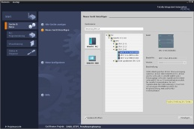

**2** SIMATIC STEP 7 Basic (TIA Portal) as of V14 SP1



**1** Engineering Station

**4** Ethernet connection

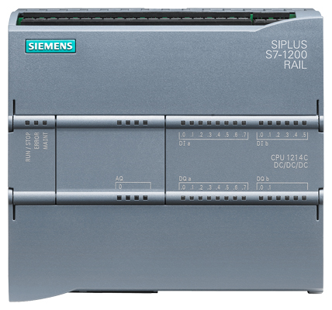

**3** SIMATIC S7-1200 controller



Control panel

# Theory

* 1. Diagnostics via web server

The web server enables monitoring and administering of the CPU by authorized users over a network.

This permits evaluation and diagnostics over long distances. Monitoring and evaluation is possible without the TIA Portal; all you need is a web browser.

The web server is deactivated in the delivery state of the CPU. This means that you must load a project in which the web server is activated to enable access using the web browser.

**The web server offers the following security functions:**

* Access via secure "https" transmission protocol
* User authorization by means of a user list
* Restriction of access from certain interfaces

You need a web browser to access the HTML pages of the CPU.

**The following web browsers have been tested for communication with the CPU:**

* Internet Explorer (Version 8)
* Mozilla Firefox (Version 21)
* Mobile Safari (iOS5)

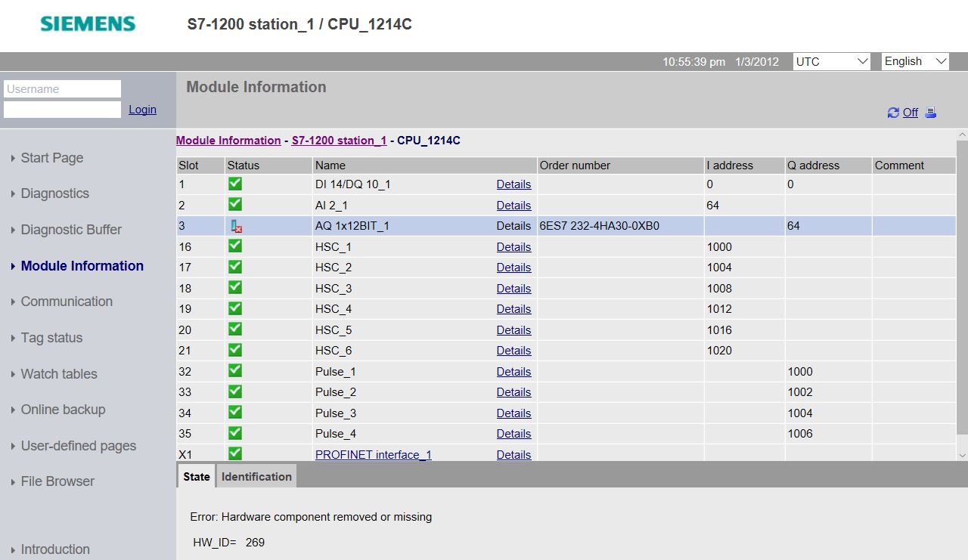

Figure 1: Web server of the CPU 1214C DC/DC/DC with Module Information

**Note:** Make sure that you protect the CPU from manipulation and unauthorized access through the use of different methods (e.g., limiting network access, using firewalls).

# Task

The following advanced diagnostic functions will be shown and tested in this chapter:

* Configuration of the web server of the CPU 1214C DC/DC/DC
* Display messages via the web server of the CPU 1214C DC/DC/DC

# Planning

The diagnostic functions will be performed using a finished project as an example.

A project in the TIA Portal that was previously downloaded to the controller should be open for this.

In our case, after starting the TIA Portal, a previously created project will be retrieved from the archive and downloaded to the associated controller.

You can then configure the web server in the TIA Portal.

To demonstrate the display of an error in the module information, the configured signal board AQ 1x12Bit, for example, can be removed. **Caution!** The PLC should be disconnected from the supply voltage beforehand.

# Structured step-by-step instructions

You can find instructions on how to carry out planning below. If you already have a good understanding of everything, it will be sufficient to focus on the numbered steps. Otherwise, simply follow the detailed steps in the instructions.

* 1. Retrieve an existing project

Before we begin with diagnostics via the web server, we need a project from the SCE_EN_031-410 Basics Diagnostics S7-1200 module. (e.g., SCE_EN_031-410_Basics Diagnostics_S7-1200_2.zap14)

To retrieve an existing project that has been archived, you must select the relevant archive with →Project →Retrieve in the project view. Confirm your selection with "Open".   
(→ Project → Retrieve → Select a .zap archive → Open)

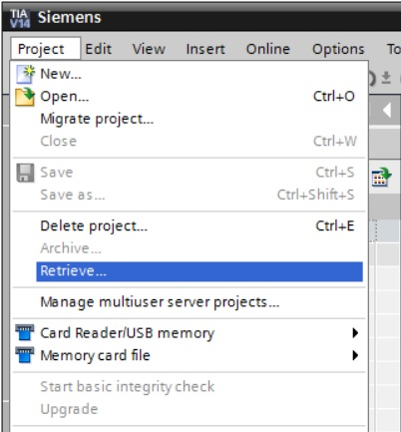

* The next step is to select the target directory where the retrieved project will be stored. Confirm your selection with "OK". (→ Target directory → OK)
  1. Configure the web server
* To configure the web server, open the device configuration of the CPU 1214C DC/DC/DC.  
  (→ CPU_1214C [CPU 1214C DC/DC/DC] → Device configuration)

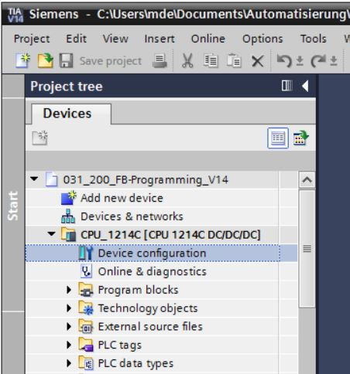

* Select the CPU and choose the 'Web server' menu item in the properties.

(→ CPU_1214C → Properties → Web server)

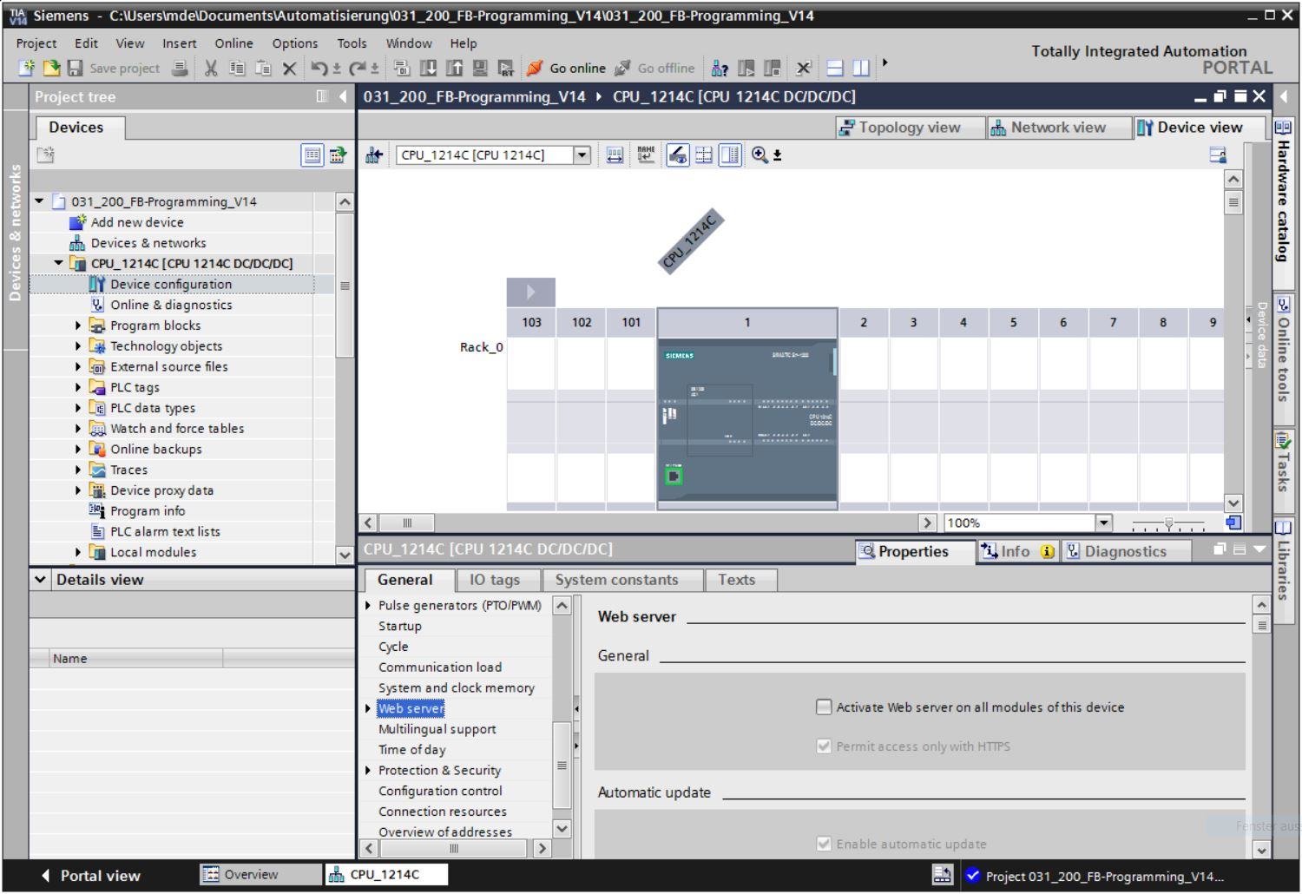

* Activate the web server on this module and confirm the security note.

(→  Activate web server on this module → OK)

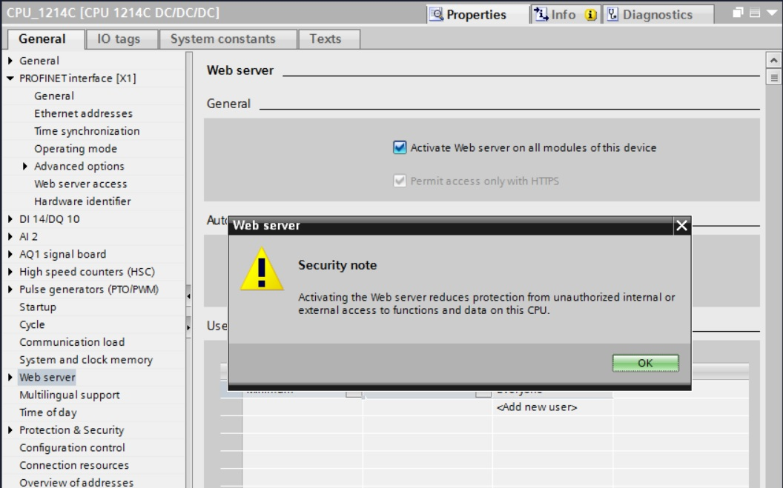

* Leave the check mark  for 'Enable automatic update', and select the security settings of the 'Everybody' user. Enable this user to carry out all possible actions and accept your settings.  
  (→  → )

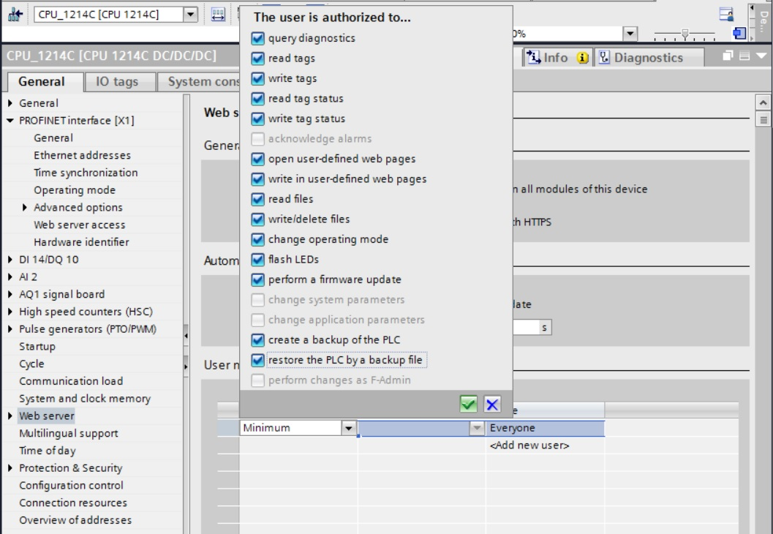

**Notes:** You can also create multiple users here with different authorizations. These users then require a password.

* As a result of these authorizations, the 'Everybody' user is now automatically assigned the access level 'Administrative'.

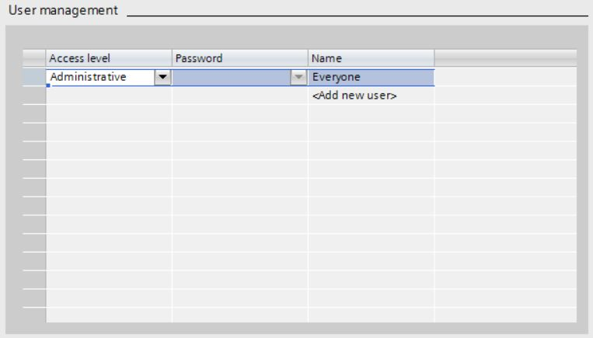

* In the 'Watch tables' menu item, the 'Watch table_Cylinder' can now be entered in the web server.   
  (→Watch table_Cylinder → )

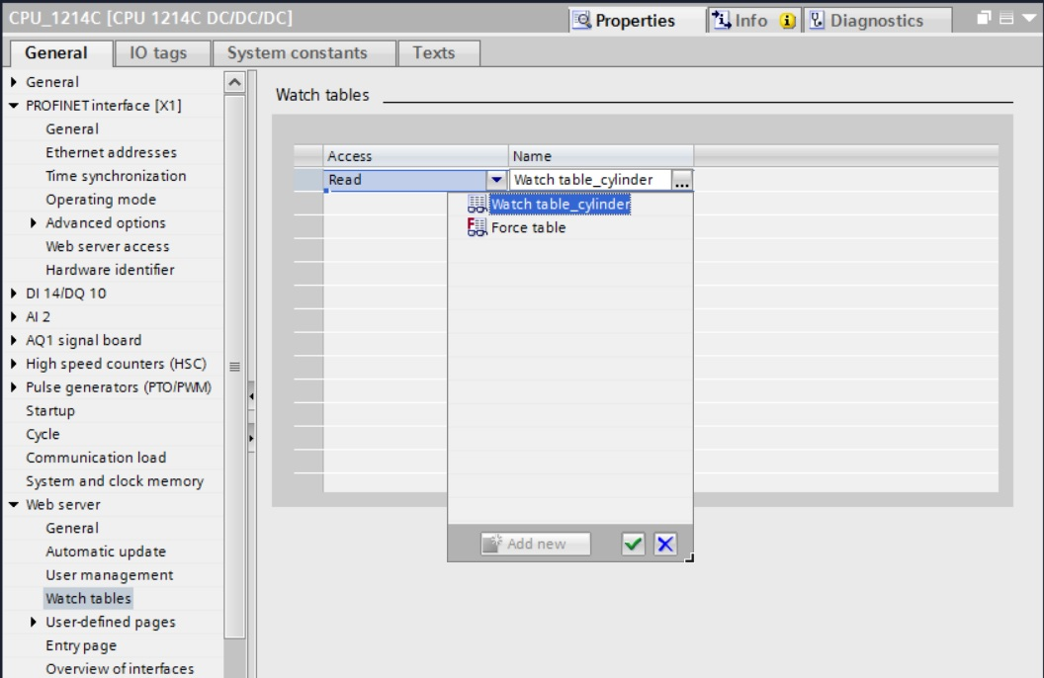

* The access here is read/write access. (→ Read/Write)

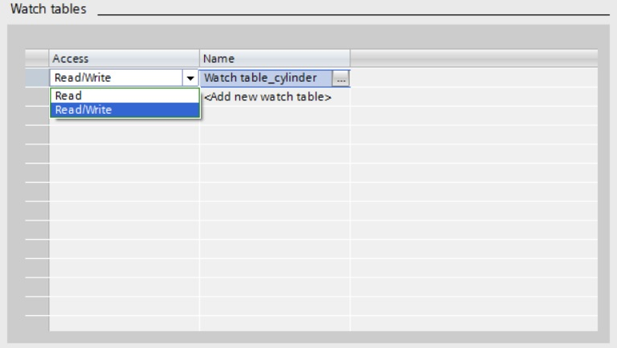

* User-defined web pages will not be created here. We must enable PROFINET interface_1 for access to the web server

(→ Enabled web server access →  PROFINET interface_1)

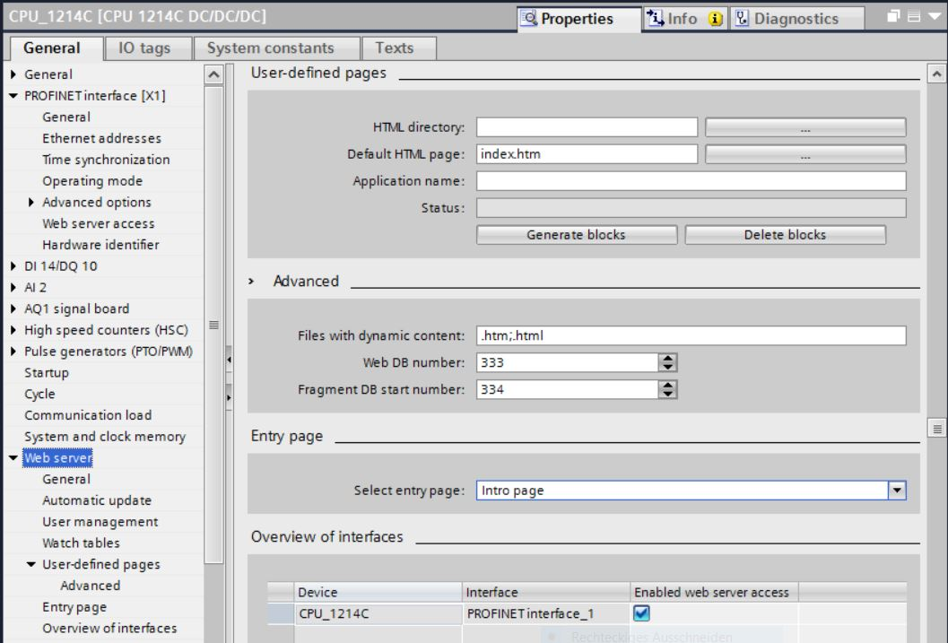

* 1. Save project and download CPU
* To save your project, click the  button in the menu. The complete controller with the modified configuration settings in the hardware configuration, as described in the previous modules, can be downloaded.

(→ → )

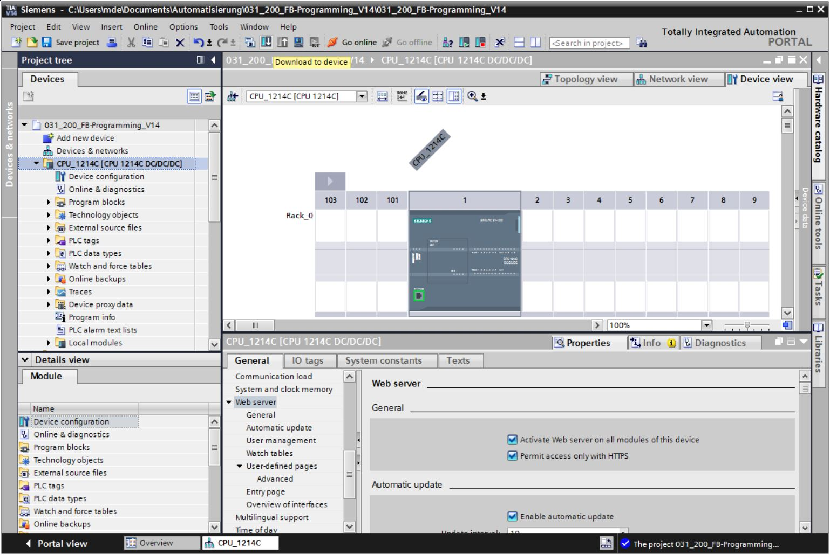

* 1. Diagnostics for the S7-1200 via the web
* In order to access the web server of the CPU 1214C DC/DC/DC, we open any web browser on a PC that is connected to the CPU via TCP/IP.

056

* There we enter the IP address of the CPU 1214C DC/DC/DC. (® 192.168.0.1)

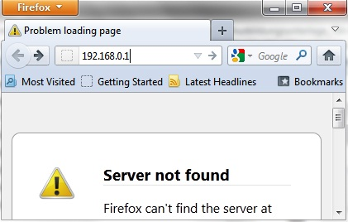

* On the displayed web page, we first select the language and then click '**ENTER**'.   
  (® English ® ENTER)

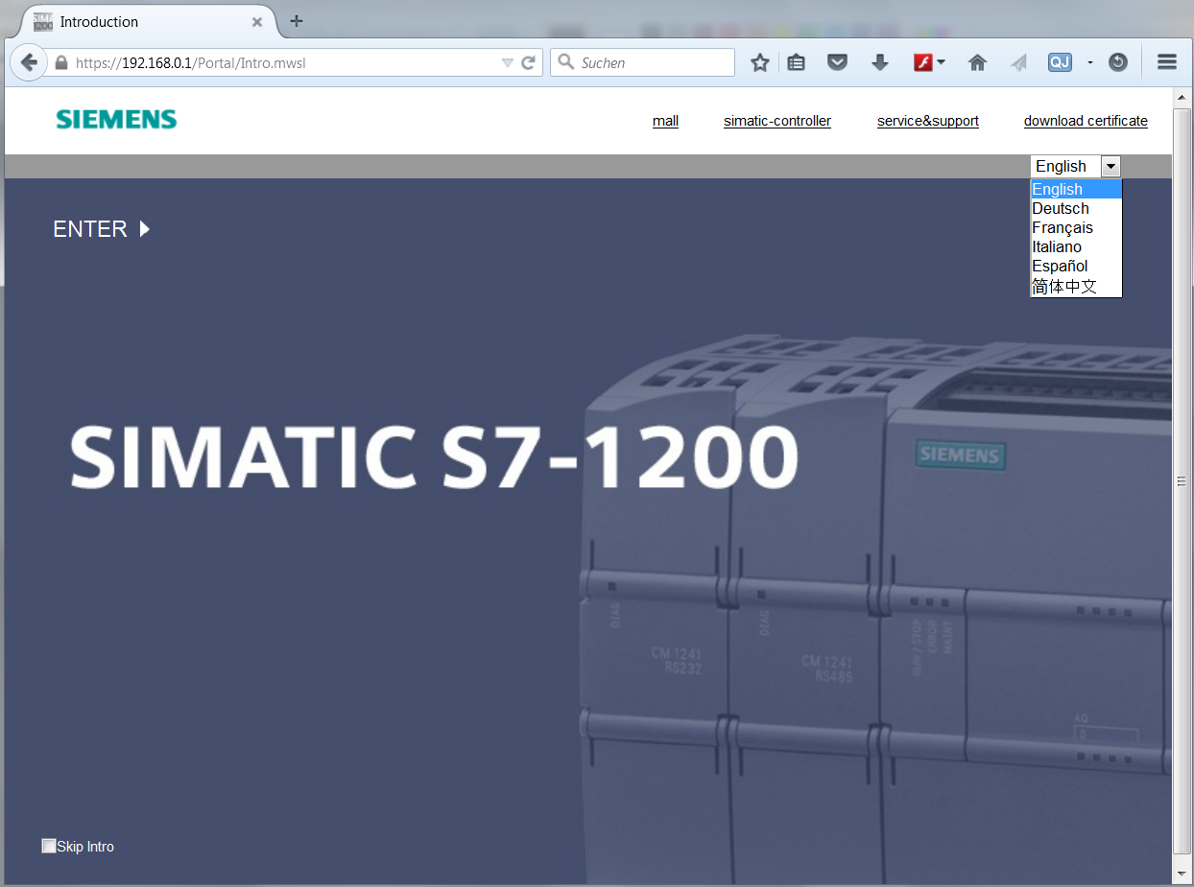

* On the '**Home Page**' we see general information about the PLC and its status.   
  (® Home Page)

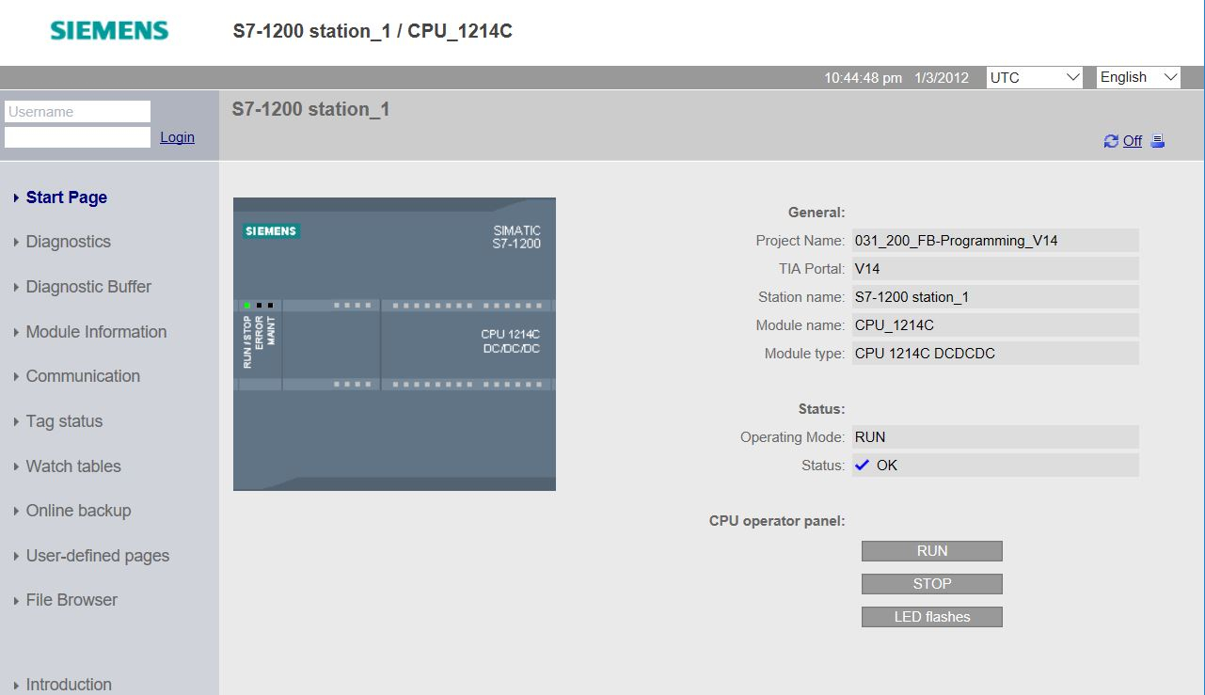

* Hardware, Firmware Version and Serial number are displayed under 'Diagnostics'.   
  (® Diagnostics)

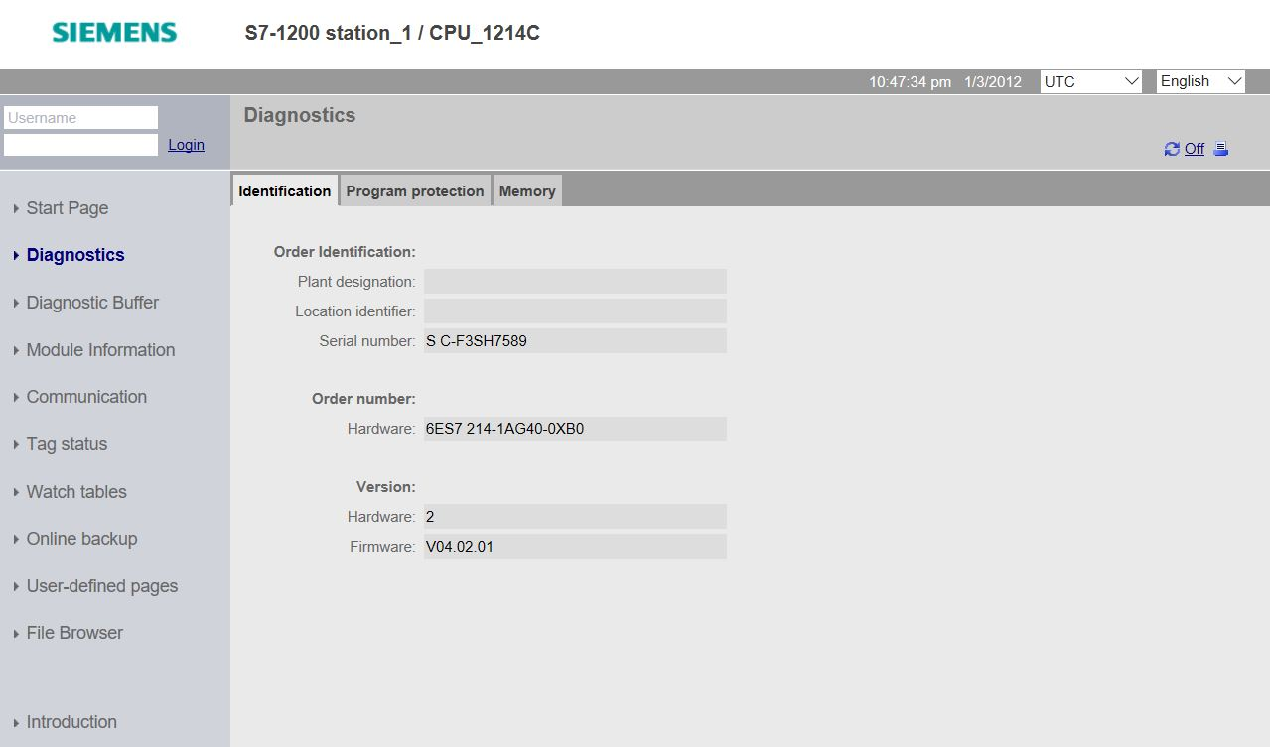

* Under 'Diagnostics Buffer' we see descriptive information for all events in the CPU. Event information is recorded in a circular buffer. The most recent alarm is displayed in the top line. (→ Diagnostics Buffer)

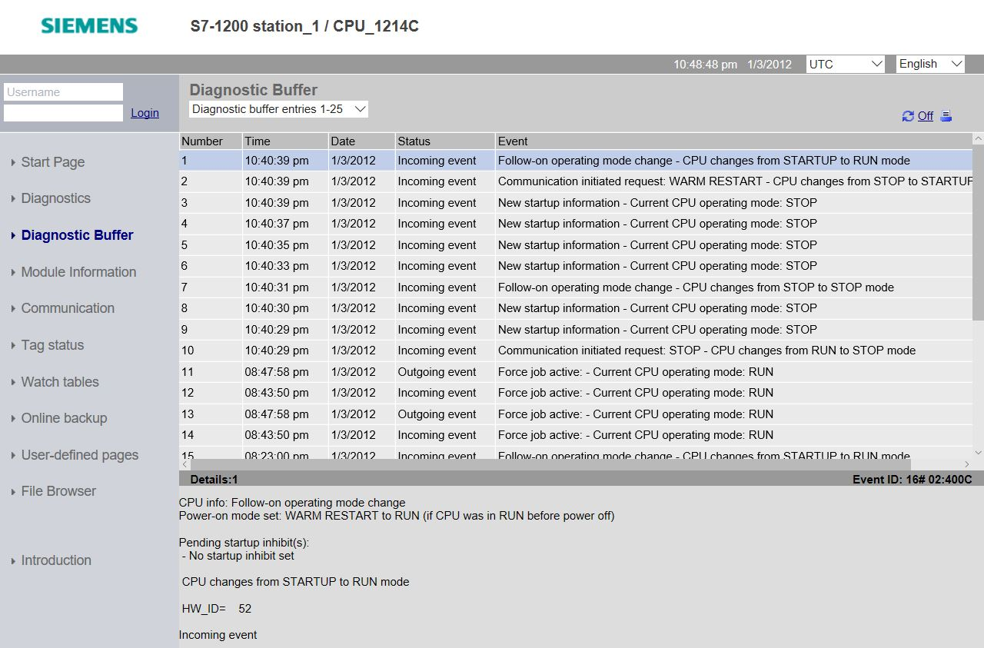

* The status of the individual modules of our SIMATIC S7-1200 is displayed with additional details in the 'Module Information' view.

(® Module Information)



* Details about communications settings are displayed under 'Communication'.   
  (® Communication)

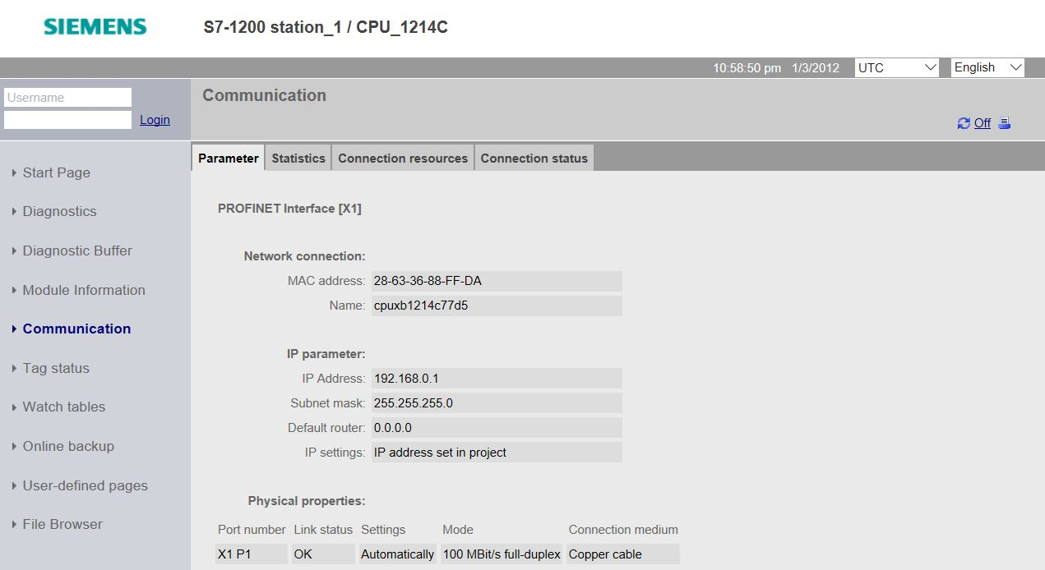

* Values of the individual tags can be displayed and changed under 'Tag Status'.   
  (® Tag Status)

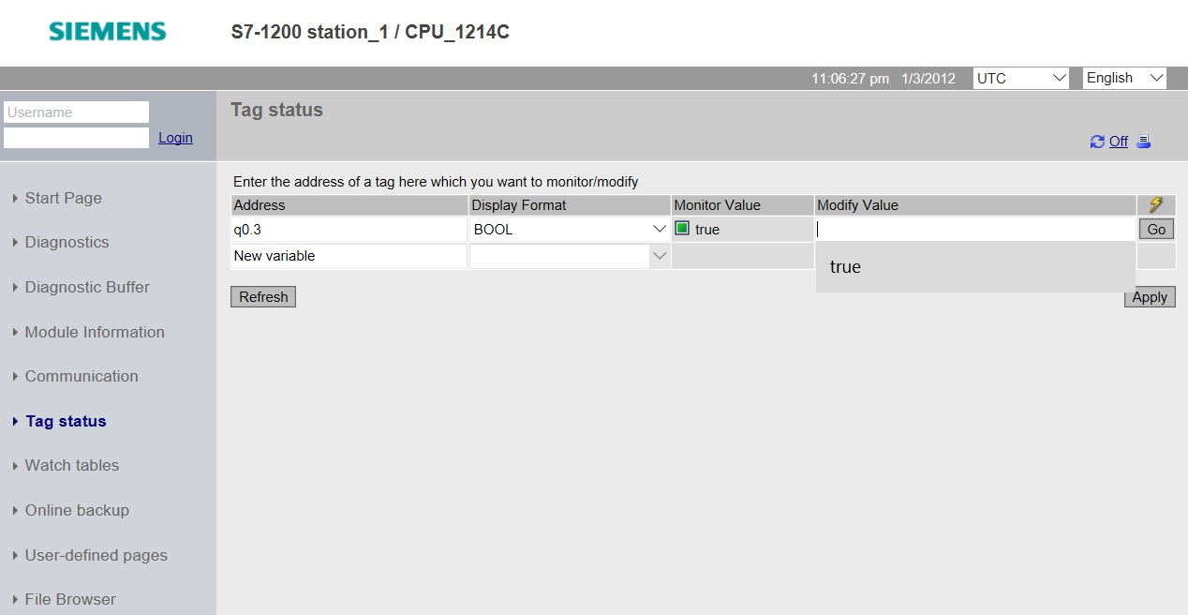

* 'Watch tables' that are linked with the web server, such as the 'Watch table_cylinder', can also be displayed. (® Watch tables ® Watch table_cylinder)

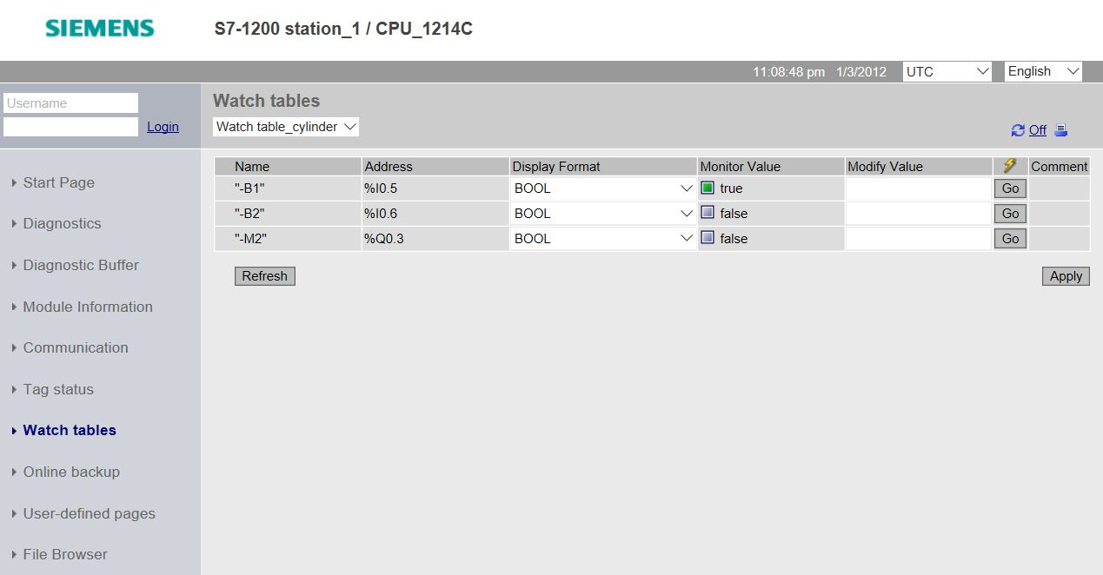

* Under “Online backup” you can create a backup of the project in the PLC and restore this backup later. (® Online backup ® Create online backup ® Restore selected online backup)

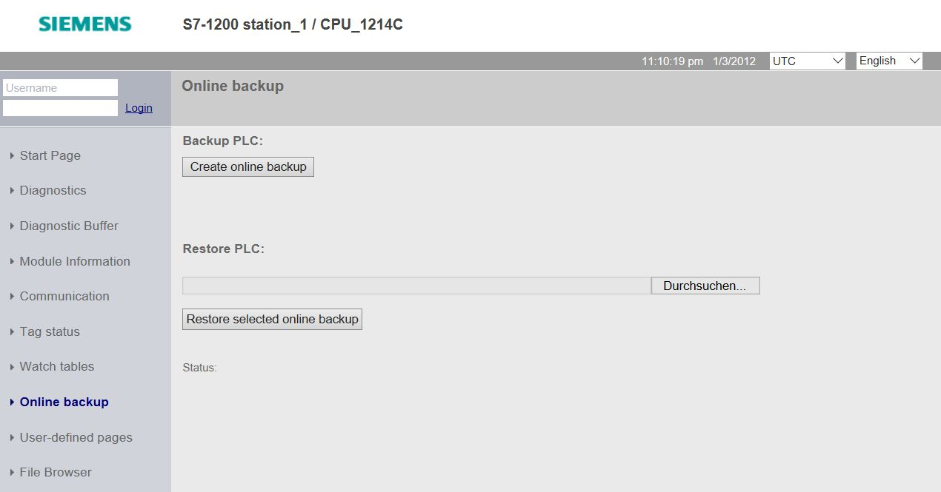

* Individually created pages for the visualization and also for operator control of processes would be seen under 'User-defined pages'. (® User-defined pages)

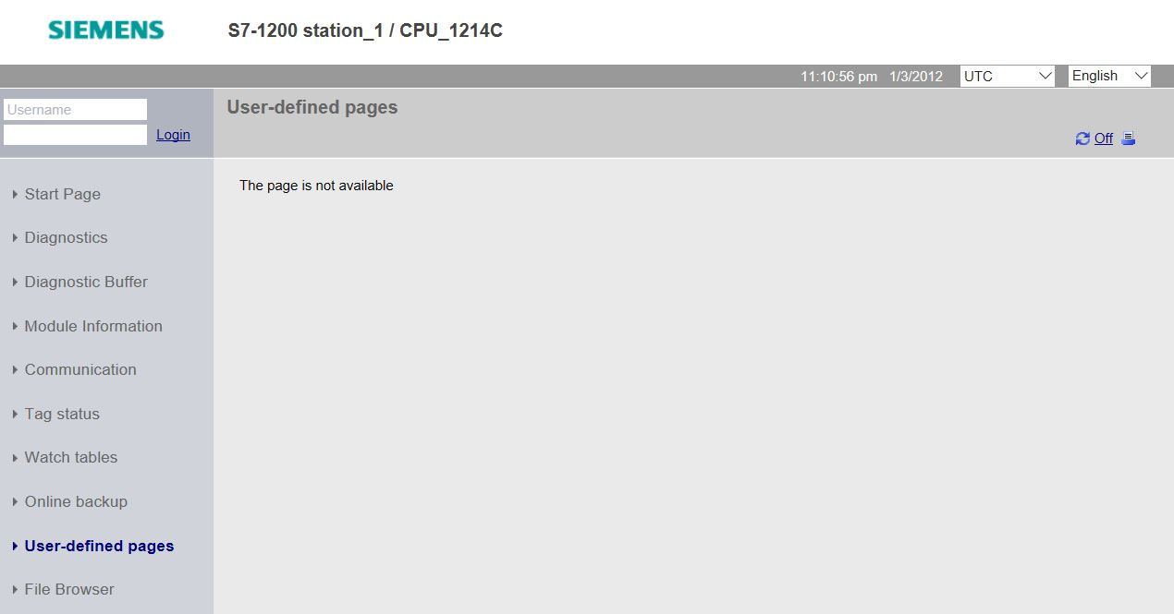

* Data can be stored directly on the memory card in the CPU or loaded from there using the 'File Browser'. (→ File Browser)

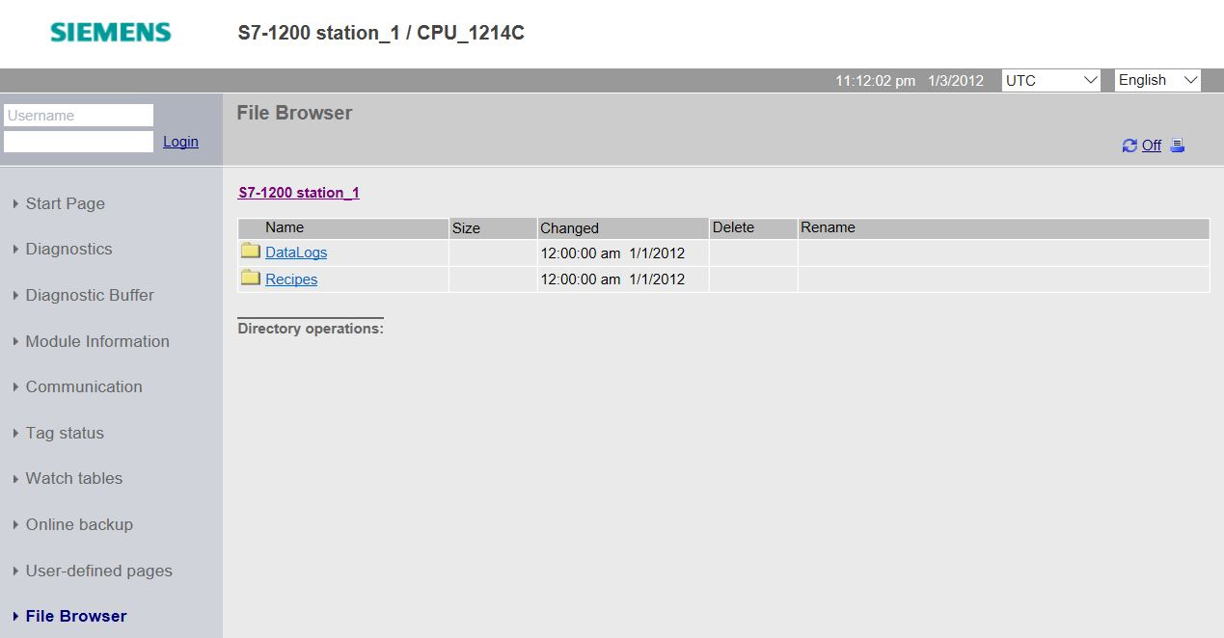

* 1. Checklist

|  |  |  |
| --- | --- | --- |
| **No.** | **Description** | **Completed** |
| 1 | Project 031-410_Basics Diagnostics_S7-1200… successfully retrieved. |  |
| 2 | Web server for the CPU 1214C from project 031-410_Basics Diagnostics_S7-1200… successfully configured. |  |
| 3 | CPU 1214C from project 031-410_Basics Diagnostics_S7-1200… successfully downloaded. |  |
| 4 | Voltage supply switched off. |  |
| 5 | Signal board AQ 1x12Bit removed. |  |
| 6 | Voltage supply switched on again. |  |
| 7 | Web server of the CPU 1214C opened in one of the approved web browsers. |  |
| 8 | Display checked for missing signal board AQ 1x12Bit in the Module Information menu item of the web server. |  |

# Additional information

More information for further practice and consolidation is available as orientation, for example: Getting Started, videos, tutorials, apps, manuals, programming guidelines and trial software/ firmware, under the following link:

[www.siemens.com/sce/s7-1200](http://www.siemens.com/sce/s7-1200)

Preview „Additional information“

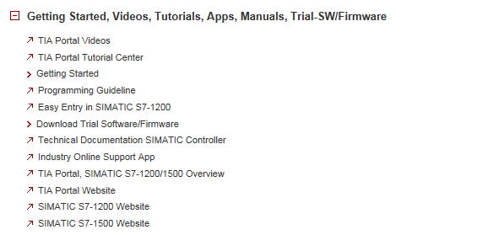

Further Information

Siemens Automation Cooperates with Education  
siemens.com/sce

SCE Learn-/Training Documents  
**siemens.com/sce/documents**

SCE Trainer Packages  
**siemens.com/sce/tp**

SCE Contact Partners   
**siemens.com/sce/contact**

Digital Enterprise  
**siemens.com/digital-enterprise**

Industrie 4.0   
**siemens.com/future-of-manufacturing**

Totally Integrated Automation (TIA)  
**siemens.com/tia**

TIA Portal  
**siemens.com/tia-portal**

SIMATIC Controller  
**siemens.com/controller**

SIMATIC Technical Documentation   
**siemens.com/simatic-docu**

Industry Online Support  
**support.industry.siemens.com**

Product catalogue and online ordering system Industry Mall   
**mall.industry.siemens.com**

Siemens AG  
Digital Factory   
P.O. Box 4848  
90026 Nuremberg  
Germany

Subject to change and errors  
© Siemens AG 2018

**siemens.com/sce**