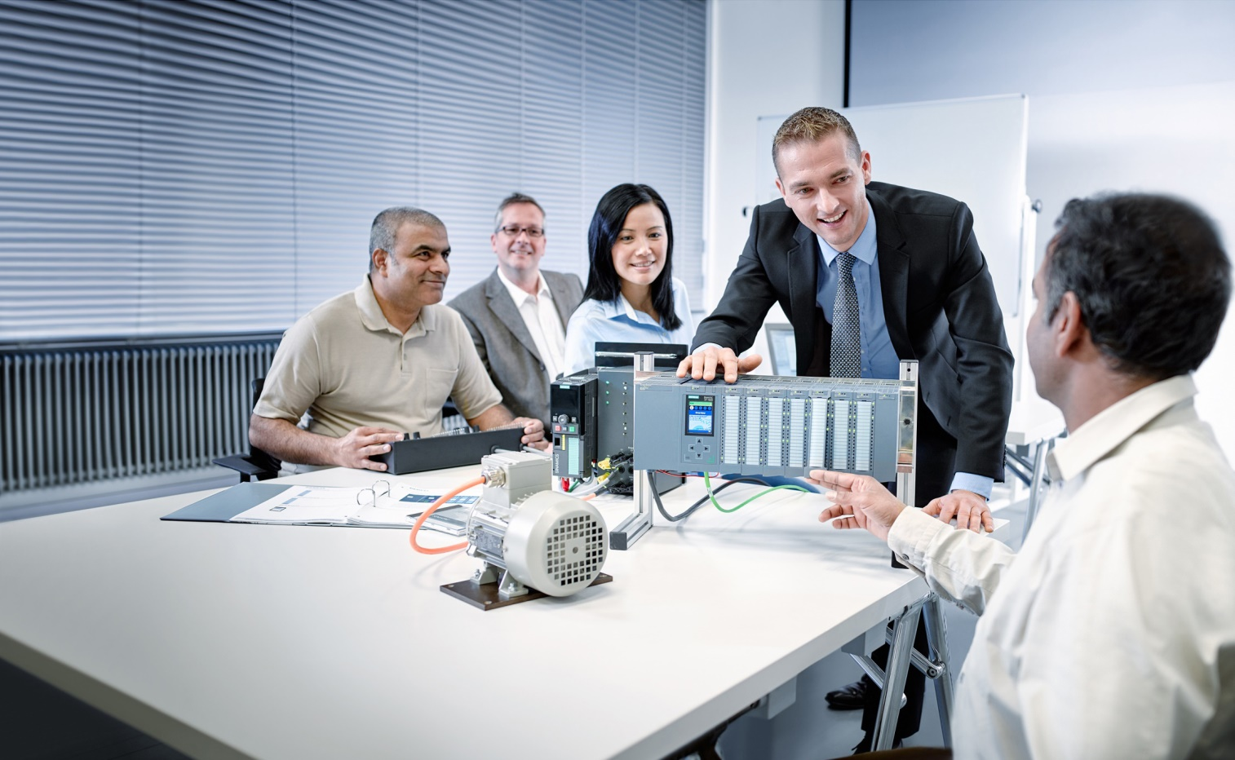

Learn-/Training Document  
  
Siemens Automation Cooperates with Education (SCE) | As of Version V9 SP1

**siemens.com/sce**

PA Module P03-03   
SIMATIC PCS 7 – Batch control with recipes

**Matching SCE Trainer Packages for this Learn-/Training Document**

* **SIMATIC PCS 7 Software Package V9.0 (set of 3)**  
  Order No.: 6ES7650-0XX58-0YS5
* **SIMATIC PCS 7 Software Package V9.0 (set of 6)**   
  Order No.: 6ES7650-0XX58-2YS5
* **SIMATIC PCS 7 Software Upgrade Packages (set of 3)**  
  Order No.: 6ES7650-0XX58-0YE5 (V8.x🡪 V9.0)
* **SIMIT Simulation Platform with Dongle V10**  
  (contains SIMIT S & CTE, FLOWNET, CONTEC libraries) – 2500 simulation tags  
  Order No.: 6DL8913-0AK00-0AS5
* **Upgrade SIMIT Simulation Platform V10**  
  (contains SIMIT S & CTE, FLOWNET, CONTEC libraries) from V8.x/V9.x  
  Order No.: 6DL8913-0AK00-0AS6
* **Demo Version SIMIT Simulation Platform V10**  
  [Download](https://support.industry.siemens.com/cs/ww/en/ps/17120/dl)
* **SIMATIC PCS 7 AS RTX Box (PROFIBUS) only in combination with ET 200M for RTX –**   
  Order No.: 6ES7654-0UE23-0XS1
* **ET 200M for RTX Box (PROFIBUS) only in combination with PCS 7 AS RTX Box –**  
  Order No.: 6ES7153-2BA10-4AB1

Note that these trainer packages are replaced with successor packages when necessary.

An overview of the currently available SCE packages is available at: [siemens.com/sce/tp](http://www.siemens.com/tp)

**Continued training**

For regional Siemens SCE continued training, get in touch with your regional SCE contact

[siemens.com/sce/contact](http://www.siemens.com/contact)

**Additional information regarding SCE**

[siemens.com/sce](http://www.siemens.com/sce)

**Information regarding use**

The SCE Learn-/Training Document for the integrated automation solution Totally Integrated Automation (TIA) was prepared for the program "Siemens Automation Cooperates with Education (SCE)" specifically for training purposes for public educational facilities and R&D institutions. Siemens does not guarantee the contents.

This document is to be used only for initial training on Siemens products/systems, which means it can be copied in whole or part and given to those being trained for use within the scope of their training. Circulation or copying this Learn-/Training Document and sharing its content is permitted within public training and advanced training facilities for training purposes.

Exceptions require written consent from the Siemens. Send all related requests to

[scesupportfinder.i-ia@siemens.com](mailto:scesupportfinder.i-ia@siemens.com).

Offenders will be held liable. All rights including translation are reserved, particularly if a patent is granted or a utility model or design is registered.

Use for industrial customer courses is explicitly not permitted. We do not consent to commercial use of the Learn-/Training Document.

We wish to thank the TU Dresden, particularly Prof. Dr.-Ing. Leon Urbas and the Michael Dziallas Engineering Corporation and all other involved persons for their support during the preparation of this Learn-/Training Document.

Table of contents

1 Goal 6

2 Prerequisite 6

3 Required hardware and software 7

4 Theory 8

4.1 Theory in brief 8

4.2 Hierarchical modeling 9

4.3 Concepts of batch control 9

4.4 Recipes and recipe types 12

4.5 Physical model 14

4.6 Process cell 14

4.7 Monitoring & evaluation 15

4.8 Special features 16

4.9 References 16

5 Task 16

6 Planning 17

7 Learning objective 17

8 Structured step-by-step instructions 18

8.1 Preparation 18

8.2 Configuring BATCH components 25

8.3 Configuring BATCH 35

8.4 Compiling and downloading objects 43

8.5 User configuration in WinCC 49

8.6 Starting simulation 52

8.7 Starting BATCH Runtime 54

8.8 User management in the Batch Control Center 55

8.9 Creating and configuring a process cell 60

8.10 Creating and configuring a recipe 66

8.11 Editing a recipe 77

8.12 Checking and releasing a recipe 87

8.13 Creating and configuring an order with batch 89

8.14 Executing an order/batch 97

8.15 Checklist – step-by-step instruction 104

9 Exercises 105

9.1 Tasks 106

9.2 Checklist – exercise 107

10 Additional information 108

Batch control with recipes

# Goal

In this chapter, students learn to model a batch process hierarchically. They can define recipes for controlling batch plants and for making batch products including the necessary process actions and then implement these in the PCS 7 control system.

# Prerequisite

This chapter builds on chapter 'Functional safety'. To implement this chapter, you can use an existing project from the previous chapter or the archived project 'p03-03-template-r1905-en.zip' provided by SCE. The download of the project(s) is stored on the SCE Internet for the respective module.

The (optional) simulation for the SIMIT program can be retrieved from the file 'p01-04-plantsim-v10-r1905-en.simarc'. It can be run in demo mode.

# Required hardware and software

1. Engineering station: Requirements include hardware and operating system   
   (for further information, see Readme on the PCS 7 installation DVD)
2. SIMATIC PCS 7 software V9 SP1 or higher

* Installed program packages (contained in SIMATIC PCS 7 Software Trainer Package):
  + *Engineering → PCS 7 Engineering*
  + *Engineering → BATCH Engineering*
  + *Runtime → Single Station → OS Single Station*
  + *Runtime → Single Station → BATCH Single Station*
  + *Options → SIMATIC Logon*
  + *Options → S7-PLCSIM V5.4 SP8*

1. Demo Version SIMIT Simulation Platform V10

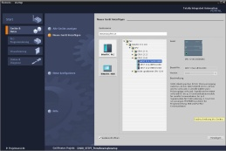

**3** SIMIT V10 or higher



**1** Engineering Station

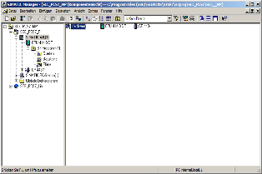

**2** SIMATIC PCS 7

V9 SP1 or higher

# Theory

## Theory in brief

Industrial production processes can generally be classified as continuous processes, single-part production processes or batch processes. Batch processes result in discontinuous production of finite quantities of products (batches) by subjecting quantities of raw materials to a series of processing activities (process operations**,** process steps) using any number of equipment. This module examines the computer-generated mapping of a defined series and automation of batch processes through recipes.

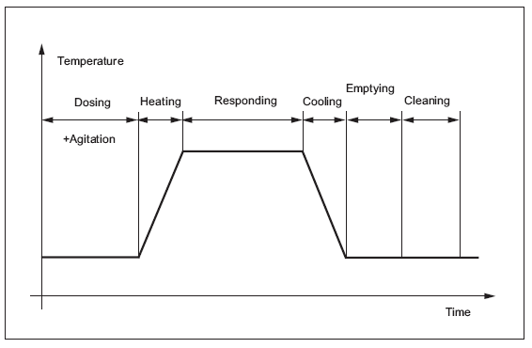

Figure 1: Time sequence of a batch process

General recipes and site recipes are information sources for creation of plant-specific master recipes and are used to specify production information without reference to specific production equipment.

They describe the materials, equipment requirements and necessary chemical and physical transformations for producing a product as a set of production rules.

A log for batch production contains information on the batch production and associated business information. It is created to fulfill a business requirement. The contents of a log for the batch production are determined by the business requirement.

## Hierarchical modeling

Batch processes in the process industry consist of numerous equipment as well as process actions that can performed on this equipment. The result is an enormous variety of products. In order to manage the sheer quantity, it is useful to structure the world of batch processes hierarchically so that previously developed blocks and components can be reused on various levels based on this hierarchical structure.

A process consists of one or more process stages, which are organized as an ordered group and can run either in series or in parallel or both. A process stage is a part of a process that ideally runs independent of other process stages. Each process stage consists of an ordered group of one or more process operations. Process operations describe related processing activities that are needed to achieve an intermediate goal. Each process operation can be subdivided into an ordered group of one or more process actions, which execute the processing needed for the process operation. Process actions describe smaller, reusable processing activities that are combined into a process operation.

## Concepts of batch control

Basic control

The basic control ensures that a certain operating state of the equipment and process is created and maintained. The basic control includes closed-loop controls, interlocks, monitoring functions, exception handling and repeatable discrete controls or procedure controls. It can respond to process conditions that influence the control outputs or trigger corrective measures. In addition, it can be activated, deactivated or modified through instructions of the operator, procedure controls or coordination controls (see Modules P01-04 to P01-07).

Procedure control

The procedure control defines that equipment-oriented actions take place in an ordered sequence so that a process-oriented task is executed. It is characteristic of batch processes and enables equipment to execute a batch process.

**Procedure**

**Unit procedure**

**Operation**

**Function**

consists of a controlled  
volume of

consists of a controlled  
volume of

consists of a controlled  
volume of

**Produce PVC**

**Polymerize vinyl chloride monomer  
Recover ´vinyl chloride residue  
Dry PVC**

**Preparation: Evacuate reactor and cost reactor  
walls with anti film**

**Fill: Destilled water wnd solvent**

**Reaction: Add VCM and catalyst, heat and reduce pressure wait**

**Add vinyl chloride monomer**

**Add catalyst  
Heat**

Figure 2: Model of the control sequence with example [3]

Procedure

The procedure is the highest level in the hierarchy and specifies the strategy for executing a comprehensive processing action, such as the production of a batch. It is defined by an ordered set of unit procedures. An example of a procedure is "Produce product".

Unit procedure

A unit procedure consists of an ordered set of operations that cause a contiguous production sequence to take place in a unit. It is assumed that only one operation is active in a unit at any time. An operation is completely executed in a single unit. However, multiple unit procedures of a procedure can run concurrently, each in a different unit.

Operation

An operation is an ordered set of functions that specify a larger processing sequence and cause the processed materials to be changed from one state to another. This usually involves a chemical or physical change. It is often desirable to put the boundaries of an operation at points in the procedure where normal processing can be safely interrupted.

Examples of operations are:

* Preparation: Emptying and cleaning a reactor.
* Filling: Adding distilled water and solvent.
* Reaction: Adding and heating educt1 and educt2.

Function

A function is the smallest element of a procedure control that can execute a process-oriented task. A function can be subdivided into smaller parts. The steps and transitions as described in IEC 60848, document a method for defining subdivisions of a function.

A step can output one or more instructions or cause one or more actions, for example:

* Activation and deactivation of closed-loop controls and state-oriented types of basic automation and specification of their setpoints and initial values
* Setting, deleting and changing of alarm limits and other limit values
* Setting and changing of loop controller constants, closed-loop control modes and types of algorithms
* Reading of process tags, e.g. gas density, gas temperature and volumetric flow from a flow meter, and calculation of the mass flow through the flow meter
* Performing the check of the operator authorization

Executing a function can result in one or more of the following:

* Commands to the basic control
* Commands to other functions (either in the same or a different equipment entity)
* Acquisition of data

The goal of a function is to bring about or define a process-oriented action, whereas the logic or the sequence of actions that make up a function is equipment-specific. Here are some examples of functions:

* Stirring
* Dosing
* Heating

## Recipes and recipe types

From the point of view of a company with many production sites, it is useful to create standardized, company-wide recipes that define exactly how a batch product is to be produced.

Because the economics of chemical plants requires them to be customized to the local energy and raw material supply conditions, structures are required that allow both of the following:

a) an abstract definition that is largely independent of the specific plant

b) a simple adaptation and mapping onto the specific equipment

It is therefore possible to go from a very abstract general recipe to a site recipe and master recipe and finally to the specific control recipe.

General recipe

The general recipe is a recipe on the enterprise level that serves as the basis for recipes on the lower levels. The general recipe is created without specific knowledge of the plant equipment that will be used to produce the product. It defines the raw materials, their relative quantities and the required processing, however, without reference to a specific factory or the equipment available in this factory. It is created by persons who are familiar with the chemistry and the processing requirements that are typical for the respective product and reflects their interests and thoughts.

Site recipe

The site recipe is specific to a particular factory. It is a combination of factory-specific information and the general recipe. It is usually derived from a general recipe to meet the requirements of a specific production site and offers a level of detail required for factory-related, long-term production planning.

Master recipe

The master recipe is the recipe level that is geared towards a plant or a group of equipment in a plant. A master recipe can be derived from the general recipe or site recipe. It can also be created as an independent unit when the recipe author has access to the information that is generally made available in the general recipe or in the site recipe.

SIMATIC Batch distinguishes here between flat and hierarchical recipes. This subdivision allows recipes to be built on one another.

Editng level 1   
Recipe procedure (RP)  
(with recipe unit procedures ((TRP 1 …))

Editing level 2  
Recipe operation (ROP)

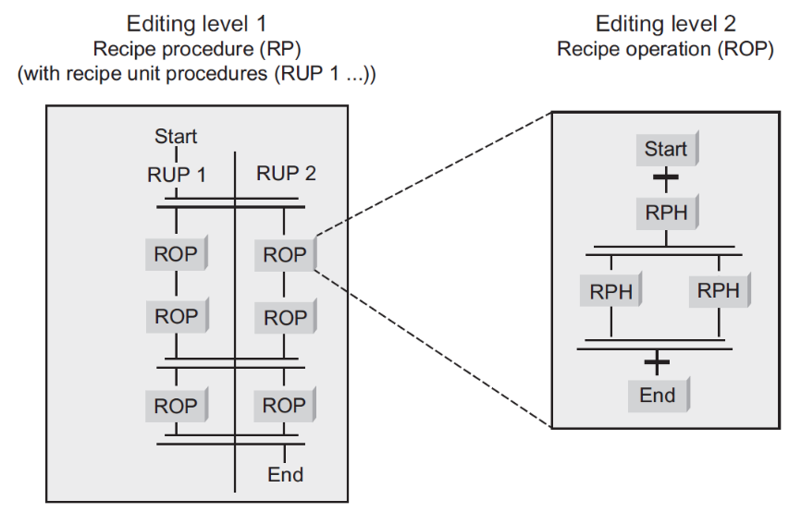

Figure 3: Implementation of the hierarchical structure [3]

Control recipe

The control recipe is a copy of a specific version of the master recipe and is then modified as required through information for production scheduling and execution in order to be specific to an individual batch. It contains the product-specific process information required for production of a specific batch. It provides the level of detail required for starting and monitoring the equipment procedure objects of a plant. The control recipe may have been modified to take into account the actual raw material qualities and the utilized equipment. The selection of units and corresponding scaling can take place at any time before this information is required.

Because changes to the control recipe based on information regarding production planning, equipment and plant operators can be made over time, a control recipe may be subject to multiple changes during the batch production.

***Application in PCS 7***

A simplified model with two types of recipe is used in SIMATIC BATCH:

* Master recipe
* Control recipe

**Control recipe**

contains

**Process cell-specific information**

**Batch identification, batch size, information regarding process, system or plant operator**

**Master recipe**

contains

Is the   
basis for

Figure 4: Difference between control recipe and master recipe [3]

## Physical model

**Process cell**

**Unit**

**Equipment  
module**

may contain

may contain

**Individual  
control unit**

must contain

must contain

**Reaction plant**

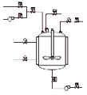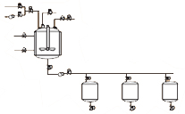

**Multi-purpose operation**



may contain

Figure 5: Physical model with example [3]

## Process cell

A process cell is the combination of all equipment for the production of a batch. A frequently encountered subset of the process cells is the stream. A stream is composed of all the units and other devices that can be used by a specific batch. Streams can remain the same from batch to batch or they can be modified for each batch.

Unit

A unit consists of equipment modules and control modules. It is an independent device group usually arranged around a larger processing device such as a stirrer tank or a reactor.

Characteristics a unit:

* A unit can execute one or more processing activities such as reaction, crystallization or solution.
* Units largely work independent of one another.
* It frequently contains a complete batch at a specific point in the processing sequence of the batch.
* A unit can never process more than one batch at a time.

Equipment module

An equipment module can consist of control modules and lower-level equipment modules. An equipment module is usually arranged around a part of a processing equipment, such as a filter.

Characteristics of an equipment module:

* It can be part of a unit or an independent equipment group within a process cell.
* It can execute a finite number of specific smaller processing activities, such as dosing and weighing.
* It does not have to but can include the raw materials of a batch.

Control module

A control module is the combination of measuring devices, actuators and other control modules as well as the associated processing equipment that is operated as an individual unit from the standpoint of the control technology.

It can also be made up of other control modules. A dosing control module, for example, could be a combination of multiple automatic control valve control modules.

There is no mapping for the control module in the procedural model and in the process model.

This means it cannot be addressed in SIMATIC BATCH.

## Monitoring & evaluation

A crucial element of batch production is the collection and historization (for example, with StoragePlus or a Central Archive Server) of the production data. The data is required for official requirements for the purpose of traceability of the produced batch as well as for the operational analysis of the production process. It is important to store both the continuously produced process data (temperatures, pressures, etc.) and the event-related sequence and status information and to have it available for a correlation analysis.

The simplest form of documentation is the batch log. It usually contains the recipe settings as well as the actual data of the actual production, the run times of the procedure modules (start, end) and, if applicable, other process and operating feedback. Depending on the market segment (pharmaceuticals, food & beverage), evidence of a tamper-proof historization and archiving must be furnished.

## Special features

Due to the procedural requirements of a BATCH control that are placed on a PCS7 project, a basic control as it was carried out until now was not transferable to a BATCH project. This subdivision is made with the help of SFC types or through configuration of individual CFCs for each function. In the case of both variants, it is necessary to identify every abort possibility and to bring the process to a defined state in a downstream abort routine. Additional information on this type of configuration is available in [3].

## References

[1] Fittler, H, & Uhlig, R. (2004) Rezeptfahrweise, Führung von Chargenprozessen. In Früh, K.F., U. Maier (publisher). Handbuch der Prozessautomatisierung. Oldenbourg.

[2] DIN EN 61512-1 (2000-01) Batch control. Part 1: Models and terminology (corresponds to IEC 61512-1:1997 and ISA-S88.01:1995).

[3] SIEMENS (2017-11): SIMATIC Process Control System PCS 7 SIMATIC BATCH V9.0   
SP1. A5E38210719-AB. ([support.automation.siemens.com/WW/view/en/109755007](http://support.automation.siemens.com/WW/view/en/109755007))

# Task

Similar to the recipe from the chapter 'Sequential control systems', a batch control recipe for the production of a batch is to be created and programmed here.

For this chapter, the recipe is reduced to the following sequence:

1. First, 250 ml is to be drained from the educt tank =SCE.A1.T1-B001 to the reactor =SCE.A1.T2-R001.
2. Then, 150 ml is to be drained from the educt tank =SCE.A1.T1-B002 to the reactor =SCE.A1.T2-R001.
3. The liquids in the reactor =SCE.A1.T2-R001 are then to be stirred with the stirrer for 20 seconds.
4. Finally, this mixture is to be drained to the product tank =SCE.A1.T3-B001.

# Planning

The BATCH component must be configured in the hardware configuration of the OS.

Then, the plant hierarchy must be assigned to the BATCH levels (S88 type definition).

The three SFC types 'Filling', 'Emptying' and 'Stirring', as well as their instances in the different parts of the plant hierarchy are already created in the template project and can be transferred to the BATCH configuration with the 'Propagate' and 'Generate' functions.

The following user configuration is to be used for the operator control of BATCH Control Center:

* User: scebatch
* Password: scebatch
* Permissions: all

The process cell must then be created in the BATCH Control Center. The raw materials 'Educt001', 'Educt002' and 'Educt003' and the output material 'Product001' are specified for this.

The utilized units 'Educt tank B001', 'Educt tank B002' and 'Reactor R001' are finally specified when a recipe is created. Likewise, the raw materials and products are assigned according to the recipe in the task description. This serves the planning of the plant allocation and enables parallel processes.

The BATCH recipe is edited very similar to an SFC, but the specification of product quantities is different. These are configured according to the task description.

Finally, a batch will be created for executing the recipe. All assignments and quantity information will be adapted once again and finally executed.

# Learning objective

In this chapter, students learn the following:

* Creating batch components.
* Adapting the structure for production of a batch in the plant view
* Creating output and input materials in the SIMATIC Batch Control Center
* Creating a control recipe in the SIMATIC Batch Control Center
* Creating, releasing and starting a batch in the SIMATIC Batch Control Center

# Structured step-by-step instructions

## Preparation

1. As source project you will use a project that already includes all CFC and SFC blocks that you need later for the production of batches with the SIMATIC Batch Control. This project will be retrieved from the archive in SIMATIC Manager to start. (® File ® Retrieve)

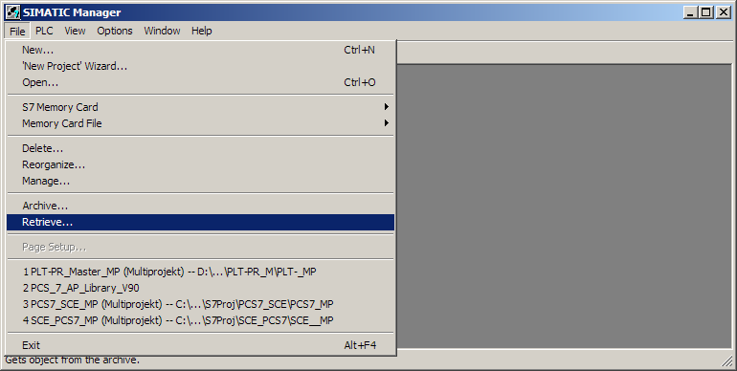

1. As a template use the project 'p03-03-template-r1905-en.zip'. (® p03-03-template-r1905-en.zip ® Open)

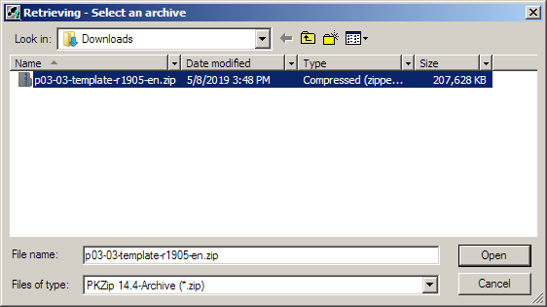

1. Next, click the '' icon to start the PLC simulation S7-PLCSIM. (® )

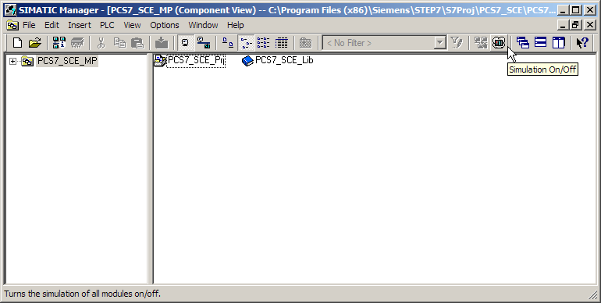

1. In S7-PLCSIM, select 'PLCSIM(TCP/IP)' as interface and check if 'PLCSIM(TCP/IP)' is also set in SIMATIC Manager. (® PLCSIM(TCP/IP))

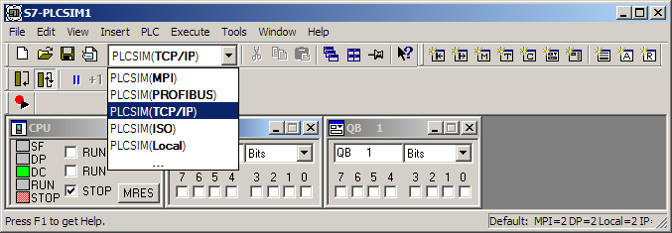

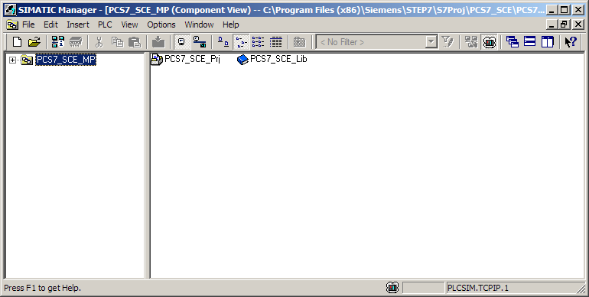

1. Now select the 'Object Properties' of the PC station that contains an Operator Station (here: OS). (® OS ® Object Properties)

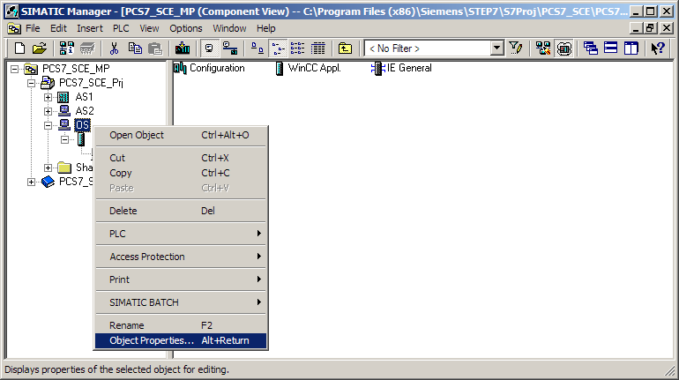

1. Under 'Computer name' in the general properties, enter the local computer name. (® Computer name: local computer name ® OK)

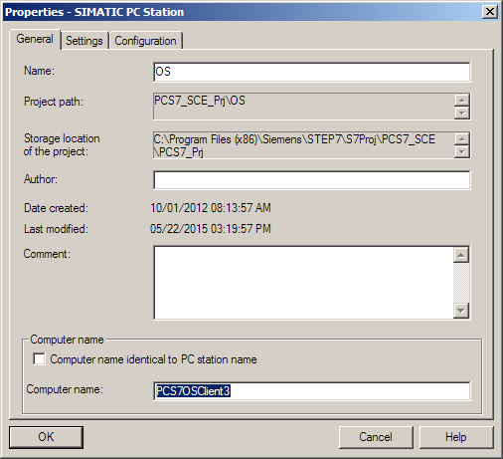

***Note:***

* *The generated Batch process cell data will also be loaded to this computer later.*

1. Now start the WinCC Explorer by selecting 'Open Object' under OS ® WinCC Appl. ® OS(1). (® OS(1) ® Open Object)

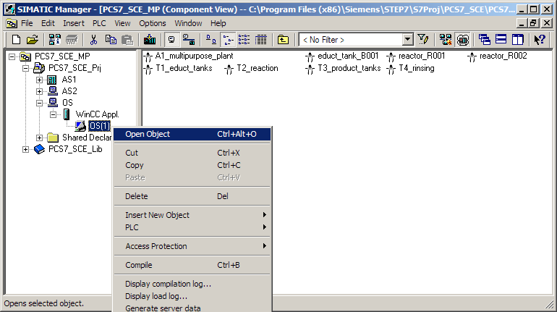

1. In Explorer, select the 'Properties' of the 'Computer'. (® Computer ® Properties)

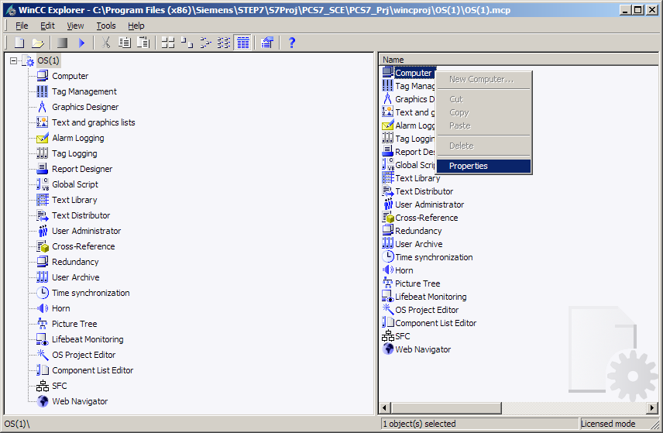

1. Then click 'Properties' of the computer again. (® Properties)

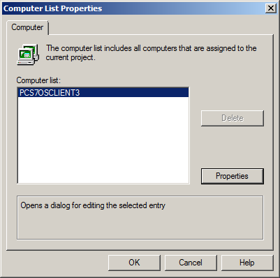

1. In the next dialog, click 'Use Local Computer Name'. (® Use Local Computer Name ® OK)

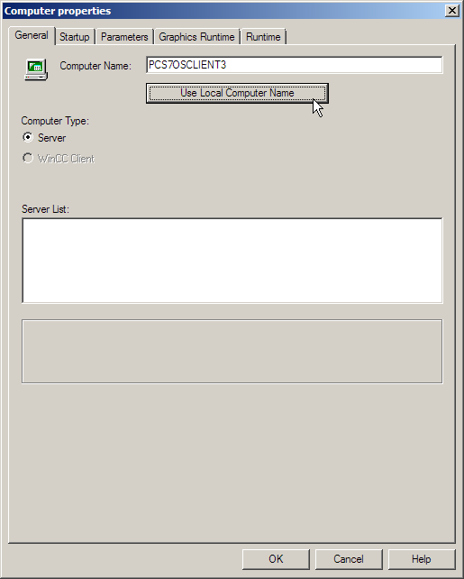

***Note:***

* *If the computer name matches, the 'Use Local Computer Name' button is grayed out. In this case, no further action is necessary.*

1. Exit Explorer and close the project. (® File ® Exit ® OK)

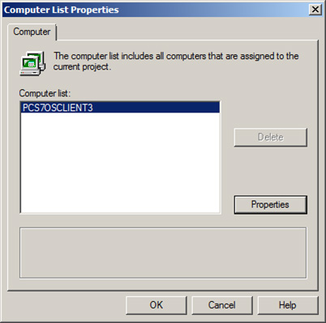

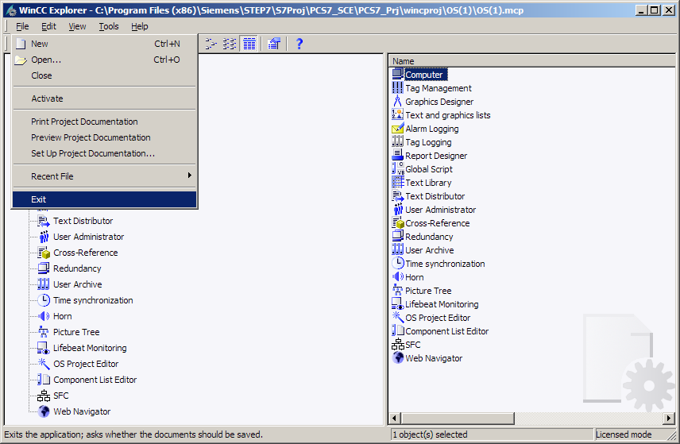

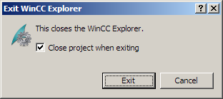

## Configuring BATCH components

1. To create the batch components, select the PC station and open the configuration. (® OS ® Configuration)

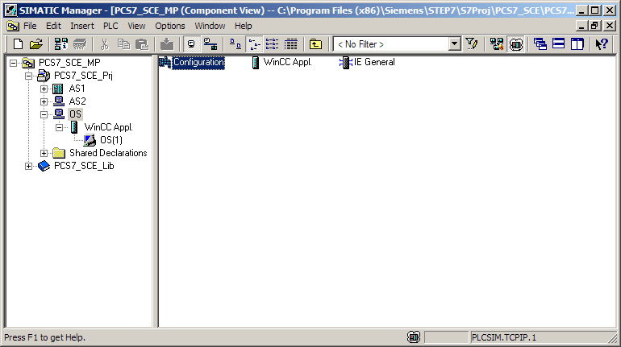

1. In the hardware configuration, drag 'BATCH Application' from the catalog in the 'SIMATIC PC Station/BATCH' folder to slot 3. (® SIMATIC PC Station ® BATCH ® BATCH Application)

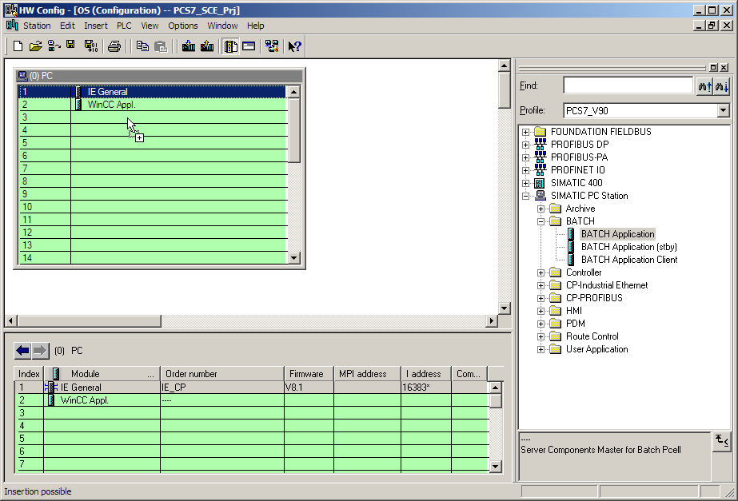

1. Drag 'BATCH Application Client' to slot 4. Then 'save and compile' the modified configuration and close the application. (® SIMATIC PC Station ® BATCH ® BATCH Application Client ®  ® )

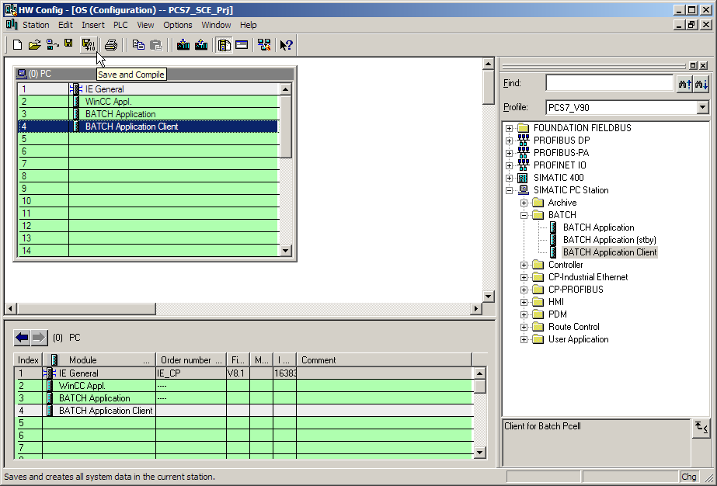

Notes:

* *A 'BATCH Application' must be configured in the hardware configuration for each PC on which a batch server application is running.*
* *If the batch server and the batch client are to run on one PC, a 'BATCH (Server) Application' and a 'BATCH Application Client' will be set up here in the hardware configuration. The name of the local PC should be entered here as the runtime computer name.*
* *A batch client can also run on a PC station on which no operator station is installed.*

1. In the following steps, the S88 type definition of the corresponding folders takes place in 'Process cell' and 'Unit'. To do this, change to the plant view, select the folder 'A1_multipurpose_plant' and select its properties. (® View ® Plant View ® A1_multipurpose_plant ® Object Properties)

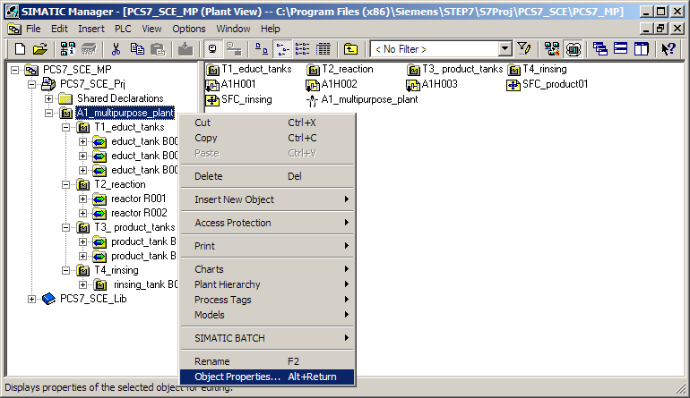

1. Under the item 'S88 Type Definition', enter 'Process cell' for this folder.   
   (® S88 Type Definition ® Process cell ® OK)

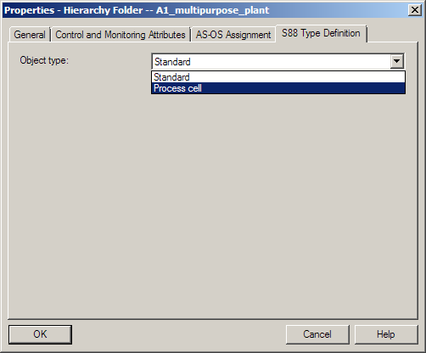

1. Enter the S88 type definition 'Unit' throughout the third hierarchy level.

(® S88 Type Definition ® Unit ® OK)

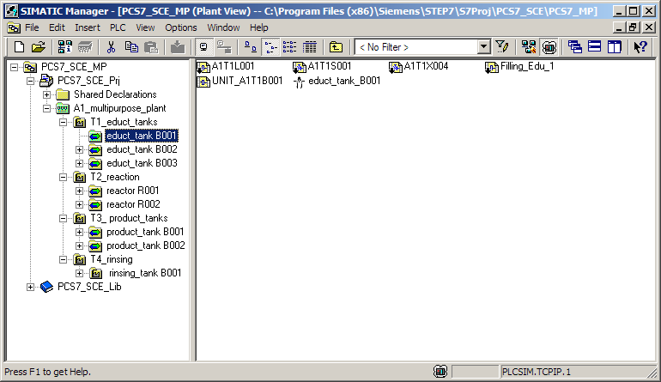

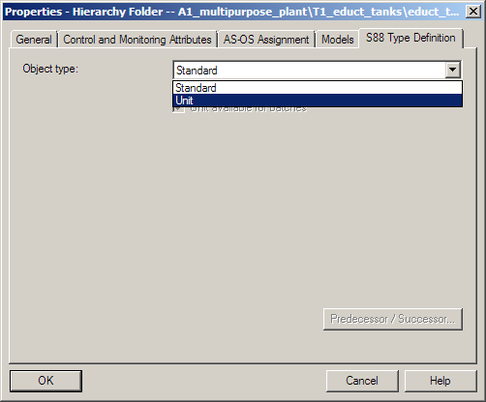

1. As a result, the S88 type definitions 'Process cell' and 'Unit' should be allocated as seen below.

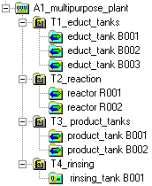

Unit

Process cell

1. Our project already includes three SFC types. These can be found in the component view in the 'Charts' folder of the SIMATIC 400 station. The 'Filling' SFC type is used for filling the reactors from the educt tanks. The 'Emptying' SFC type is used for emptying the reactors, and 'Stirring' is used for stirring the reactors.

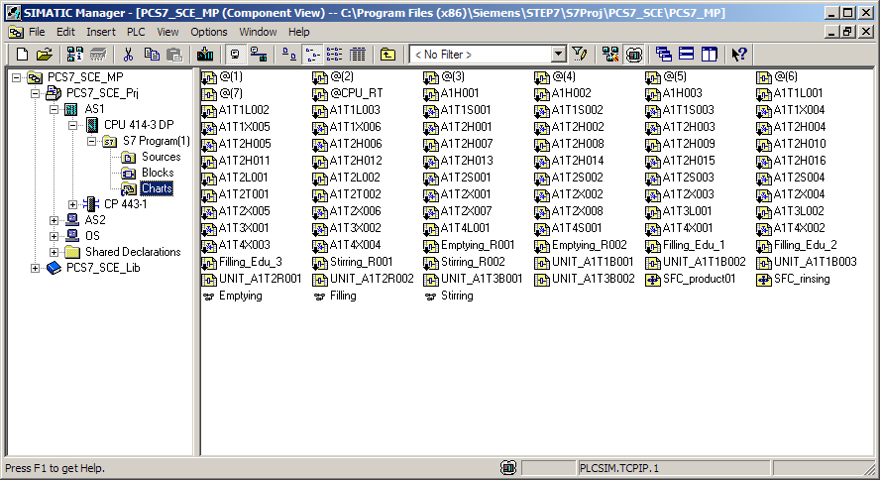

1. CFCs and SFCs are already created in our project and, thus, these three SFC types are already instantiated. You must still assign a batch category to the SFC types in the 'Object Properties' so that the S88.01-relevant information for Batch is later created automatically during type generation. In the 'Options' tab, you now assign the batch category 'EPH', allow operator instructions and activate the possible control strategies. (® Filling ® Object Properties ® Options ® Category: EPH ® Allow operator instructions ® Control strategy selection: Filling_R001 and Filling_R002 ® OK)

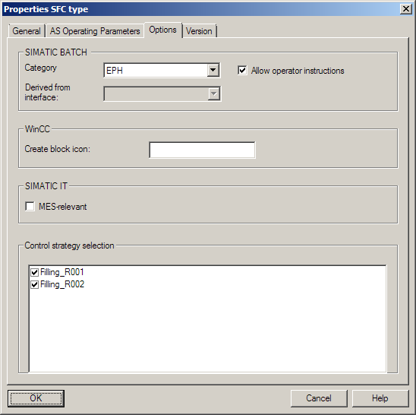

***Note:***

* *The category 'EPH' defines the SFC type as Equipment Phase in Batch. Both of our SFC types are equipment phases that are self-terminating.*

1. Also assign the category 'EPH' to the SFC types 'Emptying' and 'Stirring'. (® Emptying/Stirring ® Object properties ® Options ® Category: EPH ® Allow operator instructions ® Control strategy selection: … ® OK)

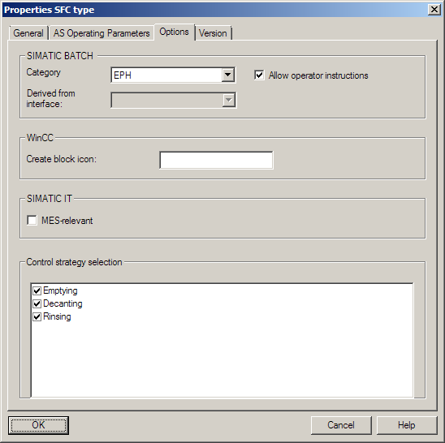

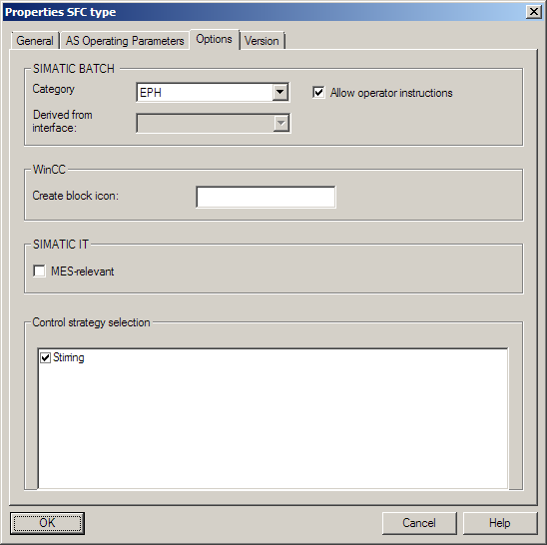

1. Now, compile the AS and OS in the project as shown in the figure below.

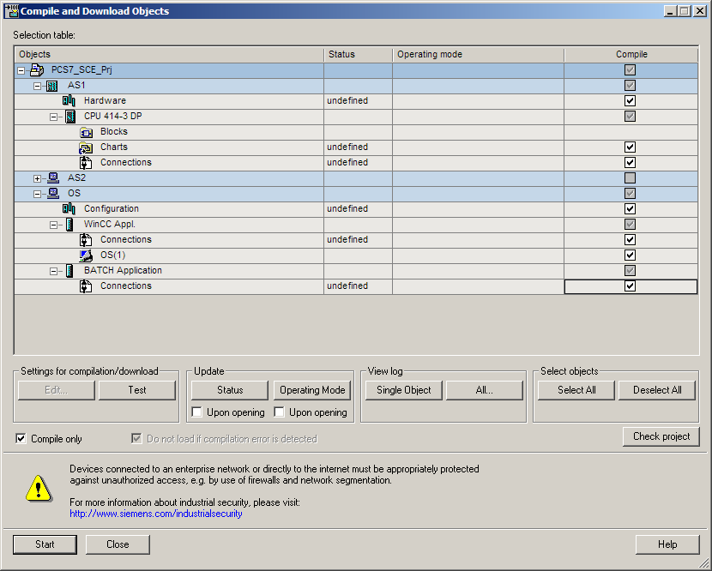

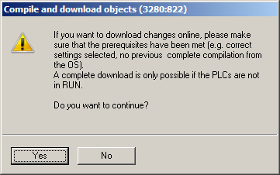

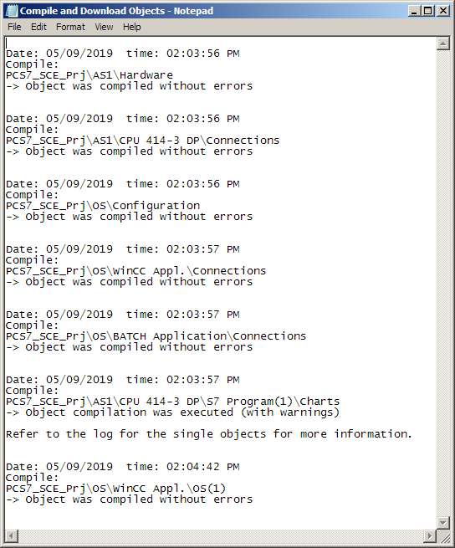

## Configuring BATCH

1. The settings for Batch will be made next. Select the multiproject in the 'Plant View' for this. (® Plant View ® SCE_PCS7_MP ® SIMATIC BATCH® Open configuration dialog…)

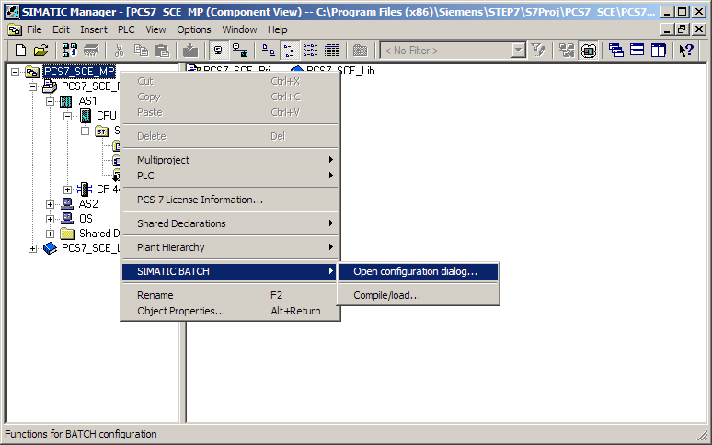

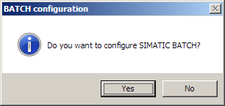

1. The batch types will now be propagated and thus distributed to the individual projects of the multiproject. (® Batch types ® Propagate)

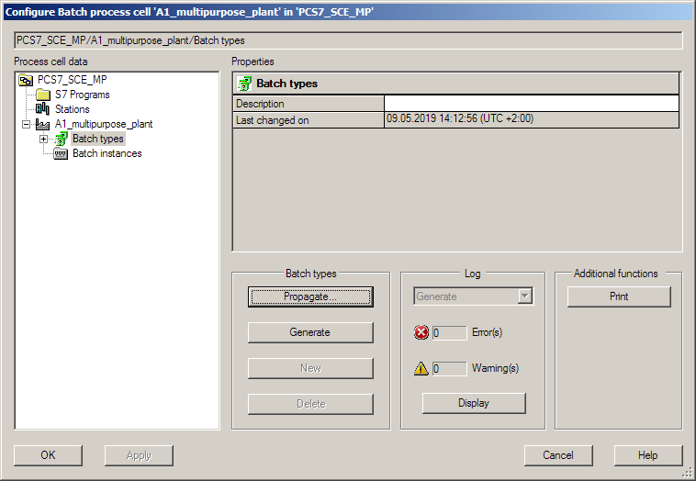

***Note:***

* *If the button is grayed out, close the dialog with 'OK' and open the configuration first in one of the hierarchy folders, e.g. 'A1_multipurpose plant'. Close the dialog again with 'OK' and open the configuration once again on the multiproject level. The button should now be enabled.*

1. Select your project, click 'Start' and then 'Close'. (® SCE_PCS7_Prj ® Start ® Close)

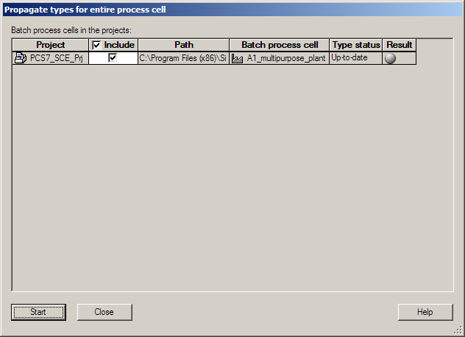

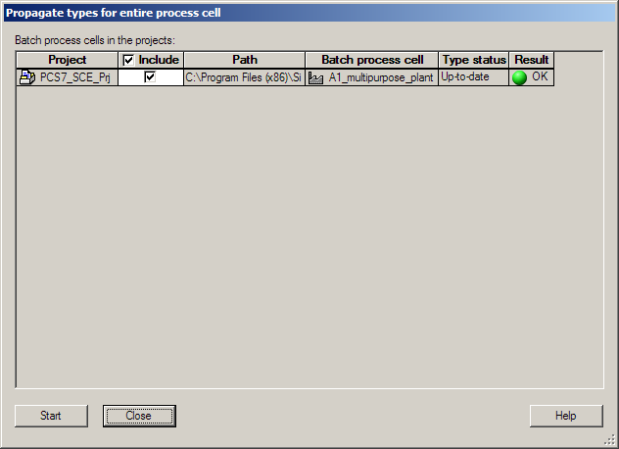

1. You can now generate the batch types. (® Batch types ® Generate)

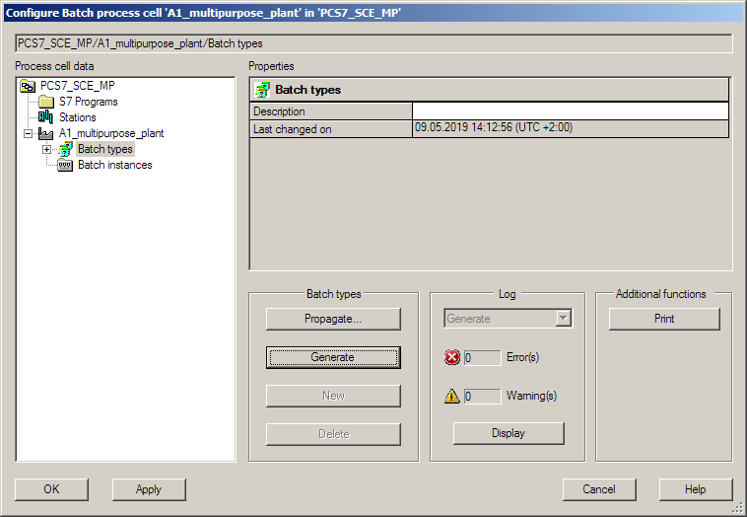

1. Select your project, click 'Start' and then 'Close'. (® SCE_PCS7_Prj ® Start ® Close)

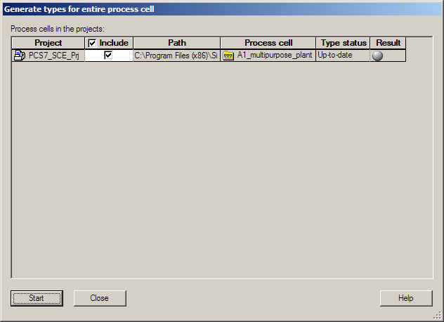

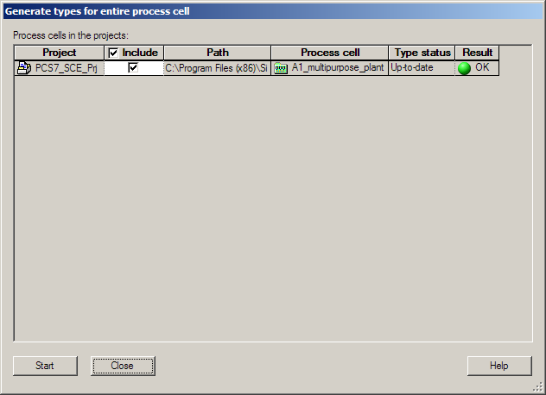

1. The three 'Phase types' 'Emptying', 'Filling' and 'Stirring' from the project are now visible.

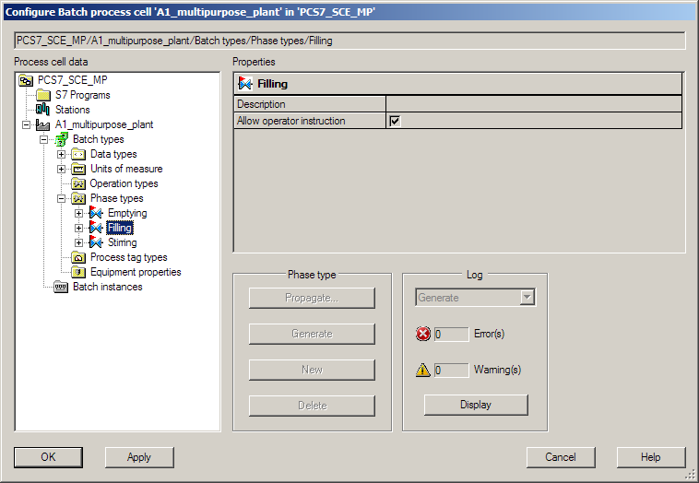

1. Next, select 'Batch instances' and use the 'Merge' function on the multiproject to make the assignment of the archive tags visible. (® Batch instances ® Merge)

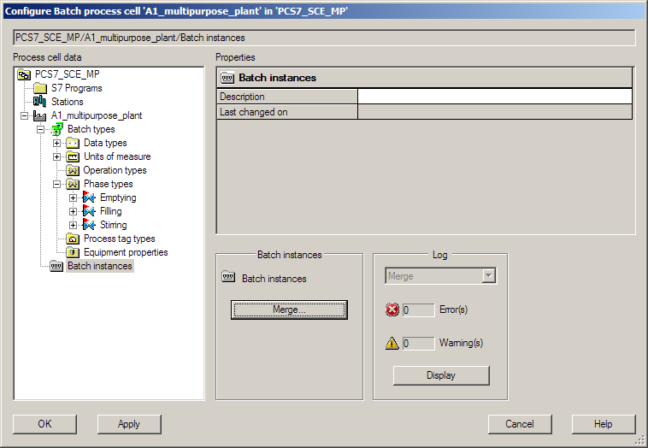

1. Select your project, click 'Start' and then 'Close'. (® SCE_PCS7_Prj ® Start ® Close)

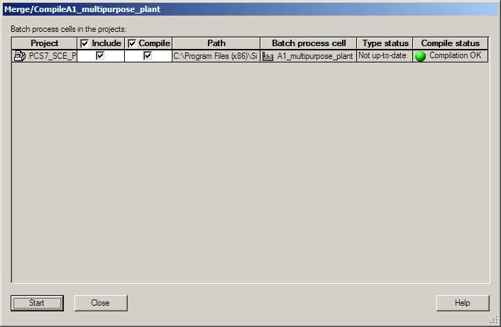

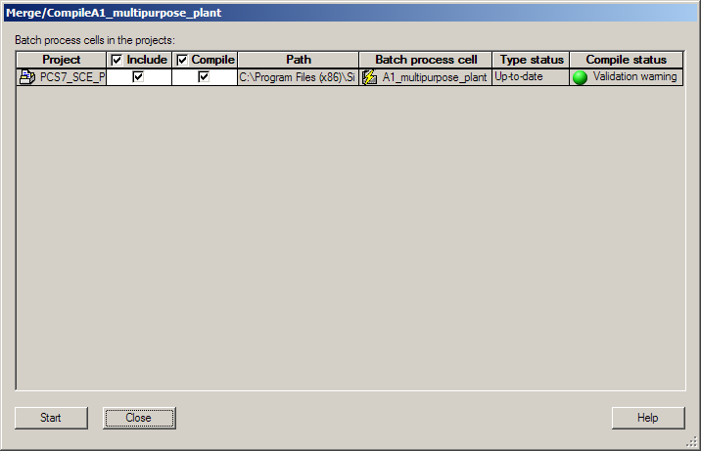

1. You can see the created instances under 'Batch instances'. Errors and warnings can be displayed under 'Log' the same as in the previous steps. (® Log ® Display ® OK)

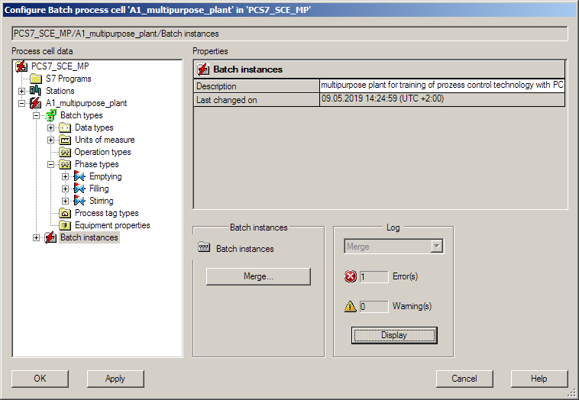

1. The following errors are detected.

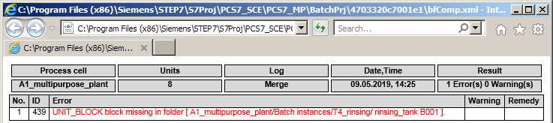

1. To remedy this error, close the BATCH configuration with 'OK' and insert a CFC with a UNIT_Block (UNIT_PLC) in the folder 'rinsing_tank B001'. To do so, create a new CFC and call it 'A1T4B001_UNIT'. Then add a UNIT_Block from the blocks or the SIMATIC BATCH Blocks library. Label the block A1T4B001. (® rinsing_tank B001 ® new CFC: A1T4B001_UNIT ® SIMATIC BATCH Blocks ® General\Blocks ® BATCH ® UNIT_PLC ® A1T4B001)

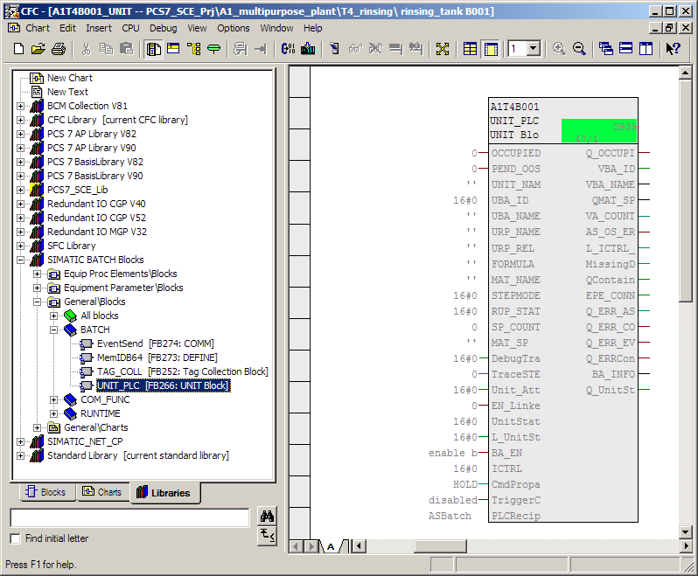

***Note:***

* *If you were to start the BATCH configuration and the merging of the batch instances again, you would receive warnings because the AS and OS were not compiled after inserting the blocks.*

## Compiling and downloading objects

1. *The next step therefore is to compile all objects.* This will also eliminate the warnings. (® SCE_PCS7_MP ® PLC ® Compile and Download Objects...)

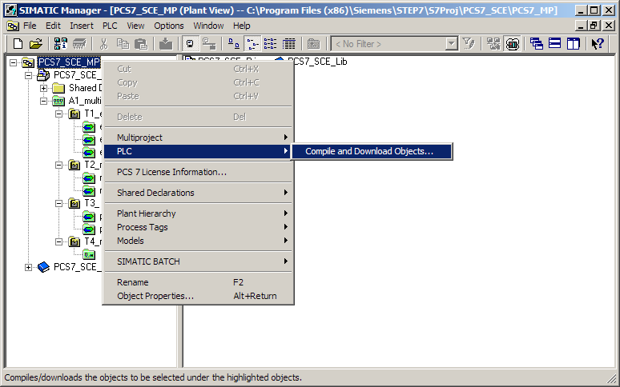

1. The 'A1_multipurpose_plant' object must be added in the following dialog. Select 'Compile' and 'Download' for all components as shown below. In row 'A1_multipurpose_plant', click 'Edit' for the compilation and download settings. (® A1_multipurpose_plant ® Edit)

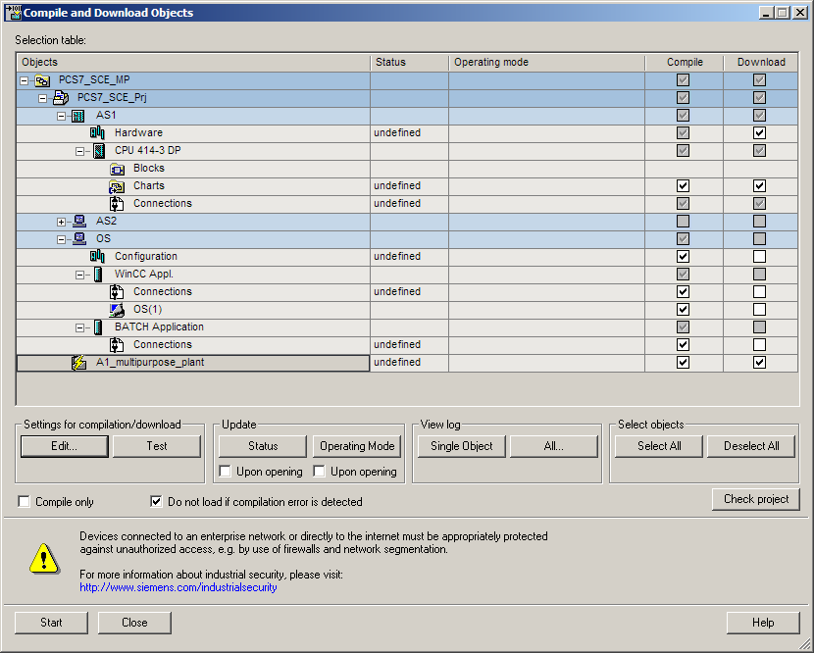

1. In the 'Merge/Compile' tab, select 'Generate types before compilation'. (® Merge/Compile ® Generate types before compilation)

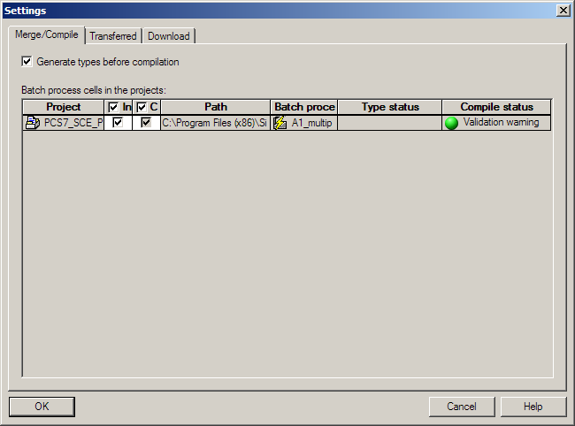

1. In the 'Transferred' tab, select 'Transfer messages'. (® Transferred ® Transfer messages)

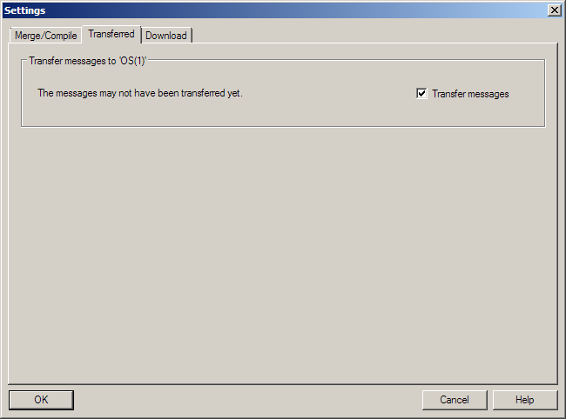

1. In the 'Download' tab, select all components that can be selected. (® Download ® OK)

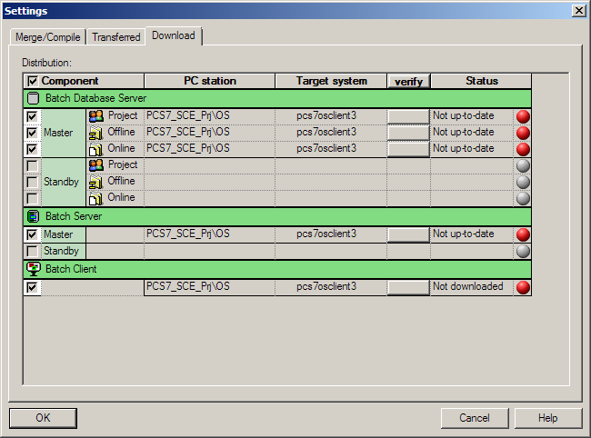

1. Now, click 'Start' in 'Compile and Download Objects' and confirm the message windows as seen in the previous chapters. (® Start ® Close)

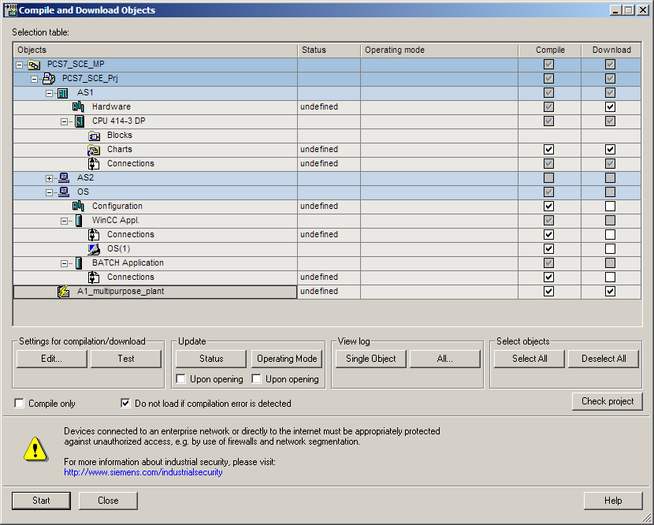

***Note:***

* *If another project has already been downloaded, you must also restart the PC. Otherwise, the other project remains loaded and you have no access to the batch data.*

## User configuration in WinCC

1. Open the OS. (® OS(1) ® Open Object)

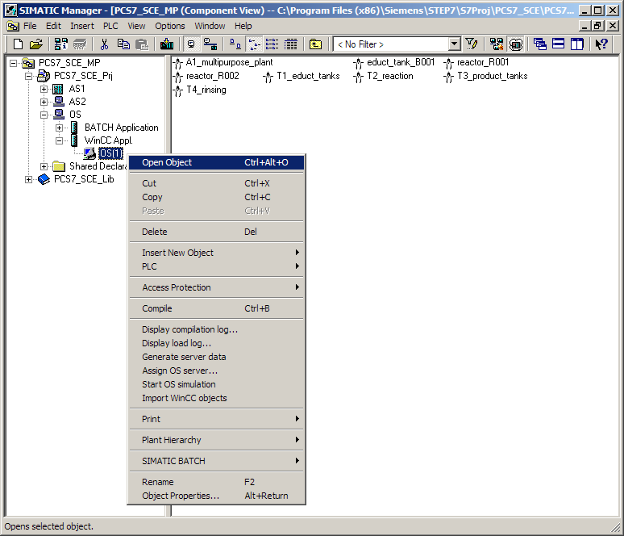

1. In Explorer you must create a user for batch in 'User Administrator'.(® User Administrator ® Open)

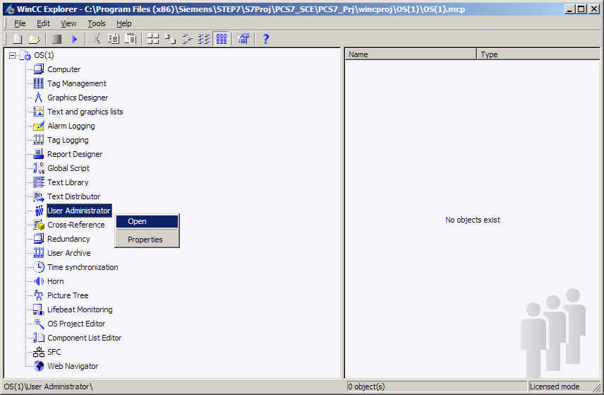

1. Under 'Administrator-Group', create a new user with the login: 'scebatch' and a password 'scebatch'. (® Administrator-Group ® New User ® scebatch ® scebatch ® OK)

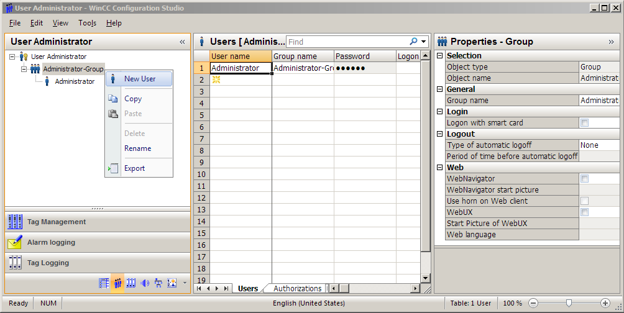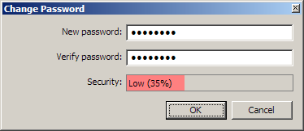

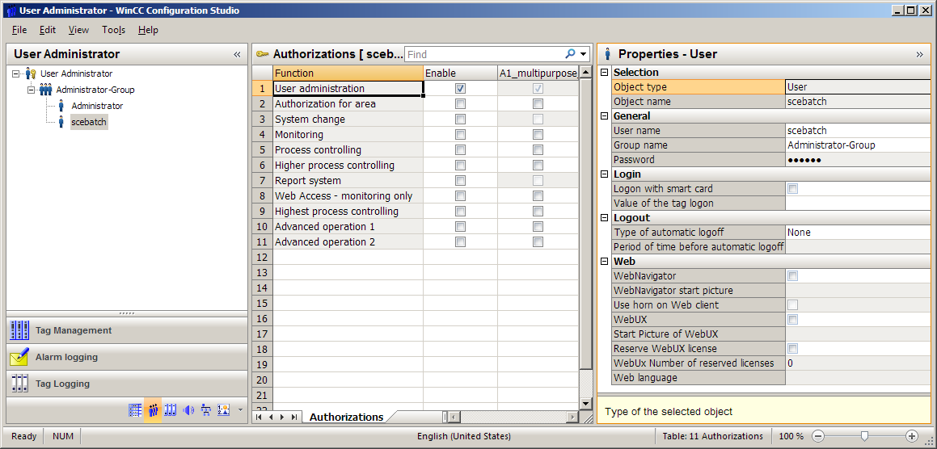

1. Now enable all options for A1_multipurpose_plant.

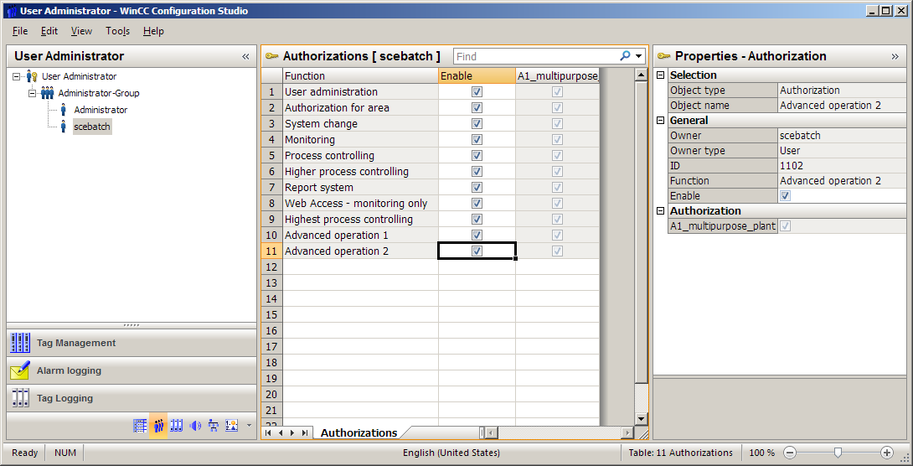

1. Then exit the User Administrator. (® File ® Exit)

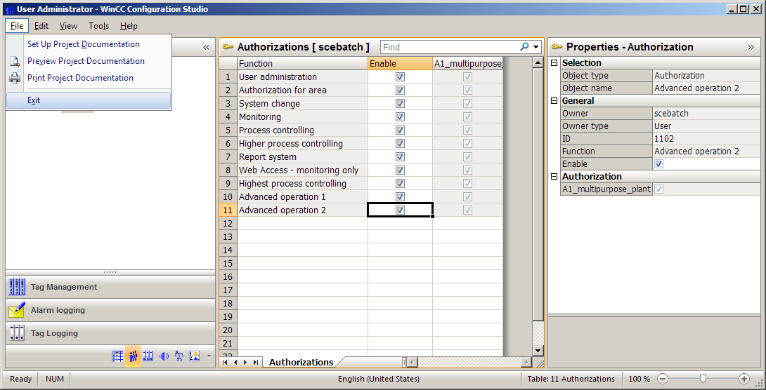

1. Now you still have to check your screen resolution. Open the 'OS Project Editor' to do so. (® OS Project Editor ® Open)

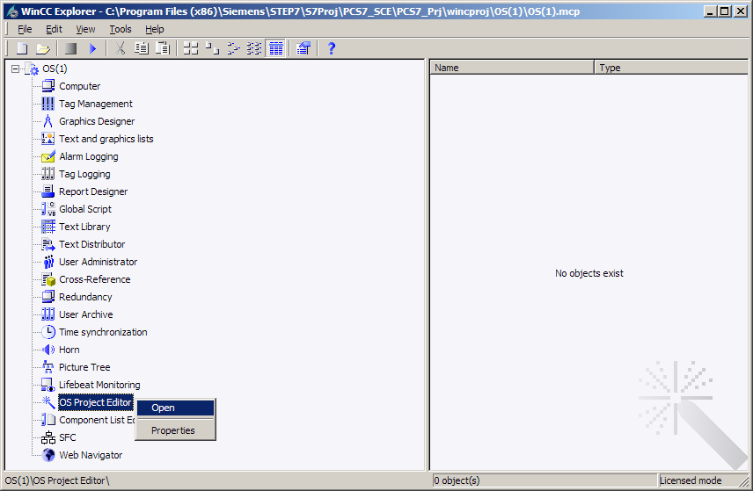

## Starting simulation

1. In order to test our recipe realistically later on, start the SIMIT Simulation with a double-click on the PC desktop. (® SIMIT SP Demo ® Retrieve/Open: p01-04-plantsim-v10-r1905-en.simarc ® Project View ® Start Simulation )

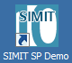

1. Now set the CPU in S7-PLCSIM to RUN-P and activate the runtime in WinCC Explorer. (® S7-PLCSIM ® RUN-P ® WinCC ®  Activate)

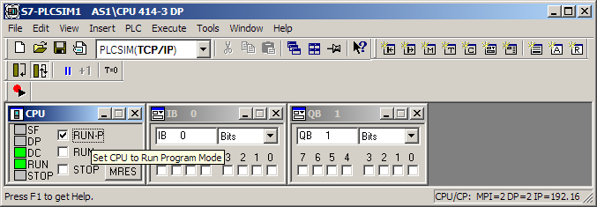

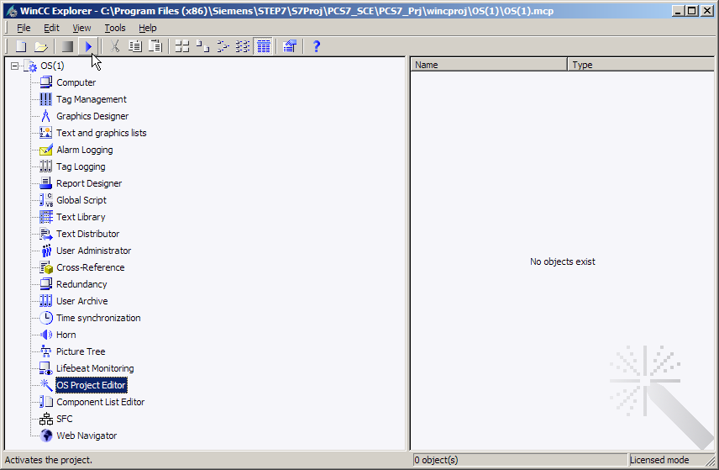

1. Enter 'scebatch' as the login and password in the example. (® scebatch ® scebatch ® OK)

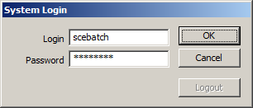

## Starting BATCH Runtime

1. If all settings you have made so far are correct, the 'BATCH Launch Coordinator' is automatically displayed in the taskbar with the status of the batch applications.



1. If this does not occur, you can manually start the it yourself. (® Start ® Siemens Automation ® SIMATIC ® SIMATIC BATCH ® Launch Coordinator)

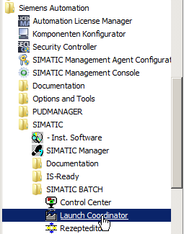

1. Depending on the settings, SIMATIC BATCH is started automatically after the OS is started. Nevertheless, if you want to influence this yourself, you can do so by right-clicking the  icon in the taskbar and manually starting and shutting down BATCH.

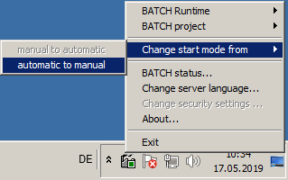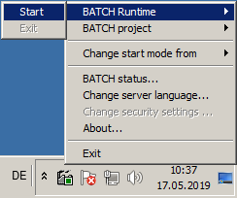

## User management in the Batch Control Center

1. In Runtime, click the  icon to change to the second key set. Start the BATCH CONTROL Center by clicking .





1. If all starting conditions for starting BATCH Control Center are not fulfilled, this will be indicated. Here, for example, the SIMATIC BATCH application is not yet started. In this case, close the OS application, establish the start conditions and start the BATCH Control Center again. (® Close application)

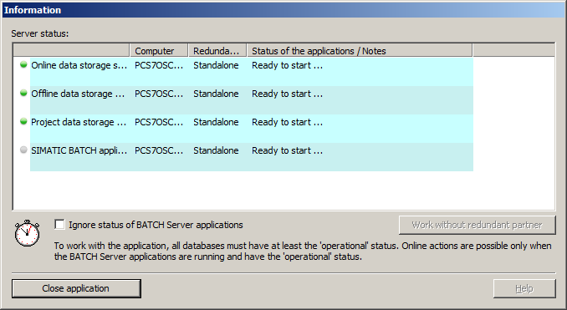

1. You must first log on. To do so, use your login information for the computer (for example: plt-admin).

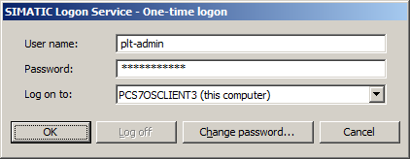

***Note:***

* *If* SIMATIC Logon *has not been installed yet, steps* 3-0 are omitted. *Please install the SIMATIC Logon Service to continue with these steps.*

1. Then open 'Roles management' in the 'Options' menu.

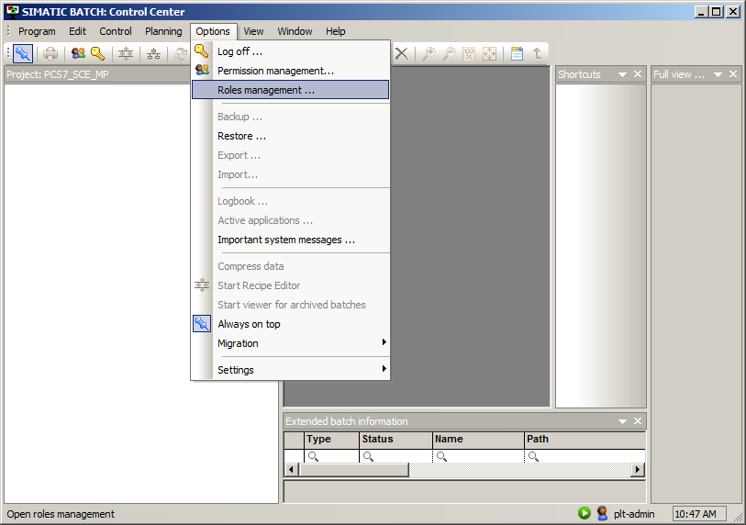

***Note:***

* *If Roles management is grayed out, note the following: The user must be a member of the Windows user group* Logon_Administrator*. Please make this setting now.*

1. Under the 'Super user' role, right-click 'Groups and users' to open the menu command 'Edit'.

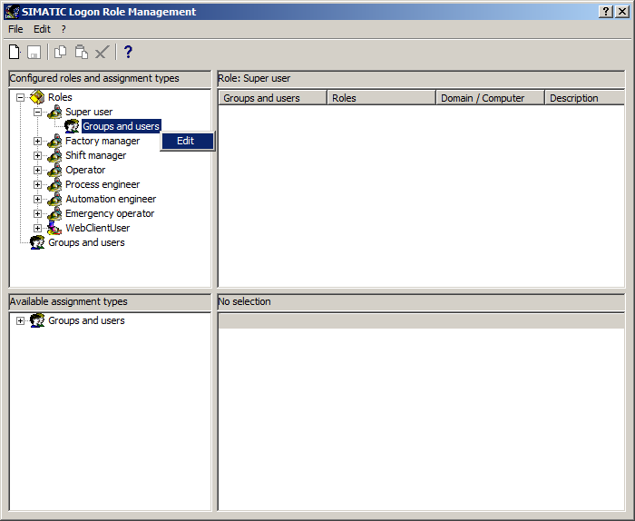

1. In the next dialog, click on 'List' and then select your user. You add yourself to the role with the arrow key.

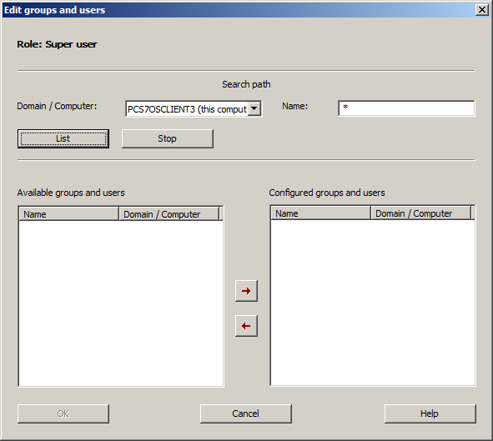

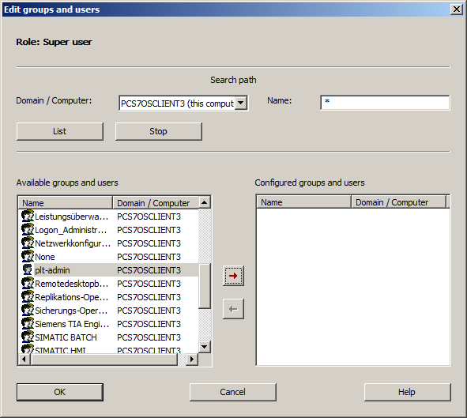

1. Exit the dialog with 'OK'. Then you must save your changes and close Roles Management.

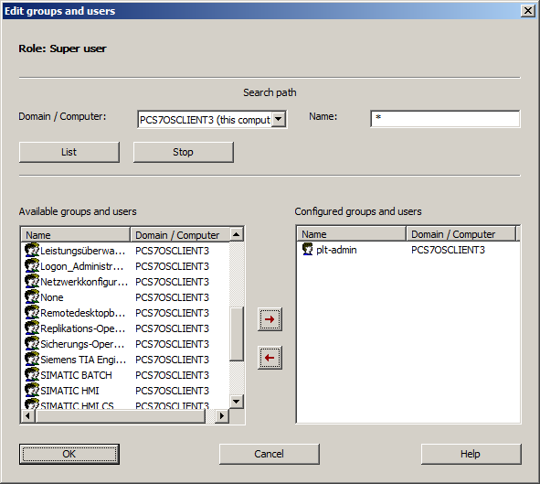

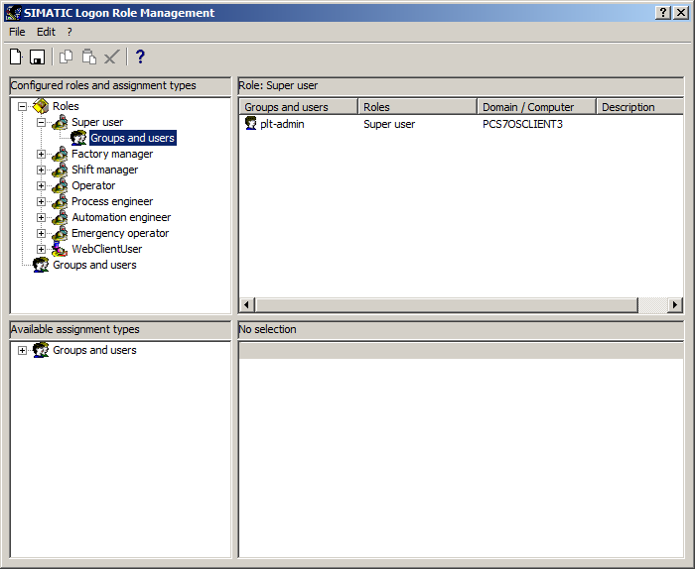

## Creating and configuring a process cell

1. Next, select the item 'New process cell...' in the 'Program' menu. The 'A1_multipurpose_plant' will be added to the project.

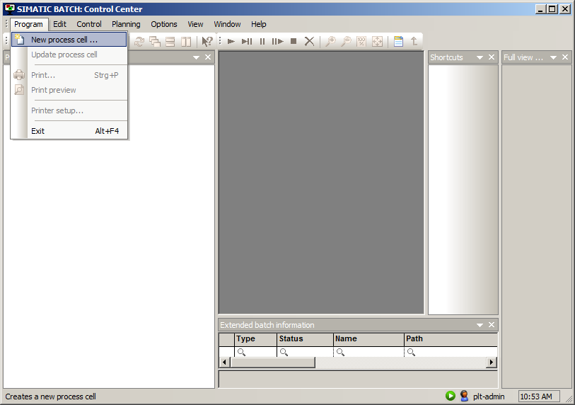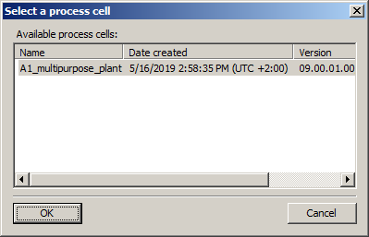

***Note:***

* *If batch data is still present, you can delete it with the steps from the following instructions:* [*support.automation.siemens.com/WW/view/en/18794587*](http://support.automation.siemens.com/WW/view/en/18794587). *Then perform a restart.*

1. Now open the menu of the process cell to specify the new input and output materials for the recipes. (® Materials ® New)

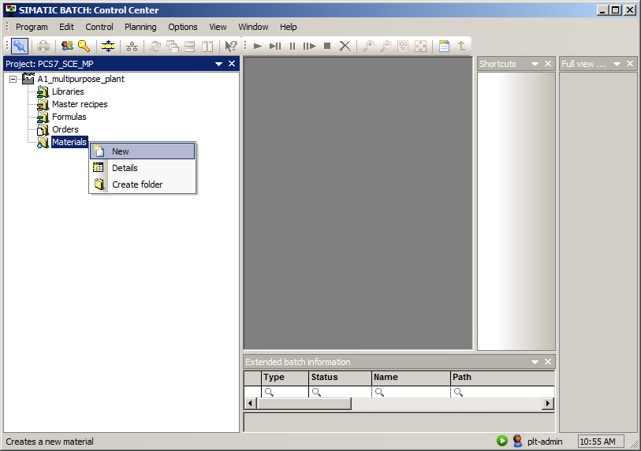

1. First, enter 'Educt001' with code 'E001' as the raw material and 'Input material' as the usage. (® Name: Educt001 ® Code: E001 ® Usage: Input material ® OK)

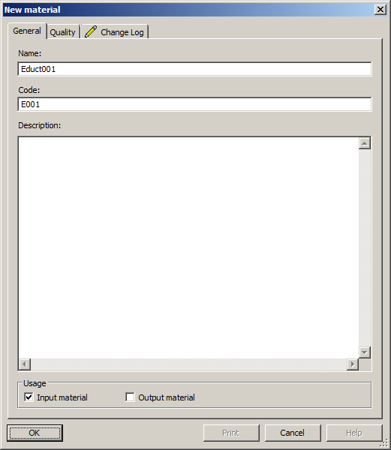

1. Enter 'Edukt002'/'Edukt003' as additional raw materials. (® Materials ® New ® Name: Edukt002/Edukt003 ® Code: E002/E003 ® Usage: Input material ® OK)

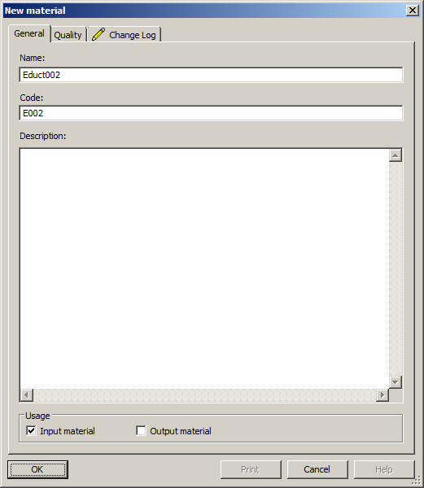

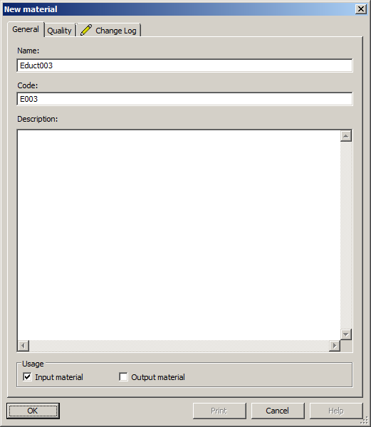

1. Define 'Product001' with code 'P001' as 'Output material'.   
   (® Materials ® New ® Name: Produkt001 ® Code: P001 ® Usage: Output material ® OK)

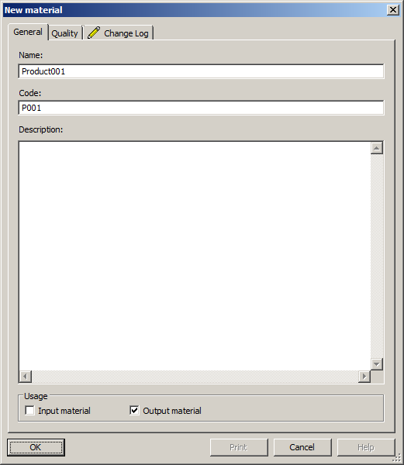

## Creating and configuring a recipe

1. Here, you create a new 'Master recipe'. Now you create a new 'Master recipe'. The recipe is to be a 'Flat' master recipe so that the unit class/unit can be assigned individually to each recipe step. (® Master recipe ® New ® Flat)

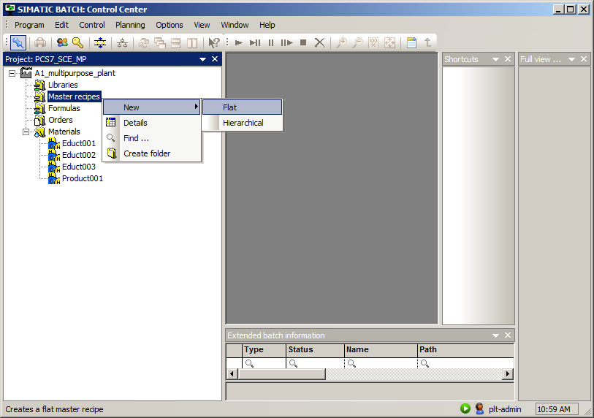

1. Specify 'Recipe_Product001' as the name of the recipe. (® Recipe_Product001 ® OK)

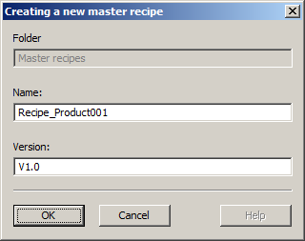I

1. Open the properties of the recipe. (® Recipe_Product001 V1.0 ® Properties)

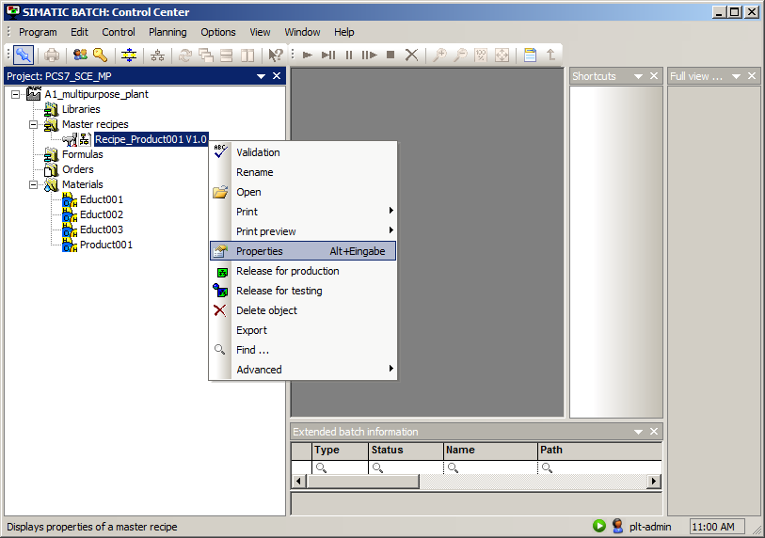

1. First you specify the allocation by clicking 'New' on the corresponding tab. Enter the 'Educt tank B001' unit as name for the first recipe assignment. Select 'Edit'. (® Allocations ® New ® Recipe assignment: Educt tank B001 ® Edit)

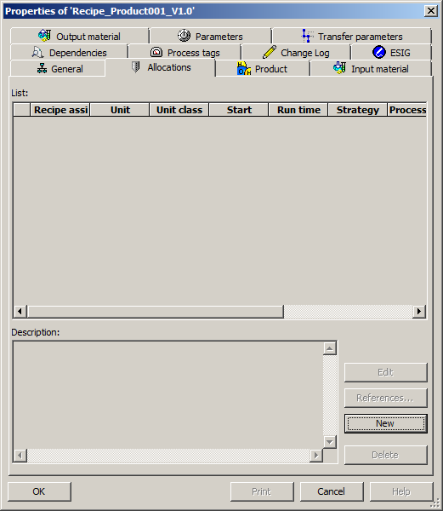

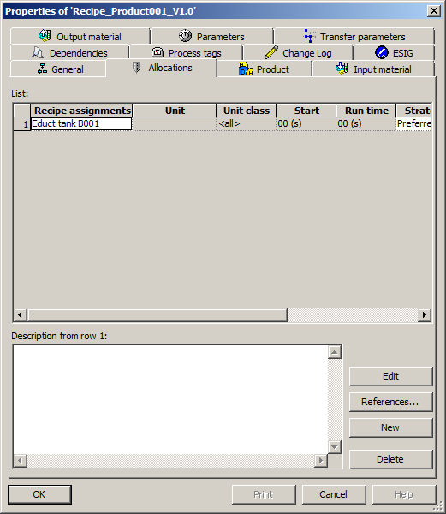

1. In the equipment selection and in the preferred unit, select 'educt_tank B001' and confirm your selection with 'OK'.

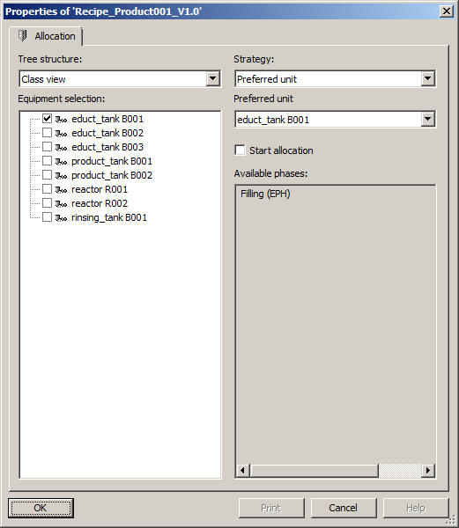

1. Repeat steps 4 and 5 for the other units involved as shown in the figure below.

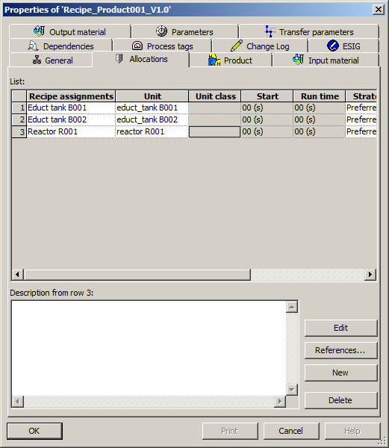

1. Next you define a product with product code, reference quantity, unit of measure, minimum quantity and maximum quantity of a batch. (® Product ® Product: Product001 ® Product code: P001 ® Reference quantity: 400 ® Unit: ml ® Minimum quantity of a batch: 300 ® Maximum quantity of a batch: 1000)

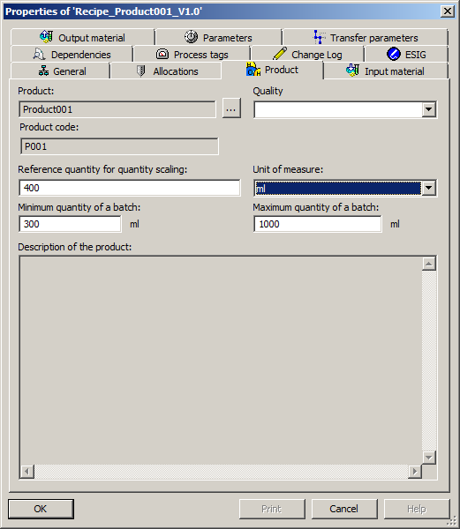

1. Then you define the first input material. (® Input material ® New)

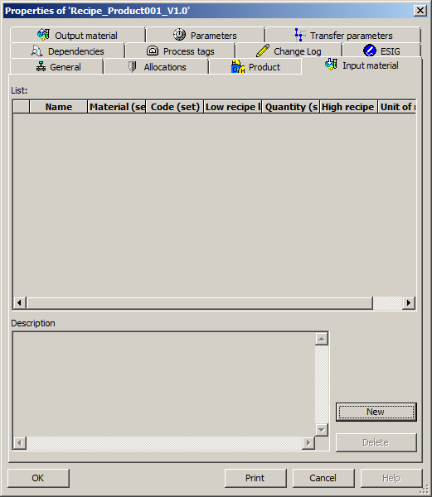

1. Name the input material and then select material Educt001.   
   (® Name: Input material 1 ® Material  ® Educt001 ® OK)

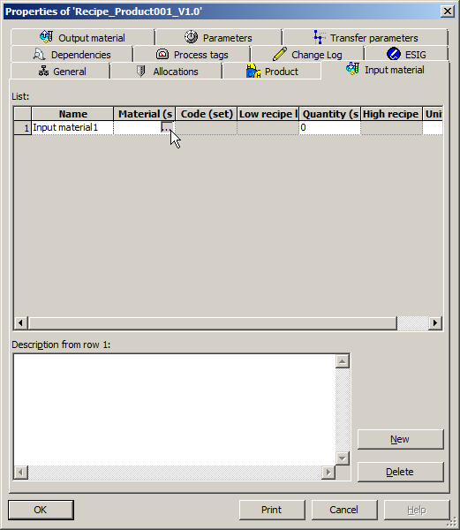

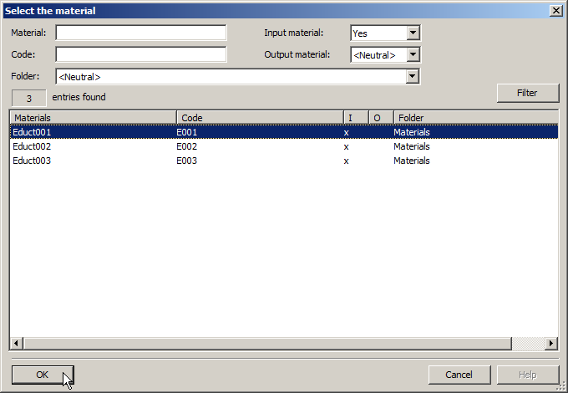

1. Once the second material Educt002 has been selected, specify the quantity and unit of the input materials. (® Quantity: 250 ® Unit: ml ® New ® Name: Input material 2 ® Material  ® Educt002 ® OK ® Quantity: 150 ® Unit: ml)

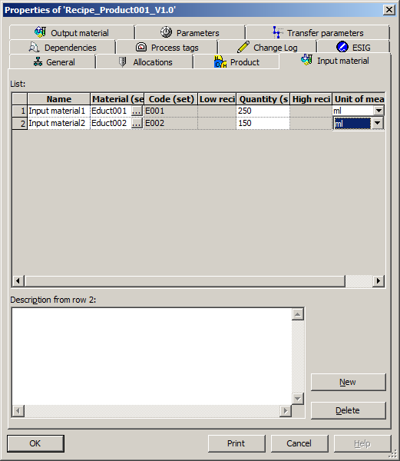

1. Then you define the output material. (® Output material ® New)

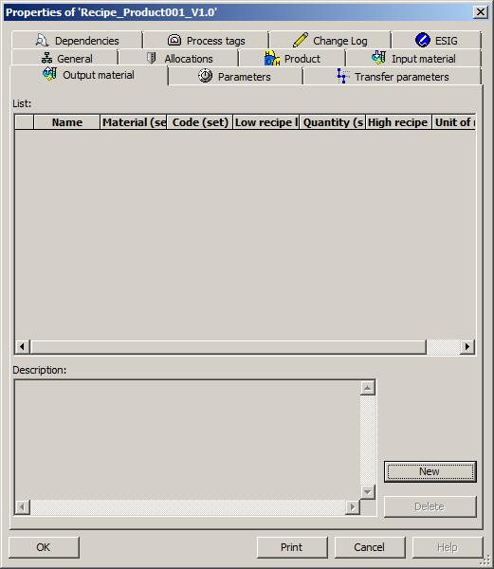

1. After you have selected the output material, you also specify its quantity and unit of measure.   
   (® Output material ® Name: Output material ® Material  ® Product001 ® OK ® Quantity: 400 ® Unit: ml)

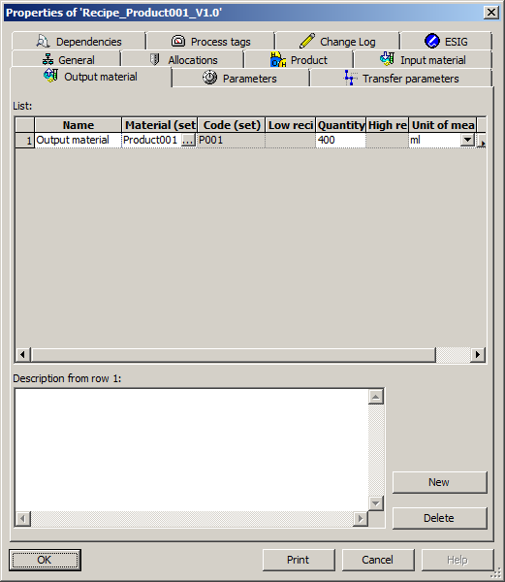

## Editing a recipe

1. Now open the recipe. (® Recipe_Product001 V1.0)

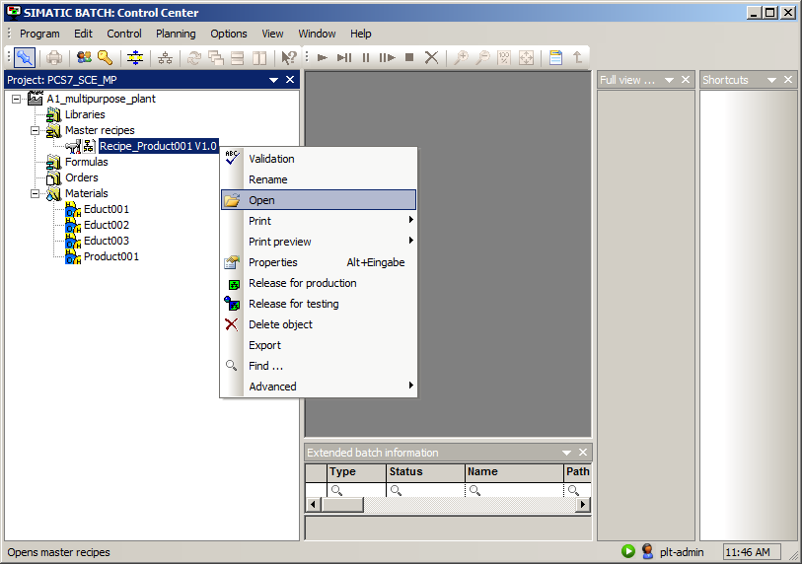

1. The recipe is created in a recipe editor. Here, you can create linear and parallel structures as well as loops. The example recipe is linear and consists of four recipe operations. Now insert four 'recipe phases/recipe operations' . (® Insert recipe phase/recipe operation )

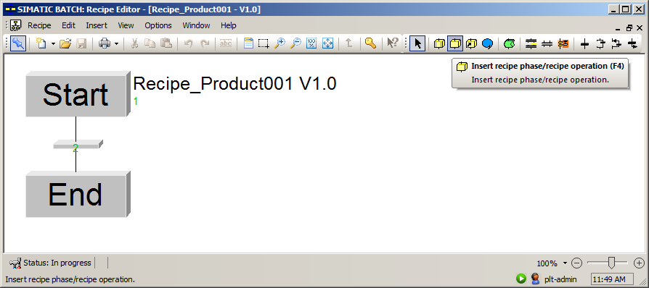

1. Change the mode to 'Select' . (® Select )

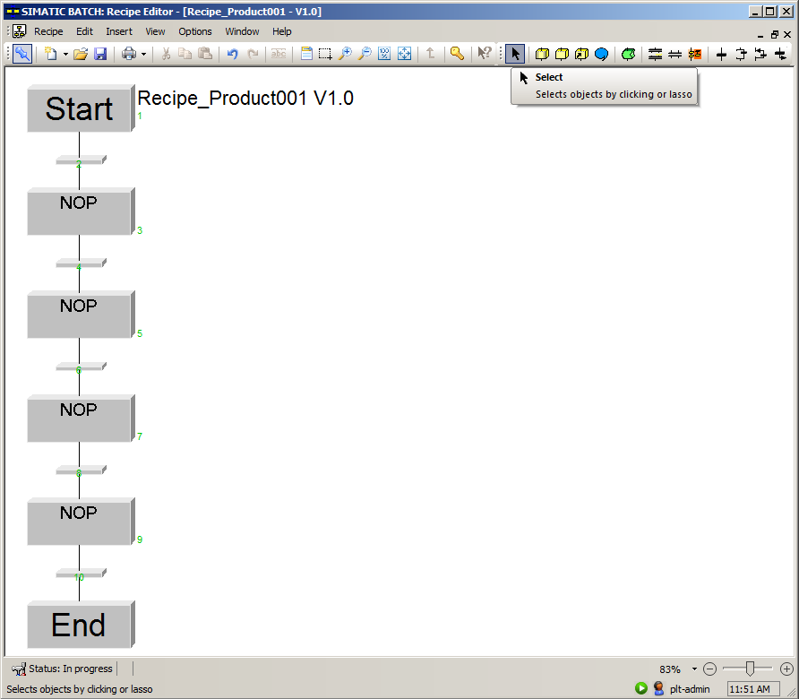

1. Select the first recipe phase/recipe operation and select its properties. (® NOP ® Properties)

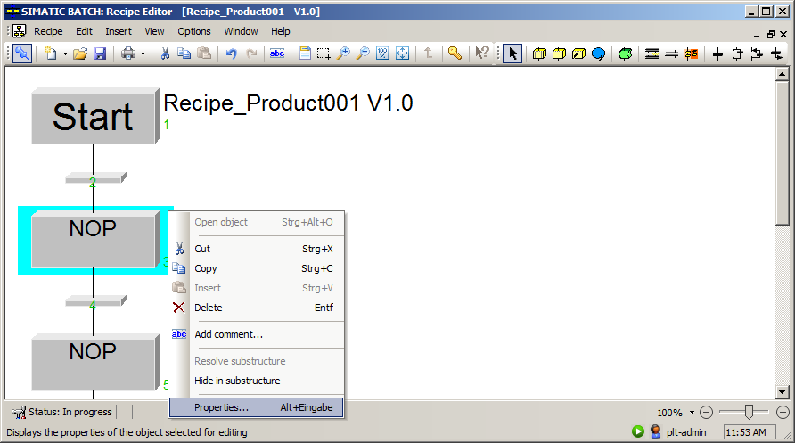

1. In the properties under 'General', select the unit 'Educt tank B001' and the phase 'Filling (EPH)' with the control strategy 'Filling'. (® General ® Unit name: Educt tank B001 ® Phase: Filling (EPH) ® Control strategy: Filling_R001)

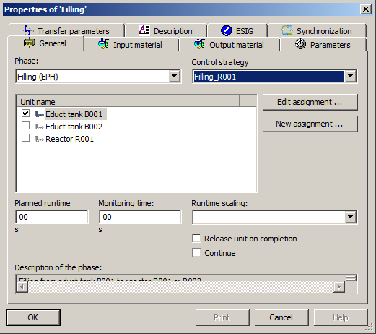

1. Under 'Parameters', select the value 250 ml for 'FillingQuantity'. (® Parameters ® FillingQuantity ® 250 ® OK)

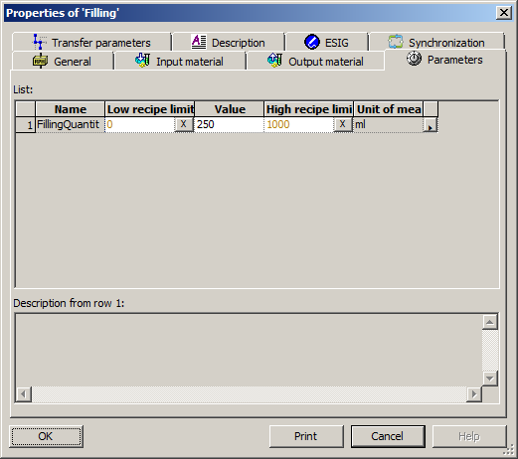

1. Now, label this recipe phase/operation (® Add comment ® Filling of reactor R001 from educt tank B001 ® OK)

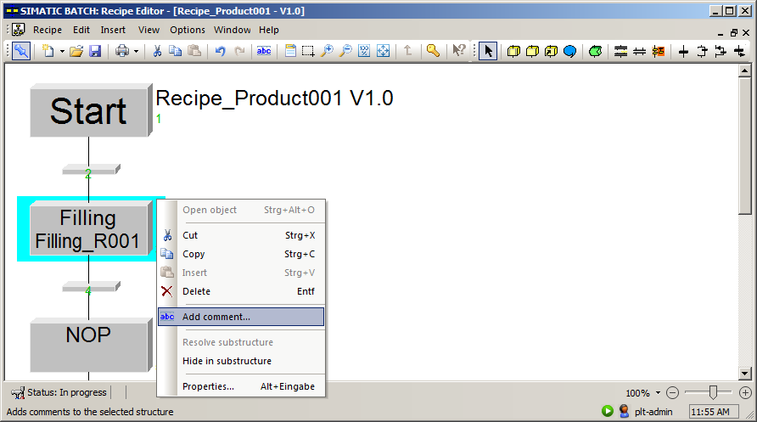

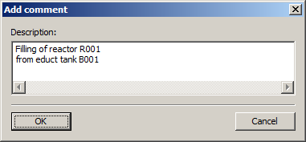

1. Also set up the second recipe phase/recipe operation with the preferred unit 'Educt tank B002', the phase Filling (EPH) and the control strategy Filling_R001. For 'FillingQuantity', select the value 150 ml. (® General ® Phase: Filling (EPH) ® Control strategy: Filling_R001 ® Unit name: Educt tank B002 ® Parameters ® Value: 150)

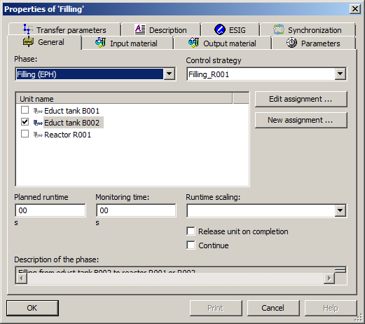

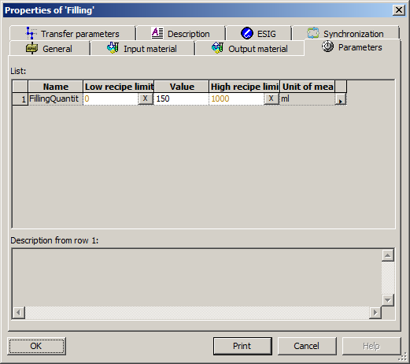

1. You set up the third recipe phase/recipe operation with the preferred unit 'Reactor R001' and the phase Stirring (EPH) with control strategy 'Stirring'. For 'Duration', select the value 20 s. (® General ® Phase: Stirring (EPH) ® Control strategy: Stirring ® Unit name: Reactor R001 ® Parameters ® Value: 20)

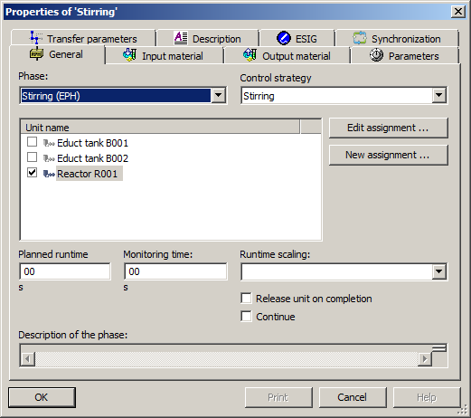

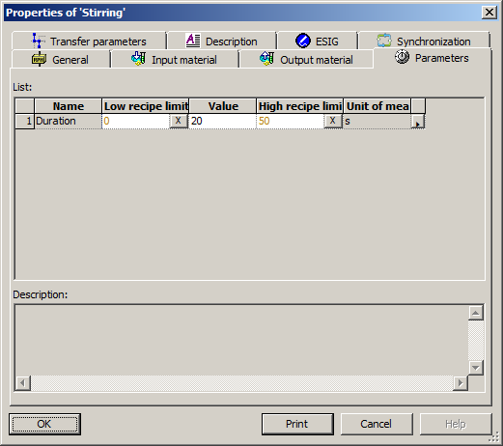

1. You set up the fourth recipe phase/recipe operation with the preferred unit 'Reactor R001', the phase Emptying (EPH) and the control strategy 'Emptying'. You do not have to assign any parameters here. (® General ® Unit name: Reactor R001 ® Phase: Emptying (EPH) ® Control strategy: Emptying)

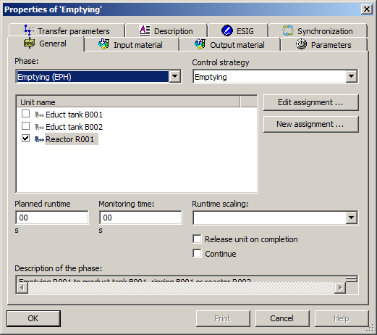

1. Once you have labeled the recipe phases/recipe operations as seen here, you save the recipe. . (® )

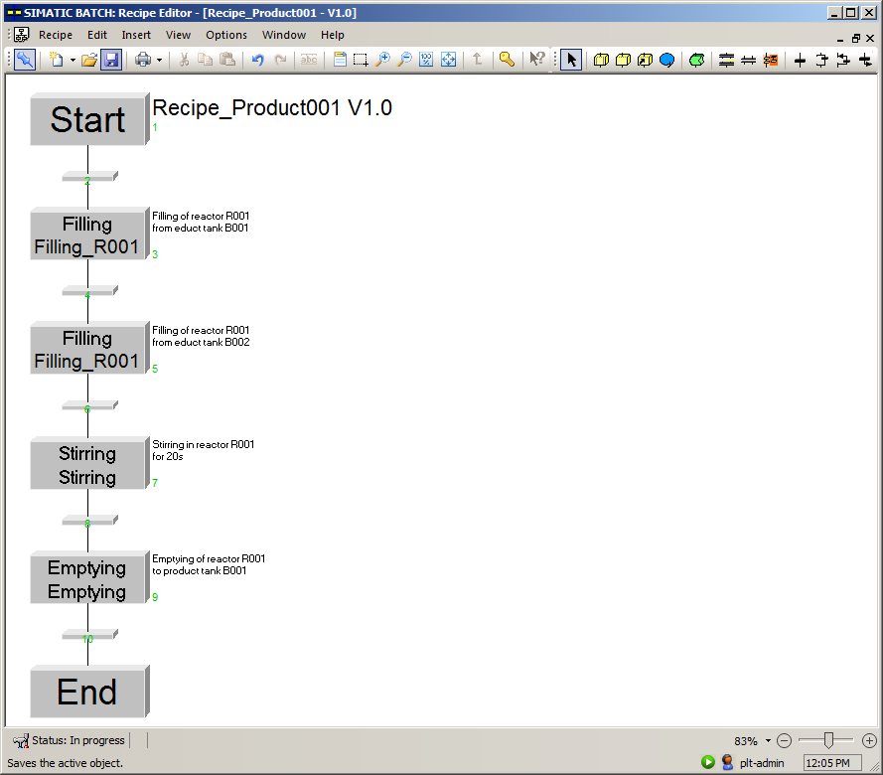

## Checking and releasing a recipe

1. Next, you should check the recipe for validity before you close it. (® Recipe ® Check validity ® OK ® )

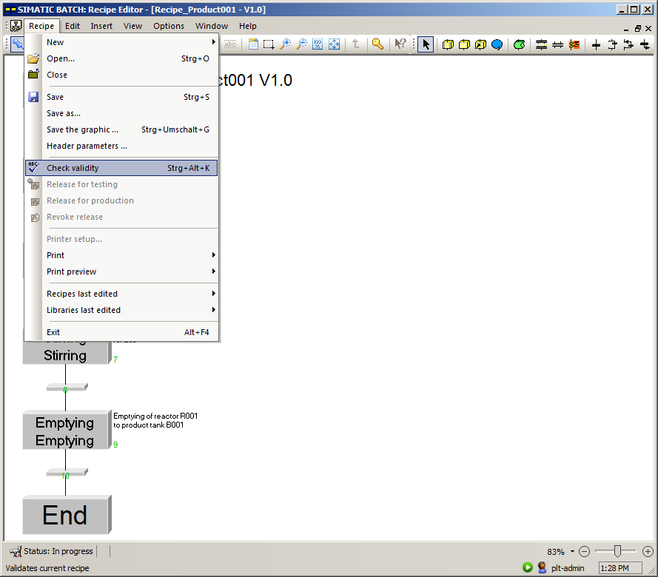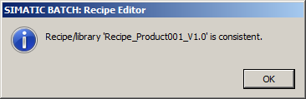

1. Now, release the 'Recipe_Product001 V1.0' for production. (® Recipe_Product001 V1.0 ® Release for production)

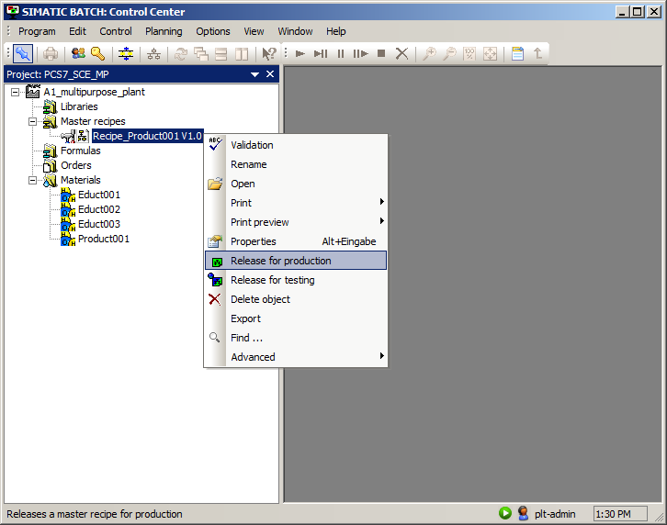

## Creating and configuring an order with batch

1. Next, you create a new order folder. (® Orders ® New)

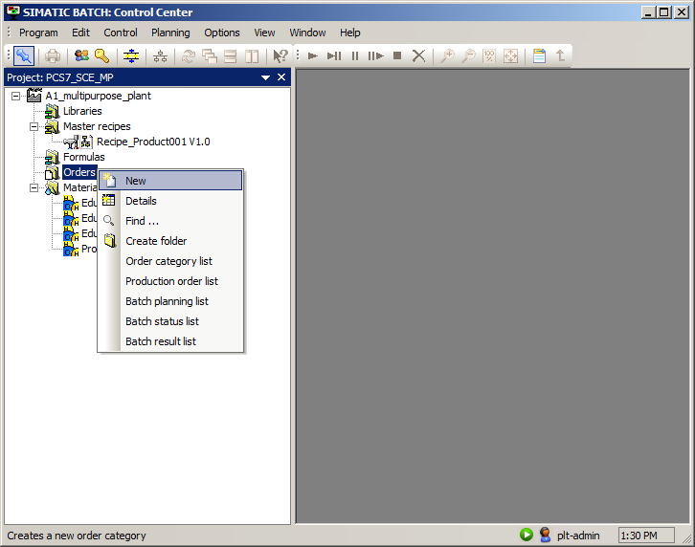

1. Name the order folder 'SCE_orders'. (® Name: SCE_orders ® OK)

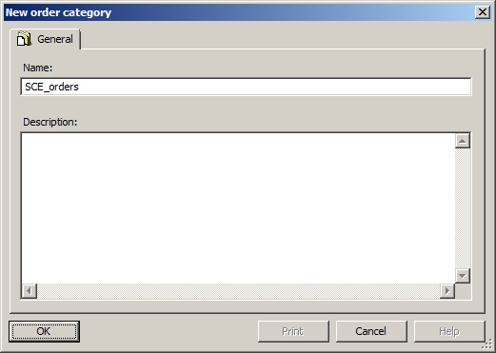

1. Create a new order inside the new order folder. (® SCE_orders ® New)

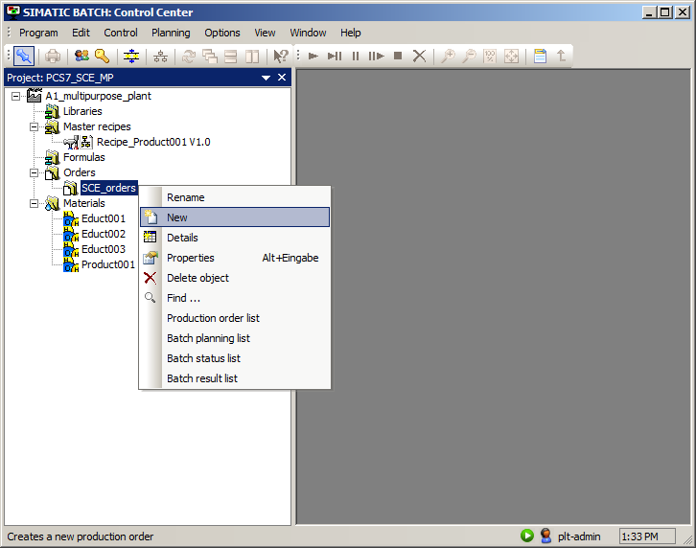

1. You name the order 'Order01'. (® Name: Order01 ® Batches)

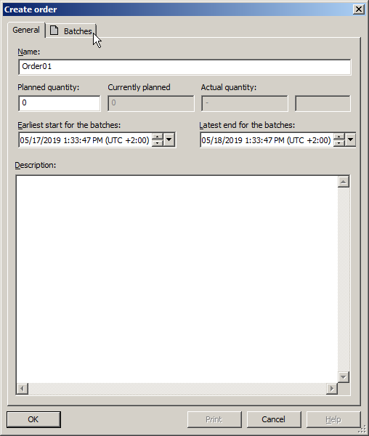

1. Create a new batch within the order. (® New)

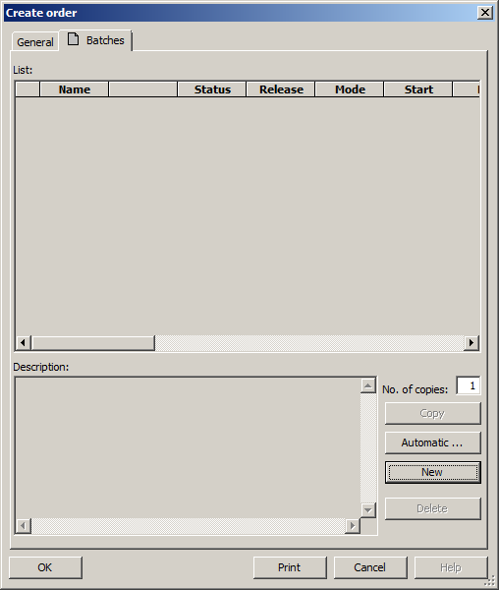

1. Assign 'Recipe_Product001 V1.0' to the batch. (® Recipe_Product001 V1.0 ® OK)

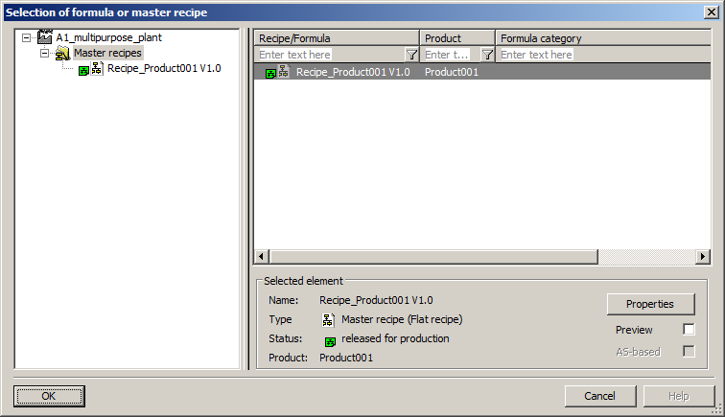

1. For each batch, the product and the quantity can in turn be specified and parameters can be selected. (® Product: Product001 ® Quantity: 400 ® Parameter)

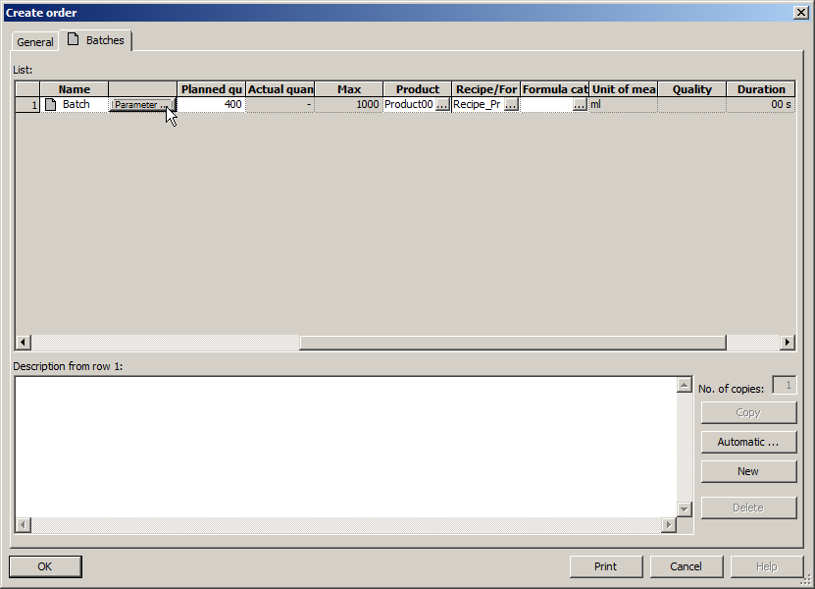

1. If several units are available for specific recipe assignments, these might be specified in the 'Allocations' tab. (® Allocations)

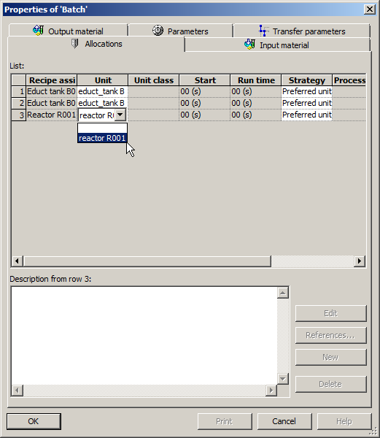

1. The utilized materials and their quantities can be set in the 'Input material' tab. (® Input material ® Quantity: 250 ® Quantity: 150)

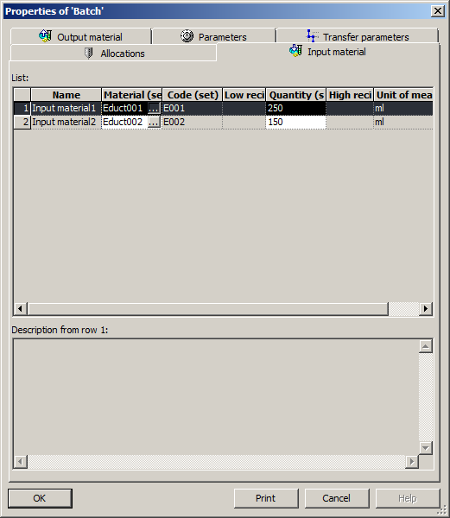

1. The output material and its quantity can be selected in the 'Output material' tab. (® Output material ® Quantity: 400 ® OK ® OK)

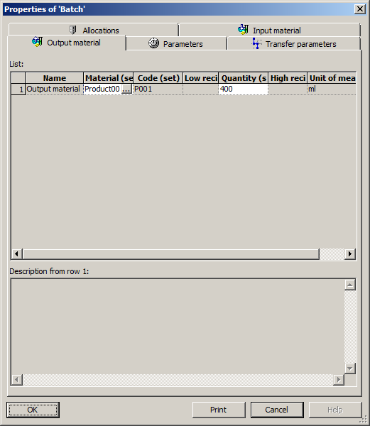

## Executing an order/batch

1. Now, open the control recipe for the 'Batch' so you can monitor and start it later. (® Batch ® Open control recipe)

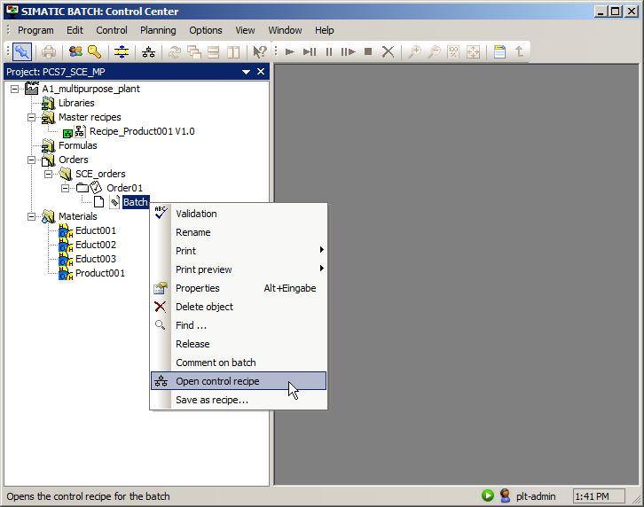

1. Then, release the batch. (® Batch ® Release ® Yes)

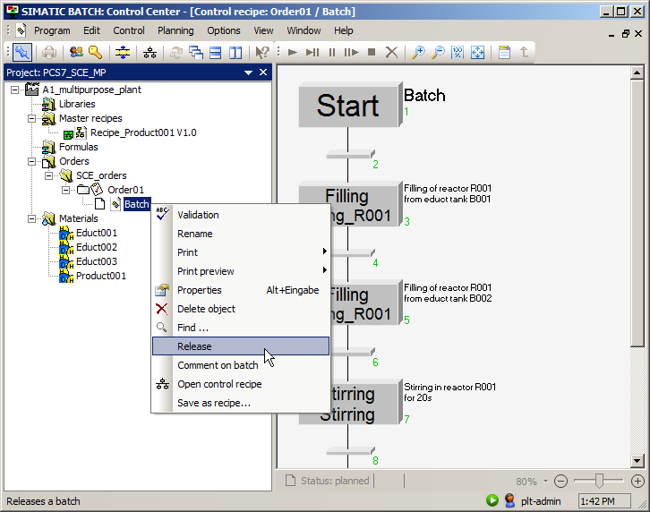

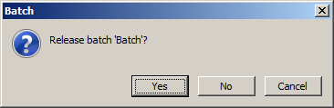

1. Start the process by clicking  to start the batch. (® Start batch  ® Yes)

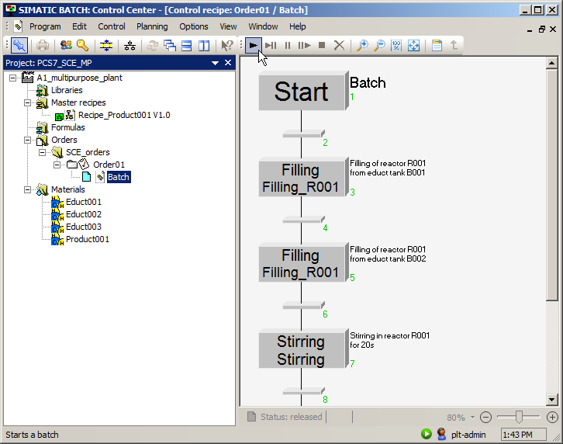

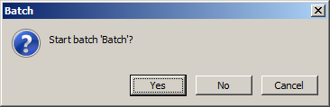

1. You can now monitor the execution of the batch. You can stop, pause, restart or abort the recipe with the commands  in the menu bar.

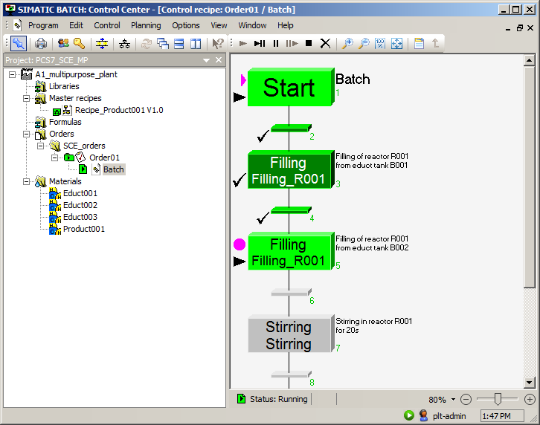

1. In Runtime, you can see the allocation of the objects by the batch in the 'Batch' view of the faceplates. (® Batch)

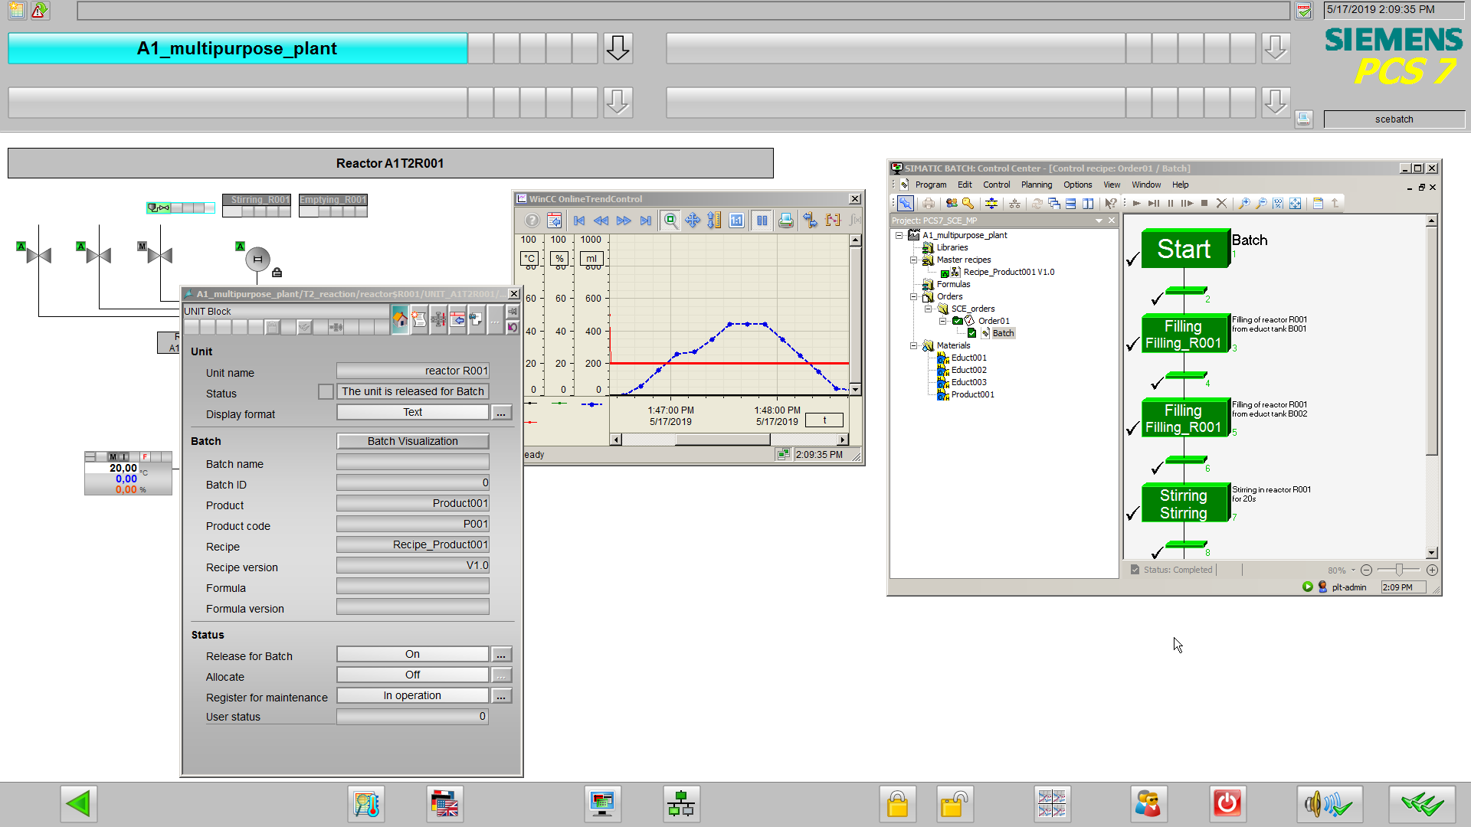

1. Once a batch has been completely processed, it must still be closed in order to collect the batch-specific measurement and alarm data and write this data to the hard disk. (® Batch ® Close)

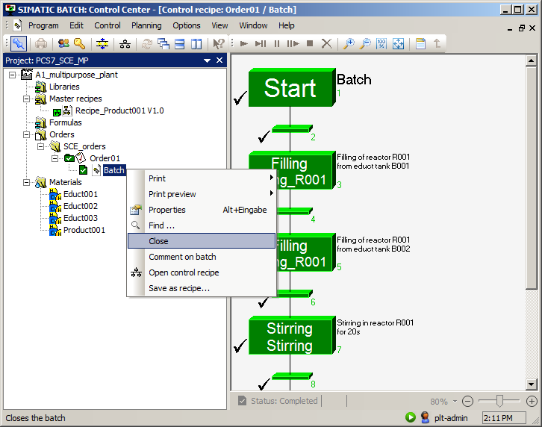

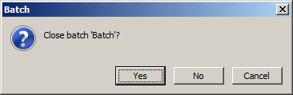

1. You can view the production data under 'Properties'. Now close the BATCH Control Center.

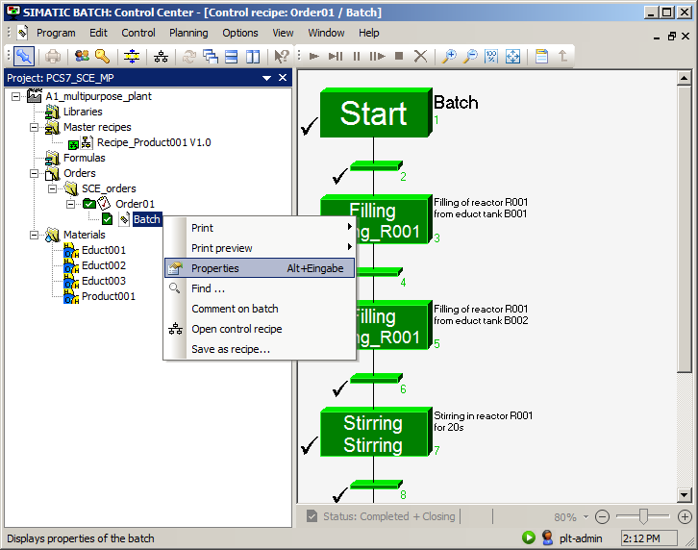

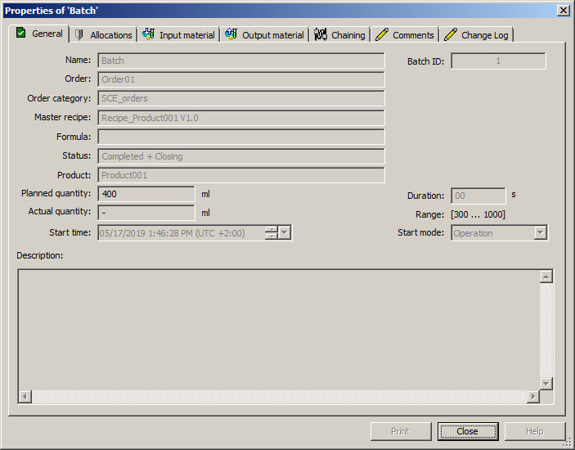

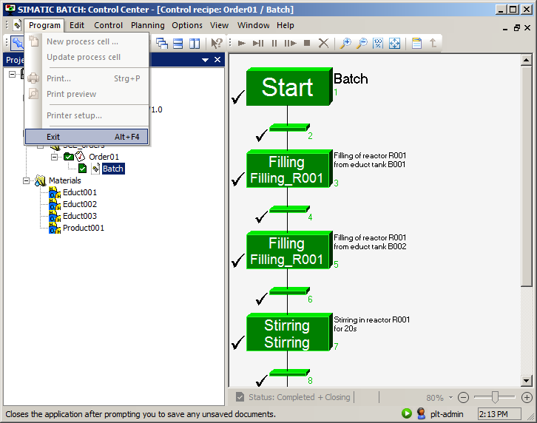

## Checklist – step-by-step instruction

The following checklist helps students to independently check whether all steps of the step-by-step instruction have been carefully completed and enables them to successfully complete the module on their own.

|  |  |  |
| --- | --- | --- |
| No. | Description | Checked |
| 1 | Project preparation complete |  |
| 2 | BATCH components configured |  |
| 3 | Objects successfully compiled and downloaded after configuration |  |
| 4 | Format converted implemented |  |
| 5 | BATCH types successfully propagated and generated |  |
| 6 | BATCH instances successfully merged (error-free) |  |
| 7 | Objects successfully compiled and downloaded after configuration |  |
| 8 | User configuration in WinCC completed |  |
| 9 | Simulation started |  |
| 10 | BATCH Runtime started |  |
| 11 | User management in BATCH Control Center completed |  |
| 12 | Process cell created and configured |  |
| 13 | Recipe created and configured |  |
| 14 | Sequential function chart for recipe finished |  |
| 15 | Recipe checked for validity and released |  |
| 16 | Order with batch created |  |
| 17 | Batch successfully released, executed and closed |  |
| 18 | Project successfully archived |  |

Table 1: Checklist for step-by-step instructions

# Exercises

In the exercises, you apply what you learned in the theory section and in the step-by-step instructions. The existing multiproject from the step-by-step instructions (p03-03-project-r1905-en.zip) is to be used and expanded for this. The download of the projects/files is stored as a zip file on the SCE Internet for the respective module.

***Notes:***

* *The project p03-03-project-r1905-en.zip can only contain the contents of the step-by-step instructions up to section 8.5. All other steps must be performed on your own. Sections 0 to 8.12 can be recovered by restoring the backup p03-03-batch-backup-r1905-en.sbb, if the plant was reset. The steps starting from section 8.13 must be performed manually, however.*
* *Sections 8.10 to 8.12 (only the control recipe) can also be recovered by importing the file p03-03-export-recipe-r1905-en.sbx.*
* *The additional files are stored in the zip file 'p03-03-files-r1905-en.zip'.*
* *All previous batch data should be deleted due to possible overlaps with other projects.*

## Tasks

The following exercises are based on the step-by-step instructions. The corresponding steps of the instructions can be used to assist with each task.

1. Implement a new material Product002 (P002) in the Batch Control Center.
2. Create a new master recipe 'Recipe_Product002' with the following properties:

|  |  |
| --- | --- |
| Allocation | |
| Unit 1 | Educt tank B001 |
| Unit 2 | Educt tank B002 |
| Unit 3 | Educt tank B003 |
| Unit 4 | Reactor R002 |
| **Product** | |
| Product002 | 500 ml / 300 ml / 1000 ml |
| **Input material** | |
| Input material 1 | E001 (150 ml) |
| Input material 2 | E002 (250 ml) |
| Input material 3 | E003 (100 ml) |
| **Output material** | |
| Output material 1 | Product002 (500 ml) |

1. Now create the following recipe:

First, 150 ml is to be drained from the educt tank =SCE.A1.T1-B001 to the reactor =SCE.A1.T2-R002.

Then, 250 ml is to be drained from the educt tank =SCE.A1.T1-B002 to the reactor =SCE.A1.T2-R002.

Then, 100 ml is to be drained from the educt tank =SCE.A1.T1-B003 to the reactor =SCE.A1.T2-R002.

The liquids in the reactor =SCE.A1.T2-R002 are now to be stirred with the stirrer for 10 seconds.

Finally, this mixture is to be drained to the product tank =SCE.A1.T3-B002.

1. Check the validity of the recipe and release it for production.
2. Create an Order02 and process a new batch of Product002 there.
3. Release the batch, open the control recipe and start the production.
4. Finally, close the batch.

## Checklist – exercise

The following checklist helps students to independently check whether all steps of the exercise have been carefully completed and enables them to successfully complete the module on their own.

|  |  |  |
| --- | --- | --- |
| No. | Description | Checked |
| 1 | Material ProductP002 created |  |
| 2 | Master recipe Recipe_Produkt002 created and configured |  |
| 3 | Sequential function chart of Recipe_Product002 created according to the task description |  |
| 4 | Validity of Recipe_Product002 successfully checked |  |
| 5 | Order02 with batch for Product002 created and configured |  |
| 6 | Batch for Product002 successfully released, executed and closed |  |

Table 2: Checklist for exercises

# Additional information

More information for further practice and consolidation is available as orientation, for example: Getting Started, videos, tutorials, apps, manuals, programming guidelines and trial software/ firmware, under the following link:

[siemens.com/sce/pcs7](http://www.siemens.com/sce/pcs7)

**Preview "Additional information"**

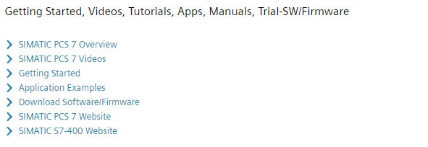

Further Information

Siemens Automation Cooperates with Education  
**siemens.com/sce**

Siemens SIMATIC PCS 7  
**siemens.com/pcs7**

SCE Learn-/Training Documents  
**siemens.com/sce/documents**

SCE Trainer Packages  
**siemens.com/sce/tp**

SCE Contact Partners   
**siemens.com/sce/contact**

Digital Enterprise  
**siemens.com/digital-enterprise**

Industrie 4.0   
**siemens.com/future-of-manufacturing**

Totally Integrated Automation (TIA)  
**siemens.com/tia**

TIA Portal  
**siemens.com/tia-portal**

SIMATIC Controller  
**siemens.com/controller**

SIMATIC Technical Documentation   
**siemens.com/simatic-docu**

Industry Online Support  
**support.industry.siemens.com**

Product catalogue and online ordering system Industry Mall   
**mall.industry.siemens.com**

Siemens  
Digital Industries, FA   
P.O. Box 4848  
90026 Nuremberg  
Germany

Subject to change and errors  
© Siemens 2020

**siemens.com/sce**