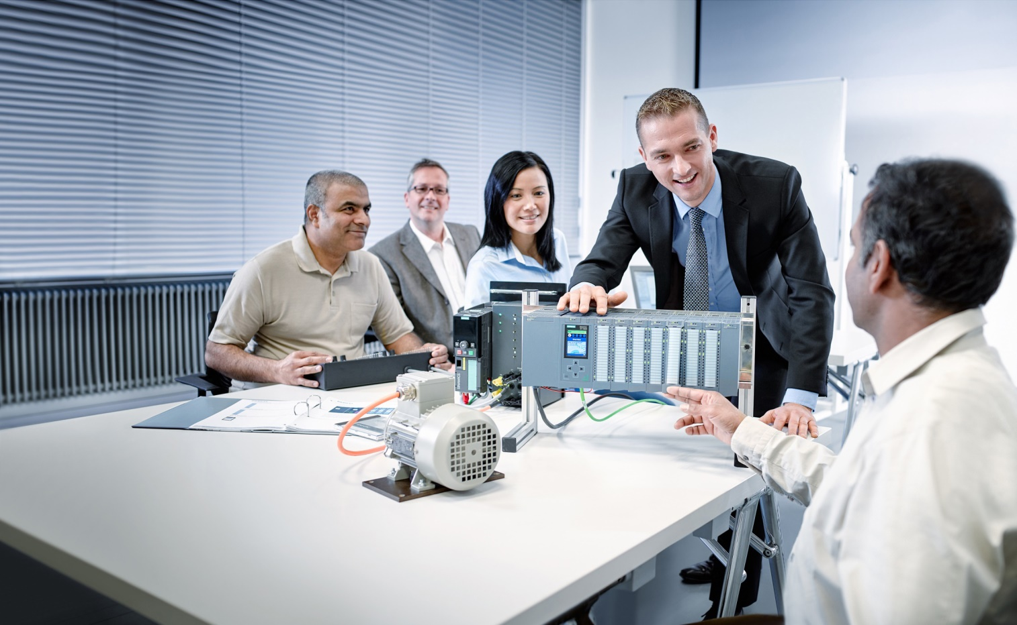

Learn-/Training Document  
  
Siemens Automation Cooperates with Education (SCE) | As of Version V9 SP1

PA Module P03-01   
SIMATIC PCS 7 – Advanced layout of UIs



**siemens.com/sce**

**Matching SCE Trainer Packages for this Learn-/Training Document**

* **SIMATIC PCS 7 Software Package V9.0 (set of 3)**  
  Order No.: 6ES7650-0XX58-0YS5
* **SIMATIC PCS 7 Software Package V9.0 (set of 6)**   
  Order No.: 6ES7650-0XX58-2YS5
* **SIMATIC PCS 7 Software Upgrade Packages (set of 3)**  
  Order No.: 6ES7650-0XX58-0YE5 (V8.x🡪 V9.0)
* **SIMIT Simulation Platform with Dongle V10**  
  (contains SIMIT S & CTE, FLOWNET, CONTEC libraries) – 2500 simulation tags  
  Order No.: 6DL8913-0AK00-0AS5
* **Upgrade SIMIT Simulation Platform V10**  
  (contains SIMIT S & CTE, FLOWNET, CONTEC libraries) from V8.x/V9.x  
  Order No.: 6DL8913-0AK00-0AS6
* **Demo Version SIMIT Simulation Platform V10**  
  [Download](https://support.industry.siemens.com/cs/ww/en/ps/17120/dl)
* **SIMATIC PCS 7 AS RTX Box (PROFIBUS) only in combination with ET 200M for RTX –**   
  Order No.: 6ES7654-0UE23-0XS1
* **ET 200M for RTX Box (PROFIBUS) only in combination with PCS 7 AS RTX Box –**  
  Order No.: 6ES7153-2BA10-4AB1

Note that these trainer packages are replaced with successor packages when necessary.

An overview of the currently available SCE packages is available at: [siemens.com/sce/tp](http://www.siemens.com/tp)

**Continued training**

For regional Siemens SCE continued training, get in touch with your regional SCE contact

[siemens.com/sce/contact](http://www.siemens.com/contact)

**Additional information regarding SCE**

[siemens.com/sce](http://www.siemens.com/sce)

**Information regarding use**

The SCE Learn-/Training Document for the integrated automation solution Totally Integrated Automation (TIA) was prepared for the program "Siemens Automation Cooperates with Education (SCE)" specifically for training purposes for public educational facilities and R&D institutions. Siemens does not guarantee the contents.

This document is to be used only for initial training on Siemens products/systems, which means it can be copied in whole or part and given to those being trained for use within the scope of their training. Circulation or copying this Learn-/Training Document and sharing its content is permitted within public training and advanced training facilities for training purposes.

Exceptions require written consent from the Siemens. Send all related requests to

[scesupportfinder.i-ia@siemens.com](mailto:scesupportfinder.i-ia@siemens.com).

Offenders will be held liable. All rights including translation are reserved, particularly if a patent is granted or a utility model or design is registered.

Use for industrial customer courses is explicitly not permitted. We do not consent to commercial use of the Learn-/Training Document.

We wish to thank the TU Dresden, particularly Prof. Dr.-Ing. Leon Urbas and the Michael Dziallas Engineering Corporation and all other involved persons for their support during the preparation of this Learn-/Training Document.

Table of contents

1 Goal 5

2 Prerequisite 5

3 Required hardware and software 6

4 Theory 7

4.1 Theory in brief 7

4.2 Hierarchy of flow diagrams 8

4.3 Trends 9

4.4 ActiveX controls 13

4.5 User-defined objects 16

4.6 References 16

5 Task 17

6 Planning 17

7 Learning objective 17

8 Structured step-by-step instructions 18

8.1 Creating a faceplate for Reactor R001 18

8.2 Editing the faceplate for Reactor R001 26

8.3 WinCC AlarmControl 34

8.4 WinCC OnlineTrendControl 39

8.5 Creating a user-defined object 49

8.6 Using a user-defined object 58

8.7 Checklist – step-by-step instruction 62

9 Exercises 63

9.1 Tasks 63

9.2 Checklist – exercise 65

10 Additional information 66

Advanced layout of UIs

# Goal

After working through this module, the students have advanced knowledge regarding the design of the user interface of an operator station. They are able to make additional information available on the detail level. In doing so, they use adapted message lists and trend curves. The students can combine created composites into a user-defined object and redesign existing objects as user-defined objects. These objects can then be made available for reuse.

# Prerequisite

This chapter builds on chapter 'Functional safety'. To implement this chapter, you can use an existing project from the previous chapter or the archived project 'p02-03-exercise-r1905-en.zip' provided by SCE. The download of the project(s) is stored on the SCE Internet for the respective module.

The (optional) simulation for the SIMIT program can be retrieved from the file 'p01-04-plantsim-v10-r1905-en.simarc'. It can be run in demo mode.

# Required hardware and software

1. Engineering station: Requirements include hardware and operating system   
   (for further information, see Readme on the PCS 7 installation DVD)
2. SIMATIC PCS 7 software V9 SP1 or higher

* Installed program packages (contained in SIMATIC PCS 7 Software Trainer Package):
  + *Engineering → PCS 7 Engineering*
  + *Engineering → BATCH Engineering*
  + *Runtime → Single Station → OS Single Station*
  + *Runtime → Single Station → BATCH Single Station*
  + *Options → SIMATIC Logon*
  + *Options → S7-PLCSIM V5.4 SP8*

1. Demo Version SIMIT Simulation Platform V10

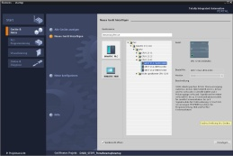

**3** SIMIT V10 or higher



**1** Engineering Station

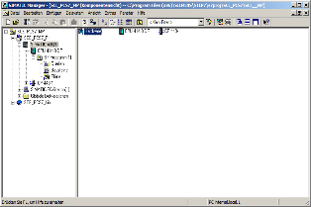

**2** SIMATIC PCS 7   
V9 SP1 or higher

# Theory

## Theory in brief

In this chapter, some aspects of OS engineering are considered in greater depth. While in chapter P02-01 automatic generation of process pictures was primarily discussed, now supplementary techniques for designing process control are described.

The flow diagrams (see P02-01) are usually structured in the following hierarchical levels:

* Plant picture
* Area picture
* Unit picture/group picture
* Detail picture

This structuring can result from the plant hierarchy. While the upper levels aim for a good overview of the entire plant or corresponding areas, the unit picture and detail picture are to provide considerably more information about the area under consideration to allow appropriate setting of parameters for the given situation and diagnostics of faults.

In addition to detailed information about the current state of the areas under consideration, the representation of process values in trends is particularly helpful for analyzing deviations. Trends show the time variation of a process value. With one glance, the operator can immediately read off the following information:

* Times at which step changes of the process value occur.
* Process values at the time of such step changes
* Gradients at certain points in time
* Dependencies between process values when displayed simultaneously
* Extreme values (when and how large)
* Fluctuation ranges
* Deviations from the setpoint
* Frequencies

Trend displays provide the operator with an expanded basis for decisions regarding control action. If a process value is outside the permissible range, the user can retrieve the trend of the process value in the recent past and see whether the value is getting worse or has already improved.

## Hierarchy of flow diagrams

In chapter P02-01 the objectives of process control as well as of basic design concepts and techniques for OCM interfaces (operator control and monitoring interfaces) were described.

Chapter P01-03 introduced the physical model of a plant consisting of a plant, unit, equipment module and control module. Similarly, a hierarchy of flow diagrams is available in process visualization that is structured as follows, according to [1]:

* Plant picture
* Area picture
* Unit picture/group picture
* Detail picture

The hierarchy of the flow diagrams facilitates orientation and specific picture selection. The uppermost plant picture and area picture levels provide an overview and are usually represented only schematically. In small plants, the plant picture corresponds to the area picture (refer to Figure 1). The direct selection of each area must be possible in the plant picture. In the area picture, the units are represented in a manner that their state can be recognized and the unit can be selected and controlled. The unit or group picture represents functional relationships, and typical equipment groups, final controlling elements and controllers can be operated. Detail pictures are of great importance to parameter assignment, commissioning and troubleshooting in the event of plant malfunctions. In detail pictures, individual items of equipment and groups of equipment are represented, and their functional relationship can be visualized using action lines. This is particularly well-suited for tracking the signal flows of a control loop [1].



Figure 1: Hierarchy of flow diagrams

## Trends

Trends are used for process control during intended operation or for diagnosing faults [2]. They supplement the displays with flow diagrams and particularly with the option of displaying the variation of process values over time.

Related displays are displays of a process value as a function of displacement, other process tags, and even multiple reference values. These are not described here, however.

Purpose of trends

Trends are displayed to show the trend of something. By selecting different time horizons, different tasks can be implemented. There are three variants with respect to the time the operator has the trend displayed.

First, the operator can have a trend display the past without the present. Such a trend is called a **history** and is used for analysis. This can be a fault analysis but also an analysis for optimization of process control.

The operator can also call up a trend of the present and recent past. This type of trend is called a recent history. It can be used to display a trend. It is the most frequently used type of display for process control. From the recent history trend, operators can read qualitative values such as rising, falling, or steady. They can also read quantitative values such as the process value at a certain time or the difference from a setpoint.

The third variant is the display of the recent past, the present and the future, which is called prediction display (refer to Figure 2). It is used to predict a process value and allows the user to intervene before an event occurs. To represent the future, the possible value trend has to be calculated in advance.

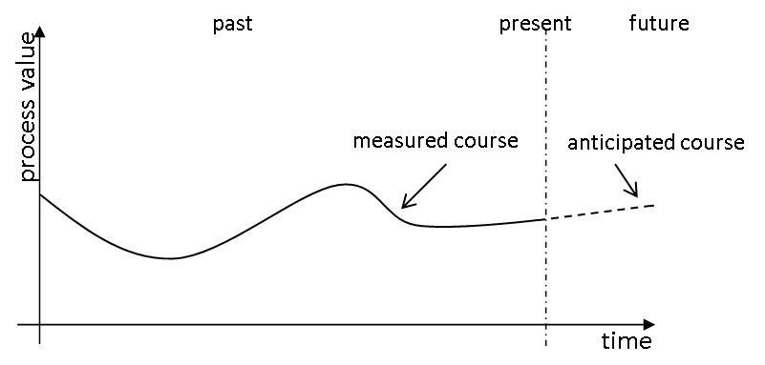

Figure 2: Prediction display according to [2]

In general, the following values can be determined through trends:

* Times at which step changes of the process value occur.
* Process values at the time of such step changes
* Gradients at certain points in time
* Dependencies between process values when displayed simultaneously
* Extreme values (when and how large)
* Fluctuation ranges
* Deviations from the setpoint
* Frequencies

The many values that can be read off shows the importance of the trend display. While the current process values and any extreme values can be represented otherwise, e.g. with analog or digital displays, the display of the other characteristics in such a compressed and immediately understandable form is difficult to conceive [3].

Acquisition and storage of trend values

Because plants produce large volumes of data, usually, only a certain amount can be archived over a certain period. The amount of data depends largely on the cost of the storage medium and on the data transmission rate. On the other hand, the acceptable level of data loss has to be considered. The degree of compression results from weighing these two criteria.

When data is compressed, not only the quantity of the stored data changes but also its statistics, e.g. mean value and variance. For that reason, such values should be calculated from the original data and if needed, archived also. This should be done time-controlled, similarly to the archived process data.

Direct and transformation methods can be used for the data compression.

When the direct method is used, the data is archived in real time. There are rules that govern the archiving of individual measured values. The data is reconstructed by connecting the individual data points.

When transformation methods are used, the data is not archived in real time because the previous data history is included in the transformation. The original data is transformed in a different range. With this method, there is the possibility to design the compression adaptively, since the algorithms often have a parameter that is critical for the quality of the compression, depending on the process.

|  | Recent history | History |
| --- | --- | --- |
| **Position of the time span shown in the trend display field** | Always relative to the present | Through an absolute time and a selected time span or through two absolute times |
| **Labeling of the time axis** | Relative time indications; if needed, can be switched to absolute time indications | Absolute time indications, can be switched to relative time indications that are relative to a defined time of an event |
| **Updating** | Trend is updated during the display whereby all trend points are shifted | Trend does not change |
| **Value axis** | The value axis is usually located at the point in time of the present (on the right edge of the picture) | The value axis is located on the left edge of the picture |

Table 1: Visible differences between recent history and history according to [2]

Design of trend pictures

In [2], guidelines for designing trend displays are provided. PCS 7 implements the basic design details by default; for that reason, they are described here only briefly. There are design rules, however, that you can implement yourself using the settings in the OS engineering. To do this in a specific way, a few details are introduced here.

The trend picture is displayed in the working area of the display area (refer to P02-01). It consists of the title field, the trend labeling field, and the trend display field. The title field should contain information for unambiguous assignment to the process environment. In the trend labeling field, it should be possible to read off the relationship between the displayed trend and the process value. The trend display field is used to display the trend and should be as large as possible. To implement the trend display field, the following information is provided.

To facilitate reading off the values, grid lines must be available. The value axis should display several lines as an extension of the scale marks, and the time axis several lines according to the current time grid. The number of grid lines should be low and remain in the background visually. To this end, they should not be shown in color or blue. Reading rulers can provide additional support.

The trends should be displayed colored as continuous lines or as a series of dots. Color coding can be selected as required. The number of trends for each trend display field should be limited to six. The colors of the trends should be easily distinguishable from each other.

To implement the trend line, the following directions are recommended:

* From right to left: more recent values to the right, older values to the left
* From top to bottom: more recent values on top, older values on the bottom

The deciding factor in this case is whether a display time span that is as large as possible (from left to right) or a value resolution that is as high as possible (from top to bottom) is needed.

When trends with a recent history are displayed, the trend line is updated. The entire trend is shifted in the direction of the past (see Figure 2). If there is a shift with each new entry, the entire trend display field can be used to display the recent history, and the operator can easily follow the display since the trend is shifted only a little each time. If needed, it should be possible to stop the updating.

For labeling the value axis, a scale division of 1, 2 and 5 as well as multiples of ten of these should be used. The value axis can be scaled in units or in percent. The location of the value axis can be found in **Fehler! Verweisquelle konnte nicht gefunden werden.**. Also, a display with two value axes can be useful; in this case, the percent axis for all curves is displayed to the left, and the display of the values of a curve in units to the right. The time axis should always be labeled as shown in Table 1.

To display time spans, [2] offers the time spans and scale marks recommended in **Fehler! Verweisquelle konnte nicht gefunden werden.**. This ensures that if there is a change to another display time span, the same point in time can be located again.

| Primary task | Preassigned display time spans | Update cycle (only for recent history) | Scale division |
| --- | --- | --- | --- |
| **Commissioning** | 5 min | 1 s | 1 min |
| **Process control or analysis** | 15 min | 1 s | 5 min |
| 30 min | 2 s | 5 min |
| 2 h | 8 s | 30 min |
| 8 h | 32 s | 1 h |
| 24 h | 96 s | 4 h |
| 4 days | 384 s | 12 h |
| **Analysis** | 7 days |  | 1 day |
|  | 30 days |  | 7 days |
|  | 90 days |  | 15 days |
|  | 360 days |  | 90 days |

Table 2: Recommended display time spans [2]

## ActiveX controls

Trends are configured in the OS engineering of PCS 7 either by creating trend groups (chapter P02-03) or by using configurable ActiveX controls. PCS 7 provides ActiveX controls for alarms, trends and tables. Trends can be used to display time variations (Online Trend Control) and to display dependencies between process values (Function Trend Control). In the Online Trend Control, two different sources exist for displaying a trend. The first source is the process value that is buffered while the ActiveX control is active. With this source, the trend can be displayed during monitoring. Here it is important that when the ActiveX control is closed, the values can no longer be retrieved. If the second source is used, the data is taken from the archive (refer to P02-03). The process values retrieved from there can be displayed again and again. Depending on the time span selected, past data (history) can be retrieved as well as the most recent data (recent history).

These values can be retrieved again as long as they are in the circular log. The size of the circular log depends on the configuration as described in chapter P02-03.

Additional ActiveX controls are the display of process values in tables (Online Table Control) and alarms in alarm lists (Alarm Control). Alarm Control receives always receives its data from the archive while the table, similar to the Online Trend Control, has different sources.

ActiveX controls are quite suitable for designing detail pictures, since they provide additional information specifically for a detail area. Specific process values for the corresponding detail picture or filters for alarm lists can be selected and pre-configured for this, e.g. using the source attribute.   
Figure 3: Sketch of a detail picture sketches a possibility for designing the detail picture.



  
Figure 3: Sketch of a detail picture

## User-defined objects

A user-defined object (UDO for short) is a dynamizable object that consists of individual objects. In OS Engineering, you identify the variable properties and select them for the user-defined object. Thus, only the most important properties of all individual objects are visible and provide a good overview of the properties. In addition, it is possible to specify some properties as invariable for all instances. At the same time, the need to connect every individual object for every instance is eliminated.

Offsetting this is the increased effort for careful selection of the properties; however, the effort quickly pays off after multiple reuse. User-defined objects that are to be used multiple times are stored in the library.

Also, the ability to make modifications is facilitated since, for example, a block name or a CFC name only has to be changed at the user-defined object and not at all individual objects.

The individual instances can be changed or supplemented with additional objects at any time. If C actions are used for dynamization, this is done in the case of user-defined objects in a script, and not in many individual objects. This increases the performance of the visualization.

## References

[1] VDI/VDE 3699, sheet 3 (Ed. 2014-01): Prozessführung mit Bildschirmen – Fließbilder (Process control using display screens – Mimics).

[2] VDI/VDE 3699, sheet 4 (Ed. 2014-01): Prozessführung mit Bildschirmen – Kurven (Process control using display screens – Curves).

[3] Kindsmüller, M. C.: Trend-Literacy, Shaker Verlag 2006.

[4] SIEMENS (2017-10): SIMATIC Process Control System PCS 7 Operator Station (V9.0 SP1). A5E39219186-AB. ([support.automation.siemens.com/WW/view/en/109754982](http://support.automation.siemens.com/WW/view/en/109754982))

# Task

In this task, you will add an additional level to your picture structure in order to show more details for the individual tanks and reactors.

In the example, you will create a detail view in the picture for Reactor R001 with a bar display for the reactor level, an Online Trend Display and an alarm window for displaying the alarms associated with Reactor R001.

You will then convert the detail view with the bar display to a user-defined object for better reusability (for example, for Reactor 002).

# Planning

Because a third level for faceplates is to be added, it is necessary to add Level 3 to the levels included in the HID. The block icons can then be automatically generated again by PCS 7.

The 'Bar' smart object is suitable for the visual representation of the level.

For the further representation of local information, the ActiveX controls 'WinCC AlarmControl' and 'WinCC OnlineTrendControl' are to be used.

The creation and reuse of user-defined objects (configurable library objects) will also be shown.

# Learning objective

In this chapter, students learn the following:

* Creation of an ActiveX control for displaying alarms
* Filtering of alarms matching the hierarchy
* Insertion and parameter assignment for display of archive tags
* Creation of a user-defined object from a group of objects
* Parameter assignment and use of user-defined objects

# Structured step-by-step instructions

## Creating a faceplate for Reactor R001

1. First, insert a picture in the 'reactor R001' folder and name it 'reactor R001'. (® reactor R001 ® Insert New Object ® Picture ® reactor_R001)

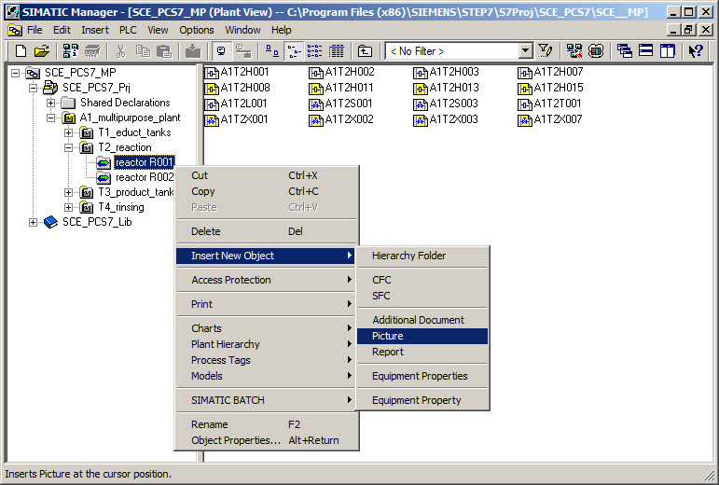

1. Then, adapt the settings of the plant hierarchy to the expansion. (® Options ® Plant Hierarchy ® Settings)

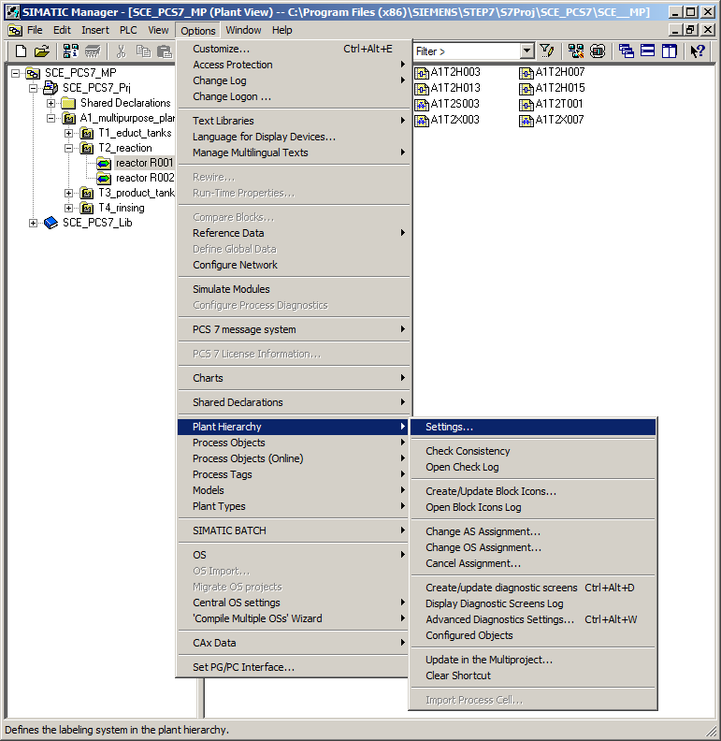

1. The number of hierarchy levels is retained. However, for the third level the 'Included in HID' check box must be selected; otherwise, there may be problems during simulation. (® Included in HID ® OK ® Yes)

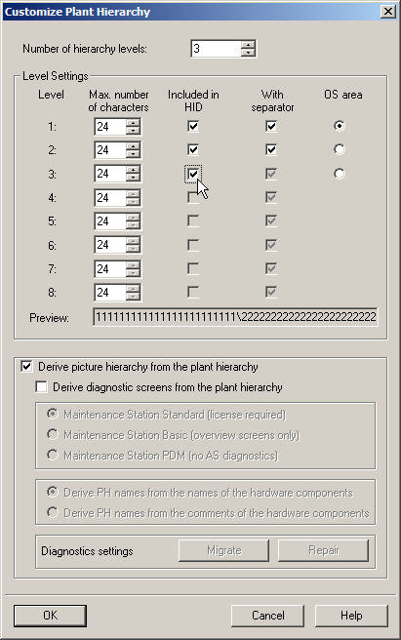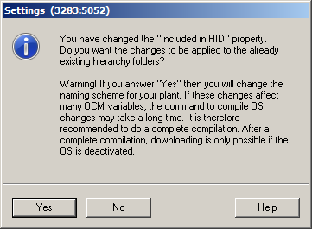

1. Then, the block icons must be generated in the new picture. (® reactor R001 ® Plant Hierarchy ® Create/Update Block Icons)

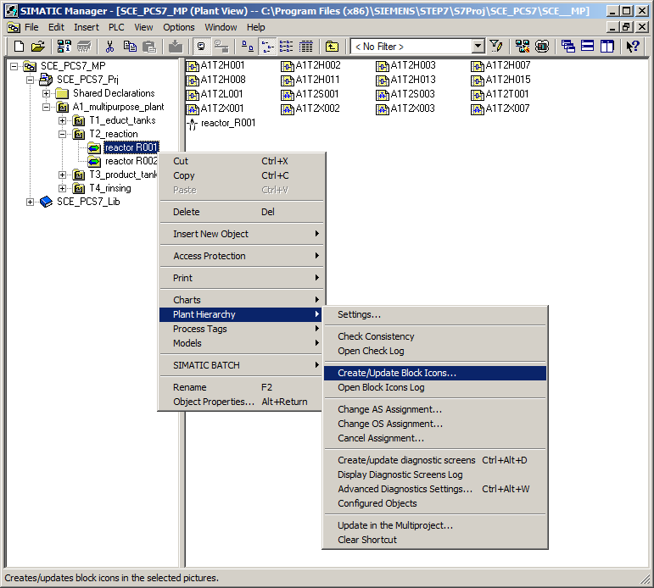

1. Have the object name created from the chart names and include, as previously, a lower level hierarchy level. (® Object name: Chart ® Lower hierarchy levels included: 1 ® OK)

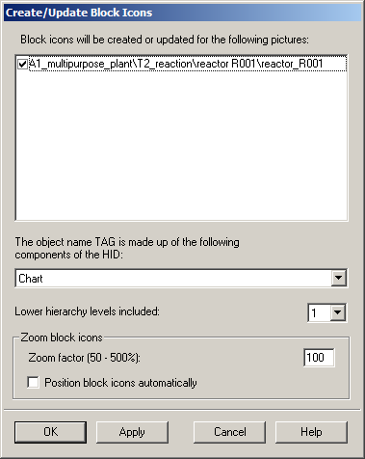

1. Now, read the note regarding the need to compile the OS. The log can also be displayed. Click 'Yes' to confirm the dialog. (® Yes ® )

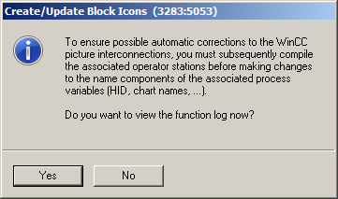

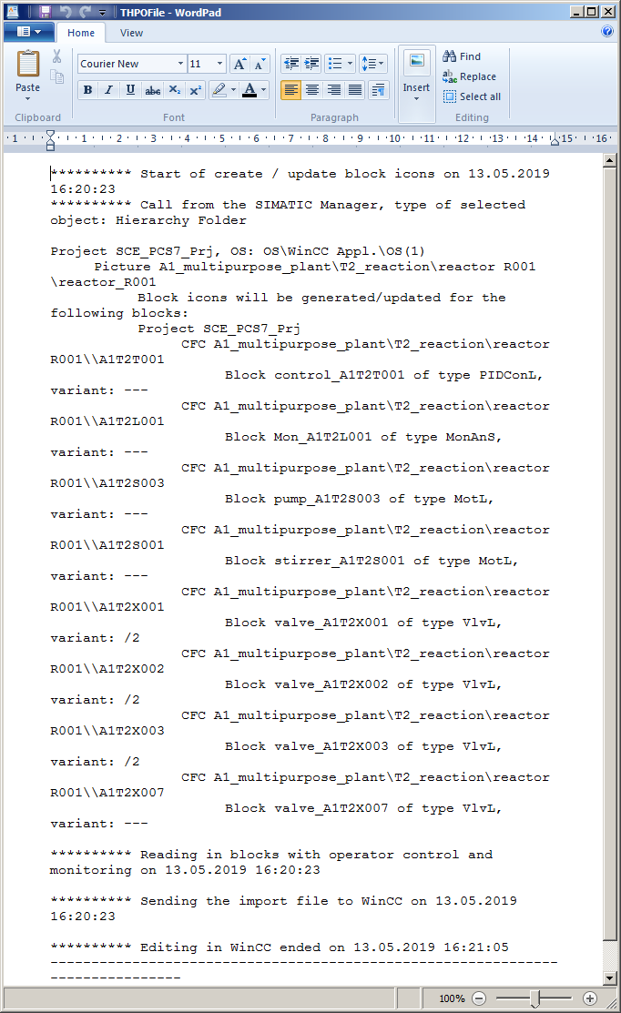

1. Back in the plant view, start the compilation and download of the objects of the project. (® SCE_PCS7_Prj ® PLC ® Compile and Download Objects)

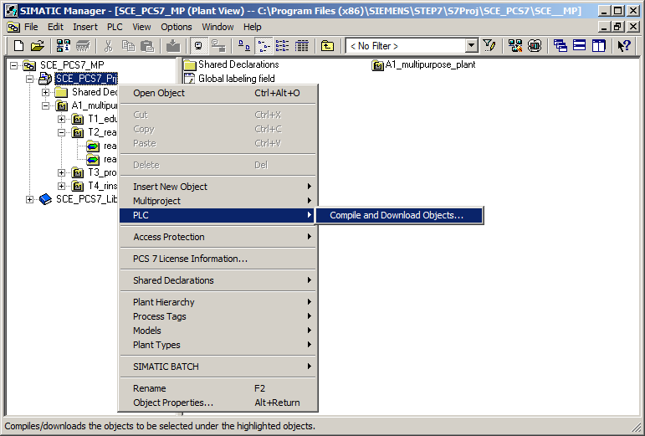

1. Prior to starting the compilation, make sure that S7-PLCSIM is started and the CPU is in the 'STOP' mode. For the charts, compile and download everything. For the OS, compile the entire OS (memory reset is not necessary). (® Start ® Close)

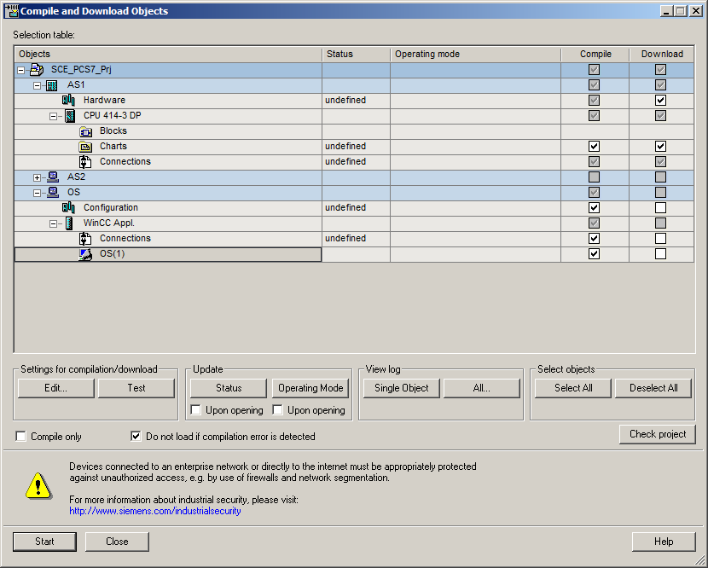

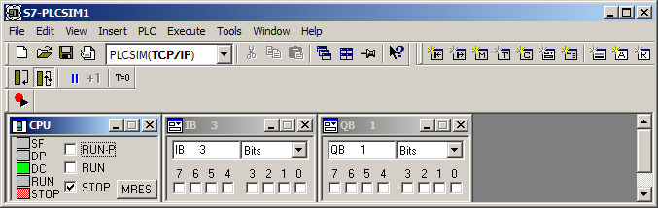

## Editing the faceplate for Reactor R001

1. Now, start WinCC by selecting and opening 'OS(1)' in the 'Component view'. (® OS(1) ® Open Object)

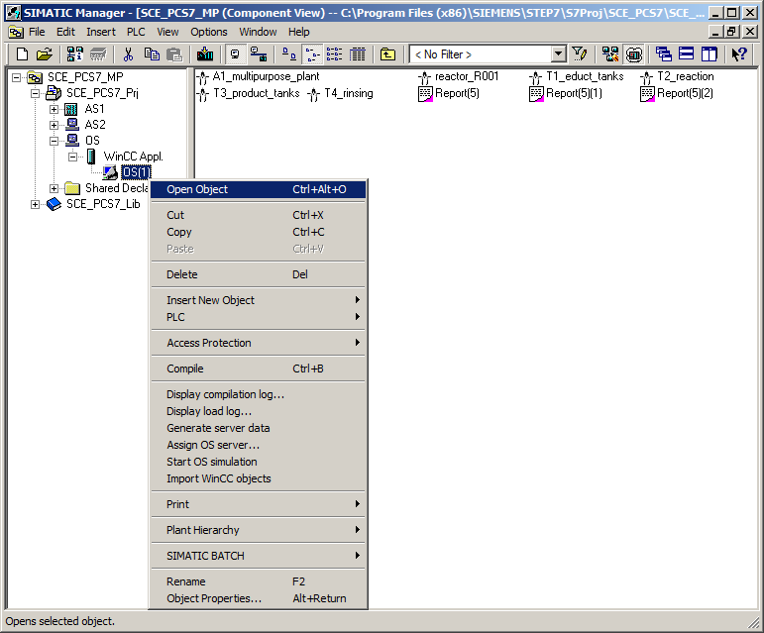

1. In the 'Graphics Designer' folder, open the picture 'reactor_R001.Pdl'. (® Graphics Designer ® reactor_R001.Pdl)

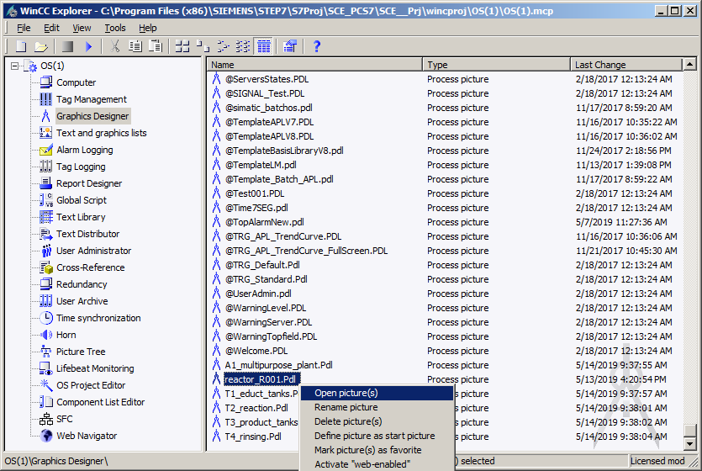

1. In the Object Properties, first change the geometry corresponding to your resolution (for example, 1920x847 for 1920x1080) and the background colors to 'white'. For the color setting to be applied, the 'Static' setting in the global color scheme must be changed to 'No'. (® Object Properties ® Colors ® Background Color ® white ®Effects ® Global Color Scheme ® No)

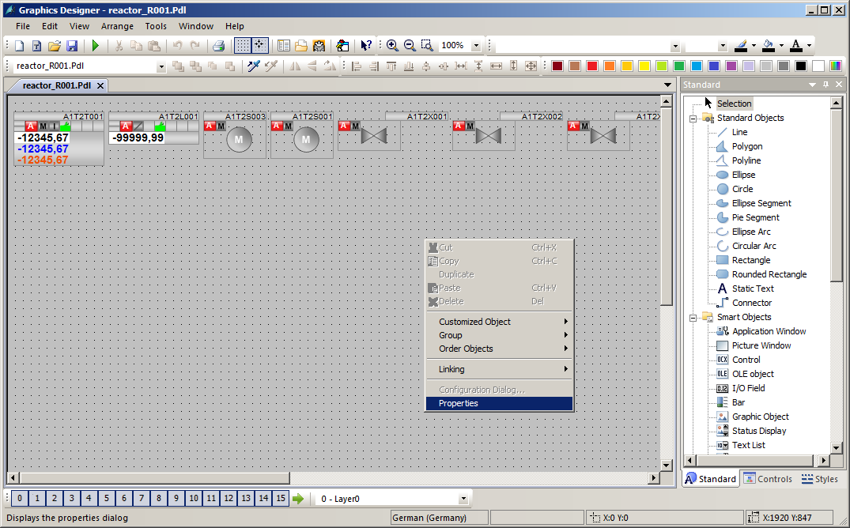

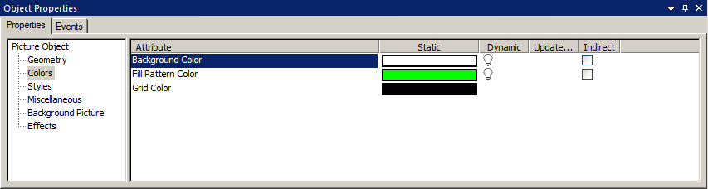

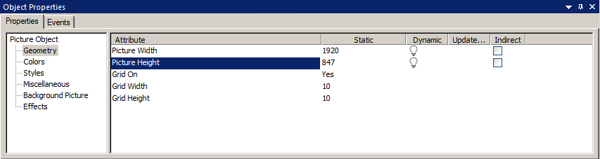

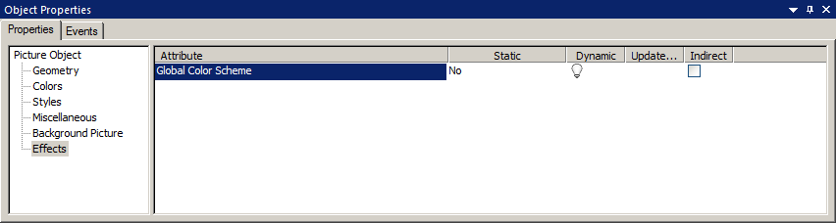

1. From the project library, drag the faceplate for reactor R001 into the picture. (® View ® Toolbars ® Symbol library ® Project Library ® reactor_V1_0)

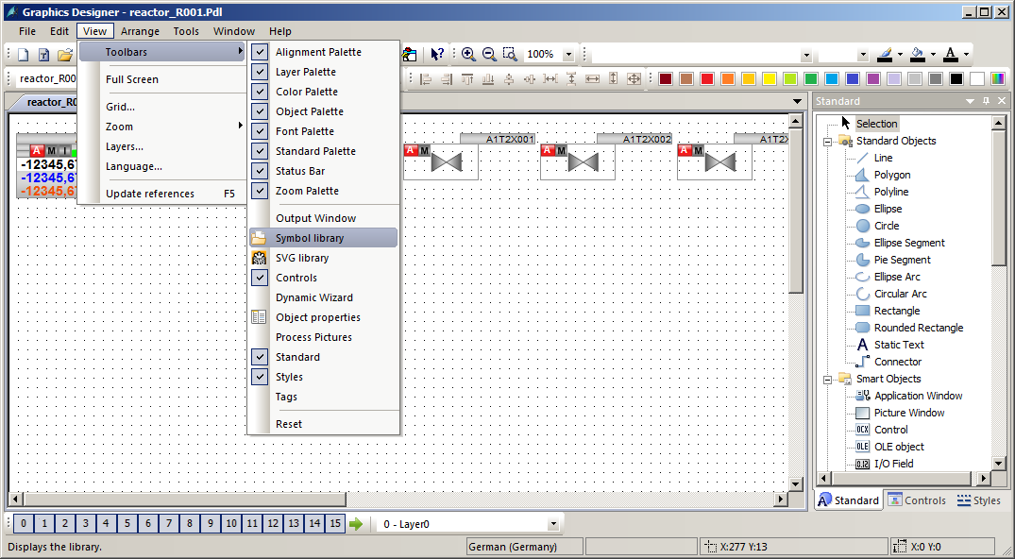

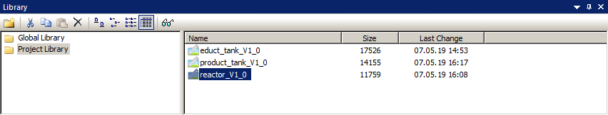

1. In 'reactor_R001.Pdl' picture, ungroup the group with the reactor in the center.

(® Group ® Ungroup)

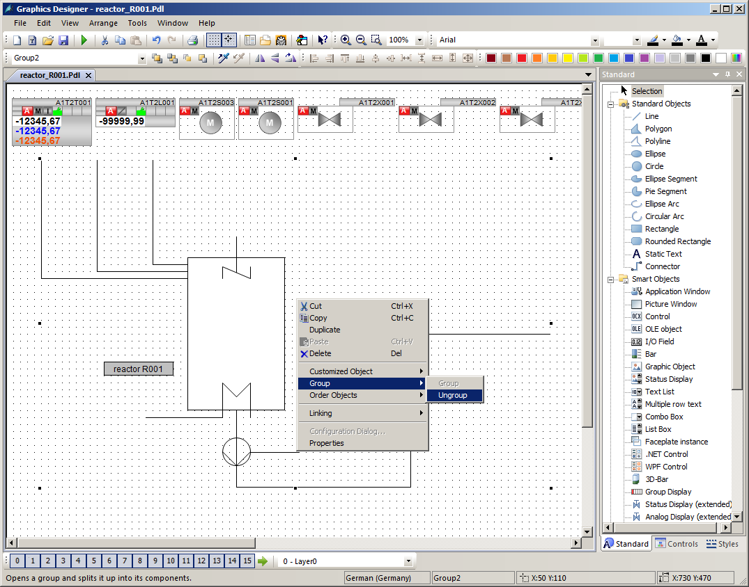

1. Next, select the Smart objects in the object palette, and select 'Bar' here. Then drag the bar over the reactor tank. (® Standard palette ® Smart Objects ® Bar)

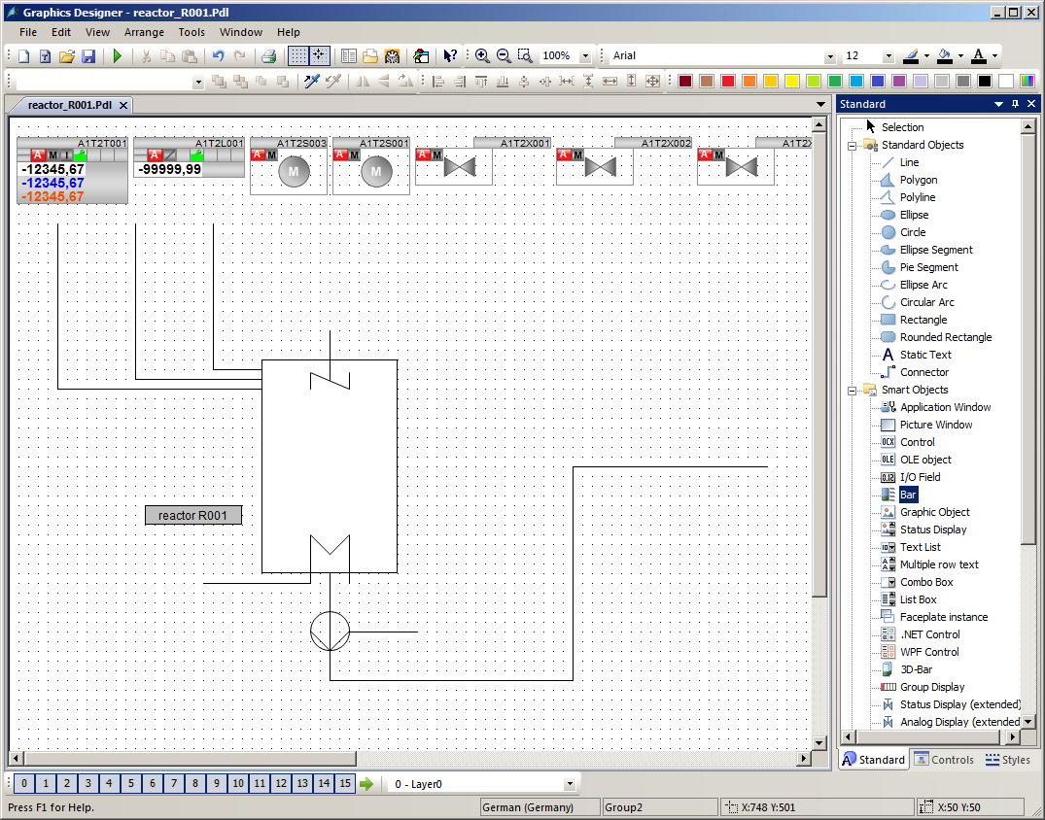

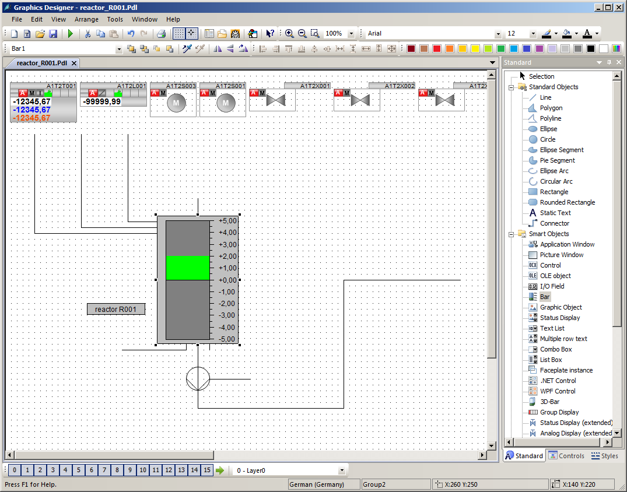

1. In the configuration dialog that appears, open the tag selection, select ES Variables as the data source and open the hierarchy 'A1_multipurpose_plant/T2_reaction/reactor R001/ A1T2L001/A1T2L001/monitor…'. On the right side, select the tag 'PV_Out#Value'.   
   (® Tag  ® ES Variables ® A1_multipurpose_plant/T2_reaction/reactor R001/ A1T2L001/Mon_A1T2L001/PV_OUT#Value ® OK)

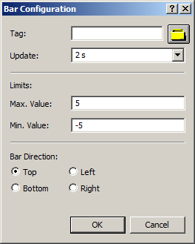

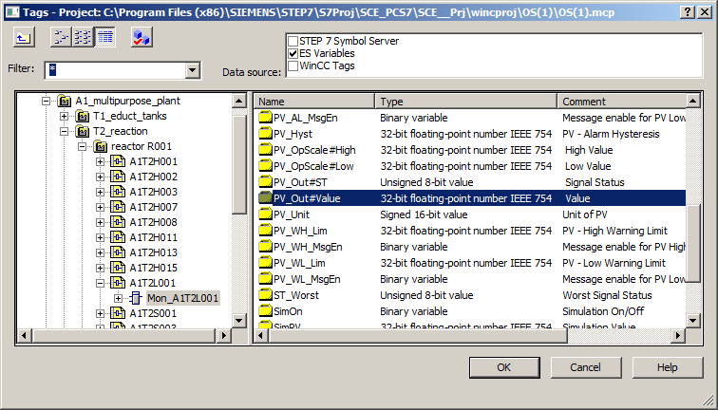

1. Next, select the update, the maximum value and the minimum value.   
   (® Update: Upon change ® Max. Value: 1000 ® Minimum value: 0 ® OK)

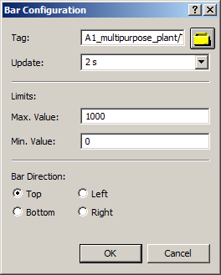

1. Now place the display on top of the reactor and move it down a few layers (Arrange ® Order Objects ® Send backward ). This makes the stirrer, heater and labeling visible again. Then, open the properties for additional adaptations. (® Properties)

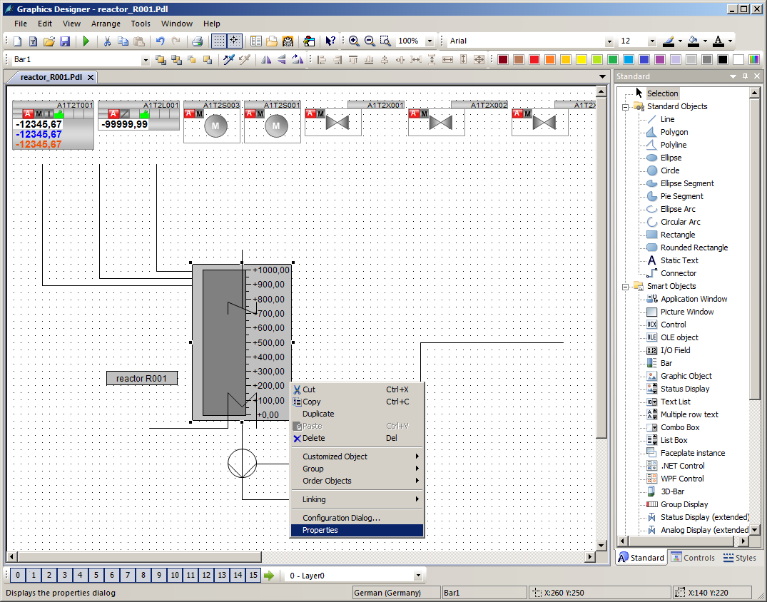

1. In the 'Properties', change the 'Tooltip Text' to 'A1T2L001' in 'Miscellaneous'.   
   (® Properties ® Miscellaneous ® Tooltip Text ® A1T2L001)

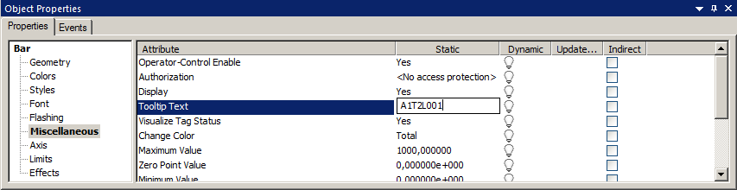

1. Then, select 'Axis'. Here, set the 'Scale' attribute to 'No'.

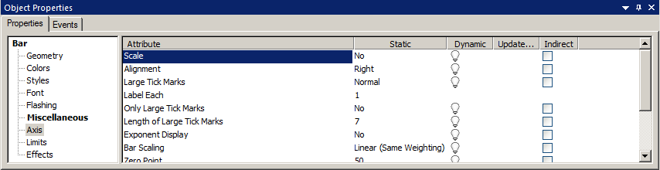

1. In 'Limits', specify the known low and high limits, their monitoring and the color of the bars if the limit is exceeded. (® Properties ® Bar ® Limits ® Low/High limit: see figure/ Monitoring: Yes ® Close)

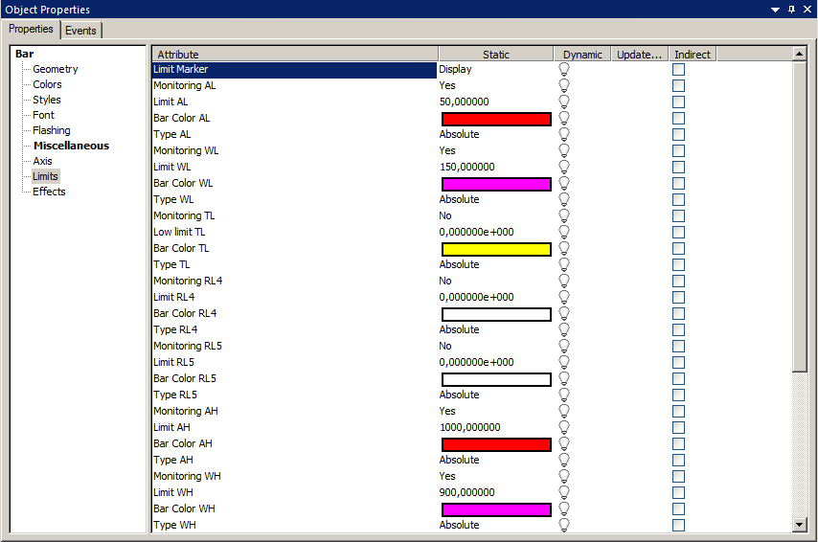

## WinCC AlarmControl

1. In the 'Controls' tab of the object palette, select the WinCC AlarmControl. Then draw a rectangle with the mouse. (® Object palette ® Controls ® WinCC AlarmControl)

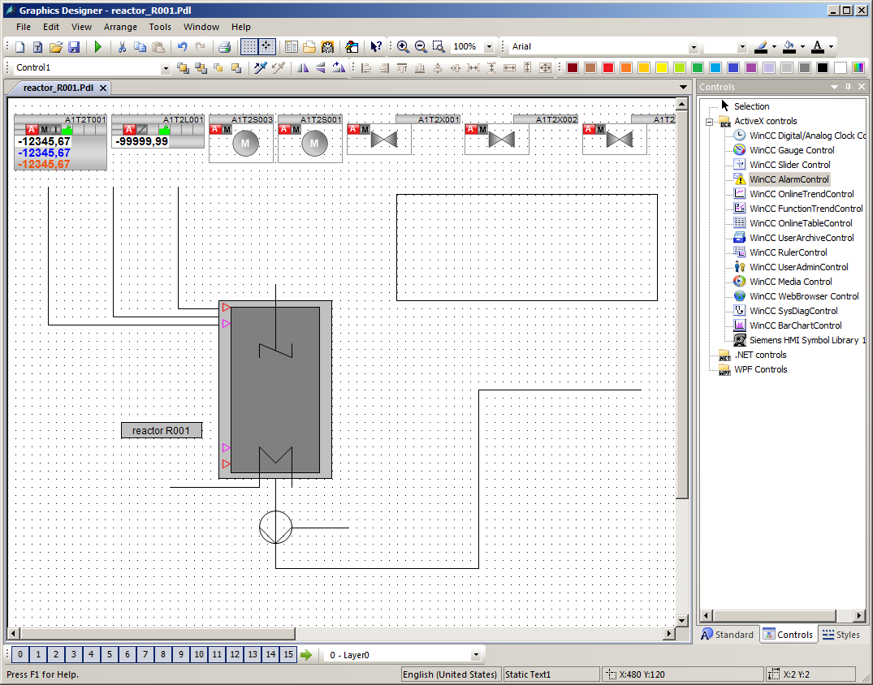

1. In the properties dialog that is displayed automatically, change the text for the window title to 'Alarm list reactor A1T2R001'. (® General ® Text: Alarm list reactor A1T2R001)

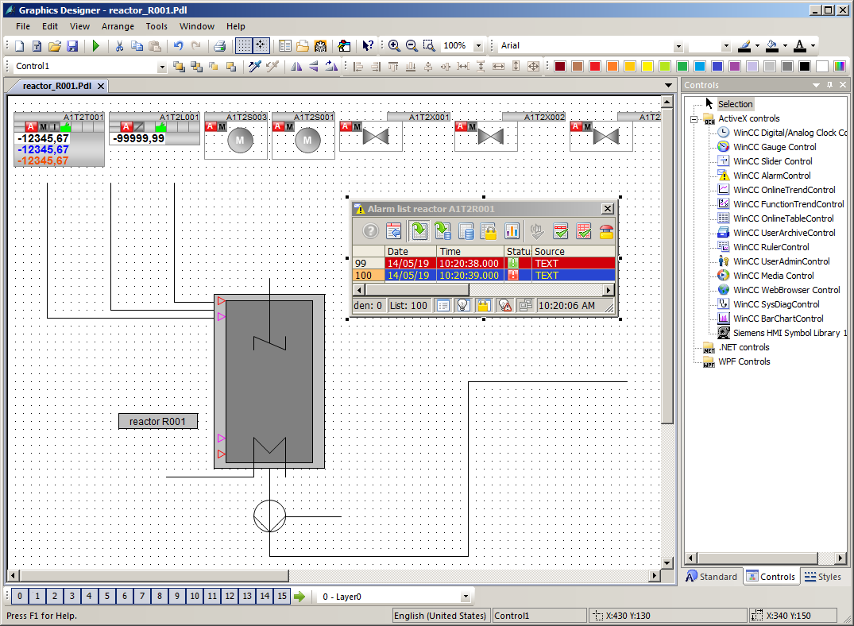

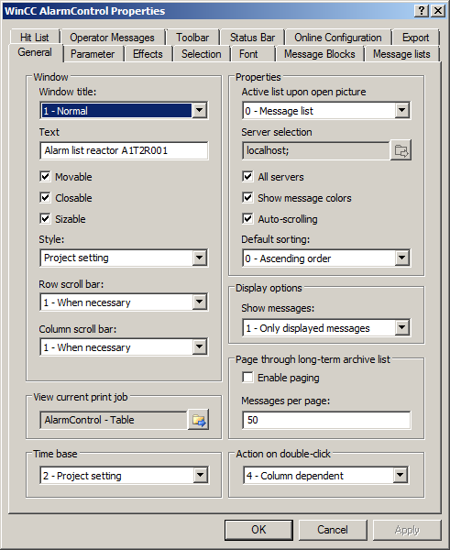

1. In the 'Message lists' tab, select the 'Message blocks' as shown here. Make the selection by adding message blocks with the  buttons and removing message blocks with the  buttons. To ensure that only the alarms that match the picture are displayed, select 'Fixed selection'. (® Message lists ®  ®  ® Selected message blocks: as shown ® Fixed selection: Edit)

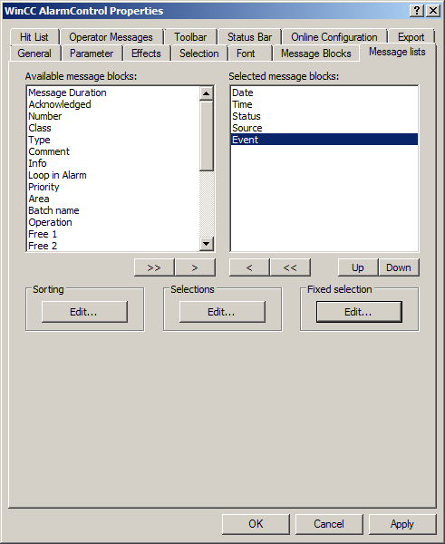

1. In the next screen, select 'Source' for 'Criterion', 'contains' for 'Operand' and the text 'R001' for 'Setting' as shown. (® Criterion: Source ® Operand: contains ® Setting: R001 ® OK)

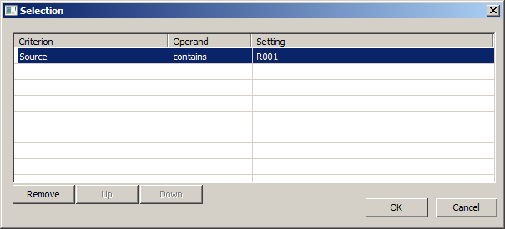

1. Under 'Online Configuration', select that the setting changes are not to be retained during runtime. (® Online configuration ® Online configuration: Do not retain ® OK)

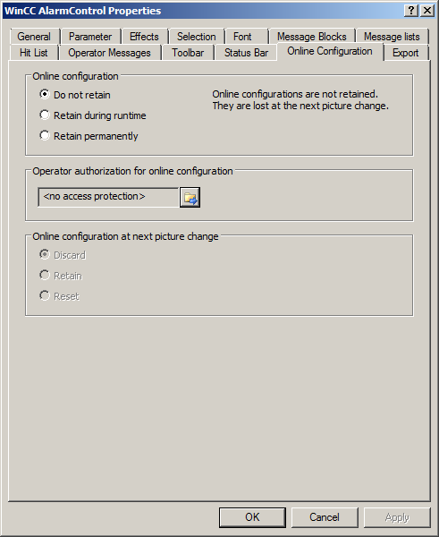

1. In runtime of the PCS7 project, you then see the alarms in picture 'reactor_R001'. You can change the configuration with the  button. However, this will be lost after a picture change.

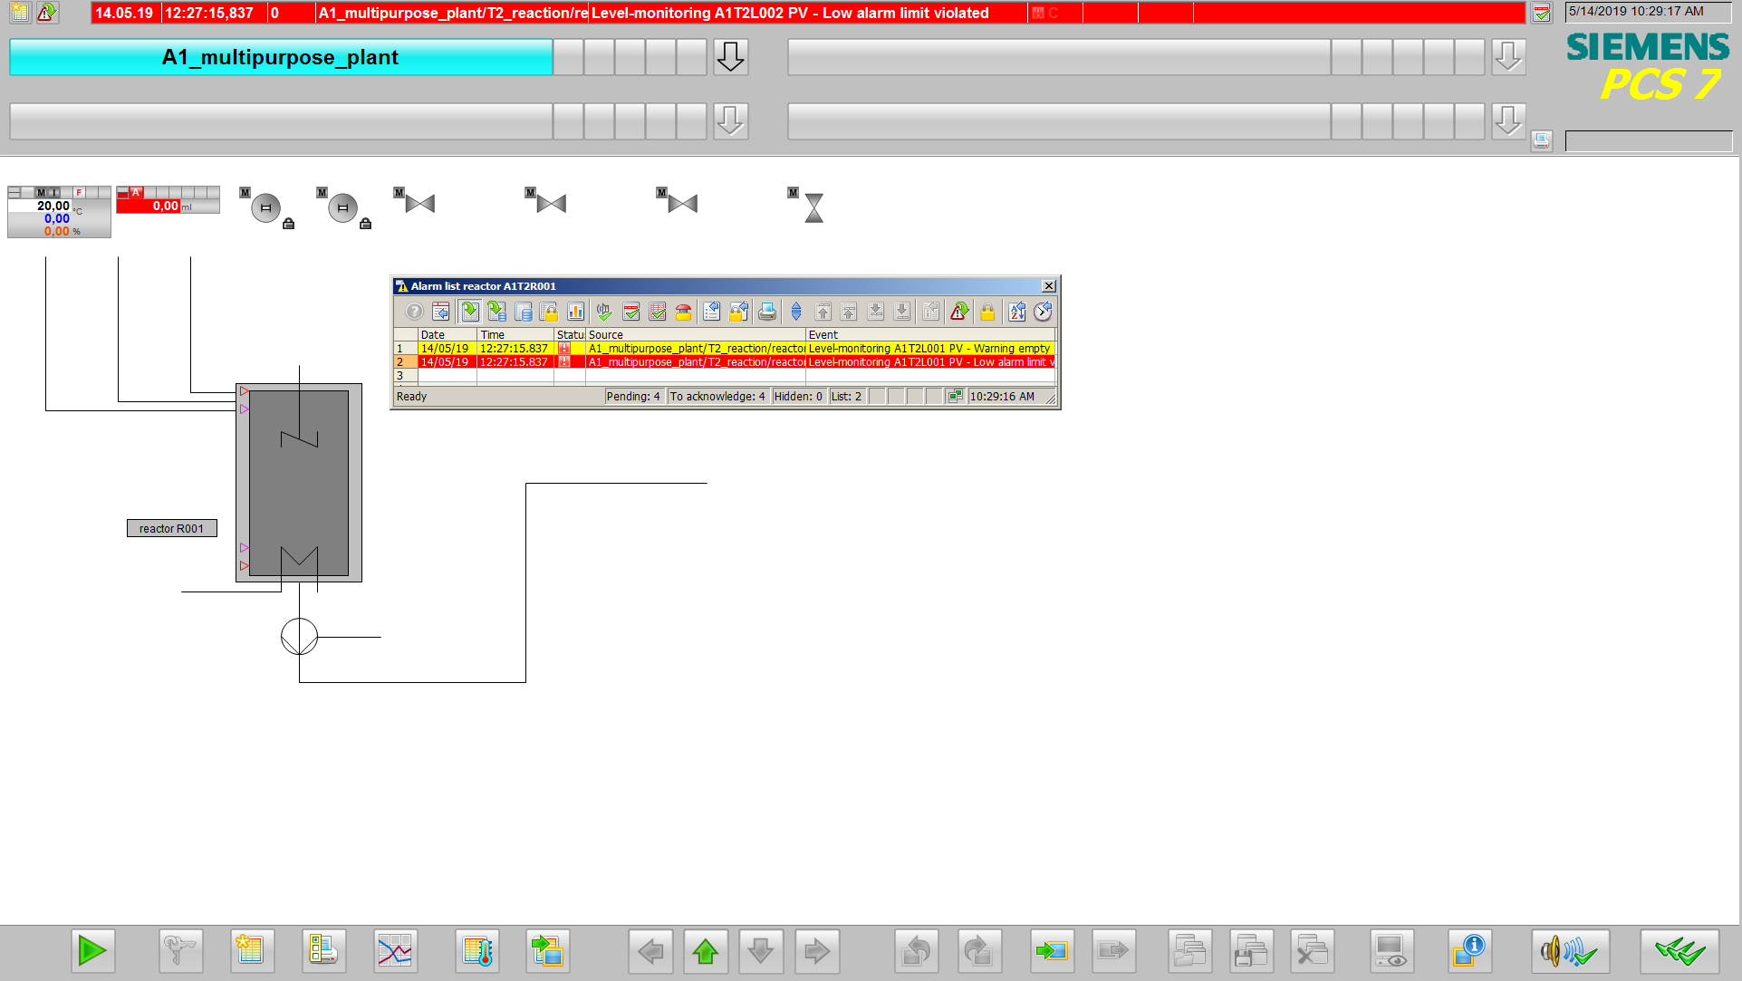

## WinCC OnlineTrendControl

1. Next, select the WinCC OnlineTrendControl in the 'Control' tab of the object palette. Draw a rectangle with the mouse to position the window for the trend view. (® Object palette ® Controls ® WinCC OnlineTrendControl)

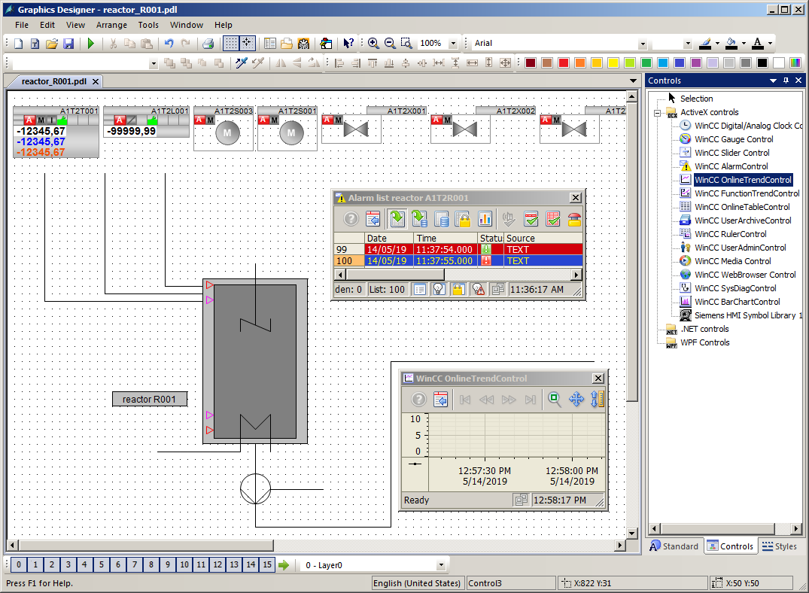

1. In the configuration dialog that is displayed automatically, first go to the 'Trends' tab and change the object name of 'Trend 1' to 'PID – Setpoint'. (® Trends ® Object name ® 'PID – Setpoint')

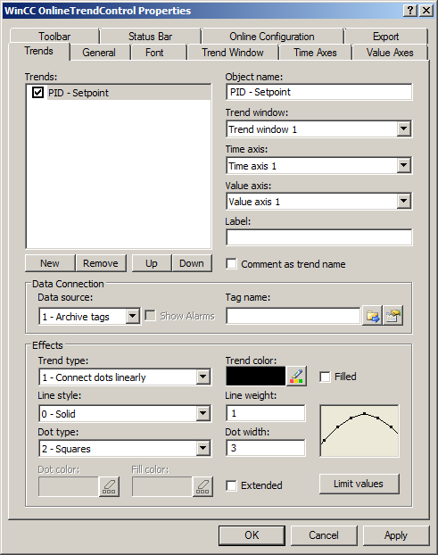

1. Next, link the trend to an archive tag by clicking on the button  and then selecting the setpoint SP#Value of A1T2T001. (® Tag name ®  ® SystemArchive ® …/control_A1T2T001.SP#Value)

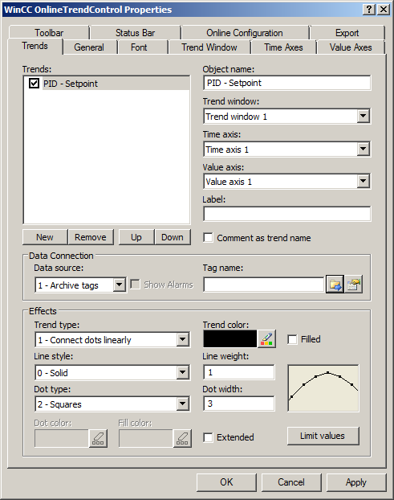

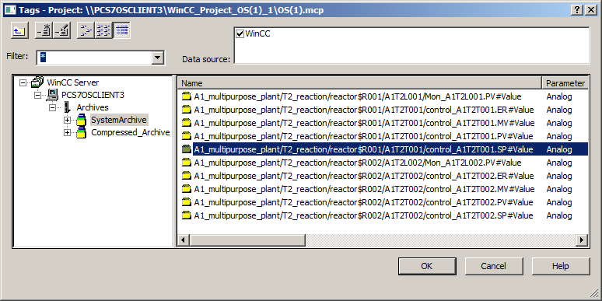

1. Now add another trend and apply the settings shown. (® Trends ® New ® Object name: 'PID – Actual value' ® Name: PV ® Tag name: control_A1T2T001.PV#Value ® Limit Values ® High limit value: 60 ® Apply)

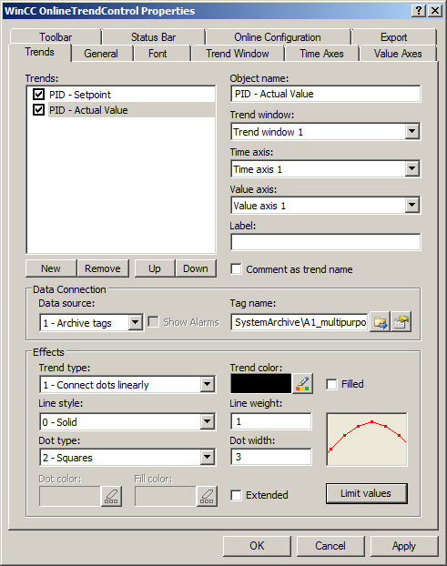

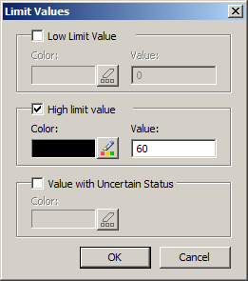

1. The next trend is the manipulated variable and has the following settings.   
   (® Trends ® New ® Object name: 'PID – Output value' ® Name: MV ® Tag name: control.MV#Value ® Trend color: Green ® OK ® Apply)

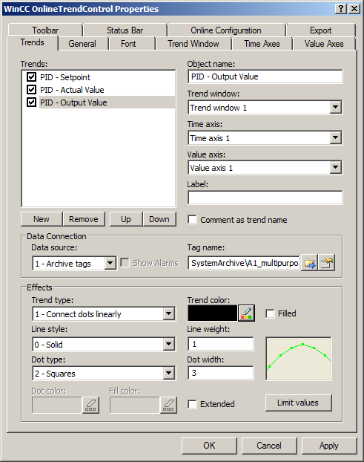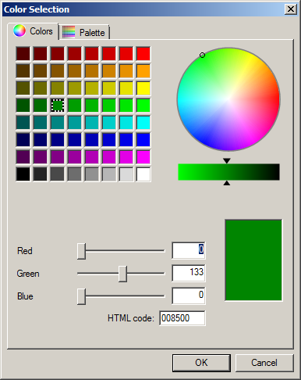

1. The last trend you add is Level A1T2L001. (® New ® Object name: Level ® Tag name: A1T2L001.PV#Value ® Trend color: Blue ® OK ® Apply)

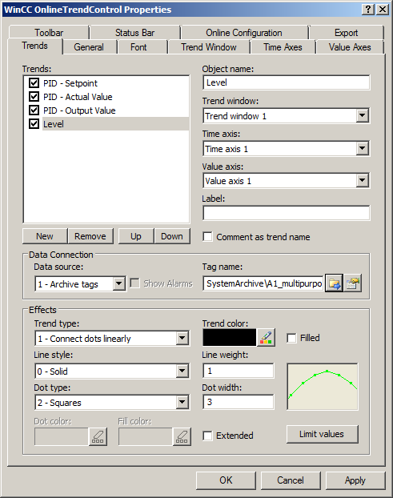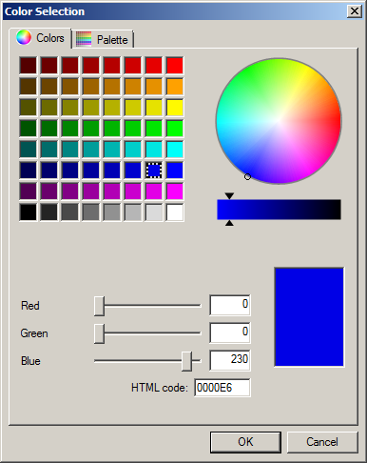

1. Now change to the Time Axes tab. There, change the parameters shown (® Time Axes ® Object name: Time axis ® Label: t ® Time range: 5 x 1 minute)

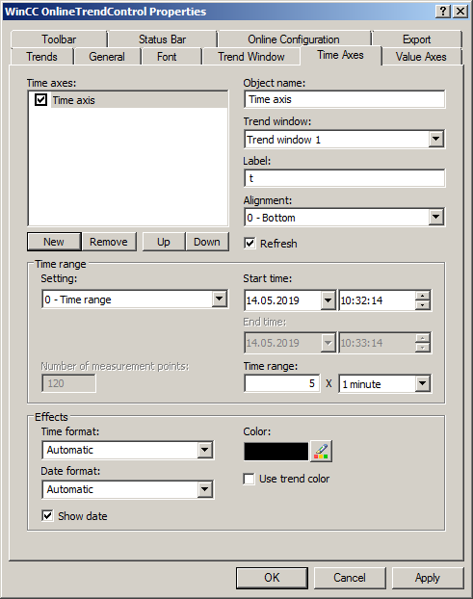

1. On the Value Axes tab, you must now create three value axes: one for the temperature values of 0 ... 100 °C, one for the manipulated variable of 0 ... 100% and one for the level of 0 ... 1000 ml. (® Value Axes ® Object name: Value axis temperature ® Label: °C ® Value range: not automatic ® New ® …)

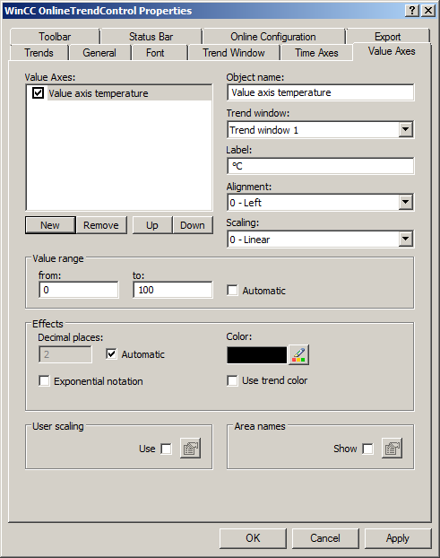

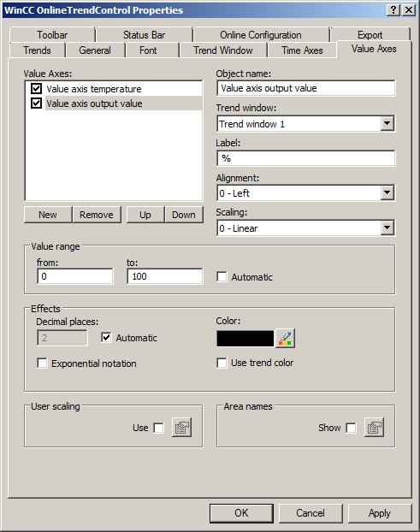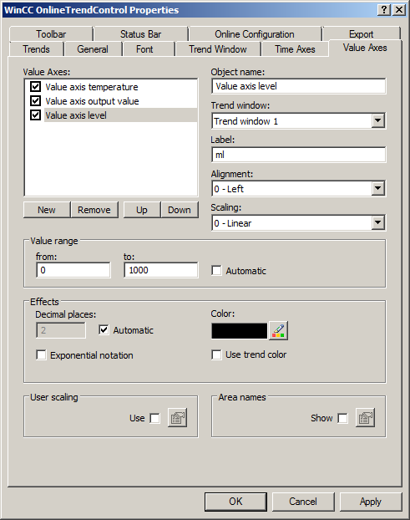

1. Now you must assign the value axes to the trends. (® Trends ® PID - Setpoint: Value axis temperature ® PID - Actual Value: Value axis temperature ® PID - Output Value: Value axis output value ® Level: Value axis level ® OK)

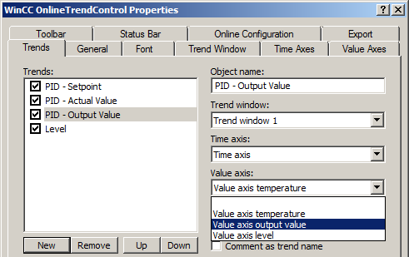

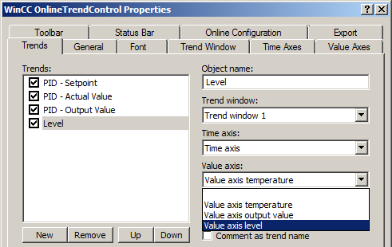

1. In the runtime of the PCS 7 project, you now see the following trend display in picture 'reactor_R001'.

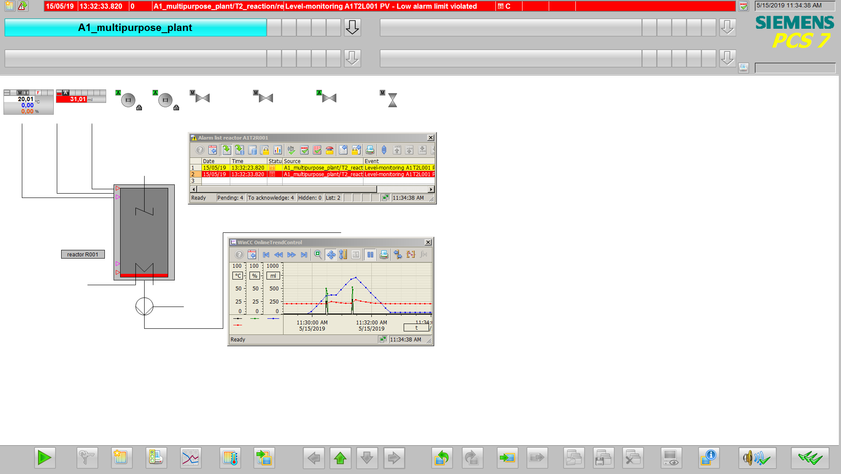

## Creating a user-defined object

1. The steps below show how a number of objects can be grouped into a single 'User-defined object'. First, however, it is important that none of the included objects has already been included in groups. If such groups already exist, they must be ungrouped. (® Group ® Ungroup)

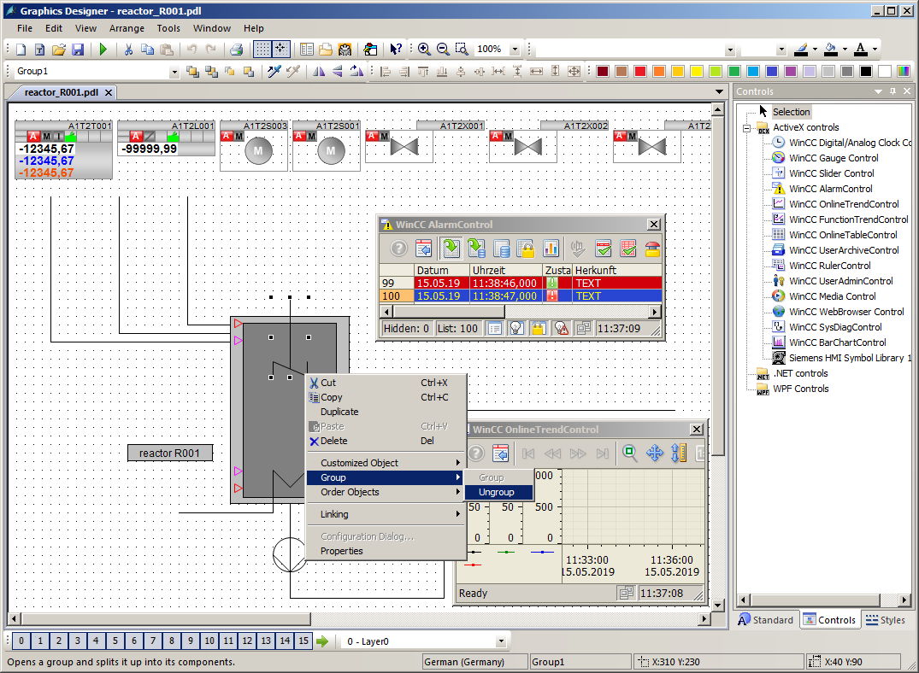

1. Now select all objects, and right-click on the selection. Select 'Customized Object' -> 'Create'. (® Customized Object ® Create)

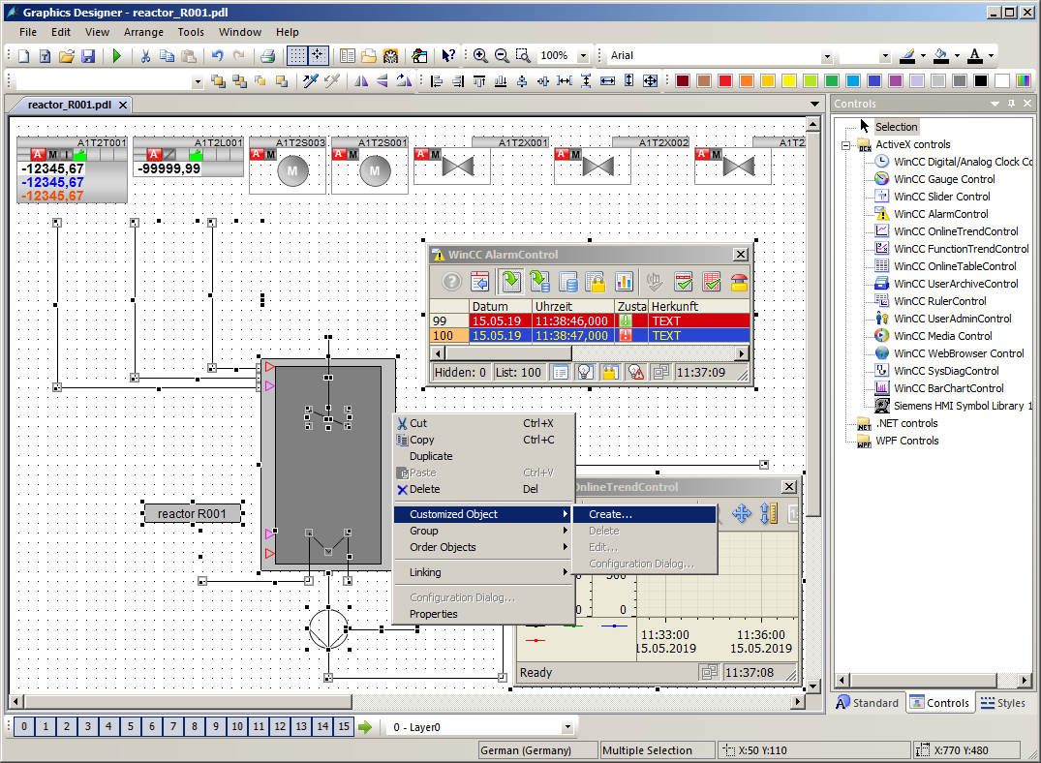

1. In the configuration dialog, click on 'User-defined' in the left window and select the first property of one of the sub-objects whose parameters are to be assigned later in the finished user-defined object. Drag this property to the left window to UserDefined2. (® User-defined ® Bar1 ® Process Driver Connection ® User-defined)

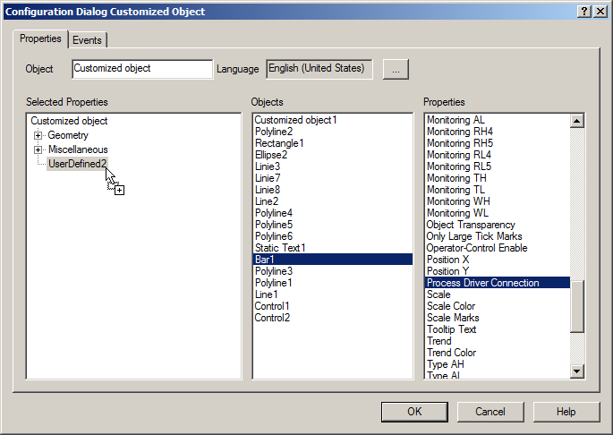

1. In this manner, select the 'Process Driver Connection', 'Maximum Value', 'Minimum Value', 'Limit AL', 'Limit WL', 'Limit AH' and 'Limit WH' properties of the Bar object. (® Bar1: Maximum value ® Bar1: Minimum value ® Bar1: Limit AL ® Bar1: Limit WL ® Bar1: Limit AH ® Bar1: Limit WH)

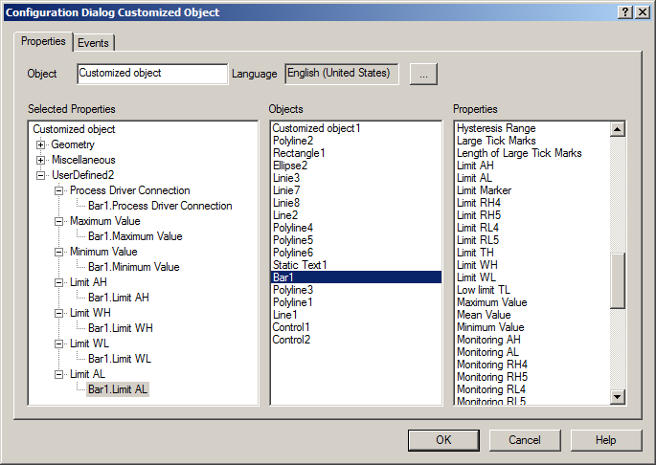

1. For the text window 'Static Text1' that describes the reactor, have the 'Text' displayed. Then, accept the user-defined object with OK. (® Static Text1: Text ® OK)

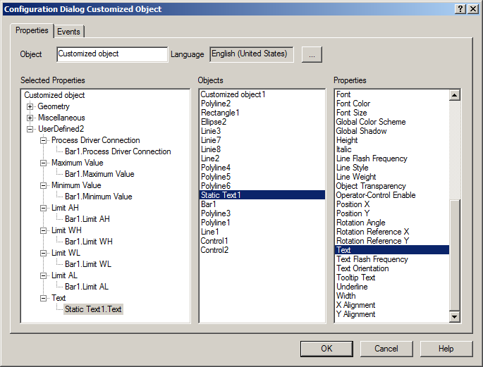

1. Now, copy the finished user object to store it for later use in the project library. (® Copy)

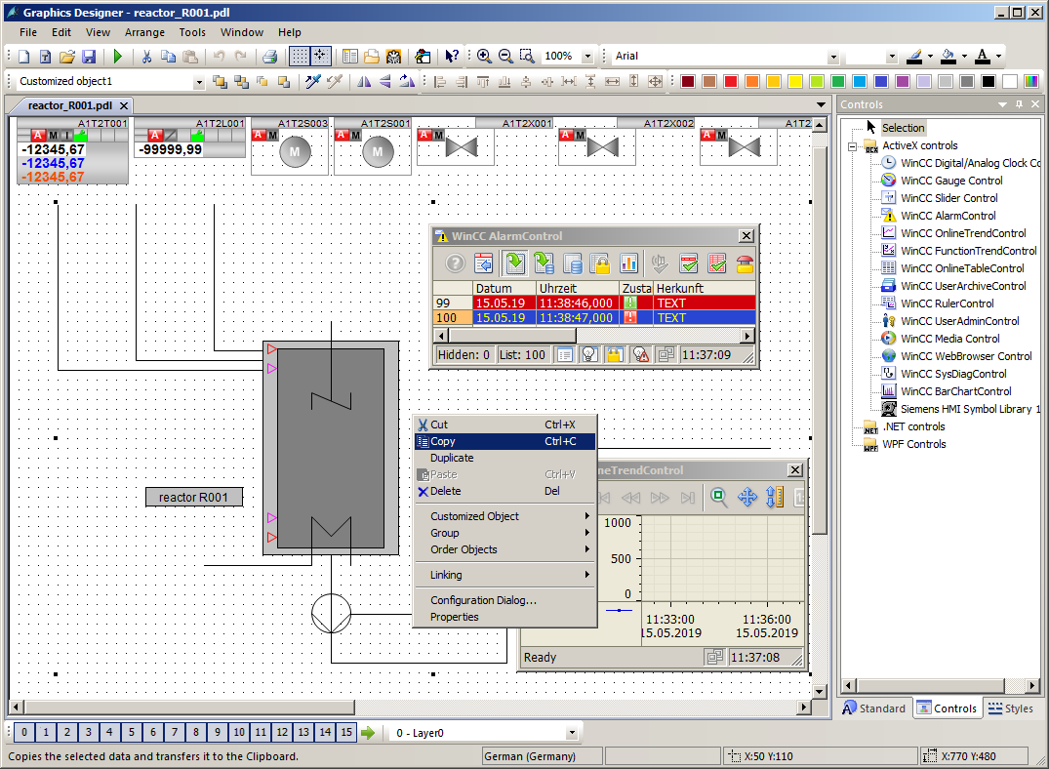

1. Next, select the  button to display the library. (®  ® Project Library ® right-click -> Paste)

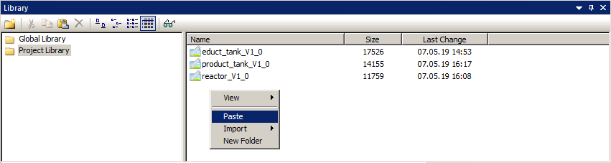

1. Next, change the name of the user-defined object in the project library to 'CustomizedObject_reactor_V1_0'. (® CustomizedObjekt_reactor_V1_0)

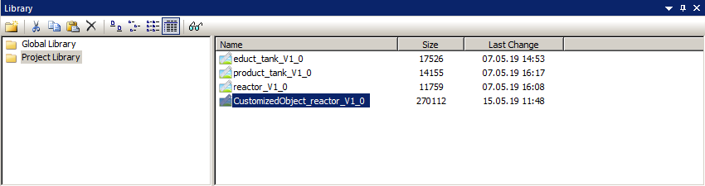

1. Now return to the user-defined object in the 'reactor_R001.Pdl' picture and select its properties. (® Properties)

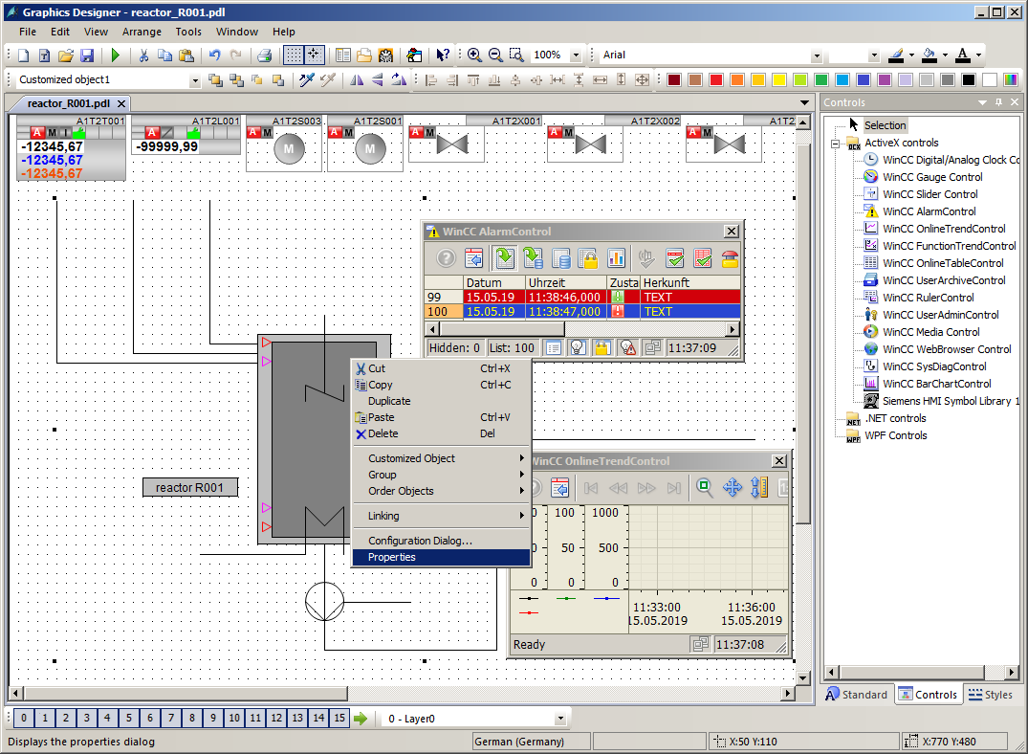

1. You will find the selected properties of the sub-objects in the properties under 'UserDefined'. For the 'Process Driver Connection', click in the '' icon for 'Dynamic' and select 'Tag'. (®  ® Tag)

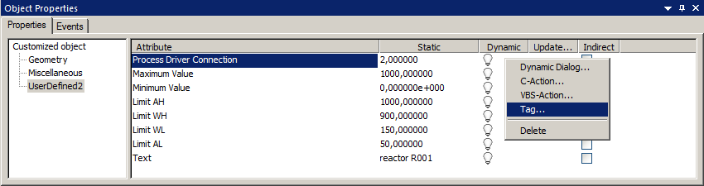

1. From the ES Variables, select 'A1_multipurpose_plant/T2_reaction/reactor_R001 /A1T2L001/A1T2L001/Monitor_A1T2L001/PV_Out#Value'. (® ES Variables ® A1_multipurpose_plant/T2_reaction/reactor_R001/A1T2L001/ A1T2L001/Mon_A1T2L001/PV_Out#Value ® OK)

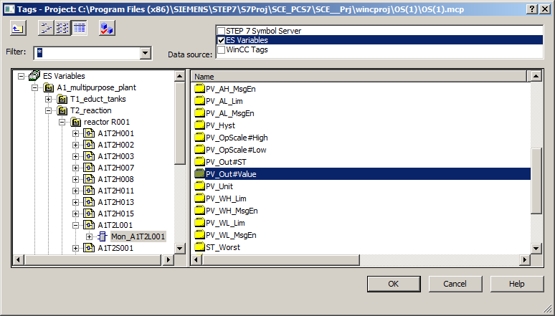

1. For 'Dynamic', also select an 'Update cycle' of '1 s'. Set the other properties as shown here. Then close the window. (® Update cycle ® 1 s® Text ® Reactor A1T2R001 ® )

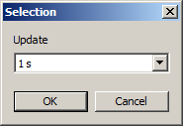 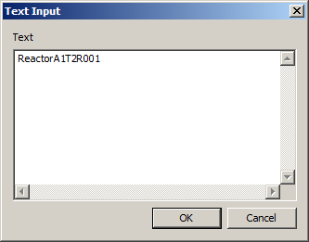

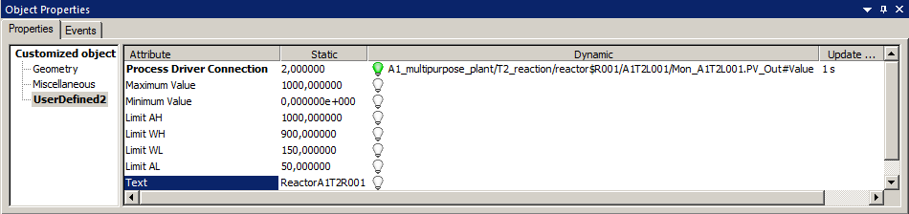

1. Finally, you should position the faceplates correctly, insert a heading and save them.

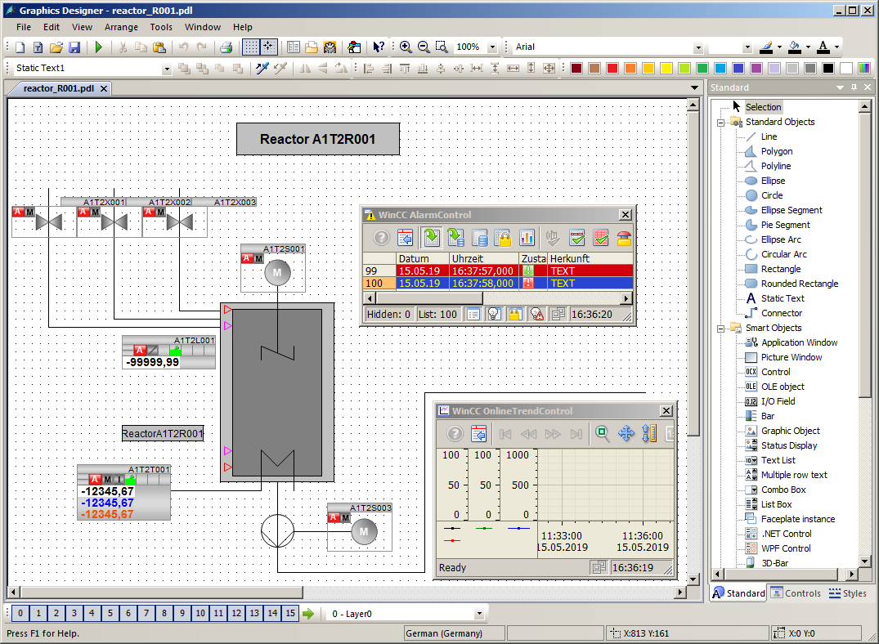

## Using a user-defined object

1. Now, the user-defined object is also to be used in picture 'reactor_R002.Pdl'. To this end, create a new picture in the plant view of SIMATIC Manager in the folder 'reactor R002', and compile the changes of the OS(1).

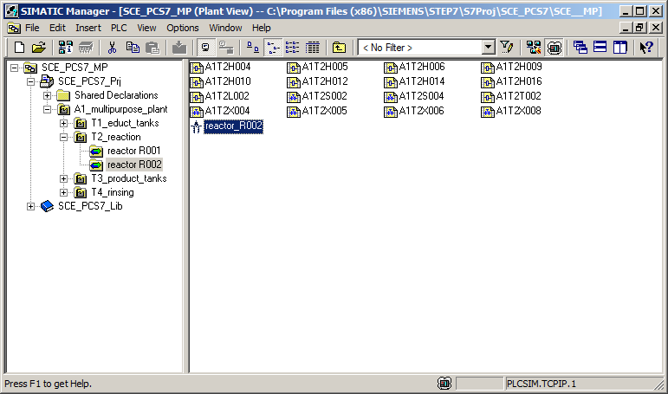

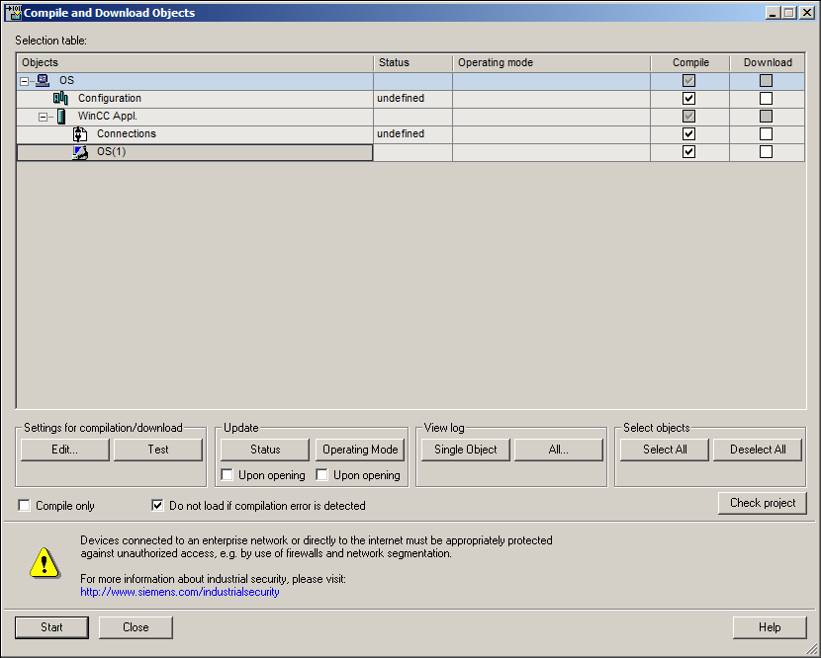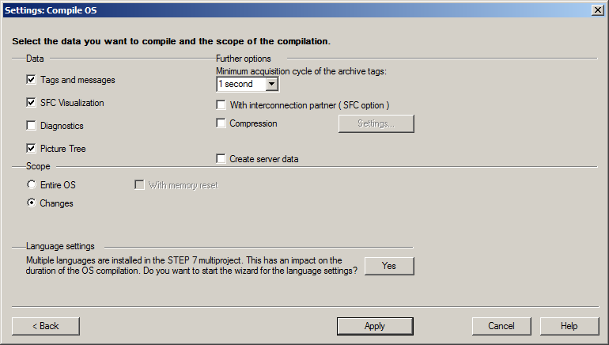

1. Then, open picture 'reactor_R002' in the Graphics Designer. (® Graphics Designer ® reactor_R002.Pdl ® Open picture)

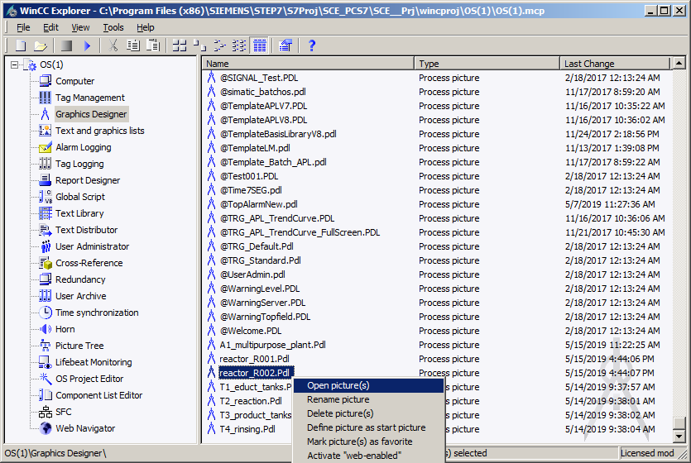

1. Start by setting the same properties as in step 11. Then click the  icon to display the libraries and drag the 'CustomizedObject_reactor_V1_0' from the 'Project Library' into the picture. (®  ® Project Library ® CustomizedObject_Reactor_V1_0)

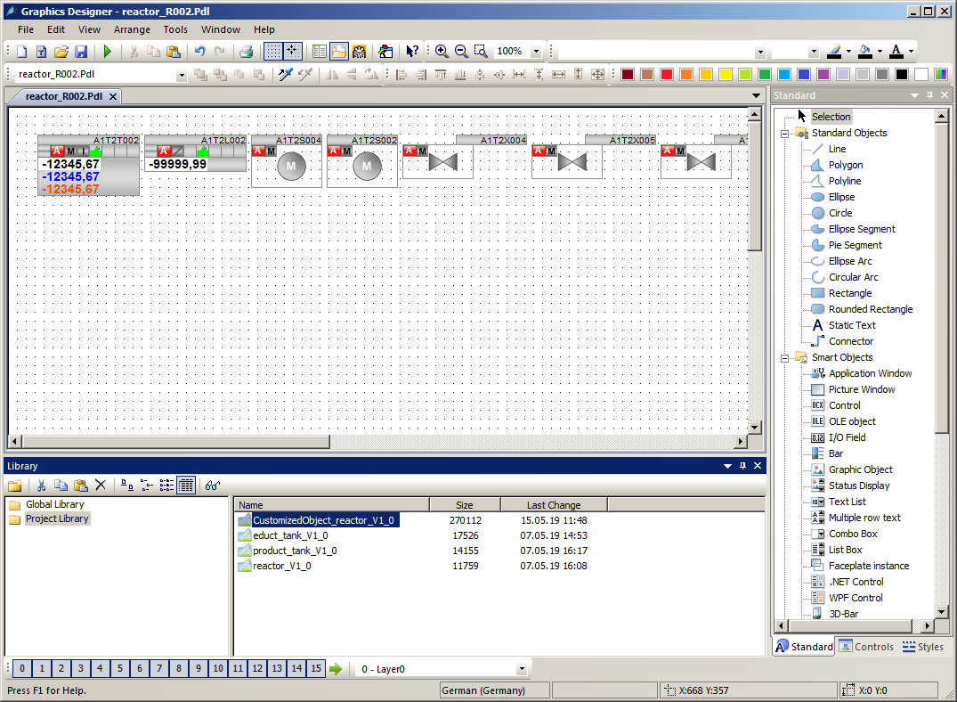

1. In the properties, you can now access the selected properties of the user-defined object again under 'UserDefined'. Thus, you have created an object with a specific selection of properties that can be used again and again quickly and efficiently. (® Properties ® Object Properties ® UserDefined)

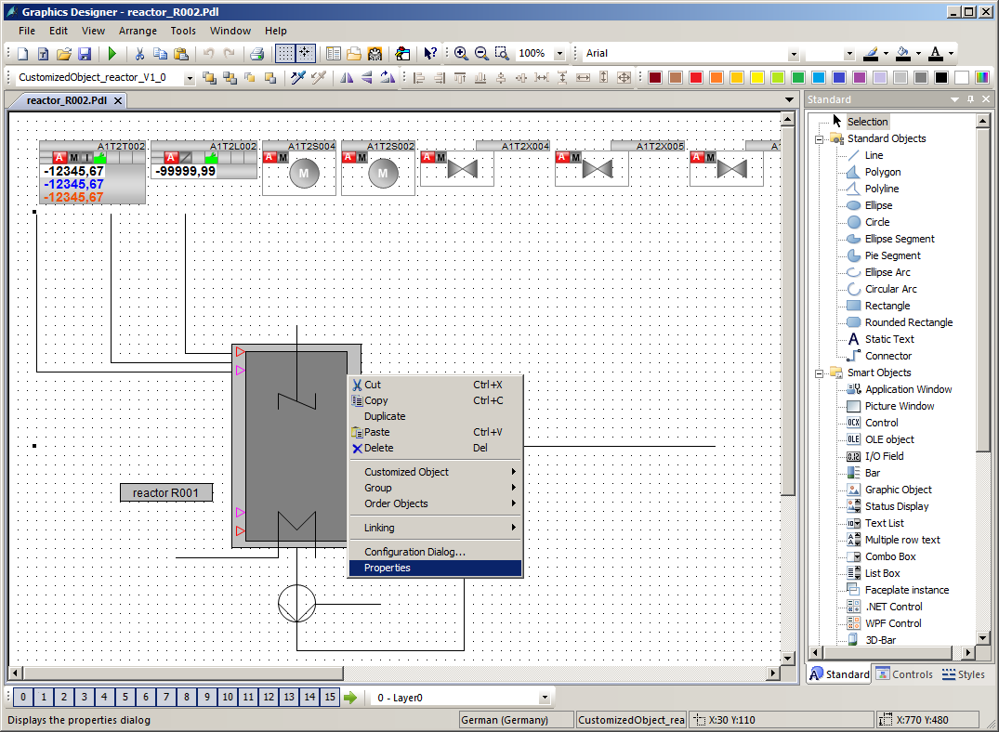

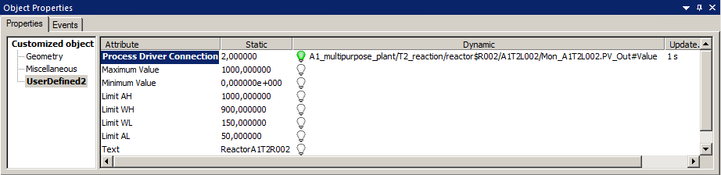

1. Finally, arrange the faceplates and insert a caption.

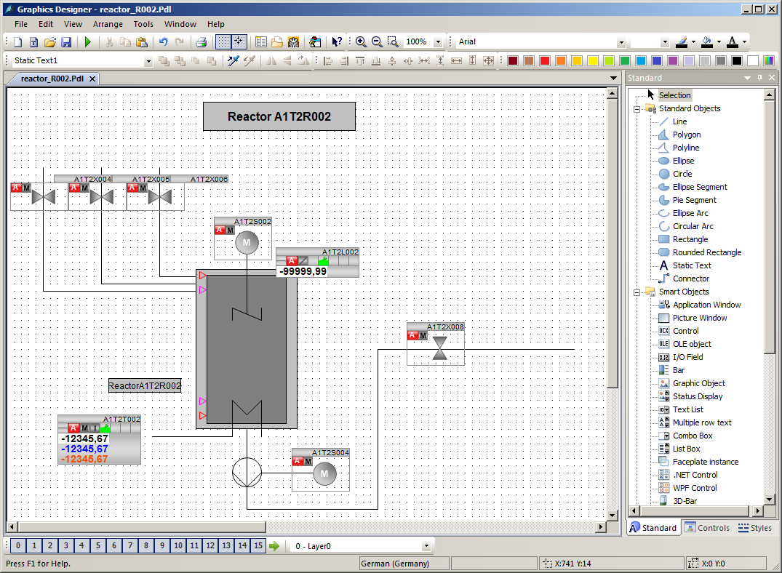

## Checklist – step-by-step instruction

The following checklist helps students to independently check whether all steps of the step-by-step instruction have been carefully completed and enables them to successfully complete the module on their own.

|  |  |  |
| --- | --- | --- |
| No. | Description | Checked |
| 1 | Faceplate for Reactor R001 created and configured |  |
| 2 | AlarmControl inserted in faceplate for Reactor R001 and configured |  |
| 3 | TrendControl inserted in faceplate for Reactor R001 and configured |  |
| 4 | User-defined object for reactor created in library |  |
| 5 | Faceplate for Reactor R002 created and configured |  |
| 6 | User-defined object from library inserted for Reactor R002 and configured |  |
| 7 | Project successfully archived |  |

Table 3: Checklist for step-by-step instructions

# Exercises

In the exercises, you apply what you learned in the theory section and in the step-by-step instructions. The existing multiproject from the step-by-step instructions (p03-01-project-r1905-en.zip) is to be used and expanded for this. The download of the project is stored as zip file "Projects" on the SCE Internet for the respective module.

A new user-defined object will be created for the tanks with an upper and lower sensor. It can now also be used to create detail pictures for the other plant units.

In addition, the detail pictures are to be accessible from the overview page by clicking on the corresponding text.

The previously created detail picture of Reactor R002 is to be supplemented with a further ActiveX control 'Online Table Control'.

## Tasks

1. Create a new picture on the level of educt_tank B001. Get the template for the tank from the library and ungroup the group.
2. Now, create a user-defined object from the tank. Select the variable parameters. The names of the new parameters are possibly not unique and should be adapted.

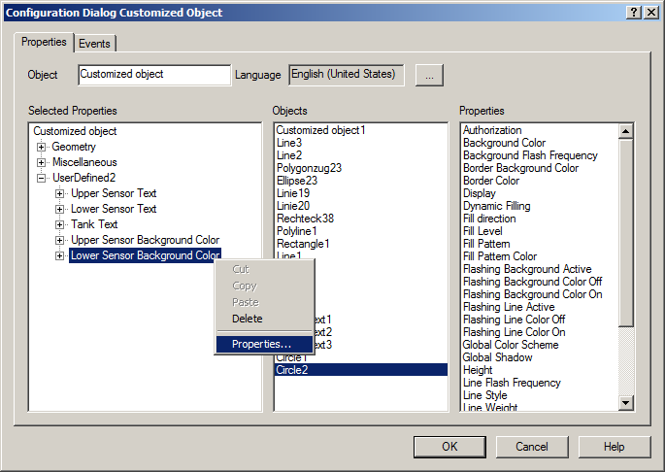

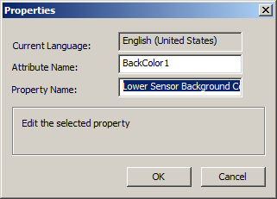

1. In the overview picture, create links to the newly created pictures by expanding the existing static texts to include a dynamic. For this, use the Dynamic Wizard – Picture Functions – Picture change in working area, as in chapter P02-01.
2. In the detail picture 'reactor_R002', insert an AlarmControl and configure the list in a way that only alarms for Reactor R002 are displayed.
3. Last, instead of an OnlineTrendControl configure an OnlineTableControl and have the level, the actual value, the setpoint and the manipulated value of the controller displayed.

## Checklist – exercise

The following checklist helps students to independently check whether all steps of the exercise have been carefully completed and enables them to successfully complete the module on their own.

|  |  |  |
| --- | --- | --- |
| No. | Description | Checked |
| 1 | Faceplate created for Educt tank B001 |  |
| 2 | User-defined object for educt tank created and configured |  |
| 3 | Link from overview picture A1_multipurpose_plant to all newly created sub-pictures created |  |
| 4 | AlarmControl inserted in faceplate for Reactor R002 and configured |  |
| 5 | OnlineTableControl inserted in faceplate for Reactor R002 and configured |  |
| 6 | Project successfully archived |  |

Table 4: Checklist for exercises

# Additional information

More information for further practice and consolidation is available as orientation, for example: Getting Started, videos, tutorials, apps, manuals, programming guidelines and trial software/ firmware, under the following link:

[siemens.com/sce/pcs7](http://www.siemens.com/sce/pcs7)

**Preview "Additional information"**

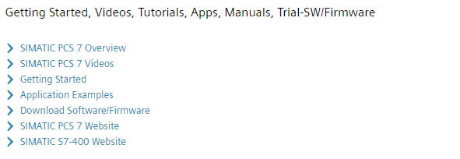

Further Information

Siemens Automation Cooperates with Education  
**siemens.com/sce**

Siemens SIMATIC PCS 7  
**siemens.com/pcs7**

SCE Learn-/Training Documents  
**siemens.com/sce/documents**

SCE Trainer Packages  
**siemens.com/sce/tp**

SCE Contact Partners   
**siemens.com/sce/contact**

Digital Enterprise  
**siemens.com/digital-enterprise**

Industrie 4.0   
**siemens.com/future-of-manufacturing**

Totally Integrated Automation (TIA)  
**siemens.com/tia**

TIA Portal  
**siemens.com/tia-portal**

SIMATIC Controller  
**siemens.com/controller**

SIMATIC Technical Documentation   
**siemens.com/simatic-docu**

Industry Online Support  
**support.industry.siemens.com**

Product catalogue and online ordering system Industry Mall   
**mall.industry.siemens.com**

Siemens  
Digital Industries, FA   
P.O. Box 4848  
90026 Nuremberg  
Germany

Subject to change and errors  
© Siemens 2020

**siemens.com/sce**