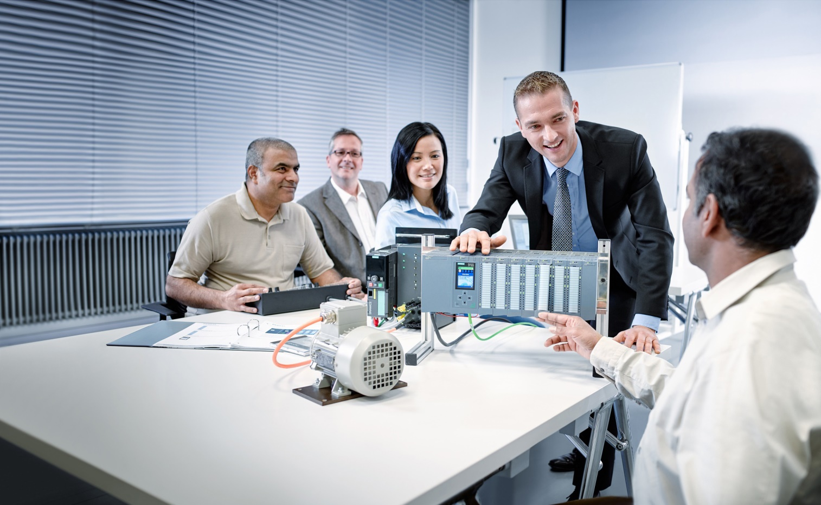As

Learn-/Training Document  
  
Siemens Automation Cooperates with Education (SCE) | As of Version V9 SP1

**siemens.com/sce**

PA Module P02-03   
SIMATIC PCS 7 – Archiving and trend reporting

**Matching SCE Trainer Packages for this Learn-/Training Document**

* **SIMATIC PCS 7 Software Package V9.0 (set of 3)**  
  Order No.: 6ES7650-0XX58-0YS5
* **SIMATIC PCS 7 Software Package V9.0 (set of 6)**   
  Order No.: 6ES7650-0XX58-2YS5
* **SIMATIC PCS 7 Software Upgrade Packages (set of 3)**  
  Order No.: 6ES7650-0XX58-0YE5 (V8.x🡪 V9.0)
* **SIMIT Simulation Platform with Dongle V10**  
  (contains SIMIT S & CTE, FLOWNET, CONTEC libraries) – 2500 simulation tags  
  Order No.: 6DL8913-0AK00-0AS5
* **Upgrade SIMIT Simulation Platform V10**  
  (contains SIMIT S & CTE, FLOWNET, CONTEC libraries) from V8.x/V9.x  
  Order No.: 6DL8913-0AK00-0AS6
* **Demo Version SIMIT Simulation Platform V10**  
  [Download](https://support.industry.siemens.com/cs/ww/en/ps/17120/dl)
* **SIMATIC PCS 7 AS RTX Box (PROFIBUS) only in combination with ET 200M for RTX –**   
  Order No.: 6ES7654-0UE23-0XS1
* **ET 200M for RTX Box (PROFIBUS) only in combination with PCS 7 AS RTX Box –**  
  Order No.: 6ES7153-2BA10-4AB1

Note that these trainer packages are replaced with successor packages when necessary.

An overview of the currently available SCE packages is available at: [siemens.com/sce/tp](http://www.siemens.com/tp)

**Continued training**

For regional Siemens SCE continued training, get in touch with your regional SCE contact

[siemens.com/sce/contact](http://www.siemens.com/contact)

**Additional information regarding SCE**

[siemens.com/sce](http://www.siemens.com/sce)

**Information regarding use**

The SCE Learn-/Training Document for the integrated automation solution Totally Integrated Automation (TIA) was prepared for the program "Siemens Automation Cooperates with Education (SCE)" specifically for training purposes for public educational facilities and R&D institutions. Siemens does not guarantee the contents.

This document is to be used only for initial training on Siemens products/systems, which means it can be copied in whole or part and given to those being trained for use within the scope of their training. Circulation or copying this Learn-/Training Document and sharing its content is permitted within public training and advanced training facilities for training purposes.

Exceptions require written consent from the Siemens. Send all related requests to

[scesupportfinder.i-ia@siemens.com](mailto:scesupportfinder.i-ia@siemens.com).

Offenders will be held liable. All rights including translation are reserved, particularly if a patent is granted or a utility model or design is registered.

Use for industrial customer courses is explicitly not permitted. We do not consent to commercial use of the Learn-/Training Document.

We wish to thank the TU Dresden, particularly Prof. Dr.-Ing. Leon Urbas and the Michael Dziallas Engineering Corporation and all other involved persons for their support during the preparation of this Learn-/Training Document.

Table of contents

1 Goal 5

2 Prerequisite 5

3 Required hardware and software 6

4 Theory 7

4.1 Theory in brief 7

4.2 Introduction 8

4.3 Process data 9

4.4 Alarms and events 9

4.5 Data compression 10

4.6 Trend reporting 10

4.7 Archiving in PCS 7 11

4.8 Archive system on the OS server 12

4.9 Storage Plus 13

4.10 Trend reporting in PCS 7 13

4.11 Summary 14

4.12 References 15

5 Task 16

6 Planning 16

7 Learning objective 16

8 Structured step-by-step instructions 17

8.1 Configuration of the MonAnS block 17

8.2 Configuring Alarm Logging 27

8.3 Configuring Tag Logging 31

8.4 Displaying archive data in WinCC Runtime 45

8.5 Creating reports 52

8.6 Checklist – step-by-step instruction 61

9 Exercises 62

9.1 Tasks 62

9.2 Checklist – exercise 63

10 Additional information 64

Archiving and trend reporting

# Goal

After working through this module, the students will know the basic requirements and objectives of archiving. They are able to apply different types of archiving to process data and alarms. The students will know how suitable cycles can be determined for time-controlled archiving and the criteria according to which event-controlled data archiving is executed. They will know the options that PCS 7 provides.

# Prerequisite

This chapter builds on chapter 'Functional safety'. To implement this chapter, you can use an existing project from the previous chapter or the archived project 'p02-02-exercise-r1905-en.zip' provided by SCE. The download of the project(s) is stored on the SCE Internet for the respective module.

The (optional) simulation for the SIMIT program can be retrieved from the file 'p01-04-plantsim-v10-r1905-en.simarc'. It can be run in demo mode.

# Required hardware and software

1. Engineering station: Requirements include hardware and operating system   
   (for further information, see Readme on the PCS 7 installation DVD)
2. SIMATIC PCS 7 software V9 SP1 or higher

* Installed program packages (contained in SIMATIC PCS 7 Software Trainer Package):
  + *Engineering → PCS 7 Engineering*
  + *Engineering → BATCH Engineering*
  + *Runtime → Single Station → OS Single Station*
  + *Runtime → Single Station → BATCH Single Station*
  + *Options → SIMATIC Logon*
  + *Options → S7-PLCSIM V5.4 SP8*

1. Demo Version SIMIT Simulation Platform V10

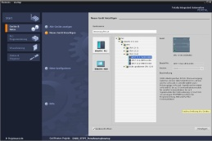

**3** SIMIT V10 or higher



**1** Engineering Station

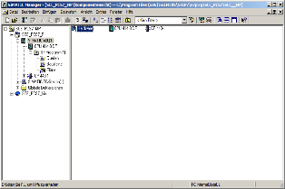

**2** SIMATIC PCS 7

V9 SP1 or higher

# Theory

## Theory in brief

The archiving of process values is an important tool for correct and optimized process control.

The archived data allows an analysis of historical data for optimizing the process, tracking fault states and quality assurance.

Not only process values but also alarms and events are suitable for archiving. Particularly in the case of fault states, the operator has to handle a large number of alarms so that only the plant has returned to normal operation or is at a standstill is it possible to determine the exact cause. Both the alarms and events in the archive as well as the archived process values can be used for this.

Process values are usually archived cyclically, while archiving of alarms and events is usually event-driven. In the case of process values, the exact cycle depends on the dynamics of the underlying process. Selecting a cycle independent of the process has major disadvantages. A cycle that is too short requires a large amount of memory and may also record the noise of the signal. A cycle that is too long results in unusable values because the trend of the process value can no longer be reconstructed.

For signals that are subject to little or no fluctuations, the recording of almost identical values is not useful. For that reason, options exist for compressing the data, for example, by setting a dead zone. Only when the process value exceeds or drops below the specified limit is the value stored again in the archive.

Trend reporting provides the operator with an overview of process trends up to the current time. From the history of the process value, it is possible to recognize an impending fault state and how soon it might occur. Thus, countermeasures can be initiated before protection mechanisms have to be activated.

## Introduction

The automating, safeguarding and monitoring of processes are basic requirements for a process control system. Archiving of data produced in the process offers the possibility of storing historical data and making it available for analysis.

There are many reasons why data needs to be analyzed. There are legal requirements on the one hand and process-related, safety-related and performance-related reasons on the other.

Legal requirements include the logging of incidents, such as the violation of limits or the occurrence of an event. Another legal reason for archiving is to provide proof for certificates and restrictions, such as emission limits. In connection with product liability and product safety, archiving of all process steps and raw materials is required for seamless tracking of the product. [1].

Product-related reasons for archiving of data are the statistical evaluation of production quantities and the statistical long-term analysis for process optimization, performance determination and reduction of production and material costs. The data is also very helpful for subsequent analysis of the impact and spread of incidents as well as for assessment and possibly revision of existing countermeasures. Thus, plant shutdowns can be avoided and the economics of the plant can be increased at the same time. Likewise, the data can be used to analyze normal operation and to identify optimization potential or quality improvement opportunities. The data is also of interest for optimizing maintenance of production facilities based on existing data.

Safety-related reasons relate primarily to the adaptation of operating parameters; i.e. limits and response times. When conducting tests for checking safety interlocks and Emergency Off functions, the recording can be used to verify the intended functions. If the data reveal safety deficiencies, the cause can be analyzed based on the data.

In addition, the storing of data in archives is intended to preserve the performance of the process database and act as a data backup. By storing data in an archive database, it is not necessary to keep paper copies of all process histories.

For the reasons mentioned, archiving turns out to be an important tool for correct and optimized process control. This gives rise to various requirements for archiving. One requirement is that the data be stored in full and in a uniform and structured manner. Likewise, structured access to data must be possible and allow criteria to be selected, e.g. through filtering.

It is also required that the data be archived for different time spans or at different intervals and at different locations.

In principle, two types of data can be distinguished: process data, which is produced cyclically, and alarms and events, which occur acyclically. This topic is discussed in greater detail below.

## Process data

Process data refers to the analog and digital values that are determined by sensors and transmitted to the process control system. It is used to control and visualize the process.

Process data is transmitted cyclically to the process control system. Changes of analog process values within a certain interval vary widely. This is caused by the different process dynamics. The process data of a flow measurement is usually more dynamic than the process data of a temperature measurement. That is, the process data of the flow measurement changes within fractions of seconds, whereas the process data of the temperature measurement likely lies within a time period of more than 10 s.

The archiving of analog values should be time-controlled. Note that the rate of archiving of process data for a very dynamic process must be much higher than for a less dynamic process. One reason for this is to tailor the size of the archives to the appropriate amount. Moreover, for a less dynamic process, the display of process data in too short time periods is not useful and may contain a strong noise signal.

Binary process data can only toggle between two states, so that event-drive archiving should be carried out for this data.

## Alarms and events

According to [3], alarms are reports of the occurrence of an event; i.e. of a transition from one discrete state to another. According to [3] an event is the spontaneous occurrence of a defined state. Important information for an unambiguous and complete alarm includes the state that occurred, the time and the location. Additional details regarding alarms and events are provided in chapter P02-02.

Alarms and events occur acyclically and can therefore not be archived at fixed intervals. Here it is necessary to select the relevant alarms and events to ensure efficient archiving. One possibility would be, for example, to archive only safety-critical alarms or alarms with a certain priority.

The archiving of alarms and events can only be event-driven.

## Data compression

Because plants produce large volumes of data, usually, only a certain amount can be archived over a certain period. The amount of data depends largely on the cost of the storage medium and on the data transmission rate. On the other hand, the acceptable level of data loss has to be considered. The degree of compression results from weighing these two criteria.

When data is compressed, not only the quantity of the stored data changes but also its statistics, e.g. mean value and variance. For that reason, such values should be calculated from the original data and if needed, archived also. This should be done time-controlled, similarly to the archived process data.

Direct and transformation methods can be used for the data compression.

When the direct method is used, the data is archived in real time. There are rules that govern the archiving of individual measured values. The data is reconstructed by connecting the individual data points.

When transformation methods are used, the data is not archived in real time because the previous data history is included in the transformation. The original data is transformed in a different range. With this method, there is the possibility to design the compression adaptively, since the algorithms often have a parameter that is critical for the quality of the compression, depending on the process.

## Trend reporting

The term trend reporting refers to the representation of process values in trends; i.e. as a function of time. The time period for the trend reporting includes the present and the recent past. It is important that the trend curves, in contrast to pure history curves, are updated [2].

By representing process values in trends, process values can be monitored, changes identified, actual values compared with desired values and faults analyzed. In contrast to the pure display of the value of the process tag, trend diagrams provide information about amplitude, slope, frequency and variation of a process tag.

## Archiving in PCS 7

The PCS 7 process control system provides the option of archiving various data that is produced during process operation. This data includes process values that are stored cyclically in two different types of system archive. It also includes alarms that the user writes to the alarm log when triggered by an event. This data is archived on the OS server by default and is used for short term archiving as shown in Figure 1. If a central archive server (CAS) is additionally configured, OS logs and batch logs can also be archived in addition to the data mentioned above. The data archived on the CAS is used for long-term archiving and can be transferred periodically to external media. With Storage Plus it is also possible to generate views of the archived data, which can then be viewed via a web browser [4, 5, 6].

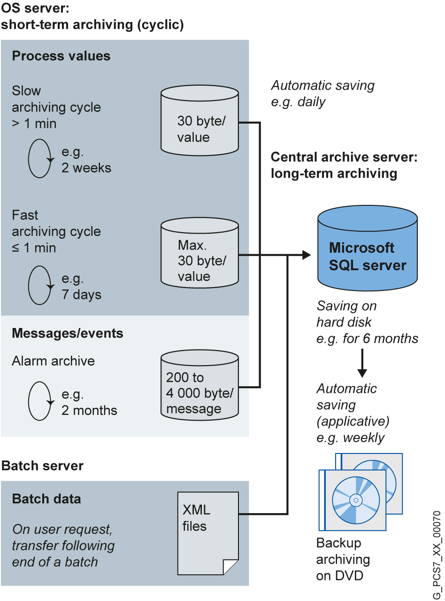

Figure 1: Overview of short-term and long-term archiving [Siemens]

## Archive system on the OS server

On the OS server, archives for process values and alarms/events can be created on the OS server.

As shown in Figure 2, these archives are organized as circular archives. They consist of individual segments that are defined either by a time period or by specifying a physical memory size. When one of these criteria is met, a segment is closed and a new one is started. If the memory of the server is exhausted, the segment that was created first is overwritten according to the FIFO principle (First In First Out). Figure 1, for example, specifies the time periods that the different archives can have for one circulation. The specified times also allow a view of the time relationships between the individual archives.

The process values are stored in the database compressed. They are compressed by setting a hysteresis. Depending on the signal change, a compression factor between 2 and 10 is reached. By selecting additional calculation functions, important statistical characteristic values can be retained despite compression.

To estimate the required memory for an archive, the average number of process values per second or the average number of alarms per second is needed. These averages are multiplied by the typical memory capacity for the data and by the desired archiving period. The period must be specified once for a segment and once for all segments together. Typical memory capacity is between 6 and 16 bytes for process values and 4000 bytes for alarms. For reasons of performance, the number of individual segments should not exceed 200 [4].

Archive Slow

Archive Fast

Message archive

**Process values**

**Alarms / Events**

Report archive

**Charge protocols  
OS Reports**

Figure 2: Circular archives for short-term archiving [4]

## Storage Plus

Storage Plus can be used alternatively or as a supplement to the CAS. Storage Plus is always installed on a separate computer and is connected to the terminal bus (Figure 3). In contrast to the CAS, Storage Plus cannot be operated redundantly. However, it allows the display and analysis of data stored in the CAS, in the Storage Plus database or on external media, for example, the display of histories [2]. The archived data is displayed with views. These views filter out the necessary data from the total data. The data is represented in tables, diagrams or reports [7].

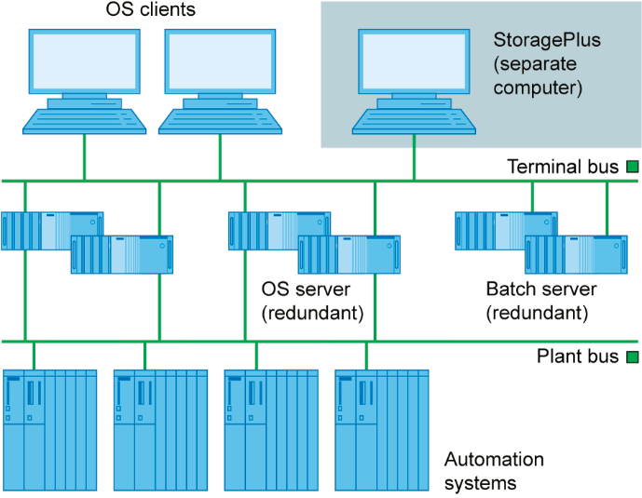

Figure 3: Role of Storage Plus in the control system structure [Siemens]

## Trend reporting in PCS 7

Below, the two possibilities for representing archived process values in PCS 7 are described. The OS servers are accessed exclusively in that case. This makes it possible to quickly trace the trend of one or more process values and a negative trend can be detected or ruled out.

Trend groups

Trend groups can be called using a button on the PCS 7 operator interface. They are available by default and do not have to be additionally configured. However, there is the option to have certain trend groups pre-configured so that they only have to be displayed at runtime. If no trends are pre-configured or if the process values needed at the moment are missing in these groups, a new group can be created at any time.

Online- and Function Trend Control

Within process pictures, the following ActiveX Controls can be used to represent process value histories. Additional information for designing faceplates with ActiveX Controls is provided in chapter P03-03.

* Online Trend Control represents one or more process values over time.
* Function Trend Control represents a process value as a function of another process value.

Online Trend Control corresponds to the trend display (refer to section Trend reporting).

Function Trend Control can be used under certain constraints to display dependent process values in one trend. Otherwise, the process values to be represented have to be archived in the same cycle and the archive has to be located on the same OS server. To facilitate analysis, a target curve can be displayed in addition to the actual curve. The data for the target curve is configured and stored in a user archive [6].

## Summary

To archive process data, alarms and events, an OS server must always be installed. The expanded archiving capabilities builds on this by reading the data for CAS and Storage Plus from the OS servers.

|  |  |  |  |
| --- | --- | --- | --- |
|  | Short-term | Long-term | Restrictions |
| **OS Server** | Yes | No | - |
| **CAS** | No | Yes | Display only via OpenPCS 7 |
| **Storage Plus** | No | Yes | No redundancy |

Table 1: Overview of short-term and long-term archiving according to servers

To display data of the short-term archiving that is located on the OS servers, the trend groups and the Online Trend Control can be used. For the Function Trend Control, only value pairs that are stored on the same OS server and with the same archiving cycle can be displayed.

Storage Plus has a web interface for displaying long-term archived data.

|  |  |  |  |
| --- | --- | --- | --- |
|  | Short-term | Long-term | Restrictions |
| **Storage Plus** | No | No | Additional computer, only from Storage Plus server |
| **Online Trend Control or trend groups** | Yes | Yes | Only from OS servers |
| **Function Trend Control** | Yes | Yes | Value pair only from an OS server and with the same archiving cycle |

Table 2: Overview for display of short-term and long-term archiving

## References

[1] TU Dresden (2010-07): Vorlesung Prozessrechen- und -leittechnik.

[2] VDI/VDE 3699, sheet 4 (Ed. 2014-01): Process control using display screens.

[3] VDI/VDE 3699, sheet 5 (Ed. 2014-09): Process control using display screens - Alarms/messages.

[4] SIEMENS (2018-03): Compendium Part A - Configuration Guidelines. A5E43228901-AA. ([support.automation.siemens.com/WW/view/en/109756485](http://support.automation.siemens.com/WW/view/en/109756485))

[5] SIEMENS (2017-12): SIMATIC Process Control System PCS 7 Engineering System (V9.0 SP1). A5E39221271-AC.  
([support.automation.siemens.com/WW/view/en/109754984](http://support.automation.siemens.com/WW/view/en/109754984))

[6] SIEMENS (2017-10): SIMATIC Process Control System PCS 7 Operator Station (V9.0 SP1). A5E39219186-AB. ([support.automation.siemens.com/WW/view/en/109754982](http://support.automation.siemens.com/WW/view/en/109754982))

[7] SIEMENS (2008-11): MDM - Storage Plus Information System. ([support.automation.siemens.com/WW/view/en/37436169](http://support.automation.siemens.com/WW/view/en/37436169))

# Task

This task deals with process value and alarm archives for the operator station (OS) and their variants and setting options.

As an example, you will create archiving of the level for Reactor A1T2R001 and display the archived values in WinCC Runtime as a trend using trend groups and as printout using the Report Designer for display.

# Planning

In order to archive tags, it will be shown which settings are required using the CFC A1T2L001 as an example.

The logging of alarms (Alarm Logging) and process values (Tag Logging) will be examined.

The archived process values are to be displayed in WinCC.

As an alternative, a report can also be created for documentation purposes.

# Learning objective

In this chapter, students learn the following:

* Activating the archiving of process tags in CFCs
* The settings for alarm properties and alarm archiving in CFCs
* The process object view as a tool for archive configuring
* The archive settings for alarms in Alarm Logging of WinCC
* The archive settings for process tags in Tag Logging of WinCC
* The trend groups for displaying archive tags in WinCC runtime
* The Report Designer for printing trends with archive tags

# Structured step-by-step instructions

## Configuration of the MonAnS block

1. To program the archiving of the level process tag of Reactor A1T2R001 using the level monitoring, first open the existing CFC A1T2L001. (® A1_multipurpose_plant ® T2_reaction ® reactor R001 ® A1T2L001)

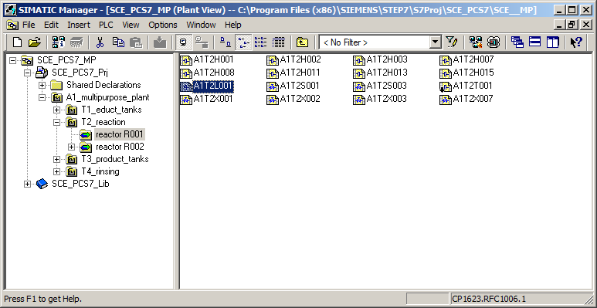

1. Open the object properties of motor block 'MonAnS' to adapt the properties. (MonAnS ® Object Properties)

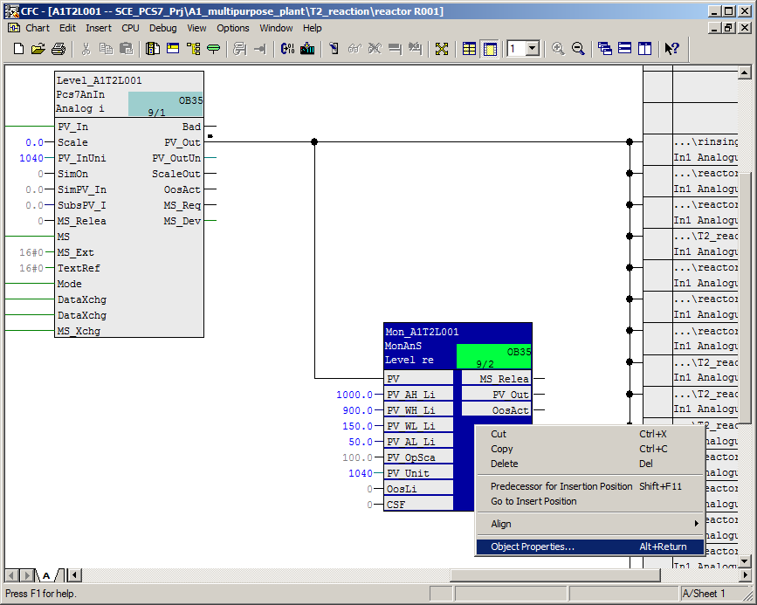

1. First, enter the comment 'Level-monitoring A1T2L001' for the MonAnS block. Click the 'Messages' button to make the settings for the message configuration. Keep these settings. Here, you see the composition of the text for an event with **key word + text**, for example: **$$BlockComment$$ Upper alarm limit violation.** After compilation of the OS, this becomes **Level monitoring A1T2L001 Upper alarm limit violation.** (® Comment ® "Level-monitoring A1T2L001" ® Messages ® Event ® Save)

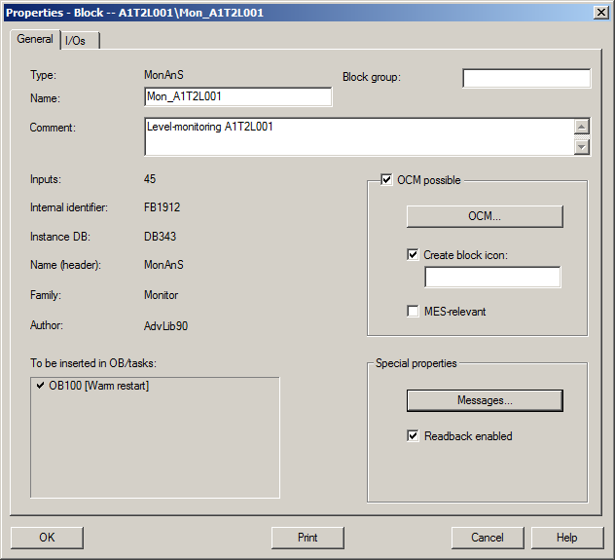

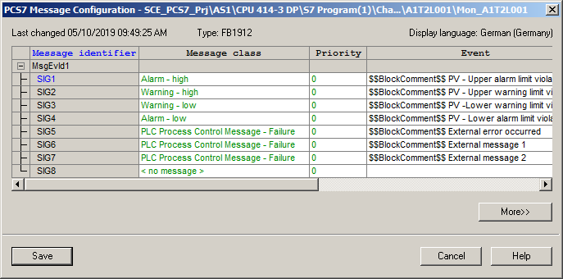

1. Click the 'OCM' button to display the tags of the MonAnS block Monitor_A1T2L001 that will be created when the OS is compiled. Only such tags of a CFC block can also be archived.   
   (® OCM ® WinCC Attributes ® OK)

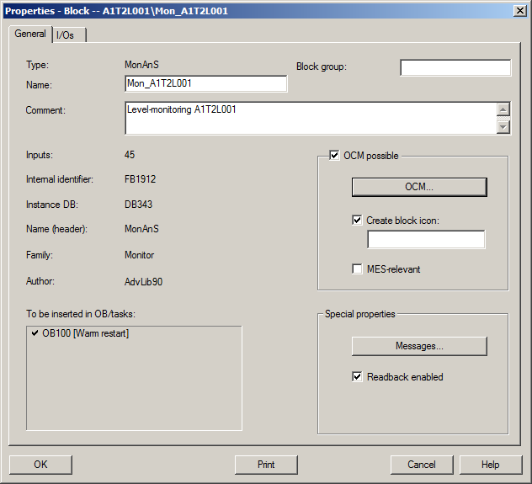

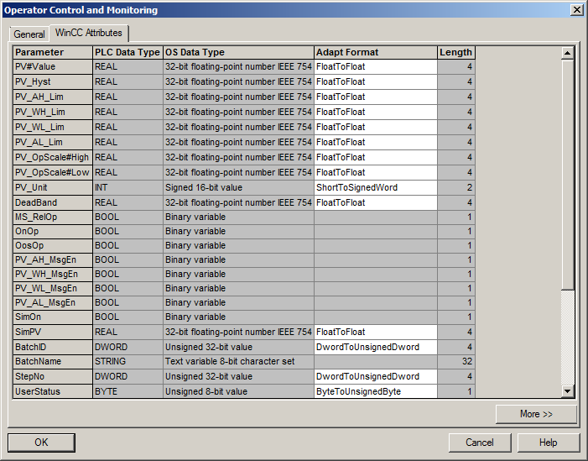

1. Now, specify the archiving of analog input values PV in the block properties. To do so, select input PV and select I/O 'Value' in its structure. The archiving is activated in the properties of 'Value'.   
   (® PV ® Value ® Archive: Archiving ® OK ® Close)

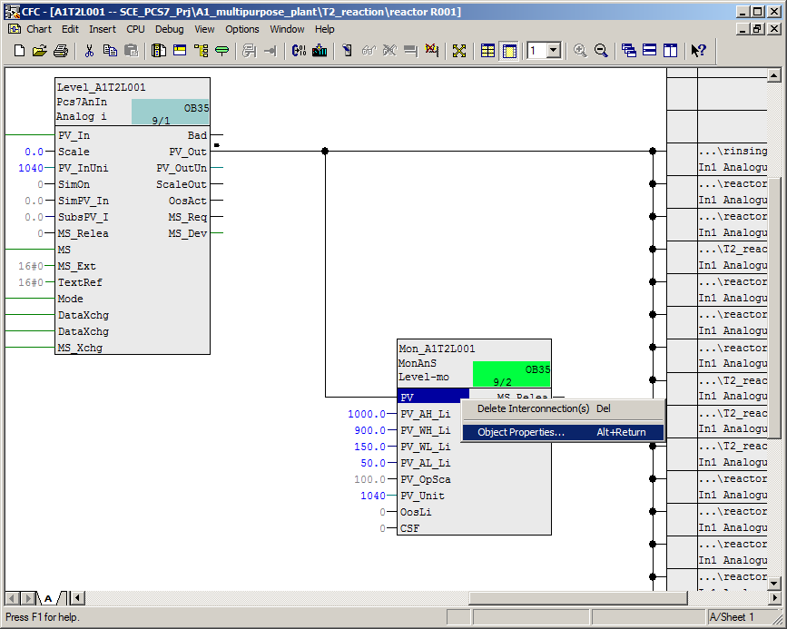

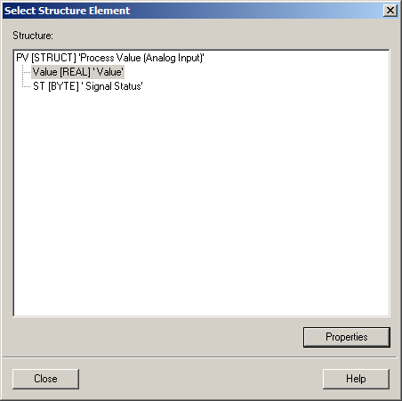

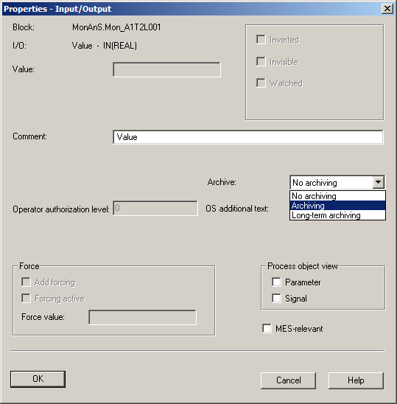

***Note:***

* *Here, you could also select a tag for long-term archiving on the central archive server (CAS).*

1. In order to see and also further edit these changes in the process object view, AS and OS must now be compiled. To do this and download the AS at the same time, select the project in the component view of SIMATIC Manager. Then, select 'Compile and Download' for the PLC. (® SCE_PCS7_Prj ® PLC ® Compile and Download Objects)

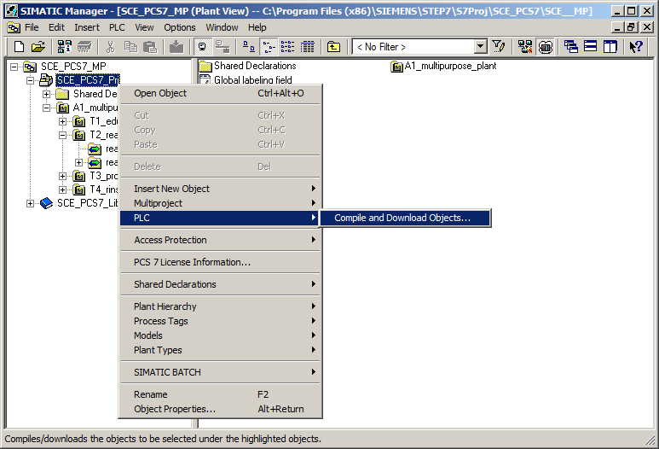

1. Next, as shown here, select the objects for compiling and start the process as you learned in the previous chapters.   
   (® Start)

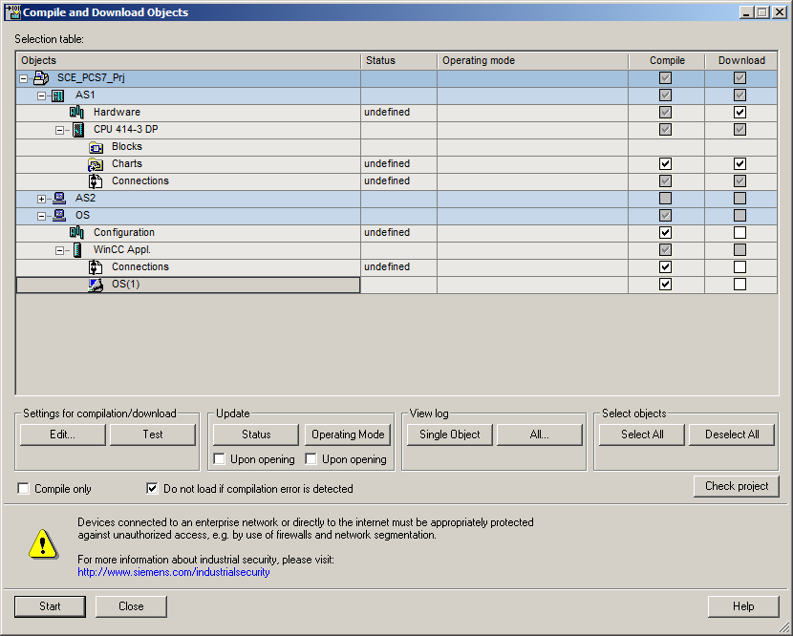

1. For making multiple changes in one or more blocks, you have already become acquainted with the **process object view**. Archive entries can be edited here, too. (® View ® Process Object View)

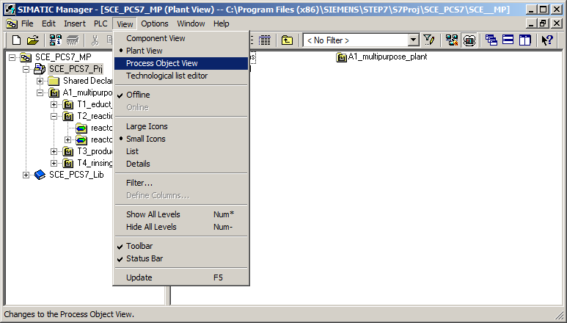

1. In the process object view, select the CFC 'A1T2L001'. Select the 'Messages' tab and change the entries for 'Event' as shown here. (® CFC 'A1T2L001' ® Messages ® Event)

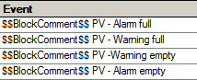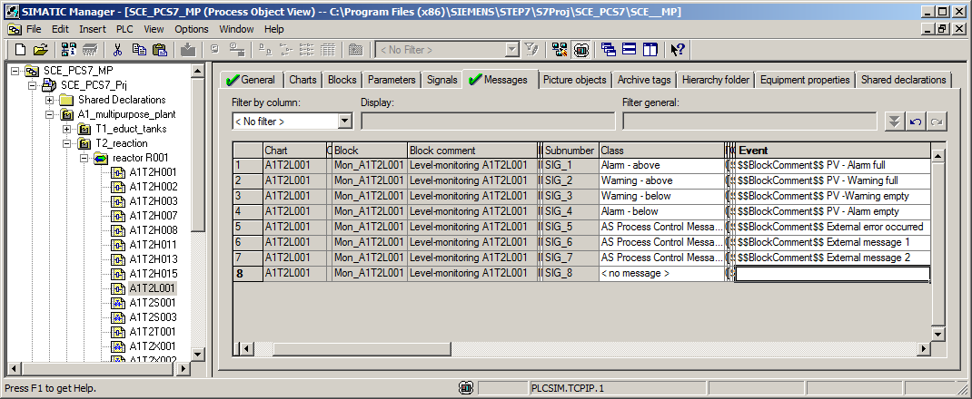

1. The settings for the archive tags can be made in the process object view also. In the 'Archive tags' tab, change the 'Archiving/display cycle' to 10 seconds. (® Archive tags ® Archiving/display cycle ® 10 seconds)

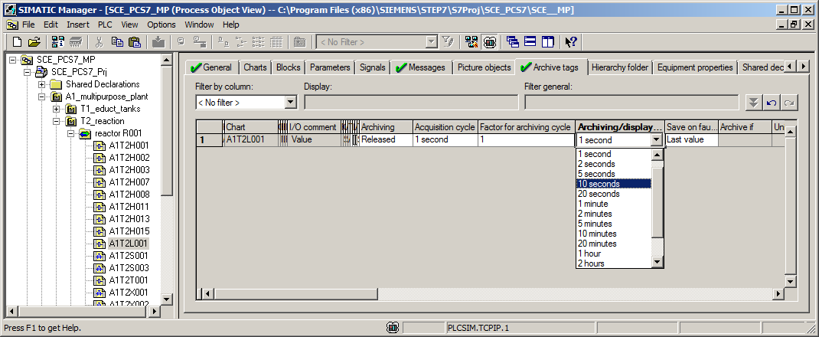

1. Apply these changes by compiling the OS only. To do so, select the 'OS' in the component view of SIMATIC Manager. Then, select 'Compile and Download' for the PLC. (® OS ® PLC ® Compile and Download Objects)

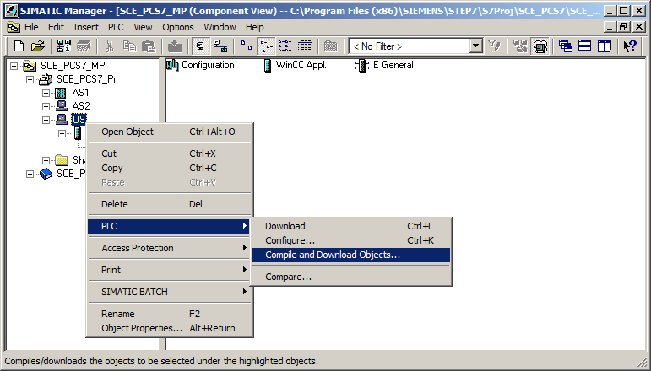

1. Next, as shown here, select the objects for compiling and start the process as you learned in the previous chapters. (® Start)

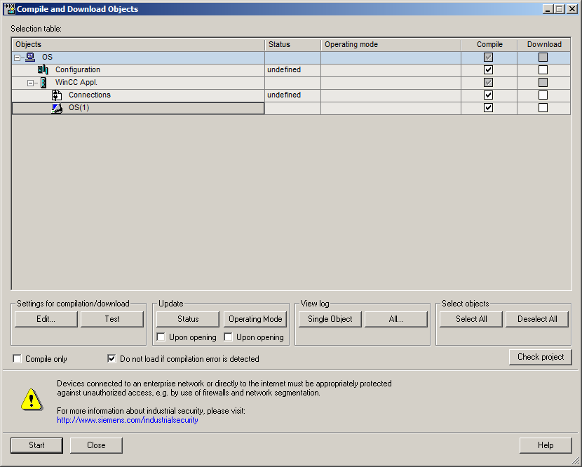

## Configuring Alarm Logging

1. After successful compilation, open the OS. (® OS(1) ® Open Object)

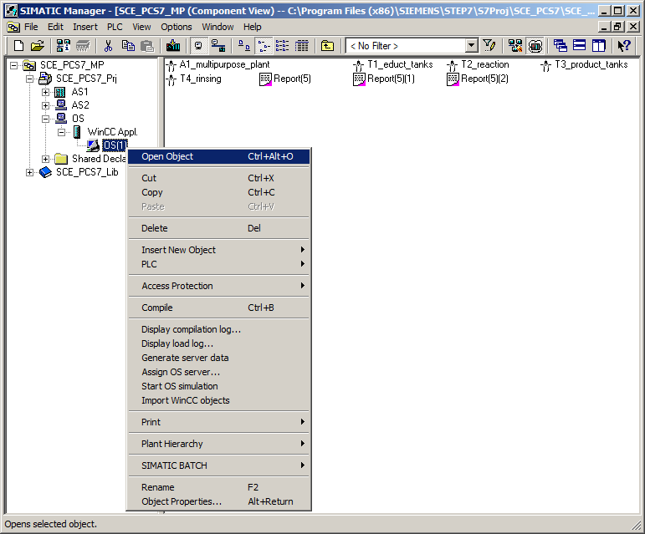

1. In WinCC Explorer, first open 'Alarm Logging' for configuring the alarm system. (® Alarm Logging)

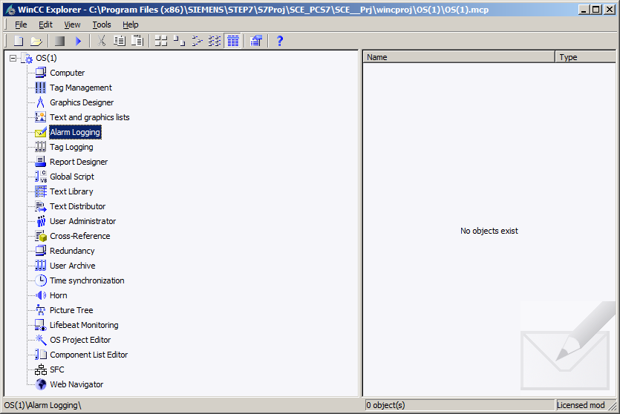

1. Select the AS messages. In the center window of Alarm Logging, you will find the individual messages and can edit their properties in the Properties area on the right edge. (® AS Messages ® Mon_A1T2L001 ® PV – Warning full)

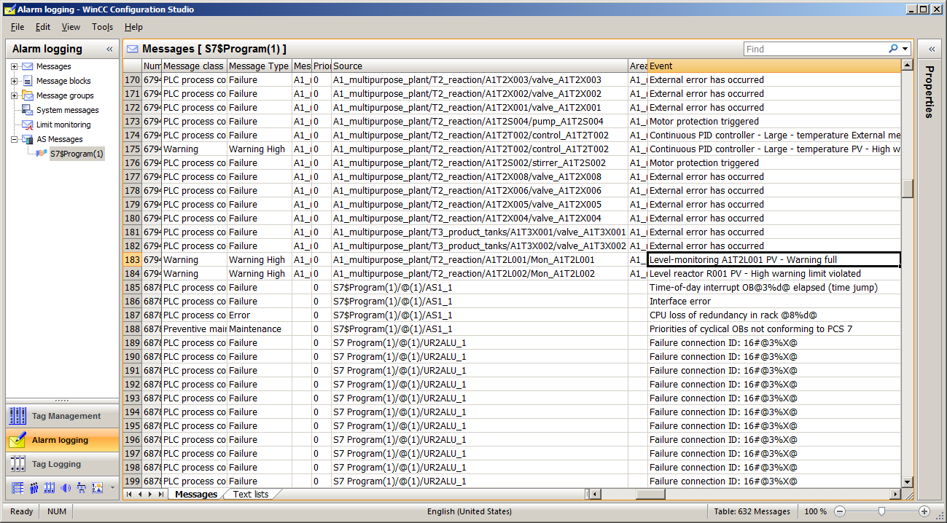



1. In the properties of the parameters, you can select, for example, whether the corresponding message is to be archived. (® Archived ® OK)

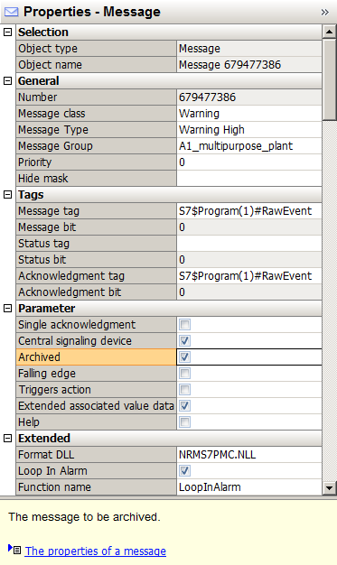

1. In the shortcut menu of the messages, under the item 'Archive Configuration', you can now select the 'Properties' of the 'Message archive' (® Messages ® Archive Configuration ® Properties)

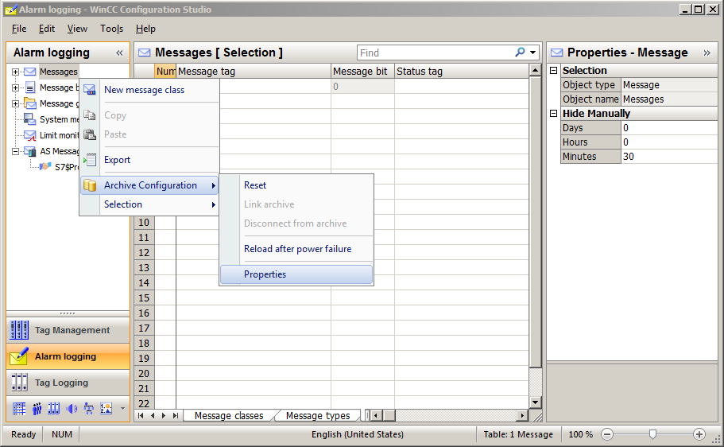

1. Under Archive Configuration, you now set the size of the entire archive and the division into segments. (® Archive Configuration ® Archive size ® Time of the segment change)

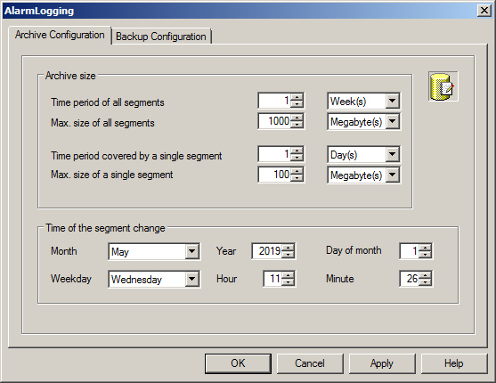

1. Under 'Backup Configuration', it is possible to activate a backup of the archive data to a 'Destination path' to ensure gapless process documentation. By default, the backup is started after the first time-dependent segment change. Accept the settings with 'OK' and exit Alarm Logging . (® Backup Configuration ® OK ® )

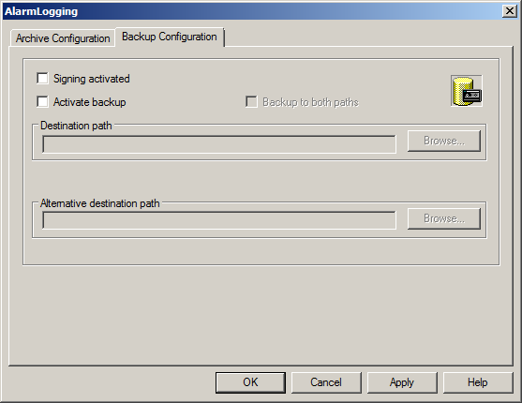

## Configuring Tag Logging

1. In WinCC Explorer, open 'Tag Logging' for configuring the process value archives. (® Tag Logging)

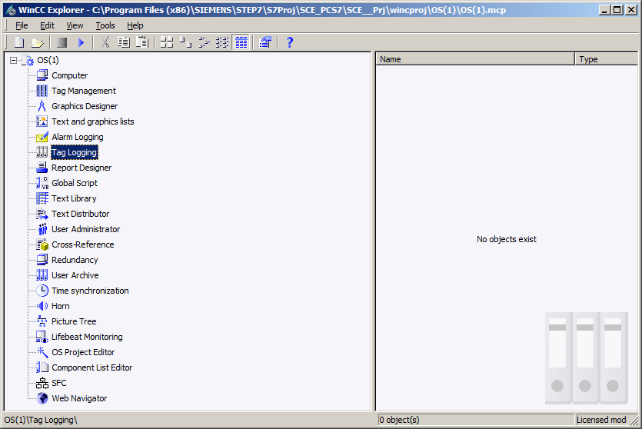

1. Process values can be archived according to different time patterns. This is important in order not to generate data volumes that are too large in the case of large archives. The shortest time is 500 ms. (® Timers ® Cycle times ® 500 ms)

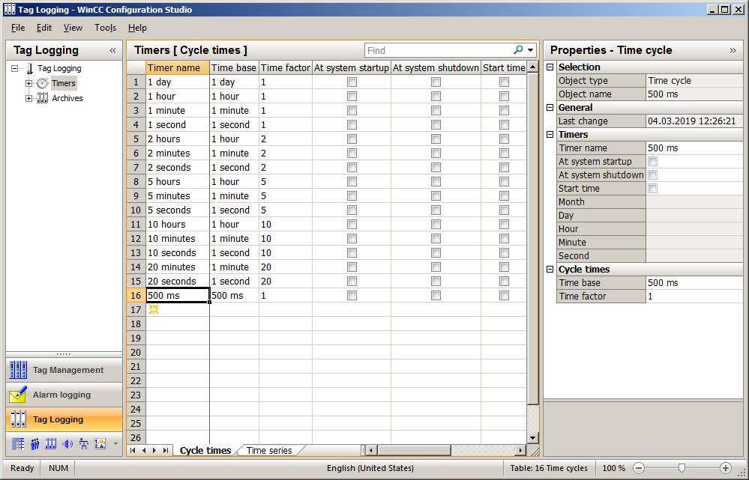

1. A 'Process Value Archive' called 'SystemArchive' is already created automatically for the PCS 7 project. Additional archives can be created in the subitems 'Process Value Archives' and 'Compressed Archives'. You will create an additional archive for a 'Compressed Archive'. The differences between these two types of archive are described via the property dialogs on the following pages. (® Archives ® Compressed Archives)

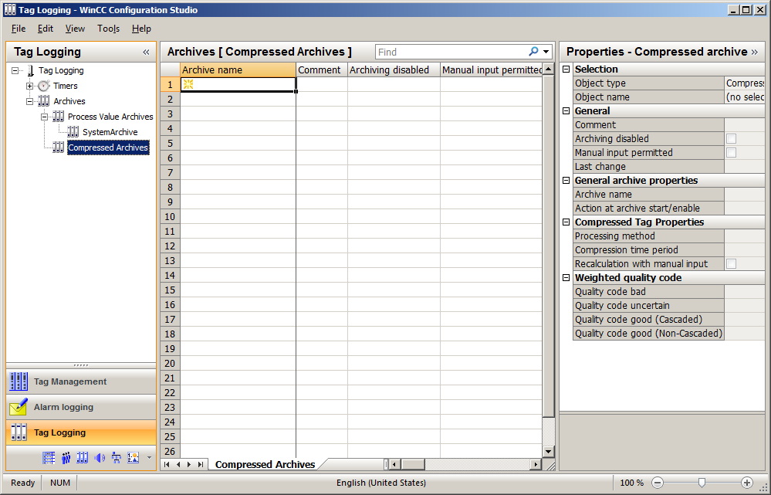

1. Assign a name to the 'Compressed_Archive'.

(®  ® Archive Name ® Compressed_Archive)

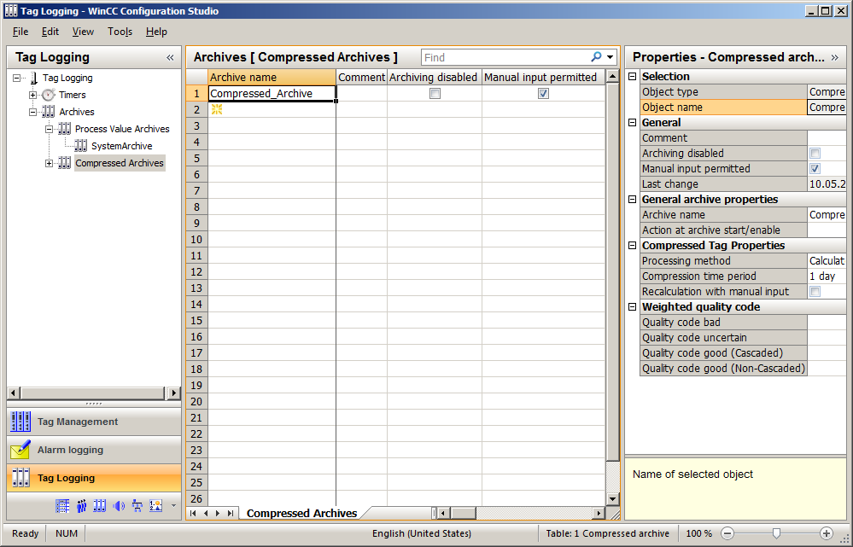

1. Now, look at the properties of such a 'Compressed Archive'.   
   (® Compressed Archive ® Properties)

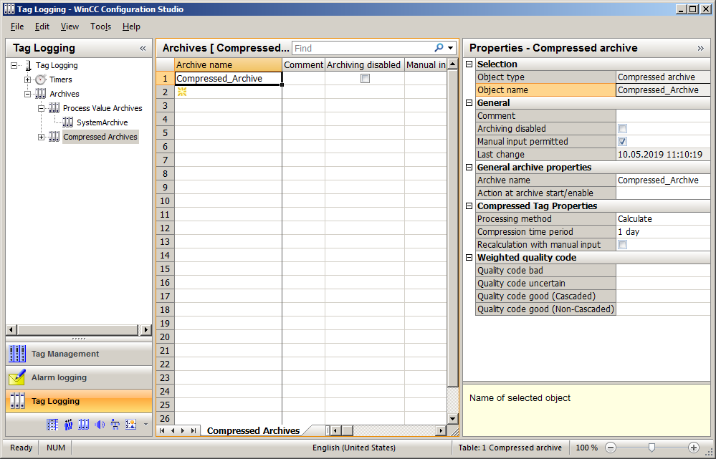

1. In the 'General' section, you can specify if this archive has already been enabled when WinCC is started and, thus, the archiving of data is to start (archiving not disabled) or if the archiving is to be enabled later via a C script. An action can also be linked to enabling/starting of the archive under 'General archive properties'. (® General ® Archiving disabled: No)

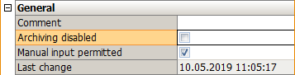

1. In the 'Compressed Tag Properties' section, the compression time period and the processing method are selected. (® Processing method: Calculate ® Compression time period: 1 day ® OK)

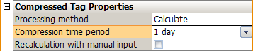

1. Tags are assigned to the compressed archives from the tags previously created in the process value archives. (®  Compressed_Archive ®  ®  ®SystemArchive ® A1_multipurpose_plant/… ® OK)

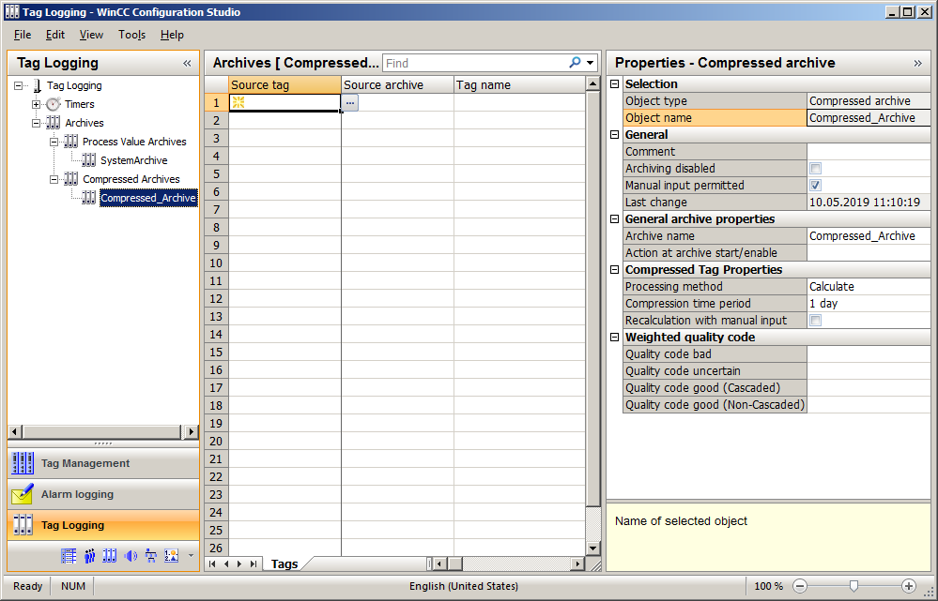

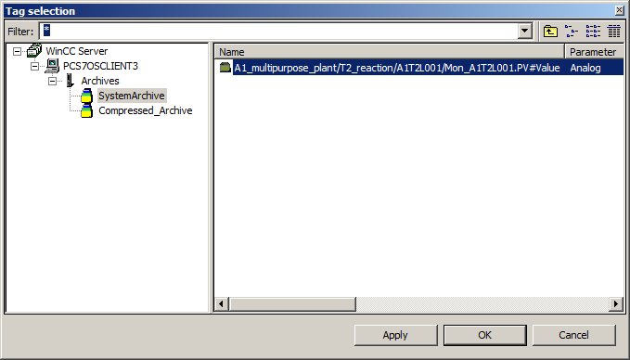

1. In the properties of the compressed tag logging, the focus will be on parameters for processing or calculating the compression. (®  Compressed_Archive ® Tag name ® Properties ® Parameters ® Processing: Average value ® Unit: ml ® OK)

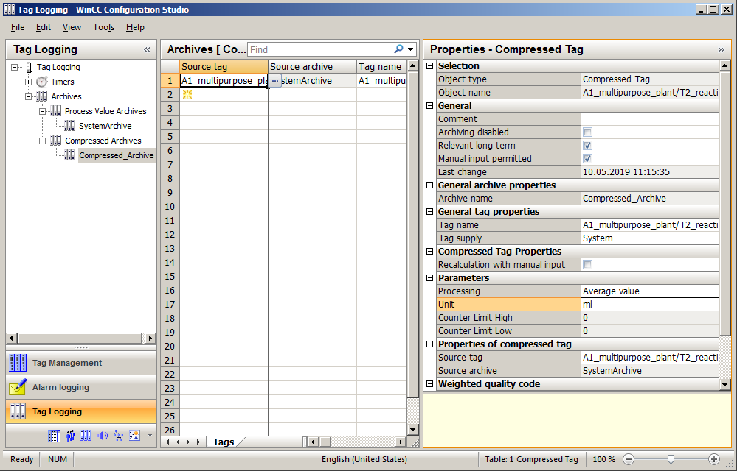

1. Then, take a look at the properties of the 'Process Value Archive'. (®  Process Value Archive ® SystemArchive ® Properties)

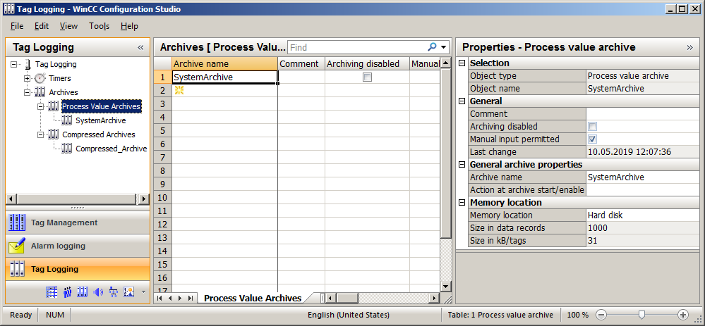

1. In the 'General' and 'General archive properties' sections, you can again specify whether this archive is to already be enabled when the OS is started (not disabled). You also specify whether an action is to be linked to the enabling/starting of the archive. (® General ® Archiving disabled: No)

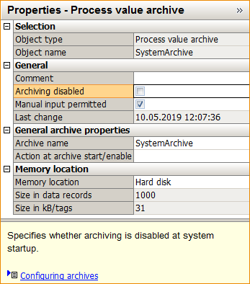

1. In the 'Memory location' section, there is the option to select the storage location for the archive. If the main memory was selected, the memory size must be restricted.   
   (® Memory location ® Hard disk)

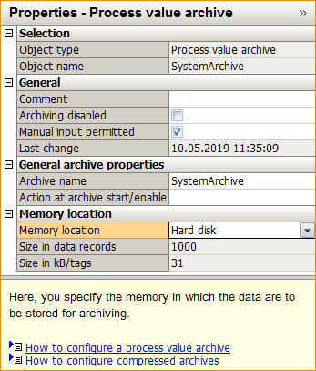

1. Now, look at the 'Properties' of the process tag that you created previously in the CFC. (®  SystemArchive ® Tag name ® Properties)

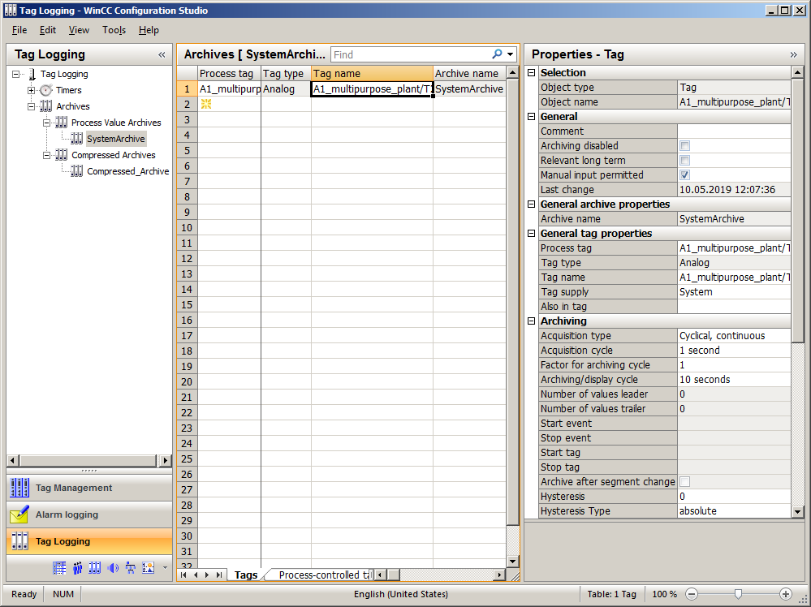

1. In the 'General' and 'General tag properties', there are basic settings for the archive tag, such as the tag supply through WinCC and not via 'Manual input', or the possible assignment to a central archive server (CAS) via 'Relevant long term'. (® Tag supply: System ® Archiving disabled: No)

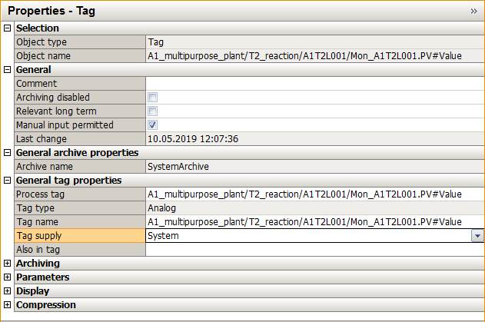

1. The archive tag is acquired according to a fixed acquisition cycle. It can be set whether archiving also follows a cyclical archiving cycle (>acquisition cycle) or whether this archiving is to take place acyclically when a change occurs (event-driven). In the 'Hysteresis' field, it is specified whether only a process value that is above or below the specified threshold in absolute (abs.) or relative (in %) terms will be archived. (® Archiving ® Acquisition type: Cyclical, continuous ® Acquisition cycle: 1 second ® Archiving/display cycle: 10 seconds)

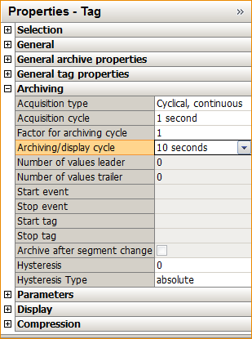

1. In the remaining 'Parameters, functions can be specified that are also to be calculated during archiving. In addition, it is possible to define the unit of the respective value. (® Parameter ® Processing: Actual value ® Unit: ml)

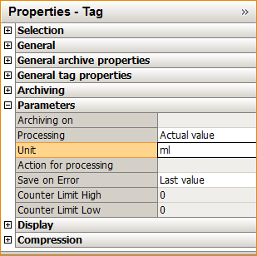

1. Now, turn to the 'Archive configuration'. There are two 'Archive types' in Tag Logging: 'TagLogging Fast' and 'TagLogging Slow'. The differences become evident in the parameters. First, the parameters for the TagLogging Fast. (®  Archives ® Archive Configuration ® TagLogging Fast ® Properties)

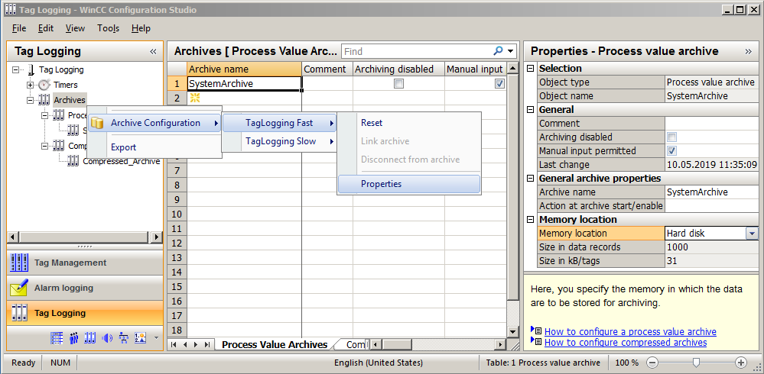

1. Under Archive Configuration, the size of the entire archive and the division into segments can be set. This item looks the same for the TagLogging slow archive type. (® Archive Configuration ® Archive size ® Time of the segment change)

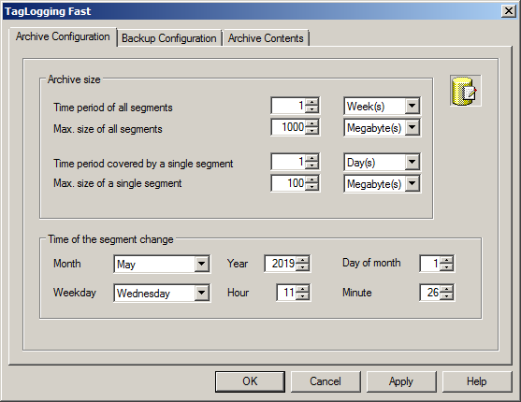

1. Under 'Backup Configuration', it is possible to activate a backup of the archive data to a 'Destination path' to ensure gapless process documentation. The backup is started by default after the first time-related segment change. (® Backup Configuration)

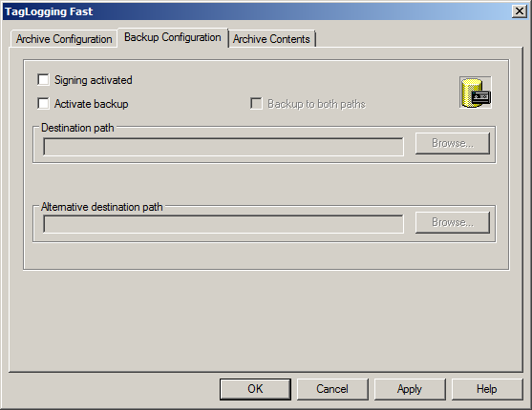

1. In the 'Archive Contents' tab, the difference compared to TagLogging Slow becomes evident. Here, the archiving criteria for TagLogging Fast are specified. The other tags with longer cycle time are located in TagLogging Slow. For the archive type TagLogging Slow, this tab does not exist. Accept the settings with 'OK' and exit Alarm Logging. (® Archive Contents ® OK ® )

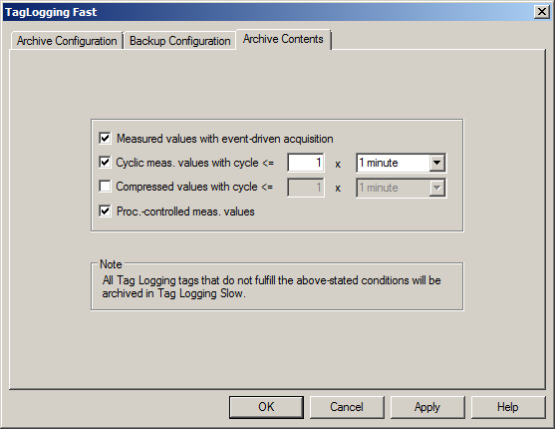

***Note:***

* *An additional individual variant of archives are the user archives. These are database tables where users can create their own data fields. User archives are used to store data and offer standardized access to this data according to SQL database description. However, this variant is not shown here, because its creation is very individual and complicated. (® User Archive ® Open ® …)*

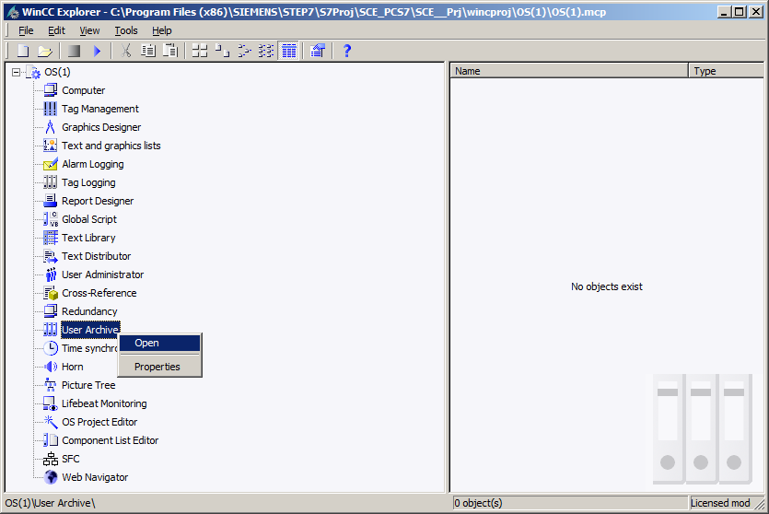

## Displaying archive data in WinCC Runtime

1. In order to display the archive data, first start OS Runtime. (® Activate OS Runtime )

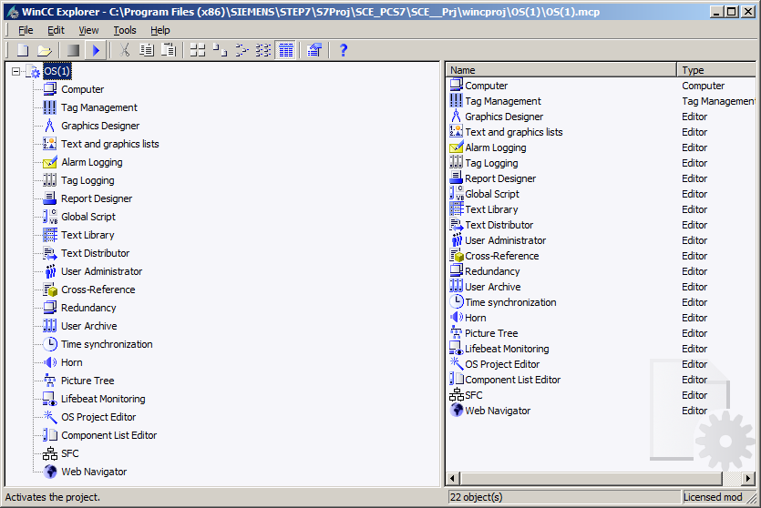

1. Click the down arrow to the right of 'A1_multipurpose_plant' and then select 'T2_reaction'. (®  ® T2_reaction)

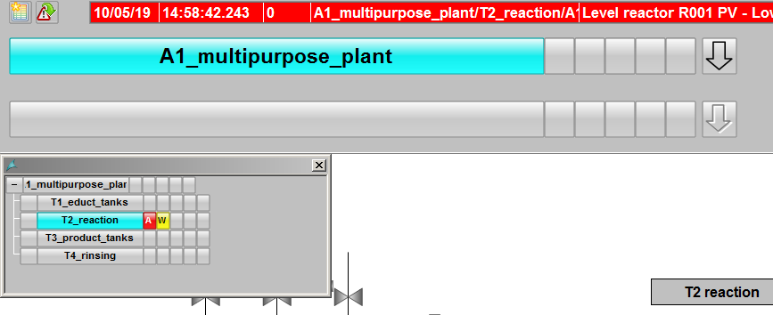

1. The simplest way to display archive data in trend form is by clicking on 041 'Assemble / retrieve trend groups'. (® Assemble / retrieve trend groups 041)

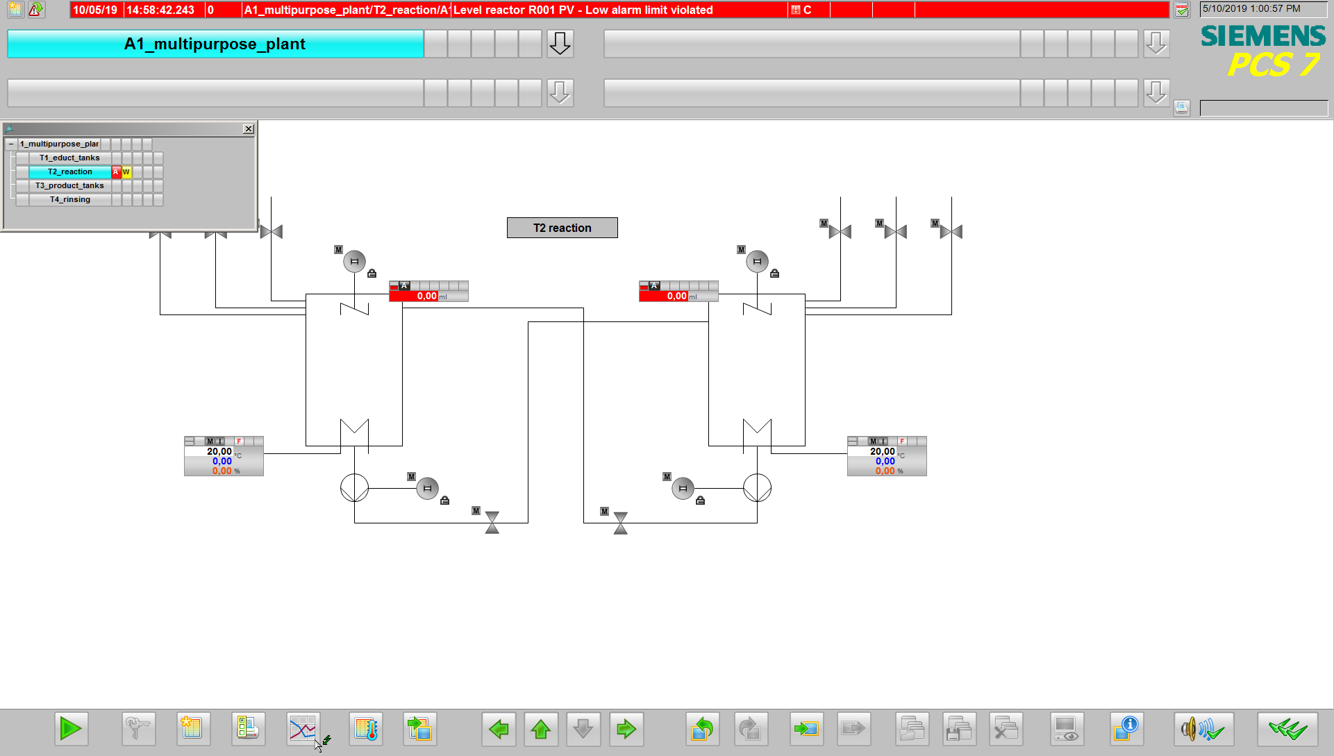

1. In the dialog below, assign a name to the 'New Trend Group' and select 'Archive' as the contents. That means that the displayed values come from an archive. As an alternative, all other online tags can be displayed directly. (® New ® Name:Trend_Group01 ® Contents: Archive ® Create)

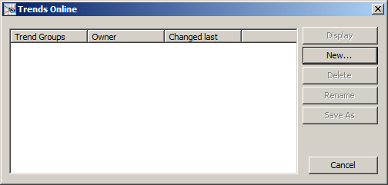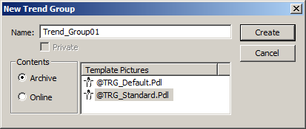

1. In the 'Trends' tab, select the folder icon next to the 'Tag name' field under 'Data Connection', and in the next dialog select the tag A1_multipurpose_plant/….   
   (® Tag name  ® SystemArchive ® A1_multipurpose_plant/… ® OK)

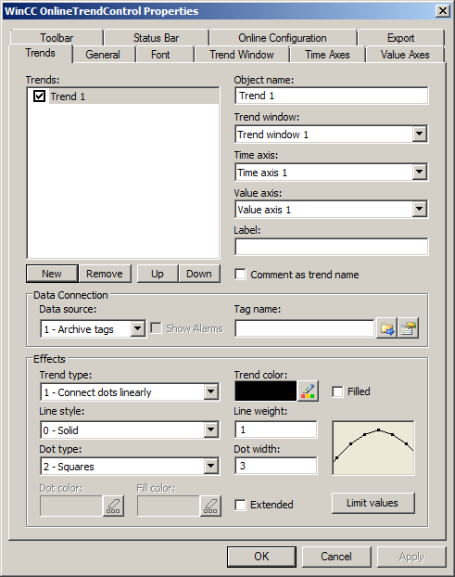

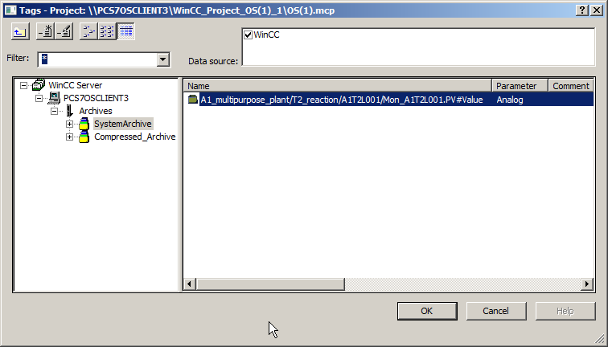

1. In the 'Value axes' tab, deselect 'Automatic' and set the value range to 0 … 1000. (® Value Axes ® deselect 'Automatic'® Value range: 0 ... 1000)

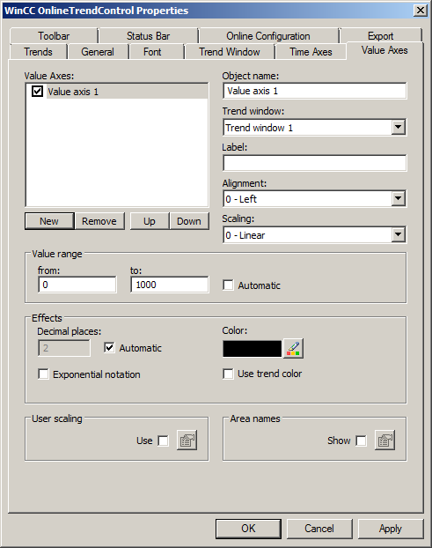

1. In the 'Time Axes' tab, select the time range 1 x 1 minute. (® Time Axes ® Time range: 1 x 1 minute)

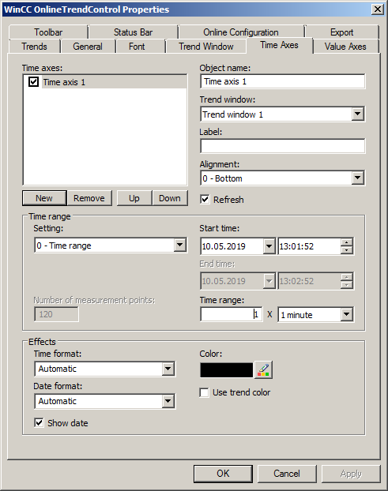

1. You now have a trend display for the archive tag whose range and segment can be modified conveniently using the task bar in the Trendgroup01 window. For displaying the trend display, the corresponding SIMIT model as well as the simulation has to be started in PCS 7.

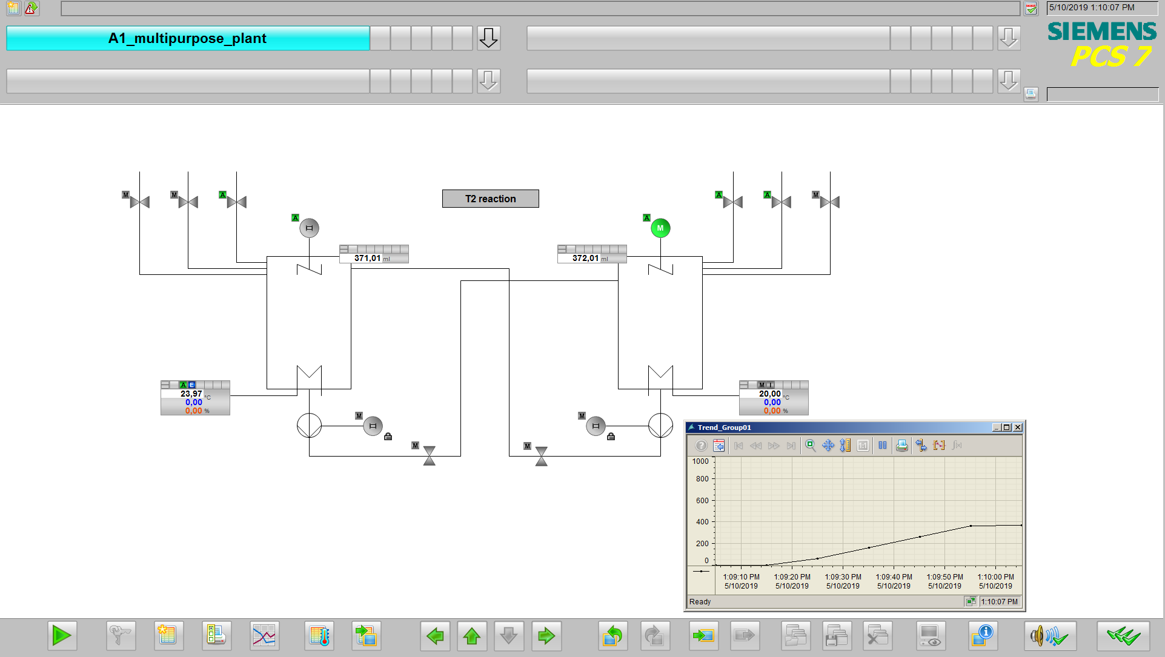

## Creating reports

1. Another variant for displaying trends from archives is to create a printout using the 'Report Designer'. Here it is important that WinCC remains started in Runtime. In the Report Designer, print jobs with contained layouts can be started. For this reason, first select a layout suitable for the archive data ('@CCTlgRTCurves_ENU.RPL') in order to adapt it. (® Report Designer ® Layouts ® English ® @CCTlgRtCurves_ENU.RPL)

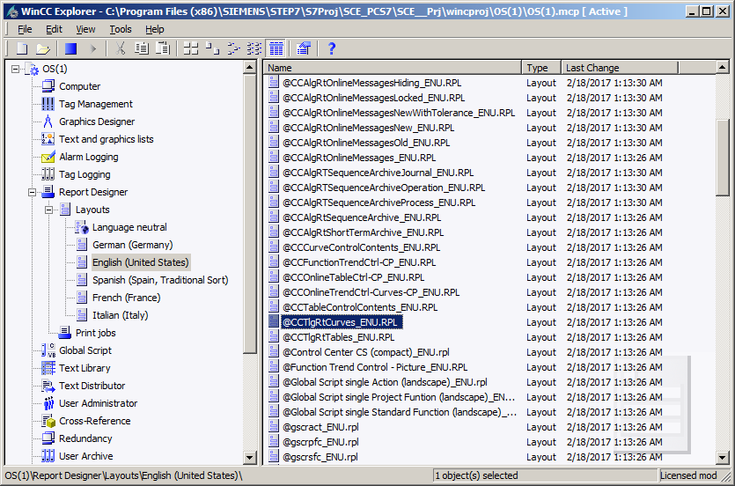

1. In the 'Report Designer Layout', the layout can now be edited. Here it is shown how the parameters of the dynamic view of the tag trend must be assigned. (® Tag Logging Runtime.Trend ® Properties)

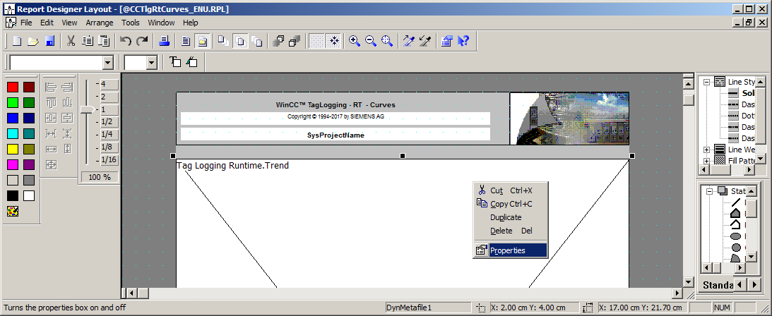

1. In the following dialog, under 'Connect' select the 'Tag Selection' for editing. Likewise, the time range, time base and format can be specified here. (® Connect ® Tag Selection ® Edit)

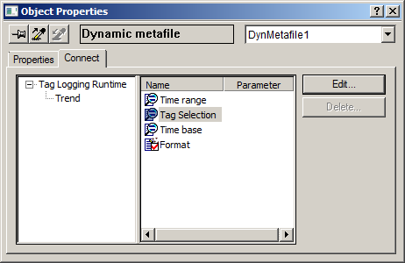

1. No tag is selected yet. Therefore, click on 'Add'. (® Add)

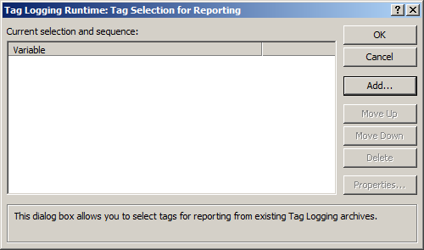

1. From 'SystemArchive': select 'A1_multipurpose plant' as the tag. (® SystemArchive ® A1_multipurpose_plant/… ® OK ® OK)

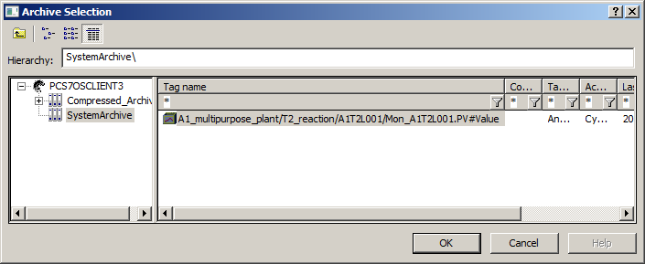

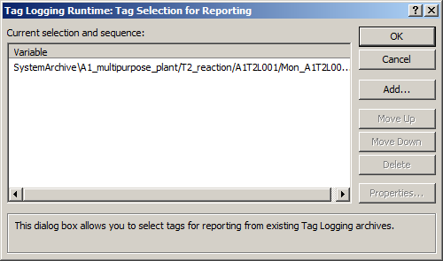

1. Close the 'Properties' dialog and save the modified layout under the same name or a different name. (® Close ® Save )

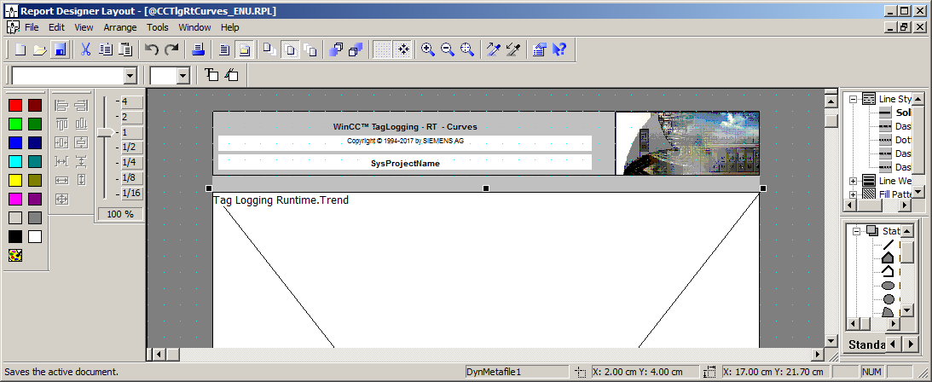

1. Now, set the properties in the print job for online trends '@Report Tag Logging RT Curves New'. (® Report Designer ® Print jobs ® @Report Tag Logging RT Curves New ® Properties)

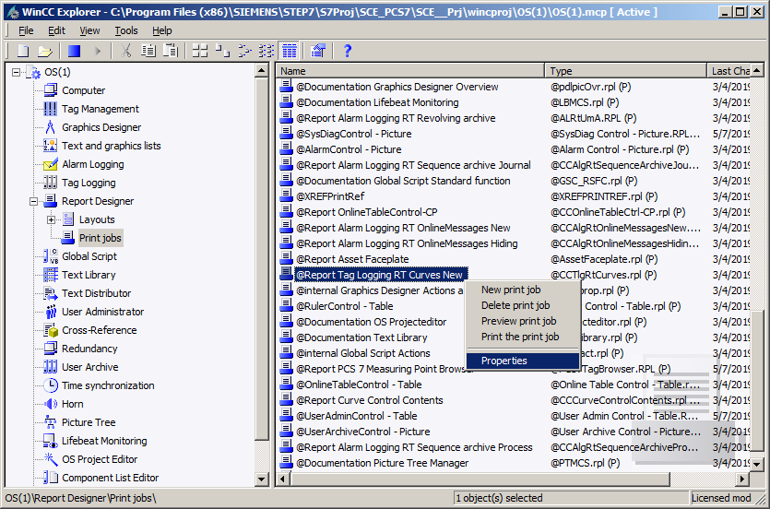

1. In the 'General' dialog, a suitable 'Layout file: @CCTlgRTCurves.RPL' is already preselected. If your own layouts were created, they can be selected here also. (® Layout file: @CCTlgRTCurves.RPL)

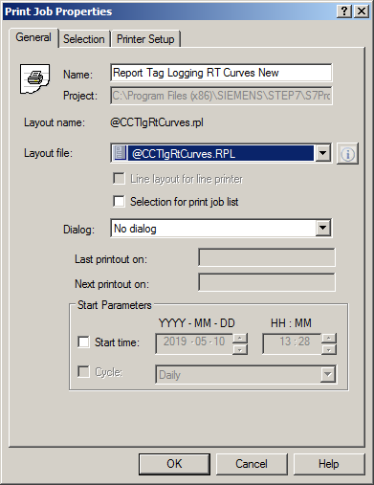

1. Under 'Selection of the print job properties', the pages and the time range are specified. (® Selection ® Page Range ® Data time range)

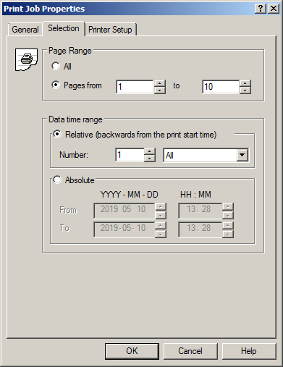

1. In 'Printer Setup', several printers can be specified sorted according to priority. (® Printer Setup ® OK)

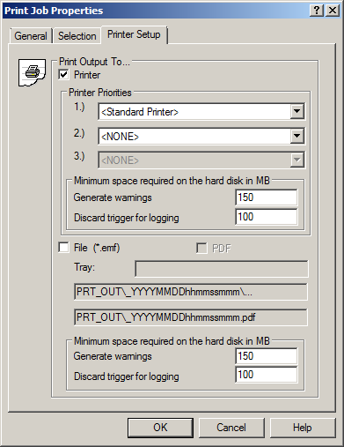

1. A printout can now be made. To save paper, you can also preview the print job. (® @Report Tag Logging RT Curves New ® Preview print job)

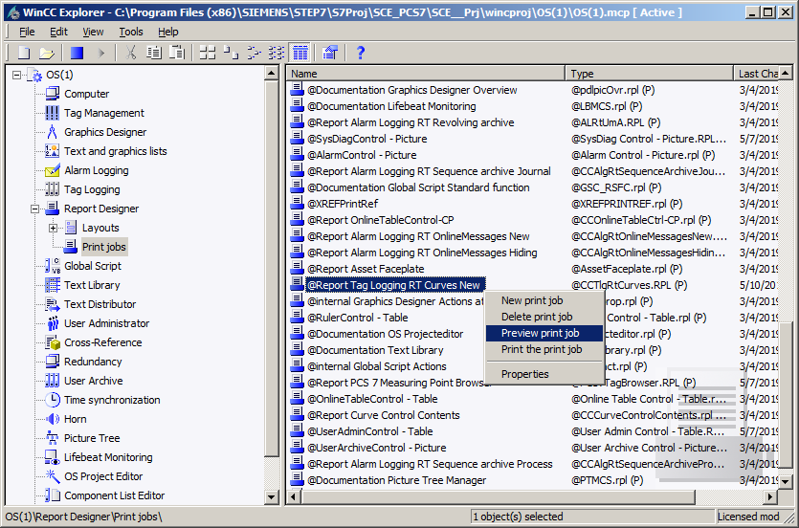

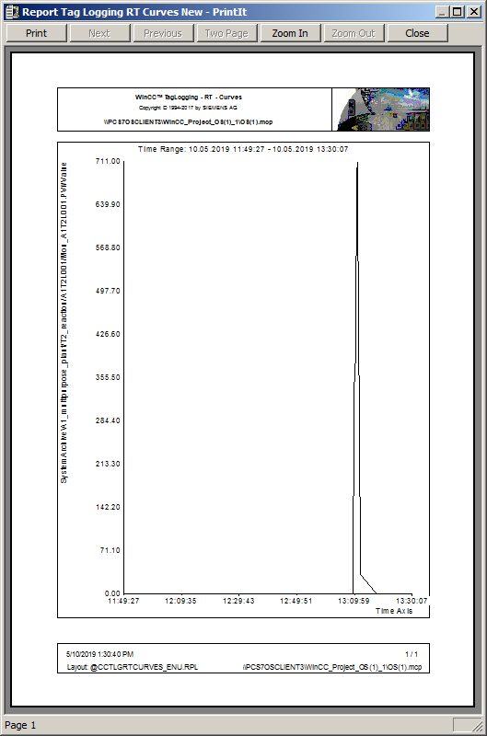

## Checklist – step-by-step instruction

The following checklist helps students to independently check whether all steps of the step-by-step instruction have been carefully completed and enables them to successfully complete the module on their own.

|  |  |  |
| --- | --- | --- |
| No. | Description | Checked |
| 1 | Messages in the MonAnS block of level measurement A1T2L001 are configured and successfully compiled |  |
| 2 | Alarm Logging configured |  |
| 3 | Tag Logging configured |  |
| 4 | Trend group successfully created |  |
| 5 | Report successfully created |  |
| 6 | Project successfully archived |  |

Table 3: Checklist for step-by-step instructions

# ExerScises

In the exercises, you apply what you learned in the theory section and in the step-by-step instructions. The existing multiproject from the step-by-step instructions (p02-03-project-r1905-en.zip) is to be used and expanded for this. The download of the project is stored as zip file "Projects" on the SCE Internet for the respective module.

The objective of this exercise is to configure two trend groups that represent various archive values for the reactors. To this end, combine the temperature- and controller-relevant data in the first trend group and the level-relevant data in the second trend group.

## Tasks

1. Archive all values that are level-, temperature- and controller-relevant. Edit the corresponding blocks in a way that these values are archived.
2. Define a trend group for Reactor R001 that displays the values of the PID controller. Add all relevant archive tags. Do the same for Reactor R002. Try different time axis and value axis settings.
3. The level-relevant data of the reactors is to be visualized together. Select them and display them.
4. 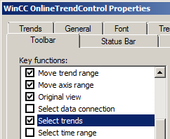Test different settings in the configuration dialog. Search for a function that can be used to select and deselect individual trends of the trend group.

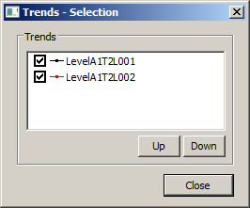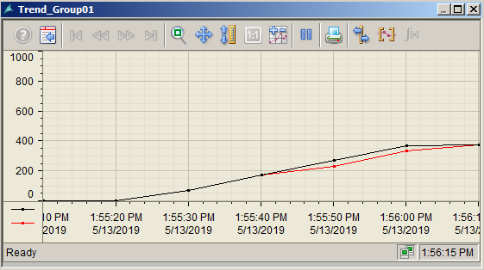

***Note:***

* *To make the trend selection visible, you must select the 'Select trends' check box in the 'Toolbar' tab in the configuration dialog* .

The tasks below were not realized in the exercise project. However, they are typical for planning archive systems.

1. Which process values should be archived for an easy-to-follow and gapless display? Develop a concept and implement it.
2. Calculate the memory needed for the tag "Tag Logging Fast". As the number of process values, utilize the results from the first task. For the analog process values, once assume 6 bytes for each process value and once 16 bytes for each process value. One segment is to store the process values for 2 weeks and all segments at least half a year.
3. Also calculate the memory requirement for Alarm Logging by assuming 4 messages per minute. One message requires 4000 bytes memory.
4. Based on the results, distribute the assumed 10 GB memory to the Tag Logging Fast, Alarm Logging and Tag Logging Slow archives. Then set the properties of the archives in your project.

## Checklist – exercise

The following checklist helps students to independently check whether all steps of the exercise have been carefully completed and enables them to successfully complete the module on their own.

|  |  |  |
| --- | --- | --- |
| No. | Description | Checked |
| 1 | Archiving for 2x level, 2x temperature and (2x3)x controlling configured |  |
| 2 | Trend groups created for Reactors R001 and R002 with 3 controller tags each |  |
| 3 | Trend group created for levels of Reactors R001 and R002 |  |
| 4 | Trends successfully shown and hidden in trend groups |  |
| 5 | Concept for gapless display of process valued created and implemented |  |
| 6 | Segment sizes and memory requirements calculated for Tag Logging Fast |  |
| 7 | Memory requirements calculated for Alarm Logging |  |
| 8 | 10 GB distributed among archives according to calculations and configured in the project |  |
| 9 | Project successfully archived |  |

Table 4: Checklist for exercises

# Additional information

More information for further practice and consolidation is available as orientation, for example: Getting Started, videos, tutorials, apps, manuals, programming guidelines and trial software/ firmware, under the following link:

[siemens.com/sce/pcs7](http://www.siemens.com/sce/pcs7)

**Preview "Additional information"**

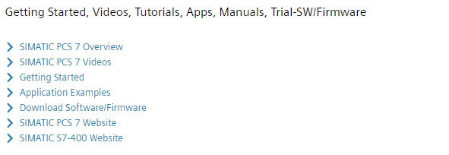

Further Information

Siemens Automation Cooperates with Education  
**siemens.com/sce**

Siemens SIMATIC PCS 7  
**siemens.com/pcs7**

SCE Learn-/Training Documents  
**siemens.com/sce/documents**

SCE Trainer Packages  
**siemens.com/sce/tp**

SCE Contact Partners   
**siemens.com/sce/contact**

Digital Enterprise  
**siemens.com/digital-enterprise**

Industrie 4.0   
**siemens.com/future-of-manufacturing**

Totally Integrated Automation (TIA)  
**siemens.com/tia**

TIA Portal  
**siemens.com/tia-portal**

SIMATIC Controller  
**siemens.com/controller**

SIMATIC Technical Documentation   
**siemens.com/simatic-docu**

Industry Online Support  
**support.industry.siemens.com**

Product catalogue and online ordering system Industry Mall   
**mall.industry.siemens.com**

Siemens  
Digital Industries, FA   
P.O. Box 4848  
90026 Nuremberg  
Germany

Subject to change and errors  
© Siemens 2020

**siemens.com/sce**