

Learn-/Training Document  
  
Siemens Automation Cooperates with Education (SCE) | As of Version V9 SP1

**siemens.com/sce**

PA Module P02-02   
SIMATIC PCS 7 – Alarm engineering



**Matching SCE Trainer Packages for this Learn-/Training Document**

* **SIMATIC PCS 7 Software Package V9.0 (set of 3)**  
  Order No.: 6ES7650-0XX58-0YS5
* **SIMATIC PCS 7 Software Package V9.0 (set of 6)**   
  Order No.: 6ES7650-0XX58-2YS5
* **SIMATIC PCS 7 Software Upgrade Packages (set of 3)**  
  Order No.: 6ES7650-0XX58-0YE5 (V8.x🡪 V9.0)
* **SIMIT Simulation Platform with Dongle V10**  
  (contains SIMIT S & CTE, FLOWNET, CONTEC libraries) – 2500 simulation tags  
  Order No.: 6DL8913-0AK00-0AS5
* **Upgrade SIMIT Simulation Platform V10**  
  (contains SIMIT S & CTE, FLOWNET, CONTEC libraries) from V8.x/V9.x  
  Order No.: 6DL8913-0AK00-0AS6
* **Demo Version SIMIT Simulation Platform V10**  
  [Download](https://support.industry.siemens.com/cs/ww/en/ps/17120/dl)
* **SIMATIC PCS 7 AS RTX Box (PROFIBUS) only in combination with ET 200M for RTX –**   
  Order No.: 6ES7654-0UE23-0XS1
* **ET 200M for RTX Box (PROFIBUS) only in combination with PCS 7 AS RTX Box –**  
  Order No.: 6ES7153-2BA10-4AB1

Note that these trainer packages are replaced with successor packages when necessary.

An overview of the currently available SCE packages is available at: [siemens.com/sce/tp](http://www.siemens.com/tp)

**Continued training**

For regional Siemens SCE continued training, get in touch with your regional SCE contact

[siemens.com/sce/contact](http://www.siemens.com/contact)

**Additional information regarding SCE**

[siemens.com/sce](http://www.siemens.com/sce)

**Information regarding use**

The SCE Learn-/Training Document for the integrated automation solution Totally Integrated Automation (TIA) was prepared for the program "Siemens Automation Cooperates with Education (SCE)" specifically for training purposes for public educational facilities and R&D institutions. Siemens does not guarantee the contents.

This document is to be used only for initial training on Siemens products/systems, which means it can be copied in whole or part and given to those being trained for use within the scope of their training. Circulation or copying this Learn-/Training Document and sharing its content is permitted within public training and advanced training facilities for training purposes.

Exceptions require written consent from the Siemens. Send all related requests to

[scesupportfinder.i-ia@siemens.com](mailto:scesupportfinder.i-ia@siemens.com).

Offenders will be held liable. All rights including translation are reserved, particularly if a patent is granted or a utility model or design is registered.

Use for industrial customer courses is explicitly not permitted. We do not consent to commercial use of the Learn-/Training Document.

We wish to thank the TU Dresden, particularly Prof. Dr.-Ing. Leon Urbas and the Michael Dziallas Engineering Corporation and all other involved persons for their support during the preparation of this Learn-/Training Document.

Table of contents

1 Goal 5

2 Prerequisite 5

3 Required hardware and software 6

4 Theory 7

4.1 Theory in brief 7

4.2 Alarm systems 8

4.3 Alarms and messages 9

4.4 Alarm processing by the operator 11

4.5 Alarm management in PCS 7 14

4.6 References 15

5 Task 16

6 Planning 16

7 Learning objective 16

8 Structured step-by-step instructions 17

8.1 Addition of monitoring to the level monitoring 17

8.2 Monitoring in faceplate T2_Reaction 21

8.3 Analog level display in faceplate A1_multipurpose_plant 24

8.4 Binary level display 29

8.5 Messages in WinCC Runtime 34

8.6 Checklist – step-by-step instruction 36

9 Exercises 37

9.1 Tasks 37

9.2 Checklist – exercise 38

10 Additional information 39

Alarm engineering

# Goal

In this module, the students become familiar with the fundamentals of an alarm system. They understand the purpose and the areas of application of alarm and signaling systems and they know the requirements for such systems resulting from this. They become familiar with the possibilities of representation and interactions with messages and alarms. This will enable the students to design a suitable and usable alarm management in PCS 7.

# Prerequisite

This chapter builds on chapter 'Functional safety'. To implement this chapter, you can use an existing project from the previous chapter or the archived project 'p02-01-exercise-r1905-en.zip' provided by SCE. The download of the project(s) is stored on the SCE Internet for the respective module.

The (optional) simulation for the SIMIT program can be retrieved from the file 'p01-04-plantsim-v10-r1905-en.simarc'. It can be run in demo mode.

# Required hardware and software

1. Engineering station: Requirements include hardware and operating system   
   (for further information, see Readme on the PCS 7 installation DVD)
2. SIMATIC PCS 7 software V9 SP1 or higher

* Installed program packages (contained in SIMATIC PCS 7 Software Trainer Package):
  + *Engineering → PCS 7 Engineering*
  + *Engineering → BATCH Engineering*
  + *Runtime → Single Station → OS Single Station*
  + *Runtime → Single Station → BATCH Single Station*
  + *Options → SIMATIC Logon*
  + *Options → S7-PLCSIM V5.4 SP8*

1. Demo Version SIMIT Simulation Platform V10

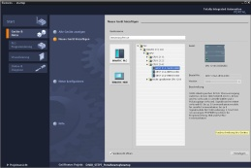

**3** SIMIT V10 or higher



**1** Engineering Station

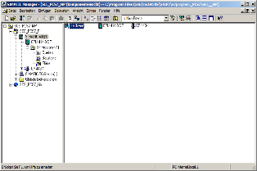

**2** SIMATIC PCS 7

V9 SP1 or higher

# Theory

## Theory in brief

Alarm systems play an extremely important role in modern process control concepts for the economic operation of process plants. Designed ergonomically, they inform the operating personnel specifically if there are unintended deviations of the process state from a defined normal state (refer also to the chapter 'Functional Safety'). They allow the operator to locate the cause of the malfunction directly and to adjust the process control strategy through tailored interventions As a result, specification-conforming products can continue to be manufactured despite the fault, or the process can be stabilized in a way that the fault causes a minimal production outage.

The **PCS 7** control system includes a number of technical resources for implementing an alarm system. The palette ranges from function blocks for generating alarms, icons for representing alarm states and group alarms along the plant hierarchy to components for representing and managing alarms in lists (refer to Figure 1).

By following a set of design rules for specifying alarms texts and assigning priorities, an effective alarm system can be implemented very efficiently that meets all the requirements of the applicable national and international standards and guidelines.

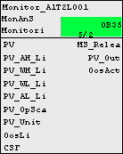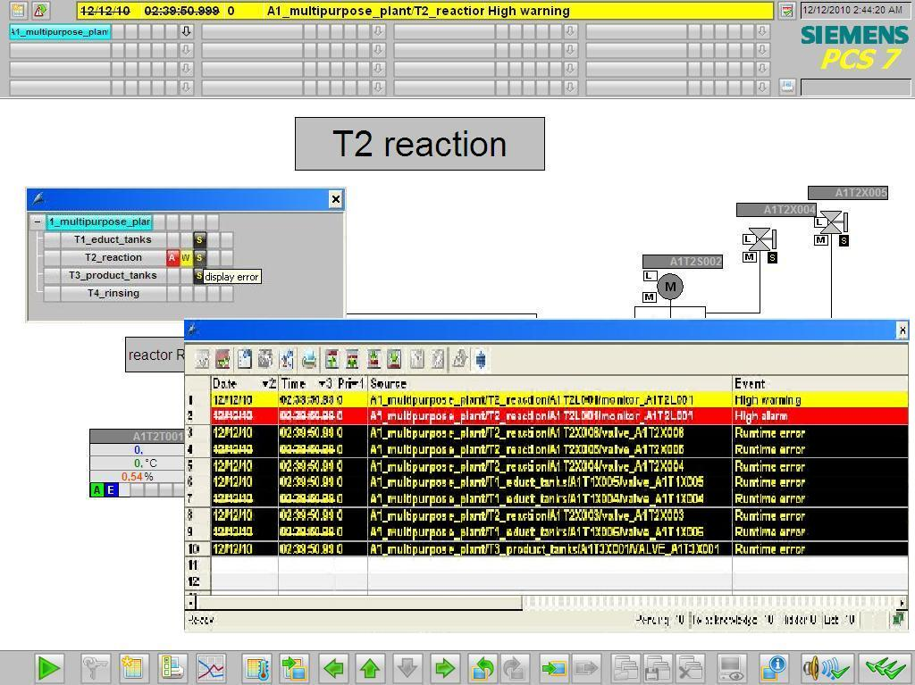

Figure 1: From alarm block to display in the faceplate and alarm lists

## Alarm systems

Through the consistent use of modern process control engineering, process plants are highly automated and optimized regarding safety. For this reason, the operator of such a plant monitors a largely automated process that only requires operator control actions if, because of a fault state of the process or the plant, a manual intervention is necessary. The objective of such a manual intervention is always to return the process to the OK range (refer also to the chapter ‘Functional Safety') before the automatic safety devices are activated.

Since safety devices generally take the monitored technical facility to a safe state, this results in a loss in product quality, production delays or even the standstill of the entire production. This has a considerable negative effect on the economics of the plant. For that reason, the risk that an impermissible fault state will trigger a safety device must be recognized early so that a suitable manual intervention can prevent this. In addition, the operator is to be informed of the activation of a safety device so that the consequences can be monitored.

The alarm system is the central interface between the operator and the monitored process and provides everything for managing messages and alarms in the control system [2]. It allows the operate to detect deviations from normal conditions within the range of the intended operation early and to specifically counteract them. Figure 2 shows the four phases of interaction between the operator and the alarm system of the process control system.

**Alarm system   
of DCS**

**Operator**

**Representation**

**Generation**

**Assessment**

**Operator**

**action**

**Process**

**plant**

Figure 2: Phases of interaction according to [2]

This means the alarm system has to provide the operator with the capability and the opportunity to respond suitably to a signaled event. To attain this, the system has to meet a number of requirements. Messages and alarms must be represented **clearly, transparently** and **consistently**.

Operators are supported in the situation-oriented evaluation of a message or an alarm as well as in the selection of suitable intervention. For this, it is necessary to provide a suitable prompt for action, depending on the process state.

To prevent the operator from becoming overwhelmed, the frequency of appearance of messages and alarms must be minimized. The operator can also be supported in his work with suitable tools for documenting and evaluating messages and alarms.

When designing an alarm system, the performance capability limits of the future operators have to be taken into account. The total volume of tasks that an alarm system requires an operator to perform must not exceed human performance limits either in the short term or long term.

On the one hand, a short-term sudden rise in the number of alarms or of the alarm rate can cause the operator to be briefly overloaded (alarm shower). Note here that on average, an operator cannot process more than 7 items of information at the same time (***7±2 rule***).

On the other hand, a long-term high workload due to a constantly high number of arriving alarms can cause the operator to be permanently overloaded. This leads to an increasing drop of the operator's performance and reliability.

In order to quickly spot important alarms and rare events, they must be highlighted to draw the user's attention. Important information should be presented redundantly to make it easier to notice. Moreover, if possible, several sensory channels should be addressed for transmitting information (for example, through acoustic warning signals).

Only if an alarm system meets these requirements can it actually support the operator in his job of monitoring and controlling the plant.

## Alarms and messages

Alarm systems are used to manage messages and alarms in control systems. In general, a "message" is any report or indication of the occurrence of a specific event. However, in the narrower sense the term is used only for such messages that do not require an immediate operator response [1].

Otherwise, the term "alarm" is used. The term "message" is thus used as both as a generic term and a narrower term. To avoid confusion, the following definitions apply consistently in the following:

* Alarm: Indication or report of the occurrence of an event that requires an immediate operator response. The response may involve an activity; for example, performing an operator control action. However, it can also be only a mental response, for example, to increased attention.
* Message: Indication or report of the occurrence of an event occurred that requires no immediate operator response.

Alarms signal deviations of the process or of the plant from the normal state and allow the operator to avert a dangerous situation or economic damage. To fulfill this task, good alarms have to have the following features [3]:

* Relevant: The alarm is justified and valuable to the operator.
* Clear: The alarm contains information for the operator. It does not repeat another alarm.
* Timely: The alarm arrives close to the time when an intervention is necessary. It arrives in time for the operator to intervene.
* Prioritized: The alarm provides information on how urgent the operator response is.
* Can be understood: The alarm contains information that can be understood clearly and easily.
* Diagnostic: The alarm allows the operator to identify the problem that occurred.
* Instructional: The alarm provides suitable action instructions to solve the problem that occurred.
* Focusing: The alarm guides the attention to the most important problems

Alarms should always be used purposefully. In so doing, it must be clarified what is being monitored, how it is being monitored and when an alarm is triggered. Furthermore, it must be defined how the operator can respond to an alarm. Based on these criteria, alarms can be subdivided into a variety of alarm types (refer to [3]).

The most important types are:

* Absolute alarm: The alarm is generated when a specified limit is exceeded or dropped below.
* Time delayed alarm: The alarm is generated when the alarm criterion is met for a specified time span.
* Process alarm: The control system itself generates an alarm that requires an immediate operator response.

## Alarm processing by the operator

The operator processes alarms in three phases: First, the operator must recognize that a problem has occurred (1st phase: Recognition). To this end, the alarm system must draw the operator's attention to the problem. The operator must then identify the cause of the problem with the help of the control system (2nd phase: Identification). Once the operator has identified the cause, he can introduce measures to eliminate the problem and compensate for the consequences of the problem (3rd phase: Troubleshooting). During each of these phases, the alarm system must support the operator in a suitable manner. Table 1 lists the most important support capabilities of the alarm system.

|  |  |
| --- | --- |
| Phase | Supporting options of the alarm system |
| Recognition | * Effective guidance of attention * Suitable presentation of information * Pre-processing and sampling information |
| Identification | * Significant description of errors * Tools for investigation of errors * Jumping to the appropriate operator display of PCS |
| Troubleshooting | * Significant instructions for solving the problem * Jumping to the appropriate operator display of PCS for operator intervention |

Table 1: Capabilities of the alarm system to support alarm processing

To make appropriate alarm processing possible for the operator of a plant, alarms that occur have to be suitably managed by the alarm system. Alarm management supports all phases of interaction between the operator and the alarm system of the process control system.

Generation

Messages and alarms are generated at the process level in the devices of the control equipment of the plant. Generation may be linked to certain conditions (for example, timing conditions, hysteresis) and is carried out always with time-synchronous stamping.

When defining messages and alarms, the operator's reaction time has to be taken into account. After a message or an alarm has occurred, the operator must have sufficient time to eliminate the reported problem before a subsequent alarm is triggered.

This can be easily illustrated using the overflow protection of a reactor as an example. Corresponding to the inflow rate of the reactor, a defined time elapses between the overflow message and the corresponding overflow alarm. If the operator's counter measures cannot take effect in time, the message is not useful to the operator since the alarm and the automated safety function are triggered in any case.

Prioritization

Large process plants have a considerable number of alarm sources available that in turn can trigger different types of alarms. To keep this diversity controllable for the operator, it is advisable to structure the alarm system. A suitable method for this is alarm prioritization. This refers to the unambiguous classification of all alarms of an alarm system according to their importance and urgency [2]. If several alarms are accumulating, a processing sequence can be suggested to the operator based on alarm priorities.

**Priority**

|  |  |  |  |
| --- | --- | --- | --- |
| **Response time** | **Seriousness** | | |
| **Priority** | Shutdown | Off spec | Delay in production |
| < 5 min | **High** | **Medium** | **Low** |
| 5 - 20 min | **Medium** | **Low** | **Low** |
| > 20 min | **Low** | **Low** | **Low** |

Figure 3: Example of a prioritization matrix according to [2]

To this end -as shown in

|  |  |  |  |
| --- | --- | --- | --- |
| **Response time** | **Seriousness** | | |
|  | Shutdown | Off spec | Delay in production |
| < 5 min | **High** | **Medium** | **Low** |
| 5 - 20 min | **Medium** | **Low** | **Low** |
| > 20 min | **Low** | **Low** | **Low** |

Figure 3- a prioritization matrix can be set up. It depends on the requirements of the respective process plant and is usually used for the entire plant. Corresponding to this matrix, each individual alarm is assigned a priority (static prioritization).

Alternatively, alarms can also be prioritized depending on the current plant situation and the combination of other queued alarms (dynamic prioritization). Usually, alarms are marked in color according to their priority.

Prioritization is designed in a way that the long-term average alarm rate for each operator station in normal operation is not more than one alarm every ten minutes [2]. For this reason, an appropriate priority distribution is the aim. For example:

* 5% Priority High
* 15% Priority Medium
* 80% Priority Low

The reduction of operator load resulting from this avoids overload consequences and ensures necessary time is left free for operator control and monitoring [2].

Representation

The representation of alarms is of vital importance to the usability of an alarm system. The representations below have proven themselves in practice and have prevailed [2]:

* Area overview of alarms: Arrangement of the alarms in an overall view that cannot be covered up (also called common status display). The alarms are arranged in a way that they can be assigned directly to the corresponding plant sections. Using corresponding jump functions, the assigned process and plant pictures are directly accessible.
* Representing alarms using an alarm list: Listing of the queued alarms in list form. Numerous options are available for sorting and filtering the list. Jump functions to the assigned process and plant pictures are also often offered in this type of representation.
* Alarm representation in a schematic flow diagram: Alarms are signaled through saturated colors (preferably red or yellow) of the corresponding symbols in the process or plant picture.
* First value alarm system: If alarms accumulate, the system determines the primary alarm and filters out the subsequent alarms resulting from it. For the operator, this decreases the number of alarms he has to process.

Often, the graphic representations are supplemented by visual or acoustic signal transmitters. They additionally inform operators that an alarm has occurred.

Operators must acknowledge alarms and messages that occurred. With that action, operators document that they have taken notice of the state change.

Evaluation

In order to evaluate an alarm or a message, the operator must be able to interpret the current process and plant state correctly. He is assisted in doing this by the types of representation just discussed, by suitable alarm texts and alarm descriptions as well as suitable tools for pre-processing larger alarm volumes.

Operator intervention

After the operator has evaluated the state of the plant and the consequences of the alarm, he must decide on an appropriate action and implement it. This takes place within the control system but outside the alarm system. It is therefore extremely helpful to the operator if he can jump from the alarm system directly to the corresponding faceplate where the necessary operator control intervention can be taken. Often, alarm systems provide corresponding jump functions. In addition, decisions regarding operator action are supported with help texts that are assigned to the different alarms.

## Alarm management in PCS 7

PCS 7 has an efficient alarm system. It informs the plant operator about occurring events and indicates them in the form of message lists and a group display during process operation. An additional list shows the operator control interventions of the plant operator. The message display is configured in WinCC.

PCS 7 differentiates three message classes [4]:

* Process control messages are generated in PCS 7 by driver blocks if they detect faults in their own components (AS, OS etc.) These messages do not have to be configured.
* Process messages signal events of the automated process such as limit violations and operational messages. These messages do not have to be configured. However, alarm texts and priority can be changed if needed.
* Operator input messages are generated when process tags are controlled, for example, on a changeover of the operating mode. Operator input messages are generated automatically if the faceplates of the PCS 7 Advanced Process Library or user-configured, PCS 7-compliant blocks are used.

Messages for the AS and distributed I/O are configured when the CFCs are created or in the process object view. Messages of block types or individual block instances can be changed, and a user's own alarm texts can be configured. SFCs, types and instances can also generate messages.

Messages for the OS are configured using the Alarm Logging application in WinCC Explorer. There, the triggering event is specified for a message.

When configuring messages, different aspects have to be taken into account: The most important aspects are explained briefly below:

* Alarm text Blocks with signaling behavior have preset alarm texts with the corresponding alarm class and alarm type. These texts and attributes can be adapted depending on requirements. In addition, information from the process or the block comment can be inserted in the message text as associated values.
* Alarm number***:*** During compilation, each message configured in the engineering station is automatically assigned a unique message number in alarm logging. The alarm number range is specified when the project is set up. Alarm numbers are assigned either project-wide or CPU-wide and are unique. The latter is a precondition for assigning message priorities.
* Alarm priority: A message can be assigned a priority between 0 (the lowest) and 16 (the highest). Alarm lists can be sorted and filtered by priority. The message line in the overview area always displays the message that has the highest priority and has not yet been acknowledged.

Technological blocks that are visualized on the OS have the Loop-In-Alarm function. This makes it possible to change directly from the alarm list to the corresponding faceplate in the case of process messages and process control messages.

PCS 7 uses a central acknowledgment concept. If a message is acknowledged on an OS, the acknowledgment is sent first to the triggering block and is forwarded from there to all other relevant operator stations.

## References

[1] VDI 3699 (Edition 2014-01): Process control using display screens.

[2] NAMUR NA 102 (Edition 2008-10): Alarm Management.

[3] EEMUA 191 (Edition 2013, Edition 3): Alarm Systems.

[4] SIEMENS (2017-10): Process Control System PCS 7: OS Process Control (V9.0 SP1).   
A5E39221482-AB. ([support.industry.siemens.com/cs/ww/en/view/109754981](https://support.industry.siemens.com/cs/ww/en/view/109754981))

# Task

In this task, alarms and warnings will be created for the operator system (OS). As an example, you will program a level monitoring for Reactor A1T2R001 and see the created alarms and warnings in ***WinCC***.

# Planning

The CFC blocks created in the preceding projects already bring their own interface for messages. These can now be accessed.

Using the monitor block for the A1T2L001 level, it will be shown which messages are available and how they can be configured and integrated in WinCC. The following limits must be considered:

* PV_AH_Lim – Alarm High
* PV_WH_Lim – Warning High
* PV_WL_Lim – Warning Low
* PV_AL_Lim – Alarm Low

For a better overview, besides the elements generated by PCS 7, you will create displays for the levels on the overview picture A1_multipurpose_plant. This will be performed by way of example for the following elements:

* A1T2L001
* A1T1L003

A subsequent test will ensure that everything is functioning as desired.

# Learning objective

In this chapter, students learn the following:

* Integration of monitoring and alarm blocks in the CFC
* The alarm system of WinCC
* Representation of alarms and warnings in the operator system (OS)
* Further functions in the WinCC Graphics Designer

# Structured step-by-step instructions

## Addition of monitoring to the level monitoring

1. To program the level monitoring, first open the existing CFC A1T2L001 for the level of reactor A1T2R001. (® A1_multipurpose_plant ® T2_reaction ® reactor R001 ® A1T2L001)

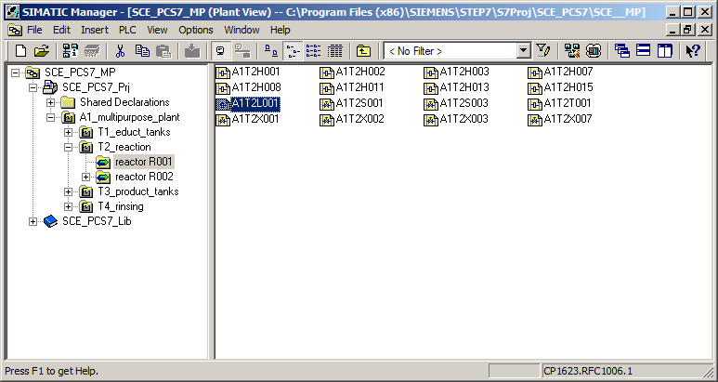

1. From the 'Monitor' folder of the PCS 7 Advanced Process Library V9.0***,*** insert the 'MonAnS' block and interconnect it as shown. (® Libraries ® PCS 7 AP Library V90 ® Blocks+Templates/Blocks ® Monitor ®MonAnS)

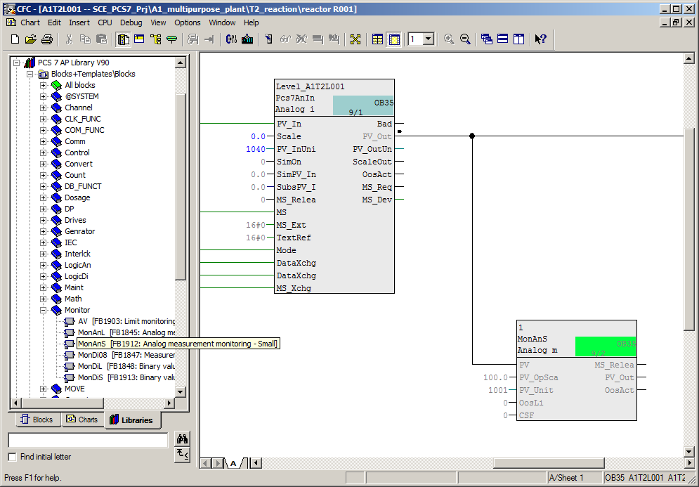

***Notes:***

* *The MonAnS block is used to monitor a measured value (analog signal) for the limit pairs:*

Warning limit (high/low)

Alarm limit (high/low)

1. In the block properties, the I/Os shown below are made visible for setting the high and low alarm/warning limits. (® PV_AH_Lim ® PV_WH_Lim ® PV_WL_Lim ® PV_AL_Lim ® Visible (Invisible))

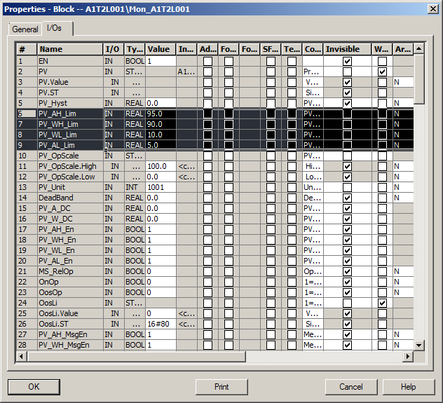

1. The warning and alarm limits shown are set for the now visible I/Os and the value of the PV_Unit input is set to '1040'. It specifies the unit that is displayed on the OS screen or in the faceplate. An excerpt from the Siemens documentation for possible units is also shown below.

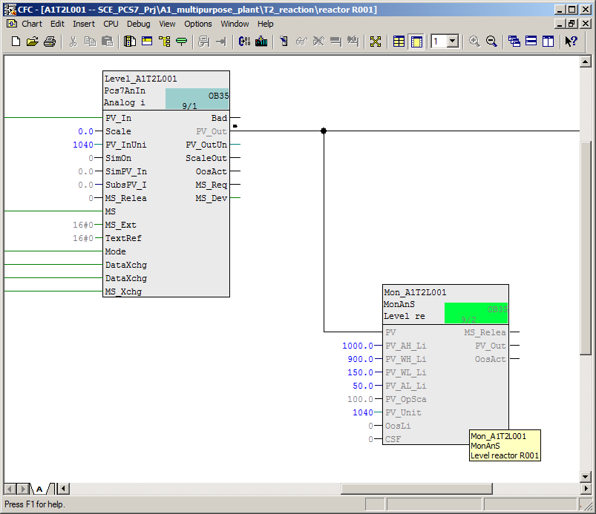

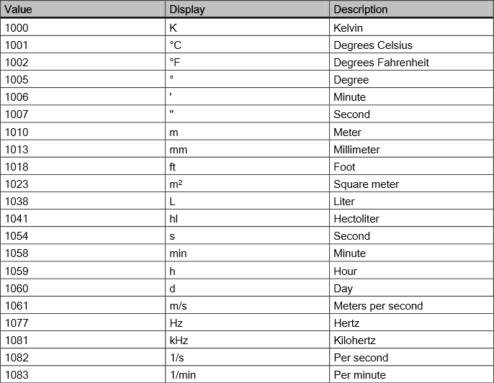

1. Here, all changes in chart 'A1T2L001Sheet1' are listed once more:

|  |  |  |
| --- | --- | --- |
| Block | Catalog/Folder | Number of connectors |
| MonAnS | Libraries/PCS 7 AP Library V9.0/ Blocks+Templates\Blocks/Monitor |  |

Table 2: New blocks in chart 'A1T2L001Sheet1'

|  |  |  |
| --- | --- | --- |
| Input | Wiring to | Inverted |
| MonAnS.PV | Pcs7AnIn.PV_Out |  |
| MonAnS.PV_AH_Lim | 1000.0 |  |
| MonAnS.PV_WH_Lim | 900.0 |  |
| MonAnS.PV_WL_Lim | 150.0 |  |
| MonAnS.PV_AL_Lim | 50.0 |  |
| MonAnS.PV_Unit | 1040 |  |
| Pcs7AnIn.PV_InUnit | 1040 |  |

Table 3: Input interconnections in chart 'A1T2L001Sheet1'

|  |  |  |
| --- | --- | --- |
| Output | Wiring to | Inverted |
| none | none | none |

Table 4: Output interconnections in chart 'A1T2L001Sheet1'

## Monitoring in faceplate T2_Reaction

1. To compile and download AS and OS at the same time, select the project in the component view of SIMATIC Manager. Then, select 'Compile and Download' for the PLC. (® SCE_PCS7_Prj ® PLC ® Compile and Download Objects)

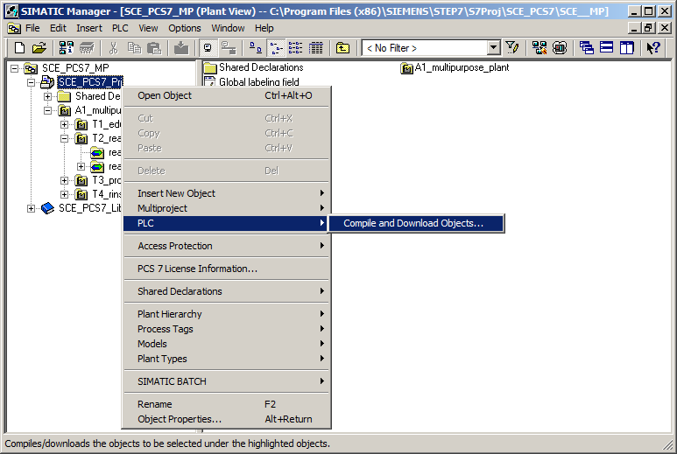

1. Next, as shown here, select the objects for compiling and start the process as you learned in the previous chapters. (® Start)

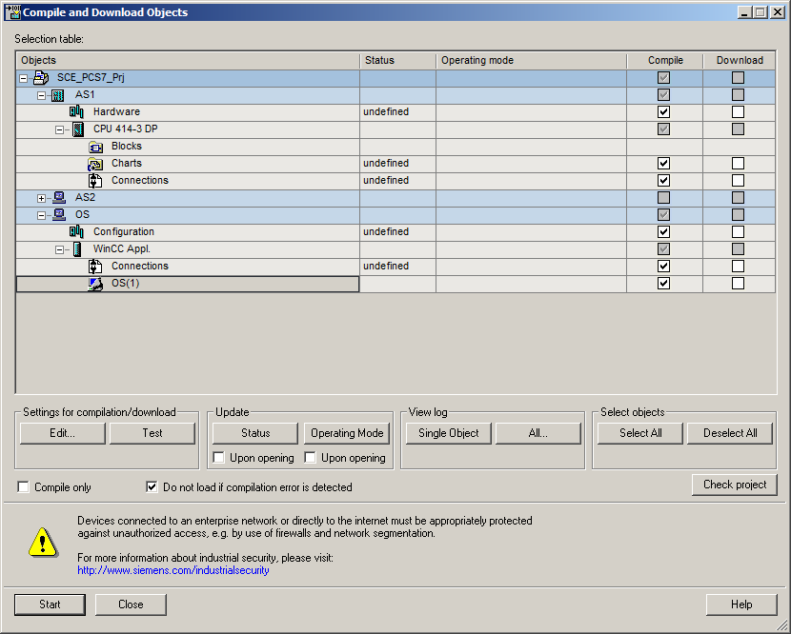

1. After successful compilation, open the OS. (® OS(1) ® Open Object)

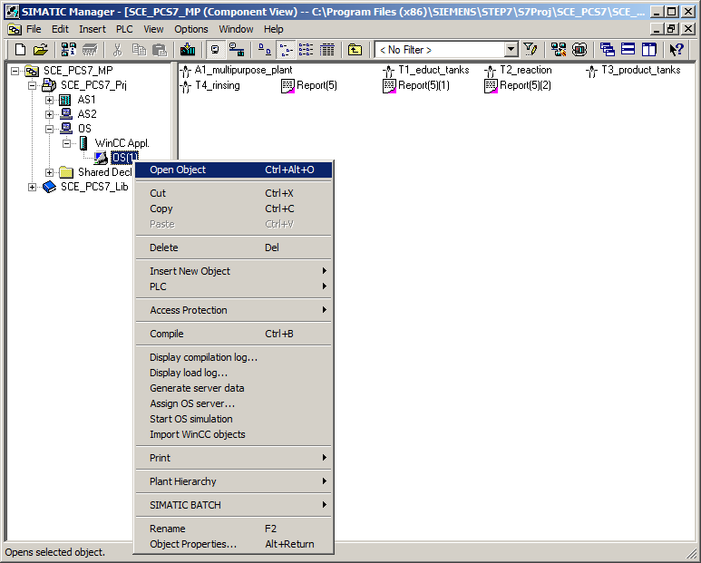

1. Within WinCC, open the picture 'T2_reaction.Pdl' in the Graphics Designer.   
   (® Graphics Designer ® T2_reaction.Pdl)

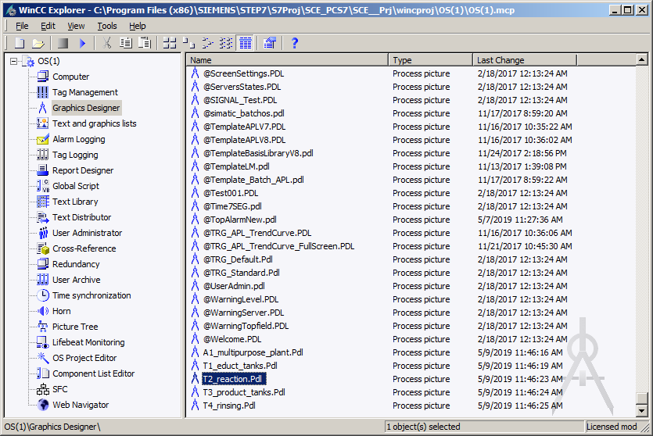

1. In this picture, the block icon for the MonAnS block 'A1T2L001' was already created during the compilation run. Position it to the right of the reactor and save the picture. (® A1T2L001 ® )

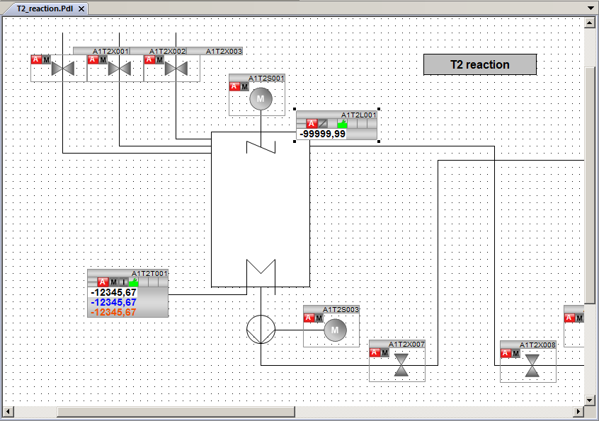

## Analog level display in faceplate A1_multipurpose_plant

1. Open the picture 'A1_multipurpose_plant.Pdl' in the Graphics Designer.   
   (® Graphics Designer ® A1_multipurpose_plant.Pdl)

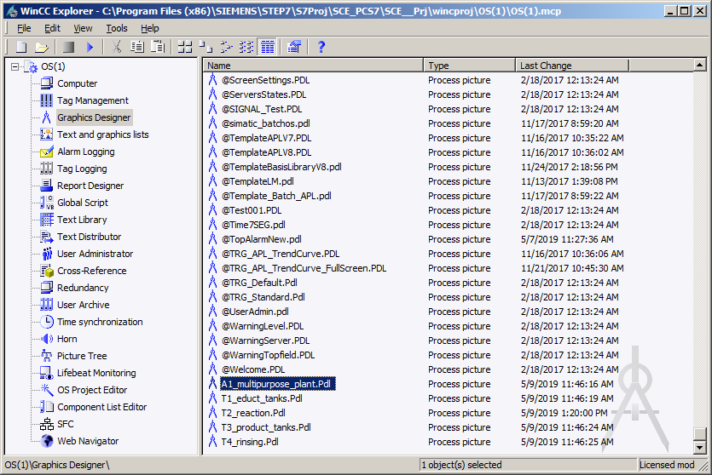

1. In this picture, drag an I/O field from the smart objects of the object palette to display the level of Reactor A1T2R001. Then, open its tag selection. (® Standard palette ® Smart Objects ® I/O Field ® )

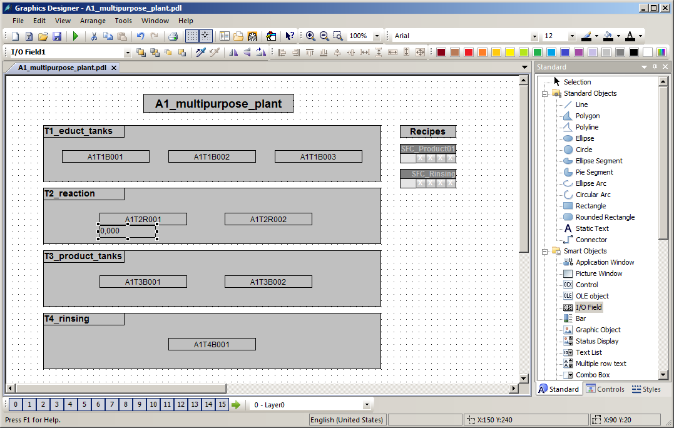

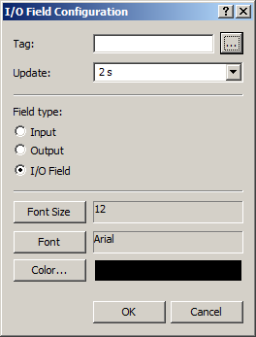

1. Within the tag selection, select the engineering station variables as the data source. In the left window you will then see the hierarchy of your project. Here you can easily locate your MonAnS block. For the display in the I/O field, select the 'PV#Value' I/O. (® ES Variables ® A1_multipurpose_plant ® T2_reaction ® reactor R001 ® A1T2L001 ® Mon_A1T2L001 ® PV#Value ® OK)

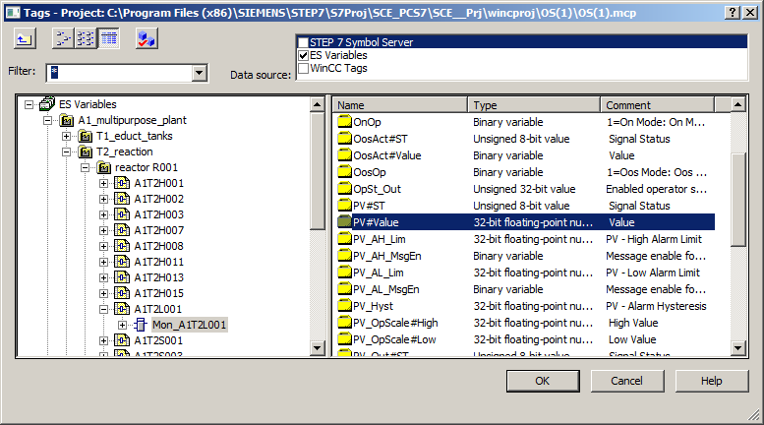

1. This tag is now displayed in the configuration dialog. After the following changes, accept this configuration. (® Update: Upon change ® Field type: Output ® OK)

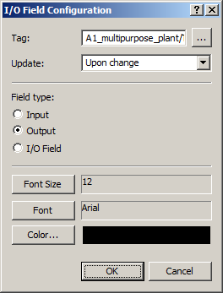

1. In the properties of the I/O field, the output format is set to 4 places before the decimal and no places after the decimal. (® Properties ® Output/Input ® Output Format ® 9999 ® OK)

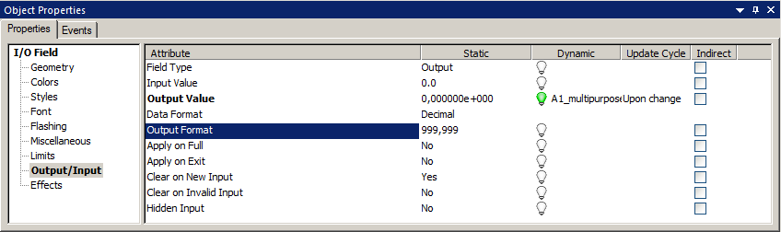

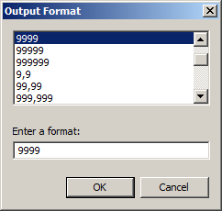

1. Next, select the following properties of the font. (® Properties ® Font ® X Alignment: Centered ® Y Alignment: Centered)

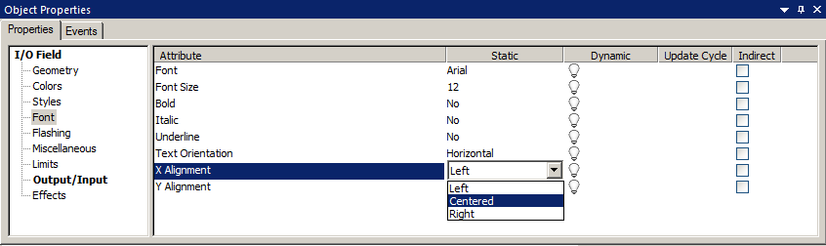

1. To better interpret the value in runtime, enter a tooltip text. (® Properties ® Miscellaneous ® Tooltip Text: Level reactor R001 ® OK)

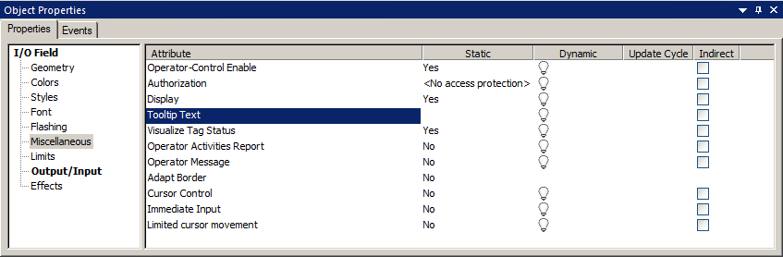

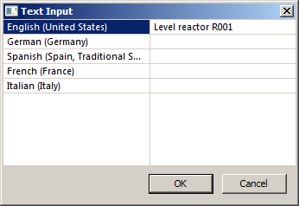

1. Next, place the I/O field under Reactor A1T2R001 and add two static texts 'Level' and 'ml'. (® Standard palette ® Static Text)

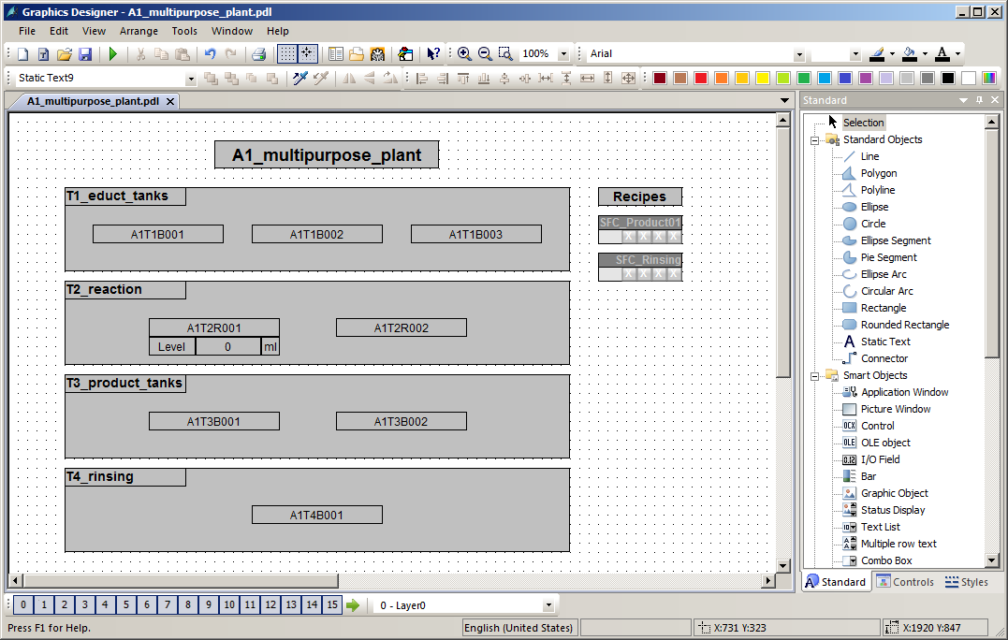

## Binary level display

1. Below the Educt tank A1T1B003, a display is to be implemented that indicates whether or not this tank is empty. A text list will be used for this. Drag this text list from the object palette to the picture and then open its tag selection. (® Standard palette ® Smart Objects ® Text List ® )

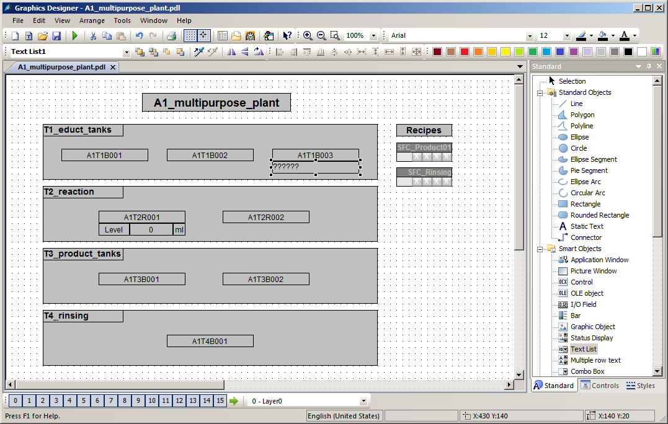

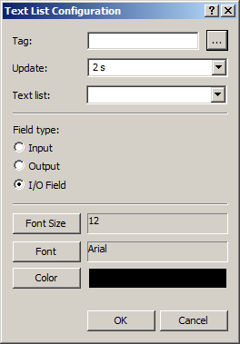

1. Within the tag selection, select 'STEP 7 Symbol Server' as the data source. You will then see the symbols of the S7 program in the left window. Here, select the input I70.5 'A1.T1.A1T1L003.LSA-.SA-'. (® STEP 7 Symbol Server ® S7 Program(1) ® Symbols ® I70.5 'A1.T1.A1T1L003.LSA-.SA-' ® OK)

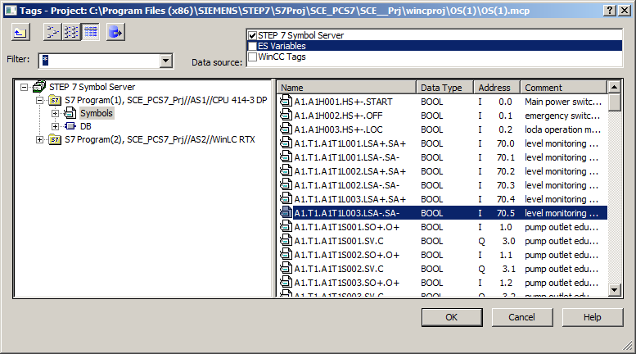

1. This tag is then displayed in the configuration dialog. After the following changes, accept this configuration. (® Update: Upon change ® Field type: Output ® OK)

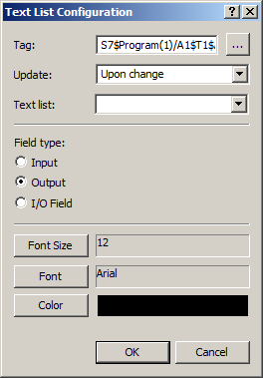

1. Next, you set the representation of the font in the properties of the text list.   
   (® Properties ® Font ® X Alignment: Centered ® Y Alignment: Centered)

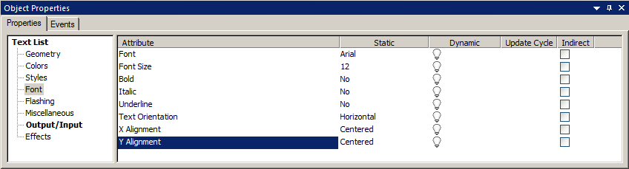

1. The texts are assigned to the values of the tag in the Properties also.   
   (® Properties ® Output/Input ® Assignments)

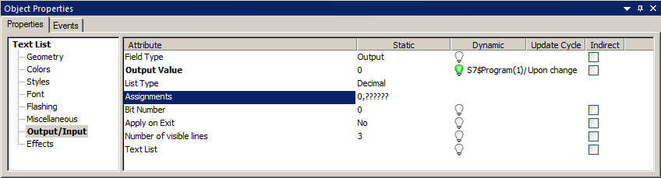

1. The text 'Empty' is assigned to the value 0 and 'OK' to the value 1.   
   (® Range type: Single Value ® Value range: 0 ® Text: Empty ® Change ® Range type: Single Value ® Value range: 1 ® Text: OK ® Append ® OK)

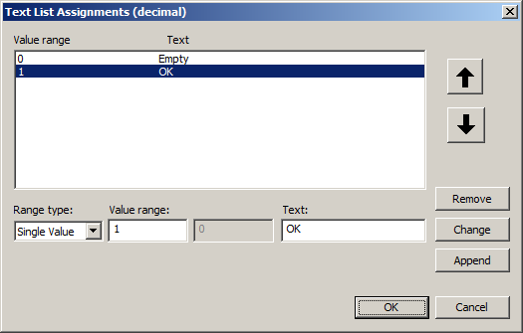

1. You will need exactly such a text list once more for a textual display below Product tank A1T3B001. It will indicate whether or not this tank is full. The previously created text list is selected and duplicated for this. (® Duplicate)

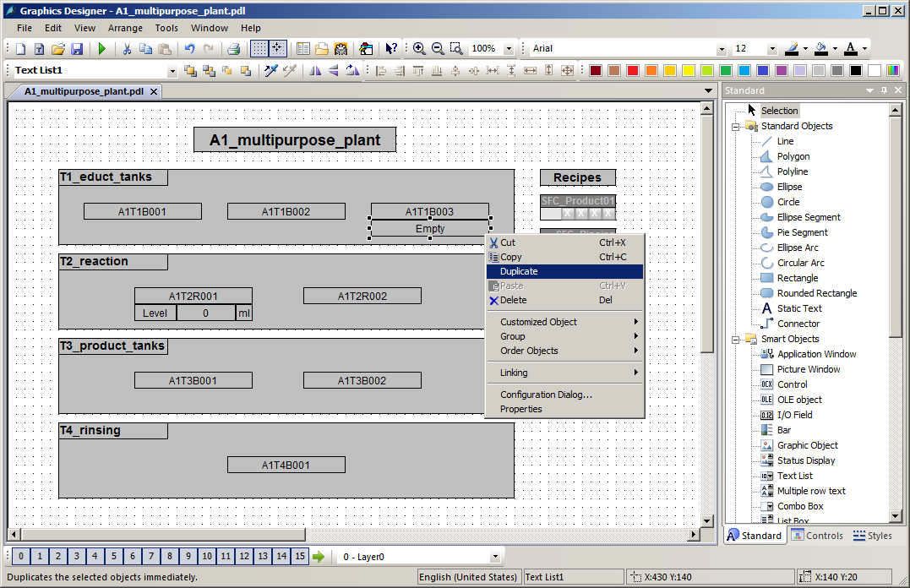

1. For product tank A1T3B001, select input I70.6 'A1.T3.A1T3L001.LSA+.SA+'. (® STEP 7 Symbol Server ® S7 Program(1) ® Symbols ® E70.6 'A1.T3.A1T3L001.LSA+.SA+' ® OK)

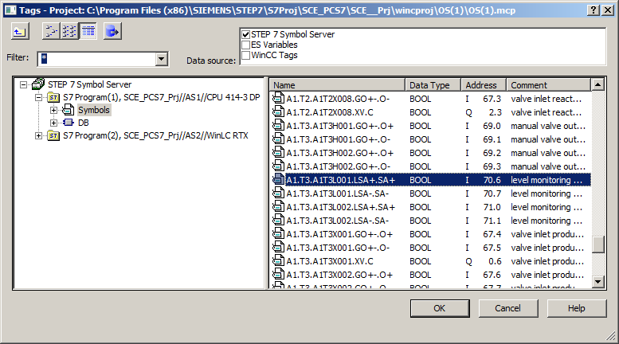

1. The assignment is also changed in the properties: This time, the text 'OK' is assigned to the value 0 and 'Full' to the value 1. (® Range type: Single Value ® Value range: 0 ® Text: OK ® Change ® Range type: Single Value ® Value range: 1 ® Text: Full ® Change ® OK)

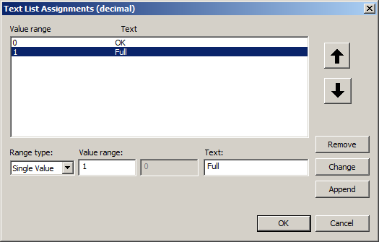

1. Place the second text list below Product tank A1T3B001 and save the picture.   
   (® Save )

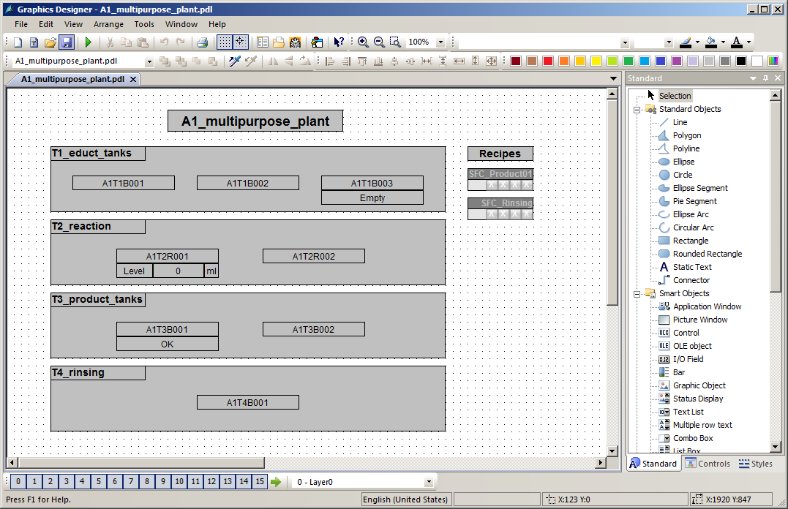

## Messages in WinCC Runtime

1. The following will show how a warning is displayed in Runtime. The warning or alarm that occurred last but has not been acknowledged appears in the alarm line. If the operator wants to change directly to the picture where the alarm or warning was triggered, he can do this in two ways:

With the Loop in Alarm button  in the alarm line

By clicking on the fault display  in the picture hierarchy (®  ® )

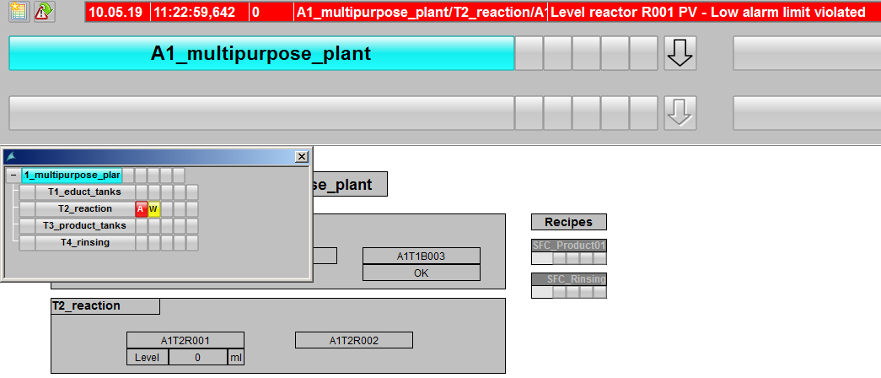

1. In the picture 'T2_Reaction', a display of the warning is provided in the block icon. By clicking on the block icon, additional information is displayed in the faceplate for the MonAnS block regarding the cause of the warning. Here, messages requiring acknowledgment can be acknowledged or limits can be adapted.

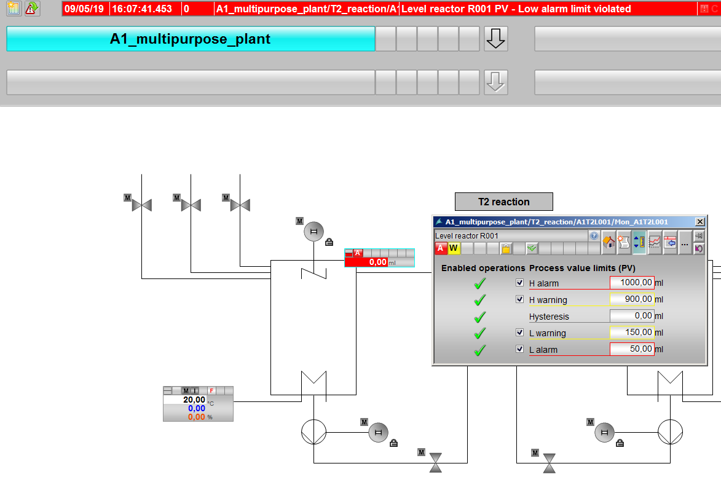

1. By clicking on the Alarm System button  in the message line, all queued messages are displayed. (® )



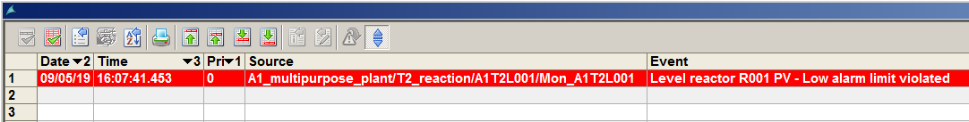

## Checklist – step-by-step instruction

The following checklist helps students to independently check whether all steps of the step-by-step instruction have been carefully completed and enables them to successfully complete the module on their own.

|  |  |  |
| --- | --- | --- |
| No. | Description | Checked |
| 1 | Monitoring of level A1T2L001 added and configured |  |
| 2 | Faceplate T2_reaction contains level monitoring |  |
| 3 | Faceplate A1_multipurpose_plant contains a display of the analog level A1T2L001 |  |
| 4 | Faceplate A1_multipurpose_plant contains a textual display of the binary levels A1T1L003 and A1T3L001 |  |
| 5 | Textual displays display the correct text |  |
| 6 | Alarms in WinCC successfully tested |  |
| 7 | Project successfully archived |  |

Table 5: Checklist for step-by-step instructions

# Exercises

In the exercises, you apply what you learned in the theory section and in the step-by-step instructions. The existing multiproject from the step-by-step instructions (p02-02-project-r1905-en.zip) is used and expanded for this. The download of the project is stored as zip file "Projects" on the SCE Internet for the respective module.

In the step-by-step instructions, only the alarm for a level of only one reactor was implemented. In the exercise, the alarm configuration of the level of reactor R002 is to now be completed and alarms and warnings of temperature violations of both reactors are to be implemented. The missing displays will then be added to the overview picture.

## Tasks

The tasks below are based on the step-by-step instructions. The corresponding steps of the instructions can be used to assist with each task.

1. Implement alarm generation also for the level of the second reactor. For this, insert the MonAnS block in the CFC A1T2L002 and assign a name and parameters to it. After compilation, place the block in the faceplate 'T2_reaction.pdl'.
2. Next, in the overview display 'A1_multipurpose_plant.pdl', insert an I/O field for the level of reactor A1T2R002 and visualize the current reactor level.
3. Design alarms for the temperatures of the two reactors similar to the levels. The temperature warning is to be triggered at 55 °C and the alarm at 60 °C. No additional monitor blocks are needed to design the temperature warnings and alarms since the PidConL blocks already include this functionality. The I/Os for the warning and alarm limits have the same name as in the MonAnS blocks.
4. Create I/O fields for the temperature below the level in the overflow picture. Represent the temperature with one place after the decimal.
5. Finally, add the missing text lists for all elements.

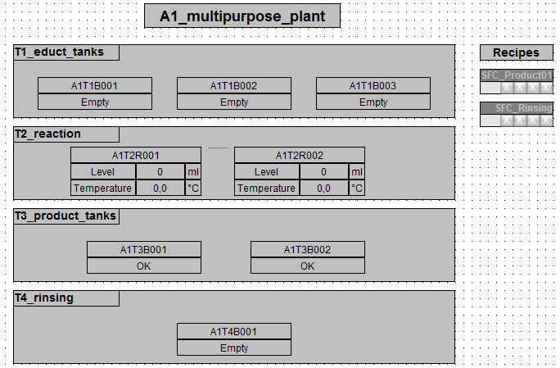

## Checklist – exercise

The following checklist helps students to independently check whether all steps of the exercise have been carefully completed and enables them to successfully complete the module on their own.

|  |  |  |
| --- | --- | --- |
| No. | Description | Checked |
| 1 | Monitoring of level A1T2L002 added and configured |  |
| 2 | T2_reaction contains monitoring of level A1T2L002 |  |
| 3 | Faceplate A1_multipurpose_plant contains a display of the analog level A1T2L002 |  |
| 4 | Monitoring of temperatures A1T2T001 and A1T2T002 configured in exiting blocks |  |
| 5 | Faceplate A1_multipurpose_plant contains a display of the temperatures A1T2T001 and A1T2T002 with one place after the decimal |  |
| 6 | Faceplate A1_multipurpose_plant contains text lists for all binary level sensors with correct display |  |
| 7 | (optional) New elements successfully tested |  |
| 8 | Project successfully archived |  |

Table 6: Checklist for exercises

# Additional information

More information for further practice and consolidation is available as orientation, for example: Getting Started, videos, tutorials, apps, manuals, programming guidelines and trial software/ firmware, under the following link:

[siemens.com/sce/pcs7](http://www.siemens.com/sce/pcs7)

**Preview "Additional information"**

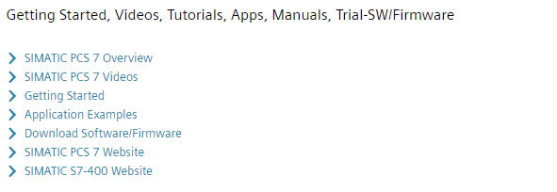

Further Information

Siemens Automation Cooperates with Education  
**siemens.com/sce**

Siemens SIMATIC PCS 7  
**siemens.com/pcs7**

SCE Learn-/Training Documents  
**siemens.com/sce/documents**

SCE Trainer Packages  
**siemens.com/sce/tp**

SCE Contact Partners   
**siemens.com/sce/contact**

Digital Enterprise  
**siemens.com/digital-enterprise**

Industrie 4.0   
**siemens.com/future-of-manufacturing**

Totally Integrated Automation (TIA)  
**siemens.com/tia**

TIA Portal  
**siemens.com/tia-portal**

SIMATIC Controller  
**siemens.com/controller**

SIMATIC Technical Documentation   
**siemens.com/simatic-docu**

Industry Online Support  
**support.industry.siemens.com**

Product catalogue and online ordering system Industry Mall   
**mall.industry.siemens.com**

Siemens  
Digital Industries, FA   
P.O. Box 4848  
90026 Nuremberg  
Germany

Subject to change and errors  
© Siemens 2020

**siemens.com/sce**