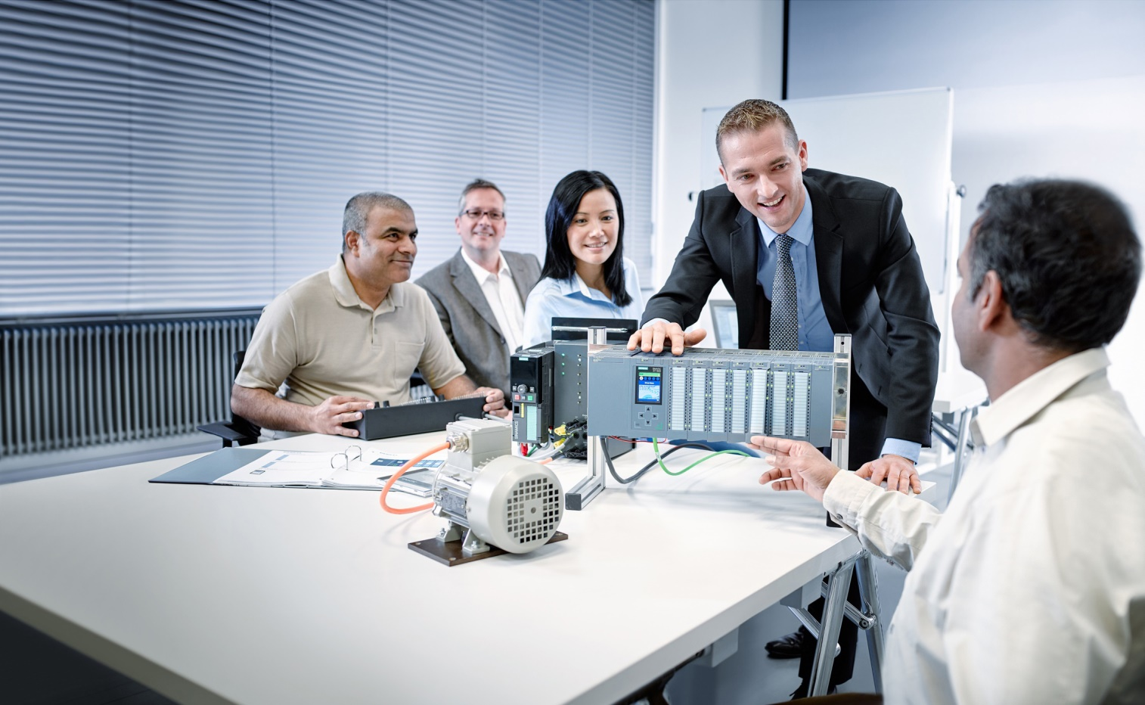

Learn-/Training Document  
  
Siemens Automation Cooperates with Education (SCE) | As of Version V9 SP1

**siemens.com/sce**

PA Module P02-01   
SIMATIC PCS 7 – HMI generation

**Matching SCE Trainer Packages for this Learn-/Training Document**

* **SIMATIC PCS 7 Software Package V9.0 (set of 3)**  
  Order No.: 6ES7650-0XX58-0YS5
* **SIMATIC PCS 7 Software Package V9.0 (set of 6)**   
  Order No.: 6ES7650-0XX58-2YS5
* **SIMATIC PCS 7 Software Upgrade Packages (set of 3)**  
  Order No.: 6ES7650-0XX58-0YE5 (V8.x🡪 V9.0)
* **SIMIT Simulation Platform with Dongle V10**  
  (contains SIMIT S & CTE, FLOWNET, CONTEC libraries) – 2500 simulation tags  
  Order No.: 6DL8913-0AK00-0AS5
* **Upgrade SIMIT Simulation Platform V10**  
  (contains SIMIT S & CTE, FLOWNET, CONTEC libraries) from V8.x/V9.x  
  Order No.: 6DL8913-0AK00-0AS6
* **Demo Version SIMIT Simulation Platform V10**  
  [Download](https://support.industry.siemens.com/cs/ww/en/ps/17120/dl)
* **SIMATIC PCS 7 AS RTX Box (PROFIBUS) only in combination with ET 200M for RTX –**   
  Order No.: 6ES7654-0UE23-0XS1
* **ET 200M for RTX Box (PROFIBUS) only in combination with PCS 7 AS RTX Box –**  
  Order No.: 6ES7153-2BA10-4AB1

Note that these trainer packages are replaced with successor packages when necessary.

An overview of the currently available SCE packages is available at: [siemens.com/sce/tp](http://www.siemens.com/tp)

**Continued training**

For regional Siemens SCE continued training, get in touch with your regional SCE contact

[siemens.com/sce/contact](http://www.siemens.com/contact)

**Additional information regarding SCE**

[siemens.com/sce](http://www.siemens.com/sce)

**Information regarding use**

The SCE Learn-/Training Document for the integrated automation solution Totally Integrated Automation (TIA) was prepared for the program "Siemens Automation Cooperates with Education (SCE)" specifically for training purposes for public educational facilities and R&D institutions. Siemens does not guarantee the contents.

This document is to be used only for initial training on Siemens products/systems, which means it can be copied in whole or part and given to those being trained for use within the scope of their training. Circulation or copying this Learn-/Training Document and sharing its content is permitted within public training and advanced training facilities for training purposes.

Exceptions require written consent from the Siemens. Send all related requests to

[scesupportfinder.i-ia@siemens.com](mailto:scesupportfinder.i-ia@siemens.com).

Offenders will be held liable. All rights including translation are reserved, particularly if a patent is granted or a utility model or design is registered.

Use for industrial customer courses is explicitly not permitted. We do not consent to commercial use of the Learn-/Training Document.

We wish to thank the TU Dresden, particularly Prof. Dr.-Ing. Leon Urbas and the Michael Dziallas Engineering Corporation and all other involved persons for their support during the preparation of this Learn-/Training Document.

Table of contents

1 Goal 5

2 Prerequisite 5

3 Required hardware and software 6

4 Theory 7

4.1 Theory in brief 7

4.2 Objectives of process control 8

4.3 Concepts of representation 8

4.4 Representation techniques 10

4.5 HMI generation in PCS 7 13

4.6 References 14

5 Task 15

6 Planning 15

7 Learning objective 15

8 Structured step-by-step instructions 16

8.1 Faceplates in the plant hierarchy 16

8.2 Creating block icons 19

8.3 Compiling and downloading objects 22

8.4 Configuring WinCC 27

8.5 Editing the faceplate for the multipurpose plant 37

8.6 Configuring the picture change 44

8.7 Editing the faceplate for T1_educt_tanks 49

8.8 Linking of picture elements with PLC tags 55

8.9 Saving in the project library 59

8.10 Adapting the orientation of the faceplates 61

8.11 Testing the faceplates 67

8.12 Checklist – step-by-step instruction 76

9 Exercises 77

9.1 Tasks 77

9.2 Checklist – exercise 80

10 Additional information 81

HMI generation

# Goal

After working through this module, the students can design and implement a graphical user interface for efficient process control. They will also become familiar with the objectives of process control. They understand the basic concepts of representation and various representation techniques. This will enable the students to generate a usable and effective graphical user interface in PSC 7.

# Prerequisite

This chapter builds on chapter 'Functional safety'. To implement this chapter, you can use an existing project from the previous chapter or the archived project 'p01-08-exercise-r1905-en.zip' provided by SCE. The download of the project(s) is stored on the SCE Internet for the respective module.

The (optional) simulation for the SIMIT program can be retrieved from the file 'p01-04-plantsim-v10-r1905-en.simarc'. It can be run in demo mode.

# Required hardware and software

1. Engineering station: Requirements include hardware and operating system   
   (for further information, see Readme on the PCS 7 installation DVD)
2. SIMATIC PCS 7 software V9 SP1 or higher

* Installed program packages (contained in SIMATIC PCS 7 Software Trainer Package):
  + *Engineering → PCS 7 Engineering*
  + *Engineering → BATCH Engineering*
  + *Runtime → Single Station → OS Single Station*
  + *Runtime → Single Station → BATCH Single Station*
  + *Options → SIMATIC Logon*
  + *Options → S7-PLCSIM V5.4 SP8*

1. Demo Version SIMIT Simulation Platform V10

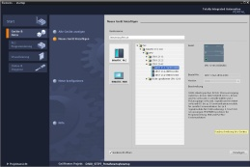

**3** SIMIT V10 or higher



**1** Engineering Station

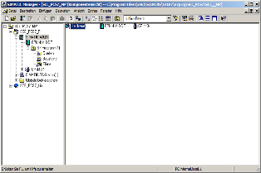

**2** SIMATIC PCS 7

V9 SP1 or higher

# Theory

## Theory in brief

A modern process control system such as PCS 7 provides operating personnel various screen-based windows to the process via which all process control tasks can be completed. Due to the large amount of information from the technical process that the operator must take in and process, it is useful to structure the information. In addition, certain rules for navigation and representation must be adhered in order to produce an easy-to-operate interface to the technical process that effectively supports operators in carrying out their various process control tasks.

PCS 7 supports the design process of process pictures for operator control and monitoring in multiple ways. First, for many of the elementary blocks and individual control functions used in basic automation, operating icons and operator panels are defined that enable project-wide uniform interaction with similar technical equipment. Second, the plant hierarchy can be used to conveniently structure the information display.

This structure allows a large number of elements of the operating system that would have to be implemented manually in other systems to be generated automatically and error-free in a single generation run. Two essential tasks remain for designing process pictures. The first is the representing of static process structures (tanks, pipes, etc.) for better orientation. The second is the inserting of elements for navigation along process streams on a plant hierarchy level.

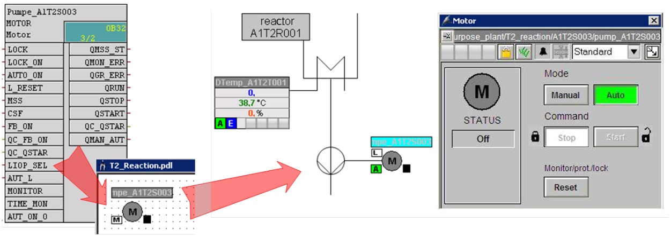

Figure 1: From the individual drive function to the faceplate

The generation run creates block icons for all operable blocks of a hierarchical level. These icons then only have to be positioned and enhanced with static elements in order to obtain a complete faceplate (see Figure 1).

## Objectives of process control

The task of an operator in a process plant is to operate this plant for the intended purpose in an economical and environmentally compatible manner. This task is called process control. They must ensure a consistently high product quality and amount (yield) and keep the amount of waste as low as possible, while at the same time compensating for disturbance factors such as varying properties of raw material, plant malfunctions or fluctuating throughput. The operator must see to it that the availability and service life of the plant is maximized. Furthermore, the operator must ensure that emission limits are observed and energy and material consumption is minimized [1].

To attain these goals, an operator must always be able to monitor the plant, diagnose problems and intervene in the running process to solve them. An operator station in the control room serves as the operator's work station. This operator station has all the displays and possibilities of intervention that an operator needs to perform his work. The control system provides the operator a user interface that he can use to carry out his tasks according to his abilities, skills and requirements [1].

## Concepts of representation

The representation of data and information on the graphical user interface has a decisive influence on the performance of the operator. For this reason, it has to be matched to the operator's abilities, skills and requirements. The following questions must therefore be answered in turn:

1. For whom and for what purpose does the representation serve?
2. What is to be represented?
3. How is it to be represented?

These questions depend on the plant that is being planned and, therefore, have to be answered for the respective project. However, the following aspects always have to be considered:

Organization of the information and data to be represented

The information and data to be represented has to be organized suitably for the representation. For this, it is necessary to specify how the existing elements are structured and arranged, how they relate to each other and how the representations can be navigated between. Accordingly, the total amount of information and data to be represented must be specified (quantitative aspect). And, the information and data that is to be visualized simultaneously and together must be specified (qualitative aspect).

Here, the ratio of what is new (information, dynamic picture components) to what is known (data, static picture components) must be decided. The aim is the maximize the proportion of information but to provide enough data to allow accurate and appropriate interpretation of the information.

The result is a distribution of information and data among the various faceplates. How the operator goes from one faceplate to another must then also be defined (navigation).

Density

Depending on the user interface, only a limited area is available for simultaneous representation of data and information. To ensure that the information and data remains legible and distinguishable in all operating situations, only a certain percentage of this area is to be occupied with characters. This percentage is referred to as the density of the representation.

The recommended density depends on the type of characters and display elements as well as on the necessary structuring of these elements. Thus, it depends on the representation technique used. For example, the density of a process flow diagram should be no more than 50%; for a message page, on the other hand, it may be up to 80% [1].

Coding

Coding is used to specify how certain information is represented. Information can be coded by color, shape, form, extension, direction (angle), position and dynamics (flashing). A uniform coding facilitates the intake and evaluation of information by the operator.

An effective coding is characterized by the fact that it is clear, distinguishable and consistent with existing conventions. That is why the color green should never be used for a STOP signal. If, for example, a red flashing signal is used instead as a coding for STOP, this coding should be used consistently for the entire user interface. Also, it is necessary to avoid reuse of this coding for other information in order to rule out confusion. In addition, an effective coding should be obvious so that it is easy to learn and remember for the operator.

Conspicuousness

A central function of the user interface is to direct the operator’s attention to important information. Because a faceplate generally displays a variety of information, it is advisable to design this information with varying conspicuousness corresponding to its relevance and priority. The more conspicuous the information is represented, the sooner it will be spotted. In addition, the operator can recognize the information that requires the most attention at the moment based on its conspicuousness. Table 1 shows the stepping up of conspicuousness using a few examples.

Increasing conspicuousness of means

Mittel



Increasing conspicuousness of visualization

Table 1: Application of stepped conspicuousness according to [1]

Consistency

Often, a particular piece of information appears in several representations at the same time. In this case it is important that this information be represented consistently throughout the user interface. This means the information has the identical appearance in all representations and behaves identically. The same terms and symbols must always be used. The operating sequence should always be the same. Likewise, it is recommended that the timing and content of the system response to operator inputs be similar.

## Representation techniques

Basic structure of the display area

The display area should always be structured the same for all representation modes. This facilitates the orientation, information intake and, thus, process control for operator. The basic structure recommended for this according to VDI 3699 [1] is shown in Figure 2. A message line in which the latest messages are displayed as group messages is located at the top. Below it is an overview field in which the available representations (for example, process pictures in PCS 7) are listed. There is the option to open any representation from here. The working area occupies the largest part of the display area. The currently selected visualization is displayed here.

The bottom area contains the key field for activating general functions. In the working area, windows with supplementary information (such as different views of PCS 7 blocks) can be opened in addition. All areas except the working area are reserved and are always displayed.

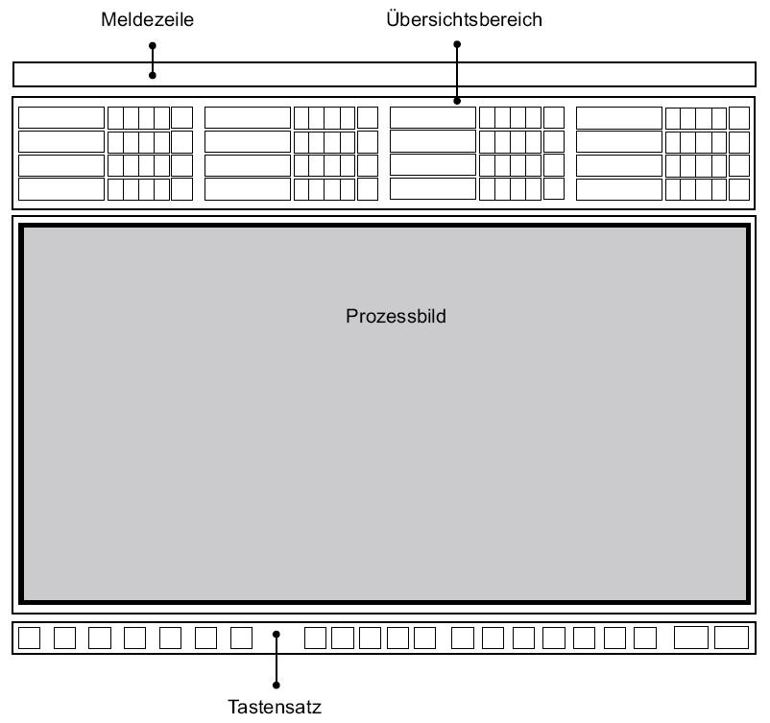

**Key field**

**Message line**

**Overview field**

**Display window**

**Working area**

Figure 2: Basic structure of a display area

Flow diagrams

A flow diagram is a "schematic representation of components including their connection through (flow) lines to show relationships in a control plant and in control engineering" [1]. It represents the plant structure in a simplified manner and provides information about the paths of material, energy and signal flows between the different plant units. With the aid of flow diagrams, process- and control-related information is represented and interventions in the process are made possible.

Flow diagrams consist of static and dynamic elements. The static picture elements are represented by the root screen. This root screen contains the dynamic picture elements that are continuously updated.

The static root screen provides the context for the dynamic picture elements, which means it indicates the meaning of the represented objects and their relationship to each other. The root screen represents all data that remains unchanged during the display. It contains, for example, the picture background, the headings and labels as well as the plant units and the devices (if their representation is not supposed to change).

The dynamic picture elements provide the information for process control. Display elementsdisplay changes, time variations and relationships of the process values. Thus, they reflect the state of the plant, control system or process. Selection and operator control elements allow the operator to perform operator interventions for process control. In addition, there is often the option to display additional information such as function diagrams or trends in the flow diagram as a window.

Flow diagrams are subdivided as follows:

* Control flow diagrams represent only components of the control system such as loop controllers, actuators and controllers as symbols. They are connected to each other with signal flow lines.
* Process flow diagrams graphically represent plant units in a simplified way using symbols. Here, three different kinds are differentiated:

A basic flow diagram represents plants, plant sections or plant units in the form of rectangles. They are connected to each other with flow lines for materials, energy or energy sources.

A process flow diagram represents processes using (simplified) graphic symbols. The symbols represent the corresponding plant units and are connected to each other with flow lines.

A piping & instrumentation flow diagram (P&I diagram) represents the technical equipment of the plant using graphic symbols. In addition, process tags, control blocks and actuators are represented. The symbols are connected to each other by lines for pipes and signal paths.

In PCS 7, flow diagrams are referred to as process pictures. Various process pictures will be created for the configured plant within the scope of the step-by-step instructions.

## HMI generation in PCS 7

PCS 7 has an extensive operator control and monitoring system that consists of the following subsystems [2]:

* A graphic system for displaying process information and for operator process control.
* A curve system for representation and analysis of time series of stored process values.
* A message system for diagnosing the process.
* A log system for documenting the process.
* An archive system for storing and keeping process values, messages and logs.

In this chapter, the graphic system of PCS 7 is introduced. The alarm system will be described in the subsequent chapter 'Alarm Engineering'.

The graphic system represents the plant in a plant overview. It displays process pictures in the working area of the user interface, provides elements for operator process and system control and indicates alarm states. The corresponding user interface is generated on the operator station (OS) of the system. The OS is thus the central station for operator control and monitoring of a PCS 7 plant [2].

Configuration of the user interface in PCS 7

The selected plant hierarchy of the project is the basis for the organization of the user interface. The created plants and subunits are represented in the user interface through corresponding process pictures. Picture names and directory names of the plant hierarchy are applied automatically. In process mode, the available process pictures are represented in the overview area corresponding to the plant hierarchy.

The process pictures of a project are first created at the corresponding location in the plant hierarchy and assigned to an OS. The OS is then compiled. The process pictures can then be configured in the Graphics Designer of the WinCC Explorer. The Graphics Designer is an editor where static and dynamic picture elements can be inserted, arranged and interconnected.

Configuration of the process pictures in PCS 7

Operator control and monitoring-capable technological blocks from PCS 7 libraries already have corresponding graphic representations, so-called block icons. When the process pictures are configured, the block icons are inserted automatically in the corresponding picture. Block icons represent the most important information about the represented block as an overview in the process picture.

Various pre-configured faceplates can be opened as a window in the working area via the block icons. Faceplates are dynamic picture elements that are connected to the parameters of the represented block and are updated automatically. They allow extensive operator control and monitoring of the associated technological block for the operator. Depending on the block type, different views exist for the associated faceplates. These views enable access to parameters for very specific tasks. For example, in addition to the standard view there often also is a parameter view for assigning parameters, an alarm view for diagnostics or a limit view for setting operational limits of the setpoint. The views offered depend on the represented technological block.

The Graphics Designer provides additional dynamic standard objects and inserts them manually. These objects can be interconnected directly with the I/Os of the blocks in the CFCs and SFCs and thus realize the desired dynamic behavior. Examples of standard objects are input and output fields for entering and displaying values, status indicators for displaying binary states of an object as well as bars for the relative representation of values.

In addition, the Graphics Designer provides various libraries with pre-assembled graphic elements such as pipes or valves that can be used to create the static root screen. Alternatively, there is the option to also create and use your own graphics.

In the step-by-step instructions below, additional characteristics and capabilities of the Graphics Designer will be presented. Several other important WinCC tools are also presented.

## References

[1] VDI 3699 (Edition 2014-01): Process control using display screens.

[2] SIEMENS (2017-10): Process Control System PCS 7: OS Process Control (V9.0 SP1). A5E39221482-AB. ([support.industry.siemens.com/cs/ww/en/view/109754981](https://support.industry.siemens.com/cs/ww/en/view/109754981))

# Task

In this task, a few presets are made in SIMATIC Manager followed by creation of the operator station (OS).

An overview picture of the multi-purpose plant and one-unit picture each for the educt tank, reactor and product tank are to be created. A solution for a tank for each plant unit will be created first.

# Planning

To start, the target system on which the OS is to run must be defined. In these instructions, this is the same computer on which the engineering is performed. But it does not have to be. The following specification will be made:

* Type of network connection: TCP/IP
* Network connection used: PLCSIM.TCPIP.1
* Number of monitors: 1
* Resolution of monitors: 1920x1080

The CFCs and SFCs created previously in the preceding projects are a basis for overview and unit pictures. Once these are automatically generated by PCS 7, they only have to be arranged on the faceplates.

The static elements that are created when implementing these instructions are another basis.

Because several very similar plant units exist, it makes sense to use the project library of WinCC and to simplify the engineering in this way. This will be demonstrated using the example of an educt tank.

# Learning objective

In this chapter, students learn the following:

* Generation of the operator station (OS) in SIMATIC Manager
* The WinCC configuration environment
* Creation of pictures with the Graphics Designer

# Structured step-by-step instructions

## Faceplates in the plant hierarchy

1. To start, you are to change the object properties of your picture of the A1_multipurpose_plant level. (® A1_multipurpose_plant ® Picture(2) ® Object Properties)

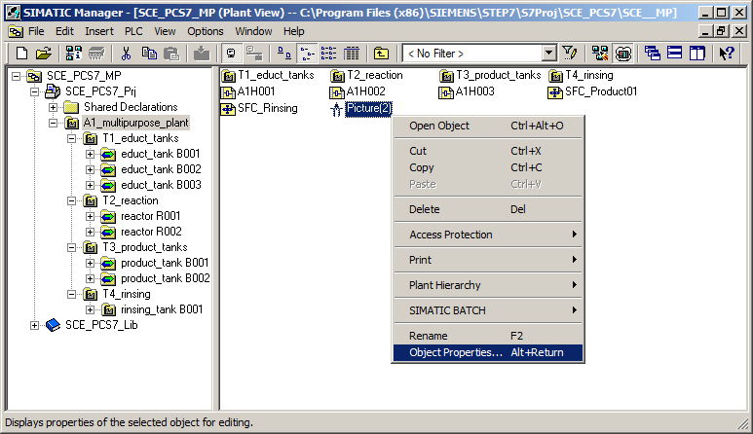

1. Enter "A1_multipurpose_plant" as the name. (® General ® Name ®A1_multipurpose_plant)

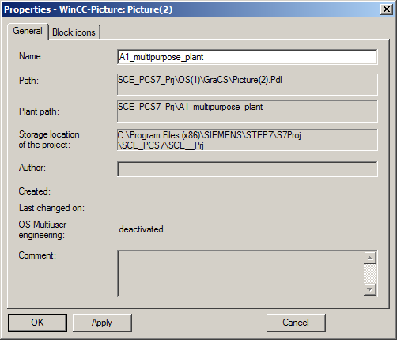

1. Derive the block icons from the plant hierarchy. (® Block icons ® Derive the block icons from the plant hierarchy ® OK)

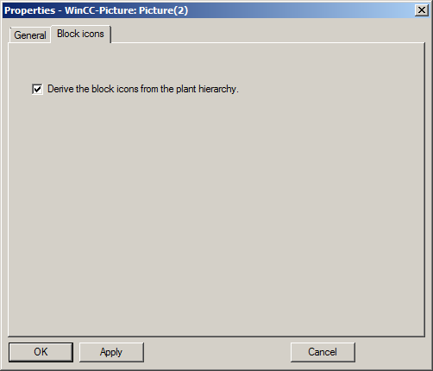

1. Insert a picture in the T2 level by right-clicking and selecting "Insert New Object". Name this as shown below. (® Insert New Object ® Picture ® Object Properties ® Name)

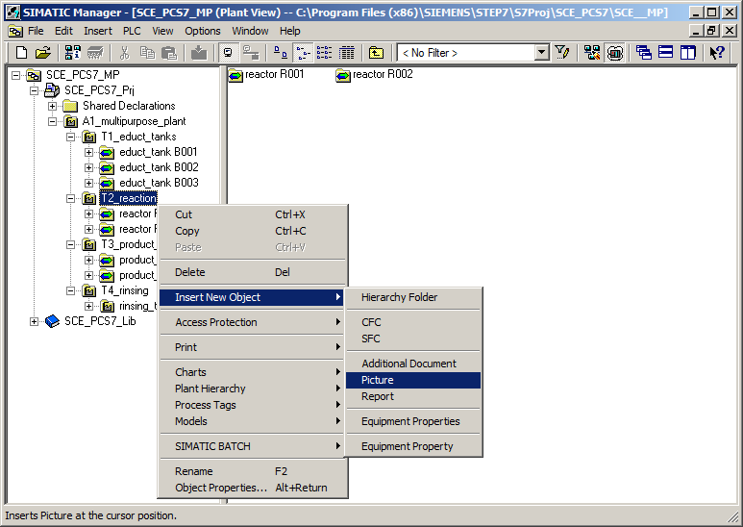

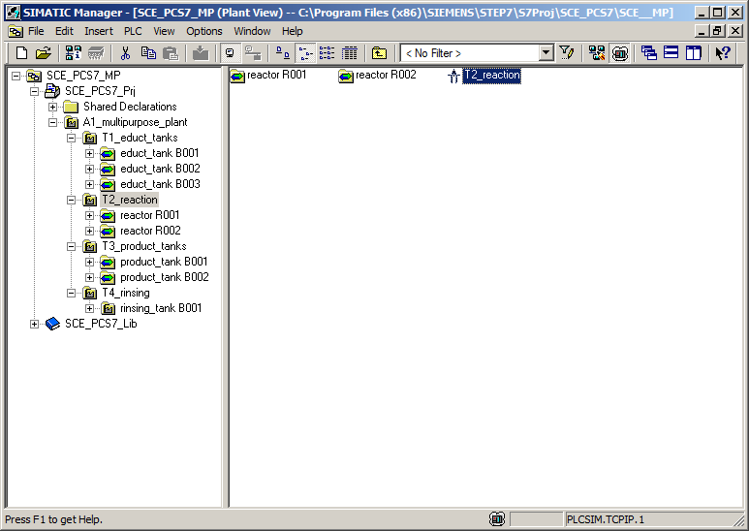

1. In the same way, create two new faceplates for units T3 and T4, rename the picture in unit T1 appropriately and delete the pictures from the three educt tanks folders.

## Creating block icons

1. The block icons must then be created or updated. (® A1_multipurpose_plant ® Plant Hierarchy ® Create/Update Block Icons)

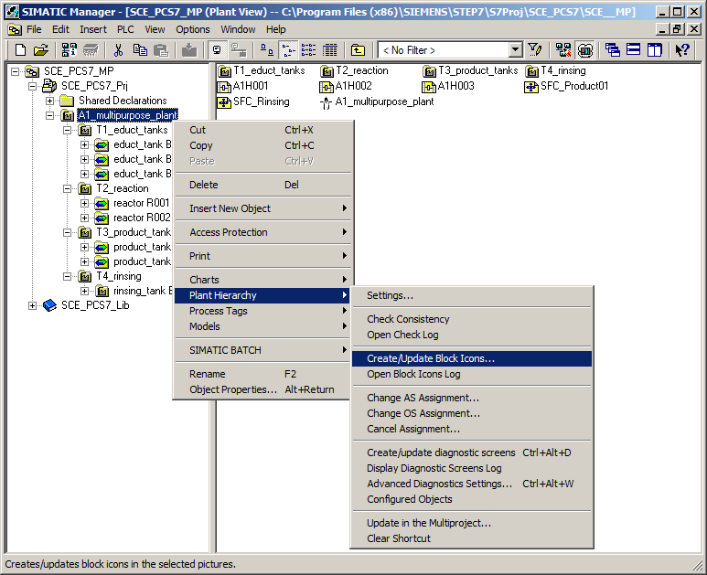

1. In the window that opens, set 'Chart' under "…name components of the HID" and the included lower-level hierarchy levels to '1'. Confirm with "OK". (® Name components of the HID: Chart ® Lower hierarchy levels included ® 1 ® OK)

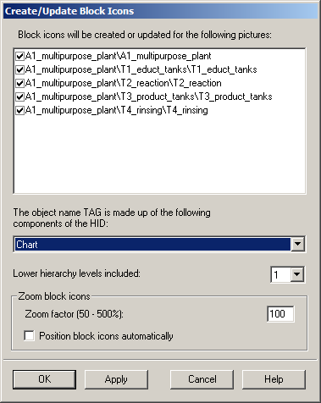

1. Next, the creation and update of the block icons takes place.

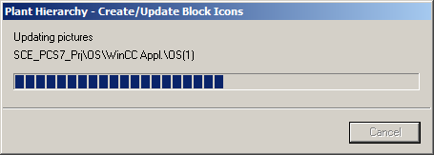

1. If the computer name in the WinCC project does not match the local computer name, you will receive the following message, which you confirm with 'Yes'.

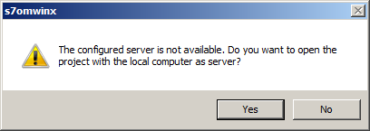

1. After the creation and update of block icons is complete, have the log displayed. (® Yes)

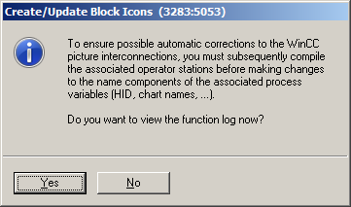

1. The log shows that no errors occurred. (® )

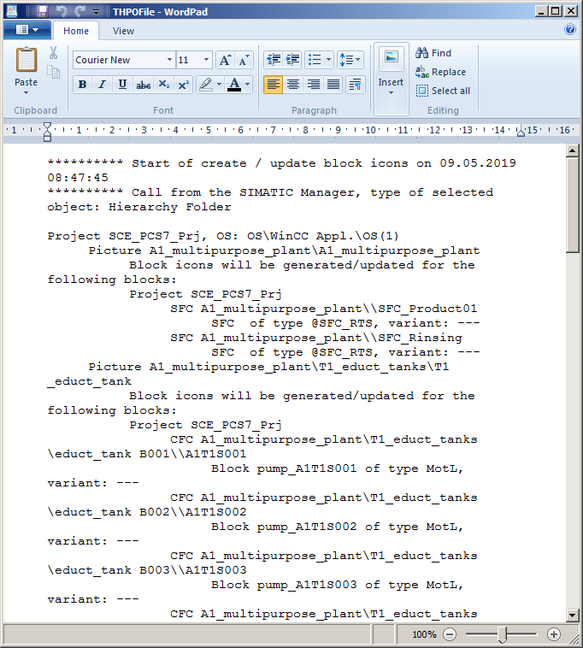

## Compiling and downloading objects

1. You can now start compiling the OS from the component view. (® OS ® PLC ® Compile and Download Objects…)

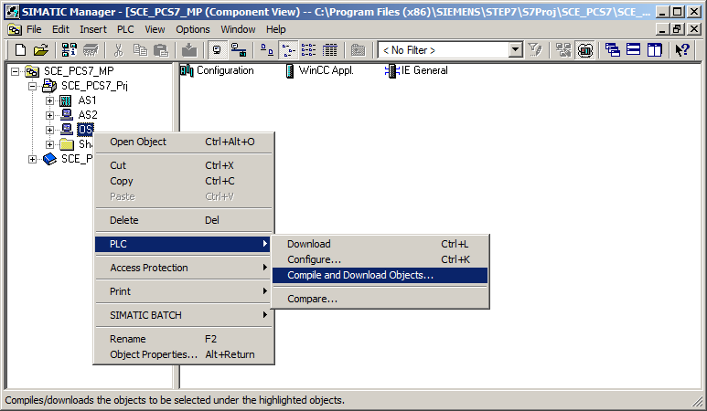

1. Before starting, check the settings for compiling the OS. (® OS(1) ® Edit…)

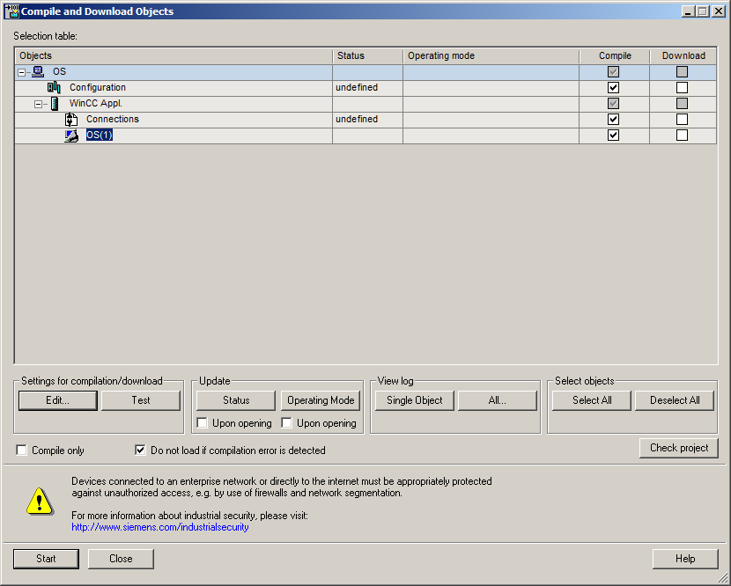

1. Leave the assignment of areas to operator stations unchanged. (® Next)

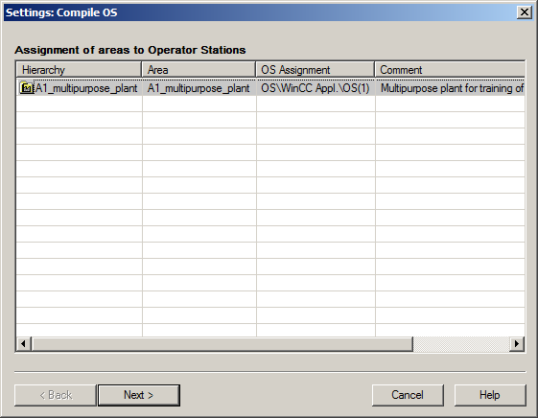

1. In the next dialog step, the network connection is checked. (® S7 Program(1) ® right-click ® Select Network Connection…)

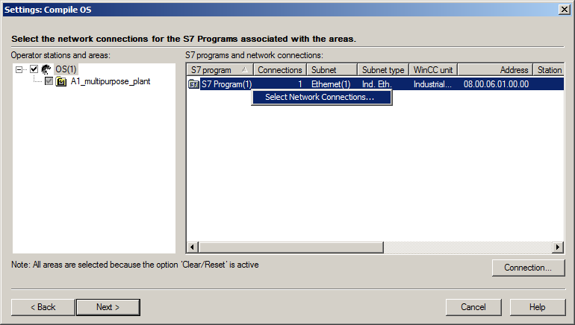

1. TCP/IP should be set as the WinCC unit. (WinCC unit ® TCP/IP ® OK)

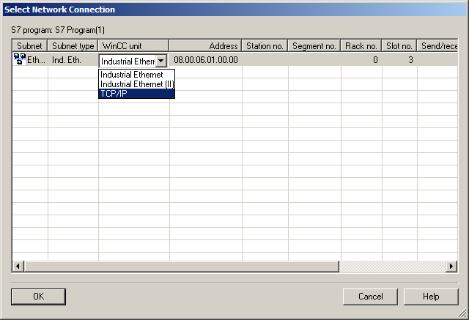

1. Now go to the next dialog step. (® Next)

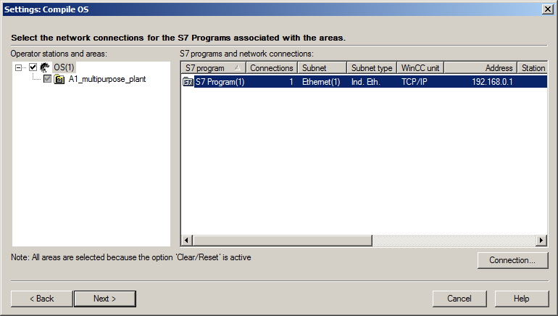

1. In the last setting window, apply the values shown below. (® Apply)

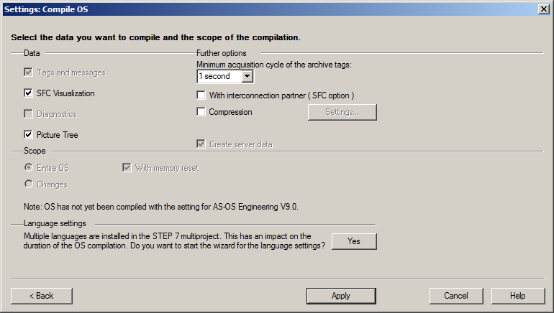

1. Because the operator station (OS) is being started on the engineering system (ES) for this plant, select only Compile here and not Download. After the compilation is started, confirm the warning with 'Yes'. (® Start ® Yes)

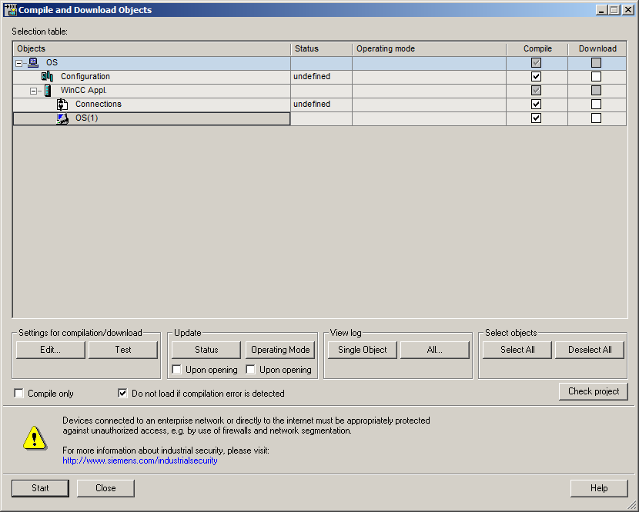

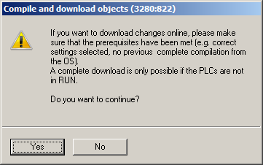

1. The log that is now displayed shows no errors. (® )

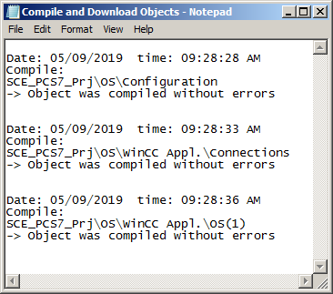

## Configuring WinCC

1. After the compilation, the operator station can be opened (® OS(1) ® Open Object)

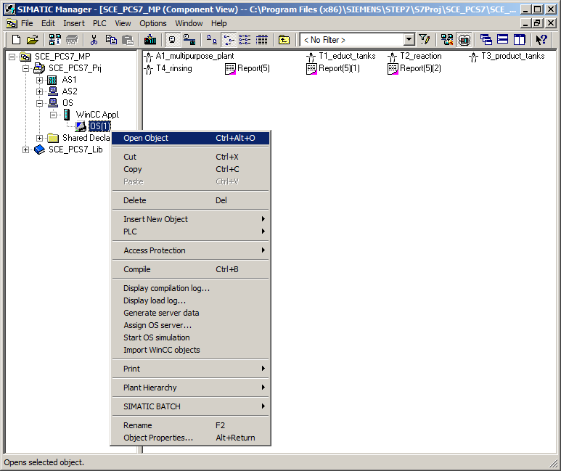

1. If the computer name in the WinCC project does not match the local computer name, you will receive the following message, which you confirm with 'Yes'.

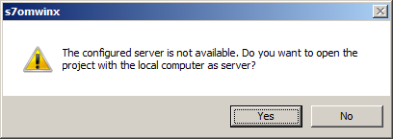

1. You should then change the name of the computer. (®  Computer ®  server computer ® Properties)

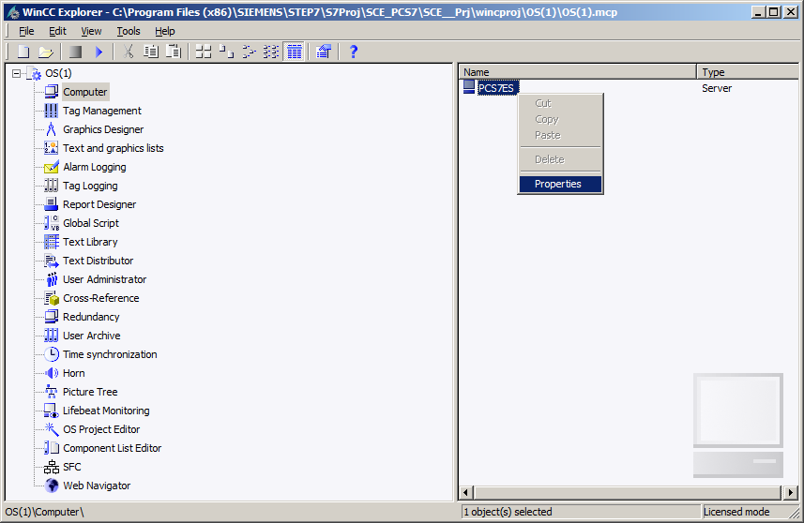

1. If the computer name is the same as the local computer name, no changes need be made. If the computer name does not match, it has to be set with the 'Use Local Computer Name' button. Exit the window with "OK". (® Use Local Computer Name ® OK)

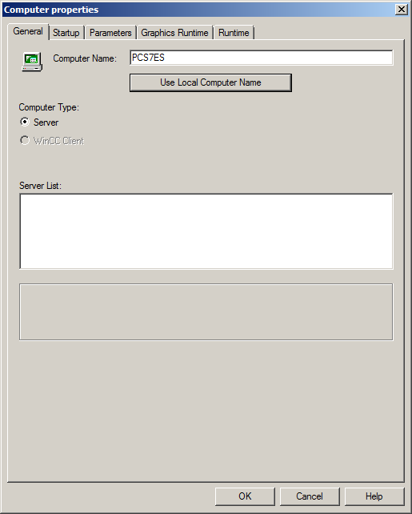 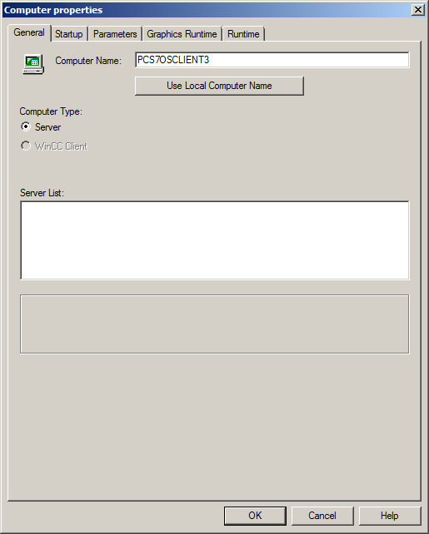

1. The change of the computer name is applied only after the restart. This means you have to close WinCC after changes to the computer name. (® OK ® File ® Exit ® Exit)

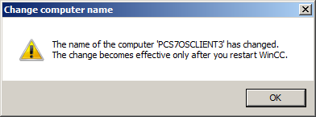

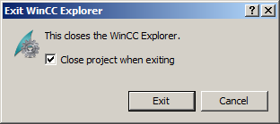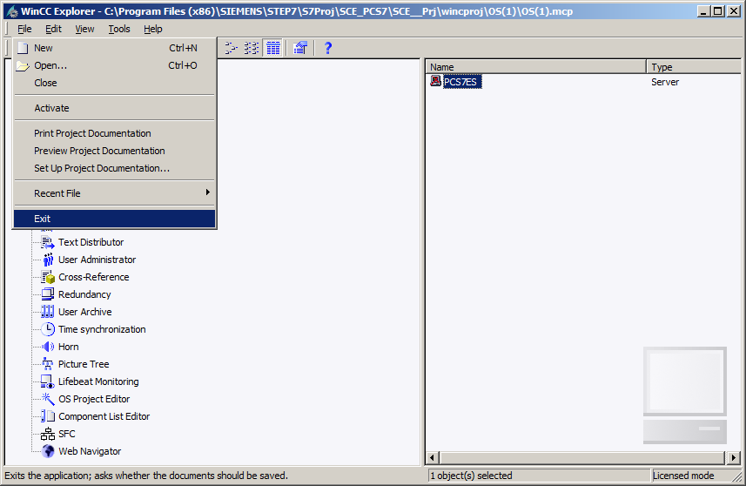

1. You can re-open the WinCC project from SIMATIC Manager.

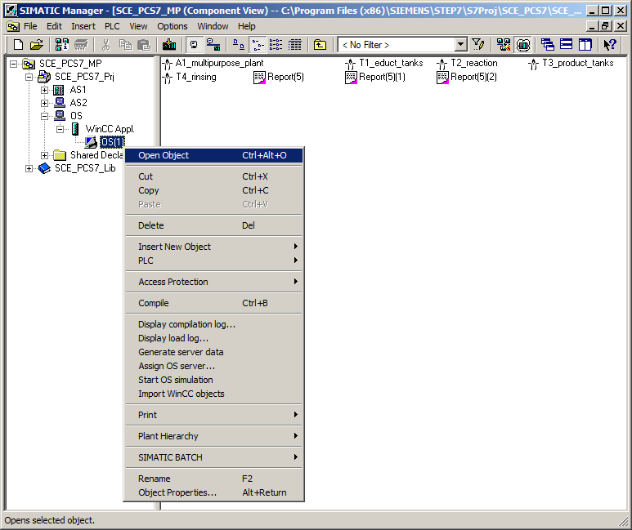

1. To set the network configuration, open Tag Management. (® Tag Management ® Open)

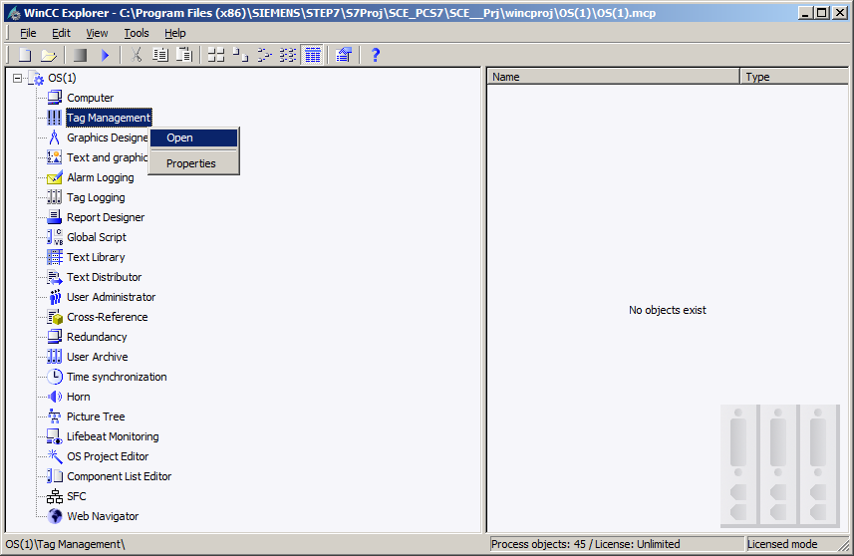

1. You can change the system parameters here. To do so, you must select the system parameters in the SIMATIC S7 Protocol Suite under TCP/IP. (® SIMATIC S7 Protocol Suite ® TCP/IP ® System parameters)

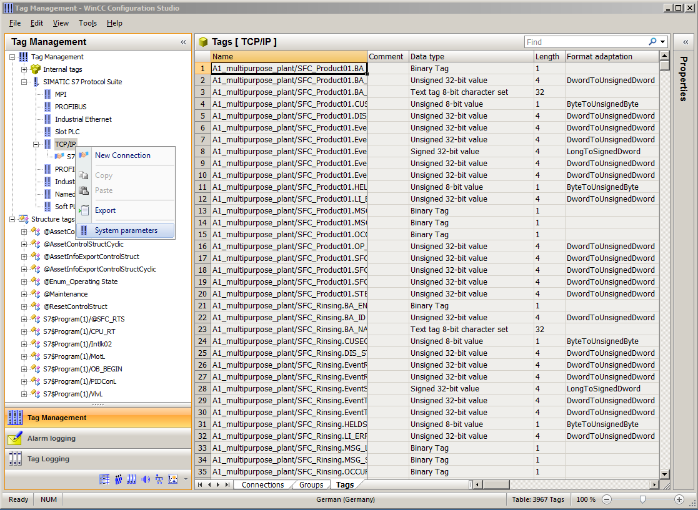

1. In the 'Unit' tab, set PLCSIM.TCPIP.1 as the logical device name. (® Unit ® Logical device name: PLCSIM.TCPIP.1 ® OK)

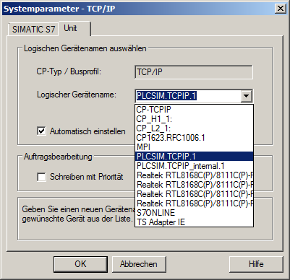

1. Close Tag Management. (® File ® Exit)

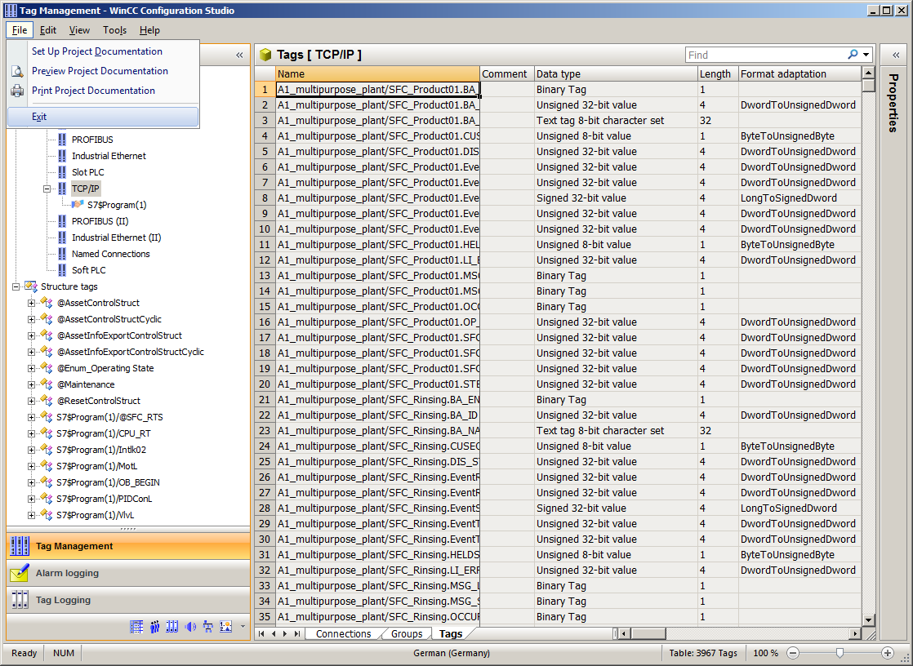

1. Open the Picture Tree Manager. (® Picture Tree Manager ® Open)

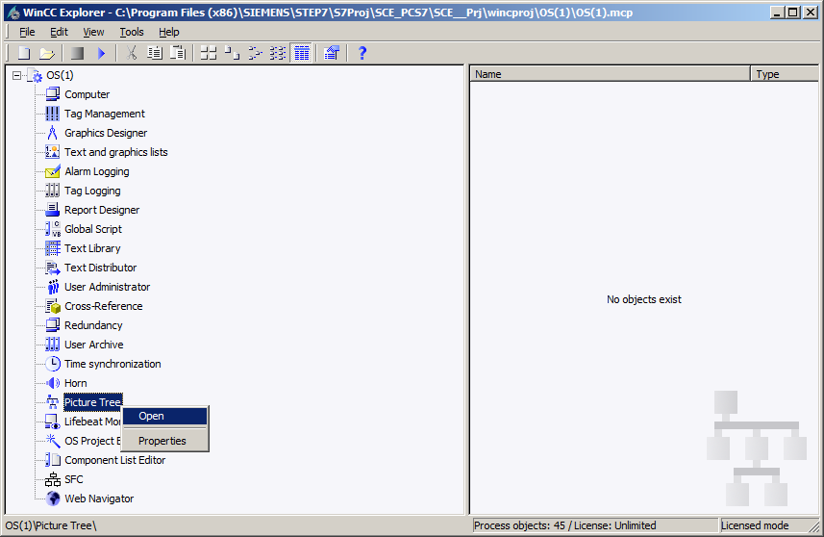

1. The order in which the pictures will be called later is specified in the Picture Tree Manager.

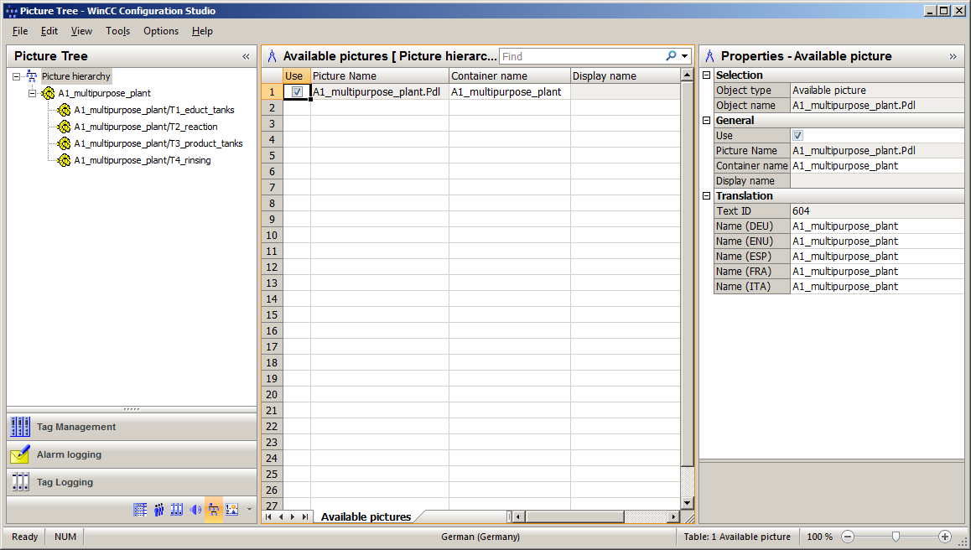

1. Keep and save the structure and close the editor. (® File ® Save ®  Close)

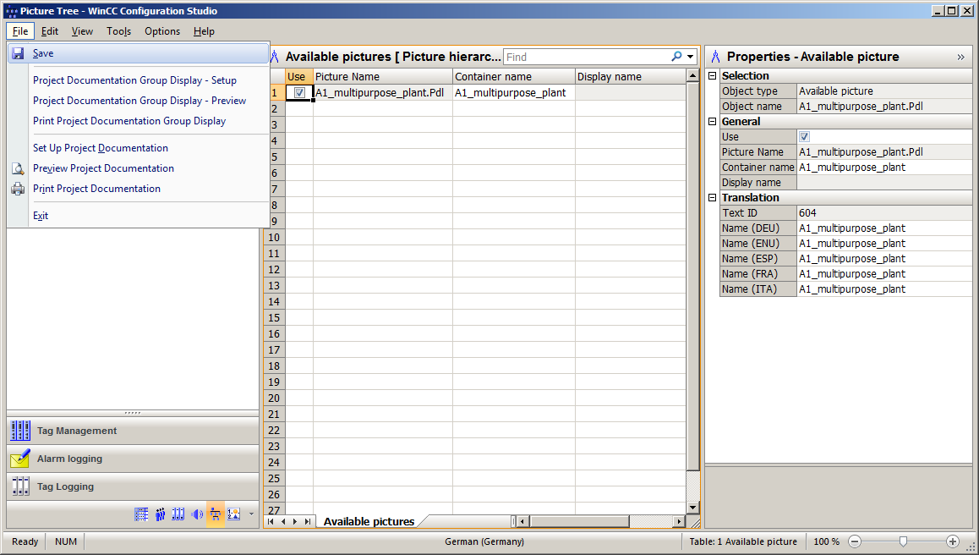

1. Then open the OS Project Editor. (® OS Project Editor ® Open)

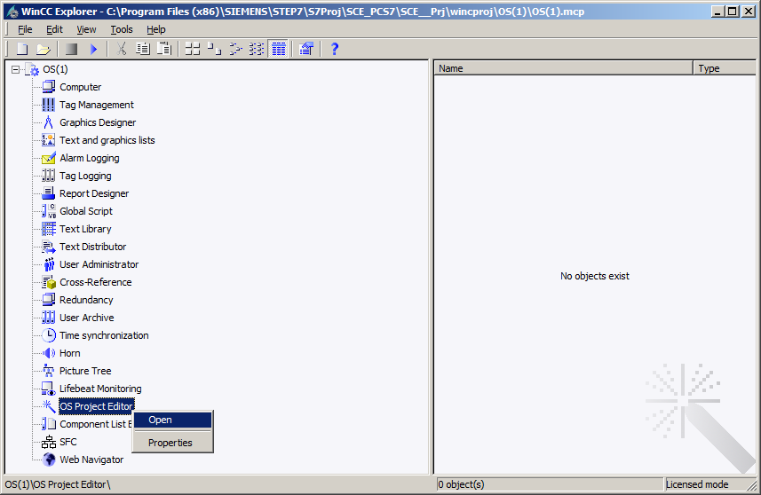

1. The motor configuration and the screen resolution can be selected under 'Layout' in the OS Project Editor. In addition, there are settings for the message display, the visible areas, the window arrangement in the Runtime window and other basic settings. Set the desired layout, the number of area keys and the monitor configuration. (® Select layout ® Select monitor configuration ® 'Detail…' button ® Number of Areas Horizontal / Vertical: 2 ® OK)

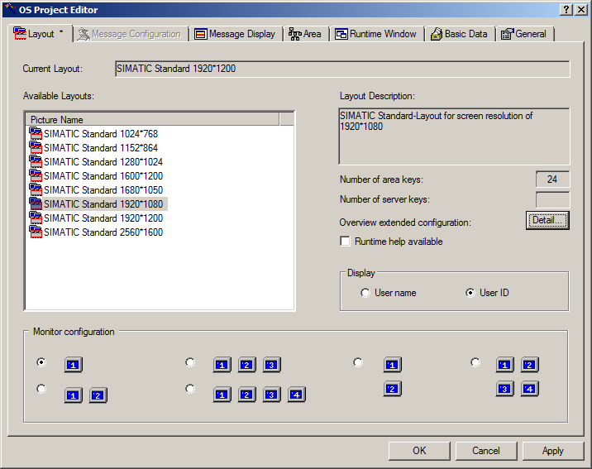

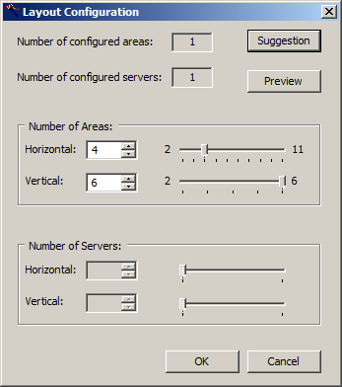 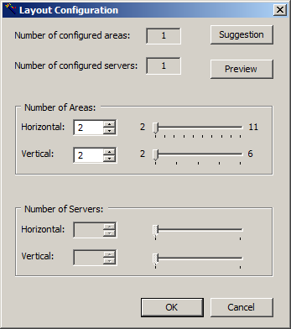

1. Exit the dialog with 'OK'. (® OK)

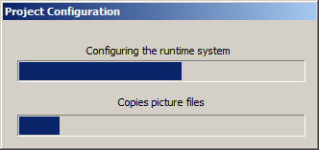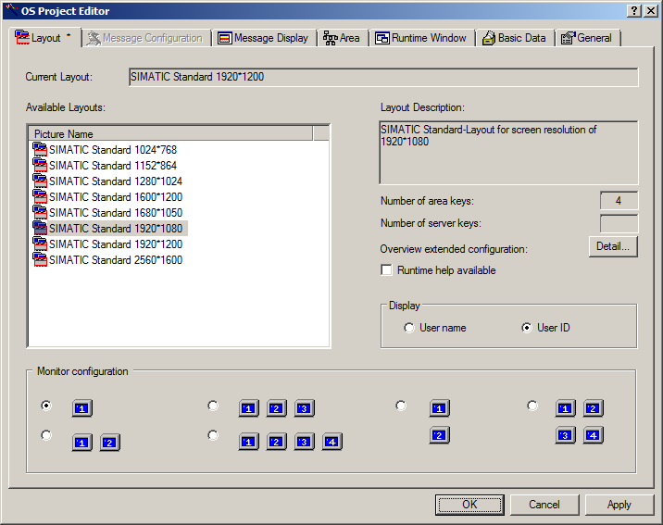

## Editing the faceplate for the multipurpose plant

1. The faceplates are created in the Graphics Designer. The best way to open individual screens is to double-click on the name in the right window. (® Graphics Designer ® A1_multipurpose_plant)

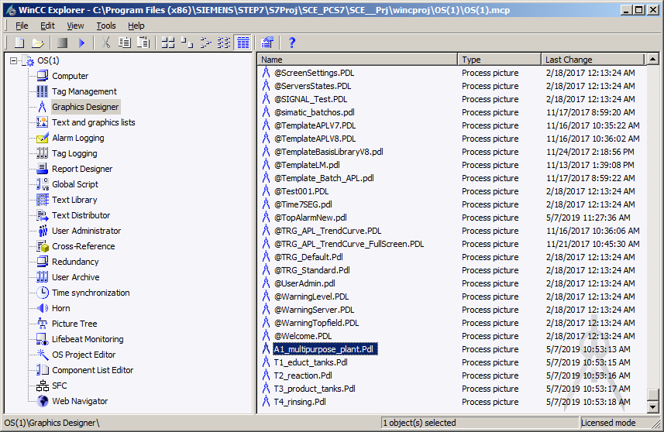

1. The Graphics Designer provides a wide range of functions for creating process pictures. They can be hidden or shown in the menu with View/Toolbars. (® View ® Toolbars)

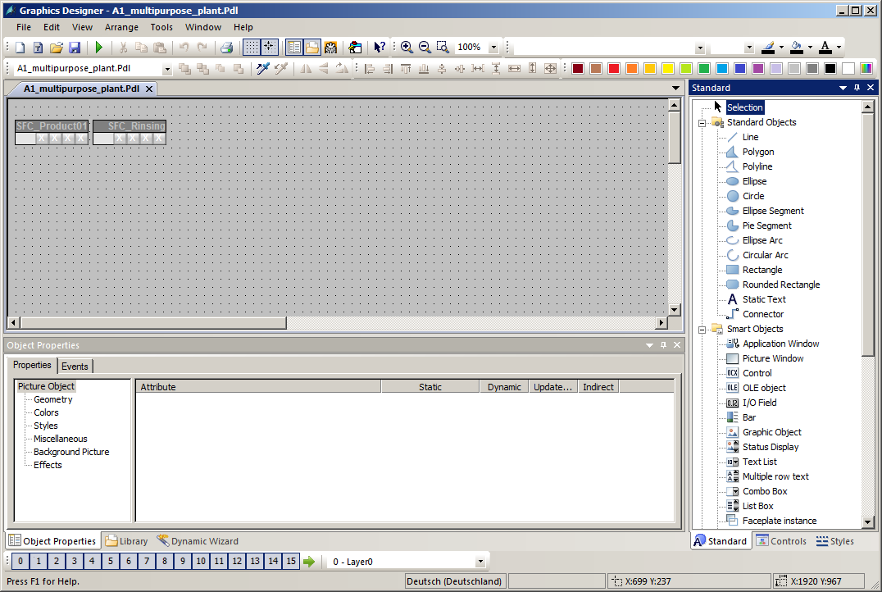

**Standard**

**Styles**

**Layer bar**

**Dynamic Wizard**

**Color palette**

**Alignment palette**

**Object Properties**

**Zoom**

**Work area**

These toolbars have the following functions:

* Standard palette: Contains icons and buttons to execute frequently used commands quickly.
* Color palette: Allows the assignment of colors to selected objects (one of 16 standard colors or a user-defined color).
* Zoom palette: Sets the zoom factor (in percent) for the active window.
* Styles: Changes the appearance of a selected object. Depending on the object, the line/border type, the line/border weight, the line end styles or the fill pattern can be changed.
* Standard: Contains the standard objects (polygon, ellipse, rectangle, etc.), smart objects (OLE control, OLE element, I/O field etc.) and Windows objects (button, check box etc.).
* Dynamic Wizard: Provides numerous frequently used functions. These can be created with the help of a dialog that guides and assists the user.
* Layer palette: Selects which of the 32 levels (level 0 to 31) is visible. Level 0 is selected by default.
* Alignment palette**:** Allows you to change the absolute position of one or more objects and the position of selected objects relative to each other or to standardize the height and width of several objects.
* Object properties: Allows you to view and change all properties of the selected object.
* Object palette: Shows you which object is currently selected and offers different options for manipulation.

1. By creating faceplates, the pictures already contain block icons, which can be positioned within the pictures as desired.

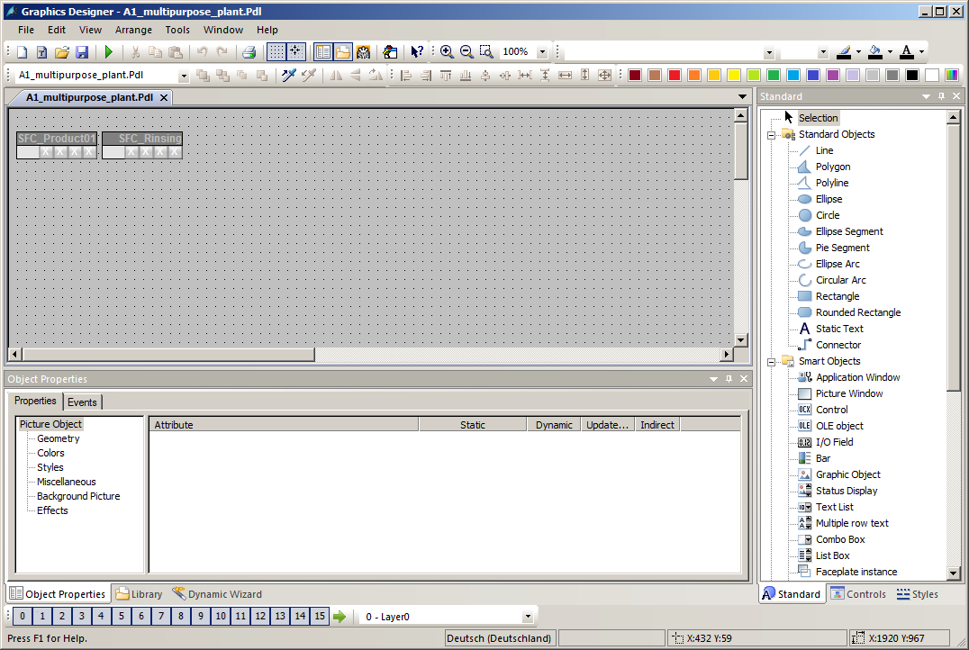

1. The name displayed in the faceplate can be specified in the properties of the block icons. Otherwise, a very long name that includes the path is displayed. Leave the name unchanged. (® Properties ® Object Name ® A1_multipurpose_plant/SFC_Product01)

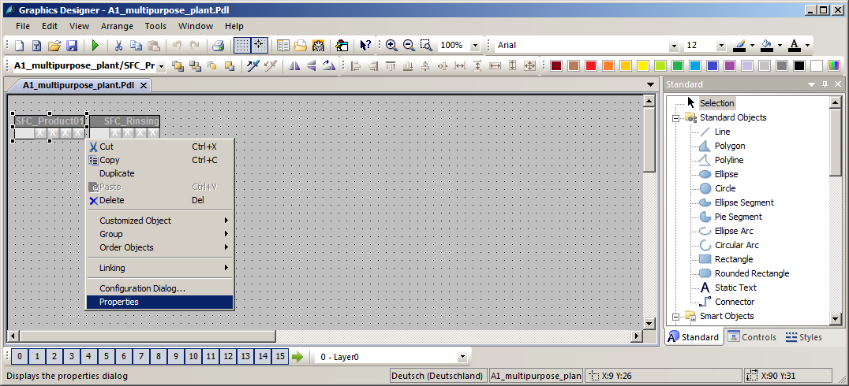

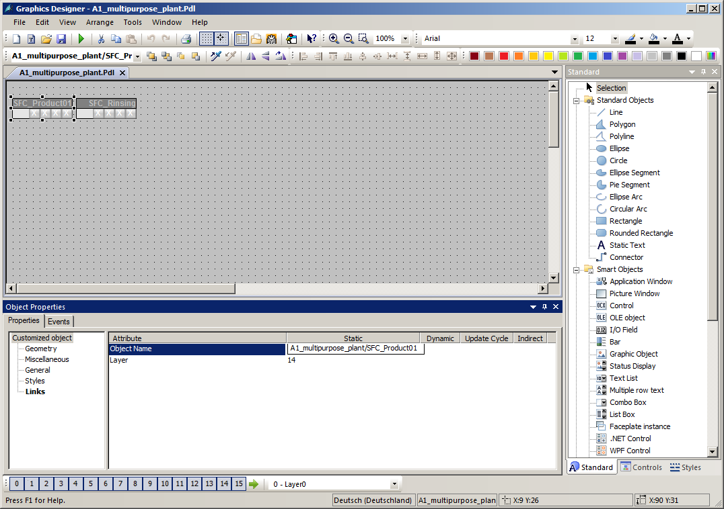

1. Now, you change the background color of the picture to white. To do so, left click in the background of the picture with activated Object Properties toolbar. The properties of the picture object open.

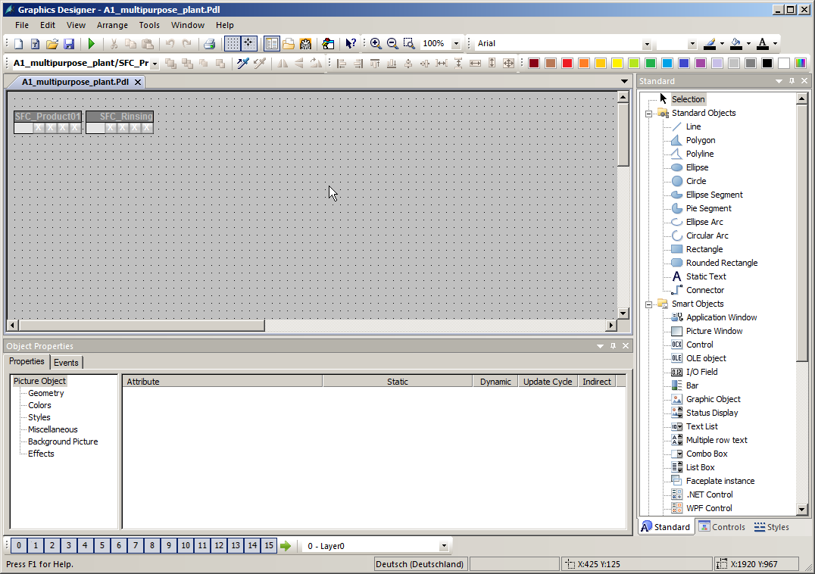

1. Each object as well as the picture itself has numerous properties that can be changed statically or dynamically (for example, connected to process tags). The background color will be edited here. (® Picture Object ® Colors ® Background Color ® Edit)

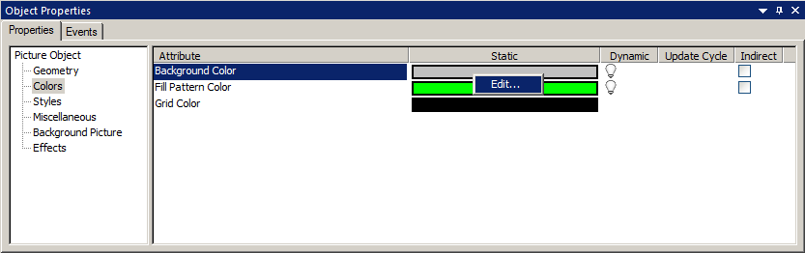

1. Select white as the color (255 255 255). (white ® OK)

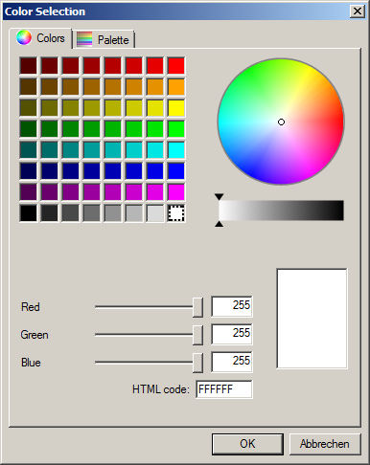

1. For the change of the background color to become effective, the global color scheme must be deactivated. (® Picture Object ® Effects ® Global Color Scheme ® No)

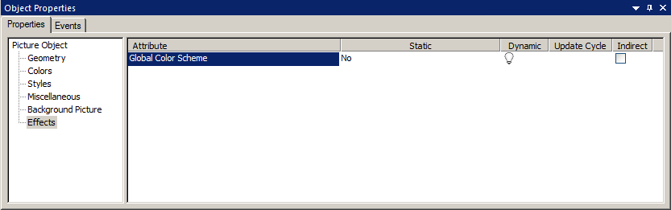

1. Now, change the picture geometry so that it can be displayed completely in the work area (1920x847) at the screen resolution configured in section 8.4 (1920x1080). (® Picture Object ® Geometry ® Picture Width: 1920 ® Picture Height: 847)

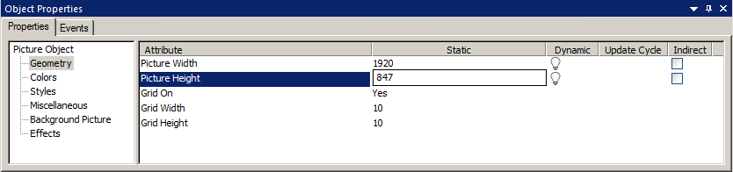

1. Next, in the Standard palette, click on Rectangle and draw a large rectangle in the picture.

(® Standard palette ® Rectangle)

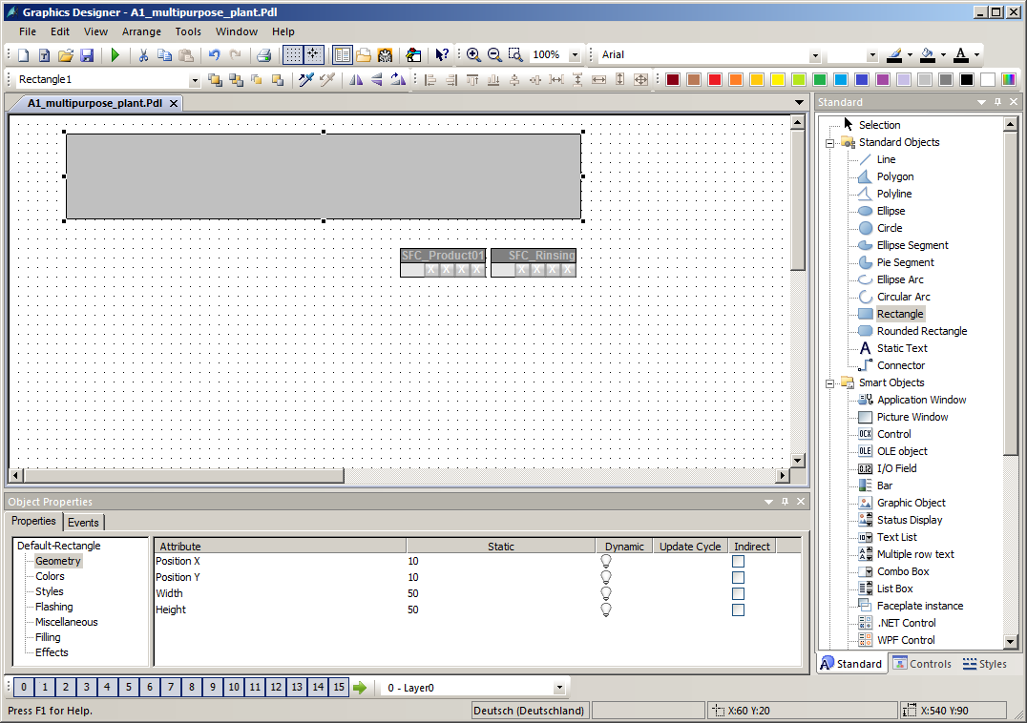

1. Arrange the icons for the SFCs as shown below next to the rectangle you just drew.

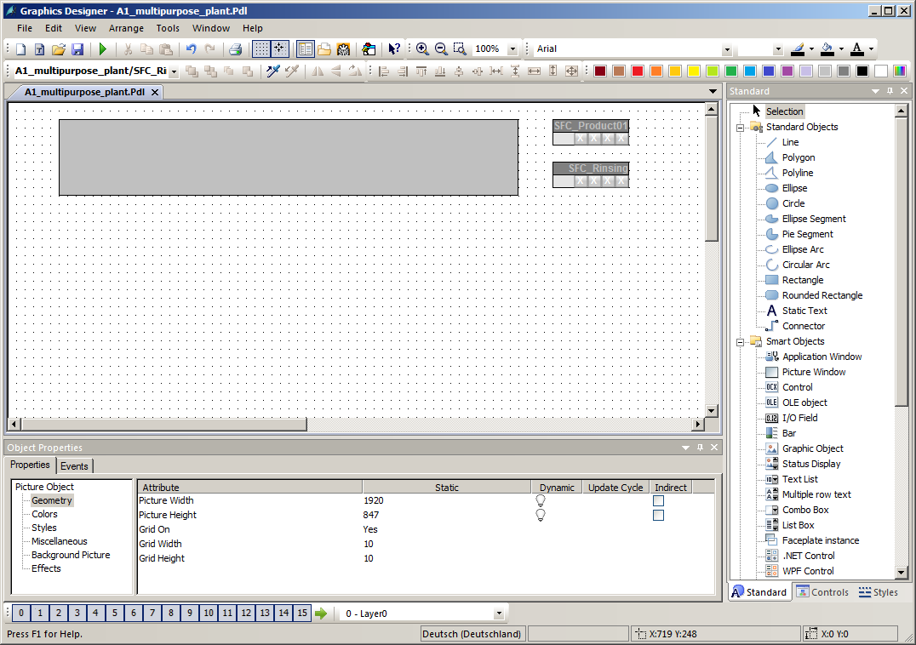

## Configuring the picture change

1. If the Dynamic-Wizard is not yet displayed, open the selection for the toolbars. (® View ® Toolbars ® Dynamic Wizard)

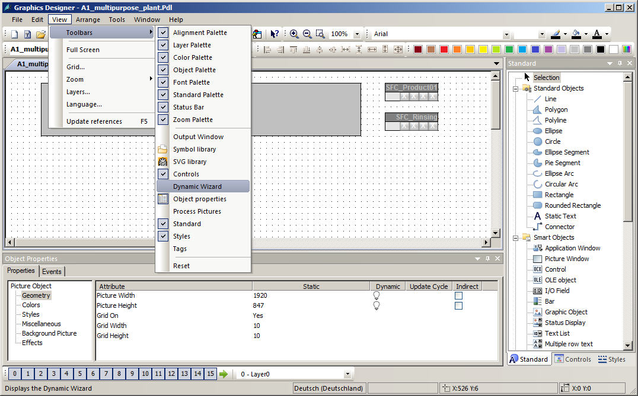

1. If the toolbar for the Dynamic Wizard is displayed, double-click the 'Picture change in working area' function in the Picture Functions to open it. In order for this function to be applied to the rectangle you have just created, it must be selected first.  
   (® Picture Functions ® Picture change in working area)

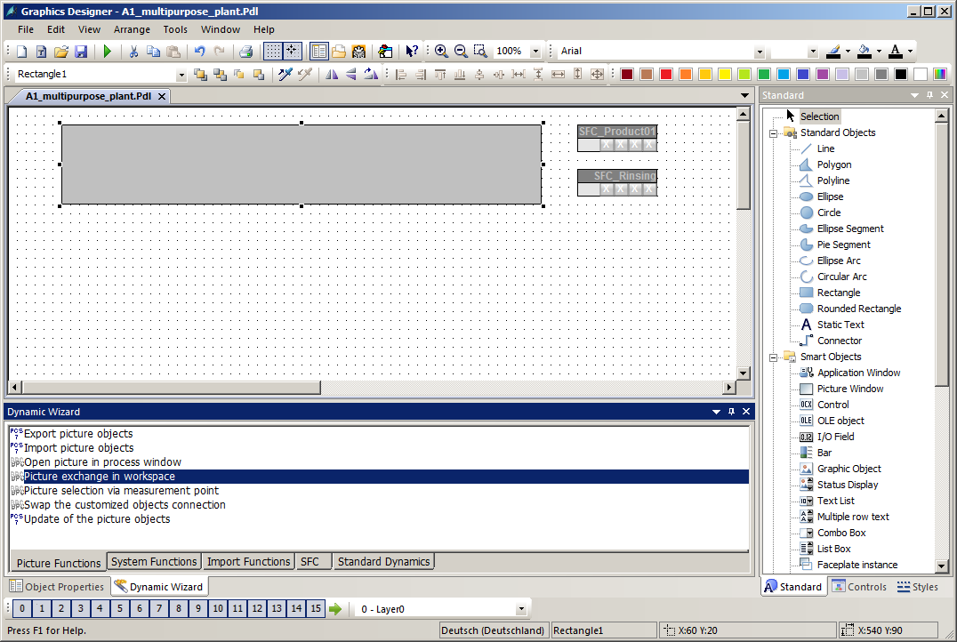

1. Read the explanation and click 'Next'. (® Next)

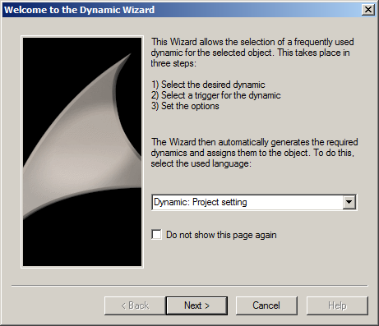

1. Select 'Mouse click' as the trigger. (® Mouse click ® Next)

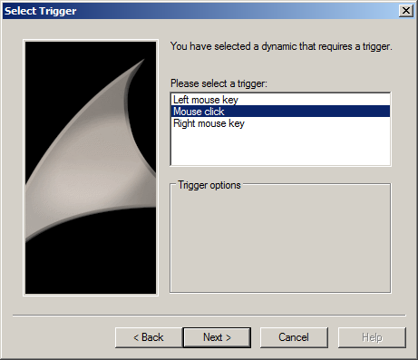

1. Now select the picture that is to be changed to. (® )

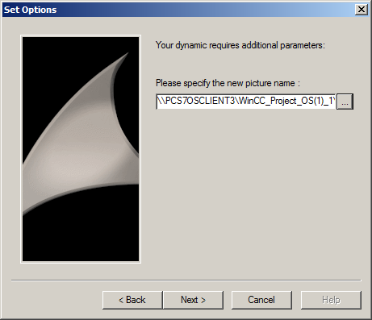

1. In the Picture Browser, select 'T1_educt_tanks.Pdl'. (® T1_educt_tanks.Pdl ® OK)

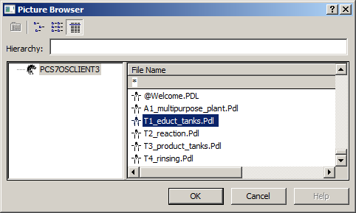

1. The name of the picture was applied and you confirm with 'Next'. (® Next)

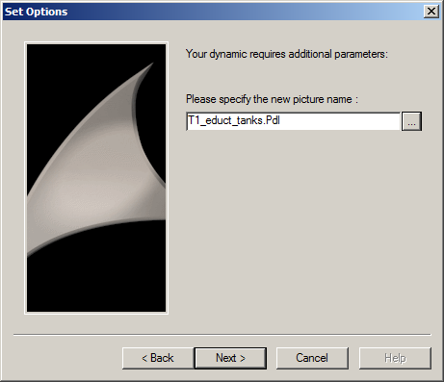

1. The wizard is closed with 'Finish'. (® Finish)

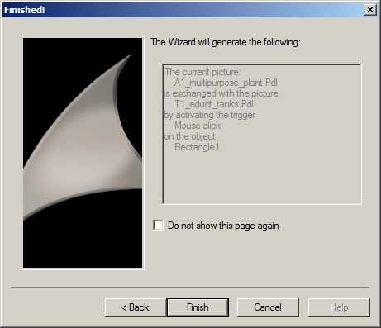

1. If you would like to view the result, you will find the mouse and the mouse click under 'Events'. With a double-click on the  icon, you can then view the created C script. (® Object Properties ® Events ® Mouse ® Mouse click  ® OK)

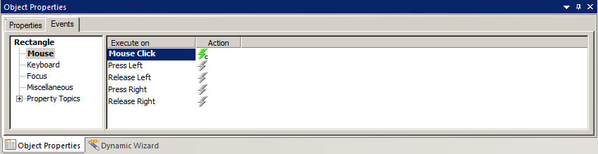

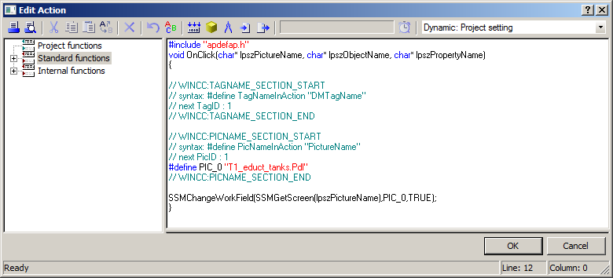

1. Using static texts, rectangles and the Dynamic Wizard, design your picture as shown here. Be sure that the language in the 'View' menu corresponds to the desired target language. Here: English (United States). (® View ® Language ® English)

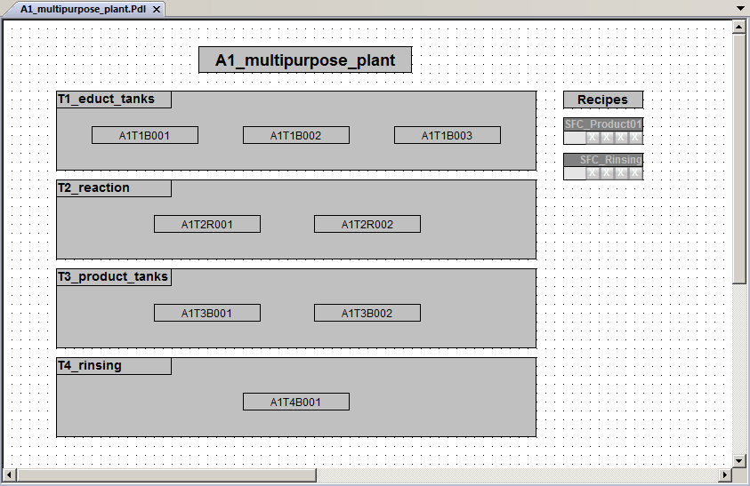

## Editing the faceplate for T1_educt_tanks

1. Next, open the picture 'T1_educt_tanks' from WinCC Explorer.

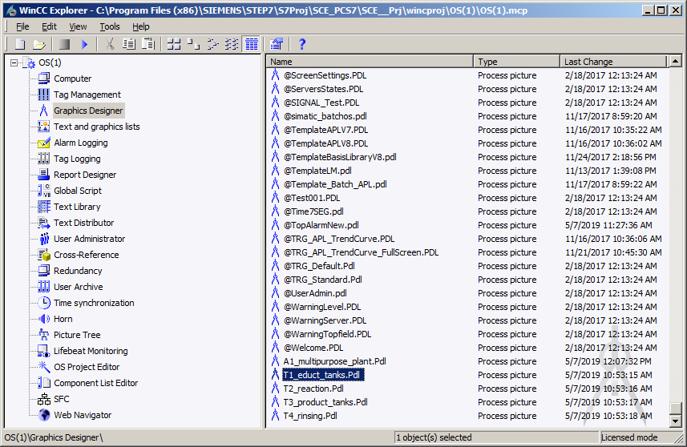

1. After you have changed the background color to white and the size to 1920x847, as you did previously for the picture of the multipurpose plant, open the library.  
   (® Show library )

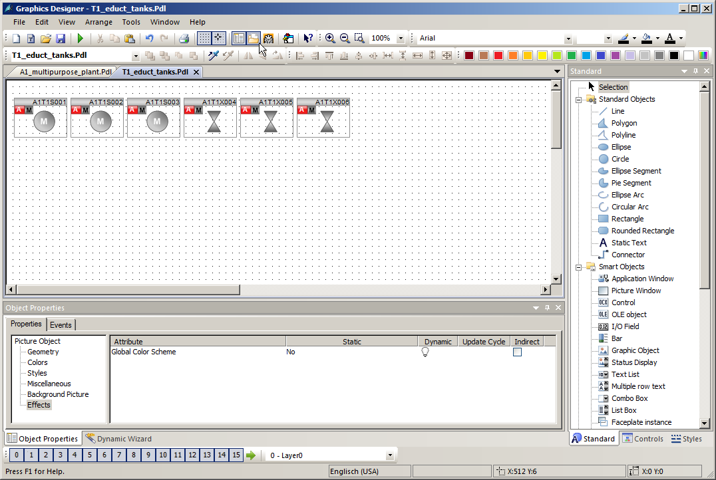

1. First, drag a symbol for the pump from the library to the work picture. (® Global Library ® Symbols ® E-Symbols ® 20_2)

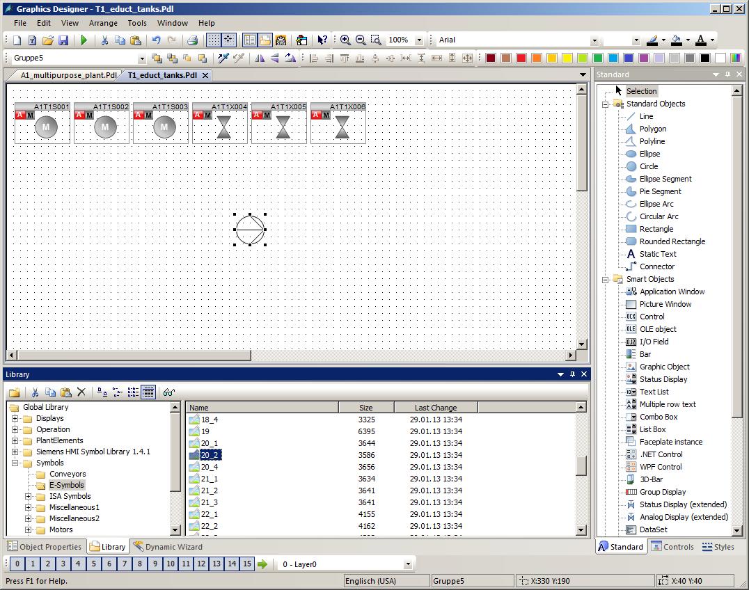

1. Now also drag a valve symbol to the work picture. (® Global Library ® Symbols ® Valves ® 45)

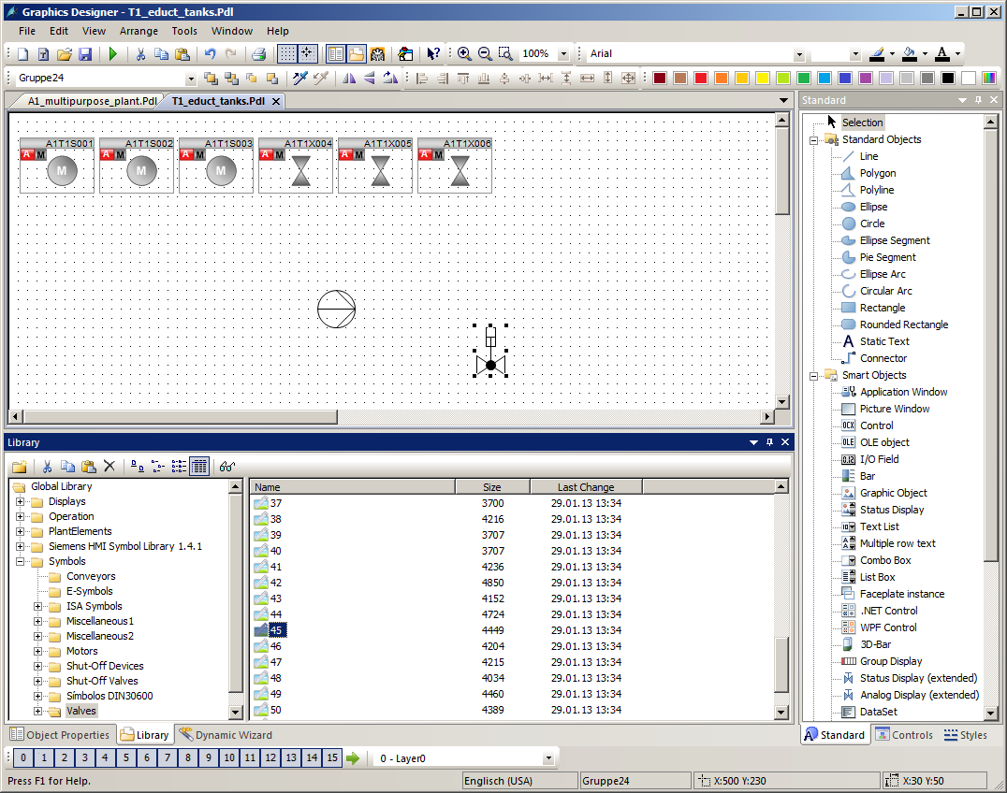

1. The static symbols can be changed in their orientation by using the button Rotate. (® Rotate object )

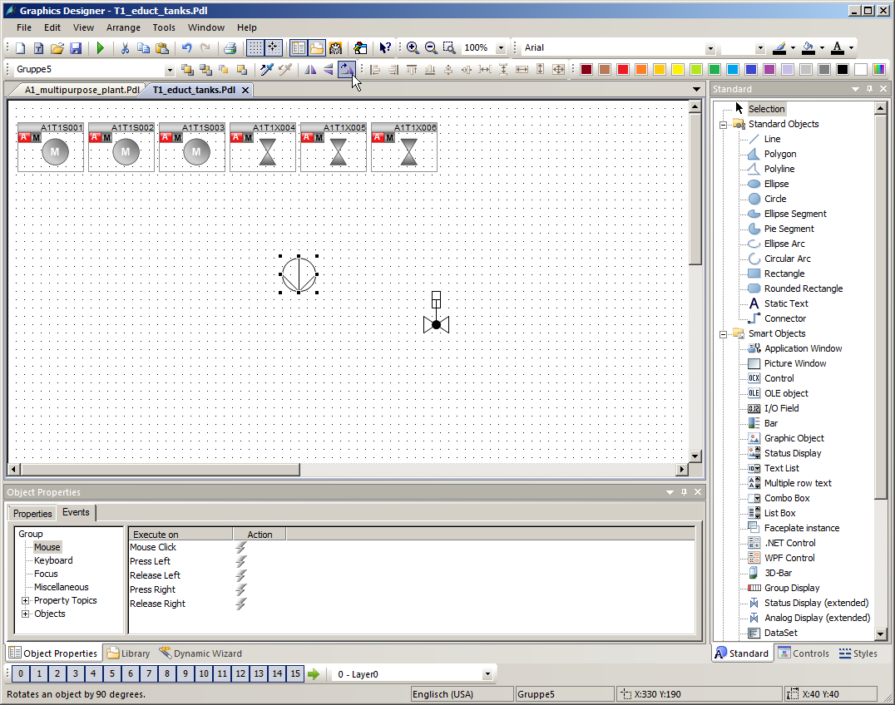

1. After you have inserted additional lines and text fields as shown here, place a rectangle for representation of the tank and select its properties. (® Rectangle ® Properties)

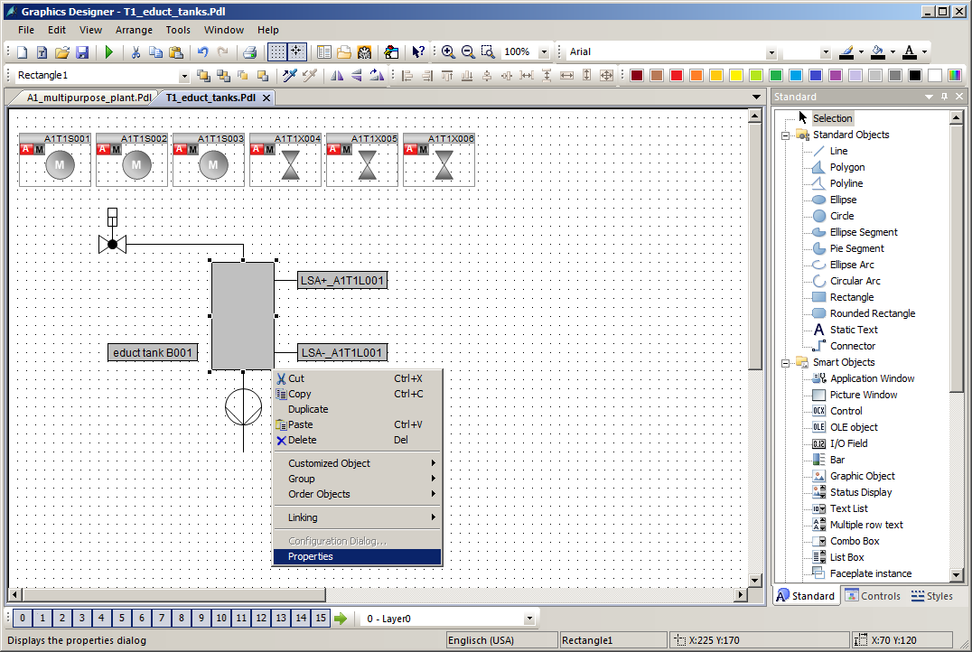

1. To change the color, deactivate the global color scheme once again. (® Properties ® Effects ® Global Color Scheme ® No)

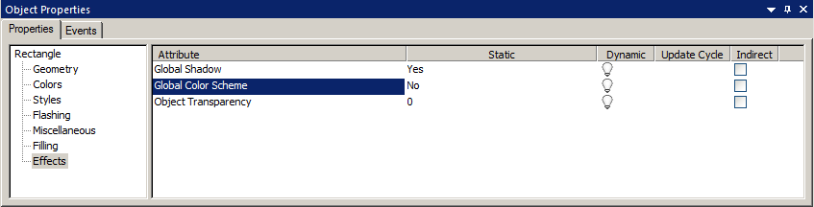

1. Now change the background color to white. (® Properties ® Colors ® Background Color)

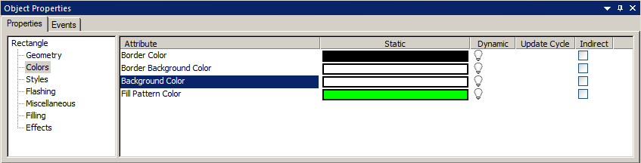

## Linking of picture elements with PLC tags

1. Next, you are to configure a display of the digital level sensors. For this, drag two circles into the picture as shown here. Then, select properties of the top circle. (® Circle ® Properties)

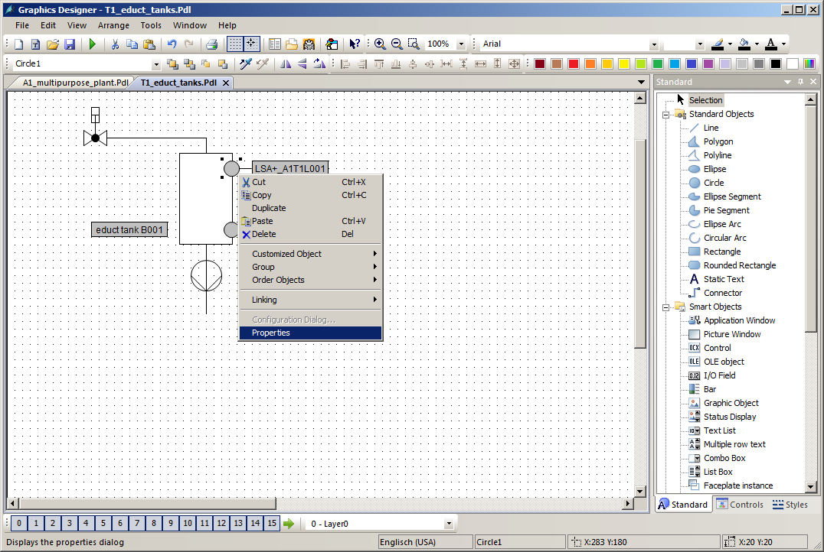

1. To have the color displayed dynamically, deactivate the global color scheme. (® Properties ® Effects ® Global Color Scheme ® No)

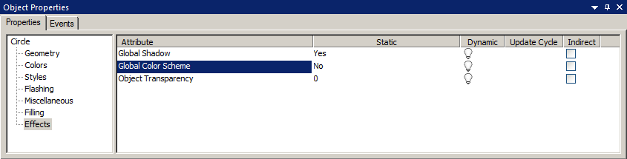

1. Select the background color with the right mouse button and then select the dynamic dialog in order to implement a dynamic display. (® Properties ® Colors ® Background Color ® right-click in Dynamic column  ® Dynamic Dialog)

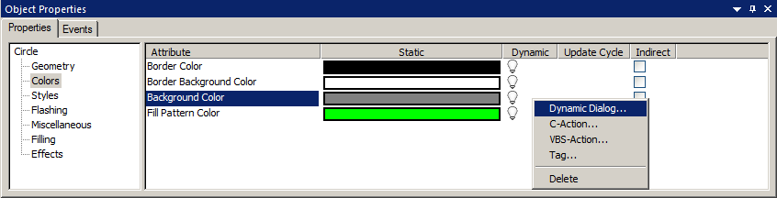

1. In the next dialog, first select Boolean as the data type. Then, change the color for Yes/TRUE to green. Finally, select and expression 'Tag' for the dynamization. (® Data Type: Boolean ® Yes/TRUE ®  ®  ® Tag …)

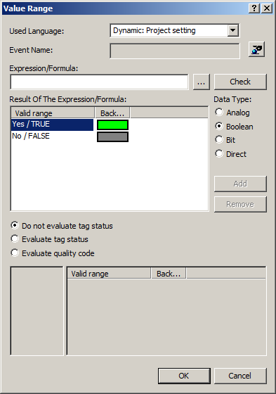 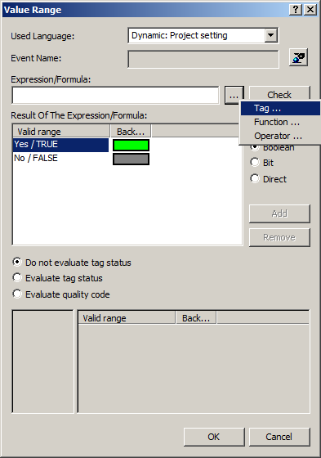

1. For the tags, select 'STEP 7 Symbol Server' as the data source. There, for the symbols, input I70.0 for the 'level monitoring educt_tank B001 operating point H'. (® Data source ® STEP 7 Symbol Server ® A1.T1.A1T1L001.LSA+.SA+ / E70.0 / level monitoring educt tank B001 operating point H ® OK)

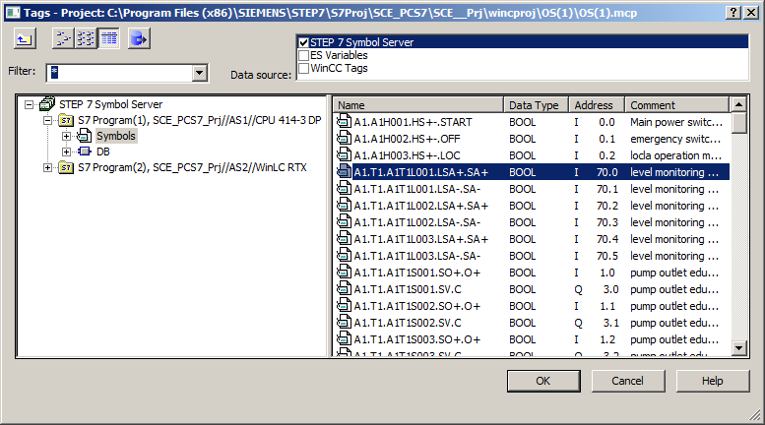

***Note:***

* *If you are using the AS1/S7-400, select the symbols under S7 Program(1). If you are using the AS2/RTX Box, however, you must select the symbols under S7 Program(2).*

1. Now, check the settings in the Dynamic Dialog. (® Check ® Close ® OK)

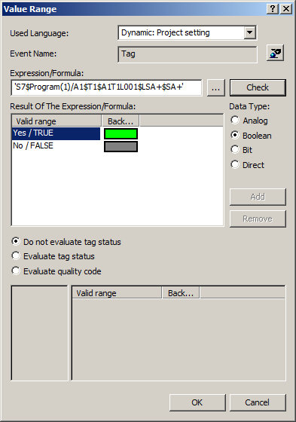

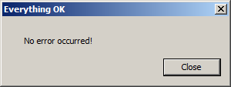

## Saving in the project library

1. The steps presented above will also be performed for the sensor 'A1.T1.A1T1L001.LSA-.SA- / I70.1 / level monitoring educt_tank B001 operating point L'. Then, the elements shown here will then be selected together and grouped. Leave enough space for a valve to be placed on the line between the tank and pump. Also take into account the function line on the pump (® A1.T1.A1T1L001.LSA-.SA- / I70.1 / level monitoring educt_tank B001 operating point L ® Group ® Group)

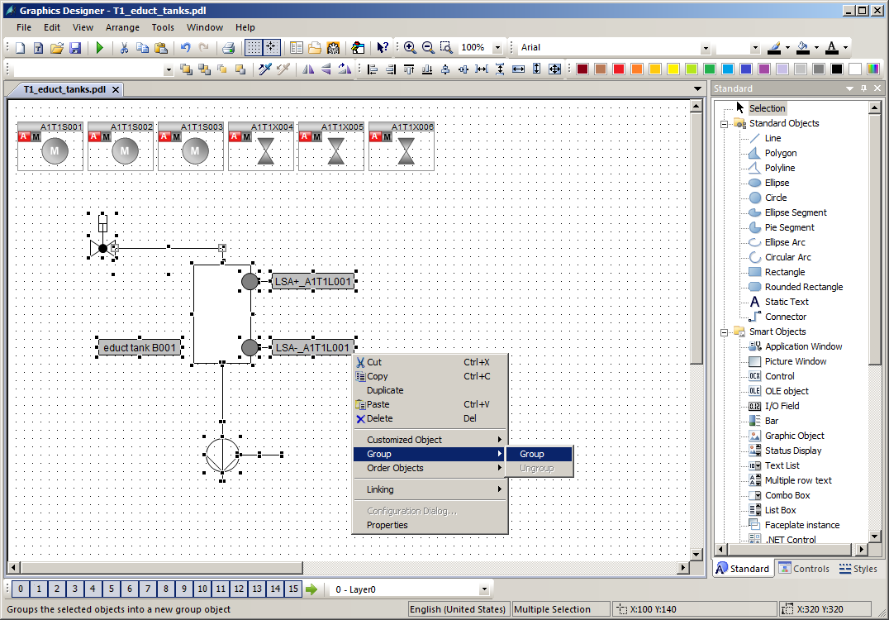

1. The group is then copied. (® Copy)

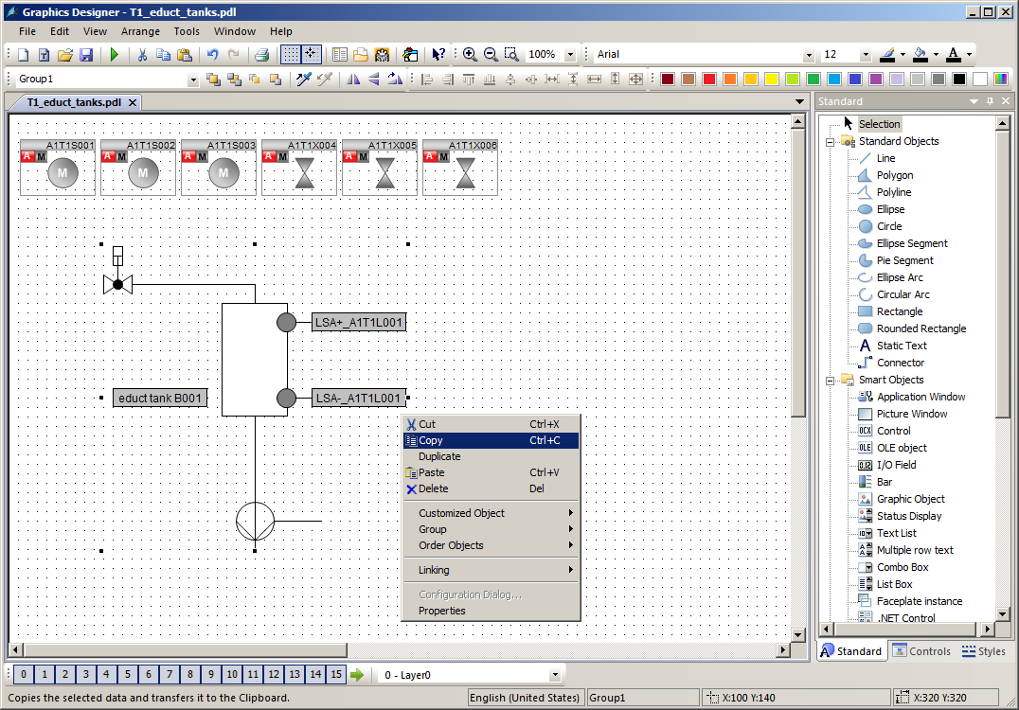

1. Now, open the library and paste the group in the project library. Name the template 'educt_tank_V1_0'. (®  ® Project Library ® Paste)

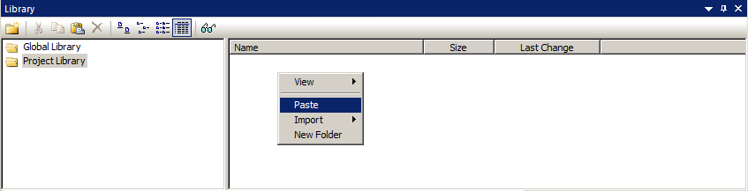

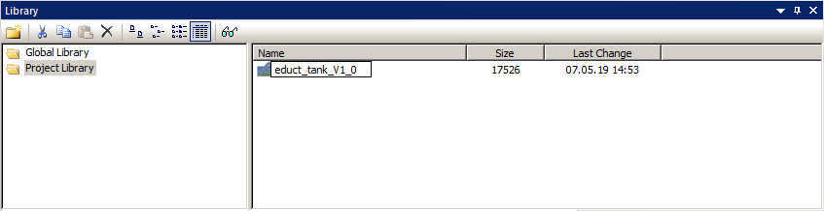

## Adapting the orientation of the faceplates

1. Next, in the picture 'T1_educt_tank.Pdl', you will position the faceplates for the valve 'A1T1X004' and for the pump 'A1T1S001' as shown here. It is recommended that the symbols within the layer be brought to the front so they cannot be covered up by other drawing elements. (® Arrange ® Order Objects ® Bring to Front).

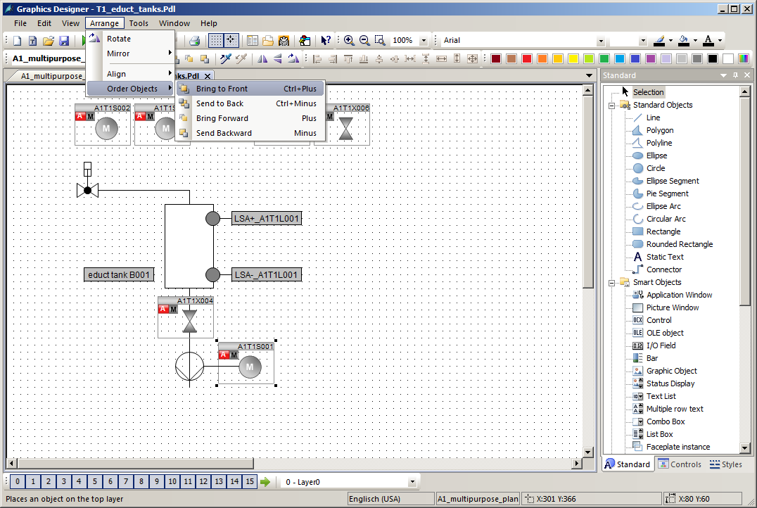

1. The orientation of the dynamic valve faceplates is not yet correct. At runtime, the faceplates are animated in such a way that they are perpendicular to the run of the pipe in closed state and are rotated parallel with the run of the pipe in open state. However, a change of the orientation can only take place via the CFC of the respective valve. To rotate a valve, first open the associated CFC and then the object properties of the valve block.   
   (® SIMATIC Manager ® Plant View ® A1T1X004 ® VlvL ® Object Properties).

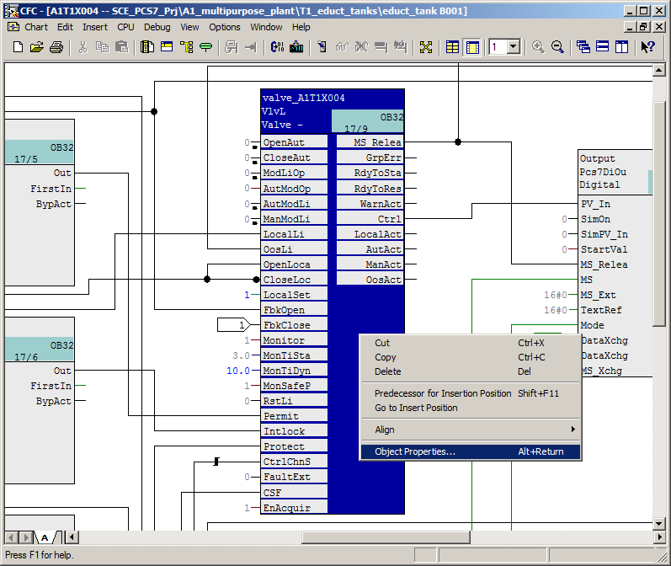

1. Now, in the 'Create block icon' field, enter a "2". This rotates the icons by 90 degrees. (® Create block icon ® 2 ® OK)

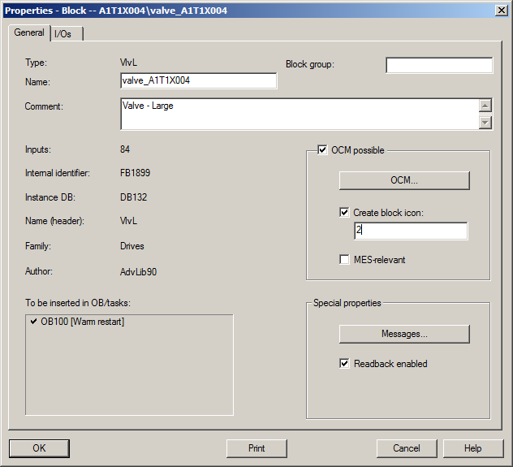

1. After you have made the changes for all valves that are located on a vertical pipe, compile the changes. (® SCE_PCS7_Prj ® PLC ® Compile and Download Objects ® OS(1) ® Edit)

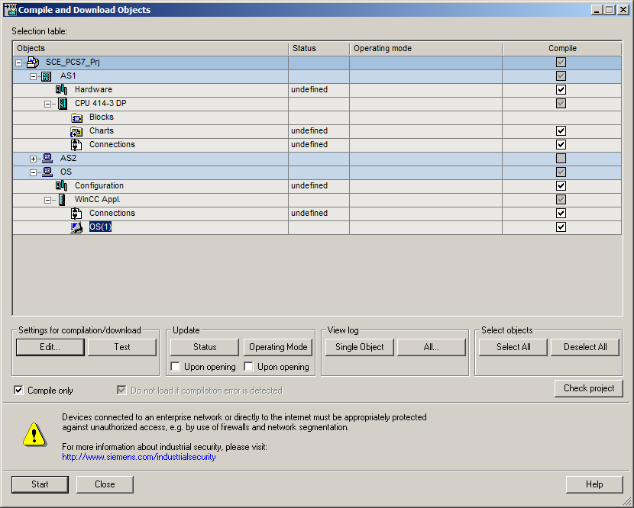

1. In the last dialog of the settings, select 'Changes' as the scope and start compiling the OS.

(® Scope ® Changes ® Apply ® Start)

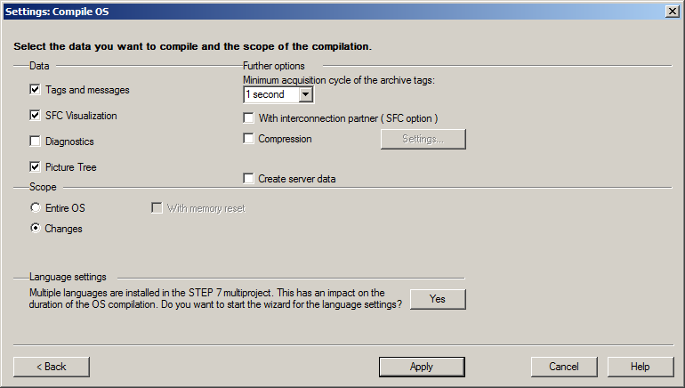

1. In WinCC, the symbol of the valve for which you made the change shown is now rotated by default. Insert a static text 'T1 educt_tank' to facilitate orientation during operation. The result is shown below.

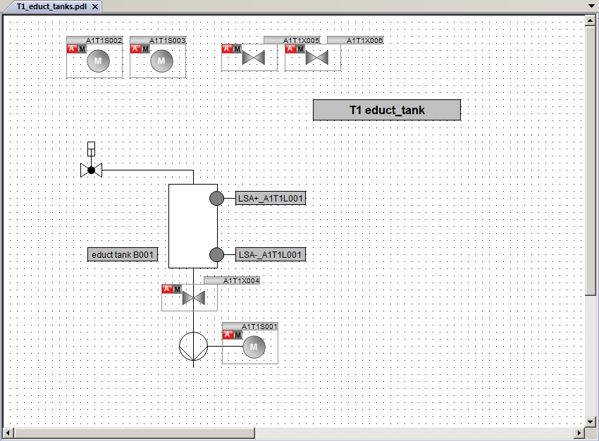

1. Just as for the picture 'T1_educt_tank', a tank/reactor will now be created in the pictures for the product tanks and reactors. You can orient yourself to the two figures below for this. In addition, create a template for the library from the one reactor as well as from the product tank.

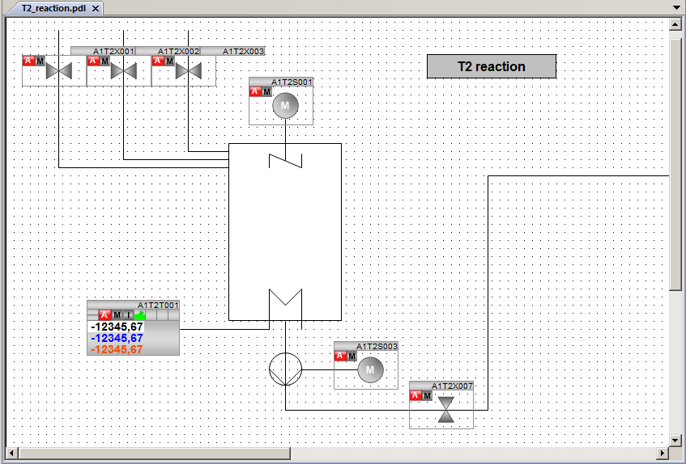

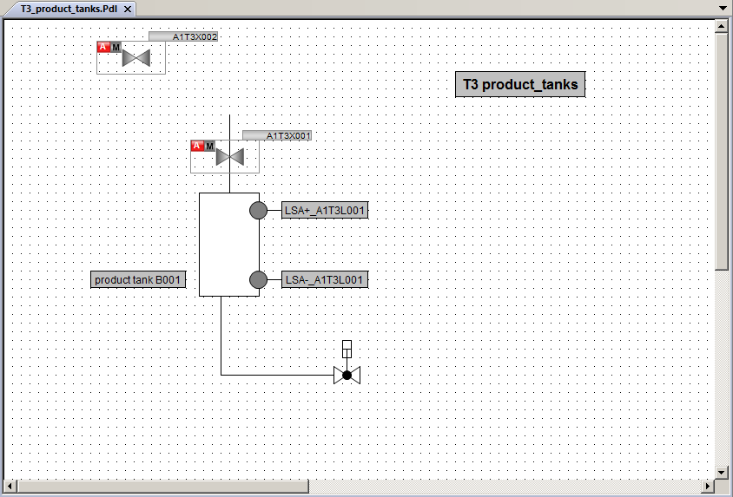

## Testing the faceplates

1. To test the HMI with SIMIT and PCLSIM, you must download the charts to PLCSIM as you already know. You must also start the plant simulation in SIMIT. Set the CPU to RUN-P mode.

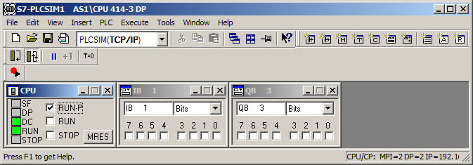

1. In the WinCC Explorer, you need to determine if activation on the ES is permitted in the properties of the OS. (® Properties ® Allow activation on ES)

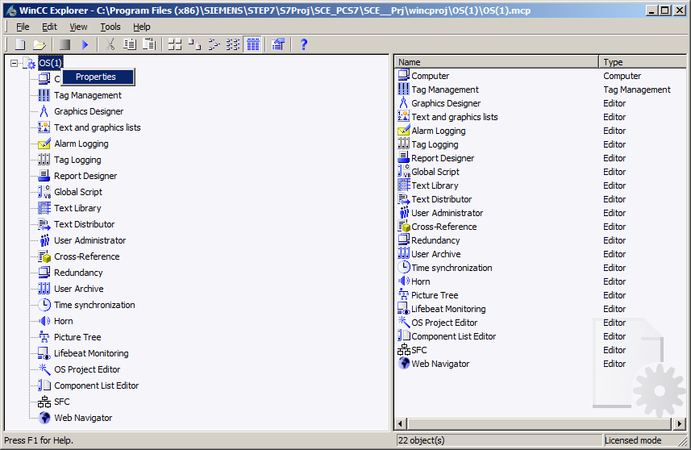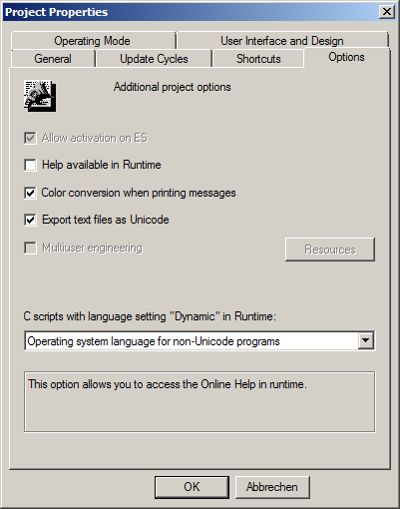

1. Then, activate OS Runtime (® Activate )

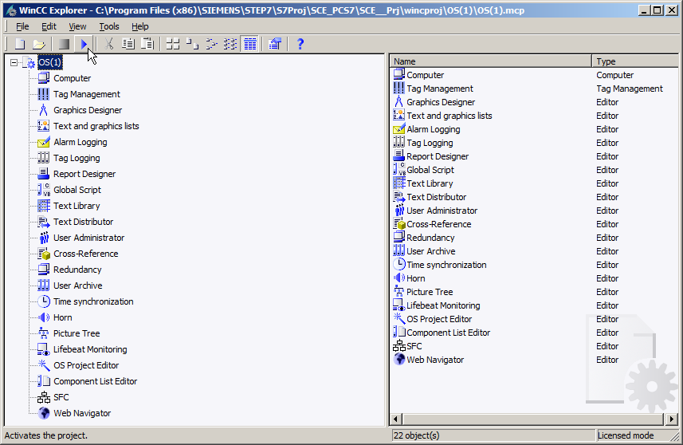

1. First, open the plant overview by clicking on the area key 'A1_multipurpose_plant' in the overview area. (® A1_multipurpose_plant)

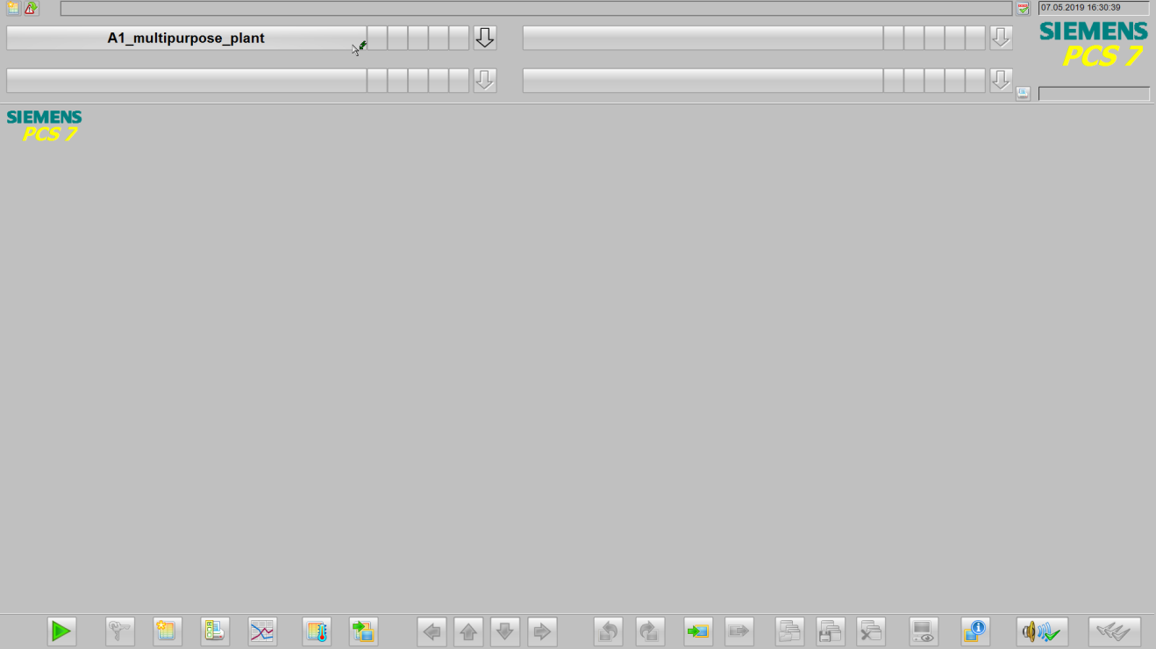

1. The picture 'A1_multipurpose_plant' with an overview of all areas of the plant and the sequential function charts (SFC) is now shown.

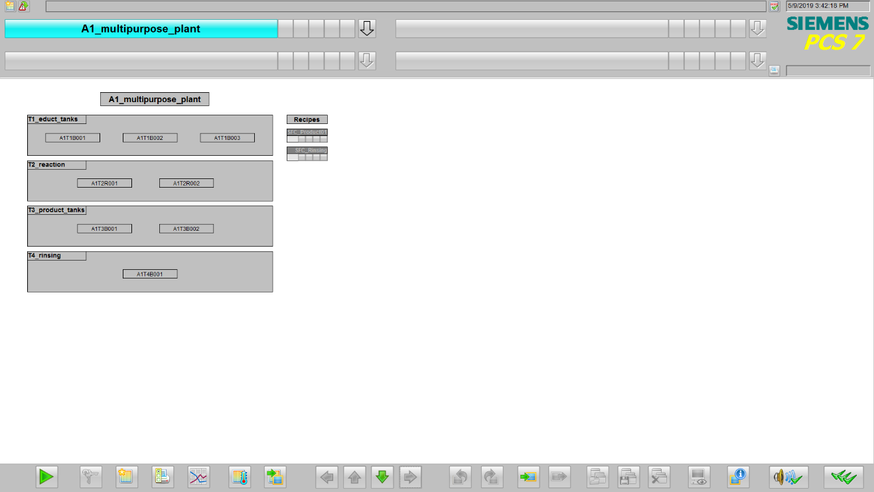

1. By clicking on the block icon of the sequential function chart, an SFC can be opened and operated. (® SFC_Product01 ® Start ® OK)

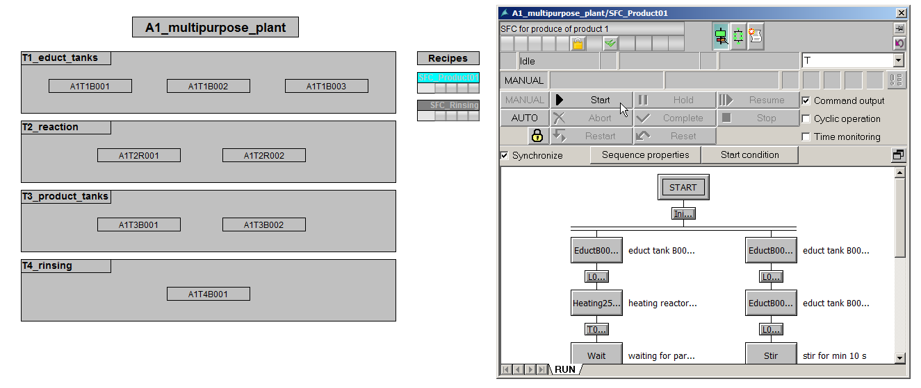

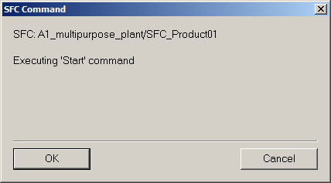

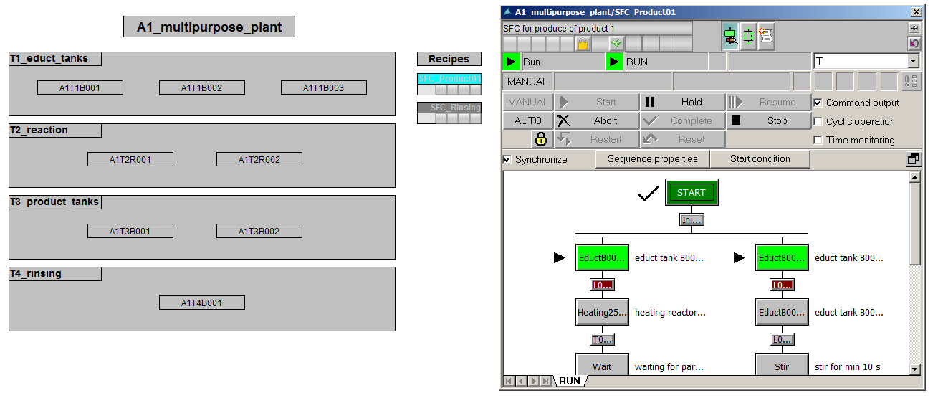

1. You get to the lower level layers either by opening the Picture Tree Navigator or by selecting the picture change you created. (® arrow to the right of the A1_multipurpose_plant  ® T1_educt_tank)

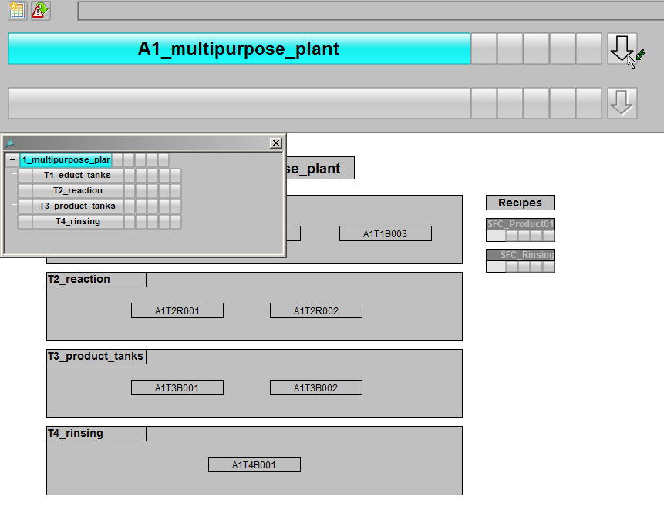

1. The educt tank screen shows the faceplates for the valves and pumps of this layer are shown. The faceplates allow the operating mode change and the operation of the valves and pumps.

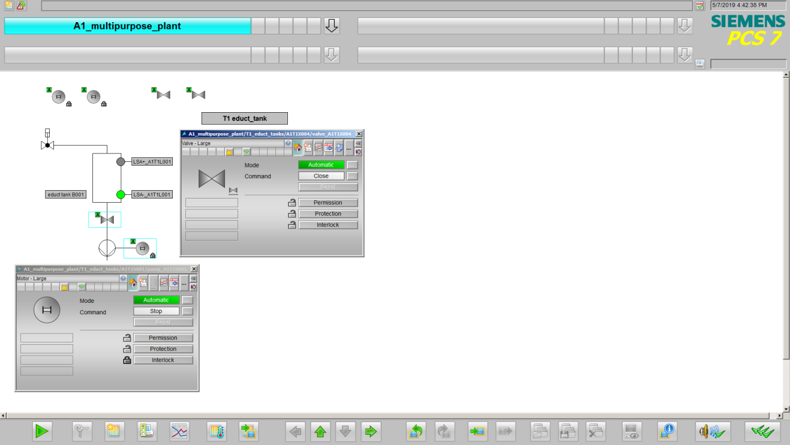

1. In order to operate a valve, you must put it into 'Manual' mode.   
   (® Valve ®Mode  ® Manual ® OK)

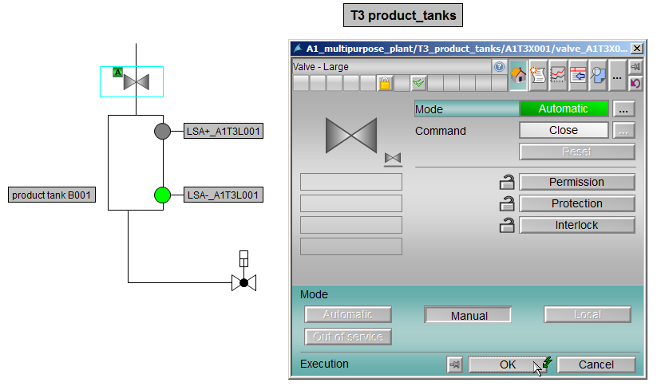

1. You can then operate the valve. (Click the command button  next to 'Close', select 'Open' and confirm your selection with 'OK'. (®  ® Open ® OK)

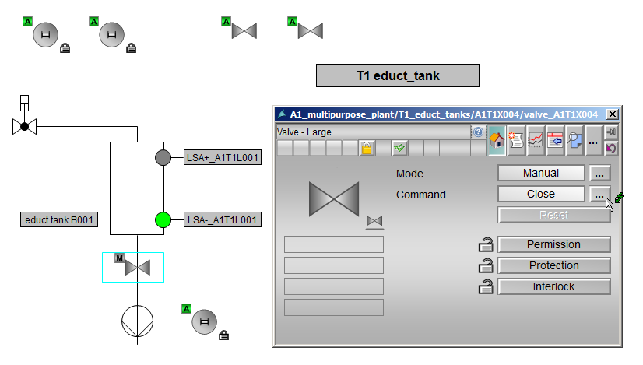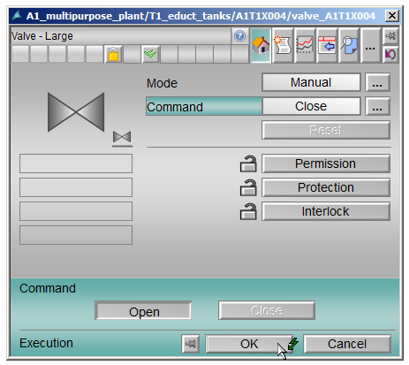

***Note:***

* *If one of the lock symbols is still locked* , *the valve cannot be opened. Only if all three interlock types are released  can the block be fully operated again.*

1. The open valve position is signaled through the rotation and the green coloring of the faceplate.

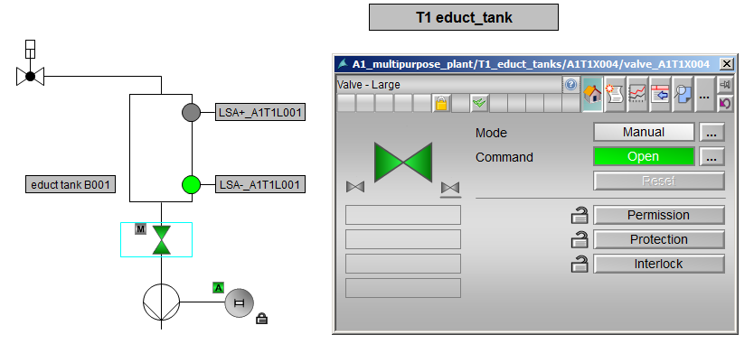

1. In addition to the faceplates for valves and pumps, the operator screen 'T2_Reaction' has a faceplate for the PID controller via which operator control and monitoring is possible.   
   (® A1_multipurpose_plant ® T2_Reaction ® Temperature control)

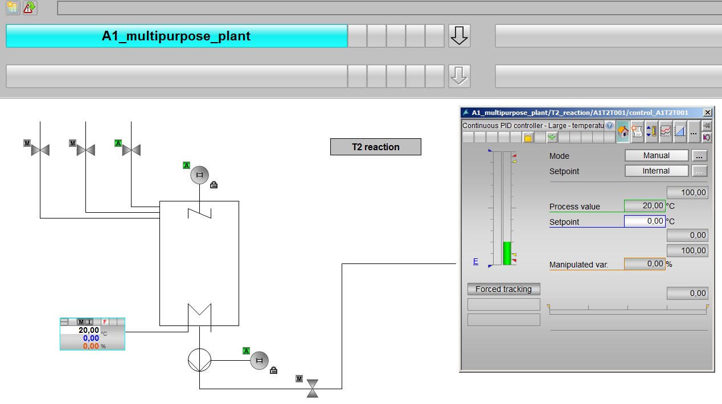

1. You close runtime by pressing the 'Key set change' button  in the control bar at the bottom.

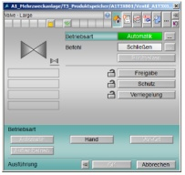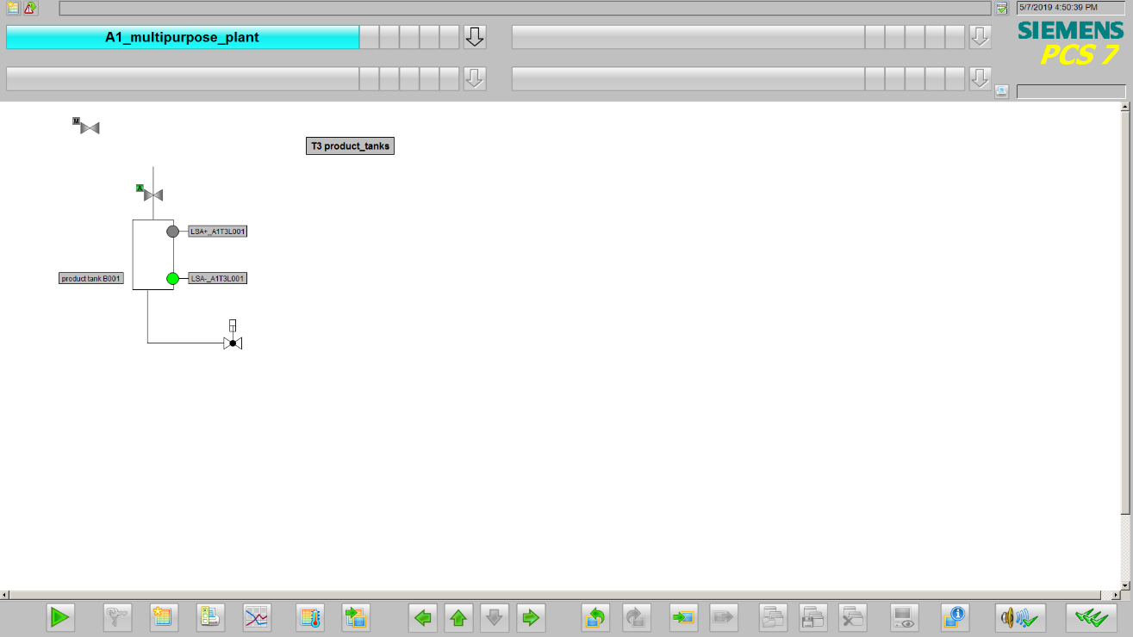



1. Then, select 'Exit runtime'  and 'Deactivate'.

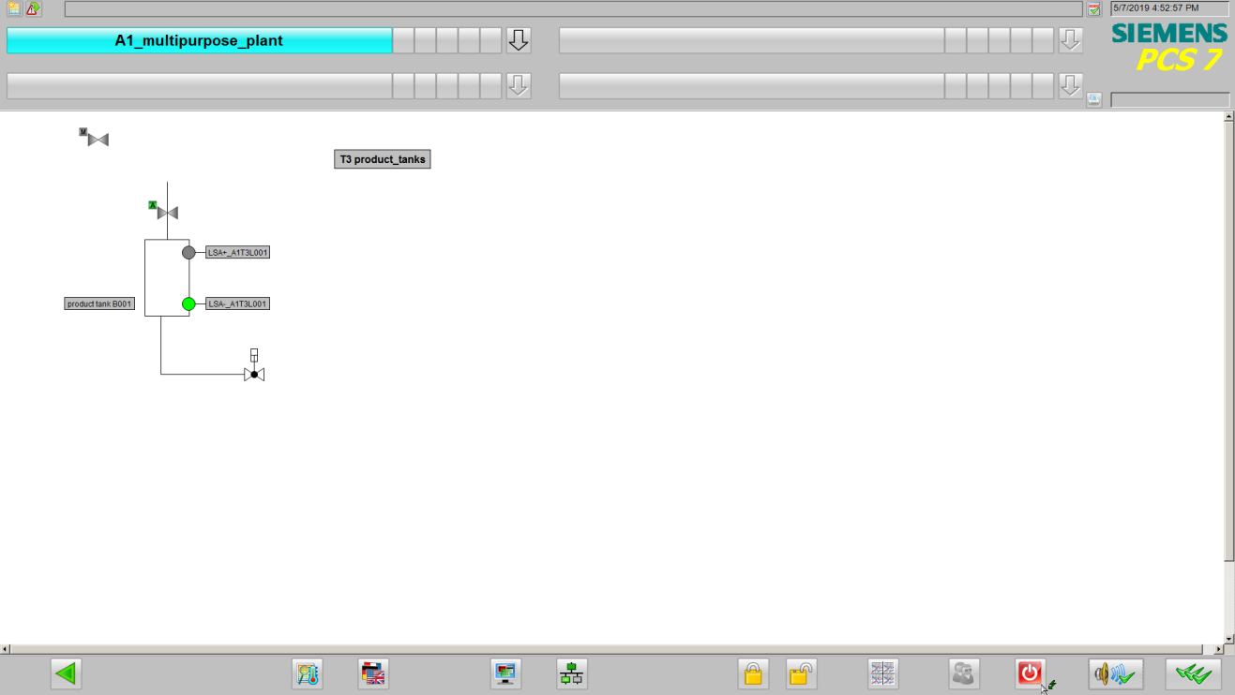



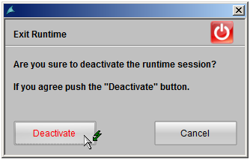

## Checklist – step-by-step instruction

The following checklist helps students to independently check whether all steps of the step-by-step instruction have been carefully completed and enables them to successfully complete the module on their own.

|  |  |  |
| --- | --- | --- |
| No. | Description | Checked |
| 1 | All 5 faceplates created |  |
| 2 | Block icons created successfully |  |
| 3 | Objects successfully compiled and downloaded |  |
| 4 | WinCC configured |  |
| 5 | Faceplate for multipurpose plant with all 4 units and SFCs edited and configured |  |
| 6 | Picture change configured for all 4 units |  |
| 7 | Faceplate for T1_educt tank with tank A1T1B001 edited and configured |  |
| 8 | Faceplate for T2_reaction with reactor A1T2R001 edited and configured |  |
| 9 | Faceplate for T3_product tank with tank A1T3B001 edited and configured |  |
| 10 | Project library contains template for educt tank, reactor and product tank |  |
| 11 | Valves are all correctly oriented |  |
| 12 | Faceplates successfully tested |  |
| 13 | Project successfully archived |  |

Table 2: Checklist for step-by-step instructions

# Exercises

In the exercises, you apply what you learned in the theory section and in the step-by-step instructions. The existing multiproject from the step-by-step instructions (p02-01-project-r1905-en.zip) is used and expanded for this. The download of the project is stored as zip file "Projects" on the SCE Internet for the respective module.

In the step-by-step instructions, only one element of the T1_educt_tank, T2_Reaction and T3_product_tank levels of the plant hierarchy were implemented. The objective of the exercise is to complete the pictures of the individual levels, or to create the pictures of the missing levels.

Then, you also design a picture for the T4_rinsing level.

## Tasks

The tasks below are based on the step-by-step instructions. The corresponding steps of the instructions can be used to assist with each task. Regarding the arrangement, the rules VDI3699 [1] must be observed.

1. Complete the picture of the 'T1_educt_tanks' level by adding the missing tanks A1T1B002 and A1T1B003. Use the template from the library for this so that the representations will be consistent. Adapt the labeling of the tank and of the binary sensors. Remember to adapt the tags for the visualization of the binary sensors. The valves and motors are already created and only have to be placed. Note, however, that it may be necessary to rotate the valves again.

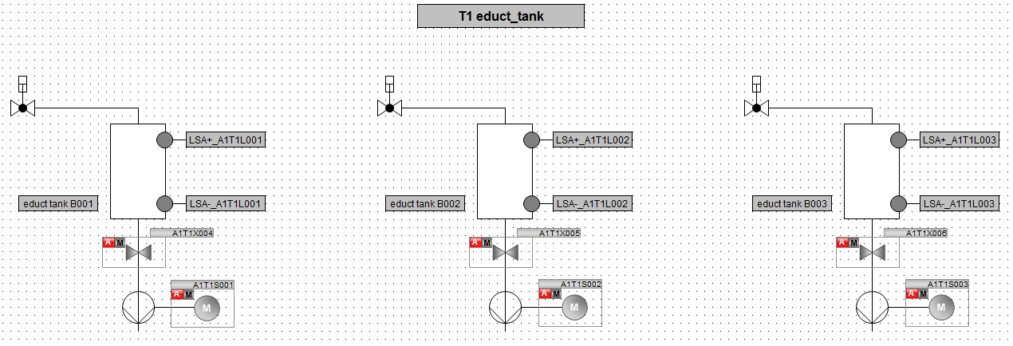

1. You now also complete the pictures of the T2_reaction and T3_product_tank levels with the missing elements (tanks or reactors). Use the P&I diagram as a guide so that all valves, motors and controllers are positioned correctly. Ensure the correct rotation of the valves.

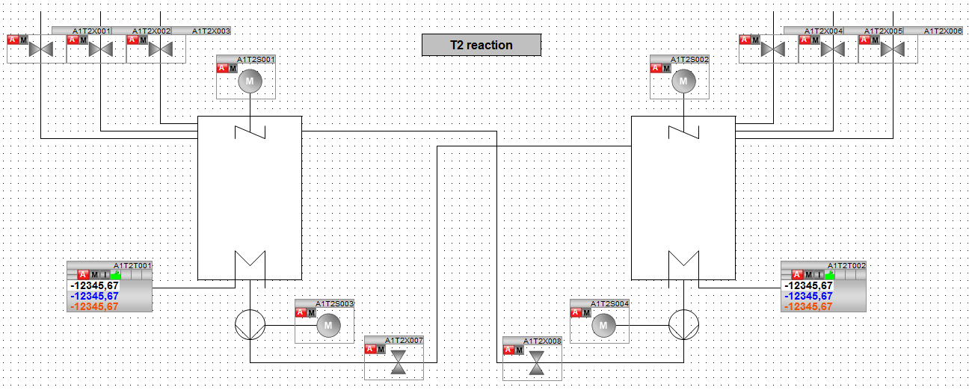

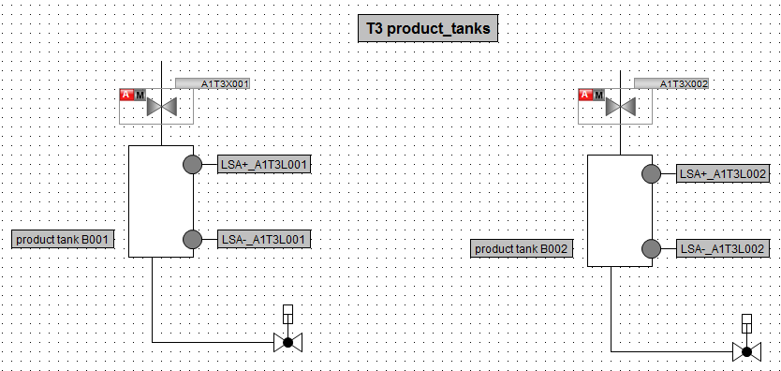

1. Finally, design the faceplate for the 'T4_rinsing' level. Adapt the background for this similar to the step-by-step instructions. Create a picture title and a tank based on the educt and product tanks. Link the tags of the binary sensors and arrange the valves and the motor using the P&I diagram as a guide.

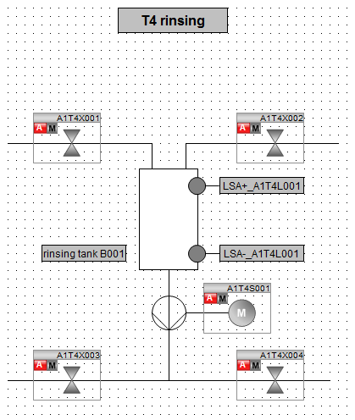

## Checklist – exercise

The following checklist helps students to independently check whether all steps of the exercise have been carefully completed and enables them to successfully complete the module on their own.

|  |  |  |
| --- | --- | --- |
| No. | Description | Checked |
| 1 | Tanks A1T1B002 and A1T2B003 inserted and configured in faceplate T1_educt_tanks |  |
| 2 | Reactor A1T2R002 inserted and configured in faceplate T2_reaction |  |
| 3 | Tank A1T3B002 inserted and configured in faceplate T3_product_tanks |  |
| 4 | Faceplate for T4_product tank edited and configured |  |
| 5 | (optional) New faceplates successfully tested |  |
| 6 | Project successfully archived |  |

Table 3: Checklist for exercises

# Additional information

More information for further practice and consolidation is available as orientation, for example: Getting Started, videos, tutorials, apps, manuals, programming guidelines and trial software/ firmware, under the following link:

[siemens.com/sce/pcs7](http://www.siemens.com/sce/pcs7)

**Preview "Additional information"**

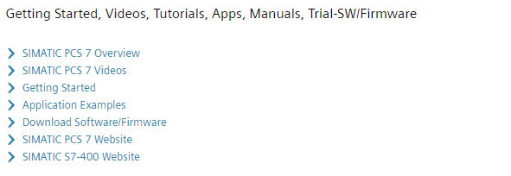

Further Information

Siemens Automation Cooperates with Education  
**siemens.com/sce**

Siemens SIMATIC PCS 7  
**siemens.com/pcs7**

SCE Learn-/Training Documents  
**siemens.com/sce/documents**

SCE Trainer Packages  
**siemens.com/sce/tp**

SCE Contact Partners   
**siemens.com/sce/contact**

Digital Enterprise  
**siemens.com/digital-enterprise**

Industrie 4.0   
**siemens.com/future-of-manufacturing**

Totally Integrated Automation (TIA)  
**siemens.com/tia**

TIA Portal  
**siemens.com/tia-portal**

SIMATIC Controller  
**siemens.com/controller**

SIMATIC Technical Documentation   
**siemens.com/simatic-docu**

Industry Online Support  
**support.industry.siemens.com**

Product catalogue and online ordering system Industry Mall   
**mall.industry.siemens.com**

Siemens  
Digital Industries, FA   
P.O. Box 4848  
90026 Nuremberg  
Germany

Subject to change and errors  
© Siemens 2020

**siemens.com/sce**