

Learn-/Training Document  
  
Siemens Automation Cooperates with Education (SCE) | As of Version V9 SP1

**siemens.com/sce**

PA Module P01-08   
SIMATIC PCS 7 – Sequential control systems

**Matching SCE Trainer Packages for this Learn-/Training Document**

* **SIMATIC PCS 7 Software Package V9.0 (set of 3)**  
  Order No.: 6ES7650-0XX58-0YS5
* **SIMATIC PCS 7 Software Package V9.0 (set of 6)**   
  Order No.: 6ES7650-0XX58-2YS5
* **SIMATIC PCS 7 Software Upgrade Packages (set of 3)**  
  Order No.: 6ES7650-0XX58-0YE5 (V8.x🡪 V9.0)
* **SIMIT Simulation Platform with Dongle V10**  
  (contains SIMIT S & CTE, FLOWNET, CONTEC libraries) – 2500 simulation tags  
  Order No.: 6DL8913-0AK00-0AS5
* **Upgrade SIMIT Simulation Platform V10**  
  (contains SIMIT S & CTE, FLOWNET, CONTEC libraries) from V8.x/V9.x  
  Order No.: 6DL8913-0AK00-0AS6
* **Demo Version SIMIT Simulation Platform V10**  
  [Download](https://support.industry.siemens.com/cs/ww/en/ps/17120/dl)
* **SIMATIC PCS 7 AS RTX Box (PROFIBUS) only in combination with ET 200M for RTX –**   
  Order No.: 6ES7654-0UE23-0XS1
* **ET 200M for RTX Box (PROFIBUS) only in combination with PCS 7 AS RTX Box –**  
  Order No.: 6ES7153-2BA10-4AB1

Note that these trainer packages are replaced with successor packages when necessary.

An overview of the currently available SCE packages is available at: [siemens.com/sce/tp](http://www.siemens.com/tp)

**Continued training**

For regional Siemens SCE continued training, get in touch with your regional SCE contact

[siemens.com/sce/contact](http://www.siemens.com/contact)

**Additional information regarding SCE**

[siemens.com/sce](http://www.siemens.com/sce)

**Information regarding use**

The SCE Learn-/Training Document for the integrated automation solution Totally Integrated Automation (TIA) was prepared for the program "Siemens Automation Cooperates with Education (SCE)" specifically for training purposes for public educational facilities and R&D institutions. Siemens does not guarantee the contents.

This document is to be used only for initial training on Siemens products/systems, which means it can be copied in whole or part and given to those being trained for use within the scope of their training. Circulation or copying this Learn-/Training Document and sharing its content is permitted within public training and advanced training facilities for training purposes.

Exceptions require written consent from the Siemens. Send all related requests to

[scesupportfinder.i-ia@siemens.com](mailto:scesupportfinder.i-ia@siemens.com).

Offenders will be held liable. All rights including translation are reserved, particularly if a patent is granted or a utility model or design is registered.

Use for industrial customer courses is explicitly not permitted. We do not consent to commercial use of the Learn-/Training Document.

We wish to thank the TU Dresden, particularly Prof. Dr.-Ing. Leon Urbas and the Michael Dziallas Engineering Corporation and all other involved persons for their support during the preparation of this Learn-/Training Document.

Table of contents

1 Goal 6

2 Prerequisite 6

3 Required hardware and software 7

4 Theory 8

4.1 Theory in brief 8

4.2 Continuous and sequential control systems 9

4.3 Structure of sequential function charts 9

4.4 Design of sequential control systems 12

4.5 Interaction of sequential control and logic control systems 13

4.6 Protective functions and operating modes in sequential control systems 14

4.7 Sequential control systems in PCS 7 15

4.8 References 16

5 Task 17

6 Planning 18

7 Learning objective 19

8 Structured step-by-step instructions 20

8.1 Creating and configuring an SFC 20

8.2 Editing the sequential function chart 23

8.3 Editing properties of steps and transitions 28

8.4 Editing steps and transitions 33

8.4.1 Transition: Init_OK 33

8.4.2 Step: EductB003toR001 36

8.4.3 Transition: L001 >= 350 ml 44

8.4.4 Step: Heating25°CStir 45

8.4.5 Transition: T001 >= 25°C 46

8.4.6 Step: Wait 47

8.4.7 Step: EduktB002inR002 47

8.4.8 Transition: L002 >= 200 ml 49

8.4.9 Step: EductB001toR002 49

8.4.10 Transition: L002 >= 350 ml 51

8.4.11 Step: Stir 51

8.4.12 Transition: Parallel_OK 53

8.4.13 Step: R002toR001 55

8.4.14 Transition: L002 <= 50 ml 56

8.4.15 Step: Heating28°C 57

8.4.16 Transition: T001 >= 28°C 58

8.4.17 Step: R001toProdB001 58

8.4.18 Transition: L001 <= 50 ml 60

8.4.19 Step: END 60

8.5 Compiling and downloading objects 64

8.6 Testing the SFC 69

8.7 Checklist – step-by-step instruction 77

9 Exercises 78

9.1 Task 78

9.2 Checklist – exercise 78

10 Additional information 79

Sequential control systems

# Goal

The students can successfully implement sequential control systems using sequential function charts. They understand the structure and mode of functioning of sequential function charts and are familiar with corresponding design methods. Their knowledge regarding operating modes and protective measures will be expanded for sequential control systems. The students understand the interaction between the programs of basic automation and sequential control systems. They know how to create sequential controls in PCS 7.

# Prerequisite

This chapter builds on chapter 'Functional safety'. To implement this chapter, you can use an existing project from the previous chapter or the archived project 'p01-07-exercise-r1905-en.zip' provided by SCE. The download of the project(s) is stored on the SCE Internet for the respective module.

The (optional) simulation for the SIMIT program can be retrieved from the file 'p01-04-plantsim-v10-r1905-en.simarc'. It can be run in demo mode.

# Required hardware and software

1. Engineering station: Requirements include hardware and operating system   
   (for further information, see Readme on the PCS 7 installation DVD)
2. SIMATIC PCS 7 software V9 SP1 or higher

* Installed program packages (contained in SIMATIC PCS 7 Software Trainer Package):
  + *Engineering → PCS 7 Engineering*
  + *Engineering → BATCH Engineering*
  + *Runtime → Single Station → OS Single Station*
  + *Runtime → Single Station → BATCH Single Station*
  + *Options → SIMATIC Logon*
  + *Options → S7-PLCSIM V5.4 SP8*

1. Demo Version SIMIT Simulation Platform V10

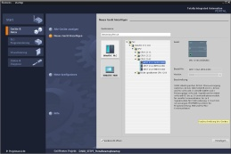

**3** SIMIT V10 or higher



**1** Engineering Station

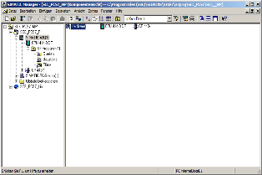

**2** SIMATIC PCS 7  
V9 SP1 or higher

# Theory

## Theory in brief

Sequential control systems allow for time-discrete or event-discrete execution of sequential and parallel processes. They are used to coordinate various continuous functions as well as to control complex process sequences. Dependent on defined states or events, changes of operating state and changes of state are produced in existing logic control systems and the desired sequential flow is thus implemented. Sequential control systems are implemented with one or more sequential function charts.

A sequential function chart is an alternating stringing together of steps, which trigger certain actions and transitions*,* which initiate the change from one step to another as soon as the corresponding step enabling condition is met. Each sequential function chart has exactly one start step and one end step as well as any number of intermediate steps that are each interconnected by arrows and interposed transitions. The charts may also generate feedback through loops within the sequential function chart. Likewise, they can contain simultaneous or alternative branches. However, in this case the design must ensure that the sequence does not contain uncertain or inaccessible parts.

Formal design methods using state diagrams or Petri nets are particularly suitable for designing a sequential control system. State diagrams are easy to learn, allow for automatic error diagnostics and can be easily converted to many existing programming languages for sequential control systems. However, the design of parallel structures is not possible because state diagrams have only exactly one active state.

Petri nets are considerably more complex and pose a greater mathematical challenge. However, all structures that are permitted in sequential control systems can be modeled and extensively analyzed. Thus, necessary properties of the control system can be verified formally. Petri nets also permit easy implementation in sequential control systems.

Parameter assignment and activation of lower-level logic control systems by sequential control systems takes place by the setting of corresponding global control signals. The effect of these control signals can be temporary or permanent, direct or delayed. Like logic control systems, sequential control systems must support various operating modes, in which manual control of transitions and temporary or permanent interruption of process sequences, in particular, must be possible. In addition, process-specific protective functions are implemented through sequential control systems.

Sequential control systems are implemented in PCS 7 with sequential function charts (SFC). SFCs provide efficient operating mode management, high controllability through multiple switching modes and extensive parameter assignment capability through various execution options. In PCS 7, SFCs and CFCs interact and are linked by means of process values and control values. The interaction behavior can also be controlled in detail.

## Continuous and sequential control systems

Within the scope of basic automation, various logic control systems are developed that each implements a limited, clearly defined function. The functions continuously process input signals and generate corresponding output signals. Activation and parameter assignment of the functions is possible through various control signals. To implement complex process sequences, such as manufacturing specifications for products (recipes), the various functions must be coordinated and activated at the right time with the right parameters. This task can be realized using sequential control systems.

Sequential control systems enable step-by-step, event-discrete processing of sequential and parallel processes using sequential function charts (also called sequencers). They produce changes of operating state and changes of state dependent on defined states or events in the existing logic control systems and thus implement the desired sequential flow. Sequencers function charts are also called Sequential function charts.

## Structure of sequential function charts

A sequential function chart is an alternating sequence of steps and transitions. The individual steps activate certain actions in each case. Transitions control the change from one step to another.

The first step of a sequential function chart is called the start step. It is the explicit entry point into the sequence and is always executed for that reason. The last step of a sequential function chart is correspondingly called the end step. It is the only step in the sequence that does not have a follow-on transition. After the end step is executed, the sequential function chart is terminated (completed) or the execution restarts. The latter case is also referred to as sequence loop.

Steps and transitions are interconnected by directed graphs. A step can be connected to several follow-on transitions; the reverse is also possible. A transition is enabled when all upstream steps are active and the step enabling condition is met. In this case, first the directly preceding steps are deactivated and then the direct follow-on steps are activated.

The simplest form of a sequential function chart is the unbranched sequence. Each step is followed by exactly one transition, which in turn is followed by exactly one follow-on step. Thus, a purely sequential process sequence is realized. Figure 1 shows the corresponding graphic basic elements.



Figure 1: Basic elements of a sequential function chart

Loops within the sequential function chart occur when a cyclical execution within the sequence is possible through the stringing together of multiple steps. The sequence loop is a special case of a loop in which all steps are run through cyclically.

Jumps are another option for structuring sequential function charts. When a jump label is reached, processing is continued with the step to which the jump label points. Jumps within the sequential function chart can also produce loops. Because this type of structuring is difficult to understand, jumps should be avoided if possible.

From the process view it is often necessary to react differently to various events during program runtime. In this case, a step has several alternative follow-on steps. This structure is called an alternative branch. The step is connected to each possible follow-on step via a separate transition. To ensure that no more than one of these transitions will be enabled at a given time (and the branches are truly alternative), the transitions should be mutually locked or explicitly prioritized. Otherwise, the transitions are evaluated from left to right in most control systems and the first transition whose step enabling condition is met is enabled.

Figure 2shows the general structure of an alternative branch with two branches. It is represented by bordering horizontal single lines with protruding ends. As you can see, alternative branches always start and end with transitions.



Figure 2: Alternative and simultaneous branches in sequential function charts

Another frequent requirement is that a step be followed by several follow-on steps that are to be processed simultaneously. In this case, the output step has exactly one transition that activates several follow-on steps simultaneously. This structure is called a simultaneous branch. The follow-on steps of the individual branches are then processed independent of one another and then joined again. All branches end in a joint transition. Only when all branches are processed completely and the step enabling condition of the follow-on transition is met can the joint follow-on step be activated.

The sequence of a simultaneous branch with two branches is also shown in Figure 2. The branches are represented by bordering horizontal double lines with protruding ends. As you can see, simultaneous branches always begin and end with actions.

A special control problem is the possibility of creating faulty sequential function charts through the unfavorable use of jumps and branches. Three possible cases have to be distinguished.

* Uncertain sequence: A sequential function chart contains a structure whose accessibility is not ensured through the defined sequential flow.
* Partial deadlock: A sequential function chart contains an inner loop that is no longer exited. Although the steps within this loop can be executed, the steps outside the loop cannot. Portions of the sequential function chart are thus not accessible.
* Total deadlock: A sequential function chart contains a structure for which there is no permissible step enabling condition. In this case the sequential function chart remains permanently in one state and all other steps are inaccessible.

Such structures are not permitted in sequential function charts and have to be ruled out with corresponding formal design methods. Figure 3 shows an example of two sequential function charts with illegal structures.

In the left sequence, it cannot be ensured that step S6 is accessible because, when transition t3 is enabled, the alternative branch after step S3 will prevent the simultaneous branch in transition t4 from being rejoined again. For this reason, the sequence is uncertain. The right sequence, on the other hand, is executed exactly once and then remains in step S4. Because step S2 is not active in this state, the simultaneous branch in transition t3 can no longer be joined. A total deadlock results and step S5 is not accessible.



Figure 3: Uncertain and illegal structures in sequential function charts

## Design of sequential control systems

Numerous formal design methods exist for sequential control systems. In practice, however, the state diagram and Petri net models have proven valuable, in particular.

A state diagram is a connected, directed graph. States are represented as circles and state transitions as arrows that connect exactly two states to one another. In a state diagram, exactly one state is always active at a time. The states can be linked to certain actions. There is the option to assign a certain sequential flow to these actions.

They can be executed once on entering the state or exiting the state, or cyclically as long as the state is active. State transitions can be subject to transition conditions.

State diagrams can be structured hierarchically and linked to each other. State diagrams are considered easy to learn and enable automatic error diagnostics, for example, through pair, time or state monitoring. These diagrams can be easily converted to many existing programming languages for sequential control systems.

Petri nets are particularly suitable for modeling concurrent processes. A Petri net consists of places and transitions that are connected to each other through arrows. This also results in a directed graph. A place is represented with a circle and a transition with a rectangle (often reduced to a bar). Active places are indicated with tokens; they are represented with a dot within the circle for the corresponding place.

In contrast to function diagrams, the state in a Petri net is determined by the number of active places in the entire network. The dynamics of the system is modeled through the movement of the tokens within the network. The meaning of the places and transitions for the modeled process (i.e. the semantics of the Petri net) is not defined and has to be specified depending on the application. Petri nets whose semantics have been specified are called interpreted Petri nets (IPN). For the control design, signal interpreted Petri nets (SIPN) are generally usable.

Petri nets can be extensively analytically tested. They also allow easy conversion to existing programming languages for sequential control systems. There are numerous expansions for Petri nets that are optimized for specific applications or provide for more exact process modeling. For this reason, Petri nets can become rather complex, which makes them more demanding as a design method. Nevertheless, based on their structural similarity to sequential function charts and their ability to model parallel processes, Petri nets offer clear advantages.

The design method that is used depends ultimately on the requirements of the design task as well on the preference of the developer. Additional information is provided in the pertinent technical literature.

## Interaction of sequential control and logic control systems

As described above, each step in the sequential function chart can be assigned certain actions. In general, these actions consist of the parameter assignment and activation of logic control systems for which corresponding control signals are suited.

Process and control signals that are used by sequential function charts must be declared globally so that they are equally available to the programs of the sequential control and logic control systems. The signals are usually listed in a symbol table.

Control signals generally act as long as the corresponding step is active. For implementing more complex function sequences, however, it is also possible to vary the processing of a control signal itself (latching or non-latching, time delayed or limited).

Usually, process-specific functions are implemented with sequential control systems while logic control systems implement all device-specific functions.

## Protective functions and operating modes in sequential control systems

As in the case of single control functions, adequate protective functions and operating modes have to be implemented for sequential control systems. Sequential control systems must be manually operable even under fault conditions. Corresponding operating modes must be provided in the control system for this.

* Automatic mode: The action of the sequential function chart is executed when the upstream transition is enabled.
* Manual mode: The action of the sequential function chart is initiated by the operator even if the upstream transition is not enabled.
* Mixed mode: The action of the sequential function chart is executed when the upstream transition is enabled or the operator has initiated it. Alternatively, both the initiation by the operator and the enable of the upstream transition can be required.

Using manual mode prevents permanent blocking of the sequential control system as a consequence of a fault. The mixed mode allows for manual interruption of the process for testing or commissioning purposes. The step enabling conditions of all transitions of the sequential control system must be expanded accordingly.

Sequential function charts must be able to respond to faults in the controlled devices. This requires continuous fault monitoring. This monitoring serves to detect and reports faults in the controlled devices. It enables automated safeguarding of the plant by automatically stopping the sequential function chart in the event of a fault. In addition, it has to be possible for the operator to stop and abort a sequential function chart when there is a fault.

In both cases, corresponding protective functions must be activated in order to bring the plant to a safe state. If the sequence is stopped, it is necessary to ensure a safe, process-compatible resumption of the sequence, even after an extended interruption. Process-specific protective functions are implemented in sequential control systems, such as sequential interlocking of several devices in the event of a fault state in the process.

## Sequential control systems in PCS 7

Sequential control systems are implemented in PCS 7 with sequential function charts (SFC). They contain the sequencers and define their sequence topology, the conditions for the transitions and the actions of the steps. The start conditions and sequence properties can be defined and prioritized separately for each sequencer.

In addition, pre-processing and post-processing steps can be defined that are executed once prior to or after execution of the sequencer.

Operating modes and switching modes

The behavior of a sequential control system in PCS 7 depends on the selected operating mode, the specified switching mode, its current operating state and the execution options. For sequential control systems, two different operating modes can be selected.

* Auto: The program controls the sequence.
* Manual: The operator controls the sequence with commands or by changing the execution options.

In manual mode, the commands Start, Stop, Hold, Complete, Abort, Resume, Restart, Reset and Error are available to the operator for operating the sequential control system manually. The behavior of a sequential function chart when advancing from active steps to follow-on steps can be controlled through different switching modes, depending on the selected operating mode.

* Switching mode T: The sequential control system runs process-controlled, which means automatically. When a transition is enabled, the predecessor steps are deactivated and follow-on steps are activated. (T = Transactions)
* Switching mode O: The sequential control system runs operator-controlled, which means manually. The transition is enabled by an operator command. Each follow-on transition of an active step automatically sets an operator prompt. (O = Operator)
* Switching mode T or O: The sequential control system runs process-controlled or operator-controlled. The transition can be enabled either through an operator command or through a fulfilled step enabling condition.
* Switching mode T and O: The sequential control system runs process-controlled and operator-controlled. The transition is only enabled when an operator command has been issued and the step enabling condition is met.
* Switching mode T/T and O: In this switching mode, it can be specified individually for each step whether the sequential control system runs process-controlled or operator-controlled. As a result, hold points can be defined in the sequential control system in test mode. (T/T = Test Transactions)

In Auto *mode,*onlythe switching modes T and T/T and O can be selected. The operating mode of the sequential control system shows the current state in the sequence and the resulting operating behavior. A corresponding operating state logic defines the possible state, the permissible transitions between the states and the transition conditions for a state change. PCS 7 defines separate operating state logic for sequential control systems and sequential function charts. It is possible to have sequential function charts run dependent on the state of the sequential control system.

Execution options

By using execution options, the runtime behavior of a sequential control system can be controlled. For example, it can be specified whether a sequential control system is executed once or cyclically (cyclic operation option) or whether the actions of the active step will actually be executed (command output option). In addition, a time monitoring can be activated for the individual steps in a sequential function chart, which reports a step error if the time is exceeded (time monitoringoption).

Interaction behavior

In PCS 7, CFCs and SFCs interact by means of process values and control values. These values are linked to each other using the desired signals, either from the global symbol table or by specifying the absolute signal address. It is possible to control the processing of the control signals using the features of the SFC. In the SFC Library, PCS 7 provides pre-assembled sequential function charts for various standard scenarios. These templates can be used and adapted to current projects.

## References

[1] Seitz, M. (2008): Speicherprogrammierbare Steuerungen. Hanser Fachbuchverlag

[2] Wellenreuther, G. and Zastrow, D (2002): Automatisieren mit SPS: Theorie und Praxis. Vieweg+Teubner

[3] Uhlig, R (2005): SPS ⎯ Modellbasierter Steuerungsentwurf für die Praxis: Modellierungsmethoden aus der Informatik in der Automatisierungstechnik. Oldenbourg Industrieverlag

[4] SIEMENS (2014): Process Control System PCS 7: SFC for SIMATIC S7 (V9.0). A5E41356233-AB ([support.industry.siemens.com/cs/ww/en/view/109755020](https://support.industry.siemens.com/cs/ww/en/view/109755020))

# Task

In accordance with the recipe in chapter 'Process Description', a sequential function chart is to be created and programmed.

1. First, 350 ml is to be drained from educt tank =SCE.A1.T1-B003 to reactor =SCE.A1.T2-R001 and at the same time 200 ml is to be drained from educt tank =SCE.A1.T1-B002 to reactor =SCE.A1.T2-R002.
2. When the filling of reactor =SCE.A1.T2-R001 is finished, the filled liquid is to be heated to 25 °C with the stirrer switched on.
3. When the filling of reactor =SCE.A1.T2-R002 is finished, 150 ml of educt A from educt tank =SCE.A1.T1-B001 is to be added to reactor =SCE.A1.T2-R002. When this is complete, the stirrer of reactor =SCE.A1.T2-R002 is to be switched on 10 s later.
4. When the temperature of the liquid in reactor =SCE.A1.T2-R001 has reached 25 °C, the mixture from reactor =SCE.A1.T2-R002 is to be pumped to reactor =SCE.A1.T2-R001.
5. The mixture in reactor =SCE.A1.T2-R001 is now to be heated to 28 °C and then drained to product tank =SCE.A1.T3-B001.

# Planning

All the needed actuators and signals are already implemented and interlocked according to the safety requirements. They only still have to be appropriately linked to the sequential control system.

The sequential function chart named in the task description only then has to be converted into steps and transitions. The following specifics are known:

* Task 1 executes parallel steps (both reactors can operate independent of each other)
* Task 3 names a time condition
* Task 4 merges the two parallel processing steps (in Reactor R001)

The following tables give an overview of the utilized actuators and must be initialized like this:

|  |  |  |  |
| --- | --- | --- | --- |
| Block | SP_LiOp .Value | SP_ExtLi .Value | SP_IntLi .Value |
| A1T2T001\control_A1T2T001 | TRUE | TRUE | FALSE |

| Block | ModLiOp .Value | AutModLi .Value | ManModLi .Value |
| --- | --- | --- | --- |
| A1T1X006\valve_A1T1X006 | TRUE | TRUE | FALSE |
| A1T1S003\pump_A1T1S003 | TRUE | TRUE | FALSE |
| A1T2X003\valve_A1T2X003 | TRUE | TRUE | FALSE |
| A1T2S001\stirrer_A1T2S001 | TRUE | TRUE | FALSE |
| A1T2T001\control_A1T2T001 | TRUE | TRUE | FALSE |
| A1T2S004\pump_A1T2S004 | TRUE | TRUE | FALSE |
| A1T2X008\valve_A1T2X008 | TRUE | TRUE | FALSE |
| A1T2S003\pump_A1T2S003 | TRUE | TRUE | FALSE |
| A1T3X001\valve_A1T3X001 | TRUE | TRUE | FALSE |
| A1T1X005\valve_A1T1X005 | TRUE | TRUE | FALSE |
| A1T1S002\pump_A1T1S002 | TRUE | TRUE | FALSE |
| A1T2X005\valve_A1T2X005 | TRUE | TRUE | FALSE |
| A1T1X004\valve_A1T1X004 | TRUE | TRUE | FALSE |
| A1T1S001\pump_A1T1S001 | TRUE | TRUE | FALSE |
| A1T2X004\valve_A1T2X004 | TRUE | TRUE | FALSE |
| A1T2S002\stirrer_A1T2S002 | TRUE | TRUE | FALSE |

# Learning objective

In this chapter, students learn the following:

* Creating and editing SFCs
* Establishing links between SFCs and CFCs
* Establishing links between SFCs and the addresses from the symbol table
* Testing of SFC programs

# Structured step-by-step instructions

## Creating and configuring an SFC

1. To start, create a new SFC in the plant view in folder 'A1_multipurpose_plant'. (® A1_multipurpose_plant ® Insert New Object ® SFC)

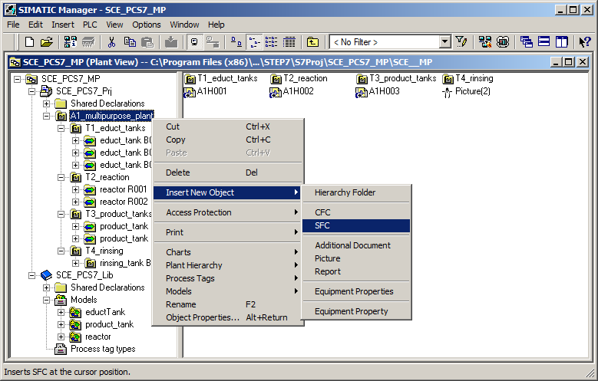

1. Then open the object properties of the SFC. (® SFC(1) ® Object Properties)

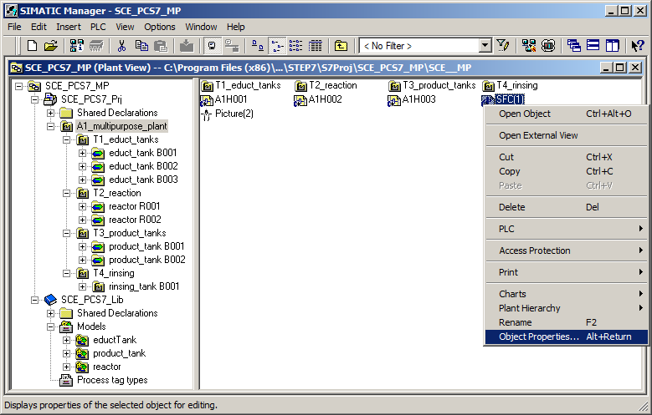

1. Next, under General, the name is changed to 'SFC_Product01' and a comment as well as the author is entered. (® General ® SFC_Product01)

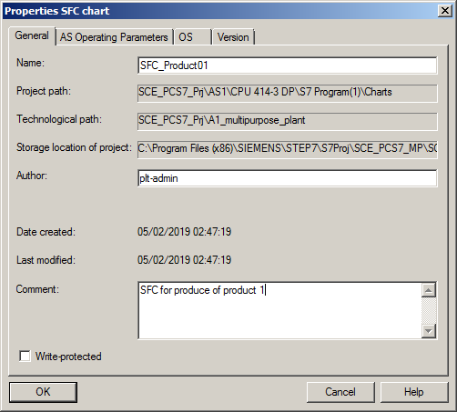

1. Set the operating parameters as follows; they can also be changed later in online mode. (® AS Operating Parameters)

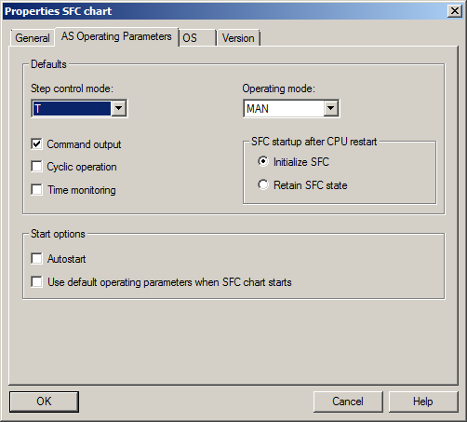

1. On the OS tab, it is important that the check box be selected so that the SFC will be available later for visualization. Accept all parameters in the "Version" tab with OK. (® OS ® Transfer chart to OS for visualization ® Version ® OK)

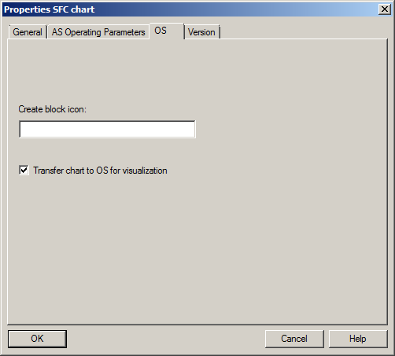 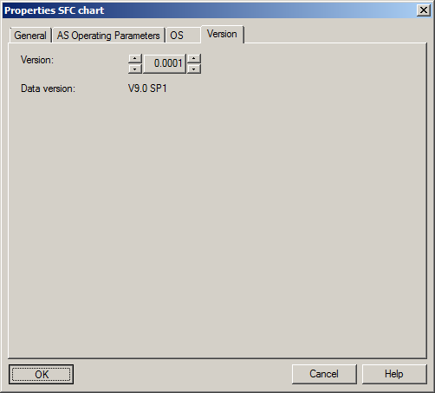

***Note:***

* *In the "Create block icon" input field, you can specify the block icon in WinCC that is to be displayed for this block. You can thus select different variants for the same block type, if present. Leaving the field blank results in the standard display.*

## Editing the sequential function chart

1. Now, double-click the sequential function chart 'SFC_Product01' in SIMATIC Manager to open it. (® SFC_Product01)

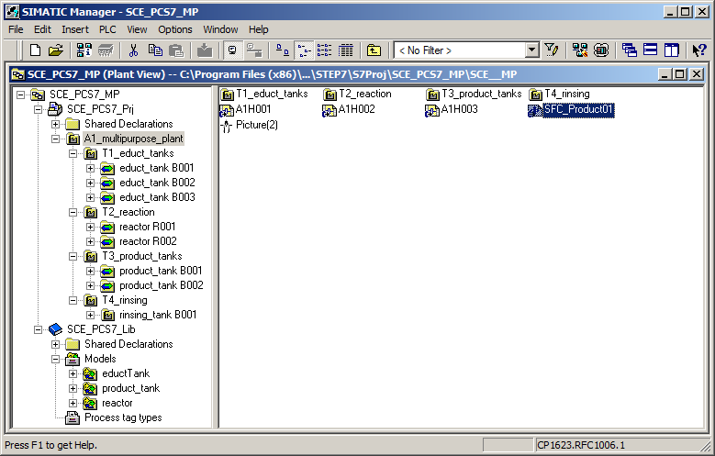

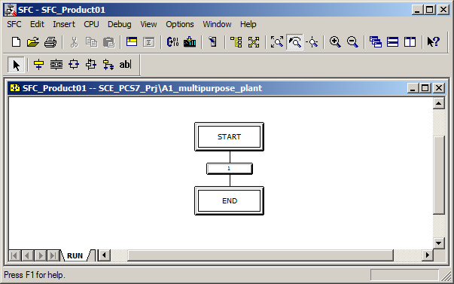

1. You can now build the sequential control system in the SFC Editor with the following toolbar buttons.

 Selection On button

 Insert Step + Transition button

 Insert Simultaneous Branch button

 Insert Alternative Branch button

 Insert Loop button

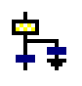 Insert Jump button

 Insert Text Field button

1. For this task, you will need additional steps and transitions. To insert both, select the  button and select the location where you want to insert them. (® )

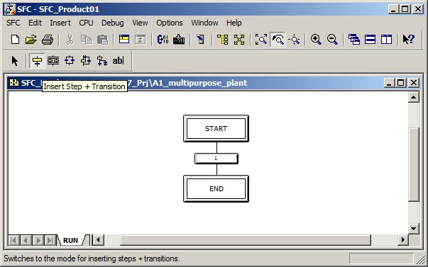

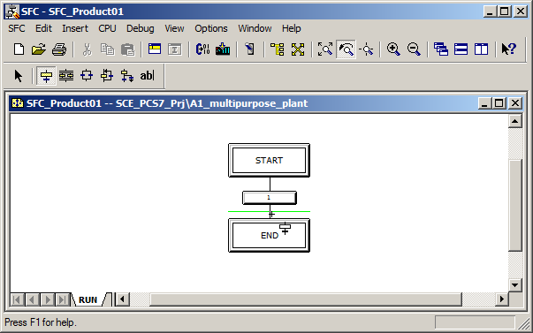

***Note:***

* *The numbering of steps and transition has no bearing on the order of execution of the sequential function chart.*

1. After three steps and transitions have been inserted in this way, click the  icon to insert a simultaneous branch. Then select the location where you want to insert it. (® )

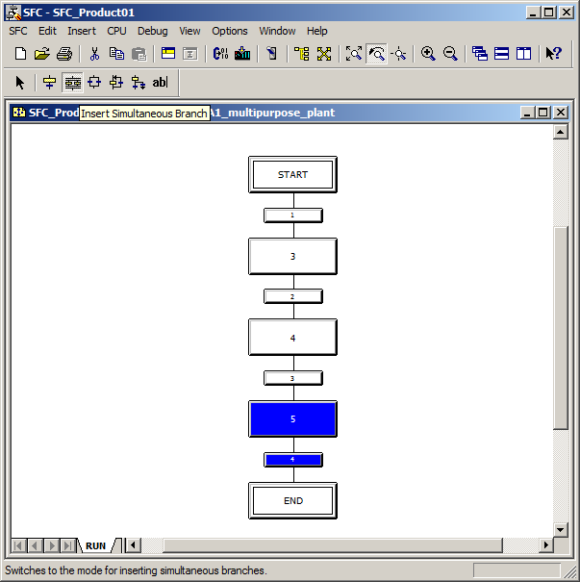

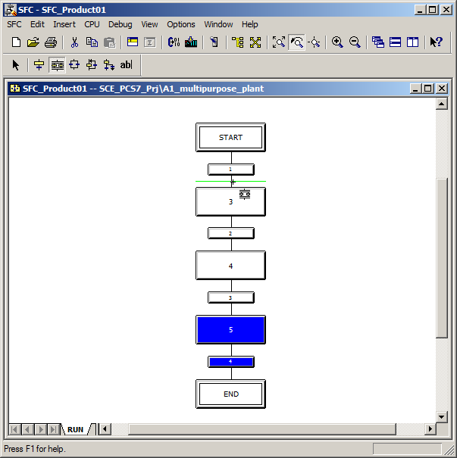

1. Additional steps and transitions are then also to be inserted in the simultaneous branch. Therefore, change back to the  button and insert the additional steps and transitions. (® )

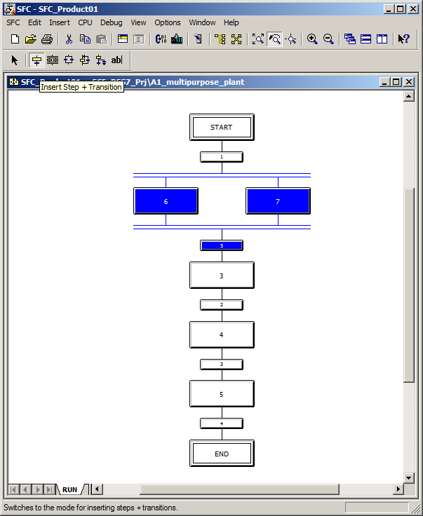

1. Then click the  icon to edit normally. (® )

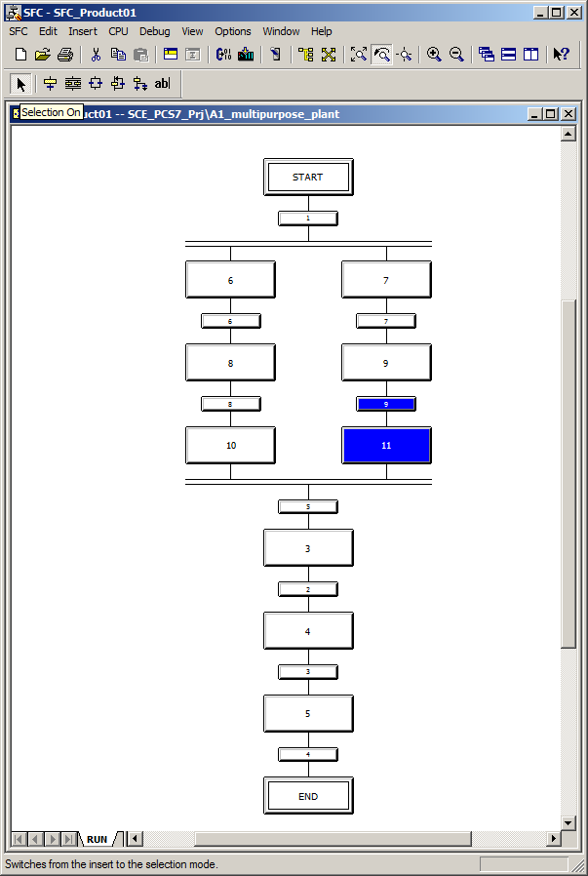

## Editing properties of steps and transitions

1. The procedure for changing properties of a step is shown next. To do this, right-click on the step and select Object Properties. (® Step 6 ® Object Properties)

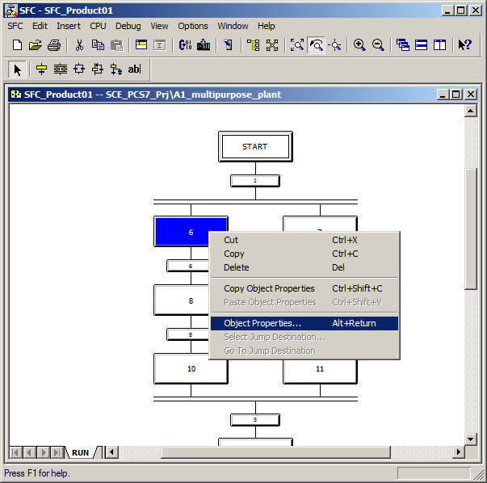

1. In the object properties, each step is to be assigned a name and a comment for better clarity. (® Name: EductB003toR001 ® Comment: educt tank B003 to reactor R001 ® Close)

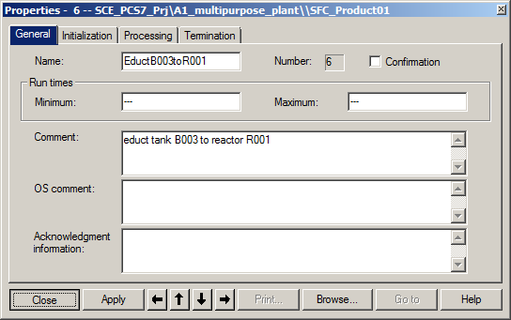

1. Confirm the prompt to save changes with "Yes". (® Yes)

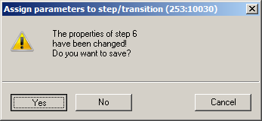

1. Similar to the properties of the steps, the properties of the transitions can also be changed. To do so, right-click the transition and select Object Properties. (® 1 ® Object Properties)

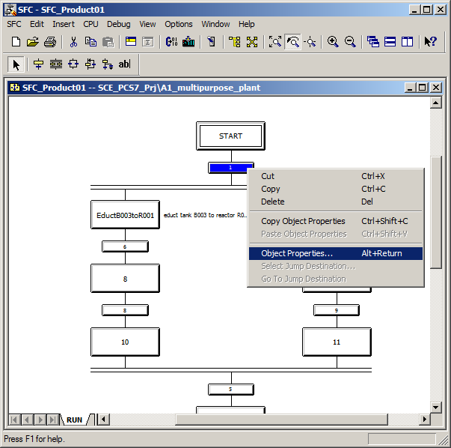

1. Here you also change the name and the comment first. (® Name: Init_OK ® Comment: all initial conditions are fulfilled ® Close)

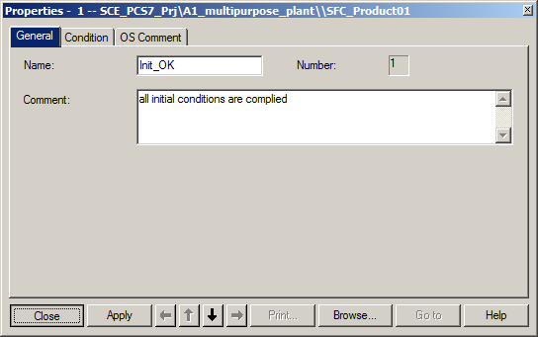

1. Save the change. (® Yes)

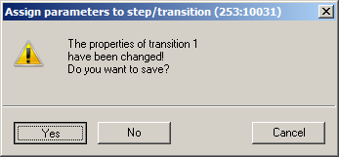

1. Repeat the previous steps until the SFC looks like this. It is important to also enter a minimum run time of 10 seconds for the 'Stir' step.   
   (® Run times Minimum: T#10s)

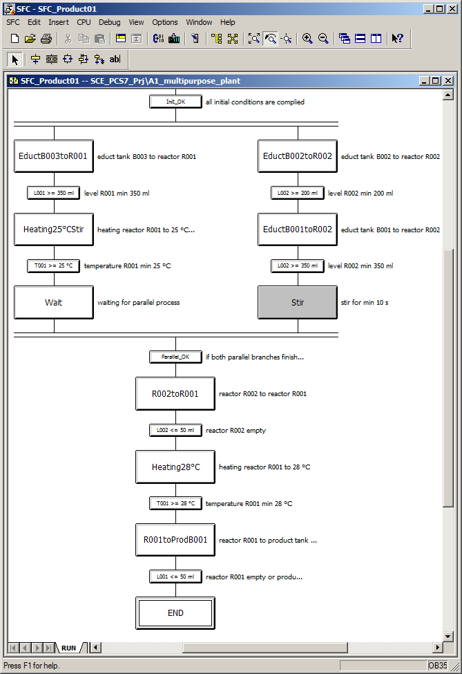

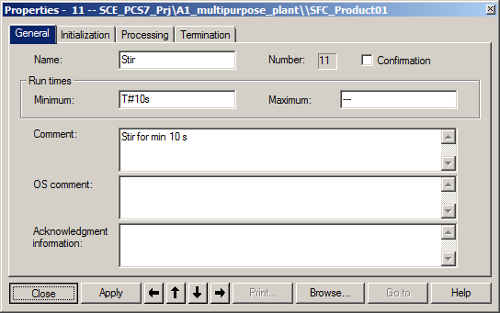

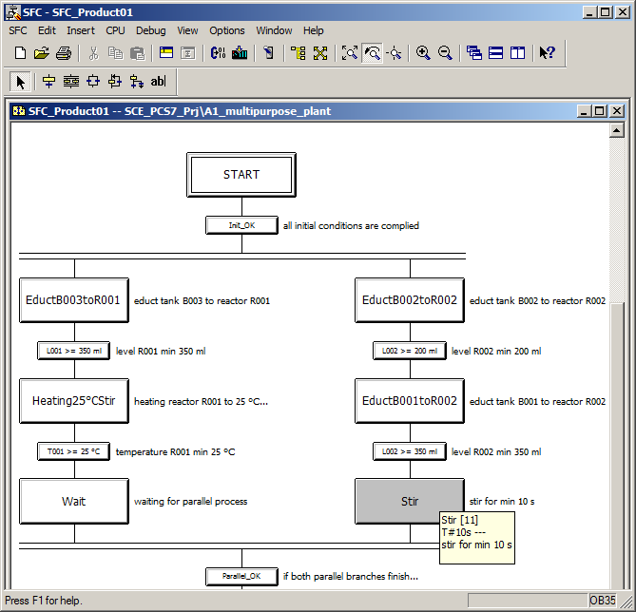

## Editing steps and transitions

### Transition: Init_OK

1. The actual function of the sequential function chart is implemented in this section. The 'START' step should not contain any instructions. Therefore, start by double-clicking on the transition 'Init_OK'. (® Init_OK)

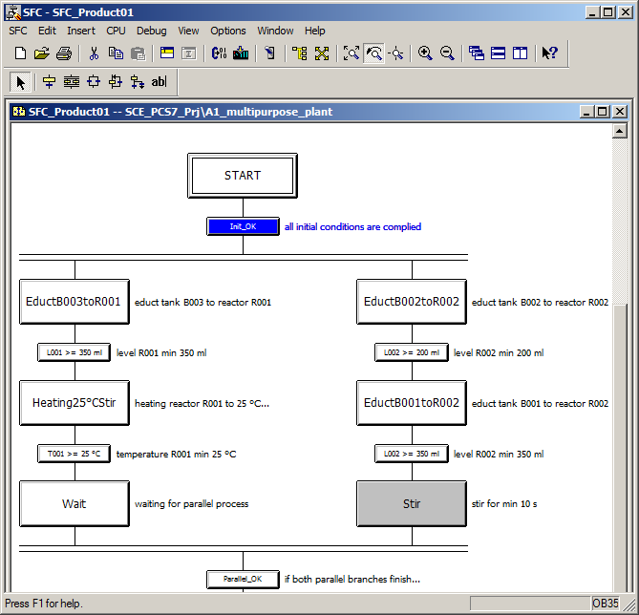

1. Select the 'Condition' tab and add the initialization conditions by clicking on 'Browse'. (® Condition ® Browse)

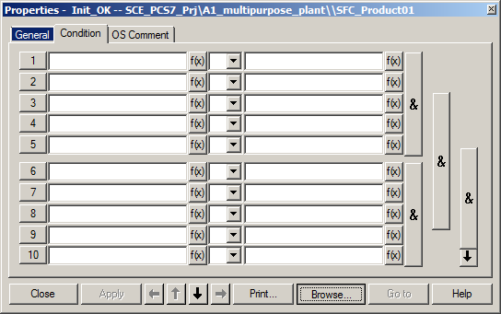

1. A window opens for adding I/Os or symbols.

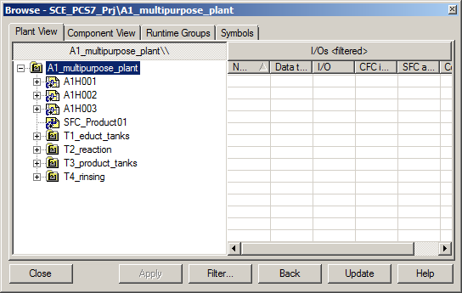

1. Now, select the 'Symbols' tab, select the symbol of the main power switch 'A1.A1H001.HS+-.START' and click 'Apply'. The symbol is entered on the left side of the first condition. (® Symbols ® A1.A1H001.HS+-.START ® Apply)

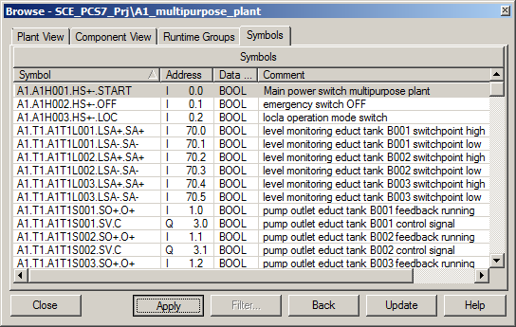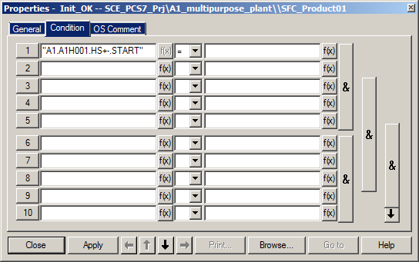

1. Next, enter '1' or 'TRUE' on the right side of the first condition, so that the next steps will be processed only when the plant is switched on. Apply this value. (® 1 ® Apply)

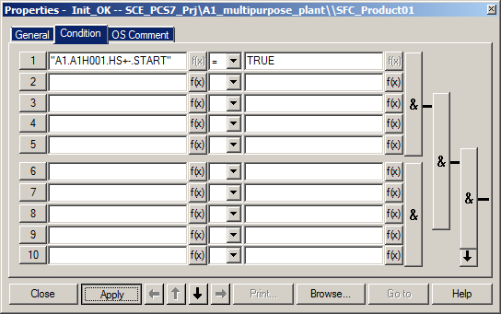

1. Now add conditions so that the EMERGENCY STOP is unlocked and the local operation is deactivated. Close the dialog. (® A1.A1H002.HS+-.OFF ® 1 ® A1.A1H003.HS+-.LOC ® 0 ® Close)

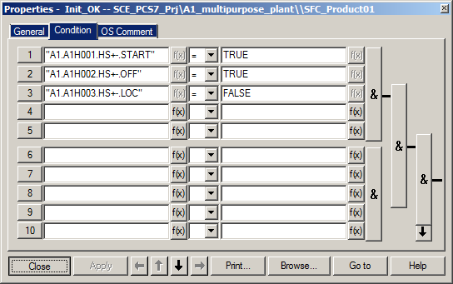

### Step: EductB003toR001

1. Next, open the 'EductB003toR001' step. (® EductB003toR001)

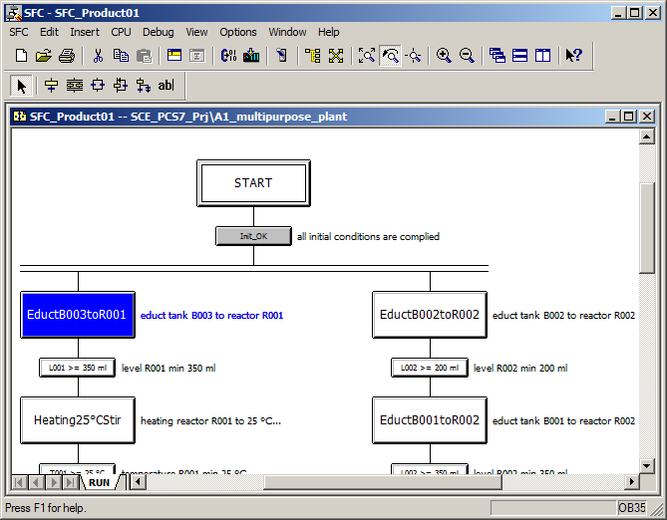

1. Select the 'Initialization' tab and click on 'Browse'. (® Initialization ® Browse)

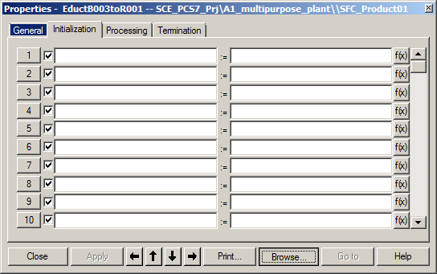

1. In the 'Plant View' tab of the selection window select the valve block 'Valve_A1T1X006' in CFC 'A1T1X006'. (® A1_multipurpose_plant ® T1_educt_tanks ® educt_tank B003 ® A1T1X006 ® valve_A1T1X006)

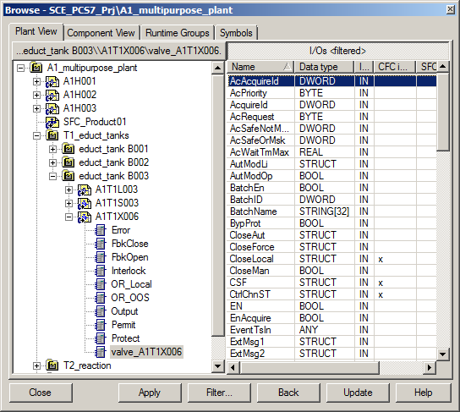

1. First, set the 'ModLiOp' input to '1', so that the valve can still only be controlled via interconnections or SFC. Because the 'ModLiOp' input is of data type 'STRUCT', you must first right-click to open the shortcut menu and click 'Open Structure' there. (® ModLiOp ® Open Structure)

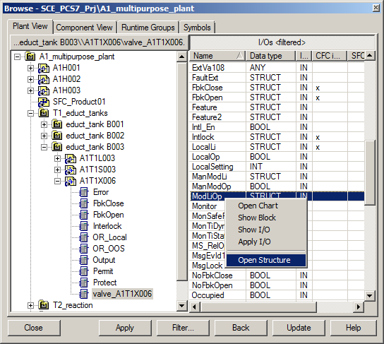

1. The structure dialog opens and you select 'Value' of data type BOOL. With Apply, your selection is applied on the left side of the first instruction. (® Value ® Apply)

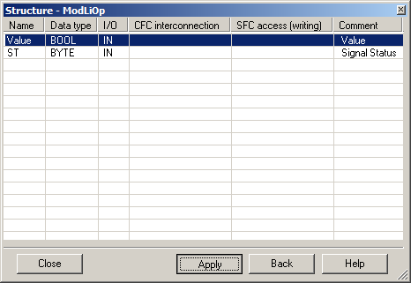

1. Now, enter "1" on the right side of the first instruction. This sets the 'ModLiOp' input to SFC mode. With 'Apply',"1" is automatically replaced with "TRUE". (® 1 ® Apply)

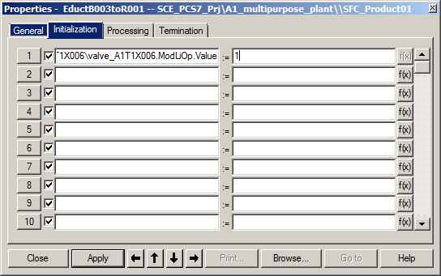

1. Then add inputs 'AutModLi' = '1' and 'ManModLi' = '0', so that the valve is set to automatic mode. (® AutModLi ® 1 ® ManModLi ® 0 ® Apply)

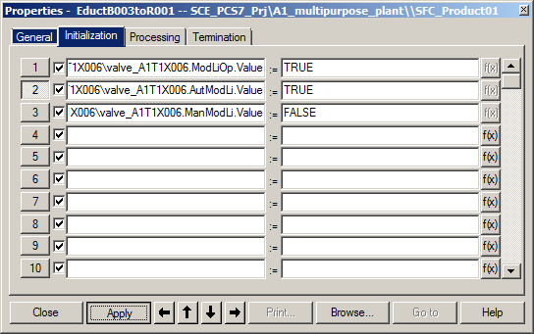

1. The same must now be done for Pump A1T1S003 and Valve A1T2X003 because they are also involved in filling Reactor R001 from Educt tank B003. Then, change to the 'Processing' tab. (A1T1S003 ® ModLiOp.Value = 1 ® AutModLi.Value = 1 ® ManModLi.Value = 0 ® Apply ® A1T2X003 ® … ® Apply ® Processing)

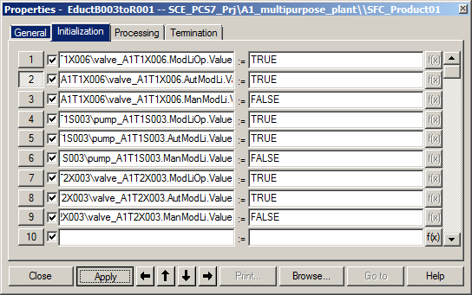

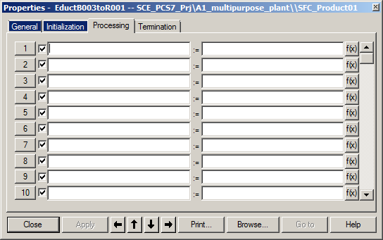

1. The instructions for opening the valves and starting the pump are entered in the 'Processing' tab. For the valves, set inputs 'OpenAut.Value' = '1' and 'CloseAut.Value' = '0'. For the pump, use inputs 'StartAut.Value' = '1' and 'StopAut.Value' = '0'. (A1T1X006 ® … ® A1T1S003 ® … ® A1T2X003 ® … ® Apply ® Close)

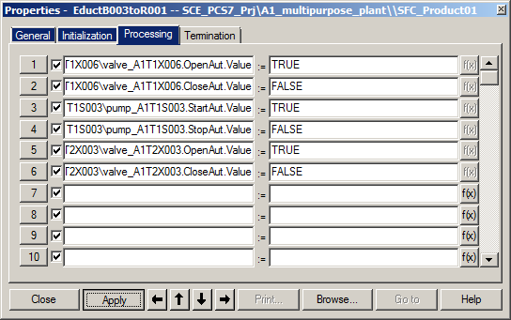

1. The instructions that are to be executed when completing the step are then entered in 'Termination'. You must close the valves and the pump here. The valves and the pump could also be reset back to manual mode and operator mode at this point. However, it is recommended that this be saved for the 'END' step. Proceed by copying the instruction from 'Processing' to 'Termination' and then inverting the values ('TRUE' -> 'FALSE' and vice versa). To copy and paste, select the numbers in front of the instructions and open the shortcut menu.

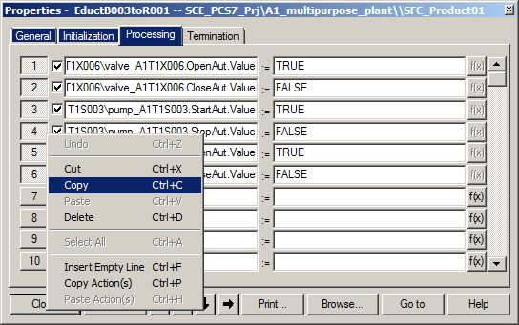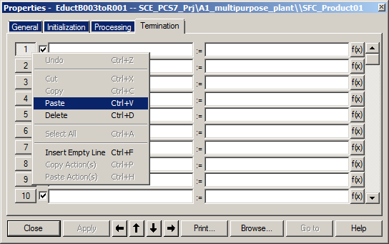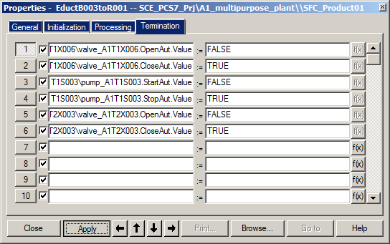

1. Then, close the properties dialog for the 'EductB003toR001' step. The SFC Editor shows the 'Init_OK' transition and the 'EductB003toR001' and 'Stir' steps grayed out because instructions already exist there. (® Close)

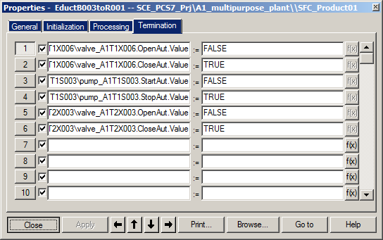

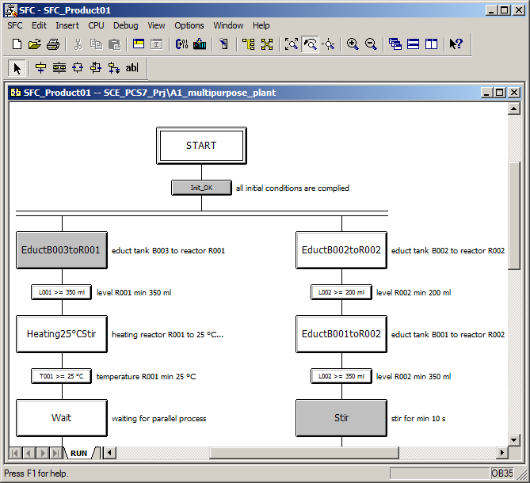

### Transition: L001 >= 350 ml

1. Now, open the 'L001 >= 350 ml' transition. Enter the condition that the level of Reactor R001 is greater than or equal to 350 ml. (® L001 >= 350 ml ® Condition ® Browse ® …Reactor R001\\A1T2L001\Level_A1T2L001.PV_Out ® right-click ® Open Structure ® Value ® >= ® 350 ® Apply ® Close)

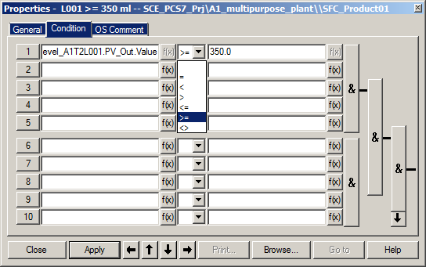

### Step: Heating25°CStir

1. In the "Heating25°CStir" step, again add inputs 'ModLiOp', 'AutModLi' and 'ManModLi' for 'stirrer_A1T2S001' and 'control_A1T2T001' in the 'Initialization' tab. For the control, switch the setpoint setting to SFC mode 'SP_LiOp' = '1' and to external setpoint setting 'SP_ExtLi' = '1' and 'SP_IntLi' = '0'. (® Heating25°CStir ® 'Initialization' ® …)

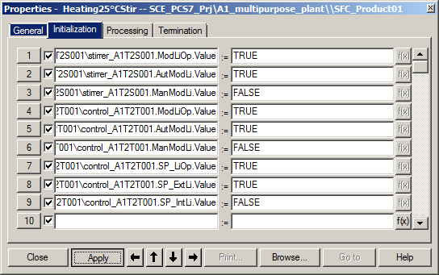

1. Then switch to the 'Processing' tab and add the I/Os and values shown. These properties are used to start the stirrer and assign the setpoint 25 °C to the control.

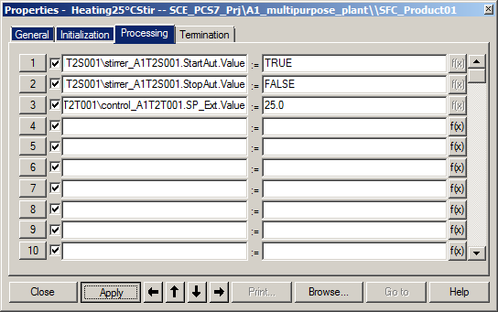

1. In the 'Termination' tab, stop the stirrer and set the setpoint to 0 °C. Then close the dialog.

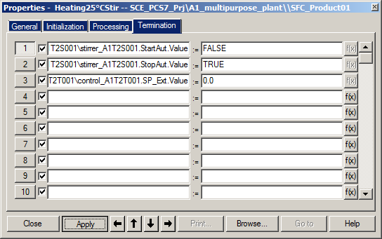

### Transition: T001 >= 25°C

1. Now you set the properties for the 'T001 >= 25°C' transition. For this you need the measured temperature. (® T001 >= 25°C ® Condition ® …\T2_Reaction\reactor R001\\A1T2T001\ In_A1T2T001 ® PV_Out ® Value ® Apply ® >= ® 25.0 ® Apply ® Close)

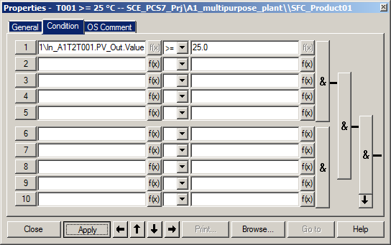

### Step: Wait

1. The 'Initialization', 'Processing' and 'Termination' tabs remain empty in the 'Wait' step. This is indicated by the tabs not being highlighted.

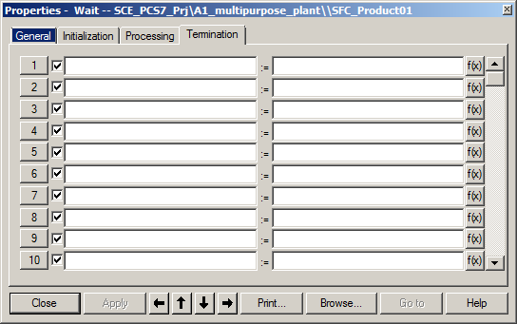

### Step: EduktB002inR002

1. Now complete the simultaneous branch. Start with the 'EductB002toR002' step and utilize the figures below. (® EductB002toR002)

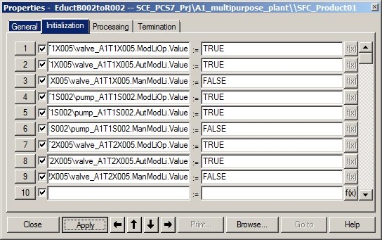

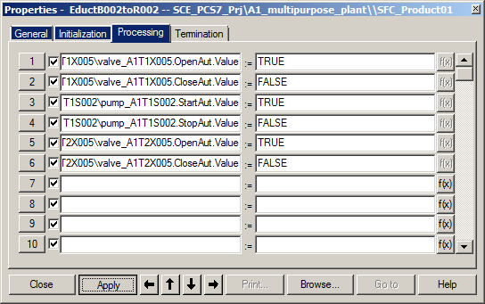

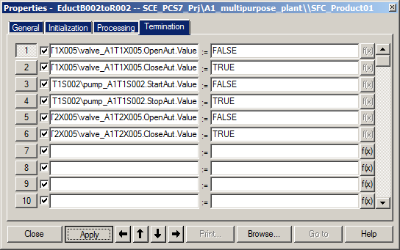

### Transition: L002 >= 200 ml

1. The 'L002 >= 200ml' transition then looks like this. (® L002 >= 200 ml)

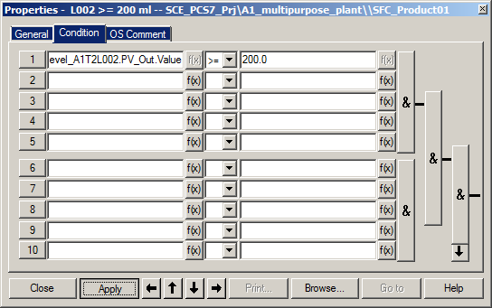

### Step: EductB001toR002

1. You must make the following interconnections in the 'EductB001toR002' step.

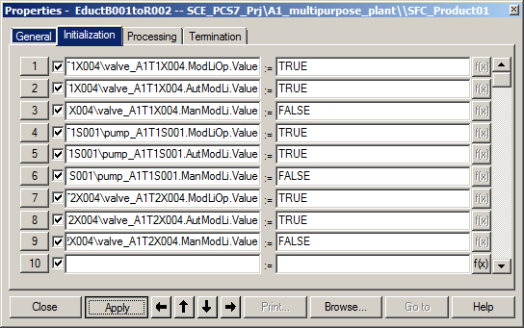

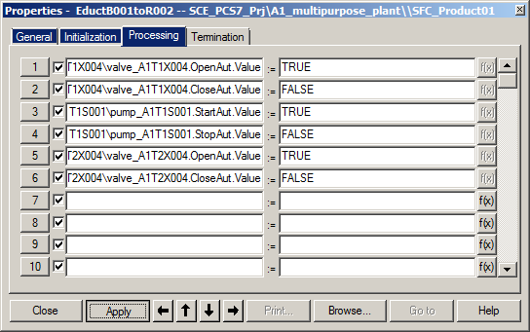

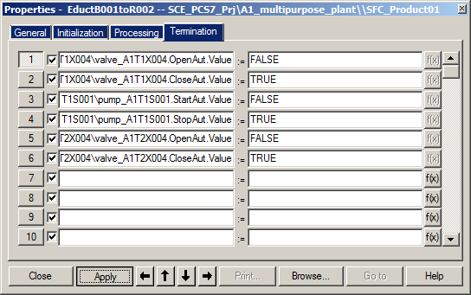

### Transition: L002 >= 350 ml

1. The 'L002 >= 350 ml' transition then looks like this. (® L002 >= 350 ml)

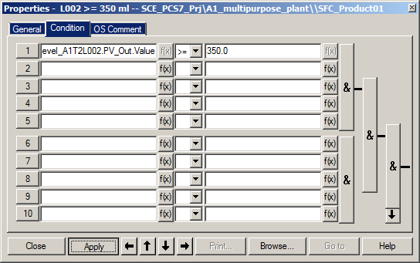

### Step: Stir

1. The 'Stir' step has a minimum run time of 10 seconds. You already set this parameter back at the beginning. You must now initialize, start and then stop stirrer_A1T2S002.

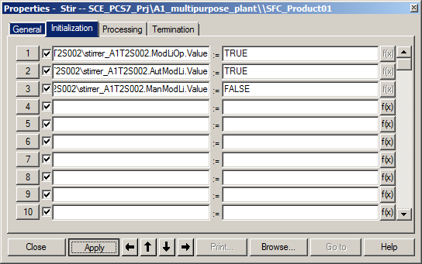

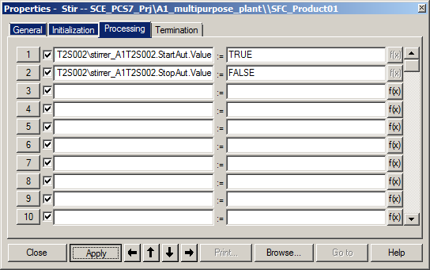

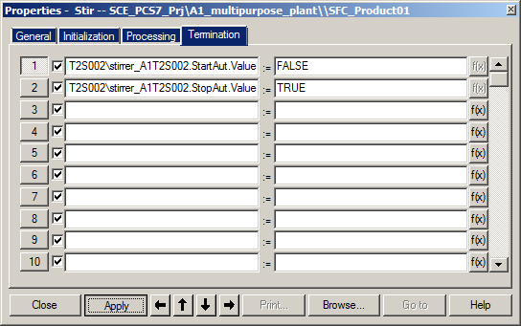

### Transition: Parallel_OK

1. Parameter assignment of the simultaneous branch is now complete. The 'Parallel_OK' transition remains blank. This means that as soon as the 'Wait' and 'Stir' steps are processed, the 'R002toR001' step becomes active.

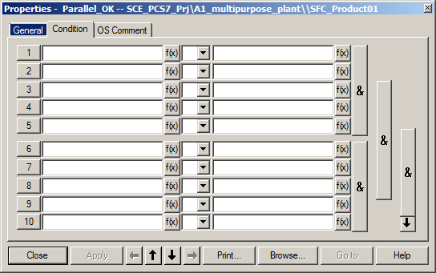

1. The sequential control system looks like this.

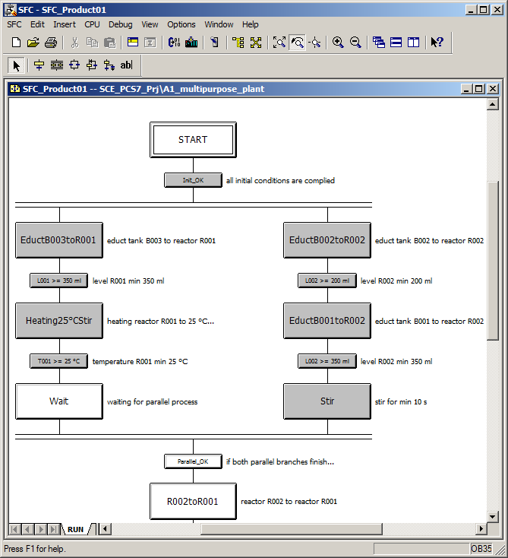

### Step: R002toR001

1. Next, interconnect the 'R002toR001' step.

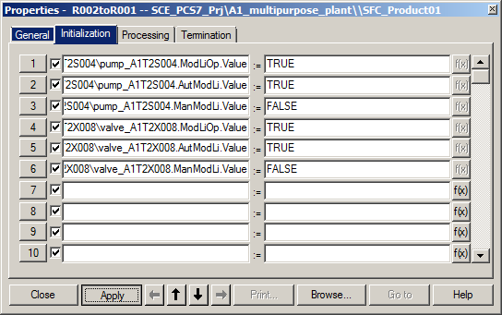

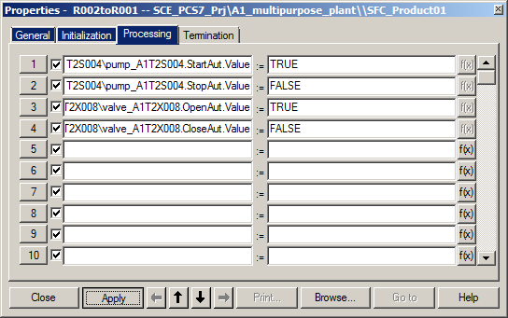

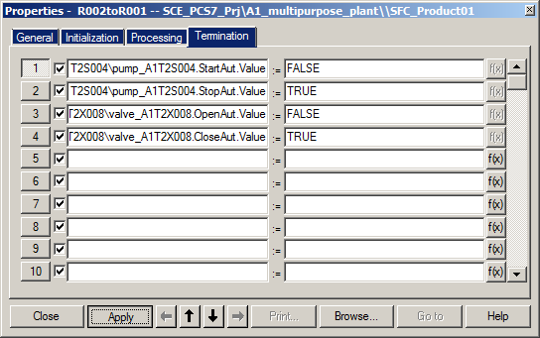

### Transition: L002 <= 50 ml

1. The 'L002 <= 50 ml' transition must be interconnected as follows.

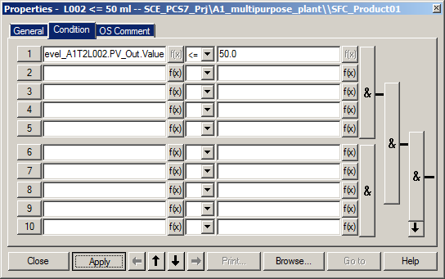

### Step: Heating28°C

1. In the 'Heating28°C' step, the control is activated again. Because it is already set to SFC mode and automatic mode, only the setpoint has to be specified. You set this back to 0°C on the Termination tab.

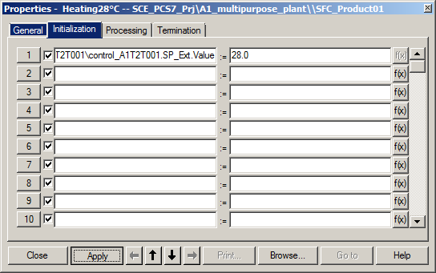

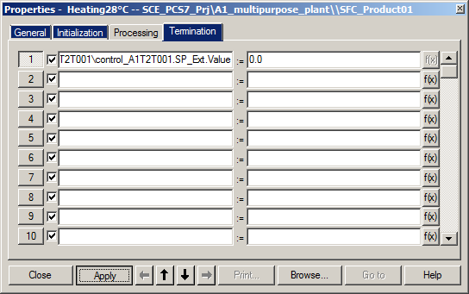

### Transition: T001 >= 28°C

1. The condition in the 'T001 >= 28°C' transition now looks like this.

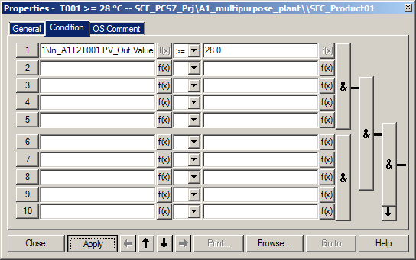

### Step: R001toProdB001

1. The last step "R001toProdB001" of the recipe fills the content of Reactor R001 into the connected Product tank B001. The interconnections are shown below.

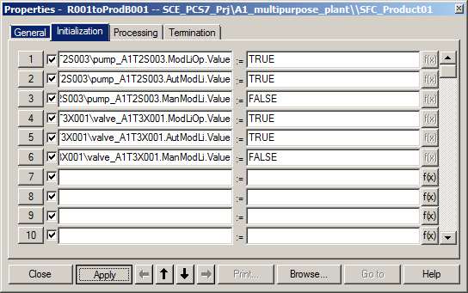

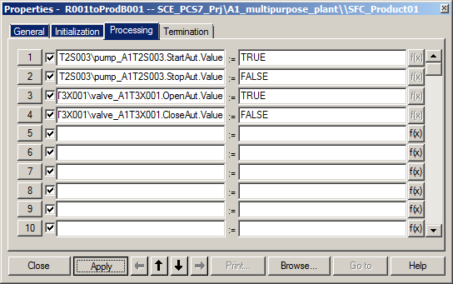

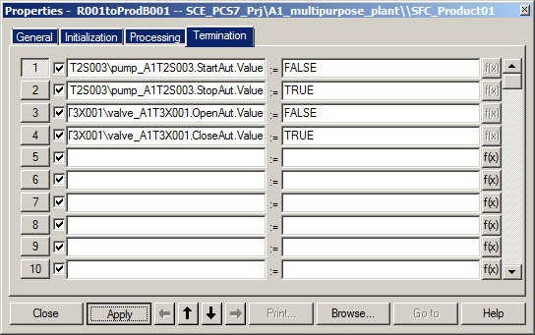

### Transition: L001 <= 50 ml

1. The 'L001 <= 50 ml' transition is the last transition of the recipe. It can be enabled when Reactor R001 is empty (<= 50 ml).

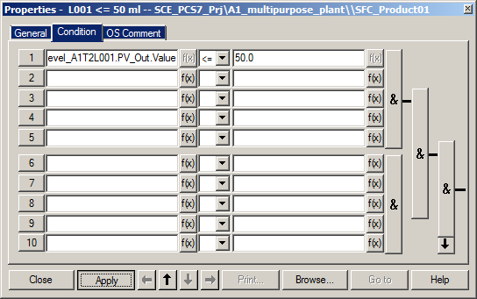

### Step: END

1. In the 'END' step, automatic mode needs to be switched off and manual mode to be switched on again for every valve, pump, stirrer and controller used. (® step 56). The internal setpoint setting must also be set again for the control. (® 'Initialization')

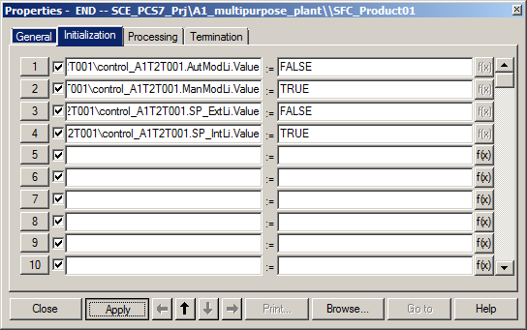

|  |  |  |  |  |
| --- | --- | --- | --- | --- |
| Block | AutModLi .Value | ManModLi .Value | SP_ExtLi .Value | SP_IntLi .Value |
| A1T2T001\control_A1T2T001 | FALSE | TRUE | FALSE | TRUE |

1. Then, all utilized pumps, valves, stirrers and controls are set back to operator mode. ('ModLiOp' = '0'). (® 'Termination' - 1)

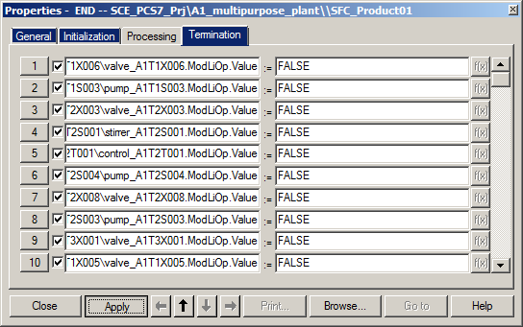

(® 'Termination' - 2)

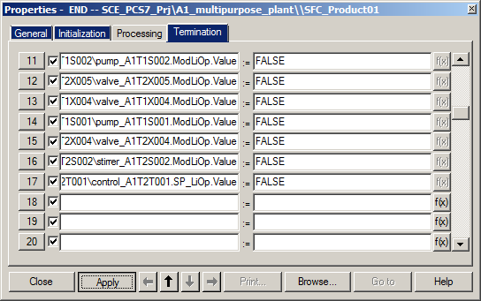

|  |  |  |
| --- | --- | --- |
| Block | ModLiOp .Value | SP_LiOp .Value |
| A1T1X006\valve_A1T1X006 | FALSE |  |
| A1T1S003\pump_A1T1S003 | FALSE |  |
| A1T2X003\valve_A1T2X003 | FALSE |  |
| A1T2S001\stirrer_A1T2S001 | FALSE |  |
| A1T2T001\control_A1T2T001 | FALSE | FALSE |
| A1T2S004\pump_A1T2S004 | FALSE |  |
| A1T2X008\valve_A1T2X008 | FALSE |  |
| A1T2S003\pump_A1T2S003 | FALSE |  |
| A1T3X001\valve_A1T3X001 | FALSE |  |
| A1T1X005\valve_A1T1X005 | FALSE |  |
| A1T1S002\pump_A1T1S002 | FALSE |  |
| A1T2X005\valve_A1T2X005 | FALSE |  |
| A1T1X004\valve_A1T1X004 | FALSE |  |
| A1T1S001\pump_A1T1S001 | FALSE |  |
| A1T2X004\valve_A1T2X004 | FALSE |  |
| A1T2S002\stirrer_A1T2S002 | FALSE |  |

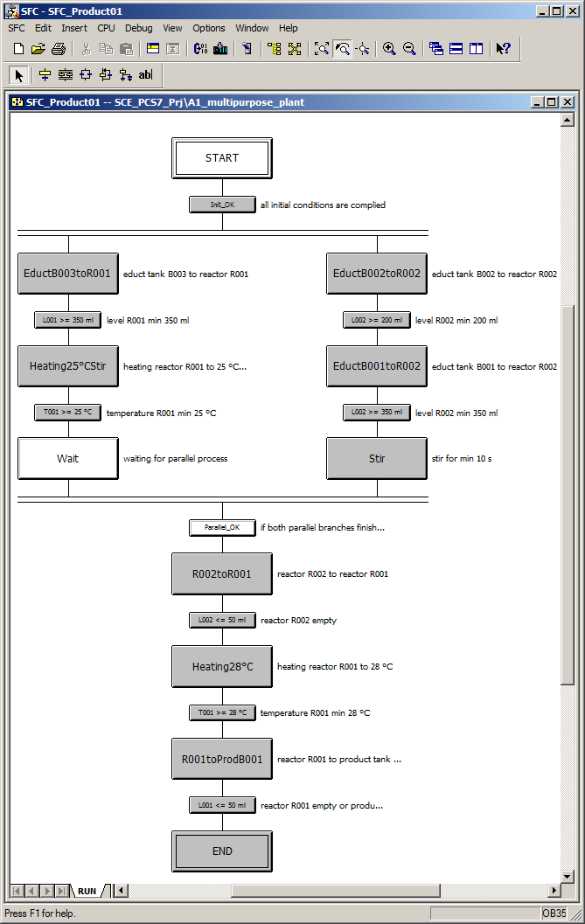

## Compiling and downloading objects

1. After all steps and transitions of the SFC are complete, you can compile and download the project, as you have already learned. (* SCE_PCS7_Prj * PLC * Compile and Download Objects…)

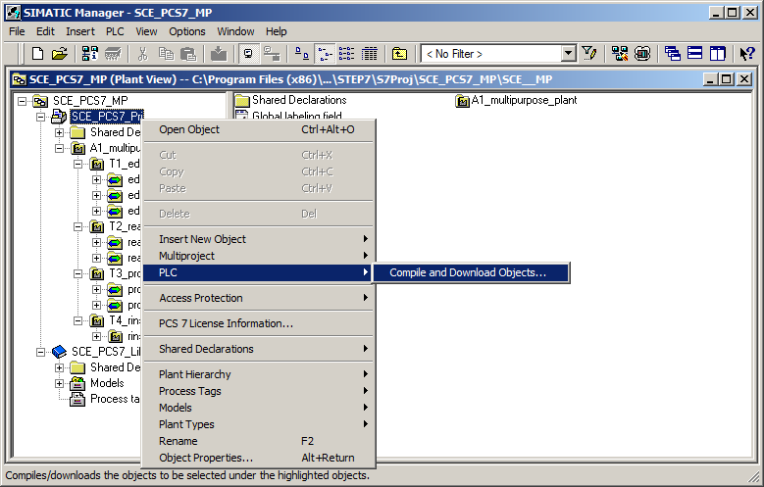

1. Prior to compiling and downloading, open the settings for compiling and downloading the charts. (® Charts ® Edit)

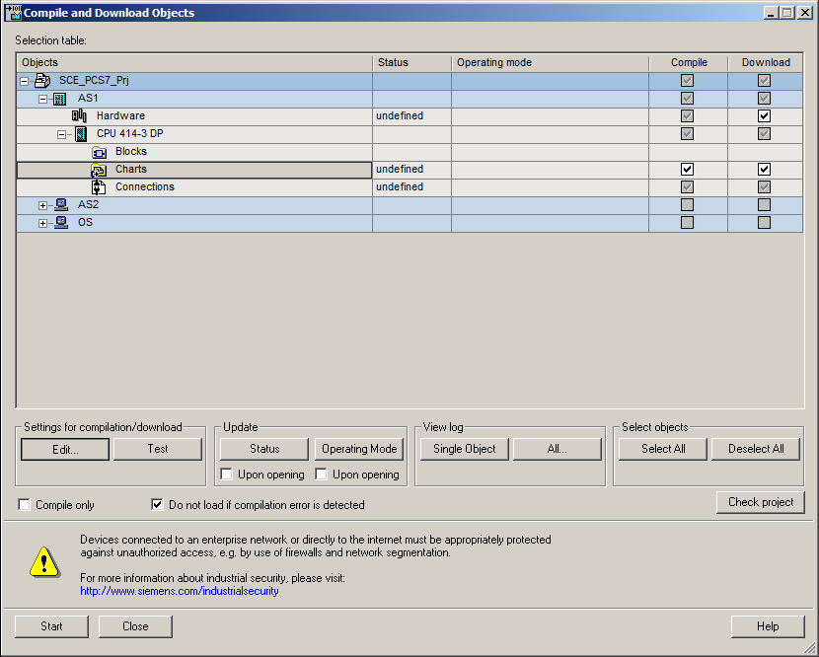

1. Here it is important to select 'Entire program' as the "Scope' and 'Download mode' on the "Compile Charts as Program" and "S7 Download" tabs, respectively. (® Compile Charts as Program ® Scope: Entire program ® S7 Download ® Download mode: Entire program ® OK)

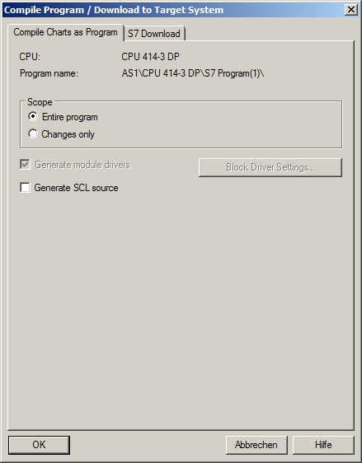 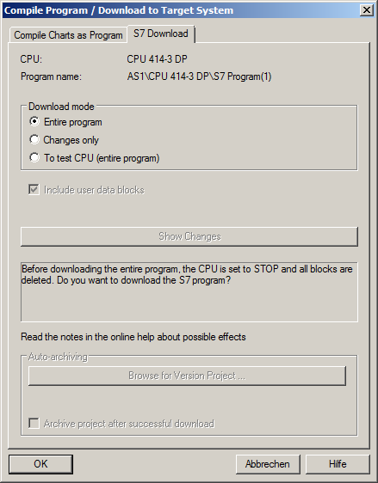

1. Confirm the warning with "OK". (® OK)

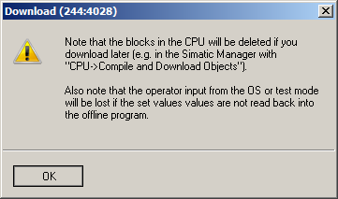

1. Now you can start compiling and downloading. (® Start)

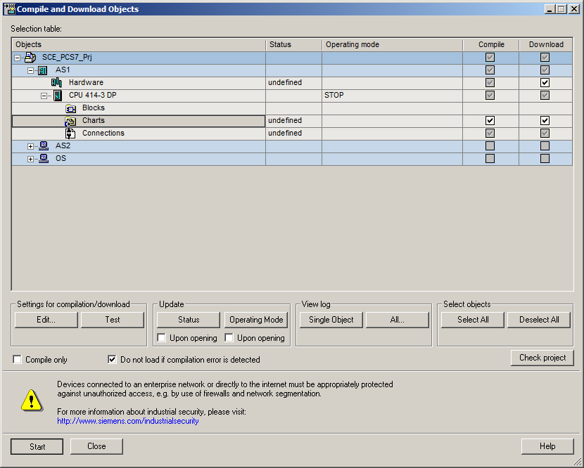

1. Carefully read all warnings that follow and confirm them. (® OK ® Yes)

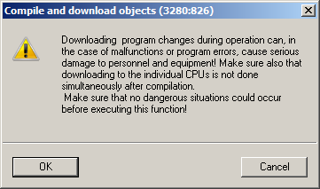

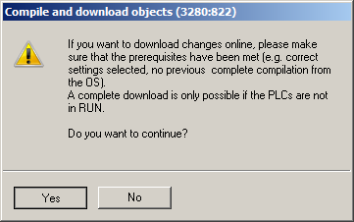

1. The log should contain no errors and at most only warnings. To see details for a warning, view the log of the single object. (® )

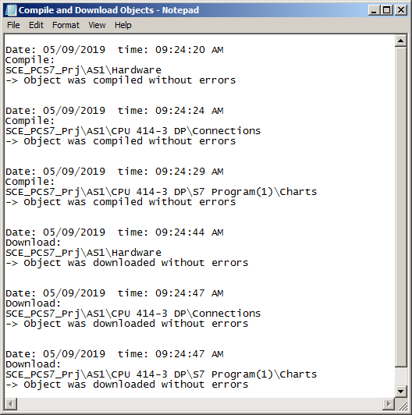

## Testing the SFC

1. You can now set PLCSIM to RUN-P mode. (® PLCSIM ® RUN-P)

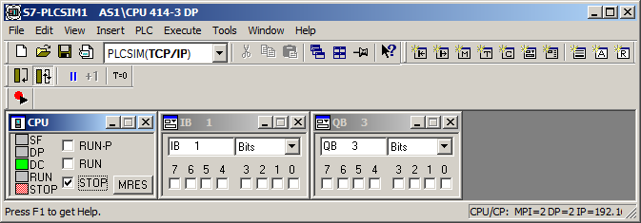

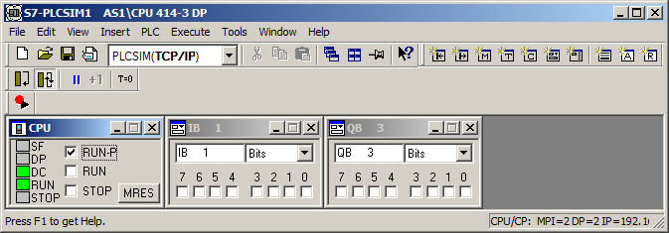

1. Double-click the sequential function chart in the plant hierarchy to open it. (® SFC_Product01)

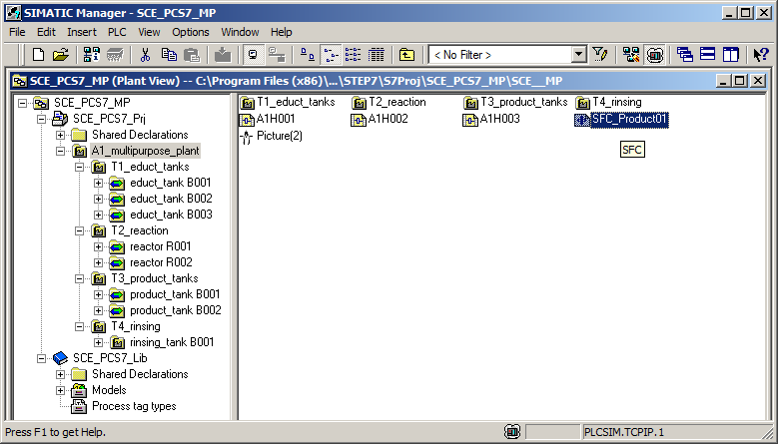

1. In order to observe the sequence, test mode must be activated .   
   (® Test Mode on/off )

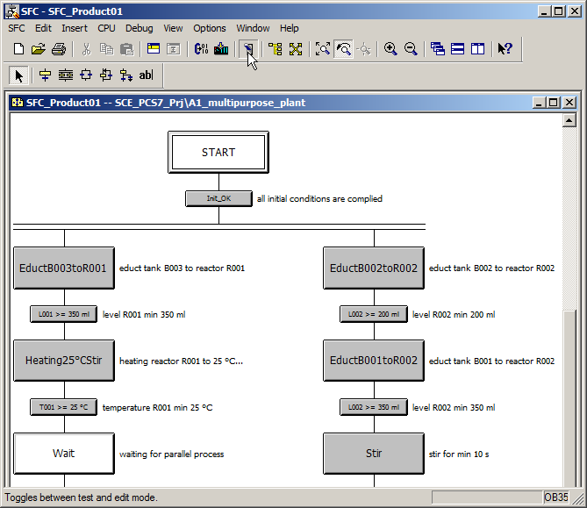

1. The simulation must be reset, the main switch and Emergency Stop selected and local operation deselected.

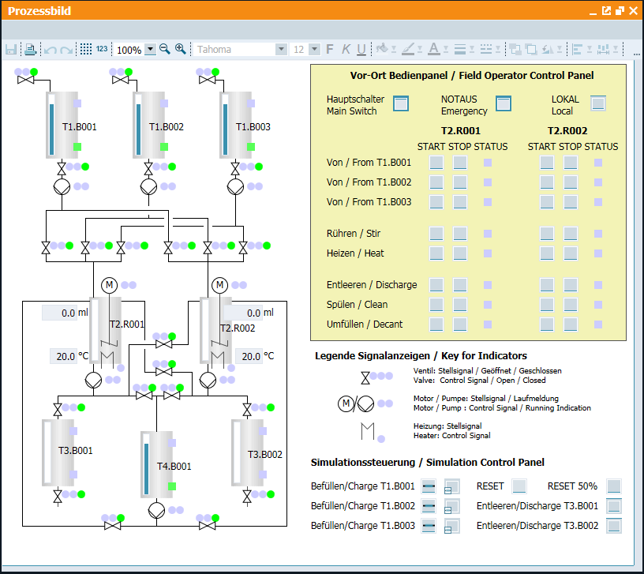

1. You can now start testing the SFC. (® Start)

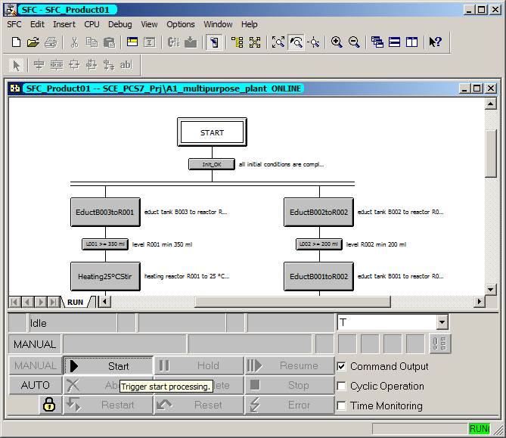

1. Der flow of the sequential function chart is then visible. Active and previously processed steps and transitions are marked.

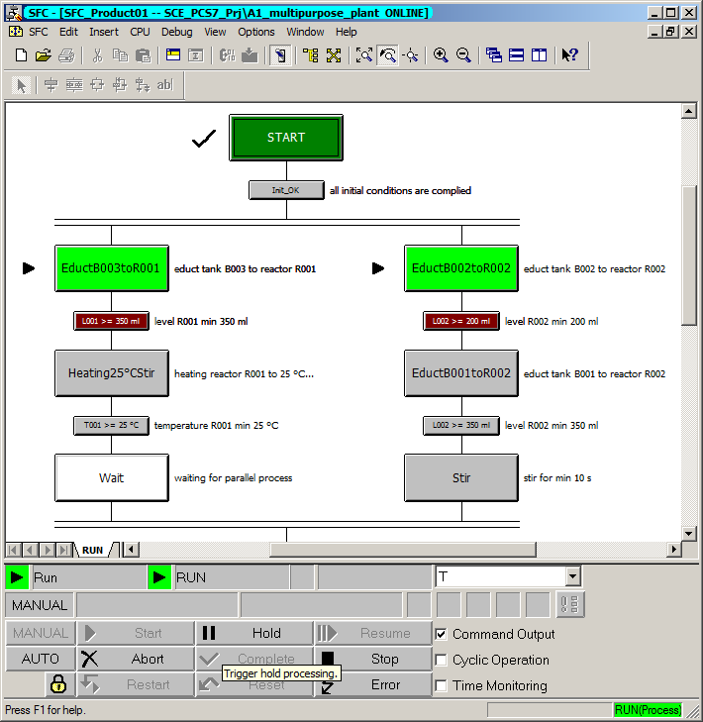

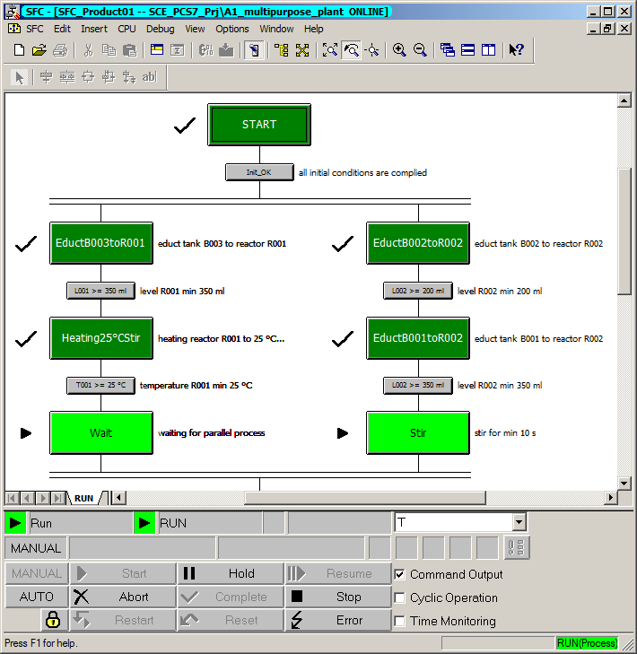

1. Current conditions and values can be displayed by double-clicking on or opening individual steps or transitions.

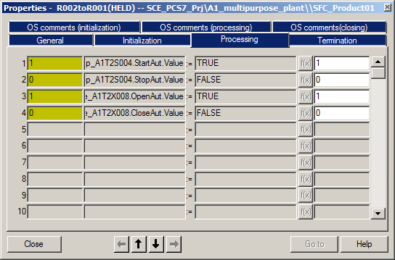

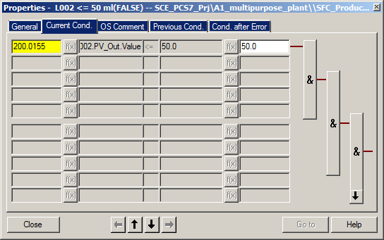

1. In the 'R001toProdB001' state, the SFC and the simulation look like this.

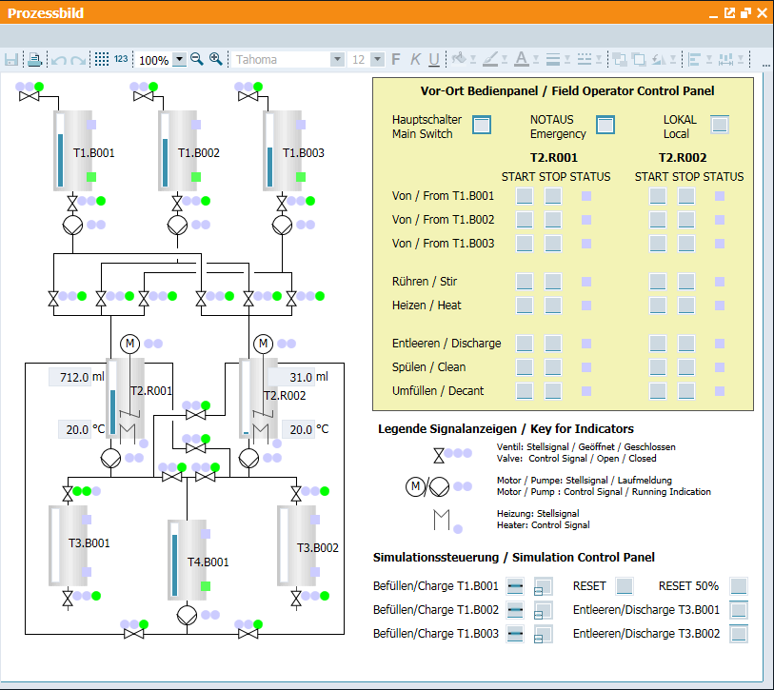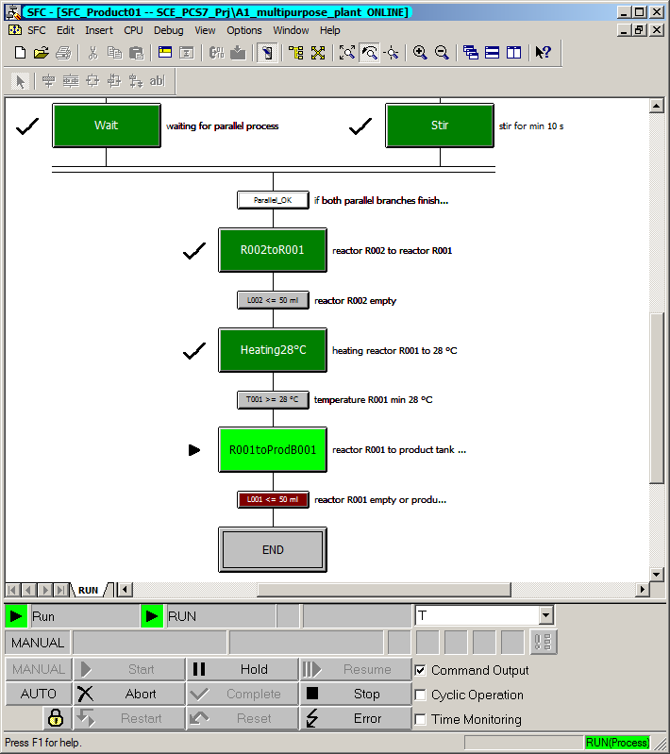

## Checklist – step-by-step instruction

The following checklist helps students to independently check whether all steps of the step-by-step instruction have been carefully completed and enables them to successfully complete the module on their own.

|  |  |  |
| --- | --- | --- |
| No. | Description | Checked |
| 1 | SFC_Product01 created and configured |  |
| 2 | Sequential function chart created |  |
| 3 | All steps and transitions named and commented |  |
| 4 | All steps and transitions (except Wait) edited (grayed out) |  |
| 5 | END step (Initialization) contains manual setpoint setting and operation of temperature control (SP_ExtLi, SP_IntLi, ManModLi, AutModLi) |  |
| 6 | END step (Termination) contains enable of operator mode of all 16 utilized blocks (one ModLiOp each) |  |
| 7 | END step (Termination) contains enable of setpoint setting of temperature control (SP_LiOp) |  |
| 8 | Successfully tested |  |
| 9 | Project successfully archived |  |

Table 1: Checklist for step-by-step instructions

# Exercises

In the exercises, you apply what you learned in the theory section and in the step-by-step instructions. The existing multiproject from the step-by-step instructions (p01-08-project-r1905-en.zip) is to be used and expanded for this. The download of the project is stored as zip file "Projects" on the SCE Internet for the respective module.

The purpose of this exercise is to implement an additional recipe that allows cleaning of the reactors. The following task suggests a possible concept.

## Task

In the 'A1_multipurpose_plant' chart folder, create the SFC 'SFC_Rinse' that cleans Reactors

R001 and R002 with rinsing water. The cleaning is to consist of the following steps:

Filling the reactors (up to 500 ml) with rinsing water

Stirring the rinsing water (for 20 seconds) in the reactors

Draining the rinsing water to the product tanks.

Design the rinsing operation in such a way that both reactors are cleaned at the same time.

Check whether both reactors are empty (< 50 ml) before rinsing starts.

## Checklist – exercise

The following checklist helps students to independently check whether all steps of the exercise have been carefully completed and enables them to successfully complete the module on their own.

|  |  |  |
| --- | --- | --- |
| No. | Description | Checked |
| 1 | SFC_Rinse created and configured |  |
| 2 | All steps and transitions named and commented |  |
| 3 | Parallel processing is available |  |
| 4 | Start transition is available |  |
| 5 | END step (Termination) contains enable of operator mode of all utilized blocks (one ModLiOp each) |  |
| 6 | Successfully tested |  |
| 7 | Project successfully archived |  |

Table 2: Checklist for exercises

# Additional information

More information for further practice and consolidation is available as orientation, for example: Getting Started, videos, tutorials, apps, manuals, programming guidelines and trial software/ firmware, under the following link:

[siemens.com/sce/pcs7](http://www.siemens.com/sce/pcs7)

**Preview "Additional information"**

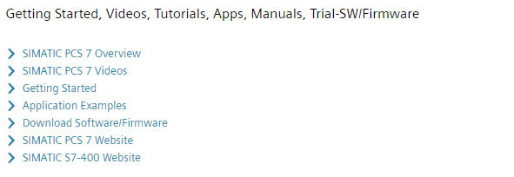

Further Information

Siemens Automation Cooperates with Education  
**siemens.com/sce**

Siemens SIMATIC PCS 7  
**siemens.com/pcs7**

SCE Learn-/Training Documents  
**siemens.com/sce/documents**

SCE Trainer Packages  
**siemens.com/sce/tp**

SCE Contact Partners   
**siemens.com/sce/contact**

Digital Enterprise  
**siemens.com/digital-enterprise**

Industrie 4.0   
**siemens.com/future-of-manufacturing**

Totally Integrated Automation (TIA)  
**siemens.com/tia**

TIA Portal  
**siemens.com/tia-portal**

SIMATIC Controller  
**siemens.com/controller**

SIMATIC Technical Documentation   
**siemens.com/simatic-docu**

Industry Online Support  
**support.industry.siemens.com**

Product catalogue and online ordering system Industry Mall   
**mall.industry.siemens.com**

Siemens  
Digital Industries, FA   
P.O. Box 4848  
90026 Nuremberg  
Germany

Subject to change and errors  
© Siemens 2020

**siemens.com/sce**