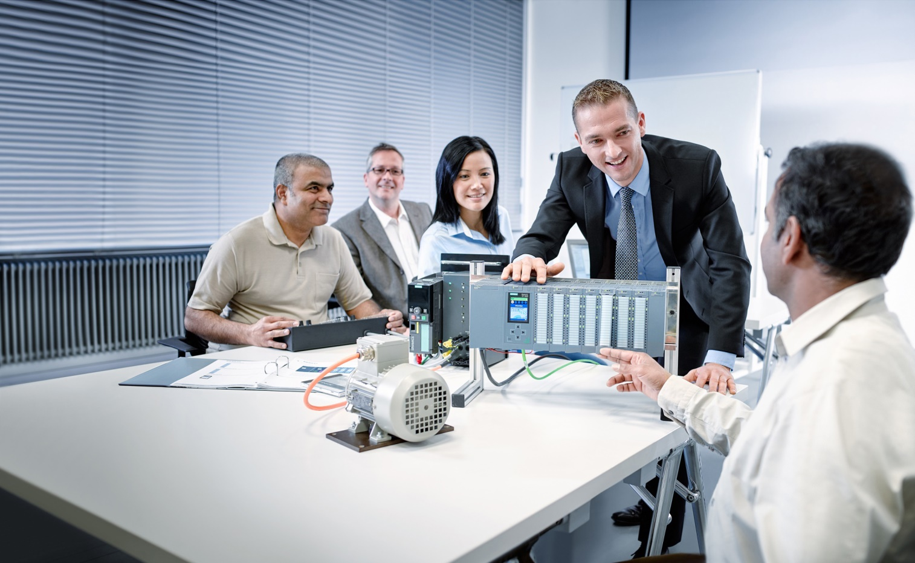

Learn-/Training Document  
  
Siemens Automation Cooperates with Education (SCE) | As of Version V9 SP1

**siemens.com/sce**

PA Module P01-03   
SIMATIC PCS 7 – Plant Hierarchy

**Matching SCE Trainer Packages for this Learn-/Training Document**

* **SIMATIC PCS 7 Software Package V9.0 (set of 3)**  
  Order No.: 6ES7650-0XX58-0YS5
* **SIMATIC PCS 7 Software Package V9.0 (set of 6)**   
  Order No.: 6ES7650-0XX58-2YS5
* **SIMATIC PCS 7 Software Upgrade Packages (set of 3)**  
  Order No.: 6ES7650-0XX58-0YE5 (V8.x🡪 V9.0)
* **SIMIT Simulation Platform with Dongle V10**  
  (contains SIMIT S & CTE, FLOWNET, CONTEC libraries) – 2500 simulation tags  
  Order No.: 6DL8913-0AK00-0AS5
* **Upgrade SIMIT Simulation Platform V10**  
  (contains SIMIT S & CTE, FLOWNET, CONTEC libraries) from V8.x/V9.x  
  Order No.: 6DL8913-0AK00-0AS6
* **Demo Version SIMIT Simulation Platform V10**  
  [Download](https://support.industry.siemens.com/cs/ww/en/ps/17120/dl)
* **SIMATIC PCS 7 AS RTX Box (PROFIBUS) only in combination with ET 200M for RTX –**   
  Order No.: 6ES7654-0UE23-0XS1
* **ET 200M for RTX Box (PROFIBUS) only in combination with PCS 7 AS RTX Box –**  
  Order No.: 6ES7153-2BA10-4AB1

Note that these trainer packages are replaced with successor packages when necessary.

An overview of the currently available SCE packages is available at: [siemens.com/sce/tp](http://www.siemens.com/tp)

**Continued training**

For regional Siemens SCE continued training, get in touch with your regional SCE contact

[siemens.com/sce/contact](http://www.siemens.com/contact)

**Additional information regarding SCE**

[siemens.com/sce](http://www.siemens.com/sce)

**Information regarding use**

The SCE Learn-/Training Document for the integrated automation solution Totally Integrated Automation (TIA) was prepared for the program "Siemens Automation Cooperates with Education (SCE)" specifically for training purposes for public educational facilities and R&D institutions. Siemens does not guarantee the contents.

This document is to be used only for initial training on Siemens products/systems, which means it can be copied in whole or part and given to those being trained for use within the scope of their training. Circulation or copying this Learn-/Training Document and sharing its content is permitted within public training and advanced training facilities for training purposes.

Exceptions require written consent from the Siemens. Send all related requests to

[scesupportfinder.i-ia@siemens.com](mailto:scesupportfinder.i-ia@siemens.com).

Offenders will be held liable. All rights including translation are reserved, particularly if a patent is granted or a utility model or design is registered.

Use for industrial customer courses is explicitly not permitted. We do not consent to commercial use of the Learn-/Training Document.

We wish to thank the TU Dresden, particularly Prof. Dr.-Ing. Leon Urbas and the Michael Dziallas Engineering Corporation and all other involved persons for their support during the preparation of this Learn-/Training Document.

Table of contents

1 Goal 5

2 Prerequisite 5

3 Required hardware and software 6

4 Theory 7

4.1 Theory in brief 7

4.2 Structuring according to DIN EN 81346-1 8

4.3 Structure of the plant hierarchy 9

4.4 Deriving the picture hierarchy and OS areas from the PH 10

4.5 AS-OS assignment 10

4.6 Type definition according to ISA-S88.01 11

4.7 References 11

5 Task 12

6 Planning 12

7 Learning objective 12

8 Structured step-by-step instructions 13

8.1 Configuring the plant hierarchy 13

8.2 Object properties of the hierarchy folders 15

8.3 Expanding the plant hierarchy 19

8.4 Checklist – step-by-step instruction 20

9 Exercises 21

9.1 Tasks 21

9.2 Checklist – exercise 22

10 Additional information 23

Plant hierarchy

# Goal

The students learn to structure an automation project according to technological aspects. A project structure that is referred to as the plant hierarchy (PH) is implemented by creating hierarchy folders. In the folders of this plant hierarchy, CFCs and SFCs are then stored for the automation systems, pictures and reports for the operator stations and supplementary documents (such as unit descriptions, process tag sheets, engineering documents from other applications such as Word, Excel, etc.). A well-planned plant hierarchy facilitates the localization of objects and is a precondition for reuse of generic solutions as well as automatic generation mechanisms.

# Prerequisite

This chapter builds on the 'Process description' chapter, which describes the example plant, and chapter 'Hardware configuration'. To perform the tasks in this chapter, you can use an existing project from the previous chapter or the archived project 'p01-02-exercise-r1905-en.zip' provided by SCE. The download of the project(s) is stored on the SCE Internet for the respective module.

# Required hardware and software

1. Engineering station: Requirements include hardware and operating system   
   (for further information, see Readme on the PCS 7 installation DVD)
2. SIMATIC PCS 7 software V9 SP1 or higher

* Installed program packages (contained in SIMATIC PCS 7 Software Trainer Package):
  + *Engineering → PCS 7 Engineering*
  + *Engineering → BATCH Engineering*
  + *Runtime → Single Station → OS Single Station*
  + *Runtime → Single Station → BATCH Single Station*
  + *Options → SIMATIC Logon*
  + *Options → S7-PLCSIM V5.4 SP8*



**1** Engineering Station

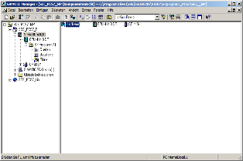

**2** SIMATIC PCS 7   
V9 SP1 or higher

# Theory

## Theory in brief

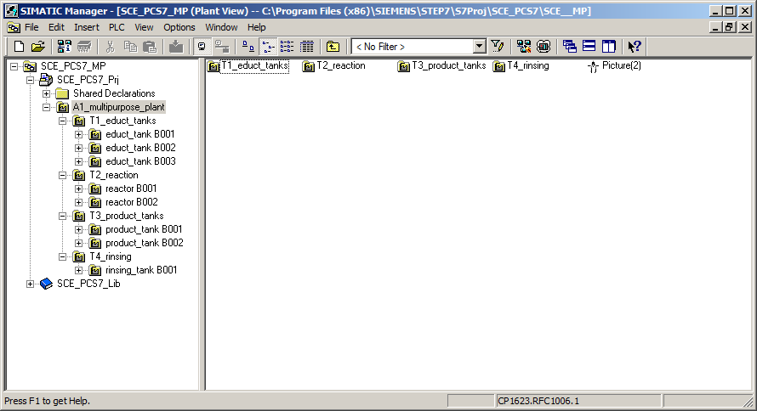

**A1_multipurpose_plant**

**T2_  
reaction**

**reactor**

**R001**

**reactor**

**R002**

**T3_  
product_  
tanks**

**product_tank  
B001**

**product_tank  
B002**

**T4_  
rinsing_  
tank**

**rinsing_  
tank  
B001**

**T1_  
educt_  
tanks**

**educt_  
tank  
B001**

**educt_  
tank  
B002**

**educt_  
tank  
B003**

Figure 1: From plant model to plant hierarchy

**The plant hierarchy essentially has three functions:**

* It is used to map a hierarchical naming scheme that can be used to break down a complex plant into sub-problems that can be solved with a reasonable amount of effort.
* It supports the structured storage of documents and objects in this hierarchical naming scheme.
* It allows for automatic generation of the picture hierarchy for operator control and monitoring.

## Structuring according to DIN EN 81346-1

To specify, plan, establish, maintain or operate a system effectively, the system as well as the information about it is usually broken down into subsystems. Each of these subsystems can be subdivided further. This successive subdivision into subsystems and the organization of these subsystems is called structuring.

Two general rules apply here:

**Rule 1:**A technical system must be structured based on 'is-part-of' relationships, applying the concept of Aspects of objects.

Aspects act on an object like a filter that is used to emphasize relevant information. The aspects used in the standard have the following focal points:

Function aspect: What is the object’s task, or what is it actually doing?

Product aspect: What are the means the object uses to perform its task?

Location aspect: Planned or actual location of the object

Figure 2 shows that the 'Object for charging' is part of the 'Object for producing of product 1' under the function aspect.

**Rule 2:**Structuring is carried out stepwise either top-down or bottom-up.

The normal procedure in the ***top-down method*** is:

1. Select an object
2. Select a suitable aspect
3. Determine the sub-objects in the selected aspect if there are any. Steps 1 to 3 can be repeated iteratively for the defined sub-objects as often as required.

The normal procedure in the ***bottom-up*** method is:

1. Select the aspect that is to be worked with
2. Select the objects that are to be considered together
3. Introduce a higher-level object for which the selected objects are sub-objects in the selected aspect.

As in the top-down method, steps 1 to 3 can also be repeated iteratively here as often as necessary for each added higher-level object.

If an aspect is retained in the entire structure, the structure is designated as aspect-related according to the standard, which means function-oriented, product-oriented or location-oriented.

The structuring of a process plant takes place under the function aspect (function view).

A function-oriented structure is based on the purpose of a system. The purpose of a technical system is to perform a technical process whereby input variables (energy, information, material) are processed into output variables (energy, information, material) taking into account specific parameters. Figure 2 shows an example.



Figure 2: Representation of the function of the reactor and its sub-functions

Structuring on this basis provides a system that can be used during all phases of the life cycle: planning the plant, automating the plant and operating the plant.

## Structure of the plant hierarchy

The plant hierarchy can be taken directly from the structuring of the plant that was already undertaken for planning the plant. In so doing, it must be taken into account that, when the picture hierarchy is derived from the plant hierarchy, this structure will be mapped 1:1. [1]

While planning a process plant, the design engineer creates a reference identification system that allows for the unique identification of an object within a given system. This reference identification system is based on structuring according to an aspect (for process plants, according to the function aspect).

In PCS 7, the reference identification system is called the higher-level item designation system (HID). The structure of the plant is implemented in PCS 7 using a folder structure. By nesting the hierarchy folders, complex plants can also be mapped. By setting the number of levels, the depth of the structure can be specified project-wide. The maximum structure depth is limited to 8 levels.

## Deriving the picture hierarchy and OS areas from the PH

The OS picture hierarchy for the plant operator on the operator station can be derived completely from the configured data of the plant hierarchy. This takes place automatically during a generation run. In so doing, an operating screen is generated for each level. In this screen, operating icons and appropriate group alarms and navigation hierarchies are created for all automation blocks used in the charts of this level.

It is possible to connect individual areas of the plant structure in the plant hierarchy to OS areas. In the case of large plants, plant operators can thus be assigned only certain plant areas. In process mode, plant operators only see and control those areas for which they have the corresponding user permissions. Only messages that are relevant to this area are displayed. As a rule, a unit corresponds to an OS area in the plant hierarchy.

In the general settings of the plant hierarchy, the hierarchy level of the plant hierarchy that is to be regarded as the OS area level is specified. For each hierarchy folder of this level, an area identifier is defined. The default setting for the area identifier corresponds to the name of the hierarchy folder in the plant hierarchy. As soon as a hierarchy folder is provided with an area identifier, all lower level hierarchy folders and objects also receive the area identifier. The representation of the hierarchy levels always starts with the hierarchy level that is defined as the OS area.

## AS-OS assignment

* For each hierarchy folder, an operator station has to be assigned to an automation system in the plant view. This AS-OS assignment has the following consequences in the component view: The user stores the CFCs and SFCs intended for insertion in the plant view in the chart folder of the assigned automation system.
* On the other hand, the user stores the pictures and reports intended for insertion in the plant view in the folder of the assigned operator station.

## Type definition according to ISA-S88.01

If, when structuring the plant, the physical model according to DIN EN 61512-1 is used (see **Fehler! Verweisquelle konnte nicht gefunden werden.**), which is largely identical to the U.S. standard ISA-S88.01-1995, PCS 7 offers the option of creating a type-defined hierarchy.



Only the four lower levels of the model (process cell, unit, equipment module and control module) are specified in greater detail in this case. They refer to defined types of facilities. Such a type is a group of process and control facilities that were combined for a defined purpose.

If the type-defined hierarchy is to be used in PCS 7 according to ISA-S88.01, the top folder of the plant hierarchy must represent the process cell level.

Below the process cell level, the hierarchy folders can be type-defined as a unit, and below that as an equipment module.

Folders or levels that are not type-defined are designated as neutral and can be used for further structuring or represent the level of the control modules.

Figure 1: Physical model according to DIN EN 61512

The type definition is the basis for working with the PCS 7 BATCH module. It should be noted that only one process cell can be defined for each project.

## References

[1] PCS 7 online help for the plant hierarchy (PH). Siemens. (→ Open multiproject → Plant view → Select multiproject → Press F1 → The STEP 7 Help Viewer appears with "Help on plant hierarchy (PH)")

[2] DIN EN 81346-1 (Edition 2010-05): Industrial systems, Installations and Equipment and Industrial Products — Structuring Principles and Reference Designations.

[3] DIN EN 61512-1 (Edition 2000-01): Batch Control.

# Task

In this chapter, a folder hierarchy will be created and documented in the plant view (plant hierarchy) corresponding to the multipurpose plant project and the associated nomenclature.

# Planning

The plant hierarchy reflects the structure of the plant.

The plant used in these instructions is named 'A1_multipurpose plant'. A1 stands for plant 1 and is used for fast identification in a complex of plants.

The multipurpose plant contains multiple educt tanks. These are grouped in unit 'T1_educt tanks'. T1 stands for Unit 1 and, similar to the plant identification, allows for fast identification within a plant.

The educt tanks unit contains, among other things, 'educt_tank_B001', which in turn has various individual control functions. Thus, we now find ourselves at the equipment module level of ISA-S88.01.

An additional unit 'T2_reaction' groups the reactors and their functions.

These three levels are then to be mapped in the plant hierarchy, as shown in Figure 3.

**educt_tank B001**

**T1_educt_tanks**

**A1_multipurpose_plant**

**T2_reaction**

Figure 3: Planning of the plant hierarchy

# Learning objective

In this chapter, the student learns the following:

* Plant view of the PCS 7 project
* Basic settings for the plant hierarchy
* How to create and rename folders in the plant hierarchy

# Structured step-by-step instructions

## Configuring the plant hierarchy

1. To create the plant hierarchy in a PCS 7 project, you must switch to the plant view. (® View ® Plant View)

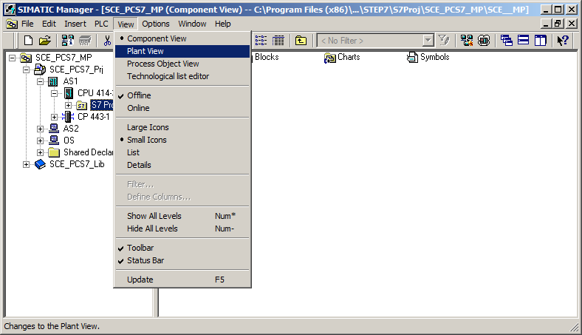

1. So that automatic compilation of the OS (operator system) is carried out correctly later on, a few basic settings for the plant hierarchy must be made. (® Plant Hierarchy ® Settings)

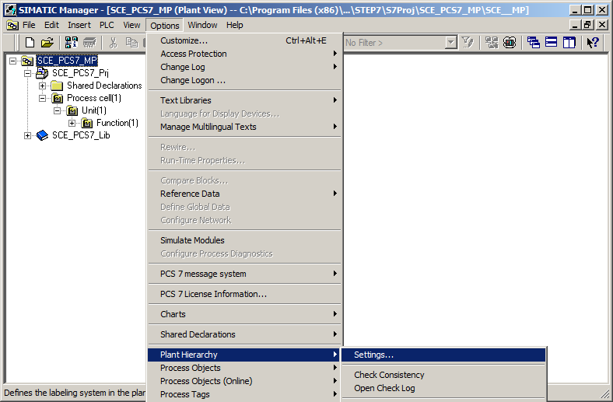

1. The following settings are made and applied with OK. (® OK)

The number of hierarchy levels is set to 3, matching the project hierarchy.   
The hierarchy then maps our plant as follows:

* + Plant (level 1)
  + Unit (level 2)
  + Tank/Equipment module (level 3)

The maximum number of characters in each level of 24 will be relevant during automatic generation of tag names for the OS.

In our project, levels 1 and 2 are included in HID. This means that only the names of levels 1 and 2 appear in the tag name of the OS.

The names have a separator '/' between the names of levels 1 and 2.

The OS area specifies the level starting from which the process pictures will be integrated in the picture hierarchy.

For the picture hierarchy to be generated automatically, it is important to select the  
'Derive picture hierarchy from the plant hierarchy' check box.

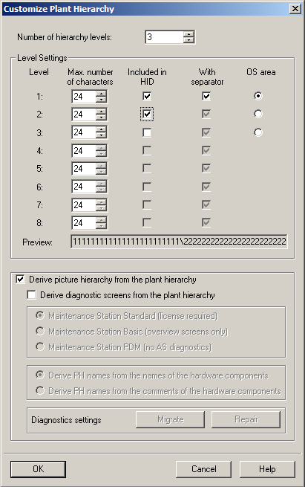

1. Also apply the changed properties to the previously created hierarchy folders. (® Yes)

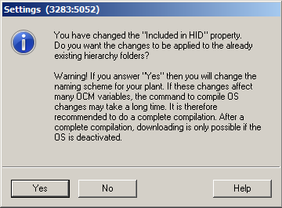

## Object properties of the hierarchy folders

1. The object properties are now set for each hierarchy folder. Here, for example, for the folder of the first level. (® Process cell(1) ® Object Properties)

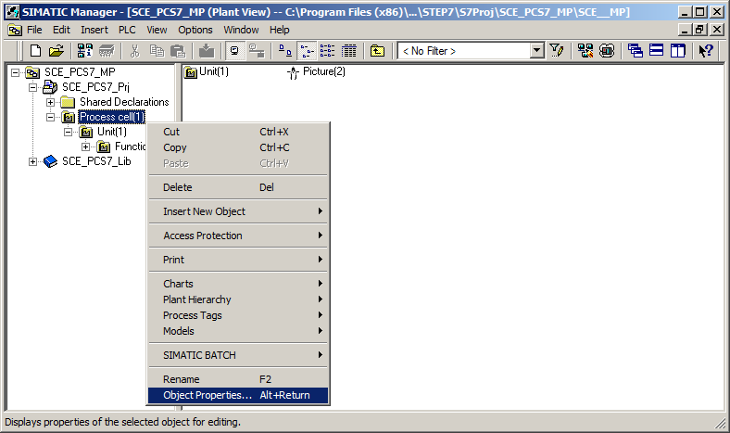

1. In the 'General' tab, the name, the author and above all a comment are entered to make the hierarchy folder easier to understand. (® General)

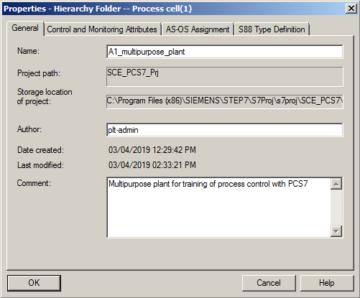

1. The 'Control and Monitoring Attributes' tab indicates whether the name is part of the HID. This is automatically entered by the system based on the settings for the plant hierarchy. (® Control and Monitoring Attributes)

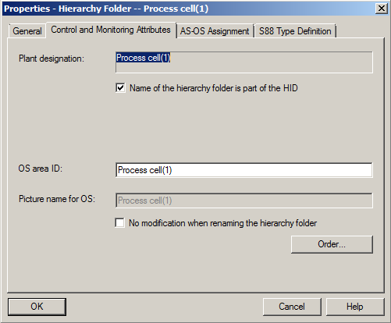

1. In the 'AS-OS Assignment' tab, a hierarchy folder is assigned to an automation system (AS) and to an operator system (OS). In our project, two automation systems (AS1 = CPU 414-3 DP and AS2 = AS RTX Box) and one OS are available for selection. The system enters the latter automatically. We select AS1 as the AS. All properties are applied with OK. (® AS-OS Assignment ® Assigned AS: AS1 ® OK)

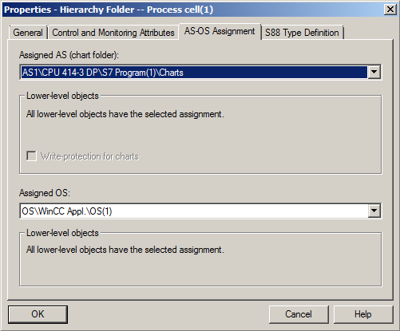

Note:

* + The 'S88 Type Definition' tab is not relevant at this point. It will be needed when batch processes are implemented.

1. Now make the corresponding changes for all three hierarchy folders:

|  |  |  |
| --- | --- | --- |
| Name of folder (old) | Name of folder (new) | Comment |
| Process cell (1) | A1_multipurpose_plant | Multipurpose plant for training of process control with PCS7 |
| Unit (1) | T1_educt_tanks | Educt tanks unit |
| Function (1) | educt_tank B001 | Educt tanks with Educt 1 |

Table 1: Object properties of the hierarchy folders

1. The hierarchy of the folders now looks like this. If you move the mouse over a folder, the comment is displayed. (® educt_tank B001)

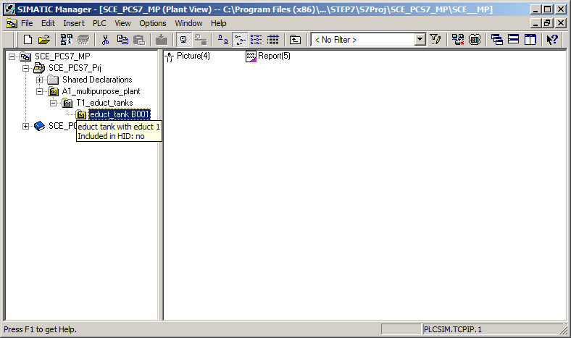

## Expanding the plant hierarchy

1. We need further folders for our project. Right-click on the hierarchy under which you want to create a new folder. Then select 'Insert New Object' and 'Hierarchy Folder'. (® A1_multipurpose_plant ® Insert New Object ® Hierarchy Folder)

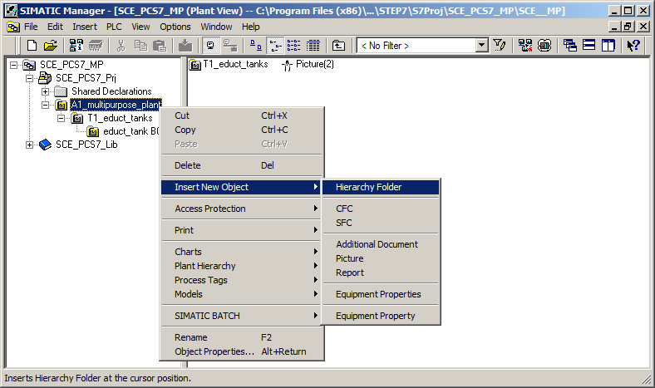

1. The name and comment of this folder are also entered. (® T2_reaction ® Unit reaction)

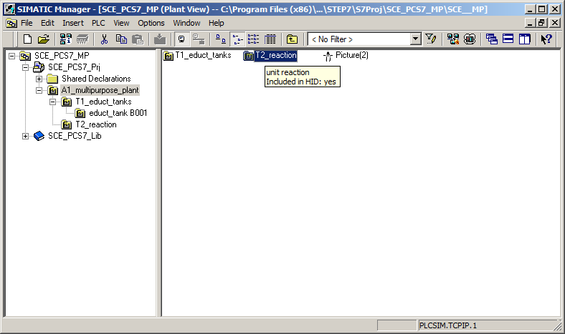

## Checklist – step-by-step instruction

The following checklist helps trainees/students to independently check whether all steps of the step-by-step instruction have been carefully completed and enables them to successfully complete the module on their own.

|  |  |  |
| --- | --- | --- |
| No. | Description | Checked |
| 1 | Plant hierarchy configured |  |
| 2 | Object properties adapted |  |
| 3 | Hierarchy folder 'T2_reaction' created |  |
| 4 | Project successfully archived |  |

Table 2: Checklist for step-by-step instructions

# Exercises

In the exercises, we apply what we learned in the theory section and in the step-by-step instructions. The existing multiproject from the step-by-step instructions (p01-03-project-r1905-en.zip) is to be used and expanded for this. The download of the project is stored as zip file "Projects" on the SCE Internet for the respective module.

## Tasks

1. Implement the entire plant hierarchy of the multipurpose plant corresponding to Figure 4 below.

**educt_tank B001**

**educt_tank B002**

**educt_tank B003**

**reactor B001**

**reactor B002**

**product_tank B001**

**product_tank B002**

**rinsing_tank B001**

**T1_educt_tanks**

**T3_product_tanks**

**T4_rinsing_tank**

**A1_multipurpose_plant**

**T2_reaction**

Figure 4: Diagram of the complete plant hierarchy

1. Add meaningful comments to the individual levels of the plant hierarchy.

Note:

* + If you want to use AS2 as the automation system instead of AS1, make this change at the highest-level folder and apply it to all subfolders.

## Checklist – exercise

The following checklist helps trainees/students to independently check whether all steps of the exercise have been carefully completed and enables them to successfully complete the module on their own.

|  |  |  |
| --- | --- | --- |
| No. | Description | Checked |
| 1 | Plant hierarchy completely mapped |  |
| 2 | Meaningful comments added for all hierarchy folders |  |
| 3 | Project successfully archived |  |

Table 3: Checklist for exercises

# Additional information

More information for further practice and consolidation is available as orientation, for example: Getting Started, videos, tutorials, apps, manuals, programming guidelines and trial software/ firmware, under the following link:

[siemens.com/sce/pcs7](http://www.siemens.com/sce/pcs7)

**Preview "Additional information"**

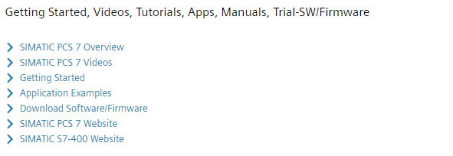

Further Information

Siemens Automation Cooperates with Education  
**siemens.com/sce**

Siemens SIMATIC PCS 7  
**siemens.com/pcs7**

SCE Learn-/Training Documents  
**siemens.com/sce/documents**

SCE Trainer Packages  
**siemens.com/sce/tp**

SCE Contact Partners   
**siemens.com/sce/contact**

Digital Enterprise  
**siemens.com/digital-enterprise**

Industrie 4.0   
**siemens.com/future-of-manufacturing**

Totally Integrated Automation (TIA)  
**siemens.com/tia**

TIA Portal  
**siemens.com/tia-portal**

SIMATIC Controller  
**siemens.com/controller**

SIMATIC Technical Documentation   
**siemens.com/simatic-docu**

Industry Online Support  
**support.industry.siemens.com**

Product catalogue and online ordering system Industry Mall   
**mall.industry.siemens.com**

Siemens  
Digital Industries, FA   
P.O. Box 4848  
90026 Nuremberg  
Germany

Subject to change and errors  
© Siemens 2020

**siemens.com/sce**