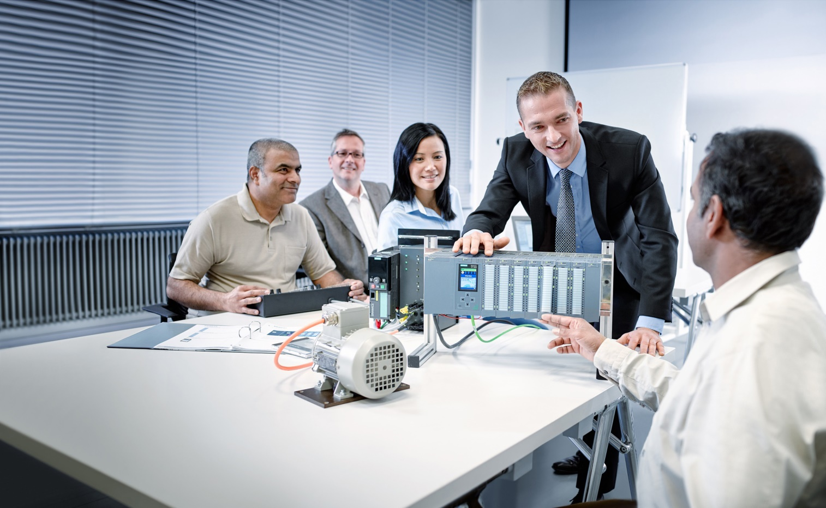

Learn-/Training Document   
  
Siemens Automation Cooperates with Education (SCE) | As of Version V9 SP1

**siemens.com/sce**

PA Module P01-01   
SIMATIC PCS 7 – Process Description

**Matching SCE Trainer Packages for this Learn-/Training Document**

* **SIMATIC PCS 7 Software Package V9.0 (set of 3)**  
  Order No.: 6ES7650-0XX58-0YS5
* **SIMATIC PCS 7 Software Package V9.0 (set of 6)**   
  Order No.: 6ES7650-0XX58-2YS5
* **SIMATIC PCS 7 Software Upgrade Packages (set of 3)**  
  Order No.: 6ES7650-0XX58-0YE5 (V8.x🡪 V9.0)
* **SIMIT Simulation Platform with Dongle V10**  
  (contains SIMIT S & CTE, FLOWNET, CONTEC libraries) – 2500 simulation tags  
  Order No.: 6DL8913-0AK00-0AS5
* **Upgrade SIMIT Simulation Platform V10**  
  (contains SIMIT S & CTE, FLOWNET, CONTEC libraries) from V8.x/V9.x  
  Order No.: 6DL8913-0AK00-0AS6
* **Demo Version SIMIT Simulation Platform V10**  
  [Download](https://support.industry.siemens.com/cs/ww/en/ps/17120/dl)
* **SIMATIC PCS 7 AS RTX Box (PROFIBUS) only in combination with ET 200M for RTX –**   
  Order No.: 6ES7654-0UE23-0XS1
* **ET 200M for RTX Box (PROFIBUS) only in combination with PCS 7 AS RTX Box –**  
  Order No.: 6ES7153-2BA10-4AB1

Note that these trainer packages are replaced with successor packages when necessary.

An overview of the currently available SCE packages is available at: [siemens.com/sce/tp](http://www.siemens.com/tp)

**Continued training**

For regional Siemens SCE continued training, get in touch with your regional SCE contact

[siemens.com/sce/contact](http://www.siemens.com/contact)

**Additional information regarding SCE**

[siemens.com/sce](http://www.siemens.com/sce)

**Information regarding use**

The SCE Learn-/Training Document for the integrated automation solution Totally Integrated Automation (TIA) was prepared for the program "Siemens Automation Cooperates with Education (SCE)" specifically for training purposes for public educational facilities and R&D institutions. Siemens does not guarantee the contents.

This document is to be used only for initial training on Siemens products/systems, which means it can be copied in whole or part and given to those being trained for use within the scope of their training. Circulation or copying this Learn-/Training Document and sharing its content is permitted within public training and advanced training facilities for training purposes.

Exceptions require written consent from the Siemens. Send all related requests to

[scesupportfinder.i-ia@siemens.com](mailto:scesupportfinder.i-ia@siemens.com).

Offenders will be held liable. All rights including translation are reserved, particularly if a patent is granted or a utility model or design is registered.

Use for industrial customer courses is explicitly not permitted. We do not consent to commercial use of the Learn-/Training Document.

We wish to thank the TU Dresden, particularly Prof. Dr.-Ing. Leon Urbas and the Michael Dziallas Engineering Corporation and all other involved persons for their support during the preparation of this Learn-/Training Document.

Table of contents

1 Classification of process plants 5

2 Plant description 6

3 Piping and instrumentation diagram 7

4 Interlock and protection functions 10

5 Recipe 11

6 References 11

7 Additional information 12

Process description

# Classification of process plants

To effectively automate process plants, structuring the plant as well as describing its intended use is necessary. It is helpful in this case to subdivide process plants into classes that are similar with respect to basic requirements for automation engineering. According to [1], the number of fundamentally different products and the physical structure of the plant can be used for the classification.

If basically the same product is always produced in a plant, it is called a single product plant. When environmental conditions change or compositions of the educts vary, only process parameters or settings are expected to be varied in these plants in order to obtain the same product. A multi-product plant, on the other hand, produces a variety of products according to different processes or according to the same process but with distinctly different parameters.

From the perspective of automation, the single train plant represents the simplest physical structure of a plant. The intermediate stages of the product flow through the units in a fixed sequence. A multi-train plant consists of several parallel single trains; however, no product transfer is intended between them. The only parts of the process that the single trains share are the input material sources and the finished product storage facilities. A multi-train & multi-path plant also consists of single trains, but in contrast to the simple multi-train plant, product exchange between the trains is possible. Here, the paths can be fixed, dynamic with a fixed connection or dynamic with a flexible connection.

# Plant description

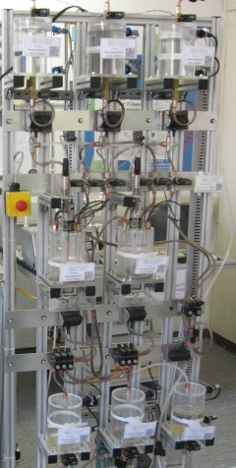

Figure 1: Multi-product and multi-train & multi-path laboratory plant of TU Dresden as a training environment for modern process control engineering

In this instruction module, the laboratory plant shown in Figure 1 will be automated.

Two reactors that are supplied with different educts are the centerpiece of the plant. The reactors can produce various products at the same time. For this reason, the plant can be classified as a multi-product plant and a multi-train & multi-path plant. It consists of several units that are connected to each other with a fixed connection. Depending on the production process, the paths between the units can be dynamically interconnected. This requires complex automation. In the following chapters of this module, however, it will be apparent that by taking into account a few simple principles and rules, the complex automation system can be assembled quite effectively and efficiently by combining existing blocks of the PCS 7process control system.

The first unit provides the educts for the reactors. It consists of three educt tanks. Their instrumentation is identical. To detect whether the tank is empty or full, the level is monitored with two sensors. With a valve at the outlet and a pump, the educt can be dosed into the second unit. In addition, the educt is replenished via a valve at the inlet.

The second unit consists of two reactors that have the same dimensions as the educt tanks but are equipped with other automation instruments. Each reactor is equipped with an agitator and a heater. The level is continuously measured with an ultrasound sensor, and the temperature with a PT100 element. The educts can be filled into the reactor via the three valves at the inlet. A pump at the outlet can be used to fill the reaction product into the other reactor in each case or into the product tank of the third unit, or to return the rinse water to the rinse tank. An additional valve at the inlet allows rinse water from the fourth unit to be fed for cleaning the reactor.

The third unit contains the finished products and consists of two tanks with two sensors that display the minimum and maximum level. While the reactors can be supplied from all educt tanks, the product containers are assigned to exactly one reactor. A valve at the inlet of the product tank opens the path from the reactor to the product tank. One valve each at the outlet of the product tanks serves the removal of the finished product from the plant.

The fourth unit consists of the rinse water tank. It also is equipped with two sensors to indicate the minimum and maximum level. A valve and a pump at the outlet allow the rinse water to be transported to the reactors of the second unit, and the valves at the inlet allow the rinse water to be transported back from the reactors to the rinse water tank.

# Piping and instrumentation diagram

Although a textual description of a plant can explain basic relationships, because of its susceptibility to misinterpretation even in small plants, it is not very suitable for communicating the joint tasks of process engineering, electro-technical engineering and automation engineering. This is especially true in the case of large plants with hundreds of devices and several tens of thousands of measuring points.

For this reason, the piping & instrumentation diagram (P&ID) has therefore developed into a central engineering document over time. The P&ID documents the structure and function of the process plant equally for both the process engineering and automation engineering. Figure 2 shows the P&ID of the laboratory plant that is to be automated in this instruction module.

Tanks, valves and pumps as well as functional requirements of the process control are represented by standardized symbols in the P&ID. The piping between the elements is indicated as solid lines, the flow of information as dashed lines. For the sake of clarity, Figure 2 presents all the units in one P&ID.

The unit to which a tank or a process control function belongs can be read from the identification system. This identification system ensures unambiguous identification for both humans and computers. As long as people are closely collaborating, they can easily distinguish between educt tank B001 and product tank B001 based on the context. It becomes more difficult when communication takes place across several departments, employees are working on many projects simultaneously and computers are involved. The complete designation for the first educt tank B001 is therefore =SCE.A1.T1-B001. This allows a clear distinction to be made between tank B001 in factory SCE, plant A1*,* unit T1 from similar plants or another unit.



Figure 2: Configured plant (Part 1)

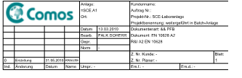

Figure 2: Configured plant (Part 2)

# Interlock and protection functions

The P&ID is not sufficient to specify all requirements for process control engineering. To ensure safe plant operation, the controller must monitor process interventions and, if needed, suppress user input, switch actuators on or off, mutually interlock functions and/or bring the plant to a safe state. For the plant described above, which is equipped with measuring instruments according to Figure 2, the following monitoring and interlock functions are required and will be implemented step-by-step with PCS 7 within the instruction modules:

* An actuator may only be operated when the main switch of the plant is switched on and the emergency stop switch is unlocked.
* No tank may overflow. That is, there is either a sensor that signals the maximum level, or the maximum level (here: 1000 ml) is numerically known and is evaluated using the measured level.
* No pump may draw in air. That is, there is either a sensor that signals the minimum level, or the minimum level (here: 50 ml) is numerically known and is evaluated using the measured level.
* A pump must not attempt to take in liquid from a closed valve or pump liquid against a closed valve.
* The temperatures in the two reactors must not exceed 60 °C.
* The user may only start up the heaters of the two reactors when they are covered with liquid (here: a minimum of 200 ml in the reactor).

The agitators of the two reactors should only be started up when they come into contact with liquid (here: a minimum of 300 ml in the reactor).

# Recipe

According to [1], a recipe is a specification for how to produce a product according to a procedure. It describes what is needed to carry out a procedure and what must be done. For the plant described above, there is the following recipe, which will be implemented with ***PCS 7*** within this instruction module:

1. First, 350 ml is to be drained from educt tank =SCE.A1.T1-B003 to reactor =SCE.A1.T2-R001, and at the same time 200 ml is to be drained from educt tank =SCE.A1.T1-B002 to reactor =SCE.A1.T2-R002.
2. When the filling of reactor =SCE.A1.T2-R001 is finished, the filled liquid is to be heated to 25 °C with the agitator switched on.
3. When the filling of reactor =SCE.A1.T2-R002 is finished, 150 ml of educt A from educt tank =SCE.A1.T1-B001 is added to reactor =SCE.A1.T2-R002. When this is complete, the agitator of reactor =SCE.A1.T2-R002 is switched on 10 s later.
4. When the temperature of the liquid in reactor =SCE.A1.T2-R001 has reached 25 °C, the mixture from reactor =SCE.A1.T2-R002 is pumped to reactor =SCE.A1.T2-R001.
5. The mixture in reactor =SCE.A1.T2-R001 is now to be heated to 28 °C and then drained to product tank =SCE.A1.T3-B001.

# References

[1] DIN EN 61512-1 (Edition 2000-01): Batch Control.

# Additional information

More information for further practice and consolidation is available as orientation, for example: Getting Started, videos, tutorials, apps, manuals, programming guidelines and trial software/ firmware, under the following link:

[siemens.com/sce/pcs7](http://www.siemens.com/sce/pcs7)

**Preview "Additional information"**

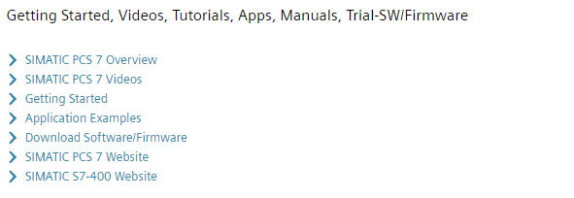

Further Information

Siemens Automation Cooperates with Education  
**siemens.com/sce**

Siemens SIMATIC PCS 7  
**siemens.com/pcs7**

SCE Learn-/Training Documents  
**siemens.com/sce/documents**

SCE Trainer Packages  
**siemens.com/sce/tp**

SCE Contact Partners   
**siemens.com/sce/contact**

Digital Enterprise  
**siemens.com/digital-enterprise**

Industrie 4.0   
**siemens.com/future-of-manufacturing**

Totally Integrated Automation (TIA)  
**siemens.com/tia**

TIA Portal  
**siemens.com/tia-portal**

SIMATIC Controller  
**siemens.com/controller**

SIMATIC Technical Documentation   
**siemens.com/simatic-docu**

Industry Online Support  
**support.industry.siemens.com**

Product catalogue and online ordering system Industry Mall   
**mall.industry.siemens.com**

Siemens  
Digital Industries, FA   
P.O. Box 4848  
90026 Nuremberg  
Germany

Subject to change and errors  
© Siemens 2020

**siemens.com/sce**