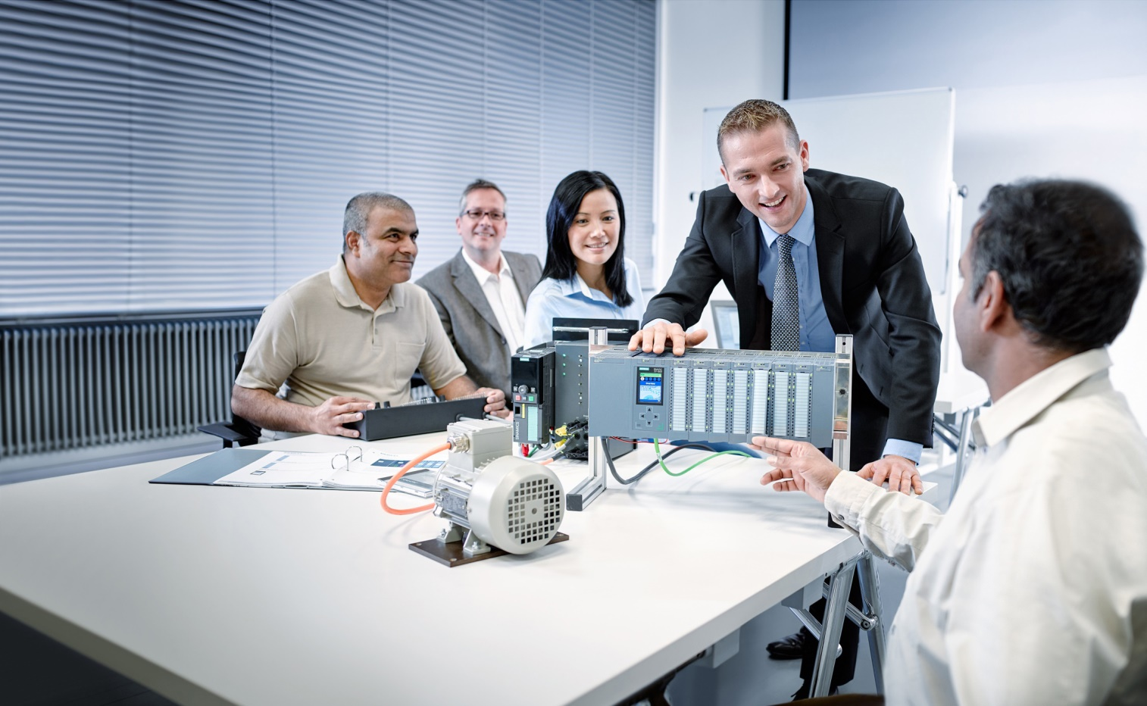

Learn-/Training Document  
  
Siemens Automation Cooperates with Education (SCE) | As of Version V9 SP1

**siemens.com/sce**

**PA Module P01-00**   
SIMATIC PCS 7 – Introduction



**Matching SCE Trainer Packages for this** **Learn-/Training Document**

* **SIMATIC PCS 7 Software Package V9.0 (set of 3)**   
  Order No.: 6ES7650-0XX58-0YS5
* **SIMATIC PCS 7 Software Package V9.0 (set of 6)**   
  Order No.: 6ES7650-0XX58-2YS5
* **SIMATIC PCS 7 Software Upgrade Packages (set of 3)**  
  Order No.: 6ES7650-0XX58-0YE5 (V8.x🡪 V9.0)
* **SIMIT Simulation Platform with Dongle V10**  
  (contains SIMIT S & CTE, FLOWNET, CONTEC libraries) – 2500 simulation tags  
  Order No.: 6DL8913-0AK00-0AS5
* **Upgrade SIMIT Simulation Platform V10**  
  (contains SIMIT S & CTE, FLOWNET, CONTEC libraries) from V8.x/V9.x  
  Order No.: 6DL8913-0AK00-0AS6
* **Demo-Version SIMIT Simulation Platform V10**  
  [Download](https://support.industry.siemens.com/cs/ww/en/ps/17120/dl)
* **SIMATIC PCS 7 AS RTX Box (PROFIBUS) only in combination with ET 200M for RTX –**   
  Order No.: 6ES7654-0UE23-0XS1
* **ET 200M for RTX Box (PROFIBUS) only in combination with PCS 7 AS RTX Box –**  
  Order No.: 6ES7153-2BA10-4AB1

Note that these trainer packages are replaced with successor packages when necessary.

An overview of the currently available SCE packages is available at: [siemens.com/sce/tp](http://www.siemens.com/tp)

**Continued training**

For regional Siemens SCE continued training, get in touch with your regional SCE contact

[siemens.com/sce/contact](http://www.siemens.com/contact)

**Additional information regarding SCE**

[siemens.com/sce](http://www.siemens.com/sce)

**Information regarding use**

The SCE Learn-/Training Document for the integrated automation solution Totally Integrated Automation (TIA) was prepared for the program "Siemens Automation Cooperates with Education (SCE)" specifically for training purposes for public educational facilities and R&D institutions. Siemens does not guarantee the contents.

This document is to be used only for initial training on Siemens products/systems, which means it can be copied in whole or part and given to those being trained for use within the scope of their training. Circulation or copying this Learn-/Training Document and sharing its content is permitted within public training and advanced training facilities for training purposes.

Exceptions require written consent from the Siemens. Send all related requests to

[scesupportfinder.i-ia@siemens.com](mailto:scesupportfinder.i-ia@siemens.com).

Offenders will be held liable. All rights including translation are reserved, particularly if a patent is granted or a utility model or design is registered.

Use for industrial customer courses is explicitly not permitted. We do not consent to commercial use of the Learn-/Training Document.

We wish to thank the TU Dresden, particularly Prof. Dr.-Ing. Leon Urbas and the Michael Dziallas Engineering Corporation and all other involved persons for their support during the preparation of this Learn-/Training Document.

Table of contents

1 Overview 5

2 Structure of the individual chapters 5

3 Interrelationship of the chapters 6

3.1 Module P01 7

3.2 Module P02 8

3.3 Module P03 8

4 Simulation 9

5 Summary 10

6 Notes for compact Train-the-Trainer workshops 10

7 Additional information 11

Introduction – Process Control Engineering Module

# Overview

The Process Control Engineering Module deals with current topics for managing technical plants with a process control system. To this end, a laboratory process plant consisting of two reactors and several tanks for input materials and products is to be automated and visualized. In addition, a process plant simulation is provided to allow the project to the implemented even without hardware.

# Structure of the individual chapters

All chapters of the module follow the same basic structure (Figure 1).

After introduction of the Learning objective, the theory underlying the learning objective is briefly described in Theory in brief. Then, various aspects of the theory are described in greater depth under Theory. A list of references provides information for more in-depth independent study of the subject matter, if needed. Step-by-step instructionsallow the reader to immediately put the theory into practice on the engineering station (ES) of the PCS 7 process control system. Each chapter concludes with Exercises for deeper understanding of the subject matter of the respective chapter.



Figure 1: Structure of the chapters

# Interrelationship of the chapters

The order of the chapters is based on the usual procedures for planning a process control system. Through the step-by-step instructions and the exercises, the complete basic automation is created for the example process in the control system. However, it was ensured for that all chapters and exercises can be used independently. All intermediate results obtained in the course of the module are available as project files. This means it is possible to start/continue at any point, and trainees can compare their own solutions with the sample solutions. Figure 2 provides a detailed overview of the chapters and their interrelationships.



Figure 2: Interrelationship of the chapters

## Module P01

Reading the chapter P01-01 Process description is recommended regardless of prior knowledge, since it introduces the process plant that is to be automated.

In chapter P01-02 Hardware configuration, the project is created and the structure of the automation components (automation station and remote I/O) is implemented. In the exercise, an additional automation station based on the AS RTX Box is integrated.

Chapter P01-03 Plant hierarchy introduces an essential structural element of PCS 7. It allows the automation of complex systems to be broken down into smaller sub-tasks (refer to P01-04 to P01-06). In addition, the plant hierarchy provides a possible structure for the visualization (P02-01) and serves as a basis for reusable elements and structural units (P01-07). The standardized implementation of the plant hierarchy also serves as a basis for recipe control (P03-03).

Chapters P01-04 to P01-08 describe various aspects of automation.

Chapter P01-04 Control module functions introduces the reader to the use of available software objects (function blocks, templates) for real objects. As an example, the control of a pump motor is implemented with a function block of the PCS 7 Standard Library in a Continuous Function Chart (CFC).

The result is tested for the first time in a plant in this chapter. If no plant is available, the simulation presented below can be used.

Chapter P01-05 Functional safety presents the interfacing of the software-side interlocking for the intended use of the plant. The previously implemented control of a motor is limited by given constraints in such a way that no serious danger can arise for humans or the plant.

Chapter P01-06 Control loop deals with the topic of closed-loop control. The temperature control of a reactor is used as an example for implementing a PID controller.

Chapter P01-07 Importing plant design data shows the possibilities of reuse of control modules and/or entire structural units.

This is illustrated using the example of a CFC and a tank as a template, which are used for generation of additional CFCs and tanks. To work through this chapter, extensive knowledge of the plant (P01-01) and its structure (P01-03) is required.

Chapter P01-08 Sequential control systems introduces the Sequential Function Chart (SFC for short). The process cell recipe is realized with the SFC. The exercise in this chapter concludes the first module, and as a complex exercise it also includes contents of the previous chapters. The exercise examples of these chapters are created in such a way that they complete the engineering of the plant step-by-step. Nevertheless, each aspect can be learned individually with the available project files.

## Module P02

Module P02 builds on the results of module P01.

Chapter P02-01 HMI generation shows the reader how to configure a graphical user interface. Building on the results of the first module, the operator station is configured, and the plant units configured so far are visualized by the PCS 7 OS.

Chapter P02-02 Alarm engineering deals with the implementation of an alarm system. Using a function block available in the PCS 7 Advanced Process Library as an example, the monitoring of the level is implemented.

Chapter P02-03 Archiving and trend reporting provides an overview of archiving process data, messages, batch logs and OS reports. Using a process value as an example, the archiving and display of archived values are implemented in OS runtime under PCS 7.

## Module P03

Module P03 builds largely on the results of modules P01 and P02.

Chapter P03-01 Advanced layout of UIs describes the function of trend characteristics in detail. It presents additional OS elements for customizing detail displays for the segment displayed and providing meaningful information for the detail level. ActiveX controls and user-defined objects are created based on the reactor. This chapter is based on P02-01 and P02-02.

Chapter P03-02 Vertical integration with OPC shows the integration of automation systems into higher-level programs of the plant control level. It explains the required basics for the structure and operating principle of OPC as well as options for integration using PCS 7. Using a Microsoft Excel sheet as an example, the query of a previously configured OPC server is demonstrated.

Chapter P03-03 Batch control with recipes describes the use of the Batch Control Center for creating and maintaining recipes. A recipe is implemented with Batch using a mixing process. Based on a different Batch approach, a project template is provided for the known plant. This chapter requires the reader to be familiar with the process description (P01-01) and the plant hierarchy (P01-03).

# Simulation

To enable you to immediately start work, even without a plant and process control components, an interactive, simulation-supported learning environment is implemented for the modules. This allows you to experience results immediately and gain practical experience. It consists of the following components:

SIMIT model: This model is used to simulate the process with tanks, pumps and valves as well as sensors and actuators. The local operator panel of the plant is also included in the model.

It must be noted, however, that the model is only used to generate sensor and actuator signals. The user should not confuse this display with a visualization interface. Operator control and monitoring takes place in the project with PCS 7 OS.

SIMATIC PLCSIM: The automation system is simulated here. The functionalities can be largely configured in Module P01. This means that changes within the automation – regardless of whether these are hardware configuration or software changes (SFC, CFC) – only take effect after reloading them to the simulation.

By combining the process model (SIMIT model) and control model (PLCSIM with its implemented and loaded functionality), the entire system can be simulated and tested as shown in Figure 3.

**REAL - World**

**SIMULATED - World**

**ES Engineering**

**AS Simulation**

**OS-Visualization**

**Plan simulated**

**AS = Automation System  
OS = Operator Station  
ES = Engineering Station**

**SIMIT**

**Simulated Plant**

**Plan**

**OS**

**OS**

**AS**

**AS**

**ES**

**ES**

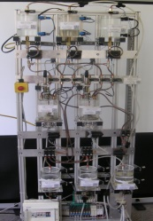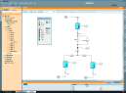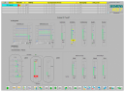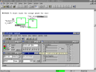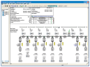

Figure 3: Similarities between the real and simulated worlds

# Summary

Modules P01 and P02 provide sufficient subject material, exercises and instructions to conduct a course of one to two semester periods per week. Depending on the desired depth of coverage of the material, 30 to 60 work hours are to be scheduled for completion (including exercises, homework, preparation and follow-up). This corresponds to 1 to 2 credits within the scope of the European Credit Transfer and Accumulation Systems (ECTS).

For Module P03, with addition of your own material, a course of one semester period per week can be planned.

# Notes for compact Train-the-Trainer workshops

**5-day PCS 7 training for trainers and instructors:**

A 5-day workshop is needed to present the Process Control Engineering modules (Modules P01, P02 and P03) with the lecture slides and to perform practical exercises based on the available learning/exercise materials.

**2-day PCS 7 training for trainers and instructors:**

For experienced engineers with PCS 7 software knowledge, a 2-day course should be sufficient. Normally, chapters P01-01 to P01-04 including exercises are worked through on the simulator in chronological order. Then, it is recommended that one chapter from P01-05 to P01-08 be completed followed by chapter P02-01.

**1-day PCS 7 training for trainers and instructors:**

Without knowledge of modules P01 and P02, the presentation of Module P03 can be used to briefly present the complete content and to then concentrate on implementing Chapter P03-03 Batch control with recipes.

# Additional information

More information for further practice and consolidation is available as orientation, for example: Getting Started, videos, tutorials, apps, manuals, programming guidelines and trial software/ firmware, under the following link:

[siemens.com/sce/pcs7](http://www.siemens.com/sce/pcs7)

**Preview "Additional information"**

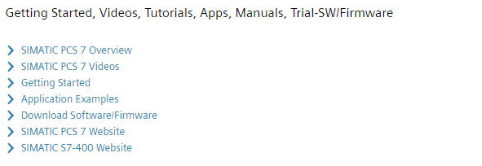

Further Information

Siemens Automation Cooperates with Education  
**siemens.com/sce**

Siemens SIMATIC PCS 7  
**siemens.com/pcs7**

SCE Learn-/Training Documents  
**siemens.com/sce/documents**

SCE Trainer Packages  
**siemens.com/sce/tp**

SCE Contact Partners   
**siemens.com/sce/contact**

Digital Enterprise  
**siemens.com/digital-enterprise**

Industrie 4.0   
**siemens.com/future-of-manufacturing**

Totally Integrated Automation (TIA)  
**siemens.com/tia**

TIA Portal  
**siemens.com/tia-portal**

SIMATIC Controller  
**siemens.com/controller**

SIMATIC Technical Documentation   
**siemens.com/simatic-docu**

Industry Online Support  
**support.industry.siemens.com**

Product catalogue and online ordering system Industry Mall   
**mall.industry.siemens.com**

Siemens  
Digital Industries, FA   
P.O. Box 4848  
90026 Nuremberg  
Germany

Subject to change and errors  
© Siemens 2020

**siemens.com/sce**