

SCE Training Curriculum

Siemens Automation Cooperates with Education (SCE) | 09/2015

Beschreibung: SIE_Logo_Layer_Petrol_RGB_A4_56mmPA Module P01-03

SIMATIC PCS 7 – Plant Hierarchy

**Matching SCE Trainer Packages for these curriculum**

* **SIMATIC PCS 7 Software block of 3 packages**Order No. 6ES7650-0XX18-0YS5
* **SIMATIC PCS 7 Software block of 6 packages**Order No. 6ES7650-0XX18-2YS5
* **SIMATIC PCS 7 Software Upgrade block of 3 packages**Order No. 6ES7650-0XX18-0YE5 (V8.0 🡪 V8.1) or 6ES7650-0XX08-0YE5(V7.1 🡪 V8.0)
* **SIMATIC PCS 7 Hardware Set including RTX Box**Order No. 6ES7654-0UE13-0XS0

Please note that these trainer packages may be replaced with subsequent packages.

An overview of the available SCE packages is provided at:[siemens.com/sce/tp](http://www.siemens.com/sce/tp)

**Continuing education**

For regional Siemens SCE continuing education, contact your regional SCE contact partner.

[siemens.com/sce/contact](http://www.siemens.com/sce/contact)

**Additional information relating to SIMATIC PCS 7 and SIMIT**

In particular, Getting Started, videos, tutorials, manuals and programming guide.  
[[siemens.com/sce/pcs7](http://www.siemens.de/sce/S7-1500)](http://www.siemens.com/sce/pcs7)

**Additional information relating to SCE**

[siemens.com/sce](http://www.siemens.com/sce/contact)

**Note on Usage**

The training curriculum for the integrated automation solution Totally Integrated Automation (TIA) was prepared for the program "Siemens Automation Cooperates with Education (SCE)“ specifically for training purposes at public educational and R&D facilities. Siemens AG is not liable for the contents.

This document may only be used for initial training on Siemens products/systems. This means it may be copied entirely or partially and handed to trainees for use within the scope of their training. Passing on or copying this document and communicating its contents is permitted within public training and continuing education facilities for training purposes.

Exceptions require written permission by Siemens AG. Contact person: Roland Scheuerer roland.scheuerer@siemens.com.

Violators are subject to damages. All rights including translation rights are reserved, particularly in the event a patent is granted or a utility model or design is registered.

Usage for industrial customer courses is explicitly not permitted. We do not agree to the commercial utilization of these documents.

We would like to thank the Technical University Dresden, particularly Prof. Dr. Leon Urbas and Annett Krause, MS, as well as the Michael Dziallas Engineering Corporation and those who provided support in preparing this SCE training document.

# Plant Hierarchy

## Training Objective

The students learn to structure an automation project according to technical aspects. A project structure, called Plant Hierarchy (PH), is implemented by setting up hierarchy folders. In the folders of this plant hierarchy, CFCs and SFCs are then stored for the automation systems, displays and reports for the operator stations as well as supplementary documents (such as unit descriptions, process tag sheets, planning documents from other applications such as Word, Excel, etc.). A well-planned plant hierarchy facilitates locating objects and is the prerequisite for the reuse of generic solutions as well as automatic generation mechanisms.

## Theory in Brief

**A1\_multipurpose  
plant**

**T2\_  
reaction**

**Reactor**

**R001**

**Reactor**

**R002**

**T3\_  
product  
tanks**

**Product  
tank  
B001**

**Product  
tank  
B002**

**T4\_  
rinsing**

**Rinsing tank  
B001**

**T1\_  
educt  
tanks**

**Educt  
tank  
B001**

**Educt  
tank  
B002**

**Educt  
tank  
B003**

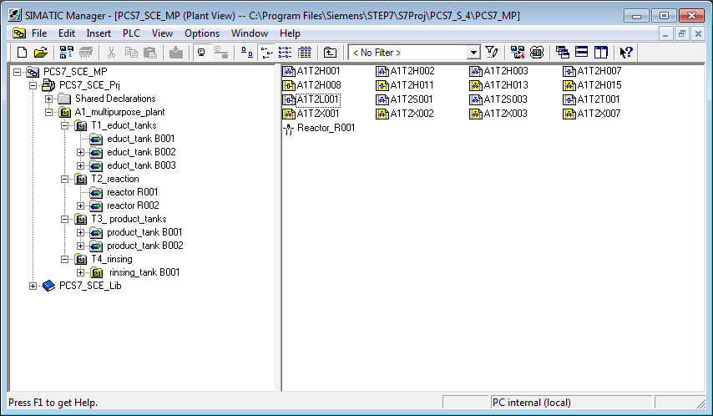

Figure 1: From plant model to plant hierarchy

The plant hierarchy essentially has three functions:

* It maps a hierarchical name scheme that can be used to break down a complex system into partial tasks that can be solved with acceptable effort.
* It is used for the structured storage of documents and objects in this hierarchical name scheme.
* It allows for the automatic generation of the picture hierarchy for operator control and monitoring.

## Theory

### Structuring according to DIN EN 81346-1

To specify, plan, create, maintain or operate a system effectively, the system as well as the information about it is usually broken down into units. Each of these units can be subdivided further. This successive subdivision into units and the organization of these units is called Structuring.

Two general rules apply in this case:

**Rule 1:**A technical system has to be structured based on *'****is part of’*** relationships, applying the concept of Aspects of objects.

Aspects act as filters for an object that is used to emphasize relevant information. Standard aspects focus on the following:

* Function aspect: What is the object’s task, or what is it actually doing?
* Product aspect: What are the means the object uses to perform its task?
* Location aspect: Planned or actual location of the object

Figure 2 shows that the 'object for filling' '***is*** part of' the object for manufacturing Product 1’ under the function aspect.

**Rule 2:**Structuring is carried out either from top to bottom (top down) or from bottom to top (bottom up).

For the top down method, we usually:

1. Select an object
2. Select the suitable aspect
3. Determine the sub-objects in the selected aspect if there are any:  
   Steps 1 to 3 can be repeated iteratively for the defined sub-objects as often as required.

For the bottom up method, we usually:

1. Select the aspect we want to work with
2. Select the objects that are to be considered together
3. Introduce a higher level object for which the selected objects are parts in the selected aspect.

As for the top down method, steps 1 to 3 can also be repeated iteratively here as often as necessary for each added higher level object. If an aspect is retained in the entire structure, the structure is called aspect-related according to the standard, which means function-oriented, product-oriented or location-oriented. A process engineering system is structured under the function aspect (function view). A function-oriented structure is based on the purpose of a system. The purpose of a technical system is to perform a technical process whereby input variables (energy, Information, material) are processed into output variables (energy, information, material) taking into account specific parameters. Figure 2 shows an example.

Figure 2: Function of the reactor and its sub-functions

Structuring on this basis provides a system that can be used during all phases of the life cycle: planning the plant, automating the plant, operating the plant.

### Structure of the Plant Hierarchy

The plant hierarchy can be taken directly from the plant structuring that was carried out when the plant was planned. It has to be taken into account, however, that this structure is mapped 1:1 when deriving the picture hierarchy from the plant hierarchy.

While planning a process plant, the planning engineer creates a reference identification system that allows for the unique identification of an object in an observed plant. This reference identification system is based on structuring according to an aspect (for process plants, according to the function aspect).

In PCS 7, the reference identification system is called Higher Level Designation System (HID). The structure of the plant is implemented PCS 7 with a folder structure. By nesting the hierarchy folders, complex plants can also be mapped. By setting the number of levels, the depth of the structure can be specified project-wide. The maximum structural depth is limited to 8 levels.

### Deriving the Picture Hierarchy and OS Areas from the PH

The OS picture hierarchy for the plant operator on the operator station can be derived completely from the configured data of the plant hierarchy. This takes place automatically during a generation run which generates an operating screen for each level. In this screen, associated operator symbols are set up for all automation blocks, if available, that are used in the charts of this level. In addition, the corresponding group alarms and navigation hierarchies are set up. It is possible to connect individual areas of the plant structure in the plant hierarchy to OS areas. In the case of large plants, plant operators can thus be assigned only certain plant areas. In the process mode, plant operators only see and operate those areas for which they have the corresponding user permissions. Plus only those messages that are relevant to this area are displayed. As a rule, a unit corresponds to an OS area in the plant hierarchy.

In the general settings of the plant hierarchy we specify the hierarchy level that is to be the OS area level for the plant hierarchy. For each hierarchy folder of this level, an area identifier is defined. The standard setting for the area identifier corresponds to the name of the hierarchy folder in the plant hierarchy. As soon as a hierarchy folder is provided with an area identifier, all lower level hierarchy folders and objects also receive the area identifier. The representation of the hierarchy levels always starts with the hierarchy level that is defined as OS area.

### AS-OS Assignment

For each hierarchy folder, an operator station has to be assigned to an automation system in the plant view. This AS-OS assignment has the following consequences for the Component view:

* All CFCs and SFCs that are inserted in the plant view are stored in the chart folder of the assigned automation system.
* All displays and reports that are inserted in the plant view are stored in the folder of the assigned operator station.

### Type Definition according to ISA-S88.01

If, when structuring the plant, the physical model according to DIN EN 61512-1 is used (refer to Figure 3) which is largely identical to the U.S. standard ISA-S88.01-1995, PCS 7 enables the setup of a type-defined hierarchy.



Only the four lower levels of the model (process cell, unit, equipment module and control module) are specified in greater detail. They refer to certain types of facilities. Such a type is a group of process and control facilities that were combined for a certain purpose.

If the type-defined hierarchy is to be used in PCS 7 according to the standard ISA-S88.01, the uppermost folder of the plant hierarchy has to represent the process cell level.

Below the process cell level, the hierarchy folders can then be type-defined as unit, and below that as an equipment module.

Folders or levels that are not type-defined are designated as neutral and can be used for further structuring, or represent the level of the control modules.

Type definition is the basis for working with the PCS 7 BATCH module. It should be noted that only one process cell can be defined for each project.

Figure 3: Physical model according to DIN EN 61512

## Literature

[1] Online Help PH Siemens

[2] DIN EN 81346-1 (Ed. 2010-05): Industrial systems, installations and equipment and industrial products - Structuring principles and reference designations.

[3] DIN EN 61512-1 (Ed. 2000-01): Batch control

## Step by Step Instructions

### Task

In this chapter, a folder hierarchy will be created and documented in the plant view (plant hierarchy) corresponding to the Multi-Purpose Plant project and the associated nomenclature.

### Training Objective

In this chapter, the student will learn the following:

* Plant view of the PCS 7 project
* Basic settings for the plant hierarchy
* Creating and renaming folders in the plant hierarchy

These instructions are based on the project 'PCS7\_SCE\_0102\_Ueb\_R1304.zip‘.

### Programming

1. To set up the plant hierarchy in a PCS 7 project, we have to switch to the Plant view.

(® View ® Plant View)

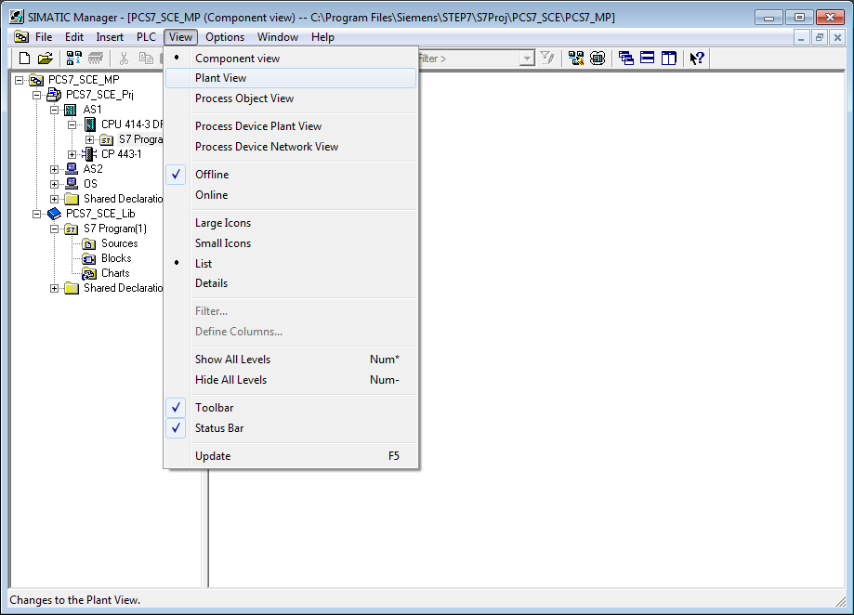

1. For the automatic compilation runs for the OS (operator system) to be executed correctly later, a few basic settings have to be made for the plant hierarchy.

(® Plant Hierarchy ® Settings)

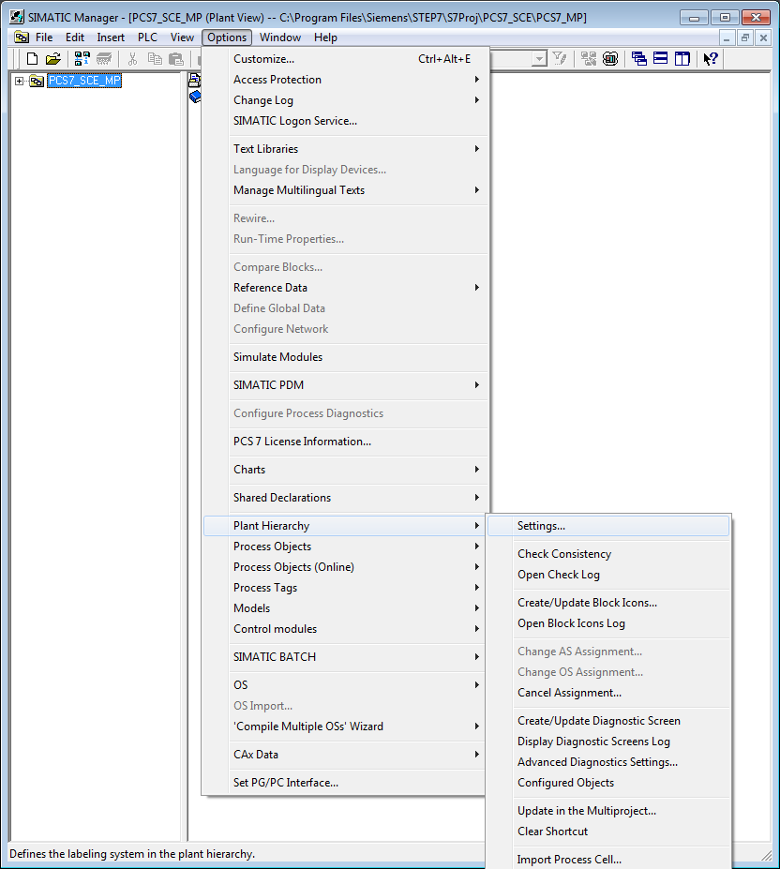

1. The following settings are made and accepted with OK   
   (® OK)

* The number of hierarchy levels is set to 3, matching the project hierarchy.   
  The hierarchy then maps our plant as follows:
  + Process cell (Level 1)
  + Unit (Level 2)
  + Containers/Equipment modules (Level 3)
* 24 as the maximum number of characters in each level will be relevant to the automatic generation of variable names for the OS.
* In our project, levels 1 and 2 generate plant identifiers.
* The names have a separator ‚/’ between the names of levels 1 and 2.
* The OS area specifies the level from which the process images are integrated in the picture hierarchy.
* For the picture hierarchy to be generated automatically, it is important to set the checkmark at 'Derive picture hierarchy from the plant hierarchy‘.

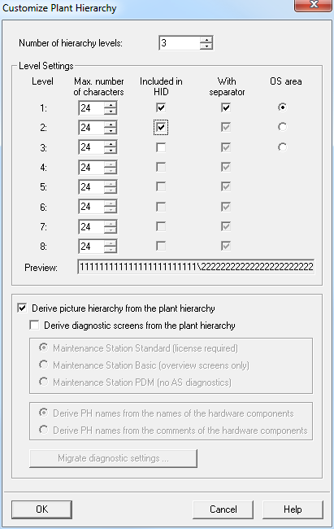

1. Accept the changed properties also for the hierarchy folders that have already been set up.   
   (® Yes)

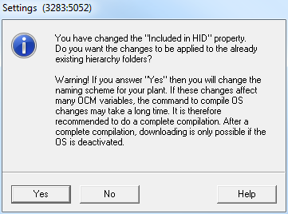

1. The object properties are now set for each hierarchy folder. Here, for example, for the folder of the first level.   
   (® Process cell(1) ® Object Properties)

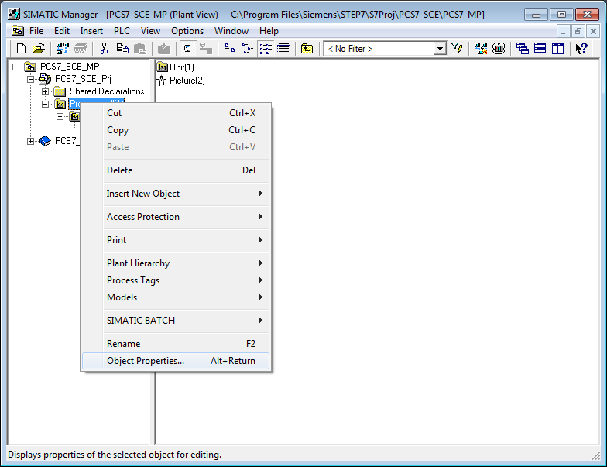

1. In the subheading ’General‘, the name, the author and above all a pertinent comment are entered.   
   (® General)

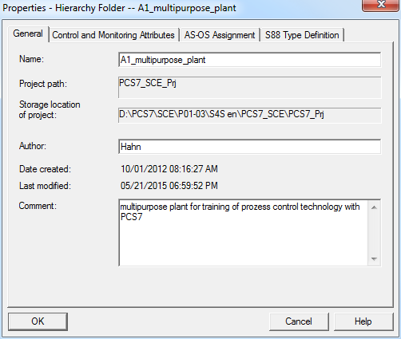

1. The subheading 'Control and Monitoring Attributes' indicates whether the name is part of the plant designation. The system enters the name automatically based on the settings for the plant hierarchy.   
   (® Control and Monitoring Attributes)

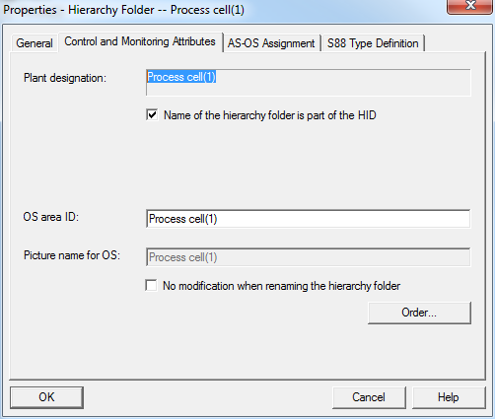

1. In the subheading 'AS-OS Assignment' a hierarchy folder is assigned to an automation system (AS) and to an operator system (OS). In our project, two ASs (AS1 = CPU 414-3 DP and AS2 = AS RTX Box) and one OS are available for selection. The system enters the latter automatically. We select AS1 as the AS. All properties are accepted with OK.

(® AS-OS Assignment ® AS1 ® OK)

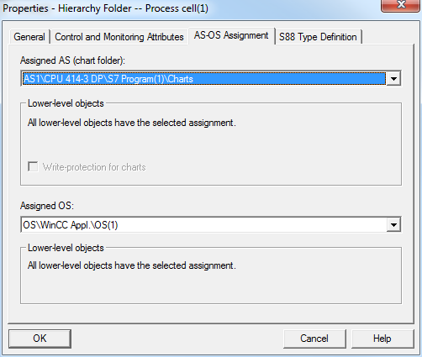

Hinweis**Note:** The subheading 'S88 Type Definition' is not relevant at this point. It will be needed when batch processes are implemented.

Now make the corresponding changes for all three hierarchy folders:

|  |  |  |
| --- | --- | --- |
| **Name Folder old** | **Name Folder new** | **Comment** |
| Process cell(1) | A1\_Multi-purpose plant | Multi-purpose plant for training of process control engineering with PCS 7 |
| Unit(1) | T1\_Educt storage | Educt storage unit |
| Function(1) | Educt tank B001 | Educt container with Educt 1 |

1. The folder hierarchy now looks like this. By moving the mouse over a folder, the comment is displayed.   
   (® educt\_tank B001)

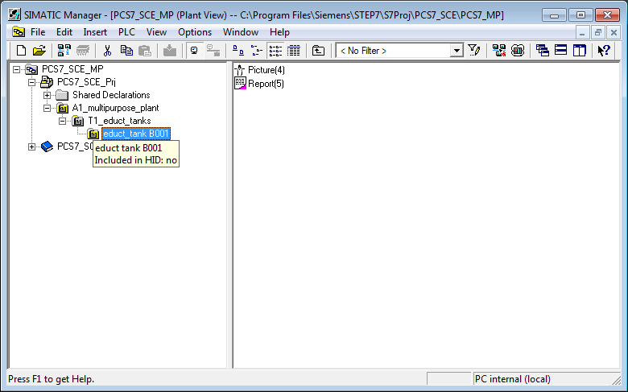

1. We need more folders for our project. To this end, right-click on the hierarchy under which you want to create a new folder. Then select 'Insert New Object' and 'Hierarchy Folder'.

(® A1\_multipurpose\_plant ® Insert New Object ® Hierarchy Folder)

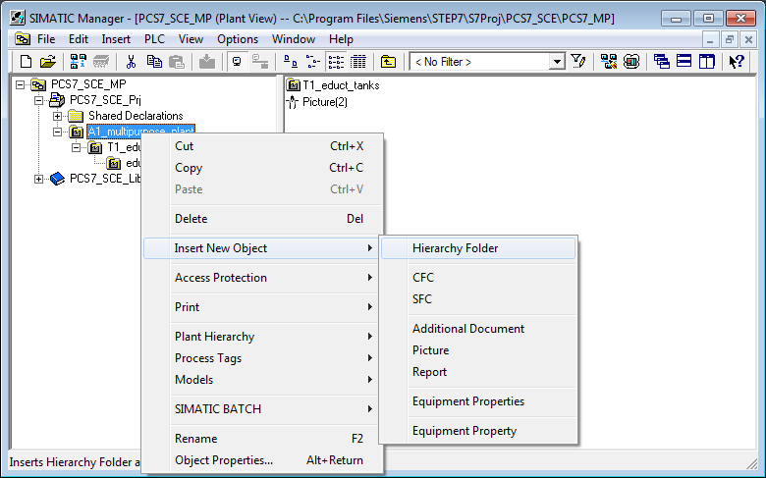

1. The name of this folder and the comment are also entered.  
   (® T2\_reaction ® unit reaction)

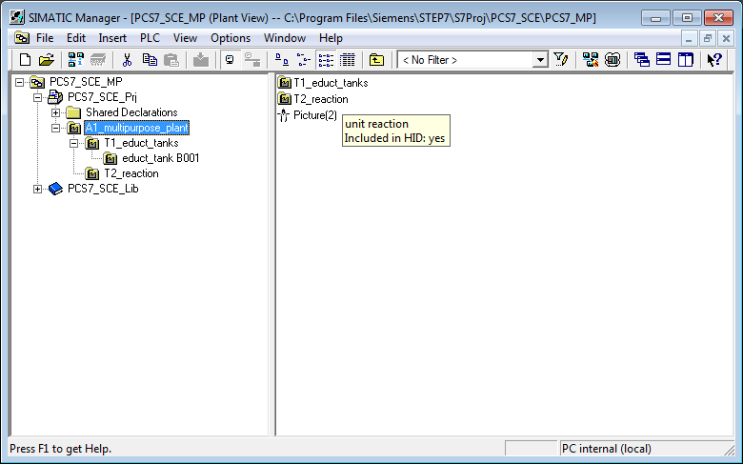

## Exercises

In the exercises, we apply what we learned from the theory and from the step by step instructions. The existing multi-project from the step by step instructions (PCS7\_SCE\_0103\_R1304.zip) will be used and expanded.

### Tasks

1. Implement the entire plant hierarchy of the multi-purpose plant according to the diagram below.

**Educt tank B001**

**Educt tank B002**

**Educt tank B003**

**Reactor B001**

**Reactor B002**

**Educt tank B001**

**Educt tank B002**

**Rinsing tank B001**

**T1\_Educt tanks**

**T3\_Product tanks**

**T4\_Rinsing**

**A1\_multipurpose plant**

**T2\_Reaction**

1. Add pertinent comments to the individual levels of the plant hierarchy.

Hinweis

**Note:** If you prefer to use AS2 as the automation system instead of AS1, you can make that change in the uppermost folder of the hierarchy, and accept it for all subfolders.