

SCE Training Curriculum

Siemens Automation Cooperates with Education (SCE) | 09/2015

Beschreibung: SIE_Logo_Layer_Petrol_RGB_A4_56mmPA Module P01-00

SIMATIC PCS 7 – Introduction

**Matching SCE Trainer Packages for this curriculum**

* **SIMATIC PCS 7 Software block of 3 packages**Order No. 6ES7650-0XX18-0YS5
* **SIMATIC PCS 7 Software block of 6 packages**Order No. 6ES7650-0XX18-2YS5
* **SIMATIC PCS 7 Software Upgrade block of 3 packages**Order No. 6ES7650-0XX18-0YE5 (V8.0 🡪 V8.1) or 6ES7650-0XX08-0YE5(V7.1 🡪 V8.0)
* **SIMATIC PCS 7 Hardware Set including RTX Box**Order No. 6ES7654-0UE13-0XS0

Please note that these trainer packages may be replaced with subsequent packages.

An overview of the available SCE packages is provided at:[siemens.com/sce/tp](http://www.siemens.com/sce/tp)

**Continuing education**

For regional Siemens SCE continuing education, contact your regional SCE contact partner.

[siemens.com/sce/contact](http://www.siemens.com/sce/contact)

**Additional information relating to SIMATIC PCS 7 and SIMIT**

In particular, Getting Started, videos, tutorials, manuals and programming guide.  
[[siemens.com/sce/pcs7](http://www.siemens.de/sce/S7-1500)](http://www.siemens.com/sce/pcs7)

**Additional information relating to SCE**

[siemens.com/sce](http://www.siemens.com/sce/contact)

**Note on Usage**

The training curriculum for the integrated automation solution Totally Integrated Automation (TIA) was prepared for the program "Siemens Automation Cooperates with Education (SCE)“ specifically for training purposes at public educational and R&D facilities. Siemens AG is not liable for the contents.

This document may only be used for initial training on Siemens products/systems. This means it may be copied entirely or partially and handed to trainees for use within the scope of their training. Passing on or copying this document and communicating its contents is permitted within public training and continuing education facilities for training purposes.

Exceptions require written permission by Siemens AG. Contact person: Roland Scheuerer roland.scheuerer@siemens.com.

Violators are subject to damages. All rights including translation rights are reserved, particularly in the event a patent is granted or a utility model or design is registered.

Usage for industrial customer courses is explicitly not permitted. We do not agree to the commercial utilization of these documents.

We would like to thank the Technical University Dresden, particularly Prof. Dr. Leon Urbas and Annett Krause, MS, as well as the Michael Dziallas Engineering Corporation and those who provided support in preparing this SCE training document.

# Module Process Control Engineering

## Overview

The module Process Control Engineering deals with current topics for managing technical facilities by using a process control system. To this end, a process control lab facility consisting of two reactors and several tanks for input materials and products has to be automated and visualized. In addition, a process system simulation is provided to make processing the project possible even if hardware is not available.

## Structure of the Individual Chapters

All chapters of the module follow the same basic pattern (**Figure 1**).

After introducing the Training Objective, first the Theory on which the training objective is based is described in Brief. Then, different aspects of the Theory are described in greater depth. A bibliography provides references for pursuing the topic further. Step by step instructions make it possible for the reader to immediately put the theory into practice at the engineering station (ES) of the process control system PCS 7. Each chapter concludes with Exercises that lead deeper into the topic of the respective chapter.



**Figure 1: General Structure of Individual Chapters**

## relationship of the Chapters

The sequence of the chapters is based on the usual sequences when planning a process control system. Based on the step by step instructions and the exercises, a complete basic automation is prepared for the sample process in the control system. However, it was provided for that all chapters and exercises can be used independently. All intermediate results attained in the course of the module are available as project files. This means it is possible to start/continue at any point, and trainees can compare their own solutions with the sample solutions.

**Module P01:**

Reading the chapter P01-01 Process Description is recommended regardless of prior knowledge, since it introduces the process plant that is to be automated.

In the chapter P01-02 Hardware Configuration, the structure of the automation components (automation station and remote IO) is implemented after the project has been set up. In the exercise, an additional automation station is integrated based on the AS RTX Box.

The chapter P01-03 Plant Hierarchy introduces an essential structural element of PCS 7. The automation of complex systems can thus be broken down into smaller partial tasks (refer to P01-04 to P01-06). In addition, the plant hierarchy provides a possible structure to visualization (P02-01) and serves as a basis for re-usable elements and structural units (P01-07). The standardized design of the plant hierarchy also serves as a basis for recipe control (P03-03).

Chapters P01-04 to P01-08 describe different aspects of automation.

Chapter P01-04 Individual Control Functions introduces the reader to the utilization of existing software objects (function blocks, templates) for real objects. As an example, we implement the control of a pump motor with a function block of the PCS 7 Advanced Process Library in a Continuous Function Chart (CFC for short).

In this chapter, the result can be tested for the first time in a plant. If no plant is available, the simulation mentioned below can be used.

The chapter P01-05 Functional Safety introduces interfacing the lock on the software-side for the intended use of the plant. The previously implemented control of a motor is restricted by means of given supplementary conditions in a way that no serious danger can arise for the plant or for persons.

The chapter P01-06 Control Loop deals with the topic Control Loop. The temperature control of a reactor is used as an example for implementing a PID controller.

The chapter P01-07 Importing Plant Design Data shows the capability of re-using individual control functions and/or entire structural units.

This is illustrated with an example of a CFC and a container as a template that are used to generate additional CFCs and additional containers. To work through this chapter, extensive knowledge of the system (P01-01) and its structure (P01-03) is necessary.

The chapter P01-08 Sequential Control introduces the Sequential Function Chart (SFC for short). With the SFC, the master recipe is realized. The exercise in this chapter concludes the first module, and as complex exercise it also includes the contents of the previous chapters. The exercise examples of these chapters are set up in a way that they complete the engineering of the system piece by piece. Nevertheless, each aspect can be learned individually using the available project files.  
  
  
**Module P02:**

Module P02 is based on the results of module P01.

The chapter P02-01 HMI Generation shows the reader how to configure a graphic user interface. Building on the results of the first module, the operator station is configured, and the plant units configured so far are visualized through PCS 7 OS.

The chapter P02-02 Alarm Engineering deals with the implementation of an alarm system. Using a function block available in the PCS 7 Advanced Process Library, monitoring a fill level is implemented.

The chapter P02-03 Archiving and Trend Reporting provides an overview of archiving process data, messages, batch logs and OS reports. Using a process value as an example, archiving and displaying archived values are implemented in OS runtime under PCS 7.

**Module P03:**

Module P03 is based largely on the results of modules P01 and P02.

The chapter P03-01 Advanced Layout of UIs addresses the function of chart characteristics. Additional OS elements are introduced to adapt detail displays individually to the segment displayed and to provide meaningful information for the detail level. Using the reactor as an example, ActiveX Controls and User Defined Objects are generated. This chapter is based on P02-01 and P02-02.

The chapter P03-02 Vertical Integration with OPC shows the integration of automation systems into higher-level programs of the plant control level. The required fundamentals for the setup and the method of functioning of OPC as well as the options for integration by means of PCS 7 are explained. Using a Microsoft Excel table as an example, polling an OPC server that was set up previously is demonstrated.

In the chapter P03-03 Batch Control with Recipes, using the Batch Control Center for generating and updating recipes is described. Using a mixing process as an example, a recipe is implemented with batch. Based on another approach for batch, a project template is provided for the known plant. As a basis for this chapter, the reader has to be familiar with the process description (P01-01) and the plant hierarchy (P01-03).



**Figure 2: Relationship of the Chapters**

## Simulation

To immediately start processing–even without a plant and control components–and to directly experience the results of your efforts as well as gather practical experience, an interactive, simulation-supported learning environment is provided for the modules. It consists of the following components:

SIMIT Model: This model is used to simulate the process with tanks, pumps and valves as well as sensors and actuators. The local operator panel for the plant is also included in the model.

It has to be noted, however, that the model is used to generate sensor and actuator signals. The display should not be mistaken for a visualization interface. Operator control and monitoring is takes place with PCS 7 OS in the project.

SIMATIC PLCSIM: Here the automation system is simulated. The functionalities are configured mainly in Module P01. This means that changes within the automation–regardless of whether these are hardware configuration or software changes (SFC, CFC)–become effective only after reloading them to the simulation.

By combining the process model (SIMIT model) and control model (PLCSIM with its implemented and loaded functionality), the entire system can be simulated and tried out as shown in Figure 3.

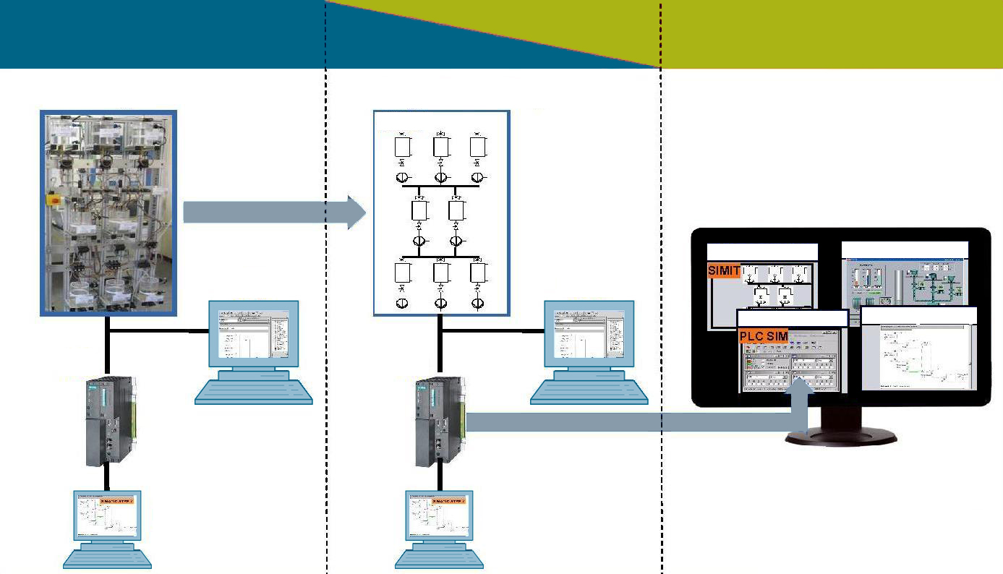

**REAL - World**

**SIMULATED - World**

**Plant**

**Simulated Plant**

**OS**

**OS**

**AS**

**AS**

**ES**

**ES**

**AS = Automation System  
OS = Operator Station  
ES = Engineering Station**

**Plant Simulation**

**OS - Visualization**

**AS Simulation**

**ES Engineering**

**SIMIT**

**Figure 3: Analogies between Simulated Learning Environment and the Real World**

## Summary

The modules P01 and P02 provide sufficient training material, exercises and instructions to conduct a course of one to two weekly semester hours. Depending on the depth of coverage of the material, 30 to 60 work hours are to be scheduled (including exercises, homework, pre and post preparation). This corresponds to 1 to 2 credits within the scope of the European Credit Transfer and Accumulation Systems (ECTS).

For Module P03, supplemented by the instructor’s own material, a course consisting of one weekly semester hour can be planned.