Importing Plant Design Data

Objective
After working through this instruction module, students know how to identify recurring structures, and how to design templates. They know the difference between a process tag type and a model. They are able to generate and implement both. This allows the students to implement many similar process tags or units in PCS7. They get to know the process object view and are able to use it in order to represent parameters plant-wide, and to change them if needed.

Theory in Short
In process engineering plants there are always recurring objects and structures that behave in the same way, are interfaced in process control in the same way, and are to be visualized in the same way.
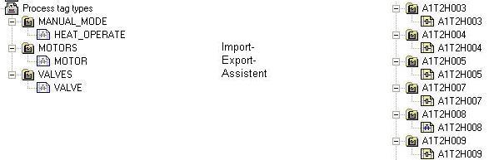
Figure 1: From process tag type to replicas
Such objects can be stored in the project’s own library as process tag types. A process tag type is a single CF chart. As shown in Figure 1, one process tag type is able to generate numerous process tags as a duplicate in a single process by using the import-export assistant. This process is controlled in an import file. It is then possible to manually adapt and wire the process tags according to their additional specific automation tasks.

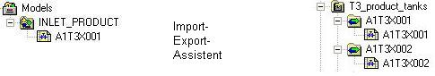
Figure 2: From model to replica
With models we define more complex functions than with process tag types (up to complete units). A model consists of hierarchy folders containing CFCs and SFCs, displays, reports, and supplementary documents. The entire structure can be stored in the project’s own library as a reusable template. By using the import-export assistant it is possible to generate -based on an import file- from a model numerous replicas in a single process as a duplicate (refer to Figure 2). Then, the replicas are adapted to the respective automation task.
In the PCS7 libraries, extensive templates are already stored as process tag types. If a template is to be used multiple times, the template is copied from the PCS7 library to the project’s library, adapted if needed and copied by means of the import-export assistant based on an import file.

Theory
When designing an automation system with PCS7, we can resort to general design principles for complex systems; principles that have proven themselves multiple times [1]. The most important ones are:
- The principle of hierarchical arrangement
- The principle of modularization
- The principle of re-use.
The principle of hierarchical arrangements was already used for structuring the plant in the chapter ’Plant Hierarchy’ By subdividing units that can be processed largely independent of each other, first a huge design task that seems highly involved is broken down into sub-problems that can be grasped and planned.
The principle of modularization means that the system to be designed is to consist of constituent parts (here, blocks, CFCs, SFCs) that are to have the following properties:
- Its scope is to be clearly laid out and easy to follow
- Largely autonomous functions that can be checked
- As few relationships to other constituent parts as possible
- Defined interfaces to other constituent parts
This results in two rivaling complexity aspects when breaking down an automation solution into individual parts:
- Low complexity of the constituent parts: the more parts, the smaller the individual parts are, and easier to follow.
- High external complexity of the constituent parts: the more parts, the higher the number of connections between them.
Hierarchical arrangement and modularization are dependent on one another. While hierarchical arrangements are determined more by the process engineering plant, modularization is dominated by the process control implementation. Based on the countercurrent complexity aspects mentioned above, and the great dependence on the concrete process and automation engineering task, early coordination of both implementations is of advantage.
Through the plant hierarchy, PCS7 supports the principle of hierarchical arrangements. The principle of modularization and re-use is implemented in PCS7 with duplication processing.
In larger projects or recurring similar projects, often numerous identical or at least very similar objects and structures can be observed. To save time and outlay for configuration tasks, it is advisable for that reason to plan the specific search for suitable, recurring objects and structures during the concept determination and design phase of an automation project. After such objects and structures are identified, first, generic solutions are implemented and tested that can then be used for numerous identical or similar objects and structures. Based on the factors below, the initial additional outlay required to prepare the generic solution (here also called type or template) should lead to appreciable time and cost savings over the duration of the project.
- A type can be implemented multiple times; that is, it has several replicas
- By using a type in several replicas, several tests are performed at he same time
- If errors should occur or changes should be necessary, only the generic solution has to be adapted and all replicas have to be updated.
In addition, existing objects and structures from earlier projects and libraries can be reused. They have the advantage of being already tried and are largely faultless. By re-using proven parts, generally the reliability of a new automation solution also increases.

Process Tag Type
Process tag types are used as a generic solution if a project contains many process tags of the same kind [2].
First, a CF chart is set up that contains all internal blocks and their connections. All input and output parameters are clearly defined as parameters or signals. From this CF chart now containing all generally valid parameters, a process tag type is generated. In an import file, all process tag specific parameters where the replicas differ are then specified.
During the import process, the import-export assistant generates the replicas of the process tag type in the specified hierarchy folders. If the hierarchy should not be available as yet, it is set up also. Each replica is an instance of the process tag type and has its properties.
In PCS7, the process tags (replicas) generated in this way can also be adapted specifically by adding different locking mechanisms, for example. Under certain conditions, they are not overwritten if there is another import.
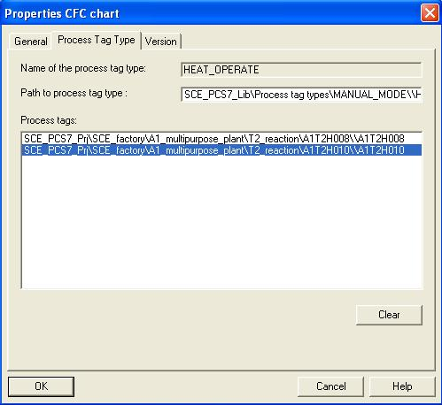
Figure 3: Replica A1T2H003 of process tag type FILL_REAKTOR_H
The following must not be changed at the process tags that were generated:
- Specific adaptations at the block connections that are parameterized by means of the import file. These adaptations are overwritten during a new import process with the parameters that are specified in the import file.
With process tag types, subsequent changes can be carried out simply by making the changes at the process tag type and in the import file. Then, the modified data is transmitted to all generated process tags with a new import process. The following changes are conceivable:
- Adding another parameter and assigning this parameter by means of the import file
- Deleting all generated process tags of a process tag type (without manual deletion in the plant hierarchy)
- Adding another block connection and parameterizing the block connection by means of the import file.

Model
The model is used as a generic solution if the project has structures that are alike.
As a rule, a plant is structured by dividing it into smaller functional units whose interfaces, performance and logic can be clearly described; for example a tank with its instrumentation. Instead of implementing these functional units anew each time, an inventory of preassembled function units (models) can be set up.
So that a model is used in only one version project-wide, all models should be stored centrally in the master data library and adapted prior to generating replicas.
A model consists of hierarchy folders with the following elements:
- CFCs/SFCs
- OS displays
- OS reports
- Supplementary documents
After a model was configured and an import file was assigned to it, replicas can be generated by means of the import process. The following steps are carried out automatically:
Step 1: The hierarchy path from the column ’Hierarchy’ of the first data line of the import file is read. A check is performed whether this path already exists. Additional actions depend on the results of the check:
- If the hierarchy folder exists and is already a replica of the model, the parameter settings from the import file are used for the existing replica.
- If the hierarchy folder exists and if it is suitable as a replica of the model, it is -together with its CFC- made into a replica of the model, and parameterized according to the import file.
- If the hierarchy folder does not exist, it is set up, a replica of the model is generated and parameterized correspondingly.
Step 2: The following elements are inserted in the tile block of the charts if the columns are available:
- Function identifier (FKZ)
- Location designation (OKZ)
- CFC name
- Chart comment
Step 3: Texts and values of the parameter descriptions and the wiring descriptions (signals) are written to the corresponding block and chart connections of the replicas.
Note: A connection is cleared if the signal name (symbol or textual connection) consists of the code word ’---’ (three dashes).

A connection remains unchanged if no connection name (symbol or textual connection) is specified.

Step 4: The data types of the connections for signals are ascertained and assigned to the connections.
Note: The following applies to connections with global operands: If the option ’Enter signal also in symbol table’ is set, the names are searched for in the symbol table of the model’s resource.
It is not advisable to use this option for PCS7, since these entries are made in HWConfig when the hardware is configured.
Please note the following rules:
- The symbol name exists in the symbol table:
The data type has to be the same, the symbol name must exist only once. The data type is parameterized according to the block/chart connection. The absolute address is overwritten and for the symbol, the symbol comment is entered (if it exists in the import file). Only what has changed is overwritten; existing attributes are retained.
- The symbol name does not yet exist in the symbol table:
The connection is set up and the data type is parameterized according to the connection. The absolute address and the symbol comment for the symbol are entered (if present in the import file).

Step 5: For each message, the message text is imported.
Then, steps 1 to 5 are repeated for each line of the import file.
If a hierarchy folder was highlighted that contains several models, the import files appear with the model respectively in the list. It can be edited if needed. Then, as described above, all models in the list are imported.

Parameters and Signals
For process tag types and models to be generated successfully, it is important to define all inputs and outputs of a CFC as parameter or as signal. Only connections that are defined as parameter or signal can be included and parameterized as a column in the import file.

Process Object View
With the process object view, all basic automation data is represented project-wide in a process engineering oriented view. Project-wide means that the data of all included projects is recorded in a multi-project.
The process object view has a similar structure as the plant view:
- In the left half of the window, the plant hierarchy is represented as a tree structure (hierarchy window). There, identical operating options are offered. In addition, the CFCs, SFCs, pictures, reports and supplementary documents are displayed.
- In the right half, a table of the lower level objects with their attributes is displayed (content window). The content window includes the tabs shown in Table 1 and thus provides different views to the project data.
Table 1: Tabs oft he process object view
Tab | Usage
General | This tab displays all the lower-level ES objects (process tags, CFCs, SFCs, pictures, reports, or additional documents) and their general information for the plant unit currently selected in the left window.
Blocks | This tab displays every block property of all CFC blocks in the selected object of the hierarchy window. In this context, SFC instances are also referred to as blocks.
Parameters | This tab displays the I/O points that you can configure or interconnect with other I/O points in the process object view, for all the process tags and CFCs displayed in the "General" tab (S7_edit = 'para').
Signals | This tab displays the I/O points that you can interconnect with a signal in the process object view, for all the process tags and CFCs displayed in the "General" tab (S7_edit = 'signal').
Messages | This tab displays the corresponding messages for all the process tags and CFCs displayed in the "General" tab.
Picture objects | This tab displays any picture interconnections which may exist in WinCC for all the process tags and CFCs displayed in the "General" tab.
Archive tags | This tab displays any archive interconnections which may exist in WinCC for all the process tags and CFCs displayed in the "General" tab.
Hierarchy folder | This tab displays the hierarchy folders of the plant hierarchy contained in the selected object of the hierarchy window.
Equipment properties | This tab displays the equipment properties contained in the selected project. These equipment properties are instances created by the equipment property types configured in the shared declarations.
Shared Declarations | This tab shows the attributes of the enumeration, units and equipment-property types in the project.

Literature
[1] Lauber, R. and Göhner, P. (1999): Process Automation 2. Springer Publishers
[2] Help for PCS 7. Siemens

Step By Step Instructions

Task
PCS7 is a software that provides the user with many aids to effectively program large plants and to duplicate program parts.
In this task, charts and hierarchy structures are generated as library objects. This makes it possible to use them multiple times. As aids, the import-export assistant and the project object view are used.
Here, we are using chart ’A1T2H008’ -for manually operating the heater in reactor R001-as the process tag template. With the aid of this process tag, we are generating chart ’A1T2H010’ for manually operating the heater in reactor R002.
As our model, we are using folder ’A1T3X001’ for the inlet valve Product Tank B001 as the template.
From this, folder ’A1T3X002’ is generated for the inlet valve Product Tank B002.

Objective
In this chapter, the student will learn the following:
- Duplication processing by using the import-export assistant
- Duplication processing in the project object view
- Duplicating charts by generating process tags
- Duplicating folder structures by generating models

Programming
- To duplicate a chart that was already generated and tested, we are generating from it a so-called process tag. In this example, we are using chart ’A1T2H008’ for manually operating the heater.
(→ A1T2H008 → Process tags → Create/Change Process Tag Type)
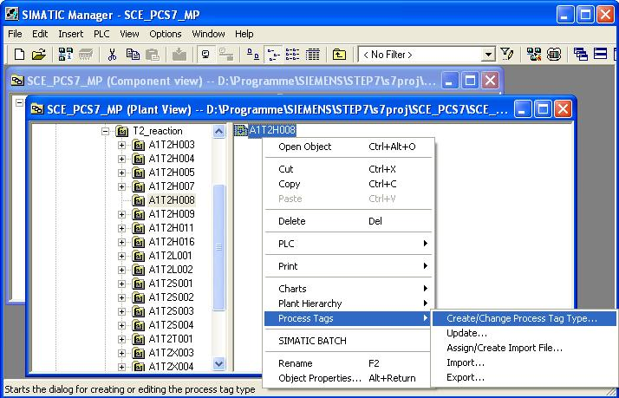
- Then, information for the assistant is displayed. (→ Next)
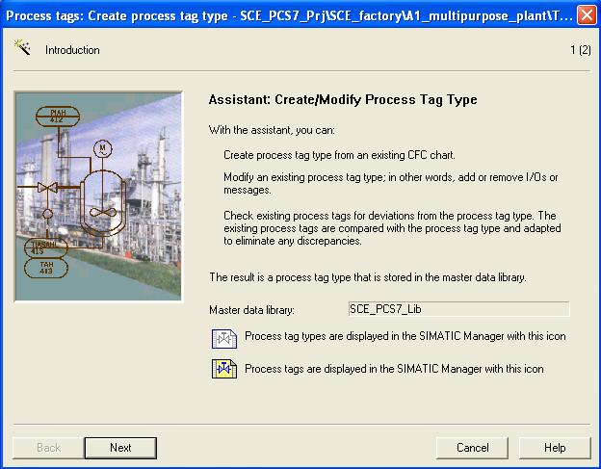

- In the following dialog, the name of the process tag type is specified, and a comment is entered. Then, with a double click on the desired block connections we specify which of them are later available as connection points during the import.
(→ HEAT_OPERATE → local operation heating → A1T2H008 → 1 → S)
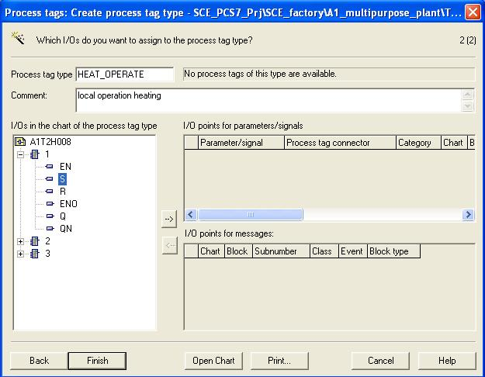
- For each connection we have to specify whether it is available as parameter or as a signal connection. (→ Signal)
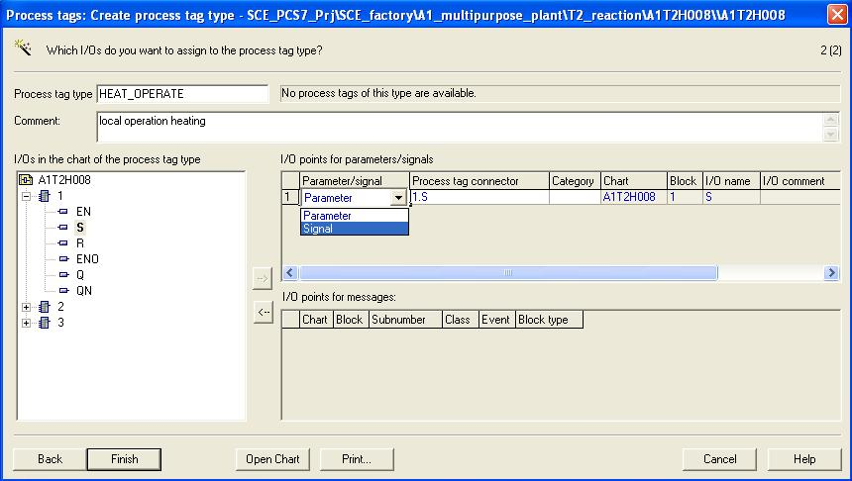

- Our example has -as shown here- three signals ’1.S’, ’1.Q’ and ’2.IN1’ and two parameters ’7.IN1’ und ’7.IN2’.
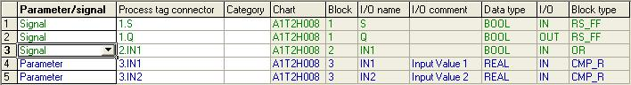
- The process tag ’HEAT_OPERATE’ is now completed. (→ Finish)
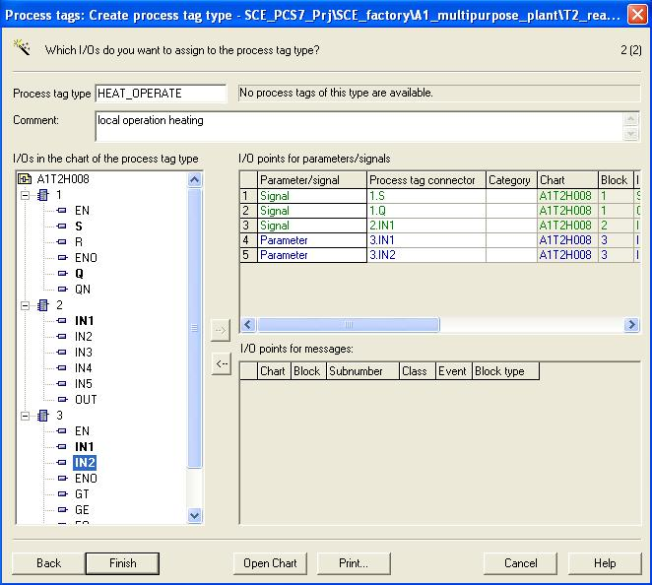

- For our process tag, a hierarchy folder is inserted in the plant view of the SIMATIC Manager.
(→ Process tag types → Insert New Object → Hierarchy folder)
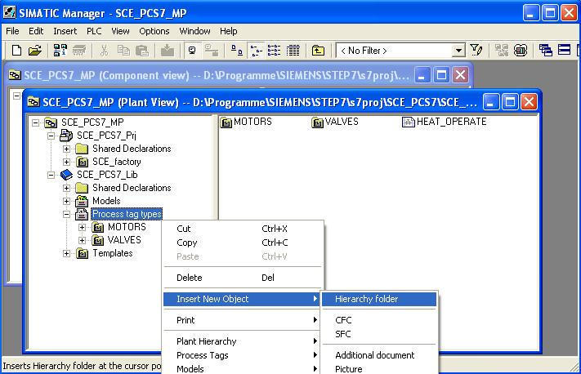
- We now rename this folder ’MANUAL_MODE’. (→ MANUAL_MODE)
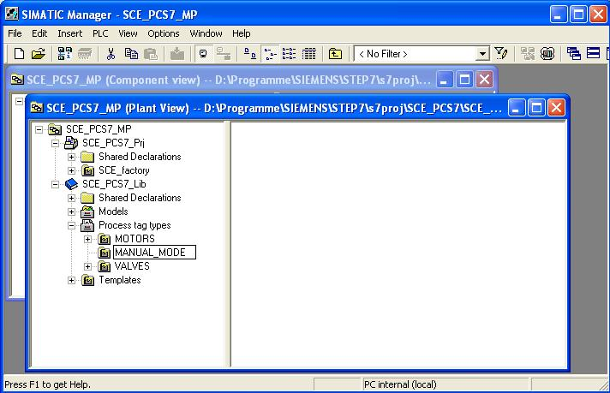

- Then, we cut the process tag ’HEAT_OPERATE’.
(→ HEAT_OPERATE → Cut)
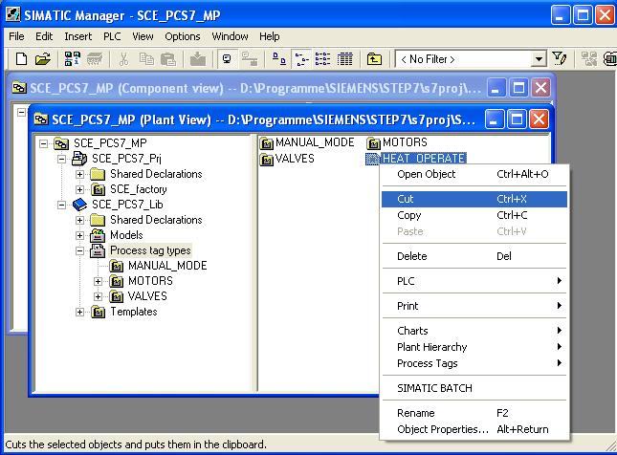
- Next we paste it in the hierarchy folder ’MANUAL_MODE’.
(→ MANUAL_MODE → Paste)
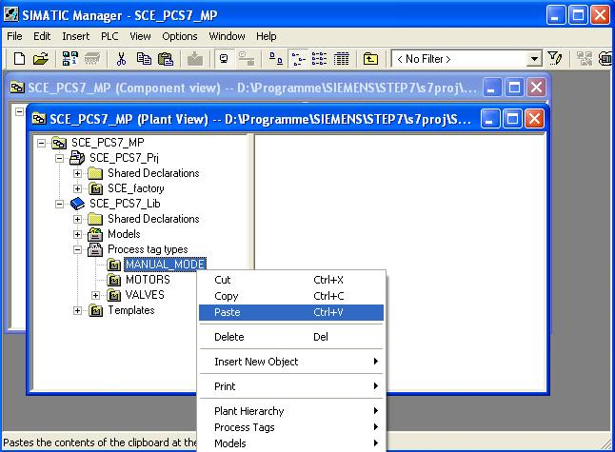

- To generate numerous CFCs of the process tag type ’HEAT_OPERATE’, it is assigned an import file.
(→ HEAT_OPERATE → Process Tags → Assign/Create Import File)
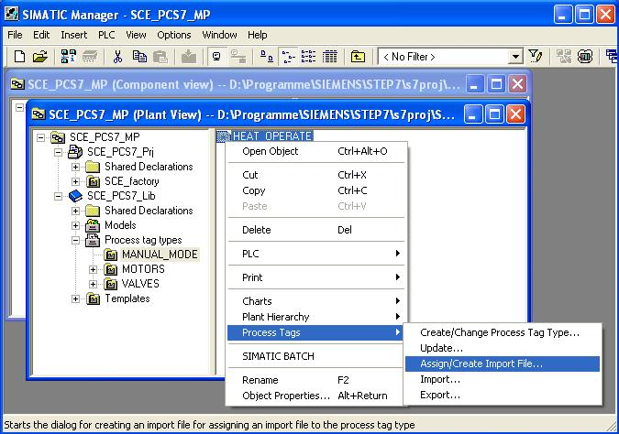
- Then information for the assistant is displayed. (→ Next)
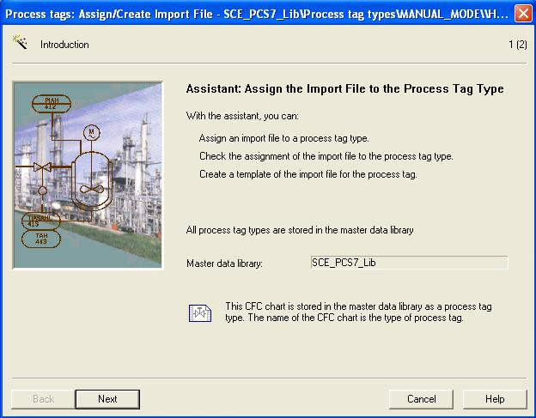

- First, we generate a file template.
(→ Create File Template → HEAT_OPERATE.IEA → OK)
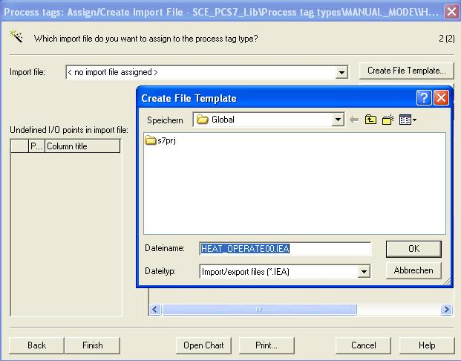
- In the following dialog we select the general columns that are displayed in the import file.
(→ General → Assigned CPU → Chart comment → Block name → Block comment)
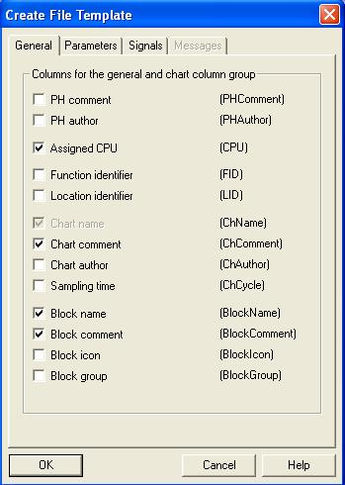

- Here, we select which columns are displayed for the parameters in the import file.
(→ Parameters → Value→ I/O comment → Textual interconnections → Identifier → Unit → Text 0 → Text 1)
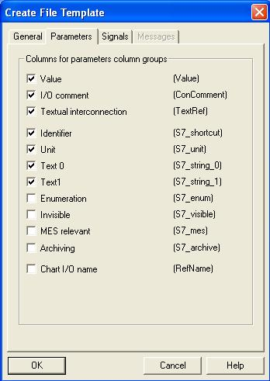
- Here, we select the columns that are displayed for the signals in the import file. (→ Signals → I/O comment → Symbol name → OK)
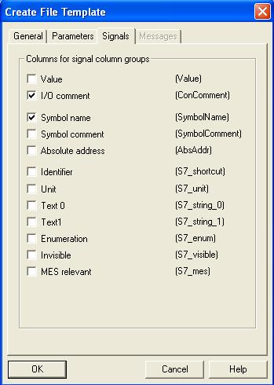

- We then open the import file that we created. (→ Open File)
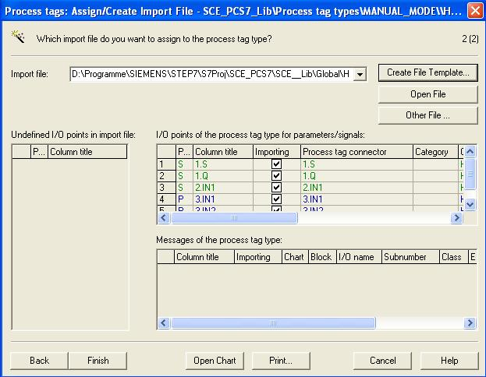
- The row of chart ’A1T2H008’ is duplicated once to set up chart ’A1T2H010’. (→ Duplicate Row → 1 → OK)
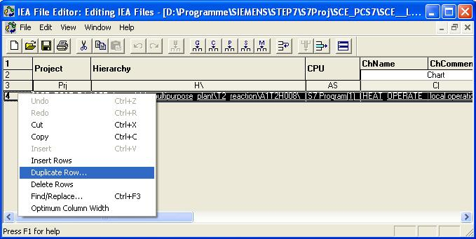

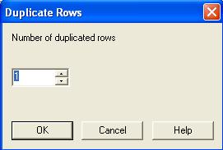

- We then change the entries for charts ’A1T2H008’ and ’A1T2H010’ in the columns of the import files, as shown here.
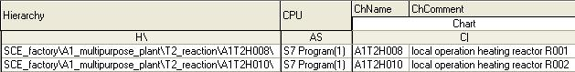

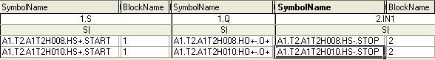

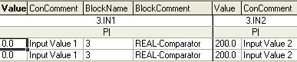

- We now save the import file and close the window of the IEA file editor. (→ → )
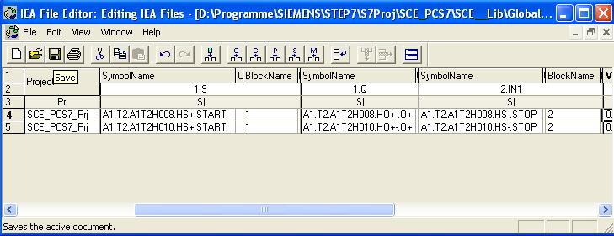

- Process tag ’HEAT_OPERATE’ can then be completed. (→ Finish)
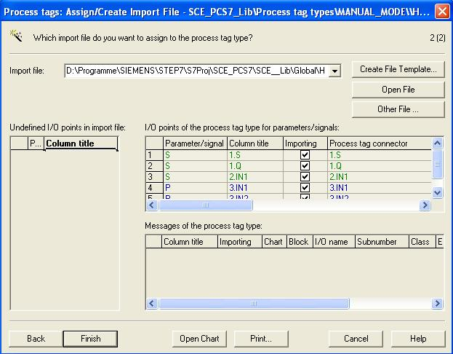
- We now start the import with the import file that we set up.
(→ HEAT_OPERATE → Process Tags → Import)
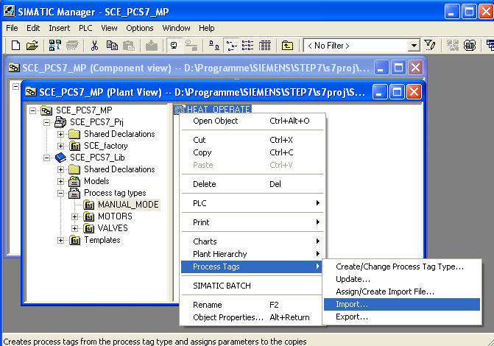

- Then, the information is displayed for the assistant. (→ Next)
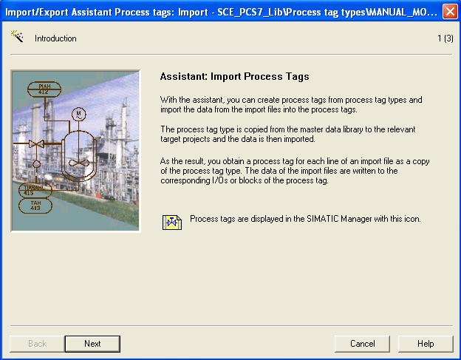
- We now select the import file we previously set up and the option ’Make textual interconnections’. (→ Make textual interconnections → Next)
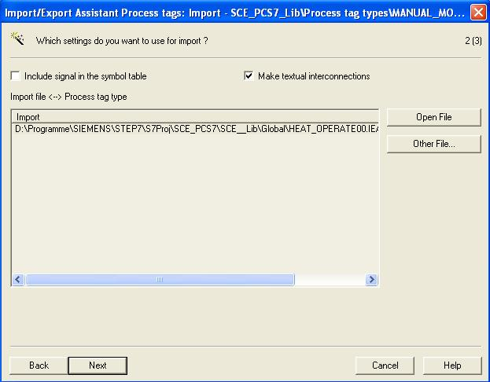

- We then start the import. (→ Finish)
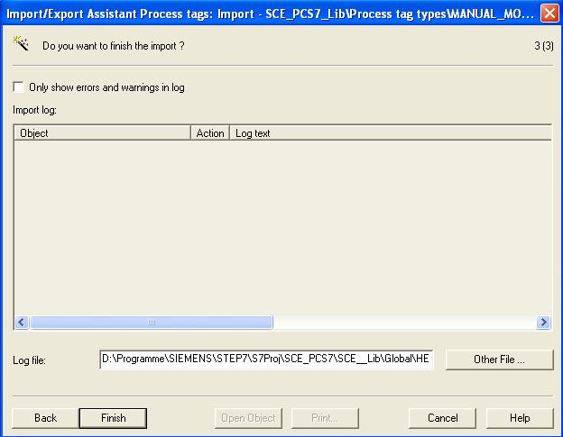
- An import log is then displayed. (→ Exit)
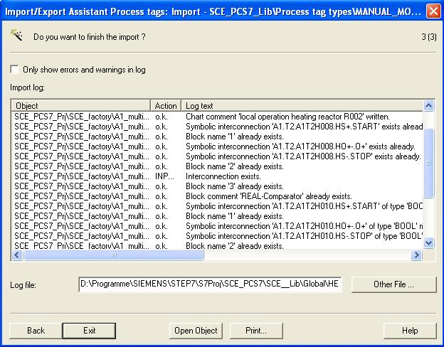
- In this manner, we can quickly and effectively set up numerous charts. The interesting aspect regarding this method is that the changes in the charts are not performed individually, but by means of the import file in table form. Nevertheless, each individual chart can be monitored and changed afterwards of course with the CFC editor. (→ A1T2H010)
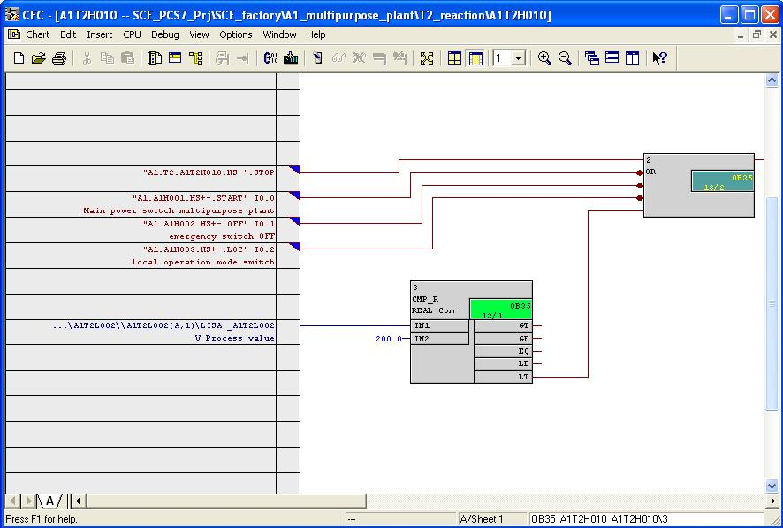
- If we want to clear the assignment of a CFC to a process tag type, its object properties have to be selected.
(→ A1T2H010 → Object Properties)
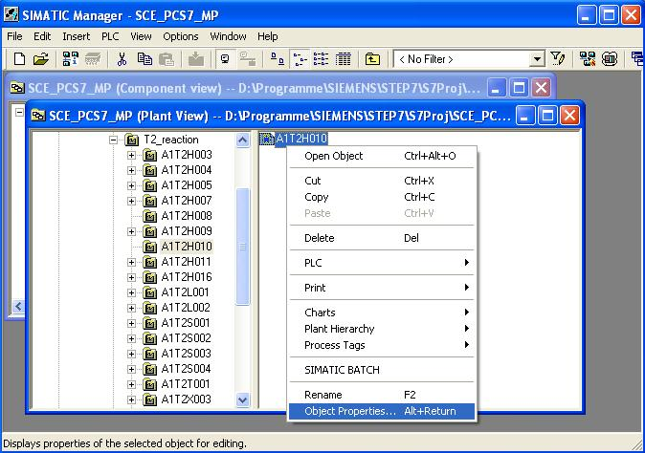

- Then we select the view Process Tag Type and clear the assignment there.
(→ Process Tag Type → Clear → OK)
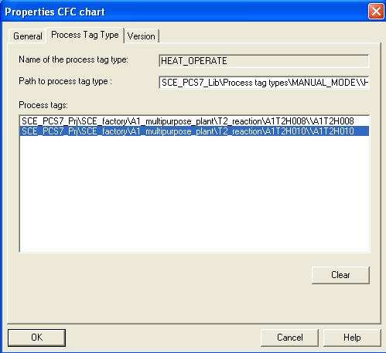
- Another method to make changes in several already established charts without opening them is using the process object view.
(→ View→ Process Object View)
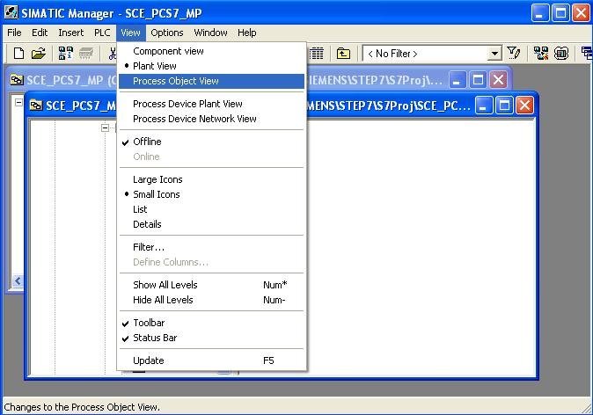

Note: Below, three examples are shown for using the process object view. Here, additional entries, texts, parameters and assignments can be changed also of course.
- Since in large plants numerous folders exist, it is important to use the process object view filter advantageously. In addition, it is important to know that always only objects are displayed below the selected hierarchy folder.
(→ T2_reaction → Hierarchy folder → Filter by column: Name → Display: A1T2H)
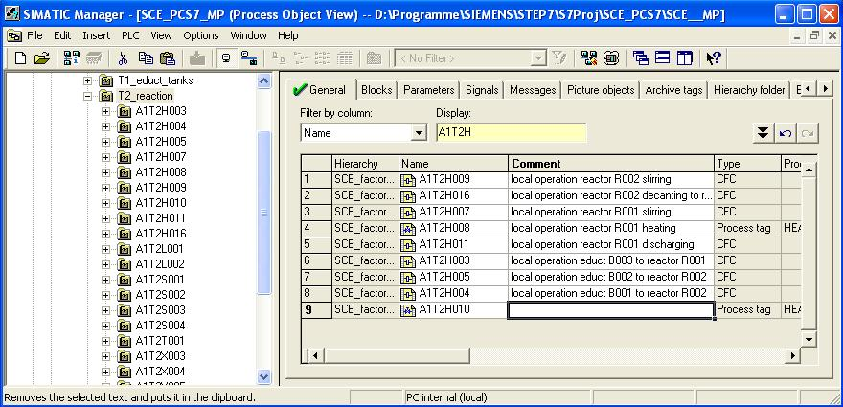

- In this example, we enter the comment for chart ’A1T2H010’. We can also do this, of course, by first copying the text of ’A1T2H008’ and then change it.
(→ A1T2H010 → local operation reactor R002 heating)
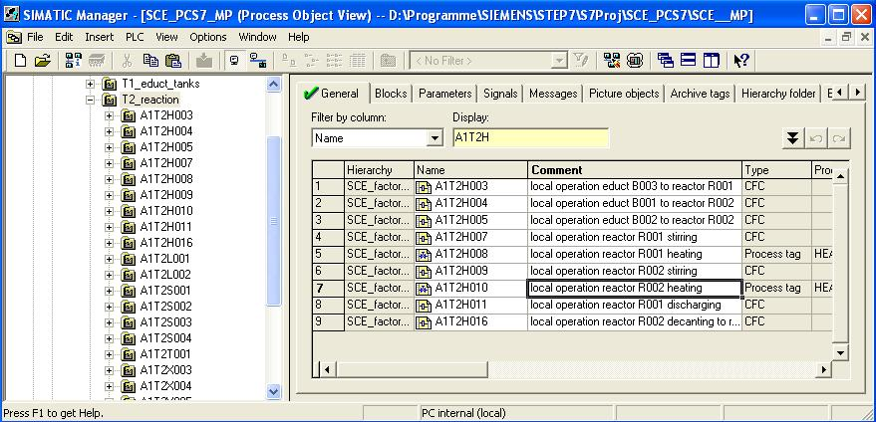
- Here, we see how, with the process object view, parameters can be changed in our charts ’A1T2H008’ and ’A1T2H010’.
(→ T2_reaction → Parameters → Filter by column: Chart → Display: A1T2H)
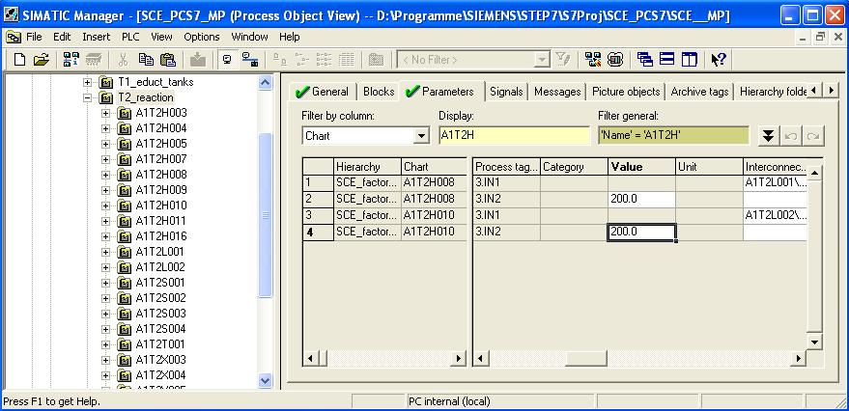

- Here we see how, with the process object view, signal assignments can be changed in our charts ’A1T2H008’ and’A1T2H010’.
(→ T2_reaction → Signals → Filter by column: Chart → A1T2H)
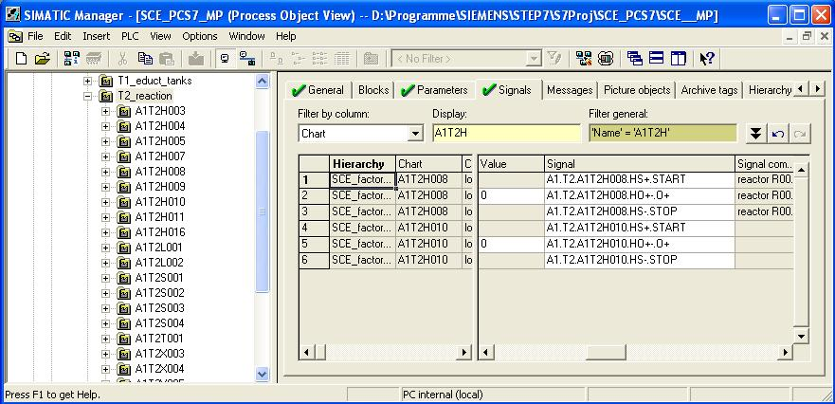
- To duplicate folder structures that were already created and tested, a model is generated from them. In the current example, we are taking the folder ’A1T3X001’ for the inlet valve Product Tank B001.
(→ A1T3X001 → Models → Create/Modify Model → OK)
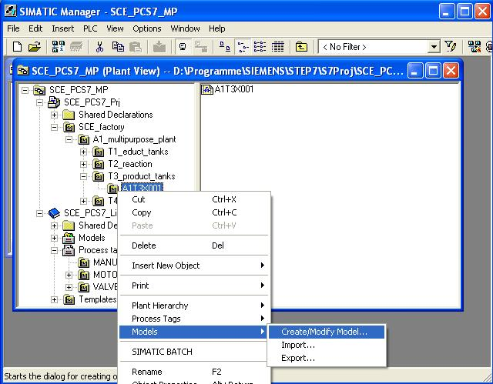

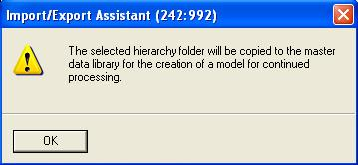
- Then, information for the assistant is displayed. (→ Next)
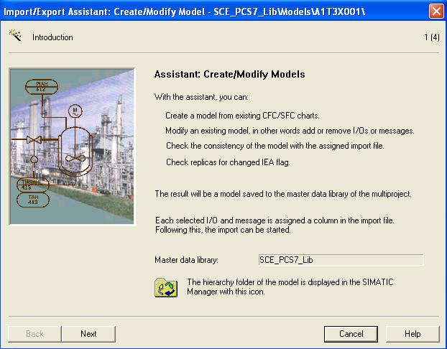

- Net, we specify which parameters (blue) and signals (green) are displayed in the Export Assistant.
(→ IEA param. → IEA signals → Next)
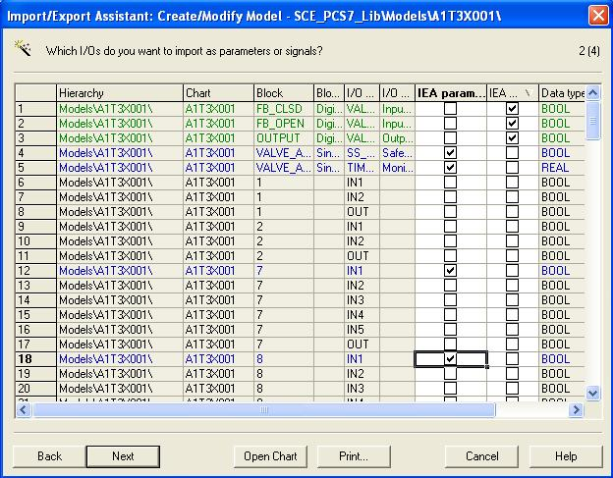
- Next, we specify the messages that are displayed in the import-export assistant. (→ IEA message → Next)
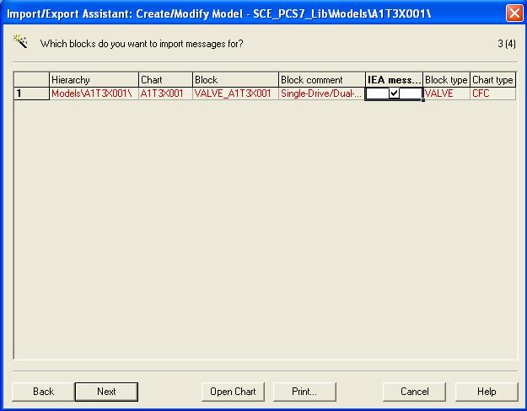

- We then generate a file template.
(→ Create File Template → INLET_PRODUCT.IEA → OK)
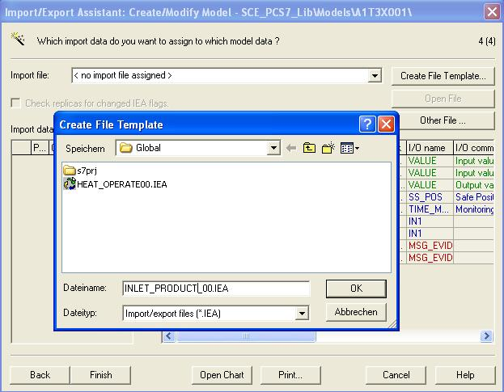
- In the following dialog we can select which general columns are displayed in the import file.
(→ General → PH comment → Assigned CPU → Chart name → Chart comment → Block name → Block comment)
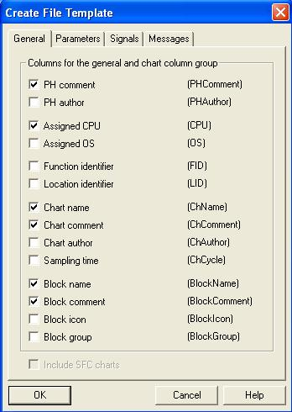

- Here we select which columns are displayed for the parameters in the import file.
(→ Parameters → Value → I/O comment → Textual interconnections → Identifier → Unit→ Text 0 → Text 1)
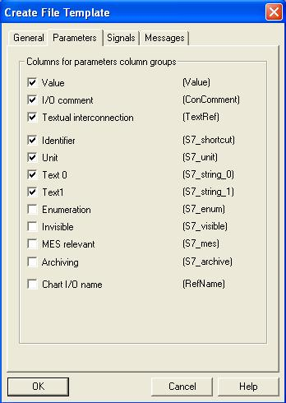

- Here we select which columns for the signals are displayed in the import file. (→ Signals → I/O comment → Symbol name)
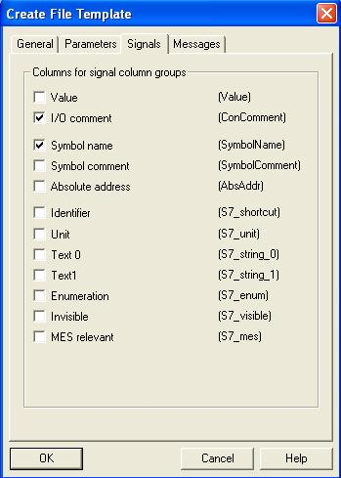

- Here we select which columns for the messages are displayed in the import file. (→ Messages → Event → OK)
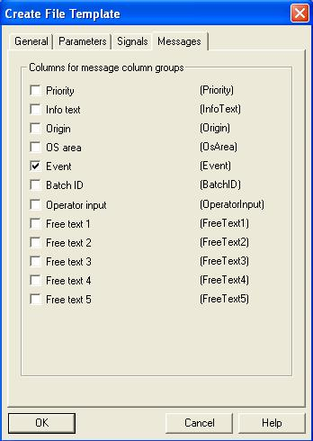
- We now open the import file that we generated. (→ Open file)
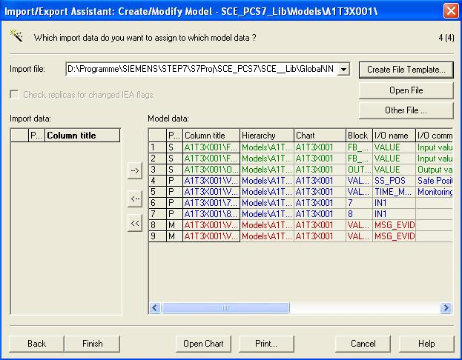

- We then duplicate the row from hierarchy folder ’A1T3X001’ once to set up hierarchy folder ’A1T3X002’. (→ Duplicate Row → 1 → OK)
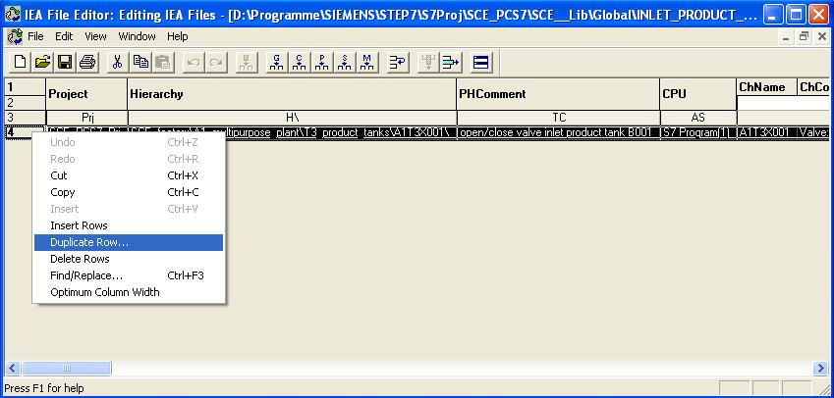
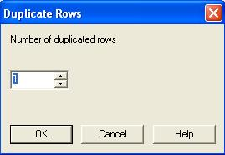

- As is shown here, we can then change the entries for hierarchy folders ’A1T3X001’ and ’A1T3X002’ in the columns of the import file. .
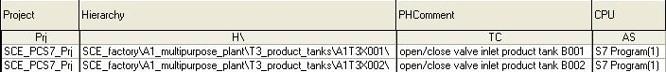

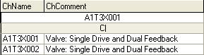

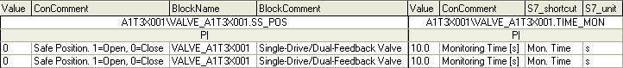

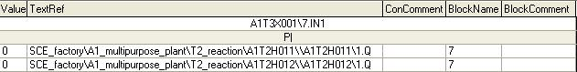

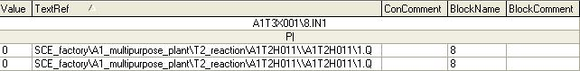

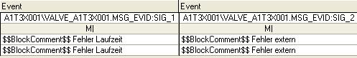

- The model can then be completed. (→ Finish)
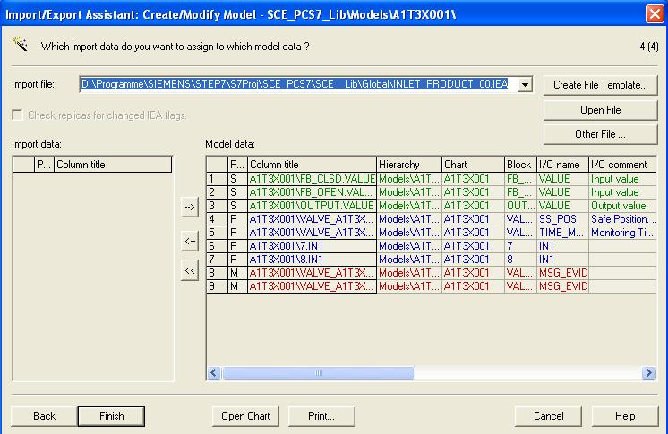

- We still have to change the name of the model to ’INLET_PRODUCT’.
(→ INLET_PRODUCT)
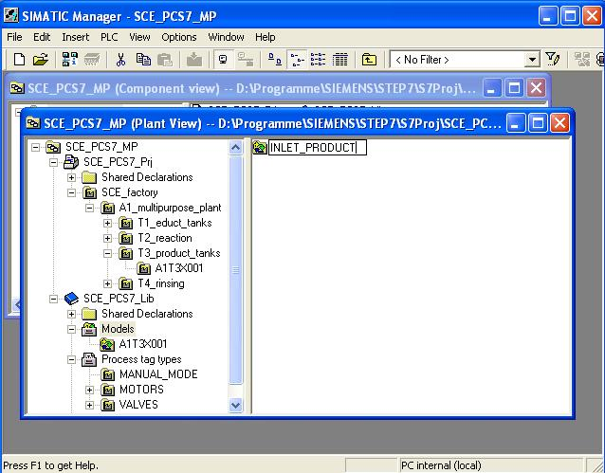
- Before we can start importing, we have to delete the original hierarchy folder ’A1T3X001’. (→ A1T3X001 → Delete → Yes)
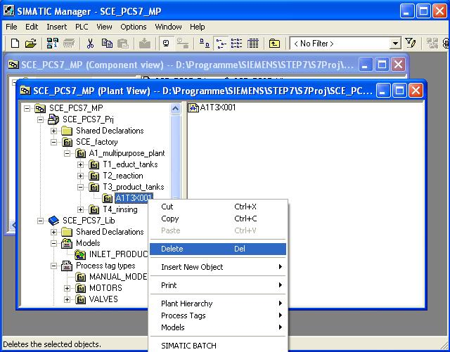

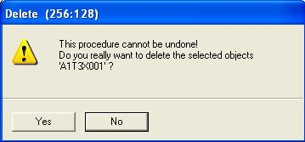

- Now we are starting importing with the import file we set up.
(→ INLET_PRODUCT → Models → Import)
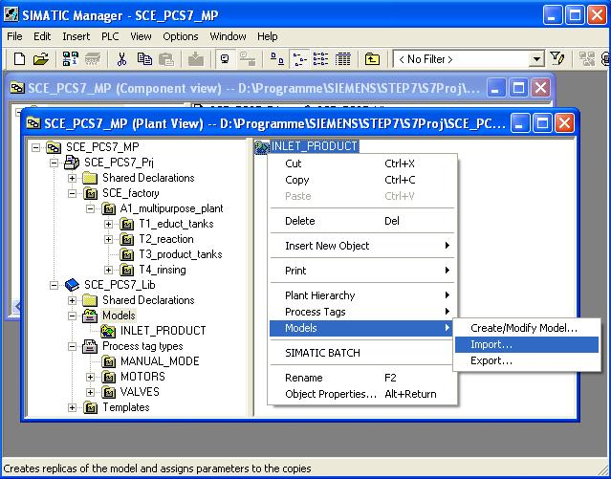

- Then, the information is displayed for the assistant. (→ Next)
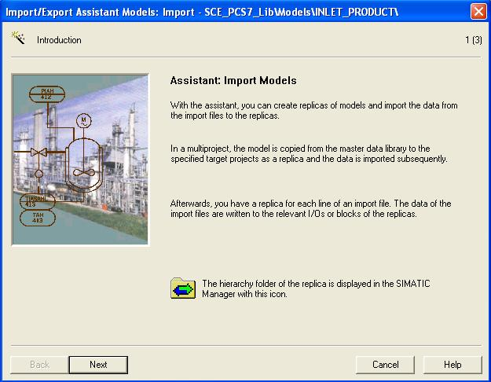
- We select the previously established import file and the option ’Make textual interconnections’. (→ Make textual interconnections → Next)
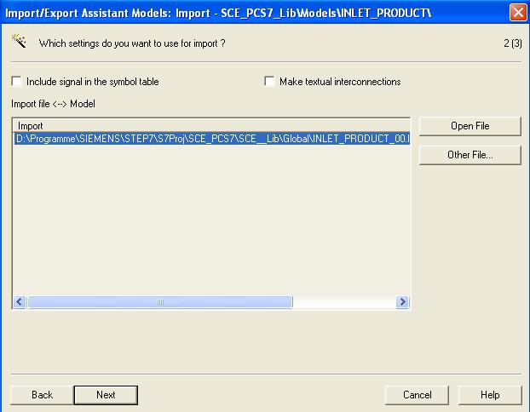

- We then start importing. (→ Finish)
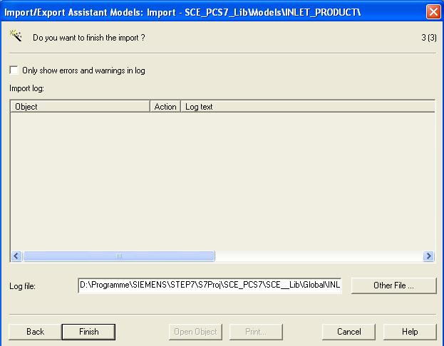
- Then, an import log is displayed. (→ Exit)
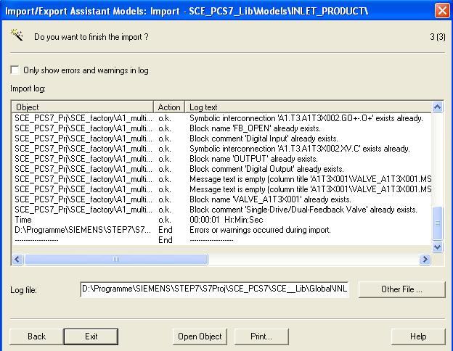

- In the SIMATIC Manager, the hierarchy folder of the model is shown with a new symbol .
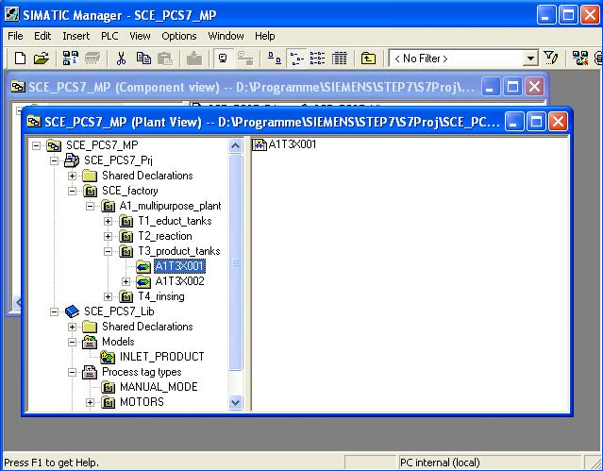

Exercises
We are going to apply what we learned in the theory chapters and the step by step instructions to the exercises. To this end, we are using and expanding the already existing multi-project in the step by step instructions (PCS7_SCE_0203_R1009.zip).
The tasks of this last exercise are to be considered comprehensive tasks. All objects not implemented so far are to be implemented.

Tasks
The following exercises are based on the step by step instructions. For each exercise, the corresponding steps in the instructions can be used as an aid.
- Analyze the different CFCs and determine the structures that recur.
- Then, create the matching process tag types and models from the existing CFCs for these structures. To do this, you may have to clear assignments that already exist.
- Generate the import file for each process tag type and each model. Add the missing information there, and import the file.
- Then, create the graphics and position the symbols that were generated automatically.
- Test your completed plant!

