Training Document for Integrated
Automation Solutions
Totally Integrated Automation (TIA)

MODULE E07
Diagnosis on the PROFINET with
IO Controller CPU 315F-2 PN/DP,
Switch SCALANCE X208 and
IO Device ET 200S

This document was prepared by Siemens AG for training purposes for the project 'Siemens Automation Cooperates with Education’ (SCE).
Siemens AG does not guarantee the content of this document.

Passing on this document, copying it and using and sharing its content is allowed within public training facilities and continued education facilities. Exceptions require written approval by Siemens AG (Michael Knust michael.knust@siemens.com).
Offenders are held liable. All rights reserved, including translation rights, particularly in the event a patent is granted or a utility model or design is registered.

We thank the Michael Dziallas Engineering corporation, the teachers of vocational schools others for their support during the preparation of this document.

PAGE

1. Preface 4

2. Notes on Using the CPU 315F-2 PN/DP 6

3. Notes on Using the ET 200S with the IM151-3 PN HF 7

4. Notes on Using the SCALANCE X208 8

5. Startup of the SCALANCE X208 on the PROFINET
(with IO Controller CPU 315F-2 PN/DP/IO Device ET 200S) 10

6. Diagnostic Functions of the SCALANCE X208 23
6.1 Diagnostic Indications of the SCALANCE X208 23
6.2 Diagnosis of the SCALANCE X208 with STEP 7 24
6.3 Diagnosis of the SCALANCE X208 using Web Based Management (WBM) 29

The following symbols guide you through Module E07:


Information



Programming


Sample Task


Notes

1. preface

Regarding its content, Module E07 is part of the training unit ’IT Communication with SIMATIC S7’.

Fundamentals of
STEP 7 Programming
2 to 3 days Modules A
Industrial
Fieldbus Systems
2 to 3 days Modules D
Additional Functions of
STEP7 Programming
2 to 3 days Modules B
Process Visualization
2 to 3 days Modules F
Programming Languages
2 to 3 days Modules C
IT Communication
with SIMATIC S7
2 to 3 days Modules E
Plant Simulation
with SIMIT SCE
1 to 2 days Modules G
Frequency Converter at SIMATIC S7
2 to 3 days Modules H

Training Objective:

In Module E07, the reader learns how, on the PROFINET, diagnoses can be performed target-oriented. A configuration consisting of the following is used: the CPU 315F-2 PN/DP as IO controller, the ET200S as IO device, and the switch SCALANCE X208 with diagnostic capability. Module E07 shows what to do in principle, providing a brief example.

Preconditions:

To successfully work through Module E07, the following knowledge is assumed:

• Experience in handling Windows
• Fundamentals of PLC programming with STEP 7 (for example, Module A3 – 'Startup’
PLC Programming with STEP 7)
• Fundamentals of network technology (for example, Appendix V – Fundamentals of Network Technology)
• Starting up PROFINET (for example, Module E 04 – PROFINET with
IO Controller CPU 315F-2PN/DP and IO Device ET200S)

Hardware and software required

1 PC, operating System Windows 2000 Professional staring with SP4/XP Professional starting with SP1/Server 2003 with 600MHz and 512RAM, free disk storage approx. 650 to 900 MB, MS Internet Explorer 6.0 and network card
- Software STEP 7 V 5.4
- PLC SIMATIC S7-300 with CPU 315F-2 PN/DP
Sample configuration:
- Power supply: PS 307 2A
- CPU: CPU 315F-2 PN/DP
- Distributed IO ET200S for PROFINET with 2 digital inputs and 4 digital outputs
Sample configuration:
- Interface module: IM 151-3 PN HIGH FEATURE
- Power module: PM-E DC 24V…48V/AC24V…230V
- Electronic module: 2DI Standard DC 24V
- Electronic module: 4DO Standard DC 24V/0.5A
- Industrial Ethernet Switch SCALANCE X208
- Ethernet connection between PC, CPU 315F-2 PN/DP, Switch SCALANCE X208 and ET200S with IM 151-3 PN HIGH FEATURE


1 PC
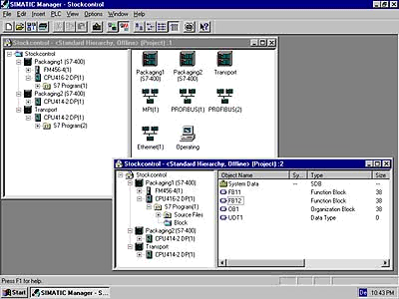
2 STEP 7

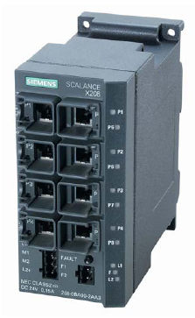
5 IE Switch SCALANCE X208

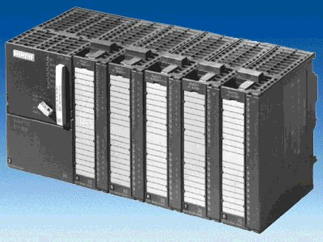
3 SIMATIC S7-300 with CPU 315F-2 PN/DP

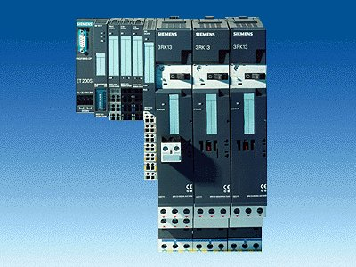
4 ET200S with
IM 151-3 PN
HIGH FEATURE

6 Ethernet Connection

2. Notes on using the CPU 315F-2 PN/DP
The CPU 315F-2 PN/DP is a CPU that is shipped with 2 integrated interfaces.
- The first interface is a combined MPI/PROFIBUS DP interface that can be used on the
PROFIBUS DP as master or slave for connecting distributed IO/field devices with very fast response timing.
In addition, the CPU can be programmed here by means of a MPI or PROFIBUS DP
- The second interface is an integrated PROFINET interface.
It allows for using the CPU as PROFINET IO controller for operating distributed IO on the PROFINET. The CPU can be programmed by means of this interface also!
- Also, fail-safe IO devices can be used at both interfaces.

Notes:
- In Module E07, the CPU 315F-2 PN/DP is used on the PROFINET as IO controller.
- To operate this CPU requires a MMC!
- The addresses of the input and output modules can be parameterized at this CPU.

3. notes on using the ET200S with the IM 151-3 PN HF
The SIMATIC ET200S is a distributed IO device set up in a fine-modular configuration. It can be operated with different interface modules:
IM 151-1 BASIC, IM 151-1 STANDARD and IM 151-1 FO STANDARD for connecting a maximum of 63 IO modules (all types, except for PROFIsafe) to the PROFIBUS DP; as an alternative, bus connection with RS 485 Sub-D connector, or by means of an integrated fiber optic connection.
IM 151-1 HIGH FEATURE for connecting a maximum of 63 IO modules (all types, including clocked mode for PROFIsafe) to the PROFIBUS DP; bus connection with RS485 Sub-D connector
IM 151-3 PN for connecting a maximum of 63 IO modules (all types, including clocked mode for PROFIsafe) to PROFINET IO controllers; bus connection by means of RJ45 connector
IM 151-3 PN HF (HIGH FEATURE) for connecting a maximum of 63 IO modules (all types including clocked mode for PROFIsafe) to PROFINET IO controllers; bus connection by means of 2x RJ45 connector
IM 151-7/F-CPU, IM 151-7/CPU or IM 151-7/CPU FO for connecting a maximum of 63 IO modules (all types; PROFIsafe only with IM151-7/F CPU) to the PROFIBUS DP; as an alternative, bus connection with RS 485 Sub-D connector or by means of integrated fiber optic connection; with integrated CPU 314 of the SIMATIC S7-300 for preprocessing process data.
The following IO modules can be used:
Power modules for individually grouping load and encoder supply voltages, and their monitoring
Digital electronic modules for connecting digital sensors and actuators
Analog electronic modules for connecting analog sensors and actuators
Sensor module for connecting IQ Sense sensors
Technology modules Electronic modules with integrated technological functions; such as counting, positioning, data exchange, etc..
Frequency converter and motor starter modules
For training purposes, we now have an integrated system that can be used for teaching a number of technologies.

Notes:
- In Module E07, the interface module IM151-3 PN HF is used as PROFIBUS DP device.
- Operating the IM151-3 PB HF requires a MMC!

4. notes on using the SCALANCE X208
The SCALANCE X208 is an 8 port Managed Industrial Ethernet switch that can be used universally. The installation of these devices ranges from machine-related applications to networked subsystems. The configuration and remote diagnosis are integrated in SIMATIC STEP 7.
The devices are equipped with PROFINET diagnosis, SNMP access, integrated Web server, and automatic email send function for remote diagnosis and signaling via the network.

Technical data:
- Eight electrical ports for setting up electrical Industrial Ethernet line, star or ring structures
- The eight RJ45 sockets of the SCALANCE X208 are designed industry-oriented with additional retaining collars
- Load separation through integrated switch functionality
- Redundant voltage supply
- Diagnosis on the device by means of LEDs (power, link status, data traffic)
- Remote diagnosis by means of alarm contact (alarm screen can be set with a button on
location), PROFINET, SNMP and Web browser possible
- Automatic detection 10MBit/100MBit by means of auto-negotiation
- Use of uncrossed connection lines through integrated auto-crossover function of the ports
- Fast device replacement if there is a fault by using the optional memory medium C-PLUG (not included in the delivery scope)

Network Topology and Network Configuration:
With the SCALANCE X208, electrical networks can be set up in line, start or ring structures.
When configuring networks, the following general requirements have to be noted:
- The length of the TP line between two switches SCALANCE X208:
max. 100m with Industrial Ethernet line
max. 10m by means of patch technology with TP cord

IP Address Assignment
In the case of the Industrial Ethernet switch SCALANCE X208, the IP address can be assigned by using the DHCP (Dynamic Host Configuration Protocol). If no corresponding server should be available on the network, the IP address is assigned by means of an included software tool (Primary Setup Tool) or with SIMATIC STEP 7.

Startup and Diagnosis
PROFINET diagnosis alarms of SCALANCE X208 can be indicated with corresponding SIMATIC engineering tools, and processed in the controller.

Moreover, the Industrial Ethernet switch SCALANCE X208 can be integrated into a network management system by means of the standardized protocol SNMP (Simple Network Management Protocol).
If faults occur on the device, error messages (SNMP traps) can be sent to a network system, or as Email to a specified network manager.
The integrated Web server allows for the configuration and diagnosis settings with a standard browser. In addition, statistical information can be read out by means of the Web server.

The following information is indicated locally with LEDs:
- Power
- Port status
- Data traffic
- Signal contact

In addition, the Industrial Ethernet switch SCALANCE X2008 can be monitored by means of the potential-free signal contact.

Notes:
- In Module E07, the switch SCALANCE X208 is used on the PROFINET between a PC with
STEP 7 as engineering tool, the CPU 315F-2 PN/DP as IO controller, and the ET200S as
IO device.
- Startup and IP address assignment is performed with STEP 7 by means of PROFINET.

5. starting up the SCALANCE X208 on the PROFINET
( with IOCOntroller CPU 315F-2 PN/DP/IO Device ET200S)
Below, a switch SCALANCE X208 is added to the configuration of a PROFINET network including the CPU 315F-2 PN/DP as IO controller, and the ET200S as IO device.
As the initial project, use the STEP 7 project 'ET200S_PN’ in Module E04 – 'PROFINET with IO Controller CPU 315F-2PN/DP and IO Device ET200S’.

1. Insert -if available- the C-PLUG. The slot is located on the back of the device. To insert the plug, the screw down cover is removed. The C-PLUG is inserted into the slot provided for it, and the screw down cover has to be closed again correctly.

Notes: The C-PLUG is to be inserted or removed only in the off load state. If the C-PLUG is missing, it is signaled with the switch’s diagnostic mechanisms (LEDs, PROFINET, SNMP, Web Based Management).

- Connect the SCALANCE X208 to 24V direct current (current requirement 350mA). This can also be done redundantly from two voltage sources.

3. By means of the Ethernet, connect the SCALANCE X208 to the PC, the CPU 315F-2 PN/DP
and the ET200S.

4. If it is desired, connect the signal contact.

The signal contact is connected using a 2pole insertable terminal block. The signal contact (relay contact) is a potential-free switch that is used for signaling error states through contact separation.

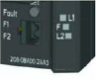
Signal contact SCALANCE X208

The following errors can be signaled with the signal contact:
• The loss of a link at a monitored port.
• The loss of one of the two redundant voltage sources.
• The C-PLUG is also monitored

Connecting and disconnecting a communication station on an unmonitored port does not generate an error message. The signal contact remains activated until the error is remedied, or until the current state is accepted with the button as the new specified condition. When the device is switched off, the signal contact is always activated (opened).
5. The message screen form that has been set can now be displayed and modified with the button. The following is required for this:

After pressing the button for approx. 3 seconds, the currently valid message screen form is displayed. The monitored ports blink with 5 Hz.
After the 3 seconds expired, the new message screen form is displayed. The blinking intervals decrease to 2.5 Hz. After another 3 seconds, the new message screen form is accepted and saved.
The monitored ports are indicated with statically lit LEDs, until the button is released.
As long as the LEDs are still blinking, the saving process can be canceled by releasing the switch.
If an empty message screen form (no ports are monitored) is set or is to be set, LEDs are blinking respectively in turn with their neighbors.
When setting the message screen form, redundant voltage supply monitoring can also be set. Voltage supply monitoring will be activated only if both voltage sources are connected while saving the message screen form. If there should be a C-PLUG in the device at the time the button is pressed, this is saved also and monitored.

By pressing the button for a longer period of time (15 seconds), the device is reset to "factory default". This is indicated by all port LEDs blinking (green). While this happens, the device must not be switched off.
6. Open the hardware configuration in your project ’ET200S_PN’ from Module E 04 – 'PROFINET with IO Controller CPU 315F-2PN/DP and IO-Device ET200S’. (→ SIMATIC Manager → File → Open → ET200S_PN → Hardware)
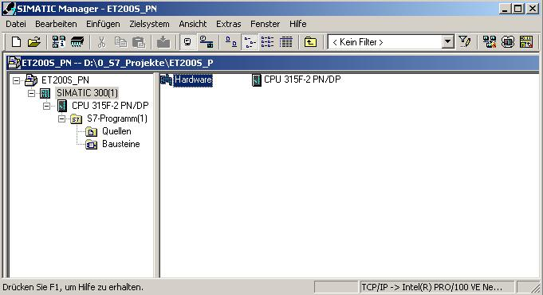

7. Using Drag&Drop, drag the switch ’SCALANCE X208’ to the ’PROFINETIO System’. (→ PROFINET IO → General → SCALANCE X-200 Switches → SCALANCE X208)

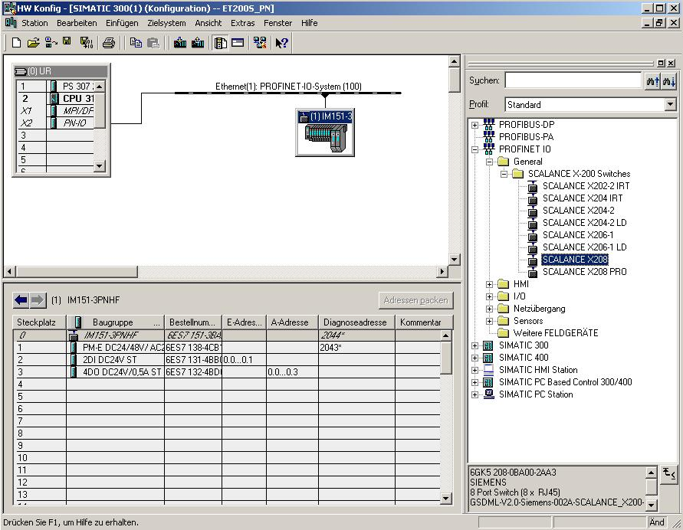
8. A double click on the ’SCALANCE X208’ opens its properties. (→ SCALANCE X208)
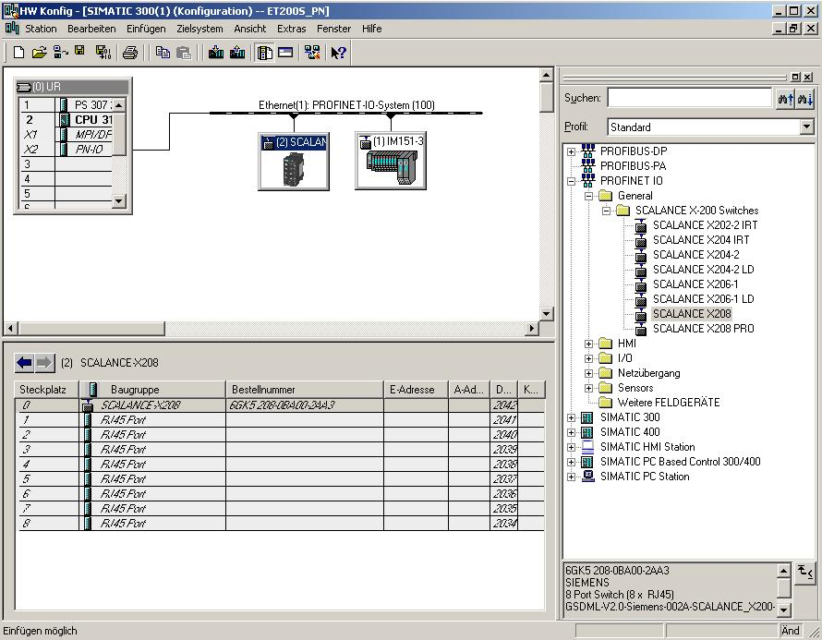

9. To each IO device, a device name <<’Gerätename’>> that is unique within the PROFINET IO systems has to be assigned, and an IP address on the ’Ethernet’. (→ Device name: SCALANCE X208 → Ethernet)
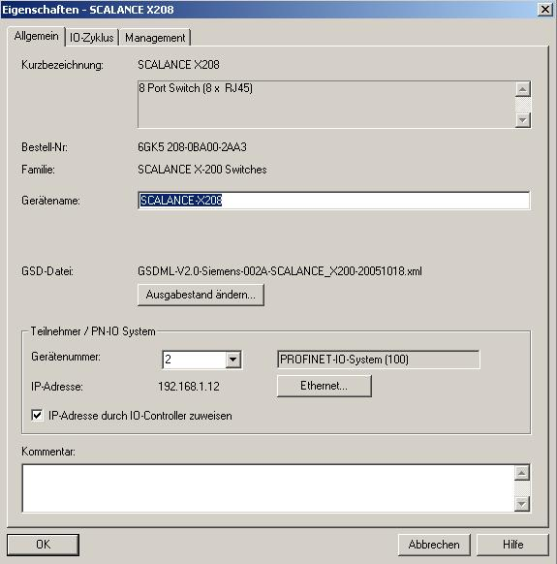

10. After you assigned the ’IP Address’, accept it with ’OK’.
(→ IP address: 192.168.1.12 → OK → OK)

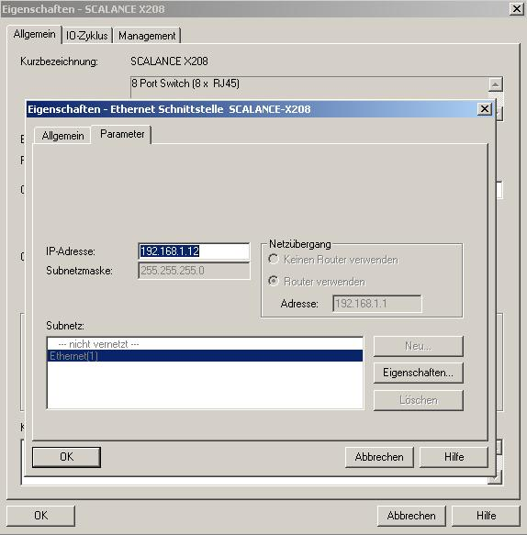
11. By double clicking on ’SCALANCE X208’, the parameters for the switch can be set that are valid for all ports. ( → SCALANCE X208 → OK)
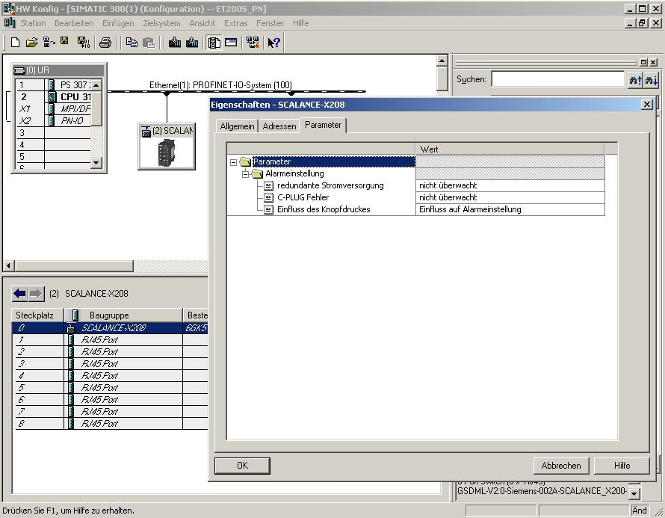
Switch parameters that are valid for all ports:

Redundant power supply
Not monitored - No alarm is generated if one of the two voltage sources fails.
Monitored - An alarm is generated if one of the two voltage sources fails.

C-PLUG
Not monitored - The C-PLUG is not monitored
Monitored - If there is an error, an alarm On C-PLUG is generated

Influence when pressing the button is configured
No influence on the alarm setting - The ports to be monitored are set not by pressing the button but by being set in HWConfig
Influence on the alarm setting - The ports to be monitored are already set on the device (for example, by pressing the button, WEB interface, etc.)

12. By double clicking on ’RJ45 Port’, the parameters for the individual ports can be set.
( → RJ45 Port → OK)

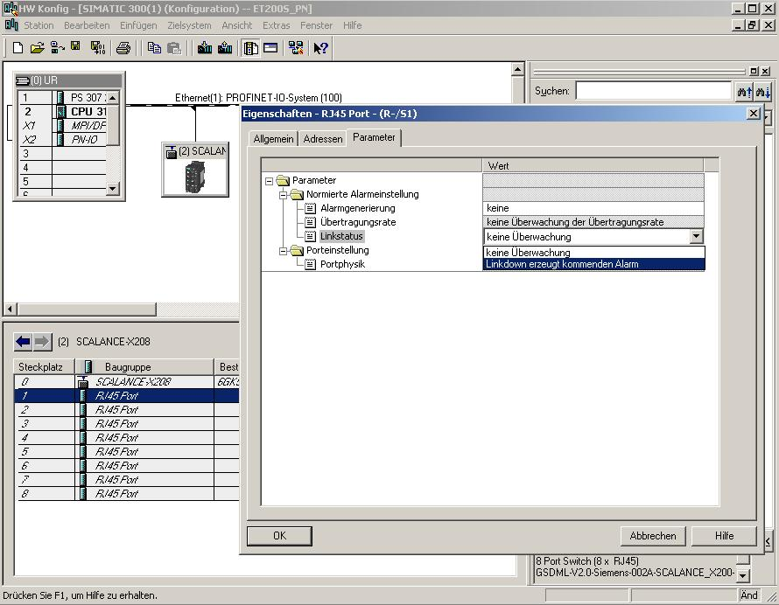
Parameters for the individual ports:

Alarm generation
None - No alarm is generated
Setpoint by means of configuring - The alarm setting is entered explicitly for each port
Setpoint when entering data traffic - The link status of the corresponding port is stored when the device transitions to data exchange with the PROFINET IO controller.

Link status
No monitoring - Monitoring deactivated
Link down generates a coming alarm - An alarm is generated if an existing link is removed.

13. Now, the IO device has to be assigned a name <<’Gerätename vergeben’>> after it was highlighted. (→ SCALANCE X208 → Target system → Ethernet → Assign device name)
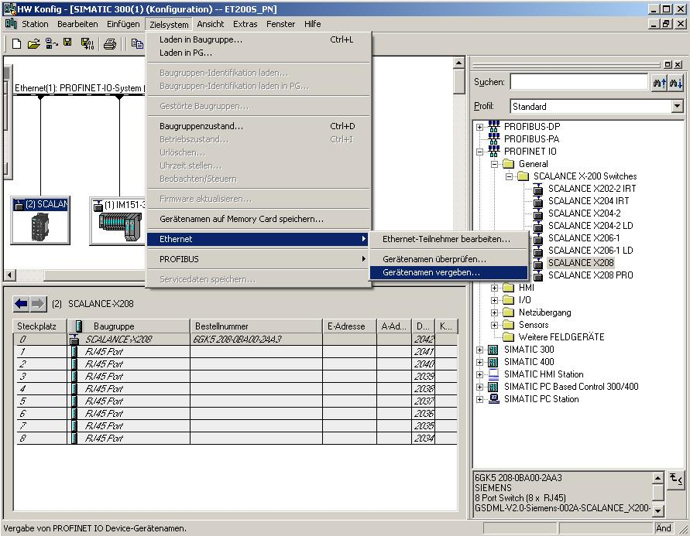
Note: A precondition for this is that the PG/PC interface is set to TCP/IP and the PC’s network card is configured correctly; for example: IP address 192.168.1.99, subnet 255.255.255.0 and router address 192.168.1.1. (refer to Module E02!)

Note: Make sure that your programming device is connected to the switch SCALANCE X208 by means of the Ethernet!

14. Now we have to select the switch ’SCALANCE X208’ in order to assign the name <<’Name zuweisen’>>. The new device name is then displayed in the area for Existing Devices ’Vorhandene Geräte’. Then, close <<’Schließen’ >> the dialog box. (→SCALANCE X208 → Assign name → Close)
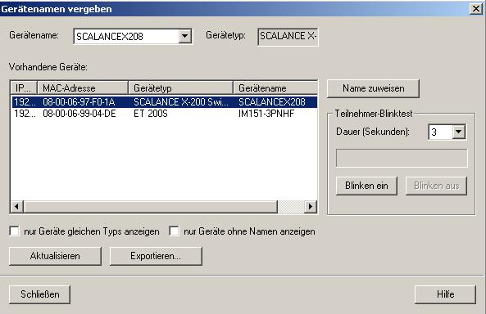
Note: If several IO devices are on the network, the device can be identified with the imprinted MAC address.

15. Now, after again highlighting the switch, it has to be assigned the Ethernet address (→ SCALANCE X208 → Target system → Ethernet → Edit Ethernet station)
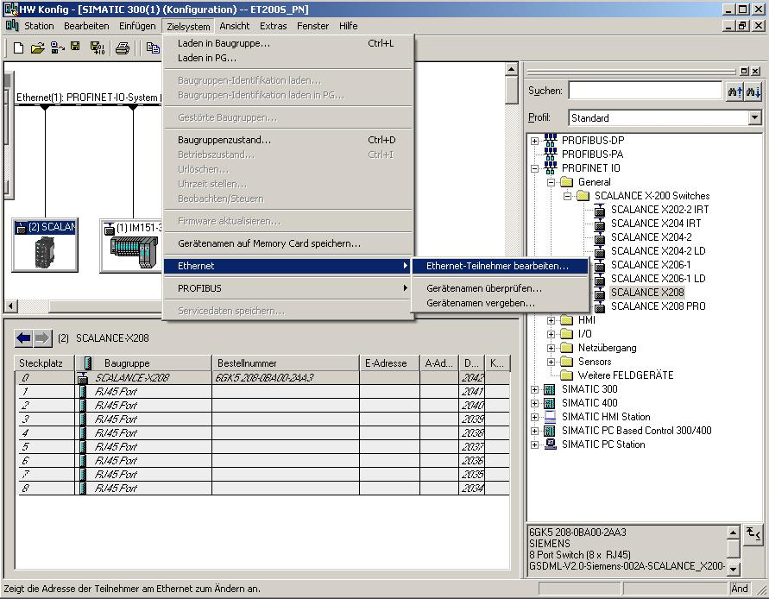

Note: A precondition for this is that the PG/PC interface is set to TCP/IP and the PC’s network card is configured correctly; for example, IP address 192.168.1.99, subnet 255.255.255.0 and router address 192.168.1.1. (refer to Module E02!)

Note: Make sure that your programming device is connected to the switch SCALANCE X208 by means of the Ethernet!

16. Now, search the network for all available devices. (→ Search)
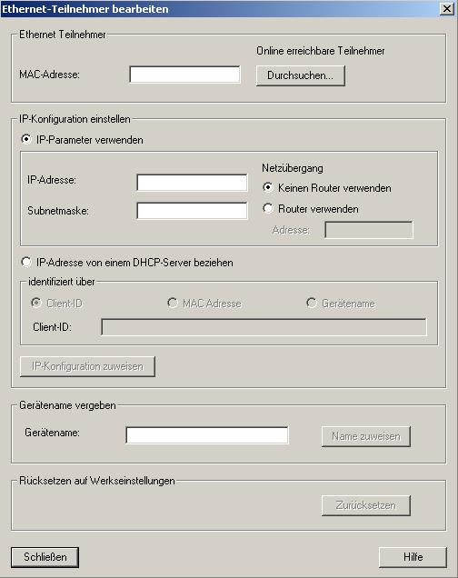

17. Then, select your switch ’SCALANCE X208’ with a double click.
(→ SCALANCE X208)

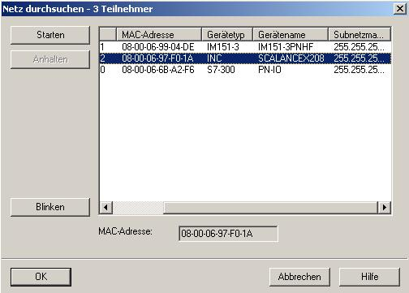
Note: If several IO devices are on the network, the device can be identified with the imprinted MAC address, or the device name previously assigned.

18. Now enter the ’IP address’, assign the ’subnet screen form’ and specify the address of a router that is possibly be used. With ’Assign IP configuration’, write your settings to the target device and ’Close’ the dialog. (→ IP address: 192.168.1.12 → Subnet screen form: 255.255.255.0 → Use router →192.168.1.1 → Assign IP configuration → Close)
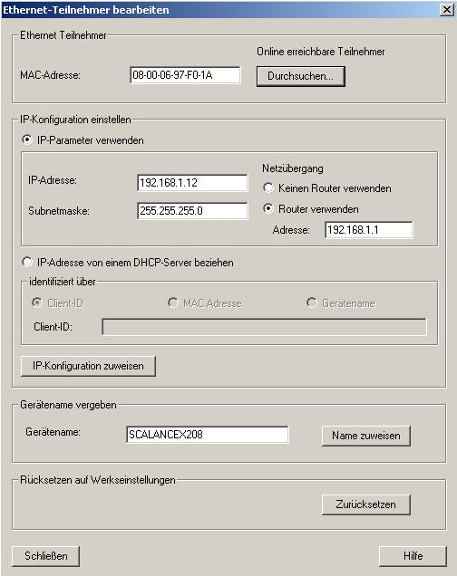
19. Now, by clicking on '’, the configuration table is saved and converted; and after clicking on
'’, it is loaded to the PLC. (→ → )

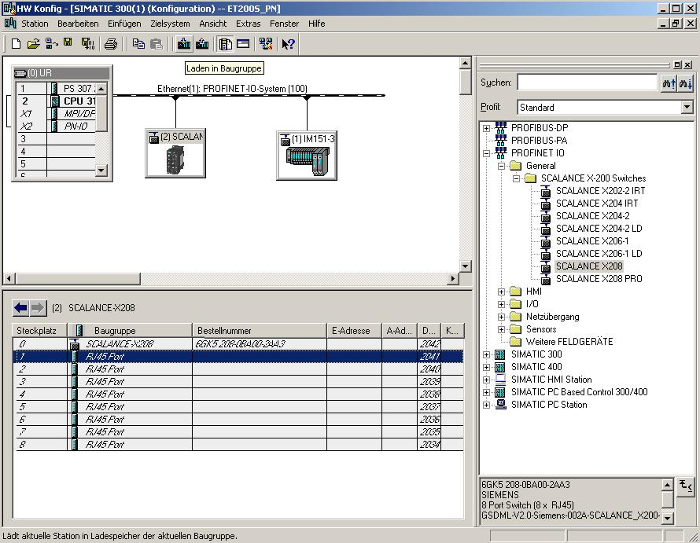

6. diagnostic functions of the SCALANCE X208
  - diagnostic indications of the SCALANCE X208
Fault Indication (red LED)
State | Description
Illuminated red | The SCALANCE X208 detected an error. At the same time, the signal contact opens. The following errors are recognized:  1. Link down event at a monitored port  2. One of the two redundant voltage supplies failed  3. C-PLUG  4. Power-up of the device; the LED is lit for approx. 20s.
Blinks red | An internal error was detected. Inform the maintenance staff and if necessary, return the device for repairs.
Not lit | SCALANCE X208 detected no errors.

Power Indication (green LED)
The status of the voltage supply is indicated by means of two green LEDs:
State | Description
Steady green | Voltage supply L1/L2 is connected.
Not lit | Voltage supply L1and/or L2 not connected, or <14V

Port Status Display (green/yellow LEDs)
The interface status is indicated with eight two-color LEDs:
State | Description
Port 1 to 8 LED is steady green | TP link present, no data reception
Port 1 to 8 LED is steady yellow | TP link present, data received at TP port, device powers up, the LED is lit for approx. 6s
Port 1 to 8 LED blinks yellow | Setting or indication of the message screen form
Port 1 to 8 LED blinks green | The function "Show Location" was activated by means of the Ethernet. PROFINET IO operation with the PN IO controller started; the attempt to modify the message screen form by pressing the button is rejected by all port LEDs blinking once. To reset the configuration, the button was pressed more than 15s.

LED Indication at Startup
When the device powers up, the following indications are lit in the time sequence listed:
• Power LEDs (green) are lit immediately after switching on the voltage.
• Port LEDs (yellow) are lit for approx. 6s, the red LED is off.
• Port LEDs go off, the red error LED is lit for approx. 20s.
After the Port LEDs go off, the correct link status is indicated after approx. 2s. The device is now ready.

  - reading out the diagnosis of the SCALANCE X208 with STEP 7
In STEP 7 you can diagnose states of the switch SCALANCE X208.

1. To this end, open the hardware configuration of your project in which the SCALANCE X208 was configured, and select the button ’Offline <-> Online’ '’.
(→Offline <-> Online )

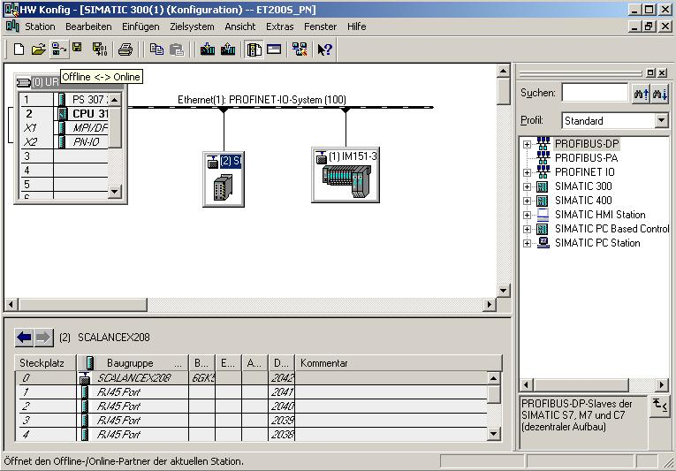

2. Then, double click on the switch ’SCALANCE X208’. In the tab ’General’, you will be provided with general information such as the version and status of your switch. .
A SCALANCE X208 error is indicated here with the symbol . (→ SCALANCE X208 → General)
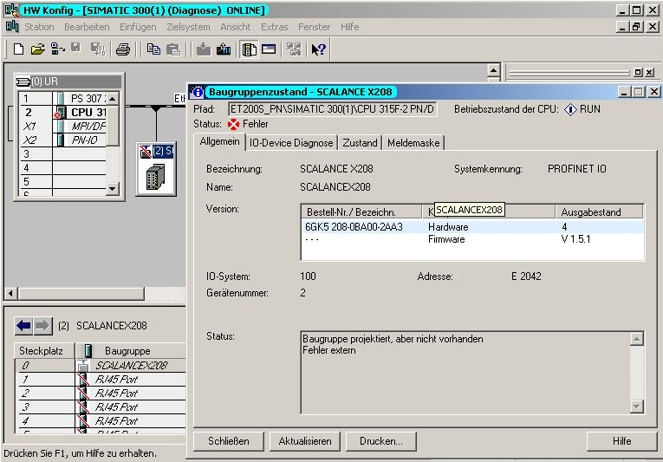

3. In the tab ’IO Device Diagnosis’ you can view the standard diagnosis for your device, together with the channel specific diagnosis
(→ IO Device Diagnosis)
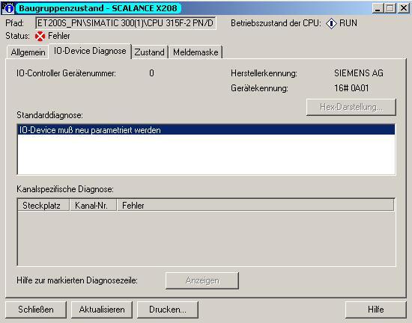
4. In the tab ’State’ you can view a representation of the SCALANCE X208 with the following graphically represented diagnosis (→ State)
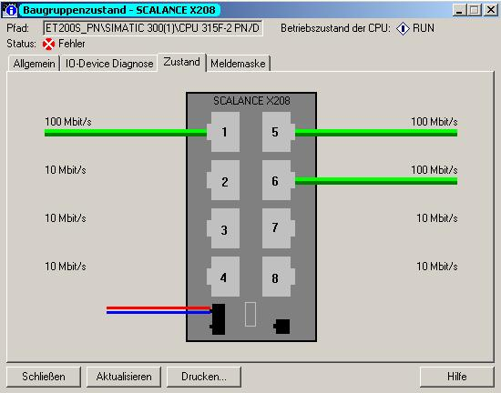
In this view, the following diagnostic information is displayed:

- At which port is a line active (link up)?
This is shown with a connected line or a missing line. For optic connections, this line is marked yellow/red.
Link up
 Link up (optic connection -> yellow/)

- What is the transmission speed (baud rate) with which the ports are run?
Note the textual indication at the lines (10 MB, 100 MB, 1 GB or 10 GB)

- Is a line in the half duplex or the full duplex mode?
Full duplex mode: continuous line
Half duplex mode: dashed line

- Is a connection crossed?
Connecting cable not crossed
Connecting cable crossed

- Is the signal contact activated?
The signal contact is shown either black (inactive) or red (active).
Alarm contact inactive
Alarm contact active

- Is a C-PLUG inserted and fault-free?
The dashed line next to the signal contact shows a missing C-PLUG. A C-PLUG that is present is shown as a filled-in rectangle.
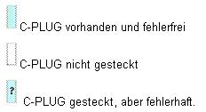

C-PLUG present and faultless

C-PLUG not inserted

C-PLUG inserted but faulty

- Is the power supply connected in the redundant mode?
This is represented with the second power supply line.

Not redundant. Power connection is shown single

Connected in the redundant mode. Power connection is shown doubled.

- Where was the alarm triggered?
The symbol indicates at which location the alarm contact was activated by an event: port, C-PLUG, or power supply

5. In the tab ’Message Screen Form’ you will see a representation of the SCALANCE X208 with the following graphically represented diagnosis. (→ Message screen form)
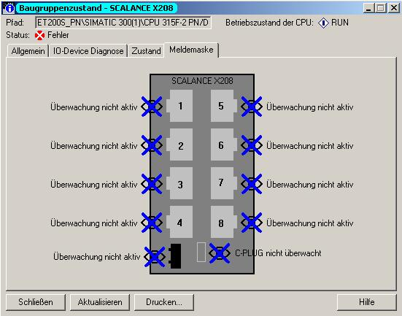
In this view, the following diagnostic information is indicated:

- Which ports and connections are monitored?
The connection is monitored
 The connection is not monitored

- Which port properties are monitored?
The following can be monitored, for example:
- Link up, Link down;
- Transmission speed (baud rate)
- Operating mode (half duplex/full duplex)

  - diagnosing the SCALANCE X208 using Web Based Management (WBM)
You can start the screens of Web Based Management (WBM) also from STEP 7. The advantage is that the SCALANCE X208 is addressed automatically with the correct IP address.

6. To this end, open the hardware configuration of your project where the SCALANCE X208 was configured, and with a double click select the properties of the ’SCALANCE X208’.
(→ SCALANCE X208)

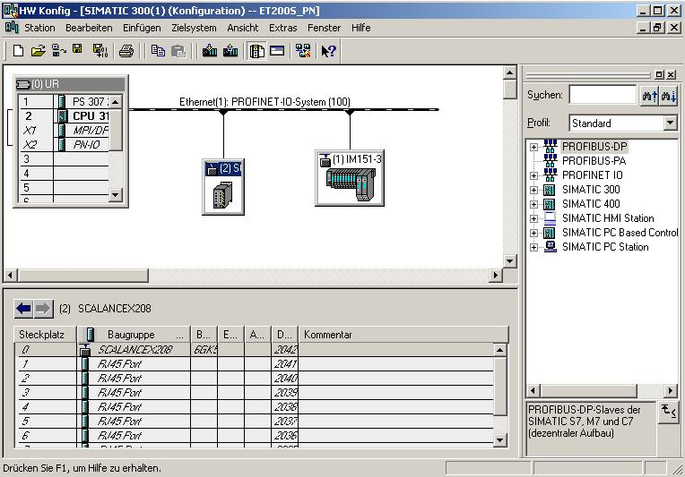

7. In the tab ’Management’ you can open the WBM in your standard browser with the button ’Web based Management’.
(→ Management → Web based Management)

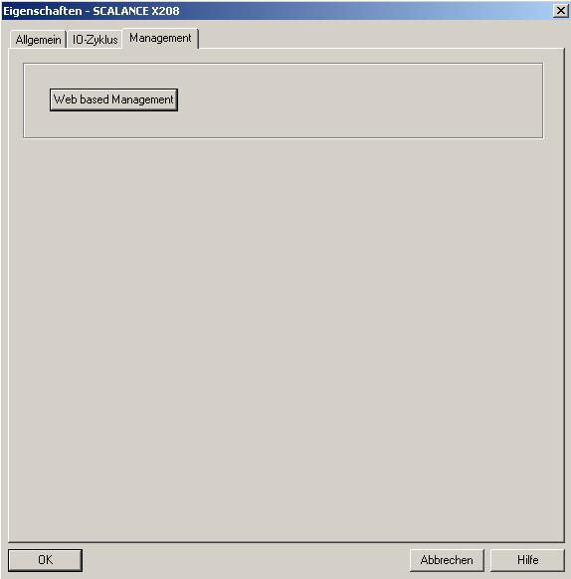

8. Then the following log-on screen is displayed -for example, in the Microsoft Internet Explorer. Here you have to log on with your user name and your password.

The factory setting looks like this:
User: | Administrator | User
User name: | admin | user
Password | admin | user
(→ admin → admin → OK)

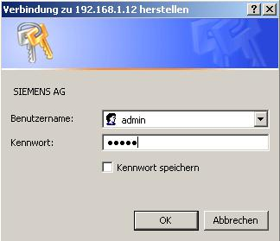
9. In Web based Management we have -by accessing the HTML pages in the SCALANCE X208- a large number of diagnostic and setting options. As can be seen below, in each figure the operating mode is represented with LEDs.
In addition, the navigation bar provides you with the following 3 links:
- ’Console’ This link opens a console window. In this window you can enter CLI commands. You are connected with the switch by means of a TELNET connection.
- ’Support’ This link initiates an Internet connection that takes you directly to the support pages of SIEMENS AG. The precondition is that the PC supports an Internet connection.
- ’Logout’ Closes the browser window.
(→Console → Support → Logout)

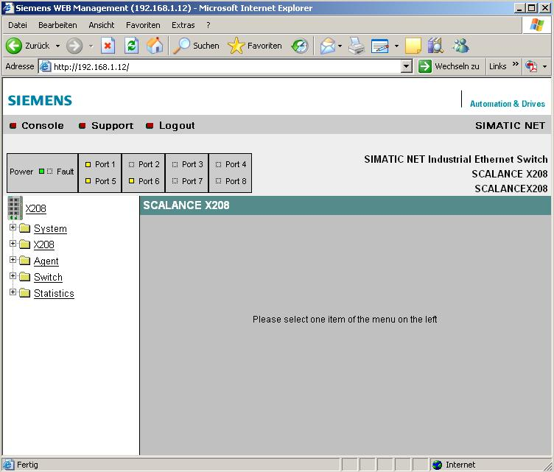

10. In the menu ’System’ configuration, system information is provided for your switch and you can make basic settings. For example, you can set the passwords.
(→ System → Passwords)

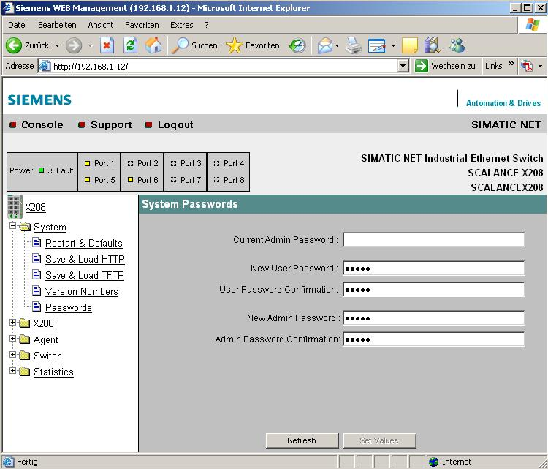

11. In the menu ’X208’ you are provided with information about error status, redundant voltage supply, ring redundancy and C_PLUG. (→ X208 → Fault Mask)
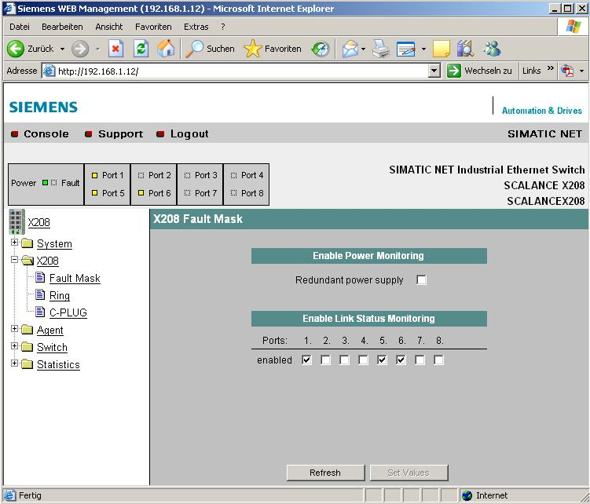

12. In the menu ’Agent’, you can change the IP address, activate the access options to the switch by means of SNMP, DHCP, TELNET and specify the reaction of the device to system events. The SCALANCE X208 can send Emails or activate SNMP traps.
(→ Agent)

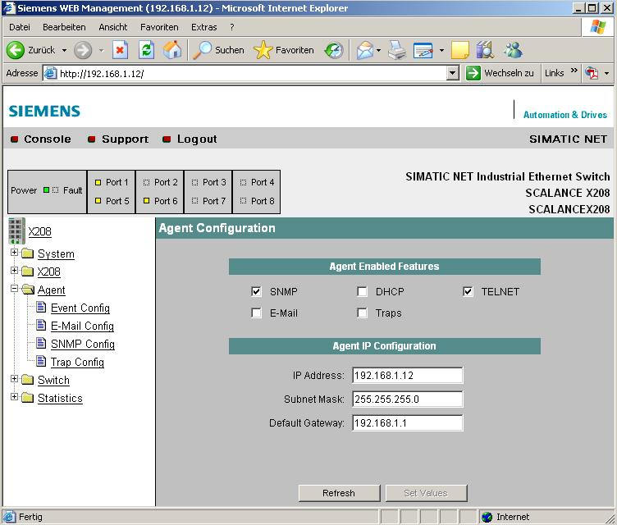

13. In the menu ’Switch’, you can enable or disable mirroring a mirror port on the Monitor Ports. In that case, only the monitoring device should be connected to the monitor port. In addition, you will see the current status of the ports in the submenu ’Ports’.
(→ Switch → Ports)

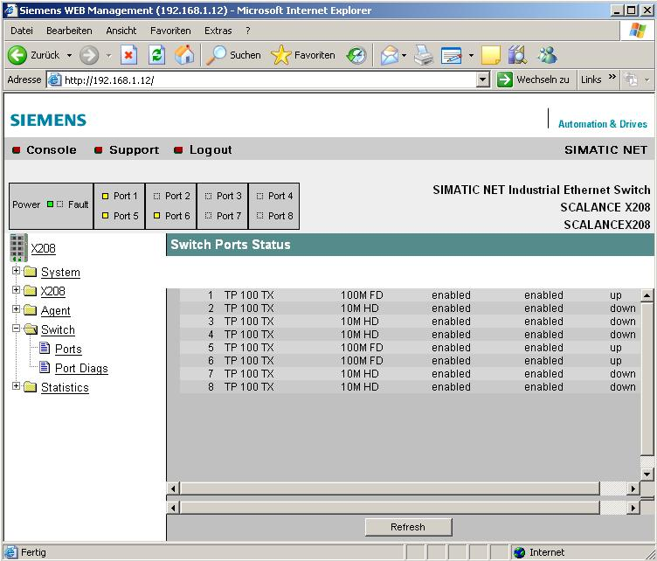

14. In the submenu ’Port Diags’ of the menu ’Switch’, open circuits as well as short circuits can be located. To this end, each individual port can perform an independent error diagnosis at the cable. This test is permissible only if no data connection has been established on the port to be tested.
(→ Switch → Port Diags)

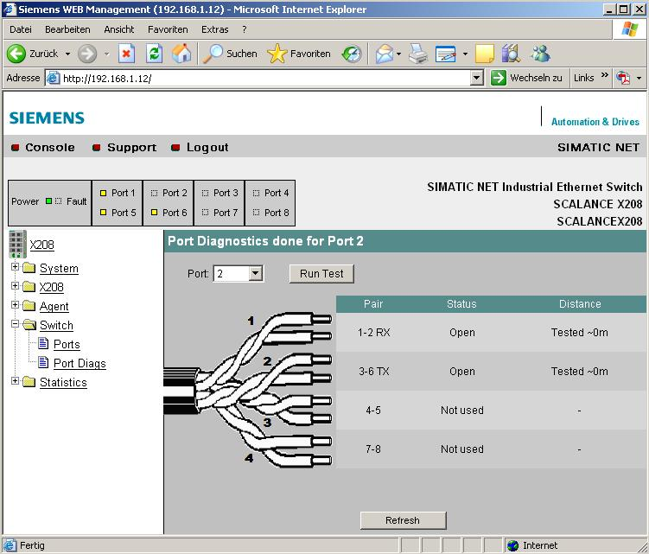

15. In the menu ’Statistics’, statistical information is provided about the type and number of received telegrams, and about transmission errors.
(→ Statistics)

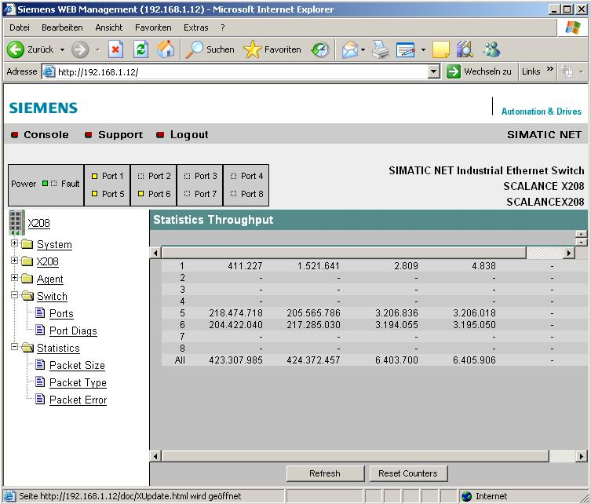

Note: Additional information about the SCALANCE X208 is provided in the Start Up manual
"SCALANCE Industrial Ethernet SCALANCE X-100 and SCALANCE X-200 Product Line“
07/2005
A5E00349864 Version 4

