8. DEBUG- and Diagnostic functions

8.1 Monitoring of the sequencer

The function block can be tested with S7-GRAPH. After the opening of the FBs, the step by step execution can be watched e.g. with the function Monitor.

It displays the signal state of the input and output variables. The active steps can be recognized in color.

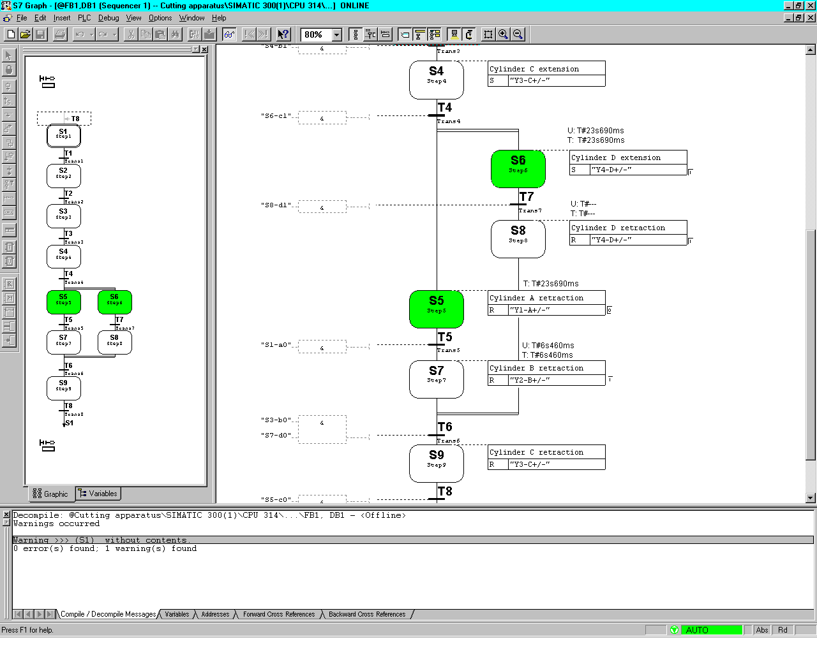

8.2 Variable Monitor/Modify
Under the menu PLC, you will find the program to observe and modify variables. After the generation of a variable table and the adjustment for the trigger, one can intervene in the running process in order to carry through with debugging functions.
8.3 Control sequencer

In the menu Debug, you will find the debug function Control Sequencer, with which the S7-GRAPH sequential control system can be debugged in all operation types. All inputs and adjustments of the dialog boxes operate themselves like the according FB-Parameters.
The entries in the Sequencer Control dialog box can vary from the settings which you used to compile the sequencers. The settings that are dealt with here have priority over the other settings that were set by the compilation of the sequence.
To be able to make modifications, the mode selector on the CPU must be set to the RUN-P position.

Adjustment of the Operation Type
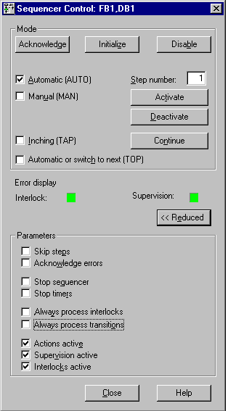
Through the activation of one of the round options‘ field, you can switch the running sequence into the chosen operation type. So you could let e.g. your sequencer run in automatic or manual mode. In manual mode, you can activate or deactivate each and every step.
Proceed to the following measures:

1. Queue the step number of the step in which editing will be done in the box “Step Number” or simply click on the desired step.
2. Choose the action that should be followed through with this step:
- Enable: The chosen step is activated when the previous step is not accomplished.
- Disable: The chosen step is deactivated.

Note that you must deactivate the present active step before activating a step since in a linear sequence only one step should be active. You can activate the desired step only if the current active step is deactivated. If a new mode of operation is set, the original mode of operation is marked by bold print. After you control a sequence in manual mode, you can return to automatic mode and close the dialog box “Sequencer Control.“

If the command button “More“ is activated, then additional parameters can be controlled.
8.4 Synchronization

S7GRAPH helps you locate possible synchronization points between the process and sequencer. A process is no longer synchronized, if it is manually brought into another condition. This can, for example, be the result when you change to manual mode in which you can activate any step even if the previous transition is not satisfied. To be able to continue the process automatically and to locate possible synchronization points, you can start the synchronization function. S7-GRAPH indicates all steps that meet the following conditions:

The transition before the step is satisfied and the transition following the step is not satisfied.

8.4.1 Requirements
The sequencer is being controlled in manual mode.

-. The block is complied with the Option "Synchronization".
(You can find this option in the tab "Compile/ Save"
in the menu under Block Settings).

    - Starting synchronization

Follow the following measurements, in order to let synchronization run:

1. Select the menu command Debug, Synchronization.
S7-GRAPH now searches for all steps that meet the synchronization condition
(transition before the step is satisfied and transition after the step is not
satisfied). All steps found are marked yellow.
2. Select one or more of these steps to be selected using the mouse pointer that
changes to a crosshair. You can also select other steps that are not marked
yellow.
3. Activate the selected steps with the command button "Activate".
4. Now switch the sequencer back to automatic mode.


Note
In a simultaneous branch, each path must contain a step to be activated.

8.4.3 Synchronization run through and activating a new step


1. Highlight the step with the mouse.
2. Click Activate.

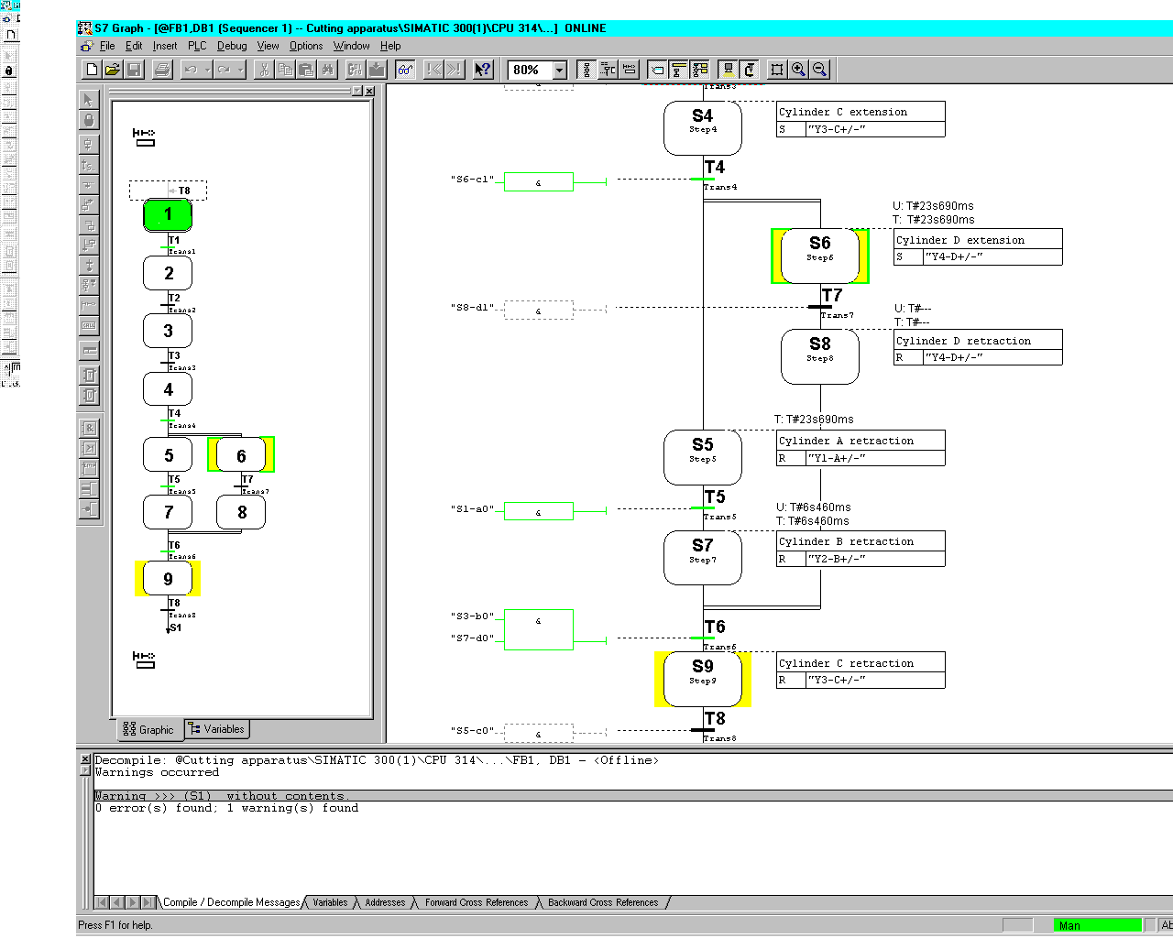

Only the chosen step is now active. Previously activated steps(e.g. Step S1) are deactivated.

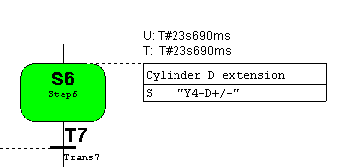
Note
Since Step S6 is found in a simultaneous branch, Step S5 or Step S7 must also be activated in addition.(When they are not highlighted yellow).
In order to follow through with synchronization, the CPU switch must be in the position RUN-P.
8.5 Diagnostic functions

The following diagnostic functions are available for further analysis of the sequential
control system. Please note, however, that not all the functions available provide
information about an S7-GRAPH sequential control system:

-· Query the module state
-· Query the operating mode
-· Evaluate CPU messages
-· Create reference data
-· Create process diagnostic data.

These functions provide you with further methods of debugging and supply important information about the use of blocks and addresses. You can also select these test functions directly in the SIMATIC Manager.

Note
If you require more detailed information about these topics, view the help texts
relating to the menu commands in the SIMATIC Manager.

8.5.1 Querying module information and the operating mode
In the menu PLC under Operation Mode, you can request different information about the modules.
As additional information on the sequential control system, the content of the diagnostic buffer and the current utilization of the work and load memory can be particularly interesting.
You can, for example, find out the reasons for errors using the Diagnostic Buffer
and Stacks tabs. With the menu command PLC under Operating Mode, you can query and modify the current mode of your CPU, for example restart.

8.5.2 Evaluating the diagnostic buffer
If the option Messages with WR_USMSG (SFC52) is set in Options under Block Settings in the register Messages, S7GRAPH enters the following messages into the diagnostic buffer.

-· Interlock errors entering/leaving state

-· Monitoring errors (execution errors) entering/leaving

From the detailed information about the message, you can find out where the error occurred.

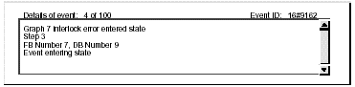

8.5.3 Evaluating the CPU messages
In the SIMATIC Manager, you can use the menu command CPU Messages under PLC to display event and alarm messages.

8.5.4 Displaying reference data
To test the sequential control system, you can call up a variety of reference data.
You create the reference data as follows:

When you save the FB, reference data is created if you have selected this function in the "General" tab which you can display with the menu command Application Settings under Options. The "Generate Reference Data" option must be selected. With the menu command Reference Data under Options, the reference data is created when required. Following this, S7-GRAPH calls the STEP 7 dialog box to display the reference data.

The following table shows the information available:
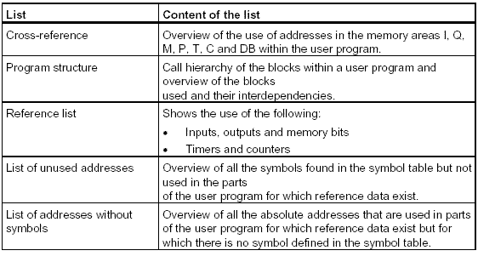
If the reference data Program Structure or Cross-Reference List are displayed, you can jump to the point in the user program at which a selected block or addresses is used.

8.5.5 Generating diagnostic data
Diagnostic data is generated when you save the FB if you select the Generate PDIAG Data option in the General tab of the Application Settings dialog box. You must also select the Message with ALARM_SQ/ALARM_S option in the Messages tab of the Block Settings dialog box.

8.5.6 Updating diagnostic data after the rewiring
If you have modified addresses in the SIMATIC manager using the menu command Rewire, and the addresses are also used by the sequencer, the corresponding diagnostic data is only updated when you open the corresponding S7-GRAPH FB again and save it.

9. Development of the cutting apparatus with additional marginal conditions

The working execution of the cutting apparatus is already present as a S7-GRAPH sequential control system. Here the extended functions from S7-GRAPH should be obtained through a modification of tasks with additional marginal conditions.

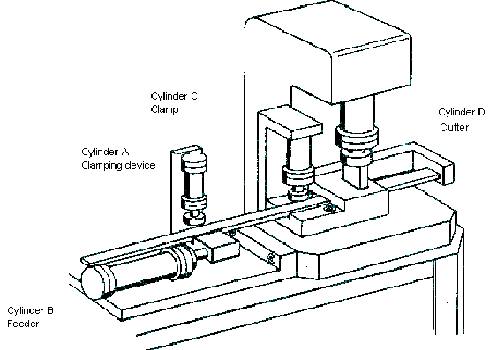

9.1 Description of the marginal conditions

- Options between “Automatic“ or “Manual“. One switches from automatic to manual in the current cycle, then the control stays in execution. After restarting in automatic mode, the cycle runs further only after the Start-button was activated.
- With the pre-selection of “Automatic“, the option between “Single Scan“ or “Continuous Scan“ exists. The continuous scan should be deleted through a switch to a single scan. An already started cycle runs to completion. Start follows by the activation of the Start-button.
- By the option “Manual“, the control can be adjusted over an Adjust-button into the initial state. With the Start-button, it is possible in manual mode to clock through the control step by step.
- The shaped material is scanned over a limit switch. If the rod material is at it‘s end, the cutting apparatus must halt in the initial state and the continuous cycle must be interrupted. After inserting new material, the control can be newly started through the activation of the Start-button.
- By power failure and recovery, the system should not automatically run further, but must be started once again through the starting signal.
- After the activation of the Emergency Stop-button, the system should halt. A new start is only possible after the cutting apparatus was adjusted in the initial state.
- The operation type “Manual“, “Automatic“, “Continuous Scan“ and “Emergency Stop“ should be displayed over the indicator lights H1 through H4.
9.2 Assigning the signal elements

I1.1 MAN/AUTO Manual-Automatic switch Signal 1 = Automatic operation mode
I1.2 SS/CS Single Scan-continuous Scan switch Signal 1 = Continuous Scan
I1.7 EMSTOP Emergency Stop-button (NC) Signal 0 = Emergency Stop
I1.6 ADJUST Adjust-button
I1.3 PART Material type
I1.0 S0-Start Start-button
I0.0 S1-a0 Limit switch cyl. A retraction
I0.1 S2-a1 Limit switch cyl. A extension
Normally Open
I0.2 S3-b0 Limit switch cyl. B retraction
I0.3 S4-b1 Limit switch cyl. B extension
I0.4 S5-c0 Limit switch cyl. C retraction
I0.5 S6-c1 Limit switch cyl. C extension
I0.6 S7-d0 Limit switch cyl. D retraction
I0.7 S8-d1 Limit switch cyl. D extension

9.3 Assigning the work elements and indicator lights

Q4.0 Y1-A+/- Valve for cylinder A ext/ret
Q4.1 Y2-B+/- Valve for cylinder B ext/ret
Q4.2 Y3-C+/- Valve for cylinder C ext/ret
Q4.3 Y4-D+/- Valve for cylinder D ext/ret
Q4.4 H1-Man Indicator light for manual operation mode
Q4.5 H2-Auto Indicator light for automatic operation mode
Q4.6 H3-CS Indicator light for continuous scan
Q4.7 H4-EM Indicator light for emergency stop

Note
First add the symbol table in your S7-Project “Cutting apparatus“.
9.4 Inserting marginal conditions in the control problem
S7-GRAPH offers the possibility of generating function blocks with additional variables in the block settings through the changing of the FB parameters. With the help of these functional modules, it is possible to activate all functions of the sequencer control over input signals. Over output variables different states of the sequencer can be displayed. Besides these conditions, interlocks and supervisions can be programmed in the single step representation. Interlock and supervision errors are registered in the diagnostic buffer of the CPU and can be displayed by requirement. With the help of these additional functions, a safe execution of the sequencer is ensured. In this way nearly all marginal conditions of the cutting apparatus are programmable.

5 Hierarchy of the control conditions

For the programming of the demanding marginal conditions, priority order should be considered. The input signals of the buttons and switches cannot often be directly used, because they allow themselves to be affected only under certain conditions (e.g. manual operation mode).

The priority rank and the posed conditions are as follows:

1. “Emergency Stop“ (Running circuit)

In electronics, the entire system is usually shut down with the occurrence of an emergency stop signal. This has achieved success in use of pneumatic power components, because of the compressibility of air and rarely missing automatic locking. One is forced to regard the possible danger moments of each individual power component and to specify for each element, emergency stop conditions (e.g. a clamping cylinder should not to be made unpressurized).

For an emergency stop situation of the cutting device, consider the following statements:
- The program must be immediately interrupted.
- The sequencer is shut off.
- The work elements remain in their position.
- All operation types (Manual, automatic, continuous scan etc.) are functionless.
- All signal generators are ineffective.
- The emergency stop light (H4-EM) lights.
2. Operation Mode „Manual“

In manual mode, the automatic mode is ineffective and manual mode can run through the function “Adjust“. With help of the Start-button, the control can be clocked through step by step. The lamp for manual operating mode(H1-Man) lights.

3. “Adjust“
Over the Adjust-button, the system can be adjusted in the initial state. For the adjustment of the cutting apparatus, let the following states be met:
- The sequencer is initialized.
- All work elements go into the initial state.
(Cylinder C first after all other cylinders are retracted).
- Error acknowledging (when an acknowledgement requirement would be programmed).
Note
Adjust should only be possible in the operation mode “Manual“.
After an emergency stop, the system must be adjusted.

4. Operation Mode “Automatic“

In automatic operation mode, all functions of the manual operation mode are ineffective. The operation types “Single Scan“ or “Continuous Scan“ are possible. Through the activation of the Start-button, the previously written program runs through automatically. Then the automatic lamp (H2-Auto) lights.

5. Operation Mode “Single scan“

After the most recent start, the program scan cycle will run through one time and the system remains in the initial state.

6. Operation Mode “Continuous Scan“

After the most recent start, the program scan cycle repeats until a switch to single scan, or the continuous scan is deleted, or there is no more shaped material available in the cutting apparatus. Then the light for the continuous scan (H3-CS) lights.
7. “Start-button“

For the function of the Start-button, let the following states be met:
-. In manual operation mode, the sequencer clocks through step by step with the Start-button.
-. In automatic operation mode, the sequential control system will start with the Start-button.
-. The restarting of the automatic operation mode is accomplished with the Start-button.
-. The insertion of a new material rod is activated with the start signal.
-. After power failure, the control can reload into the set operation mode with the Start-button.

8. “Material Query“

The shaped material is scanned over a limit switch at the feed station. If there is no longer material available, the continuous scan is interrupted and the system runs to the end of the already begun cycle.
10. Programming of the additional marginal conditions

10.1 Opening a symbol table and adding symbols

1. In the S7-Program(1) folder, double click on Symbols.
2. Amend the symbol table.

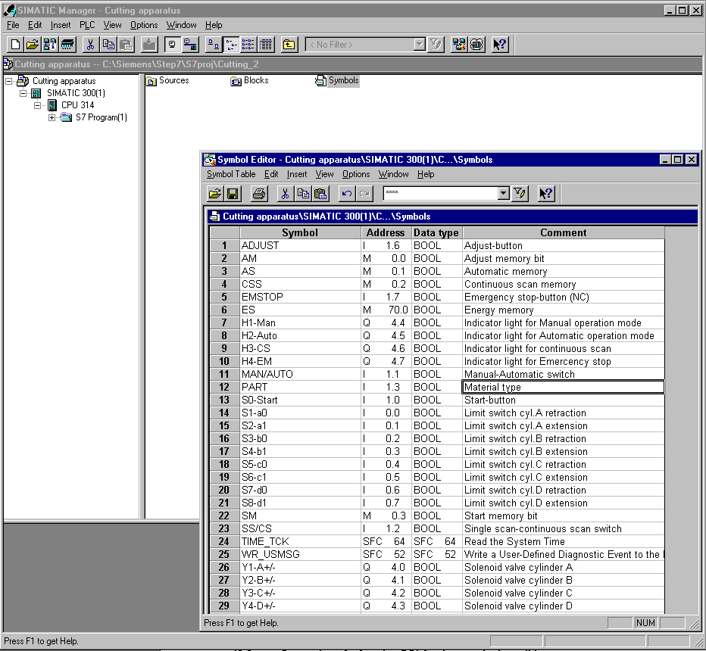

10.2 Generation of a function FC1 for the marginal conditions
Create and open an S7-Block in the SIMATIC Manager

1. Click on folder Blocks.
2. Click on menu Insert.
3. Choose S7-Block.
4. Double click on Function.
5. Choose FBD as Created in Language.
6. Click on OK.

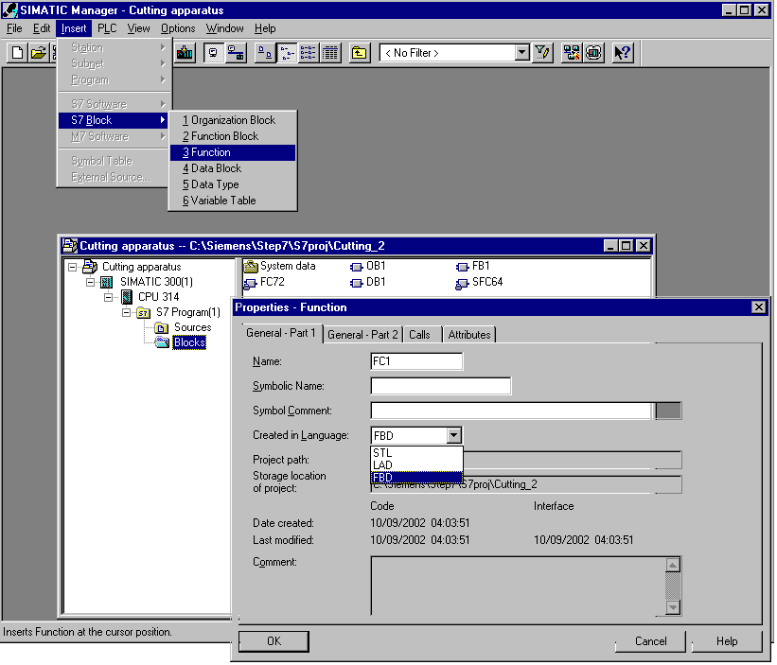

10.3 Opening function FC1 and carrying out modifications

10.3.1 Entering Network 1 and adding symbol tables
1. Double click on FC1.
2. Enter Network 1.
3. Click on M0.0 with the right mouse button and choose Edit Symbol.
4. Enter symbol and comment.
5. Click on OK.

Note
In this way addresses can be provided directly with symbols. The symbols are inserted into the symbol table automatically and are available immediately.
10.3.2 Entering FC1 control program NW1 to NW3 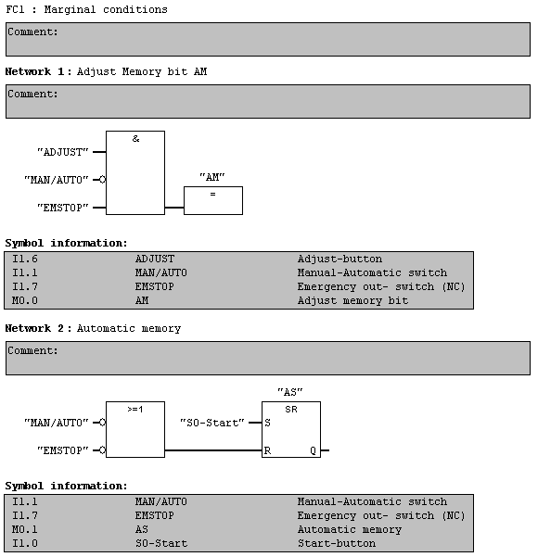
10.3.3 Entering FC1 control program NW4 to NW7
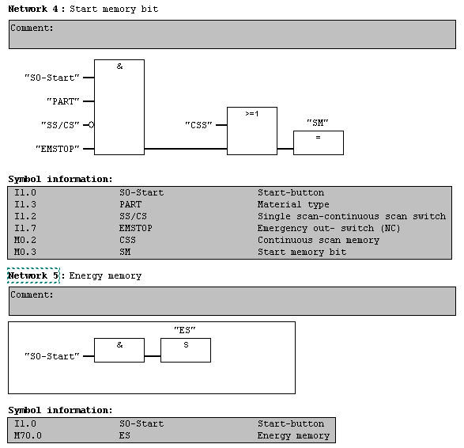
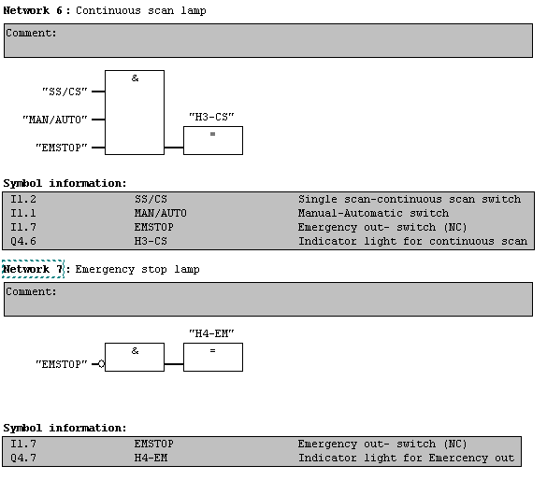
After the entry of all networks, save function FC1 and close the program window.
10.4 Opening Function Block FB1 and carrying out modifications

10.4.1 Displaying Step S1 in Single Step representation
1. Click on the folder Blocks.
2. Double click on FB1.
3. Choose Step S1.
4. Click on Single Step representation.

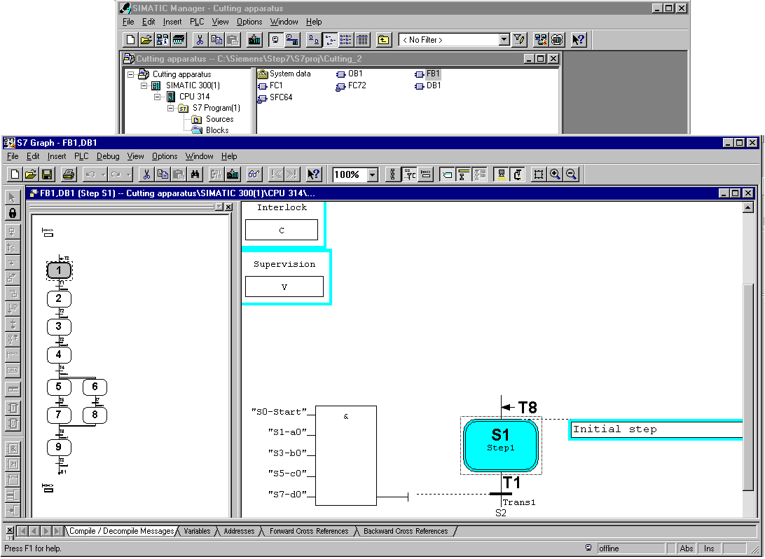
Area for Interlock
Area for Supervision

In the single step representation type, all areas are displayed in which actions and conditions can be programmed.
Interlocks and supervisions are entered here.
10.4.2 Step S1 with interlock programming
In the first step, the initial state is programmed. When adjusting the cutting device, the sequencer is initialized i.e. the initial Step S1 is activated. The work elements are to be proceeded in the output position. Note that cylinder C retracts only if all other cylinders are retracted. This condition is programmed with an interlock. An interlock is a programmable condition which affects the execution of individual actions.

1. Enter a step comment.
2. Give a condition for interlock.
3. Replace S0-Start via Start memory bit SM .
4. Insert actions.
5. Enter actions or click with the right-mouse button and select Object Properties.

This action will only be accomplished when the interlock is satisfied. The C in the step field shows a programmed interlock.
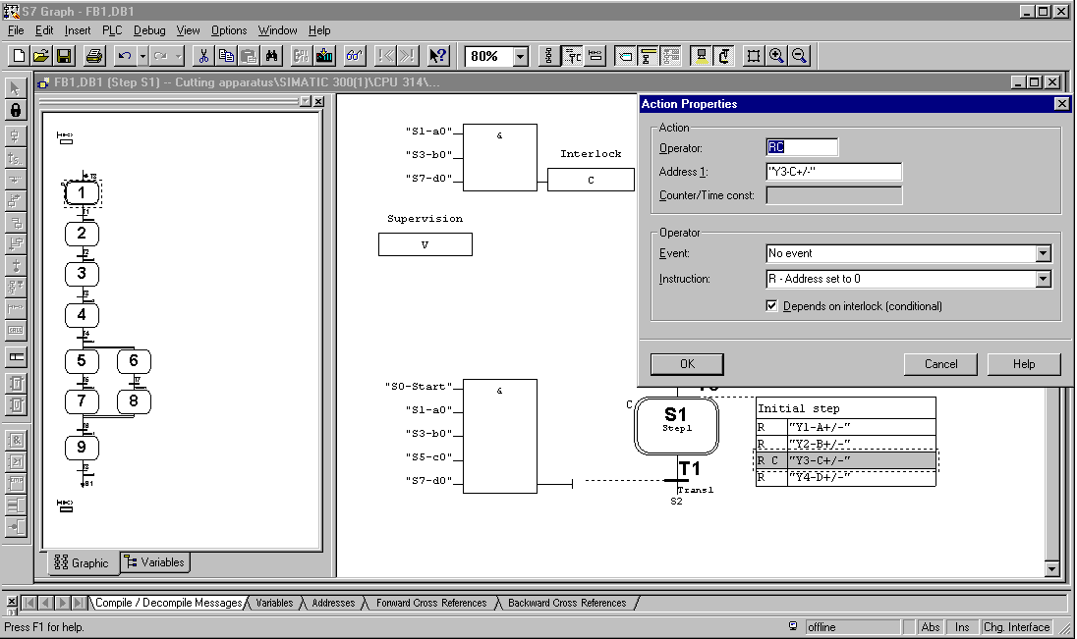

10.4.3 Step S6 with supervision programming
In the sixth step the work piece is cut. By the cutting process, the cutting tool can clamp the work piece. Here a monitoring of the step time (maximum running time of a step) is to be programmed. If this time is exceeded, then a monitoring error develops and it cannot be switched to the next step. A further switching of the sequencer is possible only if the necessary transition is satisfied and the monitoring error was acknowledged over the adjust button. These conditions are to be programmed with a supervision. A supervision is a programmable condition for step by step monitoring, which affects further switching from one step to the next.

- Choose Step S6 and enter step comments.
- Click on Step S6 and symbol Supervision V.
- Enter a time of “T#5S“.

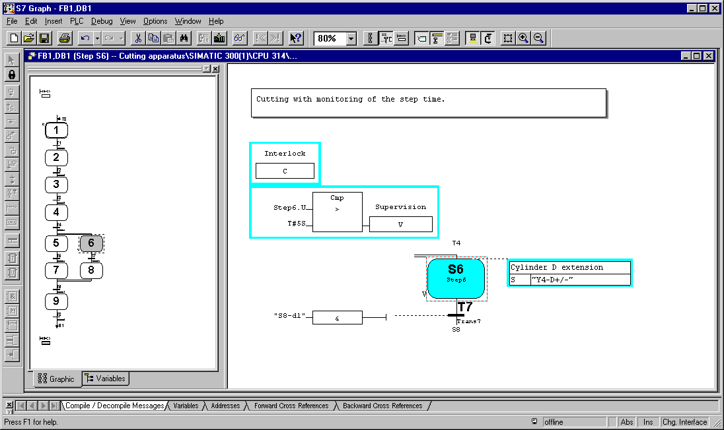

By time monitoring T, the whole step activation time will be used.
By time monitoring U, the uninterrupted step activation time will be used.
Note
In Inching mode, the step activation time must be further switched within the time monitoring.
10.5 Additional actions and results

10.5.1 Standard actions With and without interlock
All standard actions can be combined with an interlock. The actions are only
executed when the conditions of the interlock are satisfied (letter C added).

Standard actions without interlock are executed as long as the step is active.

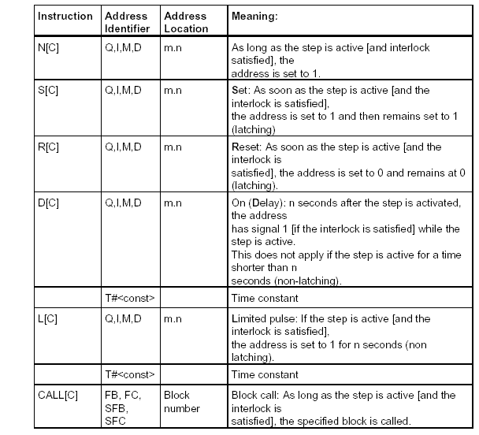
Note
All actions, which contain the operands D or L , requires a time indication. Time indications are programmed as constants with the syntax T#<const> and are arbitrarily combined.
<const>= nD (n Days), nH (n Hours), nM (n Minutes), nS (n Seconds), nMS (n Milliseconds), whereby n = number (integer values)
Example: T#2D3H: Time constants = 2 Days and 3 Hours
10.5.2 Event dependent actions

An action can be logically combined with an event. An event is the change in the
signal state of a step, a supervision or an interlock or the acknowledgment of a
message or a registration is set. If an action is logically combined with an event, the signal state of the event is recognized by edge detection. This means that the instructions can only be
executed in the cycle in which the event took place.

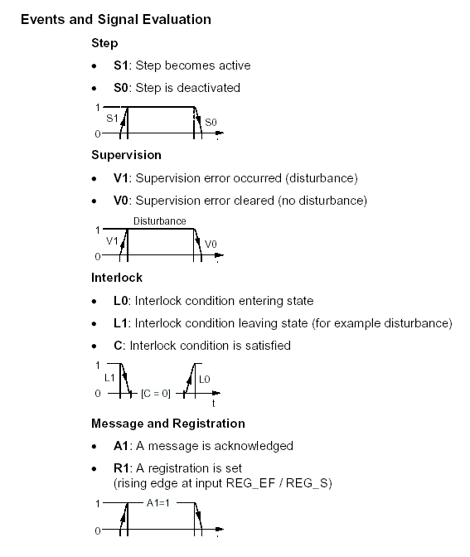

You can find a detailed description of the actions and the conditions in the S7-GRAPH manual or in the S7-GRAPH programming sequential control systems manual.
10.6 Setting block settings

The settings of the S7-GRAPH block must be changed. In Block Settings Compile/Save, a standard block with more variables is set under FB Parameters. With a standard block, the additional functions can program e.g. automatic and manual operation modes simply.

1. In the menu, double click on Options, Block Properties.
2. Set FB-Parameters to Standard.
3. Choose Acknowledge errors.
4. Click on the next tab Messages.

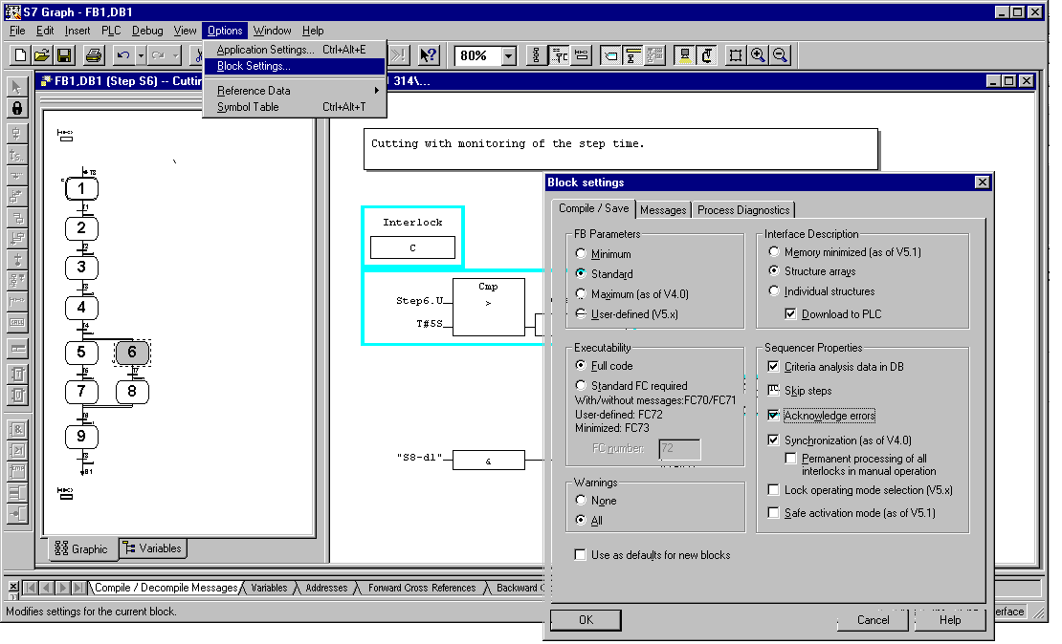

Note
Errors by monitoring (Supervision) must be acknowledged with the Adjust-button.
10.7 Accepting block settings and saving Function Block FB1
1. Choose Messages with WR_USMSG.
2. Deactivate And Send.
3. Click on OK.
4. Save and update block.
5. Close S7-GRAPH.

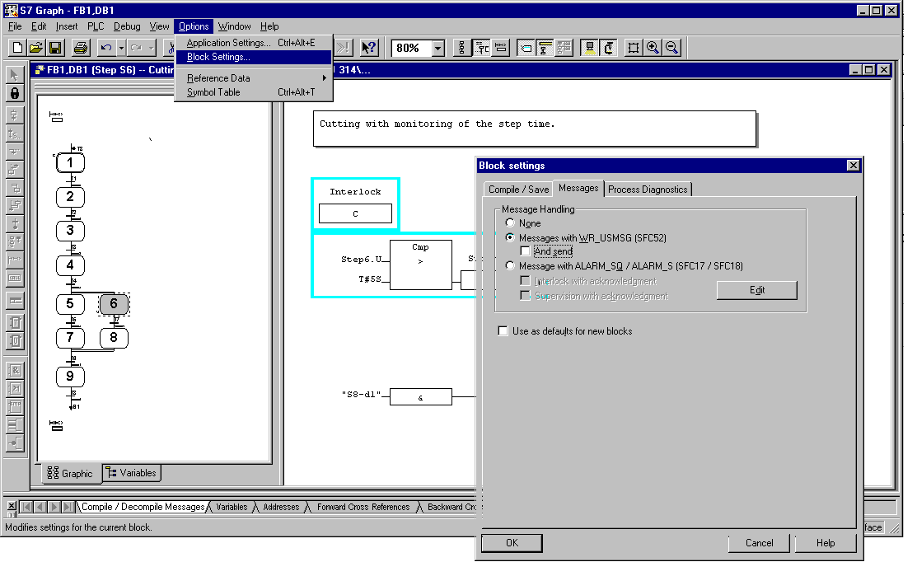
Note
With the setting „Messages with WR_USMSG“, the SFC52 is created. With this block, the error messages from interlocks and supervisions are inserted into the diagnostic buffer of the CPU .
With the function “Send“, the messages are also sent to other network nodes e.g. OP´s sent.

10.8 Organization Block OB1 modification

10.8.1 Opening OB1
1. Click on folder Block .
2. Double click on OB1.
3. Activate message with OK.

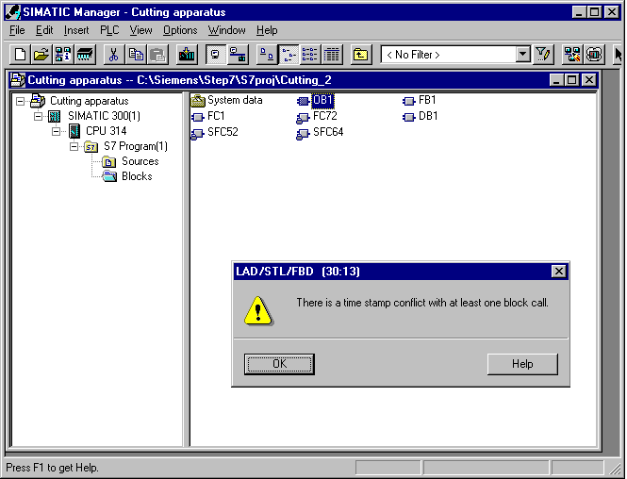

4. Click on block call in Network 1 and delete it.
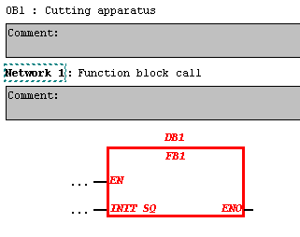
Note
The block call no longer complies with FB1. So, a new block call in OB1 must be programmed.
10.8.2 Editing OB1, entering network 1

1. Call FC1 in Network 1.
2. Call FB1 in Network 2.
3. Enter network headings for NW1 and NW2.

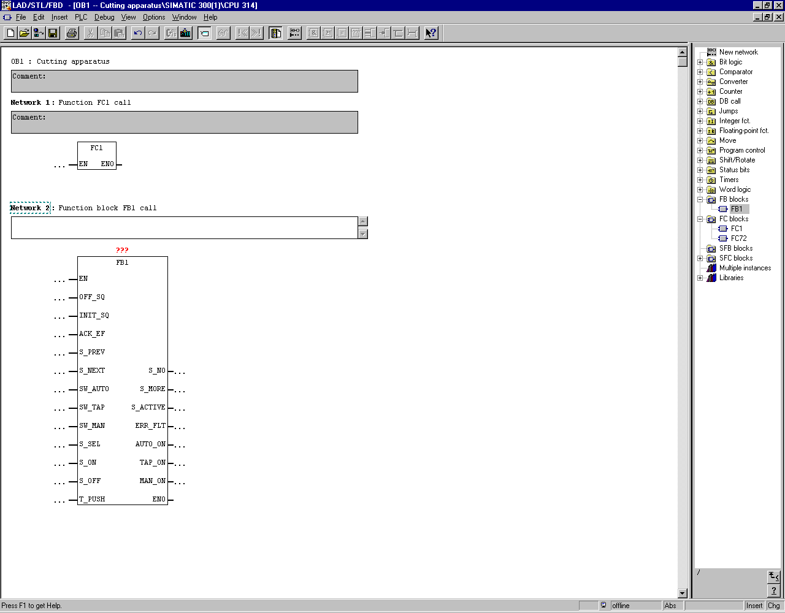

Note
The function block FB1 is now provided with standard parameters. Thus additional functions are programmable with the program call. However all parameters do not have to be programmed.

The advantage with the calling of blocks in the FBD is that logic functions can still be programmed before the parameters.

10.8.3 Network 2, entering parameters by the call of FB1

1. Enter DB1.
2. Enter parameters of the FB1.
3. Save OB1.
4. Close LAD/STL/FBD.

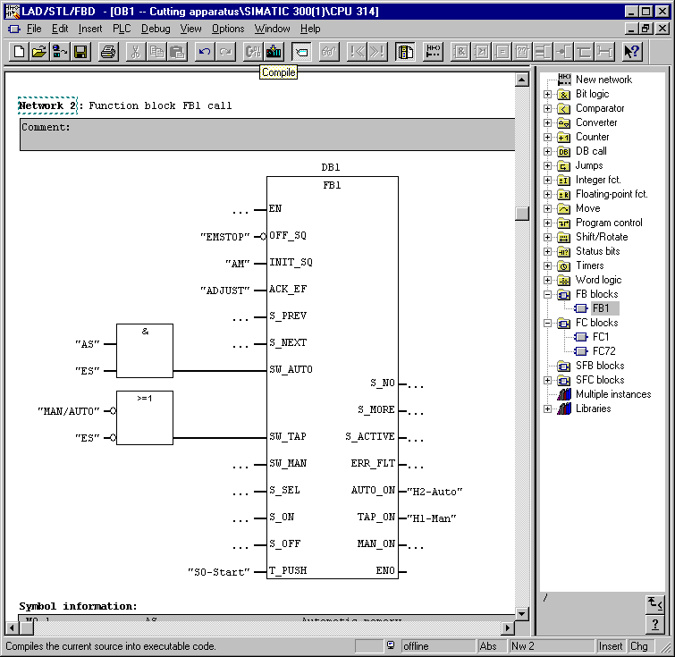

The allocation of the input parameters for automatic and inching mode. 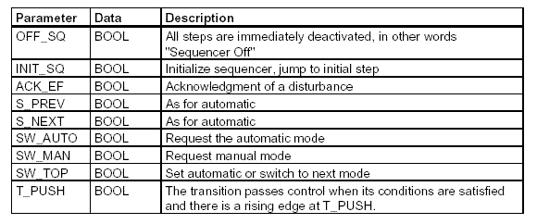
10.9 Transfer of the program into the module

1. Choose the folder Blocks.
2. Click Download.
3. Click on All.

It will transfer all blocks into the CPU. The CPU should be found in the operation mode STOP.

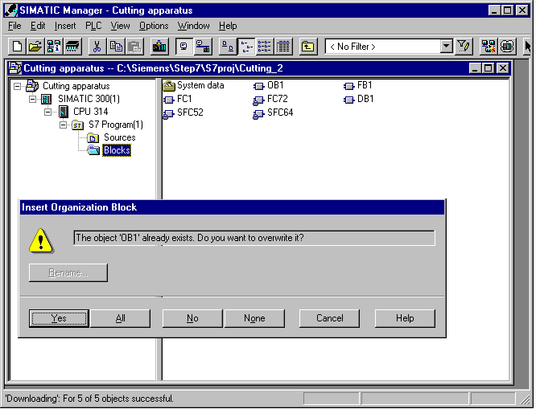

Note
After the transferring of the automation equipment into the CPU, the cutting apparatus can be debugged with the required marginal conditions.

The debug and diagnostic functions are explained in chapter 8.

11. Parameters of the S7-GRAPH-FB

11.1 Parameter sets of the FB
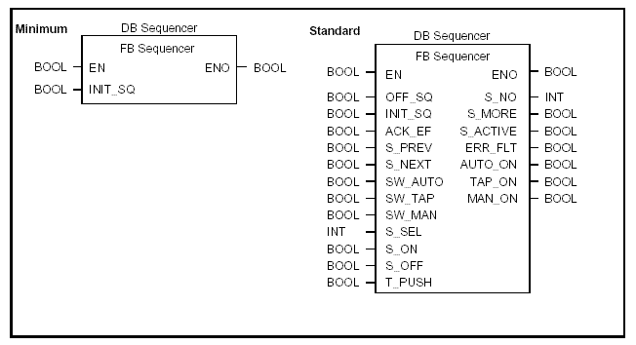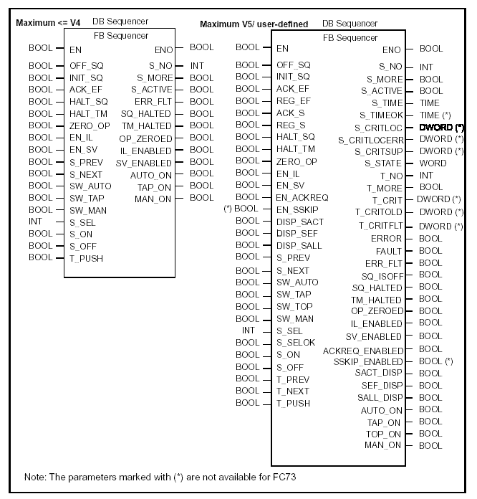

11.2 Input parameters of the S7-GRAPH-FB
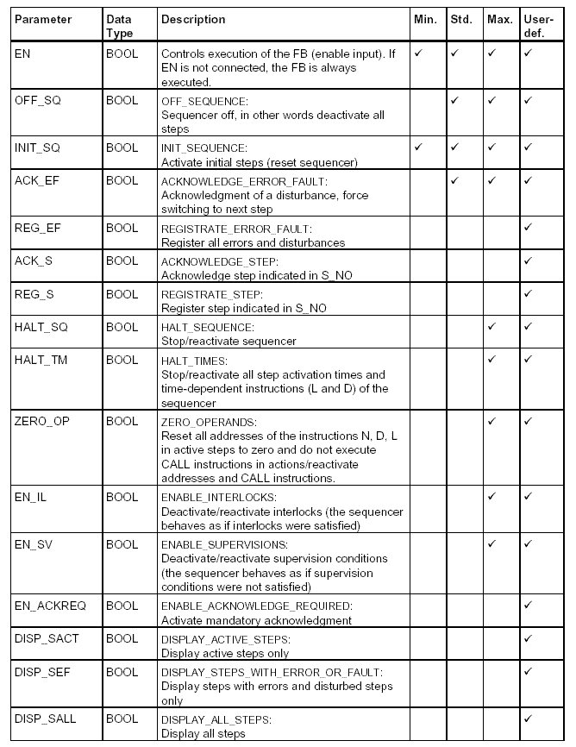
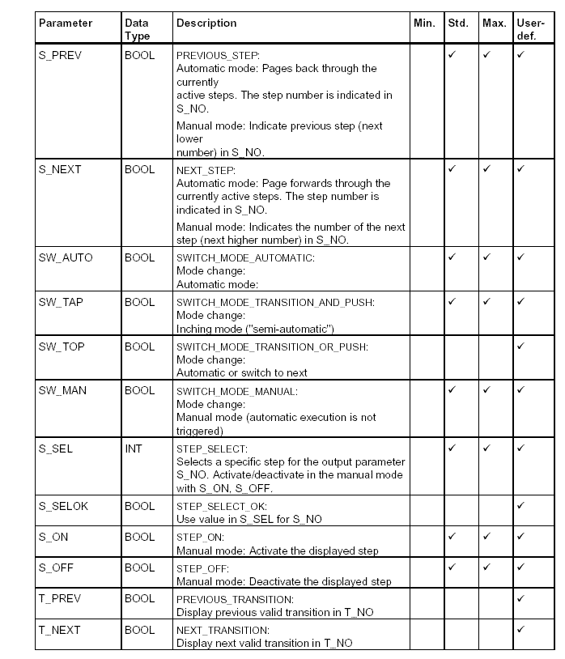
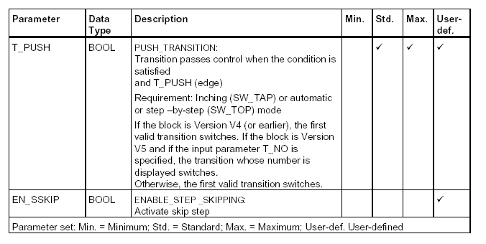

11.3 Output parameters of the S7-GRAPH-FB
