Training document for the company-wide
automation solution
Totally Integrated Automation (T I A)

MODULE C1
Step sequence programming with S7-GRAPH

This document was provided by Siemens A&D SCE (automation and drive technology, Siemens A&D Cooperates with Education) for training purposes. Siemens does not make any type of guarantee regarding its contents.

The passing on or duplication of this document, including the use and report of its contents, is only permitted within public and training facilities.

Exceptions require written permission by Siemens A&D SCE (Mr. Knust: E-Mail: michael.knust@hvr.siemens.de). Offences are subject to possible payment for damages caused. All rights are reserved for translation and any case of patenting or GM entry.

We thank the company Michael Dziallas Engineering and the instructors of vocational schools as well as further persons for the support with the production of the document.

PAGE:

1. Forward 6

2. Notes for the Operation of S7-GRAPH 8

3. Installation of the S7-GRAPH Software 8

4. Sequential Control Systems 9
4.1 Time-dependent sequential control system 9
4.2 Processor-dependent sequential control system 10

5. Display Possibilities of Motion Executions and Signal States 11
5.1 Description of the control tasks 12
5.2 Inscription in chronological order 13
5.3 Table mode 13
5.4 Short representation 13
5.5 Motion chart 14
5.6.1 Path-step chart 14
5.5.2 Path-time chart 14

6. Development of a Cutting Apparatus 15
6.1 Assignment of the signal elements 15
6.2 Assignment of the work elements 15
6.3 Function chart in DIN 40719 Part 6 15
6.4 Function chart of the cutting apparatus 16

PAGE:

7. Generation of an S7-GRAPH Program 17
7.1 Starting SIMATIC- Manager and generating a new project 17
7.2 Inserting a SIMATIC 300-Station and opening hardware configuration 18
7.3 Configuring hardware and transferring in automation equipment 19
7.4 Generating a symbol table and inputting symbols 20
7.5 Entering a S7-GRAPH Function Block 21
7.6 Opening S7-GRAPH and inputting sequencers 22
7.7 The principle of a sequencer 23
7.8 Active step 23
7.9 Elements of a sequencer 23
7.10 Generation of a sequencer in the function chart 24
7.11 Setting characteristics of the Organization Block and opening OB1 33
7.12 Editing Organization Block OB1 and downloading blocks into a module 34

8. Debug- and Diagnostic Functions 35
8.1 Monitoring of the sequencer 35
8.2 Variable Monitor/Modify 35
8.3 Control sequencer 34
8.4 Synchronization 37
8.5 Diagnostic functions 39

9. Development of the Cutting Apparatus with Additional Marginal Conditions 44
9.1 Description of the marginal conditions 41
9.2 Assignment of the signal elements 42
9.3 Assignment of the work elements and indicator light 42
9.4 Insertion of marginal conditions in the control program 43
9.5 Hierarchy of the marginal conditions 43
PAGE:

10. Programming of the Additional Marginal Conditions 45
10.1 Opening a symbol table and adding symbols 45
10.2 Generation of a function FC1 for the marginal conditions 46
10.3 Opening function FC1 and entering networks 47
10.4 Opening Function Block FB1 and carrying out modifications 50
10.5 Additional actions and results 53
10.6 Setting block settings 55
10.7 Accepting block settings and saving Function Block FB1 56
10.8 Organization Block OB1 modification 57
10.9 Transfer of the program into the module 60

11. Parameters of the S7-GRAPH-FB 61
11.1 Parameter sets of the FB 61
11.2 Input parameters of the S7-GRAPH-FB 62
11.3 Output parameters of the S7-GRAPH-FB 65

The following symbols stand for the specified modules:


Information

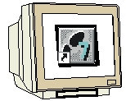
Programming


Notes

1. FORWARD
The module C1 is assigned content wise to Sequencer programming.

Basics of

STEP 7- Programming
2 - 3 days A modules
Industrial field bus
systems
2- 3 days D Modules
Additional functions of
STEP 7- Programming
2- 3 days B modules
Process
visualization
2- 3 days F modules
Sequencer
programming
2- 3 days C modules
IT- Communication
with SIMATIC S7
1- 2 days E modules

Learning goal:

In this module, the reader will learn the programming of a sequential control system with the graphic programming tool S7-GRAPH. The module shows the principle procedure in the following steps by means of a detailed example.

• Installation of the software
• Performance of types from the sequential control system and the representation possibilities from movement sequences, switch states, signal flow and motion charts.
• Generation of a simple movement execution displayed as a path step chart and as a
function chart by means of a programming example.
• The pertinent sequential control system is examined as a sequencer program in S7-GRAPH.
With the help of the debug- and diagnostic functions, the mode of operation of the generated program can be checked.
• Through a modifier of the task position with additional marginal conditions, further functions from S7-GRAPH are arranged .

Requirements:

For the successful use of this module, the following knowledge is assumed:
• Knowledge in the use of Windows 95/98/2000/ME/NT4.0
• Basics of PLC- Programming with STEP 7 (e.g. Module A3 – ‘Startup’
PLC- Programming with STEP 7)

Required hardware and software

1 PC, Operating system Windows 95/98/2000/ME/NT4.0 with
- Minimal: 133MHz and 64MB RAM, approx. 65 MB free hard disk space
- Optimal: 500MHz and 128MB RAM, approx. 65MB free hard disk space
2 Software STEP 7 V 5.x
3 Software S7-GRAPH V5.x
- MPI- Interface for the PC (e.g. PC- Adapter)
- PLC SIMATIC S7-300 with at least one digital in- and output module. The inputs must be lead through a functional unit.
Example configuration:
- Power supply: PS 307 2A
- CPU: CPU 314
- Digital inputs: DI 16x DC24V
- Digital outputs: DO 16x DC24V / 0.5 A
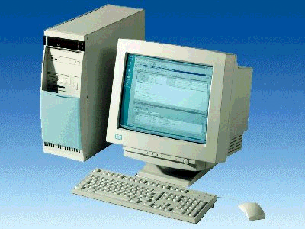
1 PC
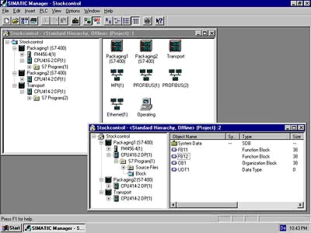
2 STEP 7

4 PC Adapter

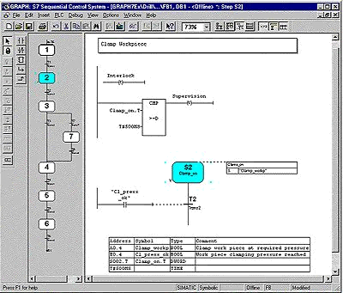
3 S7-GRAPH

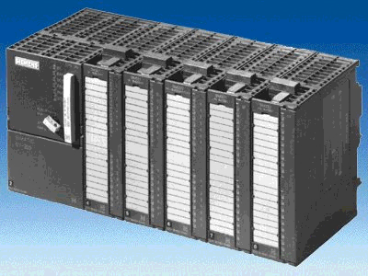
5 SIMATIC S7-300

2. notes for the operation of S7- GRAPH
With the programming language S7-GRAPH, the function range of STEP 7 is extended to a graphic programming possibility for sequential control systems. With S7-GRAPH you can clearly and quickly program a sequential control system. The process is divided into single steps and the execution is plotted.
In the single steps, the required actions are specified. The continued switching conditions to the respective next step (transitions) can be provided in the programming language LAD or FBD. The programming language S7-GRAPH corresponds to the specified execution language SFC “Sequential Function Chart”. in the Norm DIN EN 61131-3 (IEC 61131-3).

With the operation of S7-GRAPH, the following should be considered:
- The software package STEP 7 professional version (not STEP 7 Mini!) is required
- The provided programs are executable on CPUs of the SIMATIC S7-300 and S7-400.
- Due to the increased storage requirement of the program’s applications, only the CPUs starting from CPU 315 are used.
- For training purposes, simple sequencers can start from CPU 314/314-IFM, as presented in this example document.

3. Installation of the S7-GRAPH software
S7-graph is an option package to STEP 7, thus it assumes that the professional version of STEP 7 is already installed on your computer. (see module A2-Installation of STEP 7 V5.x/handling of authorizing). S7-graph is delivered on CD ROM with an enclosed disk, which contains an authorization, that must be transferred to the PC in order to make the use of S7-GRAPH possible. This authorization disk can also be used on another PC or can be copied in order to authorize the software. For the topic of installation and transmission of authorization, please refer to module A2 (Installation of STEP 7 V5.x/handling of authorization).

To install S7-GRAPH, please proceed to the following measures.

1. Place the S7-GRAPH CD in the CD- ROM drive.
- The setup program should start automatically. If not, it can be started by double clicking on the setup.exe executable file on the CD. The setup program will guide you through the whole installation process of the S7-GRAPH software.
- In order to use the professional version of S7-GRAPH, the software must be authorized on your computer. The files from the authorization disk must be transferred onto the PC. This process will execute at the end of the software installation. A dialog window will appear and ask you if you would like to authorize the software. If Yes is selected, the authorization disk must be inserted in order to transfer the proper files to the PC.

4. sequential control systems

A sequential control system is a controller with inevitable step by step execution, in which the further phases from a step depend on further conditions, which take place on the next planned step. The step sequence can be programmed in a special way, e.g. with jumps, loops, branches.
With S7-GRAPH, sequential control systems can be programmed, so that the step by step sequence can be very simply and quickly graphically displayed.

There are two types of sequential control systems:

4.1 Time-dependent sequential control system
By the time-dependent sequential control system, the further operating conditions are only dependent on time. For the creation of the further conditions, e.g. timers, time counters, drum controllers or CAM mats with a continuous number of revolutions can be used.

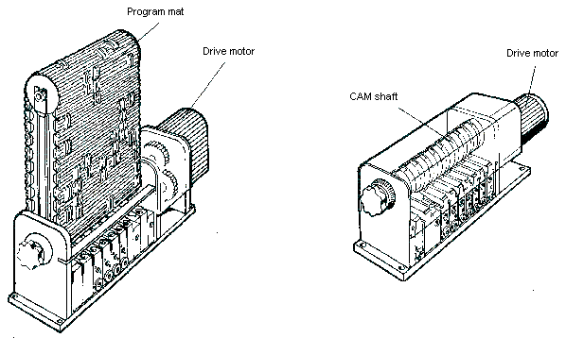

4.2 Processor-dependent sequential control system
By the processor dependent sequential control system, the further operating conditions are only dependent on the signals of the controlled system. For the creation of the signals, signal element like a limit switch, switch, button or sensors can be used. The required signals can also be operated on with timer functions.

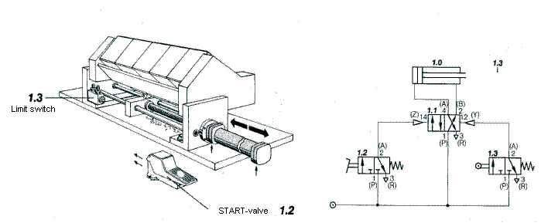

Cutting apparatus

With operation of the start-valve, the cylinder of the cutting apparatus extends. After reaching the front end position, the limit switch is actuated and the cylinder automatically retracts.

5. Display possibilities of motion execution and signal states
Cooperating work and control elements can be clearly pointed out through suitable representation possibilities. Even with the sophisticated setting of tasks, the connections are still recognized as fast and safe. Besides a simple representation of motion executions and switch states, it also makes the communication of different experts in a large framework possible.

Possible display forms of motion executions and signal states

- Description of the control tasks
The control sequence is described in the form of text.

- Inscription in chronological order
The control sequence is represented in short lines.

- Table mode
The step by step execution is queued in a table.

- Short representation
The sequence can be quickly and simply displayed by a simplified display of the motions.

- Motion chart
With help from the path-step and path-time charts, the motion execution is displayed graphically. A better overview of the connections is given.

- Function chart
A process orientated representation of the control problem. The function chart replaces or supplements the verbal description and represents a control problem with its substantial characteristics and respective applications clearly. S7-GRAPH is a programming language that basically corresponds to a function chart.

By means of a program example, the different display possibilities will be described.

5.1 Description of the control tasks
A controller for a cutting apparatus is to be sketched. With the cooperation of a supply unit and a cutting apparatus, the rod material will be shortened. The material follows through the feed cylinder (cylinder B), which moves along the pneumatic clamping device (cylinder A). If the material is pushed up against an end stopper, it is held by the clamp (cylinder C). At the same time, the cutting procedure can begin (cylinder D), and afterwards, the opening of the clamping device (cylinder A) take place. The clamping device (cylinder A) is opened so it goes back into the starting position(cylinder B). If the cutting procedure is terminated (cylinder D) and the supply unit has reached the starting position, then the clamp (cylinder C) will be opened and it can begin a new working execution. The start is released by the actuation of the START-button, if all cylinders are in the rear end position.

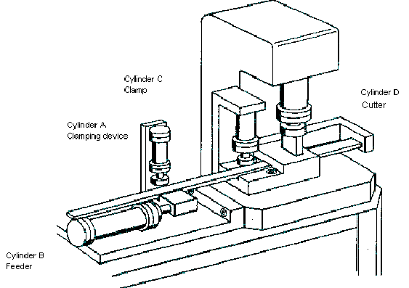

5.2 Inscription in chronological order
Cylinder A extends and closes the clamping device,
Cylinder B extends and pushes the material to the end stopper.
Cylinder C extends and clamps the rod material in the cutting apparatus.
Cylinder A retracts (the clamp device opens) and cylinder D extends (Cut),
Cylinder B retracts (the feed device returns to starting position) and cylinder D retracts,
Cylinder C retracts and opens the clamp device.

5.3 Table mode

Step | Cylinder A | Cylinder B | Cylinder C | Cylinder D
1 | Forward | - | - | -
2 | - | Forward | - | -
3 | - | - | Forward | -
4 | Back | - | - | Forward
5 | - | Back | - | Back
6 | - | - | Back | -

5.4 Short representation

For the motion sequence it is often insignificant which tasks with a movement are satisfied, so a motion sequence can also be used for many different controls. By more extensive controls, the motion sequence should first be described in short representation, since a quick overview of the movements is given here.

By short representation, movement names are assigned.

Name for the extension or forward travel of a cylinder: +
Name for the retraction or return travel of a cylinder: -

For motors, M+ can be used for moving right, M- for left and M* for stop.
Parallel movements are written in short representation.

For our program example short representation is represented as follows:

A- B-
A+ B+ C+ D+ D- C-
5.5 Motion chart

5.5.1 Path-step chart
Here the working execution of a work element is represented and as a function of the respective steps (step: A change of the condition of any physical unit), the setback way is applied. If several work elements are available for a control, then they are represented in the same way and drawn one under another. The relation is produced by the steps. With the path-step chart, the distance of the step lines is always alike. Additionally the signal lines can be registered into the path-step chart.

AND-
Operation Binary signal
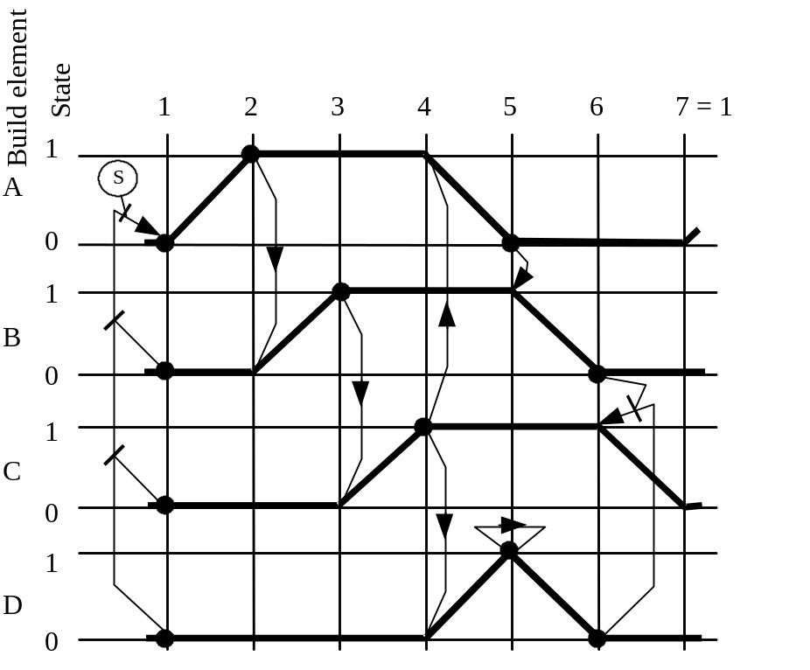
Step line
State line
Function line
Signal line
Limit switch
For our example, the path step-chart appears in the following dimensions .

5.5.2 Path-time chart
The path-time chart is a path-step chart by which the additional course of the movements is essentially pointed out by a time border at the lower end of the diagram. There the duration of a movement can be read. The distance of the step lines changes depending upon the required time. The number of steps and the kind of movements remain unchanged.
6. development of a cutting apparatus

For the developing of a cutting apparatus, a function chart should be generated after the assignment of the signal elements and work elements.

6.1 Assignment of the signal elements
S0 Start-Button
S1 a0 Limit switch cyl. A retraction
S2 a1 Limit switch cyl. A extension
S3 b0 Limit switch cyl. B retraction
S4 b1 Limit switch cyl. B extension
S5 c0 Limit switch cyl. C retraction
S6 c1 Limit switch cyl. C extension
S7 d0 Limit switch cyl. D retraction
S8 d1 Limit switch cyl. D extension

6.2 Assignment of the work elements
Y1 Solenoid valve for cylinder A ext/ret
Y2 Solenoid valve for cylinder B ext/ret
Y3 Solenoid valve for cylinder C ext/ret
Y4 Solenoid valve for cylinder D ext/ret

6.3 Function chart in DIN EN 61131-3 (IEC 61131-3)
The function chart is a process orientated representation of a control problem, independent of the realization of e.g. the used equipment. It facilitates a cooperating of different technical disciplines, e.g. mechanical engineering, pneumatics, hydraulics, process engineering, electrical engineering, electronics etc.. A control problem is clearly represented with its substantial characteristics in a basic structure (step field) and with the details in a fine structure (instruction field) necessary for respective application.

Note
Since the cutting apparatus can work in two separate stations(feed station and cutting apparatus), a function chart with a simultaneous branch must be provided.
6.4 Function chart of the cutting apparatus in DIN EN 61131-3 (IEC 61131-3)
Initial step
1
S0 Start
S1 a0 cyl. A retraction
S3 b0 cyl. B retraction
S5 c0 cyl. C retraction
S7 d0 cyl. D retraction
3
4
5
6
7
8
9
S
S
2
S
Cylinder A extraction
Cylinder B extraction
Cylinder C extraction
S2 a1
S4 b1
S6 c1
cyl. A ret.
cyl. D ext.
S1 a0
S8 d1
cyl. B ret.
cyl. D ret.
S3 b0
S7 d0
cylinder C retraction
&
&
R
R
R
S
R

7. generation of an S7-Graph Program
From the function chart, an executable S7-GRAPH program will be provided.

7.1 Starting SIMATIC Manager and generating a new project
1. Click on the symbol New.
2. Give a project name.
3. Click on OK.

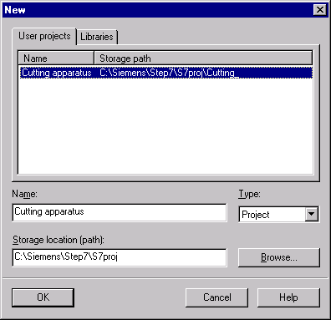

7.2 Inserting a SIMATIC 300-Station and opening hardware configuration
1. Highlight project name Cutting apparatus.
2. Click on Insert.
3. Choose a Station.
4. Click on SIMATIC 300-Station.
5. Choose SIMATIC 300(1).
6. Double click on Hardware.

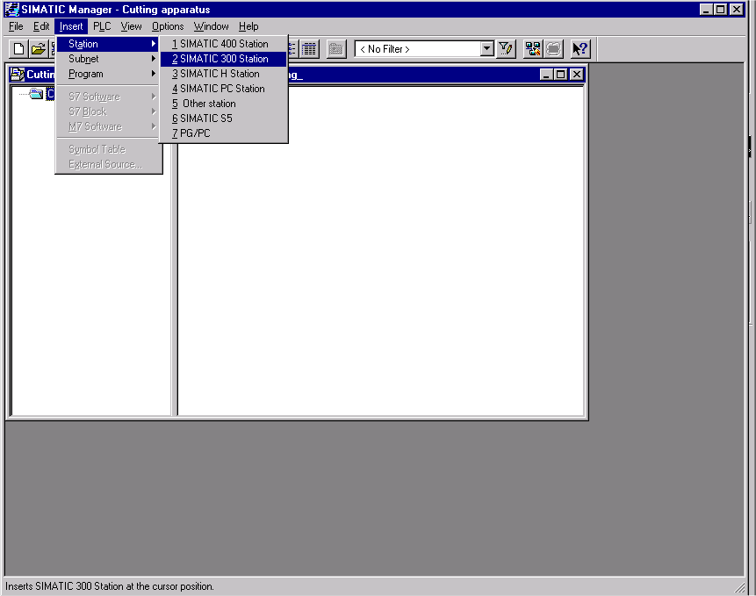

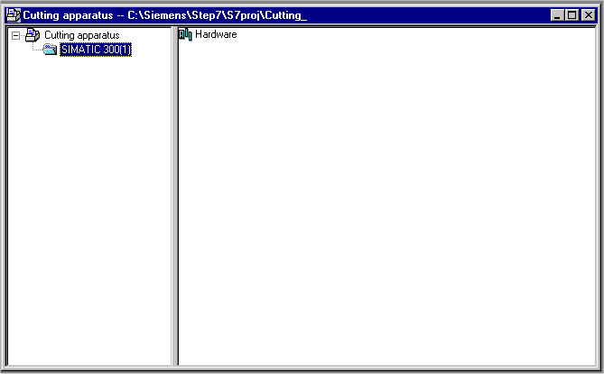
7.3 Configuring hardware and transferring in automation equipment

1. Enter hardware components.
2. Save and Compile.
3. Download hardware to Module.
4. Close window.

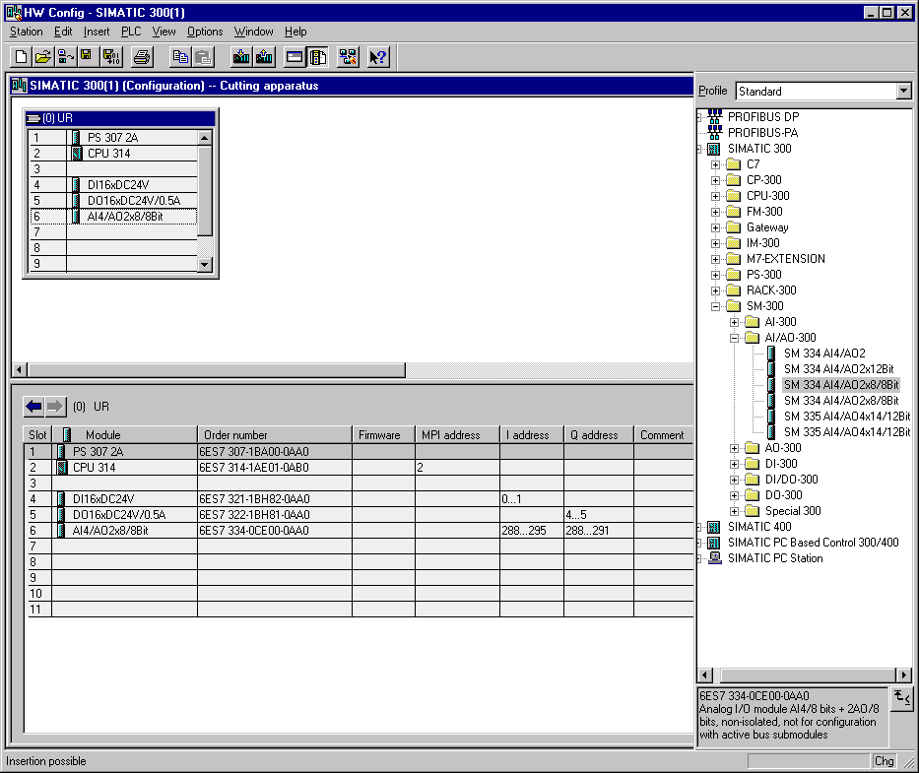

Note
The represented hardware configuration is an example.
Depending on the used automation equipment, a separate hardware configuration should be made.
7.4 Generating a symbol table and inputting symbols
1. Open CPU 314 node tree and click on S7-Program(1) .
2. Double click on Symbols.
3. Enter symbol table.
4. Save symbol table.
5. Close window.

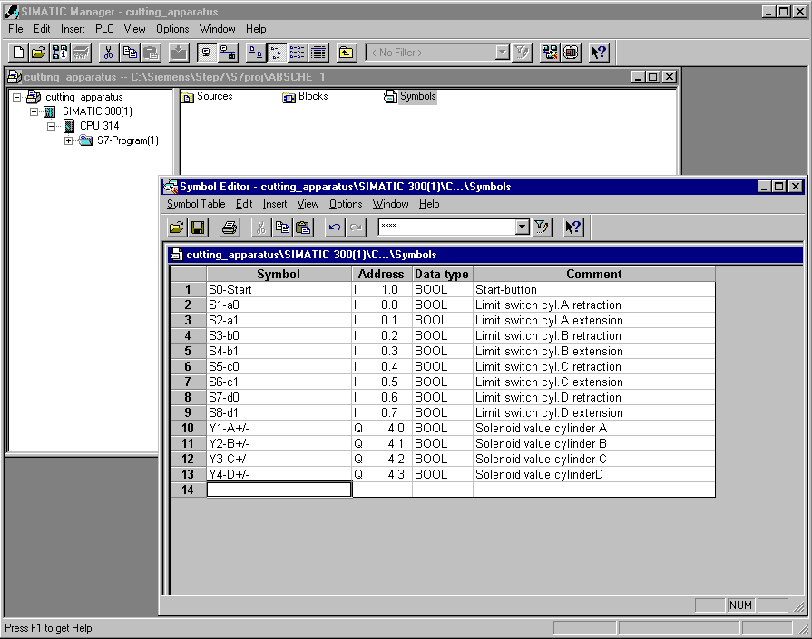

Note
The address of the operands must be adjusted to the respective automation devices.

7.5 Inserting S7-GRAPH function blocks
1. Open S7-Program node tree and click on Blocks.
2. Click on Insert.
3. Choose S7-Block.
4. Click on Function block.
5. Choose GRAPH Created in Language.
6. Click on OK.

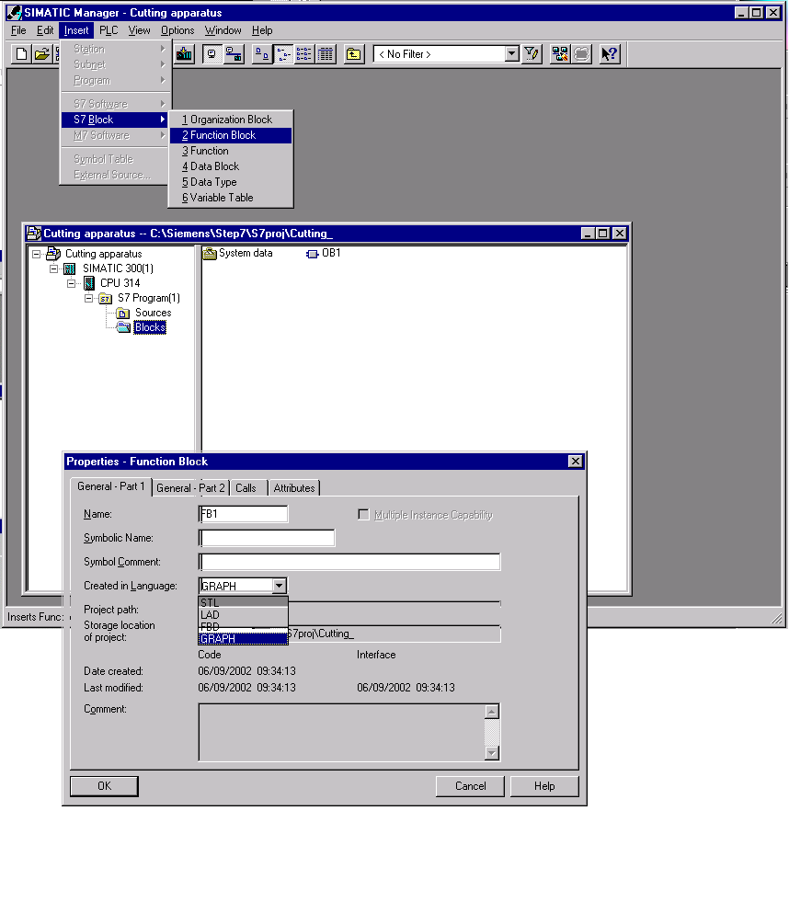

7.6 Opening S7-GRAPH and inputting sequencers.

1. Click Blocks.
2. Double click on FB1.

The S7-GRAPH will open.

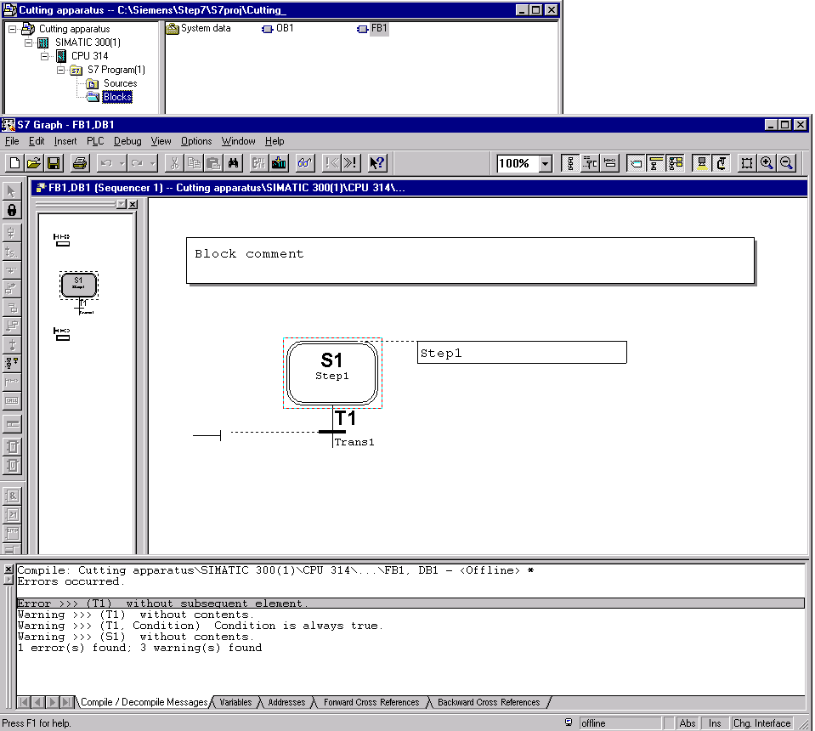
The first step of the sequencer is inserted automatically in the block. This step is recognized as the initial step and is active at the start of the sequencer.
Transition
(Further switch condition)
Actions (Instruction field)
Step field
Error messages and warnings

7.7 The principle of a sequencer

A sequencer consists of a series of steps, which are activated in a fixed order dependent on the conditions by further switching.

The editing of a sequencer always begins with an initial step or with several initial steps, that stand in an arbitrary place in the sequencer. As long as the actions of a step are implemented, the step is active. During execution of several steps, all are active at the same time.

A step is left, when all possible lined up errors are repaired and/or confirmed and the following transition is performed to the step.

The next step which follows the performed transition becomes active.

At the end of a sequencer rests a jump to any step of the sequencer or another sequencer of the FB. Thus a cyclic operation of the sequencer is possible. At the end of the sequencer rests a chain end. The execution ends with the reaching of the chain end.

7.8 Active step

An active step is a step, whose actions are directly being worked.
The step is active:

- When the conditions of the preceding transition have been accomplished or
- When it is defined as an initial step and the sequencer was initialized
- When it is called through an event dependent action.

7.9 Elements of a sequencer
Open simultaneous branch
Close simultaneous branch
Step + transition
Jump
Sequencer insert
Branch stop
Close alternative branch
Open alternative branch
7.10 Generation of a sequencer in the function chart

7.10.1 First step
1. Double click on Block comment and Step description and enter information.
2. Click on the Input of the Transition.
3. Insert an And symbol.
4. Add additional bin. inputs.
5. Enter operands on the And-symbol.

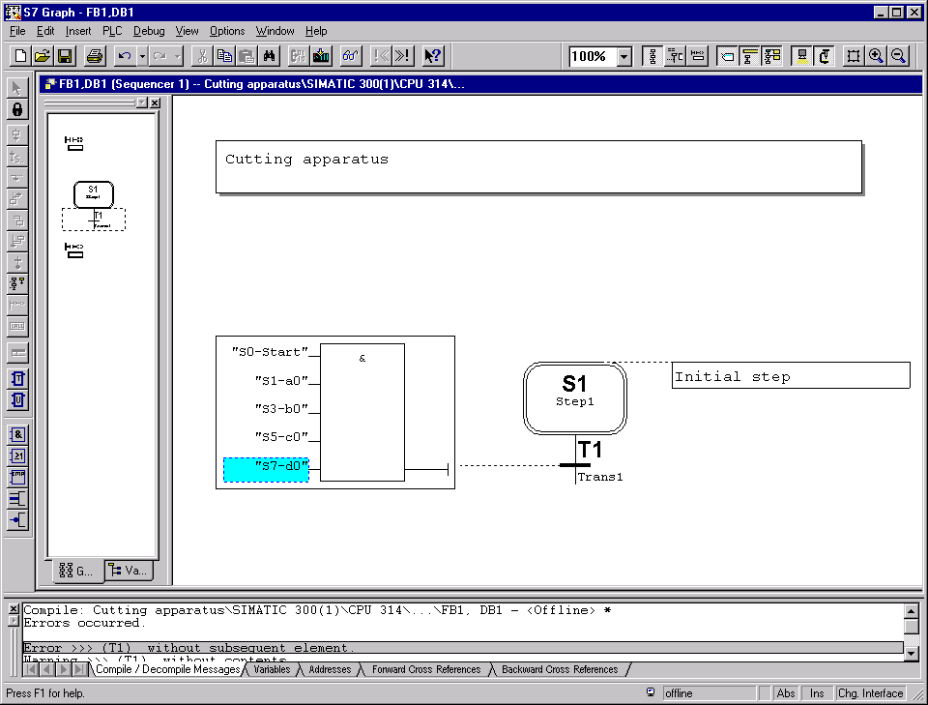

6. Right click on Transition T1.
7. Click on Step + Transition under Insert New Element.

The second step is entered.

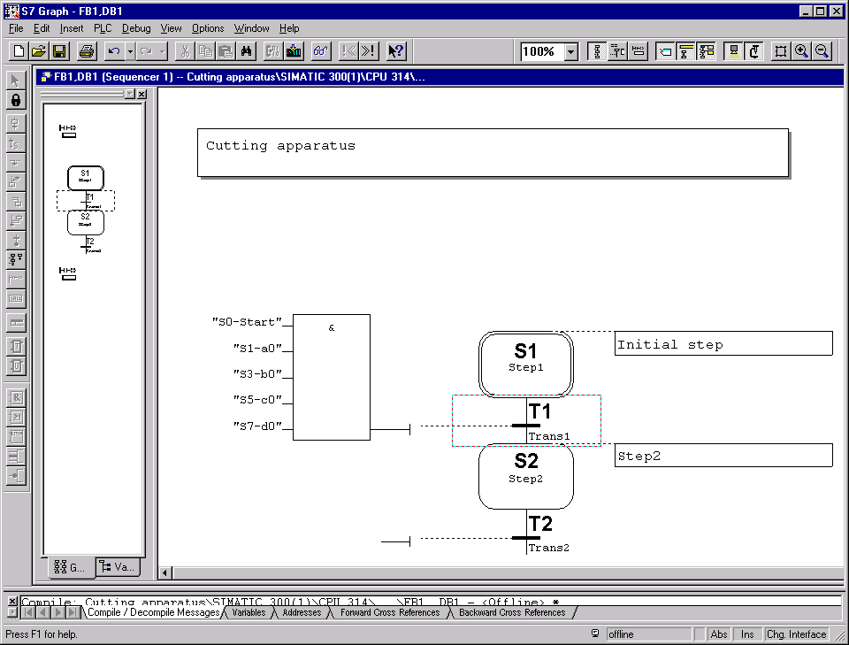
7.10.2 Second step

1. Click on Description field and enter step description.
2. Enter Action .
3. Double click on the action to be performed or click on it with the right-mouse button and choose Object Properties.
4. Enter transition.

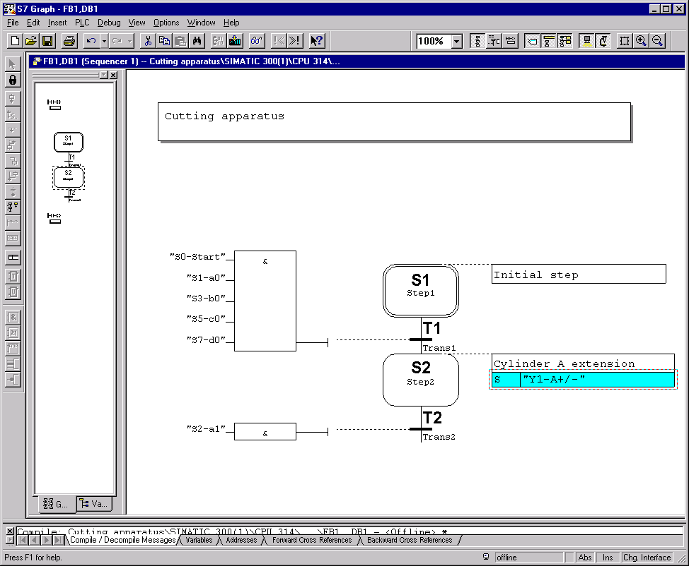

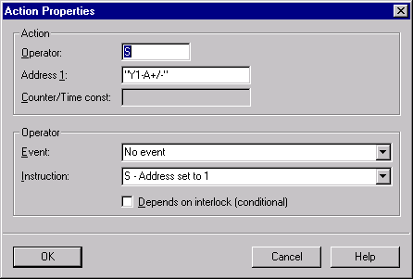
S Set operand
R Reset operand
N Don’t save
D Delay
L Limited time
Possible standard instruction
Possible event
7.10.3 Third and fourth step

1. Click on Transition T2.
2. Click on Step + Transition two times in order to insert Step S3 and Step S4.
3. Enter step descriptions and actions.
4. Enter transitions.

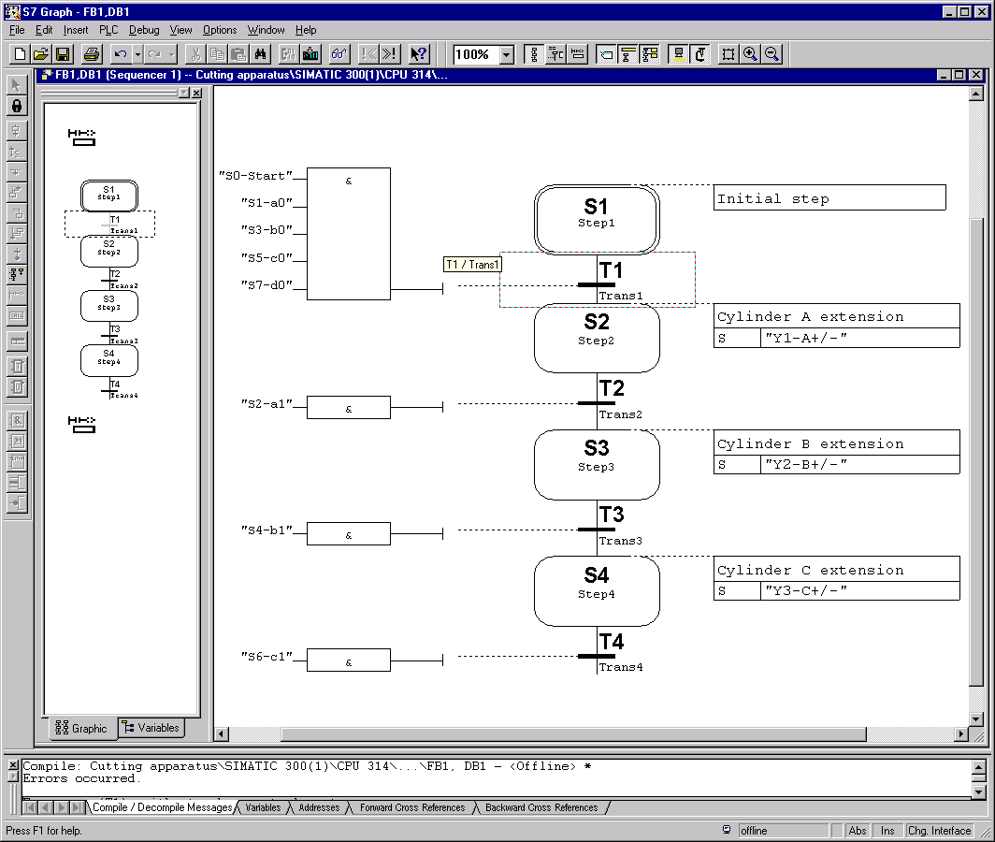
The next steps are inserted with a branch.

There are two types of branches

The alternative branch,

It is inserted after the selected step and begins with a transition.
The steps of an alternative branch are only worked on if the transition is accomplished.
The branch can be closed, either to the left to a transition or terminated with branch end.

Close alternative branch.

branch end.

The simultaneous branch,

It is inserted after the selected transition and begins with a step.
The steps of a simultaneous branch must be worked on, since they will continuously run parallel to the basic steps.
The branch must be closed to the left to a step.

Close simultaneous branch.
7.10.4 Inserting a branch

In order to insert branches, it is better to change into the overviews representation.

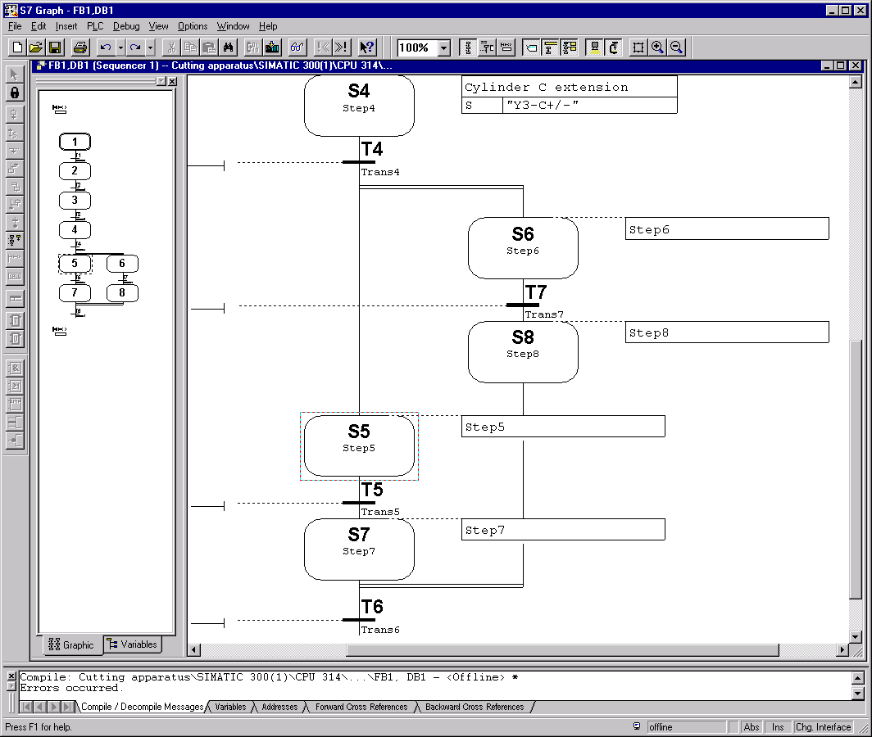

In order to generate a simultaneous branch, the following actions must be performed:

- Click on Transition T4.
- Insert Step + Transition (Step S5 and Transition T5 are inserted).
- Click on Transition T4.
- Click on Simultaneous Branch open (Step S6 is inserted).
- Click on Transition T5.
- Insert Step + Transition (Step S7 and Transition T6 are inserted).
- Click on Step S6.
- Insert Step + Transition (Step S8 and Transition T7 are inserted).
- Click on Step S8.
- Click on Simultaneous Branch close.
- Click on Step S7.

For the inputing of the actions and transitions, one should change to the one page representation.
7.10.5 Entering actions and transitions of the Step S5 to Step S8 and the entering of the last step

1. Change to One page representation (80%).
2. Enter actions.
3. Enter transitions.
4. Click on Transition T6.
5. Insert Step + Transition.

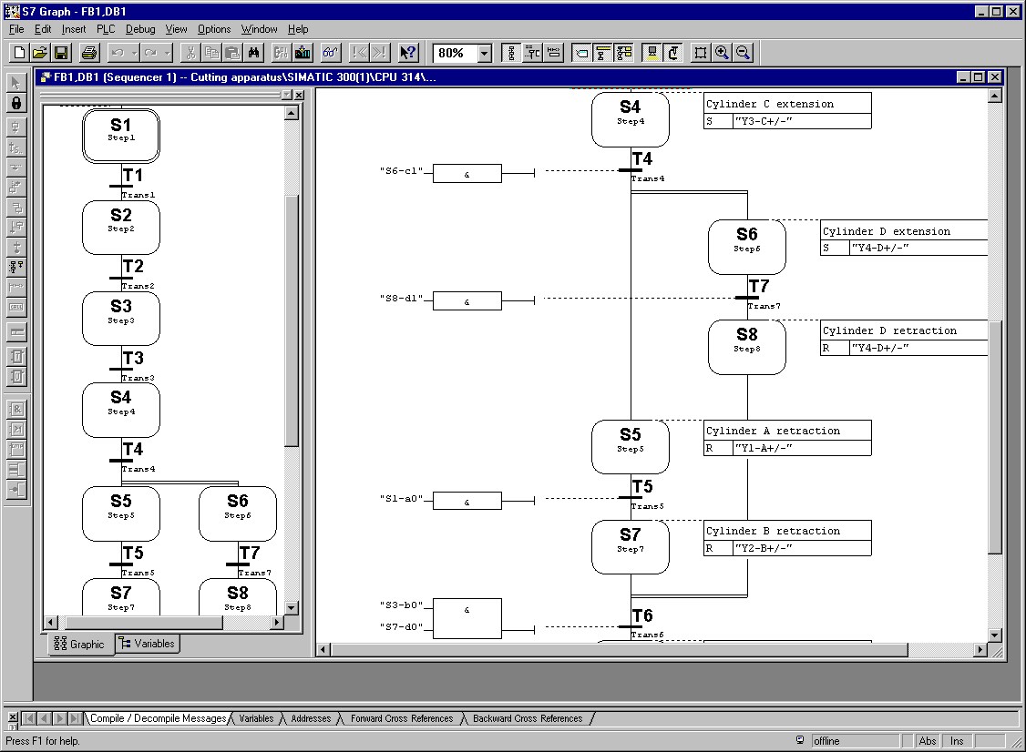

7.10.6 Editing the last step and inserting a return to the first step

1. Enter step description and action.
2. Enter transition.
3. Click on Transition T8.
4. Insert jump.

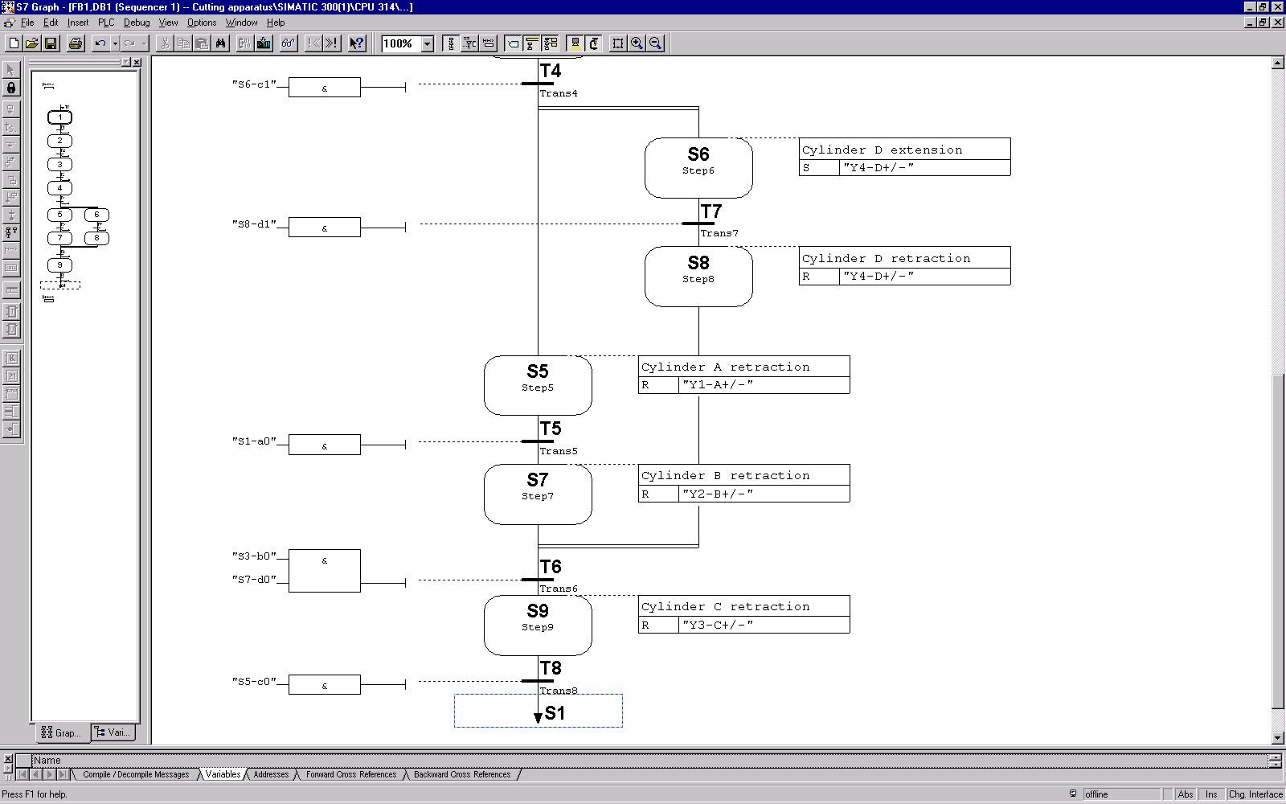

5. Insert S1 at the jump point or click on Step S1, so that the jump goal is inserted.

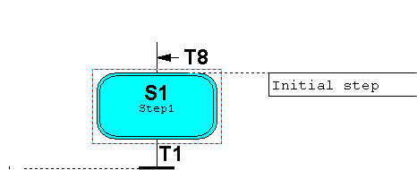

7.10.7 Block-Characteristics setting and saving finished blocks
Before saving the block, the block settings should be modified.

1. Click on Options.
2. Click on Block Settings.

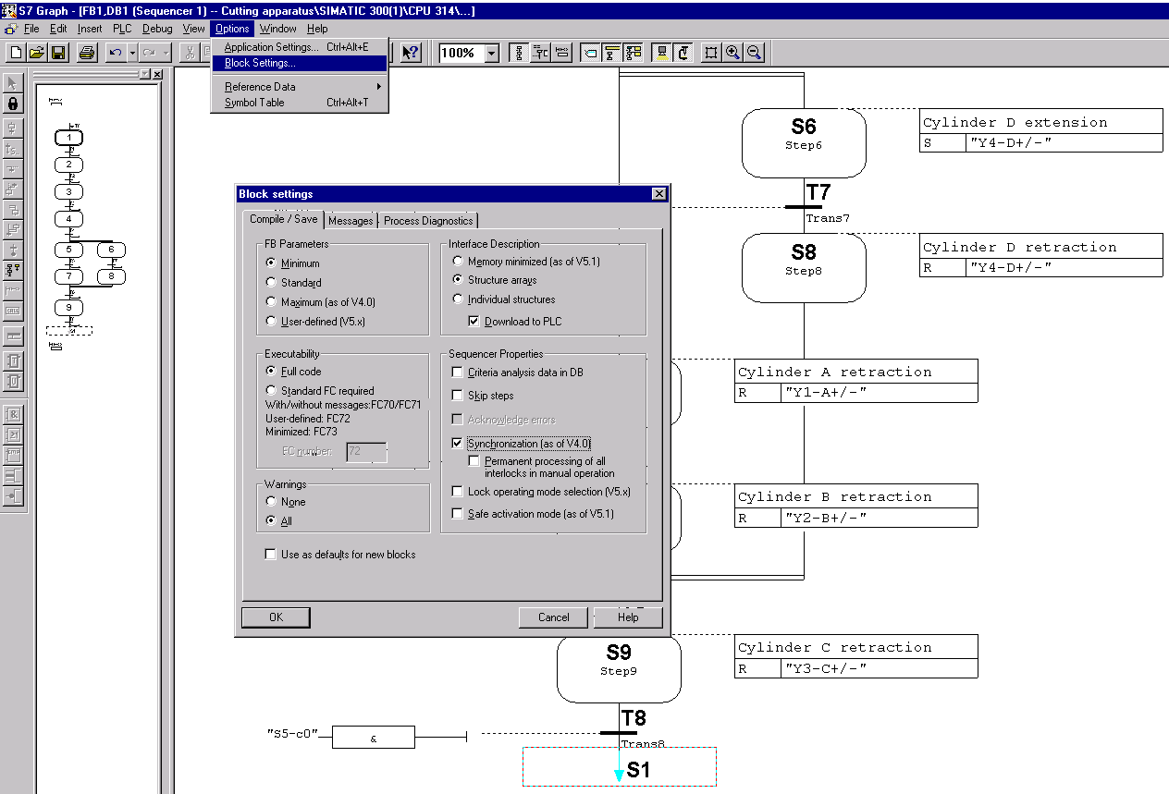

3. Set the FB Paramenter to Minium.
4. Set executability to Full code so that the standard FCs are contained in the function block.
5. Click on Synchronization.
6. Click OK.
7. Save the block.
8. Close S7-GRAPH.

Note

If there are still errors, then it cannot be not be stored in the block. An incorrect block can be generated only as source. When storing the block, a pertinent data block and the SFC64 are produced. Both are copied into the block list.
7.11 Setting characteristics of the Organization Block and opening OB1

1. Click on Blocks .
2. Double click on OB1.
3. In the properties of the Organization block select FBD as created in language.
4. Click OK.

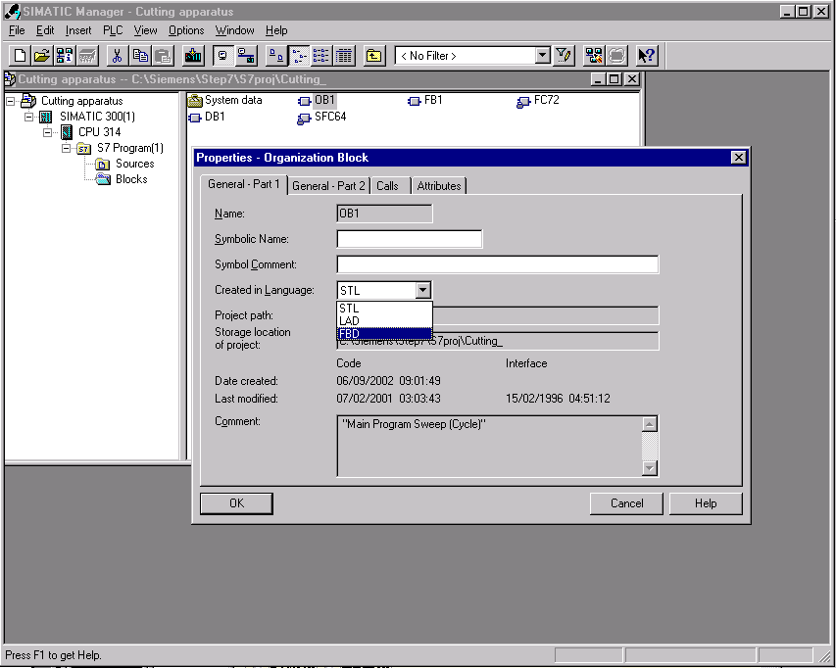

Note
If the OB1 is not automatically opened after the adjustment of the properties, then the OB1 must be double clicked once again in the block list.
7.12 Editing Organization Block OB1 and downloading blocks into a module
1. Enter block and network headings.
2. Click on the entry field
3. Open Program Elements.
4. Insert FB1 through a double click.
5. Enter DB1.
6. Save block OB1.
7. Close LAD/STL/FBD.

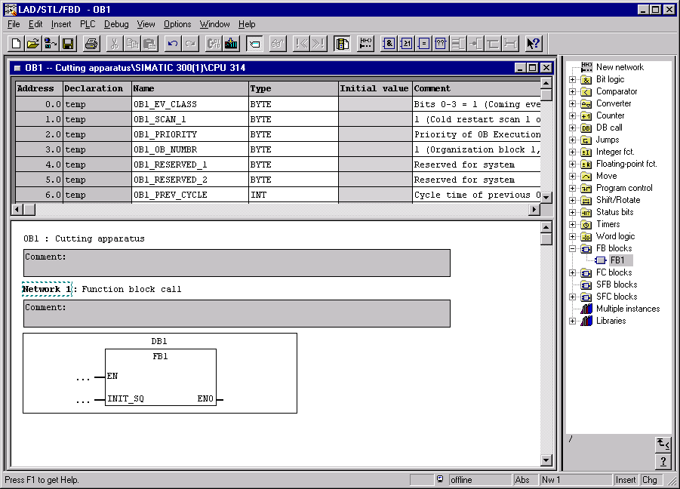

8. Click on Block and blocks and Download module.

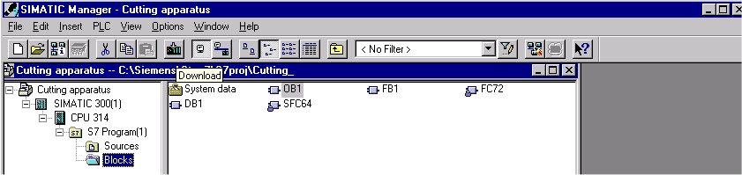

After the transferring of the blocks into the module, the program can be debugged.

