Training document for the company-wide
automation solution
Totally Integrated Automation (T I A)

MODULE 0
Guide for tutorial material

This document was provided by Siemens A&D SCE (automation and drive technology, Siemens A&D Cooperates with Education) for training purposes. Siemens does not make any type of guarantee regarding its contents.

The passing on or duplication of this document, including the use and report of its contents, is only permitted within public and training facilities.

Exceptions require written permission by Siemens A&D SCE (Mr. Knust: E-Mail: michael.knust@hvr.siemens.de). Offences are subject to possible payment for damages caused. All rights are reserved for translation and any case of patenting or GM entry.

We thank the company Michael Dziallas Engineering and the instructors of vocational schools as well as further persons for the support with the production of the document.

PAGE:

1. Goal of the Training Document 5

2. Target Groups / Job Training 6

3. Short Explanation of the Module Contents 7

3.1 A: Basics of STEP 7- Programming 7

3.1.1 Module A1 – Totally Integrated Automation (T I A) 8
3.1.2 Module A2 – Installation of STEP 7 V5.x / Handling of the authorization 9
3.1.3 Module A3 – ‚Startup’ PLC- Programming with STEP 7 10
3.1.4 Module A4 – Programming of the CPU 315-2DP 11
3.1.5 Module A5 – PLC- Simulation with PLCSIM 12
3.1.6 Module A6 – Save / Archive / Program documentation 13
3.1.7 Module A7 – Debug- and online- Functions 14

3.2 B: Additional Functions of STEP 7- Programming 15

3.2.1 Module B1 – Error diagnostics / Error handling 16
3.2.2 Module B2 – Analog value processing 17
3.2.3 Module B3 – Control engineering with STEP 7 18
3.2.4 Module B4 – Data blocks 19
3.2.5 Module B5 – Structured programming with function blocks 20
3.2.6 Module B6 - Converting STEP 5 -> STEP 7 21

3.3 C: Sequencer Programming 22

3.3.1 Module C1 – Sequencer programming with S7-GRAPH 23

3.4 D: Industrial field bus systems 24

3.4.1 Module D1 – AS- Interface with the SIMATIC S7-300 and the CP342-2 26
3.4.2 Module D2 – AS- Interface / Integration of a logic module LOGO! 28
3.4.3 Module D3 – PROFIBUS DP with Master CPU 315-2DP / Slave ET 200L 30
3.4.4 Module D4 – PROFIBUS DP with Master CPU 315-2DP / Slave ET 200M 31
3.4.5 Module D5 – PROFIBUS DP with Master CPU 315-2DP / Slave ET 200S/CPU 33
3.4.6 Module D6 – PROFIBUS DP with Master CPU 315-2DP / Slave CPU 315-2DP 35
    - Module D7 – PROFIBUS DP with Master CPU 315-2DP / Slave MICROMASTER 37
3.4.8 Module D8 – Programming of SIMATIC WinAC 38
3.4.9 Module D9 – PROFIBUS-DP with Master CP 342-5DP / Slave ET 200L 39
3.4.10 Module D10 – PROFIBUS-DP with Master CP 342-5DP / Slave CP 342-5DP 40
3.4.11 Module D11 – PROFIBUS-DP with Master CP 342-5DP / Master CP 342-5DP 41

PAGE:

3.5 E: IT- Communication with SIMATIC S7 42

3.5.1 Module E1 – Under construction 43

3.6 F: Process Visualization 44

3.6.1 Module F1 – Human Machine Interface with OP7 and ProTool 45
3.6.2 Module F2 – Human Machine Interface with TP170A and ProTool 47
3.6.3 Module F3 – Human Machine Interface with ProTool/Pro Runtime 49
3.6.4 Module F4 – Human Machine Interface with WinCC 51

4. Appendix 52

4.1 Appendix I – PLC – Programming basics with SIMATIC S7-300 53
4.2 Appendix II – IEC 61131 53
4.3 Appendix III – Basic program instructions LAD/FBD/STL in STEP 7 54
4.4 Appendix IV – Basics of field bus systems with SIMATIC S7-300 54

1. Goal of the Training Document

The presenting training concept serves as an introduction to the modern programming of automation systems.
The training document should explain the function knowledge, parameterizing and configuration of an innovative automation system to the reader and convert and strengthen the attained knowledge into practical exercises. The exercises contain examples of the automation system SIMATIC by the company SIEMENS.
The document is divided into separate modules which can be executed dependent on the previous knowledge of the reader.

The contents of all modules can be worked on in the following course structure:

Basics of
STEP 7 - Programming
2 - 3 Days A modules
Industrial field bus systems
2- 3 days D modules
Additional functions of
STEP 7- Programming
2- 3 Days B modules
Process visualization
2- 3 days F modules
Sequencer Programming
2- 3 days C modules
IT- Communication
with S7
1- 2 Days E modules

2. Target Groups / Job Training

The training documents can be used for the following job training:

Industry electronics technician
Energy electronics technician
Mechatronic technician
Industrial mechatronic technician

Polymechanic ( Switzerland )
Electronic service technician ( Switzerland )
Automation expert ( Switzerland )

And all that come in contact with automation technology in training.

3. Short description of the module contents

3.1 Basics of STEP 7- Programming
The following modules can be used as teaching tools for the theme Basics of STEP 7- Programming. Therefore the modules A3, A4 and A5 represent the different alternatives to programming for the first time with STEP 7. Module A3  arranges a quick hardware dependent introduction into automation technology with SIMATIC S7 for absolute beginners. Module A4 shows an application with the CPU 315-2DP and module A5 explains the introduction of the PLC- Simulator PLCSIM.
The time frame is approximately 20 instructional units (45 minutes).
The following sequence is therefore arranged, whereby the modules A3-A5 are optional

Basics of STEP 7- Programming

(2 -3 Days)

Module A1
Totally Integrated Automation (T I A )

Quick introduction

Module A2
Installation of STEP 7 / Authorization

Module A3
‚Startup’ PLC- Programming with STEP 7

Module A5
PLC- Simulation with PLCSIM

Module A4
Programming of the CPU 315-2DP

Module A6
Save / Archive / Program documentation

Module A7
Test- and online- Functions

Additional functions of
STEP 7- Programming
2- 3 days B modules

Industrial field bus systems
2- 3 days D modules
Process visualization
2- 3 days F modules
Sequencer programming
2- 3 days C modules

IT- Communication
With SIMATIC S7
1- 2 days E modules

3.1.1 Module A1 – Totally Integrated Automation (T I A)

Learning goal:
The reader is introduced to the philosophy of Totally Integrated Automation (T I A).
Therefore the reader should receive an overview of the several components for the realization of this fully integrated automation. These components are shown in the following modules in application.

Requirements:
No practical application is generated in this module, so there are no special requirements for it’s execution.

Required Hardware and Software
Special hardware und software does not come into operation here. This module is clearly theoretic.

3.1.2 Module A2 – Installation of STEP 7 V5.x / Handling of Authorization

Learning goal:
The reader should be shown in this module how the software STEP 7 V 5.x is installed and the how the interface for SIMATIC S7-300 is adjusted.
• Installation of the software
• Handling of the authorization
• Setting the program interface

Requirements:
For the successful use of this module, the following knowledge is assumed:
• Knowledge in the use of Windows 95/98/2000/ME/NT4.0

Required hardware and software
- PC, Operating system Windows 95/98/2000/ME/NT4.0 with
- Minimal: 133MHz and 64MB RAM, approx. 65 MB free hard disk space
- Optimal: 500MHz and 128MB RAM, approx. 65 MB free hard disk space
2 Software STEP 7 V 5.x
3 MPI- Interface for the PC (e.g. PC- Adapter)
4 PLC SIMATIC S7-300.
Example configuration:
- Power supply: PS 307 2A
- CPU: CPU 314
- Digital inputs: DI 16x DC24V
- Digital outputs: DO 16x DC24V / 0.5 A
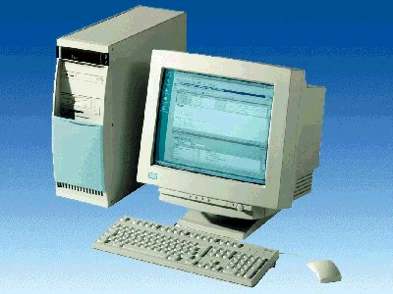
1 PC
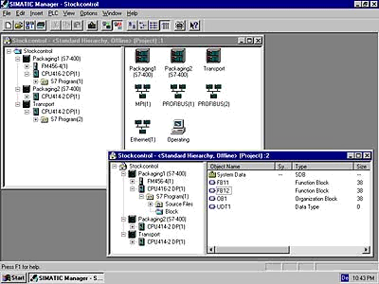
2 STEP 7

3 PC Adapter

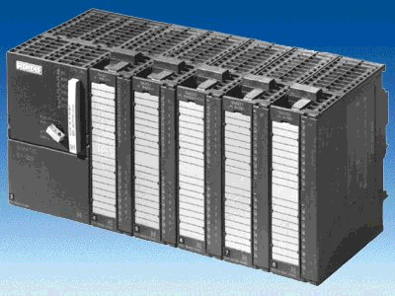
4 S7-300

3.1.3 Module A3 – ‘Startup’ PLC- Programming with STEP 7

Learning goals:
In this module, the reader will learn about the programming of a programmable logic controller (PLC) with the programming tool STEP 7. The module arranges the basics and shows the procedure in the following steps by means of a detailed example.
• Installation of software and the modification of a program interface
• Explanation of what a PLC is and how it works
• Structure and operation of a PLC SIMATIC S7-300
• Compilation of an example program
• Loading and debugging of an example program

Requirements:
For the successful use of this module, the following knowledge is assumed:
• Knowledge in the use of Windows 95/98/2000/ME/NT4.0

Required hardware and software
1 PC, Operating system Windows 95/98/2000/ME/NT4.0 with
- Minimal: 133MHz and 64MB RAM, approx. 65 MB free hard disk space
- Optimal: 500MHz and 128MB RAM, approx. 65 MB free hard disk space
2 Software STEP 7 V 5.x
3 MPI- Interface for the PC (e.g. PC- Adapter)
4 PLC SIMATIC S7-300 with a minimum of one digital In- and Output device. The
inputs must be led out of a switch bay.
Example configuration:
- Power supply: PS 307 2A
- CPU: CPU 314
- Digital inputs: DI 16x DC24V
- Digital outputs: DO 16x DC24V / 0.5 A

1 PC
2 STEP 7

3 PC Adapter

4 S7-300

3.1.4 Module A4 – Programming of the CPU315-2DP

Learning goal:
In this module, the reader will learn about the generation of the hardware configuration for the CPU 315-2DP and the writing and debugging of a STEP 7-Program. The module arranges the principle procedure and shows them in the following steps by means of a detailed example.
• Application of a STEP 7- Project
• Generation of the hardware configuration for the CPU 315-2DP
• Writing of a STEP 7- Program
• Debugging of a program

Requirements:
For the successful use of this module the following knowledge is assumed:
• Knowledge in the use of Windows 95/98/2000/ME/NT4.0
• Basics of PLC- Programming with STEP 7 (e.g. Module A3 – ‘Startup’
PLC- Programming with STEP 7)
Required hardware and software
1 PC, Operating system Windows 95/98/2000/ME/NT4.0 with
- Minimal: 133MHz and 64MB RAM, approx. 65 MB free hard disk space
- Optimal: 500MHz and 128MB RAM, approx. 65 MB free hard disk space
2 Software STEP7 V 5.x
3 MPI- Interface for the PC (e.g. PC- Adapter)
4 PLC SIMATIC S7-300 with the CPU 315-2DP and a minimum of one digital In- and Output device. The inputs must be led out of a switch bay.
Example configuration:
- Power supply: PS 307 2A
- CPU: CPU 315-2DP
- Digital inputs: DI 16x DC24V
- Digital outputs: DO 16x DC24V / 0.5 A

1 PC
2 STEP 7

3 PC Adapter

4 S7-300 with
CPU 315-2DP

3.1.5 Module A5 – PLC- Simulation with PLCSIM

Learning goal:
In this module, the reader will learn about the debugging of a STEP 7- Program with the simulation software S7-PLCSIM. The module shows the principle procedure in the following steps by means of a detailed example.
• Installation of the software
• Generation of a simple program
• Starting of S7-PLCSIM
• Debugging of a S7-PLCSIM program

Requirements:
For the successful use of this module the following knowledge is assumed:
• Knowledge in the use of Windows 95/98/2000/ME/NT4.0
• Basics of PLC- Programming with STEP 7 (e.g. Module A3 – ‘Startup’
PLC- Programming with STEP 7)

Required hardware and software
1 PC, Operating system Windows 95/98/2000/ME/NT4.0 with
- Minimal: 133MHz and 64MB RAM, approx. 65 MB free hard disk space
- Optimal: 500MHz and 128MB RAM, approx. 65 MB free hard disk space
2 Software STEP7 V 5.x
3 Software S7-PLCSIM V5.x

2 STEP 7

1 PC

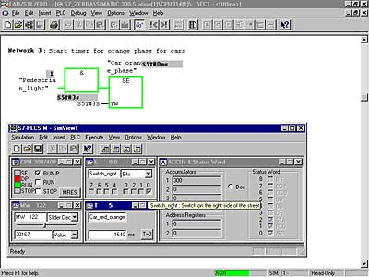
3 S7-PLCSIM

3.1.6 Module A6 – Save / Archive / Program documentation

Learning goal:
In this module, the reader will learn the tools to the program documentation and saving of STEP 7- Programs.
• Symbolic addressing
• Saving of programs in the EPROM-Memory Card of the SIMATIC S7-300
• Archiving and retrieving STEP 7-Programs.
• Viewing of the reference data to a STEP 7- Program

Requirements:
For the successful use of this module, the following knowledge is assumed:
• Knowledge in the use of Windows 95/98/2000/ME/NT4.0
• Basics of PLC- Programming with STEP 7 (e.g. Module A3 – ‘Startup’
PLC- Programming with STEP 7)

Required hardware and software
1 PC, Operating system Windows 95/98/2000/ME/NT4.0 with
- Minimal: 133MHz and 64MB RAM, approx. 65 MB free hard disk space
- Optimal: 500MHz and 128MB RAM, approx. 65MB free hard disk space
2 Software STEP 7 V 5.x
3 MPI- Interface for the PC (e.g. PC- Adapter)
- PLC SIMATIC S7-300
Example configuration:
- Power supply: PS 307 2A
- CPU: CPU 314
- Digital inputs: DI 16x DC24V
- Digital outputs: DO 16x DC24V / 0.5 A
1 PC
2 STEP 7

3 PC Adapter

4 S7-300

3.1.7 Module A7 – Test- and online- Functions

Learning goal:
In this module, the reader will learn the tools which are helpful for error searching.
• Debug functions
• Online- functions

Requirements:
For the successful use of this module, the following knowledge is assumed:
• Knowledge in the use of Windows 95/98/2000/ME/NT4.0
• Basics of PLC- Programming with STEP 7 (e.g. Module A3 – ‘Startup’
PLC- Programming with STEP 7)

Required hardware and software
1 PC, Operating system Windows 95/98/2000/ME/NT4.0 with
- Minimal: 133MHz and 64MB RAM, approx. 65 MB free hard disk space
- Optimal: 500MHz and 128MB RAM, approx. 65MB free hard disk space
- Software STEP 7 V 5.x
- MPI- Interface for the PC (e.g. PC- Adapter)
- PLC SIMATIC S7-300
Example configuration:
- Power supply: PS 307 2A
- CPU: CPU 314
- Digital inputs: DI 16x DC24V
- Digital outputs: DO 16x DC24V / 0.5 A
1 PC
2 STEP 7

3 PC Adapter

4 S7-300

3.2 Additional functions of STEP 7- Programming

The following modules can be used as teaching tools for the theme Additional functions of STEP 7- Programming.
The time frame is approximately 20 instructional units (45 minutes)..

The following sequence is therefore arranged as follows.

Basics of
STEP 7- Programming
2- 3 days A modules

Additional functions of

STEP 7- Programming

(2 -3 days)

Module B1
Error diagnostics / Error handling

Module B2
Analog value processing

Module B3
Control engineering with STEP 7

Module B4
Data blocks

Module B5
Structured Prog. with function blocks

Module B6
Converting
STEP5 -> STEP 7

Industrial field bus systems
2- 3 days D modules
Process-
visualization
2- 3 days F modules
Sequencer
programming
2- 3 days C modules

IT- Communication
with S7
1- 2 days E modules

3.2.1 Module B1 – Error diagnostics / Error handling

Learning goal:
In this module, the reader will learn about the procedure of error diagnostics. The following module contains:

• Diagnostic functions in STEP 7
• Error types and appropriate Organization Blocks
• Types of Organization Blocks

Requirements:
For the successful use of this module, the following knowledge is assumed:
• Knowledge in the use of Windows 95/98/2000/ME/NT4.0
• Basics of PLC- Programming with STEP 7 (e.g. Module A3 - ‘Startup’
PLC programming with STEP 7)
• Debug- and Online- Functions in STEP 7 (e.g. Module A7 - Debug- and Online- Functions)

Required hardware and software
- PC, Operating system Windows 95/98/2000/ME/NT4.0 with
- Minimal: 133MHz and 64MB RAM, approx. 65 MB free hard disk space
- Optimal: 500MHz and 128MB RAM, approx. 65 MB free hard disk space
- Software STEP 7 V 5.x
- MPI- Interface for the PC (e.g. PC- Adapter)
- PLC SIMATIC S7-300
Example configuration:
- Power supply: PS 307 2A
- CPU: CPU 314
- Digital inputs: DI 16x DC24V
- Digital outputs: DO 16x DC24V / 0.5 A
1 PC
2 STEP 7

3 PC Adapter

4 S7-300

3.2.2 Module B2 – Analog value processing

Learning goal:
In this module, the reader will learn about how analog values are inputted, processed, and outputted into a SIMATIC S7.
• Analog signals
• Data types in STEP 7
• Mathematical operations
• Conversion of data types in STEP 7
• Input and normalize an analog value
• Normalize and output an analog value

Requirements:
For the successful use of this module, the following knowledge is assumed:
• Knowledge in the use of Windows 95/98/2000/ME/NT4.0
• Basics of PLC- Programming with STEP 7 (e.g. Module A3 - ‘Startup’
PLC programming with STEP 7)

Required hardware and software
1 PC, Operating system Windows 95/98/2000/ME/NT4.0 with
- Minimal: 133MHz and 64MB RAM, approx. 65 MB free hard disk space
- Optimal: 500MHz and 128MB RAM, approx. 65 MB free hard disk space
2 Software STEP 7 V 5.x
3 MPI- Interface for the PC (e.g. PC- Adapter)
4 PLC SIMATIC S7-300 with at least one analog input/output module, by which a potentiometer or another analog signal transmitter is connected. Also, an analog value display must be connected to an analog output.
Example configuration:
- Power supply: PS 307 2A
- CPU: CPU 314
- Digital inputs: DI 16x DC24V, Digital outputs: DO 16x DC24V / 0.5 A
- Analog In-/ Outputs: AI 4/ AO 2 x 8Bit
1 PC
2 STEP 7

3 PC Adapter

4 S7-300

3.2.3 Module B3 – Control engineering with STEP 7

Learning goal:
In the following steps, the reader should learn how a PID controller is connected within a STEP 7, how it is toggled with analog process values and taken into operation.
• PID- Controller call in a STEP 7- Program
• Toggling of the PID-Controller with analog values
• Setting control parameters with the PID-Controller

Requirements:
For the successful use of this module, the following knowledge is assumed:
• Knowledge in the use of Windows 95/98/2000/ME/NT4.0
• Basics of PLC- Programming with STEP 7 (e.g. Module A3 - ‘Startup’ PLC programming with STEP 7)
• Analog value processing with STEP 7 (e.g. Module B2 – Analog value processing)

Required Hardware and Software
1 PC, Operating system Windows 95/98/2000/ME/NT4.0 with
- Minimal: 133MHz and 64MB RAM, approx. 65 MB free hard disk space
- Optimal: 500MHz and 128MB RAM, approx. 65 MB free hard disk space
2 Software STEP 7 V 5.x
3 MPI- Interface for the PC (e.g. PC- Adapter)
4 PLC SIMATIC S7-300 with at least one analog input/output module, by which a potentiometer or another analog signal transmitter is connected. Also, an analog value display must be connected to an analog output.
Example configuration:
- Power supply: PS 307 2A
- CPU: CPU 314
- Digital inputs: DI 16x DC24V, Digital outputs: DO 16x DC24V / 0.5 A
- Analog In-/ Outputs: AI 4/ AO 2 x 8Bit
5 Controlled system (e.g.: Fill level system W-3545-5C by the company WUEKRO)
6 Connection wires for the connection of the controlled system to the analog in and outputs of the PLC.
1 PC
2 STEP 7

3 PC Adapter

5 Controlled system
4 S7-300

6 Connection wires

3.2.4 Module B4 – Data blocks

Learning goal:
In this module, the reader should learn how a data block can be used to save data.
• Generating data blocks
• Specifying a structure of a data block
• Access to a data element in a STEP 7- Program

Requirements:
For the successful use of this module, the following knowledge is assumed:
• Knowledge in the use of Windows 95/98/2000/ME/NT4.0
• Basics of PLC- Programming with STEP 7 (e.g. Module A3 - ‘Startup’
PLC programming with STEP 7)
• Basics to structured programming (e.g. Appendix I - Basics to PLC –Programming with SIMATIC S7-300)

Required hardware and software
1 PC, Operating system Windows 95/98/2000/ME/NT4.0 with
- Minimal: 133MHz and 64MB RAM, approx. 65 MB free hard disk space
- Optimal: 500MHz and 128MB RAM, approx. 65 MB free hard disk space
2 Software STEP 7 V 5.x
3 MPI- Interface for the PC (e.g. PC- Adapter)
4 PLC SIMATIC S7-300 with at least one digital in- and output module. The inputs must be lead through a functional unit.
Example configuration:
- Power supply: PS 307 2A
- CPU: CPU 314
- Digital input: DI 16x DC24V
- Digital output: DO 16x DC24V / 0.5 A
1 PC
2 STEP 7

3 PC Adapter

4 S7-300

3.2.5 Module B5 – Structured programming with function blocks

Learning goal:
In this module, the reader should learn how a function block with internal variables is generated for structured programming.
• Generating a function block
• Defining internal variables
• Programming internal variables in a function block
• Calling and parameterizing of a function block in OB1

Requirements:
For the successful use of this module, the following knowledge is assumed:
• Knowledge in the use of Windows 95/98/2000/ME/NT4.0
• Basics of PLC- Programming with STEP 7 (e.g. Module A3 - ‘Startup’
PLC programming with STEP 7)
• Basics to structured programming (e.g. Appendix I - Basics to PLC –Programming with SIMATIC S7-300)

Required hardware and software
1 PC, Operating system Windows 95/98/2000/ME/NT4.0 with
- Minimal: 133MHz and 64MB RAM, approx. 65 MB free hard disk space
- Optimal: 500MHz and 128MB RAM, approx. 65 MB free hard disk space
2 Software STEP 7 V 5.x
3 MPI- Interface for the PC (e.g. PC- Adapter)
4 PLC SIMATIC S7-300 with at least one digital in- and output module. The inputs must be lead through a functional unit.
Example configuration:
- Power supply: PS 307 2A
- CPU: CPU 314
- Digital input: DI 16x DC24V
- Digital output: DO 16x DC24V / 0.5 A
1 PC
2 STEP 7

3 PC Adapter

4 S7-300

3.2.6 Module B6 – Converting STEP 5 -> STEP 7

Learning goal:
In this module, the reader should learn how to convert STEP 5- Programs into executing STEP 7- Programs

Requirements:
For the successful use of this module, the following knowledge is assumed:
• Knowledge in the use of Windows 95/98/2000/ME/NT4.0
• Basics of PLC- Programming with STEP 7 (e.g. Module A3 - ‘Startup’
PLC programming with STEP 7)

Required hardware and software
1 PC, Operating system Windows 95/98/2000/ME/NT4.0 with
- Minimal: 133MHz and 64MB RAM, approx. 65 MB free hard disk space
- Optimal: 500MHz and 128MB RAM, approx. 65 MB free hard disk space
2 Software STEP 7 V 5.x
3 MPI- Interface for the PC (e.g. PC- Adapter)
4 PLC SIMATIC S7-300 with at least one digital in- and output module. The inputs must be lead through a functional unit.
Example configuration:
- Power supply: PS 307 2A
- CPU: CPU 314
- Digital input: DI 16x DC24V
- Digital output: DO 16x DC24V / 0.5 A

1 PC
2 STEP 7

3 PC Adapter

4 S7-300

3.3 Sequencer Programming

The following module can be used as a teaching tool for the theme Sequencer programming.
The time frame is approximately 20 instructional units (45 minutes).

The following sequence is therefore arranged as follows.

Basics of
STEP 7- Programming
2- 3 days A modules

Additional functions of
STEP 7- Programming
2- 3 days B modules

Industrial field bus systems
2- 3 days D modules
Process visualization
2- 3 days F modules

IT- Communication
with S7
1- 2 days E modules

Sequencer programming

(2 -3 days)

Module C1
Sequencer programming with S7-GRAPH

3.3.1 Module C1 – Sequencer programming with S7- GRAPH
Learning goal:
In this module, the reader will learn the programming of a sequential control system with the graphic programming tool S7-GRAPH. The module shows the principle procedure in the following steps by means of a detailed example.
• Installation of the software
• Performance of types from the sequential control system and the representation possibilities from movement sequences, switch states, signal flow and motion charts.
• Generation of a simple movement execution displayed as a path step chart and as a
function chart by means of a programming example.
• The pertinent sequential control system is examined as a sequencer program in S7-GRAPH.
With the help of the debug- and diagnostic functions, the mode of operation of the generated program can be checked.
• Through a modifier of the task position with additional marginal conditions, further functions from S7-GRAPH are arranged .

Requirements:
For the successful use of this module, the following knowledge is assumed:
• Knowledge in the use of Windows 95/98/2000/ME/NT4.0
• Basics of PLC- Programming with STEP 7 (e.g. Module A3 – ‘Startup’
PLC- Programming with STEP 7)

Required hardware and software
1 PC, Operating system Windows 95/98/2000/ME/NT4.0 with
- Minimal: 133MHz and 64MB RAM, approx. 65 MB free hard disk space
- Optimal: 500MHz and 128MB RAM, approx. 65MB free hard disk space
2 Software STEP 7 V 5.x
3 Software S7-GRAPH V5.x
- MPI- Interface for the PC (e.g. PC- Adapter)
- PLC SIMATIC S7-300 with at least one digital in- and output module. The inputs must be lead through a functional unit.
Example configuration:
- Power supply: PS 307 2A, CPU: CPU 314
- Digital inputs: DI 16x DC24V, Digital outputs: DO 16x DC24V / 0.5 A
1 PC
2 STEP 7

4 PC Adapter

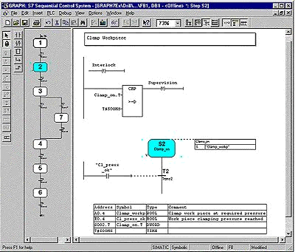
3 S7-GRAPH

5 S7-300

3.4 Industrial Field Bus Systems

The following modules can be used as teaching tools for the theme Industrial field bus systems. Therefore the modules D1 and D2 show the uses of the AS-Interface and the modules D2 to D11 the use of the PROFIBUS DP. From these modules a suitable, available hardware selection occurs.

The time frame is approximately 20 instructional units (45 minutes).

The following sequence is therefore arranged as follows
Basics of
STEP 7- Programming
2- 3 days A modules

Additional functions of
STEP 7- Programming
2- 3 days B modules

Sequencer
programming
2- 3 days C modules
Process
visualization
2- 3 days F modules

Module D1
AS-I with S7-300 and CP342-2
Module D2
AS-I with S7-300 and integrating LOGO
Module D3
Master CPU 315-2DP / Slave ET 200L
Module D5
Master CPU 315-2DP / Slave ET 200S/CPU
Module D8
Programming of WinAC
Module D4
Master CPU 315-2DP / Slave ET 200M
Module D11
Master CP 342-5DP / Master CP 342-5DP
Module D6
Master CPU 315-2DP / Slave CPU 315-2DP
Module D9
Master CP 342-5DP / Slave ET 200L
Module D10
Master CP 342-DP / Slave CP 342-5DP

Industrial field bus systems

(2 -3 days)

AS- Interface
PROFIBUS DP

Module D7
Master CPU 315-2DP / Slave Micromaster

IT- Communication
with S7
1- 2 days E modules

3.4.1 Module D1 – AS-Interface with the SIMATIC S7-300 and the CP342-2

Learning goal:
In this module, the reader should learn the fundamental functions of the AS-Interface and interface CP342-2 for the SIMATIC S7-300. A simple example is generated in the following steps:
• Commissioning of the AS-Interface with the CP342-2
• Generation of a project for a PLC SIMATIC S7-300
• Writing an example program
• Debugging the task with the CP342-2 and the SIMATIC S7- 300

Requirements:
For the successful use of this module, the following knowledge is assumed:

• Knowledge in the use of Windows 95/98/2000/ME/NT4.0
• Basics of PLC- Programming with STEP 7 (e.g. Module A3 - ‘Startup’
PLC programming with STEP 7)

Required hardware and software

1 PC, Operating system Windows 95/98/2000/ME/NT4.0 with
- Minimal: 133MHz and 64MB RAM, approx. 150 MB free hard disk space
- Optimal: 500MHz and 128MB RAM, approx. 150 MB free hard disk space
2 Software STEP 7 V 5.x
3 MPI- Interface for the PC (e.g. PC- Adapter)
4 PLC SIMATIC S7-300
Example configuration:
- Power supply: PS 307 2A
- CPU: CPU 314
- Digital inputs: DI 16x DC24V
- Digital outputs: DO 16x DC24V / 0.5 A
- CP 342-2 AS-Interface
5 AS-I- Slave 4 inputs allocated with 2 buttons
6 AS-I- Slave 4 outputs allocated with 5/2-solenoid valve for the triggering of a cylinder
7 AS-Interface power supply 30V
- AS-Interface yellow data cable
9 Address device for AS-I slaves

1 PC

2 STEP 7

9 Address device
for AS-I- Slaves

3 PC Adapter

8 AS-Interface Data cable

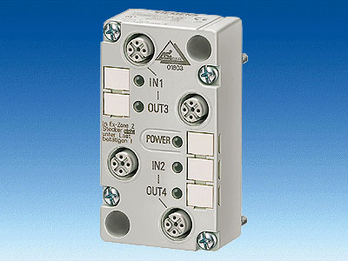
5 AS-I-Slave 4 Inputs
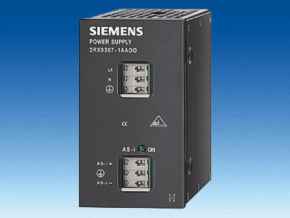
7 AS-Interface
Power supply 30V

6 AS-I-Slave 4 Outputs
4 S7-300 with CP342-2

3.4.2 Module D2 – AS-Interface / Integration of the logic module LOGO!

Learning goal:
In this module, the reader should learn the basic functions of the LOGO! logic module 24RCLB11 with integrated interface for the AS-Interface.
Typical task positions are executed by a pattern machine and an example project is processed in the following steps:
• Generation of a program for the LOGO!24RCLB11 logic module
• Debugging of task position in RUN mode of LOGO!
• Generation of a project for a PLC SIMATIC S7-300
• Integration of ASi information from the LOGO!24RCLB11 logic module in the control program of the SIMATIC S7-300CPU
• Debugging of the task position with a PLC SIMATIC S7- 300 and the LOGO!24RCLB11

Requirements:
For the successful use of this module, the following knowledge is assumed:

• Knowledge in the use of Windows 95/98/2000/ME/NT4.0
• Basics of PLC- Programming with STEP 7 (e.g. Module A3 - ‘Startup’
PLC programming with STEP 7)
• Commissioning of the AS-Interface with SIMATIC S7-300 (e.g. Module D1 – AS- Interface with the SIMATIC S7-300 and the CP342-2)

Required hardware and software
1 PC, Operating system Windows 95/98/2000/ME/NT4.0 with
- Minimal: 133MHz and 64MB RAM, approx. 150 MB free hard disk space
- Optimal: 500MHz and 128MB RAM, approx. 150 MB free hard disk space
2 Software STEP 7 V 5.x
3 LOGO!24RCLB11 logic module
4 MPI- Interface for the PC (e.g. PC- Adapter)
5 PLC SIMATIC S7-300
Example configuration:
- Power supply: PS 307 2A
- CPU: CPU 314
- Digital inputs: DI 16x DC24V
- Digital outputs: DO 16x DC24V / 0.5 A
- CP 342-2 AS-Interface
- AS-Interface power supply 30V
- AS-Interface yellow data cable
1 PC

2 STEP 7

4 PC Adapter

7 AS-Interface Data cable

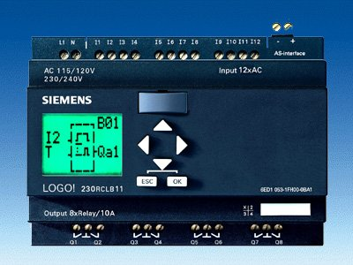
3 LOGO! 24RCLB11
6 AS-Interface
Power supply 30V

5 S7-300 with CP342-2

3.4.3 Module D3 – Profibus DP with Master CPU 315-2DP / Slave ET 200L

Learning goal:
In this module, the reader should learn how the PROFIBUS DP is taken into operation with the CPU 315-2DP as a master and the ET 200L as a slave. The module shows the principle procedure by means of a short example.

Requirements:
For the successful use of this module, the following knowledge is assumed:
• Knowledge in the use of Windows 95/98/2000/ME/NT4.0
• Basics of PLC- Programming with STEP 7 (e.g. Module A3 - ‘Startup’
PLC programming with STEP 7)
• Basics of the PROFIBUS DP (e.g. Appendix IV – Basics of
field bus systems with SIMATIC S7-300)

Required hardware and software
1 PC, Operating system Windows 95/98/2000/ME/NT4.0 with
- Minimal: 133MHz and 64MB RAM, approx. 65 MB free hard disk space
- Optimal: 500MHz and 128MB RAM, approx. 65 MB free hard disk space
2 Software STEP 7 V 5.x
- MPI- Interface for the PC (e.g. PC- Adapter)
- PLC SIMATIC S7-300 with the CPU 315-2DP
Example configuration:
- Network: PS 307 2A
- CPU: CPU 315-2DP
- Distributed I/O ET 200L with 16 digital In- and outputs
- PROFIBUS cable with 2 PROFIBUS slots
1 PC
2 STEP 7

3 PC Adapter

4 S7-300 with
CPU 315-2DP
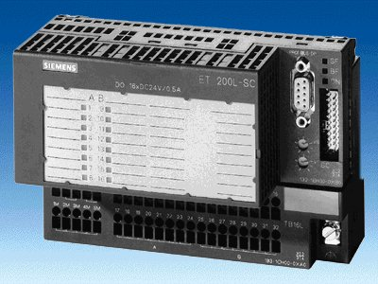
5 ET 200L

6 PROFIBUS cable

3.4.4 Module D4 – Profibus DP with Master CPU 315-2DP / Slave ET 200M

Learning goal:
In this module, the reader should learn how the PROFIBUS DP is taken into operation with the CPU 315-2DP as a master and the ET 200M as a slave. The module shows the principle procedure by means of a short example.

Requirements:
For the successful use of this module, the following knowledge is assumed:
• Knowledge in the use of Windows 95/98/2000/ME/NT4.0
• Basics of PLC- Programming with STEP 7 (e.g. Module A3 - ‘Startup’
PLC programming with STEP 7)
• Basics of the PROFIBUS DP (e.g. Appendix IV – Basics of
field bus systems with SIMATIC S7-300)

Required hardware and software

1 PC, Operating system Windows 95/98/2000/ME/NT4.0 with
- Minimal: 133MHz and 64MB RAM, approx. 65 MB free hard disk space
- Optimal: 500MHz and 128MB RAM, approx. 65 MB free hard disk space
2 Software STEP 7 V 5.x
- MPI- Interface for the PC (e.g. PC- Adapter)
- PLC SIMATIC S7-300 with the CPU 315-2DP
Example configuration:
- Network: PS 307 2A
- CPU: CPU 315-2DP
5 Distributed I/O ET 200M with at least one digital in- and output.
Example configuration:
- Power supply: PS 307 2A
- PROFIBUS terminal: IM 153-1
- Digital inputs: DI 16x DC24V
- Digital outputs: DO 16x DC24V / 0.5 A
6 PROFIBUS cable with 2 PROFIBUS slots

1 PC
2 STEP 7

3 PC Adapter

4 S7-300 with
CPU 315-2DP
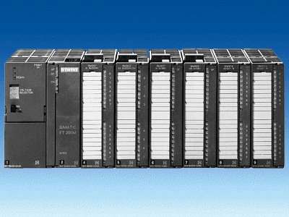
5 ET 200M

6 PROFIBUS cable

3.4.5 Module D5 – Profibus DP with Master CPU 315-2DP / Slave ET 200S/CPU

Learning goal:
In this module, the reader should learn how the PROFIBUS DP is taken into operation with the CPU 315-2DP as a master and the ET 200S with the integrated CPU as a slave. The module shows the principle procedure by means of a short example.

Requirements:
For the successful use of this module, the following knowledge is assumed:
• Knowledge in the use of Windows 95/98/2000/ME/NT4.0
• Basics of PLC- Programming with STEP 7 (e.g. Module A3 - ‘Startup’
PLC programming with STEP 7)
• Basics of the PROFIBUS DP (e.g. Appendix IV – Basics of
field bus systems with SIMATIC S7-300)

Required hardware and software
1 PC, Operating system Windows 95/98/2000/ME/NT4.0 with
- Minimal: 133MHz and 64MB RAM, approx. 65 MB free hard disk space
- Optimal: 500MHz and 128MB RAM, approx. 65 MB free hard disk space
2 Software STEP 7 V 5.x
- MPI- Interface for the PC (e.g. PC- Adapter)
- PLC SIMATIC S7-300 with the CPU 315-2DP with at least one digital in- and output.
Example configuration:
- Network: PS 307 2A
- CPU: CPU 315-2DP
- Digital inputs: DI 16x DC24V
- Digital outputs: DO 16x DC24V / 0.5A
5 Distributed I/O ET 200S with integrated CPU and with at least one digital in- and output.
Example configuration:
- PROFIBUS connection with integrated CPU: IM 151/CPU
- Power supply: PM-E DC24V
- Digital inputs: 4 DI DC24V
- Digital outputs: 4 DO DC24V / 0.5 A
6 PROFIBUS cable with 2 PROFIBUS slots

1 PC
2 STEP 7

3 PC Adapter

4 S7-300 with
CPU 315-2DP

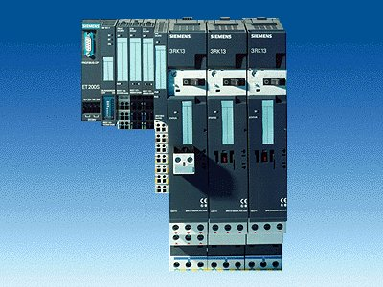
5 ET200S with
IM151/CPU

6 PROFIBUS cable

3.4.6 Module D6 – Profibus DP with Master CPU 315-2DP / Slave CPU 315-2DP

Learning goal:
In this module, the reader should learn how the PROFIBUS DP is taken into operation with the CPU 315-2DP as a master and a CPU 315-2DP as a slave. The module shows the principle procedure by means of a short example.

Requirements:
For the successful use of this module, the following knowledge is assumed:
• Knowledge in the use of Windows 95/98/2000/ME/NT4.0
• Basics of PLC- Programming with STEP 7 (e.g. Module A3 - ‘Startup’
PLC programming with STEP 7)
• Basics of the PROFIBUS DP (e.g. Appendix IV – Basics of
field bus systems with SIMATIC S7-300)

Required hardware and software

1 PC, Operating system Windows 95/98/2000/ME/NT4.0 with
- Minimal: 133MHz and 64MB RAM, approx. 65 MB free hard disk space
- Optimal: 500MHz and 128MB RAM, approx. 65 MB free hard disk space
2 Software STEP 7 V 5.x
- MPI- Interface for the PC (e.g. PC- Adapter)
- PLC SIMATIC S7-300 with the CPU 315-2DP with at least one digital in- and output.
Example configuration:
- Network: PS 307 2A
- CPU: CPU 315-2DP
- Digital inputs: DI 16x DC24V
- Digital outputs: DO 16x DC24V / 0.5A
5 PLC SIMATIC S7-300 with the CPU 315-2DP and at least one digital in- and output.
Example configuration:
- Power supply: PS 307 2A
- CPU: CPU 315-2DP
- Digital inputs: DI 16x DC24V
- Digital outputs: DO 16x DC24V / 0.5 A
6 PROFIBUS cable with 2 PROFIBUS slots

1 PC
2 STEP 7

3 PC Adapter

5 S7-300 with
CPU 315-2DP
4 S7-300 with
CPU 315-2DP

6 PROFIBUS cable

3.4.7 Module D7 – Profibus DP with Master CPU 315-2DP / Slave MICROMASTER Vector

Learning goal:
In this module, the readers should learn how the PROFIBUS DP is taken into operation with the CPU 315-2DP as a master and the MICROMASTER Vector as a slave. The module shows the principle procedure by means of a short example.

Requirements:
For the successful use of this module, the following knowledge is assumed:
• Knowledge in the use of Windows 95/98/2000/ME/NT4.0
• Basics of PLC- Programming with STEP 7 (e.g. Module A3 - ‘Startup’
PLC programming with STEP 7)
• Basics of the PROFIBUS DP (e.g. Appendix IV – Basics of
field bus systems with SIMATIC S7-300)

Required Hardware and Software
1 PC, Operating system Windows 95/98/2000/ME/NT4.0 with
- Minimal: 133MHz and 64MB RAM, approx. 65 MB free hard disk space
- Optimal: 500MHz and 128MB RAM, approx. 65 MB free hard disk space
- Software STEP 7 V 5.x
- MPI- Interface for the PC (e.g. PC- Adapter)
- PLC SIMATIC S7-300 with the CPU 315-2DP
Example configuration:
- Power supply: PS 307 2A
- CPU: CPU 315-2DP
- MICROMASTER Vector with PROFIBUS module CB15
- PROFIBUS cable with 2 PROFIBUS slots
1 PC
2 STEP 7

3 PC Adapter

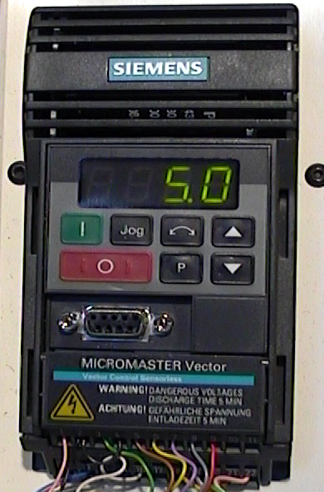

5 MICROMASTER
with PROFIBUS Module CB15

4 SIMATIC S7-300 with CPU 315-2DP
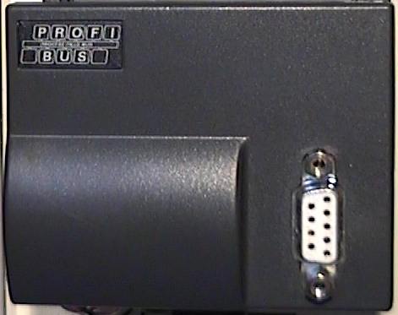

6 PROFIBUS cable

3.4.8 Module D8 – Programming of SIMATIC WinAC

Learning goal:
In this module, the reader should learn how the Soft- PLC SIMATIC WinAC is programmed and parameterized.
Therefore the PROFIBUS DP is taken into operation with SIMATIC WinAC as a master and the ET 200L as a slave. The module shows the principle procedure by means of a short example.

Requirements:
For the successful use of this module, the following knowledge is assumed:
• Knowledge in the use of Windows 95/98/2000/ME/NT4.0
• Basics of PLC- Programming with STEP 7 (e.g. Module A3 - ‘Startup’
PLC programming with STEP 7)
• Basics of the PROFIBUS DP (e.g. Appendix IV – Basics of
field bus systems with SIMATIC S7-300)

Required Hardware und Software
1 PC, Operating system Windows NT4.0 with
- Minimal: 133MHz and 64MB RAM, approx. 69 MB free hard disk space
- Optimal: 500MHz and 128MB RAM, approx. 69 MB free hard disk space
2 Software STEP 7 V 5.x
3 Soft- PLC WinAC
4 PROFIBUS interface for the PC (e.g. CP5613)
5 Distributed I/O ET 200L with 16 digital in- and outputs
6 PROFIBUS cable with 2 PROFIBUS slots

2 STEP 7

1 PC with
4 PROFIBUS interface CP5613

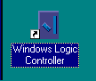
3 Soft- PLC WinAC

5 ET 200L

6 PROFIBUS cable

3.4.9 Module D9 – Profibus DP with Master CP 342-5DP / Slave ET 200L

Learning goal:
In this module, the reader should learn how the PROFIBUS DP is taken into operation with a SIMATIC S7-300 with the communication processor CP 342-5DP as master and the ET 200L as a slave. The module shows the principle procedure by means of a short example.

Requirements:
For the successful use of this module, the following knowledge is assumed:
• Knowledge in the use of Windows 95/98/2000/ME/NT4.0
• Basics of PLC- Programming with STEP 7 (e.g. Module A3 - ‘Startup’
PLC programming with STEP 7)
• Basics of the PROFIBUS DP (e.g. Appendix IV – Basics of
field bus systems with SIMATIC S7-300)

Required hardware and software

1 PC, Operating system Windows 95/98/2000/ME/NT4.0 with
- Minimal: 133MHz and 64MB RAM, approx. 65 MB free hard disk space
- Optimal: 500MHz and 128MB RAM, approx. 65 MB free hard disk space
2 Software STEP 7 V 5.x with option NCM S7 PROFIBUS
3 MPI- Interface for the PC (e.g. PC- Adapter)
4 PLC SIMATIC S7-300 with the CP 342-5DP
Example configuration:
- Power supply: PS 307 2A
- CPU: CPU 314IFM
- PROFIBUS- Communication processor: CP 342-5DP
5 Distributed I/O ET 200L with 16 digital in- and outputs
6 PROFIBUS cable with 2 PROFIBUS slots

1 PC
2 STEP 7

3 PC Adapter

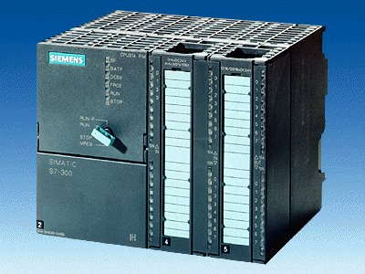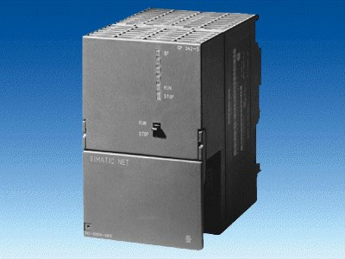
4 S7-300 with
CP 342-5DP
5 ET 200L

6 PROFIBUS cable

3.4.10 Module D10 – Profibus DP with Master CP 342-5DP / Slave CP 342-5DP

Learning goal:
In this module, the reader should learn how the PROFIBUS DP is taken into operation with a SIMATIC S7-300 with the communication processor CP 342-5DP as a master and as a slave. The module shows the principle procedure by means of a short example.

Requirements:
For the successful use of this module, the following knowledge is assumed:
• Knowledge in the use of Windows 95/98/2000/ME/NT4.0
• Basics of PLC- Programming with STEP 7 (e.g. Module A3 - ‘Startup’
PLC programming with STEP 7)
• Basics of the PROFIBUS DP (e.g. Appendix IV – Basics of
field bus systems with SIMATIC S7-300)

Required hardware and software
1 PC, Operating system Windows 95/98/2000/ME/NT4.0 with
- Minimal: 133MHz and 64MB RAM, approx. 65 MB free hard disk space
- Optimal: 500MHz and 128MB RAM, approx. 65 MB free hard disk space
2 Software STEP 7 V 5.x with option NCM S7 PROFIBUS
3 MPI- Interface for the PC (e.g. PC- Adapter)
4 PLC SIMATIC S7-300 with the CP 342-5DP
Example configuration:
- Power supply: PS 307 2A
- CPU: CPU 314IFM
- PROFIBUS- Communication processor: CP 342-5DP
5 PLC SIMATIC S7-300 with the CP 342-5DP
Example configuration:
- Network: PS 307 2A
- CPU: CPU 314IFM
- PROFIBUS- Communication processor: CP 342-5DP
6 PROFIBUS cable with 2 PROFIBUS slots
1 PC
2 STEP 7

3 PC Adapter

4 S7-300 with
CP 342-5DP
5 S7-300 cable
CP 342-5DP

6 PROFIBUS cable

3.4.11 Module D11 – Profibus DP with Master CP 342-5DP / Master CP 342-5DP

Learning goal:
In this module, the reader should learn how a FDL connection to a PROFIBUS DP with two SIMATIC S7-300 with the communication processor CP 342-5DP as a master is taken into operation. The module shows the principle procedure by means of a short example.

Requirements:
For the successful use of this module, the following knowledge is assumed:
• Knowledge in the use of Windows 95/98/2000/ME/NT4.0
• Basics of PLC- Programming with STEP 7 (e.g. Module A3 - ‘Startup’
PLC programming with STEP 7)
• Basics of the PROFIBUS DP (e.g. Appendix IV – Basics of
a field bus system with SIMATIC S7-300)

Required hardware and software

1 PC, Operating system Windows 95/98/2000/ME/NT4.0 with
- Minimal: 133MHz and 64MB RAM, approx. 65 MB free hard disk space
- Optimal: 500MHz and 128MB RAM, approx. 65 MB free hard disk space
2 Software STEP 7 V 5.x with option NCM S7 PROFIBUS
3 MPI- Interface for the PC (e.g. PC- Adapter)
4 PLC SIMATIC S7-300 with the CP 342-5DP
Example configuration:
- Power supply: PS 307 2A
- CPU: CPU 314IFM
- PROFIBUS- Communication processor: CP 342-5DP
5 PLC SIMATIC S7-300 with the CP 342-5DP
Example configuration:
- Network: PS 307 2A
- CPU: CPU 314IFM
- PROFIBUS- Communication processor: CP 342-5DP
6 PROFIBUS cable with 2 PROFIBUS slots
1 PC
2 STEP 7

3 PC Adapter

4 S7-300 with
CP 342-5DP
5 S7-300 with
CP 342-5DP

6 PROFIBUS cable

3.5 IT- Communication with SIMATIC S7

The following module can be used as a teaching tool for the theme IT- Communication

The time frame is approximately 15 instructional units (45 minutes).

The following sequence is therefore arranged as follows.
Basics of
STEP 7- Programming
2- 3 days A modules

Additional functions of
STEP 7- Programming
2- 3 days B modules

Industrial
field bus systems
2- 3 days D modules
Process
visualization
2- 3 days F modules
Sequencer
programming
2- 3 days C modules

IT- Communication with S7

(1 -2 days)

Module E1
Under construction

3.5.1 Module E1 – Under Construction

Under Construction!!!

Coming soon on the WEB:
http://www.siemens.com/sce

3.6 Process visualization

The following module can be used as a teaching tool for the theme Process visualization.

The time frame is approximately 20 instructional units (45 Minutes)

The following sequence is therefore arranged as follows.
Basics of
STEP 7- Programming
2- 3 days A modules

Additional functions of
STEP 7- Programming
2- 3 days B Modules

Industrial
field bus systems
2- 3 days D modules
Sequencer
programming
2- 3 days C modules

IT- Communication
with S7
1- 2 days E modules

Process Visualization

(2 -3 days)

Module F1
OP7 and ProTool
Module F2
TP170A and ProTool
Module F3
ProTool/Pro Runtime

Module F4
WinCC

3.6.1 Module F1 – Human Machine Interface with OP7 and ProTool

Learning goal:
In this module, the reader should become familiar with the programming of ProTool’s configuration software and the fundamental functions of the operator panel OP 7 with the integrated interface to the MPI and/or Profibus DP.

Notes for documentation
In the associated chapters we explain the fundamental functions of the operator panel, typical tasks by a pattern machine as well as further tips and tricks.

All capitals are based on the following principle:

- First of all the exercise is explained. Afterwards the several configuration steps are executed and displayed by means of a chosen dialog box.
- In the next step follows the connection by the programmable controller.
- Lastly we show you the result on the display of the operator panel so that you can directly your result after each configuration step.

Requirements:
For the successful use of this module the following knowledge is assumed:
• Knowledge in the use of Windows 95/98/2000/ME/NT4.0
• Basics of PLC- Programming with STEP 7 (e.g. Module A3 – ‘Startup’
PLC- Programming with STEP 7)

Required Hardware and Software
1 PC, Operating system Windows 95/98/2000/ME/NT4.0 with
- Minimal: 133MHz and 64MB RAM, approx. 150 MB free hard disk space
- Optimal: 500MHz and 128MB RAM, approx. 150 MB free hard disk space
2 Software STEP 7 V 5.x
3 Configuration software ProTool V 5.2
4 MPI- Interface for the PC (e.g. PC- Adapter)
5 Example configuration for PLC SIMATIC S7-300:
- Power supply: PS 307 2A
- CPU: CPU 314
- Digital inputs: DI 16x DC24V
- Digital outputs: DO 16x DC24V / 0.5 A
6 Operator Panel OP7
7 Serial data cable for the connection from OP7 to COM1 of the PC
- MPI and/or Profibus DP data cable for the connection from OP7 to the controller
1 PC

2 STEP 7

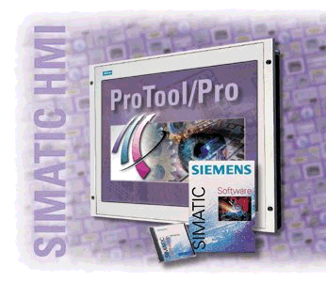
3 Configuration software ProTool
4 PC Adapter

5 S7-300

6 Operator Panel OP7

7 Serial data cable

8 MPI and/or Profibus DP data cable

3.6.2 Module F2 – Human Machine Interface with TP170A and ProTool

Learning goal:
In this module, the reader should become familiar with the programming of the configuration software Pro Tool and the fundamental functions of the touch panel TP170A with integrated interface to the MPI and/or Profibus DP.

Notes for documentation:
In the associated chapters we explain the fundamental functions of the touch panel, typical tasks by a pattern machine as well as further tips and tricks.

All capitals are based on the following principle:

- First of all the exercise is explained. Afterwards the several configuration steps are executed and displayed by means of a chosen dialog box.
- In the next step follows the connection by the programmable controller.
- Lastly we show you the result on the display of the touch panel so that you can directly your result after each configuration step.

Requirements:
For the successful use of this module the following knowledge is assumed:
• Knowledge in the use of Windows 95/98/2000/ME/NT4.0
• Basics of PLC- Programming with STEP 7 (e.g. Module A3 – ‘Startup’
PLC- Programming with STEP 7)

Required Hardware and Software
1 PC, Operating system Windows 95/98/2000/ME/NT4.0 with
- Minimal: 133MHz and 64MB RAM, approx. 150 MB free hard disk space
- Optimal: 500MHz and 128MB RAM, approx. 150 MB free hard disk space
2 Software STEP 7 V 5.x
3 Configuration software ProTool V 5.2
4 MPI- Interface for the PC (e.g. PC- Adapter)
5 Example configuration for PLC SIMATIC S7-300:
- Power supply: PS 307 2A
- CPU: CPU 314
- Digital inputs: DI 16x DC24V
- Digital outputs: DO 16x DC24V / 0.5 A
6 Touch Panel TP170A
- Serial zero modern cable for the connection from TP170A to COM1 of PC
- MPI and/or Profibus DP data cable for the connection from TP170A to the controller

1 PC

3 Configuration software ProTool
2 STEP 7

5 S7-300

4 PC Adapter

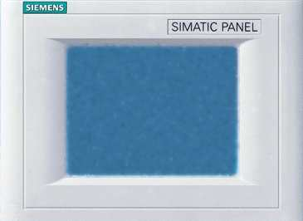
6 Touch Panel TP170A

7 Serial zero modern cable

8 MPI and/or Profibus DP data cable

3.6.3 Module F3 – Human Machine Interface with ProTool/Pro Runtime

Learning goal:
In this module, the reader should learn the fundamental functions of the software ProTool/Pro Runtime.
Typical tasks are executed by a pattern machine.
• Installation of software
• Steps for compiling a project
• Input from image objects and libraries
• Configuration of display and controls
• Creation and activation from alarm and event messages.
• Debugging of the tasks in online operation with a PLC SIMATIC S7- 300

Requirements:
For the successful use of this module the following knowledge is assumed:
• Knowledge in the use of Windows 95/98/2000/ME/NT4.0
• Basics of PLC- Programming with STEP 7 (e.g. Module A3 – ‘Startup’
PLC- Programming with STEP 7)

Required Hardware and Software
1 PC, Operating system Windows 95/98/2000/ME/NT4.0 with
- Minimal: 133MHz and 64MB RAM, approx. 150 MB free hard disk space
- Optimal: 500MHz und 128MB RAM, approx. 150 MB free hard disk space
2 Software STEP 7 V 5.x
3 Configuration software ProTool/Pro CS V5.2 and simulation software ProTool/Pro RT V5.2
4 MPI- Interface for the PC (e.g. PC- Adapter)
5 PLC SIMATIC S7-300
Example configuration:
- Power supply: PS 307 2A
- CPU: CPU 314
- Digital inputs: DI 16x DC24V
- Digital outputs: DO 16x DC24V / 0.5 A

1 PC
2 STEP 7

3 ProTool/Pro CS+RT
4 PC Adapter

5 S7-300

3.6.4 Module F4 – Human Machine Interface with WinCC

Learning goal:
In this module, the reader becomes familiar with the fundamental functions of the WinCC software.
Typical tasks are executed by a pattern system.
• Installation of software
• Steps for compiling a project
• Configuration of display and controls
• Input from image objects and libraries
• Display of measured values
• Alarm logging with logs
• Displaying functions with Global Scripts
• Debugging of the tasks in online operation with a PLC SIMATIC S7- 300

Requirements:
For the successful use of this module the following knowledge is assumed:
• Knowledge in the use of Windows 95/98/2000/ME/NT4.0
• Basics of PLC- Programming with STEP 7 (e.g. Module A3 – ‘Startup’
PLC- Programming with STEP 7)

Required Hardware and Software

1 PC, Operating system Windows 95/98/2000/ME/NT4.0 with
- Minimal: 133MHz and 64MB RAM, approx. 150 MB free hard disk space
- Optimal: 500MHz and 128MB RAM, approx. 150 MB free hard disk space
2 Software STEP7 V 5.x
3 Process visualization software WinCC V5.x
4 MPI- Interface for the PC (e.g. PC- Adapter)
5 PLC SIMATIC S7-300
Example configuration:
- Power supply: PS 307 2A
- CPU: CPU 314
- Digital inputs: DI 16x DC24V
- Digital outputs: DO 16x DC24V / 0.5 A
1 PC
2 STEP 7

4 PC Adapter

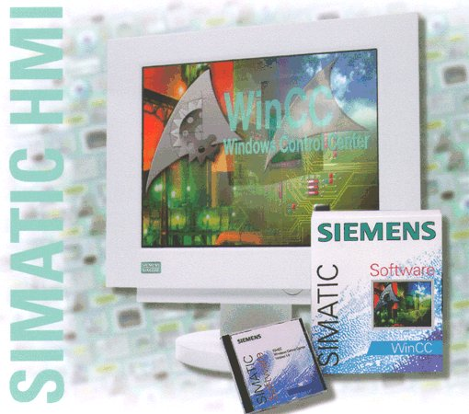
3 WinCC

5 S7-300

4. Appendix

The appendices I-IV contain the theoretical basics for the operation of the module available.

The inner part of the course structure is assigned as follows:
Appendix I
Basics S7-300
Appendix II
IEC 61131
Appendix III
Program instructions

Basics of

STEP 7- Programming
2 - 3 days A modules
Industrial field bus systems
2- 3 days D modules
Process
visualization
2- 3 days F modules
Sequencer
programming
2- 3 days C modules

Additional functions of
STEP 7- Programming
2- 3 days B modules

Appendix IV
Field bus systems

IT- Communication
with S7
1- 2 days E modules

4.1 Appendix I – Basics of PLC – Programming with SIMATIC S7 300

Learning goal:
Programmable logic controllers (PLC in brief), are considered today as a principal item of automation. With these controllers, most diverse tasks of automation can be implemented depending on the definition of the problem.

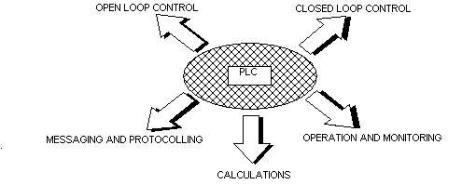

These documents give you an overview of the automation system SIMATIC S7-300 and the appropriate programming software STEP 7.

Requirements:
Since the basics are found within this appendix, no special requirements are necessary.

4.2 Appendix II – IEC 61131

Learning goal:
The reader receives information about the international Norm IEC 61131 with this appendix.

Requirements:
The theoretical basics are present here, so no special requirements are necessary.

4.3 Appendix III – Basic program instructions LAD/FBD/STL in STEP 7

Learning goal:
The reader receives a collection of the most important programming instructions which are needed for the solution of the tasks of programming in the modules within this appendix.

Requirements:
In order for the instructions and the programming mode to be understood, the following knowledge is assumed:

• PLC- Programming basics (e.g. Appendix I – PLC-Programming basics with SIMATIC S7-300)

4.4 Appendix IV – Basics of field bus systems SIMATIC S7-300

Learning goal:
This document should give you an overview of field bus systems in general and should introduce the integrated bus systems of the automation system S7-300. They are:

• Multi Point Interface (MPI)
• AS-Interface
• PROFIBUS

Requirements:
Since the basics are found within this appendix, no special requirements are necessary.

