Training document for the company-wide
automation solution
Totally Integrated Automation (T I A)

MODULE D12
PROFIBUS DP with
Master CP 342-5DP / Master CP 342-5DP

This document was provided by Siemens A&D SCE (automation and drive technology, Siemens A&D Cooperates with Education) for training purposes. Siemens does not make any type of guarantee regarding its contents.

The passing on or duplication of this document, including the use and report of its contents, is only permitted within public and training facilities.

Exceptions require written permission by Siemens A&D SCE (Mr. Knust: E-Mail: michael.knust@hvr.siemens.de). Offences are subject to possible payment for damages caused. All rights are reserved for translation and any case of patenting or GM entry.

We thank the company Michael Dziallas Engineering and the instructors of vocational schools as well as further persons for the support with the production of the document.

PAGE:

1. Forward 4

2. Notes for the Operation of CP 342-5DP 6

3. Commissioning the Profibus ( Master CP 342-5DP / Master CP 342-5DP) 7

The following symbols stand for the specified modules:


Information


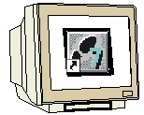
Programming


Example exercise


Notes

1. forward

The module D11 is assigned content wise to Industrial field bus systems.

Basics of

STEP 7- Programming
2 - 3 days A modules
Industrial field bus
systems
2- 3 days D modules
Additional functions of
STEP 7- Programming
2- 3 days B modules
Process
visualization
2- 3 days F modules
Sequencer
Programming
2- 3 days C modules
IT- Communication
with SIMATIC S7
1- 2 days E modules

Learning goal:

In this module, the reader should learn how a FDL connection to a PROFIBUS DP with two SIMATIC S7-300 with the communication processor CP 342-5DP as a master is taken into operation. The module shows the principle procedure by means of a short example.

Requirements:

For the successful use of this module, the following knowledge is assumed:

• Knowledge in the use of Windows 95/98/2000/ME/NT4.0
• Basics of PLC- Programming with STEP 7 (e.g. Module A3 - ‘Startup’
PLC programming with STEP 7)
• Basics of the PROFIBUS DP (e.g. Appendix IV – Basics of
field bus systems with SIMATIC S7-300)

Required hardware and software

1 PC, Operating system Windows 95/98/2000/ME/NT4.0 with
- Minimal: 133MHz and 64MB RAM, approx. 65 MB free hard disk space
- Optimal: 500MHz and 128MB RAM, approx. 65 MB free hard disk space
2 Software STEP 7 V 5.x with option NCM S7 PROFIBUS
3 MPI- Interface for the PC (e.g. PC- Adapter)
4 PLC SIMATIC S7-300 with the CP 342-5DP
Example configuration:
- Power supply: PS 307 2A
- CPU: CPU 314IFM
- PROFIBUS- Communication processor: CP 342-5DP
5 PLC SIMATIC S7-300 with the CP 342-5DP
Example configuration:
- Network: PS 307 2A
- CPU: CPU 314IFM
- PROFIBUS- Communication processor: CP 342-5DP
- PROFIBUS cable with 2 PROFIBUS slots

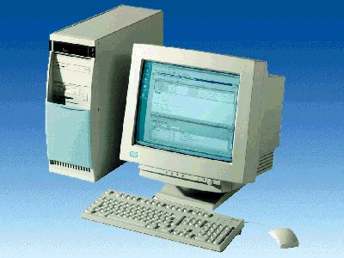
1 PC
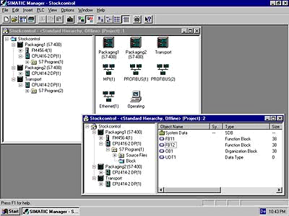
2 STEP 7

3 PC Adapter

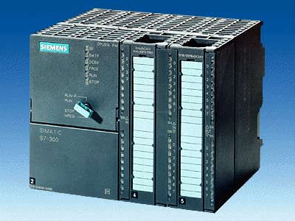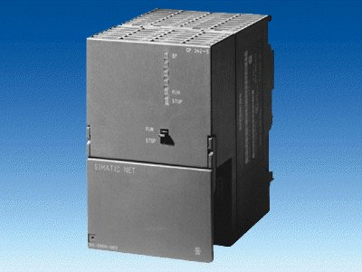
4 SIMATIC S7-300 with
CP 342-5DP
5 SIMATIC S7-300 with
CP 342-5DP

6 PROFIBUS cable

2. notes for the operation of the CP 342-5DP
The PROFIBUS communication processor CP 342-5DP makes it possible to attach to itself the SIMATIC S7-300 by the PROFIBUS with the protocol profile distributed I/O (DP).

The parameterizing of the PROFIBUS parameters for the PLC, such as the configuration of the PROFIBUS network, takes place with the software STEP 7. The requirement is the CP342-5DP and additionally the software “NCM S7 PROFIBUS “ (Contained already in STEP 7 V5.x!), so that the user has a uniform configuration tool for centralized and distributed configuration.

For the SIMATIC S7-300 with the CP342-5 as a Combimaster, the following protocol profiles are at your disposal:
• DP- Interface as master or slave according to EN 50170. PROFIBUS-DP (Distributed I/O) is the protocol profile for the connection of the distributed I/O/field equipment with a quick reaction time.
• SEND/RECEIVE- Interface (AG/AG) according to the SDA-Service (Layer 2 of the
PROFIBUS). SEND/RECEIVE (FDL- Interface) offers functions with which the
communication between SIMATIC S5 and S7 are under one another and they can simply and quickly be realized to the PC.
• S7-Functions. These offer optimal communication in the SIMATIC S7/M7/PC-connection.

On the part of the user program, the transmission of the data range for the DP and FDL communication is activated through programmed FC-Block calls and monitoring of effective execution monitored.
The block calls for the important communication FC blocks are found in the library “SIMATIC_NET_CP“. In order to use these functions, the function must be copied into the project.
Note: Here 2 SIMATIC S7-300 with the CP 342-5DP are appointed to a PROFIBUS.
Both should be masters on the network and should communicate with each other over a FDL connection.
It would also be possible to assign each master a pair of slaves at the same time.

The FDL connection enables a program controlled communication between 2 stations by the PROFIBUS with the following properties:
• The data transfer is bi-directional, e.g. it can send and received on the AG/AG connection simultaneously.
• Both stations are asynchronous, e.g. each station can activate a send and receive operation which is result dependent.
• The CP342-5 can operation a maximum of 16 connections. It can send and receive 240 bytes pro job.

3. commissioning the Profibus ( Master cp 342-5DP / Master cp 342-5DP)
In the following example, the commissioning of a multi master system with two SIMATIC S7-300 with CP 342-5DP as a master is described.
For the testing of the configuration, a program will be written in which an input (SET) can be preset in each PLC. This byte is transferred over the PROFIBUS to the other PLC and can then be displayed over a display byte (DISPLAY).

Assignment list Master- CPU1:
IB 124 SET Input byte
IB 40 Comm_IB1 Input communication Byte1
QB 124 DISPLAY Display byte
QB 40 Comm_QB1 Output communication Byte1

Assignment list Master- CPU2:
IB 124 SET Input byte
IB 40 Comm_IB1 Input communication Byte1
QB 124 DISPLAY Display byte
QB 40 Comm_QB1 Output communication Byte1

For the connection of the two CPU342-5DP, whereby one is set as a master and the other as a slave, the following steps must be followed.

1. The central tool in STEP 7 is the SIMATIC Manager, which is opened here with a double click ( → SIMATIC Manager).
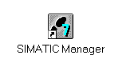

2. STEP 7- Programs are administered in projects . Such a project will be created ( → File → New).

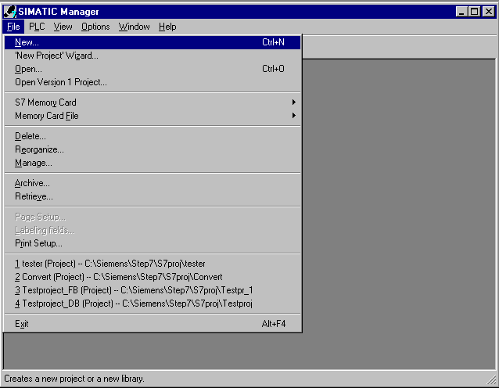

3. Give the Name CP342_FDL to the project ( → CP342_FDL → OK)

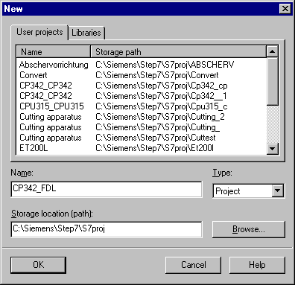

- Highlight your project and insert a PROFIBUS Subnet (→ CP342_FDL → Insert → Subnet → PROFIBUS).

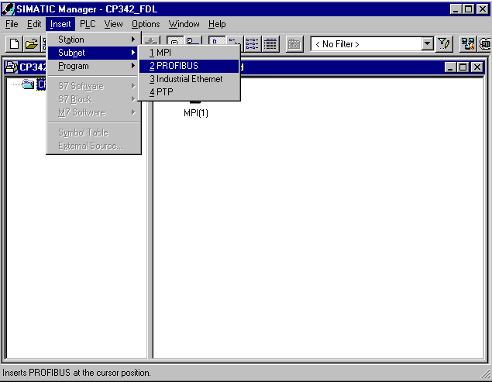

5. Then insert a SIMATIC 300-Station (→ Insert → Station → SIMATIC 300-Station).

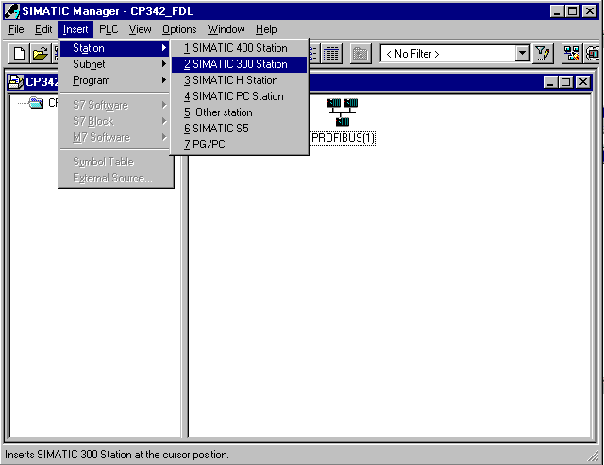

6. Change the name of the station to Master1 (→ Master1).

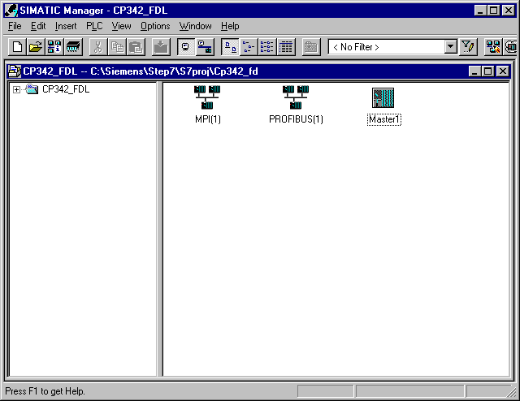

7. Open the configuration tool for the Hardware with a double click (→ Hardware).

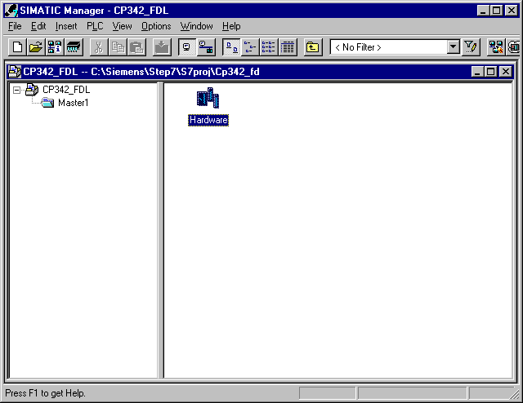

8. Open the hardware catalog with a click on the symbol (→ ).
There you will see the directories are divided into the following:
- PROFIBUS-DP, SIMATIC 300, SIMATIC 400 and SIMATIC PC Based Control,
all module racks, modules and interface modules for the configuration of your hardware configuration are made available.
Insert a Rail with a double click( → SIMATIC 300 → RACK-300 → Rail).

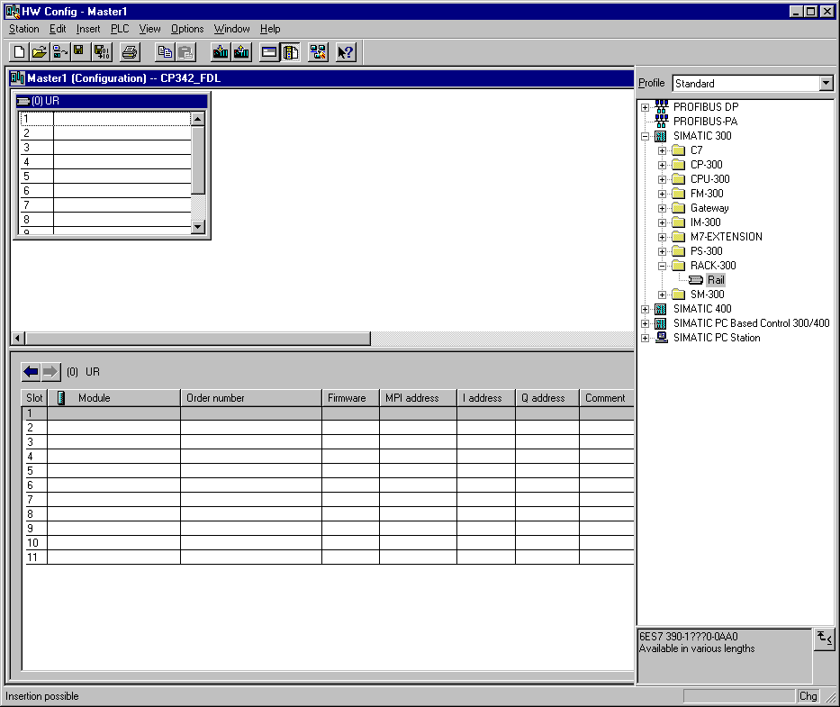

After the insert, a configurations table for the configuration of the Rack 0 appears automatically.

9. Now all modules can be chosen out of the hardware catalog and inserted into the configuration table and are also inserted into your rack. To insert, you must click on the name of the respective module, hold the mouse button and Drag & Drop the module into a line of the configurations table. We will begin with the power supply PS 307 2A (→ SIMATIC 300 →PS-300 → PS 307 2A).

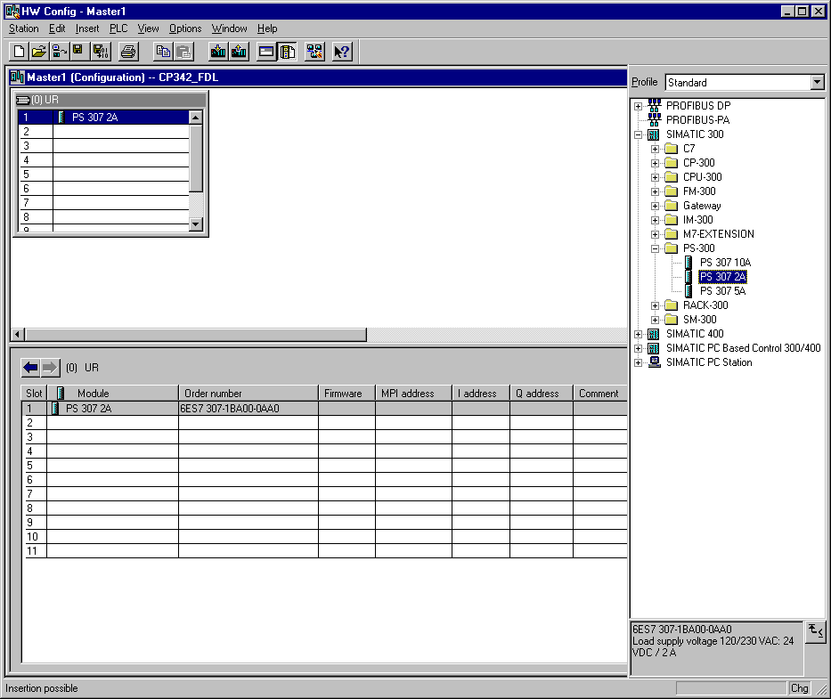

Note: If your hardware differs from what is shown above, then you must select the appropriate modules from the catalog and insert them into the rack. The part numbers of the individual modules, which are found on the components, are indicated in the footer of the catalog.

10. In the next step, we drop the CPU 314IFM into the second card location. This allows for the part number and version of the CPU to be read off (→ SIMATIC 300 → CPU-300 → CPU 314IFM → 6ES7 314-5AE03-0AB0 → V1.1 ).

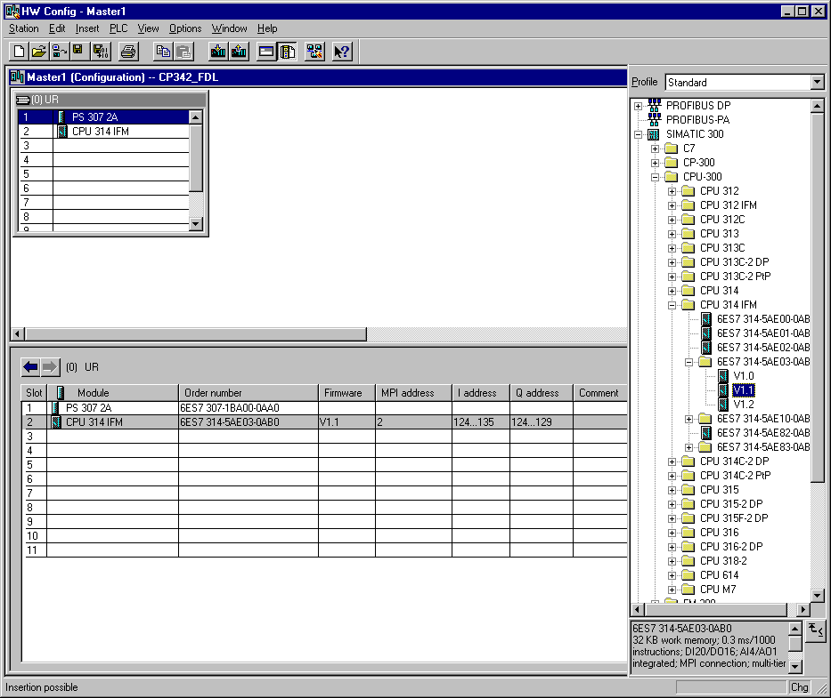

Note: The addresses of the integrated in-/outputs by the CPU314IFM can be read into the hardware configuration. However, they are directly on the CPU.
They are the digital inputs IB124 and IB125 such as I126.0-I126.3.
The digital outputs have the addresses QB124 and QB125.
The analog inputs are found on PIW128, PIW130, PIW132 and PIW134.
The analog output is found on PQW128.

11. Then we drag the communication processor for the PROFIBUS CP 342-5DP onto the fourth slot. Now the order number and version of the model can be read off the front (→ SIMATIC 300 → CP-300 → PROFIBUS → CP 342-5DP → 6GK7 342-5DA01-0XE0 → Product Version 2).

.

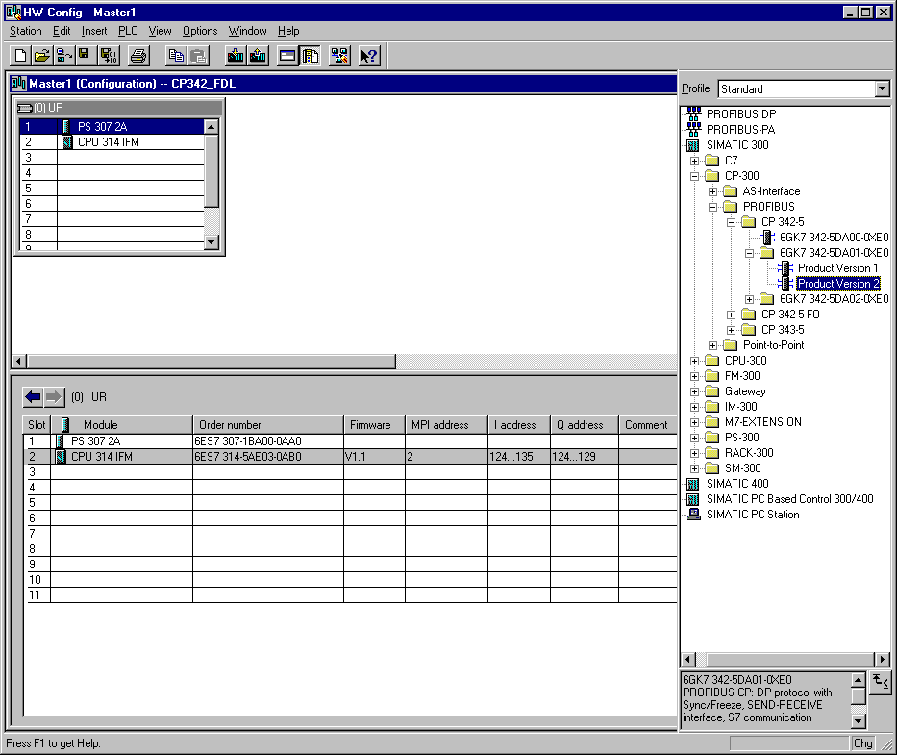

Note: Slot number 3 is reserved for interface modules and remains empty. The order number of the module is displayed in the footer of the catalog.

- By the entering of the communication processor, the following window appears, in which you assign a PROFIBUS address to the CPU 342-5DP and must already choose the first PROFIBUS net. When you want to alter the parameter of the PROFIBUS net, you must highlight it and then click on Properties (→ 2 → PROFIBUS(1)).

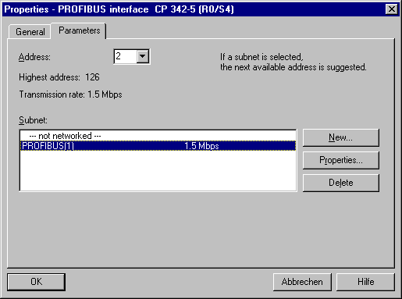

- Now you can choose the Highest PROFIBUS Address (here → 126), the Transmission Rate (here → 1,5 Mbit/s) and the Profile (here → DP). (→ OK).

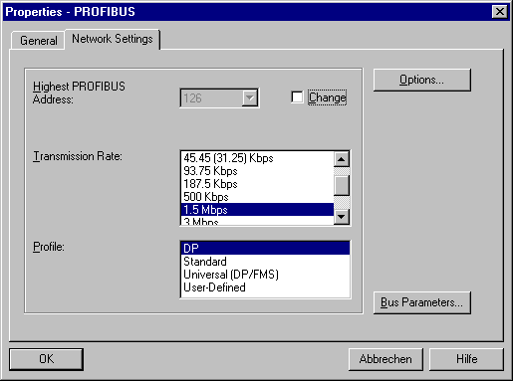

14. Now the addresses of the communication processor in the I/O address space of the CPU are noted (Here: PI 256...271 / PQ 256..271). Choose the properties of the communication process through a double click on the ‘CP 342-5DP’ ( → CP 342-5).

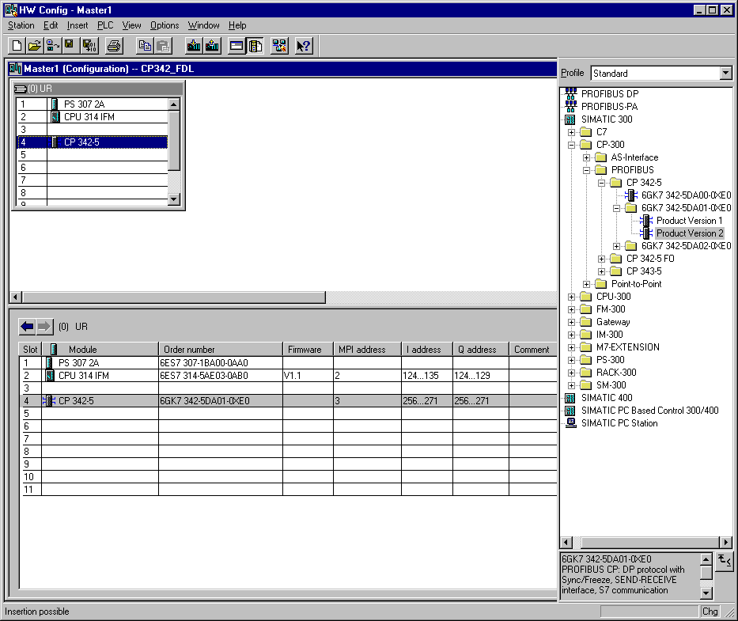

15. Set the Operation Mode to DP master and accept with OK ( → Operation Mode → DP master → OK).

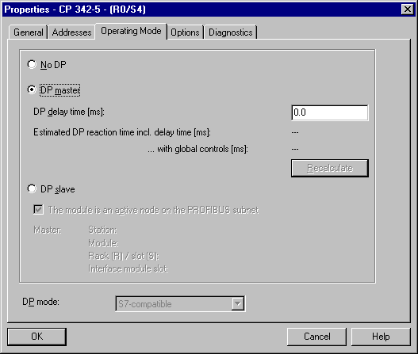

16. The configuration table is saved and compiled now with a click on . Then the hardware configuration is closed with a click on x ( → → x).

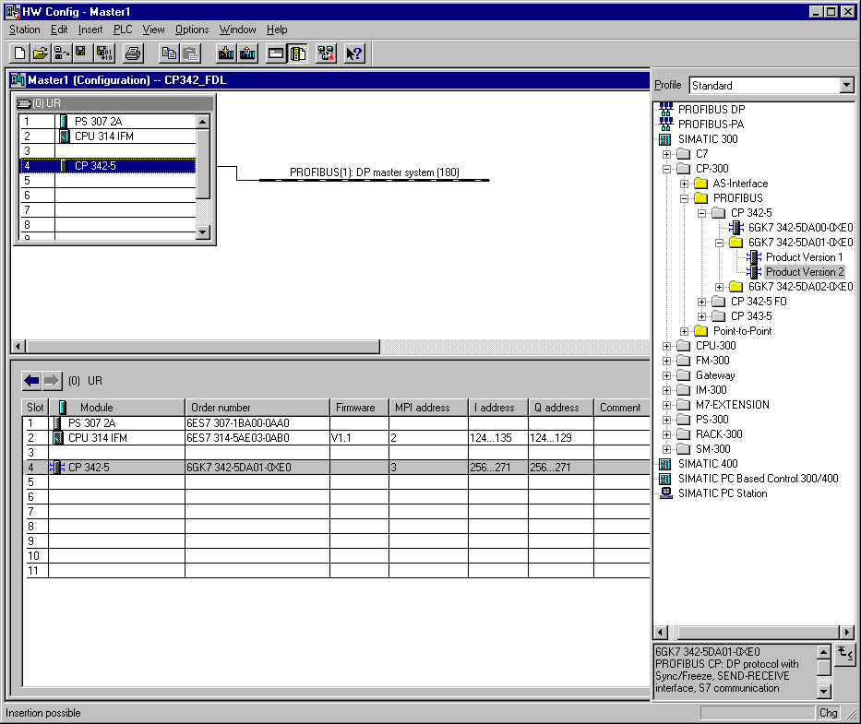

17. Now in SIMATIC Manager enter an additional SIMATIC 300-Station (→ SIMATIC Manager → Insert → Station → SIMATIC 300-Station).

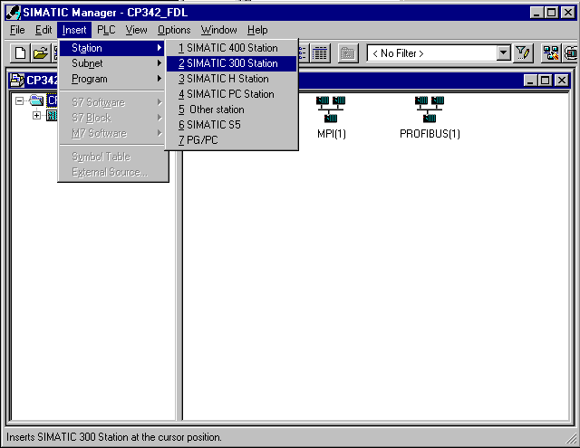

18. Change the name of the station to Master2 (→ Master2).

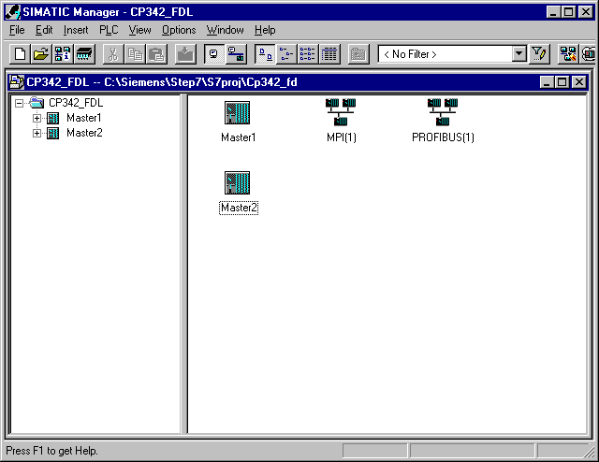

19. Open the configuration tool for the Hardware with a double click (→ Hardware).

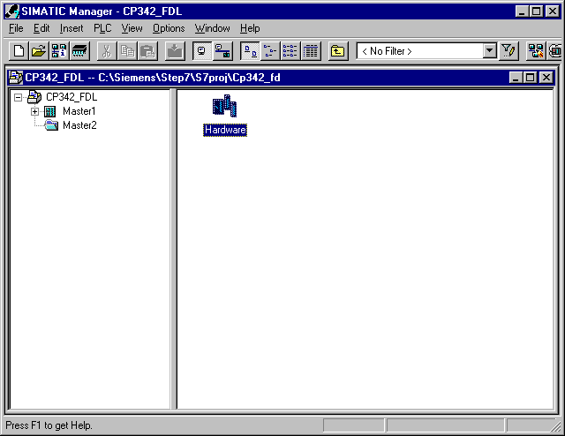

20. Open the hardware catalog with a click on the symbol (→ ).
There you will see the directories are divided into the following:
- PROFIBUS-DP, SIMATIC 300, SIMATIC 400 and SIMATIC PC Based Control,
all module racks, modules and interface modules for the configuration of your hardware configuration are made available.
Insert a Rail with a double click( → SIMATIC 300 → RACK-300 → Rail).

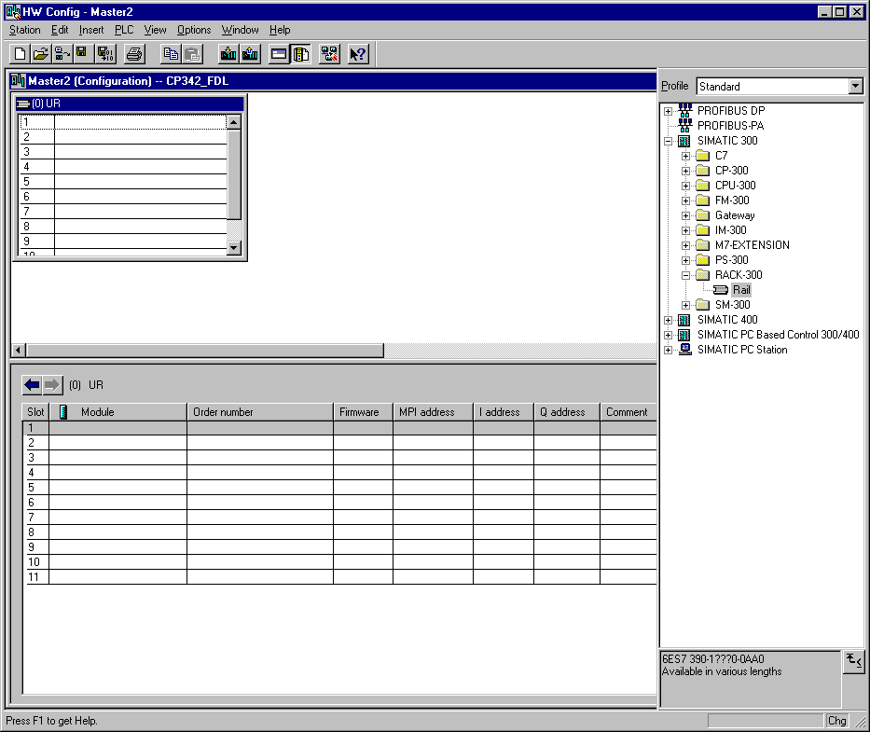

After the insert, a configurations table for the configuration of the Rack 0 appears automatically.

21. Now all modules can be chosen out of the hardware catalog and inserted into the configuration table and are also inserted into your rack. To insert, you must click on the name of the respective module, hold the mouse button and Drag & Drop the module into a line of the configurations table. We will begin with the power supply PS 307 2A (→ SIMATIC 300 →PS-300 → PS 307 2A).

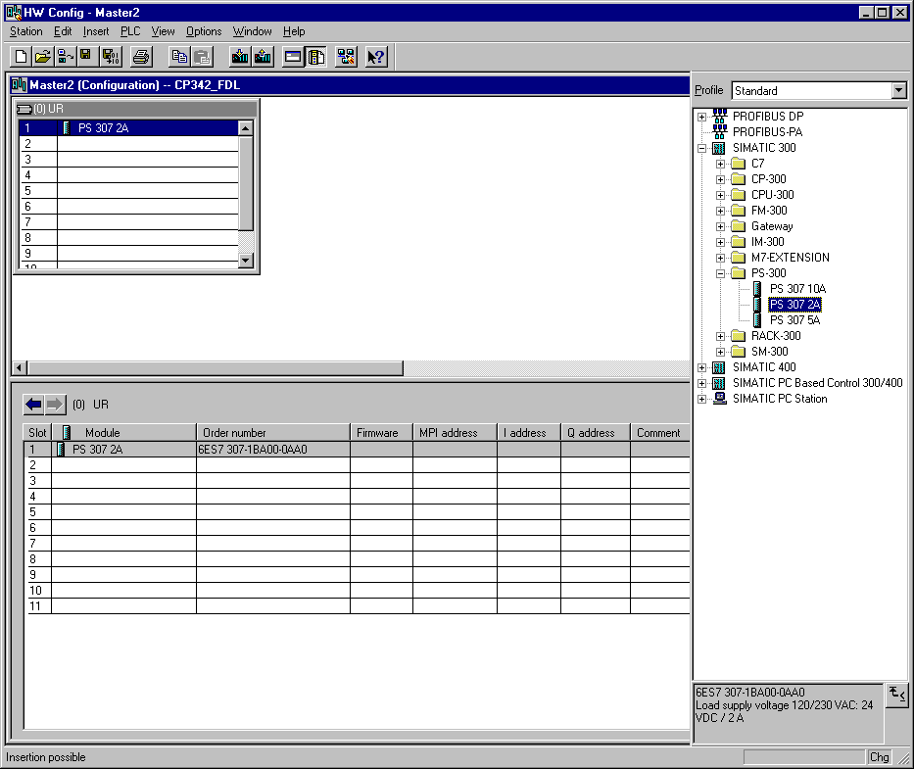

Note: If your hardware differs from what is shown above, then you must select the appropriate modules from the catalog and insert them into the rack. The part numbers of the individual modules, which are found on the components, are indicated in the footer of the catalog.

22. In the next step, we drop the CPU 314IFM into the second slot. This allows for the part number and version of the CPU to be read off the front (→ SIMATIC 300 → CPU-300 → CPU 314IFM → 6ES7 314-5AE03-0AB0 → V1.1 ).

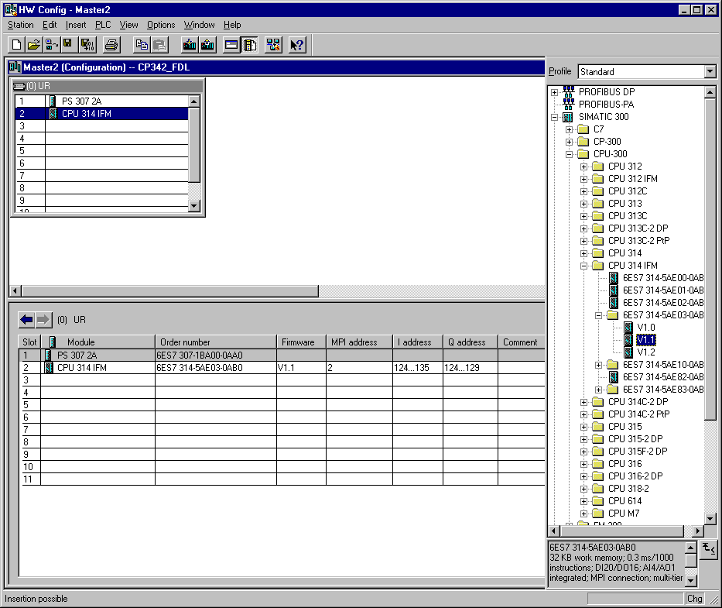

Note: The addresses of the integrated in-/outputs by the CPU314IFM can be read into the hardware configuration. However, they are directly on the CPU.
They are the digital inputs IB124 and IB125 such as I126.0-I126.3.
The digital outputs have the addresses QB124 and QB125.
The analog inputs are found on PIW128, PIW130, PIW132 and PIW134.
The analog output is found on PQW128.

23. Then we drag the communication processor for the PROFIBUS CP 342-5DP onto the fourth slot. Now the order number and version of the model can be read off the front (→ SIMATIC 300 → CP-300 → PROFIBUS → CP 342-5DP → 6GK7 342-5DA01-0XE0 → Product Version 2).

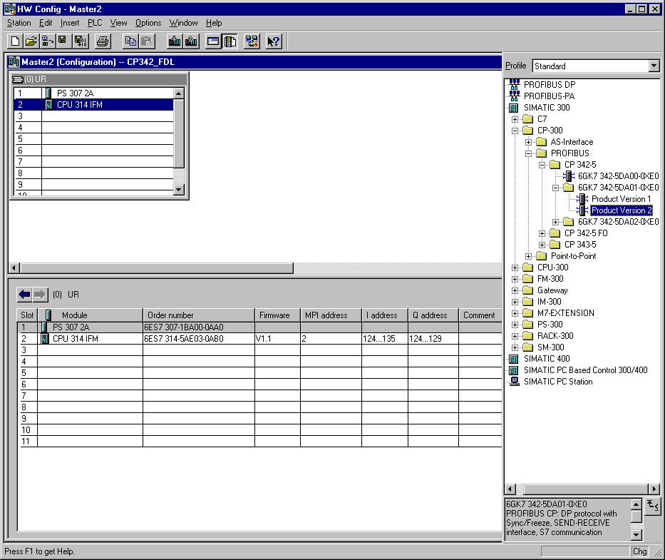

Note: Slot number 3 is reserved for interface modules and remains empty. The order number of the module is displayed in the footer of the catalog.

24. By the entering of the communication processor, the following window appears, in which you assign a PROFIBUS address to the CPU 342-5DP and must already choose the first PROFIBUS net (→ 4 → PROFIBUS(1)).

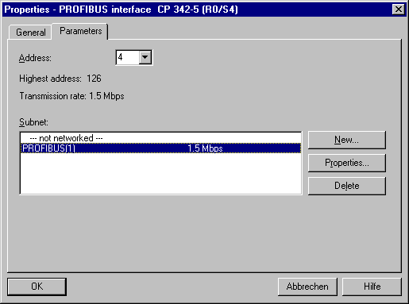

25. Now the addresses of the communication processor in the I/O address space of the CPU are noted (Here: PI 256...271 / PQ 256..271). Choose the properties of the communication process through a double click on the ‘CP 342-5DP’ ( → CP 342-5).

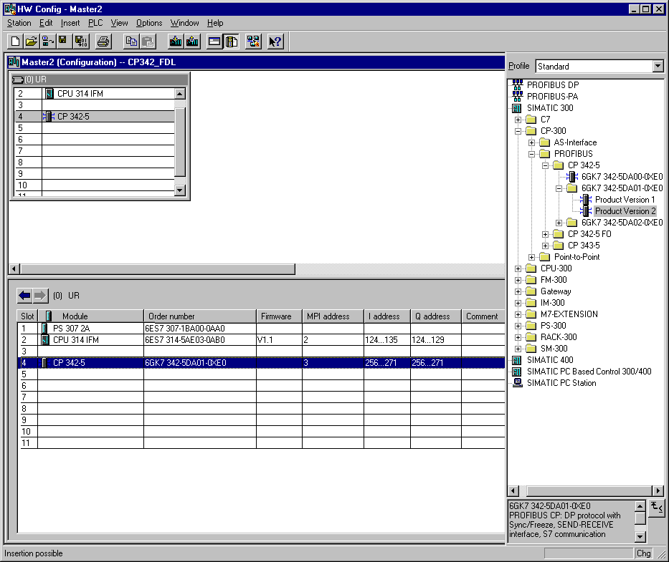

26. Set the Operation Mode to DP master and accept with OK ( → Operation Mode → DP master → OK).

27. The configuration table is saved and compiled now with a click on . Then the hardware configuration is closed with a click on x ( → → x).

28. So that both CPUs can be exchanged over the PROFIBUS and the FDL connection data, one must first open the folder Connections in either of the stations (here Master1 ) with a double click in SIMATIC Manager ( → SIMATIC Manager →Connections).

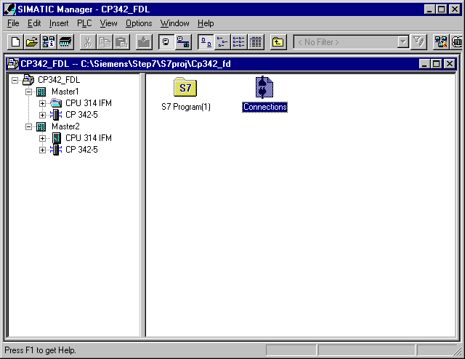

29. Then the tool NetPro is opened. Here we have a good summary about the linking network of the available components from the MPI and PROFIBUS. One of the CPUs is already chosen so now we must click on the menu command Insert New Connection ( → Insert → New Connection).

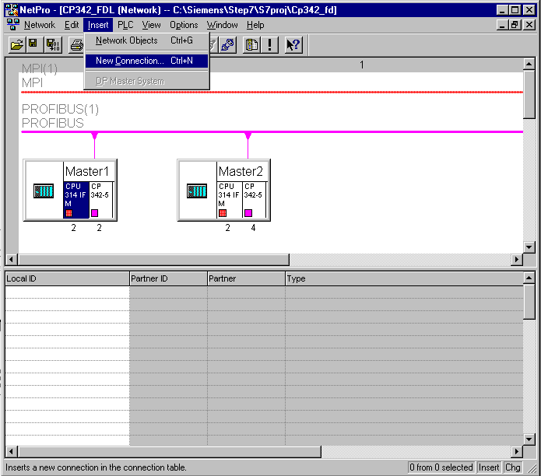

30. The other station Master2 is chosen as a connection partner with the other inserted CPU 314IFM. The connection type is FDL connection ( → Master2 → CPU 314 IFM → FDL connection →OK)

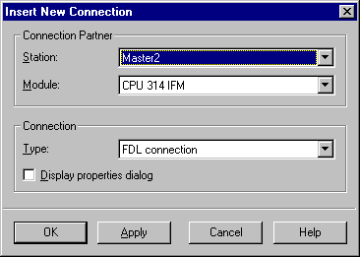

31. Out of the connection table, the ID of both connection partners is read off (Here both are set to 1). Now save and compile the connection table with a click on ( → ).

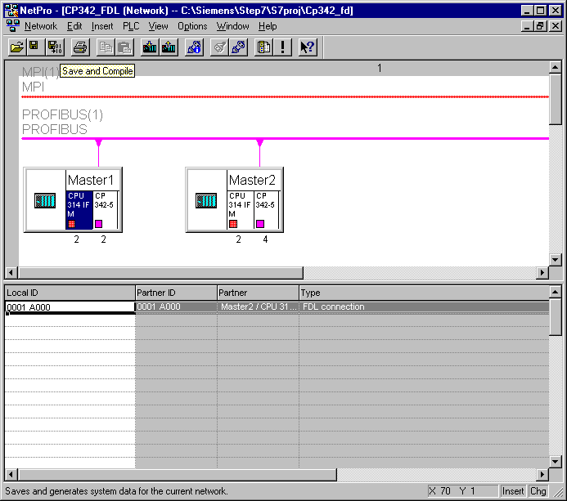

32. Choose the compile option Compile and check everything ( → Compile and check everything →OK).

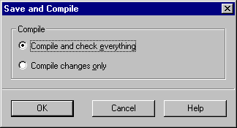

33. The following windows with the warning and error messages is closed with x ( → x).

34. From the SIMATIC Manager, open the block OB1 for the Master1 with a double click ( → OB1).

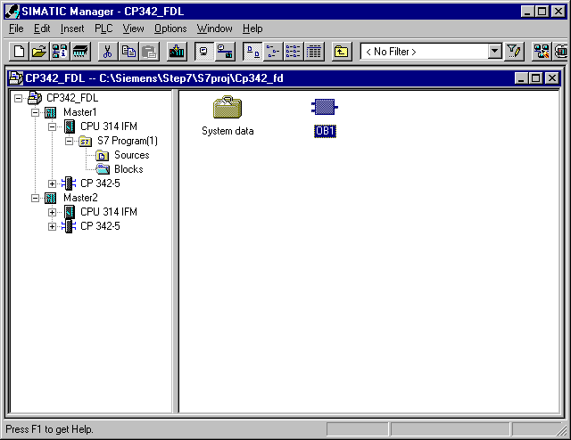

35. Optional: Enter the properties of the OB1 for documentation and accept with OK ( →OK).

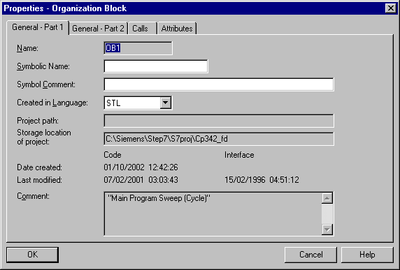

On part of the user program, the transmission of the data range for the FDL ommunication is activated through the programmed FC block call and the effective execution is monitored.
The block calls for the important communication FC blocks are found in the library “SIMATIC_NET_CP“. In order to use these functions, the functions must be copied into the project.

The FC block AG-SEND assigns data to the PROFIBUS-CP for the transmission over a configured FDL connection.
The indicated data range can be an I/O range, a bit memory address area, or a data block area.
The error free execution is signaled when the whole FDL data range is transferred over the PROFIBUS DP.
For the calling of the FC block AG-SEND, the following parameters must be entered:

Name | Type | Range of values | Comment
ACT | BOOL | 0, 1 | By ACT=1, LEN bytes are sent out of the given FDL data range with the parameter SEND.  By ACT=0, the status display updates DONE, ERROR and STATUS.
ID | INT | 1, 2,...16 | Connection number of the FDL connection
LADDR | WORD |  | Module start address (can be withdrawn from the configuration table in STEP 7).
SEND | ANY |  | Indication from the address and length of the FDL send range (The address can refer to PA ranges, bit memory address areas and data block areas).
LEN | INT | 1, 2,...240 | Display of the bytes, that should be sent with the job from the FDL data range.
DONE | BOOL | 0: -  1: New data | State parameters displayed if the execution is handled error free.
ERROR | BOOL | 0: -  1: Error | Error display
STATUS | WORD |  | Status display

The FC block AG-RECV accepts transferred data from the PROFIBUS-CP over a configured FDL connection.
The indicated data range can be an I/O range, a bit memory address area or a data block area.
The error free execution is signaled, when the whole FDL data range is transferred over the PROFIBUS DP.
By the call of the FC block AG-RECV, the following parameters must be entered:

Name | Type | Range of values | Comment
ID | INT | 1, 2,...16 | Connection number of the FDL connection
LADDR | WORD |  | Module start address (Can be withdrawn from the configuration table in STEP 7).
RECV | ANY |  | Indication from the address and length of the FDL send range (The address can refer to PA ranges, bit memory address areas and data block areas).
LEN | INT | 1, 2,...240 | Display of the bytes that would be accepted from the PROFIBUS-CP in the FDL data range.
NDR | BOOL | 0: -  1: New data | The mode parameter is displayed if new data is accepted.
ERROR | BOOL | 0: -  1: Error | Error display
STATUS | WORD |  | Status display

36. With LAD, STL, FBD: Program blocks, you now have an editor which gives you the possibility to generate your STEP 7- Program. Here the organization block OB1 was already opened with the first network. In order to generate your first logical operation, you must highlight the first network. Now you can write your first STEP 7- Program. Several programs can usually be divided into networks. Open a new network by clicking on the network symbol .

Here the received data is read into network 1 as inputs from Master2 with the block AG_RECV. You can drop this block into your network from the Libraries of blocks in the catalog ( → Libraries → SIMATIC_NET_CP → CP 300 → FC6 AG_RECV)

In network 3, the sent data is written as outputs to the Master2 with the block AG_SEND. You can drop this block into your network from the Libraries of blocks in the catalog ( → Libraries → SIMATIC_NET_CP → CP 300 → FC5 AG_SEND)

Now save the OB1 block ( → ).

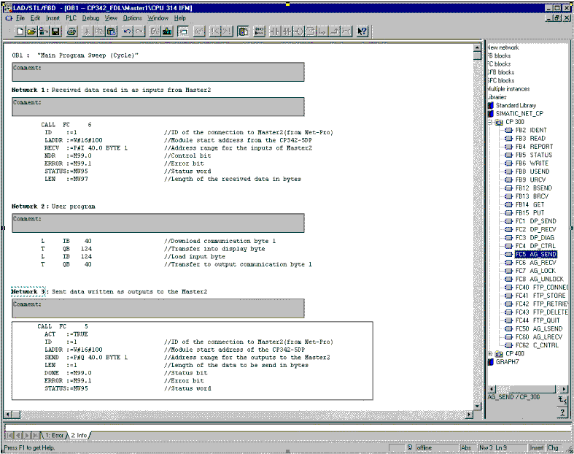

Note: Here the master is connected with 1 byte input data and 1 byte output data over a CP342-5DP on slot 5 (Module start address decimal: 256/Hexadecimal 100). The input data should be in input byte IB40. The data should be written into the other master from output byte QB40.

37. The STEP 7- Program must now be downloaded into the PLC. In our case, this can be done from the SIMATIC Manager. There, highlight the folder Master1 and then click on download . The mode switch must be on STOP and the program equipment must be connected with the MPI-Interface of the CPU! (→ SIMATIC Manager → Master1 → )

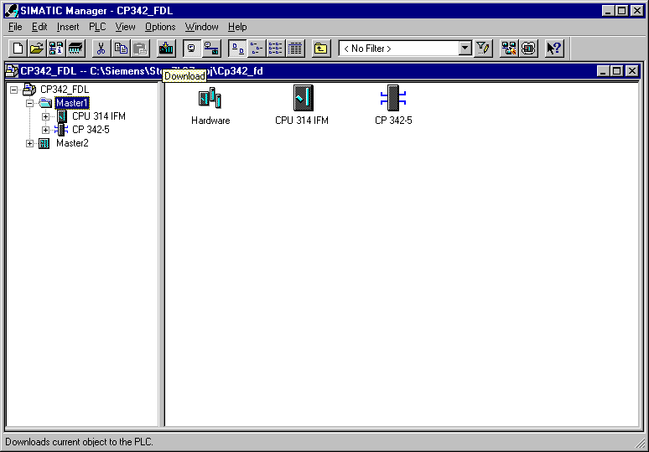

38. From the SIMATIC Manager, open the block OB1 for the ‘Master2’ with a double click( → OB1).

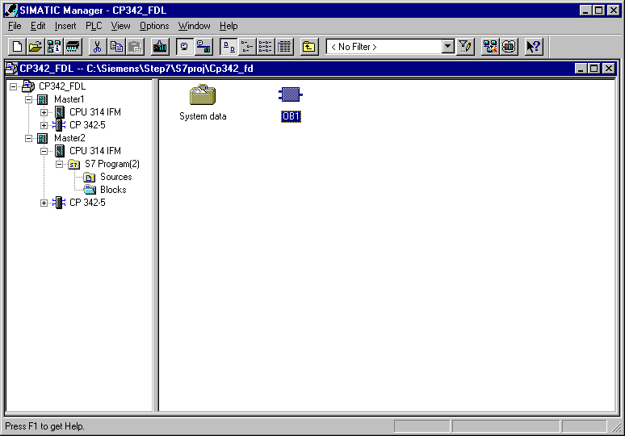

39. Optional: Enter the properties of the OB1 for documentation and accept with OK ( →OK).

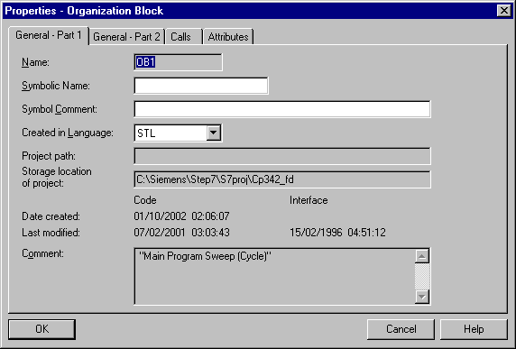

40. With LAD, STL, FBD: Program blocks, you now have an editor which gives you the possibility to generate your STEP 7- Program. Here the organization block OB1 was already opened with the first network. In order to generate your first logical operation, you must highlight the first network. Now you can write your first STEP 7- Program. Several programs can usually be divided into networks. Open a new network by clicking on the network symbol .

Here the received data is read into network 1 as inputs from Master 2 with the block AG_RECV. You can drop this block into your network from the Libraries of blocks in the catalog ( → Libraries → SIMATIC_NET_CP → CP 300 → FC6 AG_RECV)

In network 3, the sent data is written as outputs to the Master2 with the block AG_SEND. You can drop this block into your network from the Libraries of blocks in the catalog ( → Libraries → SIMATIC_NET_CP → CP 300 → FC5 AG_SEND)

Now save the OB1 block ( → ).

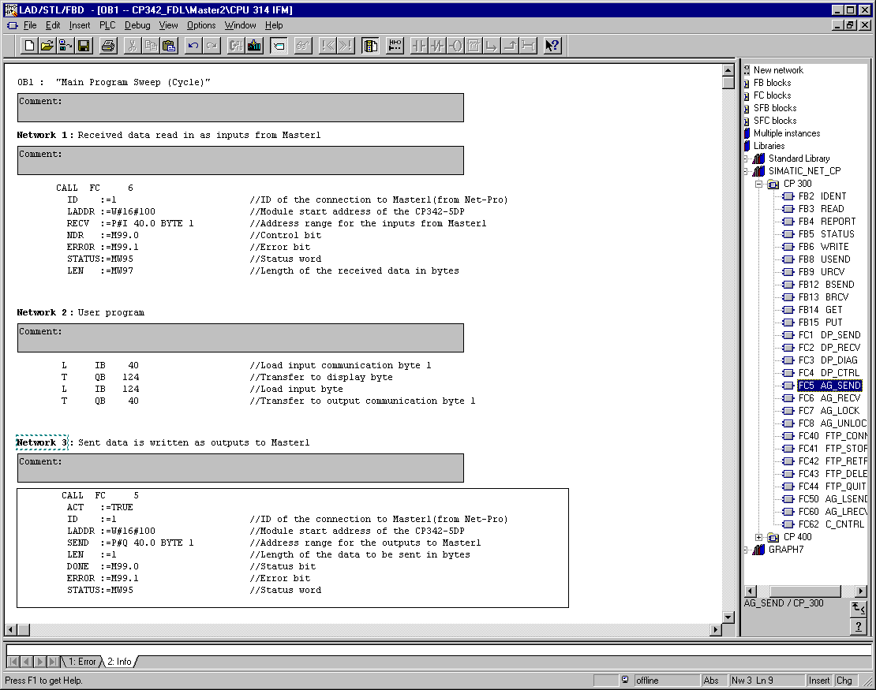

Note: Here the master is connected with 1 byte input data and 1 byte output data over a CP342-5DP on slot 5 (Module start address decimal: 256/Hexadecimal 100). The input data should be in input byte IB40. The data should be written into the master from output byte QB40.

41. The STEP 7- Program must now be downloaded into the PLC. In our case, this can be done from the SIMATIC Manager. There, highlight the folder Master2 and then click on download . The mode switch must be on STOP and the program equipment must be connected with the MPI-Interface of the CPU! (→ SIMATIC Manager → Master2 → )

42. Through the switching of the mode switch to RUN, the program is started.

