Training document for the company-wide
automation solution
Totally Integrated Automation (T I A)

MODULE D4
PROFIBUS DP with
Master CPU 315-2DP / Slave ET 200M

This document was provided by Siemens A&D SCE (automation and drive technology, Siemens A&D Cooperates with Education) for training purposes. Siemens does not make any type of guarantee regarding its contents.

The passing on or duplication of this document, including the use and report of its contents, is only permitted within public and training facilities.

Exceptions require written permission by Siemens A&D SCE (Mr. Knust: E-Mail: michael.knust@hvr.siemens.de). Offences are subject to possible payment for damages caused. All rights are reserved for translation and any case of patenting or GM entry.

We thank the company Michael Dziallas Engineering and the instructors of vocational schools as well as further persons for the support with the production of the document.

PAGE:

1. Forward 4

2. Notes to the Operation of the CPU 315-2DP 6

3. Notes to the Operation of the ET 200M 6

4. Commissioning the Profibus ( Master CPU 315-2DP / Slave ET200M) 7

The following symbols stand for the specified modules:


Information


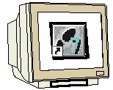
Programming


Example exercise


Notes

1. Forward

The module D4 is assigned content wise to Industrial field bus systems.

Basics of

STEP 7- Programming
2 - 3 days A modules
Industrial field bus
systems
2- 3 days D modules
Additional functions of
STEP 7- Programming
2- 3 days B modules
Process
visualization
2- 3 days F modules
Sequencer
Programming
2- 3 days C modules
IT- Communication
with SIMATIC S7
1- 2 days E modules

Learning goal:

In this module, the reader should learn how the PROFIBUS DP is taken into operation with the CPU 315-2DP as a master and the ET 200M as a slave. The module shows the principle procedure by means of a short example.

Requirements:

For the successful use of this module, the following knowledge is assumed:

• Knowledge in the use of Windows 95/98/2000/ME/NT4.0
• Basics of PLC- Programming with STEP 7 (e.g. Module A3 - ‘Startup’
PLC programming with STEP 7)
• Basics of the PROFIBUS DP (e.g. Appendix IV – Basics of
field bus systems with SIMATIC S7-300)

Required hardware and software

1 PC, Operating system Windows 95/98/2000/ME/NT4.0 with
- Minimal: 133MHz and 64MB RAM, approx. 65 MB free hard disk space
- Optimal: 500MHz and 128MB RAM, approx. 65 MB free hard disk space
2 Software STEP 7 V 5.x
- MPI- Interface for the PC (e.g. PC- Adapter)
- PLC SIMATIC S7-300 with the CPU 315-2DP
Example configuration:
- Network: PS 307 2A
- CPU: CPU 315-2DP
5 Distributed I/O ET 200M with at least one digital in- and output.
Example configuration:
- Power supply: PS 307 2A
- PROFIBUS terminal: IM 153-1
- Digital inputs: DI 16x DC24V
- Digital outputs: DO 16x DC24V / 0.5 A
- PROFIBUS cable with 2 PROFIBUS slots

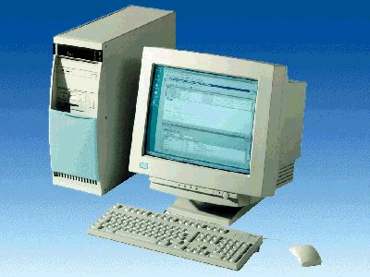
1 PC
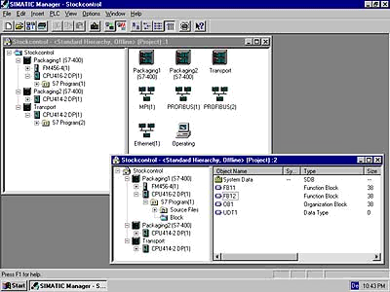
2 STEP 7

3 PC Adapter

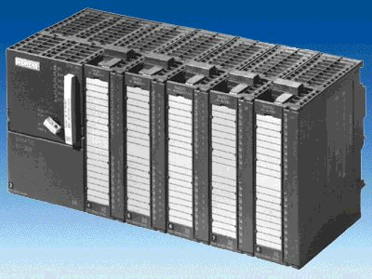
4 SIMATIC S7-300 with CPU 315-2DP
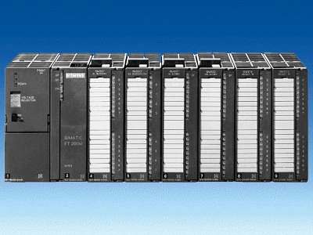
5 ET 200M

6 PROFIBUS cable

2. Notes for the operation of the CPU 315-2DP
The CPU 315-2DP is a CPU that is made available with an integrated PROFIBUS DP interface.
For the CPU 315-2DP, the following PROFIBUS protocol profiles are available at your disposal:
- DP- Interface as a master or slave in accordance with EN 50170. PROFIBUS-DP (Distributed I/O) is the protocol profile for the connection of distributed I/O/Field equipment with fast reaction time.

A further characteristic is that the addresses of the in- and output modules can be parameterized by this CPU.

The CPU capability is given with the following data:
- 16K Statements. 48Kbyte RAM (integrated) 80Kbyte RAM
- 1024 Byte DI/DO
- 128 Byte AI/AO
- 0.3 ms / 1K Instructions
- 64 Counters
- 128 Timers
- 2048 Memory bits

Note: The CPU 315-2DP is appointed here on the PROFIBUS as a master.

3. notes to the operation of the ET 200M
The ET 200M is a distributed I/O system with a small, compact configuration. The modules are identical with the standard modules of the SIMATIC S7-300. By the actuators of the CPU, there is only one interface module (e.g. IM153-1) that functions as a slave on the PROFIBUS DP.
The PROFIBUS address is adjusted by a binary coded DIL- switch block.
Another possible adjustment of the PROFIBUS address is with the power recovery. Therefore, the ET 200M must be turned off and then back on.

- Commissioning the Profibus ( Master cpu315-2DP / Slave ET200M )
In the following example, the commissioning of a mono master system with the CPU315-2DP as a master and an ET 200M as a slave is described.
For the testing of the configuration, a program will be written in which a display lamp H1 is triggered by the simultaneous activation of two buttons S0 and S1.

Assignment list:
I0.0 S0 Button selection 1
I0.1 S1 Button selection 2
Q0.0 H1 Display lamp

1. The central tool in STEP 7 is the SIMATIC Manager, which is opened here with a double click ( → SIMATIC Manager).
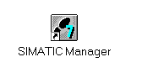

2. STEP 7- Programs are administered in projects . Such a project will be created ( → File → New).

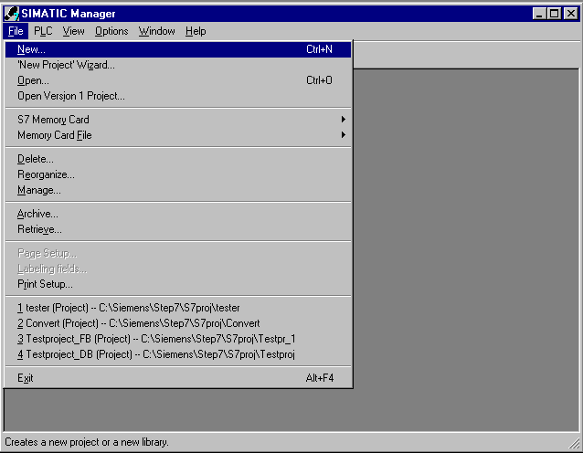

3. Give the Name ET200M to the project ( → ET200M → OK).

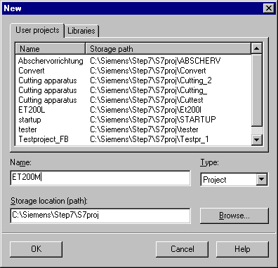

- Highlight your project and insert a PROFIBUS Subnet (→ ET200M → Insert → Subnet → PROFIBUS).

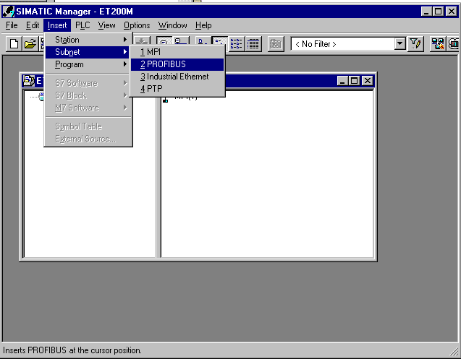

5. Then insert a SIMATIC 300-Station (→ Insert → Station → SIMATIC 300-Station).

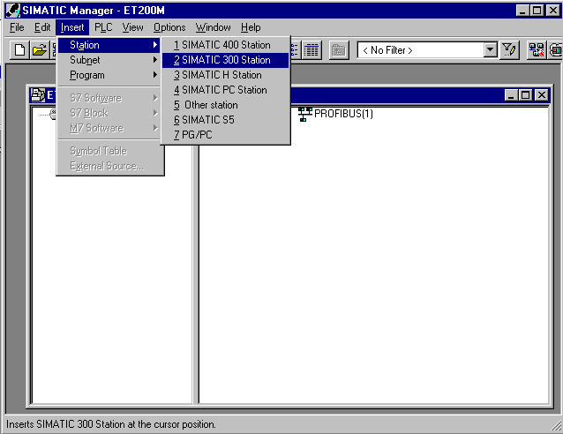

6. Open the configuration tool for the Hardware with a double click (→ Hardware).

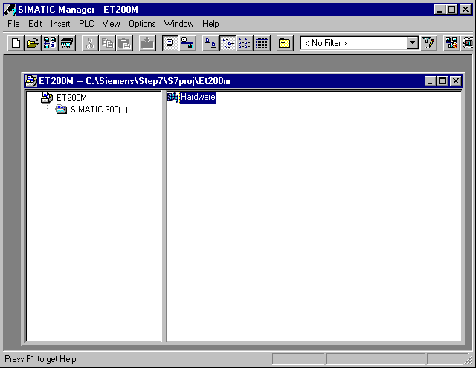

7. Open the hardware catalog with a click on the symbol (→ ).
There you will see the directories are divided into the following:
- PROFIBUS-DP, SIMATIC 300, SIMATIC 400 and SIMATIC PC Based Control,
all module racks, modules and interface modules for the configuration of your hardware configuration are made available.
Insert a Rail with a double click( → SIMATIC 300 → RACK-300 → Rail).

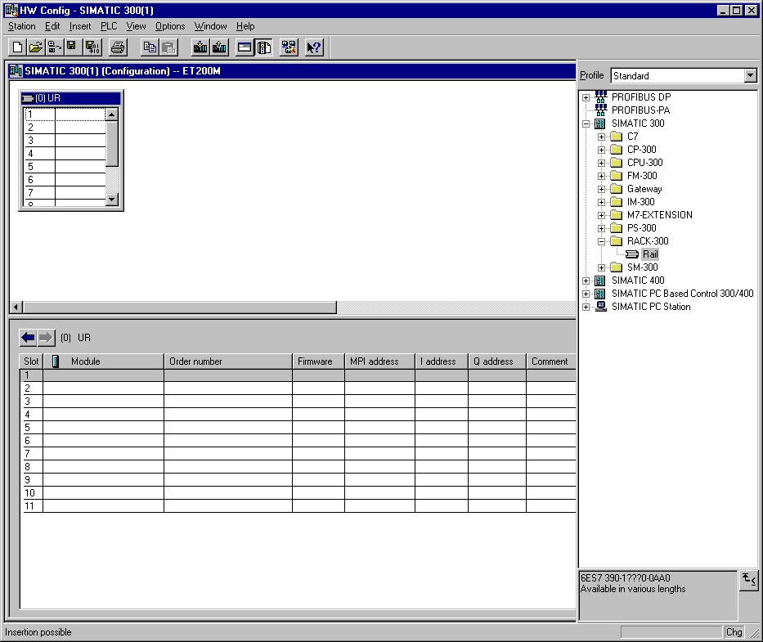

After the insert, a configurations table for the configuration of the Rack 0 appears automatically.

8. Now all modules can be chosen out of the hardware catalog and inserted into the configuration table and are also inserted into your rack.
To insert, you must click on the name of the respective module, hold the mouse button and Drag & Drop the module into a line of the configurations table. We will begin with the power supply PS 307 2A (→ SIMATIC 300 → PS-300 → PS 307 2A).

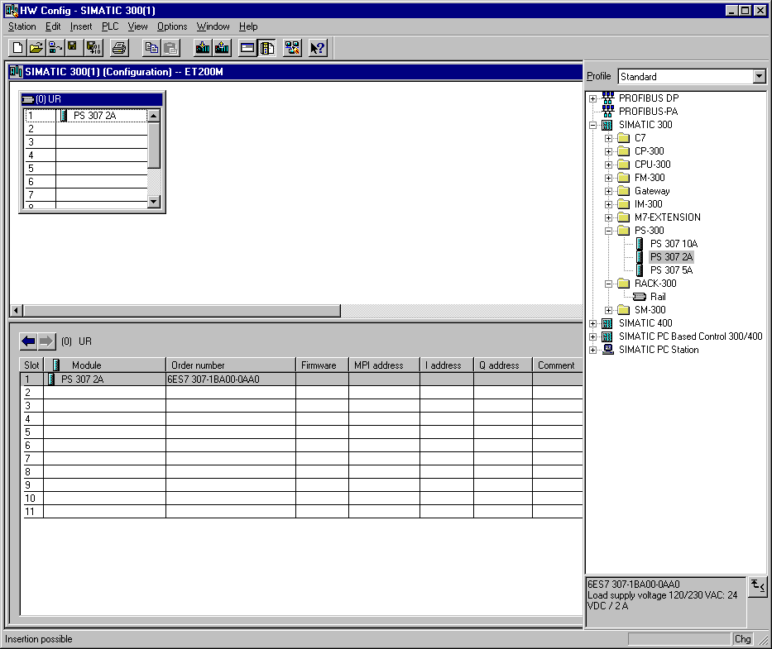

Note: If your hardware differs from what is shown above, then you must select the appropriate modules from the catalog and insert them into the rack. The part numbers of the individual modules, which are found on the components, are indicated in the footer of the catalog.

9. In the next step, we drop the CPU 315-2DP into the second card location. This allows for the part number and version of the CPU to be read off. (→ SIMATIC 300 → CPU-300 → CPU 315-2DP → 6ES7 315-2AF03-0AB0 → V1.1 ).

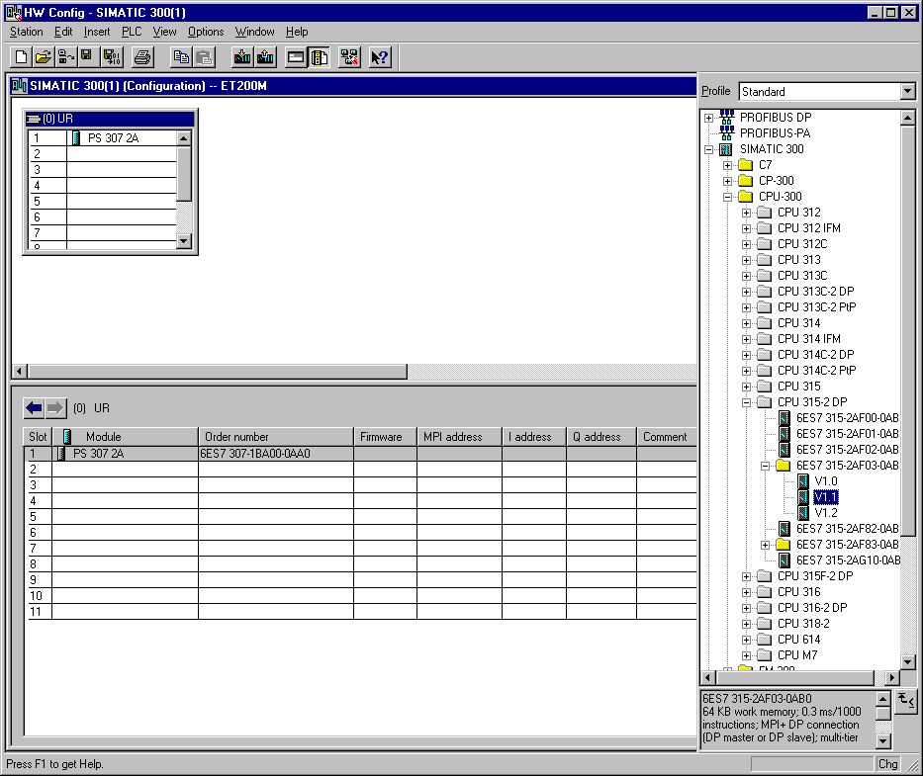

10. By the entering of the CPU, the following window appears, in which you assign a PROFIBUS address to the CPU 315-2DP and must already choose the first PROFIBUS net. When you want to alter the parameter of the PROFIBUS net, you must highlight it and then click on Properties
( → Properties).

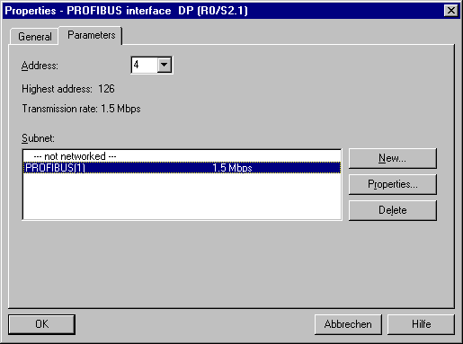

11. Now you can choose the Highest PROFIBUS Address (here → 126), the Transmission Rate (here → 1,5 Mbit/s) and the Profile (here → DP). (→ OK).

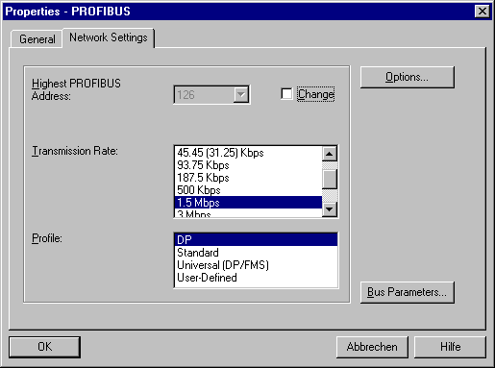

12. Then a bar chart for the Master system is shown to the right of the CPU315-2DP, in which you can arrange the PROFIBUS. This happens by clicking the desired module
(Here the IM 153-1, an ET 200M interface module) from the hardware catalog in the path
PROFIBUS-DP. By Drag & Drop click with the mouse, it can be dropped into the master system. (→ PROFIBUS DP → ET 200M → IM 153-1→ 6ES7 153-1AA83-0XB0 ).

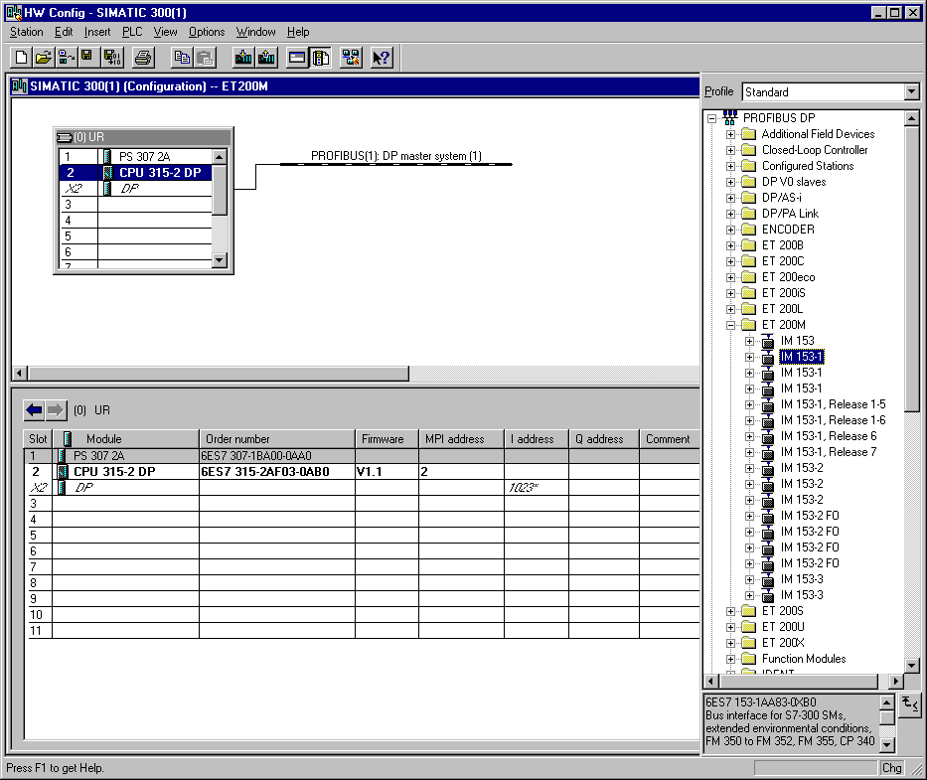

13. By the entering of the slave, the following window is displayed in which you must assign a PROFIBUS address to the slave. This address must be identical with the address that you created in the rotary switch of the IM 153-1 ( → 5 → OK ).

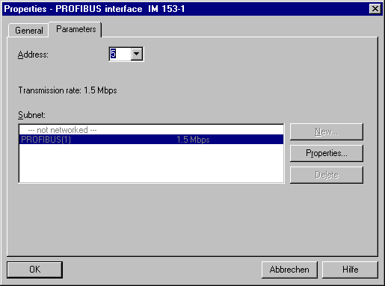

14. In the next step we see the input module for 16 inputs on fourth slot place of the ET 200M. There the order number of the module is read off the front (→ PROFIBUS DP → ET 200M → IM 153-1→ DI-300 → SM 321 DI16xDC24V).

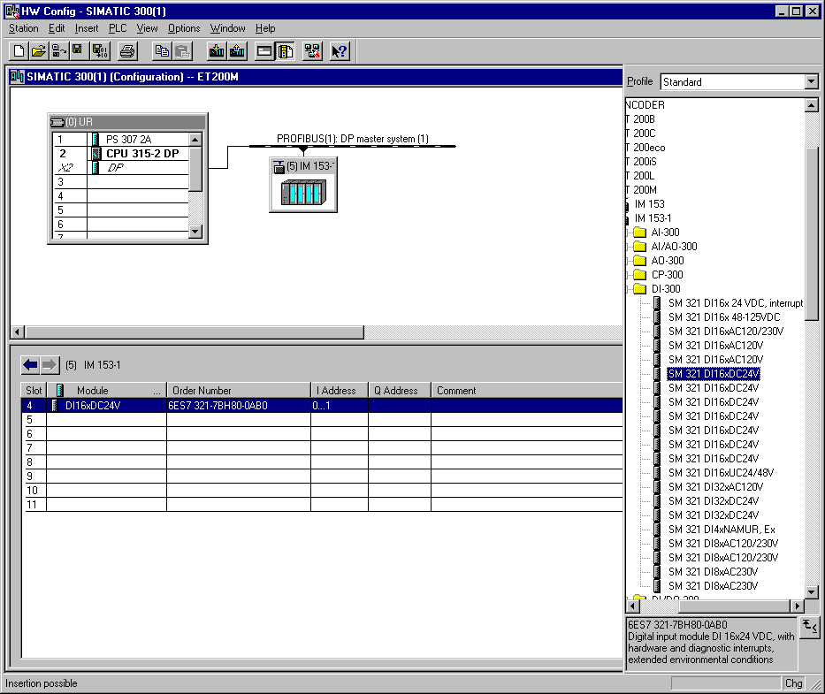

15. In the next step we see the output module for 16 outputs on fifth slot place of the ET 200M. There the order number of the module is read off the front (→ PROFIBUS DP → ET 200M → IM 153-1→ DO-300 → SM 322 DO16xDC24V/0.5A).

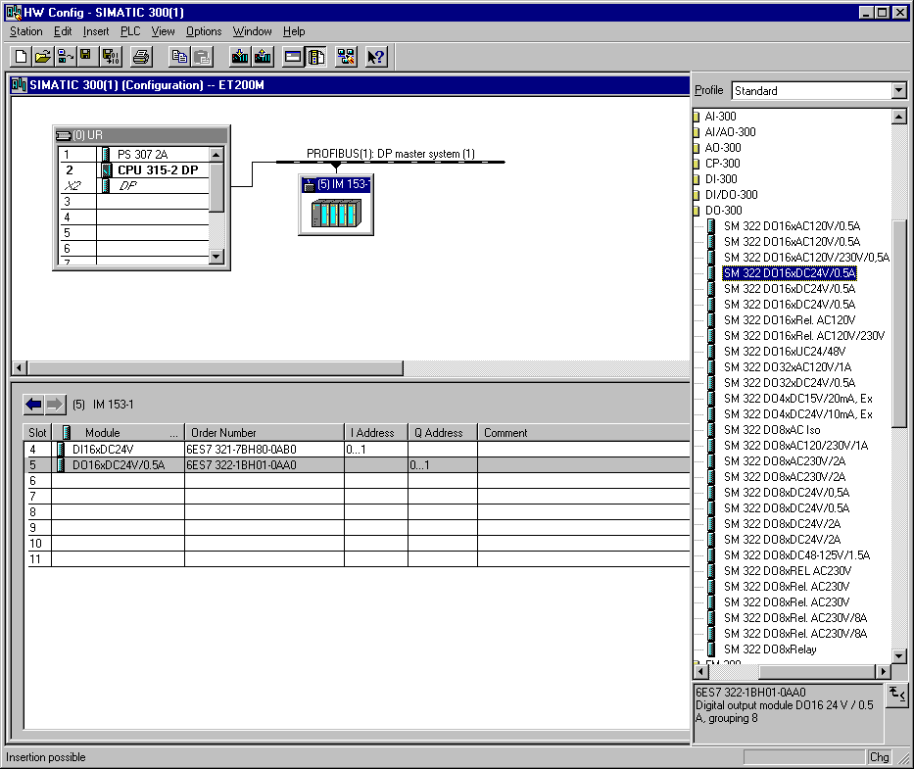

Note: The order number of the module is displayed in the footer of the catalog.

16. The addresses of the I/O modules can now be modified.
This happens by a double click on the corresponding input and output modules in the ET 200M and is adjusted in the register Address.
In any case these addresses should be required. An automatic address allocation takes place in the sequence similar to how the slaves are entered ( → DO 16xDC24V/0,5A → Adresses → OK ).

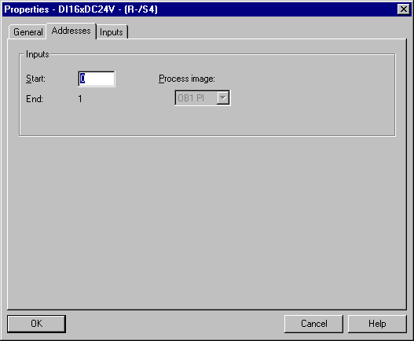

17. The configuration table should first be saved and compiled with a click on and then downloaded into the PLC with . The mode switch on the CPU must be on STOP! ( → → )

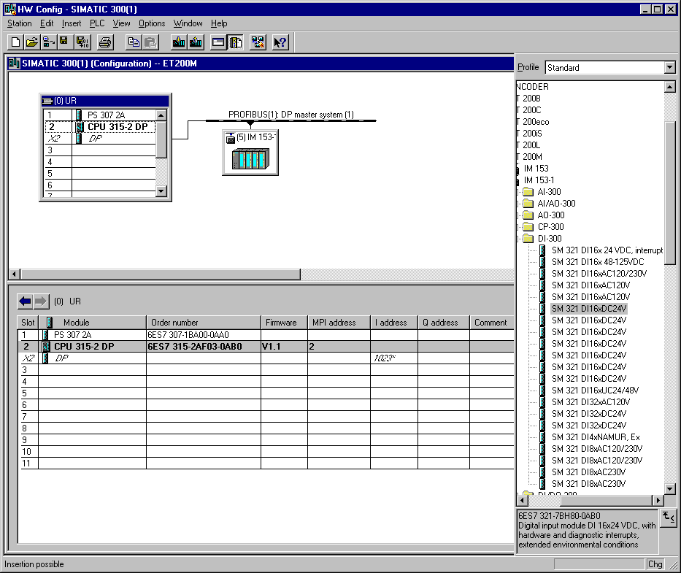

18. The CPU 315-2DP is then activated as the target module for the download activity (→ OK).

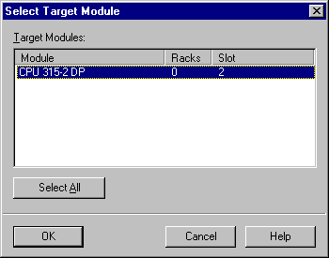

19. The station address of the CPU in the MPI net is then chosen. You are only connected with the CPU so you can accept with OK (→ OK).

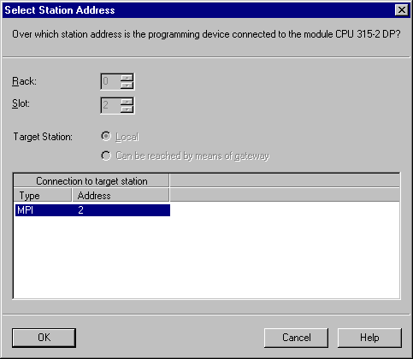

20. From the SIMATIC Manager, you can open the block OB1 with a double click in the editor LAD, STL, FBD: Program blocks ( → OB1).

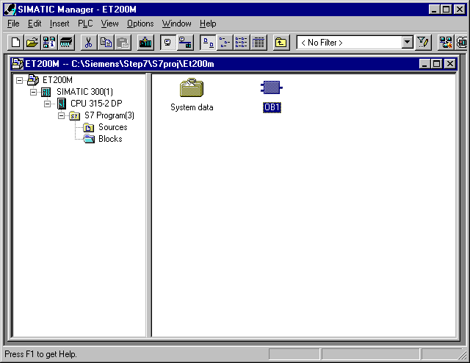

21. Optional: Enter the properties of the OB1 for documentation and accept with OK ( →OK).

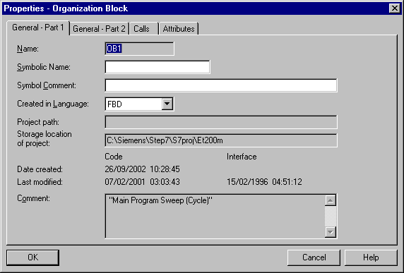

- With LAD, STL, FBD: Program blocks, you now have an editor which gives you the possibilty to generate your STEP 7- Program. Here the organization block OB1 was already opened with the first network. In order to generate your first logical operation, you must highlight the first network. Now you can write your first STEP 7- Program. Several programs can usually be divided into networks. Open a new network by clicking on the network symbol .
The STEP 7- Program to be tested can now be downloaded into the PLC.
In our case, the OB1 is the only block. Save the organization block with and click on download . The mode switch of the CPU must be on STOP! ( → → )

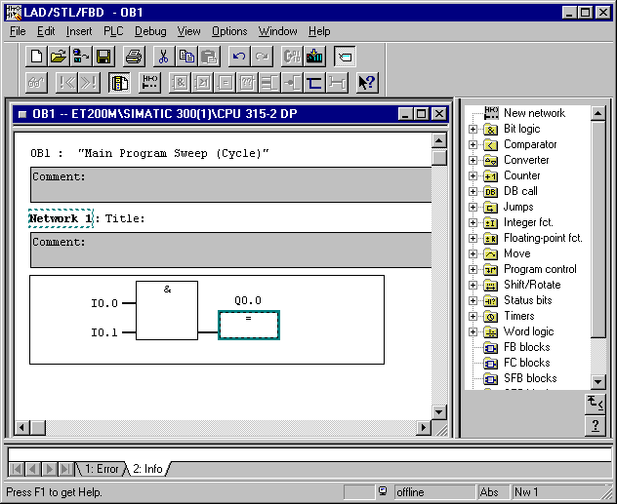

- Through the switching of the mode switch to RUN, the program is started and after a click on the symbol for monitoring, the program in the OB1 can be monitored (→ ).

