Training document for the company-wide
automation solution
Totally Integrated Automation (T I A)

MODULE D1
AS- Interface with the SIMATIC S7-300 and the CP342-2 / CP343-2

This document was provided by Siemens A&D SCE (automation and drive technology, Siemens A&D Cooperates with Education) for training purposes. Siemens does not make any type of guarantee regarding its contents.

The passing on or duplication of this document, including the use and report of its contents, is only permitted within public and training facilities.

Exceptions require written permission by Siemens A&D SCE (Mr. Knust: E-Mail: michael.knust@hvr.siemens.de). Offences are subject to possible payment for damages caused. All rights are reserved for translation and any case of patenting or GM entry.

We thank the company Michael Dziallas Engineering and the instructors of vocational schools as well as further persons for the support with the production of the document.

PAGE:

1. Forward 4

2. Notes for the Operation of the CP342-2 and the AS- Interface 6
2.1 Technical data to the AS- Interface 6
2.2 Configuration of the AS- Interface 7
2.3 Technical data to the CP342-2 10

3. Commissioning of the AS-Interface with the CP342-2 11

4. Writing a STEP 7- Program 26

5. Debugging a STEP 7- Program 31

The following symbols stand for the specified modules:


Information


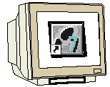
Programming


Example exercise


Notes

1. Forward

The module D3 is assigned content wise to Industrial field bus systems.

Basics of

STEP 7- Programming
2 - 3 days A modules
Industrial field bus
systems
2- 3 days D modules
Additional functions of
STEP 7- Programming
2- 3 days B modules
Process
visualization
2- 3 days F modules
Sequencer
Programming
2- 3 days C modules
IT- Communication
with SIMATIC S7
1- 2 days E modules

Learning goal:

In this module, the reader should learn the fundamental functions of the AS-Interface and interface CP342-2 for the SIMATIC S7-300. A simple example is generated in the following steps:

• Commissioning of the AS-Interface with the CP342-2
• Generation of a project for a PLC SIMATIC S7-300
• Writing an example program
• Debugging the task with the CP342-2 and the SIMATIC S7- 300

Requirements:

For the successful use of this module, the following knowledge is assumed:

• Knowledge in the use of Windows 95/98/2000/ME/NT4.0
• Basics of PLC- Programming with STEP 7 (e.g. Module A3 - ‘Startup’
PLC programming with STEP 7)

Required hardware and software

1 PC, Operating system Windows 95/98/2000/ME/NT4.0 with
- Minimal: 133MHz and 64MB RAM, approx. 150 MB free hard disk space
- Optimal: 500MHz and 128MB RAM, approx. 150 MB free hard disk space
2 Software STEP 7 V 5.x
3 MPI- Interface for the PC (e.g. PC- Adapter)
4 PLC SIMATIC S7-300
Example configuration:
- Power supply: PS 307 2A
- CPU: CPU 314
- Digital inputs: DI 16x DC24V
- Digital outputs: DO 16x DC24V / 0.5 A
- CP 342-2 AS-Interface
5 AS-I- Slave 4 inputs allocated with 2 buttons
6 AS-I- Slave 4 outputs allocated with 5/2-solenoid valve for the triggering of a cylinder
7 AS-Interface power supply 30V
- AS-Interface yellow data cable
- Address device for AS-I slaves
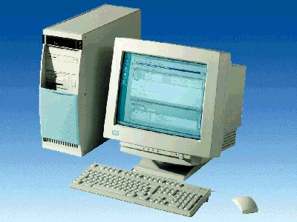
1 PC

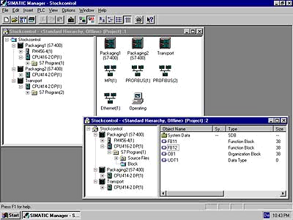
2 STEP 7

9 Address device
for AS-I slaves

3 PC Adapter

8 AS-Interface data cable

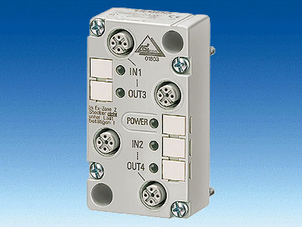
5 AS-I slave 4 inputs
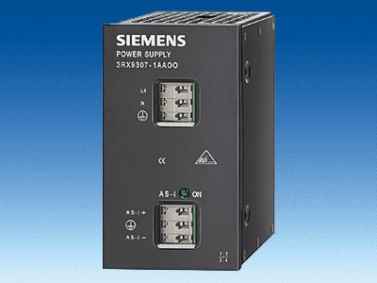
7 AS-Interface
power supply 30V

6 AS-I slave 4 outputs
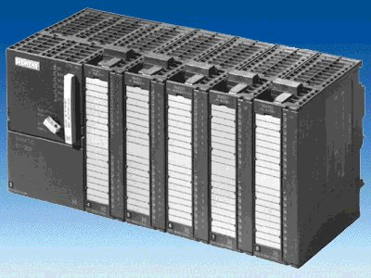
4 SIMATIC S7-300 with CP342-2

2. notes for the operation of the CP 342-2 and the AS- Interface

2.1 Technical data to the AS- Interface
The Actuator-Sensor-Interface (AS-I) serves as the information transmission in the lowest field area and like the PROFIBUS, is an open standard. A multitude of manufactures offer products and interfaces to the AS-Interface. The AS-Interface enables a simple and extremely cost efficient integration of sensors and actors in the industrial communication and provides these sensors and actors simultaneously with the important auxiliary power. With this system, predominately binary sensors and actors are operated with the controllers. So far it is important for process signals that arise before a location to transfer with conventional parallel wiring over in-/output modules into the controller. AS-I replaces the expensive cable tree by a simple and complete unprotected 2 wire cable for all sensors and actors.
Through the robust design in a degree of protection IP65 or IP67, the AS-Interface increases straight in the lowest field area of usual and hard operating conditions.

The technical data and transmission protocols of the AS -Interface are specified in the Norm EN 50 295.

The following performance data for the AS-Interface is specified here:

- Max. 31 AS-I nodes with 4 Bit I/O user data
- Max. 124 I/O sensors and actors
- Access processing with cyclic polling in the master/slave process
- Max. cycle time 5ms
- Error safe identification and iteration of faulty frames.
- Transmission medium is a usual 2 wire cable (2 x 1,5 mm² ) for data and a max. of 2A auxiliary power per AS-I pro AS-I cable. The power supply consists of 30 V DC. The signal of the data transmission is modulated. An additional power supply of 24V DC (auxiliary power) is possible.
- Connection and assembly of the AS-I components in an insulation displacement method.
- AS-I slave module with integrated circuit (AS-I chip) that requires no processor and no software. This results in an approximate, delay free processing of the frames and a small construction volume of the slave
- Special AS-I sensors and actors are directly integrated with the AS-I chips.
- Flexible configuration possibilities like in the conduit with cables, stars or tree structures
Max. wire length of 100m or 300m (with repeaters)

2.2 Configuration of the AS-Interface

The configuration of an AS-Interface can appear as follows:

AS-I-Master (e.g. SIMATIC S7-300 with CP342-2)
Power supply (24V DC)

AS-I power supply (30V DC)
AS-I slaves
4I 4O 2I 4I
2O
AS-I slave
4I
4O
AS-I slave
Repeater
AS-I slave
4I
4O
AS-I slave
4I
4O

Additionally the addressing of the AS-I slaves requires one more addressing device:

+
Address device
for AS-I slaves

The AS-Interface is a single-master system. Therefore there always exists exactly one master and up to 31 slaves in each system with the CP342-2. If more slaves are required, an additional AS-Interface system with an additional master must be inserted.

Basic components of an AS-Interface configuration:

The AS-Interfaces occurs modularly under the use of the following components:
- Power supply 30V DC (Power supply)
The 30V power supply is attached directly to the data circuit.

- AS-I data circuit as unprotected 2 wire cable.
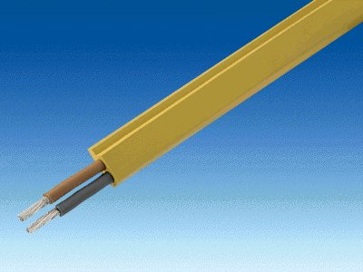
The connection of the AS-I components takes place in an insulation displacement method, where the AS-I cable is flattened in order to avoid wiring errors by assembly.

- AS-I master as a connection device for the controlling by the user or a higher level bus system with the corresponding master chips.
Over the AS-I master, the user can have access to the I/O data of the AS-I slave. This occurs at the S7-300 in the user program of the CPU.

- AS-I slaves with slave ASIC
For the AS-Interface, there is a large choice in slaves from different manufacturers. Each slave must be assigned by the commissioning of a target AS-I address that is then saved there. The addressing occurs either with the configuration device or over the master in which each slave is written a single connection by addressed frame. This also functions when one slave is exchanged.

- Configuration device for the setting of the slave addresses
With the programming and service unit (PSG), the AS-I slave addresses can be set very easily.

- Optional: Repeater for additional wire length up to 300 m (100m without repeater)
In order to implement a bus configuration with a larger expansion (e.g. by material systems), the repeaters must be interposed. This is connected with the AS-I data circuit.

- Optional: additional power supply 24V DC (power supply) for auxiliary power
When an AS-I slave requires more as 100mA or all slaves require more than 2A of auxiliary power pro AS-I cable, an additional power supply of 24V DC is required. This is connected over the AS-I network cable (black) with the auxiliary power contacts of the slaves.

- AS-I network cable for the auxiliary power as an unprotected black 2 wire cable.
The connection of the auxiliary power occurs in an insulation displacement method where the AS-I cable is flattened in order to avoid wire errors by assembly.

2.3 Technical data to the CP 342-2
The AS-Interface master CP342-2 can be used in the S7-300 or also in a PROFIBUS slave ET 200M by any activation either in the central device or in one of the 3 additional devices and occupies a slot there.

It offers the following functions and characteristics:
• Simpler operation in the I/O address range of the SIMATIC S7-300 and ET 200M
• Configuration of the CPs is not necessary
• Triggering of up to 31 AS-Interface slaves corresponding to the AS-I specification V2.0
• Up to 248 binary elements by the operation of triggerable bi-directional slaves
• Monitoring of the power supply on the AS-Interface cable
• Requires 1 Slot
• 16 bytes are occupied in the I/O operation in the analog address place
• LEDs for the displaying of operation states such as the operational readiness of the connected slaves
• Button for the switching of the operation mode and for the altering of the current configuration
• Connection possibility for the AS-Interface cable over the standard front connector
• Monitoring of the supply voltage on the AS-Interface cable

3. Commissioning of the AS-Interface with the CP324-2
The AS-Interface Master CP342-2 can be set in the SIMATIC S7-300 by any activation either in the central device or in one of the 3 additional devices and it occupies a slot there.

The CP342-2 recognizes two modes:

• Configuration mode:
This mode is set in the delivered state of the CP342-2 (LED CM).
The configuration mode serves for the commissioning of an AS-I installation. In this mode, the CP342-2 can exchange data with each of the connected slaves on the AS-I cable. New incoming slaves are quickly recognized from the master and recorded in the cyclic data exchange.

• Protected mode:
One switches into protected mode with the SET- Button.
In this mode the CP342-2 exchanges data only with slaves that are “configured“. “Configured“ means that slave addresses stored in the CP and configuration data stored in the CP agree with the values of the appropriate slaves.

The following steps must be followed by the user in to bring the AS-Interface into operation with the CP342-2, to setup a project and to set the hardware configuration with the CP342-2 AS-I.

1. First all slaves must be assigned explicit addresses with the programming and service unit (PSG):

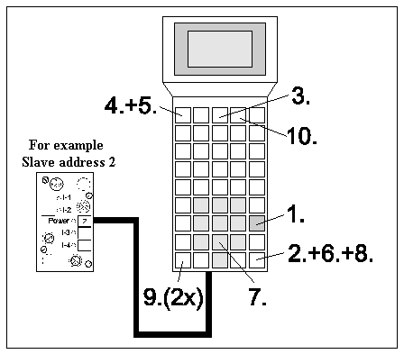
AS-I slave connected or placed on an integrated base of the PSG
- Turn on PSG (START)
- Activation (ENTER)
- Choose ‘Master‘ (F3)
- Choose ‘Single operation’ (F1)
- Choose ‘New address’ (F1)
- Activate AS-I address (ENTER)
- Enter new address (e.g.: 2)
- Activate inputs (ENTER)
- Return to the main menu (2x ESC)
- Turn off PSG (F4)

- Then the transfer of the yellow data cable and the connection of all slaves of the power supply (30V DC) and the master as well the repeater in the insulation displacement method occur. Therefore the profile of the data circuit must be accounted for.

3. When an additional power supply (24V DC) is required , it can be connected to the AS-I slaves with the black AS-I power cable. Therefore the profile must be accounted for by the connection in the insulation displacement method of the power cable.

4. Finally you can connect the sensors to the M12 connector for the AS-I slaves and they will be mounted to the slaves.

5. Now the AS-I line is ready and the CP342-2 can be setup and parameterized.

6. In order to bring the S7-300 with the CP342-2 into operation, you must switch the mode switch on the CPU to STOP.

7. Bring the CP342-2 into the configuration mode in which you activate the SET- Button of the CP342-2. The display CM lights now and the recognized slaves are displayed on the diagnostic LEDs of the CP342-2.

Note:
You can also insert or remove additional slaves on the AS-I cable. Newly inserted slaves are quickly recognized and activated from the CP3423-2.

8. Activate the SET- Button of the CP342-2. The CP now stores those activated slaves that were indicated. The “actual configuration“ as non volatile preset configuration is switched in the protected operation. The LED “CM“ lights.

9. Now switch the mode switch of the CPU to RUN-P. The system startup of the CP342-2 is now complete .

Now the hardware configuration can be set with the Software STEP 7.

10. The central tool in STEP 7 is the SIMATIC Manager, which is opened here with a double click ( → SIMATIC Manager).
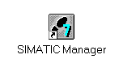
11. STEP 7- Programs are administered in projects . Such a project will be created ( → File → New)

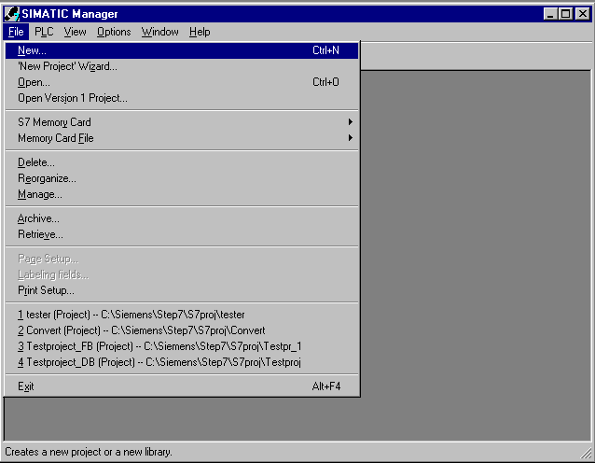

12. Give the Name ASI_CP342_2 to the project ( → ASI_CP342_2 → OK)

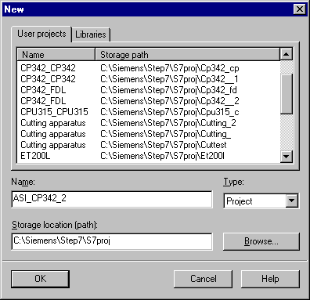

13. Then insert a SIMATIC 300-Station (→ Insert → Station → SIMATIC 300-Station).

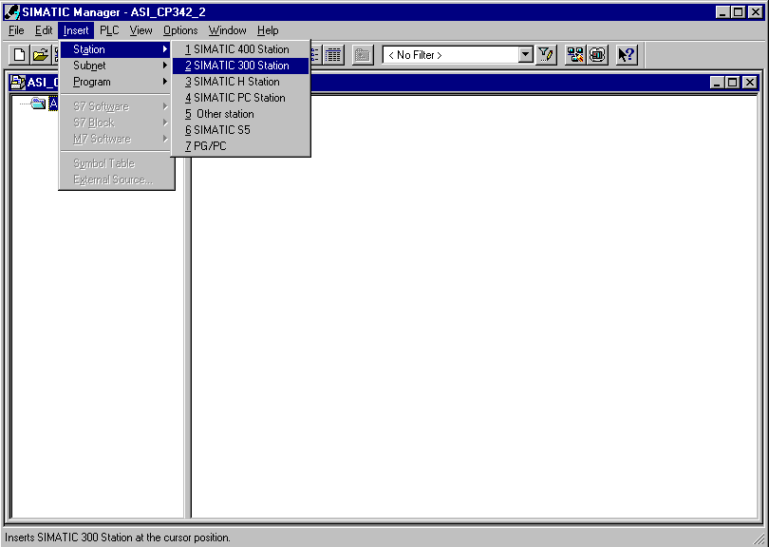

14. Open the configuration tool for the Hardware with a double click (→ Hardware).

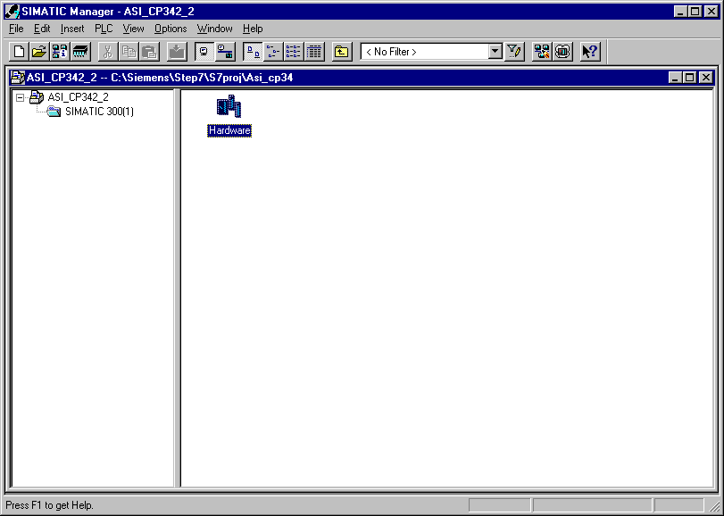

15. Open the hardware catalog with a click on the symbol (→ ).
There you will see the directories are divided into the following:
- PROFIBUS-DP, SIMATIC 300, SIMATIC 400 and SIMATIC PC Based Control,
all module racks, modules and interface modules for the configuration of your hardware configuration are made available.

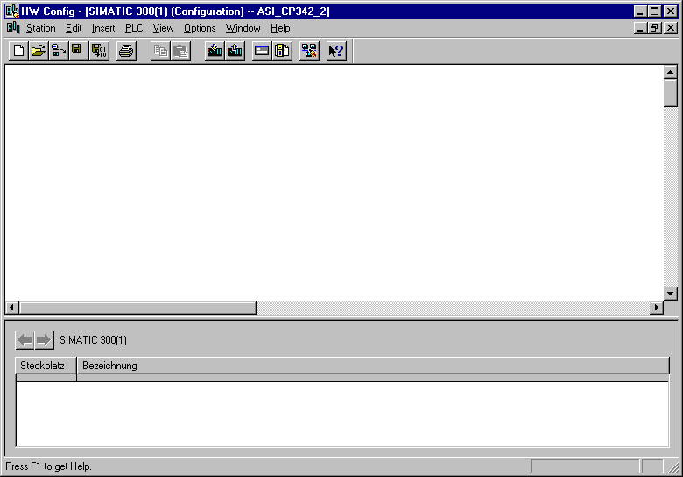

16. Insert a Rail with a double click( → SIMATIC 300 → RACK-300 → Rail).

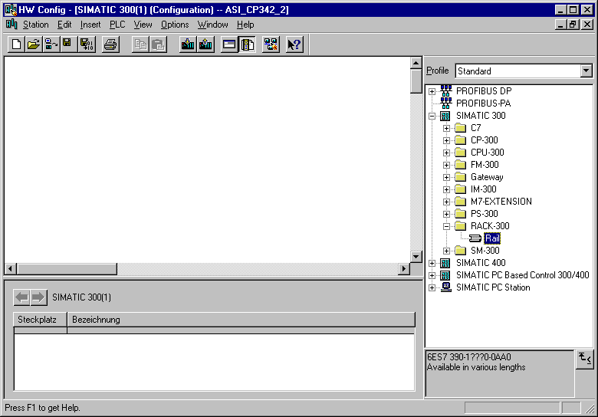

After the insert, a configurations table for the configuration of the Rack 0 appears automatically.

17. Now all modules can be chosen out of the hardware catalog and inserted into the configuration table and are also inserted into your rack.
To insert, you must click on the name of the respective module, hold the mouse button and Drag & Drop the module into a line of the configurations table. We will begin with the power supply PS 307 2A (→ SIMATIC 300 → PS-300 → PS 307 2A).

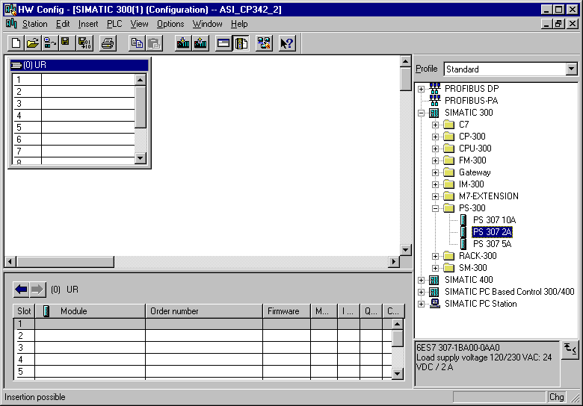

Note: If your hardware differs from what is shown above, then you must select the appropriate modules from the catalog and insert them into the rack. The part numbers of the individual modules, which are found on the components, are indicated in the footer of the catalog..

18. In the next step, we drop the CPU 315-2DP into the second card location. This allows for the part number and version of the CPU to be read off (→ SIMATIC 300 → CPU-300 → CPU 315-2DP → 6ES7 315-2AF03-0AB0 → V1.1 ).

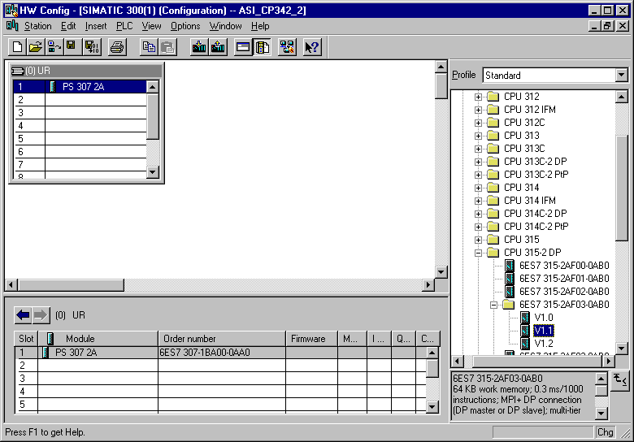

19. In the following window, the integrated PROFIBUS interface can be adjusted. Here we do not use one so we accept the setting with OK( → OK ).

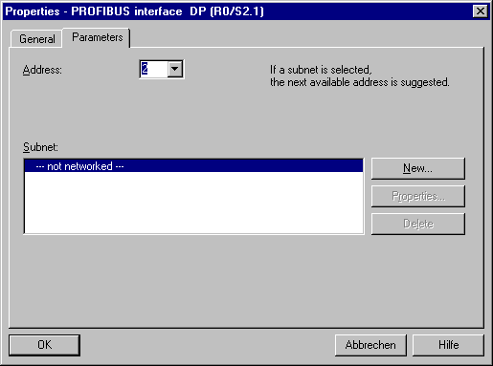

20. In the next step we see the input module for 16 inputs on the fourth slot . Now the order number and version of the model can be read off the front. (→ SIMATIC 300 → SM-300 → DI-300 → SM 321 DI16xDC24V).

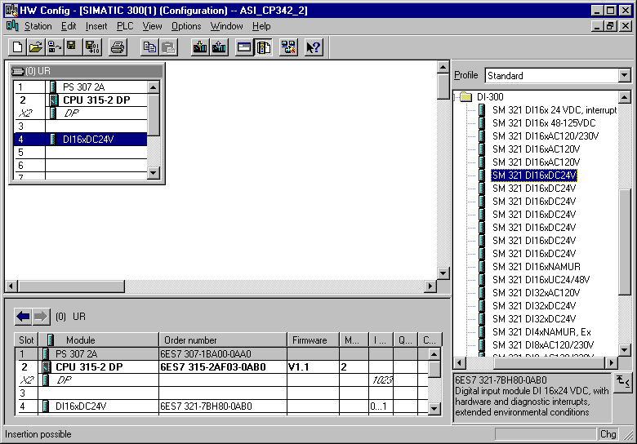

Note: Slot number 3 is reserved for interface modules and remains empty. The order number of the module is displayed in the footer of the catalog.

21. In the next step we see the output module for 16 outputs on the fifth slot. Now the order number and version of the model can be read off the front (→ SIMATIC 300 → SM-300 → DO-300 → SM 322 DO16xDC24V/0.5A).

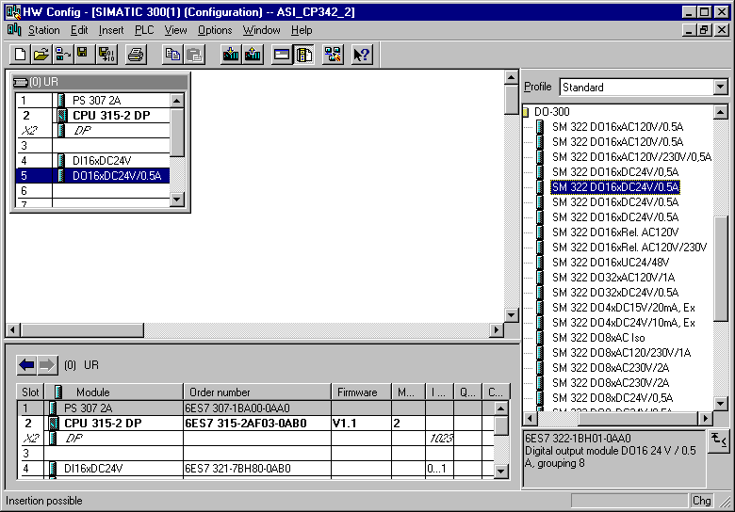

Note: The order number of the module is displayed in the footer of the catalog.

22. In the next step we see the communication processor for the AS-Interface CP342-2 AS-i in the sixth slot. Now the order number and version of the model can be read off the front
(→ SIMATIC 300 → CP-300 → AS-Interface → CP 342-2 AS-i).

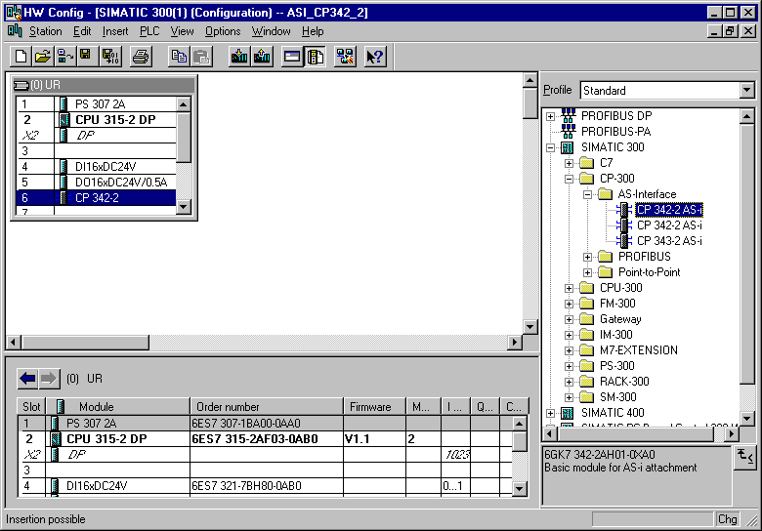

Note: The order number of the module is displayed in the footer of the catalog.

23. The address assignment of the CP342-2 occurs automatically and is bounded to the slots. The addresses can be seen in the lower window and should be noted. The addresses of the CP342-2 lie in the analog address area of the CPU. It occupies the peripheral input values PIW288, PIW290, PIW292 and PIW 302 and the peripheral output values PQW288, PQW290, PQW292 and PQW 302.

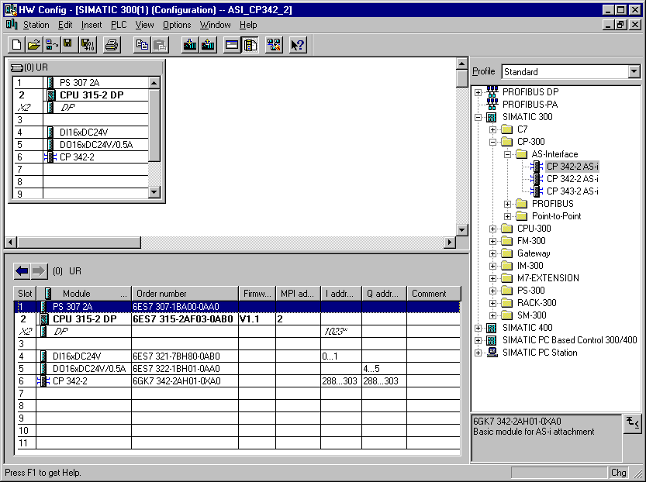

24. The configuration table is now compiled and saved with a click on and then downloaded into the PLC with . The switch mode of the CPU must be on STOP! ( → → )

25. The CPU 315-2DP is then activated as the target module for the download activity (→ OK).

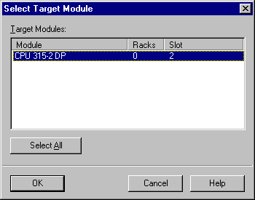

26. Then the MPI address of the CPU for the attachment of the programming connection is accepted with OK ( → OK ).

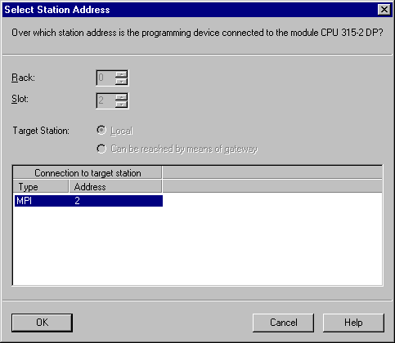

Note: This setting is only relevant when more CPUs are attached to the programming device over an MPI network. Here the desired CPU for the download of the configuration can be chosen.

4. writing a STEP 7- Program
The to be debugged program is written here in statement list (STL).
The program should control a stamp cylinder over a spring-return cocked valve ‘Y1’. A button ‘S1’ drives this cylinder forward. A button ‘S2’ drives this cylinder back again.

Assignment list:

I 65.0 S1 Button for cylinder extraction (AS-I slave address 3, IN1)
I 65.1 S2 Button for cylinder retraction (AS-I slave address 3, IN 2)
Q 66.4 Y1 Valve stamp cylinder (AS-I slave address 4, OUT 1)

In order to implement this program with the AS-Interface, you must follow the following steps.

27. In SIMATIC Manager highlight the folder Blocks ( → SIMATIC Manager →Blocks).

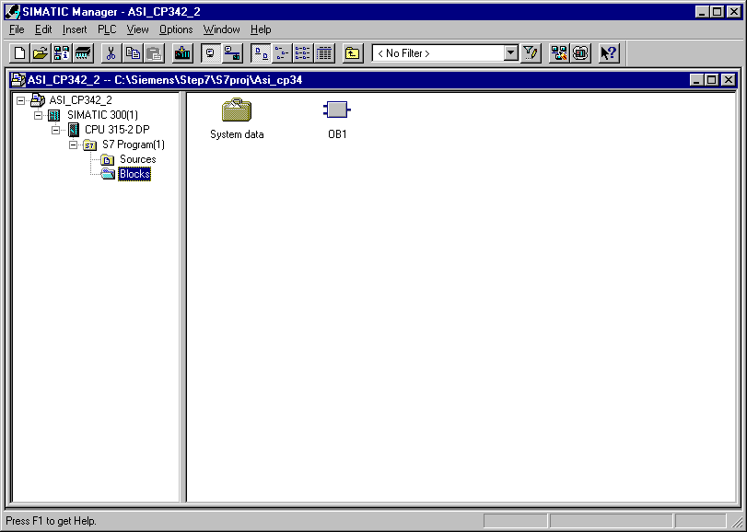

28. From the SIMATIC Manager, open the data block OB1 with a double click in the editor LAD, STL, FBD: Program blocks ( → OB1)

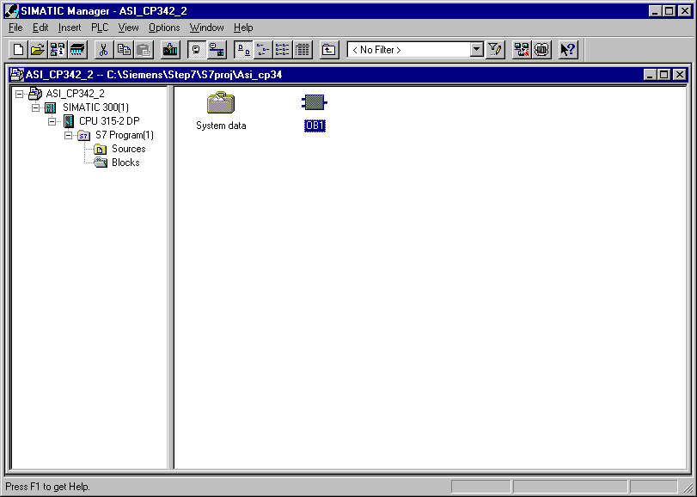

29. Optional: Enter the properties of the OB1 for documentation and accept with OK ( →OK).

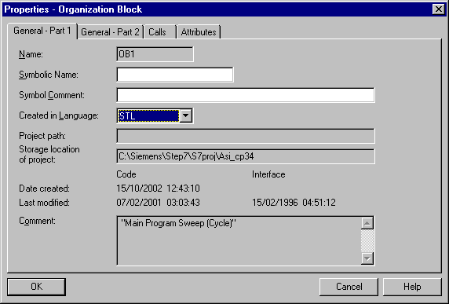

The CP342-2 occupies 16 inputs and 16 outputs in the I/O analog address range of the PLC.
The start address is assigned through a slot of the CP342-2 and can be extracted from the configurations table (here PIW288 and PQW 288).

From the in- and outputs of the AS-I slaves, the SIMATIC S7-300 can be accessed like it is from the standard modules of the analog peripherals through S7 download and transfer instructions. This access can only be word or double word-oriented from system intrinsic principles.
e.g.: L PIW X //Load peripheral input word X
L PID X //Load peripheral input double word X
T PQW X //Transfer peripheral output word X
T PQD X // Transfer peripheral output double word X

Thus no access can occur here directly on individual bits in the STEP 7 program.

With load/transfer instructions you can transmit the inputs of the AS-I slaves in any words (Data, memory bits, inputs).
Using the same method, you can transmit any words (Data, memory bits, outputs) with the load/transfer instructions into the outputs of the AS-I slaves.

The input signals of the AS-Interface should be downloaded to the input byte 64 in the process-image. They are in the address area of the CP342-2 which can be read from the hardware configuration (here from PIW288).

The output signals for the AS-Interface area readout to the output byte 64 from the process-image. These signals must be read from the hardware configuration and then must be written into the address area of the CP342-2 (here from PQW288).

Four bits (a nibble) are assigned to each slave on the AS-I line. The assignment of the individual slaves to the address is as follows:

Inputs | IN / OUT |  |  |  | IN / OUT |  |  |  | Address | Outputs
PII | 7 | 6 | 5 | 4 | 3 | 2 | 1 | 0 | CP342-2  (PI/PQ) | PIQ
PII | In4 | In3 | In2 | In1 | In4 | In3 | In2 | In1 | CP342-2  (PI/PQ) | PIQ
PII | Out4 | Out3 | Out2 | Out1 | Out4 | Out3 | Out2 | Out1 | CP342-2  (PI/PQ) | PIQ
64 | Reserved for diagnostics |  |  |  | Slave01 |  |  |  | 288 | 64
65 | Slave02 |  |  |  | Slave03 |  |  |  | 289 | 65
66 | Slave04 |  |  |  | Slave05 |  |  |  | 290 | 66
67 | Slave06 |  |  |  | Slave07 |  |  |  | 291 | 67
68 | Slave08 |  |  |  | Slave09 |  |  |  | 292 | 68
69 | Slave10 |  |  |  | Slave11 |  |  |  | 293 | 69
70 | Slave12 |  |  |  | Slave13 |  |  |  | 294 | 70
71 | Slave14 |  |  |  | Slave15 |  |  |  | 295 | 71
72 | Slave16 |  |  |  | Slave17 |  |  |  | 296 | 72
73 | Slave18 |  |  |  | Slave19 |  |  |  | 297 | 73
74 | Slave20 |  |  |  | Slave21 |  |  |  | 298 | 74
75 | Slave22 |  |  |  | Slave23 |  |  |  | 299 | 75
76 | Slave24 |  |  |  | Slave25 |  |  |  | 300 | 76
77 | Slave26 |  |  |  | Slave27 |  |  |  | 301 | 77
78 | Slave28 |  |  |  | Slave29 |  |  |  | 302 | 78
79 | Slave30 |  |  |  | Slave31 |  |  |  | 303 | 79

Note: This assignment applies for the inputs and outputs to the AS-I slaves.

Now, for example, the address of the first output in the AS-I slave 4 to be acquired is given as follows:
Byte address for Slave04 from the PIQ: 66
Bit address for Out1: 4

Resulting address: Q 66.4

30. With LAD, STL, FBD: Program blocks, you now have an editor which gives you the possibility to generate your STEP 7- Program. Here the organization block OB1 was already opened with the first network.

Note: In the first network, the input signals of the AS-Interface are downloaded here into the process-image input table (PII) starting from input word IW64. In the last network the signals from the process-image output table starting from output word QW64 area readout and written in the outputs of the AS-Interface. In the networks between, the signal can be accessed from the addresses of the AS-I slaves.

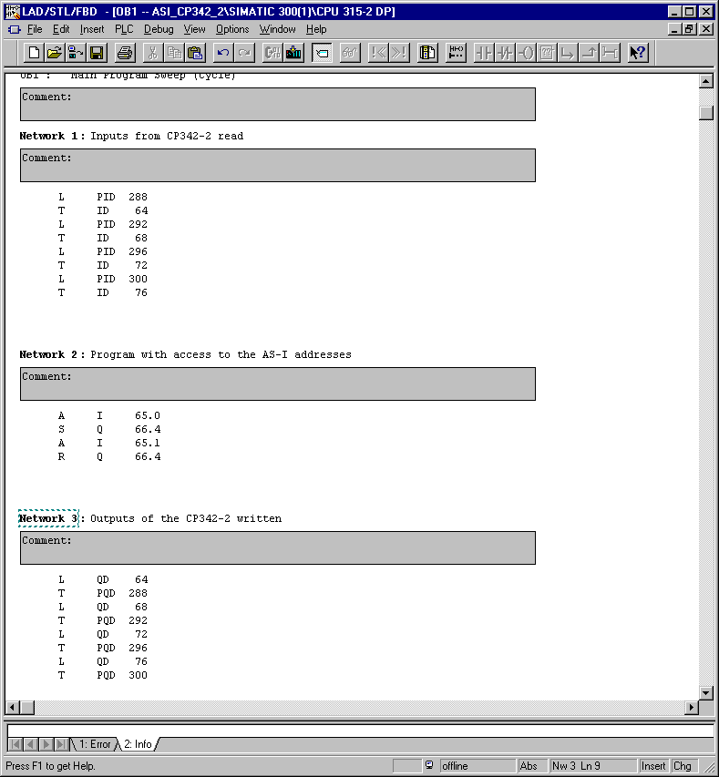

5. debugging a STEP 7- Program
The to be debugged STEP 7- Program must be downloaded into the PLC.
In our case it is only the block OB1.
31. Save the organizational block with and clock on download . The mode switch of the CPU must be on STOP! ( → ‚’ → )

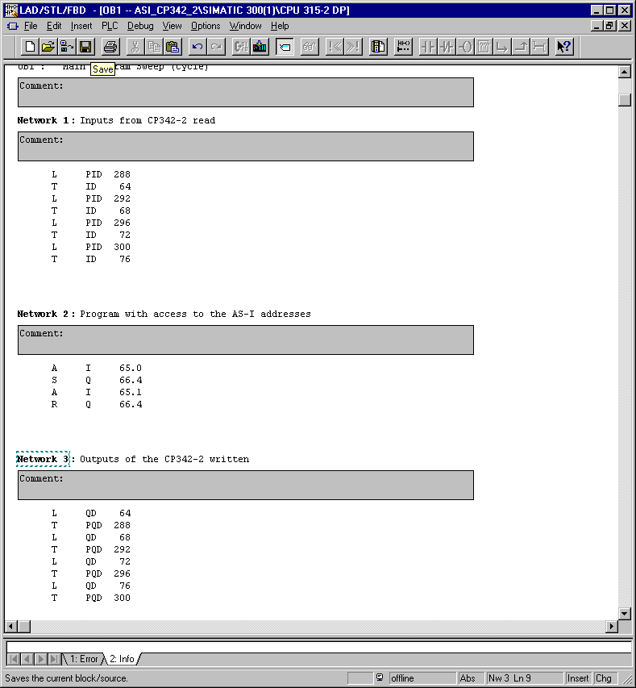

32. Through the switching of the mode switch to RUN, the program is started. The program can be monitored in the ‘OB1‘ with a click on the symbol for monitoring (→ ).

