Training document for the company-wide
automation solution
Totally Integrated Automation (T I A)

MODULE A8
Test and online functions

This document was provided by Siemens A&D SCE (automation and drive technology, Siemens A&D Cooperates with Education) for training purposes. Siemens does not make any type of guarantee regarding its contents.

The passing on or duplication of this document, including the use and report of its contents, is only permitted within public and training facilities.

Exceptions require written permission by Siemens A&D SCE (Mr. Knust: E-Mail: michael.knust@hvr.siemens.de). Offences are subject to possible payment for damages caused. All rights are reserved for translation and any case of patenting or GM entry.

We thank the company Michael Dziallas Engineering and the instructors of vocational schools as well as further persons for the support with the production of the document.

PAGE:

1. Forward 4

2. Test and online functions 6

The following symbols stand for the specified modules:



Programming


Notes

1. Forward

The module A7 is assigned content wise to the Basics of STEP 7- Programming.

Basics of

STEP 7- Programming
2 - 3 days A modules

Additional functions of
STEP 7- Programming
2- 3 days B modules

Industrial field bus
systems
2- 3 days D modules
Process
visualization
2- 3 days F modules
Sequencer
programming
2- 3 days C modules C

IT- Communication
with SIMATIC S7
1- 2 days E modules

Learning goal:

In this module, the reader will learn the tools which are helpful for error searching.

• Debug functions
• Online- functions

Requirements:

For the successful use of this module, the following knowledge is assumed:

• Knowledge in the use of Windows 95/98/2000/ME/NT4.0
• Basics of PLC- Programming with STEP 7 (e.g. Module A3 – ‘Startup’
PLC- Programming with STEP 7)

Required hardware and software

1 PC, Operating system Windows 95/98/2000/ME/NT4.0 with
- Minimal: 133MHz and 64MB RAM, approx. 65 MB free hard disk space
- Optimal: 500MHz and 128MB RAM, approx. 65MB free hard disk space
2 Software STEP 7 V 5.x
3 MPI- Interface for the PC (e.g. PC- Adapter)
- PLC SIMATIC S7-300
Example configuration:
- Power supply: PS 307 2A
- CPU: CPU 314
- Digital inputs: DI 16x DC24V
- Digital outputs: DO 16x DC24V / 0.5 A
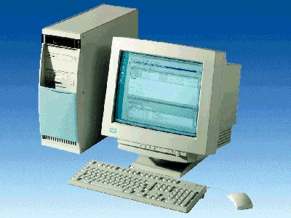
1 PC
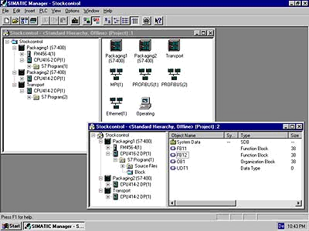
2 STEP 7

3 PC Adapter

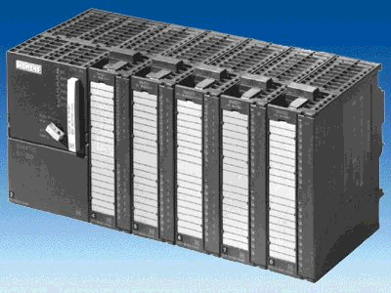
4 SIMATIC S7-300

2. Test and online functions
In the following section, the debug and on-line functions are introduced and can be tested e.g. with the STEP 7 project ‘Startup‘ from module A3 – ‘Startup‘ PLC- Programming with STEP 7.

In STEP 7, many different debug and diagnostic functions are available. In order to use the functions, the following steps must be implemented:

1. First open the LAD,STL,FBD Program blocks tool. (→ Start → Simatic → STEP 7 → LAD, STL, FBD Program blocks).
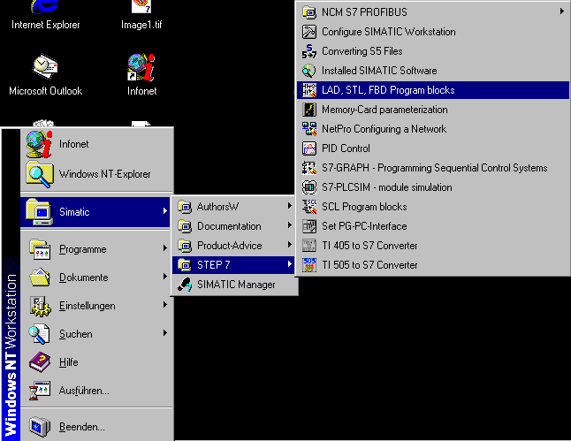

2. Open a block to observe it. (→ File → Open).

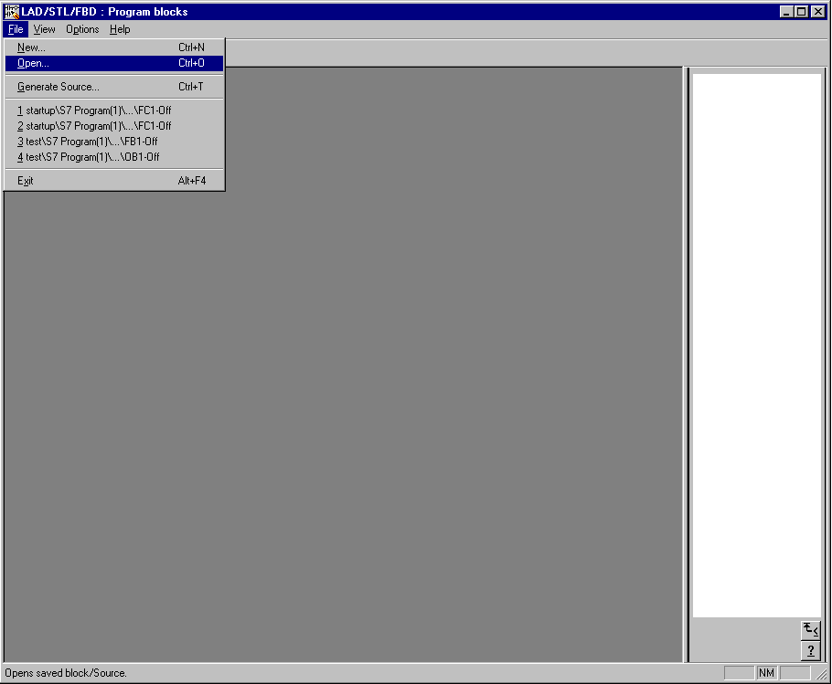

3. Open a block from the CPU Online or Available nodes ( → Entry point: Project → Name → Online → Choose block → OK).

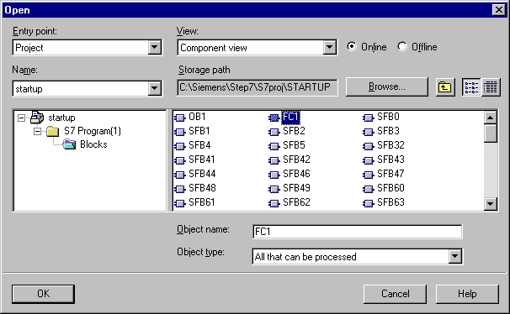

Note: Since STEP 7 V5.x can also access a project from Offline, make sure to access a block from the Online functions!!!

4. Now the variables can be monitored and modified from the PC under the menu option → PLC with → Monitor/Modify Variables and accessed on the diagnostic functions→ Module Information and → Operating Mode. From here one can also request → Clear/Reset and → Set Time of Day adjustments.

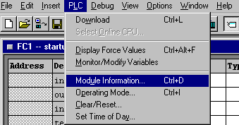

5. If the function → Variable Monitor/Modify was selected, several operations can be monitored and modified.

5.1. In addition, the necessary operands must be registered in a table and their format must be selected.

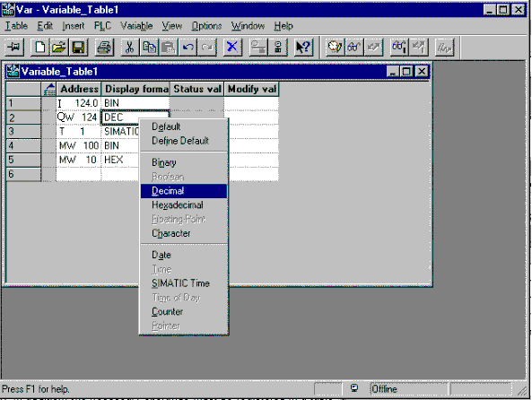

5.2. Now the times ( → Trigger ) for monitoring and modifying need to be accessed.

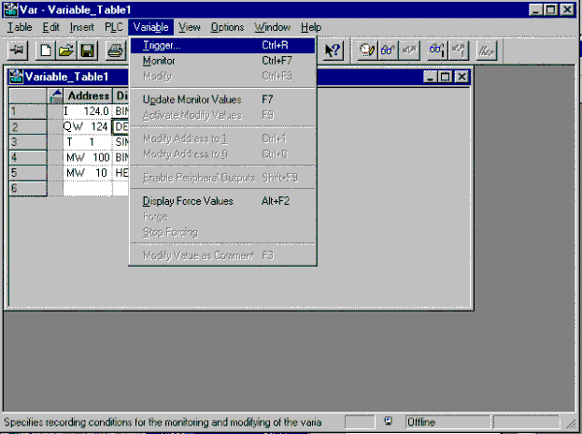

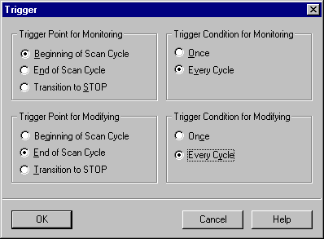

5.3. The operands can now be monitored ( → Variable → Monitor).

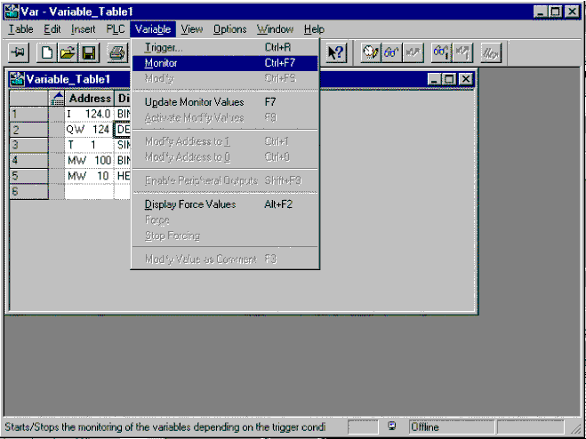
5.4. In order to modify, the modification value must be given beforehand ( → Variable → Modify).

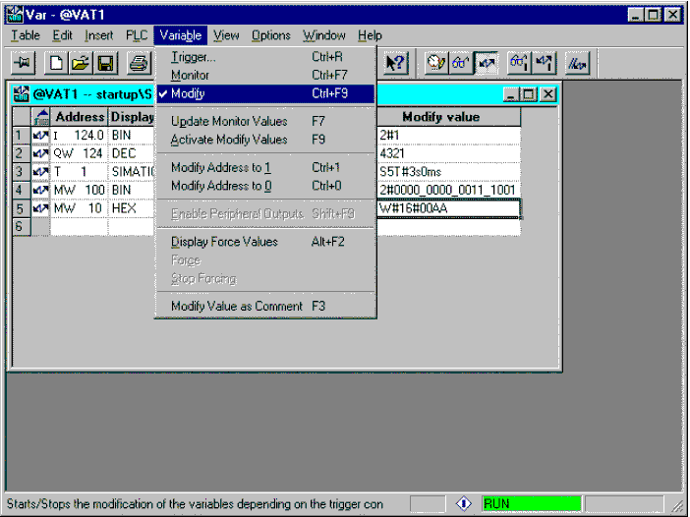

6. Another possibility for the monitoring of operands and the debugging of an executed program is with the function → Debug → Monitor.

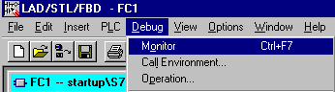

6.1. In STL, the logic operation result RLO, the value of the operand STA, and the contents from the ACCU1 STANDARD are indicated behind each operand. With a right mouse click on the area under STANDARD, the display type can be changed to the desired format.

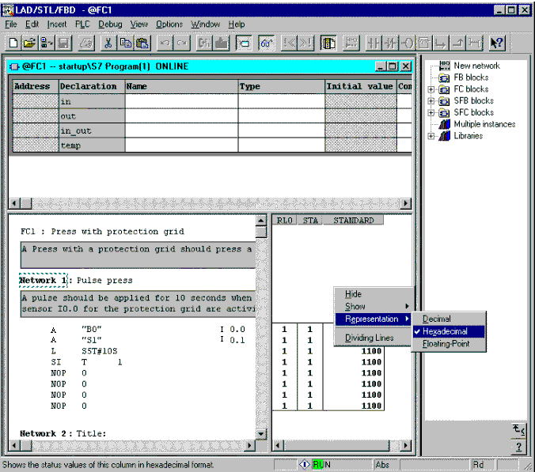
6.2. The signal chart can be monitored in a LAD.

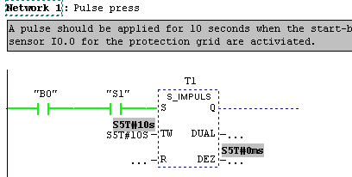

6.3. The signal chart and signal state can be monitored in a FBD.

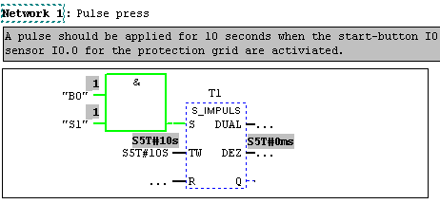

7. The diagnostic function Module Information makes an exact diagnosis possible of the system states regarding memory efficiency, communication, as well as cycle loading and offers detailed information about the selected CPU (→Module Information ).

The Diagnostic buffer, which logs the last 100 operating state modifications and error messages on the CPU as a ring buffer, is important for finding errors. Thus programming and hardware errors can be located fast and effectively ( → Diagnostic Buffer).

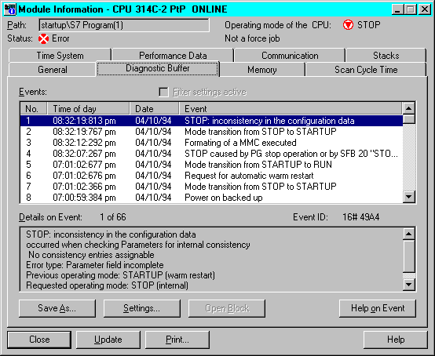

8. With the diagnosis function Operating Mode, these errors can be understood and affected. ( → Operating Mode)

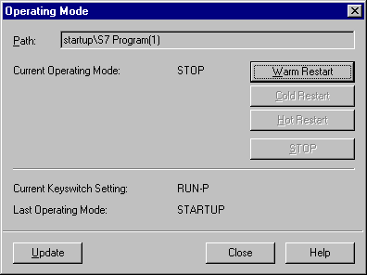

9. With the function → Clear/Reset, one can request a reset of the program equipment.

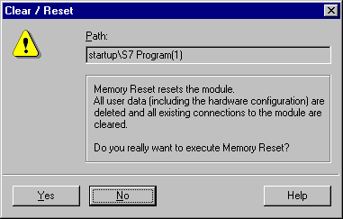

10. The time of day and date can be actuated with the Set Time of Day or accepted from the program equipment. (→ Set Time of Day)

