Training document for the company-wide
automation solution
Totally Integrated Automation (T I A)

MODULE A7
Save / archiving / program documentation

This document was provided by Siemens A&D SCE (automation and drive technology, Siemens A&D Cooperates with Education) for training purposes. Siemens does not make any type of guarantee regarding its contents.

The passing on or duplication of this document, including the use and report of its contents, is only permitted within public and training facilities.

Exceptions require written permission by Siemens A&D SCE (Mr. Knust: E-Mail: michael.knust@hvr.siemens.de). Offences are subject to possible payment for damages caused. All rights are reserved for translation and any case of patenting or GM entry.

We thank the company Michael Dziallas Engineering and the instructors of vocational schools as well as further persons for the support with the production of the document.

PAGE:

1. Forward 4

2. Symbolic Addressing 6

3. Program Saving on the EPROM- Memory Card in the CPU 9

4. Archiving / Retrieving Projects 11

5. Displaying Reference Data 15

The following symbols stand for the specified modules:



Programming


Notes

1. Forward

The module A6 is assigned content wise to the Basics of STEP 7- Programming.

Basics of

STEP 7- Programming
2 - 3 days A modules

Additional functions of
STEP 7- Programming
2- 3 days B modules

Industrial field bus
systems
2- 3 days D modules
Process
visualization
2- 3 days F modules
Sequencer
programming
2- 3 days C modules C

IT- Communication
with SIMATIC S7
1- 2 days E modules

Learning goal:

In this module, the reader will learn the tools to the program documentation and saving of STEP 7- Programs.

• Symbolic addressing
• Saving of programs in the EPROM-Memory Card of the SIMATIC S7-300
• Archiving and retrieving STEP 7-Programs.
• Viewing of the reference data to a STEP 7- Program

Requirements:

For the successful use of this module, the following knowledge is assumed:

• Knowledge in the use of Windows 95/98/2000/ME/NT4.0
• Basics of PLC- Programming with STEP 7 (e.g. Module A3 – ‘Startup’
PLC- Programming with STEP 7)

Required hardware and software

1 PC, Operating system Windows 95/98/2000/ME/NT4.0 with
- Minimal: 133MHz and 64MB RAM, approx. 65 MB free hard disk space
- Optimal: 500MHz and 128MB RAM, approx. 65MB free hard disk space
2 Software STEP 7 V 5.x
3 MPI- Interface for the PC (e.g. PC- Adapter)
- PLC SIMATIC S7-300
Example configuration:
- Power supply: PS 307 2A
- CPU: CPU 314
- Digital inputs: DI 16x DC24V
- Digital outputs: DO 16x DC24V / 0.5 A
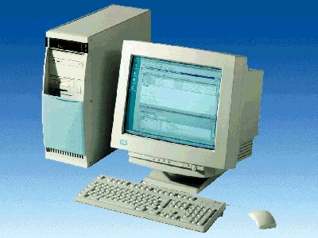
1 PC
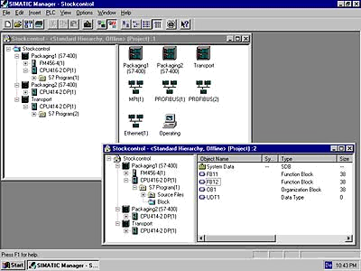
2 STEP 7

3 PC Adapter

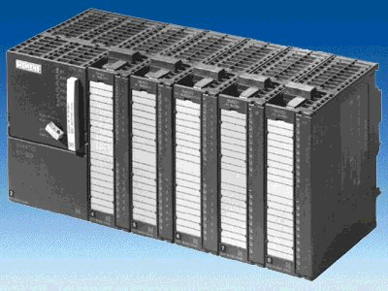
4 SIMATIC S7-300

2. Symbolic Addressing
Symbolic addressing makes it possible to work with symbols (e.g. MOTOR_ON) in place of addresses. The symbols for inputs, outputs, timers, counters, bit memories and blocks are deposited into a symbol table.
The production of a symbol table for the project ‘startup‘ from module A3 – ‘Startup‘. PLC programming with STEP 7 is accomplished as follows:

1. Open symbol table (→ Symbols).

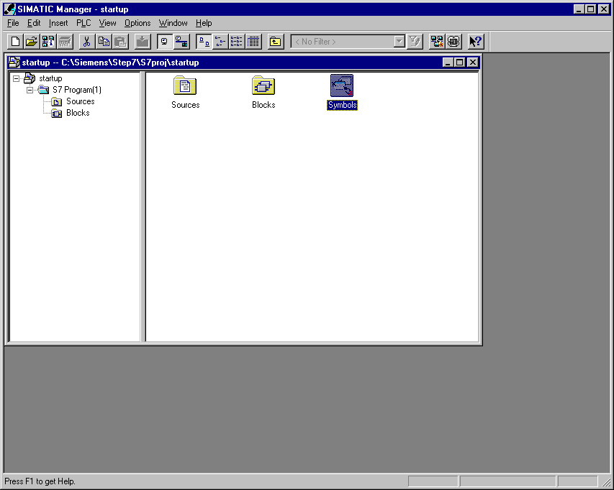

2. Queue operands in the symbol table ( → Symbol → Address → Data type → Comment ) and
save the symbol table ( → Symbol table → Save).

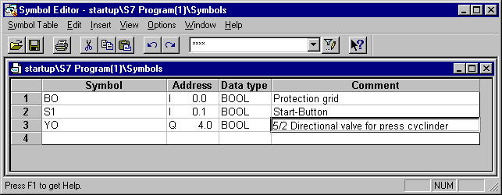

3. In the tool LAD/STL/FBD, the blocks (e.g. OB1) can now be selected with the symbolic addressing representation type.
( → View → Display with → Symbolic Representation → Symbol Information ).

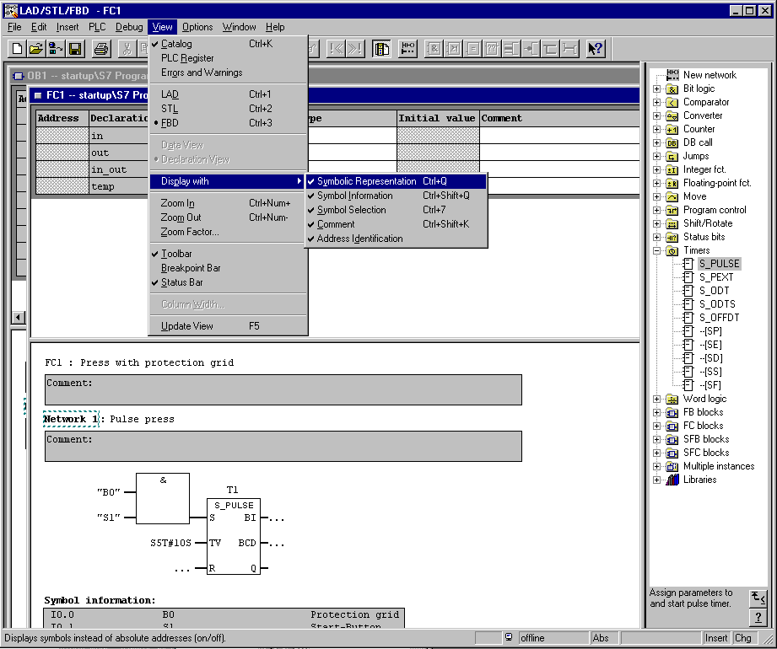

The blocks are then represented in LAD, FBD and STL with symbolic addresses as follows:

LAD:

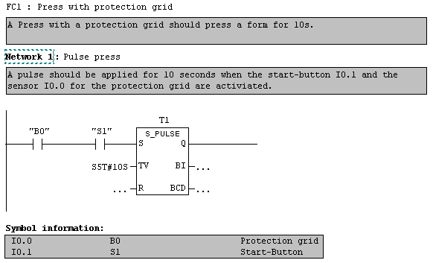

FBD:
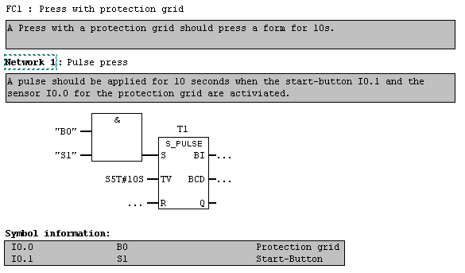

STL:

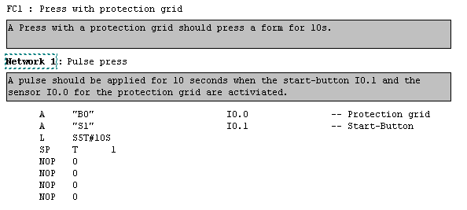

3. Program saving on the EPROM-Memory Card in the CPU
With the SIMATIC S7-300 there is the possibility for all CPUs to transfer or load a program onto a Flash EPROM. Exceptions are the CPU312 IFM and CPU314 IFM, which have an integrated EPROM. The requirement is that the programming device is connected by an MPI with the CPU and the code switch on the CPU rests on STOP. Proceed as follows:

1. In the SIMATIC Manager, highlight the folder Blocks (→ Blocks).

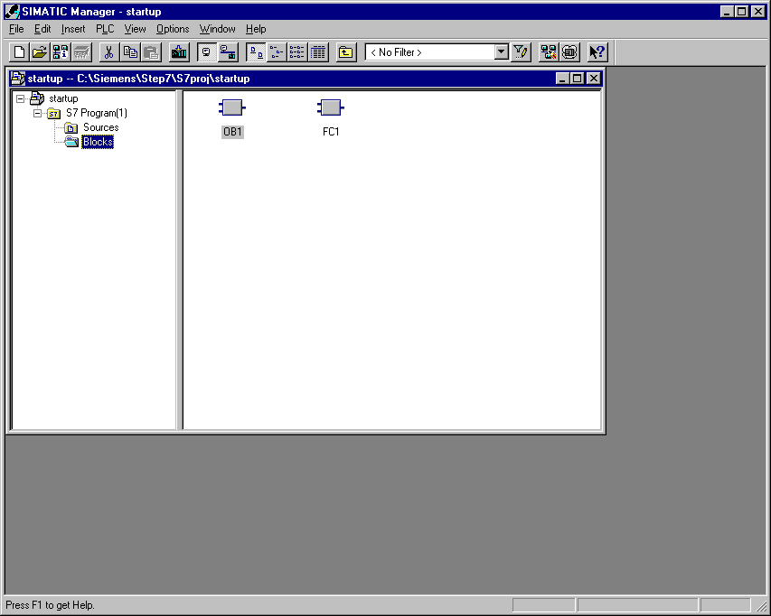

2. Choose the menu topic (→ PLC → Download user program to memory card).

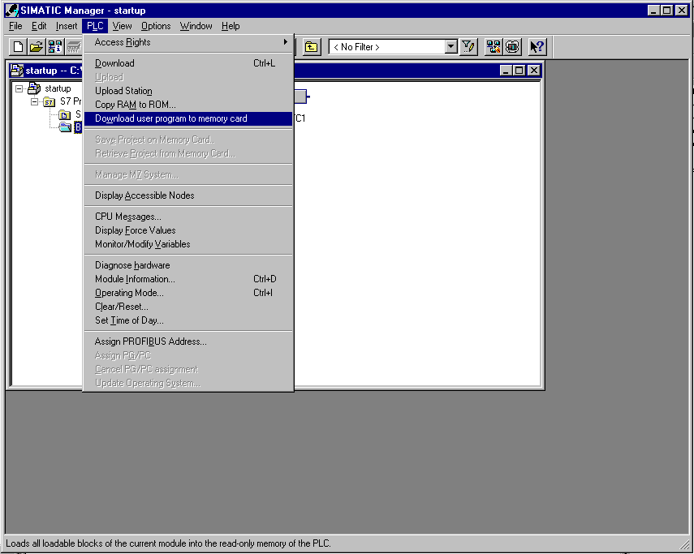

- Now all blocks from the project are transferred into the CPU and the EPROM memory card.

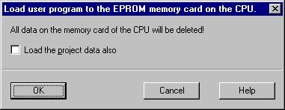

- If the same program needs to be run on a second CPU, only the second CPU must be switched off, so that the EPROM can be inserted. After restarting data, memory reset is accomplished

4. archiving/retrieving projects
The projects in STEP 7 are very large and therefore not many can be stored on the hard disk. This is why STEP 7 offers an integrated archiving function.

The following steps should be accomplished:
1. Close the finished project and choose Archive in the SIMATIC Manager (→ SIMATIC Manager → File → Archive).
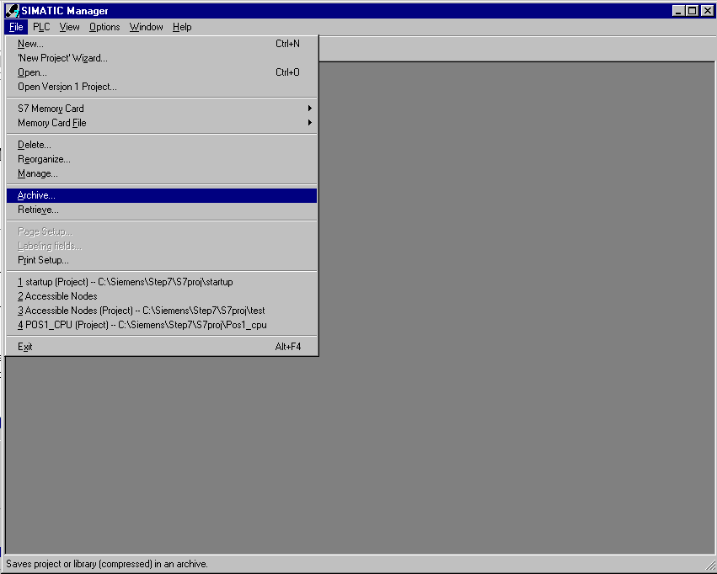

2. Choose project to archive and select OK (→ OK).

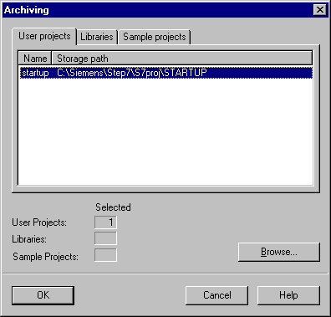

- Select target location and file name and then click Save (→ Save).

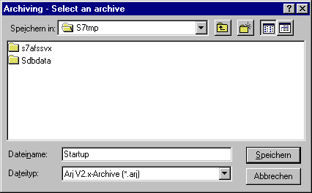

4. With large projects, select Archive that goes across diskettes when necessary (→ OK).

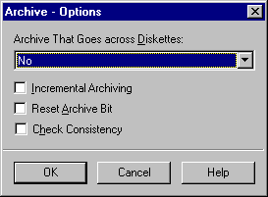

5. The steps for Retrieve follows likewise in SIMATIC Manager. (→ SIMATIC Manager → File → Retrieve).

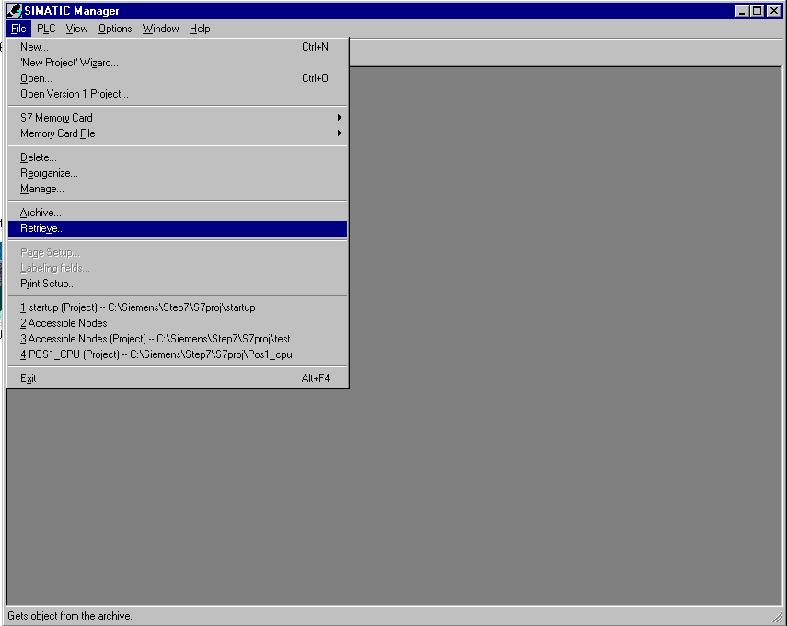

6. The archive that should be retrieved must be chosen here and then opened (→ Open).

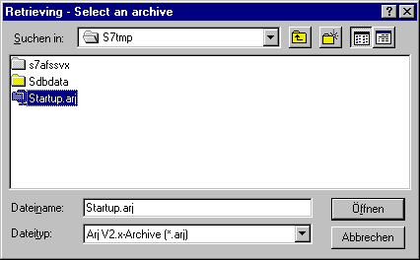

7. In the next step, choose the target location and select OK ( → OK).

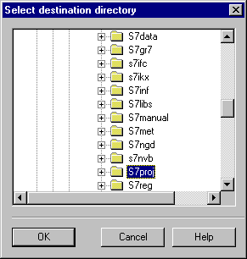

8. After retrieving, the target directory is shown one more time ( → OK).

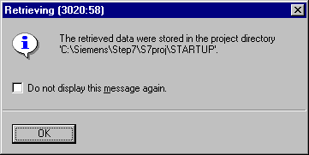

9. The built project can now be opened for follow up ( → Yes).

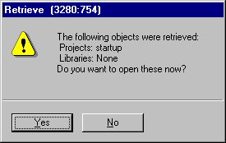

5. displaying reference data
If one must incorporate something into an external program, it is helpful to be able to indicate the program structure and further information. For this, STEP 7 offers various possibilities.

1. First the folder → Blocks must be highlighted, and then reference data chosen.
( → Options → Reference Data → Display) .

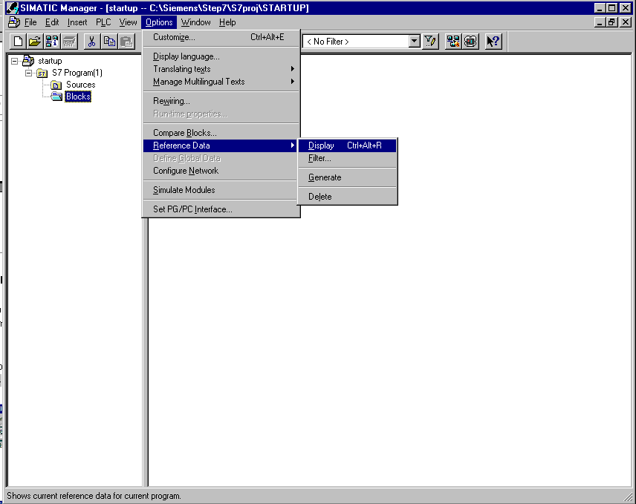

2. Now program structure, assignments (input/outputs, memory bits, timers and counters), cross references, unused symbols and addresses without symbols can be chosen for a view.

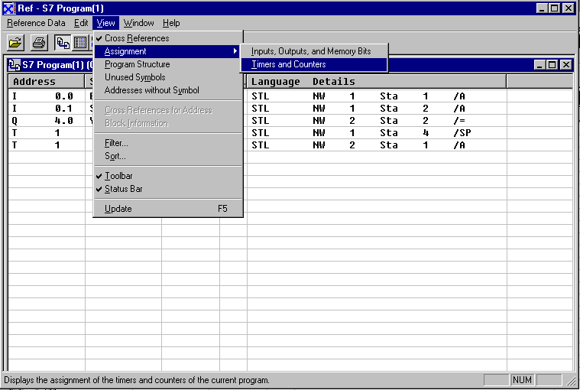

3. The data can be filtered. The option of filter can be found under (→ View
→ Filter).
Click ‘Filter‘!

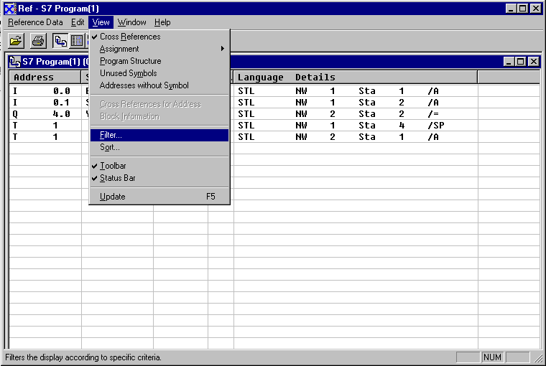

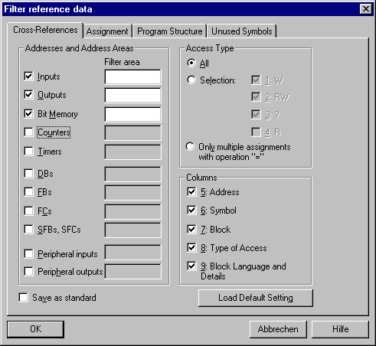
Select the filter options for the reference data!

