Training document for the company-wide
automation solution
Totally Integrated Automation (T I A)

MODULE A6
PLC simulation with S7-PLCSIM

This document was provided by Siemens A&D SCE (automation and drive technology, Siemens A&D Cooperates with Education) for training purposes. Siemens does not make any type of guarantee regarding its contents.

The passing on or duplication of this document, including the use and report of its contents, is only permitted within public and training facilities.

Exceptions require written permission by Siemens A&D SCE (Mr. Knust: E-Mail: michael.knust@hvr.siemens.de). Offences are subject to possible payment for damages caused. All rights are reserved for translation, and any case of patenting or GM entry.

We thank the company Michael Dziallas Engineering and the instructors of vocational schools as well as further persons for the support with the production of the document.

PAGE:

1. Forward 4

2. Notes for the Application of S7-PLCSIM 6

3. Installation of the S7-PLCSIM Software 7

4. Generation of a Simple STEP7- Program 8

5. Start and Configuration of S7-PLCSIM 12

6. Debugging of the STEP7- Program with S7-PLCSIM 14

The following symbols stand for the specified modules:


Information


Installation


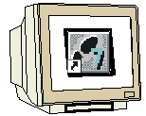
Programming


Example Exercise

1. forward

The module A5 is assigned content wise to the basics of STEP 7- Programming.

Basics of

STEP 7- Programming
2 - 3 days A modules

Additional functions of
STEP 7- Programming
2- 3 days B modules

Industrial field bus
systems
2- 3 days D modules
Process
visualization
2- 3 days F modules
Sequencer
programming
2- 3 days C modules C

IT- Communication
with SIMATIC S7
1- 2 days E modules

Learning goal:

In this module, the reader will learn about the debugging of a STEP 7- Program with the simulation software S7-PLCSIM. The module shows the principle procedure in the following steps by means of a detailed example.

• Installation of the software
• Generation of a simple program
• Starting of S7-PLCSIM
• Debugging of a S7-PLCSIM program

Requirements:

For the successful use of this module the following knowledge is assumed:

• Knowledge in the use of Windows 95/98/2000/ME/NT4.0
• Basics of PLC- Programming with STEP 7 (e.g. Module A3 – ‘Startup’
PLC- Programming with STEP 7)

Required hardware and software

1 PC, Operating system Windows 95/98/2000/ME/NT4.0 with
- Minimal: 133MHz and 64MB RAM, approx. 65 MB free hard disk space
- Optimal: 500MHz and 128MB RAM, approx. 65 MB free hard disk space
2 Software STEP7 V 5.x
3 Software S7-PLCSIM V5.x

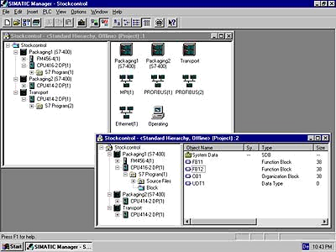
2 STEP 7

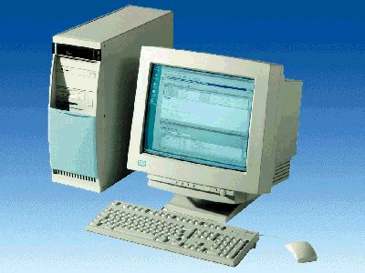
1 PC

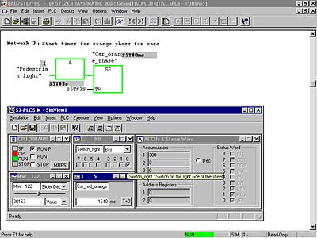
3 S7-PLCSIM

2. NOTes for the application of S7- PLCSIM
The area of application of S7-PLCSIM is mainly a test of the provided STEP 7- Programs for the SIMATIC S7-300 and SIMATIC S7-400 when one can not immediately and directly debug the hardware. This problem can have the following reasons:
- Smaller program modules, whose execution cannot yet be debugged at a machine.
- The application is so critical that damage for a person and a machine is feared if programming errors arise. With a simulation, these errors can be eliminated without causing physical harm.

There is also a possibility to use this application for the purpose of practice, if a hardware PLC is not present.

With the employment of SIMATIC-PLCSIM, the following points should be considered:
- The software package that should be used is the STEP 7 Professional or the STEP 7 Student version
( Not STEP 7 Mini ! )
- Projects for all SIMATIC S7-300 and S7-400 CPUs as well as SIMATIC WinAC can be debugged here.
- The use of function modules (FMs) and communication processors (CPs) cannot be simulated.
- Timer functions do not correspond to the real time requirement, since their execution depends on the speed of the assigned computer.

3. Installation of the S7-PLCSIM software
S7-PLCSIM is an option package for STEP 7, which assumes that the professional or student version of STEP 7 is already installed. (See Module A2 – Installation of STEP 7 V5.x / Handling of authorization).
S7-PLCSIM is delivered on 5 disks or on one CD-ROM, and also includes a disk for authorization. This disk must transfer the appropriate authorization files to the PC in order to make the S7-PLCSIM software usable.
This authorization disk can be used on another PC or can be copied in order to authorize the software. For the topic and transmission of authorization, please see Module A2 - Installation of STEP 7 V5.x / Handling of Authorization.

To install S7-PLCSIM, please proceed to the following steps.

1. Place the first S7-PLCSIM disk or CD-ROM in the appropriate drive.
- Start the setup program by double clicking on the setup.exe executable file.
- The setup program will guide you through the whole installation process of the S7-PLCSIM software.
- In order to use S7-PLCSIM, the software must be authorized on your computer. The files from the authorization disk must be transferred onto the PC. This process will execute at the end of the software installation. A dialog window will appear and ask you if you would like to authorize the software. If Yes is selected, the authorization disk must be inserted in order to transfer the proper files to the PC.

4. generation of a simple STEP7-Program
The program which can be debugged is generated with STEP 7. The example shown here turns a lamp (H1) off with an input-button (S1) and an output-button (S2).

Assignment list:

I 0.1 S1 Input-button
I 0.1 S2 Output-button
Q 4.0 H1 Lamp

The user must implement the following steps, in order to provide a project, in which the solution program can be written.

1. The main tool in STEP 7 is the SIMATIC Manager, which can be opened with a double click on the icon ( → SIMATIC Manager).
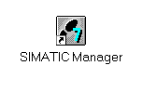
2. STEP 7- Programs are managed in projects. Each project can be newly created ( → File → New).

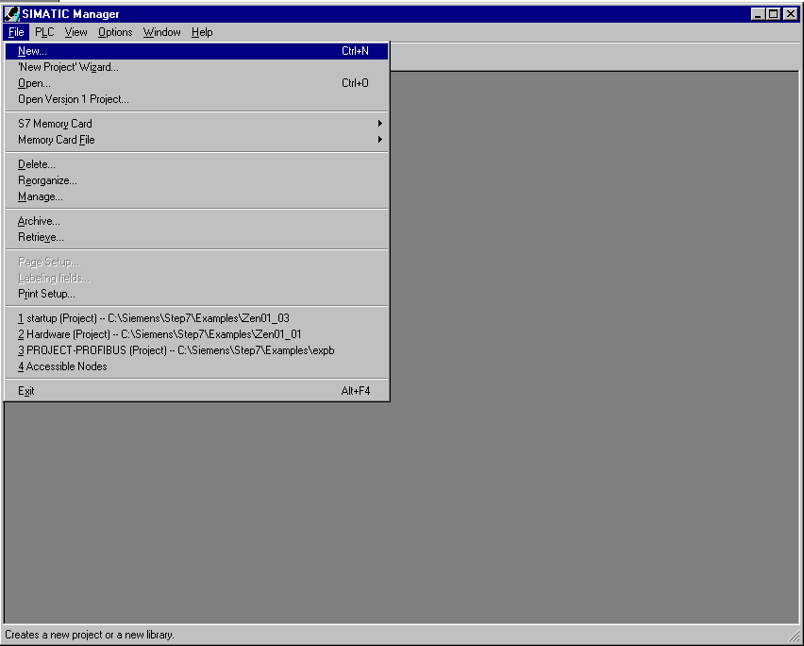

3. Give the project the Name PLCSIM_1 ( → PLCSIM_1 → OK).

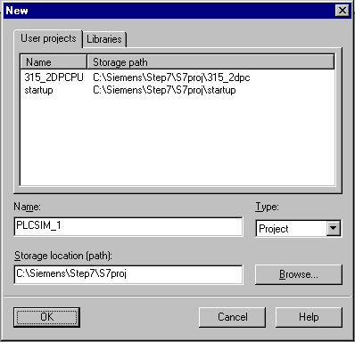

4. Insert a new S7-Program into the project PLCSIM_1. ( → PLCSIM_1 → Insert → Program → S7-Program).

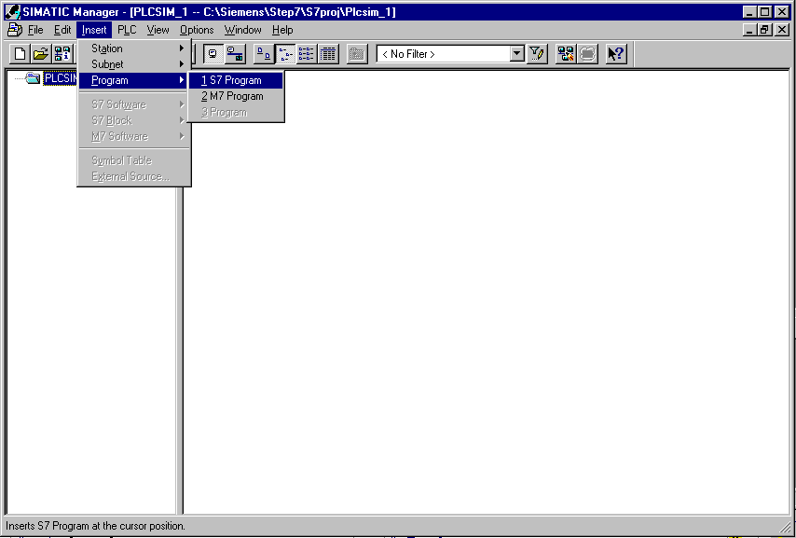

5. In the SIMATIC Manager, double click the block OB1 ( → OB1).

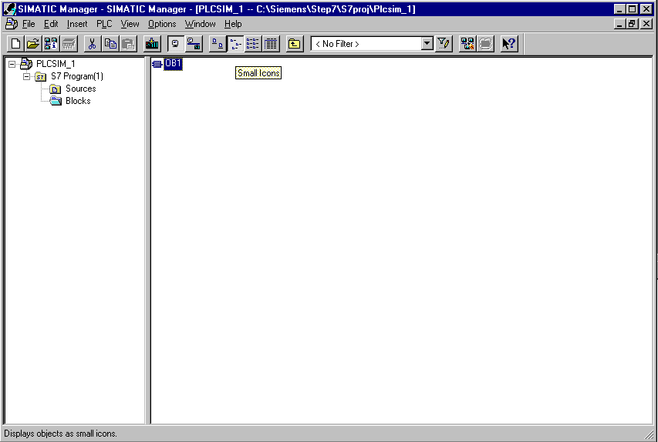

6. Accept the options of the OB1 block with OK ( →OK).

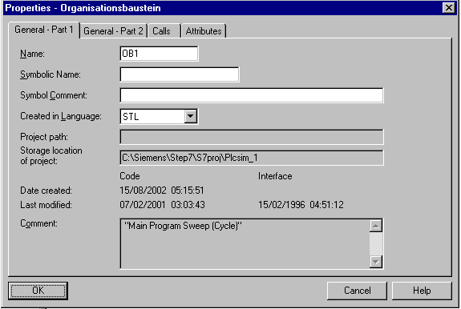

7. Now a simple program can be written in OB1 to e.g. the statement list (STL) . This program must then be saved and the OB1 must be closed with X ( → Save → X ).

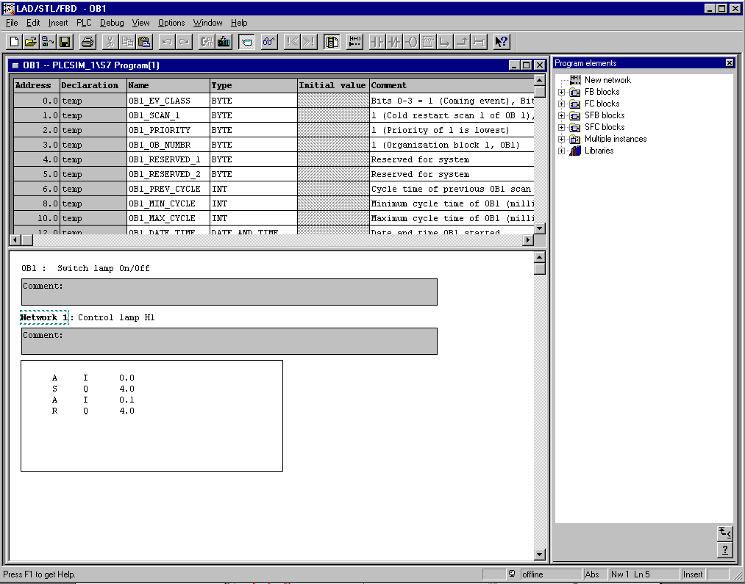

5. STart and configuration of S7-PLCSIM
If this program is to be debugged without a connection between a PC and a hardware PLC, the simulation must be activated. Then all the accesses that are implemented on the interface of the hardware PLC will be simulated internally in the S7-PLCSIM.

8. In order to start a PLCSIM, click on the Simulator button ( → Simulation on/off ).

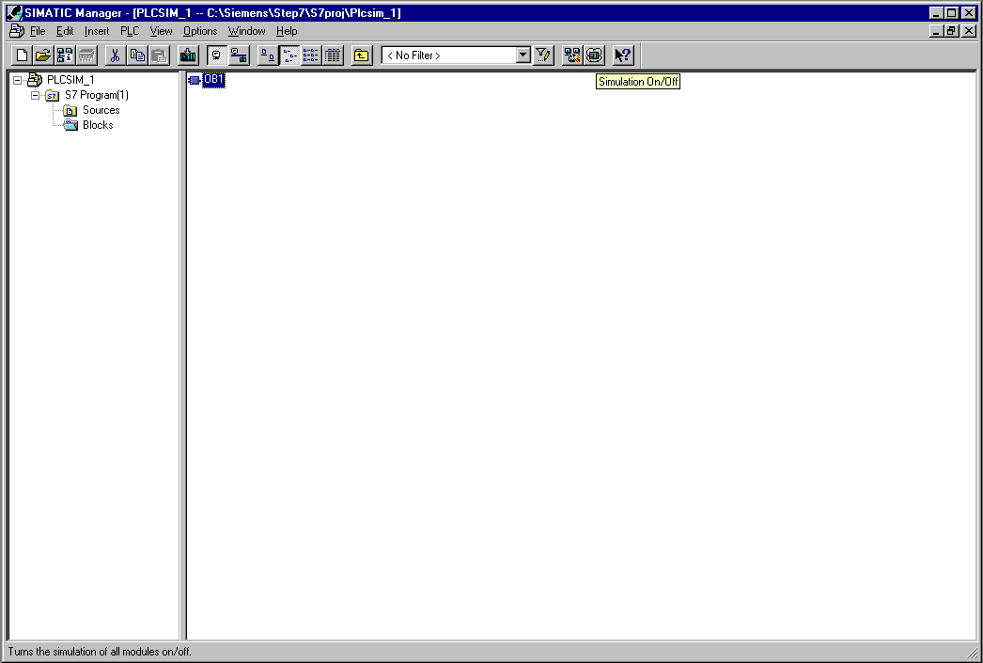

9. Now an input and output need to be placed in the program in order to debug it. This is done by calling Insert and selecting Input and Output. BIT MEMORY and Counters can also be inserted ( → Insert → Input → Insert → Output).

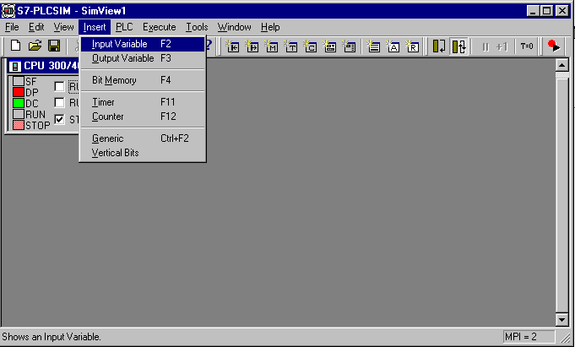

10. The desired addresses IB0 and QB4 ,and the demonstration method Bits must be chosen here (→ IB0 → Bits → QB4 → Bits).

6. Debugging of the STEP7- Program with S7-PLCSIM
The STEP7- Program to be debugged can now be loaded into the PLC simulator. For this example, only OB1 will be debugged. In addition, SDBs (System function blocks), FBs, FCs and DBs can also be downloaded.
11. Highlight OB1, and click Download ( → OB1 → Download ).

12. Now switch the simulated PLC to RUN and switch the individual input bits with the mouse when needed. The active outputs appear similar to switched inputs, but include a check mark ∨, which means that they are active(→ RUN → ∨).

