Training document for the company-wide
automation solution
Totally Integrated Automation (T I A)

MODULE B6
Conversion STEP 5 => STEP 7

This document was provided by Siemens A&D SCE (automation and drive technology, Siemens A&D Cooperates with Education) for training purposes. Siemens does not make any type of guarantee regarding its contents.

The passing on or duplication of this document, including the use and report of its contents, is only permitted within public and training facilities.

Exceptions require written permission by Siemens A&D SCE (Mr. Knust: E-Mail: michael.knust@hvr.siemens.de). Offences are subject to possible payment for damages caused. All rights are reserved for translation and any case of patenting or GM entry.

We thank the company Michael Dziallas Engineering and the instructors of vocational schools as well as further persons for the support with the production of the document.

PAGE:

1. Forward 4

2. Notes for Conversion STEP 5 => STEP 7 6

3. S5- Data Conversion 7

4. Rewiring 16

The following symbols stand for the specified modules:


Information


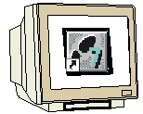
Programming


Notes

1. Forward

The module B6 is assigned content wise to Additional functions of STEP 7- Programming.

Basics of

STEP 7- Programming
2 - 3 days A modules

Additional functions of
STEP 7- Programming
2- 3 days B Modules

Industrial field bus
systems
2- 3 days D modules
Process
visualization
2- 3 days F modules
Sequencer
programming
2- 3 days C modules C

IT- Communication
with SIMATIC S7
1- 2 days E modules

Learning goal:

In this module, the reader should learn how to convert STEP 5- Programs into executing STEP 7- Programs

Requirements:

For the successful use of this module, the following knowledge is assumed:

• Knowledge in the use of Windows 95/98/2000/ME/NT4.0
• Basics of PLC- Programming with STEP 7 (e.g. Module A3 - ‘Startup’
PLC programming with STEP 7)

Required hardware and software

1 PC, Operating system Windows 95/98/2000/ME/NT4.0 with
- Minimal: 133MHz and 64MB RAM, approx. 65 MB free hard disk space
- Optimal: 500MHz and 128MB RAM, approx. 65 MB free hard disk space
2 Software STEP 7 V 5.x
3 MPI- Interface for the PC (e.g. PC- Adapter)
4 PLC SIMATIC S7-300 with at least one digital in- and output module. The inputs must be lead through a functional unit.
Example configuration:
- Power supply: PS 307 2A
- CPU: CPU 314
- Digital input: DI 16x DC24V
- Digital output: DO 16x DC24V / 0.5 A

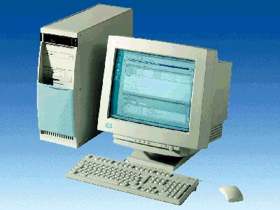
1 PC
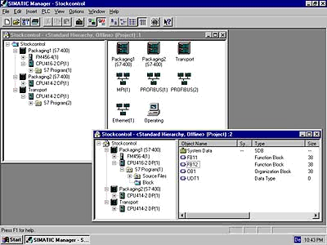
2 STEP 7

3 PC Adapter

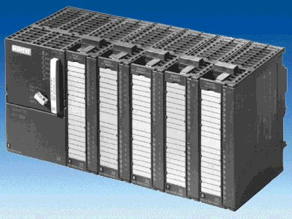
4 SIMATIC S7-300

2. Notes for Conversion STEP 5 => STEP 7
By conversion it is to be noted that it is not possible to convert all programs.
For example, there are many standard functions in STEP 7 that are no longer in a form like STEP 5.

Simplifications are mostly given here so that these functions are simply no longer required or were replaced with simple parameterization in a configurations tool.

This almost always applies when a function module is used ( e.g. FM for step motor triggers).

In this case, these blocks and their calls should be deleted before the conversion from the STEP 5- Program.

After the conversion of the remaining program lines, this function must be taken and programmed with the mean of STEP 7 in operation.

Programs that are created with the normal instruction set from STEP 5, always allows you to fully convert.

Mostly only the addressing must be adjusted.

3. S5- Data conversion
The conversion from S5- Data, that would be generated with STEP 5, takes place with the tool S5 data conversion.

The following steps must be followed by the user in order to convert S5- Data:

1. For the processing of the conversion, you must provide the follow data in a directory.

- <Name>ST.S5D Program data (the S5-Program to be converted)

It is by complex programs that the calling sequence of the blocks remain preserved. The following additional data is important:

- <Name>XR.INI Cross reference list (contains the program structure)

If you would also like to convert the symbol data, the additional data is required:

- <Name>Z0.SEQ symbol table

All newly created data by the conversion is deposited into the same directory.

2. Call conversion tool Converting S5 Files ( → START → Simatic → STEP 7 → Converting S5 Files).

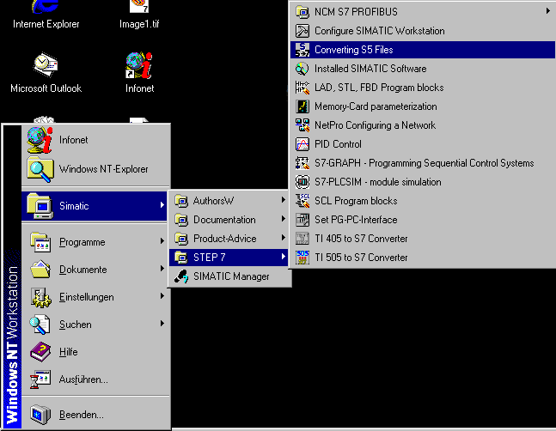

3. In the tool Converting S5 Files, open the S5-Program data (→ File → Open)

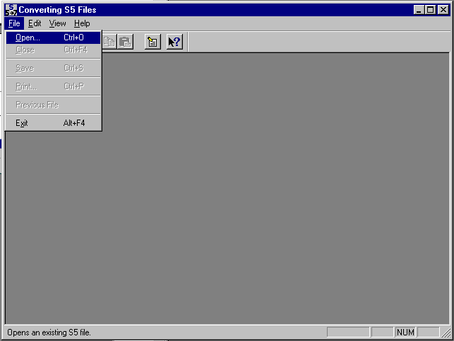

4. The S5-Program data with the ending *ST.S5D is chosen. (→ segmenST.S5T → OK)

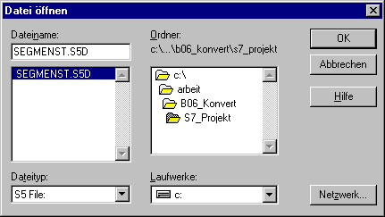

- If no cross-reference list of the type *XR.INI is available, you receive the message:
No XRF file available, blocks cannot be sorted according to their call. You can proceed further with a click on OK (→ OK).

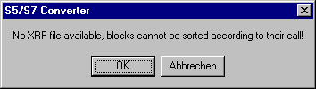

6. In the resulting dialog box, completely participating data and blocks of the conversion are displayed.
With a click on a data block name, you can modify the standard input for the name of the new data and the number of blocks.
Activate the name and start the conversion with the Start- Button. ( → Start).

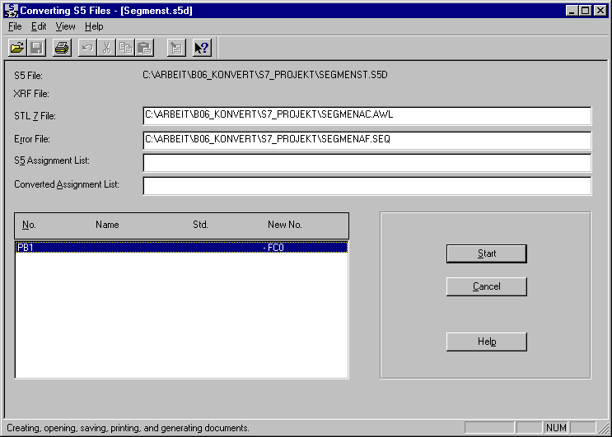

- During the conversion, the actual state of the conversion is displayed in a window (Status window). With a click on the command button Cancel, you can end the conversion.

8. Activate the end of the conversion with a click on the command button OK in the dialog box ( → OK).

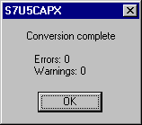

9. If problems arise by the conversion, erros and warnings are displayed in a separate message window. There notes are also given to error recovery. Follow the recommended corrective measures to remove the errors.

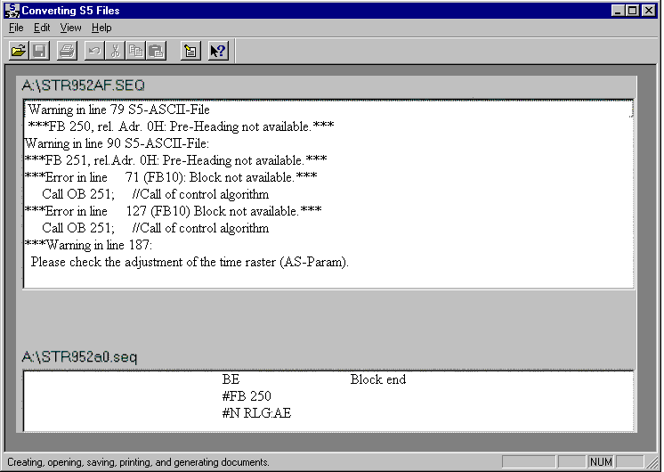

10. After the following conversion of STL data, the data must be incorporated into a STEP 7- Project. This project is generated with the SIMATIC Manager, which is opened with a double click ( → SIMATIC Manager).

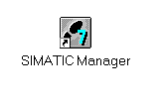
11. Create a new project ( → File → New)

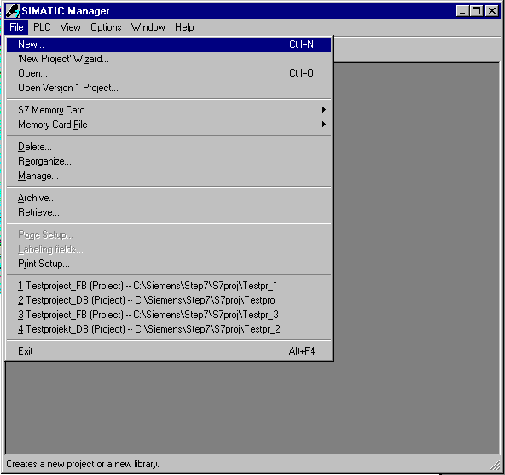

12. Create a project with the name Convert. (→ ‘Convert‘ → OK).

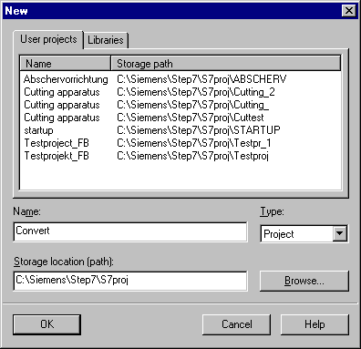

13. Insert a new S7-Program ( → Insert → Program → S7-Program).

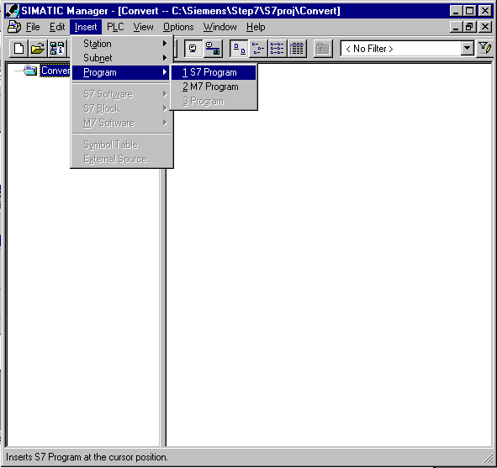

14. Highlight the folder Sources (→ Sources).

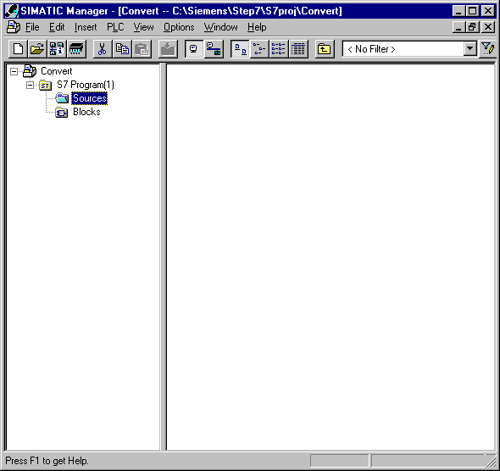

15. Then the *.AWL (German abbreviation for STL) data created during the conversion can be inserted in the directory as External Sources (→ Insert → External Sources).

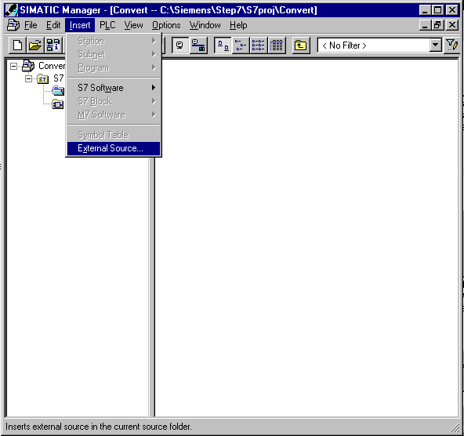

16. Choose the data Segmenac.AWL (→ Segmenac.awl → Open).

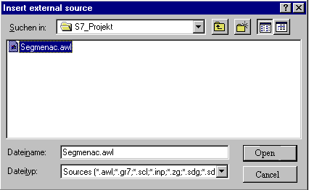

17. Now the source file Segmenac must be chosen with the right-mouse button and Compile must be started.( → Segmenac → Compile).

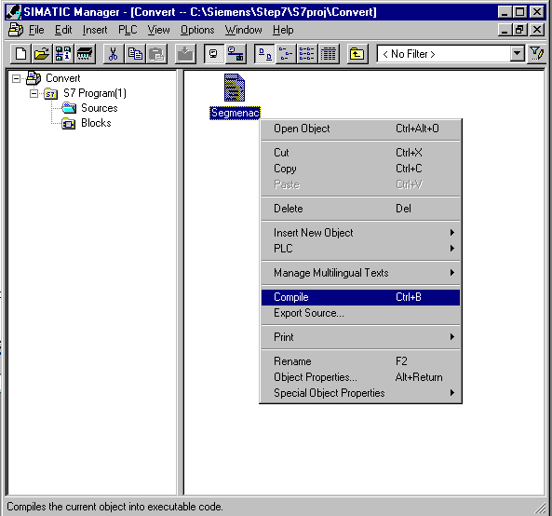

18. The status of the compilation is displayed. With Cancel, the activity can be stopped.

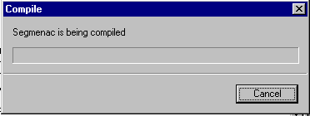

19. After the following compilation, the source file and a compile protocol are included in the warning and error display in the tool LAD/STL/FBD. The notes on the important revision of the complied blocks are given in the source data. This tool can be closed with x (→ x ).

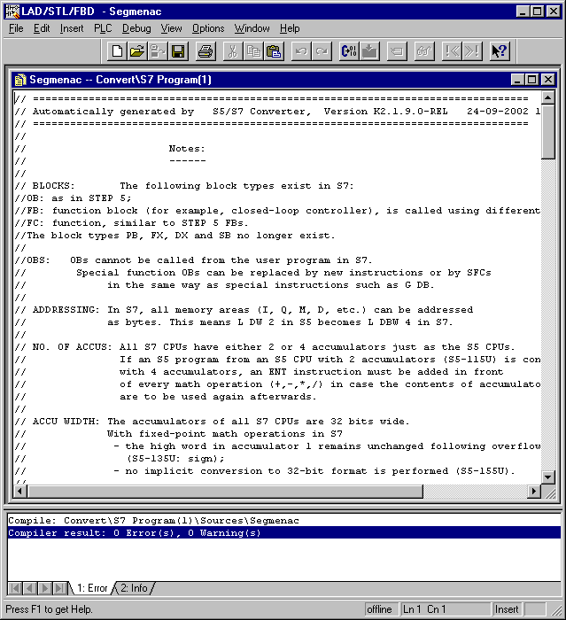

20. If no error is present, the conversion is finished and the generation of the program blocks stand in the data directory Blocks.

4. Rewiring
Because the addressing in S7 is no longer identical to the addressing in S5, all alternative operands (most In-/ and Outputs!) must be rewritten.
This rewiring takes place block wise in the tool LAD, STL, FBD: Program blocks.

The following steps must be followed by the user in order to rename the operands in a block:

1. Open the desired block in ‘SIMATIC Manager‘ with a double clock (→).

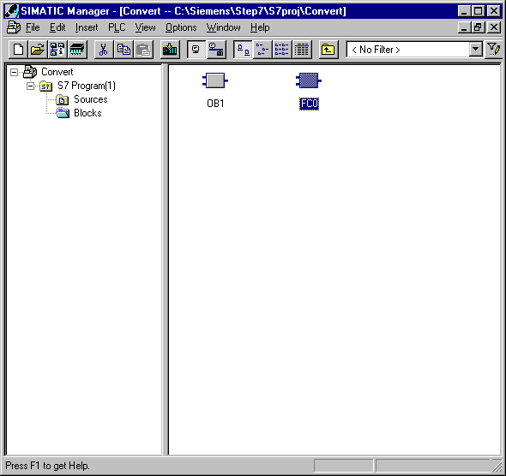

2. In the menu of the tool LAD, STL, FBD: Program blocks, choose the function Find/Replace. (→ Edit → Find/Replace)

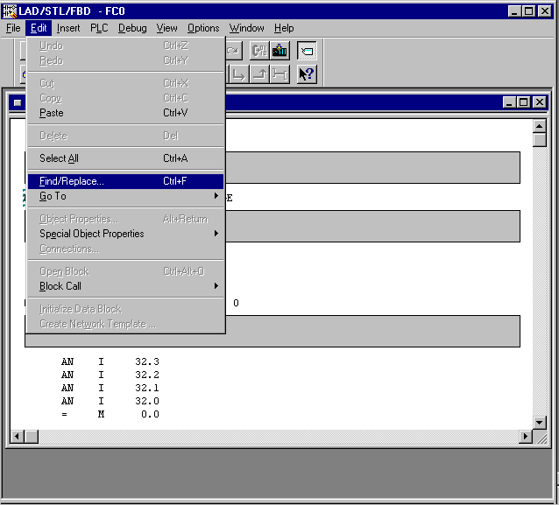

3. The operations of the replaced data should be found with Find what and the new name is entered with Replace with. The search range is actuated with All, so that the whole block is processed. After, click on Replace All ( → Find what → I32. → Replace with → I0. → All → Replace all).

Note: The search function does not only search for operands, but also character strings. Therefore only the first part of the operation needs to be given. It searches for all inputs with the byte address 32.

4. In this case, many operands will be modified. The function Undo is no longer possible, when the warning is confirmed with ‘Yes‘ (→ Yes).

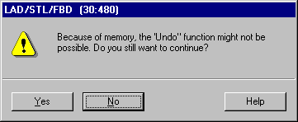

5. At the end of the rewiring, the count of the replaced words is given. Confirm this warning with ‘OK’ (→ OK).

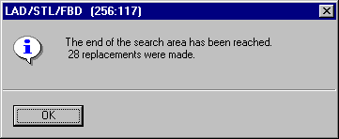

6. The outputs must also be given new byte addresses.The operations of the replaced data should be found with Find what and the new name is entered with Replace with. The search range is actuated with All, so that the whole block is processed. After, click on Replace All ( → Find what → Q32. → Replace with → Q4. → All → Replace all).

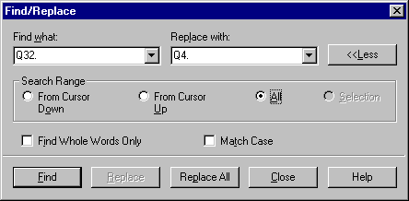

7. In this case, many operands will be modified. The function Undo is no longer possible, when the warning is confirmed with ‘Yes‘ (→ Yes).

8. At the end of the rewiring, the count of the replaced words is given. Confirm this warning with ‘OK’ (→ OK).

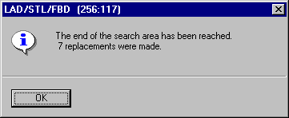

9. The FC0 is now adjusted to the peripherals of the SIMATIC S7-300 and can be saved and downloaded into the PLC ( → → ).

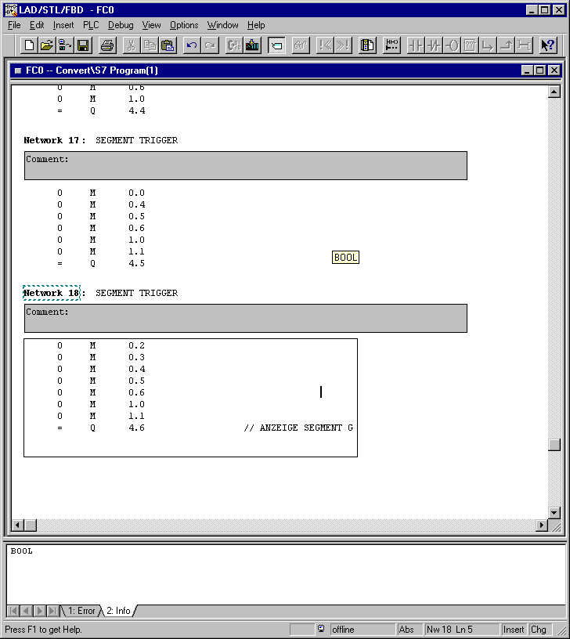

10. For the programming of the FC call, open the OB1 in SIMATIC Manager with a double click (→ SIMATIC Manager → OB1).

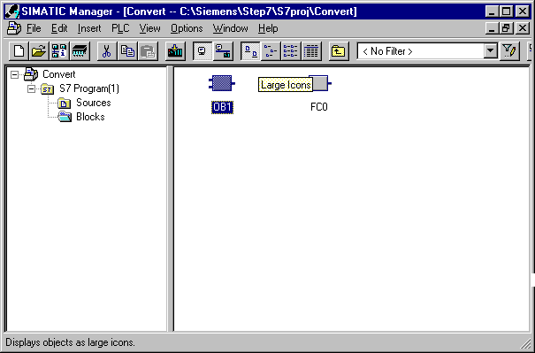

11. The properties of the OB1 are held and accepted with OK ( → OK).

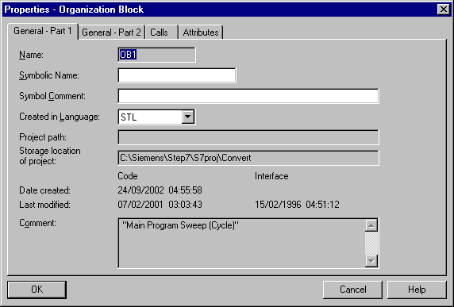

12. Now the call of the FC0 with the instruction CALL FC 0 in Network 1 from the OB1 can be entered. Then the OB1 is saved and downloaded into the PLC ( → CALL FC 0 → → ).

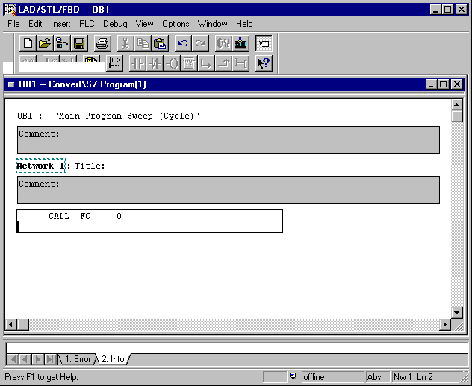

13. Through the switching of the mode switch, the program will start.
In this example, a BCD coded value can be given to the input group with the first 4 switches
(I0.0 / I0.1 / I0.2 / I0.3).
This value can then be connected to a seven segment display that will display the first byte (AB4) of the output module.

