Training document for the company-wide
automation solution
Totally Integrated Automation (T I A)

MODULE B4
Data blocks

This document was provided by Siemens A&D SCE (automation and drive technology, Siemens A&D Cooperates with Education) for training purposes. Siemens does not make any type of guarantee regarding its contents.

The passing on or duplication of this document, including the use and report of its contents, is only permitted within public and training facilities.

Exceptions require written permission by Siemens A&D SCE (Mr. Knust: E-Mail: michael.knust@hvr.siemens.de). Offences are subject to possible payment for damages caused. All rights are reserved for translation and any case of patenting or GM entry.

We thank the company Michael Dziallas Engineering and the instructors of vocational schools as well as further persons for the support with the production of the document.

PAGE:

1. Forward 4

2. Notes for Data Blocks 6

3. Generating Data Blocks 7

The following symbols stand for the specified modules:


Information



Programming


Example exercise


Notes

1. Forward

The module B4 is assigned content wise to Additional functions of STEP 7- Programming.

Basics of

STEP 7- Programming
2 - 3 days A modules

Additional functions of
STEP 7- Programming
2- 3 days B Modules

Industrial field bus
systems
2- 3 days D modules
Process
visualization
2- 3 days F modules
Sequencer
programming
2- 3 days C modules C

IT- Communication
with SIMATIC S7
1- 2 days E modules

Learning goal:

In this module, the reader should learn how a data block can be used to save data.

• Generating data blocks
• Specifying a structure of a data block
• Access to a data element in a STEP 7- Program

Requirements:

For the successful use of this module, the following knowledge is assumed:

• Knowledge in the use of Windows 95/98/2000/ME/NT4.0
• Basics of PLC- Programming with STEP 7 (e.g. Module A3 - ‘Startup’
PLC programming with STEP 7)
• Basics to structured programming (e.g. Appendix I - Basics to PLC –Programming with SIMATIC S7-300)

Required hardware and software

1 PC, Operating system Windows 95/98/2000/ME/NT4.0 with
- Minimal: 133MHz and 64MB RAM, approx. 65 MB free hard disk space
- Optimal: 500MHz and 128MB RAM, approx. 65 MB free hard disk space
2 Software STEP 7 V 5.x
3 MPI- Interface for the PC (e.g. PC- Adapter)
4 PLC SIMATIC S7-300 with at least one digital in- and output module. The inputs must be lead through a functional unit.
Example configuration:
- Power supply: PS 307 2A
- CPU: CPU 314
- Digital input: DI 16x DC24V
- Digital output: DO 16x DC24V / 0.5 A

1 PC
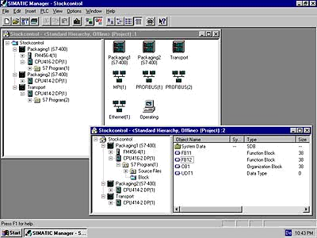
2 STEP 7

3 PC Adapter

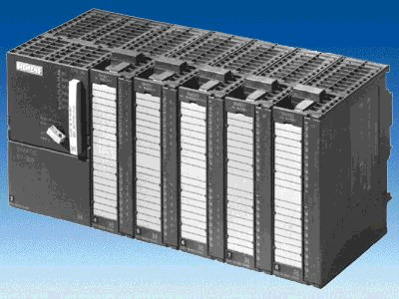
4 SIMATIC S7-300

2. Notes for data blocks
Data Blocks (DBs) can be used by your program to save data in the CPU. Your hard disk contains up to 8 KBytes ( 8192 Bytes ) space.
There are two types of data blocks. Global DBs, where all OBs, FBs and FCs read all saved data or can even write in the DB and local instance DBs, which are assigned a particular FB.
In the DBs, different data types (e.g. BOOL or WORD ) can be saved in arbitrary order.
This structuring of a DB follows through input in a table with the tool
LAD, STL,FBD - S7 Block Programming .

In the program structure from STEP 7, data blocks are found as follows:

3. Generating data blocks
Data blocks are generated and opened like program blocks in the tool LAD,STL,FBD: Program blocks. They serve e.g. for the saving of data and system states.

In the following text, the generation of a simple example is described by the use of a global data block:

Thereby values should be chosen with the switches 'S0' to 'S7' and displayed on an output module ‘Display‘. Thereby one has more switches by activation, where the representation of the value to switch S7 has the highest priority and the representation of the value to switch S1 has the lowest.

The example relates to the displayed addresses below:

Inputs:
- Switch S0 = I 0.0
- Switch S1 = I 0.1
- Switch S2 = I 0.2
- Switch S3 = I 0.3
- Switch S4 = I 0.4
- Switch S5 = I 0.5
- Switch S6 = I 0.6
- Switch S7 = I 0.7

Outputs:
- Display = QW4

In order to generate this program example, the following steps must be followed (Thereby the program is dispensed with the creation of the hardware configuration):

1. Call SIMATIC Manager with a double click ( → SIMATIC Manager)
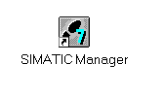
2. Create a new project ( → File → New)

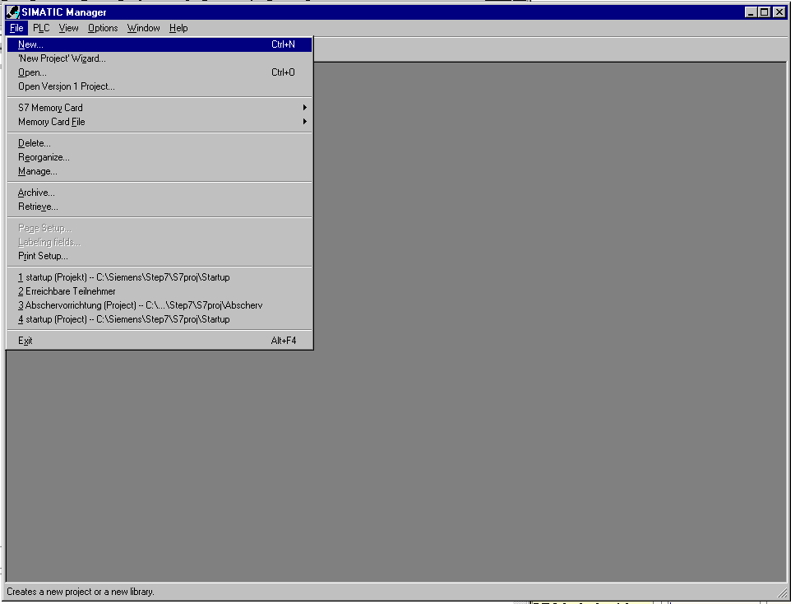

- In the name path, create the project with the name Testproject_DB.
(→ ’Testproject_DB’ → OK)

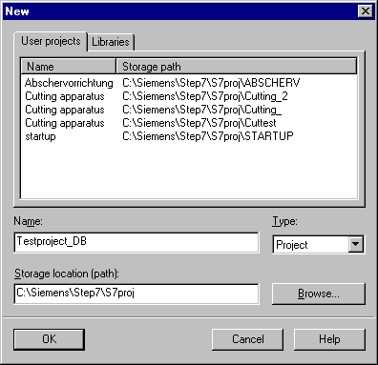

4. Insert a new S7-Program ( → Insert → Program → S7-Program).

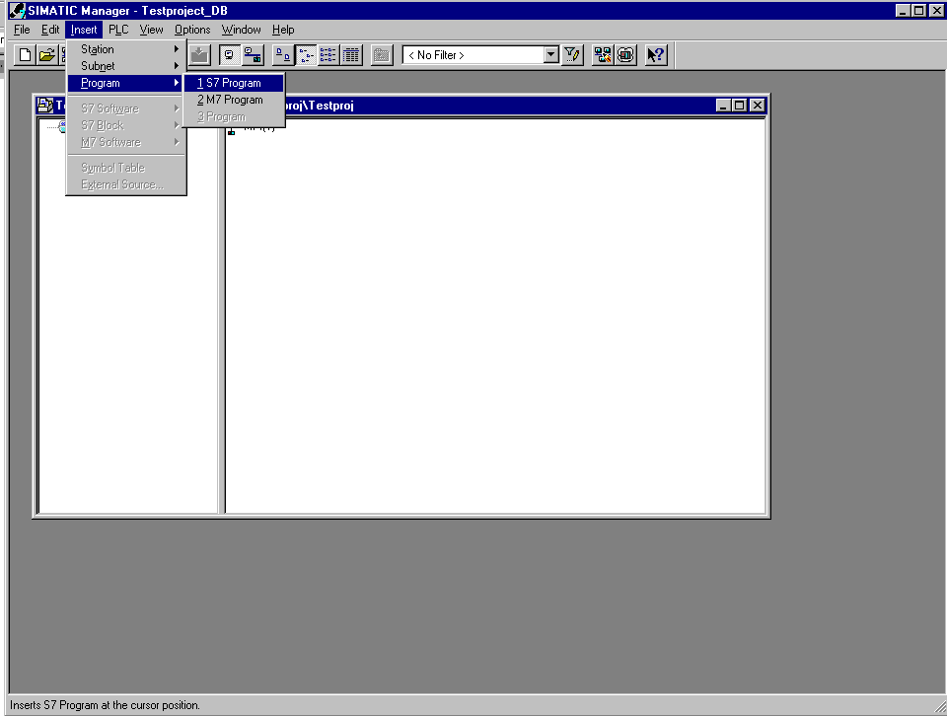

5. Highlight the folder Blocks. (→ Blocks)

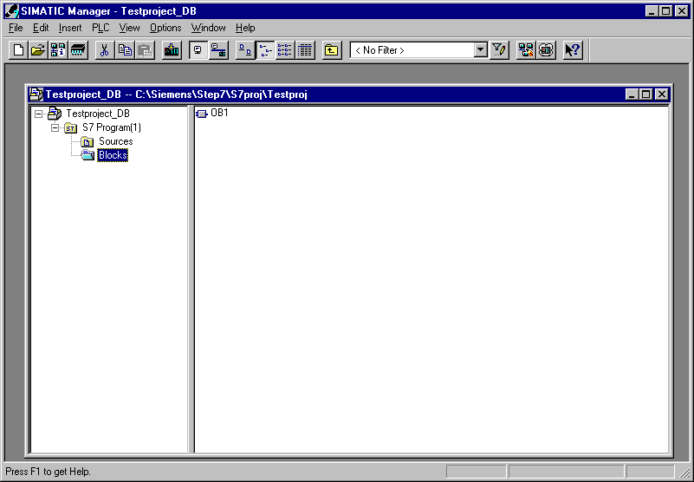

6. Insert Data Block ( → Insert → S7 Block → Data Block).

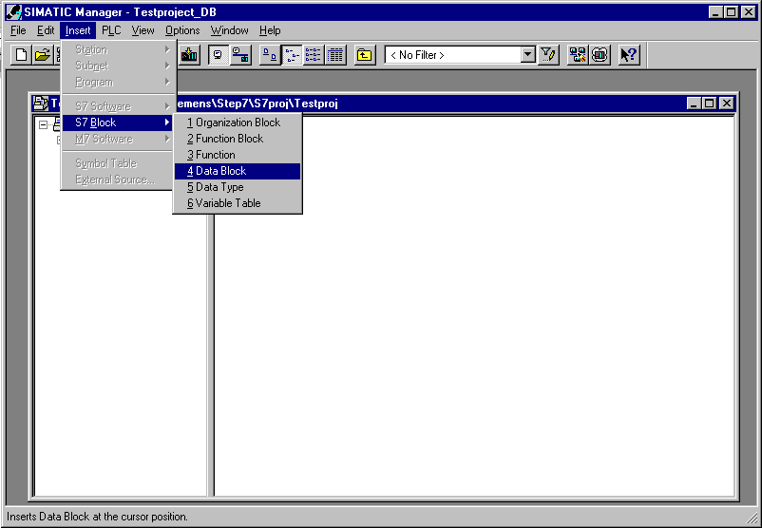

7. Enter the number DB10 for the data block and accept with OK (→ DB10 → OK).

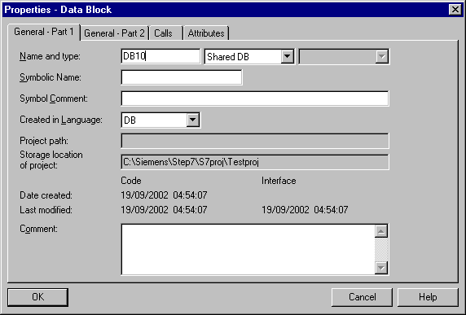

8. Open the data block DB10 with a double click(→ DB10).

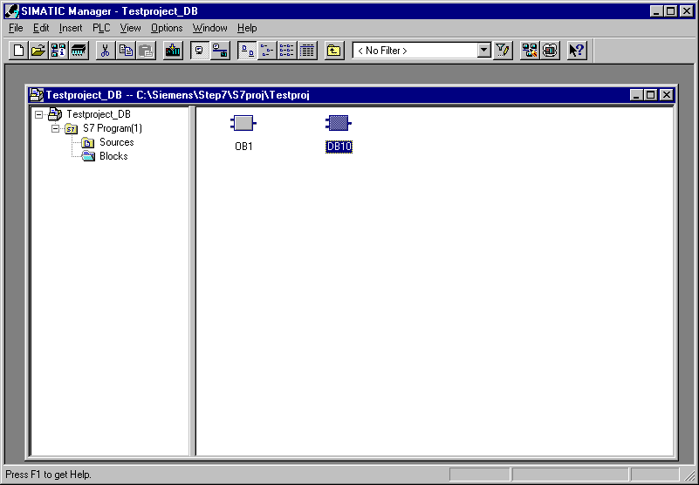

9. Acknowledge the type of data block. ( → Data Block → OK )

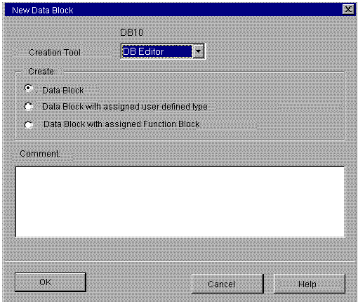
Note: Data blocks with an assigned FB are automatically displayed by the call of your associated FB. It makes no sense to create this alone. Data blocks with assigned user defined data types (UDT) are data blocks, whose structure was already assigned in this UDT.

10. The Data Block is generated with a symbol Name. The Type, an Initial value as well as a Comment (optional) are entered.
The address is automatically generated and cannot be altered.
The data block can be saved and downloaded into the PLC . The mode switch on the PLC must be on STOP! (→ Name→ Type → Initial value → Comment → → )

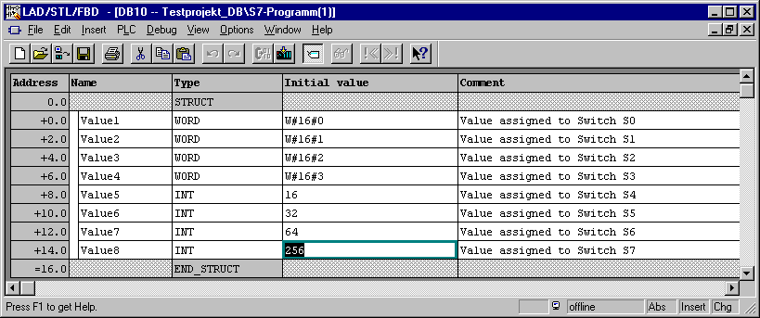

Symbolic name which is referenced to the absolute address.
Comment for
documentation
( optional ).
Initial value , to which the data type must be compatible ( optional ).
Desired data type (see below) for your data element.

The absolute address is created from STEP 7, when the DB is compiled or saved.
The address format is BYTE, BIT.
Over this address, the data elements can also be accessed. (e.g. over download- and compile operations or in logical operations.).

Note: If the data block is assigned as a local instance DB to a FB, the declarations table of the FB declares the structure of the DB.

Data in a data block must be determined through data types.
The following standard- data types are defined in the S7 below :

Type and  description | Size  in Bits | Format-Options | Range and number notation  (lowest to highest values) | Example
BOOL (Bit) | 1 | Boolean text | TRUE/FALSE | TRUE
BYTE (Byte) | 8 | Hexadecimal number | B#16#0 to B#16#FF | B#16#10
WORD (Word) | 16 | Binary number | 2#0 to 2#1111_1111_1111_1111 | 2#0001_0000_0000_0000
 |  | Hexadecimal number | W#16#0 to W#16#FFFF | W#16#1000
 |  | BCD | C#0 to C#999 | C#998
 |  | Decimal number unsigned | B#(0,0) to B#(255,255) | B#(10,20)
DWORD (Double word) | 32 | Binary number | 2#0 to 2#1111_1111_1111_1111_1111_1111_1111_1111 | 2#1000_0001_0001_1000_1011_1011_0111_1111
 |  | Hexadecimal number | DW#16#0000_0000 to DW#16#FFFF_FFFF | DW#16#00A2_1234
 |  | Decimal number unsigned | B#(0,0,0,0) to B#(255,255,255,255) | B#(1,14,100,120)
INT (Integer) | 16 | Decimal number signed | -32768 to 32767 | 1
DINT (Int,32 bit) | 32 | Decimal number signed | L#-2147483648 to L#2147483647 | L#1
REAL (Floating-point number) | 32 | IEEE floating-point number | Upper limit: +/-3.402823e+38  Lower limit: +/-1.175495e-38 | 1.234567e+13
S5TIME  (Simatic-Time) | 16 | S7-Time in steps of 10 ms | S5T#0H_0M_0S_10MS to S5T#2H_46M_30S_0MS and  S5T#0H_0M_0S_0MS | S5T#0H_1M_0S_0MS  S5TIME#1H_1M_0S_0MS
TIME  (IEC-Date) | 32 | IEC-Time in steps from 1ms, integer signed | -T#24D_20H_31M_23S_648MS to  T#24D_20H_31M_23S_647MS | T#0D_1H_1M_0S_0MS  TIME#0D_1H_1M_0S_0MS
DATE  (IEC-Date) | 16 | IEC-Date in steps of 1 day | D#1990-1-1 to D#2168-12-31 | DATE#1994-3-15
TIME_OF_DAY (Time) | 32 | Time in steps of 1ms | TOD#0:0:0.0 to TOD#23:59:59.999 | TIME_OF_DAY#1:10:3.3
CHAR (Character) | 8 | ASCII-Characters | ´A´, ´B´ etc. | ´B´

11. Values should be modified in a data block. It is not adequate to modify them in the field Initial value . This is only possible, when one switches to the Data View under View ( → View → Data View).

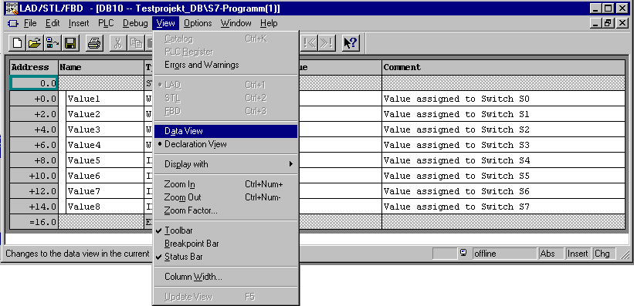

12. Now a new value can be entered in the field Actual value and saved onto the hard drive with as well as downloaded into the CPU with ( → Actual value → → ).

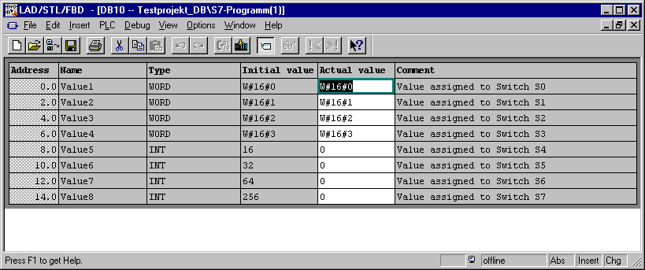

13. In order to generate the program with the accessible data elements, the OB1 must be opened through a double click in SIMATIC Manager ( → SIMATIC Manager → OB1).

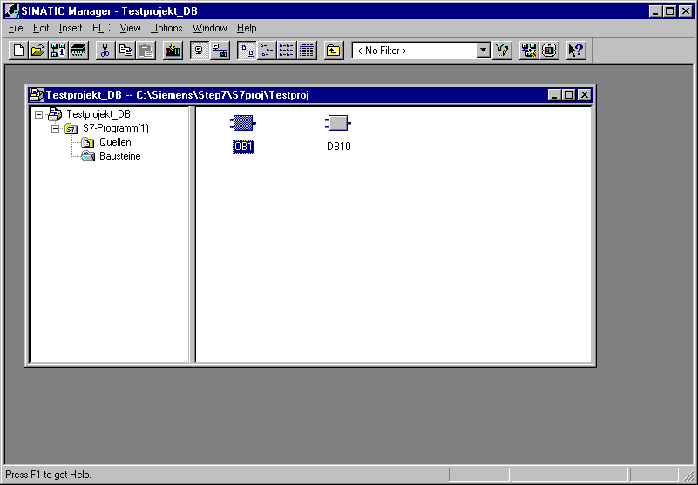

14. Then accept the setting with OK (→ OK ).

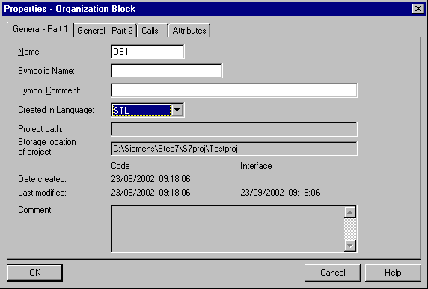

There are three possibilities to access the data:

- Direct address access:

One can access one data element in a data block with the following instructions:

Example:
L DB 20. DBB2 Load data byte 2 from DB20 into ACCU 1
L DB 22. DBW4 Load data word 4 from DB22 into ACCU 1
A DB 2. DBX5.6 Carry out an AND- logical operation with data bit 5.6 from DB2.

- Access to the data elements in the already opened data blocks:

In order to be able to access a data element over several data elements, the DB must first be opened with the instructions OPN DB or OPN DI. Then several data bits (DBX/DIX),data bytes (DBB/DIB), data words (DBW/DIW) or data double words (DBD/DID) can be processed in digital or binary operations.
In doing so, one especially uses OPN DI for the opening of instance DBs. It can also be used for global DBs, when 2 DBs remain open at the same time.

Example:
OPN DB 20 Opening of DB20
OPN DI 22 Opening of DB22
L DBW 0 Download data word 0 from DB20 into AKKU 1
T MW 1 Transfer the contents from ACCU 1 to memory bit 1
A DIX 0.0 AND- Operation from data bit 0.0 to DB22 with
A I 1.0 input bit 1.0
= Q 4.0 Assignment of the result to output bit 4.0

- Access to data out of local instance DBs by call with the function block:

Data can be transferred by the call of the corresponding instance data block with the instruction CALL FB1, DB19. The assignment of the variables that would be defined in the declarations table of the FB and whose value stands in the DB, take place directly in the absolute address (e.g. IW0, M 10.0 or QW4) with the CALL instruction.

Example:
CALL FB1, DB19
COUNT:= IW 0 The variable COUNT is assigned to IW 0 as an absolute address.
OUT:= Q 4.0 The variable OUT is assigned to Q4.0 as an absolute address.

Note: The format of the variables and the assigned absolute address must be equal.

15. With LAD, STL, FBD: Program blocks, you now have an editor that give you the possibility to generate your STEP 7-Program.
The schema for the selection of the data element through the button is shown for the first three inputs as specified below.
If the organization block OB1 is not generated for all switches S0 to S7, it should be saved and downloaded into the PLC . The mode switch of the CPU must be on STOP! ( → → )

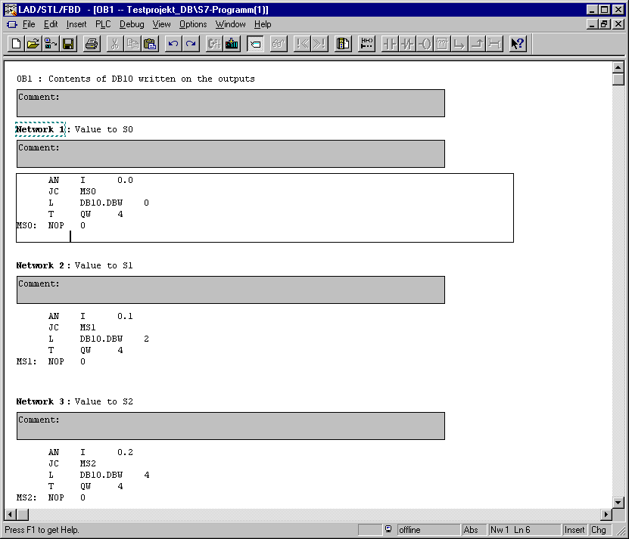

16. Through the switching of the key switch to RUN, the program is started.
If only one of buttons S0 to S7 is activated through inching, the display of the value in the data block that is assigned takes place on the output module with the address QW4.

