Training Document for Comprehensive Automation Solutions
Totally Integrated Automation (T I A)

MODULE B3
Control Engineering with STEP 7

This document has been written by Siemens AG for training purposes for the project entitled "Siemens Automation Cooperates with Education (SCE)".
Siemens AG accepts no responsibility for the correctness of the contents.

Transmission, use or reproduction of this document is only permitted within public training and educational facilities. Exceptions require the prior written approval by Siemens AG (Mr. Michael Knust michael.knust@siemens.com).

Offenders will be liable for damages. All rights, including the right to translate the document, are reserved, particularly if a patent is granted or utility model is registered.

We would like to thank the following: Michael Dziallas Engineering, the teachers at vocational schools, and all others who helped to prepare this document.

Table of Contents
PAGE

1. Preface 5
2. Fundamentals of Control Engineering 7
2.2 Components of a Control Loop 8
2.3. Characteristics 11
2.4 Step Function for Examining Controlled Systems 12
2.5. Self-Regulating Processes 13
2.5.1. Proportional Controlled System without Time Delay 13
2.5.2. Proportional Controlled System with a Time Delay 14
2.5.3 Proportional Controlled System with Two Time Delays 15
2.6 Controlled Systems without Inherent Regulation 17
2.7 Types of Controllers 18
2.7.1 Two Position Controllers 18
2.7.2 Three Position Controllers 20
2.7.3 Basic Types of Continuous Controllers 21
2.8 Objectives for Controller Adjustment 27
2.9 Digital Controllers 29
3. Discontinuous Action Controller as Two Position Controller 31
3.1 Function and Problem Description 31
3.2 Possible Solution for the PLC Program: 34
4. Controller Block (S)FB41 "CONT_C" as Software PID Controller in STEP 7 37
4.1 Task Definition for PID Standard Controller 37
4.2 (S) FB 41 “CONT_C“ 39
4.3 Exercise Example 40
5. Setting Controlled Systems 54
5.1 General 54
5.2 Setting the PI-Controller according to Ziegler-Nichols 55
5.3 Setting the PID Controller according to Chien, Hrones and Reswick 55
5.4 Exercise Example 57
6. Appendix 60

The following symbols provide a guide through this B3 module:


Information


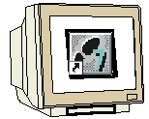
Programming


Exercise Example


Notes

1. prefACE
In terms of its contents, Module B3 is part of the teaching unit entitled "Additional Functions of STEP 7 Programming'.

Basics of
STEP 7 Programming
2 to 3 days Module A
Industrial
Field Bus Systems
2 to 3 days Module D
Additional Functions of
STEP 7 Programming
2 to 3 days Module B
Process Visualization
2 to 3 days Module F
Programming Languages
2 to 3 days Module C
IT Communication
with SIMATIC S7
2 to 3 days Module E
Plant Simulation with
SIMIT SCE
1 to 2 days Module G
Frequency Converter at SIMATIC S7
2 to 3 days Module H

Learning Objective:
In module B3, the reader learns the following: how a PID controller is integrated into a STEP7 program, how it is wired to analog process variables, and how it is started. The following steps are discussed:
• Program example for a two position controller
• Calling a PID controller in a STEP 7 program
• Wiring the PID controller to analog process variables
• Setting the controller parameters at the PID controller

Prerequisites:
To successfully work through Module B3, the following knowledge is assumed:
• Knowledge in handling Windows
• Fundamentals of PLC programming with STEP 7 (for example, Module A3 – 'Startup’
PLC Programming with STEP 7)
• Analog Value Processing with STEP 7 (for example, Module B2 – Analog Value Processing)

Hardware and software required

1 PC, operating system Windows 2000 Professional starting with SP4/XP Professional starting with SP1/Server 2003 with 600MHz and 512RAM, free hard disk storage 650 to 900 MB, MS Internet Explorer 6.0
2 Software STEP7 V 5.4
3 MPI interface for the PC (for example, PC adapter USB)
- PLC SIMATIC S7-300 with at least one analog input/output module to which, at one analog value input, a potentiometer or another analog signal transmitter is connected. In addition, an analog value display has to be connected to at least one analog output.
Sample configuration:
- Power supply: PS 307 2A
- CPU: CPU 314C-2DP
5 Controlled System
6 Connection lines for connecting the controlled system to analog inputs and outputs of the PLC

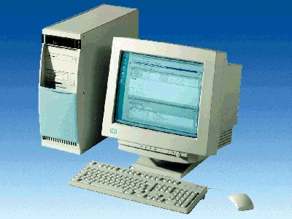
1 PC
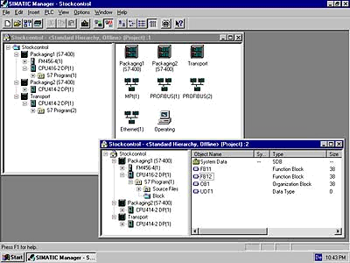
2 STEP 7

3 PC Adapter USB

5 Controlled System
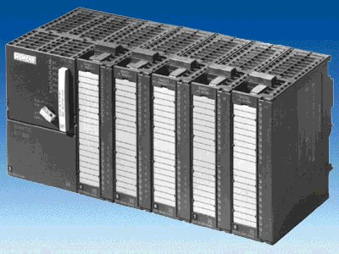
4 S7-300 with
CPU 314C-2DP

6 Connection Lines

2. fUNDAMENTALS of control Engineering

2.1 Tasks of Control Engineering

"Closed loop control is a process where the value of a variable is established and maintained continuously through intervention based on measurements of this variable. This creates a sequence that takes place in a controlled loop -the closed loop- because the process is executed based on measurements of a variable that is in turn influenced by itself.“
The variable to be controlled is measured continuously and compared with another specified variable of the same kind. Depending on the result of this comparison, the control process adjusts the variable to be controlled to the specified variable.
Diagram of a Control System

Comparing
Element
Controllg. Element
Actuator

Final Ctrl. Elem. + System
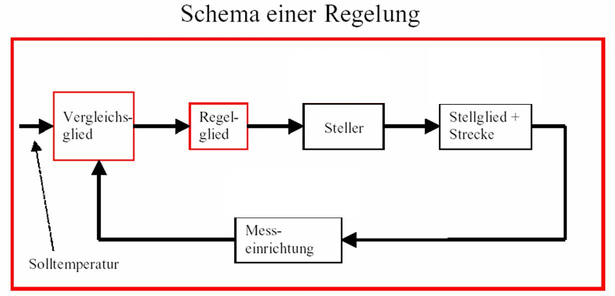
Setpoint Temperature
Measuring
Device

2.2 Components of a Control Loop

Below, the basic terminology of control engineering is explained in detail.
First, an overview shown in the diagram below:
Controller
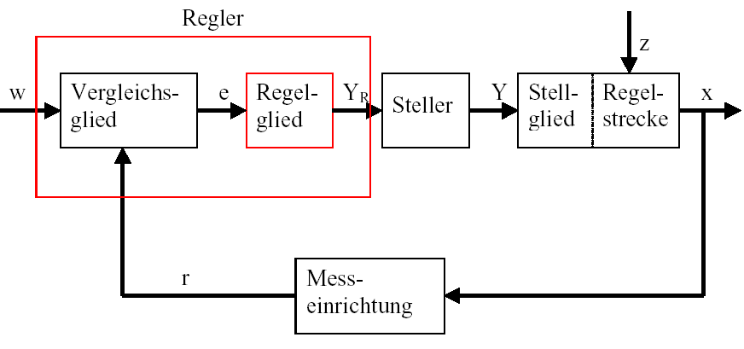

Comparing
Element
Controlling
Element

Actuator
Final Control Element
Controlled
System

Measuring Device

1. The Controlled Variable x
It is the actual “objective“ of the control process: the variable that is to be influenced or kept constant is the purpose of the entire system. In our example, that would be the room temperature. The momentary value of the controlled variable existing at a certain time is called "actual value“ at that point in time.

2. The Feedback Variable r
In a control loop, the controlled variable is constantly checked in order to be able to respond to unintended changes. The measured variable proportional to the controlled variable is called feedback variable. In the example "furnace“, it would correspond to the measured circuit voltage of the inside thermometer.

4. The Disturbance Variable z
The disturbance variable is the variable that unintentionally influences the controlled variable, and moves it from the current setpoint value. A fixed setpoint control is necessary, for example, because a disturbance variable exists. For the heating system considered here, this would be the outside temperature, for example, or any other variable that changes the room temperature from its ideal value.
5. The Setpoint Value w
The setpoint value at a point in time is the value that the controlling variable should ideally have at that time. It should be noted that the setpoint value can change continuously under certain circumstances if there is a slave value control. The measured value that the measuring device used would establish if the controlled variable would have exactly the setpoint value is the instantaneous value of the reference variable. In the example, the setpoint value would be the room temperature desired at that time.
6. The Comparing Element
This is the point where the current measured value of the controlled variable and the instantaneous value of the reference variable are compared. In most cases, both variables are measured circuit voltages. The difference of both variables is the “control deviation“ e. It is passed on to the controlling element, and evaluated there (see below).
7. The Controlling Element
The controlling element is the actual center piece of a control system. It evaluates the system deviation -that is, the information about whether, how and to what extent the controlled variable deviates from the current setpoint- as input information, and derives from this the
“Controller output variable“ Y_{R} which, ultimately, influences the controlled variable. The controller output variable would be, in the example of the heating system, the voltage for the mixer motor.
The manner in which the controlling element determines the controller output variable from the system deviation is the main criterion of the control system. Part II discusses this topic in greater detail.

8. The Actuator
The actuator is the “executing organ“, so to speak, of the control system. In the form of the controller output variable, the controlling element provides the actuator with information as to how the controlled variable is to be influenced, and implements it into a change of the “manipulated variable“. In our example, the actuator would be the mixer motor. Depending on the voltage supplied by the controlling element (that is, the controller output variable), it influences the position of the mixer (which here represents the manipulated variable).
9. The Controlling Element
This is the element of the control loop that influences the controlled variable (more or less directly), depending on the manipulated variable Y. In the example, this would be the combination consisting of the mixer, the furnace lines, and the heater. The mixer motor (actuator) sets the mixer (the manipulated variable). By means of the water temperature, the room temperature is influenced.
10. The Controlled System
The controlled system is the plant where the variable to be controlled is located; in the example of the radiator, the living space.
11. Dead Time
Dead time refers to the time that passes, starting with a change of the controller output variable until a measurable reaction by the controlled system. In our example, it would be the time between a change of the voltage for the mixer motor, and the measurable change in room temperature caused by this.

2.3. Characteristics

Controlled systems in which a new constant output value sets itself after a certain time has passed are called 'self-regulating process’.
The relationship of the output variables to the input variables in the steady state results in a characteristic.

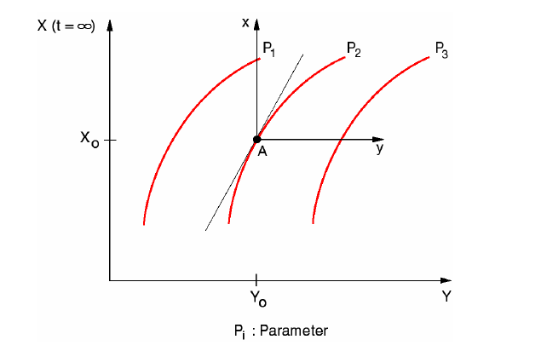

Parameter

In the environment of an operating point, the characteristic is replaced with a tangent. In the environment of an operating point, the problem is treated as a linear problem.
The zero point of the variables x(t), y(t) and z(t) refers to the operating point A:
:
x = X – Xo y = Y - Yo z = Z - Zo

2.4 Step Function for Examining Controlled Systems

To examine the behavior of controlled systems, controllers and control loops, a uniform function is used for the input signal: the step function. Depending on whether a control loop element or the entire control loop is examined, the step function can be assigned to the following: the controlled variable x(t), the manipulated variable y(t), the reference variable w(t) or the disturbance variable z(t). For that reason, the input signal, the step function, is often designated as xe(t), and the output signal as xa(t).

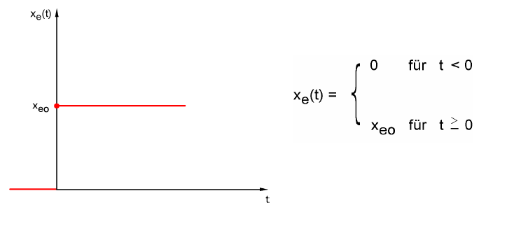

for

for

2.5. Self-Regulating Processes

2.5.1. Proportional Controlled System without Time Delay

The controlled system is called P-system for short.

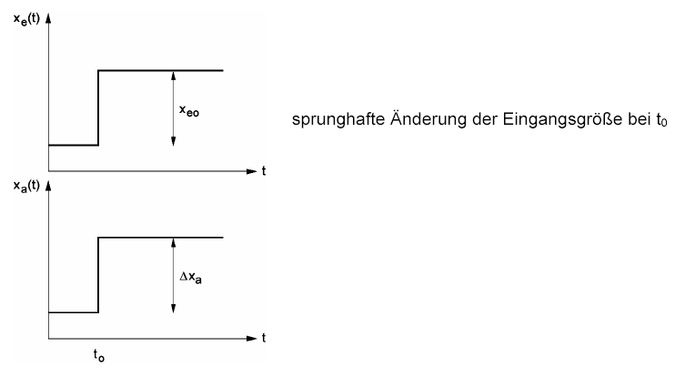

Abrupt change of the input variable for for

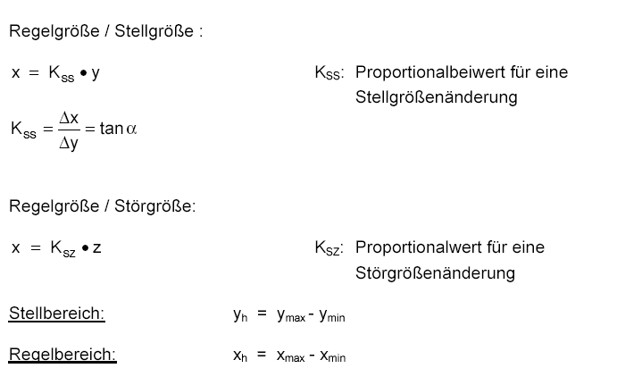
Controlled Variable/ Manipulated Variable

Proportional coefficient for a manipulated variable change

Controlled Variable/ Disturbance Variable

Proportional value for a disturbance variable change

Range:

Control Range:

2.5.2. Proportional Controlled System with a Time Delay

The controlled system is called P-T1 system for short.
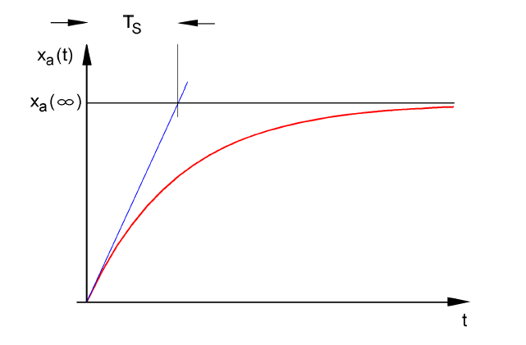

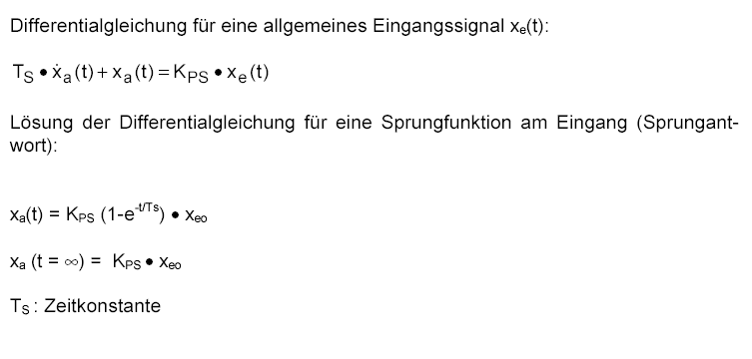
Differential equation for a general input signal

Solution of the differential equation for a step function at the input (step response)

Time constant

2.5.3 Proportional Controlled System with Two Time Delays

The controlled system is called P-T2 system for short.

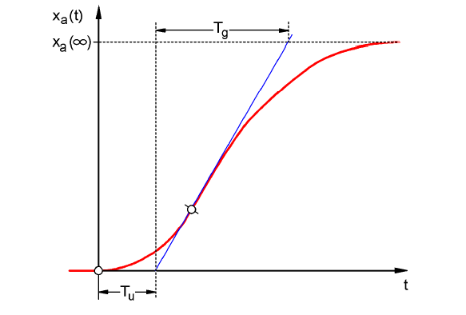

Figure: Jump Response of the P-T2 system

Tu: Delay time Tg: Transition time

The system consists of the reaction-free series connection of two P-T1 systems that have the time constants TS1 and TS2.

Controllability of P-Tn systems:
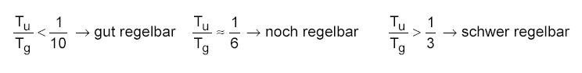
Easy to control
Can still be controlled
Difficult to control

With the rising ratio Tu/Tg, controlling the system becomes more and more difficult.

2.5.4 Proportional Controlled System with n Time Delays

The controlled system is called P-Tn system for short.
The time response is described with a differential equation of the nth degree.
The characteristic of the step response is similar to that of the P-T2 system. The time response is described through Tu and Tg.
Substitute: The controlled system with many delays can be approximately substituted with the series connection of a P-T1 system with a dead time system.
The following applies: Tt » Tu and TS » Tg.

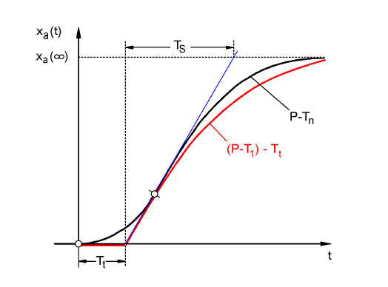

Substitute step response for the P-Tn system

2.6 Controlled Systems without Inherent Regulation

The controlled variable continues to grow after a fault, without aiming for the high range value.
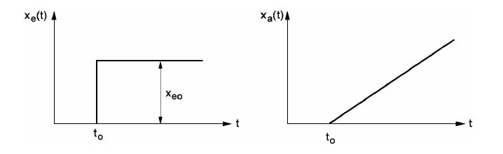

Example: Level Control
In the case of a container with a drain whose inflow volume stream and outflow volume stream are the same, a constant level is the result. If the flow rate of the inflow or the outflow changes, the liquid level rises or falls. The larger the difference between inflow and outflow, the faster does the level change.
The example shows that in practice, the integral action usually has limits. The controlled variable rises or fills up only so long until it has reached a limit that is contingent on the system: the container overflows or empties, the pressure reaches the plant maximum or minimum, etc..
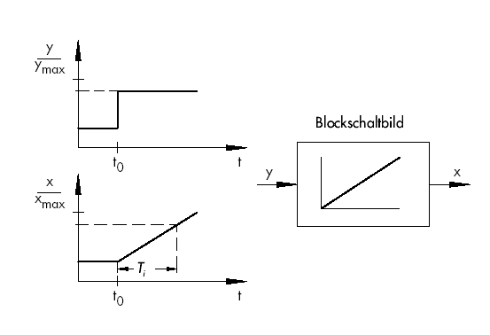
The figure shows the trend of an I-system when there is an abrupt change of the input variable, as well as the block diagram derived from it.

Block Diagram

If the step function at the input changes into any function xe(t), the following happens:
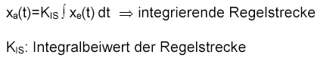
integrating controlled system

integral coefficient of the controlled system

2.7 Types of Controllers

2.7.1 Two Position Controllers

The essential feature of two position controllers consists of their knowing only two modes: “On“ and “Off“ -which makes them the simplest type of controller. Two-position controllers are used primarily
when adhering to a setpoint exactly is less important than to keep the control system as simple as possible; or, when the actuator or the final control element does not allow for a continuous control system. The heating system mentioned several times above is -with a control loop having a room thermometer and a mixer- a continuous control system. To keep the water temperature in the boiler loop constant, typically a two position controller is used since it can, on the one hand, fluctuate by a few degrees, and on the other hand it is clearly simpler to switch the burner on and off than to do an exact dosing of fuel to be added.

Since theoretically -to adhere to the setpoint exactly- it would be necessary to switch a system on and off infinitely fast, the two position controller has a so-called “hysteresis“. It represents a kind of “environment“ around the setpoint within which the actual value may fluctuate. That means, we specify a minimum value that is lower than the setpoint, and a maximum value that is a little higher than the setpoint. Only if the actual value exceeds the maximum value or drops below the minimum value does the control system react. In most cases, the minimum and the maximum value are distanced from the setpoint equally; that is, the hysteresis generates a symmetrical environment around the set point.
In the case of the boiler water temperature, the burner would be switched on, for example, when the water temperature drops below the specified setpoint by more than a certain value. The burner continues to run until a certain value that is above the setpoint is exceeded. Only then will the burner be switched off. Another typical example is cooling. Usually, a cooler also does not support a continuous control system, but only knows the states “On“ and “Off“. It is switched on when the actual temperature exceeds the setpoint temperature by a few degrees, and is switched off when the actual temperature is a few degrees too low.
It is therefore typical for the two position controller to periodically fluctuate around the setpoint whose amplitude is roughly that of the hysteresis. The selection of the hysteresis depends on how exactly the setpoint has to be adhered to. If we select a large hysteresis, the actual value can deviate more considerably from the setpoint. If we select a smaller one, the setpoint is adhered to more exactly, but the system would have to switch more frequently. This again has its disadvantages, such as a higher wear of the switching devices, and the actuator or the final control element.

The diagram below shows a two position controller:
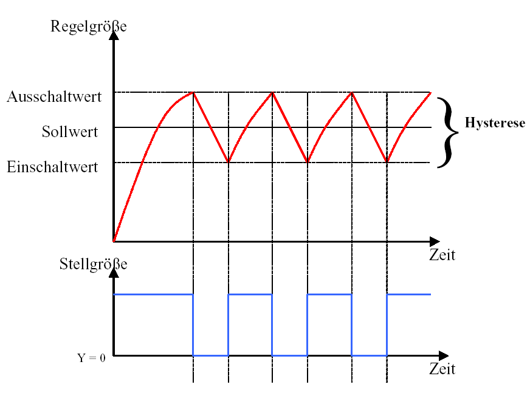
Controlled Variable

Switch-Off Value
Hysteresis
Setpoint

Switch-On Value

Manipulated Variable
Time

Time

2.7.2 Three Position Controllers

The three position controllers represent the second important class of discrete controllers.
The difference regarding the two position controllers consists in the following: The controller output can handle three different values: positive influence, no influence, and negative influence of the controlled variable.
An example is control by means of a valve that can be adjusted electrically but that itself can only be completely open or completely closed. Let’s take, for example, water level control. As soon as the water level exceeds a maximum value, the valve motor is triggered with a positive direction of rotation, and the valve is opened. The control system remains inactive -that is, the motor is idle- until the water level drops below a minimum value. When this is the case, the motor is triggered into the negative direction of rotation, and the valve is closed. Thus the actuator knows three states: rotating valve motor with positive direction of rotation, idle motor, and rotating motor in negative direction of rotation.

2.7.3 Basic Types of Continuous Controllers

The discrete controllers just discussed have, as mentioned before, the advantage of being simple. The controller itself as well as the actuator and the final control element are of a simpler nature and thus less expensive than for continuous controllers. However, discrete controllers have a number of disadvantages. If high loads, such as large electrical motors or cooling systems have to be operated, high peak loads can occur that can overload the power supply. For these reasons, we often don’t switch between “Off“ and “On“, but between a full load and a base load -with a clearly lower use of the actuator or final control element. But even with these improvements, a continuous controller is not suitable for many applications. Imagine a car engine whose speed is governed discretely. There would be nothing between idle and full throttle. Aside from it probably being impossible to transfer the power during a sudden full throttle suitably over the tires onto the road, such a car would probably be quite unsuitable for street traffic. For such applications, continuous controllers are used for that reason. Here, the mathematical relationship that the controlling element establishes between system deviation and controller output variable is theoretically virtually limitless. In practice, however, we differentiate among three classical basic types that are discussed in greater detail below.

2.7.3.1 Proportional Controllers (P-Controller)

In the case of a P-controller, the controller output y is always proportional to the recorded system deviation (y ~ e). The result is that a P-controller responds to a system deviation without a delay, and generates a controller output only if there is a deviation e.
The proportional pressure regulator sketched in the figure below compares the force FS of the setpoint spring with the force FB that pressure p2 generates on the spring-elastic metal bellows. If the force is not in balance, the lever rotates around the pivot point D. The valve position
ñ changes, and accordingly the pressure p2 to be controlled until a new power balance is established. The figure shows the behavior of the P-controller as a sudden system deviation occurs. The amplitude of the controller output step y depends on the extent of the system deviation e, and the amount of the proportional coefficient Kp: To keep the system deviation low, a proportional factor has to be selected that is as large as possible. Increasing the factor accelerates the reaction of the controller; however, a value that is too high may cause overshoot, and a considerable oscillatory tendency of the controller.
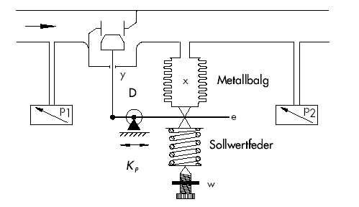

Metal Bellows

Setpoint Spring

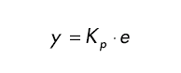

The figure below shows the performance of the P-controller:

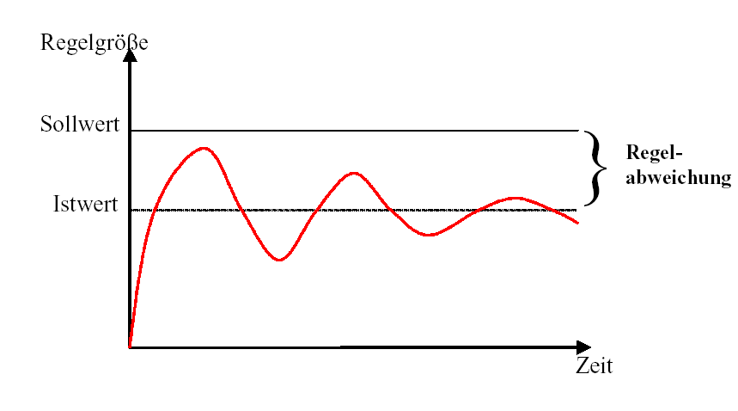
Controlled Variable

Setpoint
System Deviation
Actual Value

Time

The advantages of this controller type are, on the one hand, its simplicity (the electronic implementation can, in the simplest case, consist of merely a resistor); on the other hand, in its prompt reaction in comparison to other controller types. The main disadvantage of a P-controller is its lasting system deviation. The setpoint is never completely reached, even over long periods of time. This disadvantage as well as a reaction speed that is not yet ideal can be minimized only insufficiently by using a larger proportional factor, since otherwise, the controller will overshoot; that is, it will overreact so to speak. In the worst case, the controller oscillates continuously, whereby the controlled variable is moved by the controller itself away from the setpoint -instead of by the disturbance variable.
The problem of continuous system deviation is best solved by the integral action controller.

2.7.3.2 Integral Action Controllers (I- Controller)

Integrating controllers are used to completely correct system deviations at every operating point. As long as the system deviation is not equal to zero, the amount of the controller output changes. Only when the reference variable and the controlled variable are equal -at the latest however, when the controller output reaches its system-dependent limit (Umax, Pmax etc.)- is the controller in a steady state.
The mathematical formula for this integral action is:
The controller output is proportional to the time integral of the system deviation:
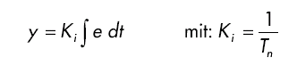
with

How fast the controller output rises (or falls), depends on the system deviation and the integration time.
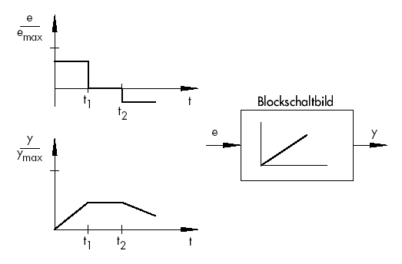

Block Diagram

2.7.3.3 PI Controllers

In practice, the PI controller is a controller type that is used very often. It consists of the parallel connection of a P-controller and an I-controller. When laid out correctly, it combines the advantages of both controller types (stable and fast, no lasting system deviation), so that their disadvantages are compensated for at the same time.

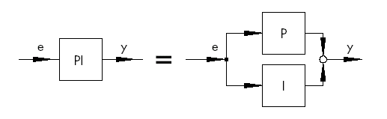

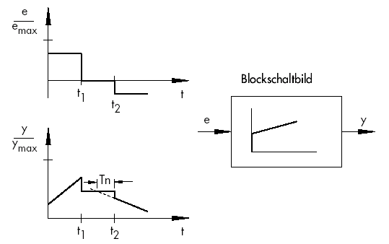

Block Diagram

The trend is indicated with the proportional coefficient Kp and the reset time Tn. Based on the proportional component, the controller output responds immediately to each system deviation e, while the integral component has an effect only in the course of time. Tn represents the time that passes until the I-component generates the same margin of the manipulated variable as it is generated immediately because of the P-component (Kp). As for the I-controller, the reset time Tn has to be reduced if you want to increase the integral component.
Controller Layout:
Depending on the Kp and Tn dimensioning, the overshoot of the controlled variable can be reduced at the expense of control system dynamics.
Applications for the PI controller: fast control loops that don’t permit lasting system deviations.
Examples: pressure, temperature, ratio control.

2.7.3.4 Derivative Action Controllers (D-Controller)

The D-controller generates its controller output from the rate of change of the system deviation, and not -like the P-controller- from its amplitude. For that reason, it still responds considerably faster than the P-controller. Even if the system deviation is small, it generates -in anticipation, as it were- large margins of the manipulated variable as soon as the amplitude changes. On the other hand, the D-controller does not know a lasting system deviation; because, regardless of how large it is, its rate of change equals zero. In practice, the D-controller is used rarely by itself for that reason. Rather, it is used together with other control elements, usually in connection with a proportional component.

2.7.3.5 PID Controllers

If we expand a PI controller with a D-component, we enhance the universal PID controller. As in the case of the PD controller, adding the D-component has the effect that, if laid out correctly, the controlled variable reaches its setpoint sooner and enters the steady state faster.
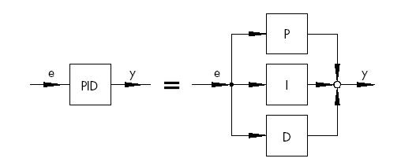

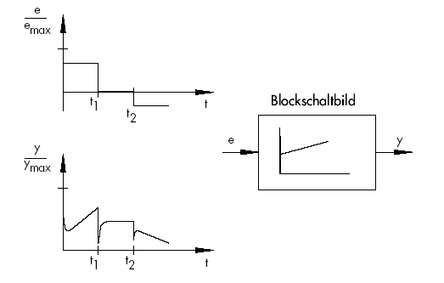

Block Diagram

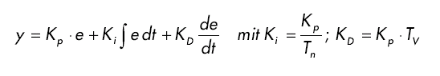
with

2.8 Objectives for Controller Adjustment

For a satisfactory control result, selecting a suitable controller is an important aspect. However, even more important is the setting of the suitable controller parameters Kp, Tn and Tv that have to be adjusted to the controlled system behavior. Usually, a compromise has to be made between a very stable but also slow controller, or a very dynamic, more unstable controlled system performance, which, under certain circumstances, tends to oscillate and can become unstable.
In the case of non-linear systems that are always to work at the same operational point -for example, fixed setpoint control- the controller parameters have to be adjusted to the controlled system behavior at this working point. If, as in the case of cascaded controls ñ, no fixed working point can be defined, a controller adjustment has to be found which provides a sufficiently fast and stable control result over the entire work area.
In practice, controllers are usually set based on empirical values. If none are available, the controlled system behavior has to be analyzed exactly, in order to subsequently specify suitable controller parameters, with the aid of different theoretical or practical layout procedures.

One possibility of a definition is the oscillation test according to the
Ziegler-Nichols method. It offers a simple layout suitable for many cases. However, this setting procedure can only be used for controlled systems that permit getting the controlled variable to oscillate autonomously. The following has to be done:

- Set Kp and Tv at the controller to the lowest value, and Tn to the highest value (the lowest possible controller effect).
- Take the controlled system manually to the desired operating point (start the controller).
- Set the manipulated variable of the controller manually to the specified value, and switch to the automatic mode.
- Increase Kp (decrease Xp) until harmonic oscillations can be recognized in the controlled variable. If possible, the control loop should be stimulated to oscillate during the Kp setting by using small, abrupt setpoint changes.

- Note down the Kp value that has been set as the critical proportional coefficient.
- Specify the duration of a complete oscillation as Tkrit, perhaps with a stop watch by generating the arithmetical mean over several oscillations.
- Multiply the values of Kp,krit and Tkrit with the multipliers according to the table, and thus set the determined values for Kp, Tn and Tv at the controller.

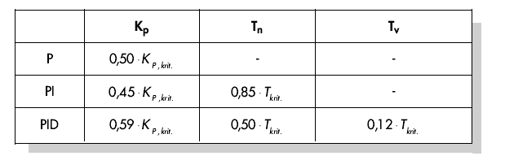

0.50

0.45
0.85

0.59
0.50
0.12

2.9 Digital Controllers

So far, mainly analog controllers were discussed; that is, such controllers that derive the controller output variable -also in an analog way- from the existing system deviation that exists as analog value. We are already familiar with the diagram of such a control loop:
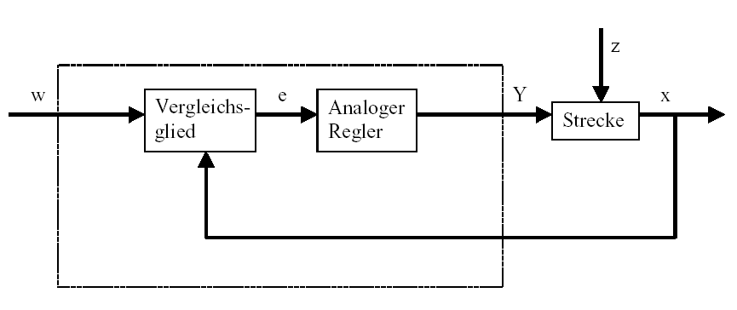

Comparing Element
Analog Controller
System

Often, however, it has its advantages to evaluate the system deviation digitally. On the one hand, the relationship between system deviation and controller output variable has to be specified much more flexibly if it is defined through an algorithm or a formula with which a computer can be programmed respectively, as when it has to be implemented with an analog circuit. On the other hand, a clearly higher integration of circuits is possible in digital engineering, so that several controllers can be accommodated in the smallest space. And finally, by dividing the computing time it is even possible -if the computing capacity is sufficiently large- to use a single computer as controlling elements of several control loops.
To make digital processing of the variables possible, the reference variable as well as the feedback variable have to first be converted in an analog-digital converter (ADC) into digital variables. These are then subtracted from each other by a digital comparing element, and the difference is transferred to the digital controlling element. Its controller output variable is then converted again in a digital-analog converter (DAC) into an analog variable. The unit consisting of converters, comparing element, and controlling element appears to the outside like an analog controller.

The diagram below shows the layout of a digital controller:
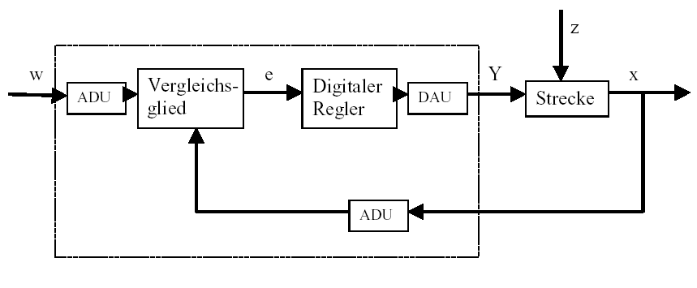

Comparing Element
Digital Controller
DAC

System

ADC

However, the digital conversion of the controller has not only advantages; this conversion also entails various problems. For that reason, some variables have to be selected sufficiently large in reference to the digital controller so that the accuracy of the control does not suffer too much on account of digitalization. Quality criteria for digital computers are:
- The quantization resolution of the digital-analog converters.
It indicates how fine the continuous value range is digitally rasterized. The resolution has to be selected of a size that no resolutions important to the controller are lost. .
- The scanning frequency of the analog-digital converters.
This is the frequency with which the analog values pending at the converter are measured and digitalized. This has to be high enough that the controller can still respond in time if the controlled variable suddenly changes.
- The cycle time
In clock cycles, every digital computer processes differently than the analog computer. The speed of the computer used has to be high enough that during a clock cycle (during which the output value is calculated, and no input value is scanned), the controlled variable can not change significantly.
The quality of the digital controller has to be high enough so that toward the outside, it responds comparably prompt and precise, like an analog controller does.

3. Discontinuous action controller as two position controller

3.1 Function and Problem Description

A process value (for example, the level) is to be kept as constant as possible with a discontinuous action controller.
The output voltage at a digital output of the PLC generates the manipulated variable y which can be set either to "ON" (voltage =24V) or "OFF" (voltage =0V).
The process value represents the controlled variable x, which is suitably recorded with a measuring sensor (PEW XY).
It is the controller’s task to keep the controlled variable X constant at a specified setpoint, whereby the influence of disturbance variables z that can not be anticipated is to be eliminated. The PLC S7-300 is used for this task as discontinuous action controller. The S7-300 is to solve the control problem by reading out a binary manipulated variable y depending on the respective setpoint/actual comparison w-x.
To prevent valve V1 from constantly being switched on and off when the controlled variable x has reached the setpoint w, a switching hysteresis is installed for discontinuous action controllers. Because of the switching hysteresis, the controlled variable x oscillates between a high response value Xo and a low response value Xu. The difference between the high response value Xo and the low response value Xu is called differential Xs = Xo - Xu.
Xs is often specified depending on the amount of setpoint w.
For example, 10% of setpoint w: Xs = w/10.

In this program, a two position controller can be switched on with the button “Start“ to fill a tank. With the button “Stop“, the controller can be switched off. The tank is filled by means of a pump that can be triggered digitally. The setpoint is specified via a potentiometer at the analog input "AI_Fill_Setpoint“.

In a subroutine, the analog value for the process variable Level is to be entered, and normalized to the physical variable "Liter“. The normalized value is made available as floating point number in MD20.
For a level of 10 liters, the level sensor returns 0V, for 100 liters 10V.
The analog value for the setpoint is also to be entered here, and made available as floating point number in MD24.

If the controller is switched on, the lamp "Display_ON“ is to light up.

Below, the structogram for the program of the step controller is provided.

Structogram
A structogram shows the rough structure of a program plan. The structogram below shows the possible structure of a program for a two position controller.
First, a scan is made whether the controller is switched on.
If it is switched off, only the program is executed in which the outputs and flags are reset.
From the program-engineering view, this is done most simply by means of jump instructions.
If the controller is switched on, the setpoint and actual value are entered, and the calculations for switching hysteresis, differential and the lower operating point are made.
Then, another scan follows: whether the actual value is below the low operating point.
If this is the case, the controller output is switched on, and a jump is made to the end of the program.
If this is not the case, the high operating point is calculated, and a scan is made whether the actual value is above the high operating point.
Then, again a jump is made to the end of the program.

 | Controller switched off?
YES | NO
Outputs  and  Flags | Display: Switch on SH10  Enter actual value x and  setpoint w  Normalize
Clear | Calculation of the switching hysteresis Xs = w/10
or | Calculation of half the differential X1 = Xs/2
Reset | Calculation of the low operating point Xu = w - X1
 | Is the actual value less than the low operating point?
 | YES | NO
 | Pump ON | Calculation of the high operating point Xo = w + X1
 |  | Actual value X larger than Xo?
 |  | YES | NO
 |  | Pump OFF

Assignment List:

Symbol: Address: Comment
Start I 1.3 Button Start
Stop I 1.4 Button Stop

AI_Level_Actual PEW 128 Analog input for the level sensor
AI_Level_Setpoint PEW 130 Analog input for the setpoint selection

AI_Level_Act_Norm MD 20 Normalized value for the level
AI_Level_Setp_Norm MD 24 Normalized value for the level setpoint
M_X1 MD 32 Intermediate flag half the differential
M_Xo MD 36 Intermediate flag high operating point
M_Xs MD 28 Intermediate flag switching hysteresis
M_Xu MD 40 Intermediate flag low operating point
Controller_On M 10.0 Flag controller is switched on

Pump A 0.0 Pump activation binary
Display_ON A 1.0 Indication: system is on

Analog FC1 Subroutine analog value processing
Two Pos.Controller FC2 Subroutine two position controller

Exercise:
Create a project with hardware configuration for a CPU314C-2 DP (refer to Module A05) and change the addresses according to the assignment list shown above.

There, create a program in an FC1 with the following functionality:
- The analog value for the process variable Level is to be entered, and normalized to the physical variable "Liter“. The normalized value is made available in MD20 as a floating point number.

Note: If the level is 10 liters, the level sensor returns 0V, for 100 liters 10V.
- The analog value for the setpoint is to be entered, and made available normalized as floating point number in MD24.
Save FC1.

Then, set up the two position controller in an FC2, based on the structogram provided above.
Call FC1 for inputting the setpoint and the actual value.

Save FC2 and call it in OB1. Save OB1 and load the entire station to the PLC.

3.2 Possible Solution for the PLC Program:

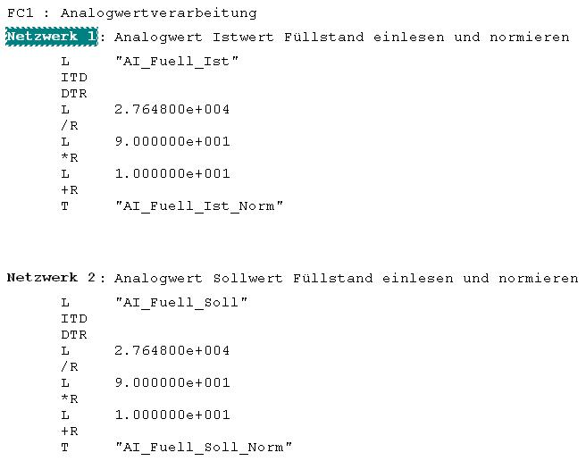
Analog Value Processing
Network 1: Enter and normalize analog value of actual level
"AI_Level_Actual“
"AI_Level_Actual_Norm“
"AI_Level_Setp“
"AI_Level_Setp_Norm“
Network 2: Enter and normalize analog value of setpoint level setpoint Level
****************************************************************************************************************
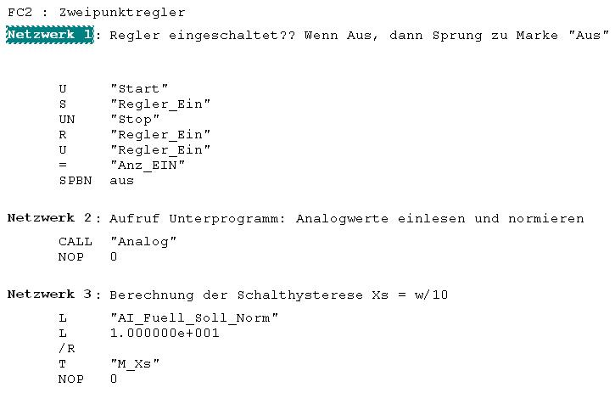
Network 1: Controller switched on?? If off, then jump to label "Off“
Two Position Contoller
"Start“
"Controller_On“
"Stop“
"Controller_On“
"Controller_On“
"Ind_ON“
exit
Network 2: Call subroutine: enter and normalize analog values
Network 3: Calculation of switching hysteresis Xs = w/10
"AI_Fill_Setp_Norm“

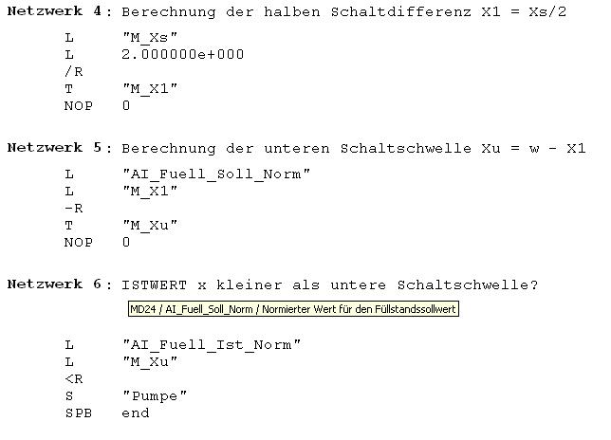
Network 4: Calculation of half differential X1 = Xs/2
Network 5: Calculation of the low operating point Xu = w – X1
Network 6: ACTUAL VALUE x less than low operating point?
D24/AI_Fill_Setp_Norm/Norm.value for level setpoint
Network 7: Calculation of the high operating point Xo = w – X1
"AI_Fill_Setp_Norm“
"AI_Fill_Actual_Norm“
"Pump“
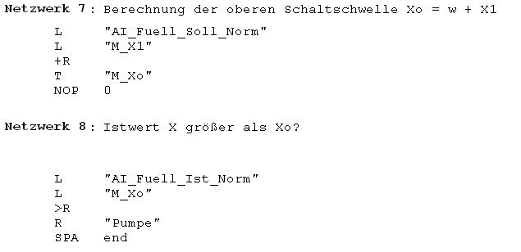
Network 8: Actual value X larger than Xo?
"AI_Fill_Setp_Norm“
"Pump“
"AI_Level_Actual_Norm“

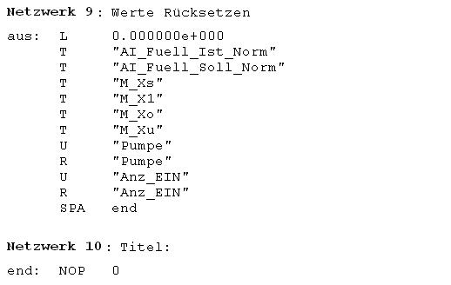
Network 9: Reset values
Network 10: Title
exit:
"AI_Fill_Actual_Norm“
"AI_Fill_Setp_Norm
"Pump“
"Pump“
"Display_ON“
"Display_ON“
****************************************************************************************************************
OB1: Title
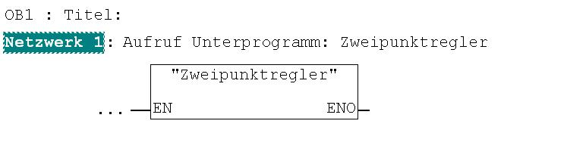
Network 1: Call subroutine: Two position controller
"Two Position Controller“
"Display_ON“

4. controller Block (S)FB41 "CONT_C" as Software PID controller in STEP 7

4.1 Task Definition for PID Standard Controller

In this B3 module, the startup of a PID controller in SIMATIC S7 is demonstrated. The output value of the controlled system is to be kept constant with a continuous controller. Depending on the setting, the controlled system can simulate a P, PT1, or PT2 system. The transfer coefficients Ks and the time constants can also be set. (refer to the description of the controlled system).

Thus, the PLC is the controller, and is connected to the controlled system by means of analog inputs and outputs.
The block (S)FB 41 in the PLC SIMATIC S7-300 is used in this task as a continuous digital software controller. It is to solve the control problem as follows: an analog manipulated variable y is read out depending on the respective setpoint/actual value w-x. The manipulated variable y is generated according to the PID algorithm.
The following control parameters can be specified:

KP: Proportional component (for (S)FB41 Gain)
TN: Integrator time (for (S)FB41 TI)
TV: Derivative time (for (S)FB41 TD)

Assignment List:

Symbol: Address: Comment
AI_w PEW 128 Analog input setpoint generator 0…10V
AI_X PEW 130 Analog input sensor actual value 0…10V

AO_Y PAW 128 Analog output manipulated variable 0 … 10V

M_w MD40 Internal setpoint (floating point number normalized)

Function Diagram of the control system with a PID controller

Controller
Controlled System
Final Control Element
Process
Generation
of
Control Function
System Deviation e = w-x
Controller Output y
Setp./Actual Value
Comparison
Contr. Variable x
Measuring Sensor
Transducer
Setpoint Generator
Setpoint Int

4.2 (S) FB 41 “CONT_C“
(S)FB 41 "CONT_C“ (continuous controller) is used for controlling technical processes with continuous input and output variables on the PLC SIMATIC S7. By means of parameter assignments, you can switch on or switch off subfunctions of the PID controller, and thus adjust it to the controlled system.

Use:

You can use the controller as PID fixed setpoint controller individually, or in multi-loop control systems as cascade controller, blended controller, or ratio controller. The working method is based on the PID algorithm of the sampling controller with analog output signal; if needed, supplemented with a pulse shaper step to generate pulse-width-modulated output signals for two position or three position controller with proportional final control elements.

Description:

In addition to the functions in the setpoint and actual value, the (S)FB implements a complete PID controller with a continuous manipulated variable output and the capability to influence the manipulated value manually.
Depending on the CPU type, it can be used as FB 41 or as SFB 41.

The following subfunctions exist:

- Setpoint branch
- Actual value branch
- System deviation generation
- PID algorithm
- Manual value processing
- Manipulated value processing
- Feedforward control

Operating modes complete restart/restart

The (S)FB 41 (CONT_C) has a complete restart routine that is run if the input parameter is set to COM_RST = TRUE.
At startup, the integrator is set internally to the initialization value I_ITVAL. When called in a time interrupt level, it continues processing starting with this value.
The other outputs are set to their default values.

Error Information

The error signal word RET_VAL is not used.

Starting Up the Software PID Controller (S)FB41 "CONT_C" with STEP 7
A SIMATIC S7-300 is programmed as a PID controller with the software STEP 7. This provides the user with a uniform configuring tool for central as well as distributed configurations. Here, only the most essential aspects can be pointed out. (Additional information is provided in the STEP7 reference manuals.)
The PID controller is parameterized with a special application included in STEP7 -Assigning parameters to a PID Control- by resetting values there in an instance DB associated with the (S)FB 41. This is done as follows:

4.3 Exercise Example

The user has to perform the steps below in order to configure the hardware as well as to generate an S7 program with the functionality of a PID controller, and then load it to a PLC:
1. Call the SIMATIC Manager
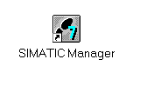
Click on symbol 'SIMATIC Manager’

2. Set up new project ( → File → New)
Click on 'New'

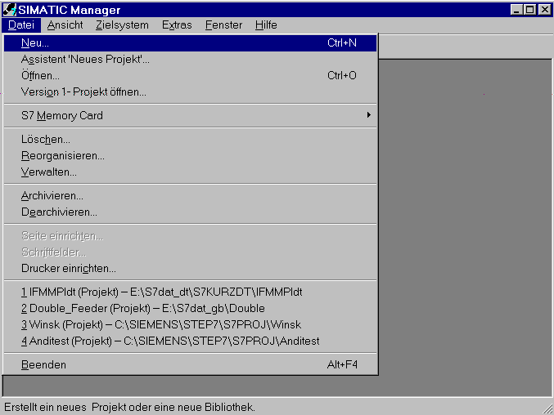

3. Generate a new project, select a path and assign a project name (→ User projects → PID_Control → OK)

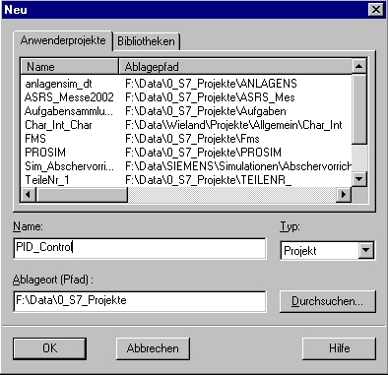
Enter project name
Cick 'OK'
Select storage location (path)
Select 'User Projects’

- Insert the SIMATIC 300 station (→ Insert → Station → SIMATIC 300 Station)

Click on 'SIMATIC 300 Station'

- Highlight 'SIMATIC 300 Station(1)’.

Click on 'SIMATIC 300 Station(1)'

6. Open configuring tool for the hardware configuration (→ Edit → Open object)

Click on 'Open object’

7. Open the hardware catalog.
Here, all racks, modules, and interface modules for configuring your hardware, are provided arranged in the directories: PROFIBUS-DP, SIMATIC 300, SIMATIC 400 and SIMATIC PC Based Control.

Click on the symbol for 'HW catalog’

- Insert mounting channel (→ SIMATIC 300 → RACK-300 → Mounting channel).

Click on 'Mounting channel'

Then a configuration table is displayed automatically for configuring Rack 0.

9. From the hardware catalog, all modules that are plugged inserted in your real rack can now be selected and inserted in the configuration table. To this end, you have to click on the name of the respective module, hold the mouse key and drag the module to a line in the configuration table.

Note: Slot 3 is reserved for interface modules, and remains empty for that reason.

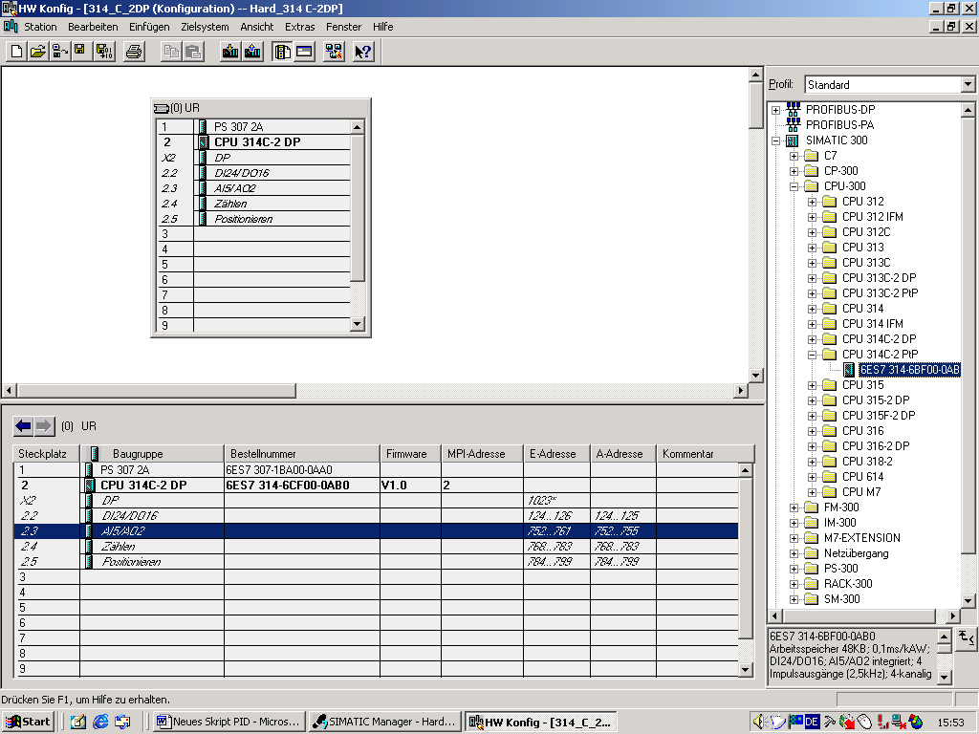

10. Note down the addresses of the IO modules (addresses are assigned automatically and tied to the slot).
For our example, change the addresses to the values PEW 128 and PAW 128.
Save the configuration table and load it to the PLC (key switch on CPU has to be on Stop!)
Click on symbol ‘Load to AS’
Click on symbol ‘Save and convert’

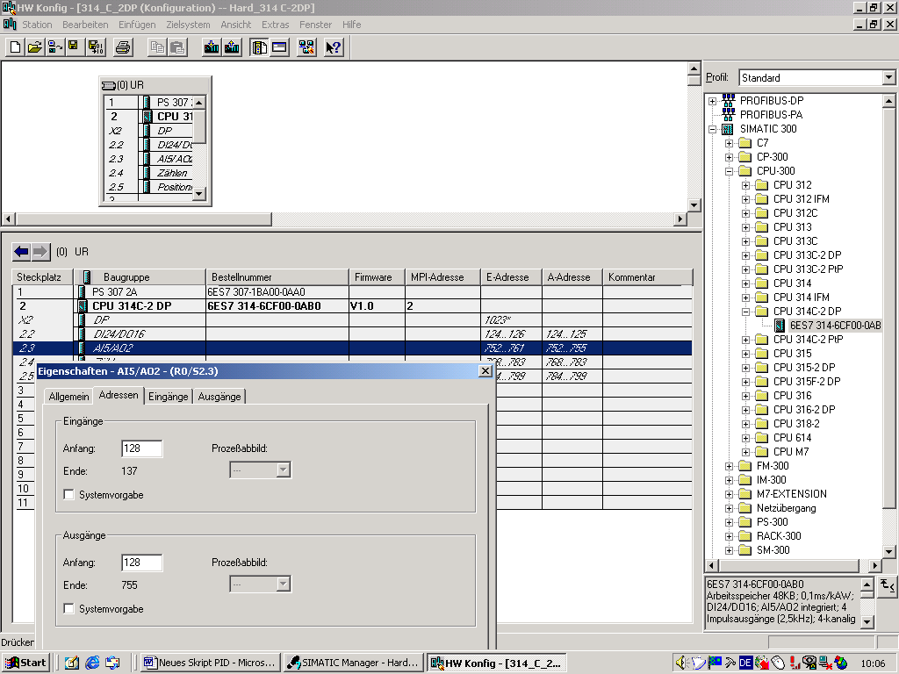

Double click on line "AI5/A02,
then re-write start addresses to PEW/PAW 128

11. Highlight Blocks in SIMATIC Manager

Click on 'Blocks'

- Insert organization block. (→ Insert → S7 Block → Organization block)

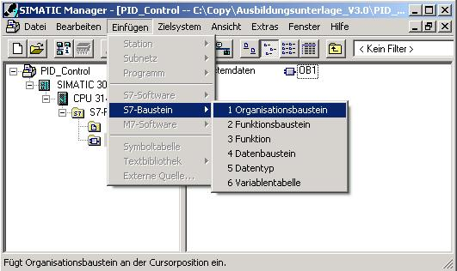
Click on 'Organization block’

- Assign OB35 as name of block.( → OB35 → OK)

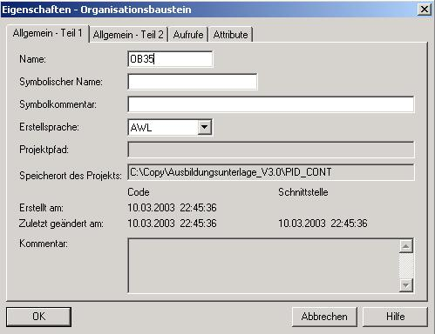

Note: OB35 is a so-called 'Time interrupt OB’ and ensures a
constant cycle for calling the PID controller block SFB41.
This is absolutely necessary so that the controller can be optimized by
setting the controller parameters KP, TN and TV (for (S)FB41 Gain, TI and TD).
A cycle that under certain circumstances would fluctuate -as in the case of OB1- would cause the controlled system to fluctuate, and in the worst case, we would have a controlled variable that would be oscillating in an unstable way.

- In the hardware configuration, at Properties of the CPU, a fixed cycle time can be set for executing OB35.
However, this cycle time should not be selected too short. It has to be ensured that all blocks called from OB35 can be processed within this time, and if OB1 is used at the same time, that there is enough time for it also. (→ Execution)
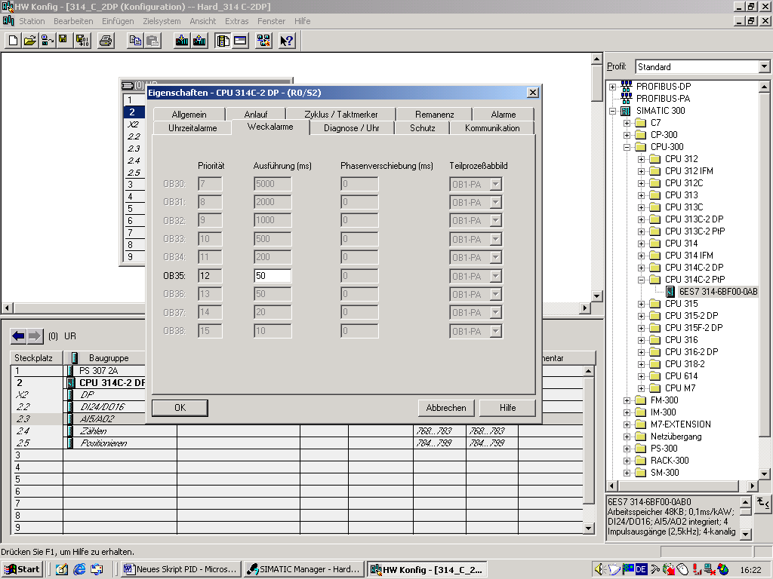

Enter execution time

15. Open ‘OB35’ from SIMATIC Manager (→ OB35)

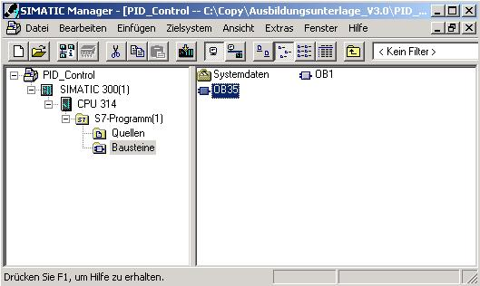
Double click on block 'OB35'

16. With ‘LAD, STL, and FBD – Program S7 Blocks’, you now have an editor that allows you to edit your STEP7 program accordingly. To this end, OB35 has already been opened with the first network.
To generate your first operations, you have to highlight the first network. Now you can write your fist STEP7 program.
In STEP 7, individual programs are usually subdivided into networks. You open a new network by clicking on the network symbol.
Note: Comments on program documentation are separated from the program commands by the character sequence“//“.
Open new network

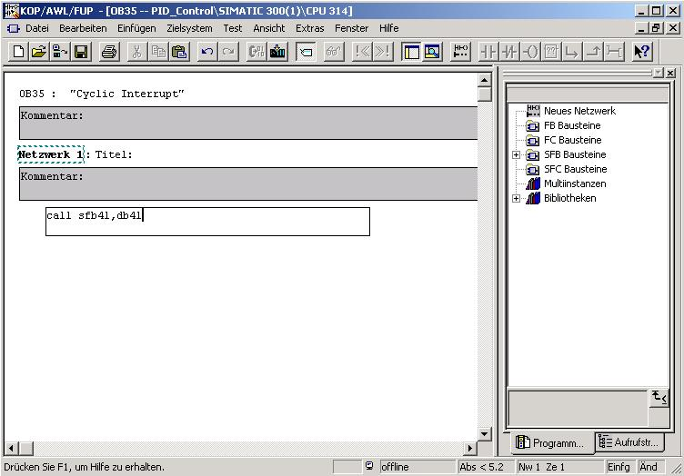
Highlight network and write program

The network Call SFB41,DB41
calls the PID controller block SFB41 together with an instance DB.

Generate instance DB (→ Yes)

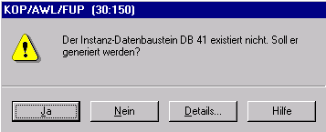

17. The setpoint value, the actual value and the manipulated variable now have to be wired to process values as follows.
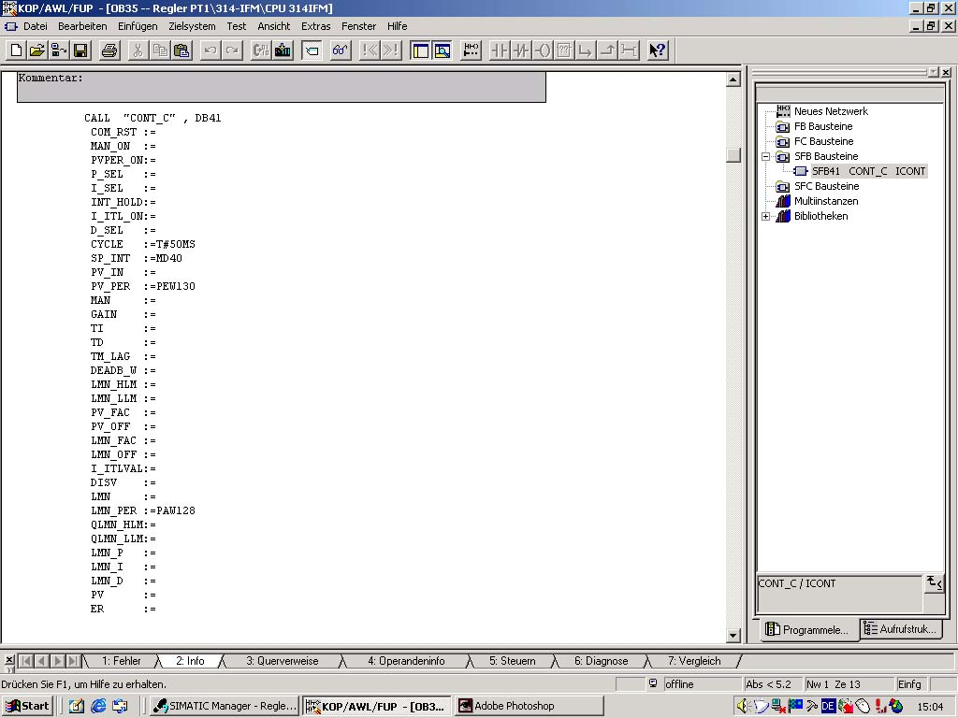

Cycle time:
Time between the block call. Should correspond to the time that is set in OB 35.

SP INT:
Setpoint selection through analog input.
Has to be normalized to a real format (refer to NW 2)

PV PER
Actual value acceptance to analog input channel

LMN PER:
Manipulated variable output at analog output

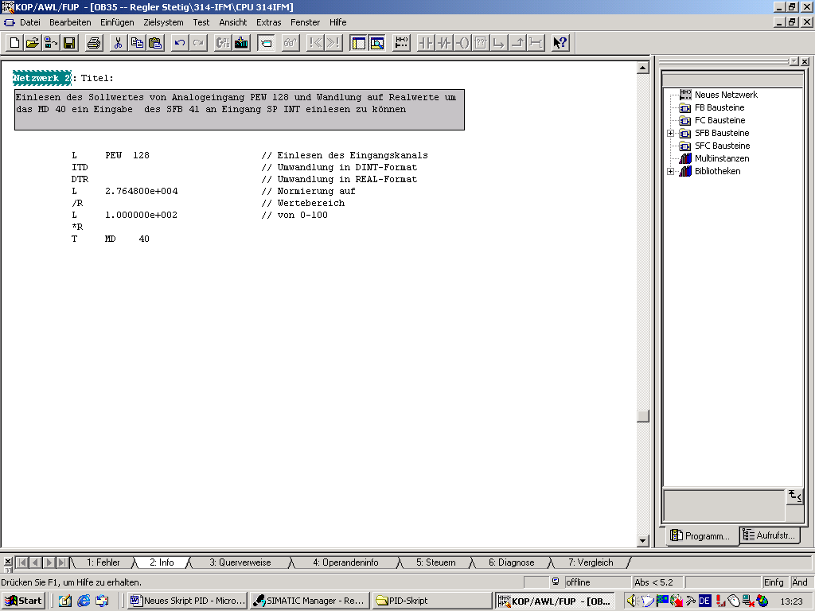

18. Save and load OB35 (CPU’s key switch is on Stop!)

19. In ‘SIMATIC Manager’, highlight block DB41 and load to the PLC. (CPU’s key switch is on Stop!)
Click on symbol ‘Load to PLC’

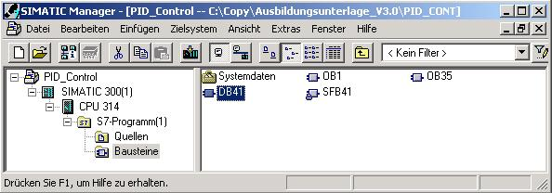
Click on DB41

20. Call the tool Assign parameters to the PID control (→ Start → Simatic → STEP 7 → Parameterize PID Control)

Click on ‘Parameterize PID Control’

21. Open data block ( → File → Open → Online
→ Select data block; for example, DB41 → OK).
Click on ‘Open’ klicken!

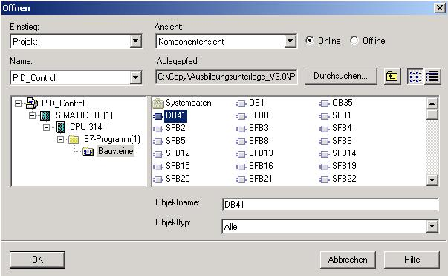
Switch block to the online mode
DB 41 auswählen
Click on ‘OK’

22. The PID controller can now be parameterized with the tool Parameterize PID Control.
Then, the DB is saved (→ Save) and loaded to the PLC (→ Load).
Now, a curve plotter can be started in order to monitor the performance of the controlled system.

Click on ‘Save’
Click on ‘Load’
Start ‘Curve plotter’

23. With the curve plotter, the curves for setpoint, actual value and manipulated variable can be recorded.

24. The program is started by setting the key switch to RUN.

5. Setting Controlled Systems

5.1 General

Below, setting controlled systems is discussed, using a PT2 system as an example.
T_{u}-T_{g} Approximation
The basis for the methods according to Ziegler-Nichols and according to Chien, Hrones and Reswick is the T_{u}-T_{g} approximation. With it, the parameters following parameters transfer coefficient of the system K_{S}, delay T_{u} und transition time T_{g} can be determined from the system step response.
The rules for controller adjustment that are described below were found experimentally, by using analog computer simulations.
P-T_{N} systems can be described with sufficient accuracy with a so-called T_{u}-T_{g} approximation; that means, through approximation by means of a P-T₁-T_{L} system.
Starting point is the system step response with the input step height K. The necessary parameters: transfer coefficient of the system K_{S}, delay T_{u} and transition time T_{g} are ascertained as shown in the figure below.
This requires measuring the transition function up to the stationary upper range value (K*Ks), so that the transfer coefficient for system K_{S,} required for the calculation, can be determined.
The essential advantage of these methods is that the approximation can also be used if the system can not be described analytically.

Turning Point

Figure: T_{u}-T_{g} Approximation

5.2 Setting the PI-Controller according to Ziegler-Nichols

By experimenting with P-T₁-T_{L} systems, Ziegler and Nichols have found the following optimum controller settings for fixed setpoint control:
3.3
0.9
In general, we get disturbance characteristics with these setting values that are quite good. [7]

5.3 Setting the PID Controller according to Chien, Hrones and Reswick

For this method, the response to setpoint characteristics as well as disturbance characteristics was examined, in order to get the most favorable controller parameters. Different values resulted for both cases.

The following settings were the result:
• For disturbance characteristics:
Apriodical transient reaction with the shortest period
20% overshoot
Minimum period of oscillation
2.3
0.7
0.6
• For setpoint characteristic:

Apriodical transient reaction with the shortest period

20% overshoot
Minimum period of oscillation

0.35
0.6

1.2

5.4 Exercise Example

To accommodate the system step response, a few modifications have to be made in OB 35 and DB41. The following steps have to be performed for this:
Save your old project under a new name, and change the wiring of (S)FB 41 as follows:
1. With STEP7, specify the manipulated value directly.
The manipulated value is to be specified in the network below in a way that with a switch
S1 (I 124.0), a selection can be made between two manipulated values.
L 0.000000e+000 //Manipulated value 0% as 32 bit floating point number
UN I 124.0 //Negation of S1 (I 124.0)
SPB M001 //Jump if RLO = 1 to label M001
L 1.000000e+002 //Manip.value 100% as 32 bit floating pt. nbr.
M001: T MD 20 //Transfer the value to flag double word MD 20
Now, for the switch position S1(I 124.0) ON, the manipulated variable y = 100%, and for OFF, the manipulated variable y = 0%. Consequently, a step of the manipulated value from 0 to 100% can be brought about with Switch S1. (For systems that tend to overshoot, the high manipulated value should amount to 90% or less.).
The external analog values and the manipulated value are assigned in OB1 as follows:
MAN := MD 20 //Specify the manipulated value as manual value
PV_PER := PEW 130 //Actual value x
LMN_PER := PAW 128 //Manipulated variable y
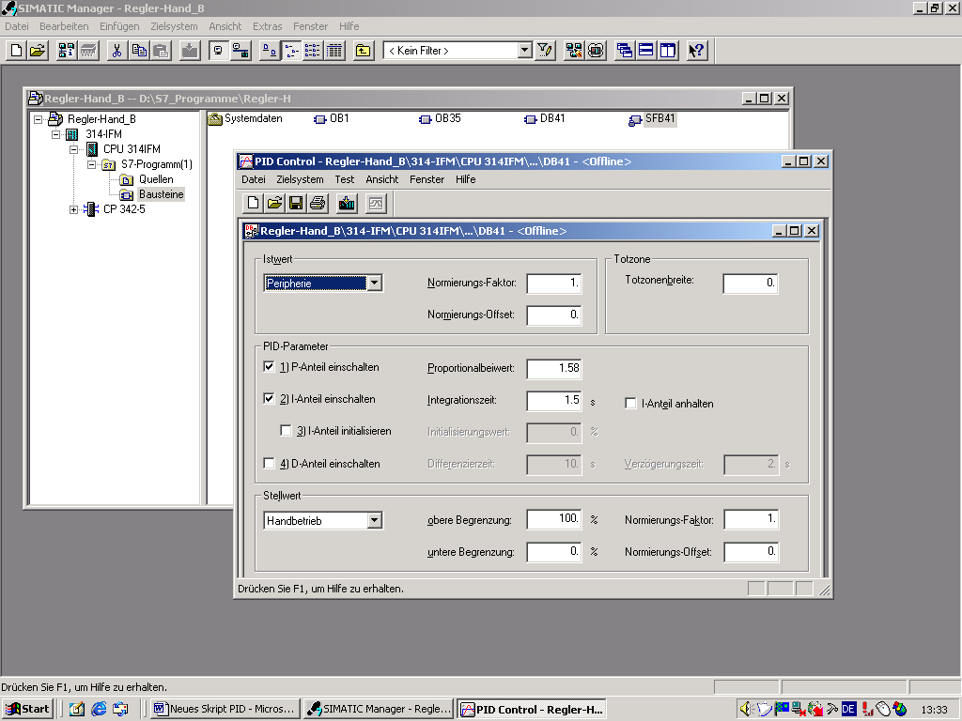

Switch manipulated value to manual mode

Solution of the PLC program:
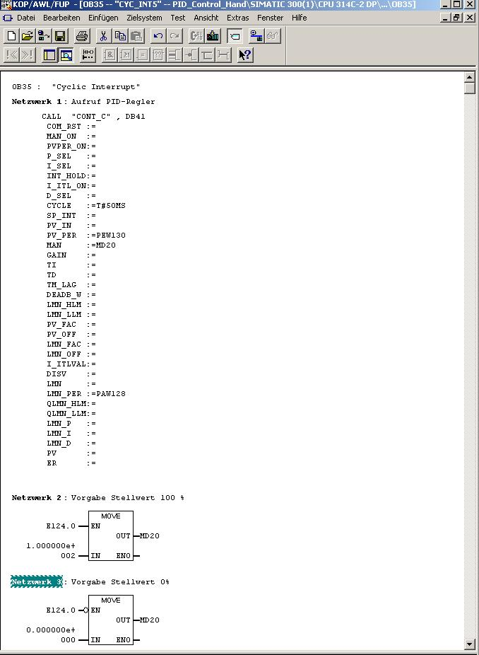
Wiring the manual value to thevalue 0 or 100% of the manipulated value
(Refer to NW 2 and NW 3)
Network 1: Call PID Controller
Network 2: Default Manipulated value 100%
Network 3: Default Manipulated value 0%

Then, the system step response is recorded with the curve plotter from 0 to 100%.
For systems that tend to overshoot, 90% should be assigned as step value.

Turning Point
Setpoint

Tu Tg

System step response for T_{u}-T_{g} approximation

After the inflectional tangent is drawn in the figure, the following values can be read:
T_{u} = 0.7s
T_{g} = 7s
1.0 * K_{S} = 1.0
The result is K_{S} = 1.0 and the ratio T_{g}/K_{S} = 7s.

Setting the PI controller according to Ziegler-Nichols

The following controller parameters result with the values T_{u}-T_{g} approximation, and the rules for controller adjustment according to Ziegler-Nichols:
K_{PR} = 9
T_{N} = 2.3s
These controller parameters are transferred to DB41.

6. appendix

Diagram of the controller block:

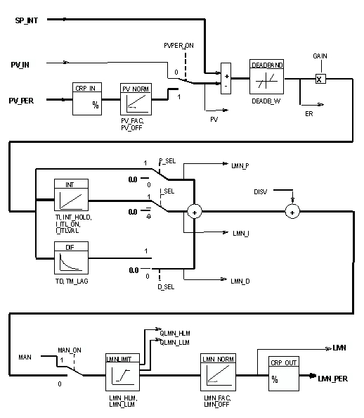
Input Parameters

Parameter | Data Type | Value Range | Default | Description
COM_RST | BOOL |  | FALSE | COMPLETE RESTART. The block has a complete restart routine that is processed if the input is set to "Complete restart".
MAN_ON | BOOL |  | TRUE | MANUAL VALUE ON / Switch on manual operation. If the input "switch on manual operation" is set, the control loop has been interrupted. A manipulated value is entered as manual value.
PVPER_ON | BOOL |  | FALSE | PROCESS VARIABLE PERIPHERY ON / Actual value  Switch on the periphery. If the periphery is to read in the actual value, input PV_PER has to be wired to the periphery, and the input "Switch on actual value periphery" has to be set.
P_SEL | BOOL |  | TRUE | PROPORTIONAL ACTION ON / Switch on P-component. In the PID algorithm, the PID components can be switched on/off individually. The P-component is switched on if the input "Switch on P-component" is set.
I_SEL | BOOL |  | TRUE | INTEGRAL ACTION ON / Switch on I-component. In the PID algorithm, the PID components can be switched on/off individually. The I-component is switched on if the input "Switch on I- component" is set.
INT_HOLD | BOOL |  | FALSE | INTEGRAL ACTION HOLD / Freeze I-component. The output of the integrator can be frozen. To this end, the input "Freeze I-component“ is set.
I_ITL_ON | BOOL |  | FALSE | INITIALIZATION OF THE INTEGRAL ACTION / Set I-component. The output of the integrator can be set to the input I_ITL_VAL. To this end, the input "Set I-component“ has to be set.
D_SEL | BOOL |  | FALSE | DERIVATIVE ACTION ON / Switch on D-component. In the PID algorithm, the PID components can be switched on/off individually. The D-component is switched on if the input "Switch on D-component" is set.

Parameter | Data Type | Value Range | Default | Description
CYCLE | TIME | >= 1 ms | T#1s | SAMPLE TIME. The time between block calls has to be constant. The input "Sample time" indicates the time between block calls.
SP_INT | REAL | -100.0...+100.0% | 0.0 | INTERNAL SETPOINT. The input "Internal setpoint" is used to specify the setpoint.
PV_IN | REAL | -100.0...+100.0% | 0.0 | PROCESS VARIABLE IN / Actual value input. At the input "Actual value input", a startup value can be parameterized, or an external actual value can be wired in the floating point format.
PV_PER | WORD |  | W#16#0000 | PROCESS VARIABLE PERIPHERy / Actual value Periphery. The actual value in the periphery format is wired to the controller at the input "Actual value Periphery ".
MAN | REAL | -100.0...+100.0% | 0.0 | MANUAL VALUE. The input "Manual value" is used to specify a manual value by means of the operator interface function.
GAIN | REAL |  | 2.0 | PROPORTIONAL GAIN /Proportional coefficient. The input "Proportional coefficient" indicates controller gain.
TI | TIME | >= CYCLE | T#20s | RESET TIME / Integration time. The input  "Integration time" determines the time response of the integrator.
TD | TIME | >= CYCLE | T#10s | DERIVATIVE TIME. The input "Derivative time" determines the time response of the differentiator.
TM_LAG | TIME | >=CYCLE/2 | T#2s | TIME LAG OF THE DERIVATE ACTION / Delay of the D-component. The algorithm of the D-component contains a delay that can be parameterized at the input "Time lag of the derivative action".
DEADB_W | REAL | >=0.0 % | 0.0 | DEAD BAND WIDTH. The system deviation is taken via a dead band. The "Dead band width" determines the size of the dead band.

Parameter | Data Type | Value Range | Default | Description
LMN_HLM | REAL | LMN_LLM...  +100.0 % or  phys. variable 2 | 100.0 | MANIPULATED VALUE HIGH LIMIT. The manipulated value is always limited to a high and a low limit. "Manipulated value high limit" indicates the high limit.
LMN_LLM | REAL | -100.0...  LMN_HLM %  phys. variable 2 | 0.0 | MANIPULATED VALUE LOW LIMIT. The manipulated value is always limited to a high and a low limit. "Manipulated value low limit" indicates the low limit.
PV_FAC | REAL |  | 1.0 | PROCESS VARIABLE FACTOR / actual value factor. The input "Actual value factor" is multiplied with the actual value. The input is used for adjusting the actual value range.
PV_OFF | REAL |  | 0.0 | PROCESS VARIABLE OFFSET / Actual value offset. The input "Actual value offset" is added to the actual value. The input is used for adjusting the actual value range.
LMN_FAC | REAL |  | 1.0 | MANIPULATED VALUE FACTOR The input "Manipulated value factor" is multiplied with the manipulated value. The input is used for adjusting the manipulated value range.
LMN_OFF | REAL |  | 0.0 | MANIPULATED VALUE OFFSET. The input "Manipulated value offset" is added to the manipulated value. The input is used for adjusting the manipulated value range.
I_ITLVAL | REAL | -100.0...+100.0% or phys. variable 2 | 0.0 | INITIALIZATION VALUE OF THE INTEGRAL ACTION / Initialization value for the I-component. The output of the integrator can be set at the input I_ITL_ON. The initialization value is located at the input "Initialization value for I-component".  .
DISV | REAL | -100.0...+100.0% or phys. variable 2 | 0.0 | DISTURBANCE VARIABLE. Feedforward control is wired at the input "Disturbance variable".

Output Parameters:
Parameter | Data Type | Value Range | Default | Description
LMN | REAL | 0.0 |  | MANIPULATED VALUE. At the output "Manipulated value", the effectively active manipulated value is read out in the floating point format.
LMN_PER | WORD | W#16#0000 |  | MANIPULATED VALUE PERIPHERY. The manipulated value in the periphery format is wired to the controller at the output of "Manipulated value periphery“.
QLMN_HLM | BOOL | FALSE |  | HIGH LIMIT OF MANIPULATED VALUE REACHED. The manipulated value is always limited to a high and low limit. The output "High limit of manipulated value reached" signals that the high limit has been exceeded.
QLMN_LLM | BOOL | FALSE |  | LOW LIMIT OF MANIPULATED VALUE REACHED. The manipulated value is always limited to a high and low limit. The output "Low limit of manipulated value reached" signals that the low limit is underrange.
LMN_P | REAL | 0.0 |  | PROPORTIONALITY COMPONENT. The output "P-component" contains the proportional component of the manipulated variable.
LMN_I | REAL | 0.0 |  | INTEGRAL COMPONENT. The output "I-component“ contains the integral component of the manipulated variable.
LMN_D | REAL | 0.0 |  | DERIVATIVE COMPONENT. The output "D-component" contains the derivative component of the manipulated variable.
PV | REAL | 0.0 |  | PROCESS VARIABLE / actual value. At the output "Actual value", the effectively active actual value is read out.
ER | REAL | 0.0 |  | ERROR SIGNAL / System deviation. At the output "System deviation", the effectively active system deviation is read out.

