 

Module 3

EXERCISE: Archive

# : 30 min

Objective:

Set up an archive for the TSU (supply air temperature), TsuSP (supply air temperature setpoint), Cvlv (Cooling valve) and Hvlv (Heating valve).

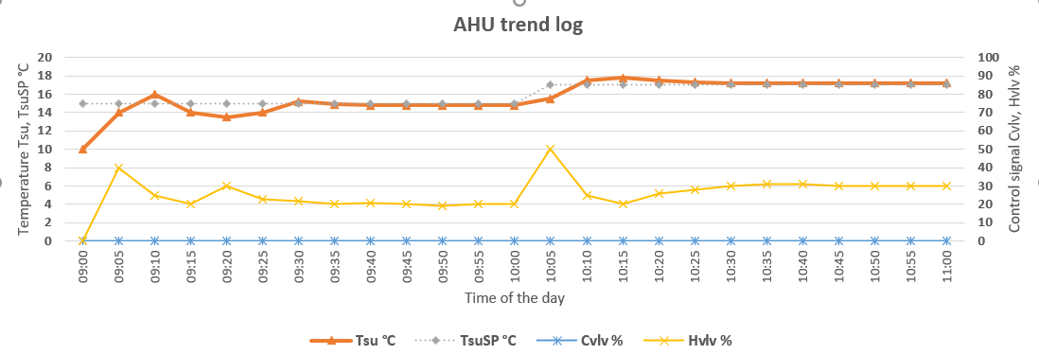

# Task:

Create an archive and observe the data.

Use the data points from the previous created function blocks (module 2).

1. enable archive
2. Set the CFG trend object to the number of data points to archive (e.g. 5)
3. Set CFG reconfigure value to active (enables the archive)
4. Browse for the data points and drug and drop them to the Archive configuration viewer.
5. Change the storage frequency and storage mode (e.g. Ringbuffer)  
   - TSU 🡪 COV value 0.1 ( high precision)  
   - Cvlv 🡪 COV value 1  
   - Hvlv 🡪 COV value 1  
   - TsuSP 🡪 value is not relevant
6. Select all datapoints and register them to the target.
7. Save the profile settings to “Configuration1 and rename it accordingly.
8. Upload stored data from the controller and observe the data.
9. View the data and zoom in to a particular time of period
10. Export the data to CSV files. (files are created as object and member combination)
11. Export the data to the SD card, therefore change the value to Metric or Imperial for each archive (prior to this task an SD card must be installed)
12. Keep the export Threshold (e.g. 15)
13. Get to know about the maintenance functions: Erase data, format Archive etc.

# Hints:

The changes on the online trend window will be updated after closing and opening the online trend

**Exercise 2. Set up archive**

**Learning goal:**

Create an archive and observe the data

**Workflow overview:**

Step1. enable archive

Step2. target and archive profile must be set up

Step3. Drag and drop data points to the profile viewer

Step4. Change COV settings

Step5. Configuration is registered in the target

Step6. Profile Configuration is saved in Scope project

Step7. Extend archive capacity (SD card)

Step8. Maintaining the archive