EXERCISE: AHU time schedule and calendar

# : 30 min

Objective:

# Allow the plant to run under the dictates of a time schedule.

# Task:

The following procedure can be used:

SAPRO:

1. Add a Schedule object on to the Plant Control page.

2. Add a Calender object on to the same page.

3. Connect the “DB” of the Calender object to the “CalDB” member of the Schedule object.

4. Connect the “CmdDB” member of the Schedule object to the “DB” of the OpMod Multistate Value object.

5. Save, generate the code and download to the controller.

SCOPE:

1. Configure new time periods for the working days.

2. The plant should can under control of these time periods.

3. These time schedule can be overridden by the Plant Switch.

4. Configure an Exception Day in the time schedule.

5. Create a Rule for this Exception Day in the Calendar Viewer.

6. Update this Rule to the Calendar object in the controller.

7. Verify that the Exception Day in working.

Result:

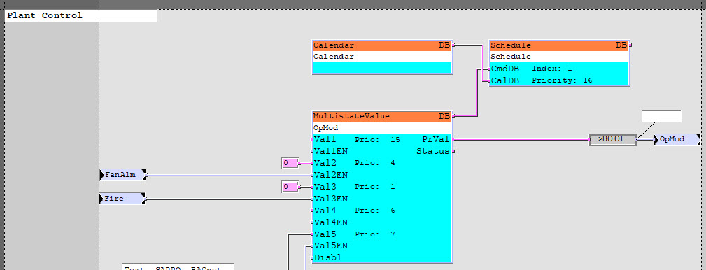

The plant is enabled and disabled by the time schedule and calendar objects

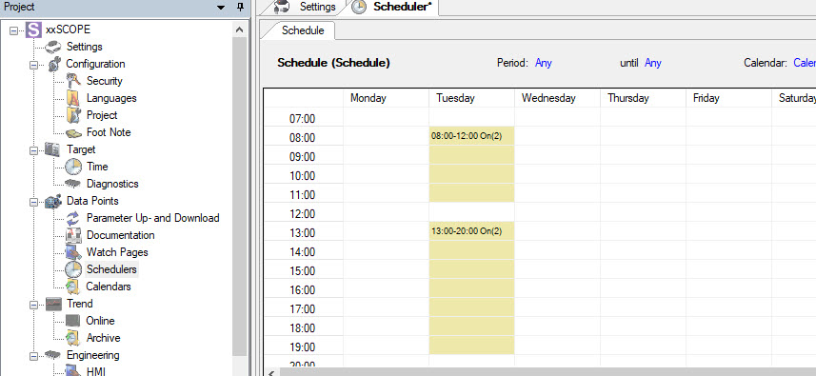

# Hints ☺:

- Use the step by step guide.