EXERCISE: AHU – temperature control

# : 30 min

Objective:

# Create the control logic to control the operation of the main heating and cooling coil valves. The heating and cooling coil valves shall be controlled in sequence controlled by a supply air temperature sensor. The valves shall be modulated using PI control to maintain a defined setpoint temperature (e.g. 15 deg C).

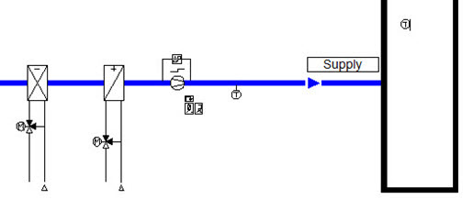

# Task:

The following procedure can be used:

1. Move the analog input object for the supply air temperature and room air temperature to a new page and name the page “Heating and Cooling Coil Control”.

2. Add two Loop Controller objects on to the page.

3. Place the analog output objects for the heating and cooling valves on to the page below, there is not enough space on one page!

4. Add a SetpointValueLimit object on to the page.

5. Add an addition function to provide a set point deadband for the two loop controller set point values.

5. Connect the required members of the loop controllers, for the sensor, set point and valves.

Result:

See next page…1) Example of a heating and cooling valve control

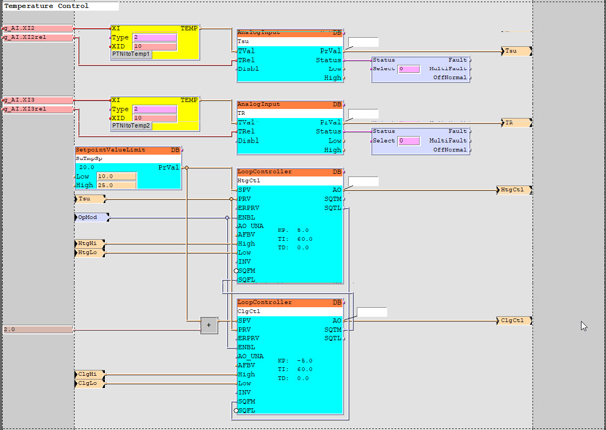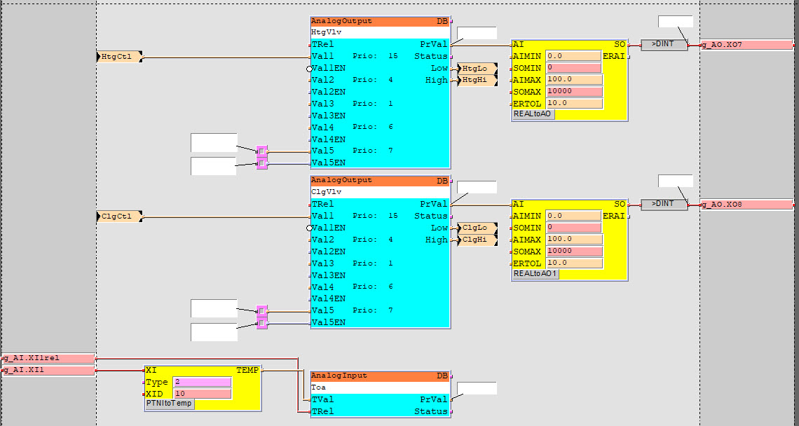

- Test the logic using SAPRO Online-Test mode and SCOPE Browser.

- The analog output objects should modulate according to the control of the loop controller depending on the set point value and value of the temperature sensor.

- Program running.

# Hints ☺:

- The Loop controller must be enabled and the sequence terminated!

- Do not use the invert (INV) member on either of the loop controllers!

- For the heating loop use a positive KP (+5) and for the cooling use a negative KP (-5).