EXERCISE: AHU – Plant control of the fans

# : 30 min

Objective:

# Create the control logic to start / stop the fans including feedback.

# Task:

The following procedure can be used:

1. Place the binary output objects for the fans on a new page and name the page “Fan control”.

2. Also place the binary input objects for the feedback on to the same page.

3. The fans shall activated by the OpMod.

4. If a either feedback fails an alarm message will be generated and the fans will stop.

5. The fans will only restart after the alarm message is acknowledged.

Result:

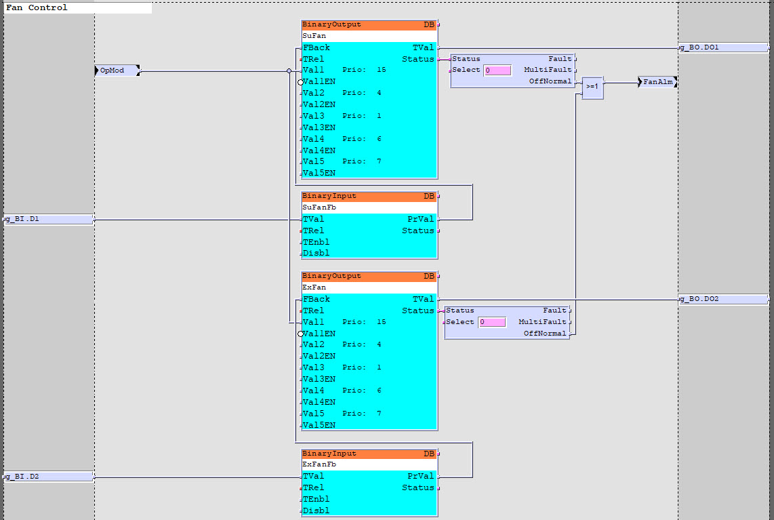

The fan feedback alarm in interlocked with the OpMod.

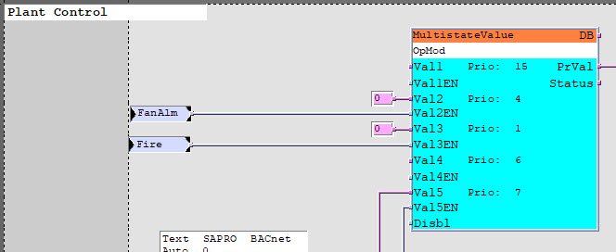

- Test the logic using SAPRO Online-Test mode and SCOPE Browser.

- The fans shall start and stop by the Plant Switch.

# Hints ☺:

BACnet priority array

