EXERCISE: AHU Plant control

# : 30 min

Objective:

# Create SAPRO program logic to start and stop the AHU manually by an operator. Consider future plant interactions (e.g. fire, time schedule etc). Disable the plant when a fire alarm in activated.

# Task:

The following procedure can be used:

1. Determine the interactions to start and stop the plant.

2. Add a MultistateValue object to a new page.

3. Add a comment field and enter the text “Plant Control”.

4. For the operator manual control, use a SetpointMultistate object and two MUX function blocks.

5. Move the control logic for the “FireAlm” on to this page, make a connection between the “FireAlm” StatusEval (OffNormal member) and the required on the Multistate Value object.

Result:

1) Example of plant control logic

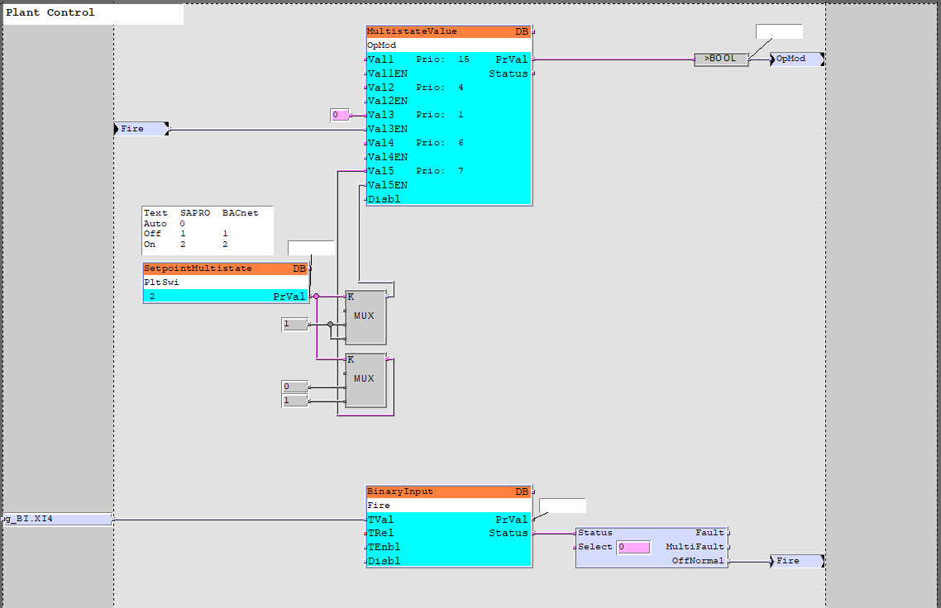

- Test the logic using SAPRO Online-Test mode and SCOPE Browser.

- The AHU should start and stop according to the operator.

- The AHU will be stopped by the fire alarm input.

- Program running.

# Hints ☺:

- Use a Multistate Value, consider the priority array.

- Use MUX UINT, when K is 0, IN1 value is sent to output.