EXERCISE: Air handling unit – create inputs/outputs

# : 30 min

Objective:

# Create the inputs and outputs for your SAPRO application for a basic air handling unit.

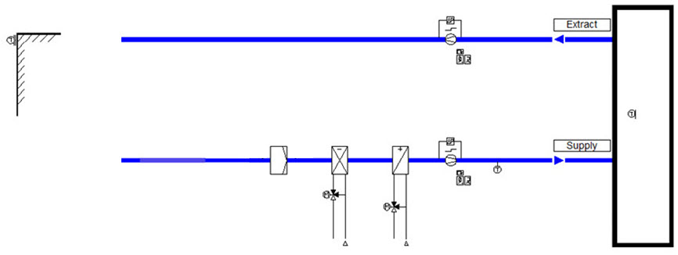

# Tasks:

1. Either use the existing project name ProgramBasics or create a new project in SAPRO. Set up the project structure and create a new program.
2. Under the aoHWIO unit object, add the global variables for the hardware inputs and outputs:
3. Under the aoHVAC unit object add the

1. Add the analog input objects for the sensors.

2. Add the binary input objects for the switches and fire alarm input.

3. Add the analog output objects for the valves.

4. Add the binary output objects for the fan commands.

5. Generate code, download and test.

# Result:

Program running

Simulation tested on the controller.

# Hints ☺:

Use the previous step by step guide.

Delete the existing variables, lines and functions on page aoHWIO.

|  |  |  |  |  |
| --- | --- | --- | --- | --- |
| **Description** | **Type** | **Signal** | **Unit** | **Controller IO** |
| Outside air temp. | AI | Ni1000 | °C | X1 |
| Supply air temp. | AI | Ni1000 | °C | X2 |
| Room air temp. | AI | Ni1000 | °C | X3 |
| Fire alarm | DI | N/O Volt free contact | Normal,ALARM | X4 |
| Supply fan diff. pressure switch | DI | 24VAC signal | No Flow,Flow | D1 |
| Extract fan diff. pressure switch | DI | 24VAC signal | No Flow,Flow | D2 |
| Supply fan command | DO | 24V Relay | Off,On | Q1 |
| Extract fan command | DO | 24V Relay | Off,On | Q2 |
| Cooling coil valve | AO | 0-10V | % Open | X7 |
| Heating coil valve | AO | 0-10V | % Open | X8 |

Climatix POL688.80/STD hardware inputs and outputs

